

Student Name: Lois Harris Student ID Number: 1907505

Programme: BEng Engineering Programmes (Part-Time)

Module: CAE & Stress Analysis
Module Code: M5X02064

Lecturer: Andrew Harrison

Assignment Title: Motion Simulation
Submission Deadline: 29/06/20

Table of Contents

ABSTRACT
SECTION 1
  - Introduction

SECTION 2
2.1 Motion simulation
2.2 Finite element analysis
2.3 Development of finite element analysis

SECTION 3
3.1 Advantages and disadvantages
3.1.1 Optimising product development
3.1.2 Achievement of required quality
3.1.3 Investment costs
3.1.4 Training and skills

SECTION 4
4.1 Application of Motion Simulation and Finite Element Analysis
4.1.1 Civil engineering
4.1.2 Automotive industry
4.1.3 Injection moulding

SECTION 5
5.1 Creating the gearbox assembly
5.2 Creating the gearbox motion simulation

REFERENCES

The subject of the paper is the research of motion simulation / FEA techniques and their application. Initially, an understanding will be developed of what both these techniques are, and how they differ. The next section will discuss several of the advantages and disadvantages that are associated with using these methods. Finally, there will be an explanation of how the gearbox assembly and motion simulation was completed.
1.1 Computer-aided engineering (CAE) has been available within the engineering sector for around 40 years now. Amongst other benefits, it enables engineers to use simulation tools like finite element analysis (FEA). Motion simulation techniques have become increasingly common practice within many engineering sectors; including civil engineering, tool design and the automotive industry; as it can help to overcome many problems, including some of those that arise during product development.
Motion simulation can be advantageous to companies as it helps to reduce the need for time consuming prototypes. This in turn reduces material waste- meaning its also beneficial for the environment. In addition to this, it allows new design to be brought to market at an increased speed. Partially useful for highly competitive markets. Despite these techniques having a largely positive influence for both manufacturers and consumers, there are some drawbacks associated with implementing such methods and programmes (SolidWorks, n.d.)
2.1 “Motion simulation provides complete, quantitative information about the kinematics – including position, velocity, and acceleration, and the dynamics – including joint reactions, inertial forces, and power requirements, of all the components of a moving mechanism. It goes further than the animation of an assembly, which is limited to the analysis of relative motion only. Information like material properties can be used to determine the inertial properties of mechanism components, and mating conditions into kinematic joints.” (SolidWorks, n.d.)
Results from motion simulation can be calculated very quickly. Generally, the information required to implement motion simulation will be defined as part of the CAD assembly model. To achieve the same results using mathematical calculations would be time-consuming, monotonous and at high risk of human error. It would also need to be restarted after every modification. Motion simulation can also be utilised to check for interferences. This can provide information including the spatial and time positions of all components plus exact interfering volumes. The results from motion simulation can be presented in any desired format- useful to enable the information to be universally interpreted. (SolidWorks, n.d.)
2.2 “Finite element analysis is commonly also known as the finite element method. It is a technique which is used within engineering to obtain approximate solutions of boundary value problems. This type of mathematical problem is where one or more dependent variables must satisfy a differential equation everywhere within a known domain of independent variables and satisfy specific conditions on the boundary of the domain. FEA can be used to solve these types of problems with a variety of variables, including for example, heat flux, physical displacement or fluid velocity.” (Hutton, 2003).
2.3 The origins of this technique can be traced back at least 50 years, although the fundamental methods for solving differential equations is much older. Originally, the technique was needed for the analysis of airframe structures. Aircraft engineers saw the potential benefits of using these methods, which caused applications to grow to include plate bending, pressure vessels, fluid flow and heat transfer. NASTRAN was the first major finite element software code to be developed in conjunction with the United States space exploration programme. It was capable of hundreds of thousands of degrees of freedom. With the evolution of technology and computing, many commercial software packages have been developed ever since. Today, FEA uses a computer-based software platform is to analyse and simulate both engineering products and systems. (Hutton, 2003)
3.1.1 One of the greatest benefits of these techniques is the optimised product performance and cost. This is largely due to the reduction in development time – as very often the testing of new products can either be eliminated completely or significantly reduced. Using these techniques and the analytical results they provide; small changes and improvements can be made to the product within the CAD software. It provides improved information for decision making. These benefits are also seen by the consumer as they can drive the overall cost of the product down.
3.1.2 Motion simulation gives engineers the ability to test designs before they become physical products – preventing mistakes being made which would be detrimental to their overall quality. In the past, risks would have needed to be taken by manufacturers, balancing the speed of their products to market with the overall quality of its design. Potentially damaging their reputation by doing so. (Baguley. D, 1994)
3.1.3 One of the main disadvantages of use of these types of software packages is the initial investment costs required. It is estimated by Innova systems, a UK Value Added Reseller of Commercial and Research SOLIDWORKS licenses, that your budget should allow for between £6,000 and £10,000 per user for the software. This is a substantial investment cost upfront, which is simply too large for some smaller engineering organisations. Likewise, some companies will spend large amounts, and result in gaining very little from the software as it does not suit their business needs.
3.1.4 One of the other issues associated with the application of such software is ensuring that everyone has the skills required to operate and fully understand the results provided. There is scepticism from some people, as they believe that vendors are developing FEA software to provide a ‘push-button solution’ for anyone to use. Although most are accurate enough to provide a good solution, the results are only as accurate as the input data provided. Due to the necessary human interaction, there is potential for catastrophic mistakes, meaning results are not 100% correct. (Monaghan, 2002)
4.1.1 An example of the use of FEA is within civil engineering. It is a useful tool to be able to numerically approximate physical structures that are too complex for other analytical solutions. One of the main reasons for its use is to ensure the safety of a building or structure. It can be used to apply analysis to the response of a structure once subjected to the loads occurring within its environment. For example, those from wind, gravity or the extreme cases of natural disasters such as earthquakes and typhoons. Prior to the developed of FEA, engineers would rely upon laboratory testing to gain analytical results. However, this was costly and not immediately accessible. Development of these techniques has made designing, testing and establishing the safety of projects and its materials easier, faster and significantly cheaper. (Harish, March 2020)
4.1.2 FEA is used in the mechanical design of automotive components as it can be used to help effectively solve any issues relating to deformation and stress distribution. There is growing pressure to ensure the safety of vehicles, whilst also trying to reduce their weight and energy consumption. Engineers can introduce motion simulation into traditional design methods – this has benefits including reduced test cost and shortening manufacturing time. Using the body of the vehicle as an example, the specification of this part requires enough stiffness to limit damage deformation, and during the normal operation of the vehicle will not appear damaged due to fatigue. Engineers can analyse both the structure and dynamics, hence allowing them to compare and improve the design by trying to use different materials. They can easily determine the effect material choice will have on the weight and strength of the component, improving its overall performance. (Gu, 2017).
4.1.3 Motion simulation or mould flow simulation is a technique commonly applied to components designed for injection moulding. Autodesk has a specific programme called Moldflow which allows plastic injection and compression mould simulation for design and manufacturing. The software has been designed to allow for geometrical changes and troubleshoot for potential issues during manufacturing. These would typically include shrinkages, warping and flow lines. Each of these issues can have a negative effect on the quality of the part, therefore rectifying them before the production of parts is time and cost saving, as well as beneficial for quality. (Autodesk, n.d.)
5.1 The task set for the assignment was to construct an assembly and motion simulation of parts including; gearbox input and output shafts, input and output gears, gear shift fork and gearbox housing using Solid Works. The assembly could be thought of as two main sub-assemblies. Initially, the gears and bearings needed to be mounted onto each of the shafts. This was done through a series of concentric, coincident and distance mates. The gearbox assembly was such that allowed the input shaft to rotate, drive the output shaft and be able to change gear using the gear shift fork. To achieve this, the primary combined first second gear was assembled to allow it to rotate with, but also move along the input shaft. The primary first and second gears were mated concentrically to the shaft and allowed to rotate independently. They were also fixed in position using both distance mates and coincident mates.
The output gears were assembled in a similar way as they were also concentrically mated to the output shaft, however, these gears could not move independently, but instead with the rotation of the output shaft. Coincident mates were used between the planes of the gears and the output shaft to allow this to happen. To organise the assembly document, two folders were created to separate the mates of the input and output shafts. Finally, interaction was needed between the sets of gears on the two shafts. To determine the distance required between the axis of these shafts, a calculation needed to be used. Firstly, the pitch diameter was found using the number of teeth and outside diameter. The spacing was then calculated by half the pitch diameter of gear one plus half the pitch diameter of gear two. A distance mate was used and set to 61.50mm between the axis of the two shafts. To finalise the assembly, the supress function was used on this mate. This was done because the primary shaft and the output shaft were fixed in place by the primary end bearing and main output bearing respectively.
5.2 Once the gearbox assembly had been completed, the motion simulation could be created within the motion study tab. To begin, gravity was added (9806.65mm/s^2) in the negative y axis. Next, a solid body contact was created to simulate the contact between the primary and secondary gears, plus the first second combined gear. Following this, a rotary motor was added to the primary shaft – set to 100RPM to allow a constant speed of rotation. To simulate the action of the gearbox, a force was placed upon the shifter fork to move the first second combined gear along the shaft, to combine with primary first gear pinion. Likewise, the same force was used in the opposing direction to move the combined gear along the shaft until it reacted the primary second gear pinion.
To improve the accuracy of the motion simulation, friction was added on the concentric mates between the output shaft and both output bearings. Material properties are stored within Solid Works; therefore, greasy steel was selected. Another way to simulate the movement of the combined gear along the shaft was using a linear motor (actuator). The displacement was set as such that the combined gear would reach the primary gear pinion but would not move through or past it. However, this method did not accurately simulate the gearbox – when the combined gear reached either of the gear pinions, they would mesh together incorrectly. The simulation would force a mesh between the parts, therefore they overlapped. When the results were transferred onto a graph, there was a spike in the results caused by a ‘jump’ in the motion simulation.
Once the motion simulation study had been solved, the software is able to determine the number of redundant mates. Essentially, having redundant mates is the equivalent of over-defining a model. For example, if there were two hinges within an assembly, only one mate would be needed to restrict the vertical translation of the component. The number of redundant mates within a motion simulation can be reduced by deleting/suppressing mates. Another method is using rigid groups which allows the motion simulation to be simplified. The effect is that all mates between components in the same rigid group are ignored. Components in the same rigid group will maintain their relative position to other components.
To further improve the quality of the motion simulation, it is possible to adjust the framerate. This is a measurement of the interactivity and is the number of still frames displayed in one second to give the impression of an interactive image. In Solid Works, the default value for motion simulation is 25 frames per second. It is important to remember that increasing the frame rate of the motion simulation will also affect the resolve time for the study. Once the study had been completed, it was possible to display various results in the form of a graph, including linear displacement and angular velocity. These values could be plotted for any of the components within the study against time.
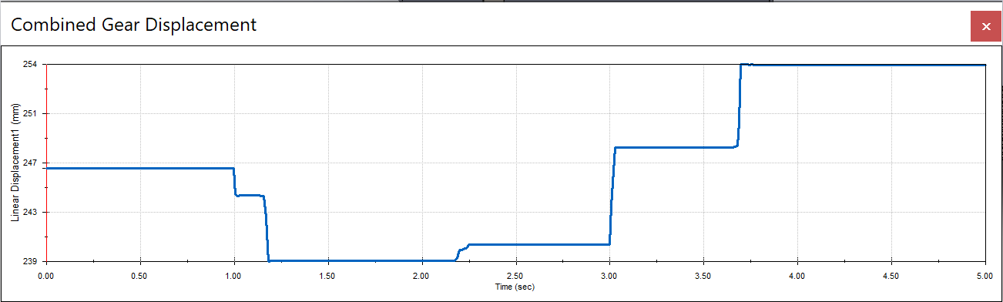
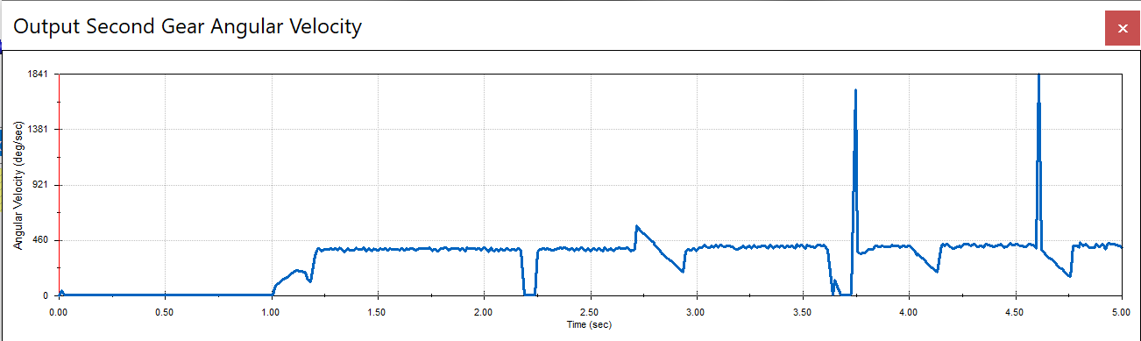

Please find below the link to my CAD files.
https://uowtsd-my.sharepoint.com/:f:/g/personal/1907505_student_uwtsd_ac_uk/Er22gzp1pFdNiJrFyBxi-dIBb3uExkb5qdFHZyPVdTmfAA?e=0psyUV

Bibliography
Autodesk, n.d. Finite Element Analysis. [Online]
Available at: https://www.autodesk.co.uk/solutions/finite-element-analysis
[Accessed May 2020].
Baguley. D, H. D. R., 1994. Why Do Finite Element Analysis. Hamilton: NAFEMS.
Gu, S., 2017. Application of finite element method in mechanical design of automotive parts. s.l., IOP Conference Proceedings.
Harish, A., March 2020. Applications of FEA in Civil Engineering, Hannover, Germany: SIMSCALE BLOG.
Hutton, D. V., 2003. Fundamentals of Finite Element Analysis. s.l.:McGraw-Hill.
Monaghan, D., 2002. Using FEA: A Word of Warning. [Online]
Available at: http://www.dermotmonaghan.com/ fea/ htm/ introduction/ word_of_caution.htm
[Accessed 21 September 2015].
SolidWorks, n.d. White Paper - Understanding Motion Simulation. [Online]
Available at: https://www.solidworks.com/sw/images/content/Training/SIM_Motion_UnderstandingMotion_WP_ENG.pdf
[Accessed May 2020].

