Amina Meah (2237650)
University of Wales Trinity Saint David
RESEARCH report

Contents
Task 1 4
Research on hypervisors 4
Types of Hypervisors 4
Architecture of Hypervisors 4
Role of the Hypervisor in Virtualization 4
Differences in Architecture between Type 1 and Type 2 Hypervisors 4
Features of Hypervisors 4
Hardware Requirements 4
Advantages and Scalability 5
Security and Compatibility 5
Market Solutions for Hypervisors 5
Research on IP addressing 6
Role of IP Addresses in Data Transmission 6
Routers and Switches in Network Communication 6
Structure, Format, and Representation of IPv4 & IPv6 6
Subnetting and Efficient IP Address Utilisation 6
Key Concepts in Subnetting 7
Diagrams and Practical Examples 7
Research on routing 7
Static vs. Dynamic Routing Protocols 8
Case study - Routing Protocols in Meah Corp's Network 8
Research on network services 10
Overview of VPNs 10
Functionality of DHCP 10
Role of Active Directory Domain Services 10
Importance of Certificate Authorities 11
References 12
Task 2 -Technical Documentation Report 14
Choice of Hypervisor 14
Justification: 14
Download and Setup 15
Downloading the OS and Clients 15
Evidence: 15
Network Deployment 16
Configure IP Addressing 19
IP Address Configuration 19
IP Addressing Scheme Justification 20
Screenshots 20
Debian Server IP Configuration 23
Test and Troubleshoot 26
Connectivity Tests 26
Screenshots 27
Troubleshooting Steps 28
Conclusion 29
Task 3 - Personal and technical reflection 30
Technical Reflection: Network Deployment and Testing 30
Personal Reflection 30

Task 1

Research on hypervisors

Types of Hypervisors
- Type-1 Hypervisor: Runs directly on hardware without a host OS (e.g., VMware ESX, Xen, Microsoft Hyper-V) .
- Type-2 Hypervisor: Runs on top of a host operating system (e.g., VMware Workstation, Oracle VirtualBox, KVM) [1].

Architecture of Hypervisors
- Type-1 hypervisors interact directly with the hardware, managing resources such as CPU and memory for virtual machines .
- Type-2 hypervisors depend on the host OS for resource management and run on top of it [2].

Role of the Hypervisor in Virtualization
- The hypervisor is responsible for managing hardware resources and allocating them to virtual machines, ensuring isolation and efficiency, and enabling virtualization [2].

Differences in Architecture between Type 1 and Type 2 Hypervisors
- Type-1: Runs directly on hardware, managing all resources.
- Type-2: Operates atop a host operating system, relying on it for managing hardware resources [2].

Features of Hypervisors
- Resource Allocation: Hypervisors allocate CPU, memory, and I/O resources to virtual machines.
- Isolation: Virtual machines are isolated from each other to prevent interference.
- Performance Optimisation: Type-1 hypervisors are designed to offer near-native performance by minimising overhead [2].

Hardware Requirements
- Key hardware components include CPU, MMU (Memory Management Unit), and I/O devices. Hypervisors need sufficient resources for effective virtualization, although the exact requirements (RAM, Storage, Network) are less detailed [2].

Advantages and Scalability
- Hypervisors enable efficient resource management and scalability by running multiple virtual machines on a single physical machine, making them suitable for cloud computing and enterprise environments [2].

Security and Compatibility
- Security: Virtual machines are isolated to prevent interaction and maintain security.
- Compatibility: Hypervisors abstract hardware, providing compatibility across different operating systems and applications, though the text does not deeply explore OS and hardware compatibility issues [2].

Market Solutions for Hypervisors
- Commercial Solutions: VMware ESX, Microsoft Hyper-V.
- Open-source Solutions: Xen, KVM, VirtualBox.
These solutions are used in various virtualization scenarios depending on the specific needs of the user or organisation [2].

Research on IP addressing
An Internet Protocol (IP) address is a unique identifier that allows devices to communicate over the internet. A static IP address remains fixed and is manually assigned to a device for long-term use, while a dynamic IP address is automatically assigned and changes periodically. Static IPs provide consistency, whereas dynamic IPs enhance flexibility and efficient address allocation [3].

Role of IP Addresses in Data Transmission
IP addresses are essential for directing data packets across networks. When data is transmitted over the internet or local networks, IP addresses in the packet headers guide routers and switches to forward the data to the correct destination. This system ensures that emails, web pages, and other data types reach the appropriate devices [3].

Routers and Switches in Network Communication
Routers direct network traffic using IP addresses (Layer 3), ensuring data reaches the correct destination. Each network segment (subnet) requires a unique IP range, and routers use ARP to map IPs to MAC addresses. By summarising routes instead of listing individual addresses, routers reduce overhead and improve efficiency [4].
Switches operate at Layer 2, forwarding data within a Local Area Network (LAN) using MAC addresses. They reduce congestion by sending data only to the intended device. VLANs help segment traffic, improving security and performance [4].
Together, routers manage external network connections, while switches optimise internal communication, creating a scalable and efficient network.

Structure, Format, and Representation of IPv4 & IPv6
IP addresses come in two primary versions: IPv4 and IPv6.
IPv4: Utilises 32-bit addresses, typically represented in dotted decimal format (e.g., 192.168.1.1). This format divides the address into four octets, separated by periods, each ranging from 0 to 255 [4].
IPv6: Employs 128-bit addresses, expressed as eight groups of four hexadecimal digits, separated by colons (e.g., 2001:0db8:85a3::8a2e:0370:7334). IPv6 was developed to address the limitations of IPv4, particularly the limited number of available addresses [4].

Subnetting and Efficient IP Address Utilisation
A subnet divides a large network into smaller, more manageable networks, improving performance, security, and efficiency. For example, different departments in a company can have their own subnet, ensuring smoother data transmission and reduced congestion. Without subnetting, all devices in a network share the same space, leading to IP waste, slow performance, and security risks [5].
By subnetting, we:
- Efficiently allocate IPs (prevent waste)
- Reduce network congestion (better performance)
- Enhance security (department isolation [5]

Key Concepts in Subnetting
- IP Addressing: Consists of a network portion (identifies the network) and a host portion (identifies devices).
- Subnet Mask: A 32-bit number defining which part of an IP address is the network ID.
- CIDR Notation: A simplified way to represent subnet masks (e.g., /24 instead of 255.255.255.0) [5].

Diagrams and Practical Examples
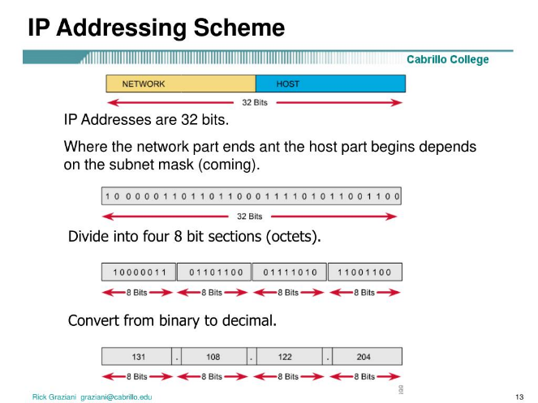
IP Addressing Scheme [6]
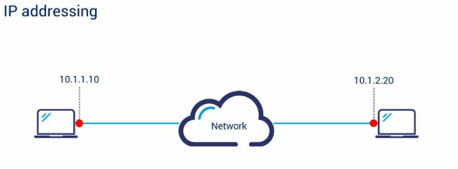
Simple Diagram of IP Addressing [7]

Research on routing
Routing is the process of selecting paths for network traffic. Routing protocols are standardised communications used by routers to determine the best paths for data transmission. [8].

Static vs. Dynamic Routing Protocols
Static Routing involves manually configuring the routing table, which doesn’t change unless modified by a network administrator. It has benefits such as reduced router CPU overhead, enhanced security (as only the administrator can modify routes), and no bandwidth usage between routers. However, static routing can be cumbersome for large networks, as it requires manual updates for every route change.
Dynamic Routing, on the other hand, automatically adjusts the routing table in response to changes in network topology. It uses complex algorithms to recalculate routes and update routers with new routing information. While it is more flexible and adaptive than static routing, it does not provide the same level of security, as routes can be modified without manual intervention [8].

Case study - Routing Protocols in Meah Corp's Network
Background: Meah Corp, a global enterprise, needed a scalable and secure network infrastructure to support its growing workforce and business applications.
Challenges:
- Ensuring network resilience and performance.
- Securing internal and external communications.
- Supporting remote offices with varying connectivity needs.
Static Routing: Used in stable, smaller network segments, such as remote offices. It offered:
- Security: Manual configuration allowed full control over network routes.
- Performance: No routing updates reduced overhead.
- Cost Efficiency: Cheaper routers could be used for simpler parts of the network.
Dynamic Routing (OSPF and BGP ) was deployed in complex areas like headquarters and data centres:
- OSPF (Open Shortest Path First) ensured efficient routing with fast convergence [9].
- BGP (Border Gateway Protocol) managed traffic between autonomous systems and optimised external connectivity [9].
Implementation: Static routing was used in predictable segments, while dynamic routing (OSPF and BGP) handled internal and external traffic, ensuring scalability and flexibility.
Results:
- Scalability: The hybrid approach supported new offices and growing data needs.
- Resilience: OSPF provided quick route updates in case of failures; BGP optimised external traffic.
- Cost Efficiency: Static routing minimised router costs in stable network segments.
Challenges:
- Complexity in Management: Maintaining both static and dynamic routes required careful coordination.
- BGP Security: Meah Corp implemented security measures like prefix filtering to protect against BGP attacks.
Analysis of Routing Protocols:
- RIP: Simple to configure but faces scalability and convergence issues, limiting its effectiveness in larger networks [10].
- OSPF: Provides efficient routing with rapid convergence but requires more resources and expertise to implement [10].
- BGP: Crucial for internet-scale routing but complex to configure and monitor. Security concerns highlight the need for additional measures to protect against vulnerabilities [10].

Research on network services
Network services are essential components that facilitate communication, security, and management within computer networks. They encompass a range of functionalities, including Virtual Private Networks (VPNs), Dynamic Host Configuration Protocol (DHCP), Active Directory Domain Services (AD DS), and Certificate Authorities (CAs).

Overview of VPNs
A VPN (Virtual Private Network) is a tool that enhances online security and privacy by encrypting internet traffic and masking the user's IP address. This prevents internet service providers (ISPs), hackers, or governments from tracking online activities. VPNs are particularly useful for business travellers and remote workers, ensuring secure access to sensitive data on public Wi-Fi networks, such as in airports. They also allow users to bypass geo-restrictions and censorship by making it appear as if they are browsing from a different location [11].

Functionality of DHCP
Dynamic Host Configuration Protocol (DHCP) is a network protocol that automatically assigns IP addresses and other essential network settings, such as subnet masks, default gateways, and DNS servers, to devices on a network. Evolving from the Bootstrap Protocol (BOOTP), it uses UDP ports 67 for server communication and 68 for client communication. When a device connects to the network, the DHCP server allocates an available IP address from a predefined pool, ensuring the device is properly configured. This automated process simplifies network management, reduces the risk of configuration errors, and makes it easier to scale networks to accommodate the increasing number of connected devices, such as mobile phones, IP telephony, and sensors [12].

Role of Active Directory Domain Services
Active Directory Domain Services (AD DS) is essential for managing and organising an organisation's IT infrastructure by providing centralised authentication, authorisation, and accounting services. It ensures secure access by verifying user credentials during login, controls access to resources based on assigned roles and policies, and tracks user activities for auditing purposes. AD DS also enables administrators to apply Group Policy Objects (GPOs) to enforce consistent security settings and configurations across the network. Domain controllers, which run AD DS, are crucial for maintaining the directory and providing access to network resources. Any downtime or failure of domain controllers can significantly impact business operations, making AD DS a critical component of modern IT environments [13].

Importance of Certificate Authorities
Certificate Authorities (CAs) play a critical role in the security of digital communications by issuing digital certificates that verify the identity of domain owners and create a trust chain for secure communications. These certificates are vital for establishing trust on the internet, as they ensure that data is encrypted and protected from malicious attacks [14].

References
[1] VMware, "Hypervisor," VMware, [Online]. Available: https://www.vmware.com/topics/hypervisor. [Accessed: Feb. 28, 2025].
[2] É. Bugnion, J. Nieh, and D. Tsafrir, "Hardware and Software Support for Virtualization," Synthesis Lectures on Computer Architecture, vol. 12, no. 1, pp. 1–14, 2017. [Online]
[3] D.-Y. Kao and S.-J. Wang, “The IP address and time in cyber-crime investigation,” Policing : an international journal of police strategies & management, vol. 32, no. 2, pp. 194, 2009
[4] M. E. Dooley and T. Rooney, IP address management, Second edition. Hoboken, New Jersey: Wiley, 2021. doi: 10.1002/9781119692263.
[5] GeeksforGeeks, "Introduction to Subnetting," GeeksforGeeks, [Online]. Available: https://www.geeksforgeeks.org/introduction-to-subnetting/. [Accessed: Feb. 28, 2025].
[6] “IP Addressing Scheme” Available: https://image3.slideserve.com/6031774/ip-addressing-scheme-l.jpg [Accessed: Mar. 1, 2025].
[7]”IP Addressing” Available: https://www.bing.com/images/search?view=detailV2&ccid=3mwzb5Hn&id=2C7509916B1FCCCF449BD90C8E0625BDE7176E25&thid=OIP.3mwzb5HnUfLLxU89rfS_PAHaEK&mediaurl=https%3A%2F%2Fwww.grandmetric.com%2Fwp-content%2Fuploads%2F2018%2F12%2Fip-addressing-1024x576.jpg&cdnurl=https%3A%2F%2Fth.bing.com%2Fth%2Fid%2FR.de6c336f91e751f2cbc54f3dadf4bf3c%3Frik%3DJW4X570lBo4M2Q%26pid%3DImgRaw%26r%3D0&exph=576&expw=1024&q=diagram+and+example+of+ip+addressing+concepts+and+practical+applications&simid=608019571741037452&FORM=IRPRST&ck=4BE95D0D8DE534E2C3F0B8A61C94D6CE&selectedIndex=11&itb=0&cw=1068&ch=1073&ajaxhist=0&ajaxserp=0 [Accessed: Mar. 1, 2025].
[8] GeeksforGeeks, "Difference between static and dynamic routing," *GeeksforGeeks*, [Online]. Available: https://www.geeksforgeeks.org/difference-between-static-and-dynamic-routing/. [Accessed: Mar. 3, 2025].
[10] R. Malhotra, IP routing. Sebastopol, Calif: O’Reilly & Associates, 2002
[9] Comparitech, "Routing Protocol Types Guide," *Comparitech*, [Online]. Available: https://www.comparitech.com/net-admin/routing-protocol-types-guide/. [Accessed: Mar. 3, 2025].
[11]Phelan, D. (2024) ‘Our guide to… VPNs (Virtual Private Networks)’, Business Traveller (UK/Europe Edition), pp. 72–73. Available at: https://research-ebsco-com.ezproxy.uwtsd.ac.uk/linkprocessor/plink?id=d7cb7a6a-770a-3287-8d93-d698d567a1cd (Accessed: 3 March 2025).
[12] M. Aldaoud, D. Al-Abri, A. Al Maashri, and F. Kausar, “DHCP attacking tools: an analysis,” Journal of Computer Virology and Hacking Techniques, vol. 17, no. 2, pp. 119–129, 2021, doi: 10.1007/s11416-020-00374-8.
[13] G. McDonald, P. Papadopoulos, N. Pitropakis, J. Ahmad, and W. J. Buchanan, “Ransomware: Analysing the Impact on Windows Active Directory Domain Services,” Sensors (Basel, Switzerland), vol. 22, no. 3, pp. 953-, 2022, doi: 10.3390/s22030953.
[14] Q. Xiong, Y. Zhang, J. Li, and F. Tong, “Enhancing Security of Certificate Authorities by Blockchain-based Domain Transparency,” in 2022 IEEE 28th International Conference on Parallel and Distributed Systems (ICPADS), IEEE, 2023, pp. 304–311. doi: 10.1109/ICPADS56603.2022.00047.

Task 2 -Technical Documentation Report

Choice of Hypervisor
For this network deployment, Oracle VirtualBox was chosen as the hypervisor due to its flexibility, ease of use, and cross-platform compatibility.

Justification:
- Pre-Installed on University Desktops: VirtualBox was already available on university systems, eliminating the need for manual installation.
- Open-Source & Cost-Effective: VirtualBox is free and open-source, making it an accessible solution for network testing.
- Cross-Platform Support: It runs on Windows, Linux, and macOS, providing versatility for different environments.
- Snapshot & Cloning Features: VirtualBox allows easy VM snapshots and cloning, aiding in testing and recovery.
- Networking Capabilities: Supports NAT, Bridged, and Host-Only networking, essential for simulating real-world scenarios.
Concrete evidence includes VirtualBox’s extensive community support and its effectiveness in educational and professional environments.

Download and Setup

Downloading the OS and Clients
- Windows Server 2019 and Debian 11 were downloaded from Microsoft and Debian official sources.

Evidence:
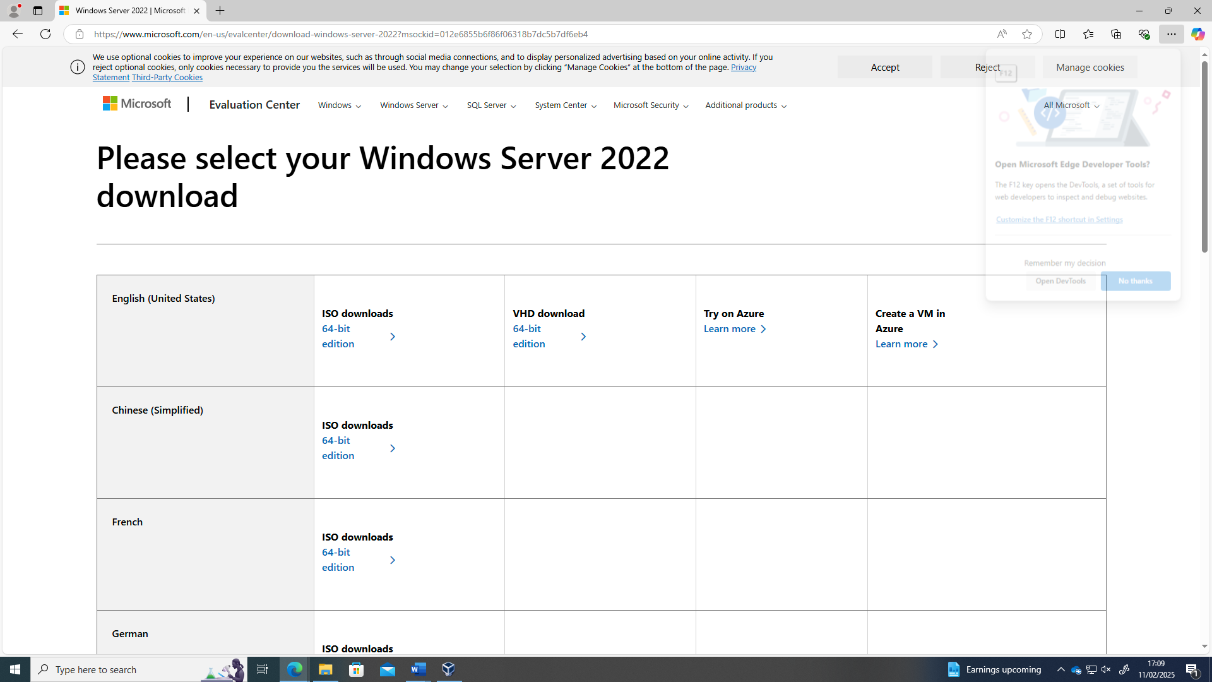
Windows Server Download taken from the Microsoft website

Debian Server Download found on the Debian website
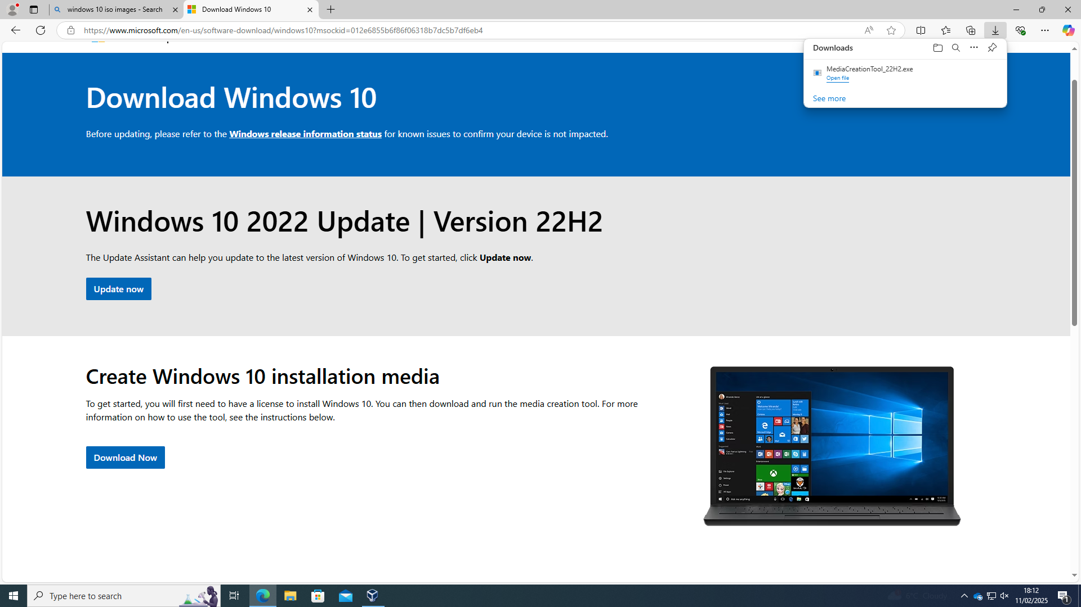
Windows 10 ISO Download found on the Microsoft website

Network Deployment
- Created virtual machines (VMs) for Windows Server and Debian using pre-installed VirtualBox.
- Configured network adapters for internal and external communication
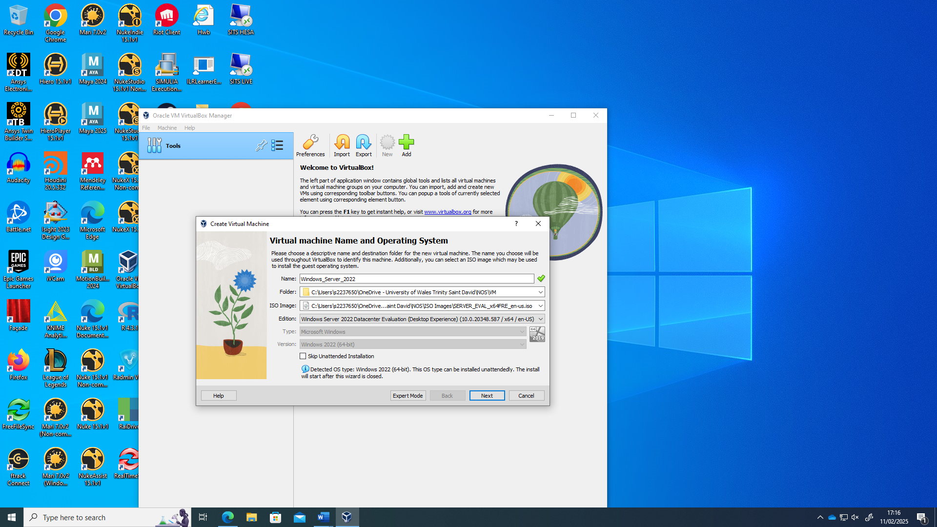
Creating Windows Server VM using iso images
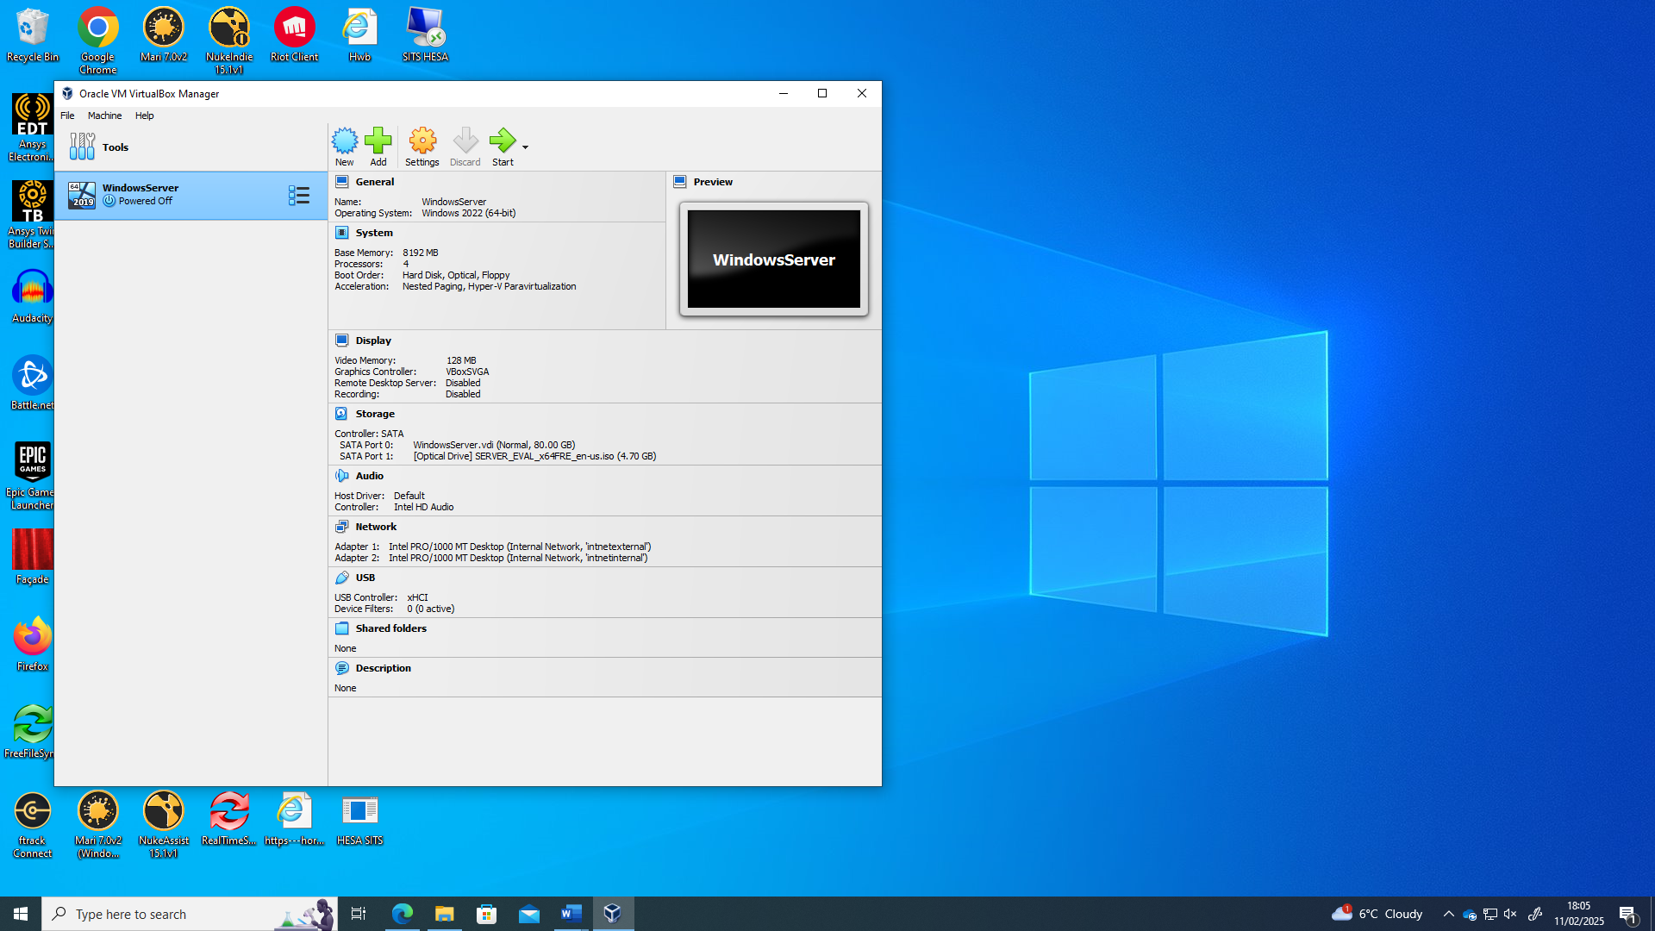
Windows Server VM Created
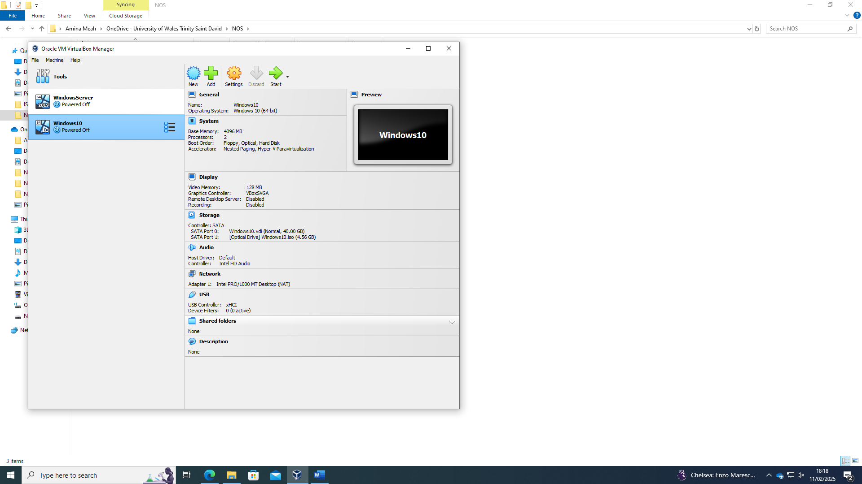
Windows 10 VM Created using iso images
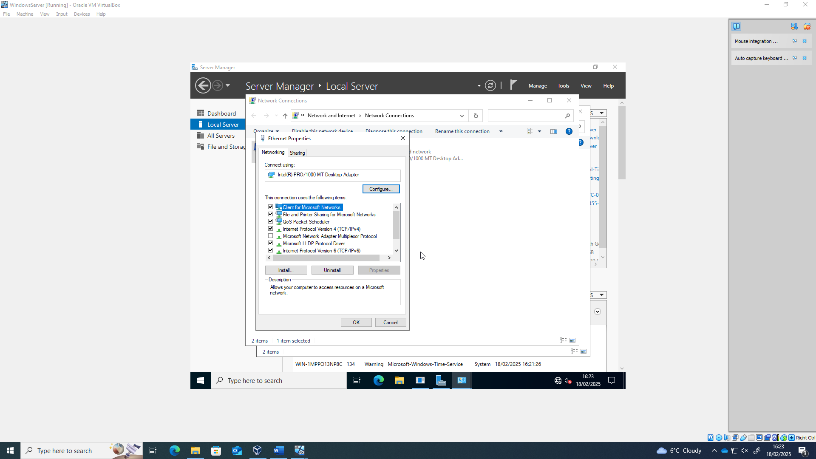
Ethernet Properties for Windows Server

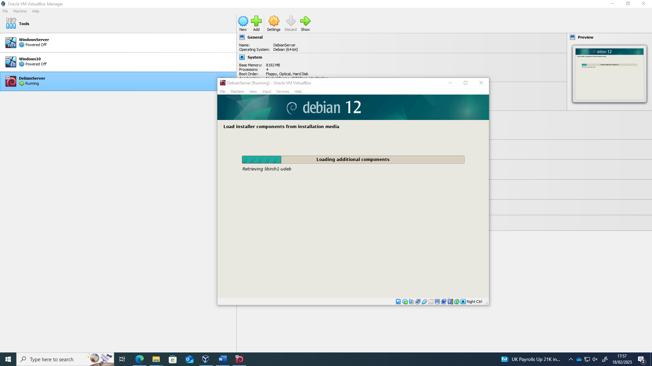
Debian Server VM Created
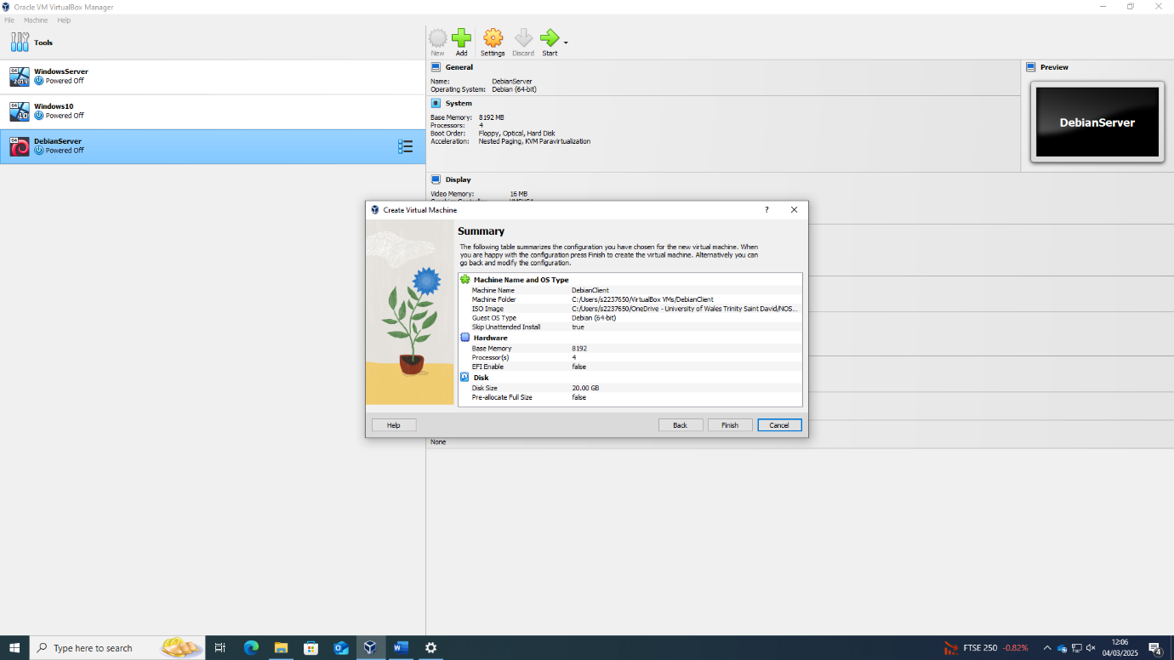
Figure 1Debian Server Creation Summary
Unfortunately, I do not have a screenshot of the client VM after creation, however I do I have additional screenshots further down the document showing the client IP creation etc.

Configure IP Addressing

IP Address Configuration
A customised IP addressing scheme was designed for better network management.
Device | IP Address | Subnet Mask |  | Role
Windows Server | 192.168.1.1 (internal) | 255.255.255.0 |  | DHCP, DNS
Windows Server | 10.0.01 (external) | 255.0.0.0 | DHCP, DNS
Debian Server | 10.0.0.2  (internal) | 255.0.0.0 |  | DHCP, DNS
Debian Server | 210.103.5.1  (external) | 255.255.255.0 |  | DHCP, DNS
Windows Client | 192.168.1.2 | 255.255.255.0 |  | Workstation
Debian Client | 210.103.5.2 | 255.255.255.0 |  | Workstation

IP Addressing Scheme Justification
- Used static IPs for servers to ensure stability.
- DHCP configured for dynamic allocation to client machines.

Screenshots
- Windows Server IP InLan Configuration
- 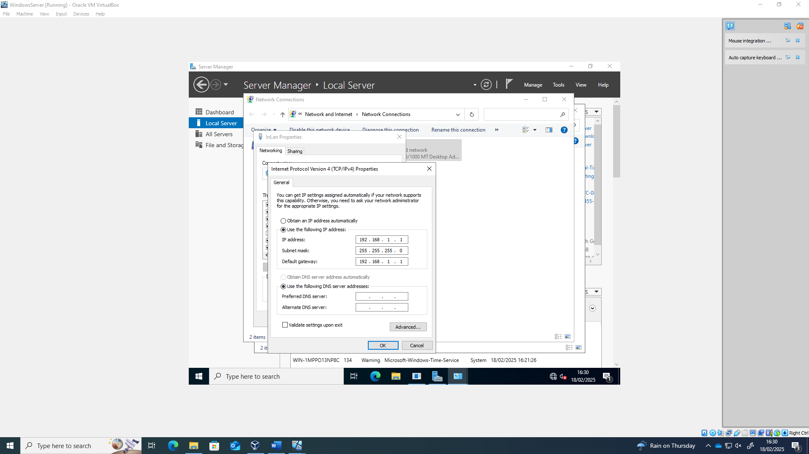
Setting up windows server internal IP Address

- Windows Server IP External Configuration

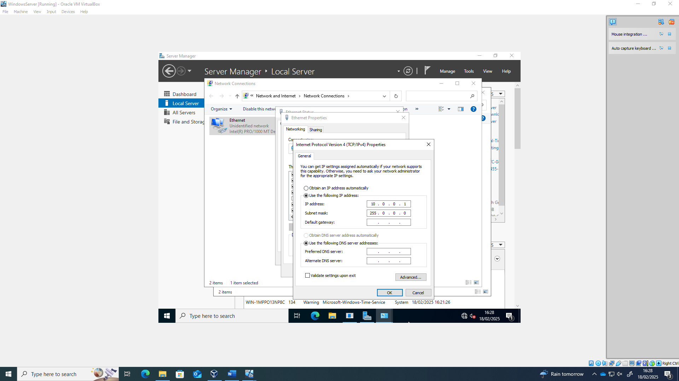
Setting up windows external server IP Address
I set up the client IP address using the same process, below is the ip config for the client.
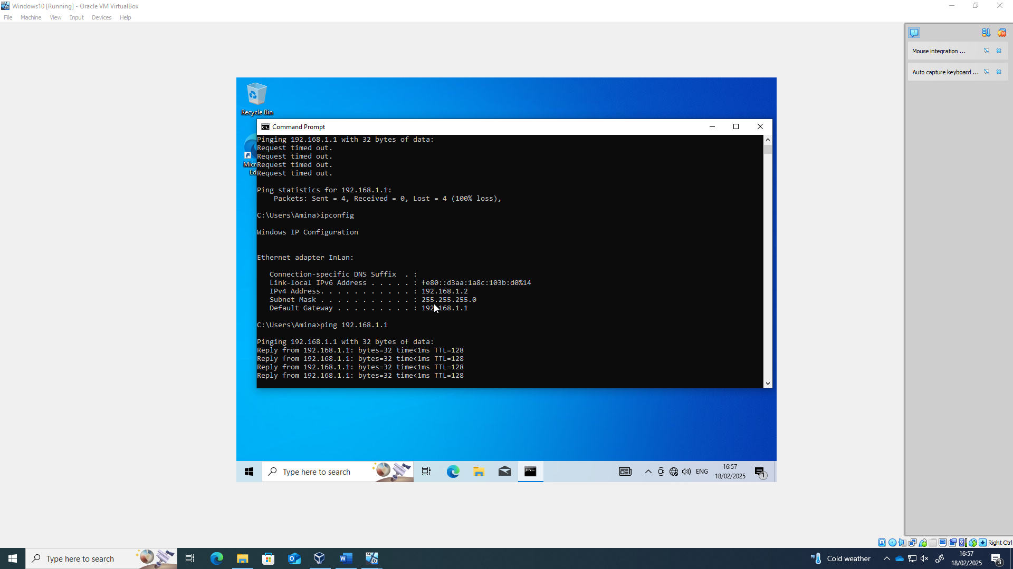

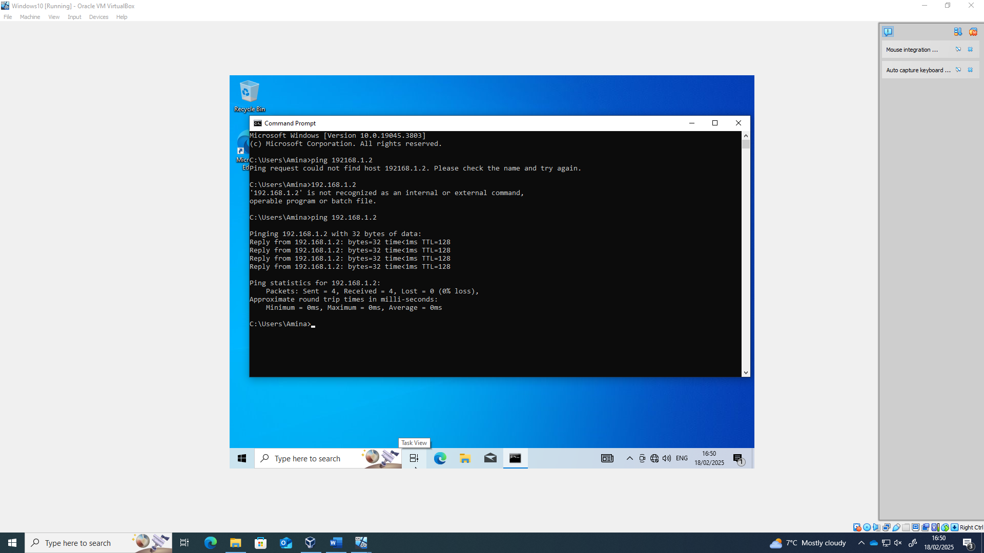
Client pinging Client successfully

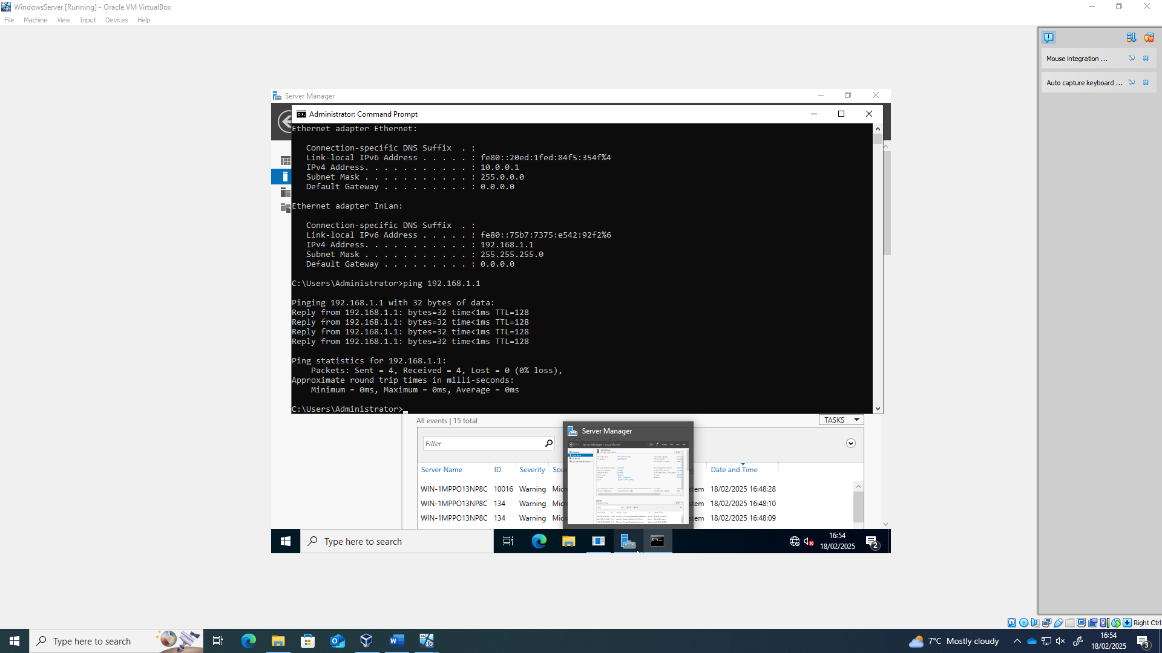
Server pinging Server Successfully

Debian Server IP Configuration

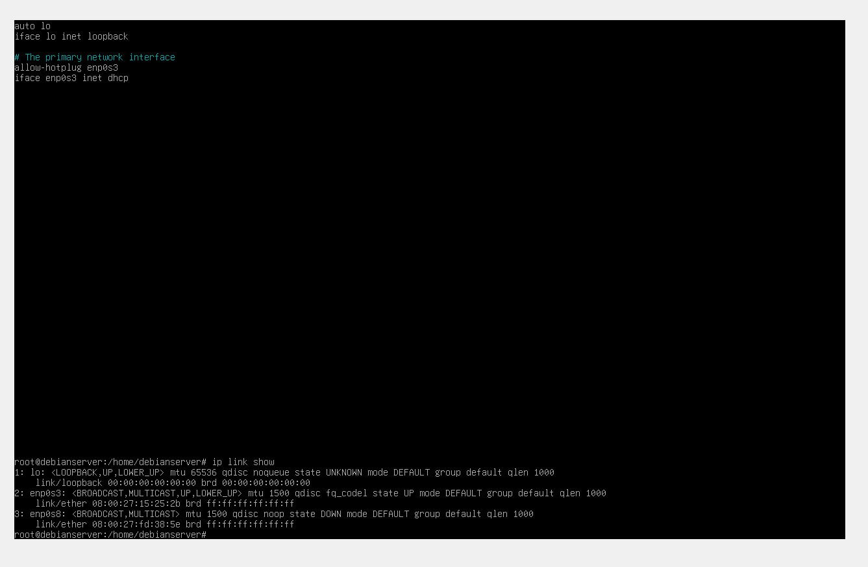
Getting Network Adapter Names on Debian Server
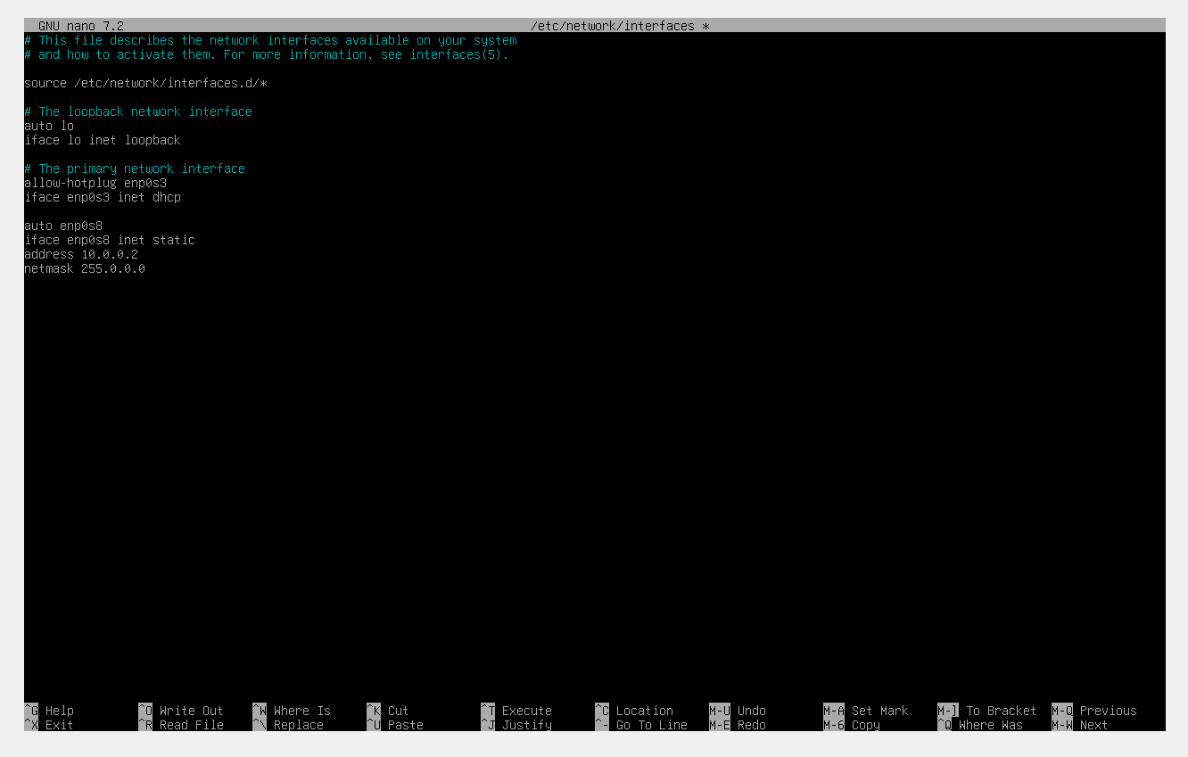
Setting up Debian server external IP address
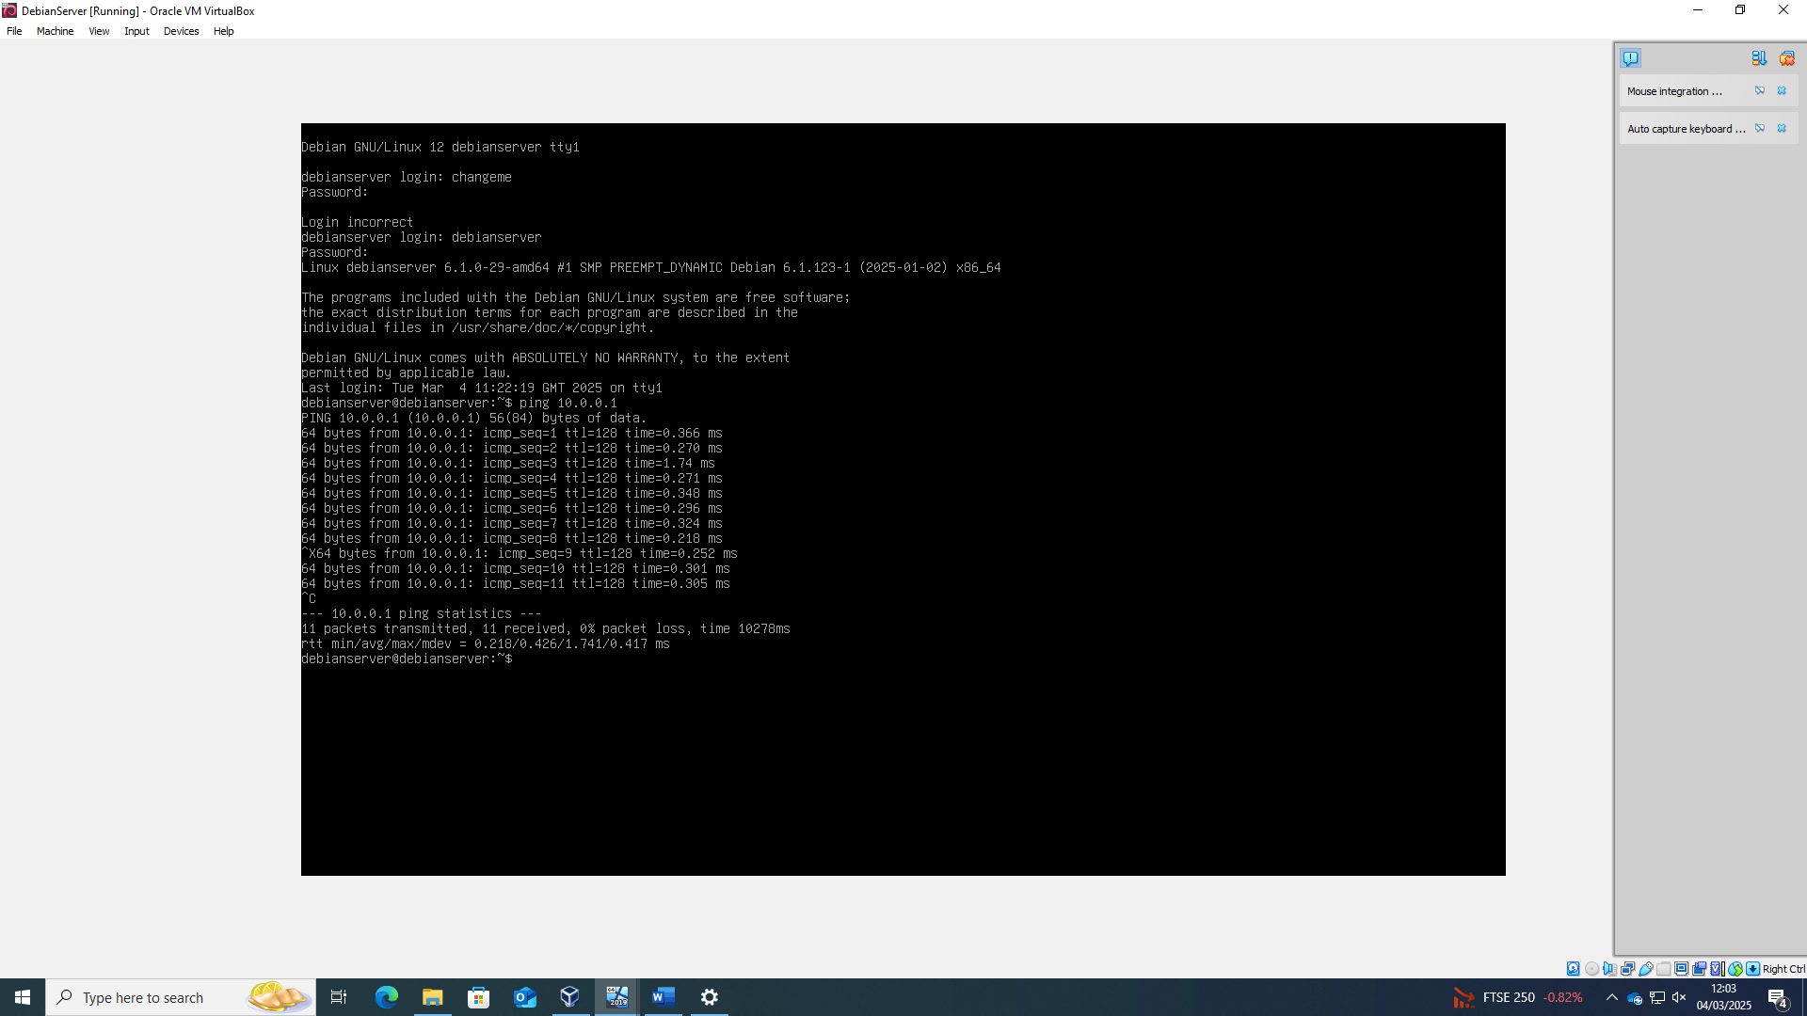
Checking external connectivity works - pinging windows server

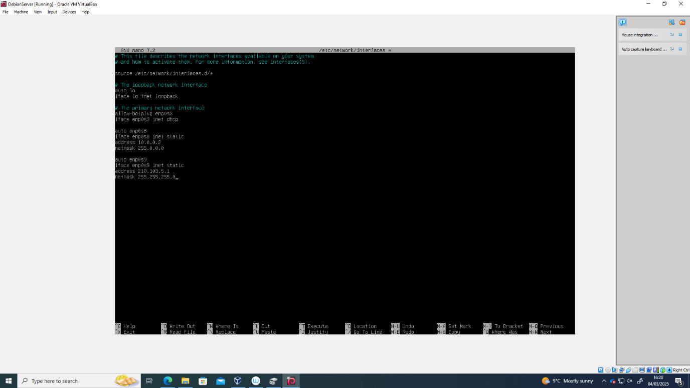
Setting up Debian Server internal IP address
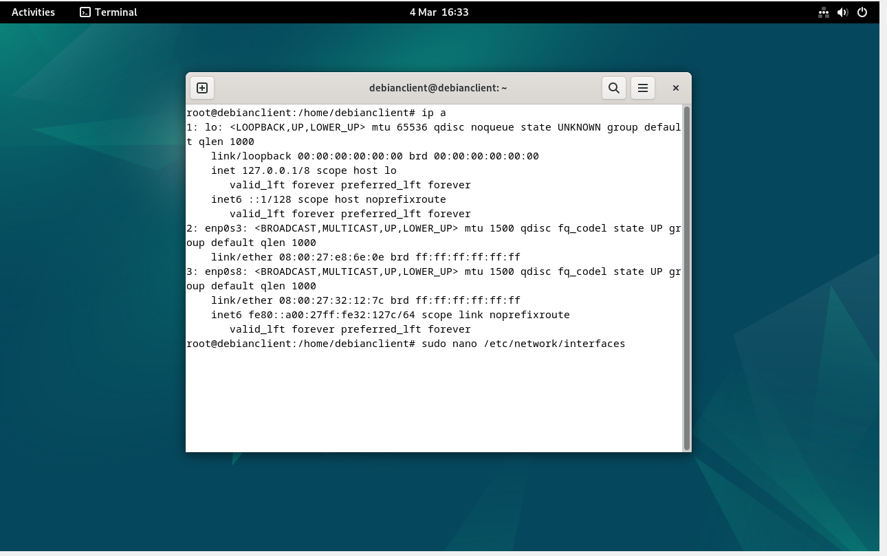
Getting network adapters on Debian client

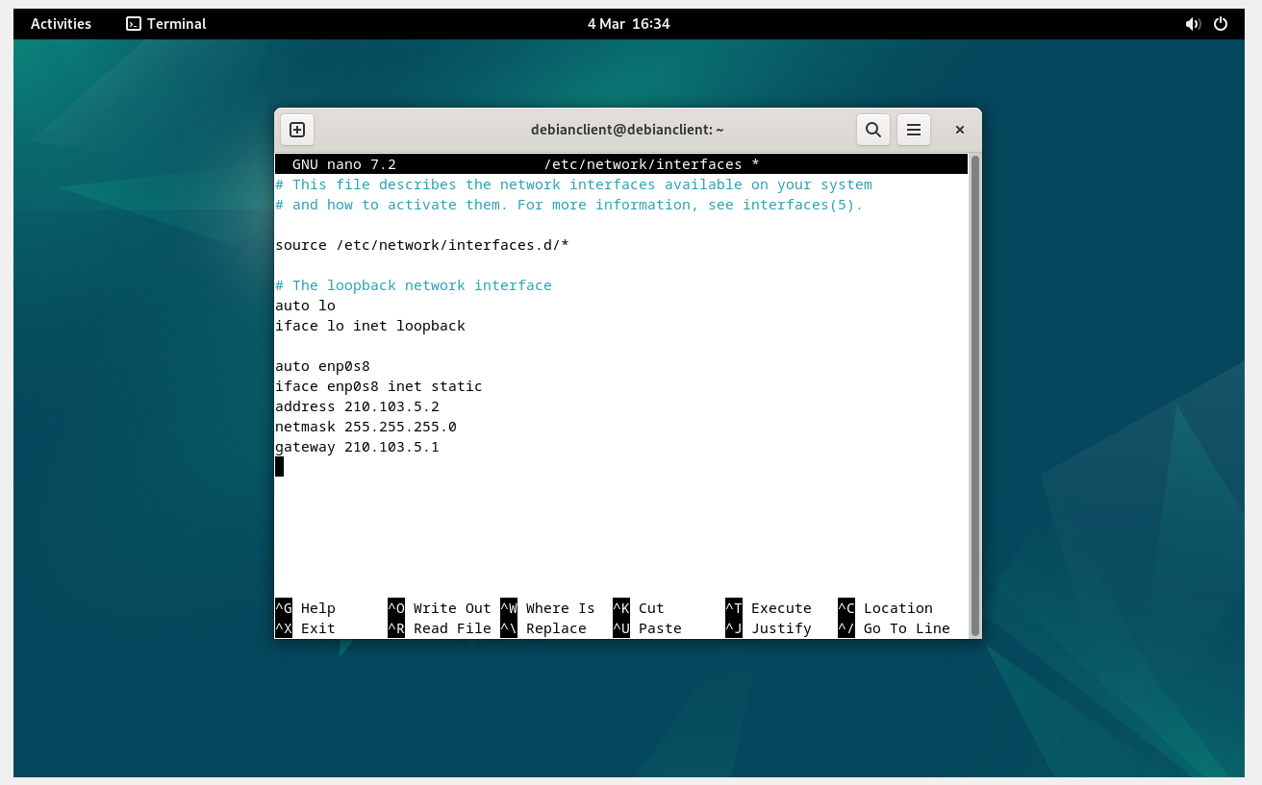
Setting up IP address for Debian client
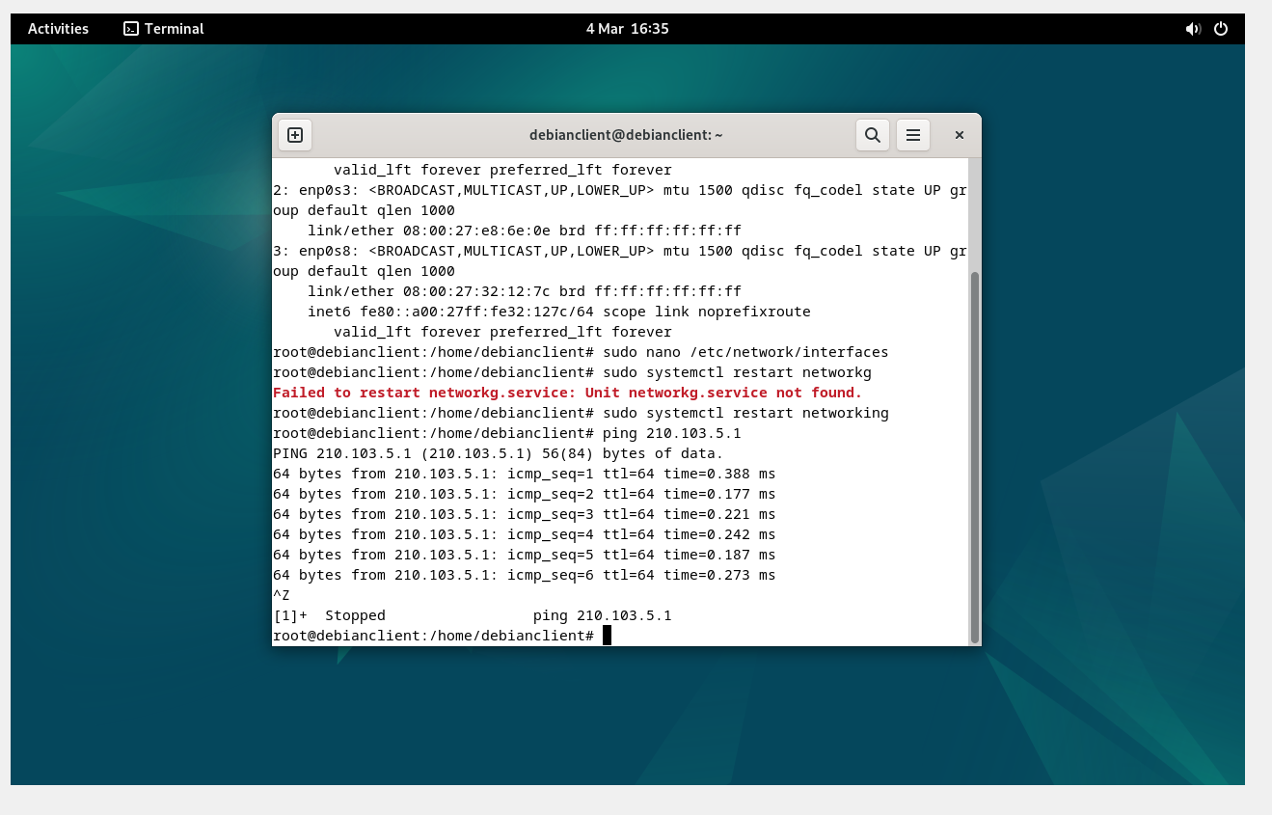
Testing connectivity between Debian client and Debian server

Test and Troubleshoot

Connectivity Tests
- Outcome 1: Successful connectivity within the same network verified using ping commands.
- Outcome 2: Unsuccessful connectivity between different networks due to routing restrictions, later resolved with proper routing table configurations.

Screenshots
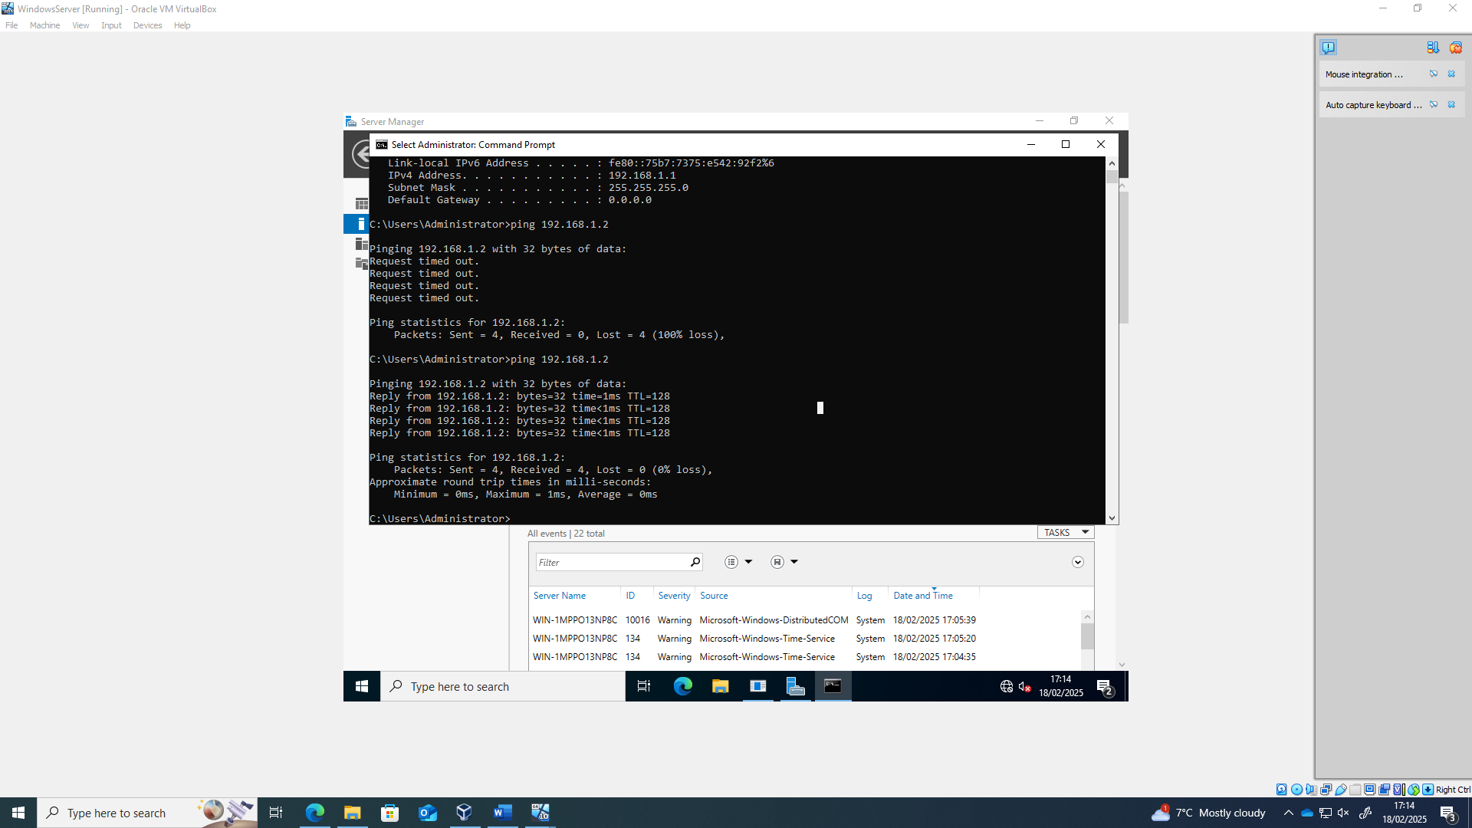
Failed and then successful Ping from Windows server to Windows client. This failed due the firewalls being on. I had to turn the firewalls off on both the server and client.
Windows Client Pinging server and failing. This was also due to the firewalls. Once I disabled the firewalls on the server and client, I was then able to ping the server successfully.

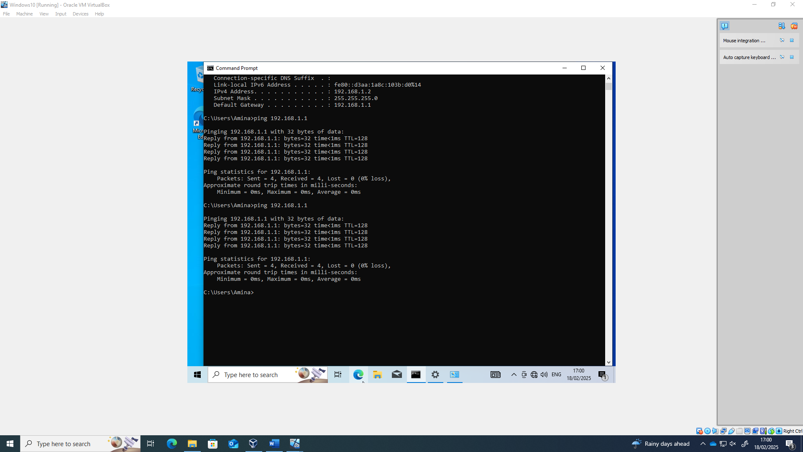
Client pinging server and it is working after disabling firewalls.
Checking external connectivity works – This is the Debian server pinging windows server successfully

Troubleshooting Steps
- Firewall & Security Configuration:
- Initially, the Windows Server and Client were unable to communicate due to active firewalls blocking ICMP requests.
- The issue was diagnosed by testing connectivity with ping and checking firewall rules.
- Solution: Disabled firewalls on both the server and client, allowing successful pings.
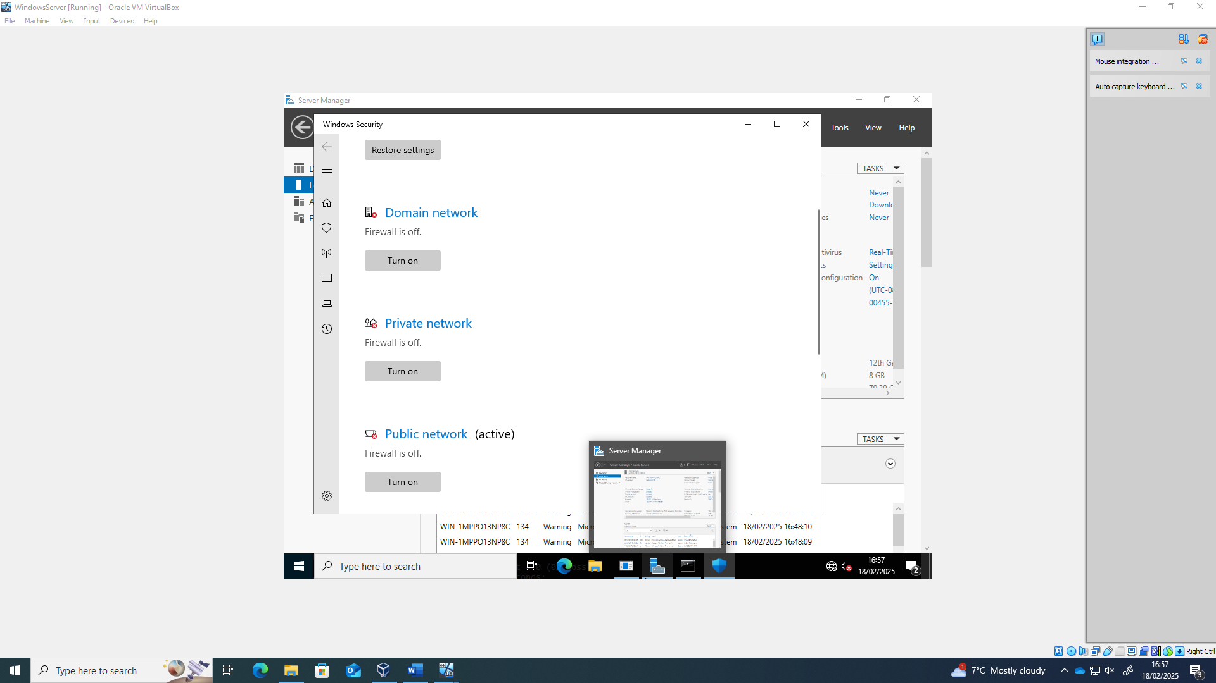
- Virtual Machine Installation Issues:
- Some ISO images were corrupt or not functioning as expected, leading to installation failures.
- One critical issue involved a Windows Server VM stuck in a reboot loop during installation.
- Solution: Deleted the virtual machine, re-downloaded the ISO, and restarted the setup process, which resolved the issue.

Conclusion
The network deployment was successfully completed, addressing challenges related to hypervisor selection, IP addressing, and connectivity. Screenshots with timestamps provide evidence of systematic execution. Further improvements include implementing VLANs and advanced security configurations for enhanced performance and secure.

Task 3 - Personal and technical reflection

Technical Reflection: Network Deployment and Testing
The network deployment process presented challenges such as IP conflicts, DNS failures, and firewall restrictions.
- IP conflicts disrupted connectivity, diagnosed using arp -a and resolved by adjusting DHCP settings.
- DNS failures led to domain resolution issues, fixed by verifying and updating DNS configurations.
- Firewall restrictions blocked communication between devices, requiring firewall rule adjustments.

Personal Reflection
This project improved my troubleshooting skills, attention to detail, and ability to work under pressure. I learned the importance of effective documentation for replicating solutions and developed confidence in diagnosing and resolving network issues. Overcoming these challenges has strengthened my ability to manage real-world network deployments efficiently.

