International Hotel Management
(Marketing plan on Sheraton Hotel, UK)
Student name:Iulia Dascal
Student ID: 2127529
Module name:Marketing Essentials
BMIH4005
Rework C2 Level 4
Lecturer’s name:Chris Wilkin
Table of Contents
Introduction 3
Marketing mix 4
The micro-business environment 5
The macro-business environment 6
Creating customer values 7
Conclusion 9
References 10
Appendix 11
Powerpoint slides 11

Introduction
A marketing plan is required for all sorts of including both small and large businesses (Baron, 2010). In this case, this report is going to represent a detailed marketing plan for Hotel Sheraton which is a global hotel business and a subsidiary of Marriott International Hotel. This is not only a hotel business but also a resort business that is an international economy hotel brand and a part of Marriott International hotel. It offers an open house atmosphere with colorful designs and new bedding solutions for customers. In the UK, it has gained a lucrative brand image. The main purpose of this marketing plan is to introduce a new service for this well-known hotel business in the UK: contactless payments considering the current situation of Covid-19. The main mission of this hotel is to be millennials as well as to blend private rental spaces with the hostel, like social experiences and bringing the hotel class comfort and security.

Marketing mix
This marketing analysis tool is used to develop a specific business's entire marketing plan (Grewal and Levy, 2016). Considering the case of Sheraton, UK, this marketing mix is going to be utilized. Such as:

Figure 1: Marketing mixes
Source: (Kotler, Armstrong, and Opresnik, 2019)
Product/Service: Sheraton Hotel offers three major categories. Its accommodation and room services are quite praiseworthy. International standards and corporate ethics are always followed for satisfying the customers fully.
Price: Luxurious, premium and economic pricing strategies are used when the business intends to provide quality and luxurious services to the customers. A premium pricing strategy is envisaged.
Place: It has been placed across the globe. The major purpose of the placement is to serve worldwide. It is a part of the Marriott International hotel. In the major cities of the countries, this luxurious international hotel is found. It serves not only in the UK but also across the globe.
Promotion: Sheraton’s focus on the millennian is busy sponsoring different local events that help promote the business efficiently. Besides, this business also deals with social media including Facebook, Instagram, LinkedIn, etc. users and promotes its brand through the use of email marketing.

The micro-business environment
For assessing the microenvironment of this business which refers to the internal issues of the business, a SWOT analysis can be conducted. Such as:
Internal | Strength | Weaknesses
Internal | This is a well-known and established hotel business. It offers an alternative to the hotels. Besides, the faith of the customers in this business is quite strong because of its strong hotel services. | It cannot adopt a sole decision for itself because it is a part of a large multinational hotel business. Besides, the corporate structure is quite different from its parent company. Its limited global locations are a major weakness (Palmer, 2014). Like, regional managers experience difficulties in terms of allowing the decentralized decision-making process among the lower-level employees.  It also follows traditional payment procedures that always discourage the guests to visit or book
External | Opportunities | Threats
External | It can explore its market opportunities in other regions or continents. In developed countries, its semi-luxurious hotel chain operation can raise huge popularity for itself (Nguyen, Yu, Melewar, and Chen, 2015). By conducting lots of market research, this hotel business can assess the potential market and grab more market shares. | Large multinational companies, like Hotel Hilton, can create threats to this hotel business. This subsidiary needs to support its parent company in terms of bringing new competitive strategies. It may not implement its competitive strategies appropriately.

The macro-business environment
When the business is externally affected by the macro-environmental factors, that is known as the macro business environment (Perreault, McCarthy, and Cannon, 2011). For assessing the macro business environment, PESTEL analysis can be used. Such as:
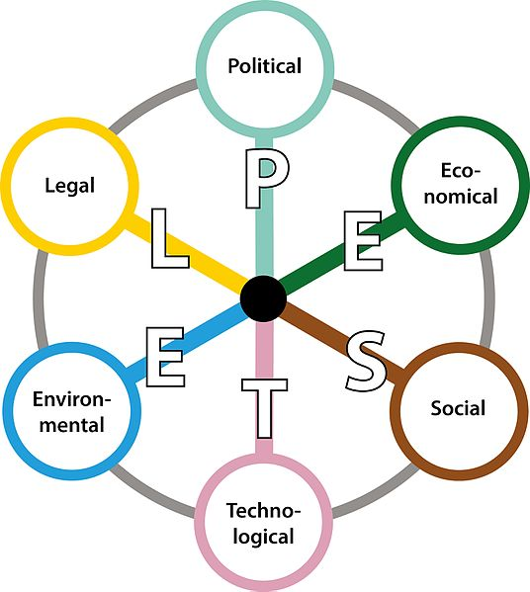
Figure 2: PESTEL analysis
Source: (Perreault, McCarthy, and Cannon, 2011)
PESTEL analysis
The hotel business has experienced a great loss due to the government restriction that was imposed for the Covid- situation. Besides, the sector has not been determining the consequences of the Brexit decision as it introduced unregulated housing laws but it benefits the homeowners and host cities. The increasing inflation rate has hampered the purchasing power of hotel visitors but the fall in British pounds has raised hopes for the hotel businesses. This business concerns the employees and the guest, as well as HR, focusing on reducing the turnover rate. By using different techniques, the entire sector has been revived, especially in the case of maintaining social distance (Pinchuk, 2022). The hotel businesses also indulge in reducing the environmental footprint and legislative issues include national minimum wage acts, immigrant laws, and so on (Badriyah, Mahmudah, and Djais, 2018).
Positive impacts: Technology and green businesses that are part of the technological and environmental factors respectively have the most positive impacts on the sector. Especially, automation systems, online booking, and different modern technology in the hotel business can attract lots of global consumers. Contactless payment can add value to the entire business value.
Negative impacts: The frequent shutdown and the Brexit issue have affected hotel businesses. Still, the new service, like contactless payments can raise new hope for this hotel giant in the UK.

Customer Value Engagement
In this case, Sheraton Hotel utilizes brand image and is also determined in terms of maintaining the entire organization’s corporate values. Besides, by following the standard norms and core competencies of the organization as part of the parent company, it creates its distinct customer values (Chakhmachyan and Zholzhanova, 2022). The customers can recognize its brand image and are eager to pay for the quality and semi-luxurious services.
This company envisages the middle to high class and diversity; that is why it has a different offering in the off-season, especially post-summer for couples and families. Even, foreign visitors can find a lucrative package for which they need to book rooms for thirty days. In the future, it intends to develop its social media platform through which it will get orders from customers. Contactless payment will be adding extra feather to the success of the business.
This hotel business has arranged different marketing channels so that it can reach its core customers of the business (Badriyah, Mahmudah, and Djais, 2018). Direct website booking and direct phone bookings are one of the most common and useful channels used by hotel businesses, like Sheraton where contactless payments can play a crucial role in completing the payment process.
Effective use of digital marketing
Digital media and communication require different technological and digital channels for communicating with customers. As part of the marketing plan, these tools have significant impacts. This includes the design of the company’s distinct websites, social media pages, email marketing, and so on. Such as:
Website design: Considering the technological advancement and huge market competition, all sorts of businesses are observed building up and strengthening their distinct website that can have positive and potential effects on the visitors (Aleksushin, 2022). Sheraton Hotel has different regional websites considering the local consumers’ demand. Like, SheratonUK.com is for British people and people residing in the UK can book rooms at the company’s regional branch in the UK for this, the hotel needs to implement e-payment on the website including VISA cards, master cards, etc.
Social media: It is one of the strongest digital marketing platforms nowadays because businesses can reach lots of customers easily. Facebook has the highest number of users and that is why businesses need to have their official pages (Sakshi, 2017). Sheraton hotel is active not only on Facebook but also needs to deal with lots of customers, clients, and suppliers on LinkedIn where it can promote its new services considering the current situation of Covid-19.
Email marketing: By sending lots of promotional emails to potential customers, different businesses endeavor to grab a significant market position in the sector (Semok Yoon, 2017). Sheraton hotel also uses this email marketing effectively. Loyal and regular customers can be mailed about the new services which can encourage them to spread the news to others.

Conclusion
Sheraton Hotel’s main challenges are its competitors and its internal issues also affect the business in various cases. The hotel industry around the world is having lots of strong and large international organizations; for which it is quite difficult and challenging for this kind of independent hotel business to sustain its competitive position in the market. In this case, the good news for Sheraton is that it is the subsidiary of a large multinational company but in this case, it needs to face obstacles raised by Covid-19 or the frequent shutdown sessions across the country in terms of adopting a decision that may affect the entire business including Accor International.
Recommendations
- Sheraton should add and implement Wi-Fi-based contactless payments in its services considering the situation raised by Covid-19,
- The contactless payment should contain a special chin that can be recognized by the readers, like the payment device,
- While using a contactless debit card for the first time, there should be an option for entering a PIN for security reasons.
- Mobile devices should be considered that will add a layer of security for the guests in the hotels.

References
Aleksushin, G., 2022. Pre-revolutionary technologies of hotel business in modern conditions. Gostinichnoe delo (Hotel Business), (3), pp.203-209.
Badriyah, S., Mahmudah, S. and Djais, M., 2018. Legal impacts from the bankruptcy of the subsidiary company to the holding company as the corporate guarantor. IOP Conference Series: Earth and Environmental Science, 175, p.012214.
Baron, S., 2010. Service marketing. Los Angeles: SAGE.
Chakhmachyan, A. and Zholzhanova, D., 2022. Benchmarking as a tool for managing the competitiveness of hotel enterprises. Gostinichnoe delo (Hotel Business), (3), pp.213-219.
Grewal, D. and Levy, M., 2016. Marketing.
Gueye Mane, A. and Alioune Diop, P., 2017. Drivers of Customer Brand Engagement and Value Co-Creation in China: A Prioritization Approach. INTERNATIONAL JOURNAL OF MANAGEMENT SCIENCE AND BUSINESS ADMINISTRATION, 3(4), pp.7-19.
Kotler, P., Armstrong, G. and Opresnik, M., 2019. Principles of marketing.
Nguyen, B., Yu, X., Melewar, T. and Chen, J., 2015. Brand innovation and social media: Knowledge acquisition from social media, market orientation, and the moderating role of social media strategic capability. Industrial Marketing Management, 51, pp.11-25.
Palmer, A., 2014. Principles of services marketing. London: McGraw-Hill.
Perreault, W., McCarthy, E. and Cannon, J., 2011. Basic marketing. Boston: McGraw-Hill.
Pinchuk, A., 2022. Qualitative assessment of the stability of the hotel. Gostinichnoe delo (Hotel Business), (3), pp.210-212.
Sakshi, 2017. Social Media: The Future of Marketing. International Journal of Contemporary Research and Review.
Semok Yoon, 2017. The Impact of Customer Participation and Expertise on the Co-creation of Value and Customer Trust of Hotel Users. Tourism Research, 42(2), pp.131-150.
Sheth, J., 2020. Customer value propositions: Value co-creation. Industrial Marketing Management, 87, pp.312-315.
Ushakov, R., 2021. Trends in the hospitality business: developing human resources, information technology, and financial potential during the pandemic at the present stage. Gostinichnoe delo (Hotel Business), (12), pp.71-85.

Appendix

PowerPoint slides
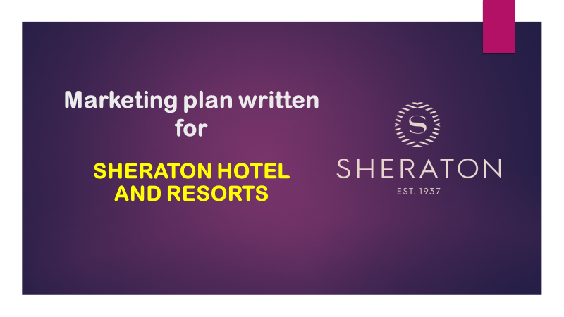

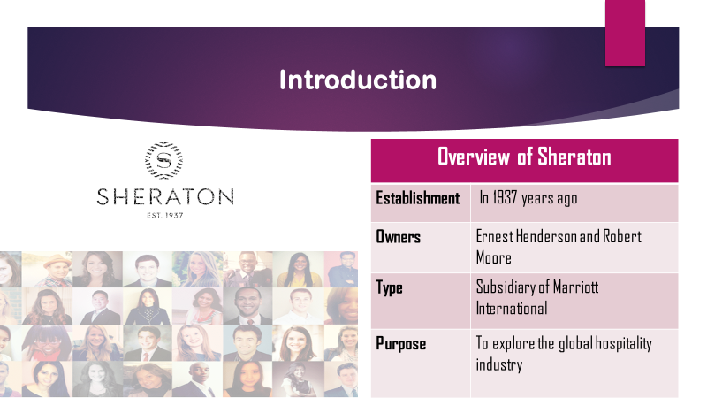
Notes: Overview: It was in 1937 years ago and the owners of this business were Ernest Henderson and Robert Moore. Its type is a subsidiary of Marriott International. Its major purpose was to explore the global hospitality industry.
This business offers an open house atmosphere with divergent designs and colors as well as new bedding solutions. The major purpose of this business is to blend private rental spaces with hostel-like social experiences and at the same time bring hotel-class comfort and security.
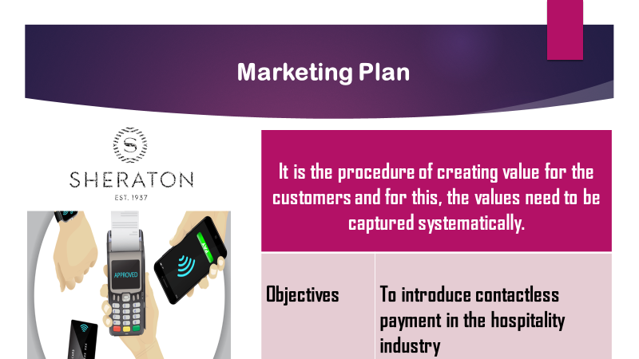
A marketing plan is a procedure of creating value for the customers and this, the values need to be captured systematically. It aims at introducing contactless payment in hotels via the use of the debit card, smart cards, etc. Unlike, touching and punching cards on e-wallets, customers can use Wi-Fi for sending money to their wallets. This can be a great way of maintaining social distance and contact in the critical situation raised by Covid-19.
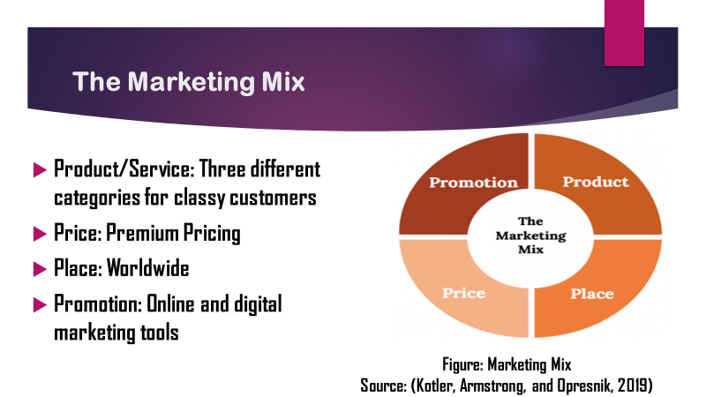
Notes: Product or service: The hotel has three different categories in terms of providing services to global customers. It allows up to twelve people with the shared bathroom whereas private rooms allow 2-3 people with a private ensuite bathroom. Besides, there is a typical room service for a maximum of two people.
Price: The luxurious hotel business focuses on premium pricing strategies for attracting global customers.
Place: It has been placed across the globe where a digital booking system also allows customers to book rooms in advance.
Promotion: For attracting and reaching the core and targeted customers, this can utilize social media platforms including Facebook, LinkedIn, Twitter, etc.
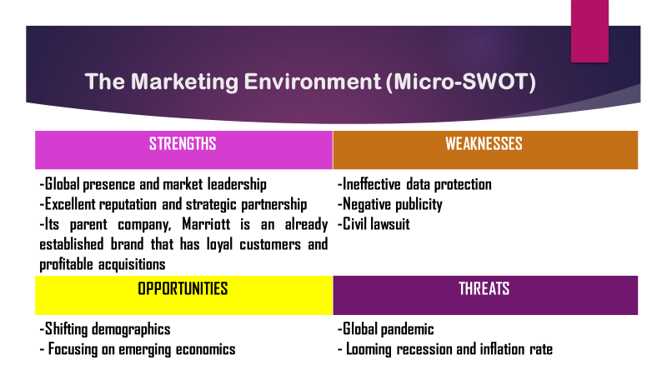
Notes: Strengths: This hotel business offers an alternative or substitute for the hotel business and also travelers’ choices and places to stay around the world. Its parent company has a significant brand image in the market and that is Marriott.
Weaknesses: It has problems with ineffective data protection and negative publicity.
Opportunities: It started shifting demographics and focusing on emerging economies.
Threats: Global pandemic can threaten the position of the business; besides, looming recession and inflation rates can also affect the hotel business operations.
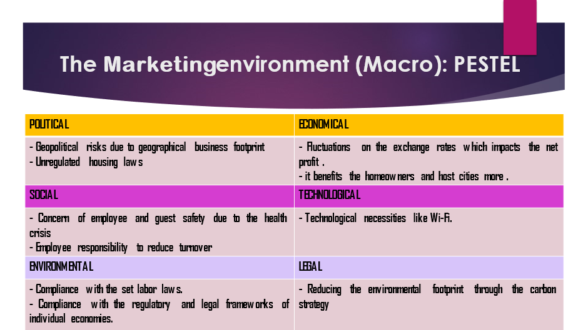
Notes: Political: Political instability and geographical risks can affect this hotel business. Besides, the absence and disastrous regulations in the housing laws can also be harmful to this business.
Economic: The inflation rate in the market has made the exchange rate and currency value fluctuate. But the fluctuation in the exchange rate aids accelerate the net profit and the homeowners and the host cities where the hotels are located.
Social: There is a great concern for the employees that help the business reduce employee turnover rate and the business is also concerned about providing quality services to the guests, especially for their health. Contactless payments can bring a new change in this hotel business.
Technological: Modern technology and WIFI facilities can help interact with divergent social media. Contactless payment is another technical issue that can boost the sales revenue of the business considering the current situation of the hotel businesses.
Environmental: For individual economies, there is compliance with the regulatory and legal frameworks.
Legal: Through different acts, like the carbon strategy, the environmental footprint can be reduced. 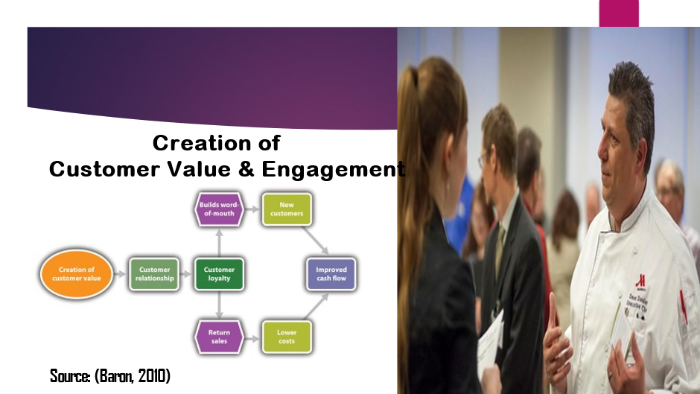
Notes: Customer value refers to whether the customer is satisfied that the products or services received are worth the money they spent. (Weinstein, 2012). This company envisages the middle to high class; that is why it has a different offering in the off-season, especially post-summer for couples and families. Even, foreign visitors can find a lucrative package for which they need to book rooms for thirty days.
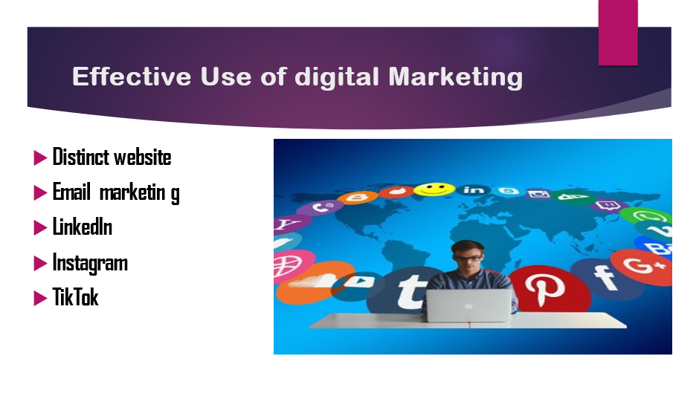
Notes: Sheraton has an engaging website that provides customers with loads of information about the hotel as well as the products offered. It has its website and promotes the business via corporate email. Sheraton has over 80,000 active followers on LinkedIn, 160,000 followers on Instagram, and 100,000 followers on TikTok.


