Individual Practice Evaluation

For my final piece, I focused upon the story ‘The Year Of Spaghetti’. From my point of view, the story highlights isolation, and how it feels to be introverted. From my own personal experience, to hearing stories from friends – this issue felt close to my heart, which is why I chose to expand further.
I curated a set of 8 images to coincide with the theme of isolation. I followed the theme of layering all the images with two different representations of isolation. The background consists of the general idea of loneliness, for example – trees, rivers, mountains. Whereas the foreground layer illustrates a more realistic, raw representation of isolation. As a source of inspiration, Sergiu Mara produces juxtaposed images, with a subtle transparency. I personally think layers make the image slightly more interesting, allowing the viewer to take a closer look at what is included.
Out of all 8 images, I decided to make the image below my final exhibition piece.
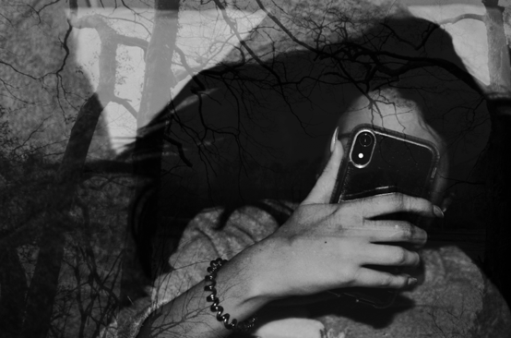

This image in particular stood out to me the most in comparison to the rest. The image shows a form of modern day isolation, something I have personally experienced. A person may be completely alone in a room, however, are you really alone when on your mobile phone? I decided to capture the phone in the image, as social media is known for having a huge effect on our mindset and mental health. I placed the phone in front of the subjects face in order to represent being consumed. A photographer known as Max Cavallari is known for capturing images of people day to day being absorbed by their mobile phones. The artists inspiration started after walking into a lamppost on the street, he said, “I was so absorbed on this little shining screen that I couldn’t see the reality that surrounds me”.
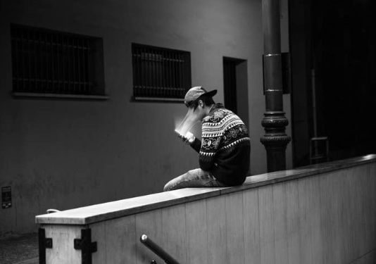

Image by Max Cavallari

My image has been edited in black and white. Black and white is often known for symbolizing depression and moodiness, which is why it is fitting with my photo of choice. The photographer known as Edward Honaker, documents his depression through dark, black and white images. He shows his vulnerability through photography as a ‘coping mechanism’. He hopes that doing so will allow people to understand this mental illness better.
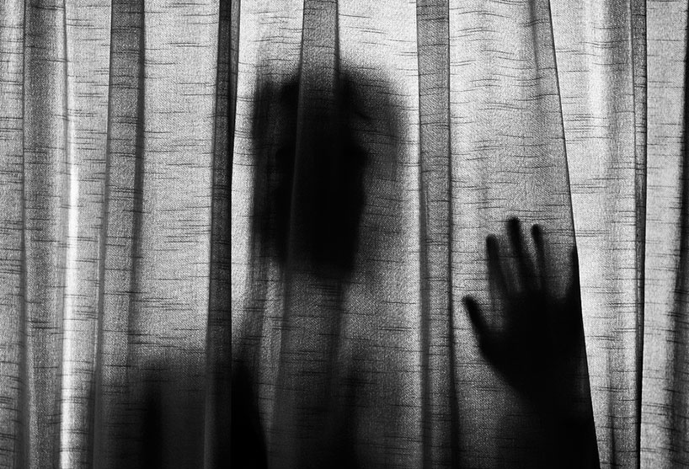

Image by Edward Honaker

The trees merged within the background represent cracks and feeling fragile, alone, vulnerable.
When it came to exhibiting my work, I wanted the image to be relatively low in scale, to represent feeling small (something that is common within isolation). As well as this, I chose to only exhibit one singular photo, to express being alone.

Bibliography

Barnes, S. ( 2016 ). 10 Photographers Creating Enigmatic Works With Double Exposure. Available at: https://layersmagazine.com/10-photographers-creating-enigmatic-works-with-double-exposure.html. Last accessed: March 8th 2020.

Dovas. ( 2016 ). “coping mechanism”. Photographer Documents His Own Depression In Dark Self-Portraits. Available at: https://www.boredpanda.com/depression-self-portraits-photography-edward-honaker/?utm_source=google&utm_medium=organic&utm_campaign=organic. Last accessed: March 7th 2020.

Gallant, L . ( 2015 ). “I was so absorbed on this little shining screen that I couldn’t see the reality that surrounds me”. A Photographer Is Using Creepy Pictures Of People Using Their Phones To Highlight Social Isolation. Available at: https://www.buzzfeed.com/lauragallant/a-photographer-is-using-creepy-pictures-of-people-using-thei. Last accessed: March 7th 2020.

