Professional Career Development
Student Name: Kashif khan
Student ID: 1815907
Moodle: (BMSW4005_LON)

Contents
Introduction 4
Understand the skills and knowledge needed for working effectively 4
Technical Skills 4
Conceptual Skills 4
Communication Skills 5
Essential Skills and Knowledge 5
Thinking Skills 6
Critical Thinking 6
Problem Solving 6
Creativity 7
Innovation 7
Communication Skills 7
Listening 8
Straight Talking 9
Non-verbal Communication 9
Stress Management 9
Emotion Control 10
Teamwork 10
Leadership 10
Lifelong learning and self-direction 11
Meta-Learning 11
Strategic Learning 12
Motivational Learning 12
Technology adoption and application 12
Demonstrate readiness for employability and personal advancement through an understanding of personal strengths and areas for further development. 12
Personal Skills Audit 13
SWOT Analysis 13
Strengths 14
Weaknesses 14
Opportunities 14
Threats 14
Need/Ability Grid 15
Establish employment goals and develop a personal action plan. 16
Personal Development Plan 17
Identification of the Development Area 17
Future Target 17
Kolb’s Learning Style 17
Resource identification 18
Plan Implementation and Monitoring 19
Conclusion 19
References 20

Introduction
Professional career development refers to the gain of skills and knowledge essential for a career as well as personal development. It comprises of all types of formal and informal learning opportunities along with meetings. Bocciardi et al. (2017) note that for career success and career development, the competence to adopt is becoming significantly relevant within the current market. Now, professionals need to be able to predict advancements in professional career development and adopt the capabilities required to meet the changing career-related circumstances. Keeping this mind, I will critically analyze my professional skills and knowledge, and will draw an action plan to cover up demanding areas.
In this report, I will discuss three aspects of career professional development. In the first section, I will discuss the knowledge and skills required for working effectively. In the second section, I will highlight my strengths to demonstrate my readiness for employability. I will also concentrate upon the areas which I need to focus upon for further career development. In the last section, I will establish employment goals and after that, I will develop a personal action plan. At last, I will conclude the report covering the main themes and points discussed in the report.

Understand the skills and knowledge needed for working effectively
In today’s knowledge economy, the conception of learning has changed. Now, learning is not only related to educational institutions, instead, but it is also a lifelong process by which professionals such as myself should keep themselves learning something new to maintain their effectiveness. The skills that I should learn for working effectively, are the same that will help me in becoming an effective family member as well as a community member. These skills are categorized into three, which are elaborated below:

Technical Skills
These types of skills include related to a specific field. These skills are acquired through technical education and academic learning. Different fields involved within an organizational process include manufacturing, management accounting, social science, electronic computer, and engineering science.

Conceptual Skills
This type of skillset requires a person to be able to utilize his conceptual knowledge to understand the problem at hand and then solve that problem according to his conceptual knowledge. Therefore, a strong contextual knowledge of a manager is essential, it will provide him with excellent expertise in problem-solving and taking business ahead. This will also provide the organization with a chance to acknowledge various opportunities that are lying unattended for the business. Discovering and exploring these discoveries can be a great achievement both for the business as well as the manager. Similarly, understanding the business framework of the organization as well as its business procedures will provide a manager with conceptual skills required to work effectively within an organization.

Communication Skills
It comprises of those skills by which information can be conveyed from one party to another. The information conveyed can be effective in the decision-making process of one party or another. Effective communication skills can alter the ideas of other parties by providing them with new and innovative ideas. The core of communication skills lies in the fact that it transfers the ideas in a way that can be easily understood. Communication skills have different aspects. Its main aspects include emphatic listening, questioning to gather new information and understand the situation at hand, spoken arrangement, and displaying skills.

Essential Skills and Knowledge
As technology has eliminated or simplified most of the routine tasks of an organization, it has become essential for an aspirant manager such as myself to be highly skilled to make sure of his worth. The complexity of workplaces also requires workers as well as managers to have more experts in social and critical thinking skills. Similarly, updating previous knowledge and skills is also an important task to work effectively. Kanwar and Mishra (2018) have noted that the nature of the job has changed, therefore, there is a gap between the skills needed by employers and the skills possessed by the graduates.
To understand the skills and knowledge needed for working effectively, I will utilize the framework offered by Cochran and Ferrari (2009). This framework highlights skills such as thinking skills, communication, teamwork, leadership, lifelong learning and self-direction, technology adoption and application, and professionalism and ethics.

Thinking Skills
According to Cochran and Ferrari (2009), thinking skills consist of critical thinking, problem solving, creativity, and innovation. Cottrell (2017) perceives thinking skills as a cognitive activity, which is associated with the usage of mind. Thinking skills involve mental processes such as judgment, selection, and categorization. For me, thinking skills are the most important tool to become an effective manager in my professional career.

Critical Thinking
Critical thinking is considered as one of the key competencies that the managers should have to succeed in the 21st-century business world. It is through critical thinking skills that we can remain flexible. It also provides us with the capacity to cope with the challenges and opportunities that are a part of our fast-changing and complex world. Similarly, the increased focus on innovation in the business environment has made this skill compulsory at different levels of the organization (Ritter and Mostert 2017).
For me, critical thinking is the ability to analyze and evaluate objectively an issue to form a judgment. There are different perspectives for critical thinking including evaluation of factual evidence, unbiased analysis, being skeptical, and being rational.

Problem Solving
The skills by which a person can deal with a problem at hand and can also identify the issues that can become problems in the future are called problem-solving. The role of a manager is to solve problems that might arise in different forms. It is the utmost duty of a manager to find ways to solve these problems. Being a confident problem solver will be essential for my success as a manager. In this regard, Van Aken and Berends (2018) write that a manager must be able to apply theory to solve practical business problems in a real-life organizational context. Different steps involved in the process of problem-solving include identification of the problem, analysis of the problem, designing solutions, interventions to solve a problem, and evaluation of the solution.

Creativity
It is the skill by which a manager can look at things and processes differently. Similarly, he can solve problems and issues by finding new ways. Creative thinking is different from the creativity of musicians and artists. In my view, it does not matter if a person is a creative type or not, everyone can learn useful techniques and skills and in return, will be able to bring new perspectives to managing change, problem-solving, and innovation. Paul and Elder (2019) point out an important aspect in this regard. In their view, creative and critical thinking might seem contrary to each other, however, in fact, they are intimately interconnected. For developing a thinking skillset, it is important to understand different thinking styles as well as how these styles are interconnected. Quite aligned with these findings, I am very much interested in learning creative skills.

Innovation
This skill enables a person to think about something new, or in other cases, think about an old thing in a new way. As the world is rapidly changing, therefore, innovative thinking is essential for every business to maintain its place in the business world and retain its competitive advantage. A manager with innovative thinking will be able to perceive new ideas, identify opportunities, and meet business challenges. There are different activities for boosting creative thinking. Some of these include: relaxing, mediating, being open to random thoughts, reading and learning, mastering one’s field, traveling to favorite places, and avoiding one’s censorship.
As a manager, I want to lead innovative thinking in my team. Therefore, I will adopt the following strategies:
- Inspiring others to think out of the box.
- Awarding thoughts, instead of people.
- Awarding attempts, instead of results.
- Avoid discounting ideas.
- Establishing a thought box.

Communication Skills
Communication skills are a set of activities, which ultimately lead to quality public performance. Effective communication will enable me to better understand situations and people. It will also enable me to build respect and trust, overcome disparities, and establish conditions for solving problems and sharing ideas. One of the top priorities for a business manager is to develop strong communication skills. Similarly, internal communication will enable me to increase employee’s productivity as Verčič and Vokić (2017) showed that internal communication and employee engagement are directly related to each other. Satisfied internal communication results in high employee engagement. Some benefits of effective communication are described in the diagram below:
(https://blog.smarp.com/hs-fs/hubfs/communication-skills-importance.png?width=602&name=communication-skills-importance.png)
There are five communication skills that a manager such as myself should excel in. These are as follows:

Listening
It is one of the most important aspects of the communication process. Effective listening does not only include listening to the person and grasping the information conveyed by the speaker but instead, it also includes the process of feeling exactly what the speaker feels, in other words, putting one’s foot in the speaker’s shoes. When a speaker feels that he is being listened to and the listener feels what he is feeling, it develops a stronger relationship between the two parties (Mayfield and Mayfield 2016). Moreover, emphatic listening returns in the same situation when the previous listener tries to convey information, the former speaker listens effectively to the information conveyed to him.
The emphatic listening helps in creating an environment where everyone can safely express feelings, opinions, and ideas. The same environment can be then utilized to solve problems as well as creatively planning future business processes.

Straight Talking
As the conversation is the basis of one to one human communication, it should be given basic importance while developing communication skills. Straight talking is another aspect of communication in business as well as personal life. In a simple example, the conversation with a colleague can provide a person with mutual trust and can help him detect the issues that might arise in the future in the form of serious problems. Similarly, examples exist that a healthy chatting with a stranger helped a person in recognizing a business opportunity. To gain this ability of straight-talking, a person must be friendly and accessible as only in this case, a person can talk to others.

Non-verbal Communication
In simple words, non-verbal communication is in the form of signals that we convey during our conversation with others. These signals might include eye contact, gestures, hand movements, facial expressions, body position, breathing style, muscle tension, and tone of voice. It is important to note that non-verbal communication conveys feelings in a better way as compared to the words. A conducted in this regard asserts that facial expressions, body posture, and eye contact of supervisors are associated with higher moral support. Similarly, the face and body reduce the engagement of subordinates in emotional work (Jia and Cheng 2020).

Stress Management
Stress is an encouraging and useful thing when it is present in a small quantity, however, when the stress is constantly present and its effects can be seen on the work, it becomes something unneeded. It affects not only a person but also his actions, behavior, clarity of opinion, and communication. In this condition, a person can use inappropriate patterns of behavior, send confusing non-verbal signals, and misunderstand others. Stress management will enable a manager to overcome subsequent regrets as well as will provide the person with the ability to influence others when they try to enter into a conflict with that person.
Stress can be managed through enrolling in a stress management course as well as engaging in mental and physical activities. These techniques of stress management are easy to practice and learn (Kassymova et al. 2018).

Emotion Control
No doubt, feelings are important during the process of communication. The emotions affect the person in the ways he thinks and feels, therefore, it affects the decision-making process of a person. Similarly, emotions affect the way a person perceives and understands others. It also affects the nonverbal behavior of a person.
It is important to understand one’s feelings and emotions because if a person is unaware of the feelings and emotions that guide his thoughts and actions, he will not be able to understand the true motives of his actions and ambitions. Therefore, learning to control one’s emotions empowers a person to control his actions and the communication that takes place. Similarly, emotion control provides a person with a chance to deal with the strong feelings that a person might have. The research conducted by Hökkä et al. (2017) shows that the emotions play an important role in the enactment of agency.

Teamwork
It is a collaborative effort made by a group of people to achieve a collective goal or complete a task most efficiently and effectively. In a teamwork, the group members are interdependent for the completion of a common task (Giudici and Filimonau, 2019). The skill of teamwork is dependent upon one’s ability, to be honest, be responsible, active listener, and a good communicator.

Leadership
The term leadership has been debated widely due to multiple aspects of its meanings. Leadership is the ability to lead effectively and efficiently. There are several key skills that upon which the leadership relies, however, these skills are not the only ones. As there are many instances where different leaders have different soft skills and both are successful in their business environment.
Leadership is a combination of key skills appropriate for different conditions. Therefore is no single right combination of skills that is applicable in all conditions. Keeping this in mind, the most important quality of a leader is to be flexible and can adapt according to the circumstances. The combination of skills that can enthuse, motivate, and built respect is sought after employers (Pomery et al. 2016). A short overview of the important skills needed by leaders is presented:
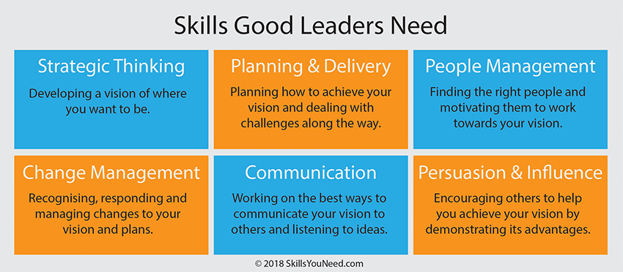

Lifelong learning and self-direction
Self-learning is a management approach by which managers can control the procedure, pace, and content of their learning. Different approaches are available regarding self-managed learning. These approaches can be categorized into three main categories, which are mentioned below:

Meta-Learning
When a learning process occurs at a strategic level, it is called Meta-learning. It offers fundamental modifications to skills and knowledge and a person already has. Meta-learning depends largely upon the mindset or mentality of the managers. If a manager is not ready to change his mentality, at that point, it is will hard to gain new knowledge, abilities, competencies, and skills.

Strategic Learning
This type of learning emphasizes utilizing those methods of evaluation which are proven to be helpful for individuals in learning quickly from activities or work. This is required as it will provide effective methods and means to be adopted towards learning. The most important benefit fo this type of learning is that it helps the business as well as managers in synchronizing their learnings along with their management practices. It is through this application that the managers tend to learn and interact with situations and in the result, they learn from each situation. Moreover, this approach helps managers in arriving at an approach that is more appropriate to the organization and the organization can overcome its issues more appropriately.

Motivational Learning
In this type of learning, managers are required to discover and learn about their natural styles of learning. For this purpose, the managers are encouraged to critically analyze themselves as well as make critical awareness of themselves and their environment. This step is taken to adopt the managers according to their learning at the workplace or identify suitable resources. This method of learning is important to identify suitable resources for learning as well as acknowledging the differences which are present in the learning process of other members of this organization.

Technology adoption and application
The knowledge of technology and its application also plays an important role in professional career development. When a manager has proper knowledge of technology, he can utilize it in business processes and can achieve better results from its team. Similarly, he can also utilize technology to better overcome problems and perceive new opportunities.

Demonstrate readiness for employability and personal advancement through an understanding of personal strengths and areas for further development.
As the professional career development is the process by which a person can improve his self-knowledge, identify his weaknesses, develop his potentiality, and increase his efficiency by overcoming his weak and unattended areas, in this part of the report, I will identify my existing skills and knowledge, and after that, I will discuss what additional knowledge and skills are required to fill in the gaps as a professional.
To understand my skills and knowledge, I will take a personal skills audit. Through this audit, I will be able to analyze my capabilities and quality of performance.

Personal Skills Audit
In this personal skill audit, I will gather the necessary information required for personal skill audit in the first place. The important thing to be considered in this regard is to be specific regarding outcomes and information because only in that case, the information will be useful to the person. There are the following stages in the personal skills audit.
For skill audits, different tools can be utilized. In this report, I will utilize the SWOT analysis to identify my strengths, weaknesses, opportunities, and threats. It is important to note that the first two aspects of this analysis are related to internal aspects while the second two aspects of this analysis are related to the external environment (Phadermrod et al. 2019). Based on the insights gained from SWOT analysis, a future action plan can be drawn.

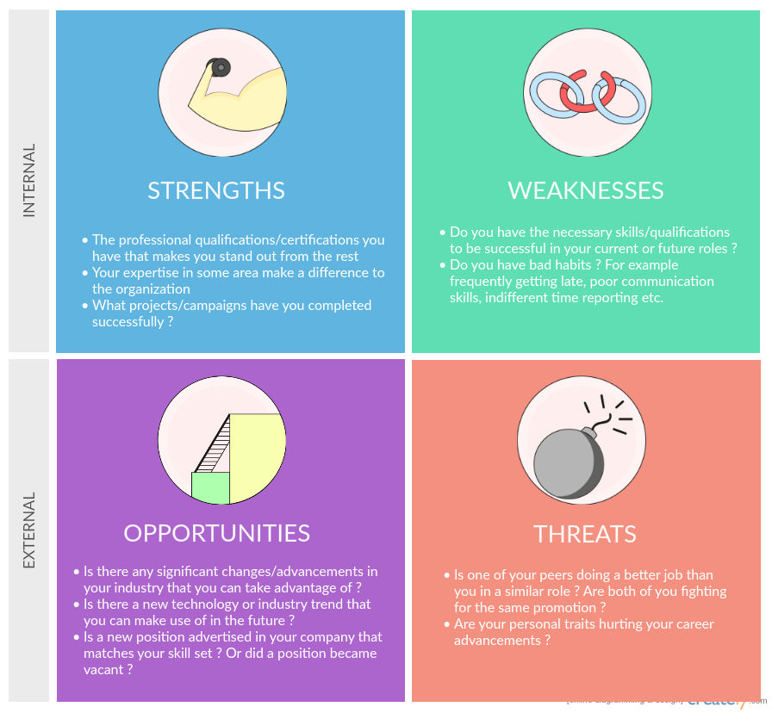

SWOT Analysis
The SWOT analysis of my skills is as follows:

Strengths
- Communication Skills
- Creativity
- Innovation
- Teamwork

Weaknesses
- Thinking Skills
- Leadership
- Technology adoption and application

Opportunities
- Lifelong learning and self-direction

Threats
- Emotional Control

It is evident from the SWOT analysis that I need to work on my weaknesses such as thinking skills, leadership skills, and technology adaptation and application. Keeping this in mind, I will analyze my skills in the need/ability grid to understand my level of efficiency and the level of effort, I need to put in each aspect.

Need/Ability Grid
It is also called a skill matrix or skill grid as it helps managers and supervisors in evaluating the fresh graduates according to the skills required by the specific job positions. This can also be used for understanding the current competence of an employee as compared to the future competence that he might possess. In this report, I will use the following need/ability grid.

A: Chores B: Confidence C: Effectiveness D: Action Needed E: Area of training
Name of Skill | A | B | C | D | E
Thinking Skills
Communication Skills
Teamwork
Leadership
Life-Long Learning
Self-Direction
Technology adoption and application
Professionalism and Ethics

It is evident from the above mentioned need/ability grid that there are two areas where action is needed. These areas include self-direction and thinking skills. Similarly, there is one area where I need to get training and that area is technology adoption and application. Keeping these three areas in mind, I will establish my employment goals and develop a personal action plan.

Establish employment goals and develop a personal action plan.
My employment goal is to become a general manager in a multinational organization. For that purpose, I need to focus upon the skills which my skill audit have highlighted to me. To focus upon these skills, I will develop a personal action plan.
After I have completed the stage I of SWOT analysis and Need/Ability Grid. I would turn to select an appropriate action plan for developing my skills and maintaining my professional outlook. I will also write my action plan in the way that it is properly documented so that I might utilize it in future and can get guidelines from this action plan. I will follow the SMART procedure to document as well as draw an action plan for the future.
After the stage II of the process has been completed, it is essential to make a complete record of the entire process. It is important to note that all of the actions are needed to be done during the process of the action. It must ensure that it highlights the aspects for which the person such as myself needs to work and need to develop.
It is important to note that the skill audit should be done by management to understand the problems existing in the management team and they should be able to decide the ways by which they can utilize these problems for future business benefits.

Personal Development Plan
My development plan is to enhance the capabilities that I lack during the SWOT analysis and need/ability grid. For the next year, I have developed the following plan.

Identification of the Development Area
The first step in this regard was the SWOT analysis. I have taken a SWOT analysis and have understood that I need to develop my skills in thinking, self-direction, and technology adoption and application sector. It is because my SWOT analysis has highlighted my weaknesses in these areas. I am good at communication skills that I will utilize in multiple ways for the development of my professional career as well as covering underdeveloped areas.

Future Target
Based on the weak areas that I have identified through the SWOT analysis, I have developed a one-year plan for developing these skills and knowledge. As the development areas are those which I can develop along with pursuing my professional career. Therefore, it will not be a major hindrance during my professional career.

Kolb’s Learning Style
It is also important to decide which learning style will be suitable for me for future development. In the report, I will utilize Kolb’s learning style as this will enable me to overcome my weak areas and then develop appropriate strategies to overcome these areas. Kolb’s learning style will enable me to identify the preferred learning style.
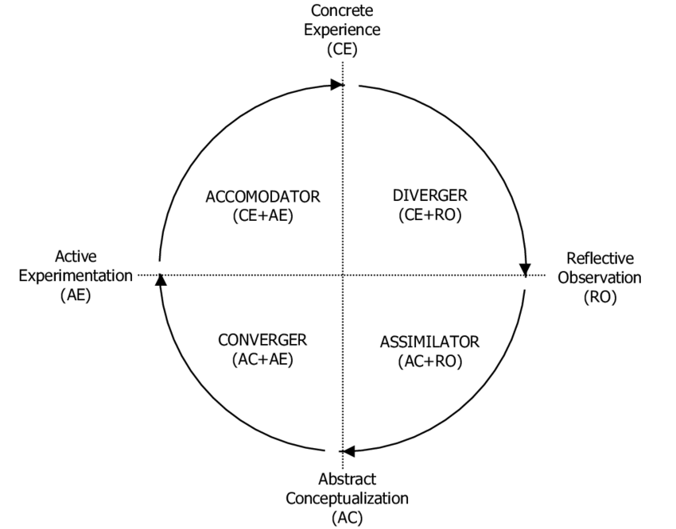
(https://www.researchgate.net/figure/Kolbs-Experiential-Learning-Model-11-Kolbs-Learning-Style-Inventory-was-originally_fig1_311307808)
As displayed in the figure, there are four learning styles:
- Diverger domain combines preferences for reflecting and experiencing.
- The assimilator combines preferences for thinking and reflecting.
- Converger combines preferences for experiences and doing.
- Accommodator combines preferences for doing and thinking.
My preferred learning style during this process of professional development will fall in the domain of diverger where I will combine preferences for reflecting and experiencing.

Resource identification
For developing technology orientation and application, I will undertake a short course, which will provide me with the basic knowledge and skills required as a manager in the field. Concerning thinking skills and self-direction, I will study these skills, practice them in my practical life, and will reflect upon them. Practicing these skills will provide me with knowledge and understanding of these skills. Moreover, I will be able to understand my efficiency level in these skills.

Plan Implementation and Monitoring
After I have implemented different aspects of my required knowledge and skills, I will go for monitoring of the processes which I intend to develop over time.
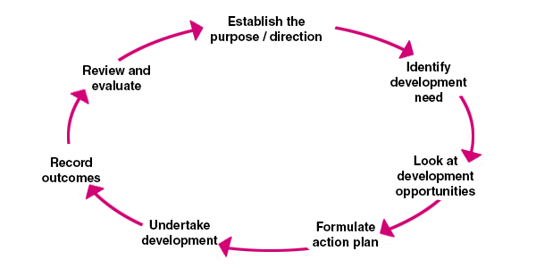
(https://www.managers.org.uk/knowledge-bank/personal-development-planning)

Conclusion
In this report, I have discussed three aspects of career professional development. In the first section, I discussed the knowledge and skills required for working effectively. I discussed the skills such as thinking skills, communication, teamwork, leadership, lifelong learning and self-direction, technology adoption and application, and professionalism and ethics. In the second section, I highlighted my strengths to demonstrate my readiness for employability. For that purpose, I undertook a personal skill audit. Here, I utilized the SWOT analysis and need/ability grid to get a clear idea of skills and knowledge. During the personal skill audit, I realized that I need to pay attention to two areas that are thinking skills and self-direction. Moreover, I also need to get training in one aspect of skills and knowledge and that is technology adoption and application. In the third section of this report, I have established my employment goal to be a general manager, and have established appropriate actions to be taken in this regard. I will utilize diverger learning style for my future learnings and developments. I plan to overcome my weak areas within a year.

References
Van Aken, J.E. and Berends, H. (2018) Problem Solving in Organizations. Cambridge University Press.
Bocciardi, F. et al. (2017) ‘Career Adaptability as a Strategic Competence for Career Development’. European Journal of Training and Development.
Cochran, G.R. and Ferrari, T.M. (2009) ‘Preparing Youth for the 21st Century Knowledge Economy: Youth Programs and Workforce Preparation.’ Afterschool Matters, 8, pp. 11–25.
Cottrell, S. (2017) Critical Thinking Skills: Effective Analysis, Argument and Reflection. Macmillan International Higher Education.
Giudici, M. and Filimonau, V. (2019) ‘Exploring the Linkages between Managerial Leadership, Communication and Teamwork in Successful Event Delivery’. Tourism Management Perspectives, 32, p. 100558.
Hökkä, P.K. et al. (2017) ‘The Reciprocal Relationship between Emotions and Agency in the Workplace’. In Agency at Work. Springer, pp. 161–181.
Jia, M. and Cheng, J. (2020) ‘Emotional Experiences in the Workplace: Biological Sex, Supervisor Nonverbal Behaviors, and Subordinate Susceptibility to Emotional Contagion’. Psychological Reports, p. 0033294120940552.
Kanwar, A. and Mishra, S. (2018) ‘Keynote Address: Higher Education in an Age of Disruption’.
Kassymova, K. et al. (2018) ‘Stress Management Techniques for Students’. In International Conference on the Theory and Practice of Personality Formation in Modern Society (ICTPPFMS 2018). Atlantis Press.
Mayfield, M. and Mayfield, J. (2016) ‘The Effects of Leader Motivating Language Use on Employee Decision Making’. International Journal of Business Communication, 53(4), pp. 465–484.
Paul, R. and Elder, L. (2019) The Nature and Functions of Critical & Creative Thinking. Rowman & Littlefield.
Phadermrod, B., Crowder, R.M. and Wills, G.B. (2019) ‘Importance-Performance Analysis Based SWOT Analysis’. International Journal of Information Management, 44, pp. 194–203.
Pomery, A. et al. (2016) ‘Skills, Knowledge and Attributes of Support Group Leaders: A Systematic Review’. Patient Education and Counseling, 99(5), pp. 672–688. DOI: 10.1016/j.pec.2015.11.017.
Ritter, S.M. and Mostert, N. (2017) ‘Enhancement of Creative Thinking Skills Using a Cognitive-Based Creativity Training’. Journal of Cognitive Enhancement, 1(3), pp. 243–253.
Verčič, A.T. and Vokić, N.P. (2017) ‘Engaging Employees through Internal Communication’. Public Relations Review, 43(5), pp. 885–893.

