
Understand and resolving the problem of stress among UK workers
Module CODE: BMSW 4004_BIRM
Costel andone 2027240
LECTURER: Dr Chijioke Uba

Contents
1. Introduction 2
2.Nature of the Stress. 2
3.Impact of the Stress. 3
4.Identifying the causes of the Stress. 3
5.Fishbone diagram 4
6.PESTEL Analysis 5
6.1. Political factors. 6
6.2. Economic Factors. 7
6.3. Social Factors 7
6.4. Technological Factors 8
6.5. Environmental Factors 8
6.6. Legal Factors 8
7. PMI – decision making tool 9
8. Solutions for the stress of workers in the UK. 9
3.Conclusion 11

1. Introduction
Work stress is reported as a harmful manifestation that workers feel at work due to stress and pressure.
Stress by nature is very difficult to measure, yet the Labor Force Survey (LFS) is the source for calculating and estimating the stress, anxiety, and depression of UK workers.
This study identifies and understand the problem of stress, nature, factors, and impact that stress can have on the UK workers. For a more relevant understanding of the problem of stress among UK workers, various methods are used such as Fishbone analysis, then PESTEL analysis for a better understanding of the factors, followed by a PMI (Plus -Minus -Interesting), and finally with the GRIT analysis, each solution will be evaluated to choose the best methods of combating stress among workers in the UK.

2.Nature of the Stress.
Stress as a definition is a change that causes psychological, emotional or physical stress.
We all face stress more or less. Our well-being in general is the difference in how we deal with stress.
Signs.
Stress can be on long-term or short-term.
Both can lead to many symptoms, but the most serious is chronic stress, and can seriously affect long-term health.
Signs of stress include:
- Headache
- Dizziness
- Low energy
- Mood swings
- Anxiety
These are just some of the signs that indicate that an individual is experiencing stress.

3.Impact of the Stress.
When you examine the connection between body and mind, it shows you the impact that stress has on you and your life in general.
There are several categories that influence the stress in the life of every worker in the UK.
These factors are:
- Obesity
- Diabetes
- Hair loss
- Heart disease
- Sexual dysfunction
- Ulcer

These factors listed above can cause serious health problems, whether it's because of a job, money, or a relationship.
When the mind encounters or experiences different levels of stress, the body will react accordingly. One of the worst stress problems is that of severe acute stress, such as participating in a verbal or physical altercation, or witnessing a natural disaster. It can cause arrhythmias, heart attacks, and even death. This can happen especially in people with heart disease.
Stress in UK workers also has an emotional charge. There are certain types of stress that cause mild anxiety, but prolonged stress leads to depression and exhaustion.
This type of stress is called chronic stress and has a serious impact on the health of workers in the UK.
The nervous system is hyperactive which will affect the body of stressed workers in the UK.
The conditions influenced by stress are:

4.Identifying the causes of the Stress.
To solve any problem the main causes must be identified.
Stress sometimes has only one source, but most of the time it has several source points.
In this context, the stress at work can influence other areas of the person.
There are some factors that can lead to work-related stress if they are not managed properly.
Stress can be :
- Acute
- Chronic
- Physical stressors
- Psychological
- Social stressors
One of the most common sources of stress is financial, because many activities depend on financial sources. (Peirce, Frone,Russel, & Cooper, 1996).
The most common stressors are those with problems in family life, financial, professional life that obviously lead to social and psychological problems. The cause of stress can be psychological or social, physical, acute or chronic stressors. (Sapolsky, 1994)

5.Fishbone diagram
There are various tools to understand the root causes and identify possible causes. In our case we will use the Fish Bone diagram, also known as the cause-and-effect diagram or Ishikawa diagram.
In the diagram we will first have the main problem which is "Stress among UK workers" followed by the other categories. (Figure.1)
These are:
- Financial
- Workplace stress
- Health stress
- Relationship stress
- Family Stress.

An effect and cause diagram helps a lot in brainstorming because it finds the causes of a problem and categorizes ideas.
This diagram offers the possibility to observe the effect and the cause. It is a much more structured way than other methods.
The main effect or problem is put in the mouth of the fish.
On the small bones there are possible causes under different categories of causes. A fish bone in the diagram below can be very helpful in finding out the probable causes that lead to certain analysis of the causes written in the diagram.

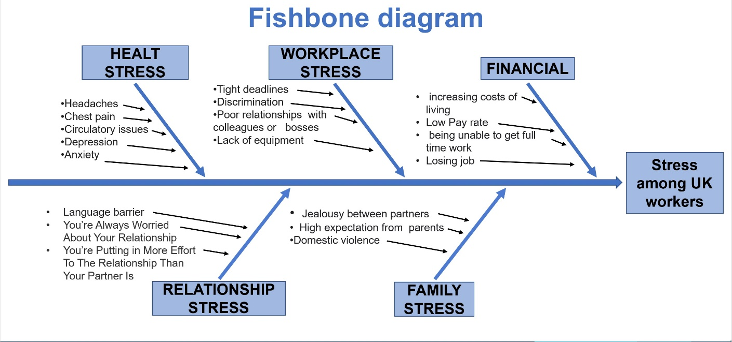
FIG.1

6.PESTEL Analysis
PESTEL analysis is an acronym for:
- Political
- Economic
- Social
- Technological
- Environment
- Legal.

PESTEL is a tool that marketers usually use to monitor and analyse the elements of the macro-environment (external marketing environment) that have an influence on a company or organization.
By this stage we have a diagram showing almost all the possible causes of the problem. Depending on its complexity and importance, it can investigate the most likely causes further.
The problem is complex, and the Fishbone is not enough to see all the causes of the problem, the PESTEL Analysis help to understand even better the different factors that have an impact on this problem. (Figure.2)

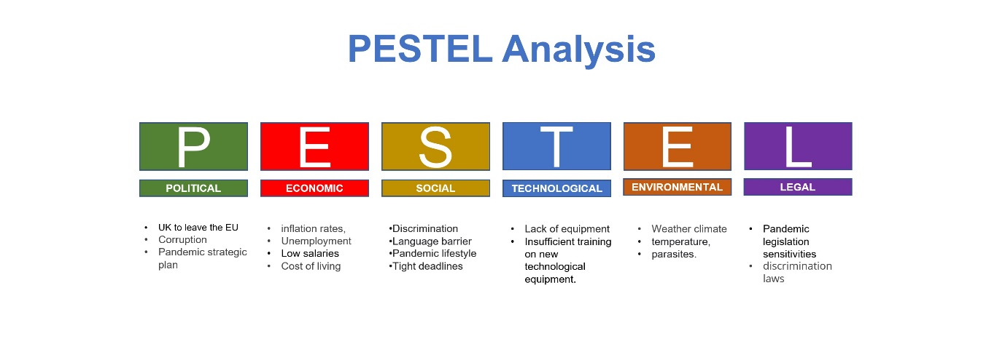
(Figure.2)

6.1. Political factors.
These factors influence the economy through the actions of the government and other elements that inevitably lead to affecting a business.
These are:
- UK to leave the EU
- Corruption
- Pandemic strategic plan.

6.2. Economic Factors.
These economic factors consider aspects of the economy that can affect a business. These factors are usually measured by banks or other government officials.
These include:
- Inflation rates,
- Unemployment
- Low salaries
- Cost of living

6.3. Social Factors
The PESTEL analysis also considers the social factors, which are attached to the demographic and cultural inclinations of the company. Social rules and pressures are the best way to condition the consumer's behaviour.
These are the things to keep in mind:
- Discrimination
- Language barrier
- Pandemic lifestyle
- Tight deadlines

6.4. Technological Factors
These technological factors refer to innovation in the industrial field but also innovation in the economy in general. Lack of knowledge of the most innovative technologies can be detrimental to operations.
These technological factors include:
- Lack of equipment
- Insufficient training on new technological equipment.

6.5. Environmental Factors
Environmental factors are the ones that have the ecological influence on business. If the weather conditions become extreme, organizations must adapt to them through careful planning that must deal with these calamities.
These factors are:
- Weather climate
- Temperature,
- Parasites.

6.6. Legal Factors
There is a doubt about the difference between legal and political factors in the case of a PESTEL analysis.
Legal factors are those that have power over business decisions. Political factors refer to the business relationship between the company and the government. Legal and political factors can be encountered when the government enacts laws that can affect the way companies operate.

These factors include:
- Pandemic legislation sensitivities
- Discrimination laws

7. PMI – decision making tool
PMI (plus, minus, interesting) was created and developed by Dr. Edward de Bono, a great supporter and supporter of critical and lateral thinking.
It is mainly used in researching ideas, experiences, and concepts from several perspectives.
In conjunction with Adair (2019), '' Implementing and evaluating decisions should be seen as part of the overall process ''.
PMI is brainstorming, a critical way of thinking about decision making, it generates analysis about negative and positive aspects and relationships associated with certain concepts or ideas.

8. Solutions for the stress of workers in the UK.
The problems can be very varied, the elements that can influence the problem related to stress must be able to solve the problem.
After finishing the analysis, we discovered 3 causes:
- Poor employee training,
- pressure from management,
- short deadlines.
The recommendation for solving these three causes would be:
1. Regular and good quality training for employees
2. Training for company managers to communicate efficiently and friendly with employees who suffer from stress at work
3. More time for those affected by stress to complete their duties and involve a therapist to deliver CBT sessions.

Plus | Minus | Interesting
Managers learn to behave with stressed employees (+6) | Management speaks to employees in a superior way (-6) | No extra costs for a trained therapist (+4)
Stressed workers can speak about stress problem (+4) | Employees feel inferior to managers and are not open to discussion. (-7) | Trainers and Managers will pay more attention to the importance of presence, efficiency, and performance. (- 5)
Trainers and Managers are more people you can talk (+5) | Trainers feel pressure from managers and tend to rush and shorten training (-4) | They are employees who fail to cope with stress.  (- 6)
Total=+15 | Total=-17 | Total=-7

Implementation plan solution, Review and Monitoring Process\ System
(Week 7)
Work related stress among UK workers.
Action | Description | Time | Staff Responsible
Identify training needs | Identify employees’ staff that require stress management training | 12 Jan 2022  19 Jan 2022 | Staff Manager
Identify Trainees | Make a survey for employees | 20 Jan 2022  27 Jan 2022 | Team leaders

Identify the Trainer | Trained Therapist | 28 Jan 2022  04 Feb 2022 | Hiring Department
Schedule/Programme Training | Schedule with time set for training | 05 Feb 2022  13 Feb 2022 | Training Manager

3.Conclusion
The conclusion of this report of the stress of the UK workers is that this problem is a common one in modern life.
Stress at work is quite common and finding a job with less or no stress is quite difficult (or impossible).

Individual solution for Work related stress:
Below are just a few of the best recommendations related to the daily activities of any individual, especially those who face stress at work and beyond.
This are:

- Healthy lifestyle and exercise
- Time management on social networks
- Be organized,
- Avoid multitasking as much as possible,
- Conflict avoidance.

Solutions offered by Companies

Companies also have a very important role to play in eliminating employee stress and anxiety as much as possible.
These are:
- Support and Training
- Encourage workplace wellness,
- Allowing flexible hours,
- Distance or workplace counselling,
- Recognition of employee merits.

Good and effective stress management helps the affected person to get rid of this serious and common problem as much as possible, and to become a healthy, happy, and productive person. A balanced life is ultimately the goal, with relationships, fun and relaxation, and of course a positive attitude at work in which each person can withstand the pressures and challenges that are offered to us at work every day!

3.References
- Anton, C., 2009. The impact of role stress on workers' behaviour through job satisfaction and organizational commitment. International journal of psychology, 44(3), pp.187-194.
- Boston, T.M., 2008. The impact of stress, burnout, and job satisfaction on rural social workers. Mississippi State University.
- Cohen, C. B. (2005) ‘Project management decision making: blending analysis and intuition’, Project Management Institute, Available at: https://www.pmi.org/learning/library/pm-decision-making-analysis-intuition-7492. Accessed: 10 November 2021).

- Cottrell, S. (2010) Successful problem-solving and task management, Palgrave Study Skills: Skills for Success Personal Development and Employability. 2nd edn. Basingstoke: Palgrave Macmillan.

- Diamantopoulou, A. et all (2002) ‘Working on Stress’, European Agency for Safety and Health at Work. Available at: https://ccsint.com/jdownloads/Stress%20Management%20Program/european_report_on_stress.pdf#page=6. (Accessed: 12 November 2021).
- Ejaz, F.K., Noelker, L.S., Menne, H.L. and Bagaka's, J.G., 2008. The impact of stress and support on direct care workers' job satisfaction. The Gerontologist, 48(suppl_1), pp.60-70.
- Ellyatt, H. (2021) ‘Hostile environment: After Brexit, some EU citizens in the UK are worried about their future’, CNBS Europe Politics. Available at: https://www.cnbc.com/2021/05/13/eu-citizens-in-the-uk-are-worried-about-their-future-ima-survey-shows.html. (Accessed: 8 November 2021).

- Hakkio, C.S. and Keeton, W.R., 2009. Financial stress: What is it, how can it be measured, and why does it matter. Economic Review, 94(2), pp.5-50.
- Health and Safety Executive (2020) Stress at work, Work-related stress and how to tackle it. Available at: https://www.hse.gov.uk/stress/what-to-do.htm (Accessed: 10 November 2021).

- Health and Safety Executive (2020) Work-related stress, anxiety or depression statistics in Great Britain. Available at: http://www.hse.gov.uk/statistics/causdis/stress.pdf (Accessed: 5 November 2021).
- Matovic, I.M., 2020. PESTEL Analysis of External Environment as a Success Factor of Startup Business. ConScienS, p.96.
- Maund, A., Schriek, M. and Tinkler, K.P. (2017) Problem Solving and Decision Making, Certificate in Higher Education: Skills for the Workplace Student Yearbook. London: SAGE Publications Ltd.
- Sze, W.C. and Ivker, B., 1986. Stress in social workers: The impact of setting and role. Social Casework, 67(3), pp.141-148.
- Thorsteinsson, E.B., Brown, R.F. and Richards, C., 2014. The relationship between work-stress, psychological stress and staff health and work outcomes in office workers. Psychology, 2014.

