

MODULE CODE: Digital Skills for Personal Development and Business Growth BMSW4008

ASSESSMENT COMPONENT: PORTFOLIO

STUDENT NAME:Yasir Hanif

STUDENT NUMBER:2516965

LECTURER:Philippa Fitzgerald

DATE:12:12:2025.
I confirm that I have not presented any AI generated materials as my own work.
I confirm that I have copies of my drafts, notes, and other resources I used, which I may be asked to provide in evidence.

Contents
Task 1 3
Assessment of Digital Skills 3
References 3
Task 2 4
LinkedIn Learning Certificates for Office365 4
Task 3 5
Essay on Relevance of Excel in professional and personal life. 5
References 5
Task 4 6
7 Minute Reflective Presentation 6
References 6

Task 1

Assessment of Digital Skills
Portfolio Example
Image 1
Screen shot of your JISC report

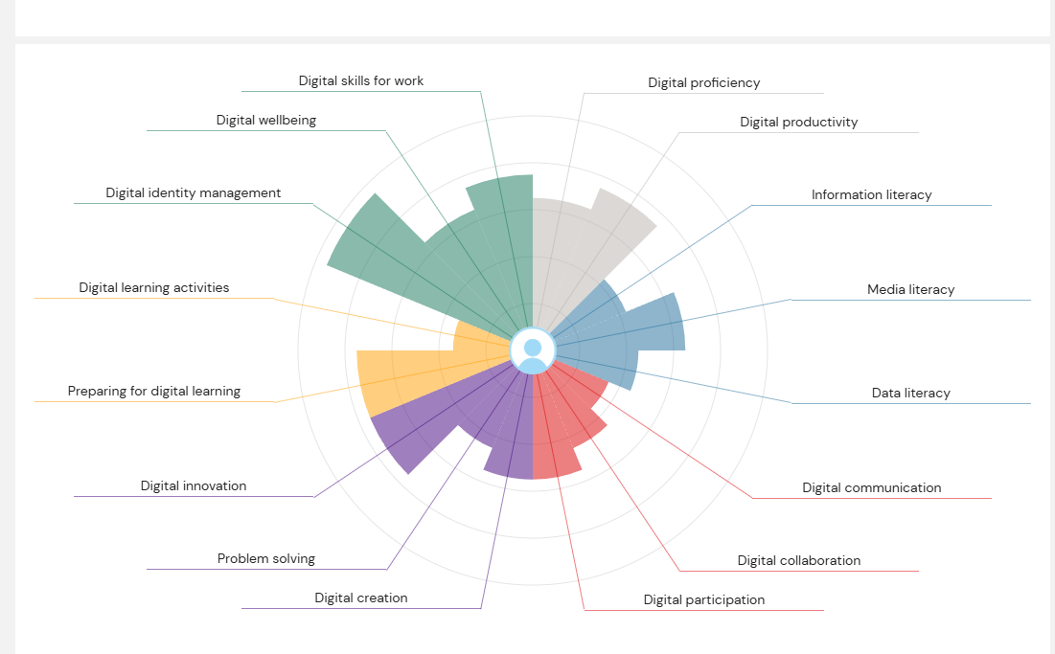

Jisc Discovery tool diagram (2025).
Digital skills reflection.
Digital skills are now important for everyone in modern society. As technology continues to change how we learn, work, and communicate with people of all age's for example students, workers, and citizens and everyone in-between need to be able to use digital tools confidently.
With the digital skills becoming increasingly important it is essential that people adapt and learn along with the times as Lytras (2021 p.31) explains how “the next future it will be necessary to explore new types of skills and abilities.” explaining how we have to keep up with digital skills and how quickly the importance is growing. They also go on to explain how it can affect everyone which really raises the importance of digital skills when they mention that “Having innovative types of knowledge permit the user to actively participate in social life, in labour market, and also in the University system” They explain here that it can help in all areas of life, communicating with friends and families, in working sectors like the labour market and them students at universities and educational system. This relays back to the importance of digital skills in modern society.
Technology also affects culture and daily life where some people are adapting g well and others may struggle with technology. As Wasilewski (2025, p.61) comments on his findings that “For some users, the digital environment is completely natural and every day,
while for others it may be foreign or unsettling, even if they are familiar with and accept technology”
This shows how people communicate and take part in digital activities as people are at different stages with technology and have different understandings and capabilities of how they use technology but shows how modern society uses technology and that it is relevant and important to each person.

In addition some research have raised concerns about what happens when technology replaces face-to-face interaction as Wasilewski (2025 p.61)comments that “Questions are often raised about the consequences for society when it is socialized in an environment where active human interaction is lacking and replaced by technology” showing how as a species we are adapting quicker than ever to a time where digital skills are replacing actual interactions, showing how important skills are to stop ourselves falling behind in the modern society.

Completing my JISC Discovery Tools I found that this helped me to understand what I am good at and what I need to improve on. One of my strongest areas is digital identity management. I can control how I present myself online and protect my personal information. This is important because employers and organisations often look at online profiles, so having a professional digital identity is useful when coming across as professional.
Another strong area for me is digital productivity and using appropriate digital skills. I can use tools like Microsoft word, Excel, and PowerPoint confidently, and these tools help me to complete tasks more efficiently. As Van Dijk and Deursen (2014) suggest, such skills are important both in education and in the workplace.
However, JISC Discovery Tools showed that I also have areas to develop. My weakest skills are digital collaboration. I sometimes find it difficult to work online with others using tools such as shared documents or virtual meeting platforms. This can make group work harder, both in university and in future jobs where teamwork often happens.
Another skill I need to improve is digital communication. Although I communicate well in person, I sometimes struggle to express myself clearly in emails, discussing forums, or online meetings. Gilster (1997 pg. 25) notes that ‘digital literacy includes the ability to create and understand online messages’ so improving this skill will help me take part more effectively in digital environments.
To improve these weaker areas, I have set two smart goals:
Goal 1: I want to improve my data literacy by learning to use Excel better. I will complete a beginner Excel course on LinkedIn. I will practice simple formulas, charts, and tables. This will help me with university assignments and improve my future job opportunities.
Specific – Learning Excel skills further
Measurable – I will know that I have done this by completing LinkedIn Course
Achievable – Yes, I have the skills to develop
Relevant – Yes as it is to do with digital skills
Time – I want to complete by end of term
Goal 2: I want to work better with others online. I will use Microsoft Teams more confidently during group work over the next six weeks. I will practice sharing files and sending clear messages.

Bibliography
“The next future it will be necessary to explore new types of skills and abilities.”
Lytras, M, D. (2021): IT and the development of digital skills and competencies in education. Published: IGI Global
“Having innovative types of knowledge permit the user to actively participate in social life, in labour market, and also in the University system”
Lytras, M, D. (2021): IT and the development of digital skills and competencies in education. Published: IGI Global
“For some users, the digital environment is completely natural and every day,
while for others it may be foreign or unsettling, even if they are familiar with and
accept technology”
Wasilewski K. (2025) Digital Humanities and Digital Skills in the Future of Work
Publisher
Peter Lang International Academic Publishers

“Questions are often raised about the consequences for society when it is socialized in an environment where active human interaction is lacking and replaced by technology”
Wasilewski K. (2025) Digital Humanities and Digital Skills in the Future of Work
Publisher
Peter Lang International Academic Publishers

Gilster (1997) notes that ‘digital literacy includes the ability to create and understand online messages’
Alexander J A M van Deursen (2014): Unlocking the information Society

Publisher
Palgrave Macmillan US

Task 2

LinkedIn Learning Certificates for Office365
Add all the certificates from LinkedIn learning here

Task 3
Essay on Relevance of Excel in professional and personal life.
Relevance Of Excel in Todays Society
Today i will be looking at the relevance of excel and if it is still a software that everyone uses or if it is limited to a niche market with only certain people using it. Excel is an application that is part of Microsoft office which was found by Bill Gates and Paul Allen and can be recognised globally. Different areas I will investigate are areas of business, education and home life to see if all areas still use excel and if they are still relevant today.
Excel is a useful tool that has helped many people at home and in many businesses worldwide. Its ability to calculate numbers and to lay out vasts amount of data can prove very useful.
One of the main areas that excel is used is business as it can help to keep track of progress and log data. As Raymond (2024) explains that “Excel proves to be a highly cost-effective solution for project management.” This means that businesses small or large can use this software effectively.
Another positive of using it alongside businesses is the ability to track data as Charlesworth (2024) comments that “ using formulas and functions to interpret data and draw conclusions” Meaning that businesses can see progressions or see failures in real time and don’t need to wait for set reviews to see that something is not working. This allows for the insights to be acted upon a lot quicker and to see the how the business adapts to the findings.
Another benefit of excel is the ability to make working more efficient excel creates more time for the other important aspects of running a business with quick to use formulas and simple calculations can be used as Wells (2024) comments “These functions cut short computing or calculating time, and aggregate data for a simplified display.” Meaning that there is less time wasting on these calculations and more time spent in areas that can be improved and focused on instead.
One area that excel can be relevant is in the home as with different functions available it can be relatable to many people. For example people who are on a tight budget can track what they spend and keep an eye on any savings as Team (2025)
comments that they can “manage their daily house expenses which can track down the spending habits of each member of the house” showing the benefits it can have within the household.
Another area that excel is incredibly useful is within education as it can help with organisation from the layouts and charts it provides, and it also has lots of ways to handle data as Lavina (2024) comments “Excel tools allow students to manage data more efficiently and practically.” This showing that excel is still relevant with younger generations and not just businesspeople.
Excel is also still relevant for budgeting reasons which can fall into both home and student lifestyle as Williams (2024) comments “Excel is an amazing tool to help with budgeting, as it has lots of powerful functions and features to help calculate data and highlight trends or issues.” Highlighting the useful aspects of excel that not only help people working with finance but also home owners and students who need to stay on top of expenses. Williams also shows that it can interactively showing good aspects of the data and can highlight any issues that can help with problem solving.
Excel has remained relevant due to its simplicity and the ability for everyone to use it with formulas already on the software so you don't have to be advanced in mathematics to succeed and Washburn (2023) further reinforces this by commenting “it can make everyday life easier by helping keep track of money, personal projects and health goals.” she also explains more ways in which excel can be used.
Another way that excel stays relevant is the costing, excel is free to most students through the hubs they use and in most workplaces as packages and for other circumstances Botha (2024) comments that “Excel is relatively inexpensive, making it an attractive option” meaning that other software's elsewhere may be charging a lot more for the same services that may not be as widely known or used.
Inconclusion I have found various ways that excel can still be relevant to all areas of life whether that be as a student budgeting expenses, in the household to keep track of savings and outgoings, and then on a financial and business level that help companies to track progress and highlight any areas of improvement within the workplace. Overall, I would say that excel is still hugely relevant and is looking to stay relevant with the younger generations learning about excel and the benefits it offers.

Bibliography
“Excel proves to be a highly cost-effective solution for project management.”
Raymond, D. (2024) :10 Advantages of Managing Your Projects with Excel. Available at:https://www.aceproject.com/blog/10-pros-advantages-of-managing-your-projects-with-excel-9387815/?afmc=pmnet
Accessed:01/12/2025
“ using formulas and functions to interpret data and draw conclusions”
Charlesworth, L (2024) What is microsoft excel used for and is it still relevant? Available at:https://kaplan.co.uk/blog/features/is-microsoft-excel-still-relevant
Accessed:01/12/2025
These functions cut short computing or calculating time, and aggregate data for a simplified display.
Wells, R. (2024) 5 Microsoft excel skills you need as a leader in 2024. Available at:https://www.forbes.com/sites/rachelwells/2024/01/09/5-microsoft-excel-skills-you-need-as-a-leader-in-2024/
Accessed: 01/12/2025
“manage their daily house expenses which can track down the spending habits of each member of the house” showing the benefits it can have within the household.
Team, G. (2025) 10 uses of ms excel in daily life –Available at: https://www.gyansetu.in/blog/best-10-uses-of-ms-excel-in-daily-life/
Accessed 01/12/2025
Excel tools allow students to manage data more efficiently and practically.
Levina (2024) Heres why its important for students to know excel. Available at: https://www.umn.ac.id/en/heres-why-its-important-for-students-to-know-excel/
Accessed: 01/12/2025
Excel is an amazing tool to help with budgeting, as it has lots of powerful functions and features to help calculate data and highlight trends or issues.
Williams, T (2024) Excel Spreadsheets: Budget Managment – Available at: https://executivesupportmagazine.com/excel-spreadsheets-budget-management/
Accessed: 01/12/2025
it can make everyday life easier by helping keep track of money, personal projects and health goals.
Washburn, E. (2023) 5 Ways to get Started Using Microsoft Excel – Available at: https://www.forbes.com/sites/emilywashburn/2023/04/05/5-ways-to-get-started-using-microsoft-excel/
Accessed:01/12/2025
Excel is relatively inexpensive, making it an attractive option
Botha, F. (2024) why do so many family offices use excel – Available at:https://www.forbes.com/sites/francoisbotha/2024/08/11/why-do-so-many-family-offices-use-excel/
Accessed: 01/12/2025

Use the following information create an Excel spread sheet, looking at income and expenditure of a typical family of 4 over the course of a year. Use formulars to achieve answers and add headings and highlight the different aspects of the finances, be realistic with the monetary amounts used for each area.
Income | Amount per month £££ | Expenditure | Amount per month £££
Wage 1 |  | Rent/Mortgage
Wage 2 |  | Council tax
Trust Funds |  | Electric
Stocks/Share payouts |  | Gas
Universal credit |  | Water rates
Student Finance |  | Food
Other |  | Car insurance
 |  | Car Tax
 |  | Fuel
 |  | Child Care Costs
 |  | Loans/credit cards
 |  | Other eg Birthdays/savings/holidays

Embed your excel here
Book 4.xlsx

Task 4

7 Minute Reflective Presentation
Create a PowerPoint presentation using techniques learned in class, reflecting on the module and what you have learned.
Maximum of 15 slides Minimum 7
You will reference your work where appropriate.
Embed PowerPoint here
Presentation 3.pptx

