Anna Nicole Price
The effectiveness of the current structure of NHS Wales
Tania Davies

Abstract
This report examines the structure of the National Health Service in Wales. The report will examine what the strengths and weaknesses have been discussed within the report. The report uses graphs and diagrams to illustrate certain points in the report. It uses government reports to back up points within the report.

Contents page
Page 4 Introduction
Page 5-7 Information and statistics
Page 7-9 Evaluation
Page 9-10 Conclusion
Page 10 Recommendations
Page 11-13 References

Introduction
Health in Wales (2019) states that the National Health Service (NHS) Wales is a publicly funded service that provides a service to 3 million plus people in Wales. The key principle of the NHS is to provide care to everyone regardless of wealth. NHS Direct (2019) states that in 2009 the NHS in Wales replaced the 22 Local Health Boards and seven trusts with seven new health boards. These made up a new structure for the ever-changing NHS in Wales. The health boards are the:
- Abertawe Bro Morgannwg University Health Board.
- Aneurin Bevan Health Board.
- Betsi Cadwaladi University Health Board.
- Cardiff and Vale University Health Board.
- Cwm Taf Health Board.
- Hywell Dda Health Board.
- Powys Teaching Health Board.

Reducing the health boards down to seven means that the NHS can offer a more streamlined service and offer a more personal service. According to Health in Wales (2019) the NHS trusts in Wales work to provide care to an increase in an aging population and those who are not able to leave their homes. Each health boards have different needs depending on the location. For example, some are rural and need more cohesive services in these areas. The Welsh Assembly published a report in 2009 which stated that the NHS needs to provide more care in people’s homes and to provide more self-care programmes. The health boards need to encourage more nurses to provide more community nursing.

Information and statistics

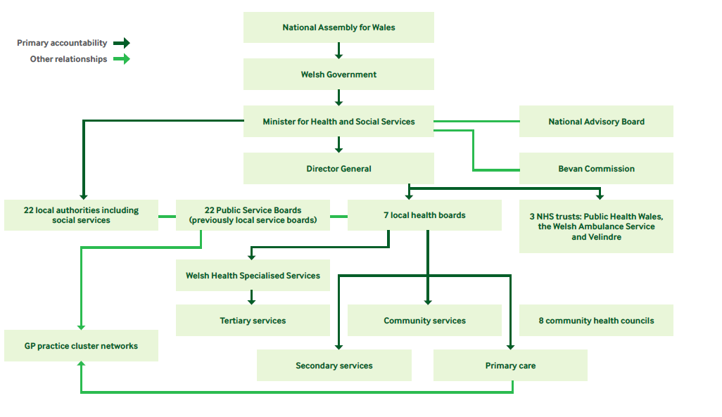
(Langley, 2012)

The diagram above shows how the general management structures in Wales generally work. The National Assembly for Wales (2015) states that the delivery for health services in Wales lies directly with the Minister for Health and Social Services. The work of the Minister for Health is to be scrutinised by the National Assembly for Wales. The centre of the health system of Wales is the seven health boards and the three trusts of the National Health Service.

According to the National Assembly for Wales (2015) in order for the National Health Service in Wales to work efficiently targets and plans are made that will shape the way health care is delivered. The targets are set out by the Welsh Government and then the National Health Service trusts and local health boards will then respond by issuing planning documents. Trusts and the local health boards will focus on how to deliver the care while delivering the long-term targets. The departments of Health and Social Services, the Local Health Boards and the National Health Service trusts will receive advice from the National Advisory Board and the National Advisory Group. The Local Health Boards will engage with local authorities. These authorities will then decide how health services will are delivered in Wales.

The National Assembly for Wales (2015) has stated that in 2009 the system changed. The seven health boards are now appointed by and are accountable to the Minister of Health.

According to NHS Wales (2019) the funding for the National Health Service Wales comes from the Welsh Government. The Welsh Government acquire the funding from the central government in Westminster. The revenue is allocated to the local health boards that secure hospital, community and primary care for the population. The capital that is allocated to the local health boards and the National Health Service trusts for operational developments. Some of the funding is allocated for improvement and other initiatives done by the Welsh Government.

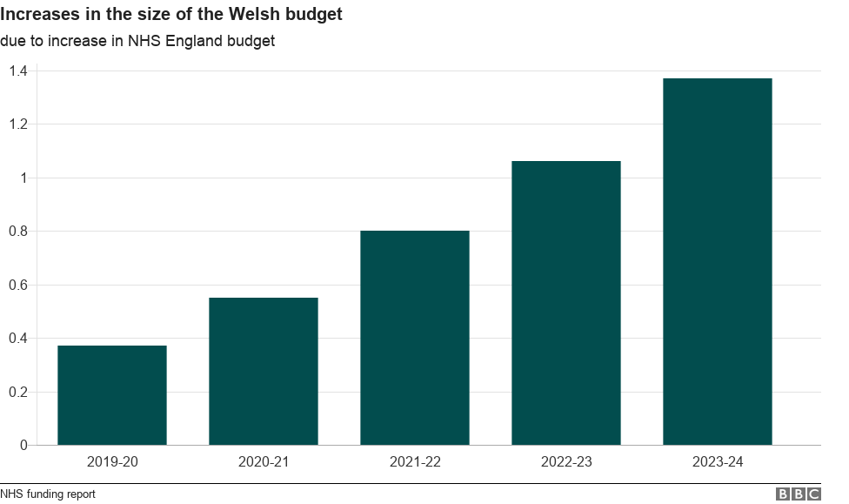
(BBC, 2018)

The chart above shows the projected spending to the NHS in wales. The chart shows that the spending will increase from 2019 to 2024 to £1.37 billion for the NHS.

The funding for NHS Wales can be influenced by the following factors:
- A growing and aging population
- Pay rises and inflammation
- Free prescriptions.

Health in Wales (2018) states that Wales there is a Strategy for Older People. This initiative came into effect in 2013 and is expected to last until 2023. This aims to address the well-being of the older generation. In Wales the NHS support health promotion initiatives that are targeted towards the elderly. NHS Wales supports stroke awareness as strokes are more common in the over 55. Stroke lead to disabilities and death. The campaign makes people aware of the symptoms of stroke. The NHS also supports a range of self-management courses to promote independent living with long-term health conditions. The keep well this winter campaign provides advice to the older generation in order for them to maintain good health throughout the winter.

According to Health in Wales (2018) the government in Wales has recently committed to raising the wage in Wales to match the wage in England. They have also committed to paying more to the staff that provide more important services in Wales. The new rate will start at £17,460 in April 2018 and will rise to £18,005 in 2020. This is to guarantee the living wage.

Health in Wales (2018) states that all prescriptions are free in Wales as of April 2007. According to the Health Secretary Vaughan Gething “Free prescriptions were introduced in Wales 2007 as a long-term investment to improve people’s health.” Although this is true there is a strain on the NHS because people are getting medications that they could buy over the counter through the free prescription service.

Evaluation
The structure of the NHS in Wales has many strengths and weaknesses. A positive of the way that the NHS is run in Wales is that the government in Westminster gives the National Assembly for Wales funding where this is given to the Welsh government. This funding is then allocated to the Minister for Health and social services. The minister will then allocate the money to the director general who gives the money to the seven health boards and the three NHS trusts. The positive of this is that the seven health boards can make decisions of where the money is allocated within their healthcare region. As stated by Simpson (2016) the Welsh government took control of the healthcare management in 1999. Since then it has under gone two changes. The first was to get rid of the general practice fundholding and to reconfigure the health bodies to align the local government with the NHS. In 2009 it changed again and changed the mixed system. This change was to implement seven local health boards to emphasis local planning.

A negative of the structure of the NHS is that the funding has to travel through so many departments before it reaches the services that need it the most. The structure of the NHS is not an easy design of follow. There are too many departments answering directly to the Minister for Health this needs to be simplified. Another negative of the structure of the Welsh NHS is that there are too many health boards. Some of these could merge together to create more larger health boards.

The most positive aspect of the NHS is that it provides free universal health care for the everyone. According to the NHS (2016) the NHS currently offers free healthcare to 64.6 million people in the United Kingdom. The NHS has been rated the most impressive healthcare system overall by the commonwealth fund.

A concern that relates to the report of the NHS after Brexit. Green (2019) published a report that examines all the potential outcomes of Brexit. The report does not address the impact of Brexit but considers the potential harm and benefits that could happen from any Brexit scenario. The NHS must consider broader health considerations on the impact of health. The health considerations include:
- Delayed or reduced medications entering the United Kingdom (U.K)
- Reduced health protection capability due to the U.K no longer participating in key public health co-ordinating systems and evidence sharing mechanisms
- It may impact the recruitment and retention of workers in the U.K
- The loss or reduced access to future EU funding for research and development
- The mental health of people impacted due to uncertainty and the future.

To conclude looking at the strengths and weaknesses in order for the NHS to survive in Wales it needs to be diversified for future generations. As reported by Hussey (2018) the NHS needs to draw from international experience. Hussey (2018) believes that there are four goals that must be followed intensely and will comprise of the Quadruple Aim. The Quadruple Aim will be adapted for Wales and support the Wellbeing for Future Generations (Wales) Act. The four supportive goals are:
- To improve the population health and wellbeing through the focus of prevention
- The core and quality of individuals through experience
- To improve the interaction between health and social care workforce
- To increase funding through improvement, innovation, use of best practice and eliminating waste.

Conclusion
The purpose of the report is to look at the structure of the NHS. It has discussed the function of the NHS and the seven health boards in Wales. It went onto to discuss the management structure from the National Assembly Wales down to the seven health boards. A diagram has been included that shows the hierarchy management of the NHS in Wales. The report found that the structure of the NHS needs to be further simplified in order for the service users to have a better understanding of how it is run.

It highlighted three things that influences the NHS in Wales. The report looked at the growing and aging population, pay rises and inflammation and free prescriptions. An additional point that was highlighted in the report is that Brexit is an uncertainty for the NHS and must be dealt with by the government in Westminster. It also highlights how much more funding that Wales needs to survive between 2019 to 2024. In the report a graph has been included to show the money that is needed between 2019 to 2024 in order for the NHS to survive in Wales. This report has used a report that was issued by the Welsh Government that illustrated in order to survive for future generations a Quadruple Aim must be followed. It will comprise of four main goals that must be followed. The report found that in order to survive more money is needs to be invested to the NHS. The recommendations for the report are to follow.

Recommendations
It is recommended that the Welsh government have a look at the structure of the NHS. The recommendation would be for the Welsh government to consolidate the seven health boards into more manageable sectors which will make it easier to keep track of what each health board is striving to achieve.

The NHS in Wales needs more money in order to survive. To achieve this the government in Westminster may consider raising taxes and national insurance in order to increase funding. The government in Wales may consider charging for prescriptions again as this will create more revenue to put back into the NHS. This would raise extra capital to reach the target of £1.37 billion by 2024 to keep the service running smoothly.

It is recommended that some of the health campaigns that are run towards the over 55’s are consolidated into one campaign. This would free up some revenue in order to be put back into the NHS. An example of this would be to combine the stay well in winter campaign with a housing campaign.

Bibliography
BBC, (2018). Sparring on spending: The latest round in the NHS funding row.
Available at: https://www.bbc.co.uk/news/uk-wales-politics-44615723
[Accessed 02 04 2019].
Gething, V. (2017). Free prescriptions are a long term investment in people’s health.
Available at: https://gov.wales/free-prescriptions-are-long-term-investment-peoples-health-vaughan-gething-0
[Accessed 08 04 2019].
Green, L. e. (2019). The Public Health Implications of Brexit in Wales: A Health Impact Assessment Approach.
Available at: http://www.wales.nhs.uk/sitesplus/documents/888/PHW_Implications_of_Brexit_ExecSum_Eng.pdf
[Accessed 12 04 2019].
Health in Wales, (2018). Budget & Charges.
Available at: https://www.wales.nhs.uk/nhswalesaboutus/budgetcharges
[Accessed 08 04 2019].
Health in Wales, (2018). Older People.
Available at: http://www.wales.nhs.uk/healthtopics/populations/olderpeople
[Accessed 08 04 2019].
Health in Wales, (2018). Pay rise offer for NHS Wales’ staff on 70th anniversary.
Available at: http://www.wales.nhs.uk/news/48872
[Accessed 08 04 2019].
Health in Wales, (2019). Structure.
Available at: http://www.wales.nhs.uk/nhswalesaboutus/structure
[Accessed 31 03 2019].
Hussey, R. e. (2018). A Revolution from Within: Transforming Health and Care in Wales.
Available at: A Revolution from Within: Transforming Health and Care in Wales
[Accessed 12 04 2019].
Langley, M. e. a. (2012). Health in transition , United Kingdom: European observotory on health systems and policies.
National Assembly for Wales, (2015). The organisation of the NHS in the U.K: comparing structures in four countries, Cardiff: National Assembly for Wales.
NHS direct Wales, (2019). Health Boards.
Available at: https://www.nhsdirect.wales.nhs.uk/localservices/localhealthboards/
[Accessed 31 03 2019].
NHS Wales, 2019. NHS Wales - About Us.
Available at: http://www.wales.nhs.uk/nhswalesaboutus
[Accessed 31 03 2019].
NHS Wales, (2019). NHS Wales funding.
Available at: http://www.wales.nhs.uk/governance-emanual/nhs-funding
[Accessed 02 04 2019].
NHS, 2016. About the NHS.
Available at: https://www.nhs.uk/using-the-nhs/about-the-nhs/the-nhs/
[Accessed 12 04 2019].
Simpson, M. (2016). How is healthcare in Wales structured?, Wales: Public Health and Healthcare Delivery.
Welsh Assembly Government, (2009). NHS in Wales: Why we are changing the structure.
Available at: http://www.wales.nhs.uk/documents/NHS%20Reform%20leaflet_October%202009.pdf
[Accessed 31 03 2019].

