
MSc Industry 4.0 Advanced Manufacturing
Introduction to Innovation Management
Critical evaluation of the introduction of digital data input at product inspection.
Date: 23rd September 2022
Written by: Gareth Frost
Safran Seats GB
Contents

Introduction 3
The Principal drivers for the innovation 4
Work Duplication 5
Non-Common recording formats 6
Difficulty in understanding the handwritten text 7
Data analysis is not real-time 7
Data Mining 8
Barriers or risks faced by the company in developing this innovation 8
Bespoke product development is seen as a short-term fix 8
Small budget and short lead time 9
Compatibility with Enterprise resource planning (ERP) tool 9
Culture 9
Key determinants for committing to develop the innovation 10
Processes and Technologies used to carry the development forward 10
Big Data and Analytics 10
Horizontal and Vertical Systems Integration 11
The Internet of Things (IoT) 11
The extent to which the development relied on external resources and the ways in which the deployment of these resources was managed. 12
How management overview of the development was maintained. 13
Conclusions 13
The extent to which you feel this innovation process represents best practice. 13
Personal Critique 15
References 16
Appendix 1 18
Graphical information detailing Innovation 18
Data Input 18
Data Consolidation 18
Automatically generated Product inspection report 19
Automated Reporting and Analysis 19

Introduction
Inspection or product validation is a critical motivator for every manufacturing company looking to build and sustain client satisfaction.
However, this process creates vast volumes of data. All this created data is pointless unless it can be organised, analysed, and applied.
At Safran seats GB, data on inspection flaws may be collected at several places during the production process. These areas are:

- Operational Electrical Inspection.
- Interstage inspection (areas that will be covered during further build).
- Customer interstage inspection.
- End of line inspection (end of build).
- Customer inspection / delegated inspection (dependent on customer requirements).
- Air framer, integrator (lease owner) / delegated inspection.

As a result, being able to better analyse, arrange, and use the data supplied from the above-mentioned domains promotes a more integrated approach to front-end design and manufacturing preparation.
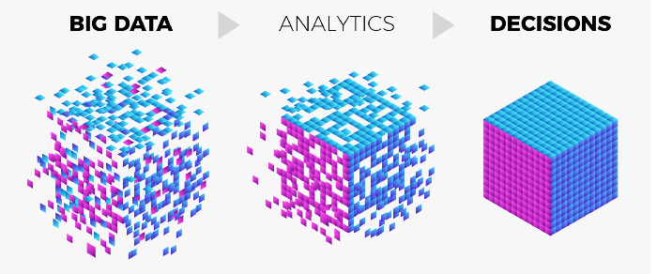
(Waden, 2020)

The Principal drivers for the innovation
The principal drivers for this innovation can be broken down into two key drivers,
- Customer Satisfaction
- Cost
Both have a negative impact on the business bottom line but in separate and distinct ways.
Customer satisfaction is a sense of how well the brief was met and so affects future business; this has a longer-term impact on the bottom line. Whereas cost, and in this case the related cost due to loss of efficiency and/or the cost of rework, are self-derived and have a direct impact on the bottom line, replacement components are not.
Safran can better understand why this innovation was produced if cost as the primary motivator and begin to explore efficiency.
(Banton, November 2020) describes efficiency as “the ability to achieve an end goal with little to no waste, effort, or energy.” They also go on to say that efficiency can be expressed as a ratio or a percentage. Ratio-Efficiency = Output/Input, Percentage-Efficiency = Output/Input x 100.
The earlier way of working involved:
- Work duplication
- Non-common recording formats
- Difficulty in understanding the handwritten text
- Inconsistent data storage locations (digital scans of Snag sheets)
- Data analysis is not real-time
- Data Mining

Work Duplication
When an inspection is performed, the individual performing the activity must complete a "SNAG Sheet," which specifies the issue of concern. This handwritten information is linked to the unique identification or a serial number of the product. After that, the data is transposed to the Waterfall chart / Attribute chart that is presented in the Manufacturing area for that product, and the data is transcribed to the "Snag Database" by the originator.
The data is managed multiple times by the originator and in multiple formats which become more complex the further along the chain, you go.

Calculations as follows: (based on worst case)
- For each defect or Snag found and written up = 2 Minutes.
- For the same snag to be confirmed for duplication and transcribed to the waterfall chart = 2 Minutes.
- For the same snag to be confirmed for duplication and transcribed to the Snag database = 3 Minutes.
According to these statistics, it might take up to 6 minutes to enter each snag into the system. Using this computation and an average fault count per product of 30, the inspection time per unit is 180 minutes, resulting in a daily throughput per inspector of around 2.5 products per day, ignoring other activities.
Step 1
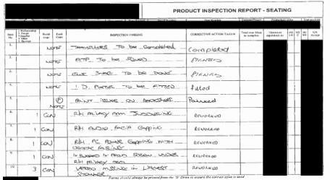
(Information redacted for security)

Step 2
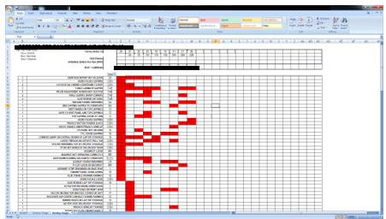
Step 3
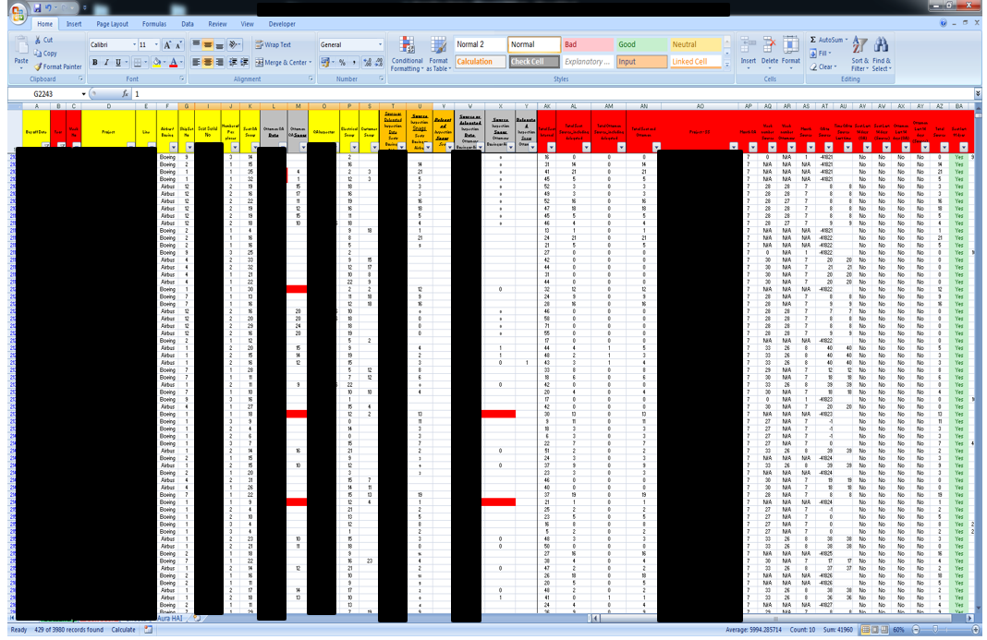

Non-Common recording formats
It is critical to provide consistent data descriptions when recording data to be analysed. This enables for effective data analysis and accurate reporting. When data is mismatched, the efficacy and efficiency of data feedback suffer.

Difficulty in understanding the handwritten text
Handwriting styles and linguistics impact the understanding of the concern and can lead to multiple ways of dealing with the concern
- Request originator for further clarification – Takes originator away from data update or next product.
- Concern is guessed at, and appropriate / non-appropriate action is taken (potential for further delay or rework)
- Concern not addressed until originator comes back to validate actions have been completed (further delay added and further validation required)
All these points lead to efficiency drops and delays.

Data analysis is not real-time
Because of the time required to compile the data (as explained above), the trend analysis is created after the production run and hence cannot be utilised to identify production patterns during that production run. This indicates that the data sent to production is out of date, and the problem may or may not exist. As a result, seeking a ghost concern may impede the manufacturing process, contributing to a loss in efficiency as a direct result of the TAKT time impact.
(Lean Enterprise Institute , n.d.) describes TAKT as “A calculation of the available production time divided by customer demand”. And “The purpose of takt time is to precisely match production with demand. It provides the heartbeat of a lean production system”.
(Barnett, 2017) States there are five reasons why real-time data is required and the importance behind it. The Five reasons are:
- Real-time data improves customer service
- Real-time data helps managers know what’s going on at a glance
- Real-time data improves operational efficiency
- Real-time data helps keep employees motivated
- Real-time data identifies superior performers and employees who need help

Data Mining
Due to the intricacies of the data and its storage, it is impossible to provide a realistic picture of the situation to the production area and the Board of Directors without significant sanitisation (still not 100%). This sanitisation and report-out process takes an average of 8 hours to complete. (IBM Cloud Education, 2021) defines data mining as “The process of uncovering patterns and other valuable information from large data sets”.
(MRP, Easy, June 2021) This ratifies the belief in the reduction of paperwork, reduced human errors, improved traceability, increased productivity via increased efficiency, and data-driven decision-making.

Barriers or risks faced by the company in developing this innovation
As with the development of any innovation, there are barriers or risks to consider. The barriers or risks considered during the implementation of this innovation are as follows:
- Bespoke product development is seen as a short-term fix
- Small budget and short lead time
- Compatibility with Enterprise resource planning (ERP) tool
- Culture

Bespoke product development is seen as a short-term fix
At Safran Seats GB, the establishment of a digital recording system for product inspection was viewed as a short-term solution to an efficiency and reporting problem. This is owing in part to the Chief Executive Officer's prior company's use of off-the-shelf technology. They did not, however, understand the nature of that system and its connection with SGB's present TAKT time and fault rate. The off-the-shelf system is correct for items that are created in high volume and regularly off-tool; the system has excellent Root Cause analysis capabilities, but it is a long process and more suited to a Part Per Million defect ratio (PPM) product.
PPM does not lend itself to SGB’s products as they are unique and highly aesthetic, with thousands of pieces. As previously said, there are several inspection locations during the manufacture of each product, and the fault count at the end might be in the hundreds. This rate is then multiplied by the number of goods produced in that run (all of which can be slightly different).
Based on this, using an off-the-shelf solution might exacerbate the problem and result in a considerably larger loss of production efficiency owing to the bottleneck and over-processing of the defect volume, some of which are not systemic concerns but more of a special case (one-time events).

Small budget and short lead time
- Since this project was considered a steppingstone toward an off-the-shelf solution, it was given a limited budget and a short lead time of six months to develop and deliver the "temporary" solution. This steered the project in two distinct directions:
- Development of the bespoke system
- Proving off-the-shelf solution presently not capable of providing required service

Compatibility with Enterprise resource planning (ERP) tool
The ERP tool at Safran Seats GB is an older version of BAAN and is unsupported, therefore any solution development requires an interface to enable retrieval of significant traceability data.

Culture
As more data is gathered and associated with trends, there is a reluctance to accept responsibility for defects created or to speak out about problems seen or received. This is counter-intuitive, but the blame is placed on the product design or the process, some of which is true, but a proportion must be attributed to product production.
The production team sees the attribution as a vehicle to blame them for the problems, which is not the case. This data may be used to properly understand what is going on in production and to assist in resolving difficulties that may arise from design, process, supplied parts, or even wrong training or instructions.
(Eric Auschitzky, 2014) stated that Manufacturers taking advantage of advanced analytics can reduce process flaws, saving time and money. They also state that Six Sigma cannot solve all the issues with a complex production system with activities that influence yield.
Therefore, the cultural approach to the collation of big data needs to be revised and seen within the business as a tool to underpin and stabilise production activities in real-time.

Key determinants for committing to develop the innovation
For this project/innovation to be developed the following are the key determinants
- Reduction in non-value-added work duplication
  - Re allocation of spare time to Quality assurance/training activities
- Provide an IT solution to the inspection process
- The system must be used on a tablet or other suitable handheld device
- Output must be digitally generated to allow rework to be conducted and validated
- The data input must be consistent
  - The use of drop-down fields for most input areas.
- System must automatically generate real-time Pareto and graphical information in the background
- All stakeholders must have the ability to interrogate information with available software
- All related data stored in one location and in generic format to aid traceability for audit purposes
(See appendix 1 for Graphical information on innovation)

Processes and Technologies used to carry the development forward
To develop the solution several of the key pillars of innovation 4.0 were used.
- Big Data and Analytics
- Horizontal and Vertical Systems Integration
- The Internet of Things

Big Data and Analytics
The innovation is the utilisation of big data and analytics, however, to be able to use this concept you first need to understand how to appropriately use the data collected.
Big data analytics examines large amounts of data to uncover hidden patterns, correlations, and other insights. With today’s technology, it’s possible to analyse your data and get answers from it almost immediately – an effort that’s slower and less efficient with more traditional business intelligence solutions. (SAS, 2022)
With the data to hand in real-time, it is easy to react and reduce or irradicate the emerging concern, this fast response and ability to react make vast gains. Bernard Marr (2015) “The real value is not in the large volumes of data but what we can now do with it”.

Horizontal and Vertical Systems Integration
Horizontal system integration enables the innovation to ensure that only items that have been loaded for manufacture and properly positioned inside the production system are subjected to product validation by inspection.
The real-time data interchange across departments, in this example, operations and Quality, might produce departmental silo friction since the data can be contested at the point of discovery rather than at a point in the near past. This provides more of a cultural difficulty than a production/engineering one and can create ethical debate around personal interpretation; this is especially prevalent when looking at aesthetic or perceived faults.
The real-time data linkages to all stakeholders are the vertical aspect of the innovation. This, in addition to the real-time graphical presentation and automatic linkages to top-level company Key performance indicators (KPIs).

The Internet of Things (IoT)
The system must be linked for the innovation to operate; this connection is maintained through the usage of the internet and connected and communicating technologies. In this scenario, the equipment was determined to be an iPad owing to the coding language and its interoperability with another system that was available at the time. Because these devices are linked to the system, data may be sent in the necessary formats, such as inspection reports, Pareto graphs, attribute charts, etc.

The extent to which the development relied on external resources and the ways in which the deployment of these resources was managed.
During the initial phase of the innovation, there had been conversations with teams at Boeing Commercial Airplanes (BCA) to discuss a method to reduce and consistently report the concerns found, this was something that they had also been struggling with and was a little way further down the road in proposing a solution. A collaboration was struck up between both Safran and Boeing to work on the solution together, however, the Boeing senior management rejected the approach and all activity ceased early on from their side leaving Safran to continue.
The mapping of the system was done within the Quality Assurance department before involving other departments. Once the general principle had been settled the IT department took hold of the project and put it out for tender.
The quotations that came back showed that external providers would not be plausible as the development cost would deplete the budget by around three quarters, a cost of £6000 just for the database development and would take around two months. Safran’s internal IT department was able to significantly reduce this cost to around three weeks and £1000 by dedicating 1 person, however, other projects had to be paused for this period.
From the technology hardware aspect, this was procured by leveraging company relations with British Telecom. The equipment purchased in Phase 1 consisted of:
- 10 iPad Mini’s @ £200
- Apple Mac Mini (server) @ £500
- iPad Charging Cabinet (10 tablets) @ £500
- Upgrade of Wi-Fi coverage @ £1000
The total cost for Phase 1 including software development totalled around £5000.
With the resources being internal the management of the innovation was straightforward as iterations could take place as and when required. However, there was a weekly reporting cadence put in place with an associated action tracker to ensure the project was on track from the development phase through testing and rollout. This was between the Quality and IT departments.

How management overview of the development was maintained.
With the potential of large savings to the business, it was written into the project charter that there would be a bi-weekly report out to senior management. This would focus on the adherence to the project plan that had been approved, any risks and mitigation actions along with any resource issues or financial obstacles that would require more senior intervention.
At a more local level, as previously discussed the project team would meet weekly and from that meeting, a report was generated and distributed to local management to show progress, this also served as a forum to escalate to senior management before the next report.
Having the meetings at various levels staggered it enabled expectations to be managed if a problem emerged and a solution or change of direction was sort.

Conclusions

The extent to which you feel this innovation process represents best practice.
The notion of “Best Practice” is by far and away a subjective statement, this is in part due to the industry, product complexity and business size.
(Trott, 2017) defines the models of innovation such as Serendipity, Linear models, Simultaneous coupling models, Architectural innovation, interactive model, Innovation life cycle and dominant designs, etc.
At SGB’s core, you could say that the Innovation life cycle and dominant designs (Trott, 2017) is the main or core business model. This is a traditional model for manufacturing entities that service customers wanting the next best or exclusive item.
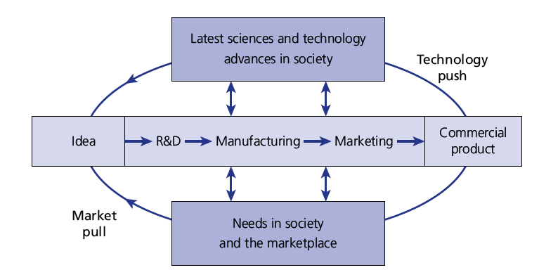
(Trott, 2017)
However, this model along with the others are more top-level and outward-facing and thus can be difficult to utilise to implement an internal or localised innovation.
(Schilling, 2019) provides a more appropriate model for the discussed innovation in this report, “Product Innovation versus Process innovation”. (Schilling, 2019) provides a key statement that underpins this innovation, “Process innovations are often oriented toward improving the effectiveness or efficiency of production by, for example, reducing defect rates or increasing the quantity that may be produced in a given time”. They also referred to the importance of both innovations detailed.
The way the innovation was managed did fit the “Stage-Gate Process” approach as discussed by (Schilling, 2019)
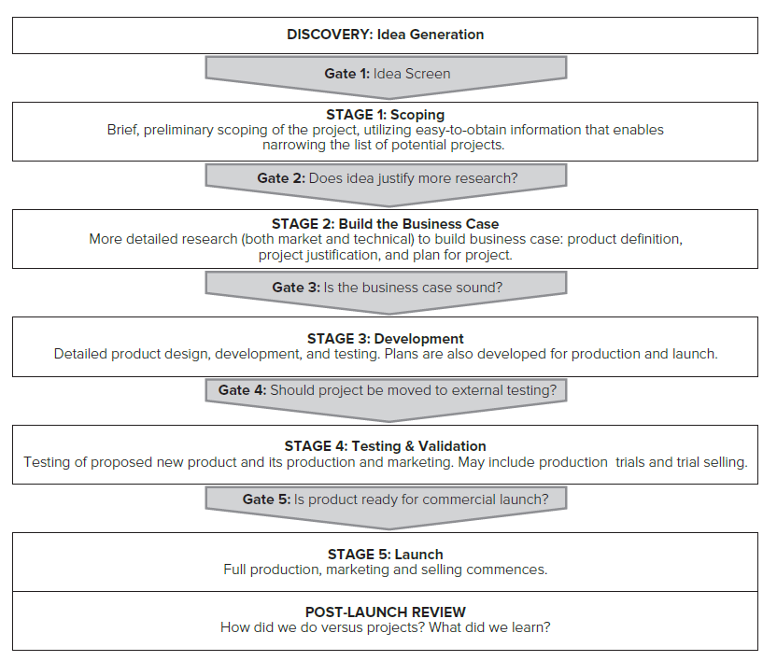
(Schilling, 2019)
This is very evident in the iterative nature of the project taken along with the research and the development outside silos. The post launch review also led to further discussions and possible iterations in including the Quality Management system into a larger integrated system. Some bench marking was conducted with several system leaders in discussions. However due to the company wide transitions and complexity of integrations this was shelved.
What did take place post launch was the addition of the system to include functionality to record images of the defects however this has yet to be switched on.

Personal Critique
Although the development and implementation went relatively smoothly at the working level, it was clear and obvious that obstacles were in place from a senior position; this was discussed earlier in the report, but what it did not outline was the operational/production element's reluctance to embrace the idea.
The system is presently in existence and has been for some time. As described, the technology permits information to be examined in real-time by anybody with access, but this is not the case. The data lies dormant as production continues to make the same mistakes until they are discovered during an inspection.
This comes as a surprise, and the attention moves to Quality to determine why these difficulties persist. Because there is a reluctance to comprehend why the issue happened, the product is moved down the line to be inspected.
As previously noted, there is a cultural blockage within the system that, unless unblocked or educated, causes the system and the business to stagnate. SGB is still primarily a quality control company, not a quality assurance company. This antiquated strategy continues to squander money with non-value-added rework at the end of production, creating a vicious cycle in which the more you rework, the more you inspect, and the more you find.
SGB must also comprehend the upstream significance of the data acquired. I have already addressed the operational reluctance to understand self-created challenges, but SGB must also examine design-related items. These stem from a lack of manufacturing awareness, as well as isolated design and industrialization.
In summary, the system gives some very valuable information as well as a platform for a better understanding of correlations and patterns; but, until the cultural component of Big data utilisation is addressed, the system is only a database and not a vehicle for corporate growth and development.

References
Banton, C., November 2020. Efficiency. [Online]
Available at: https://www.investopedia.com/terms/e/efficiency.asp
[Accessed 13th September 2022].
Barnett, M., 2017. The Importance of Real Time Data & Five Reasons Why You Need it. [Online]
Available at: https://www.fourthsource.com/data/importance-real-time-data-five-reasons-need-22014
[Accessed 23rd September 2022].
Eric Auschitzky, M. H. A. R., 2014. How big data can improve manufacturing. [Online]
Available at: https://www.mckinsey.com/capabilities/operations/our-insights/how-big-data-can-improve-manufacturing
[Accessed 16th Spetember 2022].
IBM Cloud Education, 2021. Data Mining. [Online]
Available at: https://www.ibm.com/cloud/learn/data-mining
[Accessed 23rd September 2022].
Lean Enterprise Institute , n.d. TAKT Time. [Online]
Available at: https://www.lean.org/lexicon-terms/takt-time/
[Accessed 23rd September 2022].
Marr, B., 2015. BIG DATA : Using Smart big data, analytics and metrics to make better decisions and improve performance. First ed. Chichester: John Wiley & Sons.
MRP, Easy, June 2021. QR Codes vs. Barcodes in Inventory Tracking. [Online]
Available at: https://manufacturing-software-blog.mrpeasy.com/qr-codes-vs-barcodes/
[Accessed 13th September 2022].
SAS, 2022. Big Data Analytics: what it is and why it matters. [Online]
Available at: https://www.sas.com/en_gb/insights/analytics/big-data-analytics.html
[Accessed 20th September 2022].
Schilling, M. A., 2019. Strategic Management of Technological innovation. 6th ed. New York: McGraw-Hill Education.
TIBCO, n.d. What is a Digital Factory?. [Online]
Available at: https://www.tibco.com/reference-center/what-is-a-digital-factory
[Accessed 27 April 2022].
Trott, P., 2017. Innovation Management and New Product Development. 6th ed. Harlow : Pearson.
Waden, R., 2020. How is the current state of Big Data Analytics in Controlling?. Towards Data Science.

Appendix 1

Graphical information detailing Innovation

Data Input
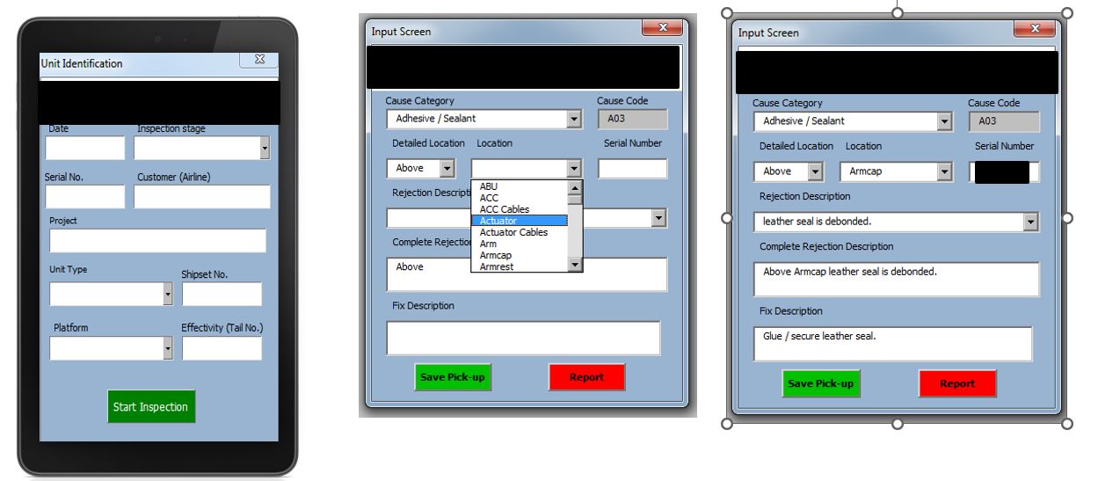
- Handheld device to allow direct entry via forms with drop down menus
- Entries saved directly to the database saving time on the line
- Consistent snag descriptions

Data Consolidation
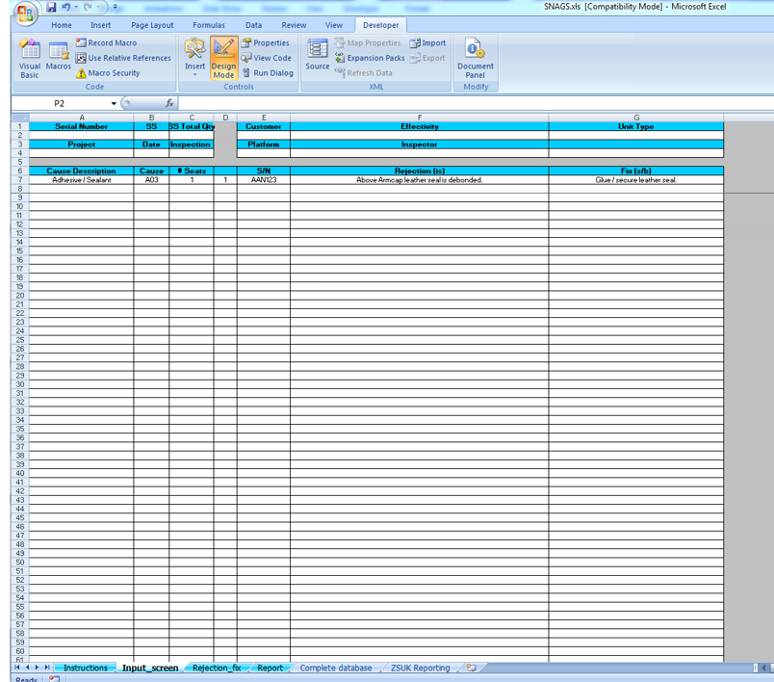
- Live system that captures all the snags in any unit at any inspection stage in a consistent manner
- Cannot be accessed from the handheld devices reducing errors and corruption of the data
- Each unit data fed into a database that hold all the information.

Automatically generated Product inspection report
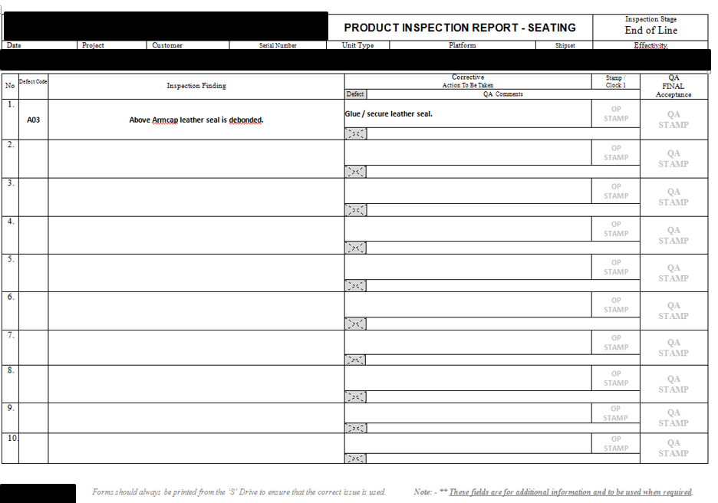
- Printed snag sheet for Operators to work from
- Consistent descriptions for issues
- Clear printed issues and required fix instead of the vague resolutions or entry left blank

Automated Reporting and Analysis
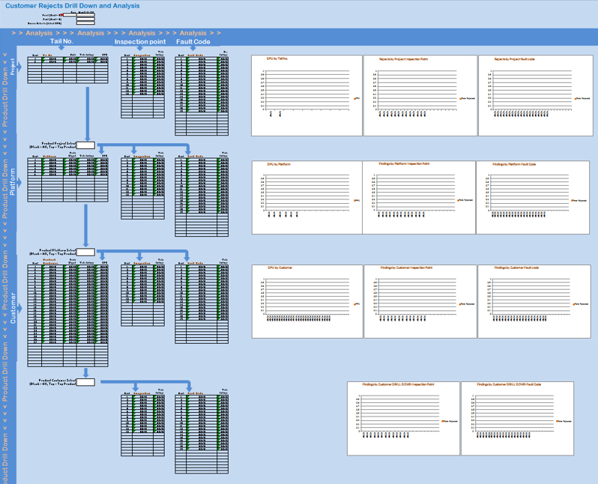
- Ability to data mine by any category:
  - Customer
  - Airframe
  - Platform
  - Defect Code
  - Project
- Automatic output of KPI’s such as DPU for each platform and in total
- Ability to generate graphical representation of the data quickly for progress and pareto

