s



Module Title: HUMAN RESOURCE MANAGEMENT – ASSESSMENT 1
Module Code: LCMB7000
Assignment Title: HUMAN RESOURCE MANAGEMENT ASSESSMENT 1
STUDENT NAME: PRUDHVI RAJ GOUD PARUPALLY
STUDENT ID:2130641
DATE OF SUBMISSION: 10TH SEP 2022

Table of Contents
Introduction 2
The current state of the labour market in the UK 2
The changes in human resource strategies post covid, post-Brexit in the external environment 6
Recommendation 10
Conclusion 10
Reference list 11

Introduction
The labour market demonstrates the economic function which constructs labour demand and labour supply. The role of human resource management is to understand the difficulties in the labour market and tackle the challenges to maintain the retention of employment. After the pandemic and post-Brexit situation, human resources strategies have been changed. Human resource strategy is the process that solves the organisation’s biggest problems after evaluating HR policy, and market situation. The purpose of this report is to evaluate the current labour market situation in the UK and the report has identified the impact of covid and Brexit affected on Human resources practices and strategies. This report has been provided on the current market situation of UK and human strategies has been changed to adjust the market fluctuation.

The current state of the labour market in the UK
Labour market overview
The high rate of inflation refers to the continued fall of real income. From April to June 2022, employment increased but the sign of employment growth is slow. The number of job vacancies fell in the last quarter. For people aged 16, the employment rate was 75.5%but employment level has risen over the past year (commonslibrary.parliament.uk.2022). 8.89 million people aged from 16 to 64 were economically inactive and the rate of inactive was 21.4%, average wages fell in real terms by 4.1%. The UK employment rate has increased by 0.2% to 75.6% but it is below the pre covid situation (ons.gov.uk.2022). The growth rate of employees' average total pay was 6.8% from February to April 2022. The unemployment rate has decreased and is below pre-pandemic rates.
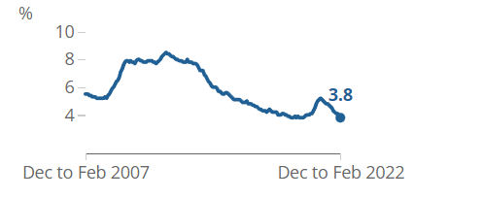
Figure 1: The unemployment rate in the UK
(Source: ons.gov.uk.2022)
Despite the forecast of recession by the Bank of England, the UK labour market has found indicators of strong recruitment and retention. Apart from raising the pay and hiring new people, employers are looking to have strong skills to tackle the recruitment and retention difficulties. Stalling the economic growth number of full employment is high and vacancies rose by 1.3 million (ft.com.2022). Economists said that this case supported the idea that the Bank of England raises the interest rate, so it is driven by full-time employment. Solid labour demand because of consumer price inflation. Because of tightening the monetary policy, the unemployment rate has decreased and but the growth rate of employment is slow.
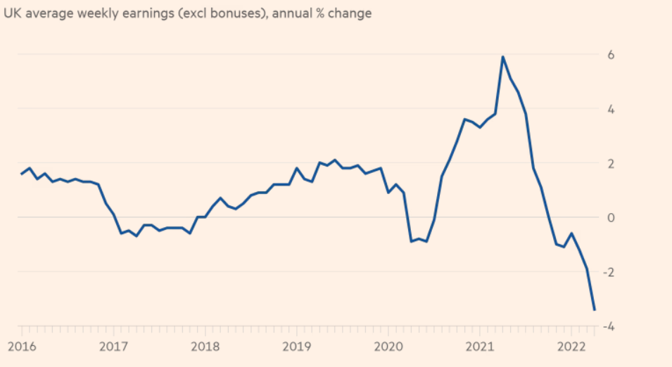
Figure 2: Impact of inflation on payment
(Source: ft.com.2022)
Inflation has a high impact on earnings as a result the real income of UK households has decreased. Payroller employees are higher than the pre covid situation. Private sector jobs reached in March 2022 over the quarter. Public sector jobs have increased by 0.8% over the quarter (economy-ni.gov.uk.2022).
Annual growth pays
Recently the Britain labour market is in a boom situation. Job vacancies are at a record level meanwhile the rise in prices is much faster than the rise in wages (theguardian.com.2022). So, it indicates that annual growth in pay exclusion bonuses remains unchanged at 4.2% despite increasing the wage rate by 6.6%. The real terms cut by £26 in a week on average workers so annual pay growth including bonus fell to 6.8% from 7% (theguardian.com.2022).
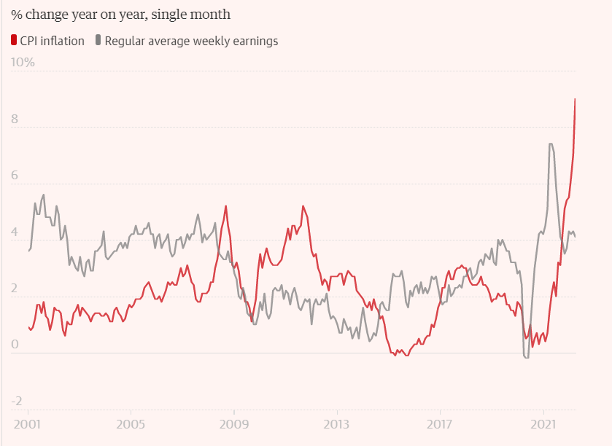
Figure 3: Relation of CPI and average earning
(Source: theguardian.com.2022)
This figure reflects that as the inflation rate increases average weekly earnings are falling, so in the post covid situation after 2020, the rate of CPI increased and close to 10% where the average earning rate is falling. The Labour force has increased because during the time of the pandemic most of the workers left their job and after the recovery, they began to work and most of the students started their careers (worldbank.org.2022).
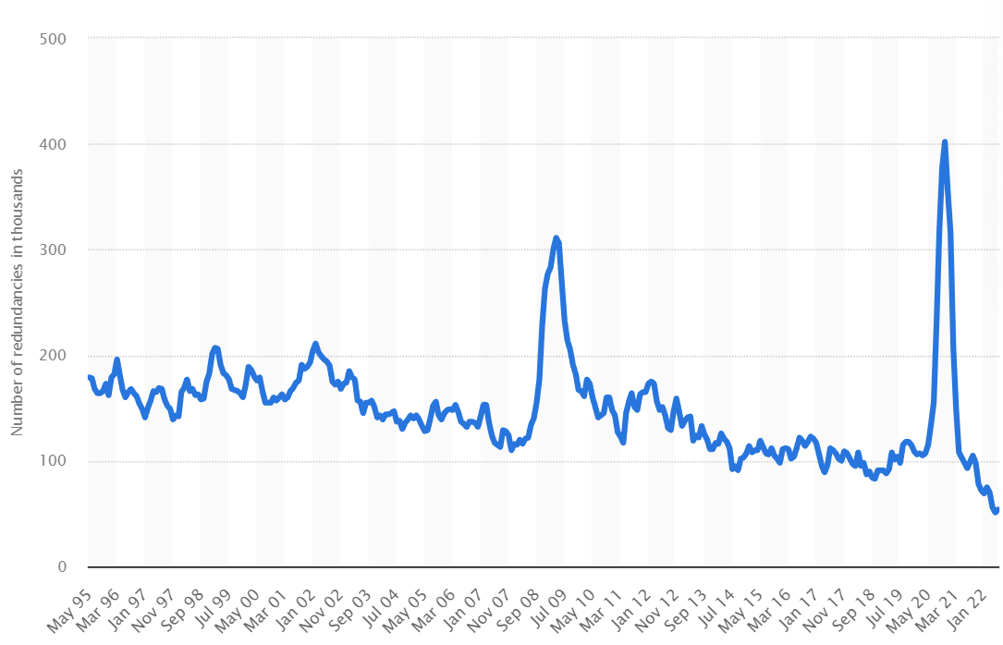
Figure 4: Redundancy rate in the UK from 1995 to 2022
(Source: statista.com.2022)
In the second quarter from April to June 54000 redundancy occurs in the UK compared to the first quarter (statista.com.2022). Post covid situation, the reduction rate has been decreased but in the recent scenario, the redundancy rate has been increased from the previous quarter.
The post-Brexit situation in the UK workforce
A share of organisations is reporting that it is hard to fill the vacancy after the Brexit situation. The Impact of Brexit in the UK business and the labour market have seen a shortage of products in the local market, and a lack of staffing. The post-Brexit situation impacted the migration flow as well as business location decisions and trade patterns (telegraph.co.UK,2022). British businesses found it very tough in labour shortage because it affected the migration system. The new rule of trade includes that a skilled worker visa is available only for workers who pay more than £25,600 and require at least A-level skill (economicsobservatory.com.2022). The new system refers to a more tightening policy to gain entry into the UK. lower paid and lower skilled jobs under the free movement affected the wage rate negatively of UK workers. The new system has shifted to the objective of maintaining the balance towards high-paid migrants including service sectors.
Opportunities and challenges from the current state of the labour market
Quality of labour market information helps to identify how to achieve better skill alignment. Demand for the skill is derived from the demand for the job which comprises the specific task. Demand-driven by the different economic shocks and trends so it recently shifted to digitalisation (assets.publishing.service.gov.uk.2022). Supply of the skill comes through education and training, and experience. Future demand for labour depends on the changes in the occupational structure which focuses on the policy-driven approach, and future trends. Qualitative measures of employability can provide the changing skill that is needed within the occupation but only can be focused on a small number of areas due to relatively high cost (assets.publishing.service.gov.uk.2022). The rapid changes of economic impact such as EU-exit, migration changes, and COVID-19 rapid technological change require the well-designed intervention of skill alignment and the quality of skill assessment through regular evaluation.
UK exits from the EU, and the government in the UK put the adoption and implementation high-quality standards In the UK economy. Labour market statistics users understand the current changes in the labour market and monetary policy to figure out the human resource strategy. The research found that in part of the economy of the hospitality and service sectors there had been large declines in EU workers and a rise in the vaccines to recruit the non-EU countries (ft.com.2022). Especially there have been raising the difficulties in recruitment. Although, in early retirement workers over the age group of 50 face problems in the UK labour market which are not related to Brexit. So, the report found that workforce shortages were highest in the sectors and dependent on the EU worker before the time of the pandemic. So, employers looking for domestic labourers rather than labour from abroad by making wage increases ad career options (ft.com.2022). so, there is an opportunity for human resource management to take into account implement to a new technological structure to collect information about labour preferences.

The changes in human resource strategies post covid, post-Brexit in the external environment
Resourcing in an organisation is affected by the internal and external factors
This section referred to the input-output optimization modelling framework for the operation during this crisis. The study noted that human resources impact the employee's livelihood on the overall workforce. Apart from people management and business continuity, it is critical in their working practices. Modern strategies of human resources operate through operational technology by ensuring a high level of communication, increased productivity and performance management. The new strategy has been reported in Deloitte to respond to the current situation which is "responsible”, “recover”, and “thrive”. The HR transformation strategy in Deloitte refers to dealing with the present situation, recovering reflects the learning stronger from the present scenario, and finally, preparing the shape of a new formal (deloitte.com.2020). Human resource leaders are plating the centre role to keep the workforce engaging and understand the recent priorities to respond to the exclusive phase.
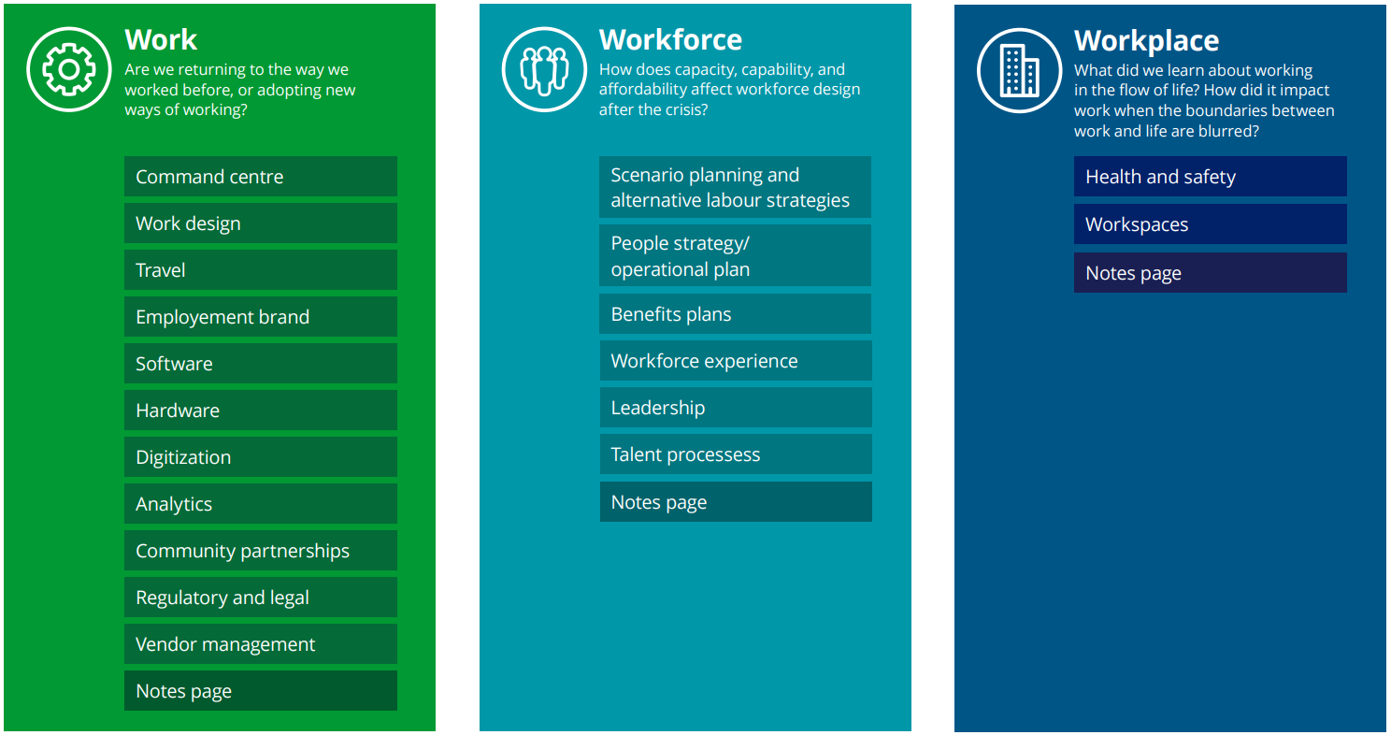
Figure 5: activation framework for HRM team
(Source: deloitte.com.2020)
To committee the way of work previously HR strategy adopted new skills of working such as improvement of analytical skill, digitization skill, and increased community partnership. Organisations try to return to the way they have workers before that is why they are adopting the new way of working. The HR team focuses on digitization skills through evolving automation, robotics, and cognitive perspective to deal with the current issues.
The COVID-19 pandemic has disrupted global economies and businesses. Although organisations are now in a recovery situation, the inherent effect of the pandemic highlighted the need for adaptability and resilience of the workforce.
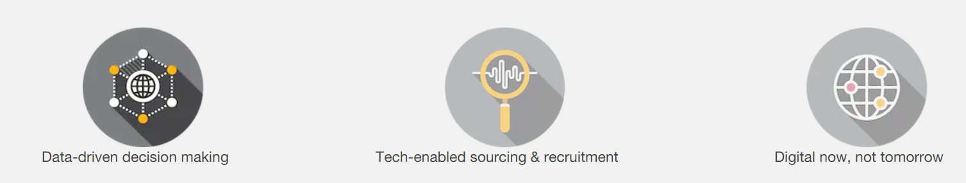
Figure 6: enable changes in workforce and recruitment process
(Source: pwc.com.2022)
Leveraging the workforce analytics by promoting data-driven decision making
To gather the workforce analytical experience HR, gather the employee experience, engagement and satisfaction through the data-driven process. To stay competitive in the complex business environment, the HR team continues to leverage business analytics to forecast workforce requirements and measure workforce performance (pwc.com.2022). Regularly analysing and monitoring the employee performance and engagement metrics HR determine the strategic talent acquisition (pwc.com.2022). It is vital that HR transform its lifecycle to meet the organisational need. HR takes the workforce rationalisation measure to manage the risk and increase employee productivity after the pandemic.
Tech-based sourcing and recruitment
Organisations looking at their new recruitment strategy by shifting toward the most cost-efficient and effective operating model. In recent eras, a rise in the success of remote working has paved alternatively on the resourcing stage and conducting a virtual environment. With the emerging technologies such as virtual reality (VR), augmented reality (AR), blockchain and AI driving the automation and digitalisation HR functions more potentially make a decision which is free from implicit bias. blockchain technology has been used to conduct the background of employees where employers can virtually acquire employee credential records (pwc.com.2022).
Accelerating the digital transformation agenda
HR is under pressure to create more value with fewer resources so HR is cutting redundant operational-related jobs and pushing operations into the wide door of technological training through AI applications. Digital learning platforms become the reality where HR created the policy to invest in the infrastructure of digital training. Financial stakeholders and HRM practices influence the employee as well as the community's behaviour. The strategic business partner model has been the core position of the HR function through this they are creating artificial boundaries within strategic and transactional work (ncbi.nlm.nih.gov.2021). These issues highlighted the strategic role versus the tactical role of HRM. covid-19 provides an opportunity with the context of suing the data-driven analytics and revolution in the remote work culture (hr.economictimes.indiatimes.com.2021).
Problems HR are facing to adopt the current HRM strategy
Once the UK has left the EU, the UK government focuses on new areas such as immigration policy, and food and farming regulation (bsa.natcen.ac.uk.2020). Adapting new policies and going with the market flow is difficult. It has been identified that wages have dropped to 2.2% in UK regular pay and almost 74% unsupported by employers as wages fail to keep pace with the cost of living (thehrworld.co.uk.2022). Growth in nominal wages has risen but because of inflation, British households' purchase power has fallen. So, the public sectors are boosting the minimum wage and governments supporting the union show are doing campaigns for fair pay. Most HR policies are trying to adopt the flexible hybrid strategy that prizes the mental health of workers (thehrworld.co.uk.2022).
Many workers are unable to access the face-to-face training and miss social interaction with colleagues. On the other hand, many freshers and graduates appreciated working in the home and being able to have less little contact and making it more flexible to do work from beds. This situation raises problems for HR, HR have to ensure the support of workers well-being. The employment market is different from the pre-pandemic state in the post-pandemic state so HR reshaping the talent in the landscape with the power balance of tipped workers.
Companies need to evaluate the remote wrong policies to decide the acceptable future because some of the employees who worked remotely have been frustrated and prefer to work in from the office premises (forbes.com.2021). So, the reintegration of remote teams is the main challenge of HRM to identify which employees want back to the office and which are not. On the other hand, continuing remote hiring HR team finds it difficult to compare the candidate's answers because of the larger candidate pool in UK HR is not finding the geographical limits (forbes.com.2021). Integrating new policies and techniques increases the recruitment budget where the role of HRM is to ensure a cost-effective solution. The organisation has been promoted to make consideration reduce their working hour temporarily, in UK government identified the strategy of partial furlough pay, based on the employment law, employers have to agree on a contractual change, this can be a costly practice.

Recommendation
Due to inflation, the real income of workers has been falling rapidly and at the same time, the growth rate of wages is slow which is why HR can set the scheme to extend the appreciation bonus (thehrworld.co.uk.2022). To fit the economy for the future, support the skill and maintain retention HR can increase the bonus and implement the reward strategy. HR can allocate the budget envelope, pay system, and bonuses which are managed by the ministries. As HRM is linked with the strategic objective so HR should focus on the issue of policy delivery, and the possibility of reallocating staff. The type of length of initial training varies from determined sectors of the different organisational groups, but HR can invest gather feedback to make substantial use of performance assessment.
It is the responsivity of the top management to enhance the well-being of employees to understand their physical and mental health. So, HRM can integrate government job retention schemes to provide health and safety in practice and schedule strategy by distinction issues (researchgate.net.2021). HR has to understand the redundancy and have to find the legal issues in terms of algorithm management to provide flexible working. So, it is recommended, that human resource management have to emphasize on the changing activity of the current market situation and different policies of government to adjust organisational culture. Furthermore, having huge employment rate, workforce it is difficult to make the decision on recruitment basis of the skilled and capacity of worker towards business success.

Conclusion
This context highlighted the central role of HR in driving operational and strategic success during the pandemic and post-Brexit situation. After the evaluation of all the perspectives, it can be concluded that the pandemic and Brexit expand the market's understanding of how this influences employee behaviour. It exposes that market uncertainties change the business environment and the strategic and operational role of HR has been exposed. In this commentary, it can be concluded that HRs are relentlessly trying to bridge the gap between employees and employers by implementing new methods to combat the risk to an organisation. In this context, the demand for new training protocols has been categorised were maximising the facilitation of remote working and reducing the redundancy of employees has been captured.

Reference list
assets.publishing.service.gov.uk 2022. Opportunities and challenges for improving labour market information on skills Skills and Productivity Board. Available at:https://assets.publishing.service.gov.uk/government/uploads/system/uploads/attachment_data/file/1078221/Opportunities_and_Challenges_of_Improving_Labour_Market_Information.pdf.[Accessed on 1st September 2022]
bsa.natcen.ac.uk 2020. Post-Brexit public policy. Available at:https://www.bsa.natcen.ac.uk/media/39375/bsa37_post-brexit-public-policy.pdf .[Accessed on 1st September 2022]
commonslibrary.parliament.uk 2022. UK Labour Market Statistics. Available at:https://commonslibrary.parliament.uk/research-briefings/cbp-9366/.[Accessed on 1st September 2022]
deloitte.com 2020. Workforce strategies for a post-COVID-19 recovery Workbook. Available at:https://www2.deloitte.com/content/dam/Deloitte/uk/Documents/human-capital/deloitte-uk-workforce-strategies-for-post-covid-recovery-workbook.pdf.[Accessed on 1st September 2022]
economicsobservatory.com 2022. How is the post-Brexit immigration system affecting the UK economy? Available at:https://www.economicsobservatory.com/how-is-the-post-brexit-immigration-system-affecting-the-uk-economy.[Accessed on 1st September 2022]
economy-ni.gov.uk 2022. Labour Market Statistics. Available at:https://www.economy-ni.gov.uk/news/labour-market-statistics-43.[Accessed on 1st September 2022]
forbes.com 2021. Top Challenges For HR Professionals Coming Out Of Covid-19. Available at:https://www.forbes.com/sites/forbeshumanresourcescouncil/2021/05/17/top-challenges-for-hr-professionals-coming-out-of-covid-19/?sh=10096e8723be[Accessed on 1st September 2022]
ft.com 2022. Brexit intensifies labour shortages as companies struggle to hire. Available at:https://www.ft.com/content/a9677ee4-281d-4d0d-8456-661982890304.[Accessed on 1st September 2022]
ft.com 2022. UK labour market remains hot despite the stalling economy. Available at:https://www.ft.com/content/812f3177-2d4d-47df-9c8a-919681f56946.[Accessed on 1st September 2022]
hr.economictimes.indiatimes.com 2021. The remote revolution - How the new normal is shaping the future of HR. Available at:https://hr.economictimes.indiatimes.com/news/trends/the-remote-revolution-how-the-new-normal-is-shaping-the-future-of-hr/82012811.[Accessed on 1st September 2022]
ncbi.nlm.nih.gov 2021. Strategic Human Resource Management and COVID‐19: Emerging Challenges and Research Opportunities. Available at:https://www.ncbi.nlm.nih.gov/pmc/articles/PMC8013558/.[Accessed on 1st September 2022]
ons.gov.uk 2022. Home Employment and labour market People in work Employment and employee types Labour market overview, UK June 2022. Available at:https://www.ons.gov.uk/employmentandlabourmarket/peopleinwork/employmentandemployeetypes/bulletins/uklabourmarket/june2022#:~:text=The%20UK%20employment%20rate%20increased,number%20of%20part%2Dtime%20employees.[Accessed on 1st September 2022]
pwc.com 2022. How the new normal is shaping the future of HR. Available at:https://www.pwc.com/m1/en/publications/how-the-new-normal-shaping-future-hr.html.[Accessed on 1st September 2022]
researchgate.net 2021. The Impact of COVID-19 on Human Resource Practices. Available at:https://www.researchgate.net/publication/350600331_The_Impact_of_COVID-19_on_Human_Resource_Practices.[Accessed on 1st September 2022]
statista.com 2022. Average number of people made redundant in the United Kingdom from June 1995 to June 2022. Available at:https://www.statista.com/statistics/1172074/uk-monthly-redundancies/.[Accessed on 1st September 2022]
telegraph.co.uk 2022. The post-Brexit labour market is a malfunctioning mess. Available at:https://www.telegraph.co.uk/business/2022/08/16/post-brexit-labour-market-malfunctioning-mess/.[Accessed on 1st September 2022]
theguardian.com 2022. Weak UK pay and jobs figures hint at tougher times ahead. Available at:https://www.theguardian.com/business/2022/jun/14/uk-pay-jobs-figures-earnings-growth-unemployment.[Accessed on 1st September 2022]
thehrworld.co.uk 2022. HR strategy. Available at: https://www.thehrworld.co.uk/category/hr-strategy/.[Accessed on 1st September 2022]

