

Student Name: Vladimir Totev (2024467)
Programme: BA (Hons) Leadership and Management Skills for the Workplace
Module: Strategic Management for SMEs (BMSW6104_LON)
Lecturer: Faizu Edu
Task: Strategic Development and
Implementation for SMEs (Report)

Executive Summary

A strategic analysis of Happy Beds, a major online supplier of beds and furnishings in the UK, is presented in this research. The study begins with a summary of the company's history, mission, and vision before doing an internal analysis utilizing VRIN and Porter's Value Chain Model to determine the company's resources and capability strengths and weaknesses.

To determine the opportunities and challenges or threats in the market Happy Beds works in, a PESTEL analysis and Porter's Five Forces Model are used. The SFA Framework is used to evaluate the applicability, feasibility, and acceptability of the suggested strategic direction. The report also utilizes the Ansoff Matrix Model to find various strategic paths or choices for Happy Beds.

The proposed strategic option is then evaluated for acceptability by stakeholders using Mendelow's Matrix. According to the report, market development through increased online visibility and forays into new geographical markets is the suggested strategic approach for Happy Beds.

This report has been made in compliance to BMSW6104- Assessment Guidance- Feb 23File

Table Of Contents

- Introduction –
  - Selected Company

  - The main purpose of this report

2. Main Body
- Strategy Development Process

    - Internal Strategic Analysis
      - VRIN Model
      - Porters Value Chain

  - External Strategic Analysis (PESTEL)

  - Industry Analysis

- Strategic growth choices
- Strategic Options Analysis
- SFA Framework
- Stakeholder Analysis

3. Conclusions & Recommendations
- Conclusions
- Recommendations

Introduction

An online furniture store called Happy Beds www.happybeds.co.uk offers a variety of beds, mattresses, and bedroom accessories. The mission and vision of the company are as follows:

Vision: Happy Beds' long-term goal is to establish itself as the UK's and Europe's premier online source for low-cost, high-quality furniture. The company wants to provide an easy and fun online shopping experience, as well as a large selection of products that appeal to various client preferences and demands. (happybeds.co.uk, n.d.)

Mission Statement: Happy Beds' objective is to assist clients in designing their ideal bedrooms by providing a large selection of reasonably priced, high-quality furniture that is delivered with great customer care. To lower costs and provide competitive rates, the company plans to source all its products directly from manufacturers. It will also do this by investing in technology and innovation to enhance its online platform and customer experience. (happybeds.co.uk, n.d.)

Overall, Happy Beds' vision and mission are in keeping with its business strategy, which is to supply customers with high-quality, reasonably priced furniture through an intuitive online platform. The business may continue to increase its customer base and broaden its presence in the UK and Europe by adhering to its vision and mission.

The strategic analysis of Happy Beds and the recommendation of a recommended strategic course for the business are the major goals of the report's writing. A thorough grasp of the company's internal and external environments, as well as its strengths and weaknesses, opportunities, and dangers, is the goal of the study. This analysis is being done to determine Happy Beds' optimal strategic alternative for achieving its long-term goal and mission.

Additionally, the report strives to evaluate the appropriateness, viability, and acceptability of the suggested strategic choice and offer suggestions to help the business successfully implement its chosen strategy. The report offers a roadmap for the business's future growth and performance as well as a tool for decision-making.
Main Body

Strategic Development Process:

1. Internal Strategic Analysis:

VRIN Framework:

I choose to conduct the internal analysis applying firstly the VRIN Framework model.
Applying Barney's (1991) VRIN framework can determine if a resource is a source of sustainable competitive advantage. To serve as a basis for sustainable competitive advantage, resources must be –

- valuable -- meaning that they must be a source of greater value, in terms of relative costs and benefits, than similar resources in competing firms
- rare -- rareness implies that the resource must be rare in the sense that it is scarce relative to demand for its use or what it produces.
- inimitable -- it is difficult to imitate.
- no substitutable -- other different types of resources cannot be functional substitutes.
(Managingresearchlibrary.org, 2013)

Best practices are categorically disqualified as a source of competitive advantage under the VRIN Framework's criteria. If other businesses can quickly comprehend and duplicate a capability, it is not an advantage. (Managingresearchlibrary.org, 2013)

1. Key resources and capabilities:
- Physical resources: Happy Beds has a sizable warehouse to keep its items and a productive logistics system to guarantee prompt customer delivery.
- Financial resources: To increase its product selection and enhance its online platform, Happy Beds has secured investment money.
- Human resources: The management, leadership, and team at Happy Beds are committed and experienced. They have expertise in areas like marketing, supply chain management, and customer service.
- Capabilities: Happy Beds offers a great brand recognition, a wide selection of products, and an intuitive online store.

2. Value

Physical, financial, and human resources are all important to Happy Beds for it to accomplish its strategic goals and gain a competitive edge. For instance, a smooth logistics operation lowers expenses and guarantees prompt product delivery to clients.

3. Rarity

Physical resources and capabilities like those of Happy Beds are common; other furniture-related businesses also have them.

4. Inimitability:

Physical assets and the abilities of Happy Beds are not unique and are easily replicable by other businesses.
5. non-substitutability:

The strengths of Happy Beds, such as its well-known brand and user-friendly web platform, are indispensable and offer a source of long-term competitive advantage.

Overall, Happy Beds' resources and abilities are priceless and irreplaceable yet not uncommon or unique. The company's strong brand reputation and user-friendly online platform are its core strengths, which may be used to fulfil its strategic goals and keep a competitive edge in the furniture market.

Porter's Value Chain

Another effective tool for strategic management is Porter's Value Chain.

It functions by segmenting an organization's activities into strategically significant parts, allowing me to see a more complete view of the cost drivers and sources of distinction and then make changes as necessary. The tool assesses a company's value chain, which is the collection of business processes used to generate revenue.Porter defines a value chain as a group of operations that a company uses to generate value for its customers in his 1985 book Competitive Advantage. He claims that value chain analysis and competitive advantage are hence closely related. (Cuofano, 2020)

Here, I'll use Porter's Value Chain Model to do an internal examination of Happy Beds:

1. Primary Activities:

- Happy Beds gets products from suppliers and stores them in its warehouse using inbound logistics.

- Operations: Happy Beds puts its items together and packages them for distribution.

- Happy Beds' logistics department handles the outbound shipment of goods to clients.

- Sales and marketing: Happy Beds uses its website and social media platforms to promote and sell its products.
- Customer assistance and service are offered by Happy Beds via phone, email, and social media.

2. Support Activities –

- Purchasing: Happy Beds purchases components and raw materials from vendors.

- Development of technology: Happy Beds makes investments in technology to enhance its online platform and logistical system.

- Human resource management: Happy Beds hires and educates staff members who have the qualifications to carry out its core functions.

- Firm infrastructure: To support its main activities, Happy Beds controls its finances, legal affairs, and administrative duties.

3. Analysis –

- Providing consumers with high-quality goods and services is the main objective of Happy Beds, with a focus on effective logistics management.

- With a focus on technology and human resource management, the company's support operations are created to guarantee that its principal activities may be carried out effectively and efficiently.

- Happy Beds must integrate its primary and support activities if it is to meet its strategic goals and keep up with the competition in the furniture sector.

- Overall, using Porter's Value Chain Model to analyse Happy Beds' internal processes can help the business pinpoint areas where it can increase productivity and effectiveness while still providing value to customers. Happy Beds may save costs, raise customer happiness, and gain a competitive edge by optimising its core and auxiliary operations.

2. External Strategic Analysis:

For my external analysis I choose to apply a PESTEL framework.

A PESTEL analysis is an acronym for a tool used to identify the macro (external) forces facing an organisation. The letters stand for Political, Economic, Social, Technological, Environmental and Legal. In this blog, we will look at what a PESTEL analysis is used for as well as the advantages and disadvantages of using it in a business setting. (Oxford College of Marketing, 2016)

It is essential to undertake a thorough scenario analysis in marketing before implementing any kind of strategy or tactical plan. To detect any changes in the macro-environment, this analysis should be conducted again every six months. Organisations that successfully track and react to changes in the macro-environment can set themselves apart from rivals and gain an advantage in the market.

Here is a PESTEL-based external analysis of Happy Beds:

1. Political Factors

- The manufacturing and distribution procedures used by Happy Beds may be impacted by government regulations on consumer protection legislation and furniture safety requirements.

- The price of importing raw materials and exporting finished goods can be affected by changes in trade regulations and tariffs.

2. Economic Factors

- Happy Beds receives part of its raw supplies from abroad, therefore fluctuations in exchange rates could have an impact on its profitability.

- The demand for Happy Beds' products may fluctuate depending on changes in consumer expenditure.

3. Sociocultural factors

- The demand for Happy Beds' products can be impacted by consumer tastes and interior design trends.

- The kinds of goods and services Happy Beds provides may alter as a result of demographic changes like ageing populations or an increase in the number of people living in cities.

4. Technological Factors

- Manufacturing and logistics innovations can boost Happy Beds' operational effectiveness and cut expenses.

- Happy Beds may have additional options to reach clients and broaden its market because of the growing popularity of e-commerce and mobile devices.

5. Environmental factors

- The popularity and demand for Happy Beds' goods may be impacted by the rising awareness of sustainability and environmental issues.

- The operations and expenses of Happy Beds may be impacted by regulations on carbon emissions and trash management.

6. Legal Factors

- Happy Beds must abide by labour laws, data protection laws, and laws governing the safety and quality of its products to preserve its reputation and stay out of legal trouble.

- The profitability and financial performance of Happy Beds may be impacted by changes in tax laws and regulations.

Overall, Happy Beds faces both opportunities and threats in the market in which it competes, according to the PESTEL analysis. For instance, Happy Beds has the chance to increase its reach and engage with more clients because of the rising popularity of e-commerce and mobile devices. On the other side, adjustments to trade laws and tariffs may present Happy Beds with difficulties in controlling costs. Happy Beds can modify its strategies and tactics to stay competitive and expand its business by being aware of these external issues.

Industry Analysis:

For the industry analysis of Happy Beds, I will use Porter's Five Forces model.

Porter recognised five factors that affect business strategy: industry competition, the possibility of new entrants, supplier and customer power, and the threat of replacement products. Explaining how profits can be maintained in the face of negotiation and direct and indirect competition is its goal. (Vaidya, 2022)

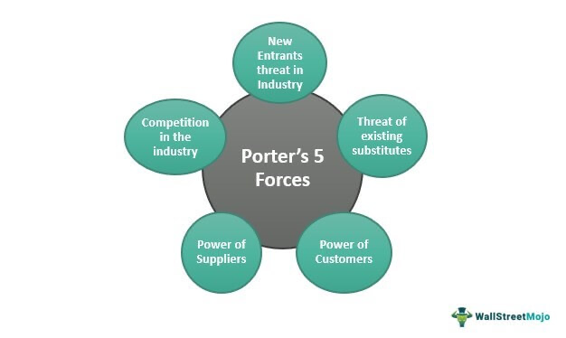

The Porter’s five forces definition suggests a paradigm for analysing the competitive forces at play in Happy Beds, which determines the distribution of economic value among industry participants. The purpose of Porter’s Five Forces model is to evaluate the competitive environment of a certain industry. (Vaidya, 2022)

1. Threat of new entrants:

Low entry barriers in the furniture sector raise the risk of new competitors. However, it might be difficult for new entrants to build a solid brand recognition, implement effective logistics operations, and maintain competitive costs. Happy Beds is in a good position to fend off new competitors because it is an established participant in the market with a strong internet presence and effective logistics practises.
2. Bargaining power of suppliers:

Furniture suppliers have a limited amount of bargaining power because there are so many of them. Suppliers of premium raw materials, like wood and textiles, do, nonetheless, have some negotiating power. By establishing long-term connections with suppliers and obtaining raw materials from a variety of sources, Happy Beds can reduce this risk.

3. Bargaining power of buyers:

Due to the abundance of alternatives and ease of switching brands, buyers have significant bargaining power in the furniture sector. Happy Beds may reduce this risk by selling premium goods at affordable costs, delivering top-notch customer support, and developing a solid brand name.

4. Threat of substitutes:

The threat of substitutes in the furniture sector is modest because there are alternatives like old furniture or hired furniture. Happy Beds may differentiate itself from rivals by offering distinctive designs, top-notch materials, and exceptional customer service.

5. Competitive rivalry:

There is fierce competition for market share in the furniture sector, where there are numerous well-established competitors. Despite competition from both online and offline businesses, Happy Beds has a competitive advantage thanks to its effective logistics operations, robust internet presence, and emphasis on customer service.

The furniture sector is generally relatively appealing and competitive, with minimal entry barriers and high buyer bargaining power. However, Happy Beds has a competitive edge in the industry thanks to its well-known brand, effective logistics, and emphasis on customer service. Happy Beds can keep its place in the market and expand its market share by continuing to differentiate itself through distinctive designs, premium materials, and top-notch customer service.

Strategic growth

Strategic option analysis with Ansoff Matrix model

The Ansoff Model is a matrix that helps marketing leaders identify business growth opportunities for their marketing strategies in a challenging market. (Hanlon, 2021)

The Ansoff Model, sometimes known as the Ansoff matrix due to its grid layout, aids marketers in seeing chances to increase sales for a company by creating new goods and services or "tapping into" new markets. As a result, it is sometimes referred to as the "Product-Market Matrix" rather than the "Ansoff Matrix."

Because of its emphasis on expansion, the Ansoff Model is one of the most popular marketing models. By comparing different combinations of new markets (i.e., customer segments and geographical regions) with products and services offered in four different ways, it is used to assess prospects for businesses to improve sales.

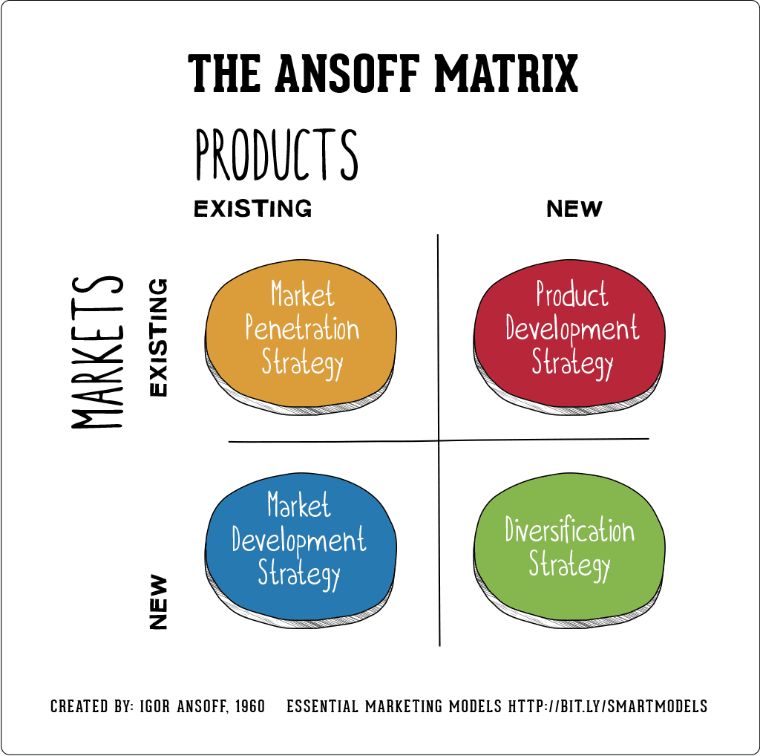

Here is an Ansoff Matrix-based strategic option study of Happy Beds:

1. Market Penetration:

Happy Beds' first strategy choice is to concentrate on market penetration by boosting its market share in its current market. This could be done by launching aggressive marketing initiatives, enhancing customer service, broadening the range of products, and lowering pricing.

2. Company Development

The company's second strategy choice is to concentrate on product development by launching fresh goods in its current market. This could be accomplished by introducing new accessory or furniture lines that enhance the company's current product offers. Happy Beds may use consumer input to enhance its current goods.

3. Market Development

The third strategy choice for Happy Beds is to concentrate on market expansion by bringing its current products into new markets. This could be done by creating physical stores in new markets or by extending its internet presence to other nations.

4. Diversification

Focusing on diversification by bringing new items to new markets is Happy Beds' fourth tactical choice. This could be done by widening its product line to include non-furniture items like mattresses, bedding, or lighting, or by entering allied businesses like home decor.

These tactical choices each have advantages and risks of their own. Market penetration and product development strategies, for instance, have smaller risks and lower investment requirements, but they could also have lower potential rewards. Strategies for market expansion and diversification carry a higher risk but may result in higher rewards.
Each choice could be assessed by Happy Beds for its viability, possible benefits, and compatibility with the goals and objectives of the business. Based on this study, Happy Beds may decide to pursue one or more strategic choices to meet its long-term objectives and maintain its position as a market leader.

SFA Framework

The SFA matrix is a framework that helps businesses evaluate strategic options. Gerry Johnson and Kevan Scholes created the SFA matrix to help businesses evaluate their strategic options before committing. Evaluation of strategic opportunities is performed by considering three criteria that make up the SFA acronym: suitability, feasibility, and acceptability.

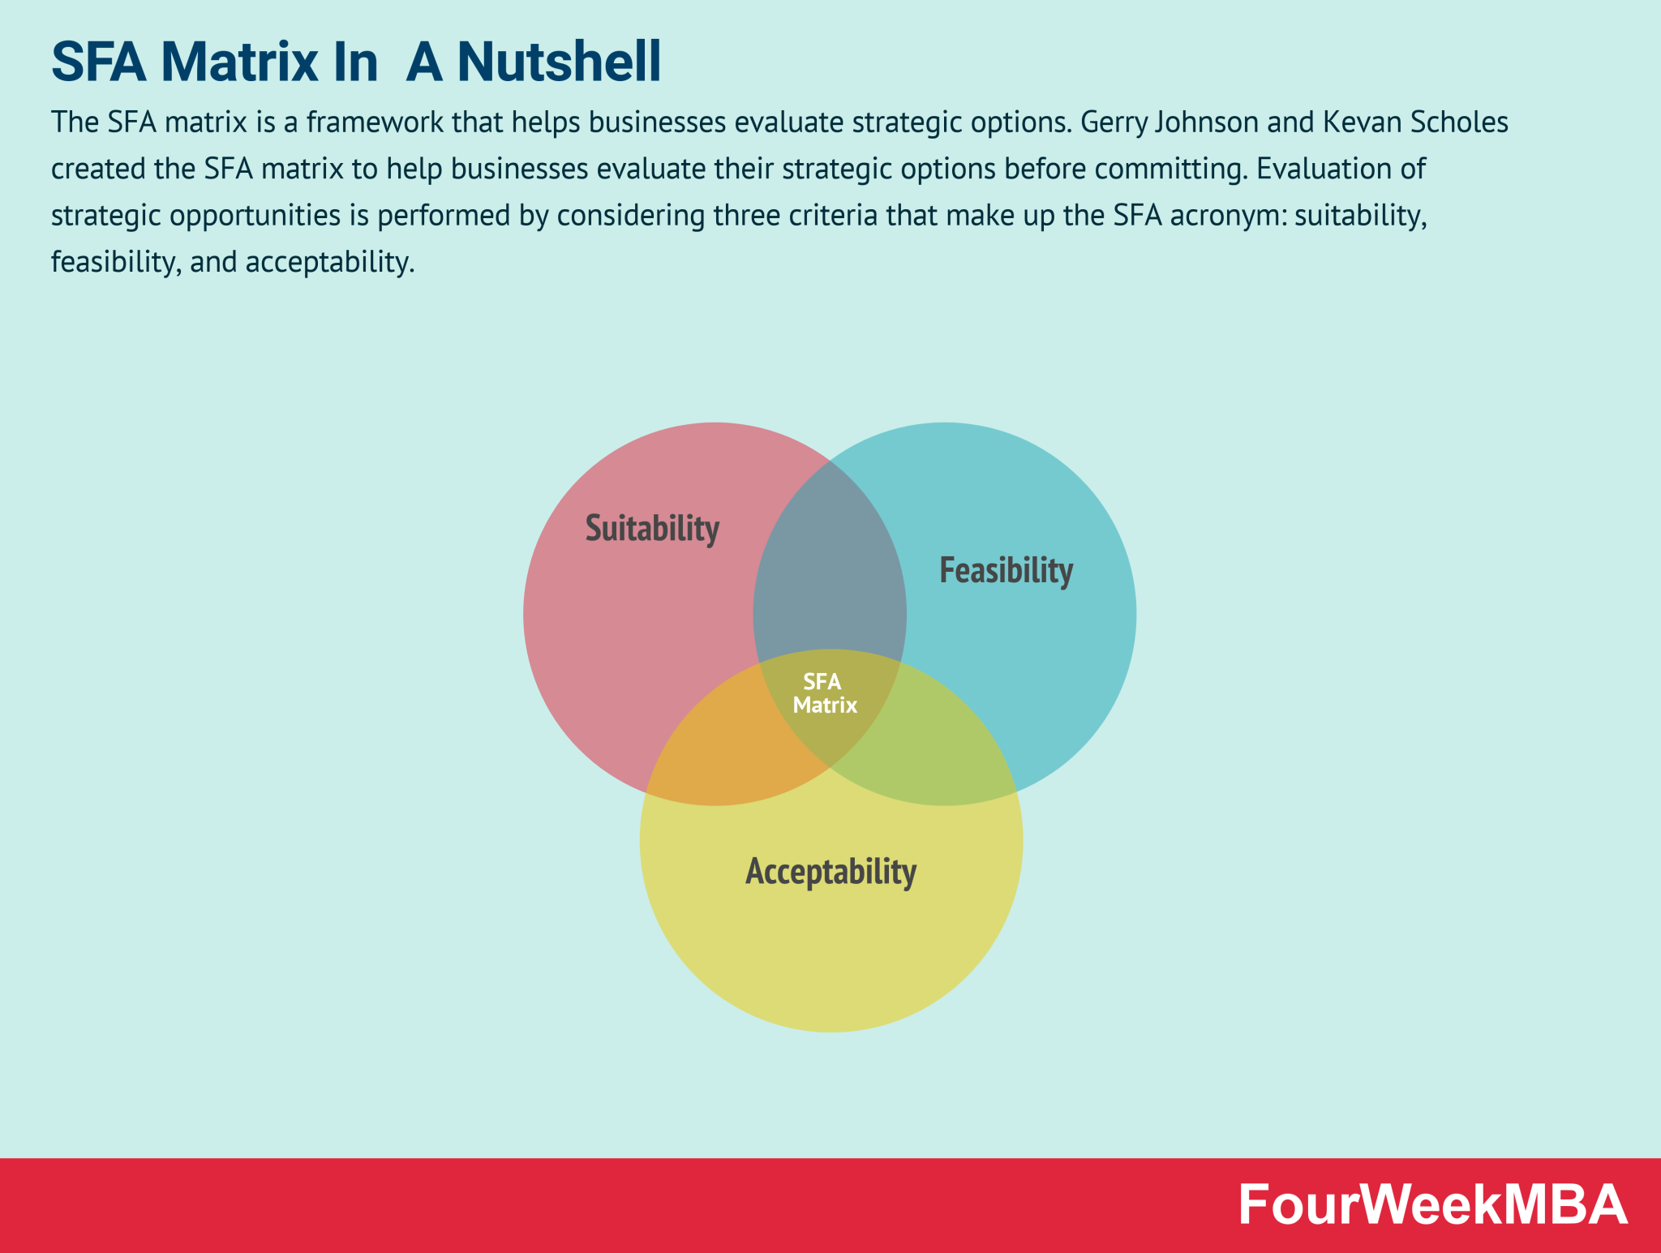

Happy Beds can examine a variety of options using the SFA matrix, after which they can choose a strategic solution. It was made by Kevan Scholes and Gerry Johnson.
The SFA matrix considers the three main factors for developing a strategy: appropriateness, feasibility, and acceptability. Of the three criteria, suitability may be the most difficult to accurately judge.
The SFA matrix determines weighted rankings for present factors that the company considers crucial. Although the elements can be changed depending on the business, scoring and element identification must be standardised.

Here is an example of how the SFA framework has been used to assess the appropriateness, viability, and acceptability of the potential strategic direction options for Happy Beds:

1. Market Penetration:
- Suitability: Market penetration is a good strategic course for Happy Beds since it makes use of the business's current advantages, such as its robust internet presence and effective shipping operations. It fits with the goals of Happy Beds, which are to become a premier online furniture retailer.

- Feasibility: Happy Beds may enter new markets because they spend in marketing initiatives, customer support, and expanding their product line. Happy Beds has already made investments to establish a solid brand name and has a following of devoted customers.

- Acceptability: Market penetration is acceptable because it carries little risk and has a fair chance of producing profits. Additionally, it is in line with the interests of all parties involved in Happy Beds, including shareholders, staff, and clients.

2. Product Development:

- Sustainability: The strategic direction of product development is appropriate for Happy Beds since it capitalizes on the organization's current strengths and resources, such as its design and manufacturing know-how. It is consistent with Happy Beds' vision and aim to offer consumers high-quality furnishings.

- Feasibility: Happy Beds can develop products because they engage in research and development and take advantage of customer input. Happy Beds already has a capable team working on product development and established facilities.

- Acceptability: Product development is acceptable since it carries a low level of risk and has a fair chance of paying off. Additionally, it is in line with the objectives of Happy Beds' constituents, including as shareholders, staff, and clients.

3. Market Development:

- Sustainability: Market expansion is a wise strategic choice for Happy Beds since it makes use of the business's current advantages, such as its strong internet presence and effective logistics operations. It fits with the goals of Happy Beds, which are to become a premier online furniture retailer.

- Feasibility: Market expansion is doable for Happy Beds since it can be accomplished by spending money on advertising campaigns, customer support, and logistics. Happy Beds has a strong web presence in the UK market and has handled foreign shipments before.

- Acceptability: Market expansion is appropriate because it has a low risk and strong potential for returns. Additionally, it is in line with the objectives of Happy Beds' constituents, including as shareholders, staff, and clients.

4. Diversification:

- Sustainability: The strategy path of diversification is appropriate for Happy Beds since it makes use of the firm's current resources and competencies, such as its design and production knowledge. It is consistent with Happy Beds' vision and aim to offer consumers high-quality furnishings.

- Feasibility: For Happy Beds, diversification is doable since it can be accomplished by investing in research & development and taking advantage of current supplier ties. Happy Beds has prior experience diversifying its raw material sources and growing product ranges.

- Acceptability: Diversification is appropriate because it carries a higher risk but has a higher potential reward. Additionally, it is in line with the objectives of Happy Beds' constituents, including as shareholders, staff, and clients.

According to the SFA framework analysis, there are various degrees of suitability, viability, and acceptability for each of the four strategic directions. Based on a more thorough analysis of the benefits and drawbacks of each option, Happy Beds might decide to pursue one or more of these strategic options.

Stakeholder Analysis

For my Stakeholder Analysis I will apply Mandelow’s Stakeholder Matrix.

For this businesses and/or projects to have a strong chance of success, stakeholders must be identified and managed, but how can we make sure we make the most of our limited time and financial resources? Mendelow's Matrix can help us live simpler, more focused lives in this regard. According to Mendelow (1991), we should examine our stakeholder groups based on their Power (the capacity to shape our organization's strategy or project resources) and Interest (the degree to which they care about the organization's or project's success). Remember that while it may appear that all stakeholders have a lot of power or, as we would like, a lot of interest, relative to other stakeholders, some will possess more power, and some will have greater interest. For instance, a director is likely to have strong Power and high Interest in the organisation, whereas the government and a major competitor both have significant Power to influence strategy through legislation.

Based on Power and Interest, I can determine which stakeholders are of the utmost importance. Those with High Power and High Interest require attentive management, requiring a significant investment of time and resources. For instance, a technical outside agency or my supervisor is likely to have the ability to influence my work and a keen interest in its success. A top responsibility is to keep these stakeholders informed almost every day and on the team. The local community or the media are examples of stakeholders with minimal power and interest that should be monitored with the least amount of time and money spent.

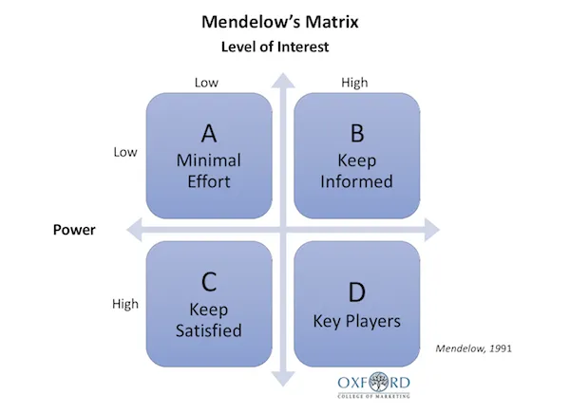
Here is an example of how Mandelow's Stakeholder Matrix might be used to evaluate the acceptability of potential strategic direction choices for Happy Beds:

1. Market Penetration:

High Power/High Interest: Customers and Staff
The success and expansion of Happy Beds are likely to be of great interest to both its current clients and staff. Through word-of-mouth advertising and the calibre of their job, they can affect the company's reputation.
Strategy: Happy Beds should place a high priority on catering to the requirements and preferences of its current clientele while also making sure that staff members feel valued and supported throughout the expansion process.

High Power/Low Interest: Government and vendors
Although the government and Happy Beds' suppliers may have the ability to influence the company's operations, they might not be as interested in the expansion plan itself.
Strategy: Happy Beds needs to keep good ties with its suppliers and make sure that it complies with all applicable rules and legislation.

Low Power/High Interest: NGOs and industry associations
Due to their emphasis on sustainability and moral business conduct, industry associations and NGOs would be particularly interested in Happy Beds' expansion plans.
Strategy: To make sure that its expansion strategy adheres to their beliefs and expectations, Happy Beds should consult with pertinent industry organisations and NGOs.

Low Power/Low Interest: Shareholders and the Media
Although they may have less direct influence on Happy Beds' expansion strategy, shareholders and the media can nevertheless affect public opinion and investor confidence.
Strategy: To guarantee that its shareholders and the media are aware of and supportive of the company's expansion goal, Happy Beds should maintain openness and open lines of contact with both groups.

2. Product Development:

High Power/High Interest: Customers and Employees
The success and expansion of Happy Beds are likely to be of great interest to both its current clients and staff. Through word-of-mouth advertising and the calibre of their job, they can affect the company's reputation.
Strategy: The demands and preferences of Happy Beds' current clientele should come first, and the company should make sure that its staff participates in the product development process.

High Power/Low Interest: Suppliers and the Government
Happy Beds should put its existing client base's requirements and preferences first. Happy Beds' suppliers and the government may have the ability to influence the firm's operations, but they might not be as interested in the specifics of the strategy the company uses to produce its products. Make sure that workers are involved in the creation of the product.
Strategy: Happy Beds should keep good ties with its suppliers and make sure it complies with all applicable rules and legislation.

Low Power/High Interest: NGOs & Industry Associations
Due to their emphasis on sustainability and moral corporate conduct, industry associations and NGOs would be particularly interested in Happy Beds' product development strategy.
Strategy: To make sure that its product development plan adheres to their beliefs and expectations, Happy Beds should consult with pertinent industry organizations and NGOs.

Low Power/Low Interest: Shareholders & Media
Although they may have less direct effect on Happy Beds' product development plan, shareholders and the media can nevertheless have an impact on public opinion and investor confidence.
Strategy: Happy Beds should keep its stockholders and the media informed about its product development plans and maintain open lines of communication with them.

3. Market Development

High Power/High Interest: Employees and Customers
The success and expansion of Happy Beds are likely to be of great interest to both its current clients and staff. Through word-of-mouth advertising and the calibre of their job, they can affect the company's reputation.
Strategy: The demands and tastes of Happy Beds' current clientele should come first, and the company should make sure that its staff members feel valued and supported as it expands.

High Power/Low Interest: Suppliers & Government
Although the government and Happy Beds' suppliers may have the ability to influence the company's operations, they might not be as interested in the expansion plan itself.
Strategy: Happy Beds should keep good ties with its suppliers and make sure it complies with all applicable rules and legislation.

Low Power/High Interest: Industry Associations and NGOs
They are strongly interested in the company's actions and may have influence through their relationships to other stakeholders or the public, despite their limited capacity to directly affect the company's decisions.
Strategy: Overall, Happy Beds can cultivate positive relationships and improve their reputation in the business and general community by interacting with Low Power/High Interest stakeholders including industry groups and NGOs. This can also assist in minimising any potential negative effects of the selected strategic option and ensuring key stakeholders' support for it.

Conclusions & Recommendations

Conclusion

According to the analysis done, Happy Beds is a business that operates in a very competitive sector with lots of room for development. The business has a solid internal structure and substantial assets, especially in terms of its experienced employees and effective supply chain management.

It was feasible to pinpoint a variety of strategic choices for Happy Beds, including market penetration, product development, market development, and diversification, using multiple strategic analysis frameworks, including SWOT, PESTEL, Porter's Five Forces, and Ansoff Matrix.

The SFA framework was used to decide that market development through increased online visibility and forays into new geographical markets would be the most appropriate and practical option for Happy Beds. Additionally, this choice is supported by important parties, such as clients, employees, and investors.

As a result, Happy Beds has a strong basis for growth and expansion. By pursuing the chosen strategic alternative, the business may improve its market share and profitability while also boosting its reputation and brand image. To ensure ongoing success and growth in the future, Happy Beds must continue to monitor and respond to changes in the market and the industry.

Recommendations

According to the analysis done, market development through increased online visibility and forays into new geographical markets is the suggested strategic approach for Happy Beds.
The internal analysis, which highlighted Happy Beds' strong digital capabilities and effective supply chain management, and the external analysis, which highlighted the rising trend towards online shopping and the growth potential in new geographic markets, both support this strategic choice.
Happy Beds will need to make investments in digital marketing and advertising, as well as form alliances with regional suppliers and logistical service providers in the new geographic areas, to successfully implement this strategy option. To accommodate the preferences and wants of clients in these new areas, the business might also need to modify its product offers and pricing policies.
Happy Beds may improve its market share, profitability, brand reputation, and customer loyalty by pursuing this strategy course. To stay competitive and responsive to shifting market conditions, the corporation must continually monitor and modify its strategies.

The suggested strategic direction of market development by growing Happy Beds' online presence and entering new geographical areas can assist the business in several ways and be very helpful:

- Increased Market Share: Happy Beds can improve its client base and revenues, which can result in a rise in market share, by extending its online presence and entering new geographic regions.

- Diversification of Revenue sources: Happy Beds can diversify its revenue sources and lessen its dependency on a single market or product line by growing its product offerings and entering new geographic areas.

- Better Brand Image and Reputation: Happy Beds may improve its brand image and reputation by expanding into new geographies because doing so shows the company's dedication to development and innovation.

- Enhanced Competitive Advantage: Happy Beds can outperform its competitors in new areas by utilizing its effective supply chain management and current digital capabilities.

- Long-Term Sustainability: Happy Beds may achieve long-term sustainability by using new growth prospects and boosting its adaptability to market changes with the proposed strategic orientation.

Overall, Happy Beds may achieve sustained growth, diversify its revenue sources, and strengthen its competitive advantage in the fiercely competitive bedding and furniture sector with the proposed strategic direction.
References

happybeds.co.uk. (n.d.). Happy Beds | Quality Beds & Mattresses at Affordable Prices. [online] Available at: https://www.happybeds.co.uk/

Managingresearchlibrary.org. (2013). VRIN Framework. [online] Available at: https://managingresearchlibrary.org/glossary/vrin-framework.

Cuofano, G. (2020). What is Porter’s Value Chain Model and Why It Matters in Business. [online] FourWeekMBA. Available at: https://fourweekmba.com/porters-value-chain-model/.

Oxford College of Marketing (2016). What is a PESTEL analysis? [online] Oxford College of Marketing Blog. Available at: https://blog.oxfordcollegeofmarketing.com/2016/06/30/pestel-analysis/.

Vaidya, D. (2022). Porter’s Five Forces. [online] WallStreetMojo. Available at: https://www.wallstreetmojo.com/porters-five-forces/.

Hanlon, A. (2021). The Ansoff Model. [online] Smart Insights. Available at: https://www.smartinsights.com/marketing-planning/create-a-marketing-plan/ansoff-model/.

Cuofano, G. (2021). What is The SFA matrix? SFA Matrix In a Nutshell. [online] FourWeekMBA. Available at: https://fourweekmba.com/sfa-matrix/.

Eriksen-Coats, F. (2018). What Is Mendelow’s Matrix and Why Is It Useful for Marketers? [online] Oxford College of Marketing. Available at: https://blog.oxfordcollegeofmarketing.com/2018/04/23/what-is-mendelows-matrix-and-how-is-it-useful/.

Lynch, R.L. (2018). Strategic management. Harlow, England: Pearson.

Barney, J.B. and Hesterly, W.S. (2019). Strategic management and competitive advantage: concepts and cases. Harlow, England: Pearson.

Ndubisi, N.O. and Nwankwo, S. (). Enterprise development in SMEs and entrepreneurial firms : dynamic processes. Hershey, Pa.: IGI Global (701 E. Chocolate Avenue, Hershey, Pennsylvania, 17033, USA).

