Student ID Myumyun Ferad 2025893
Lecturer: Nauman Ali
Moodle : BMSW4006

Assignment name: Task 1:
Based on week 5 entrepreneurial activities organized in this module, using theory/ies you have learnt on other modules (e.g., Gibbs reflective cycle), reflect, and produce 500 words report explaining 2 – 3 important things you have learnt about setting up a successful business and how you intend you use this knowledge in the near future.

Contents
Introduction 3
Main body 3
Conclusion 4
Reference list 6

Introduction

Setting the successful business is of critical importance from the step on registration of the business and then is becoming the importance of the management and results from the activity. Starting new company is very responsible activity and this is the reason why there is need of proper plan, strategy and research in advance even before the actual start of the company.

Main body

Looking over the figure one with the Gibbs reflective learning cycle we can see what are the elements of the cycle:
- Description what happened
- What are you feeling and thinking
- Evaluation good and bad experience
- Analysis what sence can be made from the situation
- Conclusion what else can be done
- Action plan about what can be done differently if this situation happen again

Figure 1

Gibbs reflective Learning Cycle

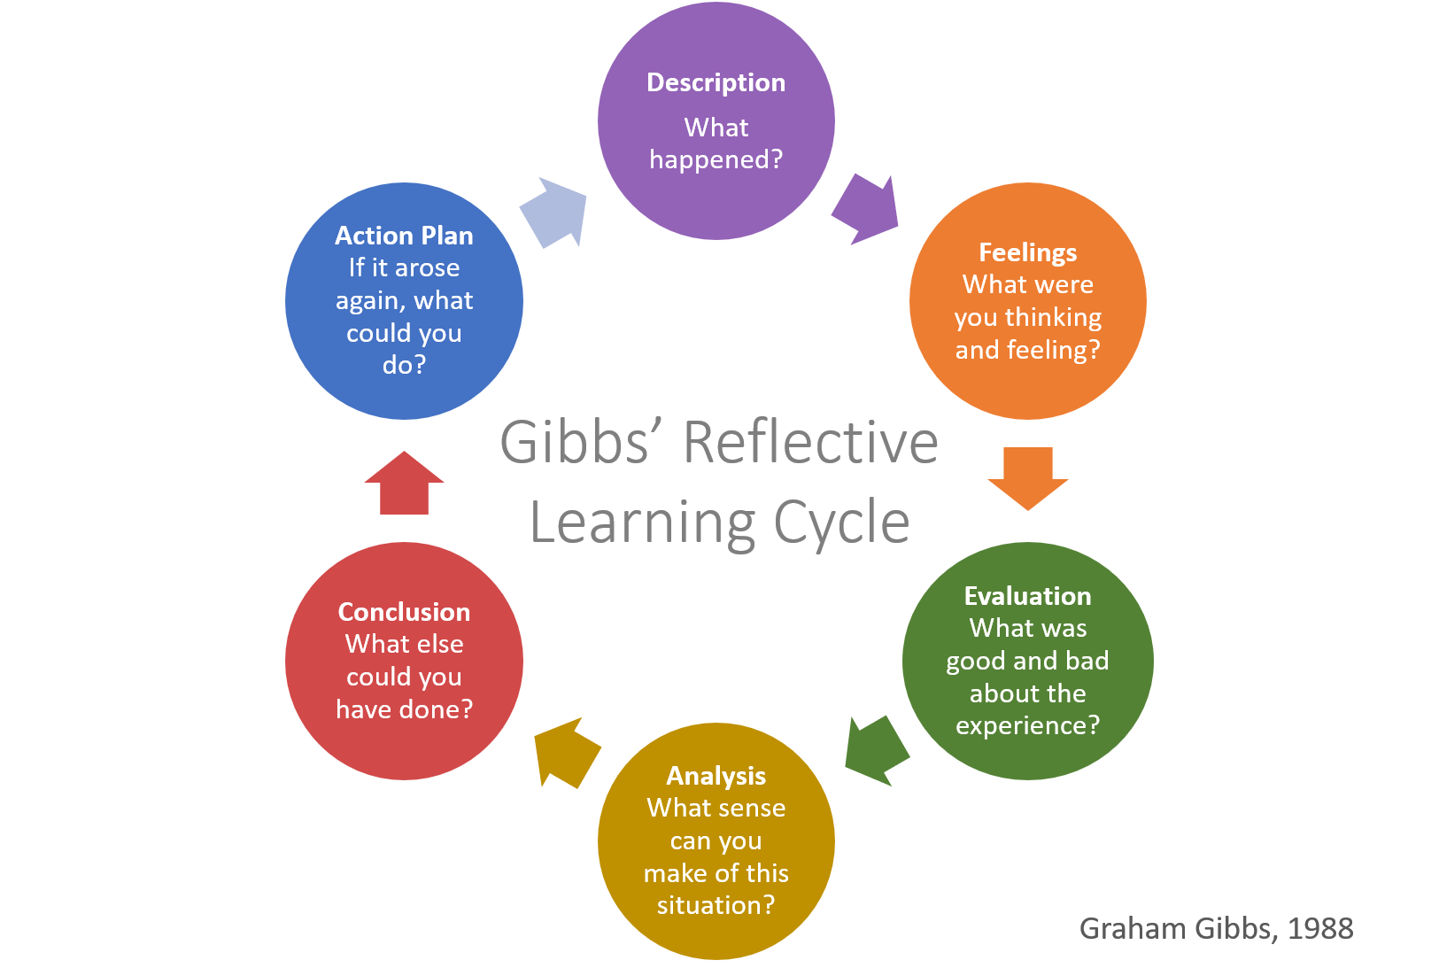

(Syafryadin,2020).

Vision of the company

Vision of the company is very important for the future success as this vision will reflect to the company brand name, client loyalty and many other positive impacts when the vision is clear and focused over the customer interest and demand (Syafryadin,2020).

Passion
Passion and consistent motivation and focus is other important element of the success. Motivation is key element for the success as the motivation leading to consistency and this lead to results which are main importance for the success (Elsden,2021).

Customer demands

Analyses and the research in advance for the customer demands is of critical main importance for the company success and profitability. Every successful company setup and operations are based over the clients demands and that the company providing solutions or products for this demand (Riandi,2019).

Business plan

Other very important point is the detailed and strict business plan for also setting the budgets, targets and goals from the company activities for specific periods of time.
Business plan is one of the critical points for the company success, because without proper plan there are limited possible results for the company. Despite the company can use many different points if there is no proper business plan this means that the company is at risk of fail and delivering damages for the investiture (Hashim,2021).

Conclusion

Understanding the details and factors which can influence the business performance and results can deliver important details and tools for better results and profit from the new companies and even the already operating ones. Being aware of the company key points which can improve the company performance is important for the future sustainability and profit for the company.

Reference list

Abidin, R., Osman, N.H. and Hashim, R., 2021, July. Critical Success Factors in Business Operation and Its Impact on Productivity Growth. In Business Innovation and Engineering Conference 2020 (BIEC 2020) (pp. 36-40). Atlantis Press.
Adeani, I.S., Febriani, R.B. and Syafryadin, S., 2020. USING GIBBS’REFLECTIVE CYCLE IN MAKING REFLECTIONS OF LITERARY ANALYSIS. Indonesian EFL Journal, 6(2), pp.139-148.
Elsden, J., 2021. Using reflective practice for personal development planning. Dental Nursing, 18(2), pp.76-78.
Sekarwinahyu, M., Rustaman, N.Y., Widodo, A. and Riandi, R., 2019, February. Development of problem based learning for online tutorial program in plant development using Gibbs’ reflective cycle and e-portfolio to enhance reflective thinking skills. In Journal of Physics: Conference Series (Vol. 1157, No. 2, p. 022099). IOP Publishing.
Yaacob, A. and Asraf, M., 2021. Empowering Learners' Reflective Thinking through Collaborative Reflective Learning. International Journal of Instruction, 14(1), pp.709-726.

