
Student’s Name: Md Faisal Miah
Student ID: 2430612
Module Name: Marketing Management
Module Code: LCMB7024
Lecturer's Name: Dr Laila Maazouz (London)
Term 1

Table of Contents
Element 1: STDP Analysis for IKEA FlexiSleep Pro 4
1. Introduction to IKEA 4
2. New Brand Concept: IKEA FlexiSleep Pro 4
3. Market Relevance and Emerging Consumer Trends 5
4. Segmentation Analysis 5
5. Target Audience Justification 6
6. Differentiation Strategy 6
7. Positioning Strategy 7
8. Conclusion 7
Element 2: Marketing Mix Strategy (7Ps) for IKEA FlexiSleep Pro 8
1. Introduction 8
2. Product Strategy 8
3. Pricing Strategy 9
4. Place (Distribution) Strategy 9
5. Promotion Strategy 10
6. People 11
7. Process 11
8. Physical Evidence 11
9. Conclusion 11
Element 4: Reflection 13
1. Introduction to Reflective Learning 13
2. Reflection on Developing the New Brand Concept 13
3. Reflection on Creating the STDP and 7Ps Strategy 13
4. Reflection on Designing and Pitching the Poster 14
5. Future Development and Skill Enhancement 14
References 15
Appendix 17
Element 3: Marketing Strategy Pitch 17

Element 1: STDP Analysis for IKEA FlexiSleep Pro

1. Introduction to IKEA
IKEA is an internationally renowned retail home furnishing company with affordable, modular, functional products that help to improve everyday life.

Figure 1: IKEA Logo
Source: (Rjoub et al., 2022)
With the concepts of smart living, sustainability and customer-centric design, the company has been able to facilitate innovation throughout its years (Rjoub et al., 2022). In order to reinforce its competitive stance in the sleep and smart furniture segment, IKEA presents FlexiSleep Pro, a brand extension that can accommodate evolving consumer lifestyles, especially in large urban settings.

2. New Brand Concept: IKEA FlexiSleep Pro
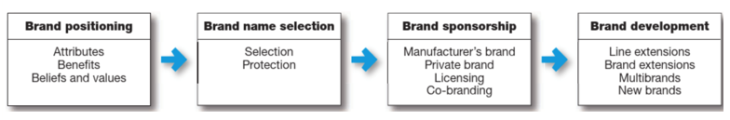
Figure 2: Steps of building strong brands; Source: (Kotler et al., 2020)
FlexiSleep Pro is a new generation smart modular mattress system, which combines comfort, flexibility and digital upgrades. The product provides five mattress types and memory foam with 35 percent pressure relief, compared to traditional mattresses, and allows users to customise firmness options through a dedicated mobile application (Hague, 2019). Embedded technology features an AI-powered sleeping device, inbuilt USB charging stations, integrated energy-efficient cooling, and 10 storage units, which facilitate the small apartment lifestyle (Burt et al., 2021). The business model is not limited to the product itself, but provides a subscription service of 9.99/month to perform maintenance, update AI, and access to new features of sleep modes.

3. Market Relevance and Emerging Consumer Trends
Sleep-enhancing technology demand remains high because consumers are becoming more concerned about the relationship between sleep quality and wellbeing (Ozturkcan, 2021). The use of smart homes by younger age groups further drives the increased curiosity towards smart furniture, with increasing urbanisation leading to the smaller size of homes necessitating multi-purpose designs (Peng, 2022). FlexiSleep Pro is directly targeted at these needs because it combines comfort engineering with digital convenience and space-saving flexibility.

4. Segmentation Analysis
Segmentation is the process of grouping consumers in terms of similar attributes in order to be able to deliver value to them in a focused manner (Parris and Guzmán, 2023). Continuing with FlexiSleep Pro, IKEA uses multi-variable segmentation, which is depicted in Table 1.
Segmentation Type | Characteristics | Market Appeal
Geographic | UK urban areas such as London & Manchester | High-density living and strong digital adoption
Demographic | Ages 24–40; young families; professionals | Willingness to invest in comfort and technology
Psychographic | Tech-savvy, health-focused, convenience seekers | Interest in smart sleep and modular living
Behavioural | Desire for improved sleep quality and multifunctionality | Openness to subscription-based comfort upgrades
Socio-economic | Middle to upper-middle income | Suitable for premium yet accessible pricing
Table 1: Segmentation Variables for FlexiSleep Pro
Source: Self-created
The segmentation is consistent with the main idea of IKEA, which is to design for the many people, but the range is expanded to reach consumers who are becoming more and more preoccupied with efficiency, personal comfort and digital lifestyle solutions.

5. Target Audience Justification
Targeting entails choosing segments that have the highest chances of responding optimistically to the offering (Almaazmi, 2017). The differentiated targeting strategy uses two high-growth segments in the UK metropolitan markets that FlexiSleep Pro focuses on.
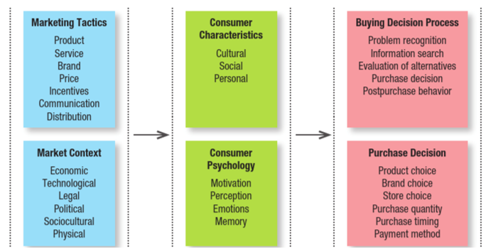
Figure 3: Customer buying behaviour model; Source: (Kotler et al., 2022).

Target Group | Lifestyle & Needs | FlexiSleep Pro Value Proposition
Young Professionals | Rent apartments, frequently relocate, and depend on digital devices | Modular structure and USB ports suit mobility and convenience
Small Urban Families | Limited living space, but prioritise wellbeing | Storage compartments and AI-based sleep support benefit shared living
Table 2: Target Customer Profile
Source: Self-created
Repeat engagement and brand loyalty in the long run are strengthened through the subscription model (Zulfikar, 2022). In focusing on the issues of comfort, integration of technology, space efficiency, IKEA is able to be very extensively relevant concerning the needs of diverse lifestyles without going astray.

6. Differentiation Strategy
Differentiation is the quality that contributes to a brand being valuable than the competitors (Putri et al., 2021). Table 3 indicates how exactly FlexiSleep Pro has distinguished itself within the sleep-tech market.
Element of Differentiation | Competitive Benefit | Supported Poster Evidence
AI-powered sleep tracking | Improves sleep using personalised data | Featured AI sleep tracker with adaptive algorithms
Adjustable firmness via app | Tailored comfort for every body type | Smart firmness based on sleep patterns
Modular storage design | Space-saving for compact homes | Ten integrated storage compartments
Subscription service | Continuous improvement of the sleep experience | Monthly upgrades and maintenance services
Energy-efficient cooling | Eco-friendly and enhances sleep | Reduces energy consumption by 15%
Table 3: Differentiation of FlexiSleep Pro
Source: Self-created
All these attributes create technological superiority, health performance, and space optimisation, which sets IKEA apart from other traditional mattress brands (Grewal and Levy, 2021).
The multifunction design and smart-home compatibility respond to the customer pain points of unhealthy sleeping habits and interior space limitations.

7. Positioning Strategy
Positioning is the way the brand would be remembered in the minds of consumers compared to the alternatives (Kotler et al., 2022). As a positioning statement, FlexiSleep Pro is:
"The go-to sleep solution in the modern compact living.
It supports the theme of comfort, adaptivity, and digital well-being and retains an affordable strategy aligned with the IKEA brand identity.

8. Conclusion
The STDP framework offers a unified strategic platform to launch IKEA FlexiSleep Pro in the UK. The brand is in line with the modern consumer behaviour influenced by health awareness, urbanisation and the development of smart homes. FlexiSleep Pro enhances the shift towards the use of technology in home living processes and competitive expansion in the marketplace of sleep innovations by IKEA through clearly specified segmentation, targeting, plausible differentiation, and formidable positioning.

Element 2: Marketing Mix Strategy (7Ps) for IKEA FlexiSleep Pro
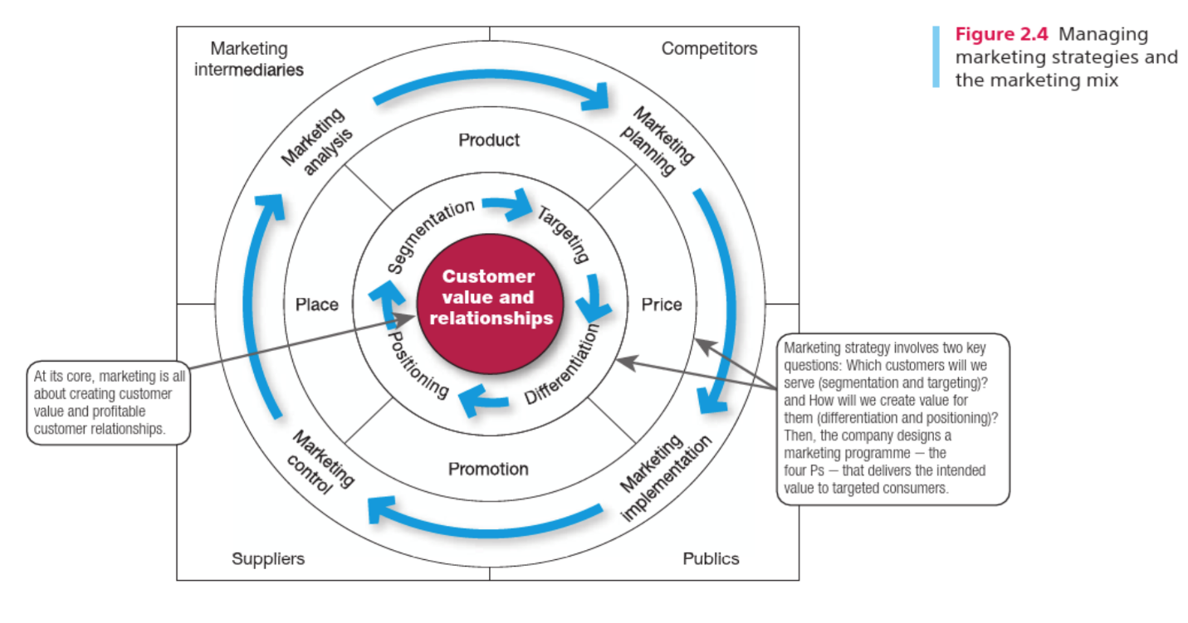
Figure 4: Marketing Mix Strategy; Source: (Kotler et al., 2020)

1. Introduction
The marketing mix is a combination of tactical instruments that organisations can control to meet customer requirements and strengthen positioning within the market (Rachmad, 2024). The 7Ps marketing mix model is the most appropriate strategic model since the IKEA FlexiSleep Pro can be approached as both a tangible product and a technology-enhanced subscription service (Hague, 2019). This guarantees that product innovation, distribution access, pricing decisions, and communication strategy are well incorporated, and service-related elements will be incorporated to help the IKEA brand expand into sleep technology (Xu et al., 2022). The following marketing mix illustrates how FlexiSleep Pro will manage to appeal to the modern market effectively and help IKEA to fulfil its mission of providing affordable and efficient wellbeing solutions.

2. Product Strategy
The marketing mix comprises a product with its physical attributes, design, branding, and service augmentations that create customer value. FlexiSleep Pro is engineered to enhance the sleep experience due to smart connectivity, modularity, and wellness design (Červený et al., 2022). The mattress also contains memory foam that provides 35 percent better pressure relief, inbuilt AI sleep monitoring, adjustable firmness through mobile application, storage space, USB charging ports and energy energy-efficient cooling system to meet the needs of urban living (Xiong et al., 2023).
Product Level | Features | Customer Value Delivered
Core Product | Physical mattress and comfort | Better sleep and body support
Actual Product | AI tech, USB ports, storage modularity | Personalisation + small-space optimisation
Augmented Product | Subscription service, updates, maintenance | Ongoing improvement and loyalty creation
Table 1: Core Product and Augmented Product Benefits
Source: Self-created
FlexiSleep Pro design and brand suggest flexibility, technology and high-standard comfort, which correlates with the principles of Scandinavian design applied by IKEA, and strengthens its reputation in the smart home market.

3. Pricing Strategy
Pricing is one of the fundamental forces in customer perception and profitability. FlexiSleep Pro uses a value-based approach pricing model and balances between its high technological benefits and the IKEA affordability promise (Liao and Song, 2021). A queen setup is being retailed at 899 items, with a favourable addition of an optional monthly subscription of 9.99, which an all-inclusive AI upgrades and mattress maintenance.
Price Component | Strategy Type | Customer Perception Outcome
Mattress purchase price | Mid-premium pricing | Higher value for performance + innovation
Subscription plan | Freemium tier with paid enhancements | Lower entry barrier, long-term engagement
Financing & offers | Interest-free instalment plans | Attractive to young renters & first-time buyers
Table 5: Pricing Value Proposition for FlexiSleep Pro
Source: Self-created
This combined pricing has made it more accessible and generates recurrent revenue and promotes continued relationships and ecosystem use, as opposed to the traditional one-time purchases of mattresses.

4. Place (Distribution) Strategy
Place involves the manner in which a brand makes products available in places that are convenient to the customers. IKEA already has a network of stores distributed through the multichannel, as well as physical showrooms and a well-developed e-commerce. FlexiSleep Pro will be distributed on the IKEA site, mobile app, and in a few retail stores in the UK (Dobrowolska and Niedbała, 2023). Interactive digital displays and AR visualisation will help customers preview the mattress, which improves the decision-making of urban consumers who cannot test the products as much in-store.
Channel | Purpose | Benefit to Brand Strategy
IKEA physical stores | Testing and experiential trial | Reinforces comfort and modularity claims
Online + mobile app | Easy purchase and subscription activation | Aligns with tech-oriented targeting
Home delivery & installation | Professional setup for modular components | Enhances convenience and satisfaction
Table 6: Distribution Strategy for FlexiSleep Pro
Source: Self-created
Digital distribution facilitates the achievement of the strategic goal of becoming a smart lifestyle retailing leader of IKEA.

5. Promotion Strategy
Promotion involves communication processes employed to create awareness and drive demand. IKEA will introduce FlexiSleep Pro with the help of the digital-only campaign that is called Sleep Smarter, Live Better, and it will achieve the aim of the poster of 12 million impressions during the first quarter (Grewal and Levy, 2021).

Promotional Method | Implementation | Communication Focus
Social media campaigns | Instagram, TikTok, YouTube | Wellness and lifestyle storytelling
In-store demonstrations | Smart room setups | Comfort, performance and adjustability
Influencer partnerships | Collaboration with tech and health creators | Reviews to build trust and authenticity (Hooley, 2020)
IKEA Family loyalty program | Exclusive offers and early access | Customer retention and subscription conversion
Table 7: Promotional Strategy Overview
Source: Self-created
This is an effective way to reach digital-native audiences and strengthen the modern and innovative IKEA brand.

6. People
Individuals in the marketing mix reflect on employees and staff engaged in providing customer interaction and satisfaction (Mahalakshmi et al., 2024). IKEA employees will be provided with expert training to clarify AI functionality, installation procedures, and the features of subscription services so that customers can comprehend the advantages of the products to the full extent (Hooley, 2020). Moreover, there will be customer service specialists and sleep advisors who will be available through the IKEA app and provide their own recommendations and technical assistance. This increases the usability and credibility of the smart mattress system.

7. Process
Process is concerned with the working procedures that would make the delivery of products consistent and efficient. In the case of FlexiSleep Pro, the customer experience involves the ability to design the product online, choose the option of professional delivery, and subscribe in a single click (D’Itria et al., 2024). Service level makes sure that sleep modes and energy performance are constantly updated. The returns and warranty procedures are fitted with the existing after-sales procedures at IKEA, which guarantee reliability and consumer confidence and encourage long-term adoption of the services offered.

8. Physical Evidence
Physical evidence is an assurance of customer trust in an offering in a physical form. The presence of the FlexiSleep Pro in the showroom design, with the actual bedroom setting, as well as the high-quality product images, increases the credibility of comfort and innovation statements. The smartphone application interface offers a digital interface and shows sleep analytics and smart features (Emam, 2022). The sustainability labelling and packaging have a positive impact on the communication of the environmental commitment of IKEA, which facilitates the premium positioning and maintenance of brand authenticity.

9. Conclusion
The 7Ps marketing mix application indicates that the UK launch of IKEA FlexiSleep Pro has a great strategic basis. The value-based pricing and digitally oriented promotion are complemented by the modular technology of the product that allows an easy entrance into the market in accordance with the changing consumer lifestyle. Backed by quality personnel, simplified operations and believable physical evidence, the strategy serves well in supporting IKEA's motif of being a leader in smart and space-efficient sleeping solutions to urban living.

Element 4: Reflection

1. Introduction to Reflective Learning
The creation of a new brand idea and the development of a complete marketing plan for IKEA FlexiSleep Pro has become a good learning experience that helped to master my analytical and creative marketing skills. Making this reflection is necessary as it enables me to see what skills I managed to gain, what difficulties I have faced, and how I can still advance my future academic and professional activities in marketing.

2. Reflection on Developing the New Brand Concept
In the development of FlexiSleep Pro, I realised that I needed to base creativity on customer needs and market realities. My initial concepts were generic, but research helped me to single out a tangible consumer problem: the necessity to sleep better and have more space in the urban areas of living. This assisted me in coming up with a product that combines comfort technology and mods. I also got to know how important it is always to stick with the identity of a brand (Strömstedt and Vaagenes Rehmberg, 2021). Connecting the product with the IKEA values of affordability and functional design took a number of revisions. A difficulty was whether to choose the smart features that were realistic and related to the market. Coming out of this enabled me to develop confidence in balancing innovation and practicality. Altogether, I gained better competencies in identifying the problems, creating value, and thinking strategically about the brand.

3. Reflection on Creating the STDP and 7Ps Strategy
The creation of the STDP analysis also helped me to learn that segmentation and targeting decisions should not be made based on assumptions, but based on observable, real consumer behaviours and trends. I realised how various segments have the ability to affect the product message, distribution, and pricing strategy. The drafting of the 7Ps marketing mix at the time assisted me in fitting in these decisions to the overall strategy that facilitates brand positioning (Burt et al., 2021). Enhancing the connection between theory and strategy increased what I knew about the ways in which marketers establish competitive advantage. Nonetheless, I have realised that I have to improve my skills in utilising more evidence-based insights, including competitor price points or customer profiles, to support decisions more substantially. This reflection has motivated me to enhance my analytical ability with market evidence in future projects.

4. Reflection on Designing and Pitching the Poster
The poster and pitch preparation allowed me to acquire key visual communication and marketing storytelling skills. It challenged me to strip down complicated concepts and present them in a straightforward manner using entertaining illustrations and succinctly. I was also able to learn time management skills, especially in giving priority to important information. Although in my opinion I used a clear narrative, I understand that I can enhance my confidence in verbal presentation with more practice and peer review.

5. Future Development and Skill Enhancement
In the future, I would like to utilise more audience research and digital marketing tools on a larger scale to aid in more persuasive strategy creation. Moreover, practising my presentation delivery by rehearsing will allow me to be more confident in speaking within the workplace. The project has had a beneficial effect on my professional development as a prospective marketing expert, and I will use these lessons in the future.

References
Almaazmi, S.M.M.K. (2017) Effects of disruptive innovation on industry-level: “IKEA-Store” case study. Master’s thesis. The British University in Dubai.
Burt, S., Dawson, J., Johansson, U. and Hultman, J. (2021) ‘The changing marketing orientation within the business model of an international retailer – IKEA in China over 10 years’, The International Review of Retail, Distribution and Consumer Research, 31(2), pp. 229–255.
Červený, L., Sloup, R., Červená, T., Riedl, M. and Palátová, P. (2022) ‘Industry 4.0 as an opportunity and challenge for the furniture industry—A case study’, Sustainability, 14(20), p. 13325.
Dobrowolska, E. and Niedbała, M. (2023) ‘The impact of furniture marketing strategies on young consumers’, Annals of Warsaw University of Life Sciences-SGGW. Forestry and Wood Technology, (121), pp. 142–153.
D’Itria, E., Pei, X. and Bertola, P. (2024) ‘Designing sustainability today: an analytical framework for a design for sustainability model in European fashion and furniture industries’, Sustainability, 16(8), p. 3240.
Emam, A. (2022) ‘The effect of applying the green marketing concept on the furniture industry in Egypt (Applied study on IKEA)’, Journal of Design Sciences and Applied Arts, 3(2), pp. 400–424.
Grewal, D. and Levy, M. (2021) M: Marketing. New York: McGraw-Hill Education.
Hague, P (2019) The Business Models Handbook: Templates, Theory and Case Studies. London, United Kingdom; New York, Ny, Kogan Page Limited.
Hooley, G. (2020). Marketing Strategy and Competitive Positioning, 7th Edition. Pearson UK.
Kotler, P., Keller, K.L., Ang, S.H., Tan, C.T. and Leong, S.M. (2022) Marketing management: An Asian perspective. Singapore: Pearson.
Kotler, P., Armstrong, G., Harris, L. and Piercy, N. (2020) Principles of marketing. 8th European edn. Harlow: Pearson.
Liao, X. and Song, Y. (2021) ‘Research on furniture design system based on big data and information technology’, Journal of Physics: Conference Series, 1744(3), p. 032025.
Mahalakshmi, S., Nallasivam, A., Kumar, S.H., Kalavathy, K.S. and Desai, K. (2024) ‘Sustainability by design: IKEA’s eco-friendly marketing efforts’, in 3rd International Conference on Reinventing Business Practices, Start-ups and Sustainability (ICRBSS 2023). Atlantis Press, pp. 145–161.
Ozturkcan, S. (2021) ‘Service innovation: using augmented reality in the IKEA Place app’, Journal of Information Technology Teaching Cases, 11(1), pp. 8–13.
Parris, D.L. and Guzmán, F. (2023) ‘Evolving brand boundaries and expectations: Looking back on brand equity, brand loyalty, and brand image research to move forward’, Journal of Product & Brand Management, 32(2), pp. 191–234.
Peng, Y. (2022) ‘An analysis of experiential marketing strategy—Taking IKEA as an example’, in Proceedings of the 5th International Conference on Economic Management and Green Development. Singapore: Springer Nature Singapore, pp. 643–666.
Putri, D.E., Sudirman, A., Suganda, A.D., Kartika, R.D., Martini, E., Susilowati, H., Trenggana, A.F.M., Zulfikar, R., Handayani, T., Kusuma, G.P.E. and Triwardhani, D. (2021) Brand marketing. Penerbit Widina.
Rachmad, Y.E. (2024) Digital marketing theories: From gimmicks to loyalty. PT. Sonpedia Publishing Indonesia.
Rjoub, H., Iloka, C.B. and Venugopal, V. (2022) ‘Changes in the marketing orientation within the business model of an international retailer: IKEA in Malaysia for over 20 years’, in Handbook of Research on Current Trends in Asian Economics, Business, and Administration. IGI Global, pp. 170–190.
Strömstedt, L. and Vaagenes Rehmberg, E. (2021) ‘Facilitating radical collaboration in open innovation: A case study in collaboration with IKEA’. (Add URL if required).
Xu, Z., Zhu, G., Metawa, N. and Zhou, Q. (2022) ‘Machine learning-based customer meta-combination brand equity analysis for marketing behaviour evaluation’, Information Processing & Management, 59(1), p. 102800.
Xiong, X., Yue, X. and Wu, Z. (2023) ‘Current status and development trends of Chinese intelligent furniture industry’, Journal of Renewable Materials, 11(3), p. 1353.
Zulfikar, I. (2022) ‘Building a strong brand: Marketing strategy to increase brand awareness and consumer loyalty’, Neo Journal of Economy and Social Humanities, 1(4), pp. 280–284.

Appendix

Element 3: Marketing Strategy Pitch


