ACCA6011 Artificial intelligence and Machine Learning
Assignment – ML Model
Serena Jonathan (2306363)
2306363@student.uwtsd.ac.uk

Abstract
This study investigates the application of machine learning techniques to predict and analyse player engagement within online gaming environments. Both supervised and unsupervised learning approaches were implemented to gain predictive and behavioural insights from gameplay data. Decision Tree and Support Vector Machine (SVM) classifiers were employed to predict engagement levels, whilst K-Means clustering was used to identify distinct player segments based on behavioural patterns.
The dataset was pre-processed using stratified sampling and feature standardisation to ensure fair model evaluation. Hyperparameter tuning was conducted using GridSearchCV with cross-validation to optimise model performance. Results demonstrated that the tuned Decision Tree model achieved the highest predictive accuracy (90.25%), outperforming the SVM across most evaluation metrics. Feature importance analysis revealed that behavioural variables, including session frequency and session duration, were the strongest predictors of engagement, whereas demographic factors had minimal influence.
Additionally, K-Means clustering identified ten player segments, highlighting both high-value and at-risk groups. Although cluster separation was limited, meaningful behavioural trends were observed, enabling actionable insights for retention strategies.
Overall, the findings confirm that combining supervised and unsupervised learning approaches provides both individual-level prediction and group-level behavioural understanding. This integrated approach offers valuable support for data-driven decision-making in the gaming industry, particularly in improving player retention, personalisation strategies, and game design.

Contents
Introduction 1
Problem Statement 1
Experiments 2
Results 4
Conclusion 8
Bibliography 9
Appendix 10

Introduction
This assignment will cover the application of machine learning techniques to predict and analyse player engagement in online gaming environments. Understanding player behaviour is essential for game developers to enhance user experience, optimise retention strategies, and design engaging gameplay. The study utilises both supervised learning methods (Decision Tree and SVM classifiers) for predicting engagement levels and unsupervised learning techniques (clustering algorithms) to identify patterns and segments among players. By combining these approaches, this assignment aims to convert data-driven insights into practical recommendations for the gaming industry.

Problem Statement
Online gaming studios often face the challenge of engaging a diverse player base with varying demographics, gaming habits, and preferences. High player engagement is directly linked to improved retention, increased revenue from in-game purchases, and overall game success. [1] Accurately predicting engagement levels enables studios to design game features, promotions, and difficulty settings tailored to different player groups. [2] In addition, clustering, an unsupervised machine learning technique, can uncover hidden groups of players with similar behaviours that are not immediately apparent from the data and may not be revealed through supervised learning alone. [3] Previous studies have demonstrated that machine learning models, such as Decision Trees and Support Vector Machines (SVMs), can effectively predict user behaviour, while clustering methods like K-Means are particularly useful for identifying behavioural groups. [4] In addition, player engagement at both the individual and group level is crucial for tailoring personalised experiences and improving overall satisfaction. [5] By analysing demographic information, gaming frequency, and how long players spend playing the game, studios can gain deeper insights into which players are at risk of losing interest. [6] Supervised learning models, such as Decision Trees and SVMs, provide the ability to make accurate predictions about individual player behaviour, enabling corrective measures that correlate with the data. [7] Whereas clustering techniques allow studios to detect behavioural patterns that are not immediately obvious, facilitating the creation of player clusters for strategic decision-making. [8] Integrating these methods ensures that both predictive and descriptive insights are considered, enhancing the reliability of data-driven decision. [9] Moreover, combining supervised and unsupervised learning approaches can help identify factors that contribute most significantly to engagement, such as session length or purchase frequency. [10] The results of this analysis can inform game design choices, marketing campaigns, and retention strategies tailored to each player segment. [11] Therefore, adopting a data-driven approach to understanding player behaviour can lead to more engaging, profitable, and sustainable gaming experiences.

Experiments
This section outlines the experimental setup used to train, optimise, and evaluate the supervised and unsupervised learning models. The dataset was split into training (80%) and testing (20%) subsets using stratified sampling to ensure proportional representation of each engagement class. This approach minimised the risk of class imbalance distorting model performance. To prevent scale dominance, all numerical attributes were standardised using Z-score normalisation, ensuring fair feature weighting within distance-based algorithms such as SVM and K-Means.
In addition to this, for supervised learning, two classifiers were implemented: Decision Tree and Support Vector Machine (SVM). Initially, baseline models were trained using default parameters to establish benchmark performance. Hyperparameter tuning was then performed using GridSearchCV with five-fold cross-validation. This means that multiple model settings were automatically tested and evaluated using five different data splits to ensure the best-performing configuration was selected reliably.
For the Decision Tree, key settings, such as maximum tree depth and minimum sample requirements for splits and leaf nodes, were optimised to enhance model performance. The macro-averaged F1-score was selected as the primary evaluation metric. This means the model was judged fairly, not just on the largest group, but on all player types equally.
Furthermore, for the SVM classifier, tuning focused on key parameters including C, kernel type, and gamma. Due to the computational cost of SVM on large datasets, stratified subsampling was applied to improve efficiency whilst maintaining class balance.
Whereas, with unsupervised learning, K-Means clustering was applied to behavioural features only, excluding the target variable. The optimal number of clusters (k) was determined using both the elbow method and silhouette analysis. Values of k from 2 to 10 were evaluated to identify the most suitable cluster structure.
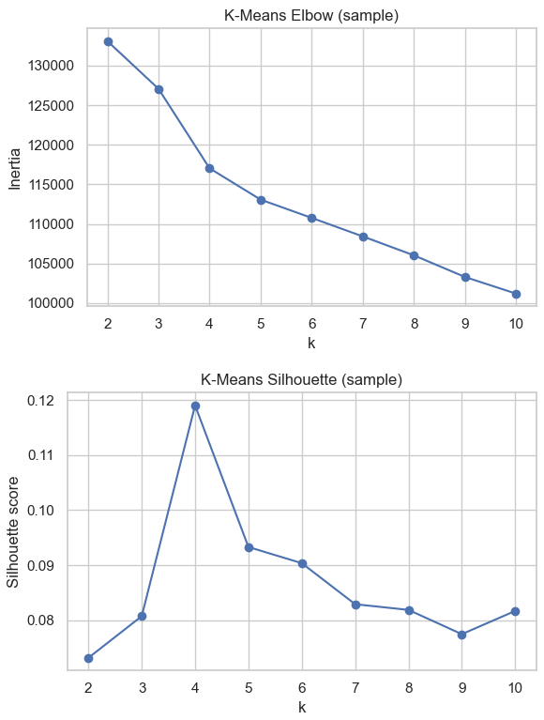
Figure 1: Elbow Method and Silhouette Score Plots
Once the optimal k was selected, the final K-Means model was fitted to the full dataset. Cluster labels were attached to the dataset for further analysis. Principal Component Analysis (PCA) was also applied to reduce dimensionality and visualise clusters in two dimensions. This is demonstrated in the screenshot below.
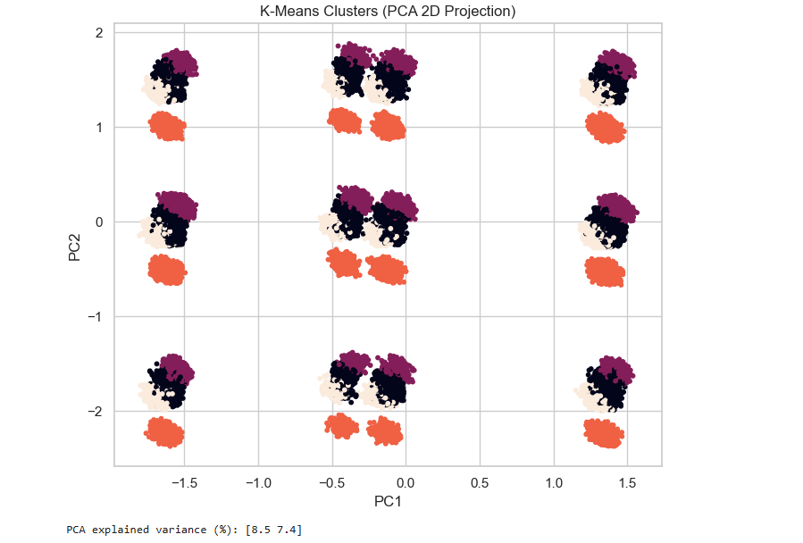
Figure 2: PCA Cluster Visualisation

Results
This section will outline the results obtained from both supervised and unsupervised learning models. For supervised learning, the tuned Decision Tree achieved the strongest overall performance, with an accuracy of 90.25%, a macro F1-score of 0.8978, and an AUC-ROC score of 0.9363. The tuned SVM achieved an accuracy of 88.21%, a macro F1-score of 0.8767, and an AUC-ROC score of 0.9394. Although both models demonstrated strong predictive performance, the Decision Tree slightly outperformed the SVM across most evaluation metrics. These metrics are demonstrated in the table below:

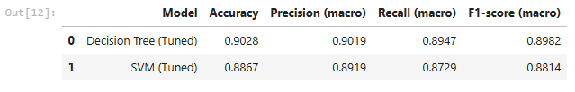
Figure 3: Model Comparison Table (accuracy, precision, recall, F1-score)

Additionally, the confusion matrix analysis revealed that both models classified Medium engagement players most accurately, with classification rates exceeding 93%. Misclassifications mainly occurred between High and Medium engagement players, indicating behavioural overlap between these groups.
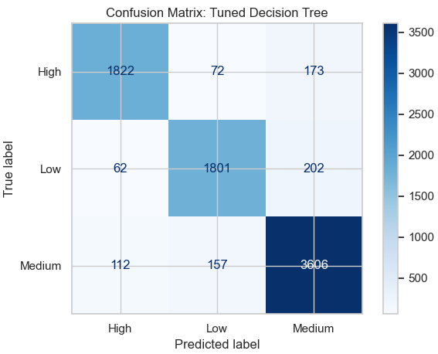
Figure 4: Confusion Matrix for the tuned Decision Tree
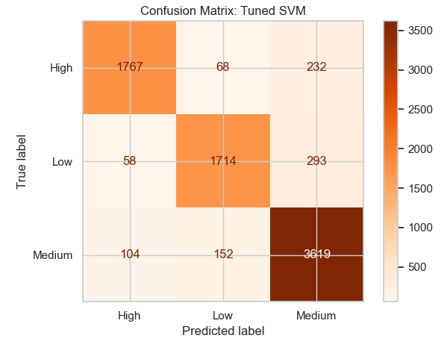
Figure 5: Confusion Matrix for SVM

Furthermore, the ROC-AUC analysis demonstrated excellent discriminative performance for both classifiers. The Decision Tree achieved an AUC of 0.9363, while the SVM achieved an AUC of 0.9394 as shown in the below graphs.

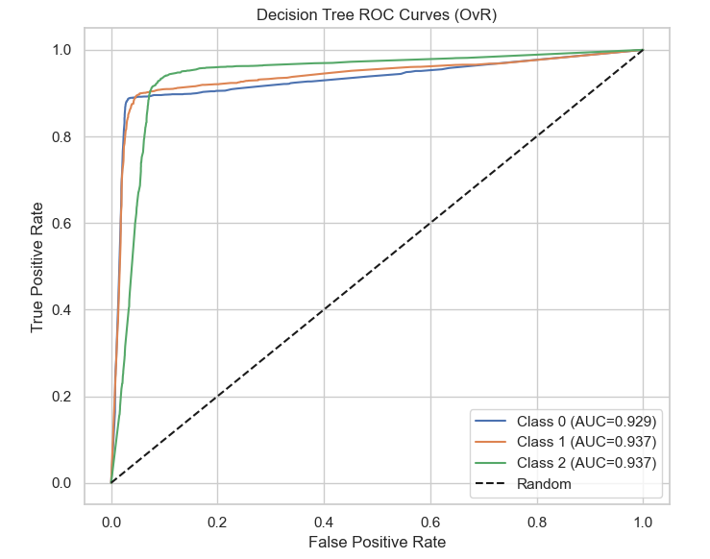
Figure 6: ROC Curves for the Tuned Decision Tree classifier (One-vs-Rest approach)
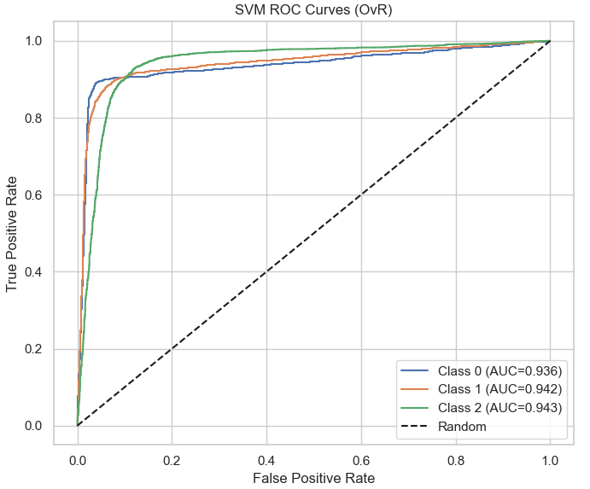
Figure 7: ROC curves for the tuned SVM classifier (One-vs-Rest approach)

Also, feature importance analysis from the tuned Decision Tree revealed that behavioural features were the most influential predictors of engagement. Sessions per week (44.8%) and average session duration (43.9%) were identified as the strongest predictors, followed by achievements unlocked, player level, and playtime hours. Whereas demographic features contributed minimally to the prediction process. This is presented in the bar chart below.

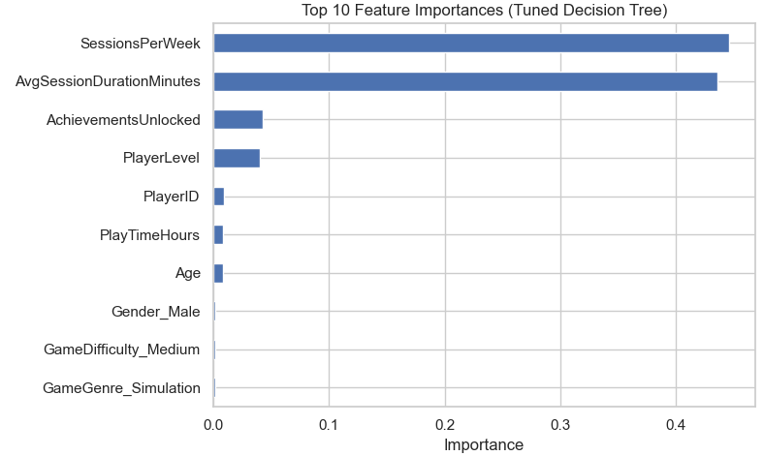
Figure 8: Top 10 Feature Importances from the Tuned Decision Tree model

Lastly, the K-Means clustering algorithm was used to identify ten distinct player groups. Although the silhouette score (0.1508) suggested limited separation between clusters, clear behavioural trends were still evident within each group. Several clusters were identified as high-value segments, while others were categorised as at-risk players based on engagement allocation. This is demonstrated below with a bar chart.

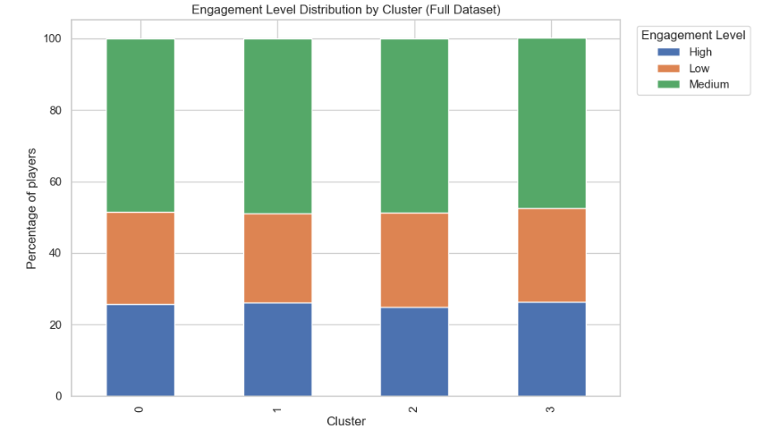
Figure 9: Cluster vs Engagement Stacked Bar Chart

Discussion
The results demonstrate that supervised learning models can effectively predict player engagement. The tuned Decision Tree achieved the highest accuracy and macro F1-score, supporting previous research that highlights the effectiveness of tree-based models for behavioural classification. The dominance of behavioural variables such as session frequency and session duration confirms that consistent gameplay behaviour is a stronger indicator of engagement than demographic characteristics.

Although the SVM achieved a slightly higher ROC-AUC score, its increased computational complexity and lower interpretability make it less suitable for real-time deployment compared to the Decision Tree. In addition to this, the interpretability of the Decision Tree model enhances its practical value for business stakeholders. This will enable easier understanding of prediction outcomes.
Furthermore, although unsupervised learning produced weaker cluster separation, it still revealed valuable behavioural observations. By identifying which players are highly engaged and which are at risk of leaving, targeted retention strategies can be applied. This highlights the importance of integrating supervised and unsupervised learning approaches to obtain both predictive and descriptive observations.
Overall, the findings demonstrate that machine learning can effectively support data-driven decision-making in the gaming industry, particularly in relation to player retention and engagement strategies.

Conclusion
In conclusion, the tuned Decision Tree model achieved over 90% accuracy, demonstrating strong predictive performance. Behavioural features such as session frequency and duration were the most influential engagement predictors, whilst demographic factors showed minimal impact. Additionally, K-Means clustering identified distinct player groups, including high-value and at-risk segments. Combining supervised and unsupervised approaches enabled both individual prediction and behavioural segmentation. Overall, the findings highlight the value of machine learning for improving player retention, guiding game design, and supporting data-driven business decisions.

Bibliography
[1] Y. Huang, S. Jasin, and P. Manchanda, “‘Level Up’: Leveraging Skill and Engagement to Maximize Player Game-Play in Online Video Games,” Information Systems Research, vol. 30, no. 3, pp. 927–947, Sep. 2019, doi: https://doi.org/10.1287/isre.2019.0839. Accessed 04, Dec, 2025.
[2] A. Rashed, S. Shirmohammadi, I. Amer, and M. Hefeeda, “A Review of Player Engagement Estimation in Video Games: Challenges and Opportunities,” ACM Transactions on Multimedia Computing, Communications, and Applications, Mar. 2025, doi: https://doi.org/10.1145/3722116. Accessed 04, Dec, 2025.
[3] T. Goswami and G. R. Sinha, Statistical Modeling in Machine Learning. Elsevier, 2022. Accessed 04, Dec, 2025.
[4] Nur, A. Majid, and Shahnorbanun Sahran, “Identification of Student Behavioral Patterns in Higher Education Using K-Means Clustering and Support Vector Machine,” Applied sciences, vol. 13, no. 5, pp. 3267–3267, Mar. 2023, doi: https://doi.org/10.3390/app13053267. 04, Dec, 2025.
[5] N. Rane, S. Choudhary, and J. Rane, “Metaverse for Enhancing Customer Loyalty: Effective Strategies to Improve Customer Relationship, Service, Engagement, Satisfaction, and Experience,” Social Science Research Network, Jan. 2023, doi: https://doi.org/10.2139/ssrn.4624197. Accessed 05, Dec 2025.
[6] R. Younas and Hafiz, “Deep Learning Model to Analyze Psychological Effects on Gamers,” Spectrum of Decision Making and Applications., vol. 2, no. 1, pp. 120–134, Oct. 2024, doi: https://doi.org/10.31181/sdmap2120254. Accessed 05, Dec 2025.
[7] Z. Azam, Md. M. Islam, and M. N. Huda, “Comparative Analysis of Intrusion Detection Systems and Machine Learning-Based Model Analysis Through Decision Tree,” IEEE Access, vol. 11, pp. 80348–80391, 2023, doi: https://doi.org/10.1109/ACCESS.2023.3296444. Accessed 06, Dec 2025.
[8] R. J. Ibáñez Alcalá et al., “RECORD, a high-throughput, customizable system that unveils behavioral strategies leveraged by rodents during foraging-like decision-making,” Communications Biology, vol. 7, no. 1, Jul. 2024, doi: https://doi.org/10.1038/s42003-024-06489-8. Accessed 06, Dec 2025.
[9] W. Strielkowski, A. Vlasov, K. Selivanov, K. Muraviev, and V. Shakhnov, “Prospects and Challenges of the Machine Learning and Data-Driven Methods for the Predictive Analysis of Power Systems: A Review,” Energies, vol. 16, no. 10, p. 4025, Jan. 2023, Available: https://www.mdpi.com/1996-1073/16/10/4025 Accessed 06, Dec 2025.
[10] D. C. Gkikas and P. K. Theodoridis, “Predicting Online Shopping Behavior: Using Machine Learning and Google Analytics to Classify User Engagement,” Applied Sciences, vol. 14, no. 23, p. 11403, Dec. 2024, doi: https://doi.org/10.3390/app142311403. Accessed 07, Dec 2025.
[11] M. Kiguchi and P. Subramanian, “Retention Analysis and Player Segmentation based on Gameplay Data,” Nov. 2023, doi: https://doi.org/10.1109/iciics59993.2023.10420913. Accessed 07, Dec 2025.

Appendix
Video link: https://youtu.be/Wdu5RipQxJU?si=-Vn7uJr9MXl329Dh

