
TEAM
TUNE

ORCHESTRATING UNITY

Business proposal letter

Problem u face?

Why Choose Us?

What are we offering?

How are we going to achieve it?

How can you see the difference?

MUKUL BAKKOLLA
2220398

PROBLEM YOU FACE?

High Employee Turnover

Let's see what causes employee turnover
- Employees may be inclined to quit if they are uninterested in their jobs, bored, and disengaged from the organisation.
- Workers may also decide to quit if they are offered a more appealing perks package or higher pay. (Firstup, 2021)

Lack of productivity due to poor morale

Let's see the causes of poor team morale
- Clear instructions were not given and poor communication
- Lack of trust among employees
- No team bonding
- Dishonesty (Justworks, 2023)

Why Choose Us?

We at Team Tune go by a very famous saying “My personal mantra for over a decade has been that I want to do work that I love, from places I love and with people I enjoy. I would argue that most people want this.” (Preston, 2017)

We Being a start up our costs are very low! As told during the presentation we don’t have any profit margins it is just cost to cost of any services we provide you if you compare our prices elsewhere they are 5-10x higher

Why choose us? We provide the best in class sessions for employee productivity and morale having all the activities we perform have a specific cause and reason all of this at the least cost for you and a new scope of growth for us it is a win-win situation for us

What are we offering?

A 3-step process specially designed to tackle your ongoing problems.
1 -step - We Will Conduct an Employee Engagement Program
2-step – Changes we will suggest for your offices.
3 -step – implement a set of activities for employees to follow periodically.

We will be offering you 3 different cost packages to choose from for the step 1 process.
The packages are –
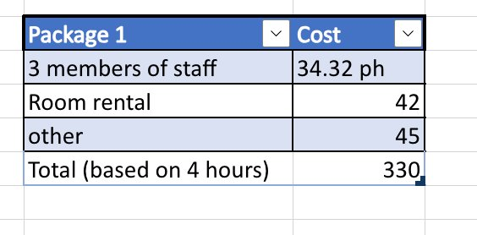
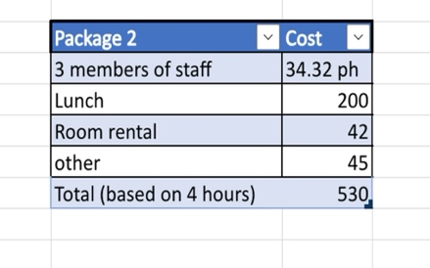
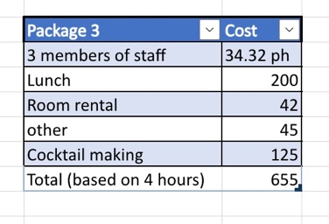

You can choose any package of your choice whichever is more suitable for you and is more comfortable for you in matter of cost.

How are we going to achieve it?

Having fun activities, wellness programs and many more fun events, having fun at work can be a crucial part of employee engagement and morale in the company (Liokumovich, 2023)

1-step – employee engagement program in this process we will conduct a Day Out Program for all your staff where we will be booking a leisure centre in Swansea and conduct some fun team bonding activities such as ice breakers, scavenger hunts, margarita-making classes and many more this event is designed for your employees to get to know each other get comfortable among themselves we can see an establishment of meaningful relations among your employees. (indeed editorial team, 2023)

2-step - changes we will suggest for your offices changes
Space spruce ups- changing the physical takes out the negative that was previously present and it will help you get rid of the Humdrum that was present previously and bring in a new atmosphere and a new vibe to your offices giving an opportunity for a new start for your employees
Office arcade- a great way for your employees to bond among themselves in the midst of the day and a great way for your employees to break that midday monotony (Robinson, 2023)
Desk Organizers- desk organizers will keep the workspace neat, comfortable and more accessible for your employees when working and help them work more efficiently
Calendars with a to-do list- This will help your employees stay calm under stressed situations and work more efficiently when they are in one. It will also help them work more efficiently (Indeed Editorial Team, 2023)

3-step- We will design some activities for your employees to follow periodically which will keep the new energy created prominent for a very long time
The activities include –
Pet A Pet- Pets are a great way to boost one’s mood and a very great way to make new friends in the workplace They will help your employees create meaningful relations. In this activity, your employees can bring in their pets one day to the office and let everyone see each other’s pets (Skerrett, 2015)
Food truck sessions- We will contact a local food truck that will do lunches from your parking lot where your employees can go in groups for lunches which will help them bond over good food and establish natural relationships among your employees. (Birtles, 2020)
Round of applause- Clapping is the most effective way to give appreciation for one’s work and give them recognition of their work in front of the team. Clapping for your employee’s work is very efficient (Lewis, 2020)
Bulletin Board Making- It is a very informative yet very fun way for your employees to work together in groups which will give them a great opportunity for bonding. For this activity, your employees should be divided into 4 groups who will go up against each other every two weeks on a topic you give them they have to prepare the bulletin board.

How can you see the difference?
We will give you a few ways to measure the productivity of your employees which are –
Absenteeism rate of your employees: the formula for calculating employee Absenteeism rate is (Total workdays lost to absenteeism / Total workdays in a given interval of time)*100
How to calculate
If an employee took 10 days off out of 60 working days, then, using the above formula, the employee absenteeism rate will be:
= (10/60)*100
=16.66%
(MILLER, 2024)

Percentage of Goals Met: the formula for calculating percentage of goals met is Percentage of goals met = (Actual/Goal)*100

How to Calculate
Let us suppose that you gave your content writing team the goal of submitting 30 blogs of 1000 words each within a week. If your team submitted 45 blogs, then the percentage goals met will be:
(Actual/Goals)*100 = (45/30)*100 = 150%

(MILLER, 2024)

Conducting surveys for your employees and asking them for the problems they face and how they have overcome the previous problems will give you a more detailed answer of your present situation

Please feel free to contact us for more information or for any changes you would like
+44744058362727/ teamtune@gmail.com
Follow us on Instagram and Facebook for ongoing events- teamtuneofficialy

Works Cited
Firstup, 2021. High employee turnover? The real causes and impact. [Online]
Available at: https://firstup.io/uk/blog/high-employee-turnover-the-real-causes-and-impact/
[Accessed 24 01 2024].
Justworks, 2023. Top 11 Causes of Low Employee Morale at the Office. [Online]
Available at: https://www.justworks.com/blog/top-causes-winter-blues-office
[Accessed 24 january 2024].
Preston, C., 2017. Council Post: Promoting Employee Happiness Benefits Everyone. [Online]
Available at: https://www.forbes.com/sites/forbescoachescouncil/2017/12/13/promoting-employee-happiness-benefits-everyone/?sh=7caa94de581a
[Accessed 25 January 2024].
Liokumovich, M., 2023. 5 Fun Employee Events to Boost Morale and Increase Engagement. [Online]
Available at: https://www.linkedin.com/pulse/5-fun-employee-events-boost-morale-increase-masha-liokumovich
[Accessed 25 January 2024].
Robinson, A., 2023. 19 Fun Ways to Boost Morale & Motivation at Work in 2024. [Online]
Available at: https://teambuilding.com/blog/morale-boosters
[Accessed 25 January 2024].
Indeed Editorial Team, 2023. How to stay calm under pressure (And why it's important). [Online]
Available at: https://uk.indeed.com/career-advice/career-development/how-to-stay-calm-under-pressure
[Accessed 25 January 2024].
indeed editorial team, 2023. Got low morale at work? Here are five ways to improve it. [Online]
Available at: https://uk.indeed.com/lead/low-morale-at-work?gad_source=1&gclid=Cj0KCQiAwbitBhDIARIsABfFYIKaFxciAcm-H4o0HI4NP9I3Nb2jgCSpw2JeRH0-PpaCMui5oXsz1mgaAoT-EALw_wcB&gbraid=123
[Accessed 25 January 2024].
Skerrett, P. J., 2015. Pets can help their humans create friendships, find social support. [Online]
Available at: https://www.health.harvard.edu/blog/pets-can-help-their-humans-create-friendships-find-social-support-201505067981
[Accessed 25 January 2024].
Birtles, K., 2020. Dining with strangers: How food brings people together. [Online]
Available at: https://www.trafalgar.com/real-word/dining-with-strangers-food-people-together/
[Accessed 25 01 2024].
Lewis, P., 2020. Gratitude is More Than Just a Round of Applause.. [Online]
Available at: https://www.linkedin.com/pulse/gratitude-more-than-just-round-applause-peter-lewis
[Accessed 25 January 2024].
MILLER, K., 2024. 7 Best Ways to Measure Productivity of Employees. [Online]
Available at: https://aboutleaders.com/measure-productivity-of-employees/
[Accessed 25 January 2024].

