Advanced Software Development

OOP Programming (C++)

Gareth Williams 1910285
11th January 2023

Table of Contents
1. Introduction 3
2. Application Design 3
2.1 Functional Design 3
2.2 Non-Functional Design 4
2.2.1 Backend Features 4
2.2.2 Data Files 4
2.3 Building the release 4
2.4 Classes 5
2.4.1 Inheritance 5
2.4.2 Attributes and Methods 5
Inheritance - Single and multiple, multi level 6
2.4.3 Constructor 6
2.4.4 Dynamic Memory Allocation (pointers) 7
2.4.5 Polymorphism 7
2.5 Files 7
2.5.1 Address File 7
2.5.2 Binary Files 7
2.6 Search Algorithm – Address Lookup 9
2.6.1 Loading The Address Data 10
2.6.2 Postcode Index BST 11
2.6.3 Searching Addresses by Postcode 13
3. References 14
4. Appendix A – Source Code 15
4.1 Main.cpp 15
4.2 Menu.cpp 18
4.2.1 Menu.h 20
4.3 User.cpp 21
4.3.1 User.h 26
4.4 Help.cpp 26
4.4.1 Help.h 27
4.5 AddressData.cpp 27
4.5.1 AddressData.h 33

Introduction

This report describes the design and use of the Object Orientated Programming paradigms to develop a fictitious Vehicle Hire System. For the purposes of demonstration, the app is a self-contained executable and run from with a terminal/cmd window. It does not use third party libraries.

To keep the application self-contained, it uses local text files for holding user, customer and reference data.

The UK street address data file used by the app for lookup purposes is a published file by Ordenance Survey, this data product is known as AddressBase [1]

Accompanying Video URL: <video failed to record>

Application Design
The application is designed to demonstrate some of the key features of OOP. It is not a fully production application and some functionality is yet to be implemented.

The programming language chosen is C++, which extends the c language.

In the article “An overview of C++” B Stoustrup summarises C++ as:

“The first aim of C++ is to be “a better C” by providing better support for the styles of programming for which C is most commonly used.” [2]

He also goes on to concludes:

“C++ has succeeded in providing greatly improved support for traditional C-style programming without added overhead. In addition, C++ provides sufficient language support for data abstraction and object-oriented programming in demanding (both in terms of machine utilization and application complexity) real-life applications.” [2]

Functional Design
The demonstration application provides the following fronted functionality:
- User maintenance – add user
- Customer Record Maintenance – add customer
- Vehicle Record Maintenance – yet to be implemented
- Vehicle Booking – yet to be implemented

Non-Functional Design

Backend Features

The backend of the application features the use of:
- Binary file – user credentials data
- Text File – address lookup data
- Binary Search Tree – efficient in memory search index

Data Files

Once compiled, the application is single standalone executable that uses local text files for the following purposes:

Maintain User Information = UserData.bin
Address Lookup = CF31.csv (ONS comma delimited text file)

Building the release
All the code is stored in a single Visual Studio 2019 project. Figure 1 shows the main cpp and associated header files.
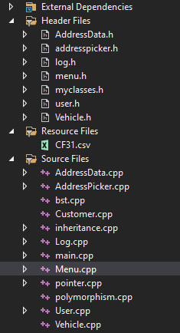
Figure 1 - Source Files

Classes
The following diagram shows a high-level diagram of the classes:

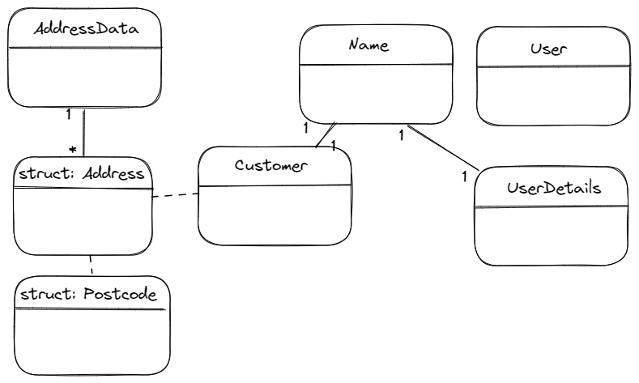

Inheritance

I. Horton and P. van Weert, describe inheritance as

“Inheritance is the means by which you can create new classes by reusing and expanding on existing class definitions.” [3]

The UserDetails class demonstrates an example of inheritance – in this case the based class is Person – the person class contains the structure of Name. The UserDetails class extends this by adding the credential structure.

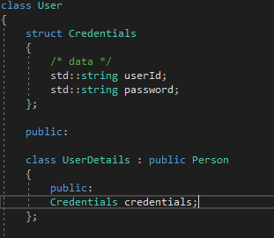

Attributes and Methods
Horton and P van Weert desfine recusion as “a function that contains a call to itself is referred to as a recursive function” [1]

An example of recursion can be found in the AddressData class, note the attribute passed to the inorder function is a binary search tree node, the function calls itself twice again passing a pointer to the node. It is this recursion that “walks” through the binary search tree.

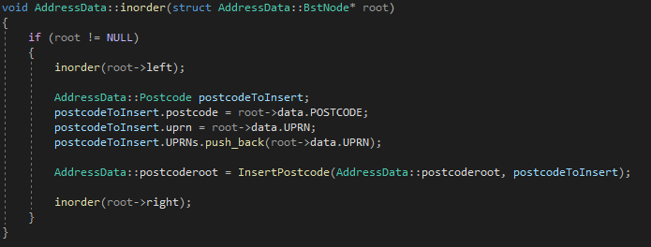

3.4.3 Encapsulation

Encapsulation is used to keep private data and functions from other classes.
To achieve this, we use Accessors of private, public and protected e.g.,

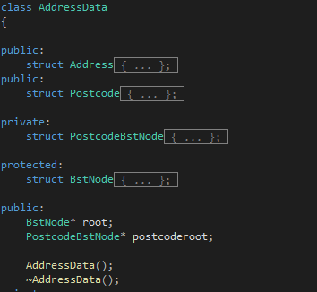

Polymorphism
B. Stroustrup in the article, “An overview of C++,” states:

“C++ provides support for object-oriented programming: the programmer can define class hierarchies and a call of a member function can depend on the actual type of an object (even where the actual type is unknown at compile time).” [2]

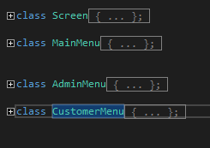
The application uses Polymorphism for the menu system as can be seen in the menu.h file. The base class is Screen and the derived classes are MainMenu, AdminMenu and CustomerMenu.

The menu classes are instantiated, then called using pointers to the address.

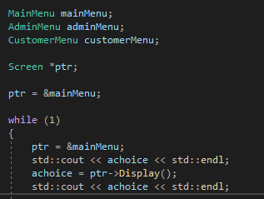

Files
The application uses two methods for reading and writing files. Read text file and Binary IO for reading and writing class objects.

Address File
ONS AddressBase is a plain comma delimited text file, it is only ever read from. The structure is fixed as this file is provided from an external source.

Binary Files
Binary write guidance was followed and adapted using notes from John’s Basement which is a youtube channel https://www.youtube.com/watch?v=Gb8_KGRGIFM

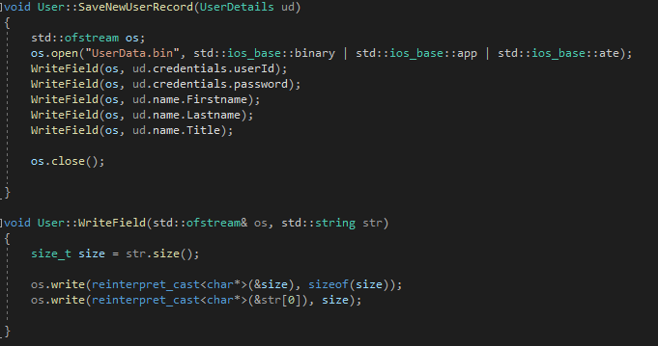
The User Detail information such as username as passwords are read/written using binary io. The usefulness with binary files is that instantiated objects can be written to and read from the binary stream.

However, the class structures within the application uses the String type rather than the fixed char[]. Note that this is not a “built in” type, therefore the size of the read and write needs to be calculated for each field and the field size stored along with the data.

A hex dump of the binary file shows the structure. The top line of the dump shows, the very first hex value is 05 which is the equivalent to decimal 5, this means the data string is 5 characters long, in this case the string “user1”.

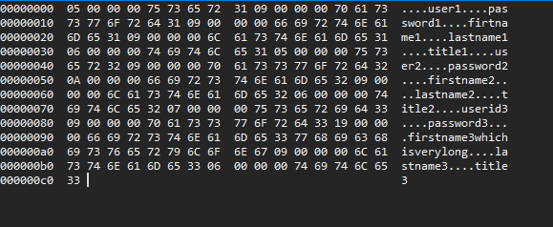

Although the binary file approach provides flexibility and efficiency in size and straight forward appending for new records. The difficulty comes when updating or deleting a record. There are two approaches to achieve this, read the whole data into an array, remove the changed record from the array then rewrite out the whole file, or simply append records and keep a timestamp as part of each data item. The timestamp can then be used to find the latest version of a record – At some point a utility will be required to clean up the old records.

The following screen shows the CheckCredentials() method, this reads the file into to an array of UserDetail objects and compares each userid and password pair in turn.

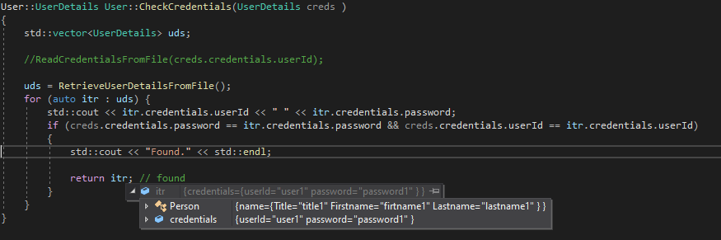

As the binary file is plain text, ideally a hashing algorithm such as SHA256 could be used to mask the password field.

Search Algorithm – Address Lookup
The implementation here was informed by the video Binary Search Tree – Implementation in c/c++ https://www.youtube.com/watch?v=COZK7NATh4k [2]

The AddressLookup file can contain Millions of uk addresses, each address has a Unique Property Reference Number (UPRN). Figure 2 shows the structure of the address file that is supplied by Ordnance Survey.

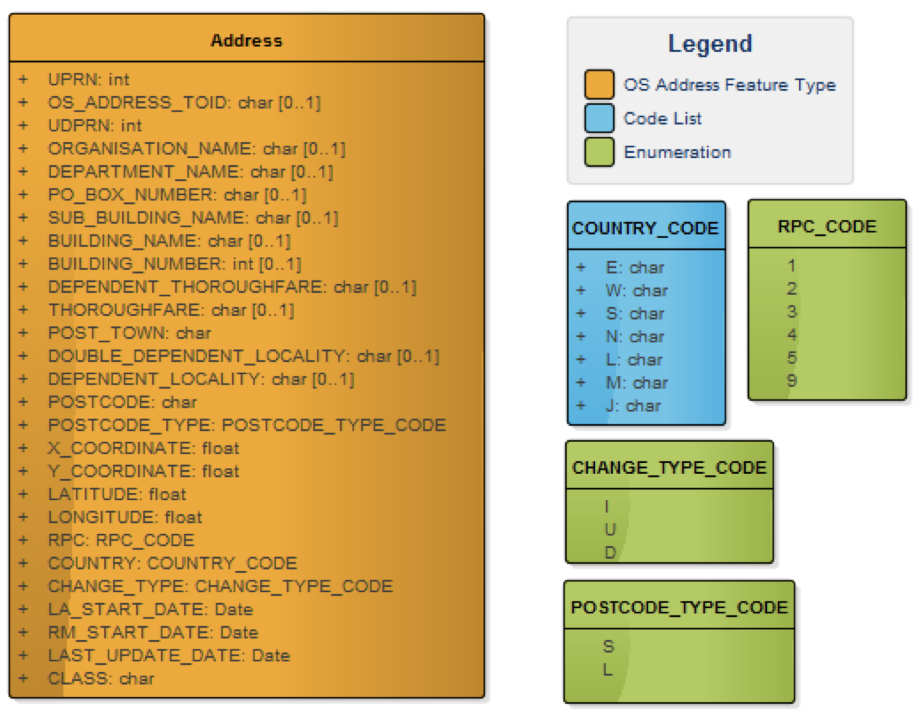
Figure 2 - Ordinance Survey - AddressBase Record Structure

Note that the address data is NOT ordered so would require a full sequential scan each time it’s searched, this would be resource intensive, so a strategy is required to help.

The user steps for searching and selecting an address involve entering the address postcode first, therefore the number of records returned can be limited by postcode.

Two Binary Search Trees have been implemented to allow for efficient search. The first BST is an index of postcodes, the second BST holds the full address data records. Figure 3 shows the one-to-many relationship between the Trees.

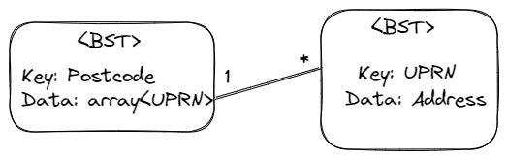
Figure 3 - BST Relationship

Loading The Address Data

It is essentially that the data is loaded into both BSTs in the correct order. The following highlevel class diagram shows the AddressData Class constructor. Once instantiated, the AddressData object and the two BSTs live for the lifetime of the application.

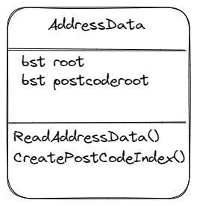

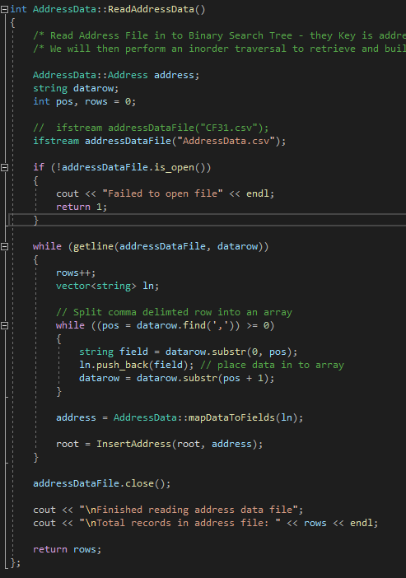
The ReadAddressData() method uses the <fstream> library to read through the address file line by line until end of file is reached. As each line is read, it is processed and then inserted into the Address BST.
sequentially.

The InsertAddress(root, address) function is the recursive method that takes the root node as the first parameter and the address data to insert

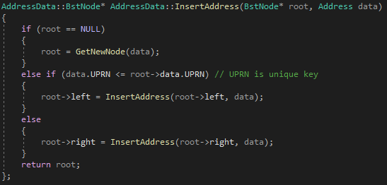

The Following screenshot shows the address in the BST data structure :

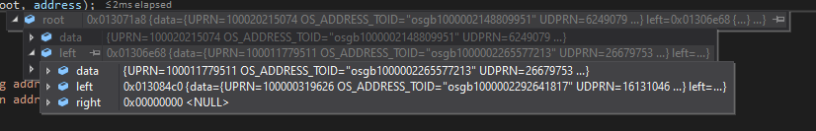

Postcode Index BST
The data is now in memory in the AddressData BST tree, an inorder traversal of the existing address tree will be used to build the Postcode BST.

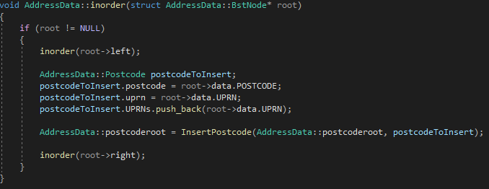

For every node in the address tree, the InsertPostcode method is called.

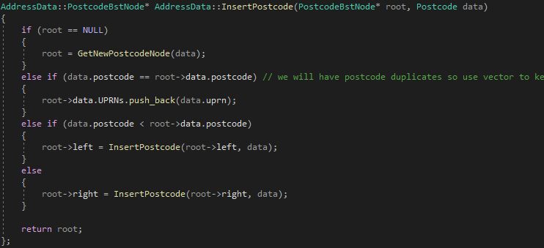

The difference between the insert for the address and insert for the postcode, is that we know that the postcode will have duplicates keys – this would break the algorithm. To maintain unique keys for each “clash” the UPRN is added to the Data – in this case an array of uprns.

The following screen shows the application output of the initialisation of the two BSTs.

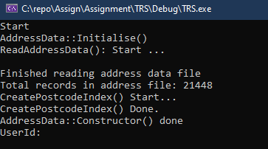

Searching Addresses by Postcode

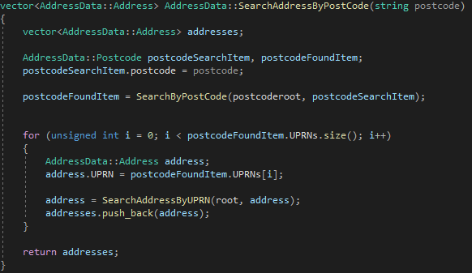
Now the two BSTs have been prepared, we can use a depth first search approach to firstly find the postcode in the Postcode BST – the data element of the node returned will contain all the UPRNs required to then search the Address BST.

The method returns an array of the found addresses using the Address object.

Testing

User Login
The app comes with two logins
user1 password1
user2 password2

New logins can be added via the admin menu

Postcodes
Choose Add Customer
Enter Details
Enter Postcode (with space!)
For dev and testing the addressFile is a subset of welsh postcodes starting with CF31

Known working postcode = CF31 5EP

This fails however, this is a display problem not an issue with the binary search tree as can be evidenced by the following screen shot. This shows the data being correctly returned from the BST search algorithm implemented.

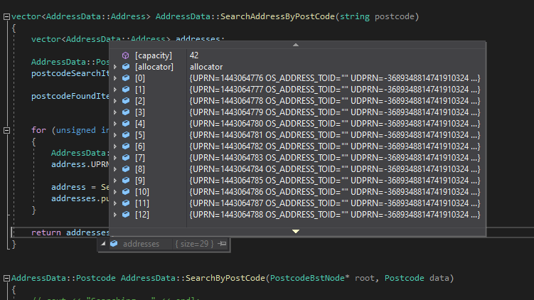

~ end ~

References

[1] | Ordnances Survey, “addressbase-premium,” Ordnance Survey, 2023. [Online]. Available: https://www.ordnancesurvey.co.uk/business-government/products/addressbase-premium. [Accessed 2023].
[2] | B. Stroustrup, “An overview of C++,” SIGPLAN notices, vol. vol. 21, no. 10, p. 7–18, 1986.
[3] | I. H. a. P. v. Weert, Beginning C++20 : from novice to professional, New York: Apress, 2020.
[4] | mycodeschool, “Binary search tree - Implementation in C/C++,” mycodeschool, 2015. [Online]. Available: https://www.youtube.com/watch?v=COZK7NATh4k. [Accessed 2023].

Bibliography

M. H. Austern, B. Stroustrup, M. Thorup, and J. Wilkinson, “Untangling the balancing and searching of balanced binary search trees,” Software, practice & experience, vol. 33, no. 13, pp. 1273–1298, 2003, doi: 10.1002/spe.564.

A. Stellman and J. Greene, Head first C#, Third edition. Sebastopol, California: O’Reilly Media, Inc., 2013.

Appendix A – Source Code

Main.cpp

#include <stdlib.h>
#include <iostream>
#include <algorithm>
// -l in build

#include <vector>
#include <fstream>
#include <string.h>
#include "log.h"
#include "AddressData.h" // need to change this to .h need to change build options
#include "addresspicker.h"
#include "myclasses.h"
#include "menu.h"
#include "user.h"
#include "customer.h"
#include "help.h"

using namespace std;

//AddressData* addressDB = new AddressData;
AddressData addressDB;

void testPostCode()
{
AddressData ad; // todo needs to be GLOBAL VAR!!!!!!!
vector<AddressData::Address> addresses;
addresses = ad.SearchAddressByPostCode("CF31 5EP");

for (unsigned int i = 0; i < addresses.size(); i++)
{
std::cout << addresses[i].BUILDING_NAME << " " << addresses[i].BUILDING_NUMBER << ", " << addresses[i].THOROUGHFARE << " " << addresses[i].DEPENDENT_THOROUGHFARE << " " << addresses[i].POST_TOWN << " " << addresses[i].POSTCODE << endl;
}
std::cout << endl;

}

void AddCustomerRecord()
{

system("cls");
// There is a bug here as the constructor keeps getting executed.

Customer::Detail* cd = new Customer::Detail;

std::cout << "Title: "; std::cin >> cd->name.Title;
std::cout << "Firstname: "; std::cin >> cd->name.Firstname;
std::cout << "Lastname: "; std::cin >> cd->name.Lastname;

std::cout << "\nChoose Address: " << std::endl;
std::cout << "Enter postcode To Search: ";

std::string postcode;
std::cin.ignore();

getline(std::cin, postcode);

//ad2.SearchAddressByPostCode("CF31 5EP");

AddressData::Address ca;
std::vector<AddressData::Address> addresses;

addresses = addressDB.SearchAddressByPostCode(postcode);
if (addresses.size() == 0)
{
std::cout << "No Addresses found." << std::endl;
}
else
{
for (unsigned int i = 0; i < addresses.size(); i++)
{
ca = addresses[i];
std::cout << ca.BUILDING_NAME << " " << ca.BUILDING_NUMBER << ", " << ca.THOROUGHFARE << " " << ca.DEPENDENT_THOROUGHFARE << " " << ca.POST_TOWN << " " << ca.POSTCODE << std::endl;
}
}
std::cout << std::endl;

system("pause");

delete cd;

}

bool MenuDriver()
{
int achoice; //= new int;
achoice = 0;
//AddressData* addressDB = new AddressData();

MainMenu mainMenu;
AdminMenu adminMenu;
CustomerMenu customerMenu;

Screen *ptr;

ptr = &mainMenu;

while (1)
{
ptr = &mainMenu;
achoice = ptr->Display();
std::cout << achoice << std::endl;

if (achoice == 1) // customer menu
{

ptr = &customerMenu;
int customerMenu = 0;

while (customerMenu != 9)
{

switch (ptr->Display())
{
case 1:

break;
case 2:

AddCustomerRecord();

break;
case 9:
std::cout << "Customer 9" << endl;
customerMenu = 9;
break;
default:
break;
}
}

}

if(achoice == 8) // adminmenu
{
ptr = &adminMenu;
int customerMenu = 0;
User u;
while (customerMenu != 9)
{
switch (ptr->Display())
{
case 1:
std::cout << "admin 1" << endl;

u.ListUsers();

break;
case 2:

u.AddNewRecord();
break;
case 9:
std::cout << "Admin 9" << endl;
customerMenu = 9;
break;
default:
break;
}
}
}
if (achoice == 7)
{
Help h;
h.Show();
}
if (achoice == 9)
{
return false;
}
}
}

int main(int argc, char** argv)
{

Logger l;

l.Log("Start");
addressDB.Initialise();

User u;
if (!u.Login())
{
return 0;
}

MenuDriver();

return 0;

}

Menu

Menu.cpp

#include <iostream>
#include <string>
#include "menu.h"

Screen::Screen() // Base class constructor
{
choice = 0;
//screenTitle = new std::string;
screenTitle = "Screen";
//system("CLS"); // clear the screen in windows console. note this is "clear" in OSs that use term;
//std::cin.ignore();

}

int Screen::Display() // virtual to allow for polymorphism
{
// this never gets called, but is required.
std::cout << "Base class Screen Display()";

return 0;
}

Screen::~Screen() // destructor
{
//delete choice;
// delete screenTitle;
}

int Screen::GetChoice()
{
//std::cin.clear();
//std::cin.ignore();
std::cout << "\nPlease Enter choice: ";
std::cin >> choice;

return choice;
}

void Screen::DisplayHeader(std::string title)
{
system("cls");

std::cout << "*****************************************************";
std::cout << "\n" << title << "\n" ;
std::cout << "*****************************************************\n\n";
}

void Screen::DisplayFooter()
{
std::cout << "\n\n9 .... Exit Menu (10 quit app):\n" << std::endl;
}

int MainMenu::Display()
{
screenTitle = "Main Menu";
DisplayHeader("Main Menu");

std::cout << "1 .... Choose Customer:\n";
std::cout << "2 .... Book Vehicle:\n";
std::cout << "7 .... Help:\n"; // encapsulate help
std::cout << "8 .... User Maintenance:\n";

DisplayFooter();

choice = GetChoice();

return choice;
}

MainMenu::MainMenu() // derived class Constructor
{

}

MainMenu::~MainMenu()// derived class Destructor
{

}

int AdminMenu::Display()
{
screenTitle = "Admin Menu";
DisplayHeader("Admin Menu: ");
std::cout << "1 .... List All Users:\n";
std::cout << "2 .... Add a User:\n";
std::cout << "3 .... Delete a User:\n";

DisplayFooter();

choice = GetChoice();

return choice;
}

AdminMenu::AdminMenu() // derived class Constructor
{

}

AdminMenu::~AdminMenu()// derived class Destructor
{

}

int CustomerMenu::Display()
{
screenTitle = "Customer Menu";
DisplayHeader("Customer Menu");
std::cout << "1 .... List All Customers:\n";
std::cout << "2 .... Add a Customer:\n";
std::cout << "3 .... Delete a Customer:\n";
//std::cout << "8 .... User Maintenance:\n";
DisplayFooter();

choice = GetChoice();

return choice;
}

CustomerMenu::CustomerMenu() // derived class Constructor
{

}

CustomerMenu::~CustomerMenu()// derived class Destructor
{

}

Menu.h

#pragma once
#include <string>

class Screen {

protected:
int choice;

public:
std::string screenTitle;
Screen(); // constructor

virtual ~Screen(); // destructor

//virtual ~Screen() = default; // virtual function

virtual int Display();

void DisplayHeader(std::string title);
void DisplayFooter();
int GetChoice();
};

class MainMenu : public Screen {

public:

MainMenu();
virtual ~MainMenu();
int Display();
};

class AdminMenu : public Screen {

public:

AdminMenu();
~AdminMenu();
protected:
int Display();
};

class CustomerMenu : public Screen {

public:

CustomerMenu();
~CustomerMenu();
protected:
int Display();
};

User.cpp

#include <iostream>
#include <string>
#include <vector>
#include <fstream>
#include "myclasses.h"
#include "user.h"
//#include <string>

bool User::Login()
{
int attempts = 0;
UserDetails user;

std::string line;

while(attempts < 5)
{
system("clear");
std::cout << "Enter username and password, attemp: " << attempts << std::endl;

attempts++;
std::cout << "\nUserId: ";
getline (std::cin, user.credentials.userId);

std::cout << "\nPassword: ";
getline (std::cin , user.credentials.password);

// if(user.credentials.userId == "g" && user.credentials.password =="g")
// {
// return true;
// }

UserDetails ud;
ud.credentials = user.credentials;

if (CheckCredentials(ud))
{
return true;
}

}
std::cout << "\nToo many login attemps.";
system("pause");

return false;

}

void User::UserAdmin()
{
int choice;
choice = 0;
//User u;

while(choice != 9)
{
system("clear");
system("CLS");
std::cout << "\nSystem Admin ...";
std::cout << "\n1 .......... List Users";
std::cout << "\n2 .......... Add New User";
std::cout << "\n3 .......... Delete User";
std::cout << "\n4 .......... Reset Password";
std::cout << "\n7 .......... Help";
std::cout << "\n\n9 .......... Exit";
std::cout << std::endl;
std::cout << std::endl;
std::cout << "Choice: ";
std::cin >> choice;

switch(choice){

case 1:
RetrieveUserDetailsFromFile();
break;
case 2:
AddNewRecord();
break;
case 3:
break;
case 7:
break;
default:
break;
}
};
}

void User::AddNewRecord()
{
system("CLS");

std::cout << "Add User ... \n\n" << std::endl;

UserDetails ud;
std::string str;
std::cout << "UserId:";

std::cin.clear();
std::cin.ignore();

std::getline(std::cin, ud.credentials.userId);

std::cout << "Password:";
std::getline(std::cin, ud.credentials.password);
std::cout << "First Name:";
std::getline(std::cin, ud.name.Firstname);
std::cout << "Last Name:";
std::getline(std::cin, ud.name.Lastname);
std::cout << "Title:";
std::getline(std::cin, ud.name.Title);

SaveNewUserRecord(ud);

}

bool User::CheckCredentials(UserDetails creds )
{
std::vector<UserDetails> uds;

//ReadCredentialsFromFile(creds.credentials.userId);

uds = RetrieveUserDetailsFromFile();
for (auto itr : uds) {
std::cout << itr.credentials.userId << " " << itr.credentials.password;
if (creds.credentials.password == itr.credentials.password && creds.credentials.userId == itr.credentials.userId)
{
std::cout << "Found." << std::endl;

return true; // found
}
else
{
return false;
}
}
}

void User::ListUsers()
{
std::vector<UserDetails> uds;

//ReadCredentialsFromFile(creds.credentials.userId);

uds = RetrieveUserDetailsFromFile();
for (auto itr : uds) {
std::cout << itr.credentials.userId << " " << itr.credentials.password;

}
}

std::vector<User::UserDetails> User::RetrieveUserDetailsFromFile()
{
std::vector<UserDetails> uds;

UserDetails ud;
std::ifstream in;
in.open("UserData.bin", std::ios::binary);

while(!in.eof())
// while(in.read(reinterpret_cast<char*>(&ud), sizeof(ud)))
{
ReadField(in, ud.credentials.userId);
ReadField(in, ud.credentials.password);
ReadField(in, ud.name.Firstname);
ReadField(in, ud.name.Lastname);
ReadField(in, ud.name.Title);
uds.push_back(ud);
//std::cout << "\n" << ud.name.Firstname << " " << ud.name.Lastname << " " << ud.name.Title << std::endl;
in.peek();// forces eof after last record is read
}
in.close();
// std::string key;
// std::cin >> key;

return uds;
}

User::Credentials User::ReadCredentialsFromFile(std::string userid)
{
std::ifstream in;
in.open("UserData.bin", std::ios::binary);

User::Credentials d;

while(in.read(reinterpret_cast<char*>(&d), sizeof(d)))
{
std::cout << d.userId << " " << d.password << std::endl;
if (d.userId == userid)
{
break;
}
}
in.close();
return d;

}

void User::SaveNewUserRecord(UserDetails ud)
{
std::ofstream os;
os.open("UserData.bin", std::ios_base::binary | std::ios_base::app | std::ios_base::ate);
WriteField(os, ud.credentials.userId);
WriteField(os, ud.credentials.password);
WriteField(os, ud.name.Firstname);
WriteField(os, ud.name.Lastname);
WriteField(os, ud.name.Title);

os.close();

}

void User::WriteField(std::ofstream& os, std::string str)
{
size_t size = str.size();

os.write(reinterpret_cast<char*>(&size), sizeof(size));
os.write(reinterpret_cast<char*>(&str[0]), size);

}

void User::ReadField(std::ifstream& in, std::string& str)
{
//std::string str2;
size_t size;
in.read(reinterpret_cast<char*>(&size), sizeof(size));
str.resize(size);
in.read(reinterpret_cast<char*>(&str[0]), size);

}
/*
void User::SaveNewUserRecord1(UserDetails ud)
{

std::ofstream os;
os.open("UserData.bin", std::ios_base::binary | std::ios_base::app | std::ios_base::ate);

os.write(reinterpret_cast<char*>(&ud), sizeof(ud));

os.close();

}
*/
void WriteExample()
{
/*
std::ofstream os;
os.open("UserData.bin", std::ios::binary);

User::Credentials d;
d.userId = "garethw";
d.password="pass";

os.write(reinterpret_cast<char*>(&d), sizeof(d));

d.userId = "user2";
d.password = "pass3";
os.write(reinterpret_cast<char*>(&d), sizeof(d));

os.close();
*/
}

User.h

#pragma once
#include <string>
#include <fstream>
#include <vector>
#include "myclasses.h"

class User
{
struct Credentials
{
/* data */
std::string userId;
std::string password;
};

public:

class UserDetails : public Person
{
public:
Credentials credentials;
};

public:
void UserAdmin();
bool Login();
std::vector<UserDetails> RetrieveUserDetailsFromFile();
void AddNewRecord();
bool CheckCredentials(UserDetails creds );
void SaveNewUserRecord(UserDetails d);
Credentials ReadCredentialsFromFile(std::string userid);
void ListUsers();

private:
void WriteField(std::ofstream& os, std::string str);
void ReadField(std::ifstream& os, std::string& str);

};

Help.cpp
#include "help.h"

void Help::Show()
{
system("cls");

std::string ln;
std::ifstream helpfile("help.txt");

if (helpfile.is_open())
{
while (getline(helpfile, ln))
{
std::cout << ln << std::endl;

}
helpfile.close();
}
else
{
std::cout << "/n*** Unable to show help file." << std::endl;
}
std::string junk;

std::cout << "\nEnter 9 to continue: ";
std::cin.ignore();
std::cin >> junk;

}

Help.h

#pragma once
#include <iostream>
#include <string>
#include <fstream>

class Help
{
public:
void Show();

};

AddressData.cpp

#include <iostream>
#include <fstream>
#include <vector>
#include <string>
#include "AddressData.h"
#include "log.h"

using namespace std;

Logger l;

AddressData::AddressData() // Constructor
{

};

AddressData::~AddressData() {

};

void AddressData::Initialise()
{
l.Log("AddressData::Initialise() ");
AddressData::root = NULL;
AddressData::postcoderoot = NULL;
l.Log("ReadAddressData(): Start ...");

ReadAddressData(); // into BST - key = UPRN

l.Log("CreatePostcodeIndex() Start...");
CreatePostcodeIndex(); // inorder traversal of address bst and pickout postcodes;
l.Log("CreatePostcodeIndex() Done.");

l.Log("AddressData::Constructor() done");
}
void AddressData::CreatePostcodeIndex()
{
/* Inorder traversal. */
inorder(AddressData::root);
};

void AddressData::inorder(struct AddressData::BstNode* root)
{
if (root != NULL)
{
inorder(root->left);

AddressData::Postcode postcodeToInsert;
postcodeToInsert.postcode = root->data.POSTCODE;
postcodeToInsert.uprn = root->data.UPRN;
postcodeToInsert.UPRNs.push_back(root->data.UPRN);

AddressData::postcoderoot = InsertPostcode(AddressData::postcoderoot, postcodeToInsert);

inorder(root->right);
}
}

int AddressData::ReadAddressData()
{
/* Read Address File in to Binary Search Tree - they Key is address UPRN which is a unique value. */
/* We will then perform an inorder traversal to retrieve and build a postcode index for efficient search. */

AddressData::Address address;
string datarow;
int pos, rows = 0;

//ifstream addressDataFile("CF31.csv");
ifstream addressDataFile("AddressData.csv");

if (!addressDataFile.is_open())
{
cout << "Failed to open file" << endl;
return 1;
}

while (getline(addressDataFile, datarow))
{
rows++;
vector<string> ln;

// Split comma delimted row into an array
while ((pos = datarow.find(',')) >= 0)
{
string field = datarow.substr(0, pos);
ln.push_back(field); // place data in to array
datarow = datarow.substr(pos + 1);
}

address = AddressData::mapDataToFields(ln);

root = InsertAddress(root, address);
}

addressDataFile.close();

cout << "\nFinished reading address data file";
cout << "\nTotal records in address file: " << rows << endl;

return rows;
};

/* Utility function to strip out unwatned characters from data string and mapp to address object */

AddressData::Address AddressData::mapDataToFields(vector<string> ln)
{
Address address;

for (int i = 0; i <= 25; i++)
{
// cout << endl << i << " " << ln[i];
if (ln[i] == "")
{
ln[i] = "0";
}
if (ln[i] == ""
""
"")
{
ln[i] = "";
}
// remove Text quotes.
string s = ln[i];
s.erase(std::remove(s.begin(), s.end(), '\"'), s.end());
ln[i] = s;

}
long test = 0;
test = stoll(ln[0]);

address.UPRN = stoll(ln[0]);
address.OS_ADDRESS_TOID = ln[1];
address.UDPRN = stol(ln[2]);
address.ORGANISATION_NAME = ln[3];
address.DEPARTMENT_NAME = ln[4];
address.PO_BOX_NUMBER = ln[5];
address.SUB_BUILDING_NAME = ln[6];
address.BUILDING_NAME = ln[7];
address.BUILDING_NUMBER = stol(ln[8]);
address.DEPENDENT_THOROUGHFARE = ln[9];
address.THOROUGHFARE = ln[10];
address.POST_TOWN = ln[11];
address.DOUBLE_DEPENDENT_LOCALITY = ln[12];
address.DEPENDENTLOCALITY = ln[13];
string s = ln[14];
s.erase(std::remove(s.begin(), s.end(), '\"'), s.end());
// cout << "Insert(): clean postcode = " << s << endl;
address.POSTCODE = s;
address.POSTCODE_TYPE = ln[15];
address.X_COORDINATE = stof(ln[16]);
address.Y_COORDINATE = stof(ln[17]);
address.LATITUDE = stof(ln[18]);
address.LONGTITUDE = stof(ln[19]);
address.COUNTRY = ln[20];
address.CHANGE_TYPE = ln[21];
address.LA_START_DATE = ln[22];
address.RM_START_DATE = ln[23];
address.LAST_UPDATE_DATE = ln[24];
address.CLASS = ln[25];
// cout << address.BUILDING_NUMBER << endl;

return address;
}

int AddressData::CountNodes(BstNode* root)
{
if (root == nullptr)
{
return 0;
}
return 1 + CountNodes(root->left) + CountNodes(root->right);
}

AddressData::BstNode* AddressData::GetNewNode(Address data)
{
BstNode* newNode = new BstNode();
newNode->data = data; // dereference
newNode->left = newNode->right = NULL;
return newNode; // mem address of new new Node;
};

AddressData::BstNode* AddressData::InsertAddress(BstNode* root, Address data)
{
if (root == NULL)
{
root = GetNewNode(data);
}
else if (data.UPRN <= root->data.UPRN) // UPRN is unique key
{
root->left = InsertAddress(root->left, data);
}
else
{
root->right = InsertAddress(root->right, data);
}
return root;
};

AddressData::PostcodeBstNode* AddressData::GetNewPostcodeNode(Postcode data)
{
PostcodeBstNode* newNode = new PostcodeBstNode();
newNode->data = data; // dereference
newNode->left = newNode->right = NULL;
return newNode; // mem address of new new Node;
};

AddressData::PostcodeBstNode* AddressData::InsertPostcode(PostcodeBstNode* root, Postcode data)
{
if (root == NULL)
{
root = GetNewPostcodeNode(data);
}
else if (data.postcode == root->data.postcode) // we will have postcode duplicates so use vector to keep track of uprns
{
root->data.UPRNs.push_back(data.uprn);
}
else if (data.postcode < root->data.postcode)
{
root->left = InsertPostcode(root->left, data);
}
else
{
root->right = InsertPostcode(root->right, data);
}

return root;
};

AddressData::Address AddressData::searchUPRN(long uprn)
{
cout << "searchUPRN: searching for " << uprn << endl;

AddressData::Address searchAddress;
AddressData::Address foundAddress;

searchAddress.UPRN = uprn;
// cout << address.POSTCODE;

foundAddress = SearchAddressByUPRN(root, searchAddress);

cout << "searchUPRN(): " << foundAddress.UPRN << " postcode: " << foundAddress.POSTCODE;

return foundAddress;
}

vector<AddressData::Address> AddressData::SearchAddressByPostCode(string postcode)
{
vector<AddressData::Address> addresses;

AddressData::Postcode postcodeSearchItem, postcodeFoundItem;
postcodeSearchItem.postcode = postcode;

postcodeFoundItem = SearchByPostCode(postcoderoot, postcodeSearchItem);

for (unsigned int i = 0; i < postcodeFoundItem.UPRNs.size(); i++)
{
AddressData::Address address;
address.UPRN = postcodeFoundItem.UPRNs[i];

address = SearchAddressByUPRN(root, address);
addresses.push_back(address);
}

return addresses;
}

AddressData::Postcode AddressData::SearchByPostCode(PostcodeBstNode* root, Postcode data)
{
// cout << "Searching..." << endl;

if (root == NULL)
{
// cout << "Debug: root is null, Returning false";
return data; // false;
}
else
{ // cout << "Debug: does root " << root->data.POSTCODE << " match with " << data.POSTCODE << endl;
/* debug*/
// if (root->data.POSTCODE <= data.POSTCODE)
// { //cout << "Root " << root->data.POSTCODE << "is less than data " << data.POSTCODE << endl ;
// }
/* debug end*/

if (root->data.postcode == data.postcode)
{
cout << "\nSearchByPostCode(): FOUND POST CODE" << endl;
// data.rowCount = 1;
return root->data;
}
else if (data.postcode <= root->data.postcode)
{ // cout << "Debug: Search Left" << endl;

return SearchByPostCode(root->left, data);
}
else
{
// cout << "Debug: Search right" << endl;

return SearchByPostCode(root->right, data);
}
};
}

AddressData::Address AddressData::SearchAddressByUPRN(BstNode* root, Address data)
{
cout << ".";
// cout << "Searching..." << endl;

if (root == NULL)
{
// cout << "Debug: root is null, Returning false";
return data; // false;
}
else
{ // cout << "Debug: does root " << root->data.POSTCODE << " match with " << data.POSTCODE << endl;
/* debug*/
// if (root->data.POSTCODE <= data.POSTCODE)
// { //cout << "Root " << root->data.POSTCODE << "is less than data " << data.POSTCODE << endl ;
// }
/* debug end*/
// cout << "SearchForUPRN(): Node.uprn = " << root->data.UPRN << " looking for: " << data.UPRN << endl;
if (root->data.UPRN == data.UPRN)
{
cout << "*";
// cout << "FOUND!!!" << root->data.POSTCODE << endl;
root->data.rowCount = 1;
return root->data; // Return the node we have found
}
else if (data.UPRN <= root->data.UPRN)
{
// cout << "Debug: Search Left" << endl;
return SearchAddressByUPRN(root->left, data);
}
else
{
// cout << "Debug: Search right" << endl;
return SearchAddressByUPRN(root->right, data);
}
};
}

AddressData.h

#pragma once

#include <string>
#include <vector>

class AddressData
{

public:
struct Address
{
long long UPRN;
std::string OS_ADDRESS_TOID;
long long UDPRN;
std::string ORGANISATION_NAME;
std::string DEPARTMENT_NAME;
std::string PO_BOX_NUMBER;
std::string SUB_BUILDING_NAME;
std::string BUILDING_NAME;
long BUILDING_NUMBER;
std::string DEPENDENT_THOROUGHFARE;
std::string THOROUGHFARE;
std::string POST_TOWN;
std::string DOUBLE_DEPENDENT_LOCALITY;
std::string DEPENDENTLOCALITY;
std::string POSTCODE;
std::string POSTCODE_TYPE;
float X_COORDINATE;
float Y_COORDINATE;
float LATITUDE;
float LONGTITUDE;
std::string COUNTRY;
std::string CHANGE_TYPE;
std::string LA_START_DATE;
std::string RM_START_DATE;
std::string LAST_UPDATE_DATE;
std::string CLASS;
std::vector<long> UPRNs;
int rowCount;
};
public:
struct Postcode
{
std::string postcode;
long uprn;
std::vector<long> UPRNs;
};

private:
struct PostcodeBstNode
{
Postcode data;
PostcodeBstNode* left;
PostcodeBstNode* right;
};

protected:
struct BstNode
{
Address data;
BstNode* left;
BstNode* right;
};

public:
BstNode* root;
PostcodeBstNode* postcoderoot;

AddressData();
~AddressData();
private:

int ReadAddressData();
void CreatePostcodeIndex();
void inorder(struct BstNode* root);
BstNode* GetNewNode(Address data);
BstNode* InsertAddress(BstNode* root, Address data);

Address mapDataToFields(std::vector<std::string> ln);
int CountNodes(BstNode* root);

PostcodeBstNode* GetNewPostcodeNode(Postcode data);
PostcodeBstNode* InsertPostcode(PostcodeBstNode* root, Postcode data);

Address searchUPRN(long uprn);

public:
void Initialise();

std::vector<Address> SearchAddressByPostCode(std::string postcode);
Address SearchAddressByUPRN(BstNode* root, Address data);

Postcode SearchByPostCode(PostcodeBstNode* root, Postcode data);

};

