Neha Asif
Student Number: 2215052
TASK 1a- ESSENTIAL SKILLS FOR STUDY & EMPLOYMENT
A vast majority of employers nowadays look to hire employees based on their skills and experience not just paper qualifications. I feel that time management is a crucial skill to possess in employment as employers not only want you to possess good people skills, but they also want you to be able to get tasks completed on time enabling ‘you to succeed in most work roles’ (Cottrell, 2021). Since studying at University of Wales Trinity Saint David I was introduced to the RAC method (Record Analyse Change) in order to manage your time more effectively it is important to analyse where you are wasting time. According to (Tsoneva, 2017) if ‘you feel like you’re not being productive enough’ and haven’t got the most out of your day you should use the RAC method to help gain control over your life. The RAC method will get you to reflect on the tasks that are not as important and will allow you to reflect and then prioritise your daily tasks.
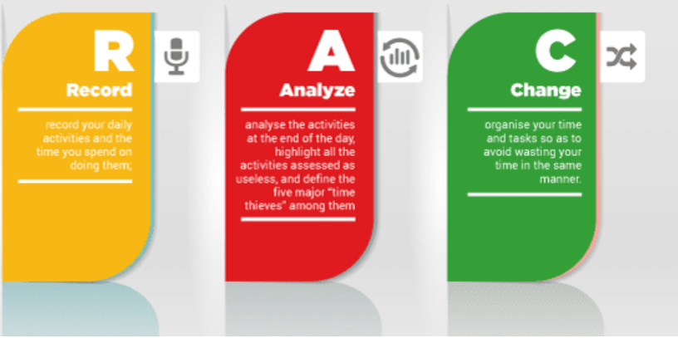 Rac Method (Jovanov, 2016)
One very popular and widely used time management method is Stephen Coveys matrix, time management method which uses a grid split into four sections ‘each representing how your work time is divided based on significance and urgency.’(Gousset, 2021). This will allow you to again prioritise|y77cxc your daily tasks in order of urgency. It is very effective method to use to help you to determine ‘whether a certain activity brings you closer to your goals or not.’ (Mueller, 2020).
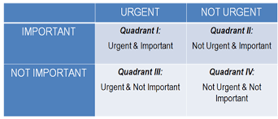Stephen Coveys matrix (Mueller, 2020)
I feel that by incorporating either one of these two methods into your daily life it will boost your confidence in yourself hence will improve your career opportunities. Employers look to hire individuals who are able to complete tasks in a timely manner without compromising on the quality of work, as it improves productivity in the workplace.

References
Cottrell, S., 2021. Skills for success. 4th ed. Macmillan Education UK, p.133.
Gousset, D., 2021. Stephen Covey's Time Management Matrix. [online] Human Skills. Available at: <https://humanskills.blog/time-management-matrix/> [Accessed 14 October 2022].
Jovanov, M. (2016) RAC. Available at: Efficient Time Management - International School (international-school.edu.rs) (Accessed: 14 October 2022).
Mueller, S., 2020. Stephen Covey‘s Time Management Matrix Explained. [online] Planet of Success. Available at: <http://www.planetofsuccess.com/blog/2015/stephen-coveys-time-management-matrix-explained/> [Accessed 14 October 2022].
Tsoneva, D., 2017. Effective Time Management. [online] unimy.com. Available at: <https://www.unimy.com/article/mba-preparation/blog-interesting-time-management> [Accessed 7 October 2022].

Neha Asif
Student Number: 2215052
TASK 1b- ESSENTIAL SKILLS FOR STUDY & EMPLOYMENT
REFLECTION
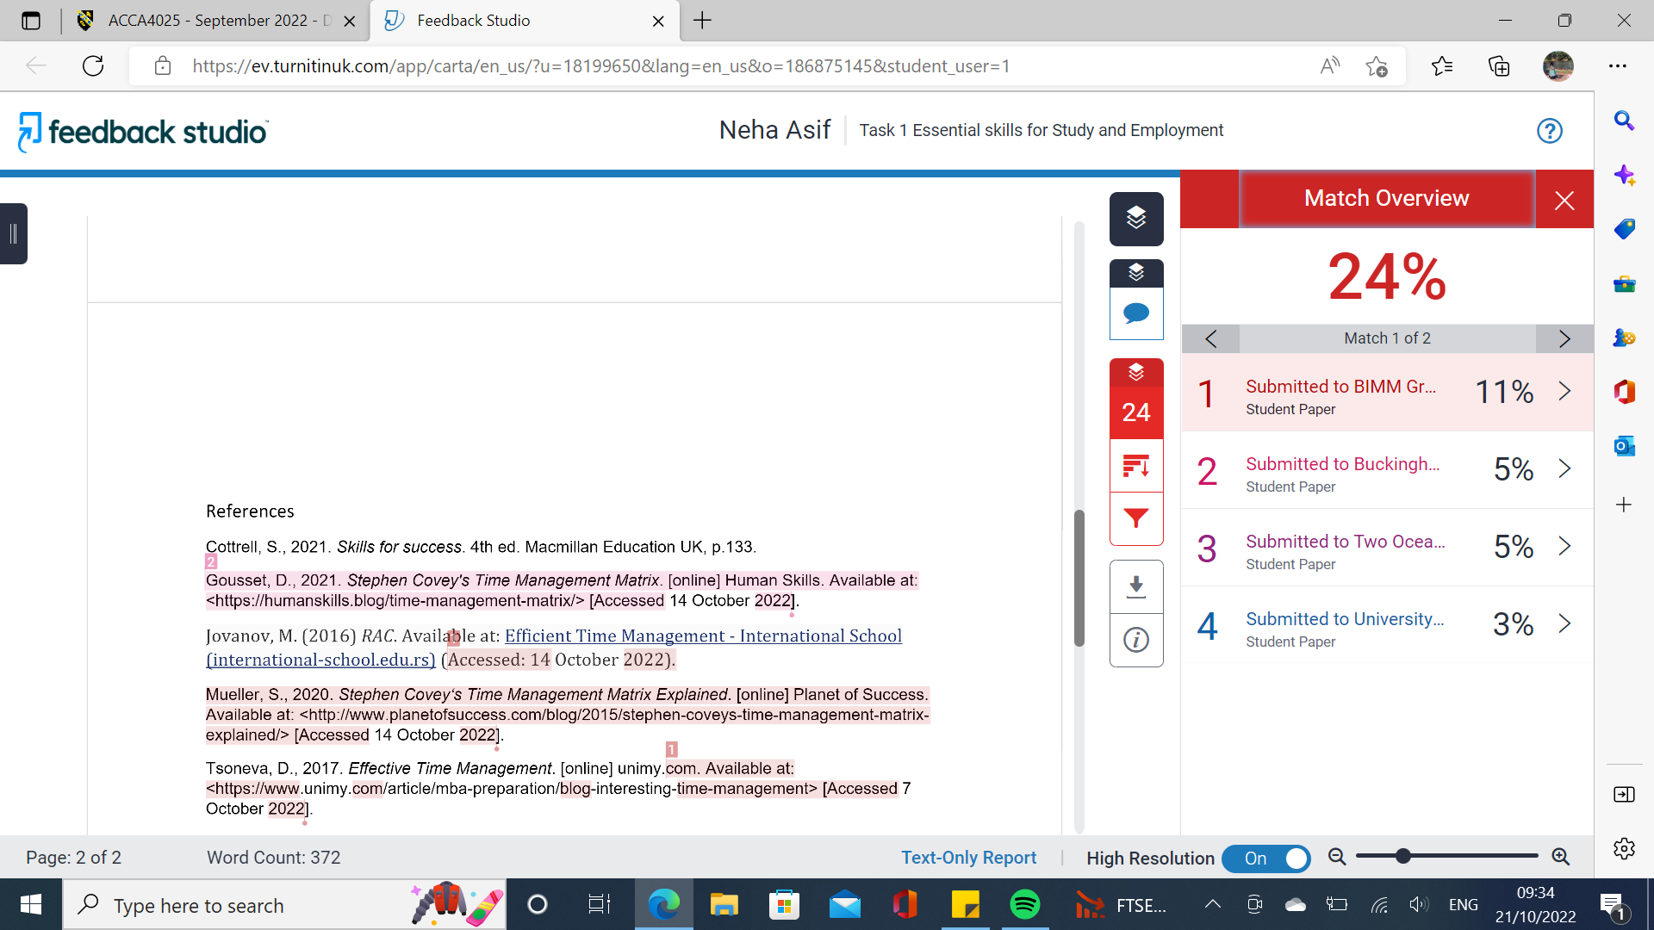
I received a similarity score of 24% of which 16% included the references, this was because other students had also used the same references in their work which Turnitin picked up. So, I could have reduced this score by filtering the setting on Turnitin to exclude the bibliography. This would have reduced my similarity score to 8%.
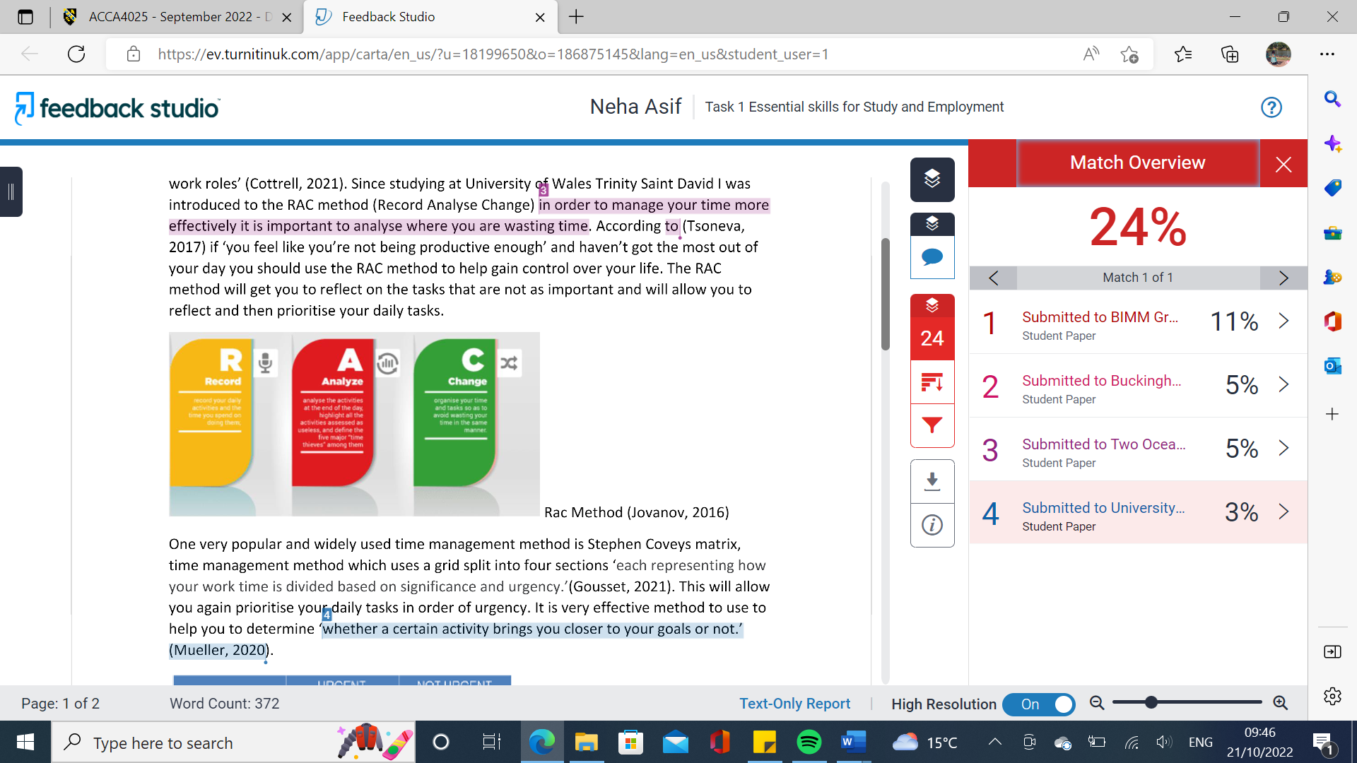
I also noted that despite using quotation marks for my in text citations one of my citations was still picked up as being 3% similar to another students paper, which shows that the exact same reference sentence was used in another students work. This shouldn’t have been picked up as it quotation marks were correctly used.
Using the Generic assessment criteria I would award myself at least 85% as I feel I have shown clear understanding of what skills are needed in employement once you have graduated, hence I have included correctly relevant sources which are correctly referenced.
Task 2 – E-PORTFOLIO SWAY
https://sway.office.com/gWkI2Dpy9B8A1J5A?ref=Link

YouTube link to presentation
https://youtu.be/iXLX5LmAG0k

Neha Asif
Student Number: 2215052
TASK 3- Automatic Referencing tool
For my assignments I found it useful to use the automatic referencing tool ‘Mendeley’ to keep a record of the references I used so that if I needed to use them later on during the course I could easily access them.
Below is a screen shot of Mendeley to add a reference to my list I first clicked on ‘Add new’.
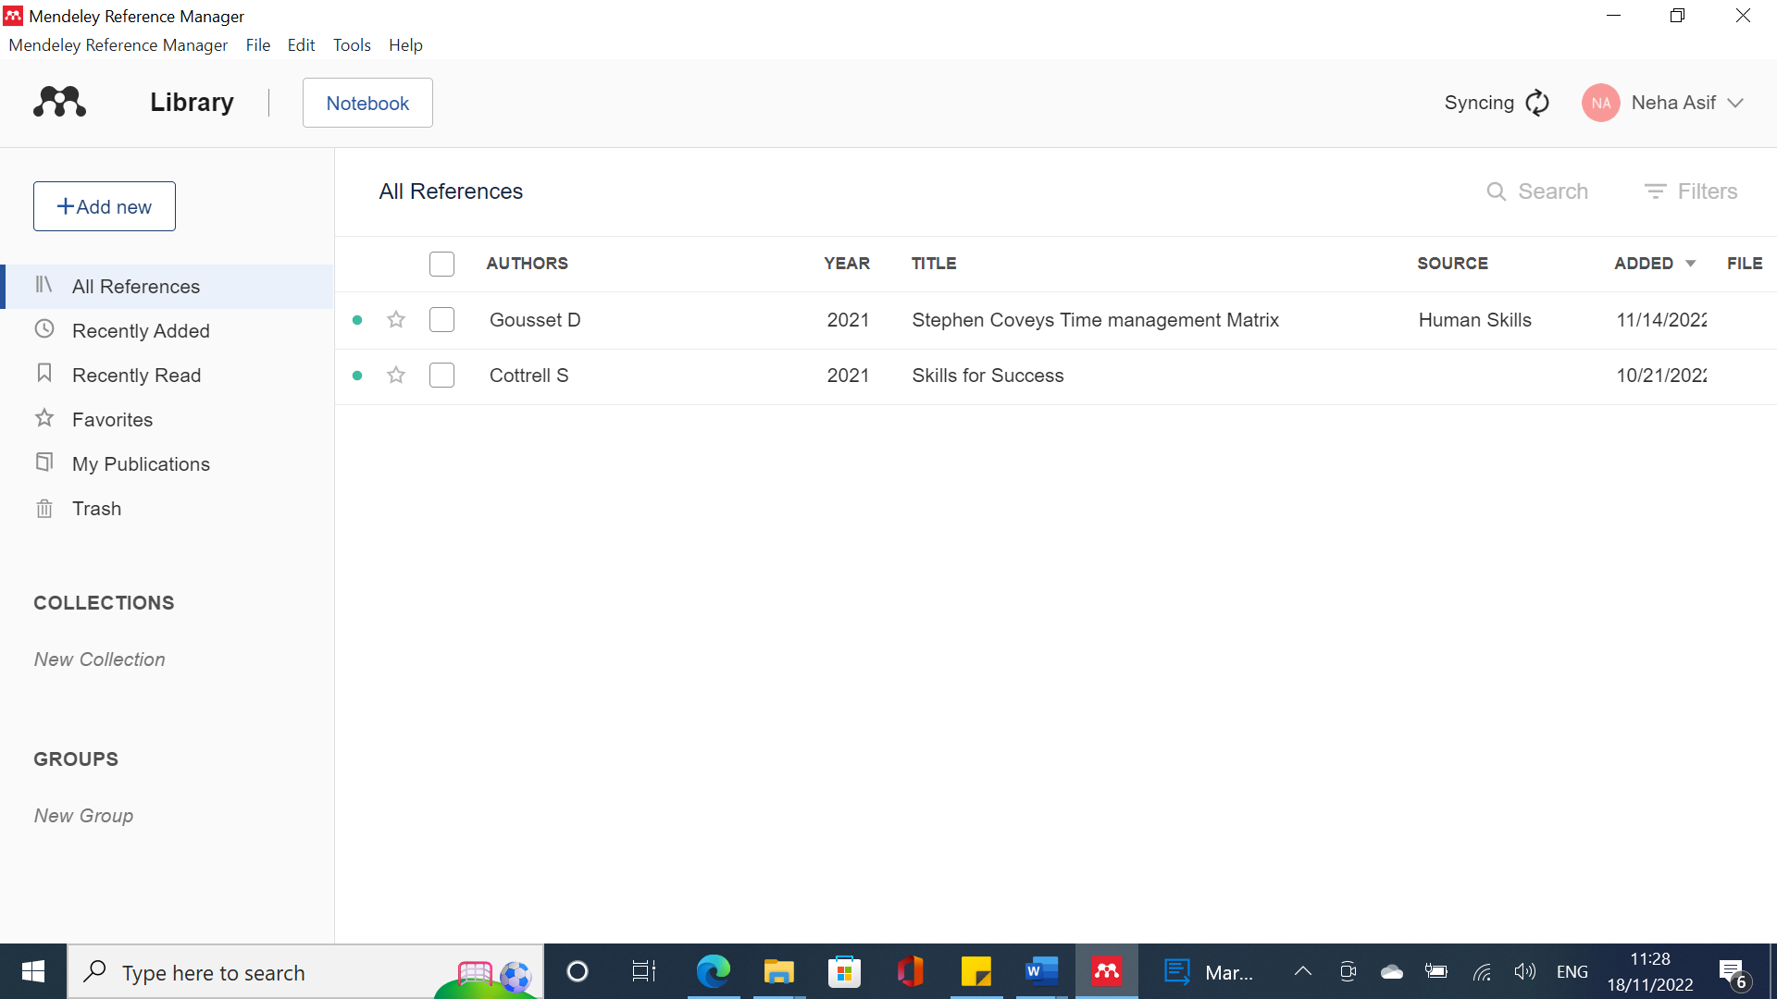
The figure above shows how to add a new reference to the Mendeley software.
Below shows I then clicked on ‘Add entry manually’ to enter in the reference I used myself. On the last slide you will see some menus such as old references or recently added references any for mark some of the references as my favourite reference you can access them through these menus.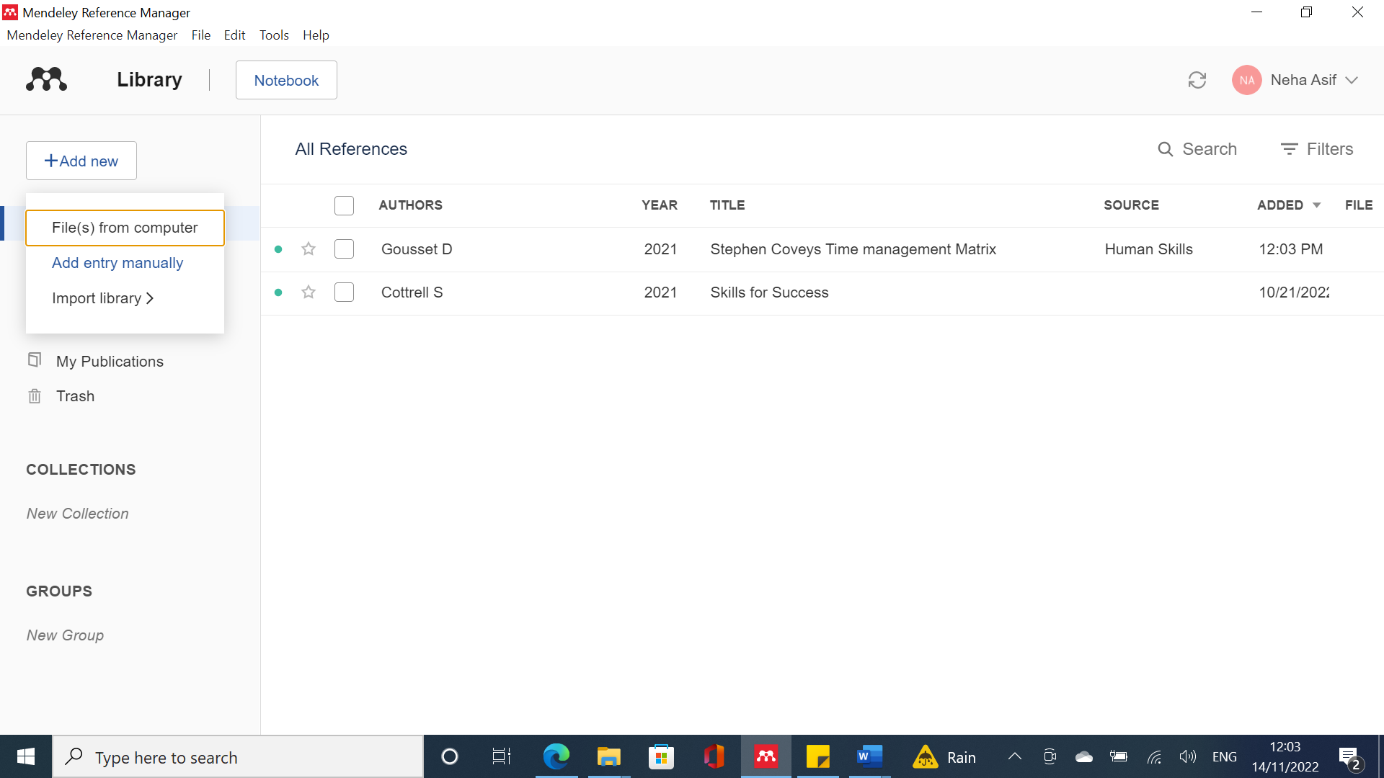
Below shows me entering the details of one of the references I used, once entering in all the details I am going to click ‘Add entry’.
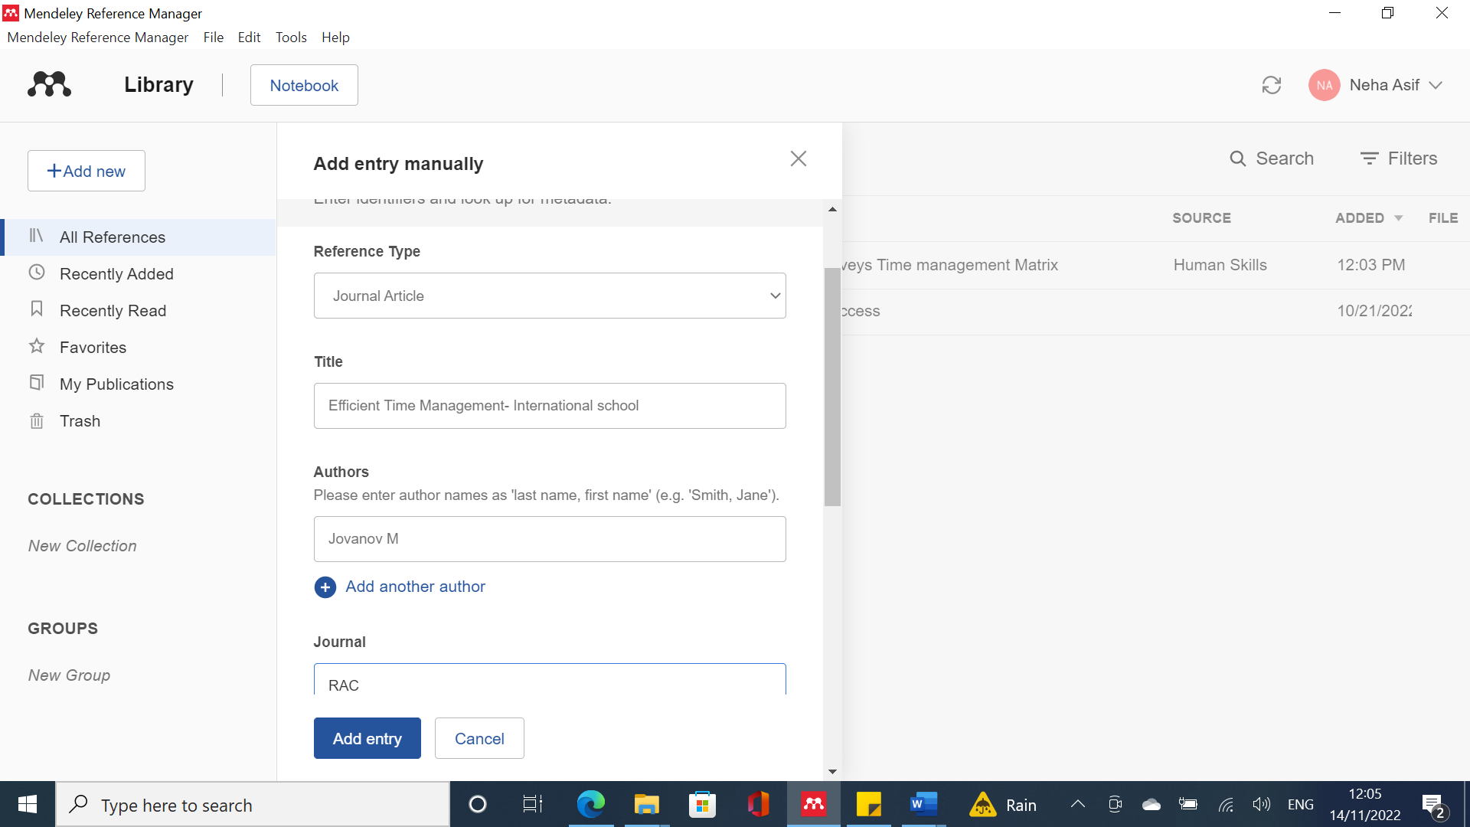
Once I clicked add entry below you can see a third reference added. Now all these references will stay in my library ready for me to access in future.
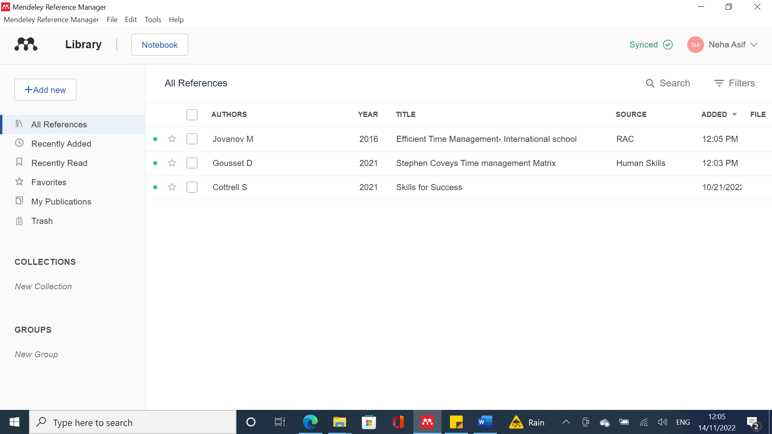
Mendeley is just a referencing tool to keep a record of all references used (like a history). It is useful to use throughout the course as I don’t have to go back into the library or online to search for these references again as I already have a record of them saved in the Mendeley library.

References:
Mendeley reference manager (2022) Mendeley. Available at: https://www.mendeley.com/reference-management/reference-manager/ (Accessed: November 18, 2022).
Takatori, K., 2016. Mendeley; Reference manager. Kyokai Joho Imeji Zasshi/Journal of the Institute of Image Information and Television Engineers 70, 320–323.
The Mendeley Support Team, 2011. 2011_Getting Started with Mendeley. Mendeley Desktop 1–16.
Tejlavwala, A.A., Stratford, M., ... Generation, D., 2016. Welcome To Mendeley Quick Start Guide Mendeley Quick Start Guide. International Journal of Innovative and Emerging Research in Engineering 3, 61–70.
Swab, M., 2016. Mendeley Data. Journal of the Canadian Health Libraries Association / Journal de l’Association des bibliothèques de la santé du Canada 37.

Group Poster
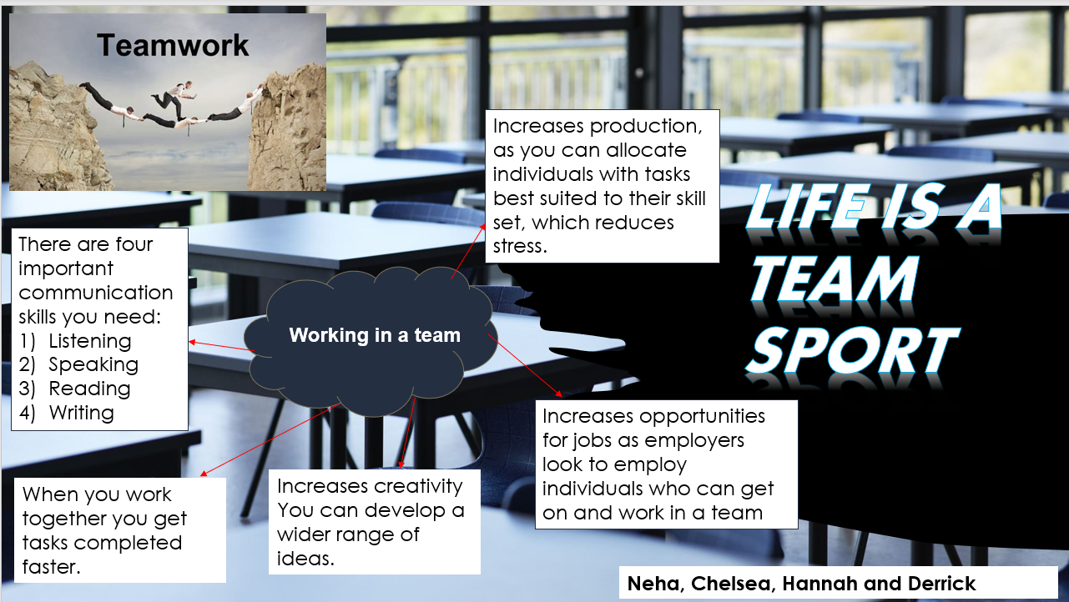
REFERENCES
- Middleton, T. (2022) The benefits of teamwork (as proven by science), Work Life by Atlassian. Atlassian. Available at: https://www.atlassian.com/blog/teamwork/the-importance-of-teamwork (Accessed: November 14, 2022).
- Parker, G.M. (2008) Team players and team work : new strategies for developing successful collaboration. 2nd ed. San Francisco, CA: Jossey-Bass.

TASK 1b- ESSENTIAL SKILLS FOR STUDY & EMPLOYMENT
REFLECTION
I received a similarity score of 24% of which 16% included the references, this was because other students had also used the same references in their work which Turnitin picked up. So, I could have reduced this score by filtering the setting on Turnitin to exclude the bibliography. This would have reduced my similarity score to 8%.
I also noted that despite using quotation marks for my in text citations one of my citations was still picked up as being 3% similar to another students paper, which shows that the exact same reference sentence was used in another students work. This shouldn’t have been picked up as it quotation marks were correctly used.
Using the Generic assessment criteria I would award myself at least 85% as I feel I have shown clear understanding of what skills are needed in employement once you have graduated, hence I have included correctly relevant sources which are correctly referenced.

