

CERTIFICATE OF HIGHER EDUCATION IN
EMPLOYABILITY SKILLS
LEVEL 4

Managing Enterprise (BMSW4011)

MODULE LEAD: Melanie Squire

EMAIL:m.squire@uwtsd.ac.uk

Submission Date: 28/03/2025

Table of Contents

Proposition of business 3
Mission statement 3
Aim 3
Objectives 3
Target Audience 4
Type of Business 4
Resources 4
Human Resources 5
Marketing activities 6
Market Research 9
Financial Resources 11
SWOT Analysis 12
What is the biggest threat to the success of your business plan and how do you propose to overcome this? 13
References 14

Proposition of business
This business plan proposes an AutoCAD training program, aimed at providing essential 2D and 3D design skills for professionals and students. AutoCAD is a widely used software in industries such as architecture, engineering, and product design, helping users create precise models while improving efficiency.

Mission statement
The course will focus on:
- Comprehensive Training: Covering AutoCAD fundamentals, intermediate tools, and advanced design techniques.
- Hands-on Learning: Practical exercises using real-world projects from Barry Council.
- Flexible Schedule: Classes offered in both morning and evening slots to accommodate different participants.
- Certification: Official recognition upon successful completion, enhancing employment prospects.

Aim
To provide high-quality AutoCAD training to students, equipping them with essential skills for academic success and professional development in design-related fields.

Objectives
- Deliver Quality Training: Provide AutoCAD courses from beginner to advanced levels.
- Offer Flexible Learning: Provide various class schedules and personalized learning paths.
- Ensure Practical Learning: Incorporate hands-on exercises for real-world application.
- Expand Reach: Attract more students through effective promotion and local partnerships.
- Maintain Affordability: Keep course fees accessible to students.

Target Audience
- Job Seekers: Research from (Indeed, 2025) and (Glassdoor, 2025) shows high demand for AutoCAD skills in roles like architect, product designer, and mechanical engineer.
- Students: Mastering AutoCAD enhances design precision, technical skills, and career preparation (Saputro & Supratno, 2020).

Type of Business
A sole trader model has been chosen due to its ease of setup, full control, and flexibility. Unlike partnerships or limited companies, a sole trader structure allows for direct decision-making without needing approvals from co-owners. Research suggests that sole traders report higher satisfaction in financial security, flexibility, and standard of living compared to employees (Houkamau et al., 2024).
However, this structure also comes with challenges, such as limited growth potential and personal liability for financial risks. Additionally, if partnerships with other organizations or funding bodies are considered in the future, a different business structure might be required, which could complicate long-term expansion (LawBite, 2023).

Resources
Barry Council has agreed to provide free lecture rooms and computers in Barry Library showed in figure 1,2 and 3, significantly reducing operational costs. As a backup plan, university facilities are also an option, as they offer computer labs and are supportive of community education initiatives.
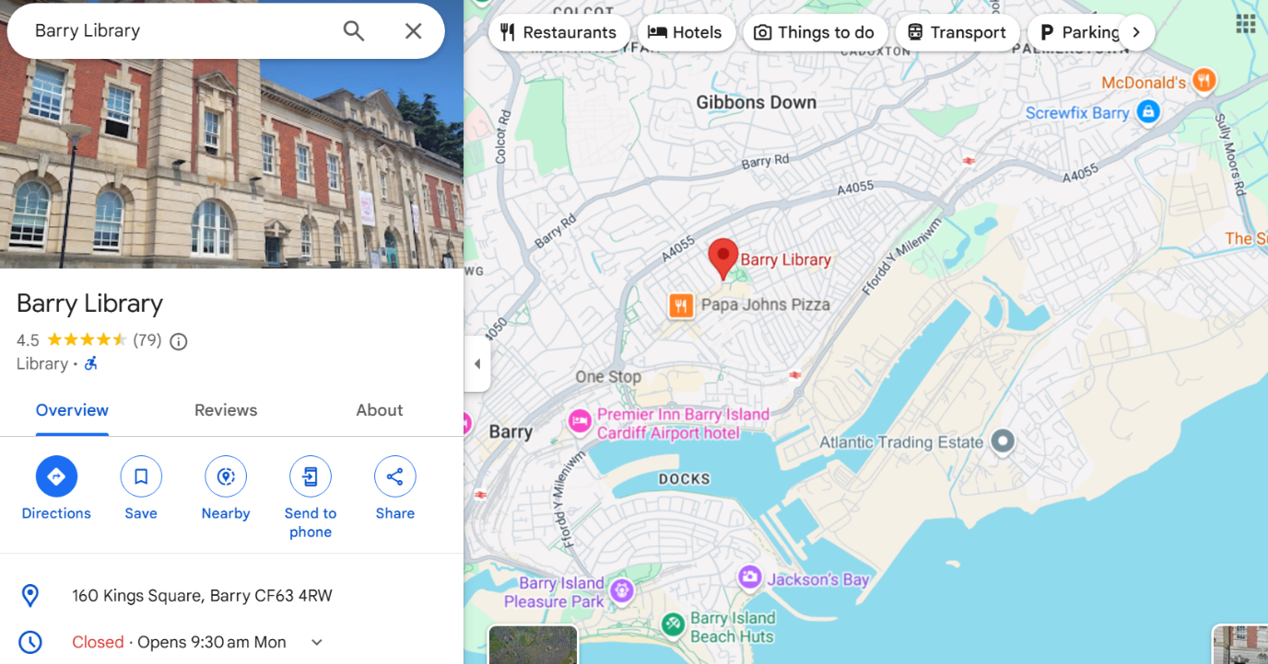
Figure 1

Figure 2
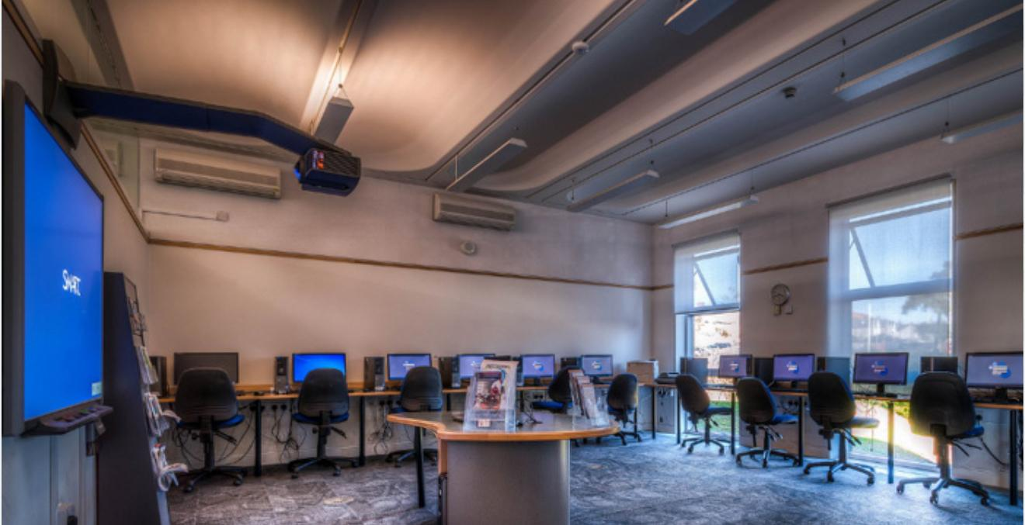
Figure 3
Each student will need to create their own AutoCAD account, which includes a 30-day free trial but they can also use the paid membership through Barry library computers. After the course, users will need to purchase a subscription, with pricing options ranging from £60 per month for 2D access to £2,046 per year for full professional access (Autodesk, 2025).

Human Resources
At the initial stage, the program will operate without additional staff, keeping costs low. If demand grows, mentorship roles may be introduced, allowing past students to assist current learners. This would create an opportunity for graduates to earn money while enhancing their teaching and technical skills.

Marketing activities
A combination of digital marketing, local outreach, and word-of-mouth promotions will be used to attract students and establish credibility (Hennigan, 2023):
- Online Promotion:
  - Social media ads targeting relevant demographics on Facebook, Instagram, and LinkedIn.
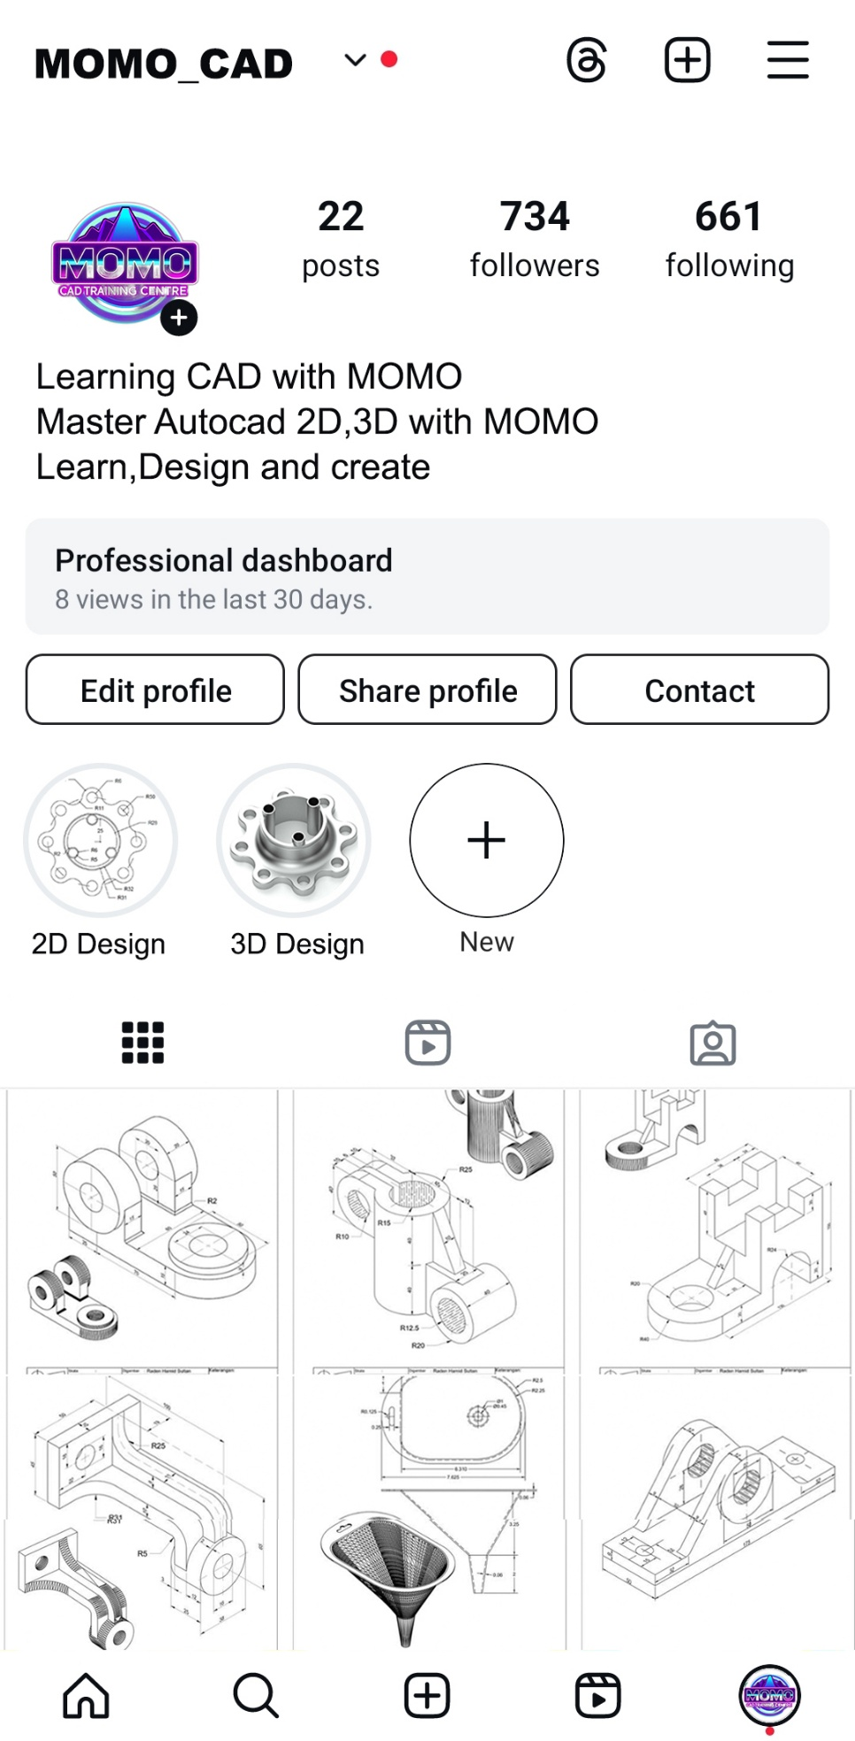
Figure 4
  - Advertising on the Barry Council website to increase visibility.
  - Email marketing campaigns targeting local job seekers, college students, and design professionals.
- Local Outreach:
  - Distributing flyers and posters at libraries, universities, and job centres.

Figure 5
  - Networking with educational institutions to encourage student referrals.
  - Word-of-mouth marketing, offering incentives such as discounts for referrals from previous trainees.
- Free Workshop: 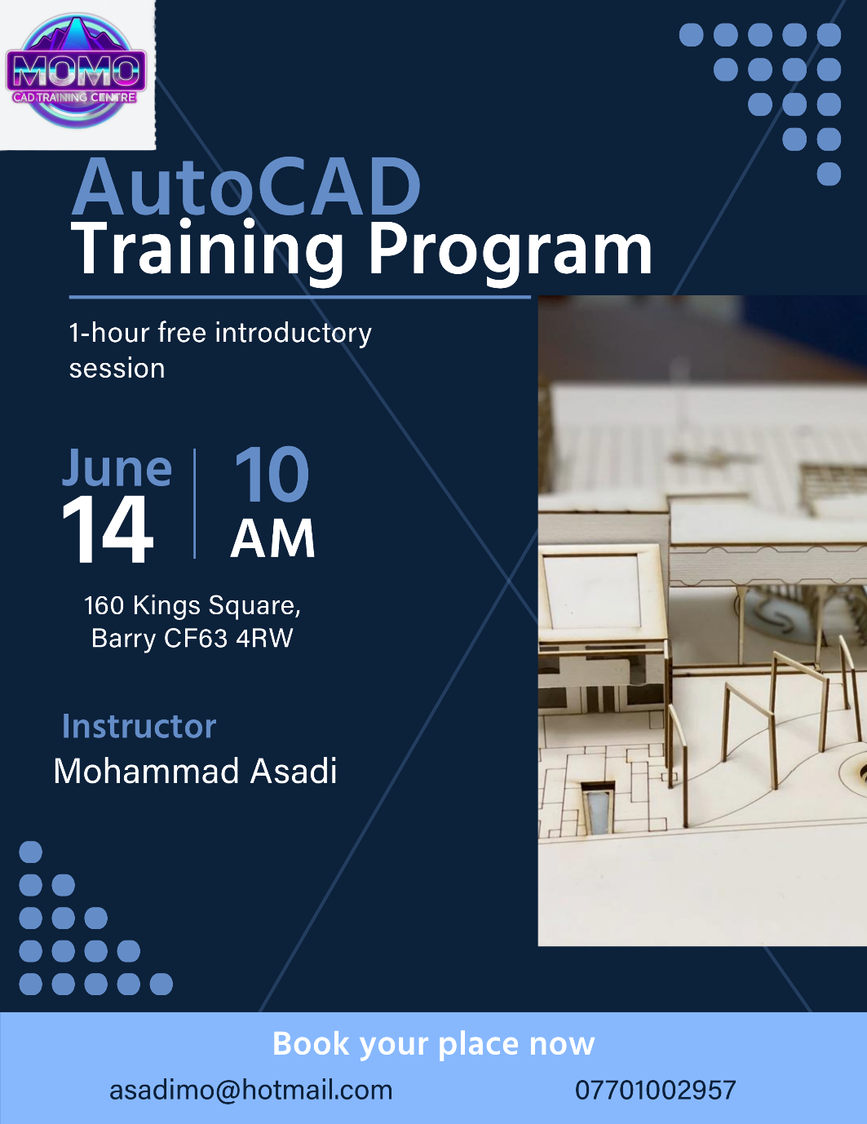
Figure 6
A 1-hour introductory session at Barry Library, providing hands-on experience to attract potential students, demonstrate course value, and encourage sign-ups.

Market Research
As shown in Figure 7, official AutoCAD courses can cost between £445 and £495 for in-centre training (AutoCAD Essentials Training, 2025). These prices cover only essential modules, and a comprehensive course could cost thousands of pounds, excluding the application membership fee and the expense of a capable computer.

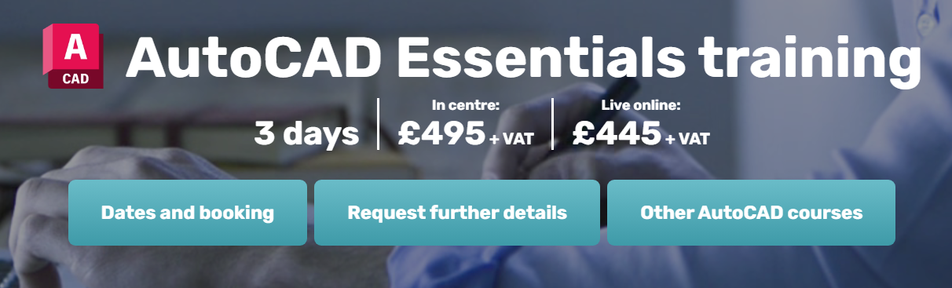
Figure 7
Research indicates no local organisations in Barry consistently offer AutoCAD training, and even in Cardiff, in-person options are limited. Many learners resort to online courses, but in-person learning provides clear advantages, including better academic performance, personalized feedback, and a stronger sense of community, contributing to a more effective educational experience (Berry College, 2024).
Figure 8 demonstrates the rising demand for vocational qualifications, with a notable 9% increase in certificates issued for the Construction, Planning, and Built Environment sector (Ofqual, 2024). This growth highlights the importance of AutoCAD in vocational education, as it equips students with essential skills for construction and engineering careers.

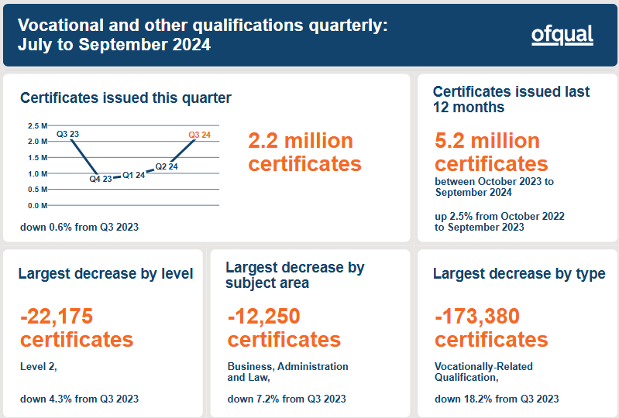
Figure 8
To refine our pricing, marketing, and course content, further research will be conducted to analyse local demand, pricing expectations, and learner preferences. This will help ensure the program aligns with what local professionals and students are looking for, making it more competitive and valuable in the long run.

Financial Resources
The business is primarily financed through self-funding and student fees, with potential future collaborations. Enrollment starts with 10 students in Month 2, increasing to 40 by Month 6, ensuring steady revenue growth. Initial setup costs (£3,000) are covered within three months, leading to profitability.
Research revealed no consistent AutoCAD courses in Barry and limited options in Cardiff, leaving many to rely on online classes. However, in-person learning offers clear advantages, including better academic performance, personalized feedback, and a stronger sense of community, enhancing the overall educational experience (Berry College, 2024).
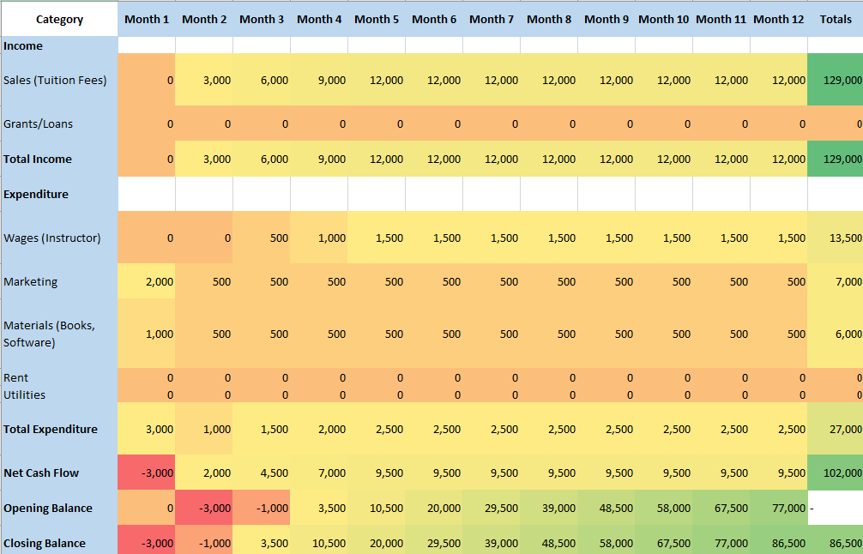
Figure 9

The pie chart illustrates the financial breakdown:
- Blue (Revenue)
- Orange (Expenses)
- Grey (Net Cash Flow)

The financial forecast indicates the business will be sustainable and profitable within the first year.

SWOT Analysis
This section uses a SWOT analysis to assess strengths, weaknesses, opportunities, and threats, helping to build a sustainable and competitive strategy and prepare for future challenges and opportunities (White and Bottorff, 2024).
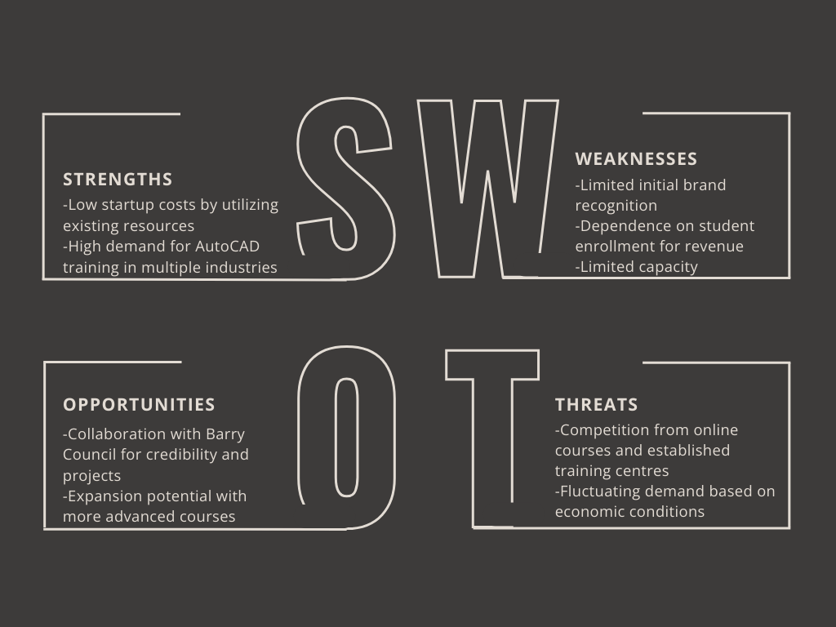
Figure 10 (Sindelkova, 2024)

What is the biggest threat to the success of your business plan and how do you propose to overcome this?
To compete with online courses and established training centers, we will emphasize practical, hands-on experience by integrating real-world projects from Barry Council, making our training more valuable than theory-based alternatives.
To manage fluctuating demand due to economic conditions, we will implement flexible payment plans and explore potential funding or sponsorships from local businesses, ensuring accessibility and steady enrollment.
To ensure that the business plan aligns with the needs of the local community, further market research will be conducted. This will include surveys targeting potential trainees, interviews with industry professionals, and an analysis of local job postings to determine the demand for AutoCAD skills. The findings from this research will help refine pricing strategies, course structure, and marketing approaches.

References
AutoCAD Essentials training (2025). Armada. [online] Armada. Available at: https://www.armada.co.uk/course/autocad-training/?msclkid=766dd40fcf831cedfe71b3bca88315a2 [Accessed 17 Feb. 2025].
Autodesk. (2025). Autodesk AutoCAD. [online] Available at: https://www.autodesk.com/uk/products/autocad/overview?panel=buy&mktvar002=afc_gb_nmpi_ppc&AID=10994792&PID=2016554&gclsrc=3p.ds&ds_rl=1232386&ds_rl=1232407&ds_rl=1232410&gclid=8238cd6c475d129a00beaadf0d2f2ec7&gclsrc=3p.ds&ds_rl=1232386&ds_rl=1232407&ds_rl=1232410&msclkid=8238cd6c475d129a00beaadf0d2f2ec7 [Accessed 17 Feb. 2025].
Autodesk.com. (2021). AutoCAD Features | 2025 New Features | Autodesk. [online] Available at: https://www.autodesk.com/uk/products/autocad/features.
Berry College (2024). The In-person Advantage: Why Face-to-face Education Has Benefits. [online] www.berry.edu. Available at: https://www.berry.edu/articles/blog/2024/in-person-advantage.
Bramble, R. (2024). What is a Sole Trader? Pros and Cons for the Self-Employed. [online] www.crunch.co.uk. Available at: https://www.crunch.co.uk/knowledge/article/what-is-a-sole-trader.
Glassdoor (2025). Glassdoor Job Search | Find the job that fits your life. [online] Glassdoor. Available at: https://www.glassdoor.co.uk/index.htm.
Hennigan, L. (2023). Small Business Marketing In 2023: The Ultimate Guide – Forbes Advisor. [online] www.forbes.com. Available at: https://www.forbes.com/advisor/business/small-business-marketing/.
Houkamau, C. et al. (2024) ‘Better off solo? Comparative well-being of Māori employers, sole traders and paid employees’, Economic and industrial democracy, 45(4), pp. 1294–1324. Available at: https://doi.org/10.1177/0143831X231224587.
indeed (2025). Job Search | Indeed. [online] Indeed.com. Available at: https://uk.indeed.com/?from=gnav-jobsearch--indeedmobile.
LawBite (2023). Advantages and disadvantages of a sole trader business. [online] www.lawbite.co.uk. Available at: https://www.lawbite.co.uk/resources/blog/advantages-and-disadvantages-of-sole-trader.
Ofqual (2024). Vocational and other qualifications quarterly: July to September 2024. [online] GOV.UK. Available at: https://www.gov.uk/government/statistics/vocational-and-other-qualifications-quarterly-july-to-september-2024.
Saputro, B.E. and Supratno, S. (2020) ‘Implementation of the use of AutoCAD applications in increasing basic competence in describing techniques in vocational education’, IOP Conference Series: Materials Science and Engineering, 830(4), pp. 42022-. Available at: https://doi.org/10.1088/1757-899X/830/4/042022.
Sindelkova, L. (2024). Black White Simple Aesthetic Business Swot Analysis Graph - Templates by Canva. [online] Canva. Available at: https://www.canva.com/templates/EAGTE4GWweg-black-white-simple-aesthetic-business-swot-analysis-graph/.

Reflection

Table of Contents

Introduction 17

Description 17

Feelings 17

Evaluation 17

Analysis 17

Conclusion 17

Action Plan 17

Final Thoughts 18

Developing my business plan was both a challenging and rewarding experience. Initially, I felt a mix of uncertainty and pressure, especially considering potential collaborations with Barry Council and other stakeholders. The possibility of managing external partnerships added to my concerns, as it meant increased accountability and expectations. However, I approached this challenge by breaking down the business plan into smaller tasks, allowing me to manage each component more effectively.
Using the Gibbs Reflective Cycle, I can reflect on this experience as follows:
Description:
At the start, I felt overwhelmed by the need to address all aspects of the business, from human resources to cash flow management. My goal was to create a realistic and practical business plan that would not only meet academic requirements but also be viable in the real world.
Feelings:
Although I initially lacked confidence, as I progressed through research and planning, I noticed my confidence growing. Successfully completing each section of the plan reinforced my belief in my entrepreneurial abilities.
Evaluation:
What went well was my methodical approach, which helped me thoroughly address each aspect of the business. My research into market demand and competitor analysis provided a solid foundation for my business strategy. However, the process was not without challenges. Navigating the legal and financial aspects of the plan required me to step out of my comfort zone and seek additional resources and guidance.
Analysis:
This experience enhanced my research and analytical skills, particularly in assessing market demand and evaluating competitors' strategies. I also deepened my understanding of different business structures, such as sole traders and partnerships, and learned how to select the best structure based on the specific needs of my business. Additionally, I improved my ability to manage resources efficiently, understanding when to sacrifice short-term gains for long-term efficiency.
Moreover, I developed strong decision-making skills, as I had to carefully evaluate different options for structuring the business and allocating resources effectively. Each choice I made required weighing potential risks and rewards to ensure the business plan remained practical and sustainable. Furthermore, this process strengthened my strategic thinking, allowing me to approach the plan with a long-term perspective. By analyzing market trends and competitor positioning, I was able to create a business strategy that was both adaptable and competitive.
Conclusion:
Overall, this process has reinforced my entrepreneurial strengths, particularly my creativity and leadership skills, which have previously contributed to the success of my food service and restaurant business. My ability to innovate and lead projects effectively was evident throughout the business plan development, boosting my confidence in pursuing new ventures.
Action Plan:
One area where I need improvement is product knowledge. While I have a strong understanding of my current businesses and their offerings, gaining insight into new products and services could open up opportunities for collaborations and business expansion. To address this, I plan to:
- Conduct broader research on diverse business models and industries.
- Network with professionals from different sectors to learn about their products and services.
- Engage with recent publications, including books and articles, to stay informed about industry trends.
By applying this action plan, I aim to enhance my entrepreneurial versatility, enabling me to adapt to new opportunities and drive future business success.

