Problem Solving and Decision Making
Report

Student name: Mariyana Rusafova
Student number: 2131037
Module code: BMSW4004
Module leader: Nadeem Mirza

Table of Contents
Introduction 3
The Workplace Problem 3
Analysing Information 4
Root Cause Analysis (RCA) 4
Pressure-Packed Environment 4
Inadequate Work-Life Balance 4
Shortage of Resources 4
Lack of Management Backing 5
Applying the Situational Analysis Model 5
PESTLE Analysis 5
Range of Alternative Solutions 6
Evaluation of Alternative Solutions 7
Implementation of the Solution 8
Communication Plan with Shareholders 9
Stakeholders 9
Influence/Power and Interest Matrix 9
Stakeholder Engagement Plan 10
Monitoring and Review Technique 10
Conclusion 11
References 12

Introduction
The hospitality sector is one in which the ability to solve problems and make sound decisions is of paramount importance. This is why hotel are service industries that must continually adjust to meet the demands of a diverse clientele and survive in the face of market shifts, economic uncertainty, and even natural catastrophes and pandemics (Clark and Chen, 2009). There are more than 130 Holiday Inns around the United Kingdom (Hospitality Net, 2023). Both business travelers and leisure tourists may take use of their contemporary conveniences and prime locations. The brand's hotels, restaurants, and other amenities are all designed to make visitors feel at home and provide them with a pleasant stay. The purpose of this report is to identify the issue leading to high staff turnover at Holiday Inn, analyze it, offer a set of remedies, and outline how those ideas will be communicated to the appropriate parties. Hotel managers who are adept problem-solvers are able to rapidly and effectively resolve guest complaints.

The Workplace Problem
Many staff at Holiday Inn in the UK suffer from stress due to their jobs. There is a lot of strain and stress in the hotel sector because of the long hours and constant interaction with visitors. This may be difficult, especially for individuals who are just starting out in the field or have never held a customer service position before (Jamal, 2011). Employees may also face challenging circumstances, such as responding to customer complaints or working through periods of high demand. All of these things might make it hard to maintain a healthy work-life balance, leading to feelings of being swamped and burned out. The COVID-19 epidemic has compounded the difficulties of already demanding jobs. Staff at hotels have had to swiftly adjust to new safety rules and constraints including stricter cleanliness standards and the implementation of social isolation policies. Because of this, already stressed workers have had even more work piled on their plates. Those worried about their own well-being or the health of those they care about have also experienced a rise in anxiety as a result of the epidemic. The health of the staff and the hotel's bottom line are both vulnerable to the effects of stress on the job. Employees may be less invested in their work as well as unable to deliver excellent service to customers when they are under stress (Schwepker Jr and Demetriou, 2021). Management must take the initiative to address the issue of stress in the workplace. Managers should be conscious of the difficulties workers encounter and offer them resources to cope with stress.

Analysing Information

Root Cause Analysis (RCA)
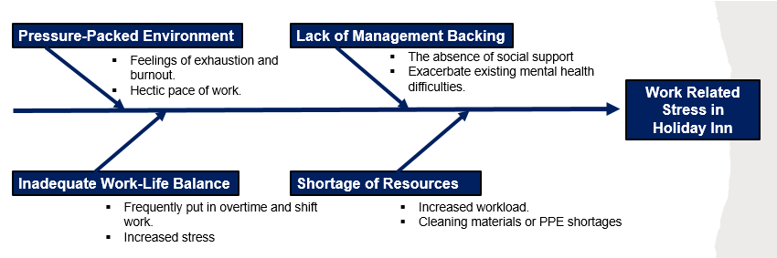
Figure – 1: Fishbone Analysis (Source: Author)

Pressure-Packed Environment
Employees may experience feelings of exhaustion and burnout if they are under constant pressure to satisfy guests' expectations but struggle to adequately manage their workload (Nickson, 2013). The hectic pace of work can make it hard for people to take care of themselves physically and mentally by taking pauses and putting themselves first.

Inadequate Work-Life Balance
Employees at Holiday Inn UK frequently put in overtime and shift work, which might disrupt their lives. Employees may experience increased stress and burnout due to the inability to adequately organize and handle their personal life around unpredictable work hours. Workers may struggle to spend quality time with loved ones, pursue personal interests, and take care of their physical and mental health. This imbalance can have an effect on both job satisfaction and motivation.

Shortage of Resources
The COVID-19 epidemic has increased the burden of hotel staff due to the necessity for additional cleaning and the implementation of social isolation policies. It's possible that workers may struggle to cope with the increased workload since they don't have access to the tools they need (Stewart and Brown, 2019). Lack of resources, such as cleaning materials or PPE, can increase the burden on workers already struggling with the stresses of their jobs.

Lack of Management Backing
If supervisors don't give appropriate training on managing stress and resilience, employees may feel unsupported. Feelings of anxiety and exhaustion can be exacerbated by the absence of social support. Managers may also contribute to the problem by failing to foster an environment where employees feel comfortable talking about their struggles with stress and mental health (Gary, 2011). Employees may be discouraged from getting treatment, which can exacerbate existing mental health difficulties.

Applying the Situational Analysis Model

PESTLE Analysis
The PESTLE study is a useful strategic tool for assessing the potential environmental influences on a company or sector.
Political Factor
The hotel business in the UK can feel the effects of political climate in a big way. Hotel business is sensitive to governmental rules, regulations, and taxes (Tan and Despotis, 2021). The hotel sector relies heavily on tourists, who may be put off by the region's political unpredictability.
Economic Factor
Holiday Inn is vulnerable to the UK economy. Hotel prices and demand can be affected by macroeconomic variables including inflation, currency exchange rates, including economic development. Business and recreational travel demand may rise when the economy is doing well and fall when it is not.
Social Factor
Holiday Inn may feel the effects of shifting societal norms and demography. For instance, a more wheelchair-accessible building may be necessary for an ageing population, while a more technologically advanced building may appeal more to a younger crowd (Tan and Despotis, 2021). The hotel's management and advertising could change because of societal shifts like the growing interest in ecotourism. The hotel needs to accommodate its guests' evolving tastes by providing them with new services.
Technological Factor
New technologies are driving ongoing change in the hotel business. Mobile applications and internet booking platforms, for instance, have simplified the hotel reservation and research processes. Technologies like computerized check-in as well as housekeeping robots are changing the way hotels function (Tan and Despotis, 2021). The Holiday Inn Hotel UK needs to spend money on technology if it wants to keep up with the competition and provide its guests a pleasant stay.
Legal Factor
Health and safety rules, as well as legislation pertaining to employees, must be followed by hotels in the United Kingdom. If the hotel wants to prevent fines and damage to its reputation, it needs to make sure it follows these rules. Food and beverage rules and green business practices are two more areas where hotels must comply. The Holiday Inn Hotel in the United Kingdom must keep its guests' health, safety, and the environment to the highest possible standards at all times.
Environmental Factor
The hospitality sector may feel the effects of climate change and other environmental problems. The hotel is responsible for reducing its carbon footprint by considering and implementing sustainability strategies. Travelers who worry about their influence on the planet may prefer lodgings that make sustainability a top priority. The Holiday Inn Hotel in the United Kingdom has introduced a number of eco-friendly policies, such as using less energy to light the building, using less water, and recycling more (Tan and Despotis, 2021).

Range of Alternative Solutions
Serial No. | Activity - 1 | Activity - 2 | Activity - 3
First Solution | Take a poll to find out how their workers feel about health and wellness in the workplace. | Develop a health and wellness program tailored to the demands of their workforce. | Feedback surveys, rates of participation, and other performance measures can be used to gauge the success of a wellness program.
Second Solution | Look at their workers' present work schedules to see if any changes may be made to increase productivity. | Create adaptable timetables that serve the hotel and its workers equally well. | Inform workers of the changes and instruct them on how to handle their task in light of the new timetables.
Third Solution | Take a poll to see how much emphasis is now being placed on educating managers to care for their employees. | Create a management course focused on the health and happiness of your staff. Topics for the course may include active listening, coping with stress, and improved communication. | Survey responses and measures of performance can be used to determine how well a training program is working..

Figure – 2: Alternative Solutions (Source: Author)

Evaluation of Alternative Solutions
The weighted decision matrix can give a numerical assessment of each choice by giving weights to different factors, so that the final decision is the most appropriate and well-balanced one possible.
Particulars | First Solution | Weight | Second Solution | Weight | Third Solution | Weight
Activity - 1 | 5 | 14 | 5 | 13 | 5 | 12
Activity - 2 | 4 | 13 | 4 | 11 | 4 | 11
Activity - 3 | 3 | 11 | 3 | 14 | 3 | 13
 | Total - 155 |  | Total - 151 |  | Total - 143

Figure – 3: Weight Decision Matrix (Source: Author)
From the weight decision matrix above we can see that the alternative to choose is the first solution.

Implementation of the Solution
Holiday Inn will have to develop an Employee Wellness Program to help its staff deal with the stress and lack of balance between work and life they've been experiencing. The ADKAR framework of managing changes will be used to carry out this solution.
Awareness: Holiday Inn will first inform its staff of the importance of the Employee Wellness Program and share its goals and objectives with them.
Desire: Holiday Inn will promote the program by emphasizing the benefits it will provide to workers in terms of their health and happiness as well as their productivity and contentment in their jobs (Tang and Tang, 2019).
Knowledge: Staff members will be informed of the program's specifics, such as what will be offered, when, and how to participate.
Ability: Holiday Inn will give tools like flexible scheduling and an intuitive web hub for workers to use in order to participate in the program.
Reinforcement: Finally, Holiday Inn will provide rewards and acknowledgment to staff who take part in the program and provide feedback to guarantee the program's success as well as long-term sustainability (Tang and Tang, 2019). Holiday Inn will also take comments from staff to fine-tune the program over time.

Communication Plan with Shareholders

Stakeholders
i. HR Manager
ii. Wellness Executive
iii. Head of Human Resources Management

Influence/Power and Interest Matrix

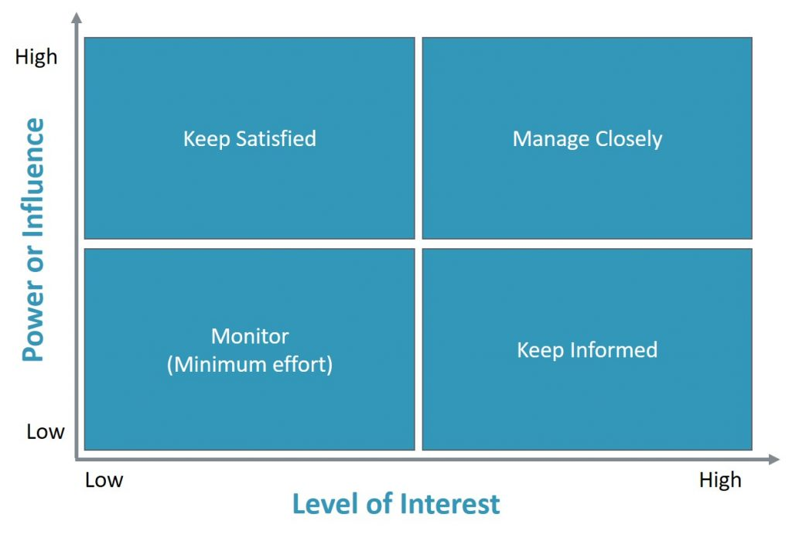
Figure – 4: Power and Interest Matrix (Source: Thamma, 2023)
In light of the matrix for Premier Inn:
i. HR Manager – Keep Satisfied
ii. Wellness Executive – Minimum Effort
iii. Head of Human Resources Management – Keep Informed

Stakeholder Engagement Plan
Stakeholder Communication Plan
Stakeholders | Power/Interest | Key Interests and Issues | Communication Vehicles | Frequency | Comments
HR Manager | High | Wellness of Employees | Virtual and Face-to-Face Meetup | Weekly | Seek Feedback
Wellness Executive | Moderate | Motivated Workforce | Virtual and Face-to-Face Meetup | Monthly | Seek Retention
Head of Human Resources Management | Low | Departmental Satisfaction | Notices and E-mails | Quarterly | Seek Growth

Figure - 5: Stakeholder Communication Plan (Source: Author)

Monitoring and Review Technique
Holiday Inn will use the ADKAR model for change management to keep an eye on the progress being made on the Employee Wellness Program's implementation plan.
Awareness: The success of the awareness stage will be measured by the percentage of employees who have been made aware of the program, who have grasped its significance, and who are eager to become involved.
Desire: Holiday Inn will measure staff sentiments about the program and their enthusiasm for taking part in it to keep tabs on the desire phase (Tang and Tang, 2019). The level of employee involvement will be monitored through regular focus group discussions and surveys to help pinpoint problem areas.
Knowledge: Holiday Inn will guarantee that all program materials are kept up-to-date and correct by conducting frequent reviews. Employees' comprehension of the program and its intricacies will be measured through questionnaires and tests designed to gauge their reactions.
Ability: The success of the program will be measured by how well the resources are distributed and utilized by the staff. In order to pinpoint problems and implement fixes, data on participation rates and thoughts on the program's timetable and web site will be gathered.
Reinforcement: The response rates to recognition and incentives will be gathered and analyzed to determine the efficacy of reinforcing strategies (Tang and Tang, 2019). We will also analyze employee comments on the program's effect on their productivity, happiness on the workplace, and health and safety.

Conclusion
Holiday Inn UK's workers' health, productivity, and contentment on the job may all benefit greatly from the introduction of a company-wide Employee Wellness Program. The ADKAR model of change management ensures the program's smooth rollout by focusing on five key areas. Regular review and modifications based on employee input and performance indicators will further strengthen the program. In the long run, prioritizing employee wellbeing may boost both employee satisfaction and the company's bottom line.

References
Clarke, A. and Chen, W. (2009) International hospitality management. Routledge.
Gary, D. (2011) Human resource management. Pearson Education
Hospitality Net, (2023) Holiday Inn by IHG. [online] Hospitality Net. Available at: &lt;https://www.hospitalitynet.org/brand/23000048/holiday-inn.html&gt; [Accessed 25 Apr. 2023].
Jamal, M. (2011) Job stress, job performance and organizational commitment in a multinational company: An empirical study in two countries. International Journal of Business and Social Science, 2(20).
Nickson, D. (2013) Human resource management for the hospitality and tourism industries. (2nd. ed.) Routledge.
Schwepker Jr, C.H. and Demetriou, C.K. (2021). Using ethical leadership to reduce job stress and improve performance quality in the hospitality industry. International Journal of Hospitality Management, 94, p.102860.
Stewart, G.L. and Brown, K.G. (2019) Human resource management. John Wiley & Sons.
Tan, Y. and Despotis, D. (2021) Investigation of efficiency in the UK hotel industry: A network data envelopment analysis approach. International Journal of Contemporary Hospitality Management.
Tang, K.N. and Tang, K.N. (2019) Change management. Leadership and change management, pp.47-55.
Thamma, L. (2023) Stakeholder analysis using the power interest grid. [online] Available at: &lt;https://www.projectmanagement.com/wikis/368897/Stakeholder-Analysis--using-the-Power-Interest-Grid&gt; [Accessed 25 Apr. 2023].

