
Module: | Academic and Employability Skills
Module code: | BMSW4001
Student Name | Bilkis H Rashid
Student I.D | 1817627

Resit (June’19 Student)
Resubmission date:16/12/2020

Contents
Term-1 3
Term-2 11
References 18

Term-1
Introduction
A students matriculating an institution to have degree needs to have a set of skills to ensure their efficiency in learning process (DuPaul et al, 2001). These skills are called academic skills. Some important academic skills are summarising skills, note-taking skills, presentation skills, comprehension skills, communication and time management skills. Our academic curricula require to do with a number of presentation, assignments, group works, class lectures that all require these academic skills to ensure our effective and efficient performance. As teachers asked to do these tasks either in team or individually, I always tried to accomplish my task on time taking guidance from my teachers, seniors, teammates, and following business icons and leaders on YouTube, reading articles and interviews published in journals. Besides, I worked in a Care Home where I had applied my skills and at the same time I faced some problems due to having lacking which I need to be improved. Here in this writing I am to present what are those skills, what I had done to learn these skills, how I had applied those skills in my workplace, what are the problems I faced in workplace not having required skills and the areas need to be developed.
Skills I have and need to develop
Here, in the following write-up, is the detail discussion of the skills I possess and the areas that need to be improved to develop my carrier in business management as of my expectation-
Summarising Skills
I have learnt summarising skills by this time undergoing a number of activities assigned by the course instructors that required to summarise given articles, papers, or journals. Summarising skills refer to the ability to cutting down the bare essentials of a content given. One can also simplify and clarify any complex article, sentences or situation using simple words and phrases. In academic writing, summarising is highly important (Passig and Maidel-Kravetsky, 2016). As a student I need to extract the most crucial points from a text given and rewrite theses points using my terms in easy way so that readers easily can have an idea about what the original article convey just by reading the summary I have written in my words in shortened form.
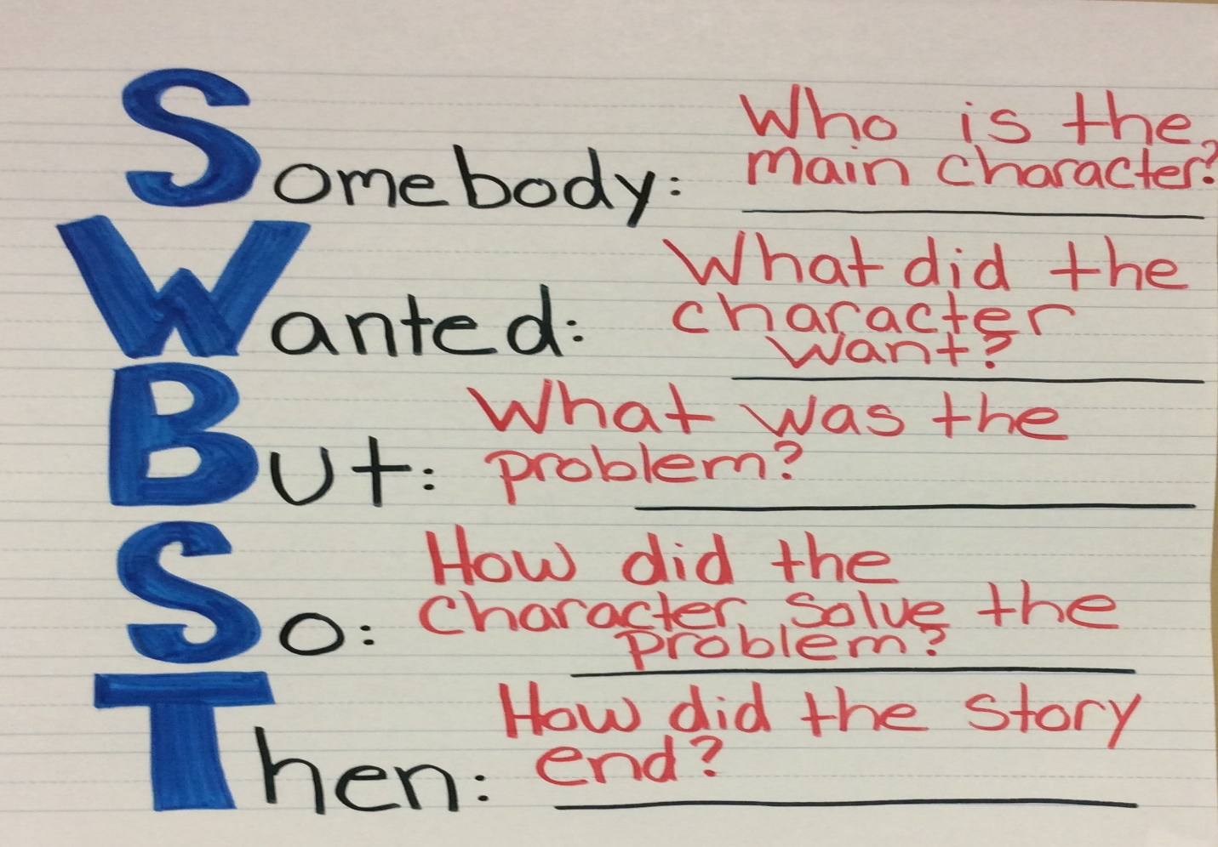
Source: (Passig, 2016)
Working in a care home, I need to tackle huge information for example if a patient everyday but all information was not of same importance. So, to retain necessary information for further use, or to do accordingly, I need to summarise. For academy purposes, I read relevant articles from different journals and papers and then, summarised what the messages been conveyed in those articles.
Summarising helps me to save time by extracting only key but relevant information to use further for any purpose, especially in academy writing. But, the only problem I have faced is I failed to use appropriate vocabulary and phrases to mean a specific thing and thus, I misinterpret my own summarised writing later on. So, I need to overcome this problem.

Presentation Skills
In today’s world presentation skills play an important role to determine to have an expected career (Griffiths, 2009). I have carried out a number of projects on presentation where I need to prepare presentation slides on specified topics and deliver speech on these slides. To prepare slides effectively, I need to learn power point presentation making and by making a number of slides, now I can easily make presentation slides for any given topic easily. But I feel have to learn more to make those slides a bit more professional looking.
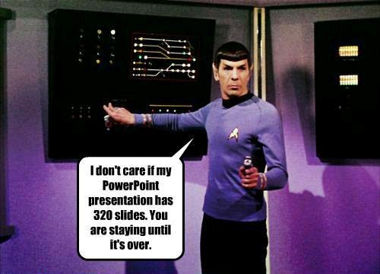
Source: UWTSD Moodle
After making presentation, I need to deliver speeches on these presentation slides. But speaking before public was a matter of shy and fear at the very beginning. Over the courses of actions, I performed for presentations been taken, I have tried to overcome my difficulties. I need to ensure proper eye contact with my audience. I need to ensure my body language and facial expressions clearly reflect what I am uttering on words too.
When I worked in care home, I had talks with patients. I need to have clear and careful conversation with them so that they can understand my words to be followed. I also maintained a proper eye contract with them, followed their body language and facial expressions.
Though all these courses of actions regarding presentation have helped me develop my presentation skills, I need to develop further to ensure professionalism in me to present any issues with more confidence and on the point.
Note-taking Skills
Notetaking means jotting down pieces of information systematically delivered in a class, seminar or other forms of discussions (Boyle, 2010). It mainly refers to the taking notes by the students in any academic discussion, especially in class lectures or on the web. I always follow a popularly goes saying that never believes your brain and thus, always try to keep notes to retain important information. In academy success that is to have expected good results it is mandatory to follow class lectures accordingly. I also took notes while working in care home to note down what have patients told me, what to do for them and when to do it.
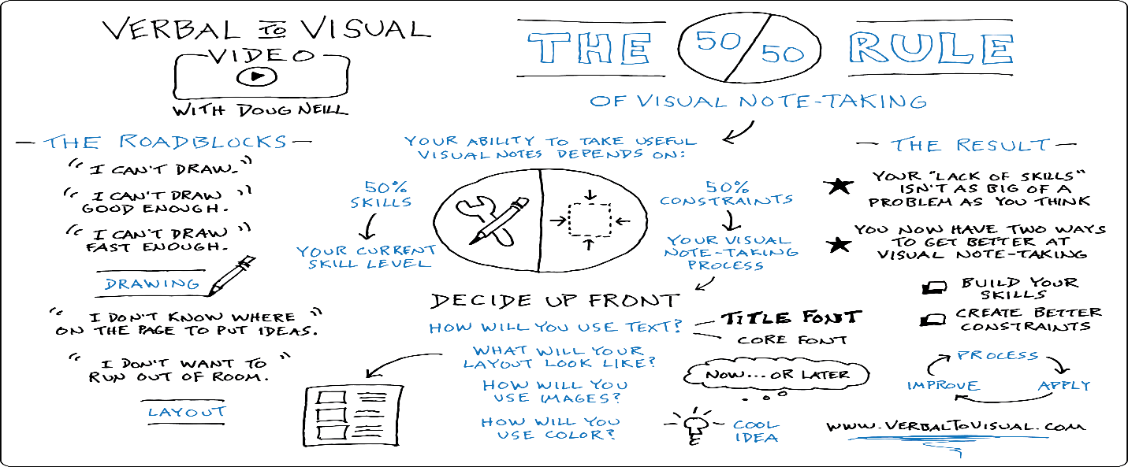
Source: (Boyle, 2010)
What I feel taking note that is it helps me to be highly concentrated and engaged with my works and thus, do on time. But the major problem by taking notes I have faced is that I often failed to understand what the teacher tried to make us understand in class and in home care, I also failed to catch some words of the patients while taking notes. So, I have to develop this skill to take note effectively.

Comprehension Skills
Comprehension skills refer to the ability of understanding any particular subject (Oakhill and Cain, 2004). In academic terms, comprehension skills help to process a text or lesson, perceive its meaning and integrate this meaning to the reader’s knowledge. To develop my comprehension skills, I need to enhance my vocabulary stock so that I can easily catch the meaning of the sentences given. To understand better, for any given situations or context to work with I raise questions to understand it clearly. Before raising questions to others I try to get it out with the clues given in the context. Sometimes I break the whole literature or passage into smaller units to understand each portion and then, relate these together to have a complete sense. Summarising can also be an appropriate way to comprehend any given passage.
Through accomplishing my course works – assignments given to be worked with, papers and journals need to go through to conduct my projects, I have followed the above mention ways to develop my comprehension skills and now, I feel a bit more confident and capable to understand any article or paper I am reading easily and this will help me in my professional life too.
Communication Skills
Communication skills refer to the skills or abilities that help a person to convey messages or any information effectively that means delivering timely information without any distortion (Grissom et al, 2015). For example, I as a student, need to share new ideas, thoughts, feelings or update of any ongoing project work, assignment with team mates to accomplish assigned tasks on time. Speaking, listening, writing and reading are four essential communication skills. There are many forms of communication in both online and offline. We communicate using verbal, non-verbal and visual communication approach. Communication helps management to direct employees working in different levels of an organisation. it is often said that a student must have well-developed communication skills to ensure his academic success. It is essential to ensure that students at all levels are able to maintain effective communication.
From the very first days, I have learnt that my academic success largely depends on my communication skills. These skills include clear oral communication, focused and legible hand writing to present my ideas and knowledge on paper and doing any creative things that convey a conspicuous message towards the audience specially in presentation to the teachers and my fellow mates. Along with developing my pronunciation, enhancing word stock and learning grammar to ensure my writing and speaking in English, I try to ensure proper eye contract, facial expressions, and body language when to talk with my teachers, friends, team mates and audiences in presentation. The writing skills have also been developed in summarising and note taking skills segment through express my understanding and thoughts clearly.
While I was working in a home care to take care of aged patients voluntarily, I needed to keep communication with patients to understand their feelings and gave support to them. Moreover, I also keep communication with my team members, teachers for any course works, assignments, etc. and all these have helped to advance my communication skills.
Time Management Skills
Time management is a dominating aspect of human competency that help people to prioritise all the tasks they need to handle and accomplish using available resources within a given span of time so that they can attain their goals effectively both in professional and personal life (Demont and Gombert, 2006). By using time in a better way, people can take benefits from new opportunities to grow business further sustainably. Good time management also a prerequisite for students to achieve their goals and aims to study in college or universities. A student having proper time management skills is able to prioritize their tasks and thus, they can accomplish their school works, assignments, academic writing and presentation on time.
Through the academic process I have learnt some time management skills that help me to manage my daily activities on time in an organised way. I am able to plan ahead, to set aside the time I need to carry out projects and assignments assigned as of course requirements and thus, can make better use of time to ensure my excellence. To develop my time management skills, I always try to complete my assignments, class works, group works on time. For this, I need to divide my tasks into smaller unit, called activity and to complete each activity within a specific time. I schedule my tasks by prioritising tasks that need to be undertaken first. Every day I go for self check to ensure that I have done with the tasks I need to carry out by that day and this self checking makes me feel intense pressure to finish every days’ tasks amid under adverse situations.
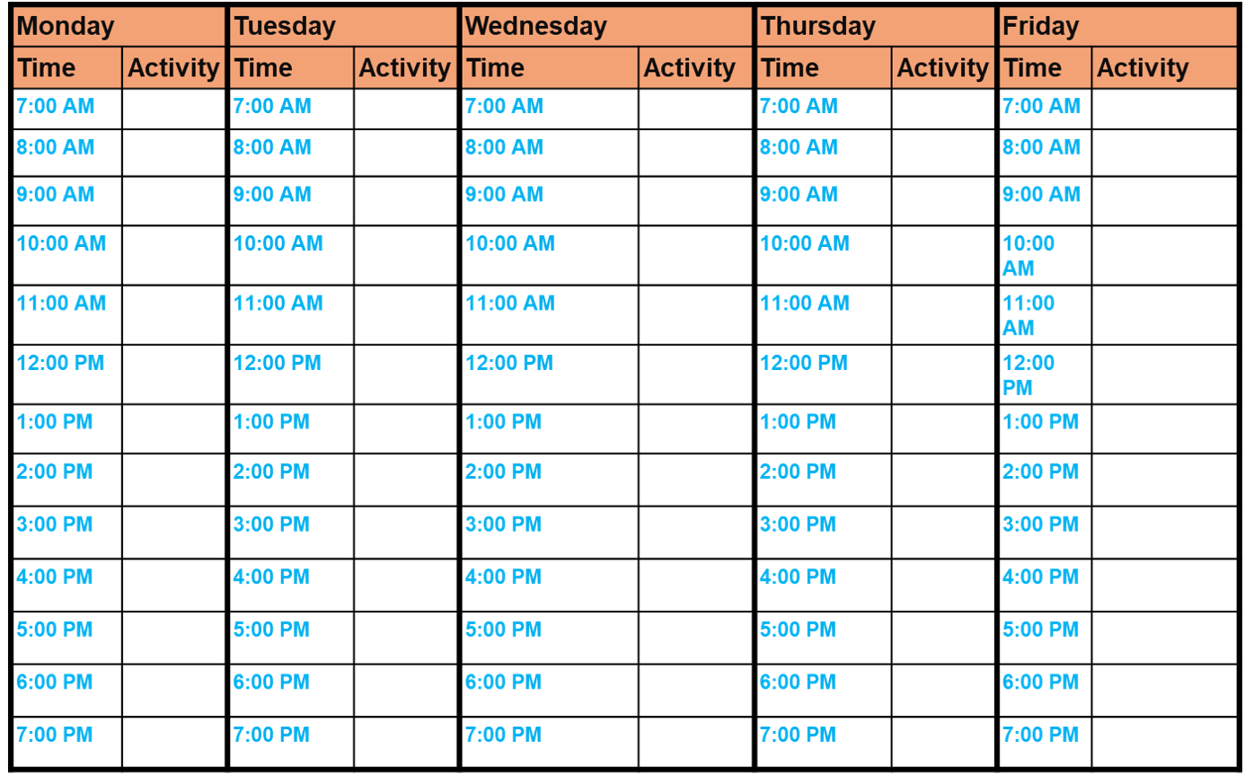
Figure: Weekly to-do List (Source: uwtsd Moodle)
Moreover, I need to take decisions appropriately to prioritise which task I will do first and now, I feel confident enough to take decisions promptly with concise consideration of all possible situations. Sometimes I need to delegate my work to my team members when we are working in a group for any assignments or presentation. Proper delegation helps us to ensure accomplishment pour assigned tasks on time. I also face challenges to direct myself and other team members to have proper direction to be followed. Later on I start to initiate setting goals for every single project I have to work on and these specified goals help to have proper direction towards goal achievement. Strategic thinking also helps to take decisions properly to any situation, even in critical and complex situation critical thinking helps to solve problems effectively.
Thus, I can say that I have learnt a number of time management skills including prioritising tasks I need to accomplish fast, delegating tasks by dividing into different parts, self check my regular performance, critically think any situation to have effective solution, and thus, I am able to make effective use of time towards achieving any goal both in professional and personal matter.
Conclusion
In this highly competitive tech-based business world, people often face challenges to find them fit for the employability skills required by different employers. Employers often look for the eligible candidates in terms of possessing required educational qualifications and other employability skills namely time management skills, communication skills (Shapiro, 2011). An individual being able to think critically visualising the situation, clearly communicate the ideas and solution on time possesses higher competency and thus, employers are more likely to select him or her for a job. In this changing business and professional fields, both undergraduates who are to enter job market and those who are already in need to develop their skills and so do I.

Term-2

ACADEMIC AND EMPLOYABILITY SKILLS.
Introduction.
As a graduate it is important to get as much knowledge and skill from the university to increase the marketability in the job market. Some of the skills a graduate should acquire from the institution are employability skills and academic. Employability skills are the skills that enable an individual to work well with colleagues in a professional setting through effective use of knowledge acquired from the university to accomplish the set tasks and get along at the organisation (Balance careers, 2020).
Academic skills are a set of study skills used to analyse, learn and retain information through use of time management tools to pass various evaluations at the learning institution (University of Birmingham, 2020). These skills are important therefore to ensure smooth transition from the learning facility to a work place.
Reflective Analysis through the Gibbs reflective style

Figure: Gibbs reflective cycle (Source: Morgan, 2017)
Description.
When I pursued this module, I learnt three topics: CV writing, cover letter writing and public speaking. This module has helped me as a health assistant to acquire the required employability skills to apply for a job vacancy through professional writing of the CV and cover letter. I can also be able make a speech to address my colleagues and service users at the care facility with proper preparation and engagement with the people I will address.
Feelings
I can now write CV correctly with the right format and correct skills and work experience. A CV is a professional document that is used by a job seeker to show the skills and work experience (Morgan, 1997). The CV should have clear statements describing the person's ability to undertake the assignment and shows a list of the previous engagements and respective duties. I have learnt that the CV should be easy to understand and captive to ensure that a potential employer can browse through it to get all the information he requires. The other thing I learnt is how to make a public address to people. The art of addressing people is a skill that I have to learn to effectively communicate with the service users or other stakeholders in the health department. I was previously unable to address the health care professionals or even the service users at the care facility because of inadequate organisation skills and level of preparedness. From the module I have learnt how to make a public speech properly. Public speaking is art of addressing a set of individuals or people with an objective of exploring, analysing or transferring knowledge to them (McNatt, 2019). Through this module I have learnt the art of addressing people to inform or transfer knowledge to them. I can now address my colleagues at the care facility through the use of skills learnt in the module and also through practice. As a speaker I should be professional, attentive and thorough in my research. The third topic that I covered is the art of writing a cover letter. A cover letter is the first professional document that a professional employer gets information of the candidate. It should therefore be precise and paint a clear picture of what the job seeker is capable of through his academic skills, past job experiences and the capabilities. I can now write a professional cover letter unlike before when I couldn’t complete an application letter.
Evaluation.
Throughout the module I have learnt skills that I will apply to my career for personal development. All the three topics will have an impact on how I present myself to potential employers through the CV and cover letter writing. To advance in my career as a health assistant I will need to equip myself with skills that put me at an advantage over the others. As a health care assistant to get advertised for a job I will need to have good writing skills to have an interview set up for me by the potential employer. Curriculum Vitae and cover letter are the documents that a potential employer will use to learn about me. Since the main aim of writing the curriculum vitae is to get invited for an interview I will need to be as honest as possible. The CV should contain all my personal information such as my name, residential address, email address and the social accounts that I can be reached on. The information provided must be accurate to ensure that the employer can easily contact me for an interview. My education history should be clearly outlined in the CV and should be done chronemically from the most recent to the one I did earliest. I have also learnt that I should list all the past achievements to show my work performance history. This will enable the potential employer get a glimpse of what I could achieve and help make changes in his organisation. The cover letter should be professionally written as it is the first document that the employer will because it is usually placed on top of the CV. The introduction part should show the position I have applied for and the origin of the job advert. The cover letter should also have details of my work experience, skills and knowledge acquired over the years and what capabilities I have that could positively impact on the organisation. I can now make a public speech because I learnt through the module that self confidence, practice and focus are among the main skills I need to have to properly address people. In my line of work I will be able to communicate and put points across to policy makers on the measures that could be put in place to improve health care. I will be able to make proposals on health issues, matters and effectively present them to the relevant authorities. I can now use the skills to apply for a better paying job, I could qualify for moving up the corporate ladder. At the care facility I will have better public speaking skills that I can use on occasions to address the service users and also my colleagues.
Analysis
In the topics covered I learnt three basic techniques: CV writing, cover letter writing the public speech making. A CV is a professional presentation of the academic skills, knowledge, capabilities and relevant work experience with an objective to get the advertised position (Cummings et al , 2020). The main purpose when drafting it should be to ensure that you get the position. To properly write a CV the academic profile should reflect all the past schools attended, the grades attained or area of specialisation in the case of a Master's degree. All educational qualifications pertaining to the advertised job should be included. This then means that the CV should always be changed depending on the job being applied for. The CV should also have a list of all the qualities being sought for in the advertised vacancy. For clarity and quick scan by an employer I should present them in bullet point form. To ensure that I stand a chance to get called in for the interview I should show the achievements accomplished in my past job hstory. These should however be modest to avoid trying to impress too much. The CV should show my ability to complete tasks through use of words like successfully managed, implemented (Reed UK Careers, 2020). The CV should have two referees. One should be a professional one like a past employer and the other an academic one. All the referees provided on the document should be properly acquainted with the person. One of my referees could for instance not be a past boss that I never worked directly with.
In the second topic on public speaking there are several steps involved to have a good speech. The steps involved are preparations before the actual speech, handing out the learning materials to the audience, making the opening remarks, delivery of the speech and making of a conclusion (Reed UK careers, 2020). I have learnt that preparation is very important before making a public speech. There should be adequate preparation through reading of the materials to be covered, proper body language, tone of voice and also the materials that could be used to explain the points being put across further during the addressing like handouts or questionnaires. To present a great speech I should be adequately prepared on what I shall present to the audience, arrive on time and also test out what should be used in the presentation like the sound system or the microphones. Without proper practice there could be a sound malfunction that could hamper the delivery of a good public speech (Mand et al, 2017). The decision whether to give reading materials or not should be considered. Whereas it is important to give the people being addressed notes they could easily get distracted and not pay attention. When giving public speech therefore I will not give any handouts till after the presentation for proper focus on the subject being addressed. (Morgan,2017). After a brief opening that should ensure that the peoples attention has been captured, I can then make the address. The speech should not be too long to avoid loss of concentration by the audience. There should be a clear mandate on what is being discussed, short and concise statements used and also audience participation to capture their attention.
The cover letter should be properly written with the position applied for clearly stated. The qualities that fit the job description are included together with job achievements and the skills that the job seeker has that could be best suited for the job. It should be written formally and it should give the potential employer a reason to hire.
Conclusion.
Academic and employability skills are very important for any graduate. A graduate should be able to work efficiently in a professional set up because he already has the necessary know how of the job execution (Morgan,2017). The topics covered have showed me the knowledge gaps that I have towards my personal development in terms of getting my dream job or a better paying one. I discovered that my CV writing and cover letter were previously wrongly done. To improve on the skills, I have embarked on a weekly practice of the same through applying for advertised jobs. This will give me the practical skill that I need to perfect the writing and ensure that I can secure jobs that I qualify for. Poor CV writing is a common mistake that denies qualified candidates jobs due to misrepresentation of the academic skills and job experience that the candidate has. I will also enrol on a communication short course to equip me with the right skills on public address and how to present proposals to potential partners or stake holders in the Health sector.
Action Plan
To bridge on the knowledge gap that I have I will pursue the short communication course to equip me with the right writing skills to ensure that I will not miss a job opportunity due to poorly prepared CV. Through the help of my lecturer, I will draft a new copy for application of the job vacancies that I qualify for in the next one week. I will seek permission from my employer at the care facility to be my referee. I will also list my Academic dean in my CV as a referee because I have previously worked under him at the university as an intern.I will also attend all my current academic year classes on employability skills to get as much information as possible on what I need to do to perfect my writing skills. I will practice fortnightly on the newly acquired skills through application of at least five jobs that I qualify for on the Linked in platform. This will be done after an upload of my CV and professional cover letter at the Linked in platform. Through the upload potential employers could give me interviews that may lead to a better paying job and also professional advice on what skills and experience are required to increase my employament prospects and marketability. Finally, I will apply for the communication short course in a months' time to study it online for the next six months to further increase my employability skills.

References

. Boyle, J.R., 2010. Note-taking skills of middle school students with and without learning disabilities. Journal of learning disabilities, 43(6), pp.530-540.
- Chang, W.C. and Ku, Y.M., 2015. The effects of note-taking skills instruction on elementary students’ reading. The Journal of Educational Research, 108(4), pp.278-291.
- Cummings, E., Cummings, E. and Fack, M., 2020. University Of Wales Institute. [online] Resume Templates. Available at: <https://www.findresumetemplates.com/university-of-wales-institute.html> [Accessed 7 December 2020].
- Demont, E. and Gombert, J.E., 2006. Phonological awareness as a predictor of recoding skills and syntactic awareness as a predictor of comprehension skills. British journal of educational psychology, 66(3), pp.315-332.
- DuPaul, G.J., Rapport, M.D. and Perriello, L.M., 2001. Teacher ratings of academic skills: The development of the Academic Performance Rating Scale. School psychology review, 20(2), pp.284-300.
- Griffiths, D., 2009. Presentation Skills. In The Experience of Managing (pp. 193-203). Palgrave Macmillan, London.
- Grissom, J.A., Loeb, S. and Mitani, H., 2015. Principal time management skills. Journal of Educational Administration.
- Lehto, J., 1996. Working memory capacity and summarizing skills in ninth‐graders. Scandinavian Journal of Psychology, 37(1), pp.84-92.
- Mand, A., Shriek, M., and Tinkler,P (2017) Certificate in Higher Education: Skills for the Workplace Student Yearbook .London: Sage.
- Mandel, S., 2000. Effective presentation skills a practical guide for better speaking. Crisp Learning.
- McNatt, D. B. (2019). Enhancing public speaking confidence, skills, and performance: An experiment of service-learning. The International Journal of Management Education, 17(2), 276-285.
- Morgan, P. (2017) The Business Students Guide to Study Employability. London .Sage.
- Oakhill, J.V. and Cain, K., 2004. The development of comprehension skills. In Handbook of children’s literacy (pp. 155-180). Springer, Dordrecht.
- Passig, D. and Maidel-Kravetsky, J., 2016. The impact of collaborative online reading on summarizing skills. Education and Information Technologies, 21(3), pp.531-543.
- reed.co.uk. 2020. How To: Write A Cover Letter | Reed.Co.Uk. [online] Available at: <https://www.reed.co.uk/career-advice/how-to-write-a-cover-letter/> [Accessed 7 December 2020].
- reed.co.uk. 2020. How To: Write A CV | Reed.Co.Uk. [online] Available at: <https://www.reed.co.uk/career-advice/how-to-write-a-cv/> [Accessed 7 December 2020].
- Shapiro, E.S., 2011. Academic skills problems: Direct assessment and intervention. Guilford Press.

