IMAGE RECOGNITION FOR WASTE SORTING AND RECYCLING USING SECONDARY QUANTITATIVE DATASET ANALYSIS

Table of Contents
1. Introduction 3
2. Research Background and Problem Statement 3
3. Research Aim 4
4. Research Objectives 4
5. Research Questions 4
6. Literature Review 5
7. Dataset Description 5
8. Proposed Methodology 6
9. Proposed Models for Upcoming Dissertation 7
10. Data Analysis Plan 7
11. Ethical Considerations 7
12. Expected Outcomes 7
13. Timeline 8
14. Conclusion 8
15. References 10
Appendix 12

1. Introduction
Waste management is a major environmental problem, as considerable amounts of domestic and industrial waste are still being thrown in landfill. Inadequate waste separation puts a strain on landfill facilities and poses significant environmental challenges, such as land pollution, water pollution, air pollution, eutrophication, leachate generation and toxic release. May also be harmful to animals if eaten by them in contaminated waste or waste that is not degraded in the environment.
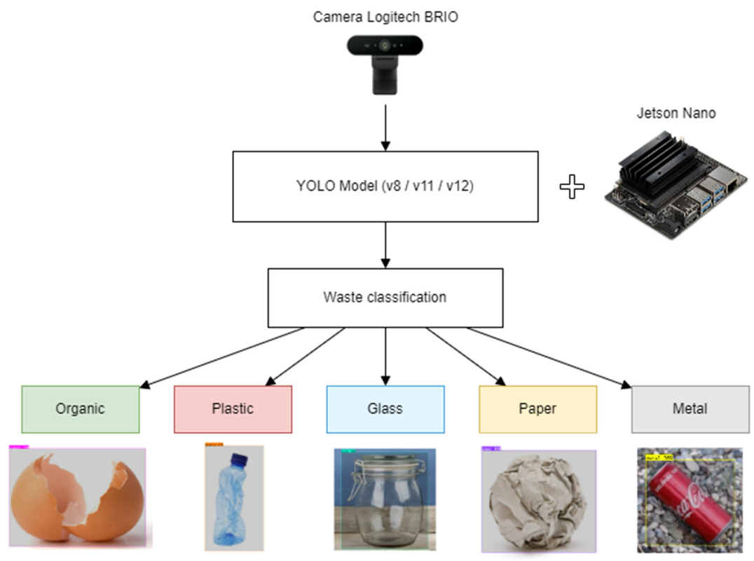
Figure 1: Automated Waste Classification Process Using Image Recognition
(Source: mdpi.com, 2025)

2. Research Background and Problem Statement
Waste sorting is one of the most challenging issues in the waste management sector because of being slow, labour-intensive and less accurate in manual sorting waste. A lot of people may not be aware of whether waste should be considered organic or recyclable. Therefore, materials which can be recycled can be fed into the organic waste stream, and biodegradable materials can be fed into the recycling stream. The wrong waste classification reduces the efficiency of waste recycling and results in the landfilling of waste which is reusable. The major issue that has been identified in the non-recycling rates in most waste management systems is the poor segregation of waste (Arbeláez-Estrada et al., 2023).
This means that an automated waste classification system is required which can quickly, reliably and precisely classify waste into categories. The images of waste can be marked and then used to train the model of machine learning and deep learning, to test images not provided to the model. All images used in the study were taken from a data set provided by Waste Classification Data by Techsash on the Kaggle platform that classifies images as “Organic” or “Recyclable” (Casao et al., 2024).

3. Research Aim
This research aims to compare the selected models of deep learning which will be used in the upcoming application of waste-sorting and recycling and to evaluate the performance of the image recognition models in the classification of waste into two different categories (organic waste and recyclable waste) from the data set of waste classification made available on Kaggle.

4. Research Objectives
- To explore the possibilities of using image recognition to enhance waste sorting and recycling.
- To use a secondary quantitative data for image classification: Kaggle Waste Classification Data.
- To train and test selected image recognition models using 50:50 data split method, 50% of the data for training and the remaining 50% of the data for testing/evaluation of samples.
- The accuracy, precision, recall and F1-score value of the Custom CNN, MobileNetV2, ResNet50 and VGG16 were tested to determine its accuracy.
- To propose the optimum model for the future research on the automatic waste sorting and recycling as dissertations.

5. Research Questions
- What can be done with the image recognition in waste sorting and recycling?
- What is the quality of Kaggle Waste Classification dataset to create a waste image classification model?
- What is the accuracy of recognizing if an image is an organic waste or recyclable waste in MobileNetV2?
- Talk about the accuracy, precision and recall value for all of the classifiers (Custom CNN, ResNet50 and VGG16) as well as the performance of MobileNetV2 over all of them?

6. Literature Review
The most basic concept of waste management is that of 'waste sorting' and if it is not sorted appropriately, the recycling effort would be futile. Organic waste may be treated by composting or anaerobic or biological treatment and recyclables such as plastics, paper, cardboard, glass or metal may be treated and reused. If wastes are not sorted properly, recyclables could be contaminated and not be worth recycling or could end up in a landfill (Choi, Lim and Yoo, 2023).
Artificial Intelligence (AI) is an aspect of the AI which helps the computer identify and classify an image. Waste sorting: Waste objects can be recognised using the image recognition based on the visual properties such as colour, texture, size, shape and appearance of the waste materials. It will be useful for making automatic waste classifications systems (Fotovvatikhah et al., 2025).
The second generation of deep learning networks, known as Convolutional Neural Networks (CNNs), can automatically extract basic visual features from the image, and is widely used for image classification. Patterns can be learnt from a labelled set of images of waste material in a CNN and then these patterns can be used to classify a new image into one of two classes: organic or recyclable (Malik et al., 2022). Transfer learning techniques can be applied to this process to further enhance it, and a large-scale data set can be used to learn general features from the images and then use that information in the other data set. Time saving and performance improvement can be achieved using models like the MobileNetV2, ResNet50 and VGG16.

7. Dataset Description
Techsash was used as the data source for this study and their Waste Classification Data was used. It's a dataset that can be utilized in this proposed study since the data is significantly centered around waste classification in household settings and can additionally be utilized for making automated waste segregation frameworks utilizing machine learning and picture acknowledgment. This information is broken down into 2 categories: Organic and Recyclable. The waste produced by the food wastes, biodegradable wastes, natural wastes such as plastic wastes, paper wastes, cardboard wastes, glass waste and metal waste (Mohammed et al., 2023) are all classified as organic wastes. A total of 25,077 images is the total number of images in the original dataset. The images are already split into 22,564 training images, and 2513 testing images (around 85% and 15% of the total, respectively).

8. Proposed Methodology
Secondary quantitative research method will be applied into this research. It is secondary as it involves working with existing set of data – provided by Kaggle – which is already created by the researcher. It's quantitative because the level of performance of the image recognition models will be measured using numbers (accuracy, precision, recall and F1-score).
In this study we will be relying on the Kaggle dataset (Techsash) for Waste Classification. Preprocessing of the images will be done prior to training the model. First, all the images will be resized to a fixed input size (in this case 224x224 pixels) to be able to be processed by a deep learning model. Secondly, the images will be normalised to scale the values of the pixels which will further enhance a training of the model (Sayem et al., 2025).
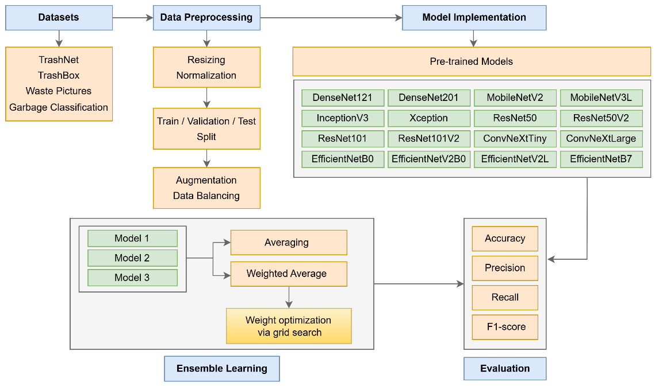
Figure 2: Proposed Model Comparison Framework for Waste Classification
(Source: mdpi.com, 2026)

9. Proposed Models for Upcoming Dissertation
The dissertation, which will be written in the near future, will use 4 models of image recognition, to classify the images of waste into 2 classes, Organic and Recyclable. The following is recommended for this dissertation: MobileNetV2. The selected data set is best suited for the model, since there are only two classes (Organic and Recyclable) and the model is suitable for binary image classification. MobileNetV2 is also lightweight in terms of the computational resources it requires, using less than the more powerful models, such as VGG16 and ResNet50. A baseline model will be created with the Custom CNN architecture, and then testing it with ResNet50 and VGG16 models to determine if bigger transfer learning models are superior.

10. Data Analysis Plan
The quantitative performance metrics will be used to evaluate the performance of each image recognition model. Each model will have its accuracy shown in the Accuracy section (%). For each class, the percentage of correct predictions will be precision for the class with the higher number of positive predictions and recall for the class with the higher number of negative predictions. If there is a difference between the performance of classes, F1-score will give a balanced measure of precision and recall. If there is confusion in Organic waste, Recyclable waste, correct or incorrect, confusion matrix will be displayed as well. These metrics (Custom CNN, MobileNetV2, ResNET50 and VGG16) will be used to make a fair comparison of these models.

11. Ethical Considerations
This is a Kaggle provided data set that will be used with secondary data that will be made public. So, there will be no humans involved in it and there will be no personal data collected. The main ethical obligation is to give credit to the source of the data set, and not misrepresent the results. It will be presented and strengths and limitations of the model will be included.

12. Expected Outcomes
The study aims at demonstrating the possibility of using image recognition to aid automated waste sorting and recycling. MobileNetV2 should be able to show a good performance, as it has been trained through transfer learning and it is suitable for light weight image classification tasks. The research might also provide clues to whether the larger models, such as ResNet50 and VGG16, are more viable, or if the mobile model is more viable (MobileNetV2).

13. Timeline
Time Frame | Activity
Week 1–2 | Literature review and research planning
Week 3 | Dataset acquisition, exploration, and preprocessing
Week 4 | Development and training of Custom CNN
Week 5 | Training and testing of MobileNetV2
Week 6 | Training and testing of ResNet50
Week 7 | Training and testing of VGG16
Week 8 | Model evaluation and comparative performance analysis
Week 9 | Interpretation of findings and discussion
Week 10 | Final report writing, revision, and submission preparation
Table 1: Proposed Timeline
The proposed research activities have been mapped out in the proposed timeline of activities which can be divided into three weeks of literature review, data preparation, and development of the model (Custom CNN, MobileNetV2, ResNet50, VGG16), evaluation of the model, comparison of the results, and preparation of the research report.

14. Conclusion
This is secondary quantitative research of image recognition of waste and recycling. The data that will be utilized for study will be divided into two parts: First, waste classification data, available on Kaggle (images of Organic Waste and Recyclable waste). There are 85 train and 15 test data in the original data set, but for this research, 50% of the data will be used for training and 50% for testing as directed. The primary model is MobileNetV2 with Custom CNN, ResNet50 and VGG16 to be compared.

15. References
Arbeláez-Estrada, J.C., Vallejo, P., Aguilar, J., Tabares-Betancur, M.S., Ríos-Zapata, D., Ruiz-Arenas, S. and Rendón-Vélez, E., 2023. A systematic literature review of waste identification in automatic separation systems. Recycling, 8(6), p.86.
Casao, S., Peña, F., Sabater, A., Castillón, R., Suárez, D., Montijano, E. and Murillo, A.C., 2024, October. Spectralwaste dataset: Multimodal data for waste sorting automation. In 2024 IEEE/RSJ International Conference on Intelligent Robots and Systems (IROS) (pp. 5852-5858). IEEE.
Choi, J., Lim, B. and Yoo, Y., 2023. Advancing plastic waste classification and recycling efficiency: Integrating image sensors and deep learning algorithms. Applied Sciences, 13(18), p.10224.
Fotovvatikhah, F., Ahmedy, I., Noor, R.M. and Munir, M.U., 2025. A systematic review of AI-based techniques for automated waste classification. Sensors, 25(10), p.3181.
Malik, M., Sharma, S., Uddin, M., Chen, C.L., Wu, C.M., Soni, P. and Chaudhary, S., 2022. Waste classification for sustainable development using image recognition with deep learning neural network models. Sustainability, 14(12), p.7222.
mdpi.com, 2025. Autonomous Waste Classification Using Multi-Agent Systems and Blockchain: A Low-Cost Intelligent Approach Available at: https://www.mdpi.com/1424-8220/25/14/4364 [Accessed on: 10.06.26]
mdpi.com, 2026. Deep Ensemble Learning Model for Waste Classification Systems Available at: https://www.mdpi.com/2071-1050/18/1/24 [Accessed on: 10.06.26]
Mohammed, M.A., Abdulhasan, M.J., Kumar, N.M., Abdulkareem, K.H., Mostafa, S.A., Maashi, M.S., Khalid, L.S., Abdulaali, H.S. and Chopra, S.S., 2023. Automated waste-sorting and recycling classification using artificial neural network and features fusion: A digital-enabled circular economy vision for smart cities. Multimedia tools and applications, 82(25), pp.39617-39632.
Sayem, F.R., Islam, M.S.B., Naznine, M., Nashbat, M., Hasan-Zia, M., Kunju, A.K.A., Khandakar, A., Ashraf, A., Majid, M.E., Kashem, S.B.A. and Chowdhury, M.E., 2025. Enhancing waste sorting and recycling efficiency: robust deep learning-based approach for classification and detection. Neural Computing and Applications, 37(6), pp.4567-4583.

Appendix
Dataset Link: https://www.kaggle.com/datasets/techsash/waste-classification-data

