[ABDUL RAHEEM KHAN]
[2435517]
[LCHS4003]
[INTRODUCTION TO HEALTH AND SOCIAL CARE]
[DEBRA ODEH]
[AMBULANCE SERVICES]

[20/10/2025]
TASK 1

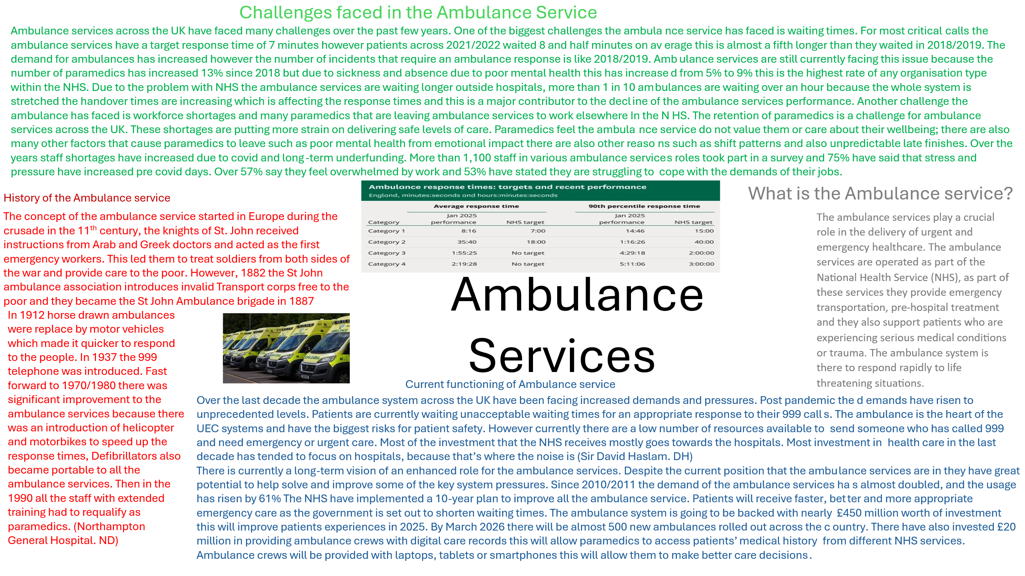

[Task 2]
There has been form of stated funded provision of a Health and Social Care in England for 400 years. Over the next 50 years there were various measures that were introduced to ensure that some form of support was there for the most needy. This was bought together under the first law in 1601. The first step in creating the health service was in 1938. The imminent war meant that the government had to establish an Emergency Medical Service and different types of hospitals were run to anticipate a large number of expected casualties. By the end of WW2, the state funded hospital service was established and in 1948 the government created the National Health Service (NHS). In 1948 Britain was the first western country which offered free use of medical care to the whole population. In 1945 the labour party led clement Attlee won the general election. After winning the Atlee government created a comprehensive welfare state which we know as is the NHS. Before the NHS when people found themselves needing a doctor of medical facilities the people were generally expected to pay. In the early years of the NHS, they were already exceeding previous expectations and charges were considered to meet the rising costs and by the 1960s these early adjustments were considered to be a strong period of growth for the NHS. The NHS which was created in 1948 was bought through hard work and dedication for the people who truly believed in the new ideas about the health services and medical ethics. Over the past 70 years the NHS has faced crisis, downturns and also so much growth over the past 70 years. To this day the NHS is facing an even greater crisis still. There are currently issues of funding and demand which are continuing to rise and the ability to provide free health care is a topic of debate for many. The current structure of the NHS is as follows. The NHS in England is not just one single organisation; it is made of different organisations and different sizes. The Department of Health and social care (DHSC) is responsible for funding decisions, overall stewardship of the NHS and is responsible for the health and social care policies. From 1 July 2022 42 statutory Integrated care boards (ICBs) were established. They are responsible for planning and commissioning for health services in their population. The DHSC allocates budgets to NHS they go through the ICBs and sets a policy/oversight which then NHS England allocates resources. The ICBs get most of the budget because they are responsible for planning and improving the health outcomes for their populations. There are also NHS Trusts and Foundation Trusts. They deliver frontline services like community care, mental health and hospitals. They operate independently but are accountable to NHS England. Another is the primary care providers this includes pharmacists, GPs and dentists. These are often contracted by the ICBs or NHS England.

There are many strengths on how its functioning today such as universal coverage, which is free to use for residents, Digital transformation which is the increase of electronical records and the final one is a strong workforce.

However, where there are strengths there also challenges that are currently being faced which is long waiting times, Staff shortages due to burnout which has increased vacancy rates. Another challenge is Funding pressures because there is rising demand and limited resources. And the final one is Access issues which is how difficult it currently is to get a GP and dental appointments.

There are reforms underway which is implementing a model to improve performance. There are also plans to train and retain more staff and there is also more investment in hospitals.

TASK 1 REFERENCE

Joy Arthurs Page, Reeves, W.H., OBE. DL. JP. and Woolston, T.H. (no date) The history of the ambulance service. https://www.northamptongeneral.nhs.uk/About/OurHistory/History-of-Ambulance.pdf.

Association of Ambulance Chief Executives et al. (2024) A VISION FOR THE NHS AMBULANCE SECTOR in co-designing urgent and emergency care provision. https://www.nhsconfed.org/system/files/2024-03/A-vision-NHS-ambulance-sector-co-designing-urgent-%20emergency-care-provision.pdf.

England, N. (2025) NHS England » New ambulances and faster emergency care for patients next winter. https://www.england.nhs.uk/2025/06/new-ambulances-and-faster-emergency-care-for-patients-next-winter/.

Alarilla, A. et al. (2022) Why have ambulance waiting times been getting worse? https://www.health.org.uk/reports-and-analysis/analysis/why-have-ambulance-waiting-times-been-getting-worse?gad_source=1&gad_campaignid=13881943846&gclid=EAIaIQobChMI6sLS5JSwkAMVqJRQBh3qeQCNEAMYASAAEgIAnfD_BwE.

Hayes, T., National Audit Office, and Charmaz (2017) Why UK Paramedics are Leaving Ambulance Services to work clinically elsewhere in the NHS, Unknown. journal-article. https://aace.org.uk/wp-content/uploads/2022/08/Why-UK-paramedics-are-leaving-ambulance-services-to-work-cinically-elsewhere-in-the-NHS-Tim-Hayes.pdf.

Ayad, F. (2022) Ambulance pressures taking a significant toll on staff, says UNISON | News, Press release | News | UNISON National. https://www.unison.org.uk/news/press-release/2022/04/ambulance-pressures-taking-a-significant-toll-on-staff-says-unison/.

Task 2 Reference

Clement, M. (2023) The founding of the NHS: 75 years on. https://history.blog.gov.uk/2023/07/13/the-founding-of-the-nhs-75-years-on/.

The birth of the NHS - Historic UK (2023). https://www.historic-uk.com/HistoryUK/HistoryofBritain/Birth-of-the-NHS/.

England, N. (no date) NHS England » Structure of the NHS. https://www.england.nhs.uk/long-read/structure-of-the-nhs.

