EBP (AC1.1)
The concept for Evidence – based practice (EBP) is for People Professionals to make better, more productive decisions by choosing the most dependable, trustworthy solutions and being less reliant on dated information, fads or superficial quick fixes (CIPD, 2023a). By doing this it will eliminate any bias. It is a process of combined evidence using different methods and tools that are gathered to work alongside critical thinking to give you that understanding and knowledge. When they say “evidence” it means information, facts or hypothesis (CIPD, 2023a). Before the search is carried out practitioners will need to ask 2 questions; “First, which are the most important problems or opportunities facing the organisation which are relevant to HR activities? Secondly, which solution or interventions are most likely to help? In other words what is going on and what can we do about it” (Briner, 2023). There are four sources that can be used to collect evidence; Scientific evidence (findings from published scientific research), Organizational evidence (data facts and figures gathered from the organization), Eexperiential evidence (the professional experience and judgment of practitioners) and Stakeholder evidence (the values and concerns of people who may be affected by the decision), (Barends, Rousseau and Briner, 2014). In their 2023a paper, CIPD have an infographic of 6 thinking steps to help when gathering the evidence.
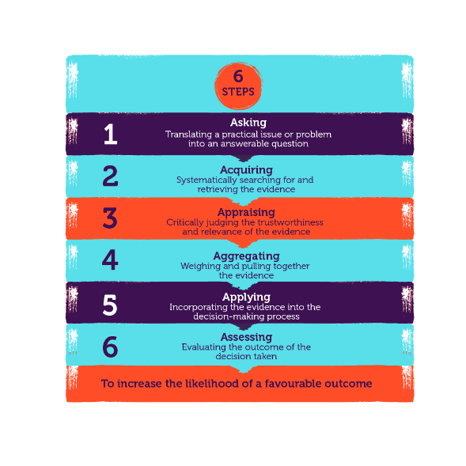
Following these 6 steps can make sure that the standard of evidence is not ignored. However, they are usually engaged to search for the evidence that supports what they want to think instead of a wider range of evidence from multiple sources. This is called “cherry -picking”. When using Cherry – picking it can make People practitioners look smart and well informed, but is deceiving and can have serious negative consequences, risks and opportunities can be neglected and damaging practices encouraged (CIPD, 2023a). The focus just needs to be what is the most reliable and trustworthy, it does not mean finding ‘proof’.
EBP (AC1.2)
There are several analysis tools that can be used to identify issues and be applied to diagnose organisational issues, these can also be used in day-to-day life. Some of these tools are Porters five forces, Fishbone analysis, Ansoff matric, PESTLE. A PESTLE analysis is the study of key external factors (Political, Economic, Sociological, Technological, Legal and Environmental) that influence an organisation (CIPD, 2023b). Whereas a SWOT analysis used by organisations from small organisations and non-profits, to large organisations, can be used for personal purposes as well (Raeburn, 2022a). SWOT stands for; strengths, weaknesses, opportunities and threats. The SWOT analysis will help to show where the organisation is now and how to get to that next step within the organisation. These lead to fact -based analysis, fresh perspectives and new ideas (Kenton, 2023). Strengths and weaknesses are often the cause that relates directly to the organisation and have been described as Internal factors, whereas opportunities and threats generally relate to factors outside the organisation that can be advantageous or identified to help the potential risks involved (CIPD, 2023c). To carry out a SWOT analysis it will have to be done as a team as it requires time and different areas within the organisation will need to come together to decide on the strengths and weakness of the organisation. Also different reasons for using SWOT in the organisation. Management team might want to use it to support strategic planning and risk management whereas the analyst department may want to look deeper into what the strengths, weaknesses and threats are. One of the advantages for using SWOT. It will help improve processes and plan for growth (Raeburn, 2022b). A disadvantage for using SWOT. The analysis needs to be repeated on a regular basis (CIPD, 2023c). To gather and measure a large amount of information that can be based on challenges within the organisation, whether it is current or passed this can be done with a survey. Carrying out a survey will allow the practitioner to collect quantitative and qualitative data unlike structured interviews where it would be only qualitative data collected. Surveys also collect a more vast amount of information allowing the organisation to have a better understating on their workforce’s ideas, views and opinions on the questions asked in the survey (Farrar, 2017). This means a better reflection and implement of the changes needed. There is also a cost benefit for carry out surveys as they are generally a cheaper and faster way to gather the information. They are also very convent for the person answering the survey, employee, stakeholder etc as it can be filled in their own time. There are also some disadvantages for using a survey as they do not allow you to prompt on the individual responses along with asking some more complex, in depth questions. Also there is the risks that the respondent won’t answer some of the questions or answer the entire survey making the response rate down.

EBP (AC1.3)
“Critical thinking is the art of making clear, reasoned judgements based on interpreting, understanding, applying and synthesising evidence gathered from observation, reading and experimentation”(Burns, Sinfield 2016). This is where the principles of EBP can be implemented in the sense to ask good questions. To be critical it doesn’t mean to find faults, It means to assess the evidence from an array of sources and then making a reasonable conclusion. Howlett (CIPD, 2019) says that there is three key parts to critical thinking. The first one; critiquing the ideas, opinions and arguments of others, second; construct arguments and opinions and thirdly along with identifying when these are being used. When it comes to gathering information, there are 2 types of sources; Primary and Secondary. Primary, a source that is closest to the event, research or experience; original letter, original diary extract. Whereas secondary source is one step away from primary; a scientific report based on notes from an original, a critique based on the original (Bitesize, 2023a). Deciding on if the source is reliable there is a number of factors to take account of. Is the source bias, impartial? What is the vested interest and lastly what is the expertise? When looking at the source the date must always be checked as information may be outdated which means it becomes inaccurate and unable to use. Check how important the actual source is and is the information relevant and useful and contains the appropriate information. “There is no single way to think critically. How you engage with information will depend on the type of source you’re using and the information you need” (Ryan, 2023). Within an organization the most department to have a strong link to unconscious bias is recruitment (CIPD, 2018). Recruitment may not give someone a chance due to the recruiter not liking the characteristic of that candidate. As CIPD 2023a paper states “The gains in making better decisions on the ground, strengthening the body of knowledge and becoming a more influential profession are surely worthwhile”.
EBP (AC1.4)
To make a decision and an effective one it can be very challenging especially in this world we now live in. Decision making skills allow a manager to consider alternatives and use judgement to choose a suitable and timely course of action in what can be a challenging environment. There are however some hurdles when carrying out decision making. In (CIPD, 2020) it states that people are influenced by their emotional responses to the situations as they might not want to report something as the fear of what would happen to the reputation or reprimand of doing so. There are certain methods that can be used to help with the decision making process. One is the Six Thinking Hats by Dr Edward de Bono. He states, “You can analyse the past but, you need to design the future” (Bono, no date). This method involves six imaginary hats that are all different colours and all represent a specific type of thinking.
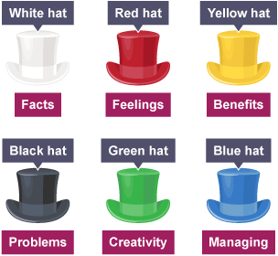
It does not necessarily mean that everyone in the discussion has their own colour hat it could be that everyone wears the same colour to come up with new ideas, feelings etc. However the red hat is usually the last one to be worn as this is the final idea and is often based on a gut feeling . The blue hat wearer will then say the final conclusions (bitesize, 2023 b). This method could be used if a disciplinary or investigation has taken place. Another approach that can be used is The Kepner-Tregoe Approach, where it is based on the premise that the end goal of any of the decisions is to make the “best possible” choice (Kepner and Tregoe, 1965). In this approach it explores all the strengths and weaknesses and prioritises the alternatives and then chooses the best. Using this approach with help make an unbiased decision. As Kepner and Tregoe (Klein, 1976) suggest, “The problem to be specifically defined before anything else is done”. There are four steps to follow to help give the best possible choice; Situation appraisal – identify concerns and outline priorities. Problem analysis- carrying risk assessments for each and make a final decision. Lastly, potential problem analysis – the final decision to evaluate the risks and identify any to minimise the risks. Whereas the previous 2 methods mentions can be quite formal there is the method of Brainstorming which can be a very relaxed way of decision making and can be used in all aspects of everyday life. It is believed that the original approach was published in 1953, however over the years researchers have made many improvements (Mindtools, no date). There is a downside to brainstorming and that is that it does not give a final solution or decision. It actually relies on getting high volume ideas that will become part of the results (Seeber, 2018). To carry out this decision method it requires interaction between practitioners sharing their ideas and thoughts on the subject matter. Once the ideas have been discussed they are then evaluated and to see which ones have the best outcome. Alongside this method there is Brain Writing, which is the verbal approach (Nongnut, Katekanok and Sasistorn, 2021). This is applied the same way as Brainstorming just written down.
EBP (AC1.5)
Ethics are at the hub of professionalism. To create cultures of transparency and trust, practitioners should show strong standards of integrity when advising business leaders (CIPD, 2022a). Ethics is about making decisions and judgments with the correct course of action. People practitioners need to think are the colleagues being treated with the dignity and respect they deserve and following the values of the organisation. Some organisations will have code of conducts and some will have codes of ethics. Although some actions in the workplace are clearly unethical but most situations that the practitioner will have to deal with are likely to be more difficult area between clearly right and clearly wrong (Talor and Woodhams, 2022a). There are a number of different ethical perspectives a practitioner can use depending on the situation. As CIPD (2015) states “There will never be a ‘golden rule’ that fits all ethical decisions: it’s always going to require effort, imagination and judgement, and the outcome is often going to be inconclusive”. CIPD have introduced Eight Lenses which are eight perspectives on workplace dilemmas to help practitioners have different points of view on workplace dilemmas. These lenses all have a different meanings and understandings. For example there is the “Fairness Lense - everyone in an organisation should be able to agree to it, whatever their place in it. Well – Being Lense - work should be good for all if us” (CIPD, 2015a).
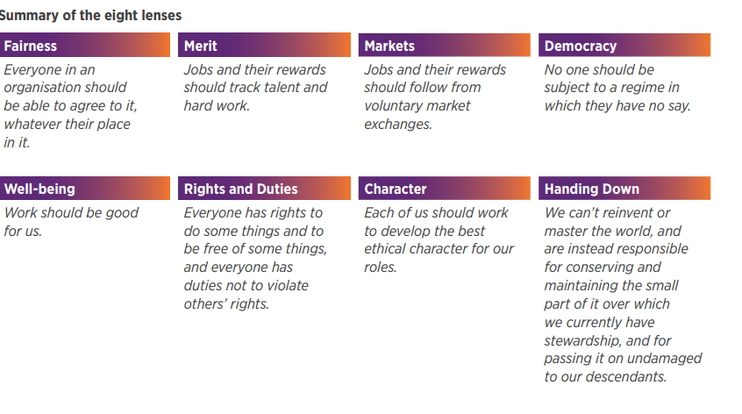
Following on from that there is the Deontological theory which is based on Kant’s theory where it focuses on moral intensions and duties rather than consequences (Place, 2010). There are the reasons rather than the rules (Rawling, 2023). This means that an individual should act based on what they actually believe to be the morally right thing to do regardless of the actions and consequences. An example of this in an organisation could be where there is an employee who has to confront their manager about their workload being too much and not agreeing they should be doing certain aspects of that job and knowing that the manager will not be happy and will be annoyed with them speaking up, they don’t worry about the consequences of speaking up. Whereas the Utilitarianism theory which works on what is right and wrong there is no in-between. It acts on maximizing the overall happiness and well-being of the effected individuals and look to what the consequences are. This usually works best when it is face to face of conflicting situations that involve stakeholders (Linkedin, 2023). As a practitioner this could be when it is decided to make a change within the organisation but ensures the organisation is an all-round positive environment for coworkers and practitioners to be a part of, considering all the potential impacts it will have on everyone. Moreover, there is the Consequentialism theory. This view’s signature thesis is that an act is morally right simply because it maximizes value (Cuneo, 2020). Yet when reading what consequentialism is it is very similar to the Utilitarianism theory except with Consequentialism there is not a desired outcome that is specified unlike the Utilitarianism theory. There are many different forms for Consequentialism all depending on how the practitioner values the outcome. If there was a manager lying to get a cheaper deal on something within an organisation but lying is not tolerated as the organisation policy states they would get fired regardless of the fact their act would have saved the organisation money. “Reputations are based not only on an organisation’s delivery of its products and services, but on how it values its relationships with its staff and stakeholders, and how it establishes responsibility and accountability towards them” (CIPD, 2022b).
EBP (AC3.1)
Measuring performance within an organisation is one of if not the most vital tasks there can be. It doesn’t mean just measuring the finical aspects but the non-financial aspects of the organisation; What are the stakeholders views, how are the employees getting on etc. When measuring the financial performance within an organisation practitioners do not need a background in finance, just by knowing the basics will help improve the decision making process as well as the chance for career success (Stobierski, 2020a). When measuring the financial performance of an organisation it will gather quantitative data this can be done in a number of ways. One of those ways would be to measure the net profit margin. It measures what percentage of revenue and other income is left after subtracting all costs for the business, including costs of goods sold (Stobierski, 2020b). If an organisation need to quickly figure out how much money it is making or loosing then a balance sheet can be used to measure financial performance (McQuarrie, 2023). However recent years have seen a sharp decline in the use of these (Demerjian, 2011). The reason for using a balance sheet for the organisation is that it gives an idea of what the company’s financial position is. It will also sate what the company owns and owes. A down side for using a balance sheet is that it uses estimates. However as previously mentioned performance can also be measured by non-financial aspects within an organisation. Mrs Bucket Cleaning Services LTD does this very well by carrying out annually “TOTM”, TOP OF THE MOPS. The awards aim to recognise employees who have gone above and beyond for the firm’s 100+ client base (Mrs Bucket, 2023). An email will go out to all the employees and clients with a number of different questions whether it’s reflecting the values, employee service, best cleaned premises etc. Everyone in the company along with the clients of Mrs Bucket will put a vote in for a cleaner or team. The results have a deadline and once they have been collected the practitioner will then read through and analyse which employees have been carrying out the best performance or the site that has the best performance for that year. They are then presented with an award. Another way Mrs Bucket works well with measing non-financial performance is by carrying out monthly Group talks with the employees and clients of Mrs Bucket. Every month a People practitioner will go out asking a number of questions that reflect on what is happing within the organisation and hope for honest answers back. This way the organisation can measure exactly how the performance is going along with identifying any issues. The only downside for carrying out these is that not all employees attend. Measuring performance is useful as the “Data can be used to set objectives for employees, to motivate them, to hold them to account and to inform decisions on pay and promotions. Data can be used for developmental purposes to inform decisions on training and resources” (CIPD, 2022)
EBP (AC3.2)
Adding value plays a vital part within an organisation. It refers to the change or effect on someone or something. So when adding it to an organisation the value and impact are the outcome of the organisation’s actions, stakeholders and employees (Stewart and Brown, 2019). From the 1980’s onward, it was huge opportunities for the people practitioner to develop and meet the specific needs of their organisation and the people employed, freed from the requirement to follow industry standards (Taylor and Woodhams, 2022b). So how do people practitioners actually add the value; Creating the policies and procedures for the organisation making sure that there is equal opportunities and diversity throughout. Assisting with the recruiting of new employees, making sure the positions that are vacant are correct and are attracting the correct candidates. Alongside the recruiting aspect of the organisation there is the training and development of the employee roles and the in depth induction training. Reward performance is another big value that people practitioners add to the organisations this could include, cash pay or benefit packages (private health care). This is an important value as it is important in attracting, retaining and engaging with employees (CIPD, 2023d). To measure the impact on people performance people practitioners use KPIs to measure the performance over time using data to show how well the organisation is performing. To be effective it should be ; relevant, balanced, understandable and shared (Xero, 2023) Another Quantitative source for measuring value would be to use a term called Benchmarking where it is the process of comparing performances, process or products with the competitors or industry leaders. It uses and equation with input variables that generate output variables (Rudy, 2023). The negative for this is it sometimes has sparse data. The reason for measuring the value is so practitioners can identify issues or make improvements that can work on having a better relationship with the employees.

Task 2
Table 1 -
The first part of this report is on Equality, Diversity and Inclusion Salary for an organisation. Where qualitative and quantitative data will be used to report on certain findings throughout the organisation. Quantitate data will be shown using different charts with numeric information that has been pulled from the report to show what is happening within the organisation to an extent but not very helpful to why it’s happening. Whereas qualitative data involves non numerical data. Like a leaver survey and find out what the reason is behind leaving. Managerial issues, salary issues etc.

Chart one
The below is the shows the findings on percentage of gender.
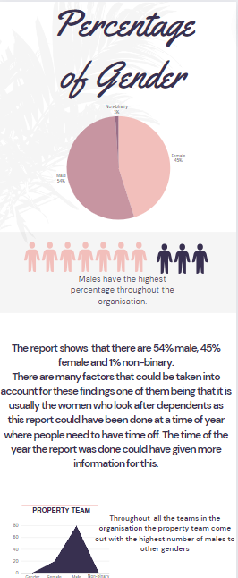

Chart 2
From the bar chart above it represents all the different ethnicity groups there are within the organisation along with what team they work in. It gives the percentages for each. It shows that the whole Housing team are Asian – Bangladesh whereas all the other teams have a mix of ethnicities. However, in a report from (CIPD, 2021) it states that only 84% of employees are actually comfortable with disclosing their ethnicity to their employer, leaving 10% uncomfortable saying it. There’s a total of over 10 different ethnicities which shows that that the organisation as a whole works well at diversity.
However, it shows that Lettings has the less amount of diversity with all the team being White British. A recommendation for this could be diversity training for managers and the recruitment team. The risk would be the cost of training and time off normal duties, but the overall impact would be much greater. It would mean that managers would have a better understanding and be able to assess and measure the diversity in the organization (CIPD, 2021).
Chart 3

Disability percentage
Row Labels | Disabled | Not disabled | Grand Total
Business Services | 0% | 3% | 3%
Community Engagement and Partnerships | 0% | 2% | 3%
Customer Services | 1% | 5% | 6%
Directors | 0% | 2% | 2%
Facilities | 0% | 1% | 1%
Finance | 1% | 3% | 4%
Governance | 0% | 1% | 1%
Green Spaces | 0% | 4% | 5%
Housing | 1% | 6% | 7%
Income Team | 0% | 7% | 7%
IT | 1% | 3% | 3%
Lettings | 0% | 3% | 4%
Marketing | 0% | 2% | 2%
People Services | 1% | 3% | 4%
Property Team | 2% | 36% | 38%
Regeneration | 0% | 2% | 2%
Supported Housing | 0% | 4% | 4%
Tenancy Team | 0% | 4% | 4%
Grand Total | 8.08% | 91.92% | 100.00%
The table above shows the percentages of disabled and non-disabled people within the organisation. It reflects on how many there are in each team. The main finding is that the highest team to have disabled people is the Property Team at 2% and the lowest team with non – disabled is also the People Team at 36%. Meaning the People Team have the highest percentage throughout the whole organisation. The number for disabled people is at a low of 8.08% this could be down the organisation not being inclusive as much as it could be, which means that people with a disability feel they cannot work for the organisation. To make the organisation more inclusive managers could undergo training. It would add a cost and mangers taking time out of daily duties is a risk. This would get higher recruitment and organisation figures. It is about individual experiences and allowing everyone to work together and be part of the organisation (CIPD, 2019)

Chart 4
Below shows the salary difference across genders within the organisation.
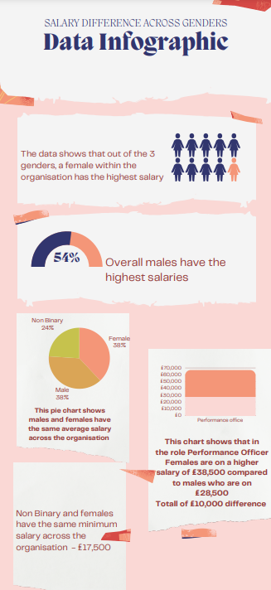

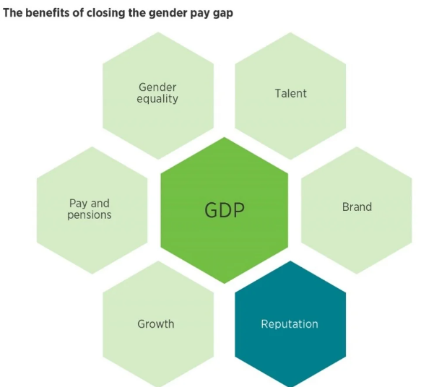

(Figure 5: CIPD, 2023)
The report shows the organisation has a gender pay gap. A recommendation would be to make sure that all employees have the same training and skills are fully utilised. All work has to be equal (CIPD, 2023) A cost might be found due to training and covering employees for the training.

Chart 5

The column chart above gives the information of the average salary throughout the whole organisation, £31,757.46. What can be taken from this chart is that the majority of employees are actually coming in under average. However the report does not sate if the employees are or have any specific type of contract or how long they have been with the organisation so this would have an impact to why it is below average. There could be a certain length of time you need to be in the organisation, complete probation to be on a certain salary. The organisation might have a pay structure. This helps with fairness and lawfulness throughout the organisation, for example pay discrimination (CIPD, 2023). The organisation could have a probationary period and after that their salary increases if they have passed. Risks, not all employees would pass so loss of turnover and cost of the training etc. However the benefit would be that everyone would be on the same salary (role dependant) after probation.

Table 2 –
If we look at the figures to which the employees agree to the questions in the survey it would show that out of 300 employees over half agree that they enjoy working from home on some of the days as it helps with work life balances. 85% said they feel less stressed about working away from their workplace and 83% of employees said they do not miss engaging with employees in the workplace. This shows that 59% of employees feel there is less conflict.
If we move on to the employees who stated they disagree with the questions it shows that a high number of employees do not feel fully supported while working at home and 64% find it hard to separate their work from personal life. Meeting targets is a main aspect of any organisation but the figures of this survey show that 68% of employees stated they do not agree working from home allows that and shows as 85% feel more stressed working from home.
However there are a few that tend to have similar figures for agreeing and disagreeing. 49.3% agree that it makes them more proactive and 49% disagree. Then there is the 1.67% who aren’t sure. There could be many factors for these results as in the employees specific job, there team, manager all play a part. Following on from that there are close figures for employees saying they get the same amount of recognition working from home, the highest percentage at 53% do disagree but there are 46.3% who agree.

To make sure that the employees feel supported whilst working from home the organisation can carry out an assessment for hybrid working, CIPD have one of these that can be followed (CIPD, 2023). Besides that the employer can carry out regular employee reviews, group sessions using the appropriate technology. Making sure targets are met is a main priority as this has a finical impact on the organisation. To ensure this happens the correct training needs to be in place along with correct policy and procedures for hybrid working.

