
Programme: MSc Computing Portfolio
Module Code: ACCA7027
Module: Cloud Engineering Principles and Practice
Student Name: Pritiben Nareshbhai Bhoi
Student ID Number:2540464

Table of Contents
1. Overview 3
2. Docker&Containerisation in Cloud Computing 3
2.1 Fundamentals of Containerisation 3
2.2 Advantages of Containerisation in Cloud Computing 4
2.3 End-to-End implementation Error! Bookmark not defined.
2.3.1 Principles of Virtualisation Error! Bookmark not defined.
2.3.2 Dockerfile and Containerisation Error! Bookmark not defined.
2.3.3 Docker Images and Docker Hub Publishing Error! Bookmark not defined.
2.3.4 Container Volumes Error! Bookmark not defined.
2.3.5 Container Networking Error! Bookmark not defined.
2.3.6 Docker Compose and Container Security (CVE Analysis) Error! Bookmark not defined.
2.4 Critical Evaluation 18
3. Cloud Concepts: Load Balancing, Scalability&Application Gateways 18
3.1 Cloud Application Overview Error! Bookmark not defined.
3.2 Load Balancing Architecture Error! Bookmark not defined.
3.3 Scalability Strategies Error! Bookmark not defined.
3.4 Application Gateway Architecture Error! Bookmark not defined.
3.5 Integration of Load Balancing and Scalability Error! Bookmark not defined.
3.6 Benefits of Combining Load Balancing, Scalability and Application Gateways Error! Bookmark not defined.
4. Expansion of Cloud Computing and Serverless Computing 24
4.1 Driving Forces Behind Cloud Computing Expansion Error! Bookmark not defined.
4.2 Serverless Functions 26
4.3 Comparison between Serverless Computing and Containerisation Error! Bookmark not defined.
4.4 Critical Reflection Error! Bookmark not defined.
5. Conclusion 29
References Error! Bookmark not defined.

1. Overview
Many industrial and commercial organizations are shifting to cloud computing to provide scalable, resilient, and cost-effective digital services in a variety of settings. Virtualisation and containerisation technologies revolutionise application deployment, allowing for efficient use of resources, streamlined management and quicker software delivery. Docker is popular because containers are consistently created, deployed and managed on cloud infrastructure. Operational consistency is maintained across development, test and production environments and overhead is reduced on the containerised applications. Virtualisation principles are used to leverage the available hardware resources and to create multiple isolated operating environments on the same physical resources. Capabilities, such as Docker images, container volumes, networking, and orchestration, enhance application portability, reliability, and deployment flexibility.
Cloud-native technologies are becoming more dominant to help support deployment and continuous deployment, ease maintenance, and speed up scaling in dynamic computing environments. Netflix is chosen for this report because it is a streaming service across the globe that illustrates practical applications of advanced cloud engineering concepts. Distributed containerised microservices, intelligent traffic management and automated resource scaling of cloud infrastructures ensure high service availability. These are used to provide ongoing delivery of content regardless of geographical demands. The concepts of serverless computing and containerisation are explored in depth, considering their role in driving cloud adoption, efficiency, and contemporary application deployment.

2. Docker&Containerisation in Cloud Computing

2.1 Fundamentals of Containerisation
Definition of Containerisation
Containerisation is a virtualisation technique, an operating system-level virtualisation, where applications and their dependencies are isolated in containers. Each container runs independently but uses the host operating system kernel across dev, test and production environments. Unlike regular virtual machines, guest operating systems reducing resource usage and improving deployment efficiency.
Core Components of Containerisation
Containerised environments are created using container images, runtimes, registries and orchestrators to manage the application lifecycle [10]. Images are built from layered file systems, and Docker Engine is used to build and run containers from a set of images. Container registries such as Docker Hub provide for safe storage, version control and distribution of reusable images for applications.
Role in Cloud Computing
Application portability, scalability and operational consistency are improved when using containerisation within cloud computing, across distributed infrastructures. Cloud-native applications are deployed quickly and always run in the same execution environment, regardless of which cloud platform is being used. As a result, the resources are utilised efficiently, infrastructure cost is minimised, while portable container technologies can efficiently facilitate continuous integration and continuous deployment.

2.2 Advantages of Containerisation in Cloud Computing
Enhanced Resource Efficiency
A major advantage of containerisation is the ability to run several different applications and use a single shared operating system kernel. Reducing computational overhead while increasing application density and decreasing infrastructure costs compared to virtual machines. As a result, cloud resources are utilised more efficiently without any impact on application performance or operational stability.
Improved Portability and Deployment Consistency
Applications are bundled with required libraries and dependencies and runtime settings to run on a variety of cloud platforms [11]. Consistent deployment because the same container images are used in the development, testing and production phases. This makes it easier to move from one cloud provider to another, and helps to minimise compatibility problems and deployment failures.
Scalability and Operational Agility
Cloud infrastructure enables highly responsive cloud infrastructures through rapidly replicating or terminating containerised applications in accordance with changing workloads [12]. Orchestration platforms such as Kubernetes and Docker Compose can help ensure uninterrupted service availability by supporting automatic scaling mechanisms. Without major service interruptions, faster deployment cycles, simplified maintenance and continuous software updates are enabled.

2.3 End-to-End implementation

2.3.1 Principles of Virtualisation
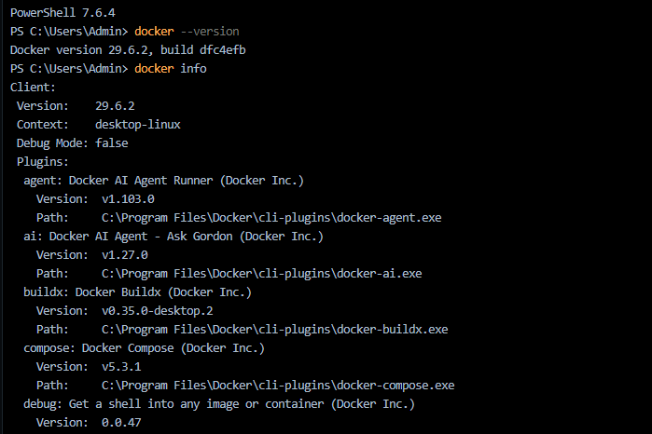
Figure 1: Docker CLI Version and Plugin Inventory
Figure 1 shows that PowerShell session where docker --version confirming Docker Engine 29.6.2 (build dfc4efb) [1]. Docker info client output showing context "desktop-linux", debug mode disabled, and installed CLI plugins (AI Agent Runner, Ask Gordon, Buildx v0.35.0, Compose v5.3.1), verifying a correctly configured Docker Desktop installation with extended plugin architecture for AI-assisted container operations.
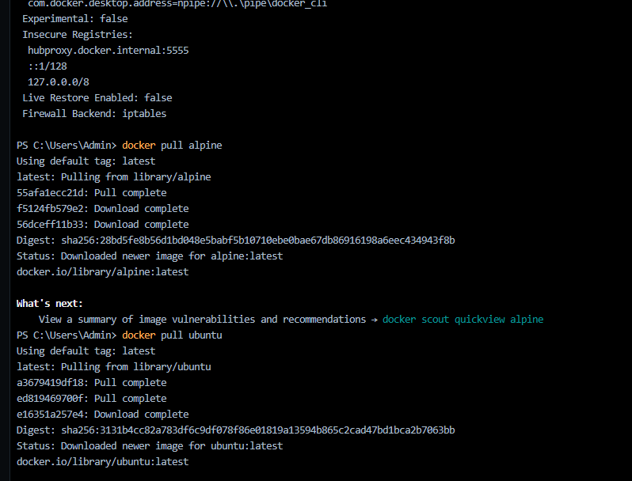
Figure 2: Registry Configuration and Image Pull Operations
Figure 2 shows Docker's insecure registry whitelist and firewall backend (iptables), followed by sequential docker pull commands retrieving alpine: latest and ubuntu: latest from Docker Hub [2]. Layer-by-layer download progress, SHA256 digests, and completion statuses confirm successful image retrieval, demonstrating content-addressable storage and registry authentication logic.
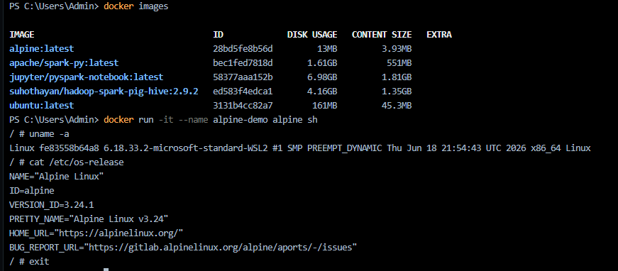
Figure 3: Local Image Registry and Container Runtime Verification
Figure 3 shows that Docker images lists locally cached images with disk usage and content size metrics (Alpine 13MB vs Jupyter/PySpark 6.98GB), highlighting layer compression efficiency. Subsequent docker run -it alpine sh spawns an interactive container, where uname -a and cat /etc/os-release confirm kernel version (6.18.33 WSL2) and Alpine 3.24.1 OS identity.

2.3.2 Dockerfile and Containerisation

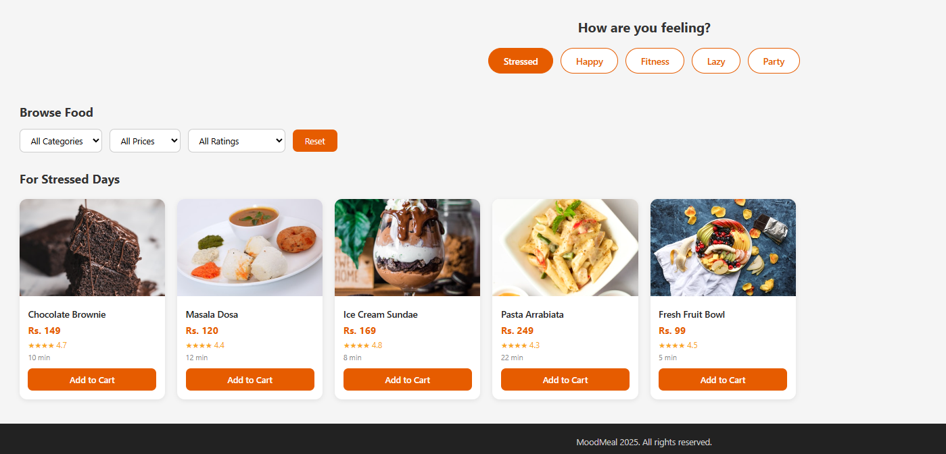
Figure 4: MoodMeal Landing Page UI
According to figure 4, Web interface screenshot displaying the application's homepage with an orange-yellow gradient hero section, navigation bar (Home/Cart). This represents the front-end presentation layer rendered via static HTML/CSS assets served through the containerised web server. It also shows dynamic UI logic were selecting a mood tab ("Stressed") triggers conditional rendering of a curated product grid with five food cards. Each containing pricing, star ratings, prep time, and "Add to Cart" actions illustrating client-side JavaScript filtering/state logic tied to category, price, and rating dropdowns.
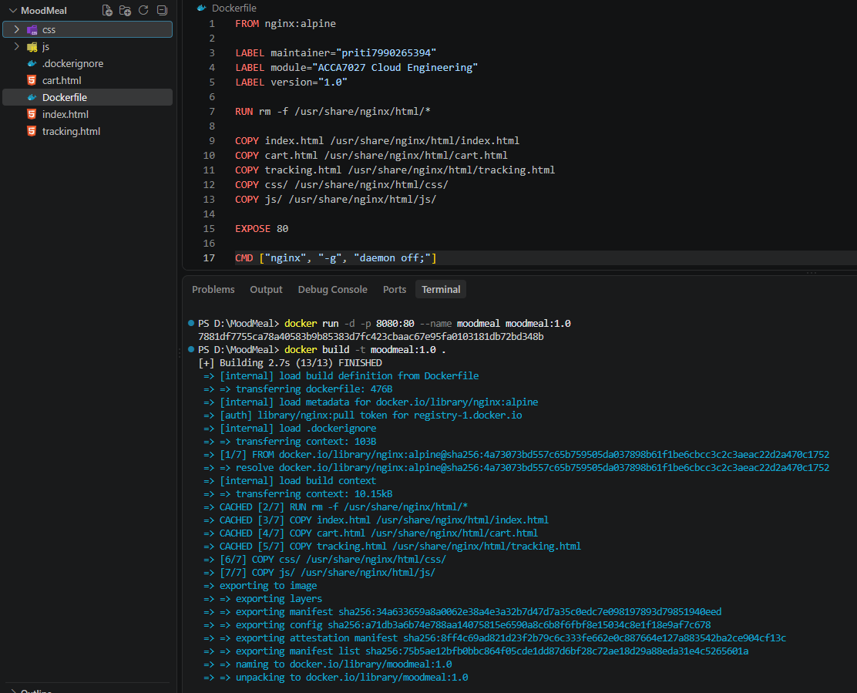
Figure 5: Container Deployment and Inspection Metadata
Figure 5 shows that Terminal executes docker run -d -p 8080:80 --name moodmeal moodmeal:1.0, mapping host port 8080 to container port 80 in detached mode. Docker ps confirms the running container's status and port bindings, while docker inspect outputs JSON metadata validating successful orchestration.
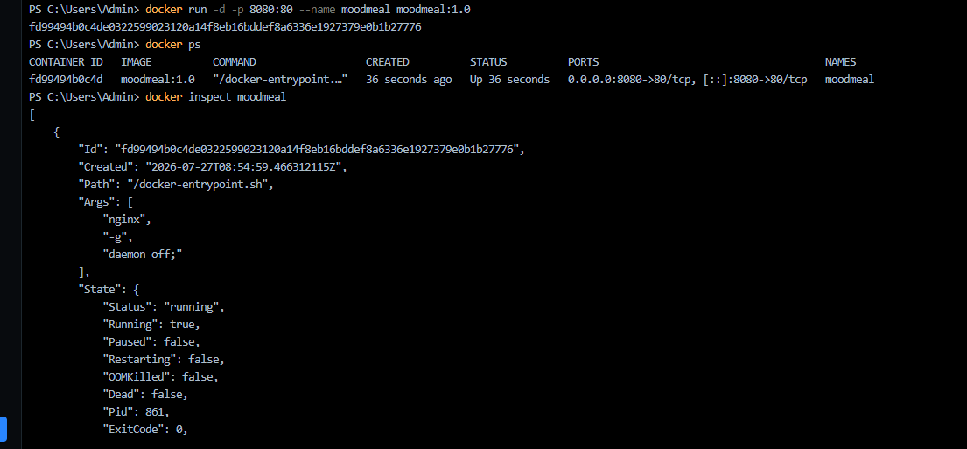
Figure 6: Container Deployment and Inspection Metadata
Figure 6 shows that Terminal executes docker run -d -p 8080:80 --name moodmeal moodmeal:1.0, mapping host port 8080 to container port 80 in detached mode, returning a container ID hash. docker ps confirms operational status with port bindings on IPv4/IPv6 interfaces. Docker inspect outputs JSON metadata detailing container ID, creation timestamp, entrypoint path/args (/docker-entrypoint.sh nginx -g daemon off), and runtime state fields collectively validating a healthy, non-terminated container instance under Docker's supervision.
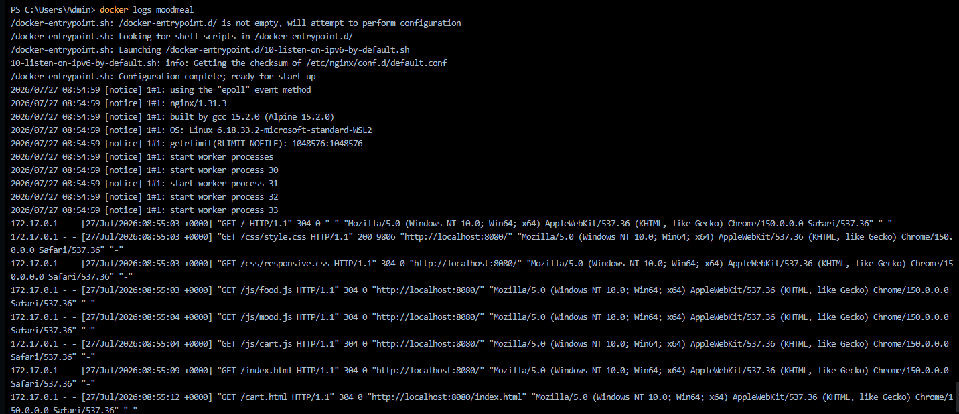
Figure 7: Nginx Access Log and Request Monitoring
Figure 7 shows that Docker logs moodmeal output displays the containerised Nginx entrypoint’s initialisation sequence: detecting non-empty /docker-entrypoint.d/, executing configuration scripts (IPv6 listener setup), computing config checksums. Subsequent notice-level logs report the epoll event method, nginx/1.13.3 build details, host OS kernel (Linux 6.18.33.2-microsoft-standard-WSL2), and spawning of four worker processes for concurrent request handling. Real-time access logs then record client HTTP GET requests from 172.17.0.1 for static assets with HTTP status codes (200/304), response sizes, referrer URLs, and browser user-agent strings. This confirming successful asset delivery and functional browser-to-container communication over the exposed port mapping [3].

2.3.3 Docker Images and Docker Hub Publishing
Container images are designed to help in creating a package of the application and its dependencies, which can be run consistently in cloud environments. Docker Hub is used as a central repository to securely store, version and share container images for reliable deployment. Image publishing and retrieval processes are shown to validate the portability and reproducibility of applications on different distributed cloud infrastructures.
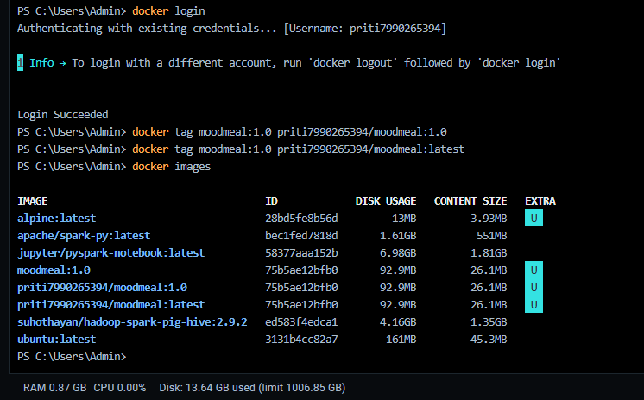
Figure 8: Docker Image Tagging and Repository Preparation
Successful login with Docker Hub is shown in figure 8 before tagging locally created container images by repository conventions. Several image tags are made to help with version control and repository identification [4]. The image metadata is validated using Docker commands, making sure that images ready to be deployed are properly prepared before being published in Docker Hub repositories.
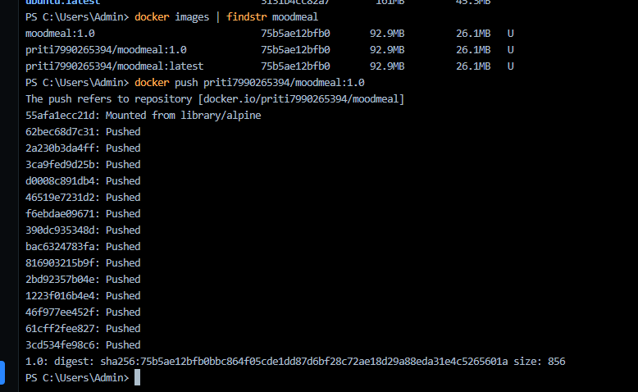
Figure 9: Publishing Container Images to Docker Hub
Figure 9 shows that the MoodMeal container image is successfully published on Docker Hub with the command Docker push. The image layers are uploaded in order, and the digests are unique to verify the integrity of the image. The synchronisation of the repository is accomplished, and the reusable images of the applications are securely distributed for their deployment in the cloud and collaborative software development.
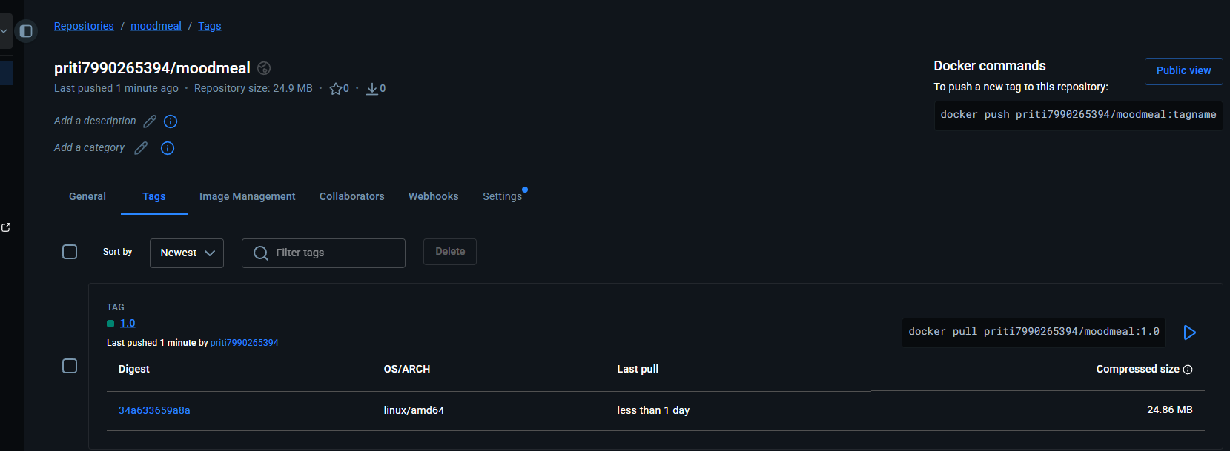
Figure 10: Docker Hub Repository Verification
Figure 10 shows the published Docker Hub repository with the versions of the image uploaded, architecture information, and size of the repository. Availability of images is checked online with the image registry interface, assuring consistent deployment, versioning and distribution of centrally managed images across various cloud computing environments.
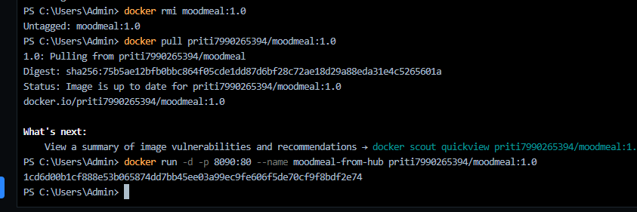
Figure 11: Docker Image Retrieval and Integrity Validation
Successful retrieval of the published image is highlighted in figure 11 when the local copy of the published MoodMeal image is removed from the host environment. Published container images can be successfully restored with authentication at the repository, download of images, authentication against a digest, and unique image identification, while deployment consistency and application portability are ensured across cloud platforms.

2.3.4 Container Volumes
Container volumes are used to store data outside the lifecycle of the containers for applications to store their data persistently across deployments. Creating, inspecting and mounting Docker volumes and sharing between containers are used to illustrate data persistence. Also, these help in easier storage management and uniform access to data during the execution and maintenance of cloud-native applications.
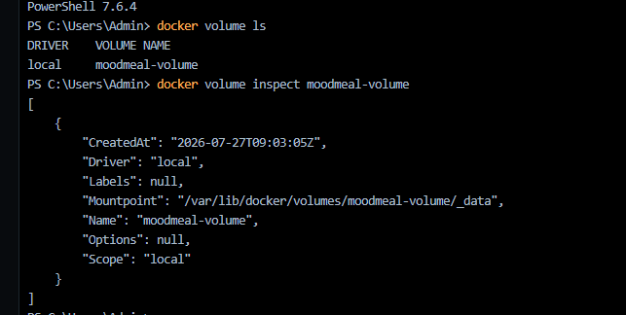
Figure 12: Docker Volume Creation and Inspection
MoodMeal Docker volume has been created and inspected successfully, as shown in figure 12, using Docker volume management commands [5]. The volume identifiers, storage drivers, mount locations and configuration information mean that persistent storage resources are created independently of container instances. The robust data retention capability, therefore, ensures data is protected across multiple container deployments and runs.
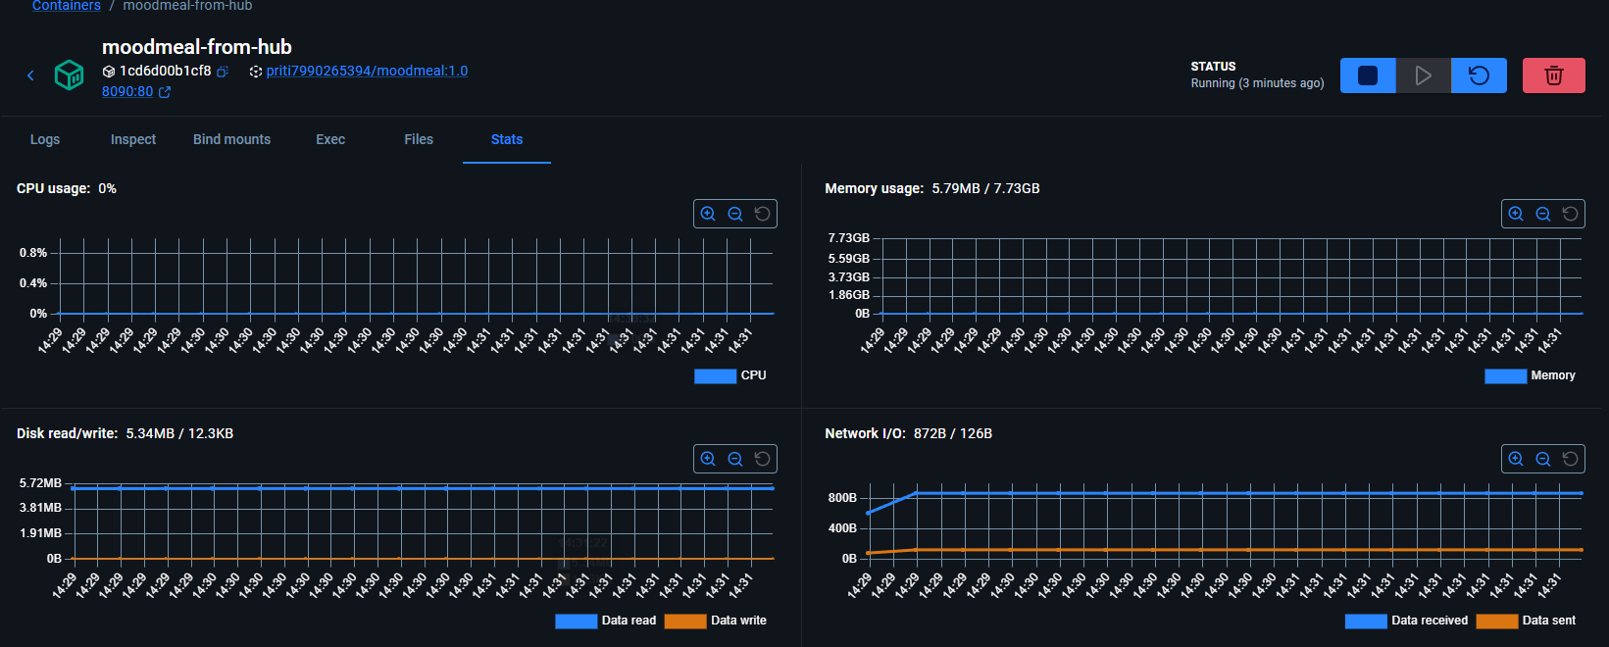
Figure 13: Container Resource and Volume Monitoring
The run-time statistics for the Moodmeal container are displayed in figure 13, which shows the utilisation of the processor, memory usage, disk input/output and network activity. Docker Desktop is used to monitor resources and continuously assess the performance of containers [6]. Efficient usage of resources and stable execution are verified when integrating persistent volumes.
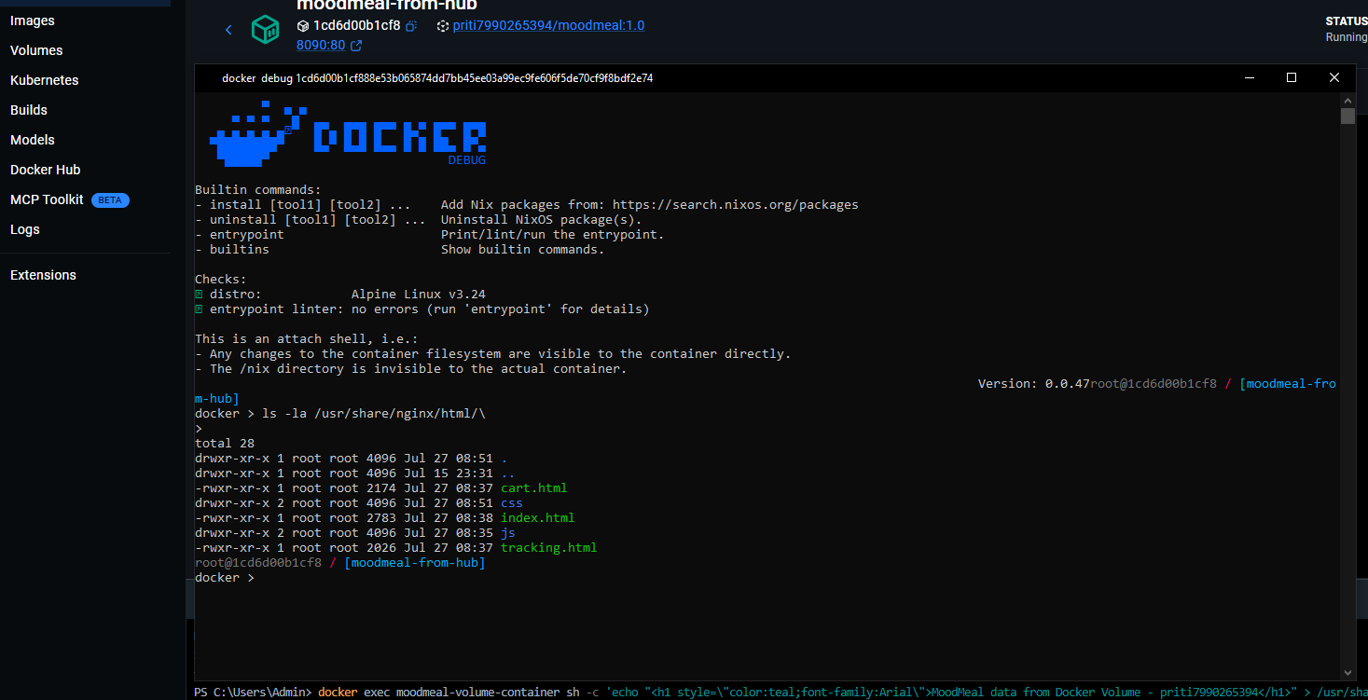
Figure 14: Volume Mount Verification within Container
According to figure 14, successful Docker volume attachment is highlighted when an interactive shell session with the running container is performed. The application directory and deployed resources are scanned within the container space to ensure that mounted storage spaces are available. Persistent applications are stored separately from the lifecycle operations of the containers.
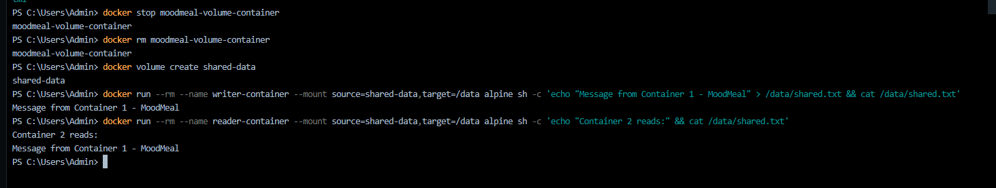
Figure 15: Shared Volume Data Persistence between Containers
Figure 15 indicates that multiple container instances are created using a Docker volume that successfully shares data. The reader container can retrieve the information from the writer container without any loss of accuracy, showing the persistent shared storage functionality. Therefore, data consistency, container interoperability, and reliable data exchange are ensured across separate containerised application environments.

2.3.5 Container Networking
A network of containers is implemented to provide secure and reliable communications between isolated application containers running in Docker environments. Custom bridge networks are set up to facilitate automatic service discovery, traffic control and network isolation. As a result, application communications are always scalable, resource sharing is efficient, and interactions with services in the cloud are secure.
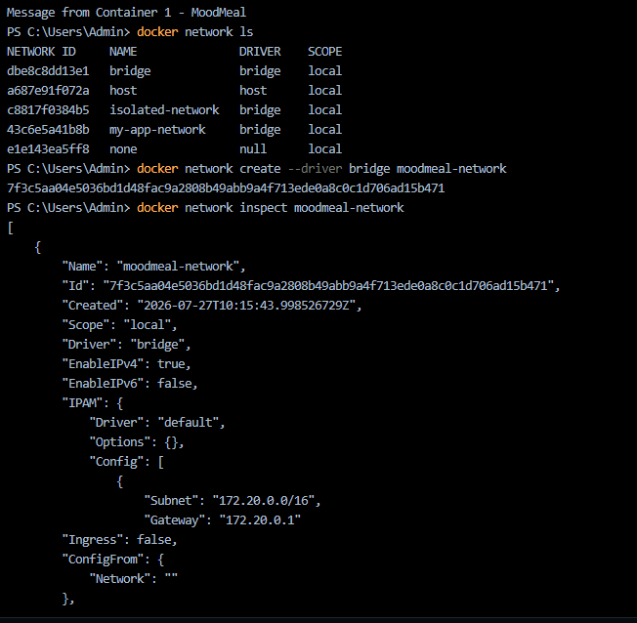
Figure 16: Docker Bridge Network Creation and Inspection
Figure 16 shows that Docker’s bridge networking has been implemented by listing the available network drivers while a moodmeal-network is created for the application. This custom bridge network creates a separate network for app traffic to run aside other Docker networks and allows for secure communication between related app containers. A network inspection is then conducted to ensure that the automatically assigned subnet, gateway address, IPv4 configuration and the bridge driver properties are correct [7]. Before deployment of the application, configuration options are presented to ensure the networking is set up properly. This implementation enables controlled network segmentation, boundary enforced communications and a scalable networking foundation for a reliable interaction between multiple containerised services in the Docker-based cloud environment.
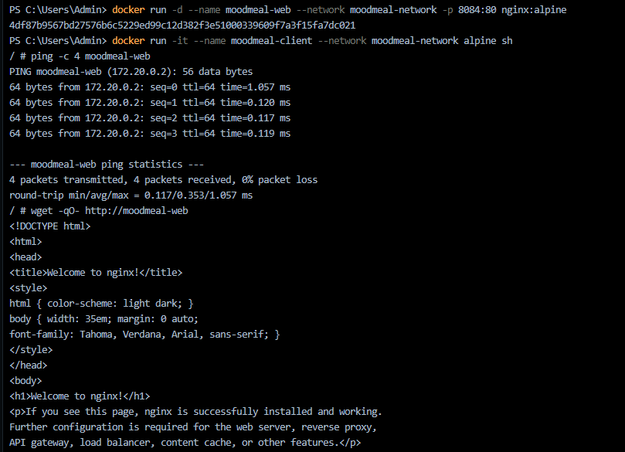
Figure 17: Inter-Container Communication Verification
According to figure 17, the two containers are connected (as a result of the previous step) using the Docker bridge network and communicate successfully. The deployment of a web server container is done in a custom network and then a client container is started to test whether a service is accessible. A network is validated for connectivity with ICMP ping packets while all sent packets indicating a valid network between isolated containers [8].
The connection at the application level is then tested by sending an http request to get the default Nginx page from the web container. When the page is successfully retrieved, this means that Docker's internal Domain Name System (DNS) is able to resolve container names correctly and that the routing of the network is working as expected. As a result, within the isolated Docker networking environment, reliable service discovery, low latency communication and seamless inter-container connectivity are proven.

2.3.6 Docker Compose and Container Security (CVE Analysis)
Docker Compose simplifies orchestration and management of services with deployment automation across multiple containers by using a single configuration file. Container security is assessed through vulnerability assessment methods that include identifying software vulnerabilities, verifying deployments and enhancing the security of applications before they are deployed in a cloud environment.
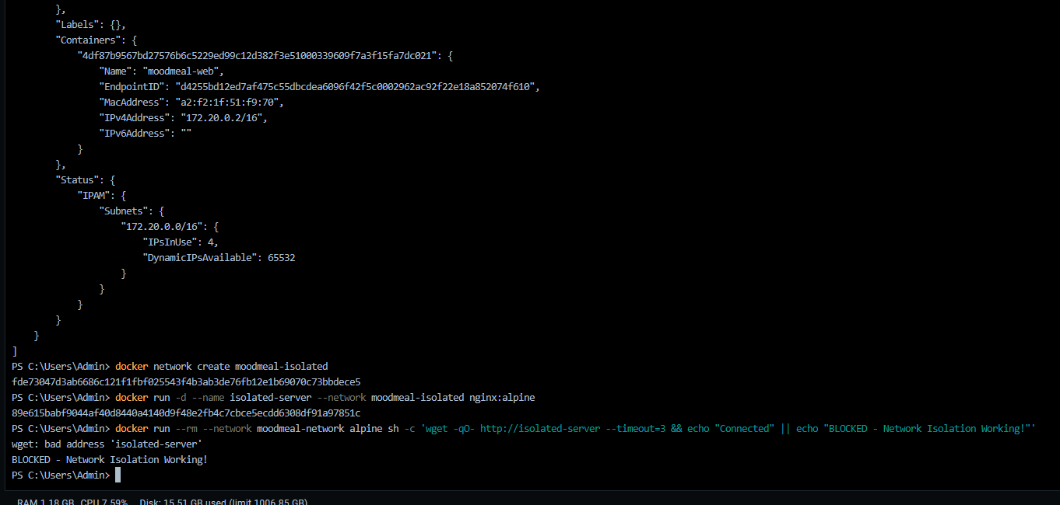
Figure 18: Network Isolation Validation
Figure 18 indicates that Docker network isolation has been successfully implemented by establishing an independent bridge network. Connectivity tests from another container are deliberately denied, to ensure that the communication restrictions are properly enforced [9]. Network segmentation is checked and container security is enhanced, as well as the possibility of unauthorised interaction among isolated application services.
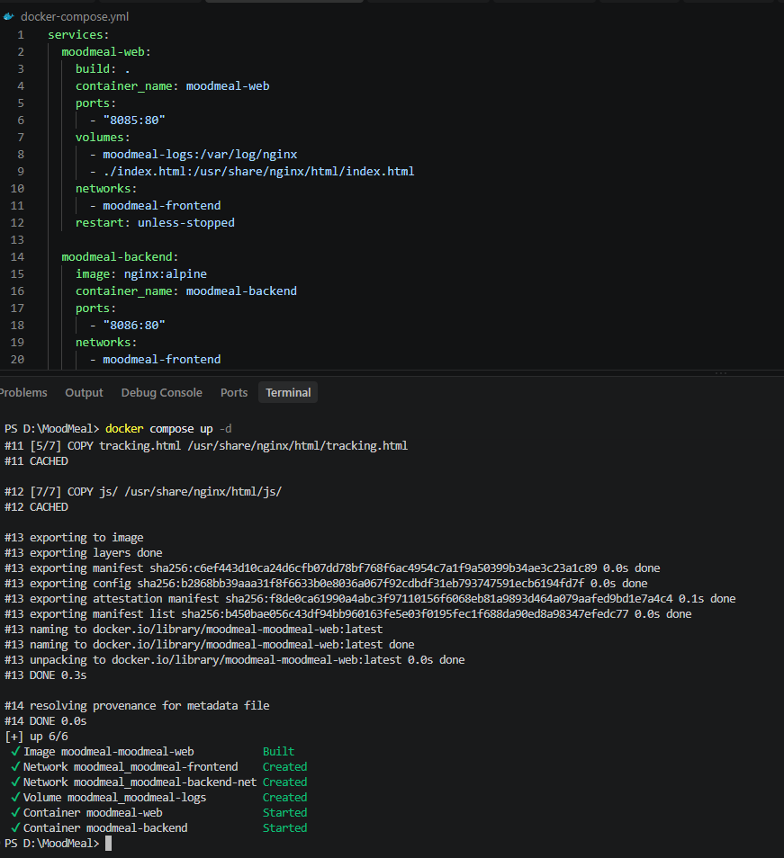
Figure 19: Multi-Container Deployment Using Docker Compose
The deployment of the MoodMeal application is done through the use of Docker Compose with a single YAML configuration file as shown in figure 19. All of the services, custom networks, persistent volumes and container images are created and started automatically together. Centralised orchestration making deployment easier and ensuring consistency in application configuration in the cloud-based container environment.
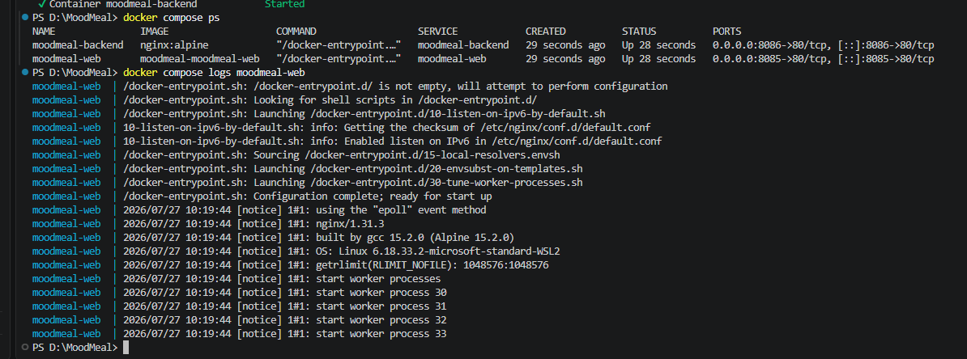
Figure 20: Docker Compose Service Monitoring
The status of the active containers and logs are displayed during running Docker Compose in figure 20. Services, their startup events, Nginx initialisation, and worker processes, as well as port mappings are continuously monitored. In this way, successful orchestration is confirmed, with stable execution, service availability and effective life cycle management of interconnected containerised applications.
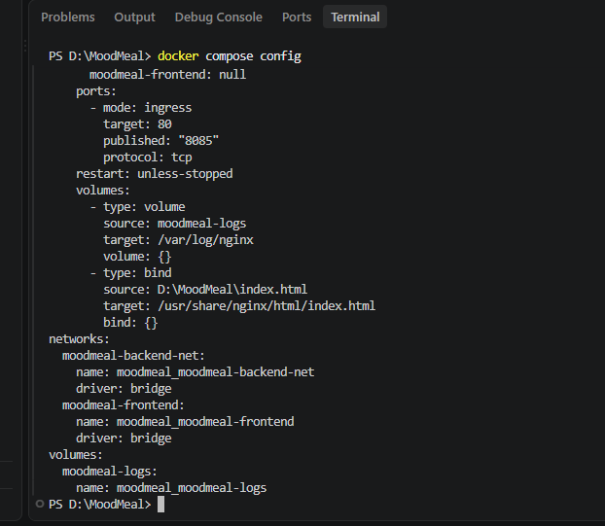
Figure 21: Docker Compose Configuration Validation
Figure 21 shows the validation of the Docker Compose configuration before deployment of an application, with Resolved service definitions, Bridge networks, Published ports, Persistent volume mappings. The configuration parameters are checked systematically which guarantees a uniform deployment, correct resource allocation and reliable orchestration of interdependent application services in the Docker environment.
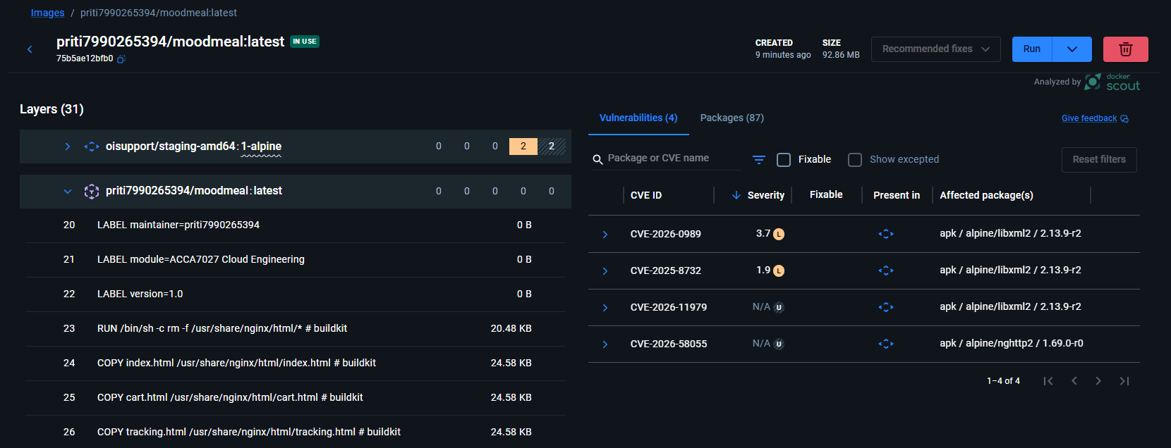
Figure 22: Container Security Assessment Using Docker Scout
The results of the Docker Scout vulnerability assessment of the published MoodMeal container image are shown in figure 22. All image layers, installed software packages, identified CVEs, severity ratings and affected dependencies are comprehensively evaluated. Security issues are discovered before deployment to remediate these issues and improve the security of containerised cloud applications. "The next video shows how to practically implement the Docker-based cloud environment, from containerisation to creating and publishing images, to volumes, networking, and more.", https://youtu.be/s5s61eQqJu4?is=bRUG1rp41-YOR3iK

2.4 Critical Evaluation
Virtualisation and uniform execution environments in Docker-based containerisation are assessed as a crucial method of application development and deployment for cloud-native applications. Multiple isolated applications can run efficiently on shared operating system (OS) kernels, rather than on traditional virtual machines, resulting in improved resource utilisation. Identical container images run the same way in development, testing and production environments, improving application portability. Docker Compose streamlines deployment automation, allowing multiple interdependent services by a single configuration file, resulting in more reliable deployments and less time spent on managing services.
Persistent storage mechanisms, combined with custom bridge networks, add an additional layer of resilience to applications, facilitating reliable data handling and secure inter-container interactions. On the other hand, enterprise cloud environments need extra complexity in terms of management of the large-scale container orchestration, which relies on specific platforms such as Kubernetes. The actual deployment shows that Docker is an effective, portable and scalable deployment solution. Docker containerisation is suited for cloud-based applications that need to be deployed quickly.

3. Cloud Concepts: Load Balancing, Scalability&Application Gateways

3.1 Cloud Application Overview
Amazon Web Services (AWS) is one of the major cloud service provider across the world. Netflix operates on AWS cloud services providing cloud-based infrastructure for the provision of globally distributed streaming applications. The choice of Netflix application for this research paper is due to large-scale content streaming, worldwide service availability, and intelligent traffic management in the cloud environment. It processes millions of requests from users concurrently on the cloud infrastructure, while maintaining application responsiveness and a high level of availability [13]. Microservices architecture is used to design a system where different components such as streaming, recommendation, authentication, and content management are developed independently.
Workload containers are deployed on distributed computing resources to gain better operational consistency, scalability, and fault isolation while managing variable traffic flow. Traffic flow management, automatic resource allocation, and infrastructure strategies are implemented to ensure the continuous delivery of video content despite regional traffic variations. Availability of service is gained by distributing data centres geographically, replicating applications, and using health checking mechanisms. Content recommendation is provided in a personalized manner through processing large volumes of data, while streaming latency is minimized using globally distributed content delivery resources.

3.2 Load Balancing Architecture
AWS Elastic Load Balancing balances the distribution of requests received by Netflix application among different instances. A load balancing technique is employed in the cloud environment of Netflix to allocate incoming requests from customers among several instances of applications without overstressing the computing resources. Policies of traffic allocation are established in order to assign requests for streaming in accordance with the availability of servers, geographic location, and the load condition of servers.
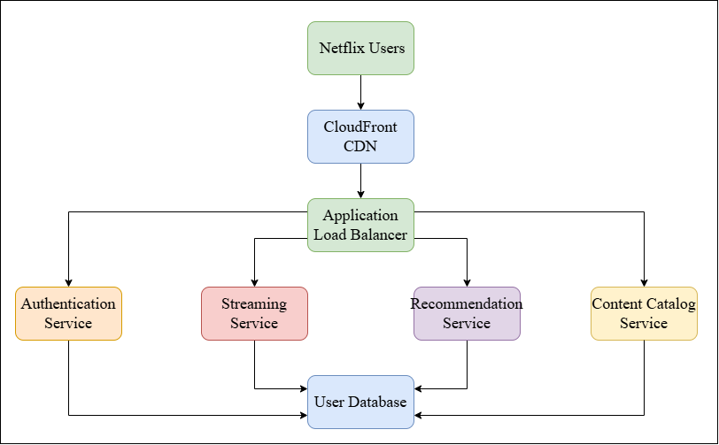
Figure 23: Load Balancing in Netflix Cloud Architecture
Figure 23 shows traffic flow from an application load balancer where incoming requests from Netflix users are directed to multiple microservices in order to maintain balanced loads, minimize latency, and ensure stream availability. Interruption of service becomes minimal since overloaded servers are automatically avoided, provided other computing resources are available [14].
Availability is maintained by distributing applications over several cloud regions, thus providing continuity of service in case of hardware malfunction and increased traffic. Monitoring of health status of servers is conducted constantly before making any decision on forwarding requests. Requests from users are forwarded to healthy server instances in case of poor server performance. Latency is minimised since geographically optimised routes of requests are used across the distributed cloud network.

3.3 Scalability Strategies
AWS Auto Scaling scales up or down computing resources in support of Netflix, ensuring that streaming performance is steady amid varying customer demands worldwide. Scalability is used in the Netflix cloud architecture so that it is possible to handle the dynamically changing requirements from users without reducing the responsiveness of applications or quality of streaming. The horizontal scalability approach is chosen due to the automatic deployment of more containers of the application in case of surpassing the defined resource utilization limits [15]. Resources are released on the fly in the case of a reduction in load. It allows avoiding extra costs on the infrastructure while using computing resources effectively.
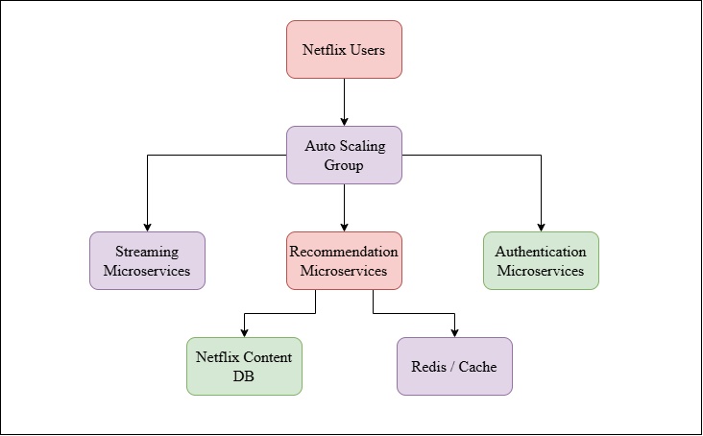
Figure 24: Scalability in Netflix Cloud Architecture
Figure 24 demonstrates automatic resource scaling using an Auto Scaling Group where microservice instances grow dynamically, providing continuous streaming performance during times of varying user demand. Orchestration frameworks are used for the management of application replication, workload scheduling, and reliability in cloud architectures. The high load caused by the release of new content and other factors is handled via scalable solutions without the need to do anything manually. The elasticity of infrastructure is ensured as the computing capacity depends on the consumption of resources rather than on hardware capacities. Availability of services is maintained even in case of handling millions of streams simultaneously in different data centres.

3.4 Application Gateway Architecture
AWS Application Load Balancer directs Netflix application traffic to containerised microservices, improving request handling and accessibility of the application. Application gateways operate within the cloud architecture of Netflix to regulate the traffic entering from users before passing on the traffic to the application services at the backend. Secure request filtering, protocol management, and smart traffic routing are conducted to establish secure communications across the distributed cloud infrastructure [16]. Secure Sockets Layer termination allows for decryption of the secure communication before application processing takes place to improve efficiency of backend operations. Policies for Uniform Resource Locator routing allow user requests to be sent to the right microservices depending on the application resources requested.
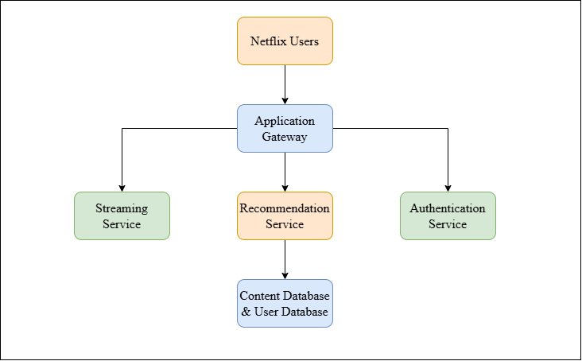
Figure 25: Application Gateway in Netflix
Figure 25 shows secure request routing through an application gateway before authorised traffic gets to Netflix microservices, thereby improving security, efficient communication, and backend service availability. Enhanced security is achieved by detecting any malicious requests, unauthorized access attempts, and abnormal traffic patterns before backend processing [12]. Session persistence is guaranteed to make sure that streaming requests correspond to the relevant services in case of streaming requests for the continuous media delivery process. The result is optimized network communication alongside application security and efficient traffic management.

3.5 Integration of Load Balancing and Scalability
Netflix makes use of the combination of Elastic Load Balancing and Auto Scaling to ensure its service continuity. Load balancing and scalability are accomplished together since traffic balancing alone will not ensure service quality as long as there are enough computing resources. Load balancing distributes incoming streaming requests among several application instances, and extra service instances are provided by scaling whenever the demand for resources goes up. Balanced workload distribution prevents heavy utilisation of particular servers, and scalability guarantees that there is enough computing power left for incoming requests [17].
Service availability is ensured because both these technologies are used simultaneously during peaks of streaming requests and regional traffic fluctuations. Resources are managed efficiently because workload balancing occurs first, and then expansion of the infrastructure takes place based on demand. This is why service availability is improved due to fewer disruptions as a result of hardware failures and sudden changes in workloads. Streaming services can be provided continuously from globally distributed cloud computing environments.

3.6 Benefits of Combining Load Balancing, Scalability and Application Gateways
Cloud Technology | Implementation in Netflix | Operational Benefit
Load Balancing | Traffic allocation is performed according to server health, resource availability, and regional proximity to minimise service interruption during fluctuating workloads [18]. | High availability is preserved because user requests are redirected automatically towards healthy service instances whenever infrastructure failures or unexpected traffic spikes are encountered.
Scalability | Computing resources are released after workload reduction, ensuring efficient infrastructure utilisation throughout continuously changing user demand. | Infrastructure elasticity is maintained without manual intervention, enabling uninterrupted streaming during large-scale content releases. Operational expenditure is optimised because computational resources are allocated according to real-time workload requirements.
Application Gateway | Client requests are inspected, authenticated, decrypted, and forwarded towards appropriate backend microservices according to predefined routing policies. | Malicious traffic is filtered before backend services are accessed, reducing security risks and maintaining reliable service delivery across globally distributed cloud environments [19].
Integrated Cloud Architecture | Load balancing, scalability, and application gateway services are deployed collectively to coordinate traffic management, infrastructure expansion, and secure application access throughout the Netflix cloud ecosystem. | End-to-end operational resilience is achieved through coordinated resource allocation. Service continuity, low latency, and consistent user experience are maintained despite rapidly changing workloads, infrastructure failures, and geographically distributed streaming requests.
Table 1: Benefits of Integrating Load Balancing, Scalability, and Application Gateway in the Netflix Cloud Architecture
Table 1 presents operational gains gained from the integration of load balancing, scalability, and application gateway techniques, showing improved availability, security, resource usage, and streaming performance.

4. Expansion of Cloud Computing and Serverless Computing

4.1 Driving Forces Behind Cloud Computing Expansion
Cost Effectivity
AWS cloud services are employed by Netflix to provide cost optimisation and flexible infrastructure for globally distributed streaming.
Cloud Cost Component | Implementation within Netflix | Operational Contribution
Pay-as-you-use Resource Allocation | Computing resources are provisioned dynamically according to streaming demand instead of maintaining permanently allocated infrastructure. Additional processing capacity is activated only during peak viewing periods, while unused resources are released automatically after workload reduction. | Infrastructure expenditure is reduced because resource consumption remains aligned with actual operational requirements. Financial efficiency is therefore improved without affecting streaming availability or application performance [20].
Containerised Resource Utilisation | Multiple containerised microservices are executed on shared operating system resources rather than dedicated virtual machines. Lower computational overhead is maintained while application isolation and deployment consistency remain preserved throughout cloud operations. | Hardware utilisation is optimised because available computing resources are shared efficiently. Infrastructure costs are reduced through improved application density and lower operating system overhead.
Automated Infrastructure Management | Cloud-native monitoring, orchestration, and deployment mechanisms are integrated to minimise manual infrastructure administration. Software updates, service recovery, and workload distribution are completed automatically across distributed cloud environments [21]. | Administrative expenditure is reduced because repetitive operational activities require limited manual intervention. Service continuity is maintained while operational efficiency is improved across geographically distributed infrastructure.
Global Content Distribution | Content delivery resources are deployed strategically across multiple geographical regions to minimise unnecessary long-distance data transmission and repeated backend processing. | Bandwidth consumption and infrastructure latency are reduced while streaming efficiency is maintained. Cost-effective service delivery is achieved through optimised utilisation of globally distributed cloud resources.
Table 2: Cost Effectiveness as a Driving Force Behind Cloud Expansion
Table 2 shows the major strategies used by Netflix in optimising cloud costs by ensuring efficient resource allocation, containerization, automation, and distribution of content across the world.
Flexibility
Flexibility is regarded as an important motivator for the growth of cloud computing as application deployment, infrastructure provisioning, and service provision are constantly adapted based on the needs of the organization and operation. In Netflix, the microservices model is used, meaning that all the application modules can be deployed separately without influencing the functionalities of other services.
The containerized applications are quickly moved between development, testing, and production phases while keeping identical execution configurations at each stage. The continuous integration and deployment processes are facilitated since changes are made gradually without needing the full application renewal. The cloud computing infrastructure is dynamically provisioned based on the changing streaming technology, geographic content distribution needs, and user demands. Business continuity is therefore ensured while making the process of deployment simpler through modular cloud-native architecture.
Elasticity
Elasticity is adopted in order to make sure that computing resources are scaled up or down depending on the ever-changing operational loads. There are considerable variations in the demands for stream services at Netflix as new releases are introduced, seasonal activities happen, or peak viewing times are experienced in different geographical locations. This results in automatic scaling procedures being set to scale up computing resources in the form of containerised service instances in case of exceeding specified load limits. Computing resources are scaled down right away after normalisation of load to avoid wastage of resources and operational inefficiencies [22]. Responsiveness of resource allocation is ensured since the capacity of the infrastructure is modified depending on processing needs, not physical limitations of the infrastructure. Availability of service is ensured due to the fact that there are enough computing resources to meet the rapidly growing demands.

4.2 Serverless Functions
The serverless feature offered by AWS Lambda can help Netflix in performing its event-based workloads without having to manage servers for the same, increasing efficiencies in its operations. Serverless functions are integrated into the cloud computing paradigm in order to run application code without managing underlying servers manually. The model of event-driven execution is used where computing resources are automatically allocated as soon as certain application events or requests are triggered. Infrastructure provisioning, operating systems management, and availability of the runtime environment become the tasks of the cloud computing platform provider, which allows application developers to concentrate on code functionality exclusively.
The billing scheme is based on the actual duration of execution and resources consumed, but not on the permanently reserved computing capacity [23]. Netflix applies serverless computing to conduct certain operations such as media processing, workflow automation, monitoring, notifications, and infrastructure management where there is no need for continuous execution of servers. Separate serverless functions are launched to run specific operations without any impact on streaming services and microservices running in containers. Automatic scaling is applied since several instances of functions are created dynamically in case of event generation and destroyed immediately after execution.

4.3 Comparison between Serverless Computing and Containerisation
Comparison Parameter | Serverless Functions | Containerisation
Execution Model | Application logic is executed only after predefined events or service requests are generated. Computing resources are allocated temporarily and released immediately after execution completion, supporting lightweight operational activities within the Netflix cloud environment. | Containerised microservices are executed continuously because streaming services require persistent application availability. Dedicated runtime environments are maintained to support uninterrupted media delivery, user authentication, recommendation services, and content management operations.
Resource Management | Infrastructure provisioning is managed automatically through cloud-native execution platforms without direct server administration. Resource consumption remains proportional to actual function execution, reducing operational overhead for event-driven workloads [24]. | Containers are deployed through orchestration platforms where application instances are managed, replicated, and monitored continuously.
Netflix Application | Serverless functions are utilised for media processing, monitoring, notification services, and infrastructure automation where continuous execution remains unnecessary. | Containerisation is adopted for streaming services, recommendation engines, authentication modules, and content delivery microservices because persistent application execution and operational consistency are continuously required.
Table 3: Comparison between Serverless Functions and Containerisation in the Netflix Cloud
Table 3 contrasts serverless functions and containerisation on the basis of execution model, resource management, and Netflix approach to illustrate the complementary nature of the two deployment approaches in cloud computing.

4.4 Critical Reflection
All AWS cloud services help Netflix with containerization, serverless, scalability, and cloud-native deployment of applications. The containerisation and serverless computing approaches are viewed as complementary cloud technologies since different operational needs are satisfied via particular deployment architectures. The use of container-based microservices to implement persistent application services for Netflix has been proved as being more suitable due to the continuous service execution, consistent runtime behaviour and deployment environment throughout all the processes of media streaming. It is possible to state that the deployment approach is more flexible, as application services are easier to maintain, and workloads are properly isolated since media streaming, recommendation, authentication and content management services are run in individual containers.
At the same time, serverless computing is seen as a suitable approach for event-driven services when the execution of application services is not required continuously. Media transcoding, notifications processing, workflowautomation, monitoring and log processing services can be run efficiently using temporary function instances, which are activated upon the occurrence of certain operational events. There is no need in additional infrastructure costs since computing resources are used solely during function execution. In general, we can say that flexibility is increased by the combination of two approaches since persistent services are isolated using containers while lightweight background processes are implemented via serverless functions.

5. Conclusion
Docker-based containerisation and cloud native architecture have been explored with the use of the implemented technologies to support the application Netflix. Implementation proved that containerisation offers reliable deployment environments with the help of Docker images, containers, networking, persistent volumes, and image publishing, and therefore application execution is possible. Virtualization principles have been used to optimise resource consumption in order to ensure an isolated application environment and reduced costs of operation. Concepts related to cloud such as load balancing, scalability, and application gateways have been studied to prove that these concepts are contributing to achieving high availability, safe traffic control, and effective workload distribution in global streaming platforms.
This task has revealed that the use of these technologies together guarantees uninterrupted operation regardless of changes in the users' demands. It has been proven that cost-effectiveness, flexibility, and elasticity are key factors of cloud expansion. Serverless computing and containerisation have been reviewed, and it has been concluded that event-driven loads are handled by means of serverless functions and persistent application services are provided through containerisation. Use of both technologies together has improved the resiliency of the operations by ensuring scalable infrastructure and efficient resource allocation.

References
[1] D. S. D'Onofrio, M. L. Fusco, and H. Zhong, CI/CD Pipeline and DevSecOps Integration for Security and Load Testing, SAND2023-08255. Albuquerque, NM, USA: Sandia National Laboratories, 2023. https://www.osti.gov/servlets/purl/2430395
[2] A. Makris et al., "Streamlining XR application deployment with a localized Docker registry at the edge," in Proc. European Conf. on Service-Oriented and Cloud Computing (ESOCC), Cham, Switzerland: Springer Nature, 2023, pp. 188-202. https://ifip.hal.science/hal-05698694/file/546872_1_En_12_Chapter.pdf
[3] J. Zeng, C. Zhang, and Z. Liang, "Palantír: Optimizing attack provenance with hardware-enhanced system observability," in Proc. ACM SIGSAC Conf. Computer and Communications Security (CCS), 2022, pp. 3135-3149. https://dl.acm.org/doi/pdf/10.1145/3548606.3560570
[4] S. K. Mondal, X. Wu, H. M. D. Kabir, H. N. Dai, K. Ni, H. Yuan, and T. Wang, "Toward optimal load prediction and customizable autoscaling scheme for Kubernetes," Mathematics, vol. 11, no. 12, p. 2675, 2023. https://www.mdpi.com/2227-7390/11/12/2675
[5] B. S. Kim, S. H. Lee, Y. R. Lee, Y. H. Park, and J. Jeong, "Design and implementation of cloud Docker application architecture based on machine learning in container management for smart manufacturing," Applied Sciences, vol. 12, no. 13, p. 6737, 2022. https://www.mdpi.com/2076-3417/12/13/6737
[6] T. Alyas, S. Ali, H. U. Khan, A. Samad, K. Alissa, and M. A. Saleem, "Container performance and vulnerability management for container security using Docker engine," Security and Communication Networks, vol. 2022, Art. no. 6819002, 2022. https://onlinelibrary.wiley.com/doi/pdf/10.1155/2022/6819002
[7] J. Nam, S. Lee, P. Porras, V. Yegneswaran, and S. Shin, "Secure inter-container communications using XDP/eBPF," IEEE/ACM Transactions on Networking, vol. 31, no. 2, pp. 934-947, 2022. https://nss.kaist.ac.kr/assets/papers/ton2022-nam.pdf
[8] F. Brasser, P. Jauernig, F. Pustelnik, A. R. Sadeghi, and E. Stapf, "Trusted container extensions for container-based confidential computing," arXiv preprint arXiv:2205.05747, 2022. https://arxiv.org/pdf/2205.05747
[9] D. B. Cruz, J. R. Almeida, and J. L. Oliveira, "Open source solutions for vulnerability assessment: A comparative analysis," IEEE Access, vol. 11, pp. 100234-100255, 2023. https://ieeexplore.ieee.org/iel7/6287639/6514899/10251527.pdf
[10] O. Liubimov, "Use of micro-services architecture and containerization for the fast development and testing of the CubeSat nanosatellites software," Journal of Rocket-Space Technology, vol. 31, no. 4, pp. 128-137, 2023. http://rocketspace.dp.ua/index.php/rst/article/download/184/152
[11] C. Lekkala, "Containerization vs. Serverless Architectures for Data Pipelines," SSRN Electronic Journal, 2023. https://papers.ssrn.com/sol3/Delivery.cfm?abstractid=4908406
[12] N. Zhou, H. Zhou, and D. Hoppe, "Containerization for high performance computing systems: Survey and prospects," IEEE Transactions on Software Engineering, vol. 49, no. 4, pp. 2722-2740, 2023. https://arxiv.org/pdf/2212.08717
[13] Segun-Falade, O.D., Osundare, O.S., Kedi, W.E., Okeleke, P.A., Ijomah, T.I. and Abdul-Azeez, O.Y., 2024. Assessing the transformative impact of cloud computing on software deployment and management. Computer Science & IT Research Journal, 5(8), p.2024. https://www.researchgate.net/profile/Tochukwu-Ijomah-2/publication/383847676_Assessing_the_transformative_impact_of_cloud_computing_on_software_deployment_and_management/links/66dc40c82390e50b2c72123c/Assessing-the-transformative-impact-of-cloud-computing-on-software-deployment-and-management.pdf
[14] Borra, P., 2024. An overview of cloud computing and leading cloud service providers. International Journal of Computer Engineering and Technology (IJCET) Volume, 15, pp.122-133. https://papers.ssrn.com/sol3/Delivery.cfm?abstractid=4914169
[15] Kumar, A., 2024. Ai-driven innovations in modern cloud computing. arXiv preprint arXiv:2410.15960. https://arxiv.org/pdf/2410.15960
[16] Mistry, H.K., Mavani, C., Goswami, A. and Patel, R., 2024. The impact of cloud computing and AI on industry dynamics and competition. Educational Administration: Theory and Practice, 30(7), pp.797-804. https://www.researchgate.net/profile/Ripalkumar-Patel/publication/383091191_The_Impact_Of_Cloud_Computing_And_Ai_On_Industry_Dynamics_And_Competition/links/66c13abf145f4d355361fdf0/The-Impact-Of-Cloud-Computing-And-Ai-On-Industry-Dynamics-And-Competition.pdf
[17] Barus, E., Pardede, K.M. and Manjorang, J.A.P.B., 2024. Transformasi digital: teknologi cloud computing dalam efisiensi akuntansi. Jurnal Sains Dan Teknologi, 5(3), pp.904-911. http://ejournal.sisfokomtek.org/index.php/saintek/article/download/2862/1846
[18] Trigka, M. and Dritsas, E., 2025. Edge and cloud computing in smart cities. Future Internet, 17(3), p.118. https://www.mdpi.com/1999-5903/17/3/118
[19] Sasikumar, K. and Nagarajan, S., 2024. Comprehensive review and analysis of cryptography techniques in cloud computing. IEEE Access, 12, pp.52325-52351. https://ieeexplore.ieee.org/iel7/6287639/6514899/10493043.pdf
[20] Andriulo, F.C., Fiore, M., Mongiello, M., Traversa, E. and Zizzo, V., 2024, September. Edge computing and cloud computing for internet of things: A review. In Informatics (Vol. 11, No. 4, p. 71). MDPI. https://www.mdpi.com/2227-9709/11/4/71
[21] Zhou, S., Yuan, B., Xu, K., Zhang, M. and Zheng, W., 2024. The impact of pricing schemes on cloud computing and distributed systems. Journal of Knowledge Learning and Science Technology ISSN: 2959-6386 (online), 3(3), pp.193-205. https://jklst.org/index.php/home/article/download/238/206
[22] Golec, M., Hatay, E.S., Golec, M., Uyar, M., Golec, M. and Gill, S.S., 2024. Quantum cloud computing: Trends and challenges. Journal of Economy and Technology, 2, pp.190-199. https://www.sciencedirect.com/science/article/pii/S2949948824000271
[23] Nguyen, H.T., Krishnan, P., Krishnaswamy, D., Usman, M. and Buyya, R., 2024. Quantum cloud computing: a review, open problems, and future directions. arXiv preprint arXiv:2404.11420. https://arxiv.org/pdf/2404.11420
[24] Thavi, R., Jhaveri, R., Narwane, V., Gardas, B. and Jafari Navimipour, N., 2024. Role of cloud computing technology in the education sector. Journal of Engineering, Design and Technology, 22(1), pp.182-213. https://dept-mechanical-engineering.s3.ap-south-1.amazonaws.com/NBA2025/C6/6.1/6.1.6.1/CAYM3_(2021-22)/7.pdf

Programme: MSc Computing Portfolio
Module Code: ACCA7027
Module: Cloud Engineering Principles and Practice
Student Name:
Student ID Number:

