Yanik Francois greene sales associate

Detail-focused, results-driven sale strategies with years of professional experience providing interpersonal skills, as well as, skills gained from training and from working in various companies of a fast-paced target driven environment. Demonstrated aptitude for customer service; whilst still being able to show a willingness to gain new skills. Effective in working as part of a team-body, as well as, demonstrating strong leadership ability when required. I am enthusiastic and a highly motivated individual who understands the importance of Customer Service within a fast-paced retail environment to create an enjoyable and stimulating atmosphere; ensuring customers enjoy their shopping experience. Areas of Expertise include:
Strategic Planning & Forecasting | Professional Communication | Process Implementation
Organization | Relationship Building | Project Management
Results Driven | Team Collaboration | Problem Resolution

Experience & Notable Contributions

FOOTLOCKER London, UK Sales associate (team leader in training) April 2015 - Present
Ensuring daily Comp and Plan targets are met daily.
- Stock taking for regular audits, maintaining standards and replenishment of stock on shop floor.
- A proven track-record of excellent customer service.
- Ensuring ingoing and out-going deliveries are met according to
- Schedule and company policy standard.
DANIEL FOOTWEAR London, UK Sales associate/key holder April 2014 – April 2015
Ensuring that all stock input is logged into the system
- Processing web orders; external and internal transfers.
- Ensuring daily figures are entered into the retail-realm after every shift.
- Exercising excellent customer service and notifying customers of current and upcoming sales and promotions on stock.
PREMIER INN London, UK night shift team July 2013 – Oct 2013 Taking bookings for guests over the phone, and walk-in bookings.
- Handling cash and card payments and ensuring that the guest experienced our policy of a Good Night ● Guarantee, regular corridor checks and on-site checks as well as answering guest queries. ● Bar work and food preparation.

achievements
Peter Duffy Human Rights Award Aug 2006
Awarded by London’s organisations’ JUSTICE and LIBERTY
Young Londoners Network Mar 2004 - Apr 2004 (City Hall, London)
Coordination and development of London Youth Centres
Millennium Volunteers Oct 2000 - Mar 2002
Implementing and managing special projects for Young People in London; including ‘Safe 2002’ event.

education
London College of Business and Finance
HND in Interactive Media
ST. PATRICK’S UNIVERSITY | London, UK | May 2013 -May 2015
Introductory in Business & Entrepreneurship
NVQ Level 1
CITY OF WESTMINSTER COLLEGE | London, UK | Nov 2012 – Dec 2012
BTEC National Diploma in Art & Design
AS Level Advanced Graphics
HARROW WEALD COLLEGE | London, UK | Sept 2006 – July 2009
Essentials to Youth Work
NVQ Level 2
L.O.C.N (LONDON OPEN COLLEGE NETWORK) | London, UK | May 2006 – Sept 2006
Harrow, London HA3 9BS +447398800376 y.francois.greene@gmail.com
Certificates, First Aid, Health and Safety, Food Hygiene and Extinguisher Local Intervention Fire Project
LONDON FIRE AUTHORITY PROJECT | London, UK | Mar 2004 – Apr 2004
BTEC First National Diploma in 2D/3D
Animation for Film and Television
CITY VARSITY: SCHOOL OF FILM & TELEVISION | Cape Town, SA| Feb 2002 – June 2004
Math’s (B) English (B), Art (A*)
Science Biology (C), Science Physics (B)
ALPERTON COMMUNITY SCHOOL| London, UK | Sept 1995 – July 2002

personal interests
I am a freelance graphic designer, photographer and voice over artist. I invest much of my time developing new ideas for projects; Character designs, Logos, Posters, DVD covers, Album covers, funeral programs etc. During my spare time I indulge reading, writing and creating new designs. I am computer literate and am competent in the use of Word Document, Microsoft Power Point, Adobe Suite; Illustrator, Photoshop and After Effects. I’m computer literate and competent in operating PC
Mac systems.
Harrow, London HA3 9BS +447398800376 y.francois.greene@gmail.com

STUDENT NAME: Yanik Greene
MODULE: Employability and
Career Development
MODULE CODE: LCLM4005
LECTURER: Dr. Inderjit Grewal
SUBMISSION DATE: 27/04/2026 (Re-upload)
TIME: 10AM

Graphic Designer & Digital Print Operator

JOB SELECTION 1
IMAGE LINK ADDRESS BELOW.
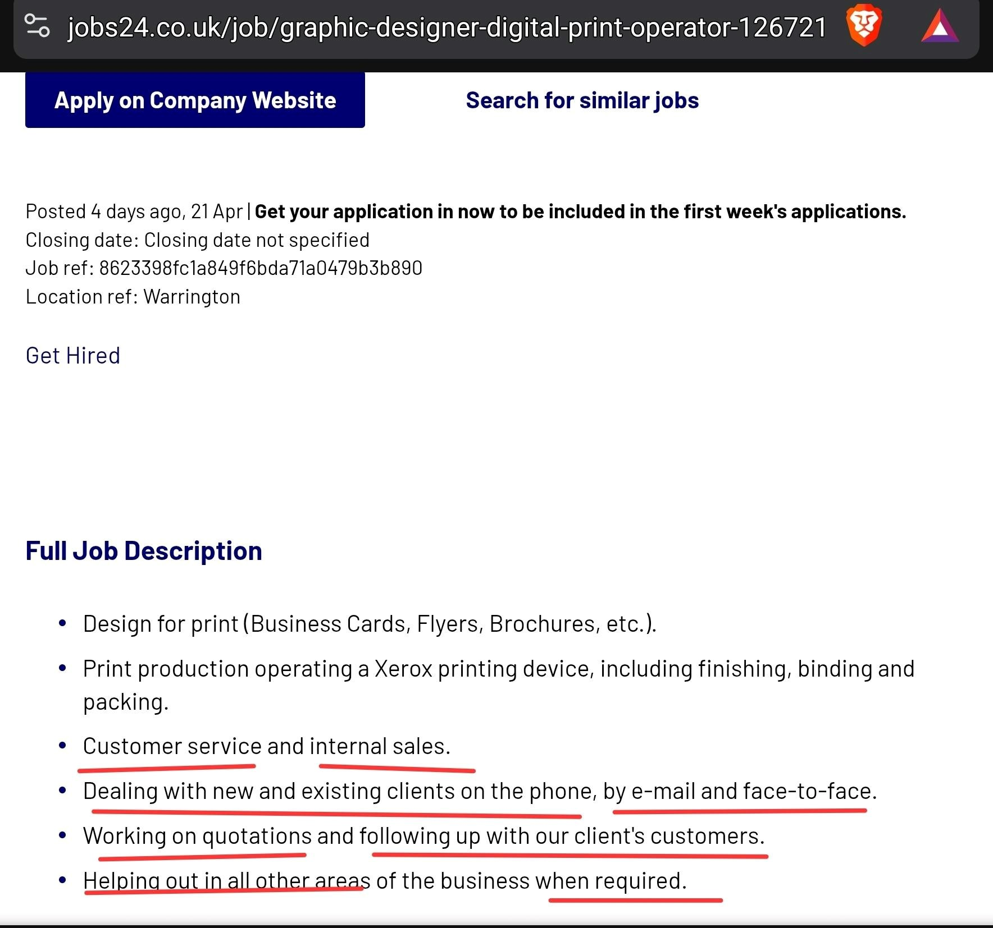

Experience & Skills

To be hired by a print company of this trade aligns accurately with my experience of over 30 years in organic arts and graphic design programmes and tools, with over 30 years of graphic design and animation learned skills. Currently, with over 7 years of Print and Design this position would be best suited to align with future prospects, and to enhance my knowledge and sharpen my skills further within the Graphic Design and Print field. Art is a form of expression, and Print gives tangible form to vision.

With over 20 years experience within various fields of customer service, I have built up a repertoire and a proven track record of Quality Customer Service, and Advisory within a
plethora of in-house and public customer matters.

SHARED SKILL: Customer Service

I have specifically chosen Customer Service as the first point of protocol within the parameters of this job description.. As it is a Trade Observable Fact that quality interaction with customers builds quality relationships between clients and businesses, which in effect creates a quality social environment for both public and businesses within the public

From the age of 17 I began my journey at Y.C.T.V. (Youth Culture Television), located at that time at Ladbroke Grove West London. I had gathered together a team of various Artists; all of whom I knew personally from the earliest of my school years. We had all discovered that we were artists while in high school. We collaborated, inspired onlookers in the school library while we were all working on our own drawing, yet with a similar theme. Some were strong at drawing certain features where others would lack, but we assisted one another. That is a foundation of Social Interaction that is essential for the workplace and any business establishment.

We eventually, through consistent meetings at Y.C.T.V. managed to secure a meeting at Cartoon Network: Toonami Studios located in Central London, discuss and demonstrate our portfolios and propose our ideas, and secured a Donation/Funding to begin works on cresting Y.C.T.V.’ first ever Creative Animation Suite. This opened up.the opportunity for the public and new members of Y.C.T.V. to experience creating their own cartoons, being hands on with accessible Stop Motion Animation tools and Programs and Adobe Suite software, as well as enhancing their knowledge in various other artistic methods.
In conclusion, I strongly advocate that this profession which requires these skills are transferable and benefits on a macro scale.

Strategy & Communication
● "No design works unless it embodies ideas held common by the people for
whom the object is intended." — Adrian Forty
● "Good design is actually a lot harder to notice than poor design, in part
because good designs fit our needs so well that the design is invisible." —
Unknown
● "The goal of design is to raise the expectation of what design can be." —
Michael Bierut
● "Design creates culture. Culture shapes values. Values determine the future."
— Robert L. Peters

Youth Worker

JOB SELECTION 2
IMAGE LINK ADDRESS BELOW
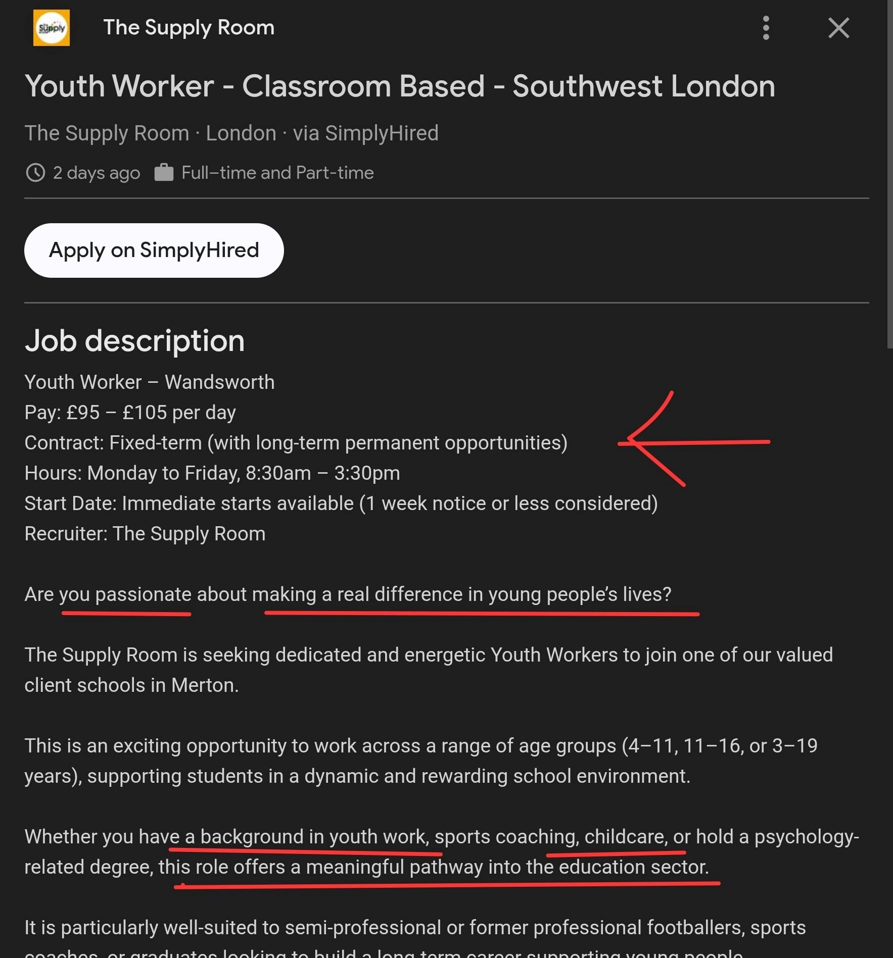

Experience & Skills

At the ages 19 - 20+ I began volunteering within my local community, and being involved with other joint communities within the Youth Work sector. As an inner city youth at that time I had experience in understanding Youth Culture and other factors surrounding the wellbeing of inner-city youth, facing not only my peers, but even myself during that present time. In 2007 - 2010 I was a member of a locally organised Creative Youth Group known as the Young Londoners Network: The Voices of Young People , spearheaded at the time by Youth Engagement Service member R. Palmer.

SHARED SKILLS: Achievements & Experience

Peter Duffy Human Rights Award Aug 2006
Awarded by London’s organisations’ JUSTICE and LIBERTY
Young Londoners Network Mar 2004 - Apr 2004 (City Hall, London)
Coordination and development of London Youth Centres
Millennium Volunteers Oct 2000 - Mar 2002
Implementing and managing special projects for Young People in London; including ‘Safe 2002’ event.

Higher Education and Academics
London College of Business and Finance
HND in Interactive Media
ST. PATRICK’S UNIVERSITY | London, UK | May 2013 -May 2015
Introductory in Business & Entrepreneurship
NVQ Level 1
CITY OF WESTMINSTER COLLEGE | London, UK | Nov 2012 – Dec 2012 (short course) With these achievements and vast experience in community engagement through volunteering over a period of time, I was offered the opportunity to attain an NVQ LEVEL 2 in Working With Young People ages 6 - 12 and 13 - 25 and began my first bank job at P3:
Kilburn Youth Centre.

REFLECTIVE SELF-ASSESSMENT

This Reflective Self-Assessment will focus on my various experiences within my academic achievements, work experience, extracurricular activities and feedback from mentors and peers.

Since my earliest years of age I have always been artistic and creative. Visions give birth to creation. Through my various life experiences I have always kept my skills sharpened, being an inner city youth, I wanted to make a difference; a real strong and firm difference
long-lasting difference not just within my local community, but to branch outward to present accessible opportunities giving room for Creative Expression within the Arts and its various forms. If by Testimony and Evidence of such matters I can fully relate the importance of my passions by highlighting its grandeuresque values, I aim to fully demonstrate my skills and
experience in the fields of Graphics and Digital Print. I have spent my years freelancing and
doing small contracted jobs for clients who needed my expertise in creating various forms of art and promotional materials, including Garment Printing of my own Brand Service.

PERSONAL DEVELOPMENT PLAN

The current limitations I face are a lack of equipment to fully exercise my abilities.
- NETWORK using Social Media Platforms
- Promote my designs through various works
- Sourcing New Digital Programmes
- Ongoing Creation of Templates
- Update my Business Plan & proposals

All these actions are ongoing, since the launch of my own brand in 2020. The foundation is laid, and the building up of my limited business is ongoing and slowly developing into something more than I had expected.

CURRENT ACTIONS TO TAKE
- Currently studying a Business Course at UWTSD, London Branch that Increases my understanding of the politics and protocols of Entrepreneurship, to complete my Undergraduate Year.
- Inquiring related Digital Print companies to take me on so that I may enhance my know-how in the fixed of Digital Print and Design.
- Continue development of my skills through daily practice and small projects.

EVIDENCE OF READINESS

With my years of experience and active participation within a variety of fields where I am having to interact with the public, and also my experience with working with young people I have a strong established foundation and an understanding of the importance of contributions, collaborative opportunities and transferable skills necessary for the development of others who wish to explore the realm of the Arts. With a proven track record of my skills known by those of my peers and also professionals whom I have partnered up with through Youth Organisations, I am in a position to actually teach by operating workshops relating to said interests for Young Adults and Mature Adults alike.
Also, with these workshops I will also teach how to source app relating to design and how they can systematically synthesise the usage of these apps to produce greater works. One of the first mass printed works was known as the Gutenberg Bible, famously known to be one of the first mass printed copies since the ability to print press was just introduced.

Key Historical Developments in Mass Printing
Sourced from AI Answer, Showing a brief history on Mass Printing

1440: Johannes Gutenberg completes his printing press design in Mainz, Germany, using metal alloys and oil-based inks.

1455: The Gutenberg Bible is produced, marking the start of mass-produced books in Europe.

1040 (Early Precursor): The first known movable type printing press was created in China, though it did not achieve the same rapid spread and economic impact as Gutenberg’s. Pre-Gutenberg Methods: Hand-carved wooden block printing was used for centuries prior, including in China (650–700 AD) and for amulets in the Islamic world.

Impact of Mass Print
Increased Literacy: Books became accessible beyond the wealthy elite.
Information Age: Facilitated the Renaissance, the Reformation, and the Scientific Revolution. Rapid Distribution: Allowed for the mass production of newspapers, pamphlets, and books.

This will increase their chances for being hired into a Graphic Design and Print company, as they would then develop the skills necessary for being hired into these placements of work.


