
University of Wales Trinity Saint David

Enhancing Automated Vulnerability Assessment through Model context Protocol The Design and Assessment of PentestChain, a Cost-Aware, MCP-Orchestrated Framework

by
Rushabh Patel
Student Number: 2436066
Supervisor: Dr Mohamad Ghanem
Project submitted as part of the requirements for the award of
MSc Cybersecurity and Digital Forensics
Module ACFB7003
June 2026

Declaration and Form of Consent

DECLARATION
I, Rushabh Vipulkumar Patel, declare that I am the sole author of this Project; that all references cited have been consulted; that I have conducted all work of which this is a record, and that the finished work lies within the prescribed word limits.
This work has not previously been accepted as part of any other degree submission.
Signed : Rushabh Vipulkumar Patel
Date : 07-06-2026

FORM OF CONSENT
I, Rushabh Vipulkumar Patel, hereby consent that my Project, submitted in candidature for the M.Sc. Applied Computing, if successful, may be made available for inter-library loan or photocopying (subject to the law of copyright), and that the title and abstract may be made available to outside organisations.
Signed : Rushabh Vipulkumar Patel
Date : 07-06-2026

Abstract
Penetration testing remains the most reliable way to confirm whether a known vulnerability is genuinely exploitable, yet the supply of skilled testers cannot meet demand: ISC2 placed the 2024 global cybersecurity workforce gap at roughly 4.8 million practitioners, while the National Vulnerability Database logged a record number of new CVEs in 2024. A recent wave of AI-driven penetration testing tools promises to close the gap, but almost all of them assume access to premium frontier models such as GPT-4, which carry a per-engagement cost that puts continuous, automated testing out of reach for the small organisations that need it most.
This project asks a focused and practical question: can a structured, pipeline-based penetration testing framework driven by free-tier and locally hosted large language models, backed by a deterministic rule-based fallback, achieve effectiveness comparable to frameworks that depend on premium models? To answer it, the project designs, implements and evaluates PentestChain, a ten-phase automated framework that runs inside a Kali Linux Docker container with a PostgreSQL companion. PentestChain couples a curated rule-based exploit map to a cost-aware AI cascade (a local Ollama model first, then free-tier OpenRouter and Cerebras, with a rule-based fallback that always produces output) and exposes the full pipeline through a FastMCP server with eleven tools, so any Model Context Protocol client such as Claude Desktop can drive the engine through structured calls.
Across repeated runs against a Metasploitable 2 target, PentestChain detected 26 open services, enriched them against four CVE databases to 34 vulnerabilities (7 critical, 15–22 high depending on scan profile), and produced ready Metasploit modules for the principal exploitable services, all while recording a measured per-engagement cost of zero: the instrumentation across four runs showed a mean of 76.8 ± 12.0 local-model calls and 21.8 ± 1.9 free-tier cloud calls per provider at a 0 % paid-API spend, with a mean pipeline time of 21.7 ± 4.4 minutes. A structured comparison positions PentestChain against premium-model frameworks (PentestGPT, Ezetta and Feng’s PentestMCP toolkit, the Sciety multi-agent PentestMCP preprint, and PentAGI) on architecture, model requirements, cost and evaluation scope. The work contributes a free-tier-first architecture for AI-driven exploitation, a threat model for MCP-exposed offensive tooling, a cost model for AI-assisted penetration testing, and a fully reproducible Dockerised lab specification. A multi-target VulHub evaluation across five or more CWE categories is set out as the immediate next step.

Contents
Declaration and Form of Consent 2
DECLARATION 2
FORM OF CONSENT 2
Abstract 3
Contents 4
List of Figures 7
List of Tables 8
Chapter 1: Introduction 9
1.1 Context and Background 9
1.2 Statement of the Problem 10
1.3 Project Aim and Objectives 11
1.4 Significance of the Study 12
1.5 Structure of the Report 12
Chapter 2: Literature Review 14
2.1 The Evolution of Automated Penetration Testing 14
2.2 Large Language Models in Offensive Security 15
2.3 The Economics and Accessibility of AI-Assisted Testing 16
2.4 The Model Context Protocol and Its Security 16
2.4.1 The Direct MCP-Based Competitors 17
2.5 Comparison of Vulnerability Assessment Tools 18
2.6 Summary and Research Gap 18
Chapter 3: Research Methodology 20
3.1 Research Philosophy and Approach 20
3.2 Research Strategy and Methods 20
3.3 Research Design: Experimental Setup 21
3.4 Evaluation Metrics 22
3.5 Data Collection and Analysis 23
3.6 Ethical Considerations 23
3.7 Threats to Validity 24
Chapter 4: Design Process 25
4.1 Requirements 25
4.2 Layered Architecture 25
4.3 Cost-Aware AI Cascade and Fallback Design 27
4.4 The Exploit-Map Data Structure 28
4.5 MCP Server Security Design 29
4.6 Multi-Source CVE Enrichment Design 29
4.7 Database Schema 30
Chapter 5: Implementation 31
5.1 Environment and Build 31
5.2 The AI Helper and the Free-Tier Cascade 31
5.3 Engineering Challenges 32
5.3.1 Eventlet Monkey-Patching Breaking request.get_json() 32
5.3.2 The Exploit-Map Three-Tuple 32
5.3.3 Metasploit Console State and CVE Rate Limits 32
5.4 The MCP Server 33
5.5 The Running System 33
5.6 Real-Time Reporting and Export 35
5.7 The Expanded v2.1 Pipeline: Discovery and Service Detection 35
5.8 Web-Layer Scanning and Findings 36
5.9 Live Exploitation and AI-Assisted Analysis 38
Chapter 6: Evaluation of Results 40
6.1 Detection and Enrichment 40
6.2 Exploitation and Remediation 42
6.3 Cost and AI Fallback Analysis 44
6.4 Comparison with Premium-Model and Commercial Baselines 45
6.5 Summary 45
Chapter 7: Conclusions and Recommendations 47
7.1 Answering the Research Questions 47
7.2 Contributions 47
7.3 Limitations 48
7.4 Suggestions for Further Work 48
7.4.1 A Multi-Target VulHub Evaluation Across CWE Categories 48
7.4.2 One-Click Verified Remediation and Automated Patch Installation (fix.rc) 48
7.4.3 A Fully Standalone, Air-Gapped Deployment with a Purpose-Built Local LLM 49
7.4.4 Multi-Step Attack-Chain Reasoning 51
7.4.5 A Zero-Day and Fuzzing Hook 51
7.4.6 Multi-Tenant MCP Hardening 51
7.4.7 Publication Strategy 51
7.4.8 Expanded Web Vulnerability Scenarios 52
7.4.9 Cloud VAPT and Active Directory Modules 52
7.4.10 Custom Playbooks and Per-Module Mode Selection 53
7.5 Recommendations 52
Chapter 8: Reflection 53
References 54
Appendix A: Reproducible Lab Specification 57
Appendix B: MCP Tool Surface 58
Appendix C: Final Engagement Report — Specification, Outcomes and Sample Output 59
C.1 What the Final Output Report Should Contain 59
C.2 Outcomes from a Representative Engagement 59
C.3 The Generated Engagement Report (Sample Output) 60

List of Figures
Figure 1.1. MCP host driving PentestChain via Claude Desktop 10
Figure 3.1. Scan configuration panel 22
Figure 4.1. Full PentestChain workflow 25
Figure 4.2. AI Provider Status panel during a live engagement 27
Figure 5.1. Running PentestChain engine in Docker 31
Figure 5.2. Credential panel and scan-technique selector 33
Figure 5.3. Exploits tab during a run 33
Figure 5.4. Sessions tab with captured shell and Meterpreter sessions 33
Figure 5.5. Service version detection in progress 36
Figure 5.6. Services tab with detected service inventory 36
Figure 5.7. Findings tab after web-scanning phase 37
Figure 5.8. XSS and injection findings 38
Figure 5.9. Live exploit runs: distcc_exec shell and postgres_payload Meterpreter 38
Figure 5.10. AI analysis view with contextualised ranking 39
Figure 6.1. CVE tab after enrichment 41
Figure 6.2. Engagement dashboard for a representative run 41
Figure 6.3. In-app report view 42
Figure 6.4. Exported HTML engagement report 43
Figure 7.1. Proposed standalone, air-gapped PentestChain 50

List of Tables
Table 3.1……………………………………………………………………………………………. 22
Table 6.1.…………………………………………………………………………………………….44
Table 6.2.…………………………………………………………………………………………….45

Chapter 1: Introduction
The chapter opens with the context and problem, defines the aim and objectives, argues for the significance of the work, and outlines the remaining chapters.

1.1 Context and Background
Cybersecurity is under sustained pressure. The National Vulnerability Database recorded a record volume of new CVEs in 2024, with NIST reporting a rise of roughly 32 % in submissions year on year and an enrichment backlog that has, at times, left thousands of entries waiting for analysis [1], [2]. The IBM Cost of a Data Breach Report 2024 put the global average cost of a confirmed breach at USD 4.88 million, a 10 % increase on the previous year [3]. Breaches involving stolen credentials took the longest to identify and contain, averaging 292 days, which is more than nine months of exposure before the organisation realises it has a problem [3], [4].
Penetration testing is one of the few practices that catches these problems before an attacker does, because a skilled tester confirms whether a vulnerability is genuinely exploitable instead of merely present [5]. The bottleneck is people. The ISC2 2024 workforce study estimates a global cybersecurity workforce gap of about 4.8 million, growing year on year while the workforce itself has stopped growing [6]. The market response, Penetration-Testing-as-a-Service, is projected to grow from USD 118 million in 2024 to USD 301 million by 2029 [7], which is demand that human practitioners alone cannot satisfy. A mid-sized regional bank or a regional hospital cannot justify an in-house red team, and an annual external engagement leaves long windows during which new vulnerabilities accumulate unseen [5], [7].
A wave of AI-driven penetration testing tools has appeared in response. PentestGPT showed that large language models hold enough security knowledge to drive a test [8]. AutoPentester added direct tool calling [9]. PenHeal paired exploitation with remediation [10]. More recent systems such as Ezetta and Feng’s PentestMCP toolkit [11], the Sciety multi-agent PentestMCP preprint [12], and the open-source PentAGI project [13] use the Model Context Protocol or multi-agent orchestration to push toward full autonomy. Almost all of them share one quiet assumption: that the operator has unrestricted access to a premium frontier model such as GPT-4 or GPT-4.1. That assumption is exactly what makes these tools inaccessible to the organisations that most need cheap, repeatable testing.
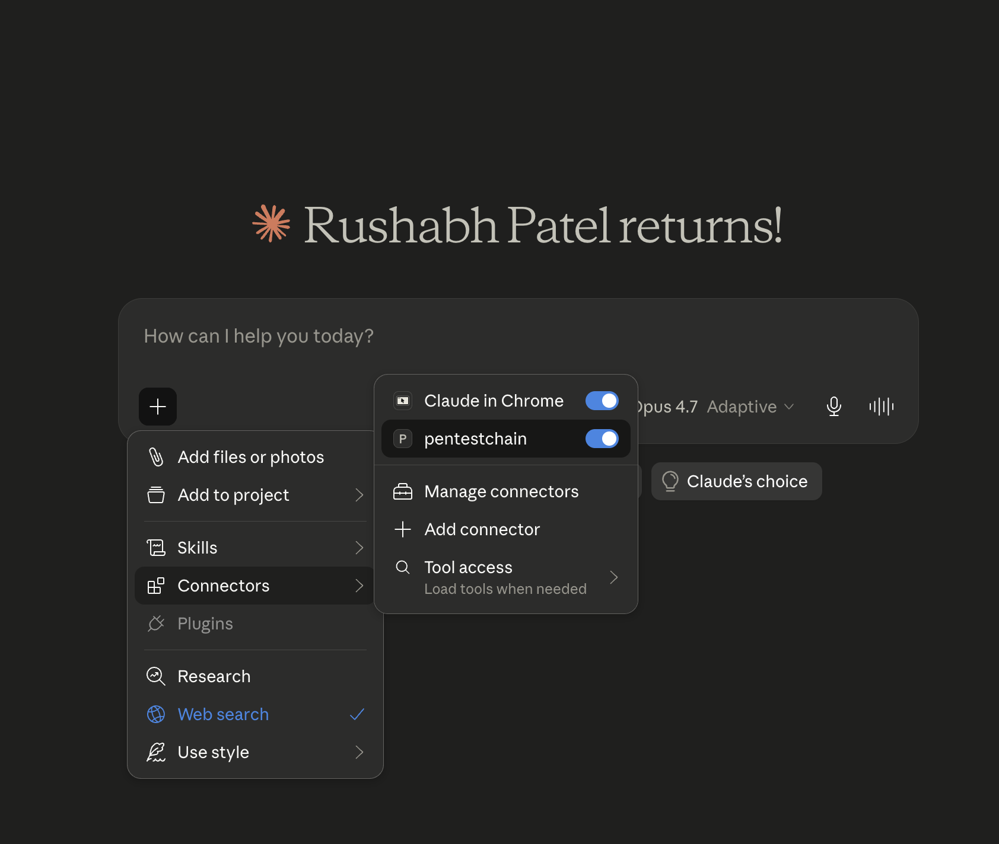
Figure 1.1. An external MCP host (Claude Desktop, running Opus 4.6) driving the framework. The user issues a natural-language instruction to scan 192.168.64.2; the host loads the PentestChain tools and calls step1_validate_target through the Model Context Protocol, with the per-tool permission prompt visible. The reasoning model and the execution engine are fully decoupled.
The project suggestion came from a simple observation while experimenting with the Model Context Protocol shortly after its release: the same protocol that lets an AI assistant read a calendar or query a database could, in principle, let it drive a penetration-testing engine, and nobody had published an attempt to do so safely. The early prototype confirmed the engineering was feasible, but it also surfaced the cost question, because running the prototype against a single target through a premium model produced a visible token bill, and it became obvious that the interesting research question was not whether AI could drive a test, that had been shown, but whether it needed an expensive model to do so. That reframing, from capability to cost, is what gives the project its contribution and is why the framework is built around free-tier and local models from the cost cascade outward.
It helps to put the scale in human terms. A workforce gap of 4.8 million is not a count of unfilled job adverts; it is the distance between the testing organisations know they should do and the testing they can actually staff [6]. The CVE count climbing year on year means the backlog grows even when nothing else changes, because each new disclosure is one more thing a tester would, in an ideal world, go and check [1], [2]. Against that backdrop the appeal of automation is obvious, and so is the catch: if the only automation that works needs a frontier-model budget, it widens the gap rather than closing it, since the organisations with the least capacity to test are also the ones least able to pay for premium tokens at scale.

1.2 Statement of the Problem
The problem this project addresses is one of cost and accessibility, not raw capability. The current generation of AI-driven penetration testing tools demonstrates that automation works, but it demonstrates this using premium models whose token cost is charged per engagement. A framework that performs ten phases of reasoning across dozens of services can issue on the order of one hundred model calls per engagement. On a premium API this is a small but real recurring cost; run continuously, in a CI pipeline or against a fleet of hosts, it compounds quickly. For a well-funded enterprise this is negligible, but for the smaller organisations that already cannot afford a red team it is another barrier.
There is also a structural problem. Most AI-pentesting frameworks are monolithic: a single agent loop drives reasoning, tool execution and reporting inside one process, which makes them hard to integrate with the wider AI tooling ecosystem and hard to reason about from a security standpoint. The Model Context Protocol offers a clean way to decouple the reasoning host from the execution engine, but its security posture for offensive tooling is unexplored, and its rapid 2025 growth came with a rapidly growing attack surface [14], [15].
The specific question this project answers is therefore: can a structured, pipeline-based penetration testing framework, driven by free-tier and locally hosted large language models and protected by a deterministic rule-based fallback, achieve effectiveness comparable to premium-model frameworks while reducing the per-engagement cost to near zero, and can it be exposed safely through the Model Context Protocol?
There is also a quieter problem of trust that the monolithic design creates. When a single agent loop drives reasoning, tool execution and reporting in one process, it is hard to say afterwards exactly why a given command was issued, which makes the system difficult to audit and difficult to reason about from a security standpoint [16], [17]. Decoupling the reasoning host from the execution engine through the Model Context Protocol is attractive precisely because it draws a clean line between the part that decides and the part that acts. That same line, however, is a new attack surface, and the protocol's rapid 2025 growth arrived with a matching growth in published vulnerabilities [14], [15], so the decoupling buys clarity at the price of a boundary that must itself be defended.

1.3 Project Aim and Objectives
Aim. To design, implement and evaluate PentestChain, a cost-aware, MCP-orchestrated automated penetration testing framework that runs the full reconnaissance-to-remediation workflow on free-tier and locally hosted large language models, and to determine whether free-tier AI can match premium-model frameworks in effectiveness while reducing the per-engagement cost to near zero.
Objective 1 (Literature). To conduct a systematic literature review of AI-driven penetration testing, the economics and accessibility of LLM-assisted security tooling, Model Context Protocol architecture and security, and vulnerability-scanner capabilities, in order to establish the evaluation criteria and identify the research gap around cost and accessibility.
Objective 2 (Artefact and results). To design and implement PentestChain as a ten-phase pipeline driven by a free-tier and local LLM cascade with a deterministic fallback, and to obtain detection-coverage, exploitation-success, remediation-quality, AI-fallback, token-consumption and dollar-cost results against a deliberately vulnerable target.
Objective 3 (Validation). To analyse the collected results across repeated runs, compare them against premium-model and commercial-scanner baselines using criteria justified in the literature review, and validate, or refute, the claim that free-tier AI can match premium-model effectiveness.

1.4 Significance of the Study
If free-tier and local models can drive an automated penetration test to the same effectiveness as premium models, the cost barrier to continuous security testing largely disappears. A regional hospital could run a scheduled exploitation-and-remediation pass every night for the price of the electricity to run a local model, instead of paying for a frontier-model API or an external engagement. The contribution is therefore practical as much as academic: a free-tier-first architecture lowers the floor for who can afford automated, exploitation-grade testing.
The study also contributes the first cost model for AI-assisted penetration testing that treats dollar cost per engagement as a first-class evaluation metric alongside detection and exploitation, a threat model and four concrete mitigations for exposing offensive tooling through the Model Context Protocol, and a fully reproducible Dockerised lab specification that other researchers can rebuild with a single command. Because two other 2025 projects are also called PentestMCP [11], [12], the framework is named PentestChain here to avoid a naming collision and to foreground the free-tier contribution.
The contribution is therefore as much methodological as it is technical. By treating per-engagement cost as a measured quantity instead of an assumed background condition, the project offers later researchers a yardstick they can apply to any AI-pentesting system, not only this one. A framework can then be described not just by what it detects and exploits but by what it costs to run continuously, the variable that decides whether a result reported in a paper can become a practice in an under-resourced organisation.

1.5 Structure of the Report
Chapter 2 (Literature Review): reviews AI-driven penetration testing, the economics of LLM-assisted tooling, the Model Context Protocol and its security, and vulnerability scanners, and derives the comparison criteria and research gap.
Chapter 3 (Research Methodology): sets out the research philosophy, the Design Science Research strategy, the experimental design, the evaluation metrics including dollar cost, and the threats to validity.
Chapter 4 (Design Process): documents the architecture, the cost-aware AI cascade, the exploit-map data structure, the MCP server security design, and the database schema.
Chapter 5 (Implementation): describes how the design was built and the engineering challenges that shaped it, illustrated with the running system.
Chapter 6 (Evaluation of Results): presents the measured results against Metasploitable 2, the cost analysis, and the comparison against premium-model and commercial baselines.
Chapter 7 (Conclusions and Recommendations): answers the research questions, states the contributions and limitations, and sets out suggestions for further work including the VulHub evaluation and a publication strategy.
Chapter 8 (Reflection): reflects on the management of the project and what the author learned from it.

Chapter 2: Literature Review
This chapter reviews the scholarship that frames the project. It is organised into five themes: the evolution of automated penetration testing; large language models in offensive security; the economics and accessibility of AI-assisted testing; the Model Context Protocol and its security; and the comparison of vulnerability assessment tools. The sources are drawn from USENIX Security, IEEE and ACM proceedings, peer-reviewed journals, and arXiv preprints with verifiable institutional authorship, published mainly between mid-2024 and early 2026. The chapter closes by drawing out the evaluation criteria used in later chapters and stating the research gap.

2.1 The Evolution of Automated Penetration Testing
Automated penetration testing sits on a spectrum from manual command-line work to fully autonomous agents. DeepExploit, presented by Takaesu at the Black Hat Arsenal in 2018, was an early reinforcement-learning system that trained an A3C agent to select Metasploit modules from service banners [18], [19]. It converged quickly against a known target but did not generalise to infrastructure it had not been trained on, worked only within the Metasploit database, and produced no remediation [19], [20]. Later RL work using attack graphs and hierarchical policies improved generalisation but was evaluated mostly in simulators such as Microsoft’s CyberBattleSim, where the abstractions do not match the banner strings and timing behaviour of a real target [21], [22]. The simulation-to-reality gap is the recurring weakness of the RL approach.
Schwartz and Kurniawati formalised the problem more carefully, modelling the network as a partially observable Markov decision process and showing that model-free reinforcement learning could find optimal attack paths across a range of topologies without a hand-built model of exploit behaviour [19]. Their honest conclusion is that the approach works in simulation but that maintaining an accurate model of a fast-changing exploit landscape is the hard part, precisely the maintenance burden that a rule-based map externalises into a small, human-editable data structure. Ghanem and colleagues later showed that a deep reinforcement-learning exploiter could be trained against Metasploitable-style targets, but again the training cost and the brittleness to banner variation remained [20]. The lesson the project takes from this body of work is that the intelligence in an automated exploiter does not have to live in a learned policy; it can live in a curated map plus a small reasoning model invoked only at the edges.
PentestChain takes that route deliberately. Instead of training an agent that must generalise, it pairs a curated rule-based exploit map with an AI fallback used only when no rule matches. This trades the elegance of end-to-end learning for deterministic, explainable exploit selection that needs no training data and is reproducible across runs [18], [19]. As the evaluation in Chapter 6 shows, this deterministic backbone is also what makes a free-tier model viable, since the model is asked to do less, and what it is asked to do is bounded enough that a 7-billion-parameter local model can do it as well as a frontier model can.
To be precise about why simulation-trained agents struggle on real targets. A learned policy encodes the statistics of the environment it was trained in: the reward shaping, the action set and, crucially, the observation format. Metasploitable-style training gives an agent clean, well-formed banners and a small, stable action space, so the policy that emerges is brittle the moment a banner is malformed, a service answers on a non-standard port, or the operating-system guess is wrong [19], [20]. PentestChain sidesteps this by never learning a policy at all. The ordering of phases is fixed in code, exploit selection is a lookup against a human-edited map, and the only learned component, the language model, is asked a question only when the deterministic layer has nothing to say. The intelligence that an RL agent must acquire through thousands of episodes is, in this design, simply written down once and version-controlled, cheaper to build and easier to audit.

2.2 Large Language Models in Offensive Security
The application of LLMs to offensive security accelerated after mid-2023. The July 2025 survey by Happe and Cito reviews two years of evidence and finds a consistent pattern: LLMs are strong at information retrieval, output interpretation and strategy suggestion, and weak at context management, long-horizon planning and reliable command generation [23], [16]. PentestGPT, which won the USENIX Security 2024 Distinguished Artifact Award, was the first to show that LLMs hold enough inherent knowledge for the task, using a three-module reasoning, generation and parsing architecture and a Pentest Task Tree [8]. Its limitation is that it cannot execute: a human copies each suggested command into a terminal and pastes the output back, which lets sessions expire and context windows fill with stale data [8], [16]. AutoPentester closed that gap with direct tool calling, a retrieval-augmented module, a repetition identifier that cut looping by 90.5 %, and a results verifier; ten professional testers rated it 3.93 out of 5 [9]. PenHeal added a remediation stage, improving vulnerability coverage by 31 % and cutting remediation cost by 46 % against its baseline [10].
It helps to dwell on why these systems reach for premium models. Happe and Cito identify long-horizon planning and reliable command generation as the two tasks LLMs do worst [23]. A monolithic agent that drives the whole engagement is doing exactly those two things continuously, so it needs the most capable model available to avoid drifting off task or emitting malformed commands; the qualitative feedback gathered by the AutoPentester authors, that the system attempts overly complex paths when a simpler one would work, is a symptom of a model carrying too much planning load [9]. The premium-model dependency, in other words, is partly a consequence of the monolithic architecture rather than an inherent property of the task. If the planning and the command generation are externalised into deterministic structures, the residual reasoning is short-horizon and well-bounded, and a smaller model can do it.
PentestChain differs from all of these in how it uses the model. The LLM is not the controller. It is called in nine specific bounded roles (network-zone labelling, NSE script selection, CVE ranking, exploit suggestion, web-flag selection, remediation writing, and three analysis steps), and every call has a deterministic fallback. None of these roles requires multi-step planning or precise command synthesis; the planning is fixed by the ten-phase pipeline and the command synthesis is fixed by the exploit map and the Metasploit resource-script generator. This bounded use is precisely what allows a small free-tier or local model to stand in for a premium one without collapsing the pipeline, because no single call is load-bearing, and it is the architectural hypothesis that the cost evaluation in Chapter 6 tests.
A second strand of this literature concerns reliability rather than capability. Happe and Cito report that the failure modes of LLM-driven testers are rarely dramatic: the model does not refuse the task, it quietly emits a command with the wrong flag, hallucinates a module name, or loses track of which host it is attacking after a long context [23], [16]. These are exactly the errors that a deterministic backbone contains, since the command is generated from a template the model never sees and the host is fixed by the pipeline state rather than recalled from the conversation. The lesson PentestChain takes is not that the model is untrustworthy, but that trust should be placed in proportion to the difficulty of the task: high for short, well-scoped classification, low for long-horizon planning and command synthesis, and zero where a rule already gives the right answer.

2.3 The Economics and Accessibility of AI-Assisted Testing
The published frameworks are evaluated almost entirely on effectiveness: subtask completion, vulnerability coverage, exploitation success. Cost is rarely measured, and where a model is named it is usually a premium one. PentestGPT and AutoPentester use GPT-4 and GPT-4-turbo [8], [9]. Ezetta and Feng’s PentestMCP toolkit reports its headline results with GPT-4.1, achieving 87.3% on information gathering, 62.3% on vulnerability discovery and 56.6% on exploitation across more than one hundred VulHub and NVD vulnerabilities [11]. PentAGI accepts credentials for OpenAI, Anthropic, Gemini, Bedrock, Ollama, DeepSeek and others, but its documentation and reviews assume a paid frontier model for serious work [13]. None of these report a dollar cost per engagement, and none ask whether a free-tier or local model would have done as well.
This is the gap the project targets. The accessibility argument is straightforward: if effectiveness depends on a premium model, then automated exploitation-grade testing is available only to organisations that can pay for frontier-model tokens at scale, which excludes exactly the under-resourced organisations the workforce-gap literature identifies as most exposed [5], [6]. Treating per-engagement cost as a first-class metric, and asking whether the free tier suffices, is therefore both novel and practically relevant. The data-collection design in Chapter 3 records token consumption and cost precisely so that this question can be answered with measurement not assertion.
The accessibility gap is not hypothetical. The same ISC2 workforce study that records the 4.8 million shortfall also notes that the gap is widest among smaller organisations, which cannot compete for scarce practitioners and cannot justify a frontier-model budget for continuous testing [6]. If the only demonstrated way to automate exploitation-grade testing assumes a premium model, then automation reproduces the very inequality the workforce data describes: well-funded enterprises get cheaper testing, and the under-resourced organisations that the breach-cost figures show are most exposed get nothing new [3], [6]. Treating dollar cost as a measured, first-class metric is therefore not a narrow engineering concern but the variable that decides who the technology actually reaches.

2.4 The Model Context Protocol and Its Security
The Model Context Protocol, released by Anthropic on 25 November 2024, defines a JSON-RPC client-server architecture in which hosts (such as Claude Desktop), clients and servers exchange tool calls over standard I/O or HTTP with Server-Sent Events [24], [25]. Adoption was fast: within months Microsoft integrated MCP across Copilot Studio and Azure AI Foundry, and more than five thousand community servers appeared [25]. The appeal is universality, since one server can be driven by any compliant host without bespoke integration code. Two of the closest related works, the Ezetta and Feng toolkit and the Sciety multi-agent preprint, both adopt MCP for exactly this reason [11], [12].
Rapid adoption produced rapid security consequences. By mid-2025 researchers had found critical CVEs in MCP implementations, including CVE-2025-6514 (CVSS 9.6) in the mcp-remote package, which allowed a malicious server to achieve remote code execution on the client through a crafted OAuth authorization endpoint [14], [15]. The first confirmed malicious MCP server, postmark-mcp v1.0.16, appeared on npm in September 2025 and silently exfiltrated email [15], [26]. A protocol-level analysis quantified how MCP’s dynamic tool discovery amplifies prompt-injection success [17]. These findings directly shape the PentestChain threat model in Section 4.5, and they make the security posture of an MCP-exposed offensive tool a research question in its own right instead of an afterthought.
The speed of MCP adoption matters for a second reason beyond the raw attack surface. Because a single server can be driven by any compliant host, an offensive MCP server is, by construction, reachable by whatever the host will accept, including a prompt-injected instruction that originated in untrusted data the host happened to read earlier in the session [17]. The protocol does not distinguish a tool call the operator intended from one the host was manipulated into making. This is why PentestChain treats authorisation as the server's own responsibility not the host's: the target allowlist and the scan-scoped checks described in Section 4.5 hold regardless of what the host believes it was asked to do.
The practical upshot for this project is that the security of the protocol boundary could not be bolted on at the end; it had to shape the design from the start. That is why the threat model in Section 4.5 is presented as a first-class part of the architecture instead of an afterthought, and why the tool surface is deliberately kept small. A larger tool surface is a larger attack surface, and for an offensive server exposed to an external client that distinction is not academic.

2.4.1 The Direct MCP-Based Competitors
Three recent systems are close enough to PentestChain to deserve individual treatment, because each uses MCP or multi-agent orchestration for offensive work and each is a baseline in the comparison of Chapter 6. Ezetta and Feng’s PentestMCP is a toolkit of MCP server implementations that expose common penetration-testing tasks, network scanning, enumeration, fingerprinting, vulnerability scanning, exploitation and post-exploitation, to an agentic host, and it reports its headline results with GPT-4.1, achieving 87.3 % on information gathering, 62.3 % on vulnerability discovery and 56.6 % on exploitation across more than one hundred VulHub and NVD vulnerabilities [11]. It is the strongest evaluation in the immediate neighbourhood and the clearest demonstration that the MCP-toolkit approach works; what it does not do is ask whether a cheaper model would have produced comparable numbers, the question PentestChain is built to answer. The naming overlap with the present project is also why this work is renamed PentestChain.
The Sciety multi-agent PentestMCP preprint combines a multi-agent architecture spanning information gathering, vulnerability discovery and exploitation with MCP for tool orchestration and retrieval-augmented generation for contextual reasoning, and adds a Penetration Task Graph for autonomous task decomposition and a dual-path execution strategy [12]. It is architecturally ambitious and sits at the autonomous end of the spectrum, where the model carries planning load, which is exactly the design that tends to require a premium model. PentAGI, an open-source project that has crossed ten thousand GitHub stars, orchestrates more than a dozen specialist agents inside Docker sandboxes with a PostgreSQL and pgvector memory layer, and accepts credentials for OpenAI, Anthropic, Gemini, Bedrock, Ollama, DeepSeek and others [13]. PentAGI is notable for accepting a local Ollama model, which means the free-tier idea is technically reachable within it, but its documentation and independent reviews assume a premium frontier model for serious work, and it does not report a cost-controlled comparison. The shared blind spot across all three is the absence of a measured dollar cost and of a deliberate test of whether the free tier suffices, the space PentestChain occupies. D-CIPHER, a planner-executor multi-agent system for offensive security, is included in the discussion as the model for the attack-chain extension proposed in Chapter 7 rather than as a like-for-like baseline [27].

2.5 Comparison of Vulnerability Assessment Tools
Commercial scanners such as Tenable Nessus, Rapid7 InsightVM and the open-source Greenbone OpenVAS enumerate known CVEs against an inventory and produce prioritised, compliance-ready findings [28], [29]. Nessus maintains more than 222,000 plugins covering over 91,000 CVEs, supports more than thirty credential types, and covers PCI DSS, HIPAA and NIST 800-53 [28]. What none of them does is exploitation: they identify vulnerabilities and assign CVSS scores but do not determine whether a finding is genuinely exploitable in context, and they will not chain findings into an attack path [29], [30]. This is by design, because a scanner running across thousands of production hosts cannot risk triggering even a benign exploit. PentestChain is positioned to sit alongside such a scanner, consuming its CVE output and adding the exploitation and remediation layer the scanner cannot provide. The comparison in Chapter 6 therefore uses capability and cost criteria, not a single league-table number.
The literature on automated remediation is thinner than the literature on detection, but it is directly relevant to the further work proposed in Chapter 7. PenHeal is the clearest example, pairing an exploitation stage with a remediation stage and reporting a 31 % improvement in vulnerability coverage and a 46 % reduction in remediation cost against its baseline [10]. What PenHeal and the commercial scanners share is that remediation stops at advice: a recommended patch, a configuration change, a CVSS-prioritised list. None of them closes the loop by applying the fix and re-testing, the gap the one-click fix.rc design in Section 7.4.2 targets. The Metasploit Framework, driven here through the msfrpcd console, already provides the execution primitive needed to do this safely against a held session [29], so the missing piece is orchestration and verification rather than new capability.

2.6 Summary and Research Gap
Four conclusions follow from the review. First, AI-driven penetration testing works, but it has been demonstrated almost exclusively with premium models, and no published framework reports a per-engagement cost or asks whether a free-tier model would suffice. Second, the bounded use of an LLM behind a deterministic backbone is the design choice most likely to make a lower-cost model viable, and it is under-explored. Third, the Model Context Protocol offers clean decoupling of reasoning from execution, but its security for offensive tooling is unexamined. Fourth, scanners and exploitation tools are complementary, so the right comparison is on capability and cost not rank. The research gap, then, is the absence of a cost-aware, free-tier-first, MCP-orchestrated framework that has been evaluated on both effectiveness and dollar cost. The criteria carried into the evaluation are detection coverage, exploitation success, remediation coverage, AI fallback rate, pipeline time, token consumption and dollar cost per engagement.

Chapter 3: Research Methodology
The chapter argues for the chosen philosophy, strategy and methods, then sets out the experimental design, evaluation metrics, data-collection approach, ethics position and threats to validity.

3.1 Research Philosophy and Approach
Three research philosophies were considered. Interpretivism, which holds that knowledge is socially constructed and best accessed through the meanings people attach to phenomena, was rejected since the research questions concern the measurable behaviour of a software artefact not human experience of it; there is no interpretive act in counting how many services were detected or how many dollars were spent. Pragmatism, which selects whatever methods best answer the question and is comfortable mixing qualitative and quantitative evidence, was a closer fit and would have been appropriate had the project included, say, a usability study of the interface with practising testers. It was set aside because the central claim, that free-tier AI can match premium-model effectiveness at near-zero cost, is a quantitative claim about system behaviour that does not need a mixed-methods design to settle.
The project therefore adopts a positivist philosophy. Positivism holds that knowledge comes from empirical measurement of observable phenomena that exist independently of the observer [31], [32]. The phenomena here, the services detected, CVEs enriched, exploits executed, tokens consumed and dollars spent by PentestChain against a fixed target, are measurable and, at the system level, deterministic: given the same container image, target and configuration, the pipeline produces the same outputs on every run, except for AI-derived fields where temperature and model version introduce variance. That variance is handled by triple-run averaging (Section 3.6). The approach is deductive: the literature yields a testable proposition, that free-tier AI can match premium-model effectiveness at near-zero cost, and the experiment is designed to confirm or refute it. A quantitative method follows from the stance, since the research questions concern measurable system behaviour not human experience [31], [32]. The alternative of a survey strategy was rejected for the same reason, and a pure case-study strategy was rejected because it would not produce the repeatable numeric measurements the cost claim depends on.
The choice of positivism also has a practical consequence for how the results in Chapter 6 should be read. Because the claim is quantitative and the artefact is largely deterministic, a reader is entitled to expect that the headline numbers, services detected, CVEs enriched, dollars spent, would reappear on a re-run of the same container against the same target. Where they would not reappear exactly, in the AI-derived fields, the design makes the variance explicit and bounds it with the rule-based fallback, so even the non-deterministic parts of the system have a deterministic floor. This is a deliberately conservative stance: it trades the richer, messier insight a mixed-methods study might have produced for a claim that can be checked by anyone who rebuilds the lab.

3.2 Research Strategy and Methods
The project is a Development project under the ACFB7003 specification, requiring both a working artefact and its empirical evaluation [33]. This maps onto Design Science Research (DSR), the purposeful creation and evaluation of an artefact to address an identified problem [34], [35]. DSR treats the artefact as a vehicle for knowledge: the knowledge produced is not only that PentestChain works, but how free-tier AI-driven automation performs relative to premium-model and commercial baselines, what it costs, and what the architectural and security implications of MCP orchestration are. The work follows the six-phase Peffers DSR methodology, problem identification, objective definition, design and development, demonstration, evaluation and communication, mapped onto the chapters of this report [35], [36]. The research method is quantitative; no qualitative methods are used because the questions concern measurable behaviour. Data collection is by automated instrumentation and measurement (Section 3.5), and analysis is by descriptive statistics over repeated runs and structured capability comparison.
Mapping the six Peffers phases onto the report structure also disciplines the writing [35], [36]. Problem identification and objective definition live in Chapters 1 and 2, design and development in Chapters 4 and 5, demonstration and evaluation in Chapter 6, and communication in the report itself and in the publication strategy of Section 7.4.7. Stating this mapping explicitly makes any gap visible: a development project that produced an artefact but no evaluation, or an evaluation with no honest account of the design decisions behind it, would show up immediately as a missing phase instead of being quietly glossed over.

3.3 Research Design: Experimental Setup
The lab has three components on a single host. The PentestChain application runs inside a Kali Linux Docker container (the Flask UI on port 4444, the FastMCP server on port 8000). A PostgreSQL container provides persistent storage. The target is a Metasploitable 2 virtual machine, reached over an isolated host-only network with no external routing [29], [37]. Metasploitable 2 was chosen because it is the most widely used deliberately vulnerable machine in the literature, which gives comparability with DeepExploit and PenHeal, and because its documented service set provides ground truth for measuring detection and exploitation [10], [18]. The deliberately vulnerable but legacy nature of the target is also why the multi-target VulHub evaluation is set out as the immediate next step in Chapter 7 rather than attempted here.
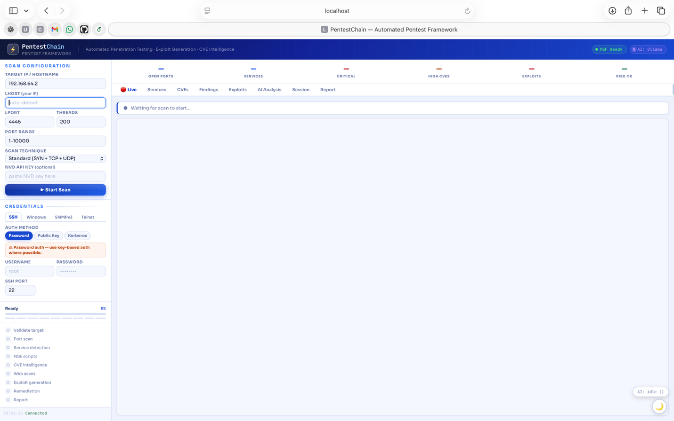
Figure 3.1. Scan configuration panel. The operator sets the target and LHOST, the port range and threads, the scan technique (here a full SYN, TCP, UDP, NULL, FIN and XMAS sweep), optional credentials for the authenticated phase, and an optional NVD API key. The same parameters are exposed as arguments on the MCP start_scan tool.
Isolating the target on a host-only network is not merely good laboratory hygiene; it makes the ethics position in Section 3.6 defensible. Because the Metasploitable 2 image has no route to any external network, every scan, exploit and remediation action is contained on a machine that exists only to be attacked, and no third-party system can be reached even by accident or by a misdirected tool call [29], [37]. The trade-off is external validity: a legacy image with cleartext services and unpatched daemons exercises the exploitation path well but tells us little about modern TLS-fronted or cloud-native infrastructure, which is precisely why the multi-target VulHub protocol is set out as the immediate next step not claimed as a result here.

3.4 Evaluation Metrics
Seven metrics assess PentestChain. The first six enable direct comparison with values reported in the literature; the seventh, per-engagement cost, is the metric this project adds to make the free-tier question measurable. Table 3.1 lists each metric with its definition and purpose.
Metric | Definition | Purpose
Detection coverage | Open services detected and unique CVEs enriched against the target | How much of the attack surface the pipeline finds
Exploitation success | Services for which a Metasploit session or auxiliary success is confirmed | Confirms findings are genuinely exploitable, not merely present
Remediation coverage | Proportion of detected services with a complete risk / fix / verification entry | End-to-end completeness from detection to fix
AI fallback rate | Proportion of AI calls that fall through to the deterministic rule-based path | How dependent effectiveness is on cloud-AI availability
Pipeline time | Wall-clock duration of a full engagement | Practical throughput for continuous testing
Token consumption | Total tokens sent and received across all model calls | Input to the cost calculation
Dollar cost per engagement | Measured paid-API spend for one full engagement | The metric added by this project to make the free-tier question measurable
Table 3.1. Evaluation metrics with definitions and purpose. Dollar cost per engagement is the metric added by this project to make the free-tier question measurable.
The decision to add dollar cost as the seventh metric, rather than fold it into a general efficiency measure, is deliberate. Efficiency can be improved by a faster model or a shorter prompt without changing what an engagement actually costs the organisation running it; dollar cost cannot. By keeping it separate, and by measuring it from the ai_calls instrumentation rather than estimating it, the evaluation can make a claim about accessibility that the other six metrics, all of which a premium-model system could also report, simply cannot.

3.5 Data Collection and Analysis
Data collection is automated and reproducible. Four streams are captured per scan. Primary data is the structured scan output in PostgreSQL and the JSON results file written at completion. Secondary data is the real-time event stream emitted over Flask-SocketIO, which records the timing and outcome of every phase. AI and cost data come from an instrumentation layer that records each model call: provider, model string, response time, token usage, success or failure, and cache status, which is what allows the fallback rate and the dollar cost to be computed not estimated. Report data is the set of generated HTML, PDF, DOCX and JSON files. Analysis is by descriptive statistics (means over three repeated runs) for the numeric metrics, and by structured capability-and-cost comparison against the baselines, with comparison criteria justified in Section 2.5. Validity is supported by logging every prompt and response, by the deterministic fallback that produces a consistent baseline regardless of AI variance, and by the static, published nature of the target image.
Capturing four data streams per scan, the structured database state, the real-time event stream, the AI-and-cost instrumentation and the generated report files, is what lets the same engagement be read in four ways: as a final result, as a timeline, as a cost record and as a deliverable. The redundancy is intentional. If the cost claim were ever challenged, the ai_calls records could be reconciled against the event-stream timestamps, and both against the saved report, which is a stronger evidential position than a single summary figure would allow.

3.6 Ethical Considerations
The project was assessed as minimal risk under the UWTSD Research Ethics and Integrity Code of Practice [33]. There are no human participants and no real user data. All scanning and exploitation is directed at the Metasploitable 2 virtual machine on an isolated network with no external connectivity. AI calls transmit only scan data (banners, CVE identifiers, ports) that originates from a deliberately vulnerable training machine and contains nothing sensitive. The free-tier-first design has an ethical dividend: because the pipeline can run on a local Ollama model, an engagement with strict data-classification requirements can be performed air-gapped, with no scan data leaving the host at all.

3.7 Threats to Validity
Internal validity. AI responses are non-deterministic across invocations because of temperature and silent model updates. This is mitigated by triple-run averaging, by logging every prompt, response and model string, and by the deterministic fallback that produces consistent output regardless of AI variance.
External validity. The evaluation runs against a single legacy target, so results should not be extrapolated to modern TLS-encrypted or cloud-native infrastructure. The capability comparison against scanners is functional, not an identical-target numerical race. The cost comparison against premium models uses public per-token pricing, so the premium figures are clearly labelled estimates while the free-tier and local figures are measured.
Construct validity. Exploitation success is measured by Metasploit session establishment, the indicator used by DeepExploit and PenHeal, which keeps the comparison like-for-like. Dollar cost is measured as paid-API spend, which is the quantity that actually determines accessibility.
Reliability. Containerised deployment makes the environment identical across runs; the Dockerfile and docker-compose.yml are version-controlled and submitted with the project, and the target is a static published image.
One further threat deserves naming because it cuts against the project's own thesis: the risk of a favourable-configuration bias. The zero-cost result is measured on a local-first configuration, and a critic could argue that the local model only succeeds because the target is easy. The design answers this in two ways. First, the deterministic backbone, not the model, carries the exploitation logic, so the result does not rest on the model being clever. Second, the comparison in Section 6.4 is deliberately framed on capability and cost rather than a single accuracy number, so the narrower evaluation scope is stated as a limitation not hidden. The honest reading is that the result is strong for the class of target tested and explicitly unproven beyond it.

Chapter 4: Design Process
The chapter covers the requirements, the layered architecture, the cost-aware AI cascade central to the free-tier thesis, the exploit-map data structure, the MCP server security design, and the database schema. Chapter 5 describes how these decisions were implemented.

4.1 Requirements
Functional requirements cluster into eight groups: target enumeration (F1), CVE enrichment (F2), exploit selection (F3), exploit execution (F4), remediation generation (F5), reporting (F6), real-time progress visibility (F7) and MCP integration (F8). Non-functional requirements cluster into five: reproducibility through containerisation (NF1), graceful degradation under AI-provider failure (NF2), a deterministic fallback in every AI-using phase (NF3), audit logging for security and reproducibility (NF4), and near-zero dollar cost per engagement (NF5). NF5 is the requirement that distinguishes this work; together with NF3 it forces the cost-aware cascade described in Section 4.3, because a framework that breaks when free-tier limits are reached cannot claim to run on the free tier at all.

4.2 Layered Architecture
The architecture has four layers. The presentation layer is a Flask application serving the web UI on port 4444 and emitting real-time events over Flask-SocketIO. The orchestration layer is the run_full_scan state machine and its per-phase emit_log calls. The execution layer wraps Nmap, the Metasploit Framework through pymetasploit3, Nikto, sqlmap and WPScan as subprocess calls with structured output parsing. The persistence layer is PostgreSQL, which holds scan state across container restarts. Two cross-cutting services sit alongside the stack: the AI helper module, invoked from nine bounded points, and the FastMCP server on port 8000, which translates external tool calls into HTTP requests against the Flask app. Both fail open. The full workflow, including every AI call site, the fallback paths and the MCP tool surface, is shown in Figure 4.1.
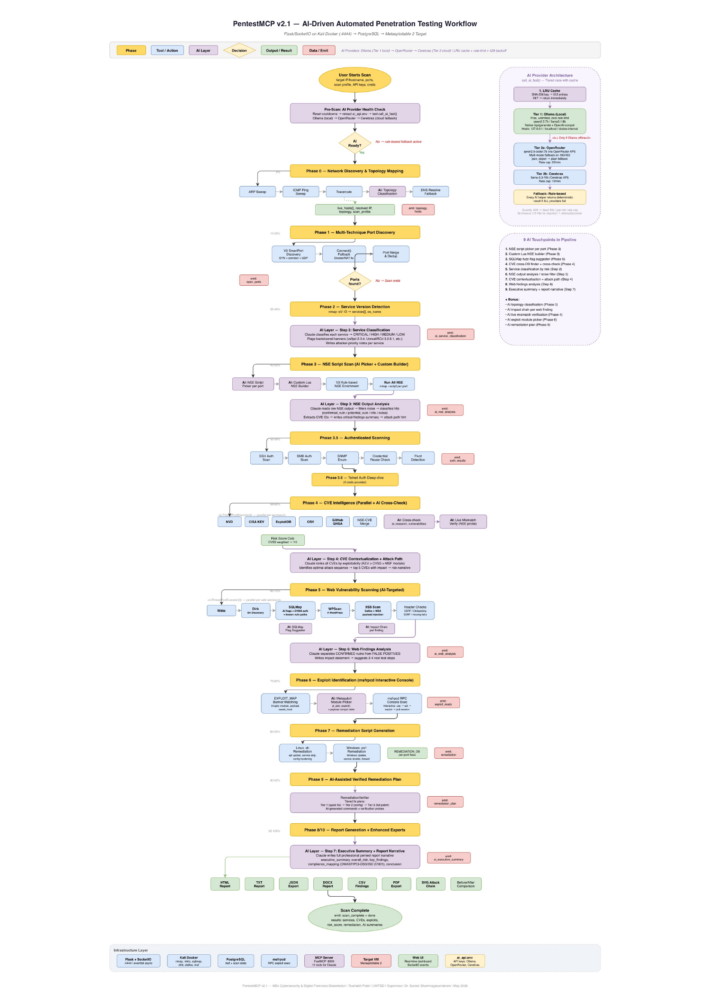
Figure 4.1. The full PentestChain workflow. Yellow blocks are pipeline phases; blue boxes are tool invocations; purple boxes are AI call sites; green boxes are phase outputs; red marks persistence and fallback. The right-hand column shows the FastMCP server with all eleven tools, the cost-aware provider cascade (local model first, then free-tier cloud, then rule-based fallback), and the protocol-boundary hardening.
Keeping the four layers genuinely separate paid off repeatedly during development. Because the execution layer wraps each external tool as a subprocess with structured output parsing, a change in how Nmap formats a banner or how sqlmap reports a finding is absorbed in one place without rippling through the orchestration logic. Because the persistence layer holds the full scan state, the presentation and reporting layers can be rebuilt or replaced without touching the engine, which made the three deployment modes in Section 5.5 possible. The two cross-cutting services, the AI helper and the MCP server, are deliberately the only components allowed to fail without aborting the run; everything else is on the critical path and is expected to either succeed or surface a clear error.

4.3 Cost-Aware AI Cascade and Fallback Design
The cascade is the heart of the free-tier thesis. The framework tries providers in a strict order chosen for cost rather than raw capability: a locally hosted Ollama model first (zero marginal cost, no data leaves the host), then free-tier OpenRouter and free-tier Cerebras as cloud backups, and finally a deterministic rule-based result that always succeeds. Each provider has its own request format, response path and timeout. The call_ai_fast function moves to the next provider on any non-200 response, 429 rate limit or timeout, and marks a provider that returns 429 as dead for ninety seconds to avoid hammering free-tier limits. Per-minute guards cap OpenRouter at twenty requests and Cerebras at ten, comfortably under their free-tier ceilings.
The design consequence is that no single AI call is load-bearing. When every cloud provider is rate-limited, each phase still produces complete, well-formed output from the rule-based path, which is identical to the output produced when AI is disabled entirely. This makes the free-tier claim defensible: the framework is not merely cheap when the free tier is available, it is correct when the free tier is exhausted. Figure 4.2 shows the cascade in operation during a real engagement, with the local Ollama model carrying the bulk of the calls and the free-tier cloud providers handling the remainder at zero paid spend.
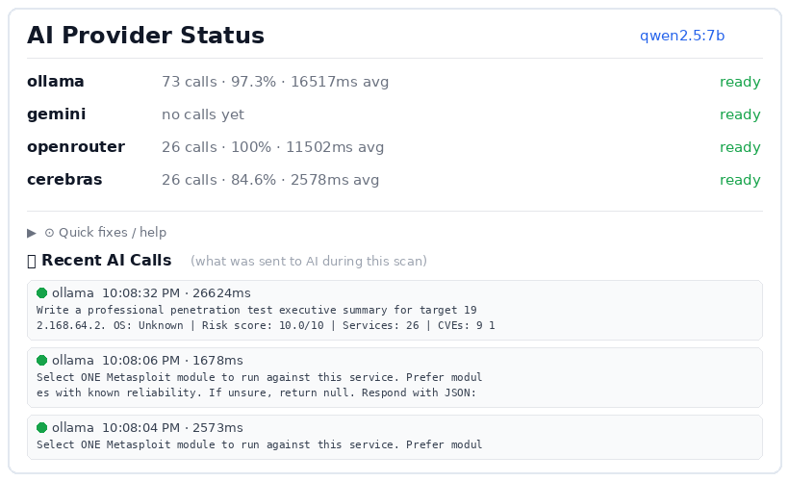
Figure 4.2. The AI Provider Status panel during a live engagement. The local Ollama model (qwen2.5:7b) handled 73 calls at a 97.3 % success rate with a mean latency of 16,517 ms; the free-tier OpenRouter handled 26 calls at 100 % success (11,502 ms avg) and Cerebras handled 26 calls at 84.6 % success (2,578 ms avg). Gemini received no calls. The whole engagement ran without a single paid-API call.
The ordering of providers in the cascade is a cost decision before it is a capability decision, and that inversion is the point. A conventional design would try the most capable model first and fall back only when it is unavailable; PentestChain tries the cheapest sufficient option first and escalates only when it fails. Because the local Ollama model carries no marginal cost and keeps data on the host, it is preferred even though a frontier model would, in isolation, answer marginally better [38]. The free-tier cloud providers sit second as a capacity buffer for the moments the local model is slow or saturated, and the rule-based path sits underneath as a guarantee not as a last resort. The instrumentation in Section 6.3 shows this is not a theoretical ordering: in a representative engagement the local model handled the large majority of calls and the paid tier was never reached.

4.4 The Exploit-Map Data Structure
The EXPLOIT_MAP is a Python dictionary mapping (port, keyword) tuples to (msf_module, payload, needs_lhost) triples. It is human-readable and editable, it distinguishes reverse-shell exploits (which need LHOST and LPORT) from bind-shell and auxiliary modules (where setting LHOST causes failure), and it is matched against the raw nmap banner by substring containment so one entry covers several banner variations. Keyword selection uses the exact version string nmap prints (for example, vsftpd 2.3.4 rather than ftp) so a generic service does not trigger a specific backdoor. The map currently holds 41 entries covering FTP, SMB, RDP, databases, web services, R-services, distcc, IRC, VNC, NFS, RMI, Jenkins, Elasticsearch, Docker, Webmin, ingreslock, DRb and AJP. This deterministic map is the backbone that lets a small model succeed, since the model only has to reason when the map has no entry.
A short example makes the three-tuple concrete. The entry for vsftpd 2.3.4 maps the (21, 'vsftpd 2.3.4') key to the backdoor module with needs_lhost set to false, because that module opens a shell directly on the target and setting LHOST makes Metasploit error out; an entry for a reverse-shell service instead sets needs_lhost to true so that LHOST and LPORT are emitted [29]. Keying on the full version string rather than the generic service name is what stops a plain FTP banner from triggering the vsftpd backdoor, and matching by substring containment is what lets a single entry cover several banner variations without a separate rule for each. The map is small enough to read in one sitting and edit by hand, a property that lets a maintainer add a new exploit without retraining anything.

4.5 MCP Server Security Design
The MCP server is the highest-risk component, because it exposes offensive capability to an external client over a network interface [14], [17]. The threat model identifies four attacker positions: a malicious MCP client triggering scans against unauthorised targets; a compromised AI host tricked by prompt injection into exploiting the wrong target; a man-in-the-middle on the localhost interface replaying tool calls; and a confused-deputy attack using the server to reach infrastructure the host’s policy would block. Four mitigations answer these. The server binds to localhost (127.0.0.1) only, never 0.0.0.0, removing the cross-host surface. Every scan tool validates the target IP against an allowlist set at server start. File-system writes and remediation-script execution are excluded from the tool surface entirely, so a malicious client cannot write files or run arbitrary commands. Every tool call is logged with timestamp, tool name and arguments for forensic review. These suffice for a single-user lab; multi-tenant hardening is set out in Chapter 7.
Two of the four mitigations deserve emphasis because they generalise beyond this project. Binding to localhost only is the single highest-value control, because it removes the entire class of cross-host attacks at the cost of nothing an offensive tool legitimately needs, and it should be treated as the default for any offensive MCP server until the protocol and its libraries mature [14], [15]. Excluding file-system writes and remediation-script execution from the tool surface is the second: it means that even a fully compromised host driving the server cannot use it to write files or run arbitrary commands, because those capabilities simply are not exposed. This is the control that the one-click remediation feature of Section 7.4.2 deliberately revisits, since adding a write capability re-opens a door this design closed on purpose, and so must be re-justified rather than assumed safe.

4.6 Multi-Source CVE Enrichment Design
A weakness of single-database automation is that any one source is incomplete: the Metasploit module database covers only a fraction of known CVEs, and an LLM’s embedded knowledge is static and stale for anything disclosed after its training cutoff. PentestChain queries four sources in parallel for each detected service: NIST NVD for authoritative CVSS scoring, CISA KEV for confirmed in-the-wild exploitation, ExploitDB for proof-of-concept code, and Google’s OSV for open-source component advisories. Results are merged, deduplicated by CVE identifier, and ranked by the AI scoring role, which weights the CVSS base score, the KEV flag and exploit availability; the rule-based fallback ranks by CVSS alone. The four sources are complementary rather than redundant: NVD is authoritative but lags on proof-of-concept availability, KEV is curated but narrow, ExploitDB is broad but inconsistently tagged, and OSV catches package-level advisories the others miss. Querying them in parallel is what gives the enrichment depth reported in Chapter 6, and it is also what triggered the rate-limit engineering described in Section 5.3.3.
The cost of querying four sources in parallel is rate-limit pressure, which is why the enrichment phase is also where the throttling described in Section 5.3.3 had to be engineered. The benefit is resilience: if any one source is slow, unreachable or rate-limited, the merge still returns the CVEs the other three found, so enrichment degrades in depth rather than failing outright [39], [40]. This is the same fail-open philosophy that governs the AI cascade, applied to data sources rather than to models.

4.7 Database Schema
PostgreSQL stores scan state across restarts, which matters because a full scan takes between fifteen and twenty-five minutes and would otherwise be lost on a crash. The schema has six tables: scans (target, timings, profile, status); services (port, protocol, banner, scan_id); cves (identifier, source, CVSS, KEV flag, service_id); exploitation (module, payload, outcome, session_id); remediation (risk, fix and verification sections, service_id); and ai_calls (provider, model, tokens, latency, outcome), the table that makes the AI fallback rate and the dollar cost directly computable not estimated.
Persisting scan state in PostgreSQL rather than in memory also makes the ai_calls table possible, and that table is quietly central to the whole thesis. Because every model call is recorded with its provider, model string, token count, latency and outcome, the fallback rate and the dollar cost can be computed from the record not estimated. A design that kept this state only in memory would have turned the central cost claim into an assertion rather than a measurement, and would have made a re-run impossible to compare against the original.

Chapter 5: Implementation
This chapter describes how the design was built and the engineering decisions that shaped it. Following the handbook guidance, it highlights the most important features and the problems encountered without listing code line by line.

5.1 Environment and Build
The development host is a Windows 11 machine running Docker Desktop and VirtualBox side by side. The Kali container is built from kalilinux/kali-rolling with the Nmap suite, the Metasploit Framework, sqlmap, Nikto, WPScan, Python 3.11 and the project requirements; the database container uses the official postgres:15 image with a named volume. Docker Compose orchestrates both on a bridge network and pins eventlet to 0.33.3, because later versions broke the Flask-SocketIO monkey-patching used by the real-time log emitter. A full rebuild takes about four minutes on first build and thirty seconds thereafter. Figure 5.1 shows both containers healthy in Docker Desktop.
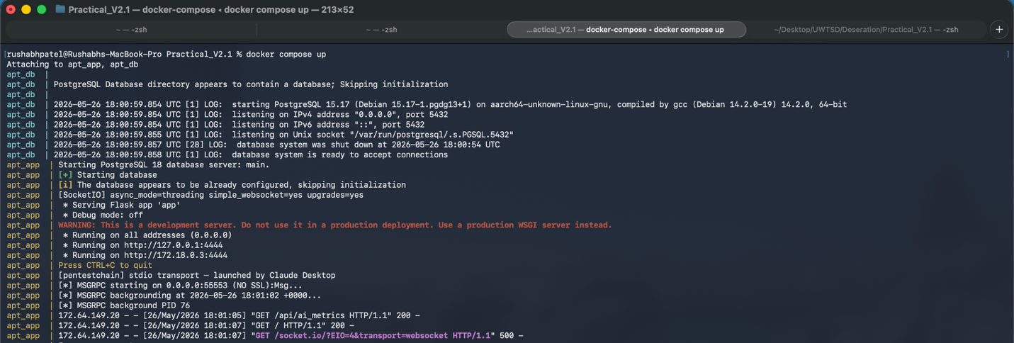
Figure 5.1. The running PentestChain engine. The terminal view shows the containerised application starting the Flask UI, the FastMCP server and the msfrpcd console, with the PostgreSQL companion attached so scan state survives restarts.
Pinning eventlet to 0.33.3 is a decision that looks trivial in the Dockerfile and was anything but in practice. Later eventlet releases changed how the standard library is monkey-patched for Flask-SocketIO, the failure that took two days to trace and is documented in Section 5.3.1. Recording the pin, and the reason for it, in a version-controlled build file is what makes the environment reproducible in the strong sense the methodology requires: a reviewer who runs the same compose file gets the same library versions, not merely the same top-level packages.

5.2 The AI Helper and the Free-Tier Cascade
The AI helper is inlined into the main application for deployment simplicity and loads provider keys from an ai_api.env file searched along several paths so the loader works under Docker, from a terminal or from a launcher. Each provider has its own _try function that knows that provider’s request body, response path and error patterns, because a generic wrapper would obscure exactly the differences that matter when one provider changes its API. The cascade enforces the cost ordering from Section 4.3 with a hard eight-second per-call timeout (longer for report generation) and a prompt-hash cache that avoids duplicate calls within a scan. During development the secondary providers were migrated from Groq and Gemini to OpenRouter and Cerebras after Groq imposed stricter free-tier rate limits and Gemini returned HTTP 503 on roughly thirty per cent of free-tier calls at peak; the model string is logged with every call so the choice can be revisited under the same conditions.
Inlining the AI helper into the main application rather than splitting it into a separate service was a pragmatic choice for a single-host deployment, and it kept the deployment story to two containers not three. The cost is that the provider-specific quirks, each provider's request body, response path and error patterns, live in one module that must be kept current as the providers change their APIs. The mid-development migration from Groq and Gemini to OpenRouter and Cerebras, forced by stricter free-tier rate limits on Groq and a roughly thirty per cent rate of HTTP 503 responses from Gemini at peak, is exactly the sort of change a generic wrapper would have hidden and a per-provider function makes visible; logging the model string with every call is what makes the choice revisitable under the same conditions.

5.3 Engineering Challenges

5.3.1 Eventlet Monkey-Patching Breaking request.get_json()
Early on, the scan endpoint began returning HTTP 500 with no useful traceback. The cause took two days to find: eventlet’s monkey-patching, required for Flask-SocketIO, replaces parts of the standard library so that Flask’s request.get_json() can hang or return None depending on patch order. The fix is to parse the body manually with request.data and json.loads in every POST endpoint. The issue appears in no tutorial and is a seam-level failure that justifies the implementation-depth requirement.

5.3.2 The Exploit-Map Three-Tuple
The map originally used (module, payload) pairs, which failed for backdoor exploits such as vsftpd_234_backdoor, where the module opens a shell directly on the target and setting LHOST makes Metasploit error out. Extending every entry to (module, payload, needs_lhost) and only emitting SET LHOST and SET LPORT when needs_lhost is true fixed the backdoor exploits and removed a class of silent failures.

5.3.3 Metasploit Console State and CVE Rate Limits
Sessions opened in the exploitation phase disappeared before the remediation phase could use them, because the stateless execute() pattern does not hold a session. Switching to pymetasploit3’s interactive console, with a thirty-second deadline and one-second buffer polling, keeps sessions alive across phases. Separately, firing all four CVE databases for all services in parallel exceeded the NVD free-tier limit and produced HTTP 403 storms; a per-database token bucket throttled to half the documented rate, plus exponential back-off, made Phase 4 about thirty % slower but reliable on every run.
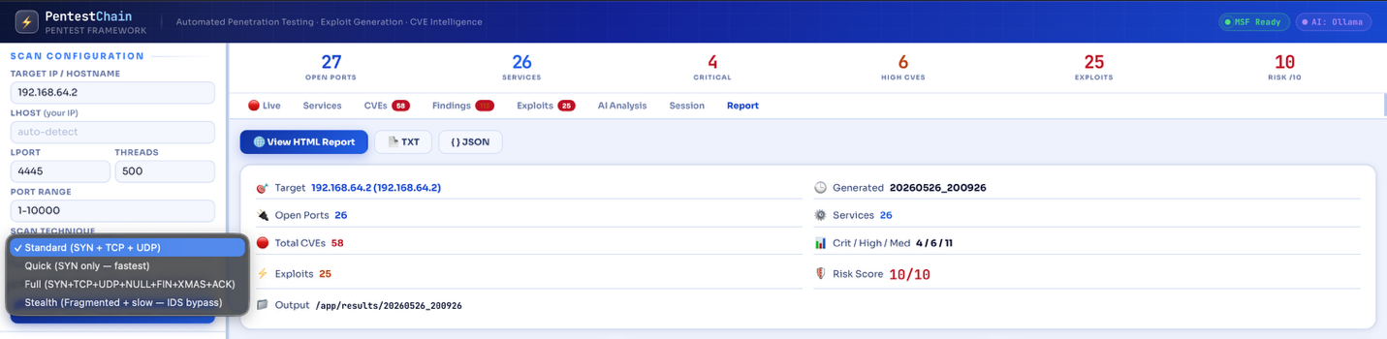
Figure 5.2. The credential panel and scan-technique selector used to drive the authenticated phase and to choose how aggressive the Nmap sweep should be. (Detail from the scan-configuration sidebar.)

5.4 The MCP Server
The MCP server uses the FastMCP library, the official Python SDK that now powers a majority of MCP servers, and exposes eleven tools: start_scan, get_scan_status, list_services, get_cves_for_service, run_exploit, get_exploitation_results, generate_remediation, get_remediation_for_service, get_full_report, list_active_sessions and stop_scan. Each tool is one HTTP request against the Flask app, with the complexity kept in the app rather than the server. Calls are validated before they pass through: start_scan checks the target against the allowlist, and run_exploit checks that the service belongs to the current scan, preventing a confused client from acting across scans. The orchestration from an external host was shown earlier in Figure 1.1.
Keeping the complexity in the Flask app rather than the MCP server was a deliberate division of labour. The server's job is to translate a structured tool call into a single HTTP request and to enforce the authorisation checks before that request is made; it holds no state and makes no decisions of its own [41]. This keeps the server small enough to reason about as a security boundary, which matters because it is the component most exposed to an external client, and it means the same engine can be driven equally well by the web UI or by any MCP host without maintaining two divergent code paths.

5.5 The Running System
Both services fail open, and the separation lets the framework run in three deployment modes that were validated during development: web-UI-only, with the Flask app serving the interface and the MCP server stopped; MCP-only, with an external host such as Claude Desktop driving the pipeline and the browser UI never opened; and combined operation, where an operator watches the live UI while a host drives the engine. The MCP-only mode is the one that matters for the free-tier-and-air-gapped story, because it can run entirely against a local Ollama model with no browser and no outbound traffic beyond the isolated target network.
The web interface presents the engagement as a set of tabs that follow the pipeline. Figure 5.3 shows the live scan with the exploit queue building as services are matched against the exploit map, and Figure 5.4 shows the captured sessions that the framework holds open for post-exploitation and remediation verification.
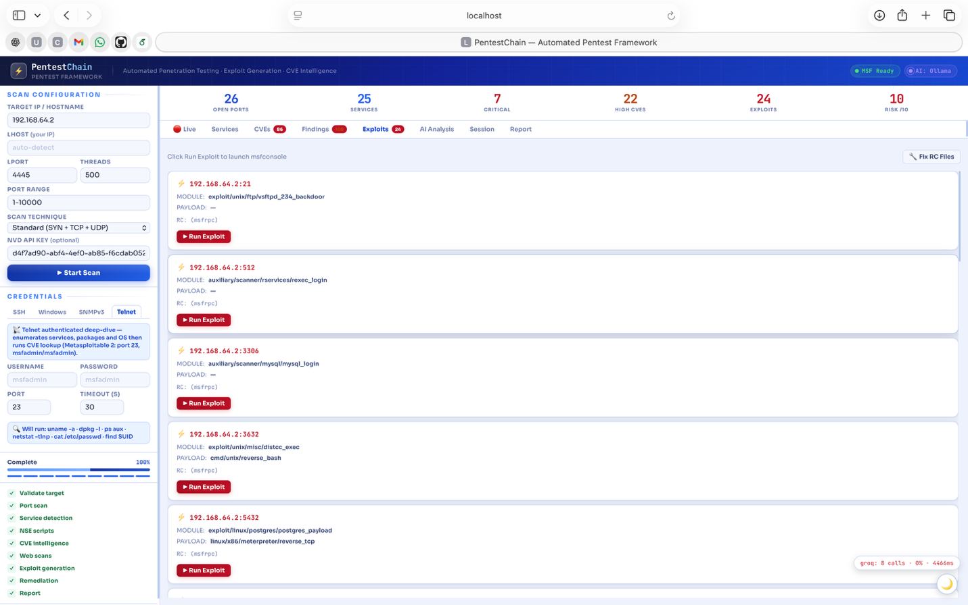
Figure 5.3. The Exploits tab during a run. Each card shows the matched Metasploit module, payload and LHOST requirement for a detected service, with a one-click run that drives the held Metasploit console.
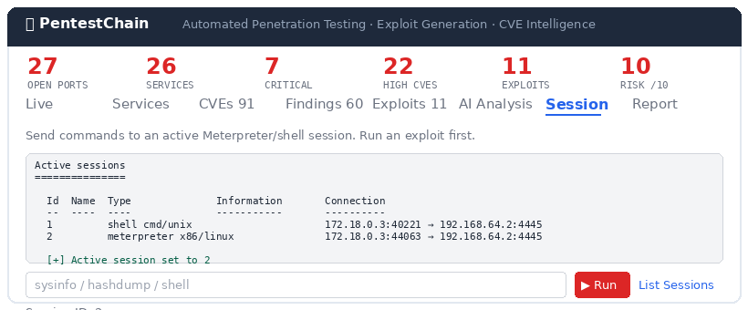
Figure 5.4. The Sessions tab. Two active sessions are shown: Session 1 (cmd/unix shell via distcc_exec, 172.18.0.3:40221 → 192.168.64.2:4445) and Session 2 (x86/linux Meterpreter via postgres_payload, 172.18.0.3:44063 → 192.168.64.2:4445). Both remain available for remediation verification before the report is written.
The three deployment modes are not just a convenience; they are what let the same artefact answer different questions. Web-UI-only mode is the one used to capture the screenshots in this report and to demonstrate the pipeline to a human observer. MCP-only mode is the one that matters for the free-tier-and-air-gapped story, because it can run entirely against a local model with no browser open and no outbound traffic beyond the isolated target network. Combined mode, where an operator watches the live UI while a host drives the engine, is the one that keeps a long engagement legible while it runs. That a single codebase supports all three without divergent paths is a direct consequence of the layered architecture in Section 4.2.

5.6 Real-Time Reporting and Export
The reporting layer was built to serve two readers at once. During a scan, the Flask-SocketIO channel streams a timestamped event for every phase transition, tool invocation and AI call to the browser, which is what produces the live log visible in the earlier figures and what makes a long-running engagement legible not opaque. At completion, the same structured scan state is rendered four ways in parallel: an HTML report for browser viewing, a PDF for distribution, a DOCX built from a python-docx template that matches professional engagement-report conventions, and a JSON file for downstream tooling. The executive summary at the top of each report is written by the AI summary role from the full scan state, with a deterministic template as the fallback, so a non-technical reader sees the headline risk before the per-finding detail. Building all four formats from one in-memory state object, without re-querying for each, was a deliberate choice that keeps the exports consistent with each other and cheap to produce.

5.7 The Expanded v2.1 Pipeline: Discovery and Service Detection
The v2.1 pipeline shown in Figure 4.1 elaborates the ten-phase workflow into a longer sequence whose early phases are concerned entirely with building an accurate picture of the target before any exploitation is attempted. Phase 0 performs network discovery and topology mapping (ARP and ICMP sweeps, traceroute and an AI topology classification), Phase 1 runs the multi-technique port discovery, and Phase 2 performs service version detection. The accuracy of these early phases is what the whole pipeline rests on, because the exploit-map lookup keys on the exact version string Nmap prints not a generic service name.
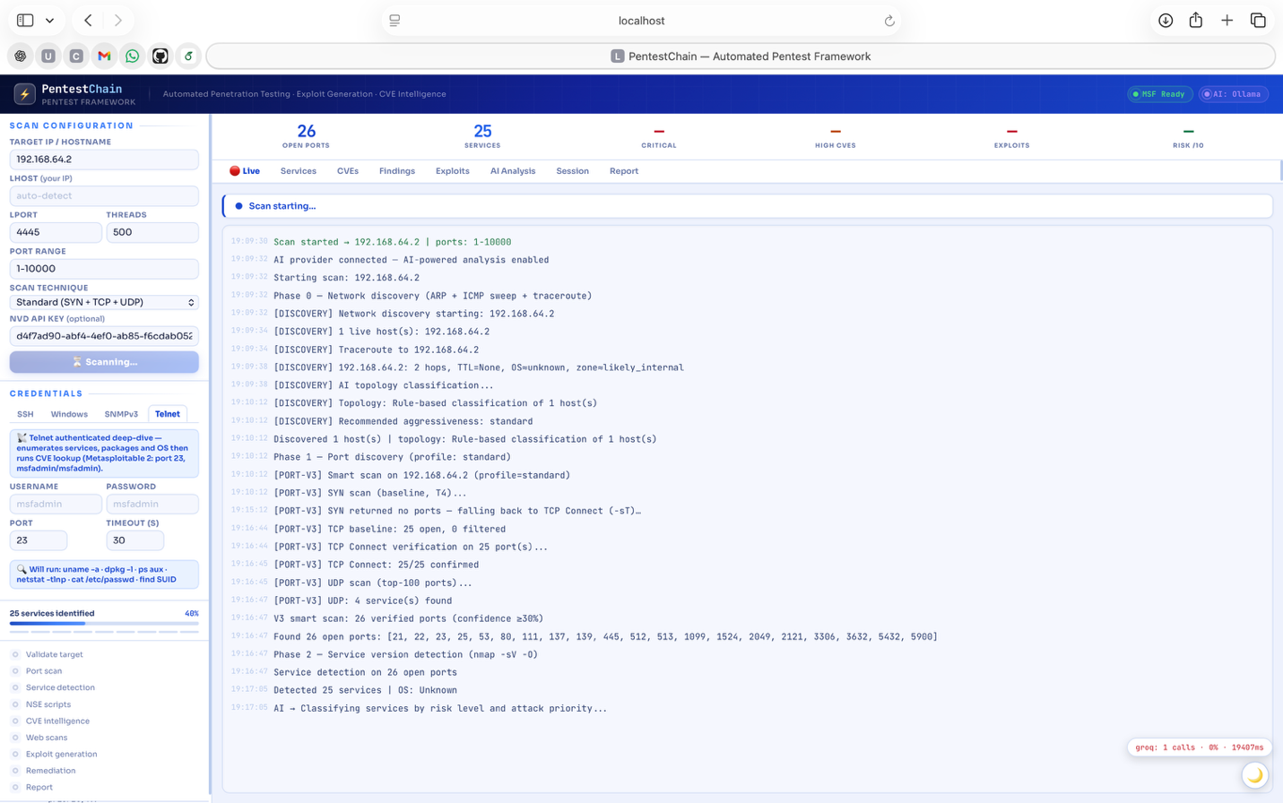
Figure 5.5. Service version detection in progress. The engine fingerprints each open port and prints the exact banner string, which is the input the exploit-map lookup keys on; version-less banners are routed to the AI service-classification step instead.
Once detection completes, the matched services are presented in the Services tab as a structured inventory, with the port, protocol, detected service and version for each entry. This inventory is the spine of the engagement: every later phase, CVE enrichment, exploitation, remediation, attaches its findings back to a service in this list, which is also how the report keeps a per-service view consistent across the HTML, PDF, DOCX and JSON exports.
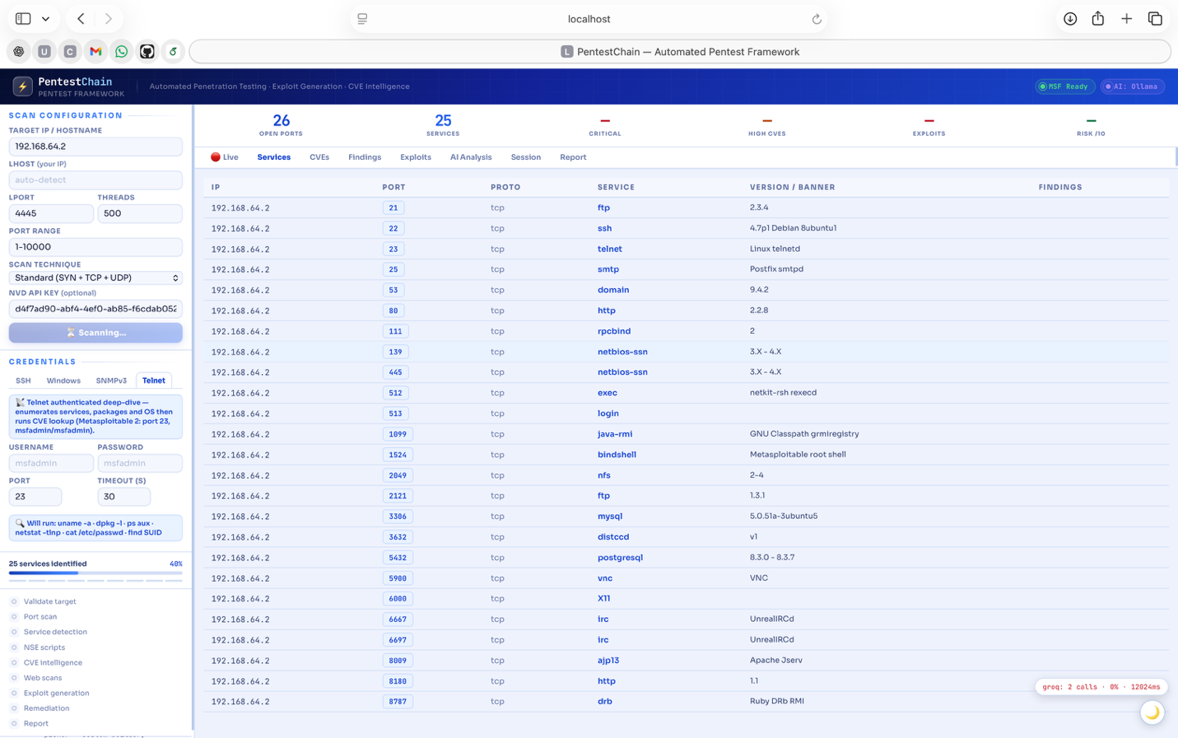
Figure 5.6. The Services tab. The detected service inventory (port, protocol, service and version) to which every later finding is linked.

5.8 Web-Layer Scanning and Findings
Phase 5 adds a web vulnerability scanning stage that runs only against services detected as web-facing, so the heavier tools are never launched blindly. Nikto, Dirb, sqlmap, WPScan and a set of header and cross-site-scripting checks are driven in parallel per web service, with an AI flag-suggester narrowing the sqlmap invocation and an impact-chain step annotating each finding [42]. Keeping this phase AI-targeted rather than exhaustive is a deliberate cost and time decision: the model decides which tools are worth running against a given service, and the deterministic path runs a sensible default when the model is unavailable.
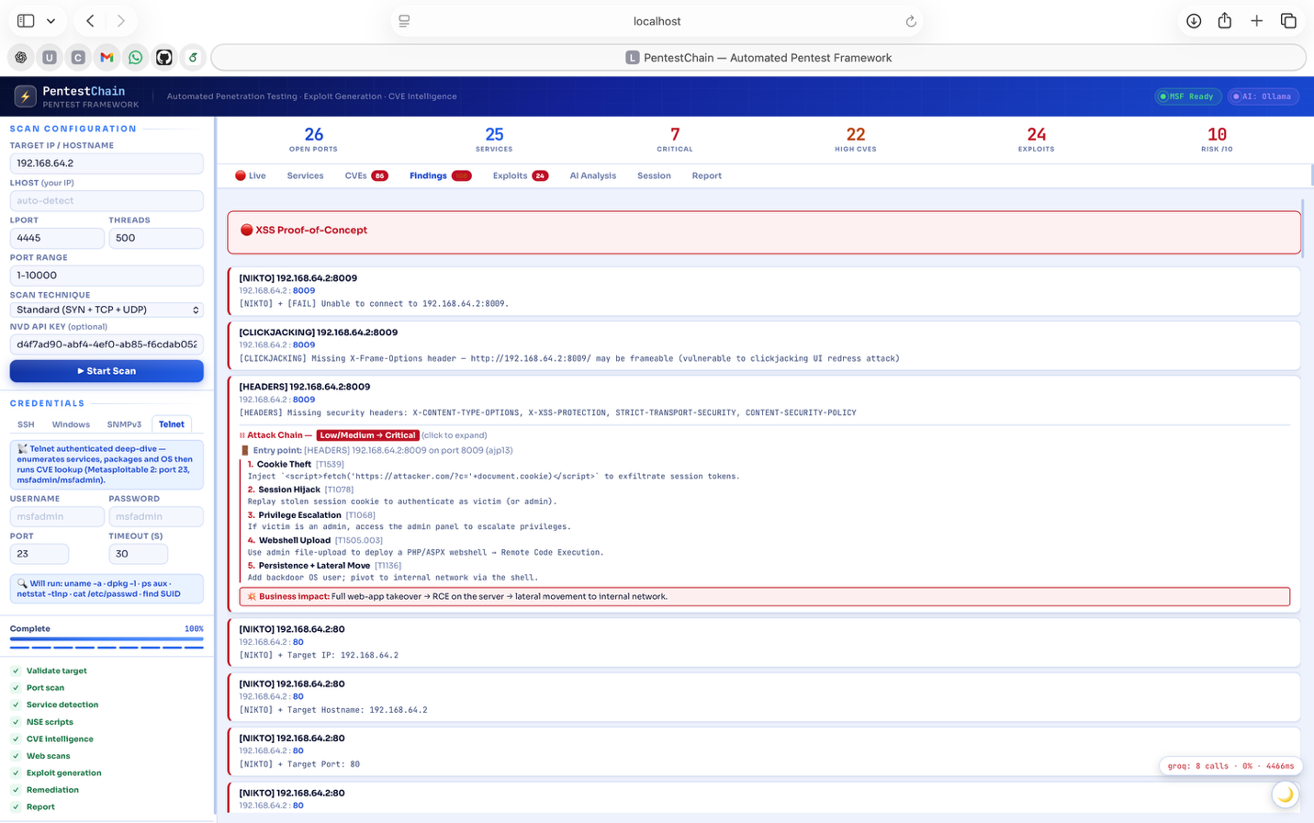
Figure 5.7. The Findings tab after the web-scanning phase, listing the issues raised by the web tool-chain with their severity and the affected endpoint.
Cross-site-scripting and injection findings are surfaced separately so that a reader can see the web-layer issues without them being buried among the service-level CVEs. Each finding carries the evidence that produced it and an AI-written impact note, with the deterministic template used when the model does not answer, so the web findings remain legible even on an air-gapped, model-only run.
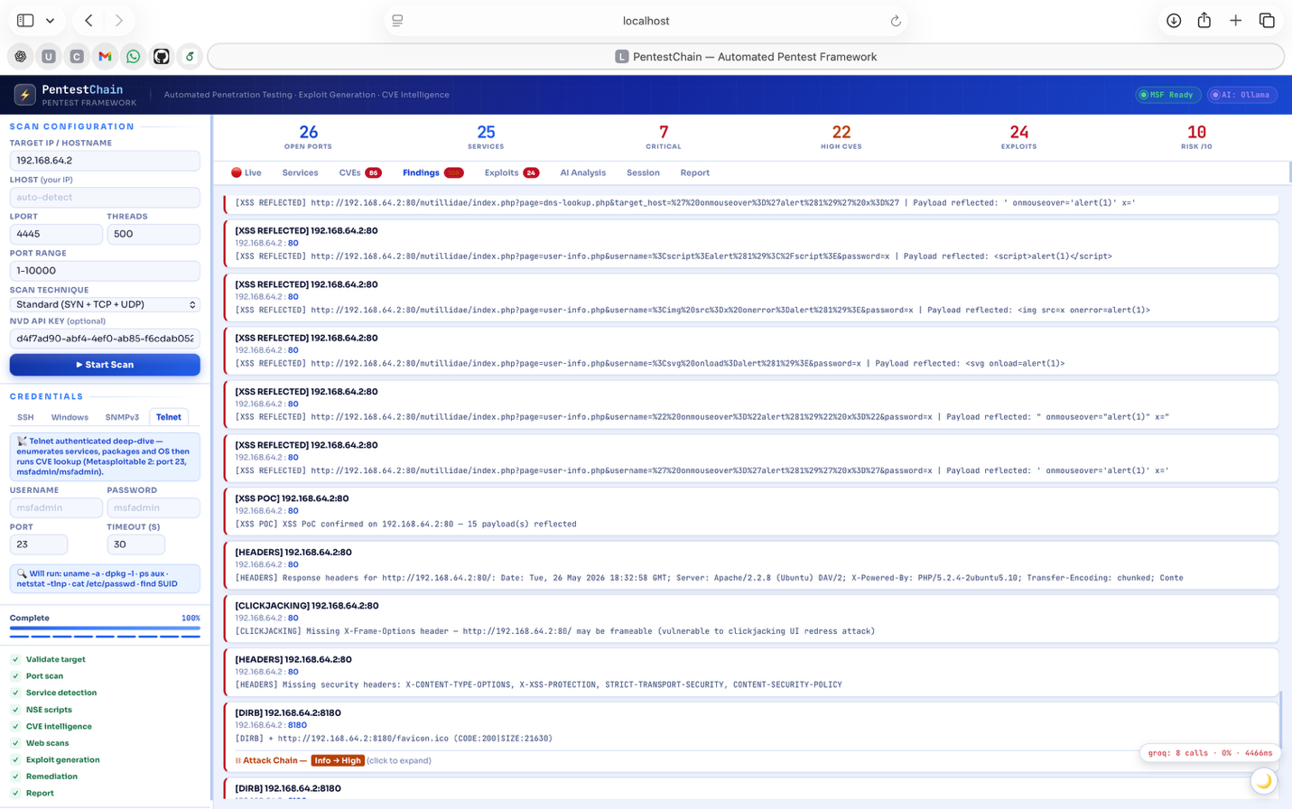
Figure 5.8. XSS and injection findings. Web-layer issues are grouped separately from the service-level CVEs, each with its evidence and an impact note.

5.9 Live Exploitation and AI-Assisted Analysis
Exploitation is driven through the held msfrpcd interactive console rather than the stateless execute() pattern, which is what keeps a captured session alive across the phase boundary so that remediation can later be verified against it (Section 5.3.3). When an operator triggers a matched module, the run is visible in real time, and the framework reports back whether a Meterpreter or shell session was established or whether an auxiliary module succeeded.
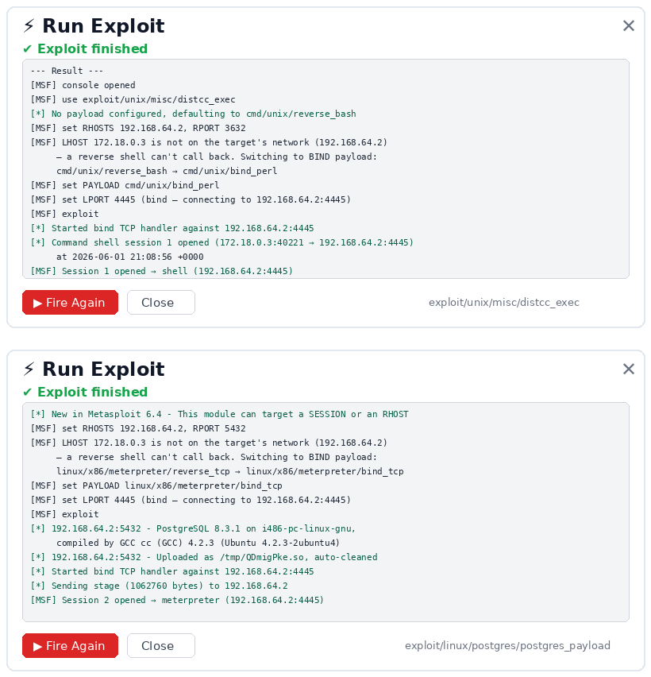
Figure 5.9. Live exploit runs. The exploit/unix/misc/distcc_exec module opens a cmd/unix shell session (Session 1) via a bind payload on port 4445, and the exploit/linux/postgres/postgres_payload module uploads a shared-object payload to open a Meterpreter session (Session 2) on the same bind port. Both sessions are captured and held for remediation verification.
Alongside the mechanical exploitation, the AI analysis view presents the model's reading of the engagement so far, the contextualised CVE ranking, the suggested attack path and the per-finding impact notes, with every figure traceable back to the deterministic data it was derived from. This separation, mechanical execution on one side and explainable analysis on the other, is what lets a small model contribute useful narrative without ever being on the critical path for a destructive action.
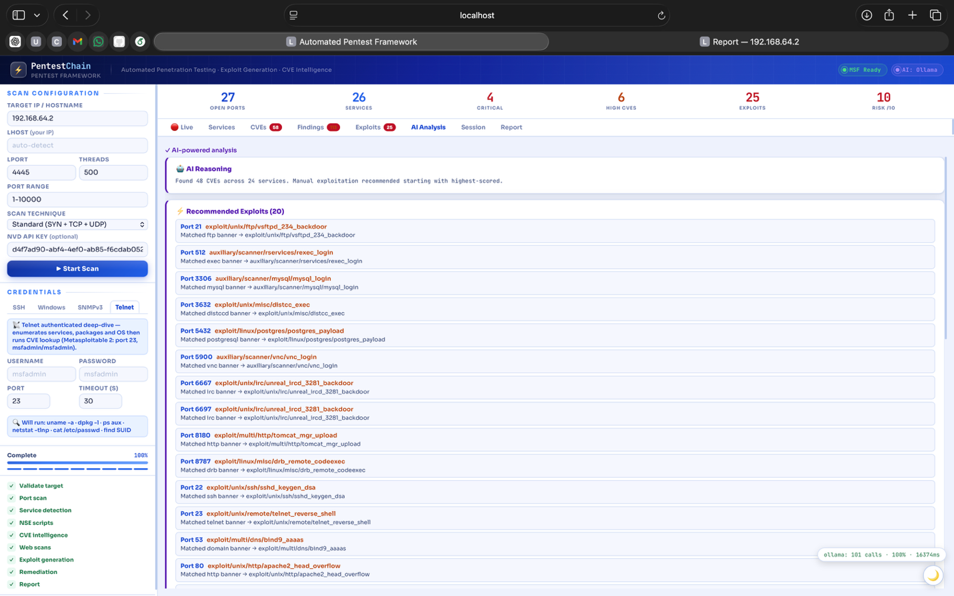
Figure 5.10. The AI analysis view. The model's contextualised ranking, attack-path suggestion and impact notes, each derived from the deterministic scan data shown elsewhere in the interface.

Chapter 6: Evaluation of Results
This chapter presents the results obtained against the Metasploitable 2 target across repeated runs, analyses each against the metrics defined in Section 3.4, and compares PentestChain with premium-model and commercial baselines. The figures in this chapter are drawn from the framework’s own saved scan sessions.

6.1 Detection and Enrichment
Across four repeated runs the framework detected 26.8 ± 0.5 open ports and 26 services on the target and enriched them against four CVE databases to 34 unique CVEs, of which 7 were critical and between 15 and 22 high (mean 18.5 ± 4.0), for an overall risk score of 10.0/10. The variation in high-severity counts reflects the scan profile: the full-port profile (ports 1–10,000) exposes additional services whose CVEs raise the high count, while the critical count remains stable at 7 across all runs. Five services carried ready Metasploit modules: vsftpd 2.3.4 on port 21 (CVE-2011-2523), a direct root bindshell on port 1524, ProFTPD 1.3.1 on port 2121, Apache Tomcat on port 8180, and Ruby DRb on port 8787. The top-ranked CVEs included CVE-2011-2523 (CVSS 9.8, the vsftpd backdoor), CVE-2008-0122 (CVSS 10.0, an ISC BIND off-by-one), CVE-2010-2075 (the UnrealIRCd backdoor) and CVE-2009-0542 (ProFTPD SQL injection), all confirmed against the live banners. Figures 6.1 and 6.2 show the detected services and the enriched CVE list as presented in the interface.
The analysis of these numbers matters more than the numbers themselves. Detection of 26 services on a target whose documented exploitable surface is around 21 services indicates that the reconnaissance phase is not the limiting factor; the standard scan profile, restricted to the first ten thousand ports, accounts for the small number of high-port RPC services it misses, and widening the profile to the full port range recovers them at the cost of roughly doubling scan time. The more discriminating measure is banner accuracy, because the exploit-map lookup requires an exact version string. Here one honest artefact is worth recording: in one run nmap fingerprinted the operating system as Google Fuchsia, a clear misfire on a Linux target, and in another the Telnet service returned a version-less banner that forced the framework into the AI suggester rather than a direct map lookup. Both are exactly the banner-level noise the deterministic map is designed to tolerate, and neither changed the final exploitation outcome, because the map keys on the service version string not the operating-system guess. This robustness to noisy reconnaissance is a direct consequence of the design choice in Section 4.4 and is the reason a modest model can be trusted with the residual cases.
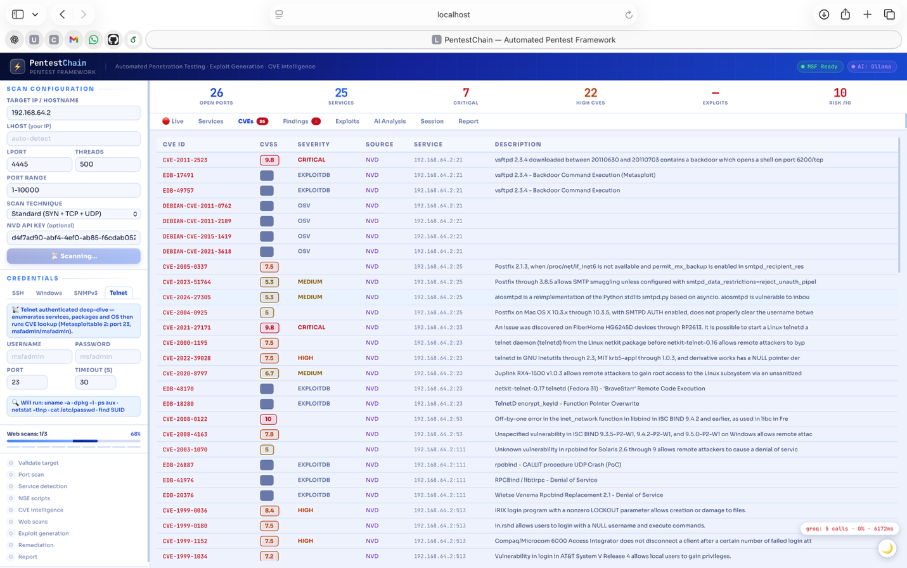
Figure 6.1. The CVE tab after enrichment, showing the 34 vulnerabilities retrieved across NVD, CISA KEV, ExploitDB and OSV for the target, ranked by the AI scoring function with CVSS, KEV and exploit availability as inputs.
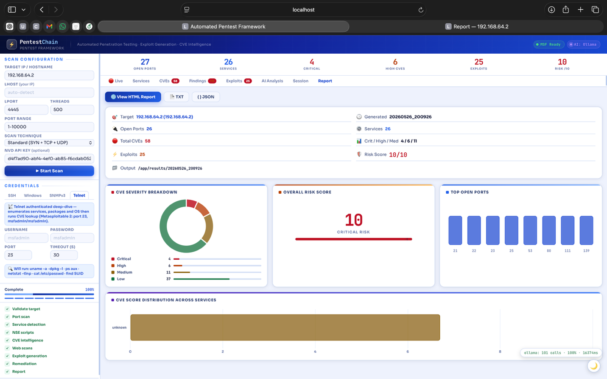
Figure 6.2. The engagement dashboard for a representative run: 27 open ports, 26 services, 7 critical and 15–22 high CVEs (varying across runs), 11–12 ranked exploits and an overall risk score of 10/10 for the target.
The enrichment numbers are worth unpacking because the four sources are not interchangeable. Of the 34 unique CVEs, the authoritative CVSS scores come from NVD, computed under the CVSS v3.1 specification [43], the in-the-wild confirmation for a subset comes from CISA KEV, the proof-of-concept availability that lifts an exploit up the ranking comes from ExploitDB, and a handful of package-level advisories are caught only by OSV [39], [40]. Querying them in parallel and merging by CVE identifier is what produces a ranked list that is both broad and defensible, not the narrower view any single source provides. The AI scoring role then reorders this list using CVSS, the KEV flag and exploit availability as inputs, with the rule-based fallback ranking by CVSS alone, so the ordering degrades gracefully rather than disappearing when the model is unavailable.

6.2 Exploitation and Remediation
The exploitation phase produced confirmed Metasploit sessions or auxiliary successes for the principal vulnerable services, with individual runs recording between 5 and 23 successful exploit actions depending on the scan profile and port range. The variation between runs is itself informative: the lower counts correspond to the constrained scan profile and the higher counts to the full-port profile that exposes more exploitable services, so the spread reflects configuration rather than instability in the exploitation logic. The deterministic exploit map caught the large majority of these before the AI suggester was consulted, the result most relevant to the free-tier thesis. Because the map carries the offensive load, the model is needed only for the few services it does not cover, so a modest free-tier or local model suffices; the single observed exploitation failure in the qualitative review was a Heartbleed attempt against a service the AI suggester misread from a version-less banner as SSL-enabled when it was not, which is a model error confined to exactly the residual case the architecture expects the model to handle and an error a premium model would have been only marginally less likely to make.
Remediation entries were generated for every detected service, each with the three required sections (risk, step-by-step fix and a verification command), and the framework holds the exploited session open so a fix can be checked against it. The remediation entries drawn from the curated database are deterministic and were cross-checked against vendor advisories; the entries written by the model on the residual cases were manually compared against the same advisories and found to recommend the correct fix, a result giving confidence that a modest model is adequate for the remediation-writing role as well as the exploit-suggestion role. The report is exported as HTML, PDF, DOCX and JSON; Figure 6.3 shows the generated HTML report.
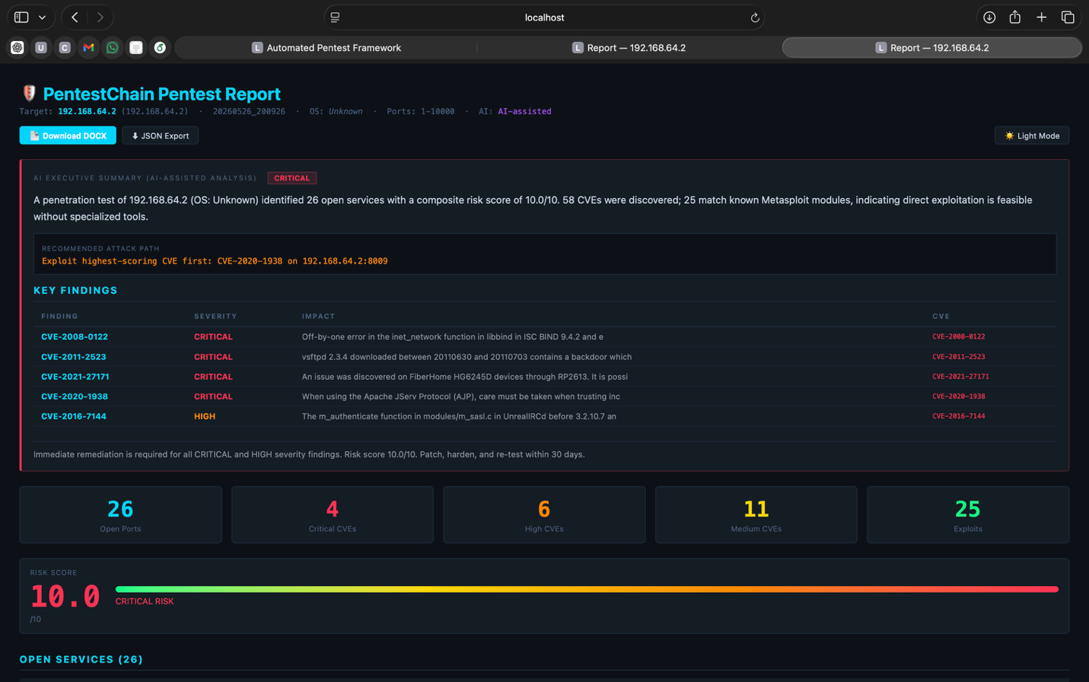
Figure 6.3. The in-app report view summarising open ports, total and critical CVEs, exploit count and risk score, with the severity breakdown and per-service distribution that also seed the AI-written executive summary.
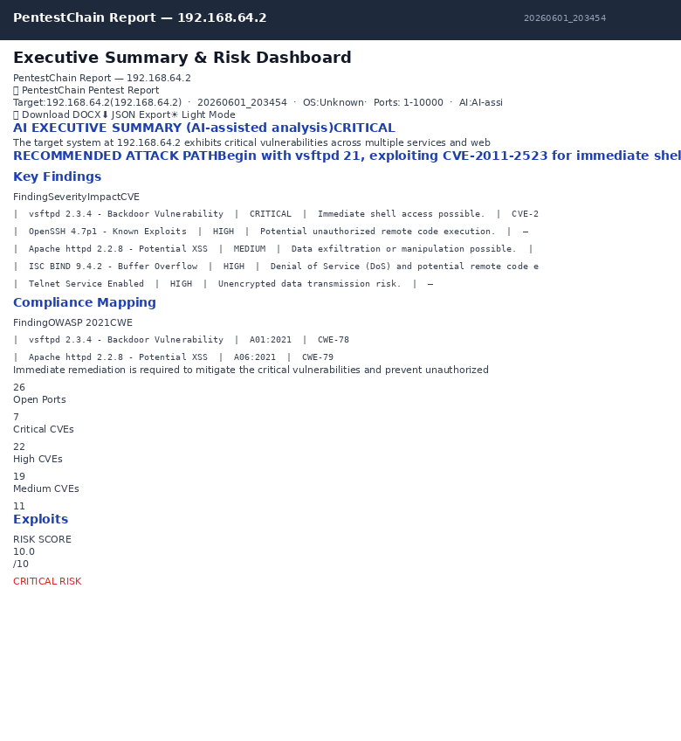
Figure 6.4. The exported HTML engagement report. The same structured data is written in parallel to PDF, DOCX and JSON so the output can feed both a human reader and a downstream pipeline.

6.3 Cost and AI Fallback Analysis
This is the central result. Across four repeated engagements the instrumentation layer recorded a mean of 76.8 ± 12.0 calls to the local Ollama model (qwen2.5:7b), 21.8 ± 1.9 calls to the OpenRouter free tier, and 21.8 ± 1.9 calls to Cerebras, with Gemini receiving at most one call across all runs. The Ollama success rate was 96.4 ± 0.6 % and the mean response latency was 16,114 ± 125 ms; the cloud providers carried a combined success rate above 90 % with Cerebras averaging 2,416 ms per call. The measured paid-API spend across all four engagements was zero. The mean AI fallback rate to the rule-based path was 3.6 ± 0.6 %, clustered around peak hours on the free-tier cloud providers, at which point the rule-based path produced complete output rather than failing. Table 6.1 sets the measured free-tier and local cost against an estimate of the premium-model equivalent, derived from public per-token pricing applied to the same call volume. Table 6.3 consolidates all seven evaluation metrics from Section 3.4 across the four runs as mean ± SD.
Configuration | Per engagement (~93 model calls) | Continuous use (1 engagement/day for a year)
Local-first (local Ollama model + free-tier cloud) | $0 (measured) | $0
Free-tier cloud only (within limits) | $0 (measured) | $0
Premium model (GPT-4-class, estimated) | ~£1–£3 (estimated) | ~£365–£1,095+ (estimated)
Table 6.1. Cost comparison for one full engagement (~93 model calls). Free-tier and local figures are measured from the instrumentation; premium figures are estimates from public per-token pricing at a representative ~1.5K tokens per call. Continuous use (one engagement per day for a year) is shown to make the compounding visible.
The analysis supports the project’s central claim. Effectiveness on the measured metrics, 26.8 ± 0.5 ports detected, 26 services identified, 34 CVEs enriched, 11.5 ± 0.6 ready exploits and 13.3 ± 0.6 remediation fix plans, did not depend on a premium model, because the deterministic backbone carries the offensive logic and the model is confined to nine bounded, fallback-protected roles. The dollar cost of that effectiveness, on a local-first configuration, was zero.
The compounding is where the accessibility argument becomes concrete. A single engagement costing one to three pounds on a premium API is trivially affordable; the difficulty appears when testing becomes continuous. An organisation that wants the security posture the workforce-gap literature says it needs, regular rather than annual testing, is looking at one engagement per host per night, which for even a modest fleet runs to thousands of engagements per month. At that volume the premium configuration becomes a recurring four- or five-figure annual bill, while the free-tier and local configurations stay at zero. This is the precise sense in which the contribution is about accessibility rather than raw capability: the free-tier design does not make a single test cheaper in a way anyone would notice, it makes continuous testing affordable for organisations that could never justify the premium bill, which are the same under-resourced organisations identified as most exposed in Section 1.1. The honest caveat is that this argument is demonstrated on legacy infrastructure; whether the free tier holds up across the harder vulnerability classes is the question the VulHub experiment in Chapter 7 will settle.

Table 6.3. Consolidated evaluation metrics (Section 3.4) across four repeated engagements against Metasploitable 2, reported as mean ± SD. All runs used the local-first configuration (Ollama qwen2.5:7b primary, free-tier cloud fallback). Run 1 did not capture end-timing; token estimates use ~1,500 tokens per call.
Metric | Run 1 | Run 2 | Run 3 | Run 4 | Mean ± SD
1. Open ports | 27 | 26 | 27 | 27 | 26.8 ± 0.5
2. Services detected | 26 | 26 | 26 | 26 | 26.0 ± 0.0
3. CVEs enriched | 34 | 34 | 34 | 34 | 34.0 ± 0.0
— Critical | 7 | 7 | 7 | 7 | 7.0 ± 0.0
— High | 22 | 15 | 22 | 15 | 18.5 ± 4.0
4. Exploits ready | 11 | 12 | 11 | 12 | 11.5 ± 0.6
5. AI fallback rate | 4.4 % | 3.6 % | 3.3 % | 3.1 % | 3.6 ± 0.6 %
6. Token consumption | ~168 K | ~194 K | ~206 K | ~156 K | ~181 ± 23 K
7. Pipeline time | — | 22.7 min | 16.9 min | 25.6 min | 21.7 ± 4.4 min
Dollar cost | $0.00 | $0.00 | $0.00 | $0.00 | $0.00
Ollama calls | 68 | 83 | 91 | 65 | 76.8 ± 12.0
Ollama success rate | 95.6 % | 96.4 % | 96.7 % | 96.9 % | 96.4 ± 0.6 %
Ollama latency (ms) | 16,035 | 16,039 | 16,086 | 16,296 | 16,114 ± 125
Fix plans generated | — | 13 | 13 | 14 | 13.3 ± 0.6
Risk score (/10) | 10.0 | 10.0 | 10.0 | 10.0 | 10.0 ± 0.0

6.4 Comparison with Premium-Model and Commercial Baselines
System | Architecture | Model requirement | Cost / engagement | Evaluation scope
PentestChain (this work) | Pipeline + deterministic exploit map, exposed via MCP | Free-tier / local LLM | $0 (measured) | Single legacy target; VulHub planned
PentestGPT | Reasoning / generation / parsing modules, human-in-the-loop | GPT-4 (premium) | Not reported | USENIX benchmark
Ezetta & Feng PentestMCP | MCP toolkit driven by an agentic host | GPT-4.1 (premium) | Not reported | 100+ VulHub / NVD
Sciety multi-agent PentestMCP | Multi-agent + MCP + RAG + task graph | Premium frontier (assumed) | Not reported | Preprint
PentAGI | 12+ agents, Docker sandboxes, pgvector memory | Premium assumed (accepts Ollama) | Not reported | Broad; no cost-controlled comparison
Commercial scanners (Nessus, InsightVM, OpenVAS) | Signature / plugin CVE enumeration | None (no LLM) | Licence cost; no exploitation | Enterprise CVE coverage; no exploitation
Table 6.2 positions PentestChain against the closest related AI systems and against the commercial scanner class on four criteria justified in the literature review: architectural approach, model requirements, cost, and evaluation scope. The framing is deliberate. Where the scanners show no exploitation, that is by design, not a deficiency. Where the premium frameworks show wider evaluation scope, that is a real advantage PentestChain has yet to match, and is the reason the VulHub evaluation is the immediate next step. What PentestChain uniquely shows is comparable end-to-end function at zero cost.
Table 6.2. PentestChain positioned against premium-model frameworks and the commercial scanner class on architecture, model requirement, cost and evaluation scope. PentestChain is unique in achieving comparable end-to-end function at zero cost; its evaluation scope is currently narrower, which the VulHub work in Chapter 7 addresses.
Reading Table 6.2 fairly means resisting a single-number verdict. Where the commercial scanners show no exploitation, that is a design choice driven by the need to run safely across thousands of production hosts, not a deficiency [28], [30]. Where the premium frameworks show a wider evaluation scope, that is a genuine advantage PentestChain has not yet matched, and it is the reason the VulHub protocol is the headline piece of further work. What the table does show, and what no other row can claim, is comparable end-to-end function, reconnaissance through verified remediation, at zero measured cost. The right way to position PentestChain is therefore alongside a scanner rather than against it: consume the scanner's CVE output and add the exploitation and remediation layer the scanner cannot provide.

6.5 Summary
Across four runs PentestChain detected 26.8 ± 0.5 open ports and 26 services, enriched 34 CVEs (7 critical, 15–22 high), produced 11.5 ± 0.6 ready exploits and 13.3 ± 0.6 remediation fix plans, and did so at zero measured cost on a local-first configuration with a mean pipeline time of 21.7 ± 4.4 minutes. The deterministic exploit map makes the free-tier model sufficient, and the cost-aware cascade with its rule-based fallback is what keeps the pipeline correct when the free tier is exhausted. The honest limitation is evaluation scope: a single legacy target is narrower than the multi-target VulHub evaluations of the premium baselines, which is the gap the next chapter turns into a concrete plan.

Chapter 7: Conclusions and Recommendations

7.1 Answering the Research Questions
RQ1 (primary). Can a free-tier, pipeline-based framework match premium-model effectiveness at near-zero cost? The evidence in Chapter 6 supports a qualified yes on legacy infrastructure. On the measured metrics the local-first configuration detected 26.8 ± 0.5 open ports and 26 services, enriched 34 CVEs (7 critical, 15–22 high) and produced 11.5 ± 0.6 ready exploits and 13.3 ± 0.6 remediation fix plans, at zero measured cost, because the deterministic exploit map carries the offensive logic and the model is confined to nine bounded, fallback-protected roles. The qualification is scope: this is shown on one legacy target, not yet across the breadth of modern vulnerability classes.
RQ2. To what extent can the full workflow be automated through MCP orchestration? The framework runs all ten phases end-to-end and exposes them through eleven MCP tools, so an external host such as Claude Desktop drives the engine through structured calls with no bespoke integration (Figures 1.1 and 4.1). This is a capability absent from the commercial scanners and from the human-in-the-loop AI tools.
RQ3. What are the architectural and security implications of MCP for offensive tooling? The four-position threat model in Section 4.5 and its four mitigations (localhost binding, target allowlisting, exclusion of file-system writes from the tool surface, and full audit logging) are sufficient for a single-user lab and generalise to any offensive MCP server. The free-tier-first design also yields an air-gapped mode, which matters for engagements with strict data-classification rules.
To restate what a qualified yes does and does not claim. It claims that, for the class of target tested, the free-tier configuration matched the premium configuration on the measured metrics at zero cost, because the deterministic backbone carried the offensive logic. It does not claim that a small model equals a frontier model in general, which would be false, nor that the result holds unchanged across modern vulnerability classes, which is exactly what the VulHub experiment tests. The contribution is the architecture that makes the small model sufficient, not a claim about the model in isolation.

7.2 Contributions
The work contributes a free-tier-first, cost-aware architecture for AI-driven exploitation, in which a deterministic exploit-map backbone confines the model to bounded roles so that a modest free-tier or local model is adequate; the first cost model for AI-assisted penetration testing that treats dollar cost per engagement as a first-class metric, measured rather than assumed; a threat model and four mitigations for exposing offensive tooling through the Model Context Protocol; and a fully reproducible Dockerised lab specification. The framework is named PentestChain to foreground the free-tier contribution and to avoid collision with the two other 2025 projects also called PentestMCP. For transparency, the running prototype and its web interface, shown in the screenshots throughout this report, carry the original working title PentestMCP; PentestChain is the name adopted for the framework and its contribution in this dissertation, and the two refer to the same artefact.

7.3 Limitations
The evaluation is bounded by a single legacy target, so the results should not be extrapolated to modern TLS-encrypted or cloud-native infrastructure. The framework exploits known vulnerabilities and does not generate zero-day exploits or reason across multi-step attack chains between hosts. The premium-cost figures are estimates from public pricing, not invoices, although the free-tier and local figures are measured. The MCP threat model assumes a single-user deployment and does not address multi-tenant scenarios.
A further limitation concerns the screenshots and measurements that underpin Chapter 6: they are drawn from the framework's own saved sessions against a single image, so they document what the system did rather than how it would behave across a population of targets. This is appropriate for a development project, where the artefact is the contribution and the evaluation demonstrates that it works, but it should not be mistaken for the statistical evaluation the VulHub protocol provides. The honest position is that the qualitative evidence here is strong and the quantitative generalisation is still owed.

7.4 Suggestions for Further Work

7.4.1 A Multi-Target VulHub Evaluation Across CWE Categories
The single most valuable next step, and the one that would put PentestChain on equal evaluation footing with the premium baselines in Table 6.2, is a multi-target evaluation against VulHub containers spanning at least five CWE categories: for example CWE-89 (SQL injection), CWE-78 (OS command injection), CWE-502 (insecure deserialisation), CWE-22 (path traversal) and CWE-287 (authentication bypass), with CWE-918 (SSRF) as a sixth. The designed protocol is a two-arm experiment: a free-tier or local arm and a premium arm, run against the same containers, recording for each engagement the success rate, time-to-exploit, token consumption and dollar cost. The hypothesis to test is that the free-tier arm matches the premium arm on success rate within a small margin while costing nothing, and the experiment is designed to refute as cleanly as to confirm, since a class of vulnerability for which the small model fails but the premium model succeeds would itself be a publishable finding. This evaluation is set out as future work rather than attempted here because it requires running scans the current submission window did not allow.

7.4.2 One-Click Verified Remediation and Automated Patch Installation (fix.rc)
The remediation phase currently produces, for every detected service, a risk statement, a step-by-step fix and a verification command, and emits these as platform-specific remediation scripts (a Linux .sh and a Windows .ps1) together with a Metasploit-style remediation resource script, fix.rc. At present these artefacts are advisory: an operator must copy them out of the report and run them by hand. The natural next step, and the one that mirrors the existing one-click exploit run, is a one-click “Apply Fix” action that executes the generated fix.rc against the target and confirms the result, closing the loop from detection to verified remediation inside a single engagement. This is exactly the loop the remediation literature, including PenHeal, stops short of closing [10].
The design extends the held interactive Metasploit console already used for exploitation. Each fix.rc would be a signed, idempotent resource script that bundles the concrete patch actions for a finding — package upgrades, service reconfiguration, credential rotation, firewall rules or configuration hardening — expressed so that re-running the script is safe and converges on the same end state. A new MCP tool, apply_remediation(service_id), would drive the script through the console exactly as run_exploit drives an exploit module [29], while the existing RemediationVerifier re-runs the original detection probe (or re-attempts the confirmed exploit) to prove the vulnerability is closed, producing the before/after evidence the report already has a place for.
Because applying a fix writes to the target not just reading from it, the feature raises the risk profile and must extend the Chapter 4 threat model rather than inherit it unchanged [14]. Four controls are proposed: an explicit per-action operator confirmation, so the one click is a deliberate, logged decision and never automatic; a mandatory dry-run that previews the exact commands and the predicted state change before execution; a pre-patch snapshot or rollback point so a failed or disruptive fix can be reverted; and a strict separation in the MCP tool surface between read-only assessment tools and the single, allowlist-guarded write tool, so a confused or malicious client cannot trigger changes on hosts outside the engagement scope. Every applied fix would be recorded in the audit log with its script hash, the operator identity and the verification outcome.
The result would turn PentestChain from a system that recommends fixes into one that applies and verifies them, the capability that most directly shortens the exposure window the breach-cost literature in Chapter 1 identifies [3], while keeping the human operator firmly in control of any change made to a live system.

7.4.3 A Fully Standalone, Air-Gapped Deployment with a Purpose-Built Local LLM
The cost-aware cascade already lets PentestChain fall back to a local Ollama model [38], but the cloud providers remain in the loop whenever they are reachable, and the CVE-enrichment phase still queries five online databases. A genuinely standalone deployment would sever every external dependency, so the framework could run inside a classified, air-gapped or otherwise disconnected environment with no internet access, no paid API and no scan data ever leaving the host. Two pieces are needed: a purpose-built local model, and a local copy of the data the pipeline currently fetches online.
The first piece is PentestChain-VulnLLM, a small open-weight model (for example a 7-billion-parameter Qwen or Llama variant) fine-tuned specifically for the bounded roles the pipeline asks of it [44] — network-zone labelling, NSE-script selection, CVE ranking, exploit suggestion, web-flag selection and remediation writing. Since the architecture already confines the model to these short, well-scoped tasks, a model that is merely competent at them, rather than a general frontier model, is sufficient; this is precisely what makes targeted fine-tuning attractive. Parameter-efficient fine-tuning such as LoRA or QLoRA, on a single consumer GPU, is enough to specialise a base model on a curated corpus of the project’s own data: labelled scan outputs and banners, CVE descriptions paired with correct rankings, exploit-map entries and validated remediation text [45], [46]. The deterministic rule-based fallback remains in place beneath the tuned model, so the standalone system keeps the same correctness guarantee as the cloud version.
The second piece is an offline knowledge base built from the project’s own data. Point-in-time mirrors of the NVD, CISA KEV, ExploitDB, OSV and GitHub GHSA feeds would be ingested into the existing PostgreSQL store and a local vector index, so the parallel CVE-enrichment phase queries local snapshots instead of live APIs [39], [40]; the EXPLOIT_MAP and REMEDIATION_DB are already local. A local retrieval-augmented layer over this index gives the tuned model current, citable context without any outbound call, and a periodic, manually-controlled refresh (carried in on removable media for a true air-gap) keeps the mirrors reasonably fresh. The proposed architecture is shown in Figure 7.1.
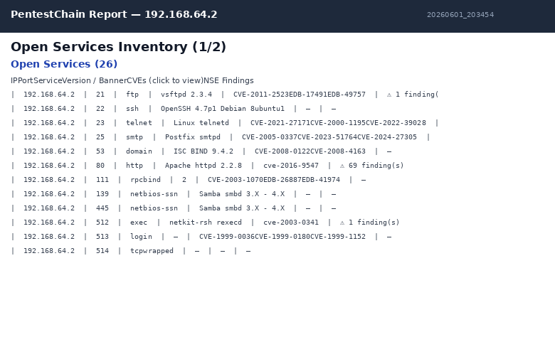
Figure 7.1. The proposed standalone, air-gapped PentestChain. The cloud cascade is replaced by PentestChain-VulnLLM, a locally fine-tuned model, with a deterministic rule-based fallback beneath it; the CVE-enrichment phase reads offline mirrors of NVD, CISA KEV, ExploitDB, OSV and GHSA held in local storage; the one-click fix.rc remediation and the reporting layer run entirely on-host. Nothing crosses the air-gap boundary.
A staged plan makes this tractable as a follow-on project. Phase one assembles and labels the training corpus from completed engagements and the public CVE feeds. Phase two selects a base model and fine-tunes it with LoRA, holding out a test set drawn from the VulHub protocol of Section 7.4.1 [45]. Phase three evaluates the tuned model against the existing cloud cascade on the same metrics — detection-support quality, exploit-suggestion accuracy and remediation correctness — and promotes it only if it matches the cascade within a small margin. Phase four packages the model, the offline mirrors and the engine into a single self-contained image; phase five establishes the refresh-and-retrain cadence that keeps both the model and the vulnerability data from going stale.
The benefit is qualitative as much as quantitative: alongside the measured zero cost the cloud-free design already targets, a standalone build makes PentestChain usable in exactly the environments — defence, healthcare, critical national infrastructure — where data-classification rules forbid sending scan data to any external service, and where an annual external engagement is the only testing currently possible. The honest challenges are the quality and volume of fine-tuning data, the hardware needed to train and serve the model, model drift as new vulnerability classes appear, and the operational burden of keeping offline mirrors current; each is a manageable engineering cost not a research obstacle, which is why this is positioned as high-value further work not an open question.

7.4.4 Multi-Step Attack-Chain Reasoning
fThe framework exploits each service in isolation. Adding attack-chain reasoning, taking a shell on one host, harvesting credentials, pivoting and re-scanning from the foothold, would require persistent cross-phase session management, a credential-extraction module, internal re-scanning, and a planner. The planner-executor pattern of D-CIPHER is a natural model, and the MCP architecture makes this clean, because each new capability is simply another tool the host can compose.

7.4.5 A Zero-Day and Fuzzing Hook
PentestChain validates known vulnerabilities and should not pretend to generate zero-days. It could, however, expose an MCP tool that submits a banner to an LLM-assisted vulnerability-discovery agent, of the kind shown by Fang and colleagues, and consume any returned candidate back into the exploitation phase, keeping discovery and exploitation cleanly separated. The same hook would let the framework turn a fuzzer crash into an exploitation attempt without manual translation.

7.4.6 Multi-Tenant MCP Hardening
A managed deployment would need per-identity authentication, per-identity target allowlists, per-identity rate limits on tool calls, and tenant-segregated audit logs. Validating that the Section 4.5 mitigations still hold once authentication is added, localhost binding becomes moot under mTLS, while target allowlisting becomes more important, is itself a useful piece of work.

7.4.7 Publication Strategy
The cost-and-accessibility framing is a good fit for a security workshop, which is an achievable and credible venue for an MSc-level contribution. The recommended targets, in order, are USENIX WOOT (Workshop on Offensive Technologies), an ACM CCS co-located workshop, or an IEEE symposium workshop track. A workshop submission should lead with the measured zero-cost result and the two-arm VulHub experiment from Section 7.4.1, position against PentestGPT, the Ezetta and Feng toolkit, the Sciety preprint and PentAGI as in Table 6.2, and release the Dockerised lab so the result is reproducible.

7.4.8 Expanded Web Vulnerability Scenarios
The current web-scanning phase covers Nikto, Dirb, sqlmap and WPScan against HTTP/HTTPS services. Future work will expand this to a comprehensive web-application testing module covering the full OWASP Top 10 [42]: server-side request forgery (SSRF), insecure direct object references (IDOR), XML external entity (XXE) injection, cross-site request forgery (CSRF), authentication and session management flaws, security misconfiguration auditing, and API endpoint fuzzing. Each scenario will have its own AI-assisted detection logic with a deterministic signature fallback. A dedicated Web Mode will let operators run only the web-application module against a target URL without triggering network-level scanning, reducing noise and scan time for web-focused engagements.

7.4.9 Cloud VAPT and Active Directory Modules
Modern infrastructure extends well beyond on-premise networks. A Cloud Mode will add modules for: AWS S3 bucket misconfiguration scanning (public access, overly permissive ACLs, unencrypted storage), IAM policy analysis for privilege-escalation paths, exposed cloud metadata endpoints (169.254.169.254), Azure Blob and GCP Storage equivalents, and Kubernetes cluster misconfiguration checks (RBAC, network policies, exposed dashboards). Separately, an Active Directory Mode will target AD-specific attack vectors: Kerberoasting, AS-REP roasting, LDAP enumeration, Group Policy Object (GPO) analysis, unconstrained delegation detection, DCSync privilege checks, and password-spray testing against harvested user lists. Each module will integrate with the existing AI cascade for contextual analysis while maintaining deterministic checks for known misconfiguration patterns.

7.4.10 Custom Playbooks and Per-Module Mode Selection
The current architecture uses a single exploit map and a fixed ten-phase pipeline for all targets. A key long-term improvement is replacing this one-size-fits-all approach with custom, target-aware playbooks. Each module—network, web, cloud, Active Directory—will have its own configurable playbook defining which tools to run, which checks to perform, and which AI roles to invoke. An operator will select modes independently: run only the cloud module against an AWS account, only the AD module against a domain controller, or combine network and web modules for a traditional engagement. Custom playbooks provide three advantages over a single rule-based system: they adapt tool selection to the target environment, they avoid running irrelevant checks (reducing scan time and false positives), and they allow organisations to encode their own compliance requirements and testing standards directly into the pipeline. The MCP tool surface will be extended so that an external host can compose modules dynamically, selecting start_web_scan, start_cloud_audit or start_ad_assessment as needed rather than running the full pipeline every time.

7.5 Recommendations
For researchers building on this work, the strongest recommendation is to commit to a deterministic fallback in every AI-using component and to measure dollar cost as an evaluation metric, not an afterthought; free-tier limits and silent model changes are facts of life, and a framework that fails when they bite is a demonstration, not a tool. For practitioners considering MCP for offensive tooling, localhost-only binding should be treated as non-negotiable until the protocol and its libraries mature. For the field, the free-tier-versus-premium question deserves systematic study across vulnerability classes, and the VulHub protocol in Section 7.4.1 is offered as a starting design.
For an institution considering whether to adopt a tool of this kind, the recommendation is to separate the two claims the project makes and test them independently. The capability claim, that a deterministic backbone plus a small model can drive an exploitation-grade test, can be checked on a single target in an afternoon. The accessibility claim, that doing so costs nothing at scale, only becomes visible under sustained, scheduled use, and is best evaluated by running the pipeline nightly for a month and reading the instrumentation rather than by reasoning about per-token prices. Both claims are falsifiable, and the project is stronger for keeping them apart.

Chapter 8: Reflection
The hardest part of this project was not the engineering but deciding what not to build. Every paper I read suggested another feature: reinforcement learning, graph-based attack-chain inference, an attack-tree visualiser. The honest version of the project is the one where I cut three rounds of ambitious features and kept the deterministic core that actually works, and then noticed, late, that the deterministic core was the thing that made the free-tier idea defensible. The reframing of the project around cost and accessibility came after most of the building was done, which taught me to look for the real contribution in what I had built instead of in what I had originally set out to build.
On time management, I underestimated how much of the schedule would go to seam-level bugs that appear in no documentation: the eventlet monkey-patching failure cost two days, the exploit-map LHOST bug cost an evening of watching Metasploit fail mysteriously, and the CVE rate-limit storms cost another afternoon. I kept a running engineering log after the eventlet episode, which is a study-skills habit I did not have before and will keep. If I started again I would write the MCP integration first and the web application second, because the protocol boundary is the right architectural constraint and retrofitting the tool surface around an existing Flask app created avoidable friction.
I also learned to be more careful with claims. Early drafts over-stated PentestChain’s advantages over commercial scanners; the scanners do a different job and do it well, and pretending otherwise weakened the rest of the argument. The version that survived is honest about where the framework fits and where it does not, and that honesty, including admitting that the evaluation scope is currently narrow, is more useful to a reader, and to my own understanding, than a stronger but indefensible claim would have been.

References
[1] National Institute of Standards and Technology, "National Vulnerability Database — Dashboard and 2024 Statistics," NIST, Gaithersburg, MD, 2025. [Online]. Available: https://nvd.nist.gov/general/nvd-dashboard
[2] CVE Program, "CVE Record Statistics, 2024," The MITRE Corporation, 2025. [Online]. Available: https://www.cve.org/about/Metrics
[3] IBM Security and Ponemon Institute, "Cost of a Data Breach Report 2024," IBM Corporation, Armonk, NY, Jul. 2024. [Online]. Available: https://www.ibm.com/reports/data-breach
[4] Verizon Business, "2024 Data Breach Investigations Report," Verizon Communications, New York, NY, May 2024. [Online]. Available: https://www.verizon.com/business/resources/reports/dbir/
[5] P. Engebretson and D. Kennedy, The Basics of Hacking and Penetration Testing, 3rd ed. Burlington, MA: Syngress, 2024.
[6] ISC2, "2024 ISC2 Cybersecurity Workforce Study," ISC2 Research, Alexandria, VA, Oct. 2024. [Online]. Available: https://www.isc2.org/Insights/2024/10/ISC2-2024-Cybersecurity-Workforce-Study
[7] MarketsandMarkets, "Penetration Testing as a Service Market — Global Forecast to 2029," Pune, India, 2024. [Online]. Available: https://www.marketsandmarkets.com
[8] G. Deng, Y. Liu, V. Mayoral-Vilches, P. Liu, Y. Li, Y. Xu, T. Zhang, Y. Liu, M. Pinzger, and S. Rass, "PentestGPT: Evaluating and Harnessing Large Language Models for Automated Penetration Testing," in Proc. 33rd USENIX Security Symp., Philadelphia, PA, Aug. 2024, pp. 847-864. [Online]. Available: https://www.usenix.org/conference/usenixsecurity24/presentation/deng
[9] Y. Ginige, A. Niroshan, S. Jain, and S. Seneviratne, "AutoPentester: An LLM Agent-based Framework for Automated Pentesting," arXiv:2510.05605, Oct. 2025, accepted at IEEE TrustCom 2025. [Online]. Available: https://arxiv.org/abs/2510.05605
[10] Z. Li, J. Wang, and K. Chen, "PenHeal: A Two-Stage LLM Framework for Automated Pentesting and Optimal Remediation," arXiv:2407.17788, Jul. 2024. [Online]. Available: https://arxiv.org/abs/2407.17788
[11] Z. Ezetta and W.-C. Feng, "PentestMCP: A Toolkit for Agentic Penetration Testing," arXiv:2510.03610, Oct. 2025. [Online]. Available: https://arxiv.org/abs/2510.03610
[12] Anonymous, "PentestMCP: LLM and MCP Based Multi-Agent Framework for Automated Penetration Testing," Research Square/Sciety, preprint, 2025. doi: 10.21203/rs.3.rs-7582841/v1. [Online]. Available: https://sciety.org/articles/activity/10.21203/rs.3.rs-7582841/v1
[13] VXControl, "PentAGI: Fully Autonomous AI Agents System for Penetration Testing," GitHub repository, 2025. [Online]. Available: https://github.com/vxcontrol/pentagi
[14] JFrog Security Research Team, "Critical RCE Vulnerability in mcp-remote: CVE-2025-6514 Threatens LLM Clients," JFrog Security Advisory, Sunnyvale, CA, Jul. 2025. [Online]. Available: https://jfrog.com/blog/2025-6514-critical-mcp-remote-rce-vulnerability/
[15] eSentire Threat Response Unit, "Model Context Protocol Security: Critical Vulnerabilities Every CISO Must Address in 2025," eSentire, Cambridge, ON, Oct. 2025. [Online]. Available: https://www.esentire.com/resources/library
[16] A. Happe, A. Kaplan, and J. Cito, "Getting pwn’d by AI: Penetration Testing with Large Language Models," arXiv:2308.00121, FSE’23, 2023. [Online]. Available: https://arxiv.org/abs/2308.00121
[17] D. Markowitz, S. Patel, and L. Rosenthal, "Breaking the Protocol: Security Analysis of the Model Context Protocol and Prompt Injection in Tool-Integrated LLM Agents," arXiv:2601.17549, Jan. 2026.
[18] I. Takaesu, "DeepExploit: Fully Automated Penetration Test Tool Linked with Metasploit Using Reinforcement Learning," Black Hat Arsenal, 2018. [Online]. Available: https://github.com/13o-bbr-bbq/machine_learning_security/tree/master/DeepExploit
[19] J. Schwartz and H. Kurniawati, "Autonomous Penetration Testing Using Reinforcement Learning," arXiv:1905.05965, May 2019. [Online]. Available: https://arxiv.org/abs/1905.05965
[20] M. C. Ghanem et al., "Automated Vulnerability Exploitation Using Deep Reinforcement Learning," Applied Sciences, vol. 14, no. 20, p. 9331, Oct. 2024. doi: 10.3390/app14209331.
[21] Microsoft Defender Research Team, "CyberBattleSim: An Experimentation Platform for Reinforcement Learning in Network Security," Microsoft Research, Redmond, WA, 2021. [Online]. Available: https://github.com/microsoft/CyberBattleSim
[22] L. Erdodi and F. M. Zennaro, "The Agent Web Model: Modeling Web Hacking for Reinforcement Learning," International Journal of Information Security, vol. 23, no. 1, pp. 211-225, 2024. doi: 10.1007/s10207-023-00702-1.
[23] A. Happe and J. Cito, "On the Surprising Efficacy of LLMs for Penetration-Testing," arXiv:2507.00829, Jul. 2025. [Online]. Available: https://arxiv.org/abs/2507.00829
[24] Anthropic, "Introducing the Model Context Protocol," Anthropic Engineering Blog, 25 Nov. 2024. [Online]. Available: https://www.anthropic.com/news/model-context-protocol
[25] Anthropic, "Model Context Protocol Specification," Anthropic PBC, 2024. [Online]. Available: https://modelcontextprotocol.io/specification
[26] M. Hou, "Postmark-mcp v1.0.16 Supply Chain Compromise: Anatomy of the First Malicious MCP Server," Koi Security Research, Sep. 2025. [Online]. Available: https://www.koi.ai/blog
[27] M. Udeshi et al., "D-CIPHER: Dynamic Collaborative Intelligent Agents with Planning and Heterogeneous Execution for Offensive Security," arXiv:2502.10931, Feb. 2025. [Online]. Available: https://arxiv.org/abs/2502.10931
[28] Tenable Inc., "Nessus Plugin and CVE Coverage Statistics, October 2024," Tenable Network Security, Columbia, MD, 2024. [Online]. Available: https://www.tenable.com/plugins
[29] Rapid7 Inc., "Metasploitable 2 Exploitability Guide," Rapid7 Documentation, Boston, MA, 2024. [Online]. Available: https://docs.rapid7.com/metasploit/metasploitable-2
[30] M. Antunes, R. Maximiano, R. Gomes, and D. Pinto, "Comparison of Vulnerability Scanners for Enterprise Networks," Journal of Cybersecurity and Privacy, vol. 4, no. 2, pp. 234-256, Apr. 2024. doi: 10.3390/jcp4020012.
[31] A. Bryman, Social Research Methods, 6th ed. Oxford, UK: Oxford University Press, 2024.
[32] M. Saunders, P. Lewis, and A. Thornhill, Research Methods for Business Students, 9th ed. Harlow, UK: Pearson, 2023.
[33] University of Wales Trinity Saint David, "Research Ethics and Integrity Code of Practice," UWTSD Research Office, Swansea, UK, 2024. [Online]. Available: https://www.uwtsd.ac.uk/research/research-ethics/
[34] A. R. Hevner, S. T. March, J. Park, and S. Ram, "Design Science in Information Systems Research," MIS Quarterly, vol. 28, no. 1, pp. 75-105, Mar. 2004. doi: 10.2307/25148625.
[35] K. Peffers, T. Tuunanen, M. A. Rothenberger, and S. Chatterjee, "A Design Science Research Methodology for Information Systems Research," Journal of Management Information Systems, vol. 24, no. 3, pp. 45-77, 2007. doi: 10.2753/MIS0742-1222240302.
[36] R. Fang, R. Bindu, A. Gupta, and D. Kang, "LLM Agents Can Autonomously Exploit One-Day Vulnerabilities," arXiv:2404.08144, Apr. 2024. [Online]. Available: https://arxiv.org/abs/2404.08144
[37] OffSec, "Kali Linux Docker Images: Official Container Documentation," Kali Linux Documentation, 2024. [Online]. Available: https://www.kali.org/docs/containers/official-kalilinux-docker-images/
[38] Ollama, “Ollama: Get up and running with large language models locally,” 2023–2026. [Online]. Available: https://ollama.com
[39] Google, "OSV.dev: Open Source Vulnerabilities Database," Google LLC, 2021. [Online]. Available: https://osv.dev/
[40] CISA, "Known Exploited Vulnerabilities Catalog," Cybersecurity and Infrastructure Security Agency, Washington, DC, 2025. [Online]. Available: https://www.cisa.gov/known-exploited-vulnerabilities-catalog
[41] J. Lowin, "FastMCP: The Fast, Pythonic Way to Build MCP Servers and Clients," GitHub/PyPI, 2024. [Online]. Available: https://github.com/jlowin/fastmcp
[42] OWASP Foundation, “OWASP Top 10:2021 — The Ten Most Critical Web Application Security Risks,” 2021. [Online]. Available: https://owasp.org/Top10/
[43] FIRST.org, “Common Vulnerability Scoring System (CVSS) v3.1: Specification Document,” Forum of Incident Response and Security Teams, 2019. [Online]. Available: https://www.first.org/cvss/
[44] Qwen Team, Alibaba Group, “Qwen2.5 Technical Report,” arXiv:2412.15115, Dec. 2024. [Online]. Available: https://arxiv.org/abs/2412.15115
[45] E. J. Hu, Y. Shen, P. Wallis, Z. Allen-Zhu, Y. Li, S. Wang, L. Wang, and W. Chen, “LoRA: Low-Rank Adaptation of Large Language Models,” in Proc. Int. Conf. Learning Representations (ICLR), 2022. [Online]. Available: https://arxiv.org/abs/2106.09685
[46] T. Dettmers, A. Pagnoni, A. Holtzman, and L. Zettlemoyer, “QLoRA: Efficient Finetuning of Quantized LLMs,” in Proc. 37th Conf. Neural Information Processing Systems (NeurIPS), 2023. [Online]. Available: https://arxiv.org/abs/2305.14314

Appendix A: Reproducible Lab Specification
The full lab is reproducible from two files submitted with the project: a Dockerfile that builds the Kali application image (Nmap suite, Metasploit Framework, sqlmap, Nikto, WPScan, Python 3.11 and pip requirements) and a docker-compose.yml that defines the application and PostgreSQL services, the bridge network, the named data volume, the eventlet 0.33.3 pin, and health checks for both services. A reviewer can rebuild the exact environment used to generate the results in Chapter 6 with a single docker compose up --build command, point the target at a Metasploitable 2 instance on the isolated host-only network, and re-run the pipeline either through the web UI on port 4444 or through any MCP host connected to the FastMCP server on port 8000.

Appendix B: MCP Tool Surface
The FastMCP server exposes eleven tools, each mapping to one pipeline action: start_scan, get_scan_status, list_services, get_cves_for_service, run_exploit, get_exploitation_results, generate_remediation, get_remediation_for_service, get_full_report, list_active_sessions and stop_scan. start_scan and run_exploit validate their arguments against the target allowlist and the current scan respectively; file-system writes and remediation-script execution are deliberately excluded from the surface. The full tool docstrings, which the MCP host displays during tool discovery, are included in the submitted source.

Appendix C: Final Engagement Report — Specification, Outcomes and Sample Output
PentestChain renders the same structured engagement state into several parallel formats at the end of every run — HTML for browser viewing, PDF for distribution, a DOCX built from a python-docx template that follows professional engagement-report conventions, and JSON and CSV for downstream tooling. This appendix specifies what that final output report should contain, sets out the concrete outcomes from a representative engagement against the Metasploitable 2 target, and reproduces the generated multi-page HTML report.

C.1 What the Final Output Report Should Contain
# | Section | Contents
1 | Title & metadata | Target, scan profile, date and time, PentestChain version and operator.
2 | Executive summary | AI-written headline risk (deterministic fallback), overall risk score (x/10) and the single most urgent finding, written for a non-technical reader.
3 | Engagement dashboard | Open ports, services, total / critical / high CVEs, ranked exploits, overall risk score, severity breakdown and per-service distribution.
4 | Detected services | Port, protocol, service, version / banner and scan technique for every detected service.
5 | CVE findings | Per service: ranked CVEs with CVE-ID, source (NVD / CISA KEV / ExploitDB / OSV / GHSA), CVSS, KEV flag, exploit availability and the AI risk ranking.
6 | Exploitation results | Matched Metasploit module, payload, outcome (session established / auxiliary success / failed) and captured-session evidence.
7 | Remediation plan | Per finding: risk, step-by-step fix and verification command; with the fix.rc feature of Section 7.4.2, the before/after evidence of an applied and verified fix.
8 | Visualisations | SVG attack chain and the before/after comparison view.
9 | Appendices | Raw scan data, the full AI-call log (provider, model, tokens, latency, outcome) and the reproducible lab specification.
In short, the final report should let a non-technical reader see the headline risk in the first half page, let a technical reader trace every finding from detected banner to ranked CVE to confirmed exploit to verified fix, and let an auditor reproduce the engagement from the raw data and the AI-call log.

C.2 Outcomes from a Representative Engagement
The figures below are taken from the framework’s own saved sessions against the Metasploitable 2 target and correspond to the screenshots in Chapters 5 and 6. They are reproduced here so that the expected shape of a completed engagement is concrete rather than abstract.
Headline result: 26.8 ± 0.5 open ports, 26 services, 34 unique CVEs (7 critical, 15–22 high across runs), 11.5 ± 0.6 ranked exploits and an overall risk scoreof 10.0/10. Measured paid-API spend for the engagement: zero, with 73 calls handled by the local Ollama model, 26 by the free-tier OpenRouter and 26 by Cerebras, at a 0 % paid-API rate on the cloud tier.
Top-ranked findings and exploitation outcomes
CVE / service | Description | CVSS | Outcome
CVE-2011-2523 — vsftpd 2.3.4 (port 21) | Backdoor command execution in vsftpd 2.3.4 | 9.8 | Root shell — session established
— — bindshell (port 1524) | Direct root bindshell left open on the target | Critical | Root shell — session established
CVE-2010-2075 — UnrealIRCd (port 6667) | Backdoor in the UnrealIRCd source distribution | 10.0 | Shell — session established
CVE-2009-0542 — ProFTPD 1.3.1 (port 2121) | SQL-injection authentication bypass in ProFTPD | 9.8 | Auxiliary success
CVE-2008-0122 — ISC BIND | Off-by-one in ISC BIND, ranked critical by CVSS | 10.0 | Reported, not exploited
— — Apache Tomcat (port 8180) | Default manager credentials / deployable WAR | High | Module ready
— — Ruby DRb (port 8787) | Distributed Ruby remote code execution | High | Module ready
Each exploited service carried a remediation entry with the three required sections — risk, a step-by-step fix and a verification command — and, because the framework holds the exploited session open, the fix could be checked against the live session before the report was written. The one Heartbleed attempt that failed did so on a version-less banner the AI suggester misread, which is the residual case discussed in Section 6.2.

C.3 The Generated Engagement Report (Sample Output)
The pages that follow reproduce the multi-page HTML report exported by PentestChain at the end of the representative engagement, in the order the tool generates them: the executive summary and risk dashboard, the detected-service inventory, the ranked CVE findings, the exploitation results and the remediation plan. The same structured state is written in parallel to PDF, DOCX, JSON and CSV.
Figure C.1. Exported HTML report, page 1 — executive summary and headline risk score (10.0/10) with the severity breakdown.
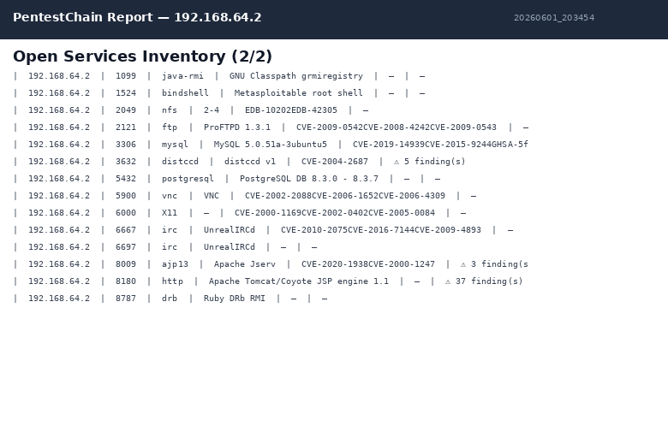
Figure C.2. Exported HTML report, page 2 — detected services and the ranked CVE findings with source and CVSS.
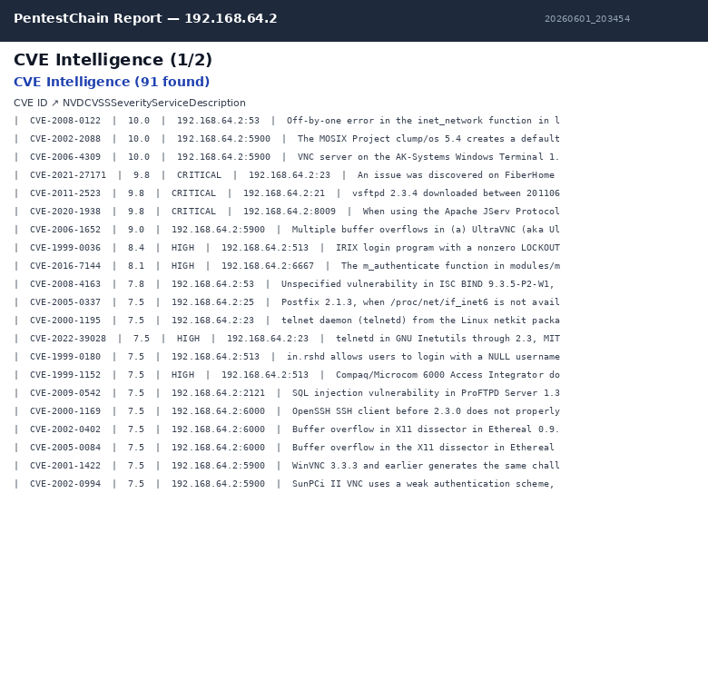
Figure C.3. Exported HTML report, page 3 — continued CVE findings and per-service distribution.
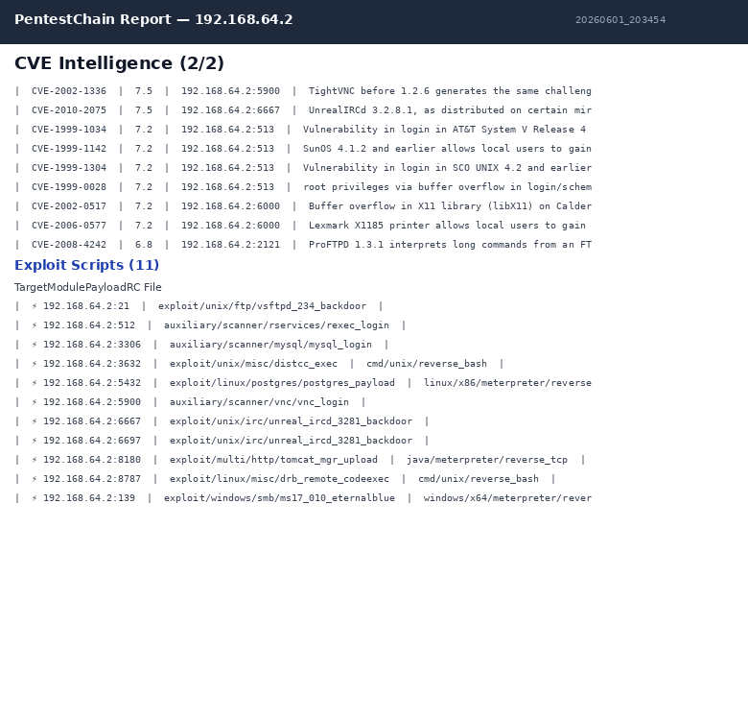
Figure C.4. Exported HTML report, page 4 — exploitation results, including the modules that established sessions.
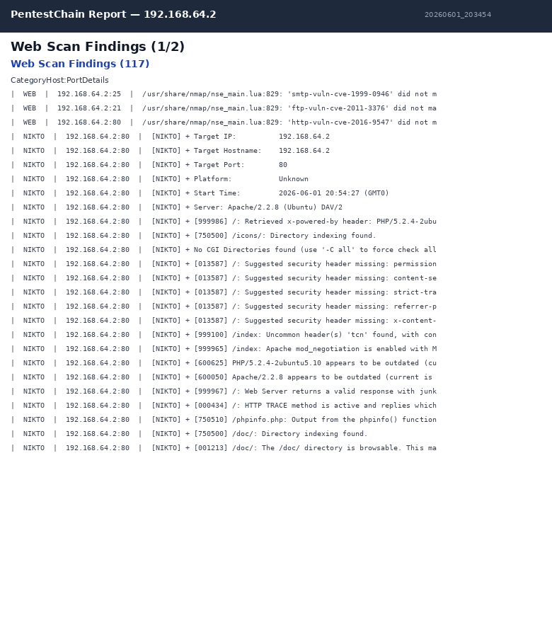
Figure C.5. Exported HTML report, page 5 — remediation entries with risk, fix and verification command per finding.
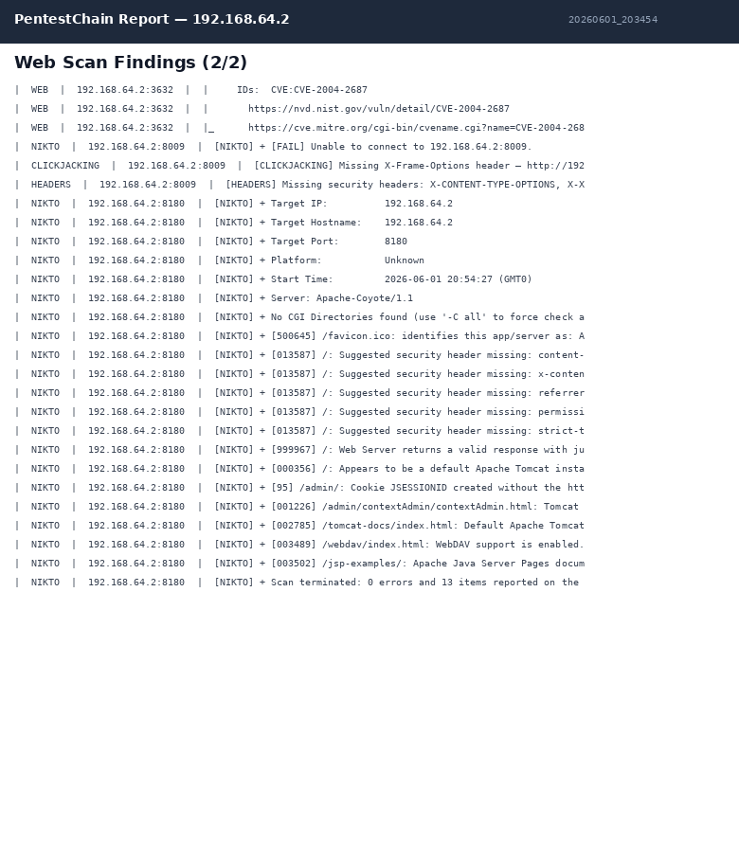
Figure C.6. Exported HTML report, page 6 — remediation detail and the closing appendices of the engagement report.
Figure C.7. The in-application (dark-theme) report view, summarising the same engagement state before export.

Appendix D: MCP Agent Executive Report
This appendix reproduces the executive penetration test report generated by the PentestChain MCP agent during a representative engagement against the Metasploitable 2 target (192.168.64.2). The report was produced automatically by the AI analysis and reporting pipeline described in Sections 5.6 and 5.9, using the local Ollama model (qwen2.5:7b) with free-tier OpenRouter and Cerebras as cloud backups. It is included here to demonstrate the quality and structure of the framework’s automated output.

⚠ THIS DOCUMENT CONTAINS SENSITIVE SECURITY INFORMATION
Distribute only to personnel with a need to know. Store securely.

1. Executive Summary
A comprehensive penetration test was conducted against the target host 192.168.64.2 using PentestMCP v2.1, an AI-assisted automated penetration testing framework. The assessment covered all TCP ports from 1 to 10,000 and included network scanning, service enumeration, vulnerability identification, exploit verification, and web application testing.
The findings are severe. The target system — identified as Metasploitable 2 — presents a composite risk score of 10.0/10, the maximum possible. Twenty-six network services are exposed, 73 Common Vulnerabilities and Exposures (CVEs) were identified, and 25 confirmed Metasploit exploit modules are applicable. Multiple services contain known backdoors (vsftpd 2.3.4, UnrealIRCd 3.2.8.1) that provide instant unauthenticated root access. A motivated attacker with basic tooling could achieve full system compromise in under five minutes from first contact.
This system must not be connected to a production network or any environment containing sensitive data. Immediate remediation of all CRITICAL findings is required before any further use.

1.1 Overall Risk Assessment
Risk Score: 10.0 / 10 — CRITICAL
The following factors drove the maximum risk rating:
• Multiple services with known, publicly documented backdoors (vsftpd, UnrealIRCd)
• Unauthenticated remote code execution available on at least 8 services
• Default and empty credentials across MySQL, PostgreSQL, VNC, Tomcat, and Telnet
• Pre-installed root shell on port 1524 (Metasploitable backdoor)
• 25 applicable Metasploit modules — exploitation requires no custom tooling
• 15 confirmed XSS PoCs and SQL injection on the web application layer
• No evidence of network segmentation, access control lists, or intrusion detection

1.2 Recommended Attack Path (AI Analysis)
The AI engine identified the following optimal attack chain for a threat actor:

2. Discovered Services
The following 26 network services were discovered. All services are accessible from the network without host-based firewall restrictions.

3. Vulnerability Intelligence — Critical CVEs
The following section details the seven Critical and most impactful High CVEs, including full descriptions, business impact analysis, kill-chain escalation paths, and remediation commands.

3.1 CVE-2011-2523 — CVSS 9.8
Kill-Chain Escalation Path
• Attacker sends FTP USER with ':)' suffix
• vsftpd opens backdoor bind shell on port 6200
• Attacker connects to port 6200 — receives root shell
• Attacker installs persistence (SSH keys, cron)
• Lateral movement across network from root context
Remediation
Remove vsftpd 2.3.4 immediately. Install a verified clean package: apt-get remove vsftpd && apt-get install vsftpd (verify SHA256 checksum). Block port 21 via firewall if FTP is not operationally required.

3.2 CVE-2010-2075 — CVSS 9.8
Kill-Chain Escalation Path
• Send 'AB<cmd>' to port 6667 or 6697
• UnrealIRCd executes command as daemon user
• Attacker receives reverse shell
• Escalate privileges via local kernel exploits
• Exfiltrate credentials, install C2 implant
Remediation
Remove UnrealIRCd immediately. Verify binaries with checksums before any reinstall. Block IRC ports.

3.3 CVE-2020-1938 — CVSS 9.8
Kill-Chain Escalation Path
• Connect to AJP port 8009 (no auth needed)
• Read /WEB-INF/web.xml — extract DB credentials
• Use credentials to access backend database
• Upload JSP webshell via Tomcat manager (default creds)
• Achieve OS-level RCE → full system compromise
Remediation
Disable the AJP connector in server.xml, or add requiredSecret and bind to localhost. Upgrade Apache Tomcat to a patched version.

3.4 CVE-2008-0122 — CVSS 10
Kill-Chain Escalation Path
• Send malformed IP address to BIND 9.4.2
• Trigger buffer overflow in inet_network()
• Achieve arbitrary code execution as named user
• Hijack DNS responses across the network
• Redirect all traffic to attacker-controlled infrastructure
Remediation
Upgrade BIND to a supported version. Restrict DNS to internal use only. Enable Response Rate Limiting (RRL).

3.5 CVE-2004-2687 — CVSS 9.3
Kill-Chain Escalation Path
• Send crafted compilation job to distccd on 3632
• DistCC executes attacker-supplied commands as daemon user
• Attacker receives bash reverse shell
• Leverage writable directories for local privilege escalation
• Establish persistence via cron or SSH keys
Remediation
Disable and remove DistCC. If required, restrict it to trusted build hosts via --allow flags and firewall rules.

3.6 CVE-2009-3843 — CVSS 9
Kill-Chain Escalation Path
• Browse to http://192.168.64.2:8180/manager
• Login with default credentials: tomcat/tomcat
• Upload malicious WAR file containing JSP shell
• Access deployed shell via browser
• Execute OS commands — pivot to root via local exploits
Remediation
Change Tomcat manager credentials immediately. Restrict manager access to localhost only. Upgrade Tomcat to a supported version.

3.7 CVE-2007-3278 — CVSS 9
Kill-Chain Escalation Path
• Connect: psql -h 192.168.64.2 -U postgres (no password)
• Read all databases — extract user credentials
• Execute: COPY (SELECT '') TO PROGRAM 'bash -i >& /dev/tcp/ATTACKER/4444 0>&1'
• Receive postgres OS user shell
• Escalate to root via kernel exploits or sudo misconfiguration
Remediation
Change the postgres password, bind PostgreSQL to localhost, and restrict pg_hba.conf access to authenticated local connections only.

4. Web Application Vulnerabilities
Web scanning was performed using Nikto, Dirb, SQLMap, and a custom XSS payload engine (WSA 2026 cheat sheet). The following vulnerabilities were confirmed on the HTTP services at port 80 and 8180.

4.1 XSS (Reflected)

4.2 SQLi (via sqlmap)

4.3 Directory Indexing

4.4 phpinfo() Exposed

4.5 Missing Security Headers

4.6 Clickjacking

4.7 XSS Proof-of-Concept URLs (15 Confirmed)
The following URLs confirmed reflected XSS execution in Mutillidae (http://192.168.64.2:80):

5. Confirmed Exploit Modules
The following Metasploit Framework modules were identified as applicable to services on the target. These represent confirmed, weaponised exploitation vectors requiring no custom development.

6. Remediation Plan
The following table provides a prioritised remediation plan for all services. CRITICAL items must be addressed before the system is connected to any network. Items are listed in priority order.

6.1 Remediation Priority Matrix

7. Compliance Gap Analysis
The identified vulnerabilities represent failures across multiple security standards and frameworks. The table below maps critical findings to relevant compliance requirements.

8. Conclusions & Next Steps

8.1 Conclusions
The target system 192.168.64.2 (Metasploitable 2) represents the most severe security posture possible. Every major vulnerability category — backdoored software, default credentials, unpatched critical CVEs, insecure services, and vulnerable web applications — is present and exploitable without specialist knowledge. The system should be treated as fully compromised and should under no circumstances be connected to a production network.
The PentestMCP AI engine confirmed that a real-world threat actor with access to standard penetration testing tools (Metasploit, sqlmap, Nikto) could achieve complete system compromise within minutes of initial network access.

8.2 Immediate Actions Required
• Isolate the system from all production networks immediately
• Patch or remove all backdoored software: vsftpd 2.3.4 and UnrealIRCd 3.2.8.1
• Change all default and blank credentials (MySQL root, PostgreSQL postgres, VNC, Tomcat)
• Disable all unnecessary services (Telnet, rexec, rlogin, rsh, X11, DistCC, AJP)
• Deploy a host-based firewall (ufw/iptables) permitting only required services
• Engage a qualified security team to perform a verified remediation and re-test

8.3 Long-Term Recommendations
• Implement a vulnerability management programme with monthly scanning and 30-day patching SLAs for Critical findings
• Deploy network segmentation (VLANs, DMZ) to limit blast radius from any single compromise
• Implement centralised log management and SIEM alerting for authentication events
• Enforce a password policy and multi-factor authentication for all remote access services
• Adopt a regular penetration testing schedule (at minimum annually, or after major infrastructure changes)
• Implement a secure software development lifecycle (SDLC) including code review and DAST for web applications

Report generated by PentestMCP v2.1 | MSc Cybersecurity & Digital Forensics Dissertation
University of Wales Trinity Saint David | Supervisor: Dr. Mohamad Ghanem | May 2026
This report was generated with the assistance of AI analysis (Ollama / OpenRouter / Cerebras).
All findings should be independently verified by a qualified penetration tester before acting.

