What Time Leaves Behind: A Personal Reflection on St Fagans

I woke up earlier than expected on the morning of our visit to St.Fagans due to a fire alarm drill which left me feeling worried about being late but still rather excited about the trip. The morning was rather cold, accompanied by a slight drizzle that eventually gave way to brighter skies later in the day. On the bus, I spent much of the journey reading Camus’ The Plague; as I tend to get slightly travel sick, the distraction was quite welcome. Although it had nothing to do with the museum itself, it was part of how I experienced that morning. Although I enjoyed the trip as a whole, I often found my interest fleeting as I walked between the buildings with two of my classmates, rather than experiencing any sustained sense of curiosity or captivation. My classmates seemed generally more engaged with the museum than I was, which made me increasingly aware of the difference in our experiences and left me looking for something I could personally connect with. Welsh heritage has never been particularly important to me, either as a personal interest or as part of my identity; whilst I could appreciate the museum's purpose, that did not necessarily make its exhibits personally meaningful to me. In retrospect, however, I can recognise that certain aspects of the trip left a greater impression upon me than I had initially appreciated, even if they did not fundamentally change my experience of the day as a whole.

The first building that came to mind upon reflection was the Oakdale Workmen’s institute. I already had a little background knowledge about its history; built in 1917, it provided the local mining community with facilities for education, recreation and social gatherings before its unfortunate closure in 1987 (Museum Wales, 2010; Museum Wales, n.d -b). Walking around the building, I felt a strange surrealism when imagining the number of people who once filled its rooms, which was now practically empty in contrast. Despite not being particularly captivated by the exhibits themselves, I could not help but think about how something that was once part of ordinary community life had, for all intents and purposes, had vanished from the community which it came from. The building had been preserved, yet the day to day activities and relationships that once gave it purpose could not have been preserved in quite the same way. As an addendum, this reminded me of Tuan’s (1977) exploration of how human experiences and emotional attachments can give a place a certain meaning. As someone who comes from a small community, this realisation was particularly poignant after the fact; although the building itself had literally survived, I found myself wondering how much of its original essence could truly remain without the people who once made it what it was through relationships and experiences that had once given it life.
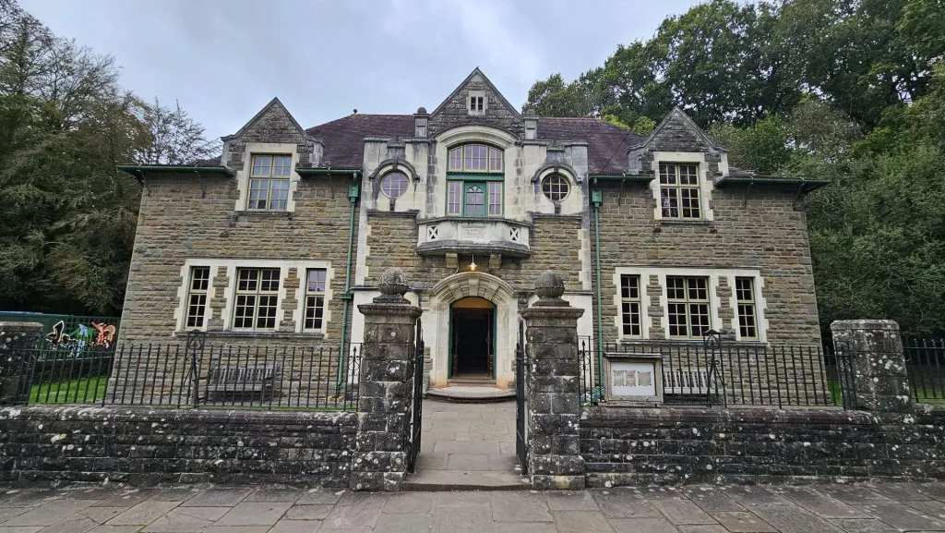
Figure 1: Oakdale Workmen’s institute, St. Fagans National Museum of History. Photograph taken by author (2026)

While walking around the institute I was, however, captivated by one particular object; a typewriter sitting upon a wooden desk. I’ve always had a particular fascination with older technology, partly because of my fondness for literature and fashion. The interesting thing to me was how something that I find charming and fascinating would once have been an entirely mundane piece of office equipment, much like the computers we use today. I also found myself rather curious about the old safe beside the desk and what it once might have contained. Shortly after the field trip and while I was reflecting on the day I stumbled onto Borgmann’s (1984) discussion of technology and how technological advancements change the way we engage with everyday activities. I found myself wondering whether technological advancement necessarily makes the experience of using something more meaningful.
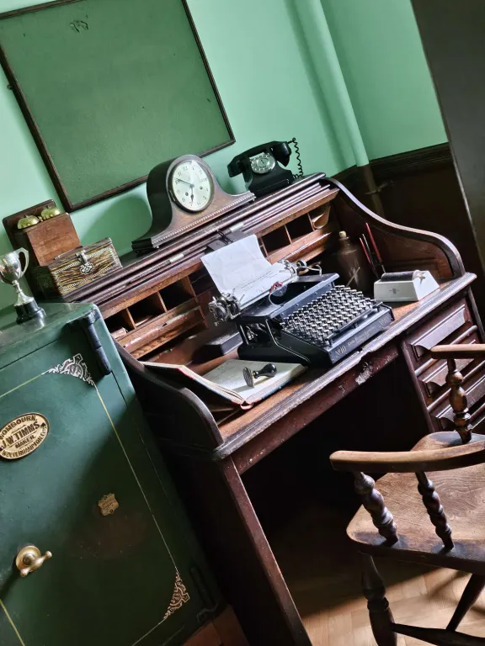
Figure 2: Typewriter and office equipment displayed inside the Oakdale Workmen's Institute, St Fagans National Museum of History. Photograph taken by the author (2026).

The exhibit I found most unsettling during the trip was the remains of two individuals discovered at Llanbedrgoch, an adult man and a young boy who had lived during the tenth century (Museum Wales, n.d -a). The realisation that these had once been people with their own lives, relationships and stories that had it me in a rather existential way. They may have had their own hopes or aspirations, yet everyone once knew them has long since died. The world simply continued without them and much of what made them individuals has been lost to time. I found this particularly unnerving; after all, the same will eventually be true of everyone.

Reflecting on this reminded me of two books I had previously read but never really found a way to put together yet their contrasting approaches to existence ended up being rather fitting here. Kierkegaard's The Sickness Unto Death (2004) and Camus’ The Myth of Sisyphus (2013). Kierkegaard examines despair through the way a person relates to themselves and ultimately God. Conversely, Camus’ examines the possibility that there is no meaning at all. Despite their differing approaches, both got me to consider the significance of individual existence. The most unsettling part however was not necessarily that these individuals’ lives had been meaningless, on the contrary, they may have been profoundly meaningful to those who lived them and yet the world continued regardless.
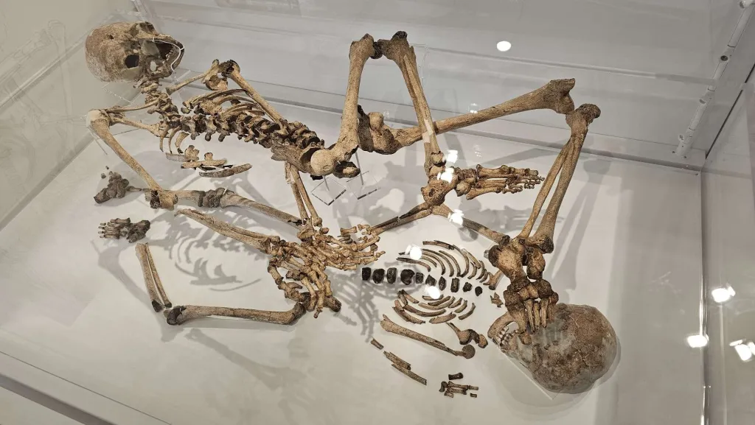
Figure 3: Human remains discovered at Llanbedrgoch, displayed at St Fagans National Museum of History. Photograph taken by the author (2026).

Bibliography
Borgmann, A. (1984) Technology and the Character of Contemporary Life: A Philosophical Inquiry. Chicago: University of Chicago Press.
Kierkegaard, S. (2004) The Sickness Unto Death. Translated by A. Hannay. London: Penguin Classics.
Museum Wales (2010) Laying foundations: Workmen's Institutes. Available at: https://museum.wales/blog/1214/Laying-foundations-Workmens-Institutes/ (Accessed: 20 October 2026).
Museum Wales (n.d.-a) Early Medieval human remains. Available at: https://museum.wales/collections/online/object/1b692349-4779-3d08-b30e-dba0b293e5c9/Early-Medieval-human-remains/ (Accessed: 20 October 2026).
Museum Wales (n.d.-b) Oakdale Workmen's Institute. Available at: https://museum.wales/collections/historic-buildings/25/Oakdale-Workmens-Institute/ (Accessed: 20 October 2026).
Tuan, Y.-F. (1977) Space and Place: The Perspective of Experience. Minneapolis: University of Minnesota Press.

