

Assessment Component 2
Written Essay

Student name: Kabirat Adegbite
Student ID: 2011967

Module name: Community Care and Development
Module code: (BMHP6022)
Lecturer name: Laila Surani

Contents
1. Introduction 3
1.1. Demographic and diversity of a community 3
2. Health and Social care needs within Southwark Community 4
3. Prevalence of Childhood Obesity 4
4. Approaches and initiatives of Childhood Obesity in Southwark. 5
5. Campaigns and initiatives 7
6. Recommendation 8
7. Conclusion 9
8. References 10

Introduction
This report will explore how Childhood Obesity will be addressed in the London Borough of Southwark, as well as how different modes of communication may be utilised to teach communities about how to improve their health and social care needs. Furthermore, this report will look into how various types of communication might be used to teach communities on how to improve their health and social care requirements.

Demographic and diversity of a community

One definition of community is "a group of people who live or work in the same geographic area and have developed close relationships with one another." This definition describes the people who make up a community. In addition to this, it may develop relationships with a variety of communities. It is open to all locals, and those who take part in it have established connections with individuals from both inside and beyond the community in order to strive towards the accomplishment of goals and principles that are held in common (Disciple Team, 2019).
Obesity in children is a medical disorder that is characterised by an abnormally high proportion of body fat in the affected child. This condition is damaging to the child's health and well-being and raises the risk that the child may experience a range of health problems in the future. The likelihood of developing this trait is influenced by both genetic and environmental variables, amongst other things, eating habits, levels of physical exercise, and cultural standards. As a direct consequence of this, childhood obesity has emerged as a major problem impacting not only the physical but also the mental health of people all over the world. There have been many different strategies put into place in order to combat the issue of children obesity. These strategies include initiatives that are centred on schools, treatment that focuses on families, and community-based projects. According to Sahoo et al. (2015), education plays a crucial role during the formative years of childhood in fostering a healthy way of life.
Southwark is a borough in the English metropolis of London, England. Southwark is situated on the south bank of the Thames, directly across from the City of London. Bermondsey, Walworth, Camberwell, Peckham (partially), Nunhead, East Dulwich, Herne Hill (partially), Dulwich, and Sydenham Hill are all covered. In 1965, the urban districts of Bermondsey, Camberwell, and Southwark united to become the Southwark borough. Southwark was formerly part of Surrey (Encyclopaedia Britannica, 2020).
In 2018, the population of Southwark was 317,256, with 54% being white, 27% being Black, Black British African, or Caribbean, 9% being Asian or Asian British, and 9% being Mixed or belonging to multiple ethnic groups. As of the 2021 census, the population of Southwark was 307,700, with 51% being White, 25% being Black, Black British African or Caribbean, 10% Asian or Asian British, and 13% being mixed or belonging to other ethnic groups (Southwark Council, 2023).
In 2021, the most populous religious groups in Southwark are as follows: "others" account for 36.4% of the population, Christians 43.3%, Muslims 9.6%, Buddhists 1.0%, Hindus 1.1%, Jews 0.4%, and Sikhs 0.2% (ONS, 2023).

Health and Social care needs within Southwark Community
In Southwark, there are many different health, social, and economic indicators, including child poverty, obesity, hospital admissions, and life expectancy, with the centre and northern boroughs seeing worse outcomes. Different issues are faced by many communities. Particularly those in Faraday and Peckham, where socioeconomic deprivation is at its highest while Dulwich Village has the lowest level. The possibility of poverty in privileged neighbourhoods must be recognised. The Downtown area in Surrey Docks and the Kingswood neighbourhood in Dulwich Wood are two examples of such communities (Southwark, 2023).

Prevalence of Childhood Obesity
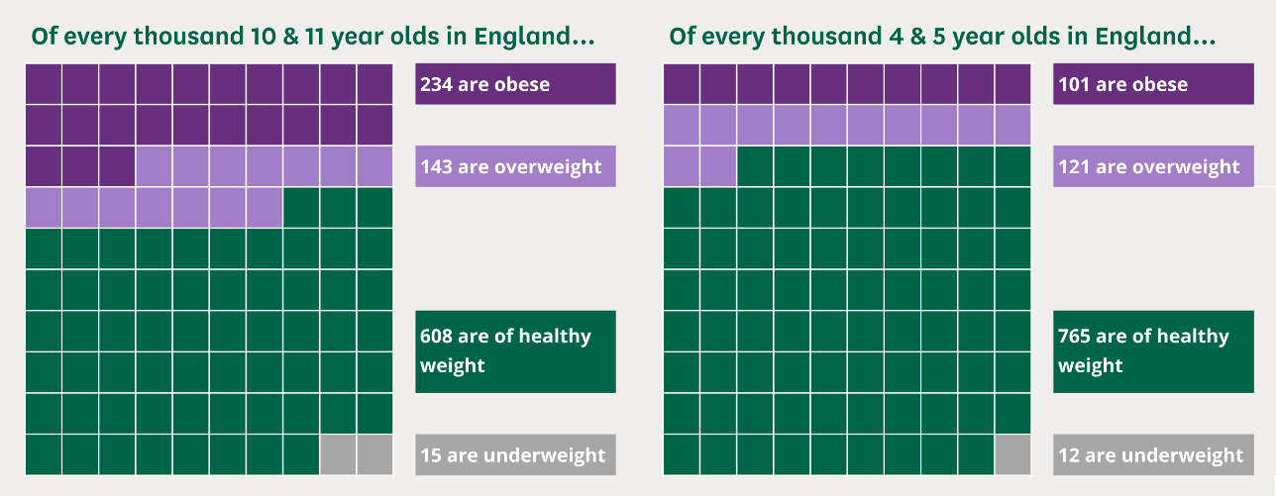
Sources: (House of Commons Library)
During the period extending from 2021 to 2022, it was seen that 10.1% of children at the age of reception in England were classified as obese, while 12.1% were categorised as overweight within the age range of 4 to 5 years. Furthermore, it was found that 14.3% of children in year 6 were overweight, whilst 23.4% of children aged 10 to 11 were identified as obese. Research findings indicate that boys have a greater possibility for obesity across all age groups, with the differences being less than 1% for children in reception but rising to 6% among children in year 6 (Baker, 2022).

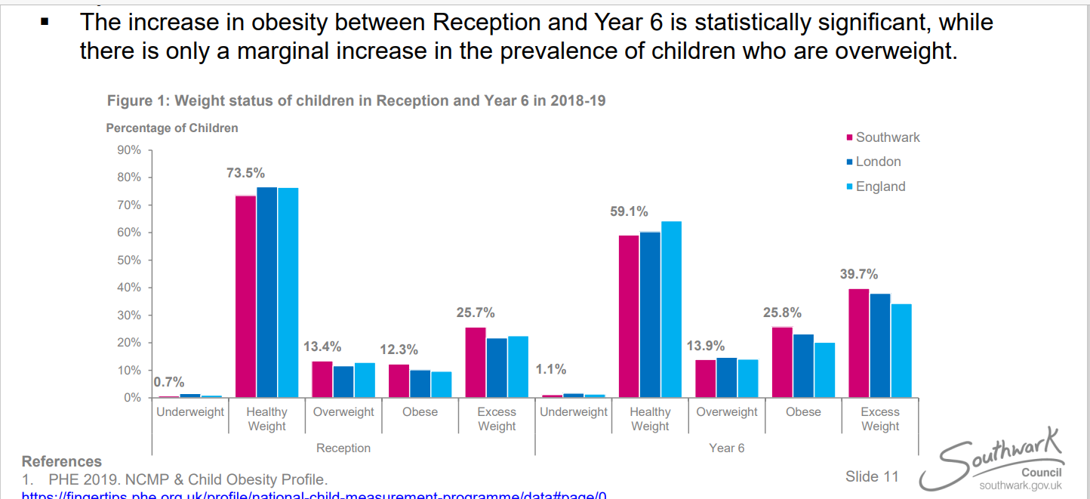
Sources: (Southwark council)
Obesity and overweight rates in Southwark are higher than in London and England generally among children aged 4 to 5 years old in reception and 10 to 11 years old in year 6. By the sixth grade, more than one in every three children is overweight or obese, whereas in reception, the proportion is one in every four. Between Reception and Year 6, there is a statistically significant increase in the number of children who are overweight, but only a slight increase in the proportion of children who are overweight (William and Steele, 2020a).
In both the Reception and Year 6 groups, the rate of obesity is greatest among children who identify as being from black or black British ethnic groups. Both in Reception and Year 6, children from black ethnic groups in Southwark had a much greater prevalence of obesity compared to children from black ethnic groups in London and England. his is the situation for black ethnic minority children in Southwark (William and Steele, 2020b).

Approaches and initiatives of Childhood Obesity in Southwark.
Active Southwark Sport and physical activity strategy 2019 to 2023 is one of the many ways and initiatives that Southwark has implemented to encourage a healthy lifestyle among the children of the community. These methods and programmes focus on encouraging children to participate in sports and other forms of physical activity. The programme advises parents on how to encourage their children to participate in exercise, whether through unstructured or structured active play, and works to reduce the prevalence of overweight and obese children through the promotion of increased levels of physical activity (Southwark Council, n.d.).
Alive ‘N’ Kicking programme is a free 12-week programme that GP, school nurses, dieticians and so on refer families with children between the age 4 and 17 years old . The programmes encourage children to try new things, make friends and aims to get them and their families to be more active by teaching them about exercise, nutrition, and lifestyle (Southwark Council, 2023b). The programme is mainly for residents of Southwark and children also attend schools within Southwark, it will allow families to make life long healthy lifestyle choices (Everyone Health, n.d.).
A tax was placed on the soft drink industry in the United Kingdom in 2016, as part of the government's campaign titled "Childhood Obesity: A Plan for Action," with the goal of lowering the current gap in the rate of childhood obesity in England within ten years. A campaign that is aimed at preventing obesity is being funded using the money obtained from the levy. The goal of this programme is to get children of school age to engage in more physical activity and to eat healthier diets. Making school food healthier is a further aspect of the strategy. This will enable all schools to enhance the overall quality of their meals by complying to the sugar and nutrition guidelines that have been established. A healthy start scheme was made available to families, and over the period of 2015 and 2016, this initiative distributed vouchers for a total of £60 million to families in England with low incomes. Using the voucher, families are able to purchase fresh fruits, vegetables, and milk, and they also receive free vitamins to help them during pregnancy and the early years of their children's lives (HM Government, 2016).

Campaigns and initiatives

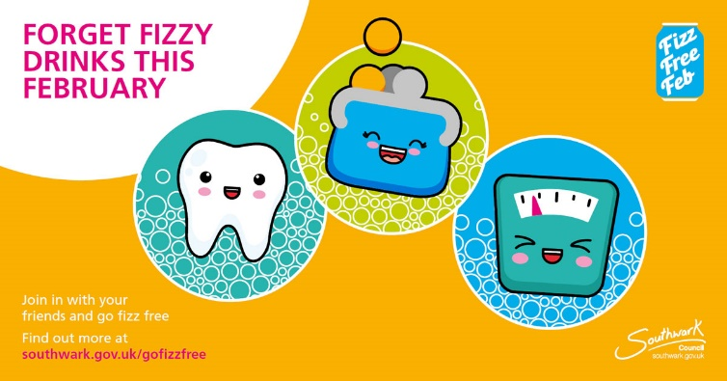
Sources: (Sugar Smart UK, 2019b)
Southwark Council launched a campaign in 2018 to reduce the prevalence of childhood obesity called “Fizz Free February” , joining other local authorities from across England in identifying hidden sugars that may contribute to unhealthy eating habits and make it harder for children to maintain a healthy weight while developing. Primary schools all throughout the UK, including those in Southwark, take part in activities called "Fizz Free February" for the whole month of February. The goal of these activities is to teach youngsters about how the food choices they make as they grow older can influence their overall health. The programme has the goal of encouraging youngsters to take on the role of influencers and start changing habits that can lead to better lifestyles beginning in primary school and continuing into early adulthood (Southwark Council, 2020).
The resources used in promoting the Fizz Free February campaign consist of posters, calendar charts for schools, social media with the hashtag of #gofizzfree, website, certificates for children who participate in the campaign and illustrations (Sugar Smart UK, 2019a).

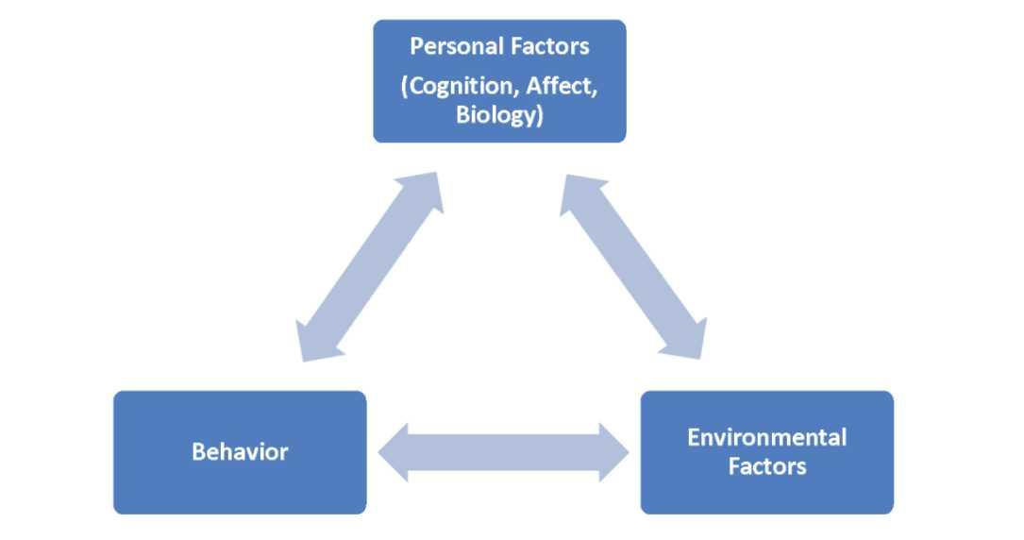
(Sam May-Varas, Margolis and tmead, 2022)
The social cognitive theory focuses on the several kinds of elements that contribute to an individual's experiences, whether those factors be the acts of individuals in the individual's immediate environment or environmental circumstances that impact the choices towards their own health (Rural Health Information Hub, 2018).
During the month of February dedicated to fizz free, social cognitive theory was utilised to address one of the contributing reasons to childhood obesity, particularly the consumption of sugar. Together with their families, the campaign educates children about the negative effects that sugar may have on their bodies and encourages them to choose healthier food choices. Children tendency to consume an abnormally high amount of sugar can be related to the fact that this is the behaviour of the people in their environments, which children see as typical and do not believe to be harmful.

Recommendation
As a result of the fact that children attending schools in Southwark are not eligible for universally free nutritious school meals, there have been proposals made to address childhood obesity by expanding the universally free nutritious school meal programme to include children attending nursery schools. Additionally, schools are urged to improve the overall quality of their meals by following to the dessert policy, which outlines the appropriate quantity of sugar that should be added to desserts served to children. This helps ensure that children have a balanced diet (William and Steele, 2020b) .
To avoid childhood obesity, it is vital to embrace a new way of life, because children's mental condition, the environment in which the child lives, and the child's social life can all contribute to the child's obesity. Regardless whether it is inherited, their way of life must change. Seeking support through therapy can help a child suffering from obesity improve their mental health. This is because factors such as bullying or eating disorders might lead to a child's weight problems. It's likely that the child's bad eating habits are a product of their environment or the community in which they grew up. To reduce the possibility of the child developing bad eating habits, the child's surroundings and eating habits must be adjusted. This might involve eating more veggies instead of traditional meals or junk food, increasing physical activity, drinking more water, and avoiding sweets.

Conclusion
In conclusion, it seems that various attempts are being made to successfully combat childhood obesity, and the council is working to ensure that all of its suggestions are communicated to the entire family of a child who is obese rather than just the child themselves. Efforts are being made to ensure that families have access to nutritious food and opportunities for physical activity in order to combat the problem of childhood obesity. Even while participation in certain of the programmes designed to address childhood obesity is limited, the council is obligated to ensure that such programmes are accessible to anybody who has a need for them so long as they adhere to the requirements.

References
Baker, C. (2022). Obesity Statistics. commonslibrary.parliament.uk. Available at: https://commonslibrary.parliament.uk/research-briefings/sn03336/#:~:text=Childhood%20obesity%20in%20England (Accessed 17 August 2023).
Baker, C. (2023). Obesity statistics. House of Commons Library. Available at: https://commonslibrary.parliament.uk/research-briefings/sn03336/#:~:text=Childhood%20obesity%20in%20England,and%20published%20by%20NHS%20Digital. (Accessed 15 August 2023).
Disciple Team (2019). Step 1.1: What does ‘Community’ really mean? [online] Disciple. Available at: https://www.disciplemedia.com/building-your-community/what-does-community-mean/ (Accessed 16 August 2023).
Encyclopedia Britannica (2020). Southwark | borough, London, United Kingdom | Britannica. In: Encyclopædia Britannica. Available at: https://www.britannica.com/place/Southwark-London (Accessed 13 August 2023).
Everyone Health (n.d.). Alive ‘N’ Kicking. Everyone Health Southwark. Available at: https://southwark.everyonehealth.co.uk/services/child-weight-management/ (Accessed 17 August 2023).
HM Government (2016). Childhood Obesity A Plan for Action. Available at: https://assets.publishing.service.gov.uk/government/uploads/system/uploads/attachment_data/file/546588/Childhood_obesity_2016__2__acc.pdf (Accessed 18 August 2023).
ONS (2023). How Life Has Changed in Southwark: Census 2021. sveltekit-prerender. Available at: https://www.ons.gov.uk/visualisations/censusareachanges/E09000028 (Accessed 17 August 2023).
Rural Health Information Hub (2018). Social Cognitive Theory Model - Rural Health Promotion and Disease Prevention Toolkit. Ruralhealthinfo.org. Available at: https://www.ruralhealthinfo.org/toolkits/health-promotion/2/theories-and-models/social-cognitive (Accessed 19 August. 2023).
Sahoo, K., Sahoo, B., Choudhury, A.K., Sofi, N.Y., Kumar, R. and Bhadoria, A.S. (2015). Childhood obesity: Causes and consequences. Journal of Family Medicine and Primary Care, [online] 4(2), p.187. doi:https://doi.org/10.4103/2249-4863.154628.
Sam May-Varas, E.D., Margolis, J. and tmead (2022). Social Cognitive Theory. openoregon.pressbooks.pub. Available at: https://openoregon.pressbooks.pub/educationallearningtheories3rd/chapter/chapter-3-social-cognitive-theory-2/ (Accessed 19 August 2023).
Southwark (2023). Southwark’s Joint Health and Wellbeing Strategy 2022 -2027 Full Report & Action Plan.
Southwark Council (2020). Fizz Free February 2020 tackles childhood obesity by uncovering hidden sugar in soft drinks. Southwark Council. Available at: https://www.southwark.gov.uk/news/2020/jan/fizz-free-february-2020-tackles-childhood-obesity-by-uncovering-hidden-sugar-in-soft-drinks (Accessed 17 August 2023).
Southwark Council (2022). Southwark’s Joint Health and Wellbeing Strategy 2022 - 2027. Southwark.gov.uk. Available at: file:///C:/Users/2011967/Downloads/Southwark-s-Joint-Health-Wellbeing-Strategy-2022-27%20(1).pdf (Accessed 17 August 2023).
Southwark Council (2023a). Census 2021. Southwark Council. Available at: https://www.southwark.gov.uk/health-and-wellbeing/public-health/health-and-wellbeing-in-southwark-jsna/census-2021?chapter=2 (Accessed 17 August 2023).
Southwark Council (2023b). Healthy Weight. Southwark Council. Available at: https://www.southwark.gov.uk/health-and-wellbeing/health-advice-and-support/healthy-weight?chapter=3 (Accessed 17 August 2023).
Southwark Council (n.d.). Southwark Physical Activity and Sport Strategy 2019 - 2023.
Sugar Smart UK (2019a). Take part in Fizz Free February. [online] www.sugarsmartuk.org. Available at: https://www.sugarsmartuk.org/news/fizz_free_february_2019/ (Accessed 18 August 2023).
Sugar Smart UK (2019b). Take part in Fizz Free February. www.sugarsmartuk.org. Available at: https://www.sugarsmartuk.org/news/fizz_free_february_2019/ (Accessed 17 August 2023).
William, C. and Steele, R. (2020a). Childhood Obesity in Southwark Southwark’s Joint Strategic Needs Assessment.
William, C. and Steele, R. (2020b). Childhood Obesity in Southwark Southwark’s Joint Strategic Needs Assessment.
Williamson, C. and Steele, R. (2020). Childhood obesity in Southwark Southwark’s Joint Strategic Needs Assessment.

