Big Data Storage and Processing

Ren Li
School of Applied Computing
University of Wales Trinity Saint David
Swansea, Wales

Abstract— Network and data centre design is an important task for university providing high speed, stable and secure IP service. In this paper, the author designed the network and data centre architecture and conducted test for them. And from the perspective of future growth of university, big data storage and processing technology were researched and discussed. Finally, the author suggested the corresponding improvements for UWTSD’s future IT service.
Keywords-network; data centre; big data storage; big data processing

Introduction
Nowadays Internet has become an important way for people and plays an important role in every aspect of our life, especially for education field. A high speed and high available network and a stable data centre are the essential and significant infrastructures for a university. In this paper, the author designed an enterprise and data centre for University of Wales Trinity St David (UWTSD) campuses and implemented them using Cisco Packet Tracer software. Then based on the future development of the university, the author conducted the research of big data storage and processing technology and proposed how to support the future growth of university.
In the next section, the author will describe the network design process, including network architecture, IP addressing and subnetting, technology used, etc. In section 3, the implementation and running results of network will be discussed. Section 4 is the literature review of big data and its storage and processing technology. In section 5, based on the network implemented in section 3 and big data technology researched, the author suggested improvements of IT service for the future growth of university.

Network Design

Design Principles
For UWTSD, there are five campuses need to be connected. Swansea, Carmarthen, Lampeter and London are four campuses located in UK while Malaysia campus is in Southeast Asia. The campuses are far away from each other, especially between UK campuses and Malaysia campus, so the distance should be an important factor to be considered when determining the technology connecting them.
For Swansea campus, because it is main campus, the kernel server farm and critical e-resources should be placed here. And other campuses should be able to access these resources conveniently and securely.

Network architecture of Swansea campus

For Swansea campus, a spine and leaf hierarchical network model is employed, where each leaf switch acts as the access layer and connects to all the spine switches. In spine layer two core switches are used redundantly to prevent one single failure.

IP addressing & subnetting
For Swansea campus, there are five network segments and subnet masks of them are 255.255.255.0. Around 1250 private IP addresses can be allocated to devices altogether. For other campuses, because of not main campus, the devices will be less. So each campus has two network segments, and subnet masks are also 255.255.255.0. Around 500 devices can be allocated IP address.
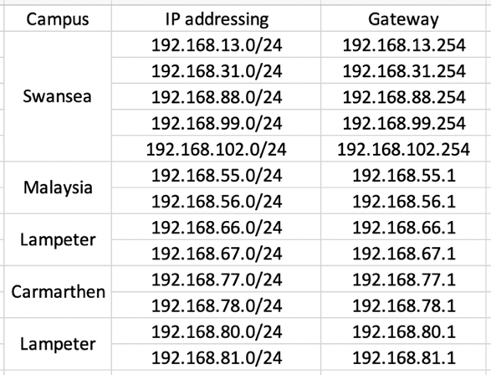
- IP addressing & subnetting

Frame-Relay Technology
Frame Relay is a kind of WAN technology which utilize packet switching method to transmit data among multiple local area networks over wide area networks. And it also specifies the physical and data link layers of digital telecommunication channels [1]. And Frame-Relay has strong scalability. When data transmission volume increases, there is no need to change the bandwidth of line. And within a certain range, the frame relay can automatically adjust the required bandwidth according to the actual traffic. Moreover, Frame Relay has no bandwidth control, higher utilization, low cost and high efficiency characteristics, which is an economical data transmission technology for university having distributed campuses. In this paper, the author employed Frame-Relay technology to transmit data among UK campuses.

IPSec VPN Technology
VPN is used to provide remote access and create end-to-end private network connection via third-party networks. And Internet Protocol Security VPN is a secure network protocol suite where data transmitted over Internet will be authenticated and encrypted [2]. In this paper, IPSec VPN is used to build VPN tunnel between Malaysia campus and UK campuses and encrypt the data flow between them, so these campuses will be connected securely, though the data is sent over Internet.

NAT Technology
Network address translation (NAT) is a method that remaps one IP address to another. It is mainly used to alleviate the consumption of IPv4 address [3]. In this paper, the author remaps servers’ local IP address to a specific public IP address so Internet PC can access the web server and FTP server which are located in LAN.

Network Implementation and Test

Network Overview

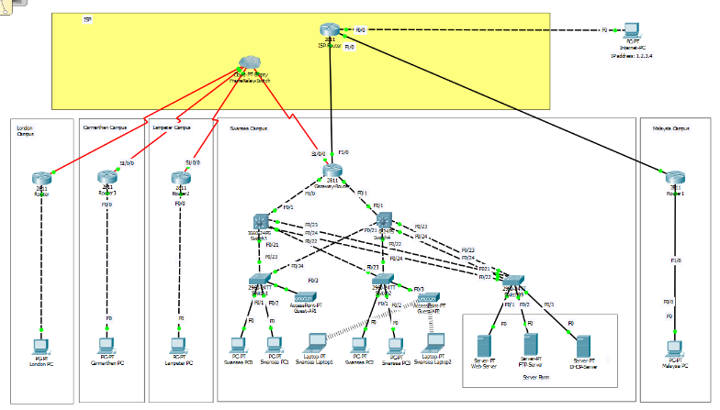
- Network Overview
The network design is fully implemented using Cisco Packet Tracer. And for simplicity, there are only a part of PCs implemented in Cisco Packet Tracer and in actual there will be more PCs connected.

Frame-Relay Implementation
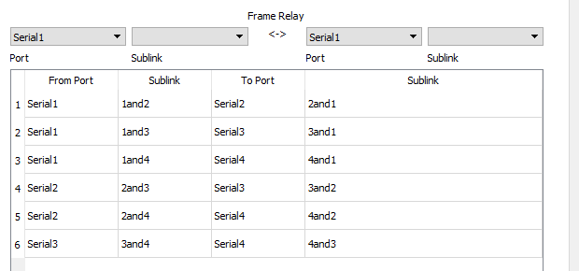
- Frame-Relay configuration
There are 3 DLCIs (Data Link Connection Identifiers) assigned for each router, and the IP addresses assigned to interfaces are from 172.18.0.1 to 172.18.0.4.

IPSec VPN Implementation
IPsec VPN is setup between Swansea campus router and Malaysia campus router, and because the other UK campuses transmit data to Malaysia campus through Swansea campus so it will also be encrypted. After three data transmissions, the IPSec status of Swansea router is below:
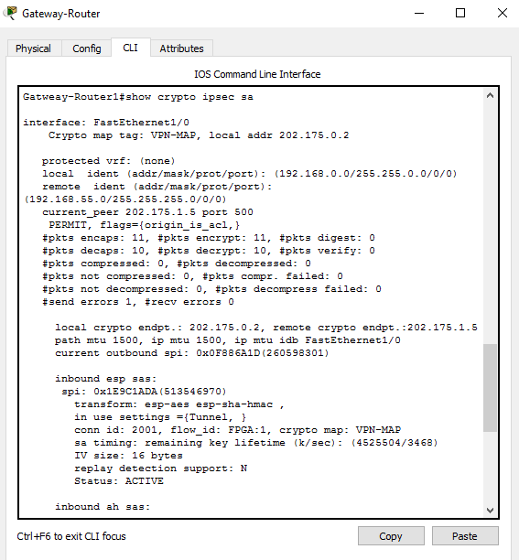
- IPSec status

NAT Translation Implementation
NAT is implemented for Web server and FTP Server, translation rules are below:
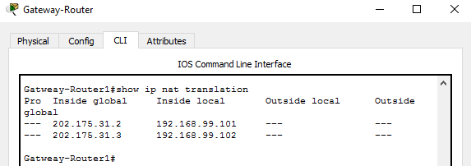
- NAT translation rules

Connectivity Test
Some connectivity ping tests are below:

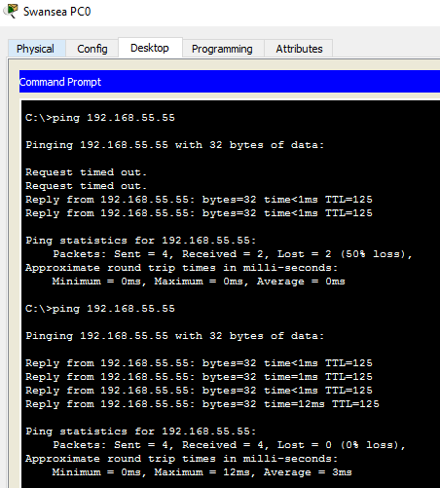
- From Swansea to Malaysia

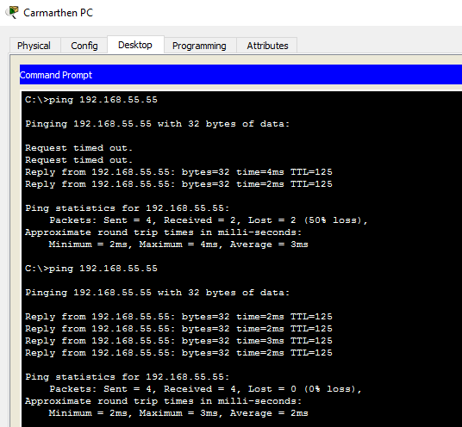
- From Carmarthen to Malaysia

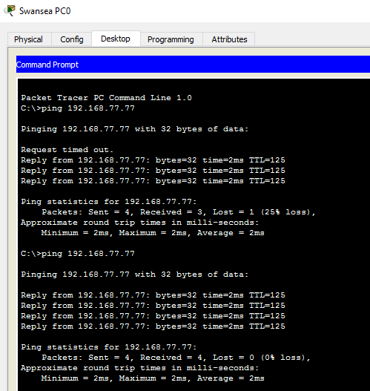
- From Swansea to Carmarthen

Big Data Storage and Processing Literature Review

What is Big Data
“Big data” is an important and hot term generated with the development of modern computer and network technology. Big data refers to data sets whose sizes are too large and above the capability of usual software to store, process and compute [4].
Big data has five important dimensions: volume, velocity, variety, value and veracity, which represent five typical characteristics of big data and are called 5 V. Volume defines the large size and scale of big data, the metrics of which are often petabyte (PB), exabyte (EB), zettabyte (ZB) or even more. Usually distributed or cloud storage are employed to storage these data rather than single high-performance server. Variety shows that there are different data types including not only traditional structured data, but also semi-structured and unstructured data like video, audio, image, positional information, etc. How to process these data and extract out useful information jointly to support final decision is another big challenge. Value refers that with the increment of data amount, density of effective data goes down. Big data processing tools need more attention to distinguish important information from “noise” and capture them in an efficient way. Velocity describes the continuity of arriving data in the form of stream. Data storage, computing and evaluating will be conducted real-timely. In this case, results should be worked out at a low latency as precise as possible. The last V, veracity, describes the quality and reliability of data from various places [4][5].

Big Data Storage Technology
Traditional relational databased stores data in rows and if query does not have index, it will consume a lot of I/O resources and be in an inefficient way (it must access every entry one by one until find the result). So in order to deal with this situation, there are many other database types and technologies are proposed.

Column-oriented Databases: Column storage is different from traditional relational databases. For column-based database, the data of same type is stored in the same column, so the data itself is index and query without index will only access corresponding column, which will significantly reduce system I/O.
- Difference between row-based and column-based table
And also because of the similar data type in one column, efficient compression algorithm can be used to save storage space. All of above features make column-based database more efficient and economical in big data scenario [6]. Nowadays the column-based database includes HBase, C-store, etc.

Schema-less database: Schema-less databases are also called NoSQL databases (NoSQL means Not only SQL) which employs a mechanism for data storage and retrieval not by means of tabular relations [7]. There are two main types of NoSQL databases which are document databases and key-value databases. Key-value based databases mainly uses a hash table where a key and a pointer will be corresponded to specific data. The advantage of the key-value model is simple, easy to deploy, and more efficient. However, if only a small amount of data is queried or updated, key-value based database will be inefficient. Document databases model data as document in specific format, such as JSON, or semi-structured documents. Document database can be considered as the upgrade of key-value database, which allows nested key values between them [8]. In most scenarios document-based databases are more efficient than key-value databases. Nowadays popular key-value database includes Redis, Voldemort, Oracle BDB and document database includes CouchDB, MongoDb, etc.

Hadoop: Hadoop is an open source tool developed by Apache Software Foundation for handling big data, designed to be deployed on large amount of low-cost hardware to reach high performance. It is a programming framework implemented in Java and supports computing large scale distributed data sets. Users are able to develop programs without knowing the details of distributed devices and take full advantage of the power of cluster. Hadoop implements a distributed file system called Hadoop Distributed File System (HDFS). Because of the large amount of components nodes, fault detection and automatic, fast recovery is a core design goal of HDFS, which makes it a highly fault-tolerant file system [9].

Big Data Processing Technology
After storing the large amount data in the database, there is another challenge that how to compute and process these data in an efficient way. As the high-expense of single high-performance device, nowadays there are more and more enterprises pay attention to virtualize and recombine lots of low-cost hardware to reach high processing capability in holistic. The most popular technology is cloud computing.
Cloud computing is a computing technology where scalable and virtualized resources are provided as the form of service over the Internet. It can provide on-demand, shared centralized computing resources through a cloud services platform over the Internet [10]. So by using Cloud Computing technology, users can access servers and a large amount of application services via Internet at a low cost.
To support the cloud computing service, there is one important technology: virtualization. Virtualization is a kind of resource management tool which abstracts and transforms various physical computer resources (CPU, memory, disk space, network adapter, etc.) into a form that can be recombined. Thus users are allowed to leverage these computer resources as virtual machine in a flexibly configured way [11]. And to balance the computing load among virtual computer resources, virtual switching technology is used to forward network traffic between the virtual machines. And in another aspect, virtual switching also let virtual machines be able to maintain their configuration consistency when being moved around physical hosts, so their usage will not be limited to the position of hardware devices.
When applying cloud technology, there are three cloud service models we can select: Software as a Service (SaaS), Platform as a Service (PaaS), and Infrastructure as a Service (IaaS). Each of these has their own benefits and applicable scenes. SaaS is a software licensing and delivery model. Most SaaS applications run in the form of web browser, and client side does not need downloads or installations. Data storage and processing are also conducted on cloud side and users can finish their work only using a web browser. For PaaS, it provides clients a platform allowing them use and manage applications without building and maintaining complex system platform [12]. And for IaaS, it provides highly scalable and virtualized whole computing infrastructure including system, CPU, memory, disk, etc., which allows clients to purchase resources on-demand and as-needed. The most popular IaaS providers contain Amazon Web Services (AWS), Microsoft Azure, Alibaba Cloud and so on.

Recommendation and Future Work
In the future, with growth of university, the student number, educational resource and service provided will all increase much more. How to handle the large amount of data will be a big challenge for school technicians. In my opinion, we should improve our work in two aspects: big data storage and cloud service.

Big Data Storage
In task 1, a server farm is used to store and process data, which is an economical way for university without too much data. While with the future growth of university, the data generated, stored and processed will all increase a lot. In that scenario, only server farm will not provide enough data access speed and data storage space. To improve data access speed, on the one hand, we can use Storage Area Networks (SAN) to transfer data between storage devices and server hosts, which can improve the data transmission speed. On the other hand, from database aspect, we can utilize NoSQL database to cooperate with traditional relational database. As relational database has better performance of data modification operation, while NoSQL database can access large-scale data in a quicker speed. So in different scenario we can employ different database to improve data access efficiency. And for data storage space, the usage of SAN can provide scalability and flexibility of storage device, which we can adjust storage space with the variation of data size easily. And we can employ NoSQL to organize data in various forms and construct corresponding data compression algorithm.

Cloud Service
In task 1, all of our services are provided by local server farm. And if data computing and processing need increases significantly, adding new servers and maintaining original configurations will be a tough task. So we can switch the computing service to cloud end. On the one hand, we can use Software as a Service (SaaS) to deploy some separate applications like My Timetable, Student Guides, Student Bulletin to the cloud end. So students can only use web browser accessing the website to get information. On the other hand, we can use Infrastructure as a Service (IaaS) to deploy majority of school service to cloud. It will not only reduce the day-to-day maintenance work and security risk of school IP service, but also provides great flexibility of computing sources so we can get an on-demand delivery of compute power with pay-as-go pricing.

References
- Le Pennec, Jean Francois, and Guy Euget. "Method and system for establishing a virtual path capability in a frame relay network." U.S. Patent No. 6,963,585. 8 Nov. 2005.
- Elkeelany, Omar, et al. "Performance analysis of IPSec protocol: encryption and authentication." 2002 IEEE International Conference on Communications. Conference Proceedings. ICC 2002 (Cat. No. 02CH37333). Vol. 2. IEEE, 2002.
- Srisuresh, Pyda, and Kjeld Egevang. Traditional IP network address translator (Traditional NAT). No. RFC 3022. 2000.
- S.Vijayarani and S.Sharmila, “Research in Big Data – An Overview”, IEIJ Informatics Engineering International Journal, vol. 4, no.3, pp. 1-20, Sept. 2016.
- John Walker, Saint. "Big data: A revolution that will transform how we live, work, and think." (2014): 181-183.
- Abadi, Daniel J., Peter A. Boncz, and Stavros Harizopoulos. "Column-oriented database systems." Proceedings of the VLDB Endowment 2.2 (2009): 1664-1665.
- Han, Jing, et al. "Survey on NoSQL database." Pervasive computing and applications (ICPCA), 2011 6th international conference on. IEEE, 2011.
- Navarro, Gonzalo, and Ricardo Baeza-Yates. "Proximal nodes: A model to query document databases by content and structure." ACM Transactions on Information Systems (TOIS) 15.4 (1997): 400-435.
- Shvachko, Konstantin, et al. "The hadoop distributed file system." Mass storage systems and technologies (MSST), 2010 IEEE 26th symposium on. Ieee, 2010.
- Armbrust, Michael, et al. "A view of cloud computing." Communications of the ACM 53.4 (2010): 50-58.
- Fox, Armando, et al. "Above the clouds: A berkeley view of cloud computing." Dept. Electrical Eng. and Comput. Sciences, University of California, Berkeley, Rep. UCB/EECS 28.13 (2009): 2009.
- Dillon, Tharam, Chen Wu, and Elizabeth Chang. "Cloud computing: issues and challenges." Advanced Information Networking and Applications (AINA), 2010 24th IEEE International Conference on. Ieee, 2010.

marking criteria and Student FEEDBACK

This section details the assessment criteria. The extent to which these are demonstrated by you determines your mark. The marks available for each criterion are shown. Lecturers will use the space provided to comment on the achievement of the task(s), including those areas in which you have performed well and areas that would benefit from development/improvement.

Common Assessment Criteria Applied (Assignment 1) | Marks available | Marks  awarded
1. Research-informed Literature
Extent of research and/or own reading, selection of credible sources, application of appropriate referencing conventions.
You can do such good research but try to utilise more updated credible sources say within the last 5 years (Grade mark: 73.33%) | 15 | 11
2. Knowledge and Understanding of Subject
Extent of knowledge and understanding of concepts and underlying principles associated with the discipline.
Knowledge is extensive. Exhibits understanding of the breadth and depth of established views. Refer to above to utilise more updated sources. (Grade mark: 73.33%) | 15 | 11
3. Analysis
Analysis, evaluation and synthesis; logic, argument and judgement; analytical reflection; organisation of ideas and evidence
Thoroughly logical work, supported by evaluated evidence. It's a pity you have not written a conclusion and future recommendation. (Grade mark: 73.33%) | 30 | 22
4. Practical Application and Deployment
Deployment of methods, materials, tools and techniques; application of concepts; formulation of innovative and creative solutions to solve problems.
Overall the network design is good, ping tests were successful. However you have not configured basic security measures on the core devices. There are no password on switches and routers. (Grade mark: 76.67%) | 30 | 23
5. Skills for Professional Practice
Attributes in professional practice: individual and collaborative working; deployment of appropriate media; presentation and organisation.
The report read and flow well. Some grammatical errors such as starting a sentence with conjunction; And. You need to spell out all acronyms first time used. (Grade mark: 65.00%) | 10 | 6.5

Assignment Mark (Assessment marks are subject to ratification at the Exam Board. These comments and marks are to give feedback on module work and are for guidance only until they are confirmed. ) | Late Submission Penalties (tick if appropriate) |  | 73.5%
 | Up to four weeks late |  | 73.5%
 | First Attempt? |  | 73.5%

