Fundamentals in Construction Technology: Swansea Ice Cream Parlour - Matthew Morgan - 1708254  Matthew Morgan - 1708254 | 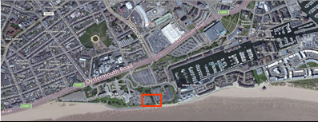  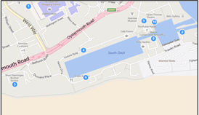  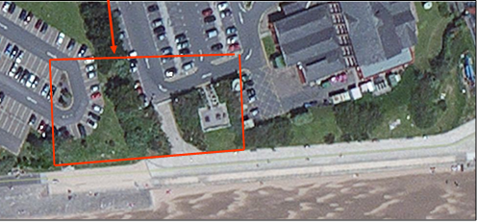

Contents Page
Desk Top Study and Site Walk Over |  | 3
Identified Issues |  | 4
Existing Site Layout Diagram |  | 7
Historical Use of the Site |  | 8
Recommendations for Further Investigation of the Site |  | 12
Proposed Site Layout Diagram |  | 14
Foundation and Sub-Structure |  | 15
Pre-cast Concrete Displacement Pile Diagram |  | 16
Ground Floor Construction |  | 17
Contents Page – Continued…

Block and Beam Floor Diagram |  | 18
Super Structure and Proposed Layout |  | 19
Structure of Flat Roof Diagram |  | 20
Roof Weathering Detail Diagram |  | 21
External Wall, Window and Door Intersections |  | 22
Lintels Above Door Intersections |  | 23
Site Set Up and Plant Required |  | 24
References |  | 25

Desk-Top Study and Site Walk-Over
The city and county of Swansea, in conjunction with Marriot Hotels, are proposing to build a new restaurant and ice-cream parlour, together with associated staff and customer welfare facilities, and accommodation, on Swansea sea-front, between the existing Marriot Hotel and county hall building. The aim of this initial study, is to identify the proposed site’s suitability for use; to identify any previous usage of the site; and to make recommendations for any further investigative works that will need to be carried out before construction can commence. The proposed site can be clearly identified by figure 1 below.
A site walk-over inspection was conducted on the14th of December 2018. The proposed site occupies a fairly level position located at the foreshore of Swansea Bay; occupying a fairly rectangular plot, it measures approximately 75 meters along the south and north frontages, and extends 40 meters from the south-west to north-west corner, and 35 meters from the south-east to north-east corner. The location currently occupies a mixture of car parking area for both the city and county of Swansea and Marriot Hotel, and consists of a tree lined path dividing the two car parks, running from south to north. Whilst undertaking the walk-over inspection, several potential issues were identified, which will require further research and investigation before work can commence.

Identified Issues

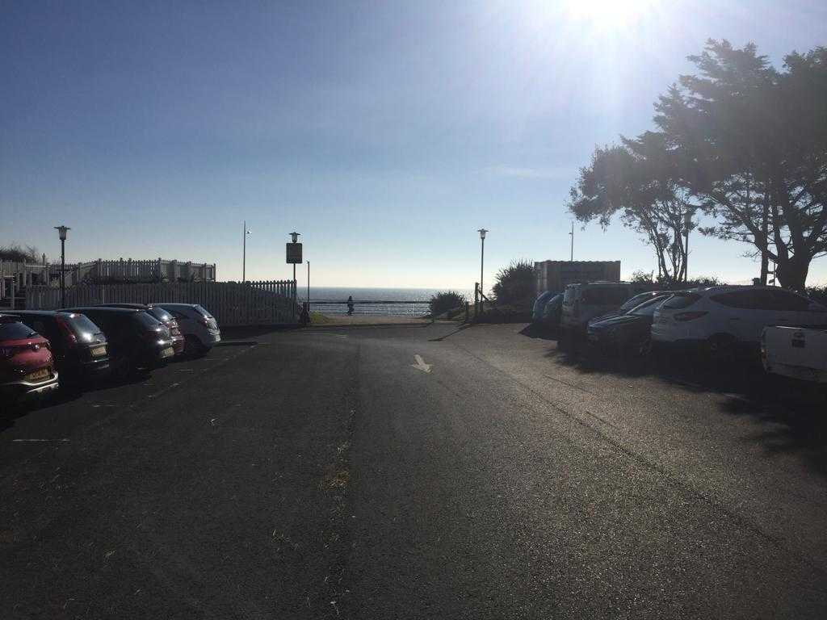
- There is an access road which currently links the foreshore path with the Marriot car park. This section of the sea front is used for several events throughout the year; this busy area of the beach facilitates a high pedestrian usage all year round. This driveway currently provides an important access point for emergency vehicles to use in the event of an incident on the seafront or beach in this area. There appears to be no access point other than this for vehicles for several hundred meters in either direction.

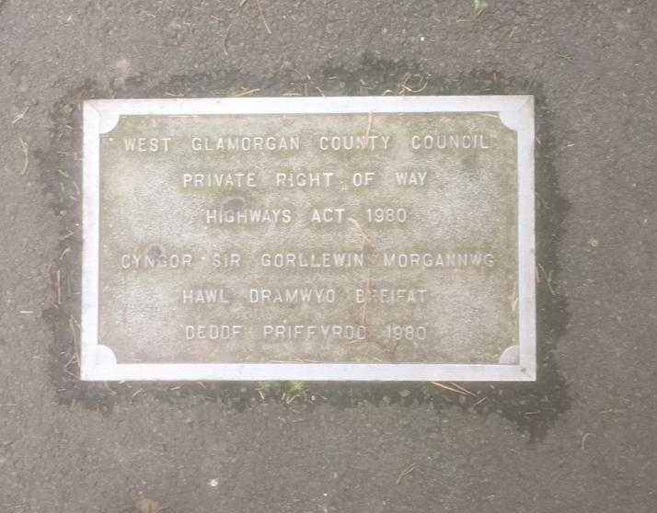
- Occupying a central point on the proposed site, there is a small path that is linking the city council car park and the Marriot Hotel car parks. This has been clearly marked by a private right of way notice, as highlighted in the photograph on the right.

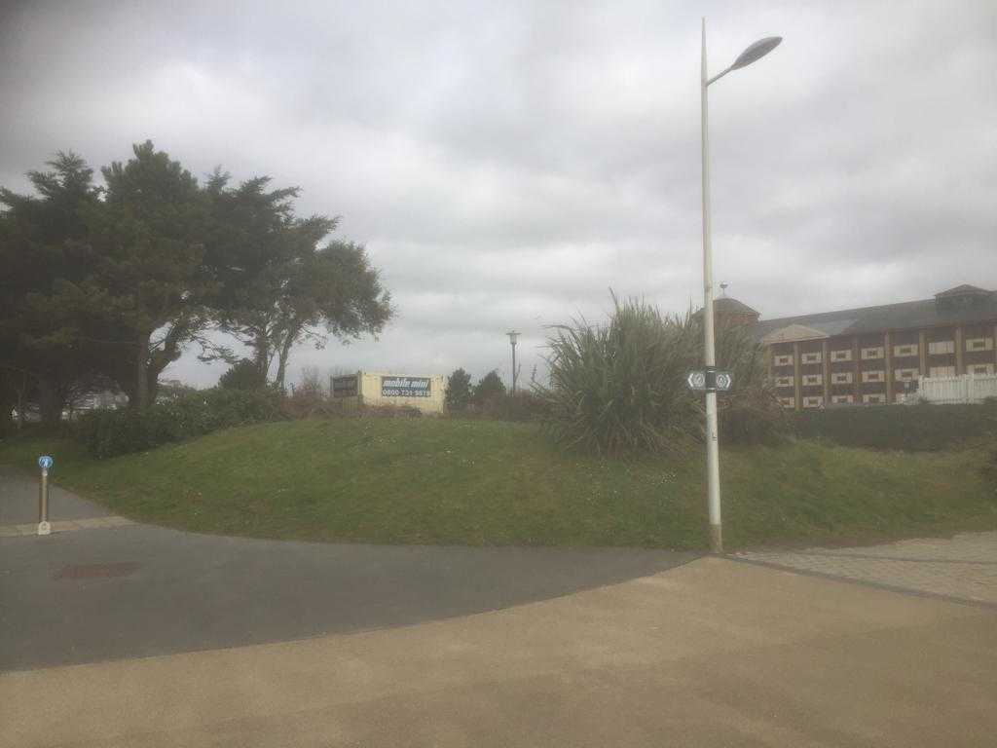
- There is a public footpath running through the central area from north to south of the proposed site, which links the seafront to Oystermouth Road. In this photograph the footpath can clearly be seen and should be maintained throughout the proposed works.
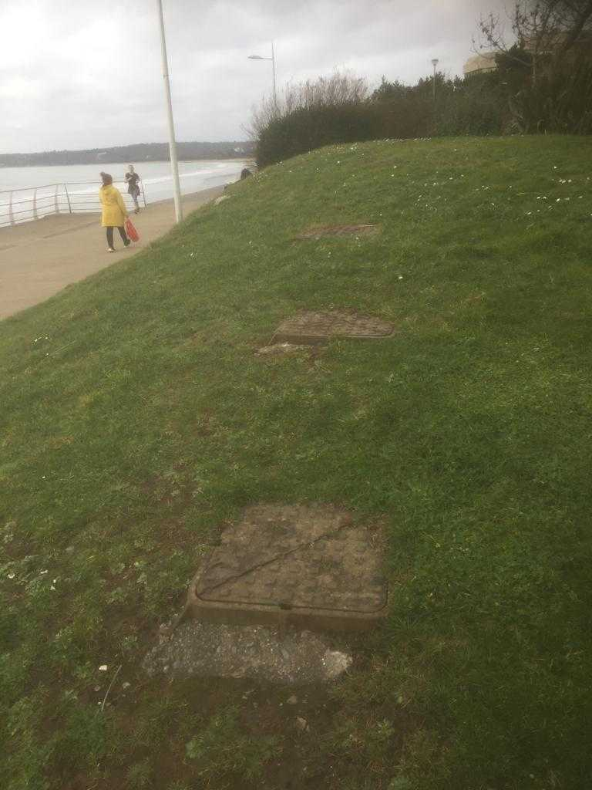
- There are, what appear to be, three raised sewer inspection chambers, located on the south-west section of the site, close to the boundary with the foreshore path. These will require further investigation before construction can commence to determine their purpose and feasibility or potential to perhaps move these if required.

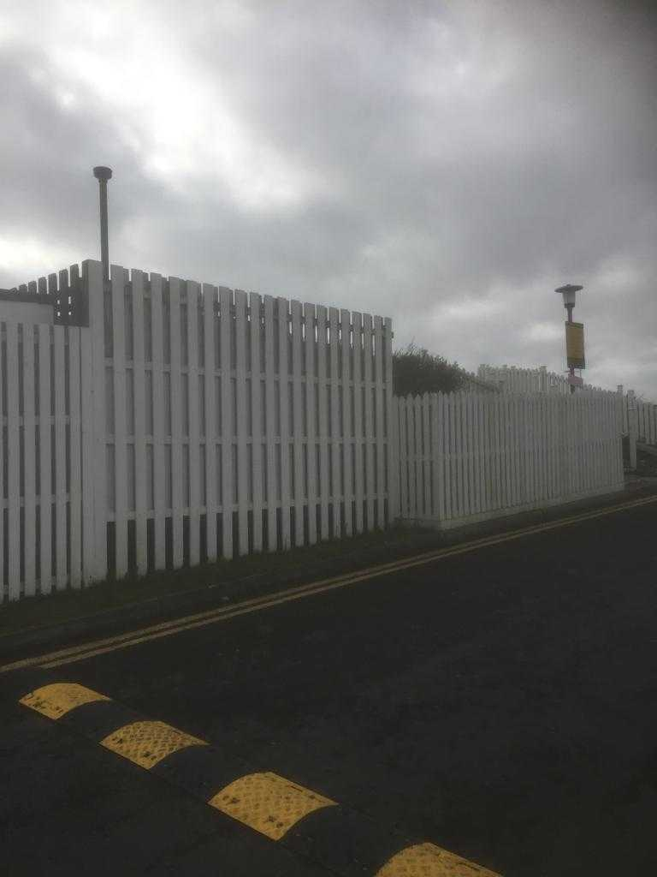
- There is currently a raised patio area at the front of the site which, upon inspection, is for the exclusive use of guests of the hotel. The Marriot Hotel will need to be consulted regarding their wish to either maintain the use of this facility, or alternatively to have it removed from the site.
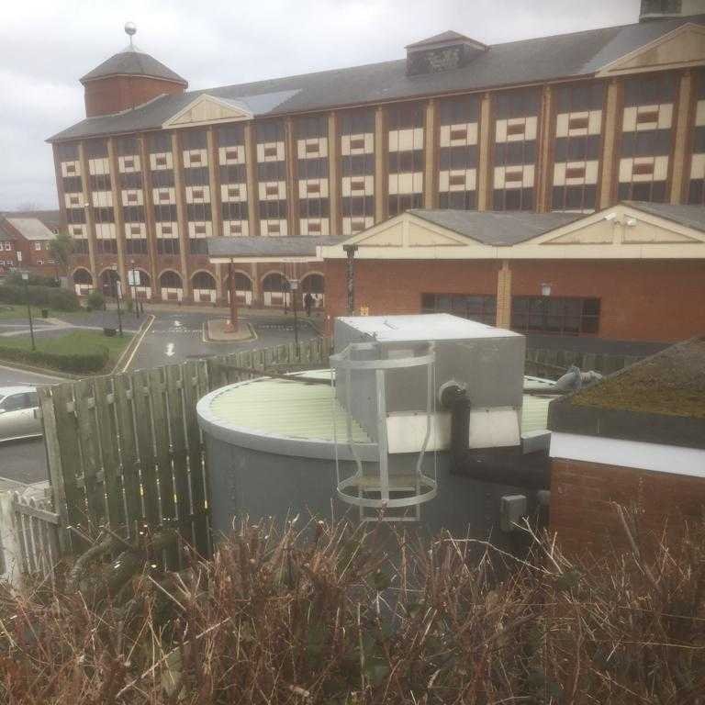
- There is also, what appears to be, a large storage tank and boiler house, located on the eastern section of the site, which is presumed to be linked to the hotel’s heating and ventilation system. Further consultation should be made with the hotel regarding this facility and the potential importance of retaining it, and maintaining its use during construction.

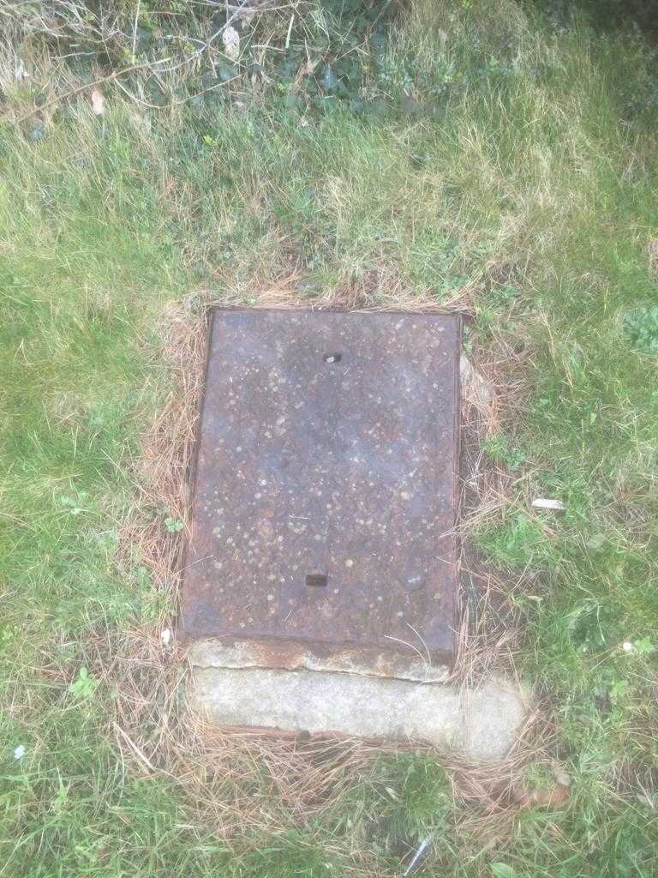
- An inspection/manhole cover was located in the south-central part of the site, alongside the public footpath linking the foreshore with Oystermouth Road. Occupying a central location on the plot, further assessment needs to be made of this to assess its usage and feasibility to be moved if required.

Existing Site Layout Diagram

Historical Use of the Site
The proposed site is located to the south-west of the south dock, within Swansea, the construction of which was completed in 1859 (Swansea and Port-Talbot Docks, 2019). In order to assess the previous usage of the site effectively, a visit was paid to the County Archives Service, Swansea Reference Library, County Hall Survey, and whilst there, the following map was retrieved. The map of the area in 1919 (map 1), clearly illustrates the location to be comprised of a mixture of railway lines and a timber yard; it is also understood that the site of the timber yard, was later used to house a cannister works and oil storage facility, as map 2, drawn in 1940, illustrates. With the obvious previous industrial use of the area, there will undoubtedly be the risk of oil spill, industrial waste, and contaminants present.
The photograph below clearly demonstrates the previous heavy industrial usage of the area.
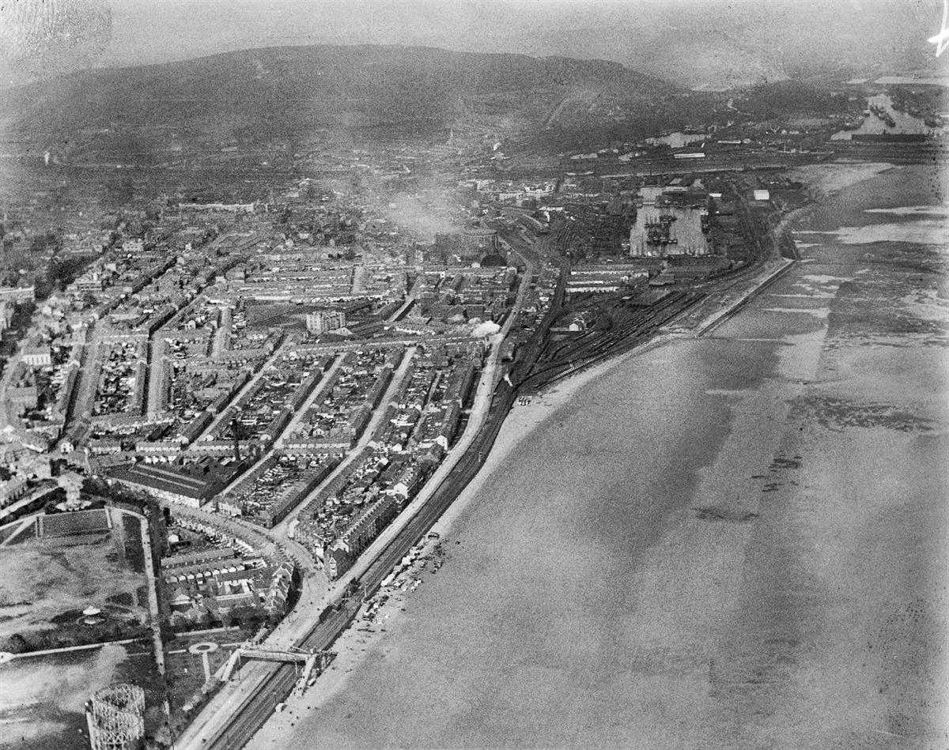
(Coflein, 2019)
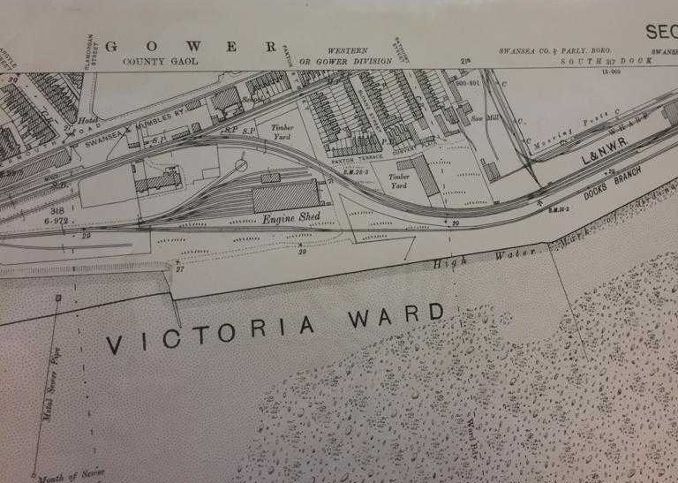
(County Hall Archives, 2019)
MAP 1
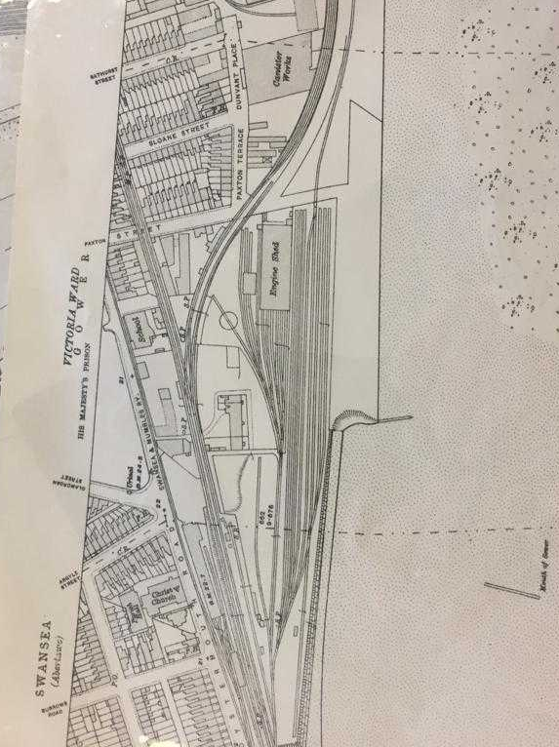
(County Hall Archives, 2019)
MAP 2
The British geological survey highlights this area to be a mixture of mud/sand, and made ground, mainly colliery and mineral smelting spoil, with road and rail embankments, as well as areas of blown sand.
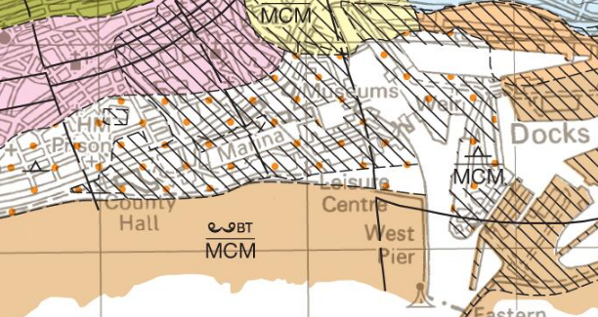
(British Geological Survey, 2011)

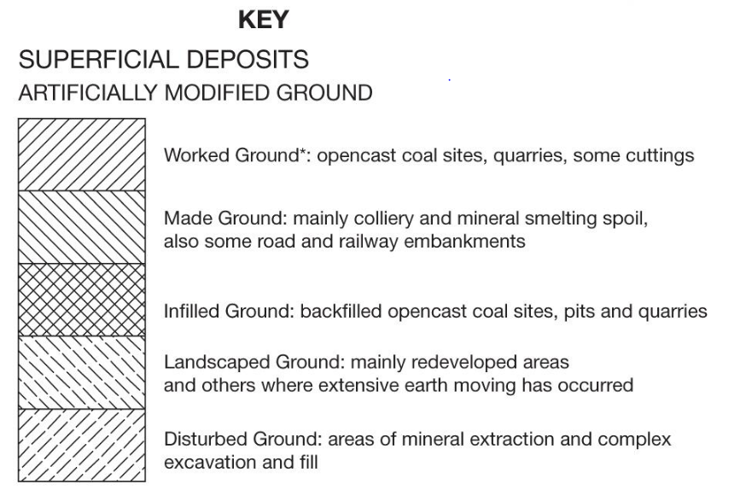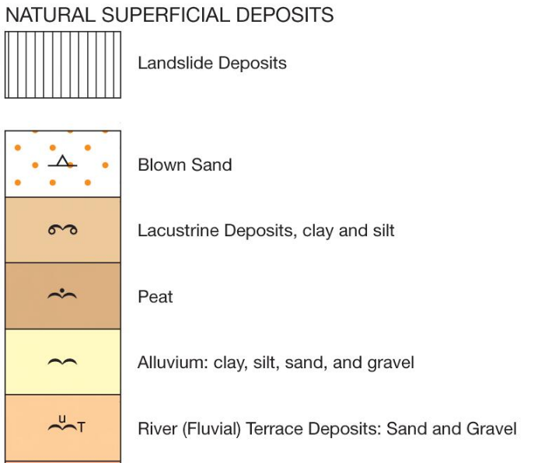
- Denotes Site Location
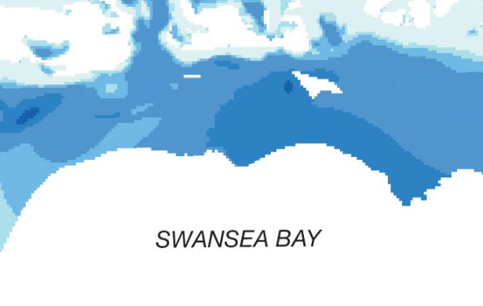
(British Geological Survey, 2011)
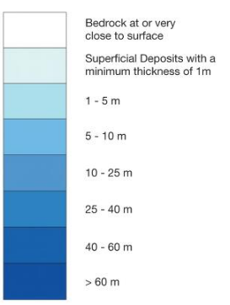
- Denotes Site Location
Site
The map above illustrates the location of bedrock to be 5 – 10 meters below the surface. This, along with the information regarding the sub-ground conditions, gives an indication as to the sub-structure required for the new building.
Recommendations for Further Investigation of Site

- Test boreholes to be carried out on site, specifically in areas where the building is to be located in order to assess ground conditions and to be able to install the correct sub-structure and foundation system for the building

- Relevant soil samples to be taken off-site and assessed for contaminants

- Consult with Welsh Water to establish the location of sewers within the site boundary, and feasibility for connection of water supply and sewerage pipes to the new building

- SUDS (sustainable drainage to manage on site water) application needs to be submitted to the local authority. This needs to be a separate application that runs alongside the planning permission application

- Consult with the local authority regarding any potential tree preservation orders on the site

- Consult with Wales and West utilities regarding the location of gas pipes in the area and also connection of the gas required to the new building

- Consult with the local authorities’ highways department regarding maintaining a public access path between the foreshore and Oystermouth Road, not only after but during construction

- Consult with Western Power Distribution regarding the location of electrical cables in the proximity, and also to establish the new connection to the new building

- Consult with local authority and emergency services regarding the current emergency access road, and the need to maintain this both during and after construction

- Consult with the Marriot Hotel regarding the existing raised patio area at the front of the site

- Consult with Marriot Hotel to further investigate storage facilities on the eastern section of the site

- The location of the site is prone to extremely high winds, which have been known to blow sand up from the beach on to this area. The design of the building and landscaping to the front of the site, should take this factor in to consideration.

The following drawing proposes a site layout for the new building, highlighting where test holes need to be drilled, the site of a new public footpath and access road for emergency vehicles

Proposed Site Layout Diagram
Foundation and Sub-Structure
Having assessed the site, and upon analysing the sub-ground conditions, the foundation system chosen consists of a series of pre-cast concrete piles, with a reinforced concrete ground beam above. These pre-cast displacement piles have been chosen for several reasons; they are particularly suited to a marine environment and are unaffected by ground water. For delivery purposes, there is good access to the site, facilitating the transport of these pre-fabricated piles to the build site, and improving the speed of installation, as well as allowing the continuation of construction; this negates the need for concrete to be poured, and omits the waiting period that setting concrete usually requires. Balfour Beatty (2019) and Bangesh (2003) advise that this piling system is particularly compatible with made up ground that is covering bedrock. Another advantage of this system highlighted by Chudley et al (2011), is that very little spoil is generated, negating the need for large scale excavation, thus reducing the potential for removing waste to landfill and cutting down on costs as a result of this. The piles manufacture should be in line with BES 6001 standards to show that the steel and concrete has been responsibly sourced (British Standards Institution, 2019) (UK Government, 2016). The piles will be installed using a hydraulic power rig. Other methods of foundation construction such as strip or trench-fill foundations, the use of which, suggests Foster (2000) is commonplace among buildings of this type, were deemed inappropriate for this build site due to the unstable made up ground conditions. A reinforced concrete foundation, or surface raft, could also have been a possible alternative if not in such an unstable environment (Varghese, 2009). The following drawing illustrates the proposed location of the piles and ground beam (lower diagram), together with a drawing of a single pile in situ (upper diagram).

Pre-cast Concrete Displacement Pile Diagram

Ground Floor Construction
The ground floor of the proposed building will be constructed using a suspended concrete floor, employing a ‘beam and block’ method. The beams will be fabricated off site, therefore ensuring a fast installation time onsite. Chudley et al (2011) join Fahmy et al (2014) in suggesting that this method of block and beam flooring will have the ability to span over any unstable ground that lies beneath, as well as reducing waste generated from large scale concrete pours. As this structure is vented from the underneath, it can enable potentially intrusive gases emanating from the ground, from entering the building. The void underneath the ground floor, as seen in the photograph below, can also prove to be useful when installing service and waste-pipes to a building (Mesaros and Mandiak, 2015).
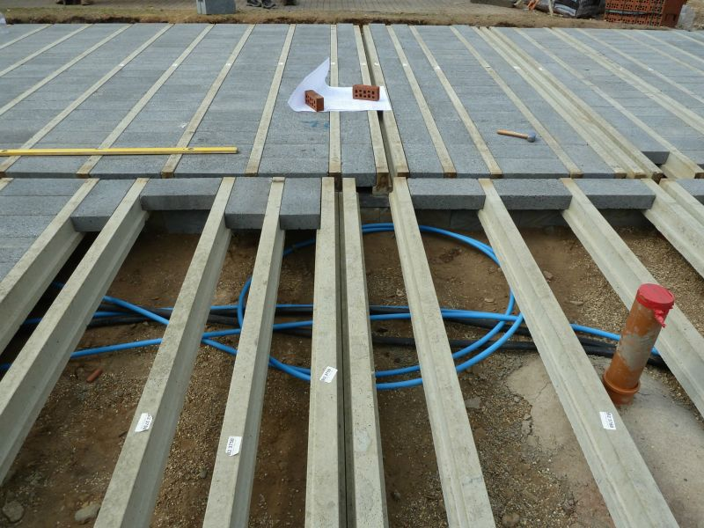
(Jablite, 2019)

The following diagram aims to illustrate the design and layout of a block and beam floor.

Block and Beam Floor Diagram

Super Structure and Proposed Layouts
As the proposed building is in close proximity to, and indeed funded by, the Marriot Hotel, the idea for the design is for it to match the hotel façade. The building will consist of a red-faced brick work exterior, a black slate roof, with elements of sandstone sills and quoins. The building envelope will comprise of a dense concrete block internal skin, a cavity with insulation, and a face brick outer skin. A standard brick measuring 215 millimetres by 102.5 millimetres, by 65 millimetres is to be used; due to the marine location of the site, all mortar joints should be fully filled and flush with the face of the brick. There will be large openings of full-height glass doors at the sea-front side of the building to take advantage of the extensive views over Swansea bay. All glazing for the building will take the form of adonised aluminium, and tinted glazing; this same method is popular among commercial building design globally, having been employed in numerous high-profile constructions including the Willis Tower in Chicago; the benefits of this being the adonised aluminium’s durability to exposure of extreme elements (Adams, 2007), and the tinted glazing’s ability to maintain temperature control within the building (Ali, 2001).
In addition to the ground works and sub-structure, the super structure must conform to building regulations approved document A, regarding structure. The proposed construction should be able to withstand the shear forces that will be placed on it due to its location and exposure to high wind and driving rain.
The structure of the roof chosen for the kitchen area on the ground floor is a flat roof design, with an ethylene propylene diene methylene (EPDM) rubber covering. This choice of roof is extremely durable (Chipperfield Architects, 2019) and is recommended for use in areas of high heat or inclement weather. Whilst being called a flat roof, there will in fact, be a gradient of up to 10% on it to allow rainwater to run off sufficiently and in to the gutters. This is achieved by placing firring strips on top of the flat roof joists (Sedlbauer, 2010).
The following two pages illustrate the structure and detail of the flat roof, and also the weathering detail on the intersection between the flat roof and wall.

Structure of Flat Roof Diagram

Roof Weathering Detail

External Wall, Window and Door Intersections
The door entrances to the building must comply with approved document M of the building regulations and the British Standard (BS 8300) in order to make the building safe and accessible for disabled individuals. The approved document states that the main entrance threshold to the building must be level, and wide enough for a wheelchair (British Standard Institution, 2019) (UK Government, 2016). All cavities must remain open and not closed off with block work, the appropriate insulated cavity closers must be used to comply with building regulations and prevent the bridging of cold air between the outer and inner skins of block and brickwork. Stainless steel cavity lintels can be used, although it should be noted that they will have to be specially designed on the ground floor due to the size of the openings. Calculations will need to be made to ensure the structural performance of the lintels. It is vital that cavity trays are installed above all window and door openings, with weep holes located above the windows.
The following diagrams aim to highlight the above points.

Drawings of Lintels Above door and Window Openings

Site Set-Up and Plant Required
The build area is subject to a large amount of daily public usage; therefore, the complete perimeter of the site will need to be secured before any construction work of the site can commence. The preferred option would be to fence off, with 2.5-meter-high boards, fixed to securely installed 150 by 150-millimetre fence posts, so as to provide, not only a physical, but a visual barrier to the site. An appropriate site access point will need to be identified at the north end of the site; welfare facilities need to be provided, including site toilets, a site office, a rest area for workers, and hot and cold running water. It would also be advisable for the site to have a storage container for small plant and equipment, as well as building materials that need to be protected from the elements.; it is important that an area is designated for waste management. The Welfare requirements must comply with the Construction (Health Safety and Welfare) Regulations (2007) (The National Archives, 2019).
The following plant will be required for the construction works; this list is not exhaustive;
- An excavator to remove top soil from the site
- A dumper to move the soil to a lorry and for ongoing movement of material on site throughout the build
- A mobile hydraulic rig for piling
- A mobile crane for lifting beams in to place and installing roof trusses
- Mobile elevated working platforms (MEWPS)
- Smaller plant such as hand-held breakers/drills
- A forklift truck to take site deliveries and move them to appropriate areas
It is vital that site cleanliness is maintained and that adequate space is provided on site for heavy vehicles and machinery coming in and going out.

REFERENCES
Adams, N. (2007). Skidmore, Owings & Merrill: The experiment since 1936. Milan: Phaidon Press.
Ali, M. M. (2001). Art of the Skyscraper: The genious of Fazlur Kahn. New York: Rizzoli International Publications Inc.
Balfour Beatty. (2019). Driven Pre-cast Piling. Basingstoke: Balfour Beatty Ground Engineering.
Bangesh, Y. (2003). Structural Detailing in Concrete (2 ed.). London: Thomas Telford.
British Geological Survey. (2011). Geological Survey of England and Wales 1:63,360/1:50,000 geological map series, New Series. Retrieved February 14, 2019, from BGS: https://www.bgs.ac.uk/data/maps/maps.cfc?method=viewRecord&mapId=9862
British Standards Institution. (2019). BES 6001 Responsible Sourcing of Construction Products. Retrieved February 4, 2019, from bsi: https://www.bsigroup.com/en-GB/bes-6001-responsible-sourcing-of-construction-products/
Chipperfield Architects. (2019). Soft building skins: Rubber sheeting and architectural carpeting for facades. Retrieved January 28, 2019, from Architecture and Construction Details: https://www.detail-online.com/article/soft-building-skins-rubber-sheeting-and-architectural-carpeting-for-facades-16769/
Chudley, R., Greeno, R., Hurst, M., & Topliss, S. (2011). Construction Technology (5 ed.). Essex: Pearson Education Limited.
Coflein. (2019). Aerofilms Collection - Swansea Aero Image. Retrieved January 28, 2019, from Coflein: https://www.coflein.gov.uk/en/archive/6370218/details/504
County Hall Archives. (2019). Ariel Map of Swansea Marina Area. Retrieved from Maps.
Fahmy, E., Shaheen, Y., Abdelnaby, A., & Zeid, M. (2014). Applying the Ferrocement Concept in Construction of Concrete Beams Incorporating Reinforced Mortar Permanent Forms. International Journal of Concrete Structures and Materials, 8(1), 83 - 97.
Jablite. (2019). Block and Beam Image. Retrieved January 31, 2019, from Jablite Intelligent Insulation: https://www.jablite.co.uk/?s=block+and+beam
Mesaros, P., & Mandiak, K. (2015). Factors affecting the use of modern methods and materials in construction. Materials, Science and Engineering, 71.
Sedlbauer, K. (2010). Flat Roof Construction Manual: Materials, Design, Applications. Hamburg: Edition Detail.
Swansea and Port-Talbot Docks. (2019). Retired Section Swansea Docks. Retrieved February 5, 2019, from Swansea & Port Talbot Docks Retired Section Website: http://www.swanseadocks.co.uk/South%20Dock.htm
UK Government. (2016). Access to and use of buildings: Approved Document M. Retrieved February 7, 2019, from gov.uk: https://www.gov.uk/government/publications/access-to-and-use-of-buildings-approved-document-m
Varghese, P. C. (2009). Design of Reinforced Concrete Foundations. New-Dehli: PHI Learning Limited.

