
Module Name: Enterprise Development and Commercial Innovation
Module Code: BMBS5000
Student Name: Lauren Dalling
Student Number: 2506840
Lecturer: Chris Wilkin
Deadline: 12th October 23:59

AI Acknowledgement

I acknowledge the use of River (https://meetriver.com/desktops/6ac4af2874cdfb6b03c6000b) to help identify areas to consider when developing and strengthening my Value Proposition Canvas (VPC).

I acknowledge the use of Canva (https://www.canva.com/design/DAHVQtsnsvw/MBCKjfvQtoy3lV_djLQs6Q/edit) to design my Business Model Canvas (BMC) and Value Proposition Canvas (VPC) using templates.

I acknowledge the use of HubSpot (https://www.hubspot.com/make-my-persona#/) to generate ideas and help develop my customer personas.

I confirm that I have not presented any AI-generated text as my own work.
I confirm that I have copies of my drafts, notes and other resources used before and after using these tools, which I may be asked to provide as evidence.

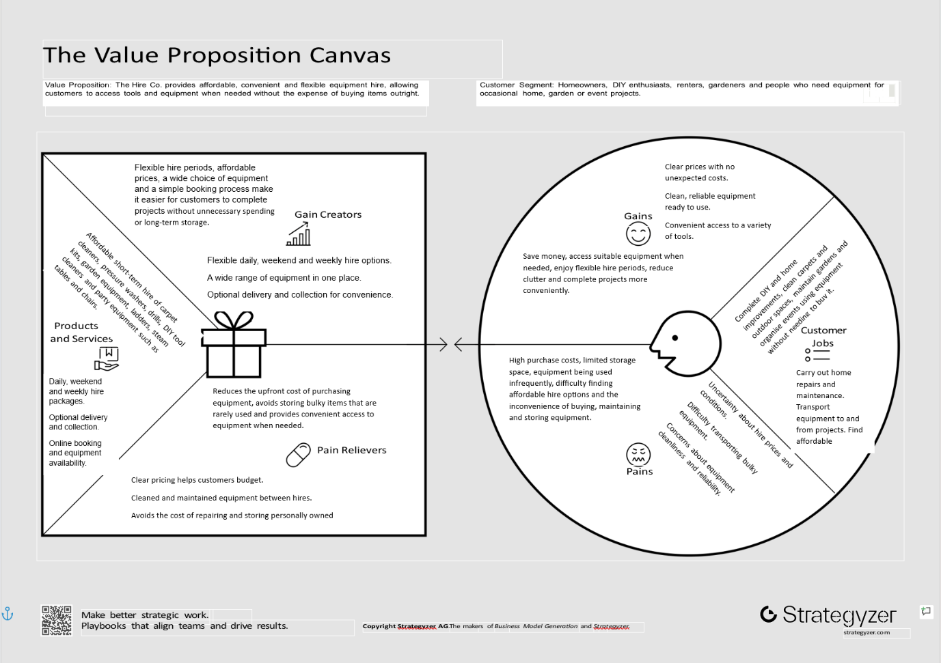
Value Proposition Canvas

Link to mind map: https://mm.tt/map/4085748227?t=gooj5gCWJD

Reference List

Blank, S. (2013). Why the lean start-up changes everything. Harvard Business Review, 91(5), pp.63–72.
Bocken, N.M.P., Weissbrod, I. and Antikainen, M. (2021). Business model experimentation for the circular economy: Definition and approaches. Circular Economy and Sustainability, [online] 1(1), pp.49–81. doi:10.1007/s43615-021-00026-z.
Bowman, C. and Faulkner, D. (1994). Measuring product advantage using competitive benchmarking and customer perceptions. Long Range Planning, 27(1), pp.119–132. doi:10.1016/0024-6301(94)90012-4.
Brown, T. (2008). Design thinking. Harvard Business Review, 86(6), pp.84–92, 141.
Card, A.J. (2017). The problem with ‘5 whys’. BMJ Quality & Safety, [online] 26(8), pp.671–677. doi:https://doi.org/10.1136/bmjqs-2016-005849.
Carroll, R. and Casselman, R.M. (2019). The lean discovery process: The case of raiserve. Journal of Small Business and Enterprise Development, [online] 26(6/7), pp.765–782. doi:10.1108/jsbed-04-2019-0124.
Christen, T., Hess, M., Grichnik, D. and Wincent, J. (2022). Value-based pricing in digital platforms: A machine learning approach to signaling beyond core product attributes in cross-platform settings. Journal of Business Research, [online] 152, pp.82–92. doi:10.1016/j.jbusres.2022.07.042.
Fluhrer, P. and Brahm, T. (2023). Positioning in SMEs: Entrepreneurs’ perceptions and strategies. Journal of Research in Marketing and Entrepreneurship, 25(3). doi:10.1108/jrme-09-2021-0120.
Hankammer, S., Brenk, S., Fabry, H., Nordemann, A. and Piller, F.T. (2019). Towards circular business models: Identifying consumer needs based on the jobs-to-be-done theory. Journal of Cleaner Production, 231, pp.341–358. doi:10.1016/j.jclepro.2019.05.165.
Hulbert, B., Gilmore, A. and Carson, D. (2015). Opportunity recognition by growing SMEs: A managerial or entrepreneurial function? Journal of Strategic Marketing, 23(7), pp.616–642. doi:10.1080/0965254x.2014.1001868.
J.L., A., Schmidt, A.L., Kanbach, D.K. and Meyer, N. (2024). Enacting disruption: How entrepreneurial ventures innovate value propositions to increase the attractiveness of their technologies. International Journal of Entrepreneurial Behavior & Research, 30(4), pp.885–915. doi:10.1108/IJEBR-07-2023-0688.
Kim, W.C. and Mauborgne, R. (2015). Blue ocean strategy : How to create uncontested market space and make the competition irrelevant. Massachusetts: Havard Business School Publishing Corporation.
Kotler, P., Keller, K.L. and Chernev, A. (2022). Marketing management, global edition. 16th edn. S.L.: Pearson Education Limited.
Lopez, E., Flecha-Ortiz, J.A., Santos-Corrada, M. and Dones, V. (2024). The role of organizational resilience in SME service innovation and value cocreation. Journal of Services Marketing, 38(4), pp.443–459. doi:10.1108/jsm-03-2023-0081.
Mankiw, N.G. (2021). Principles of economics. Boston, Ma: Cengage Learning.
Martin, M., Heiska, M. and Björklund, A. (2021). Environmental assessment of a product-service system for renting electric-powered tools. Journal of Cleaner Production, 281, p.125245. doi:10.1016/j.jclepro.2020.125245.
Mills, A. (2024). Designing the human business: Leveraging design thinking to craft powerful and innovative business models. Packt Publishing.
Moritz, A., Diegel, W., Block, J. and Fisch, C. (2022). VC investors’ venture screening: The role of the decision maker’s education and experience. Journal of Business Economics, 92(1), pp.27–63. doi:10.1007/s11573-021-01042-z.
Osterwalder, A., Pigneur, Y., Bernarda, G. and Smith, A. (2014). Value proposition design : how to create products and services customers want. John Wiley & Sons.
Rahman, S.A., Khan, G.M., AlAbri, S. and Taghizadeh, S.K. (2022). The role of Intellectual Capital on entrepreneurial opportunity recognition among SMEs in the sultanate of Oman. Journal of Intellectual Capital, 23(4), pp.816–839. doi:10.1108/JIC-05-2020-0177.
Rintamäki, T. and Saarijärvi, H. (2021). An integrative framework for managing customer value propositions. Journal of Business Research, [online] 134, pp.754–764. doi:https://doi.org/10.1016/j.jbusres.2021.05.030.
Sanasi, S. (2023). Entrepreneurial experimentation in business model dynamics: Current understanding and future opportunities. International Entrepreneurship and Management Journal, 19. doi:10.1007/s11365-023-00836-7.
Schoonover, H.A., Mont, O. and Klintman, M. (2022). Communicating access-based business models: Company framings of home furnishings rental. Cleaner and Responsible Consumption, 4, p.100047. doi:10.1016/j.clrc.2022.100047.
Shane, S. and Venkataraman, S. (2000). The promise of entrepreneurship as a field of research. Academy of Management Review, 25(1), pp.217–226. doi:10.5465/amr.2000.2791611.
Shepherd, D.A. and Patzelt, H. (2021). Entrepreneurial strategy starting, managing, and scaling new ventures. Springer International Publishing.
Shukla, Y., Mishra, S., Chatterjee, R. and Arora, V. (2023). Consumer minimalism for sustainability: Exploring the determinants of rental consumption intention. Journal of Consumer Behaviour, 23(2), pp.514–529. doi:10.1002/cb.2219.
Stevenson, R., Allen, J. and Wang, T. (2022). Failed but validated? The effect of market validation on persistence and performance after a crowdfunding failure. Journal of Business Venturing, 37(2), p.106175. doi:10.1016/j.jbusvent.2021.106175.
Teoh, M.F., Ahmad, N.H., Abdul‐Halim, H. and Kan, W.H. (2023). Digital Business Model Innovation among small and medium‐sized enterprises (SMEs). Global Business and Organizational Excellence, 42(6). doi:10.1002/joe.22200.
Tunn, V.S.C., Van den Hende, E.A., Bocken, N.M.P. and Schoormans, J.P.L. (2021). Consumer adoption of access‐based product‐service systems: The influence of duration of use and type of product. Business Strategy and the Environment, [online] 30(6), pp.2796–2813. doi:10.1002/bse.2894.
Ulwick, A.W. (2016). Jobs to be done: Theory to practice. Idea Bite Press.
Which? Trusted Traders. (2024). Which? Trusted traders | 7 reasons why hiring tools can be better than buying them. [online] Available at: https://for-traders.which.co.uk/advice/7-reasons-why-hiring-tools-can-be-better-than-buying-them [Accessed 6 Oct. 2026].

