
University of Wales Trinity Saint David

Master of Business Administration

Marketing Management (LCMB7024)

Designing a Marketing Environment Analysis and Strategic Growth for Rio Tinto in the Low-Carbon Economy

Assessment Component 1: Individual Report

Assessment Component | Marketing Environment Analysis
Student Name | Kathan Sanjaykumar Joshi
Student ID | 2538334
Programme | Master of Business Administration
Module | Marketing Management (LCMB7024)
Lecturer | Laila Maazouz / Taonga Kaonga Sobere-Snithers
Word Count | 2607 words
Submission Date | 23 July 2026

Marketing Environment Analysis and Strategic Growth for Rio Tinto in the Low-Carbon Economy
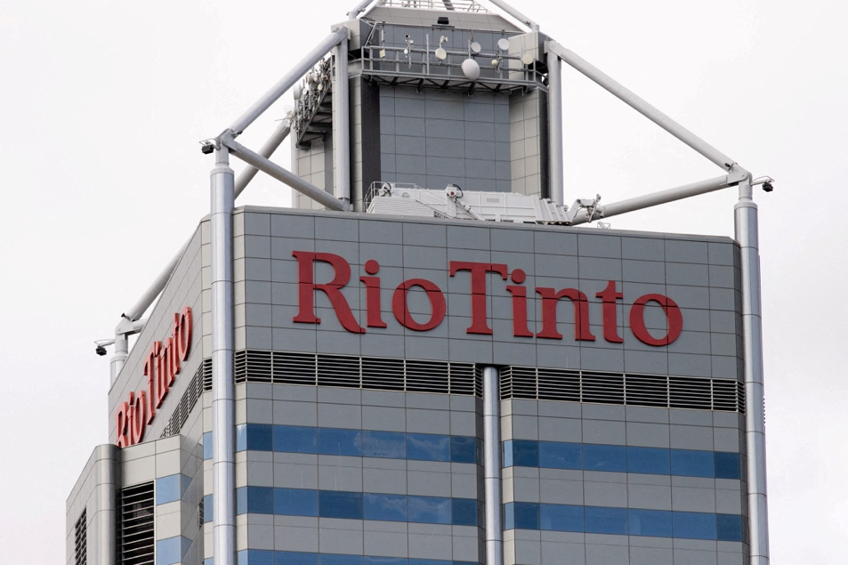
Table of Contents
Introduction 4
Task 1: Marketing Environment Analysis 5
1.1 The Natural Environment as the Primary Marketing Environment Actor 5
1.2 Customers as the Secondary Marketing Environment Actor 7
Task 2: Strategic Growth and Competitive Positioning 9
2.1 Evaluating Growth Opportunities Using the Ansoff Matrix 9
2.2 Achieving Competitive Advantage Through Sustainable Differentiation 11
3.3 Strategic Recommendations 13
Task 3: Critical Reflection on the Use of Artificial Intelligence 14
References 16

Introduction
The mining industry has competed traditionally via operational efficiency, cost leadership and production capacity. Hence, growing concerns related to climate change, responsible resource extraction, and greenhouse gas emissions have fundamentally changed the competitive landscape. Today, mining organisations are increasingly assessing the quality and cost of the products along with how responsibly those products are manufactured, produced, and communicated to customers. Marketing therefore plays a more strategic role by enabling organisations demonstrating the environmental performance, strengthen long-term customer relationships and build stakeholder confidence (Kotler et al., 2024).
Rio Tinto is considered as one of the world’s leading mining companies, which is operating in almost 35 countries and supply aluminium, copper, iron ore, lithium, and other minerals which are crucial for renewable energy systems, modern infrastructure, and electric vehicles (Rio Tinto, 2025a). Although demand for these minerals is expected to increase with the shift of economies towards decarbonisation, Rio Tinto deals with increasing pressure to minimise emissions, provide greater transparency and improve environmental performance throughout its supply chain.
Instead of viewing sustainability only as an environmental obligation, this report evaluates how sustainability has become a source of competitive marketing edge. The report critically evaluates the impact of Natural Environmental and Customers as two major external marketing environments factors impacting the company’s transition towards lower-carbon products. Based on this analysis, the report also analyses suitable growth strategies using the Ansoff matrix before making recommendations about a suitable competitive positioning strategy which is capable of supporting sustainable growth in long-term.

Task 1: Marketing Environment Analysis

1.1 The Natural Environment as the Primary Marketing Environment Actor
One of the most influential external marketing environmental factors affecting the business strategy of Rio Tinto is natural environment. Since environmental factors were previously considered mainly as operational concerns, they now influence customer expectations, competitive positioning and corporate reputation. Climate change, resource sustainability and carbon reduction commitments have transformed the way mining companies market their products as well as communicate value to stakeholders (Kotler et al., 2024).
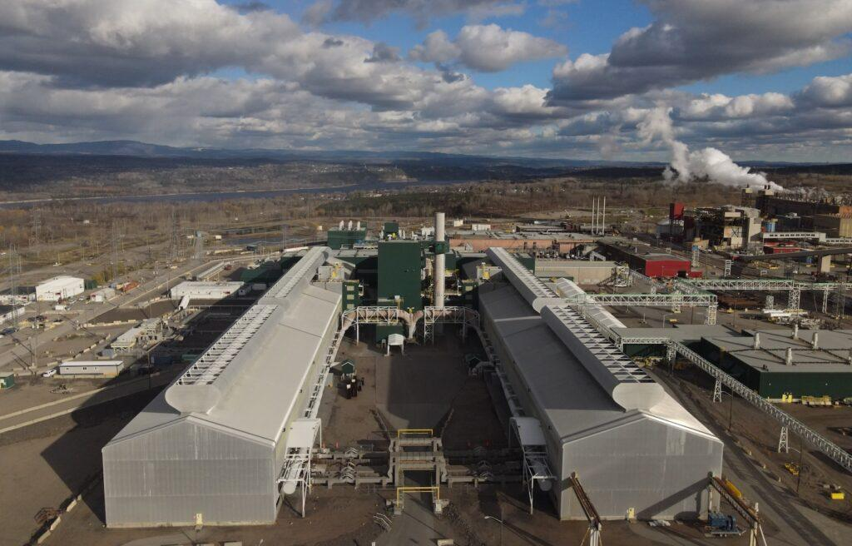
Figure 1 Rio Tinto's mining operations
Source: Rio Tinto (2025)
With the global shift towards a low-carbon economy has significantly increased the demand for different minerals like aluminium, copper, and lithium, which are required for modern infrastructures, electric vehicles and renewable energy systems. This therefore creates a significant growth opportunities for business like Rio Tinto, whose portfolio is linked with the industries who are working for decarbonisation. However, customers and investors increasingly expect these materials to be produced in a sustainable manner with strong environmental transparency and lower carbon emissions (International Energy Agency, 2025).
By recognising this shift, Rio Tinto has induced sustainability into its corporate strategy by investing in renewable energy, developing lower-carbon production technologies, and improving operational efficiency. The company has made the commitment to reduce operational emissions alongside innovation projects like low-carbon aluminium production. These initiatives strengthen the market position of Rio Tinto by demonstrating that environmental performance can create the customer value instead of simply satisfying regulatory requirements (Rio Tinto, 2025a).
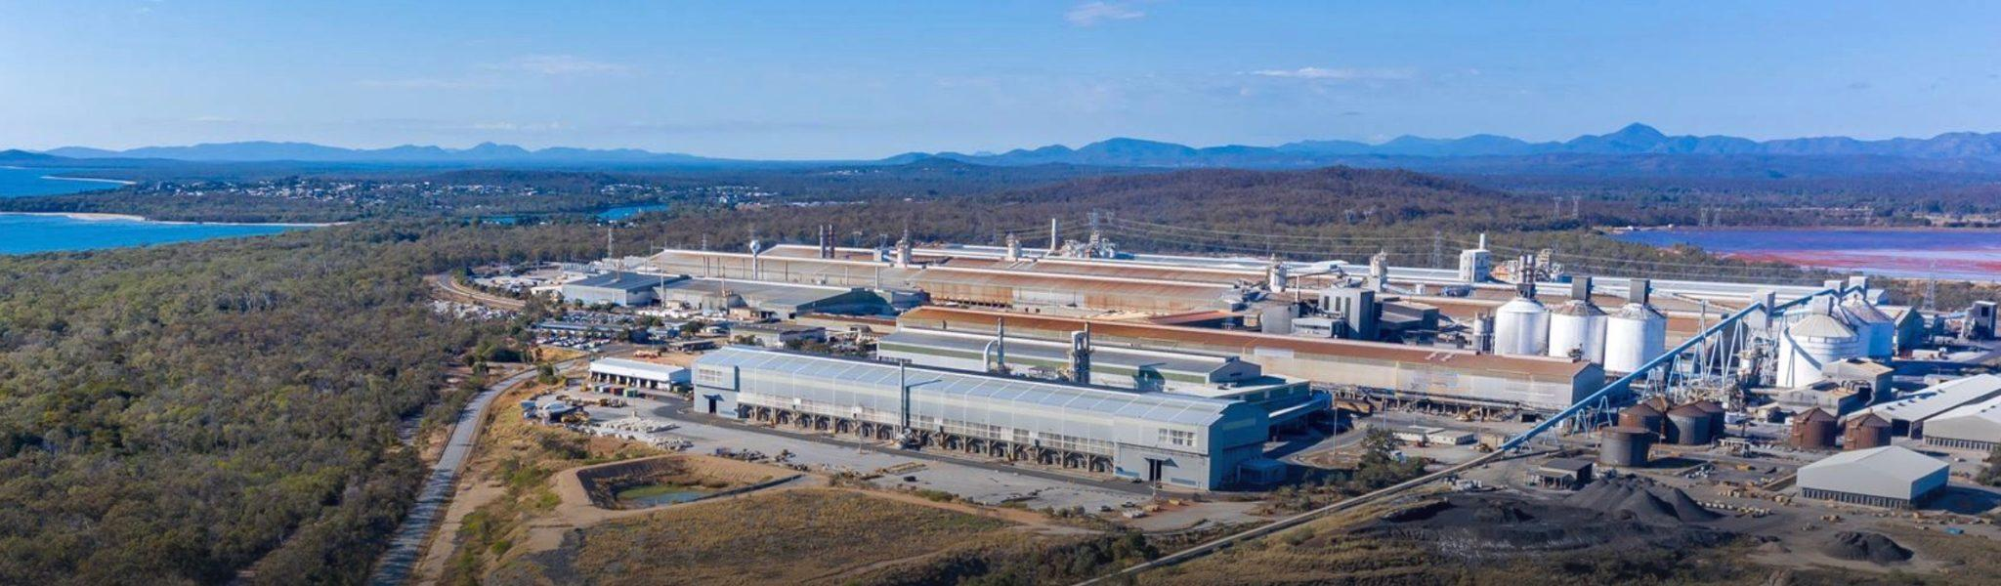
Figure 2 Rio Tinto's iron ore mining operations illustrating the natural environment and resource base that support its global mining activities.
Source: Rio Tinto (2025)
The natural environment also influences directly the brand reputation of Rio Tinto. Industrial customers increasingly evaluates suppliers using Environmental, Social, and Governance (ESG) criteria before committing to the long-term contracts. Investors, in the similar line, evaluate climate-related risks when making decisions for investments. Consequently, sustainability has become a source of competitive differentiation, allowing the company to position itself as a reliable supplier for the company looking for minimising the emissions across their own supply chains.
Regardless of these opportunities, there are still few challenges. Achieving lower-carbon production needs substantial amount of investment whereas mining activities continues to deal with the criticism regarding land disturbance, biodiversity loss, and greenhouse gam emissions. These concerns indicates that sustainability claims need to be supported by measurable environmental improvements instead of only promotional marketing. Additionally, many emissions occur across the broader value chain, which means that success of Rio Tinto also relies on collaboration with industry partners and customers.
Overall, the natural environment has changed from being an external operational constraint into a strategic marketing factor. Organisations who are able to combine environmental responsibility with transparent communication and product innovation are better positioned to strengthen the trust of customers, achieve long-term competitive edge and improve corporate reputation.

1.2 Customers as the Secondary Marketing Environment Actor
For shaping the transition of Rio Tinto towards lower-carbon products, customers have become one of the most influential external marketing environmental factor. Unlike traditional mining markets where purchasing decisions were mainly based on quality, price, and supply reliability, today’s industrial customers increasingly consider sustainability performance at the time of selecting suppliers. This shift reflects the growing pressure on businesses to minimise carbon emissions across their whole value chain, making environmental responsibility a significant purchasing criterion instead of an optional consideration (Kotler et al., 2024).
The customer base of Rio Tinto includes automotive companies, steel manufacturers, electronic producers, and renewable energy developers, all of which are experiencing increased stakeholder and regulatory pressure to achieve net-zero emissions. As a result, these organisations look for suppliers who are capable of providing responsible sources materials with lower level of carbon emissions. For example, manufacturers of electric vehicle needs copper and aluminium which only meet technical specifications but at the same time also contribute towards their own environmental commitments. Subsequently, customers now expect mining companies to disclose transparent information on carbon intensity, responsible sourcing of material and environmental performance throughout the production process (International Energy Agency, 2025).
Identifying these changing expectations, Rio Tinto has made a huge investment in partnerships and technologies which supports the production of lower-carbon aluminium and other critical minerals. The company has also worked in strengthening its sustainability reporting and climate disclosures, enabling customers to develop better understanding of the environmental impact of materials they purchase. These initiatives helps in boosting customer confidence whilst supporting the company’s position as a supplier which supports industrial decarbonisation instead of simply extracting and selling raw materials (Rio Tinto, 2025a).
However, responding to customer expectations also indicates towards a significant challenges. Lot of industrial buyers demand environmentally responsible materials while remaining highly sensitive to cost, which creates a pressure on Rio Tinto to balance the sustainability investments with competitive pricing. Additionally, customer expectations continue to evolve as new environment related standards and reporting framework comes into picture. A sustainability initiative which creates competitive edge today might become an industry requirement in the span of few years.
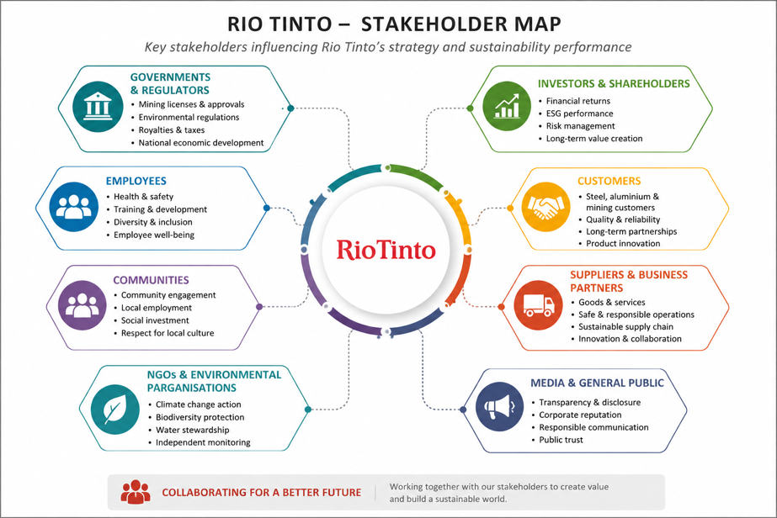
Regardless of these challenges, changing customer behaviour points out towards a significant opportunity for Rio Tinto to strengthen long-term relationships using value chain instead of price competition. By collaborating with customers for developing an innovative lower-carbon solutions and providing independently verified sustainability data, the company can boost trust, improve brand reputation and secure long-term supply agreements. Therefore, customers are not only purchasers of Rio Tinto’s products but strategic partners impacting product development, company’s long-term competitive position, and marketing communication.

Figure 3 Stakeholder Mapping
Source: Self

Task 2: Strategic Growth and Competitive Positioning

2.1 Evaluating Growth Opportunities Using the Ansoff Matrix
The external marketing environment represents that the future growth of Rio Tinto will depend on its ability to respond to increasing demand for responsibly produced minerals whereas supporting the global transition towards a low-carbon economy. As government strengthen climate policies and industrial customers puts great emphasis on sustainable sourcing, the organisation requires a growth strategy which aligns commercial objectives with environmental innovation. the Ansoff Matrix provides with a useful framework for assessing the strategic options available to Rio Tinto by taking into consideration growth through both new and existing markets (Ansoff, 1957).
Market penetration, which emphasises on boosting sales of existing products within existing markets, provides with a relatively limited opportunities. Rio Tinto already holds a substantial market share in aluminium, iron ore, and copper production, making substantial expansion through existing products increasingly difficult. Even though operational efficiencies and stronger customer relationships might improve profitability, this strategy do not sufficiently respond to the growing market preference for lower-carbon materials.
Another potential growth option is been provided by market development offers by introducing existing products into new geographical markets. Demand for critical minerals is growing continuously across emerging economies investing in renewable energy infrastructure. However, it is difficult to provide sustainable performance alone with the geographical expansion because customer expectations regarding environmental performance are becoming increasingly consistent across different global markets. Emerging new regions without strengthening product sustainability would therefore only offer the growth in short run.
The highest level of strategic risk is presented by diversification. Entering a completely new business, industry or developing an unrelated business activities will require a substantial investment whereas moving Rio Tinto away from it already established expertise in mineral and mining processing. Even though diversification might create future opportunities, it will reduce management focus at a time when substantial investment is already needed to decarbonise existing operations.
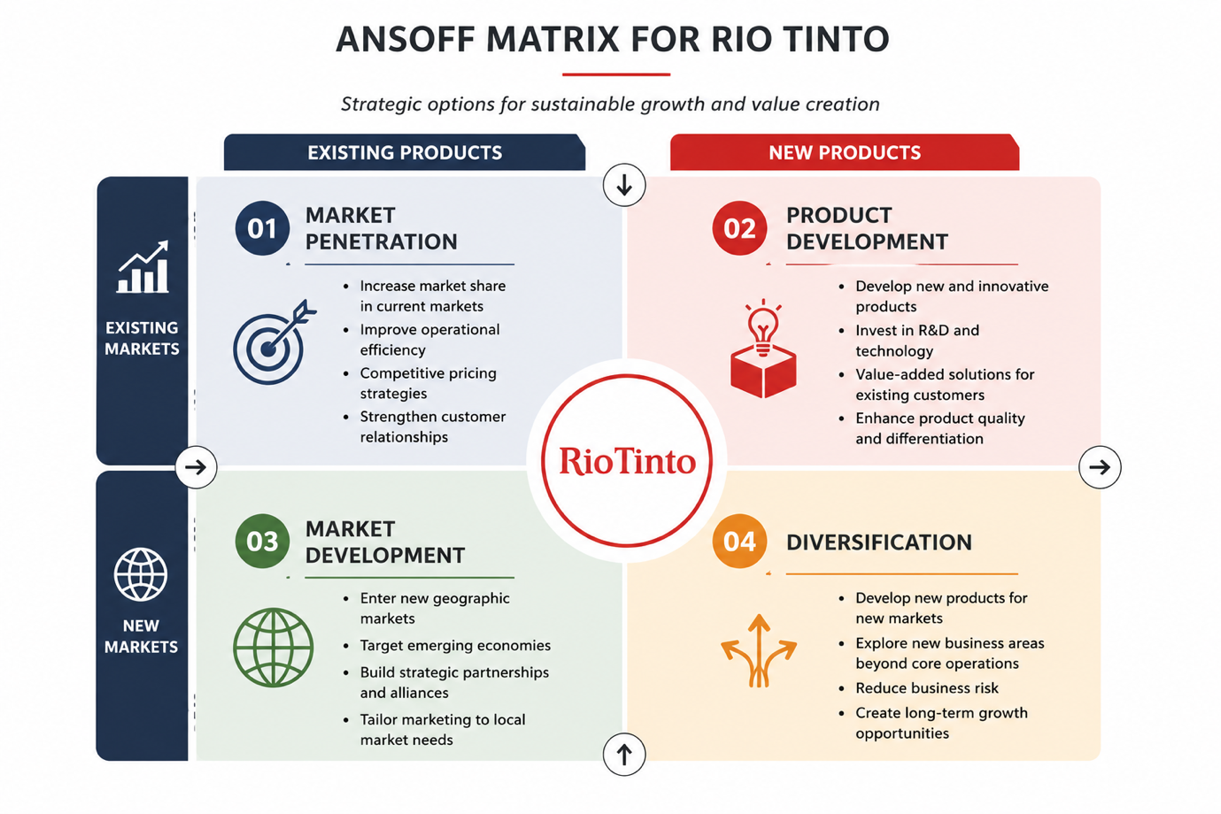
Subsequently, Product Development represents the most appropriate growth strategy. Instead of expanding into an unknown market, Rio Tinto can strengthen its position by responsible sourced copper, lower-carbon aluminium, innovative processing technologies, and renewable-powered mining operations. This approach enables the company for delivering greater value to already existing industrial customers whilst responding directly to changing sustainability expectations. By improving the existing products instead of replacing them, Rio Tinto can reinforce loyalty of customers, enhance brand credibility and position itself as a strategic partner in industrial decarbonisation instead of simple a supplier of raw materials.
Figure 4 Ansoff matrix
Source: Self

2.2 Achieving Competitive Advantage Through Sustainable Differentiation
While product development helps Rio Tinto with a clear path for growth, achieving long-term success will highly depend on how effectively a company is able to differentiate itself from its competitors. According to Porter (1985), organisation can achieve competitive advantage through cost leadership, focus or differentiation. Although mining companies have competed traditionally on operational efficiency as well as cost of production, these factors are becoming less important as industrial customers increasingly prioritise supply chain transparency, sustainability, and responsible sourcing when selecting suppliers.
For Rio Tinto, a differentiation strategy focused on sustainable value creation provides the most competitive position. Instead of competing only on price or production volume, the company is able to distinguish itself by supplying responsibly sourced copper, low-carbon aluminium and other critical minerals supported by transparent environmental reporting. This strategy allows Rio Tinto to move beyond being merely a commodity supplier and position itself as a strategic partner which can help customers achieve their own ESG and decarbonisation objectives. As a result, instead of only being a compliance requirement, sustainability becomes a source of customer value (Porter and Kramer, 2011).
Rio Tinto has already secured this position through investments in renewable energy, innovative partnerships, emissions reduction technologies, including initiatives to produce lower-carbon aluminium. These efforts enhance the reputation of the company whilst building stronger relationships with customers operating in different sectors like electric vehicles, advanced manufacturing, and renewable energy, where demand for sustainably produced materials continues to grow (Rio Tinto, 2025b).
However, differentiation based on sustainability is not likely to remain a unique advantage indefinitely. Competitors like Anglo American and BHP are making same investments in decarbonisation and cleaner production technologies, increasing a competitive pressure across the industry. To safeguard its leadership position, Rio Tinto should continue its investment in technological innovation, independently verified carbon reporting and digital traceability. By consistently demonstrating measurable environmental improvements alongside with supply reliability and product quality, the company is able to create a competitive edge which is both difficult and credible for competitors to replicate.
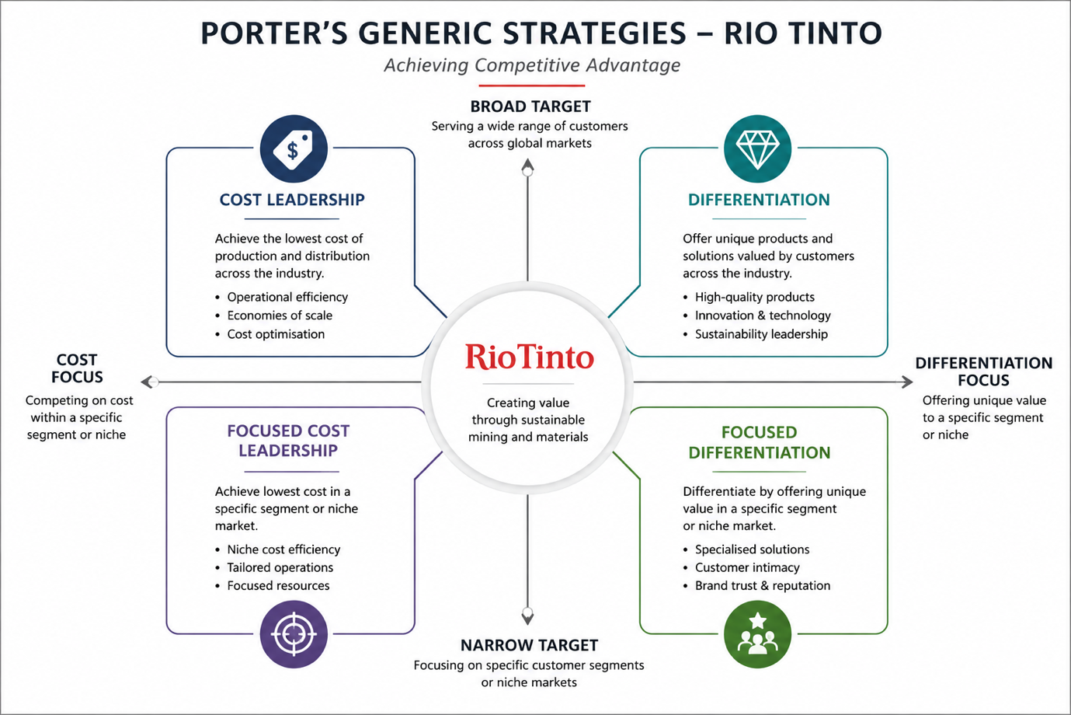
Figure 5 Rio Tinto Porter's Generic Strategies
Source: Self

3.3 Strategic Recommendations
Based on the analysis, Rio Tinto should prioritise Product Development whereas strengthening its differentiation strategy through measurable sustainability initiatives.
First, the company should accelerate the investment in lower-carbon mining technologies and renewable-powered operations to further minimise the carbon intensity of its products. Demonstrating measurable environmental improvements will strengthen the confidence of the customers and support premium market positioning.
Second, Rio Tinto needs to expand strategic partnerships with the manufacturers of electric vehicle, renewable energy developers and steel producers to jointly develop the innovative lower-carbon materials. Collaborative innovation will help in improving customer retention while developing a solutions that competitors might find difficult to replicate.
Third, the company should enhance the transparency in supply chain by introducing digital product traceability and independently verified carbon reporting for its major products. Providing reliable environmental information for the customers will reinforce the trust and support increasingly stringent ESG reporting requirements.
Finally, Rio should strengthen its marketing communications by positioning itself not only as a global mining company but as a strategic partner enabling decarbonisation of the industry. This shift from commodity supplier to sustainability partner reflects towards the changed customer expectations and support the long-term competitive edge. By combining the continuous product innovation with customer collaboration, and transparent environmental performance, Rio Tinto will be better positioned to achieve the sustainable growth while maintaining the leadership within the dynamic global mining industry.

Task 3: Critical Reflection on the Use of Artificial Intelligence
Artificial Intelligence (AI) usage was very limited and was done in a responsible manner during the completion of this report. Its primary role was to provide the support at the initial stages of the research process and helped in identifying the suitable company for doing the analysis along with providing an overview of current sustainability trends within the global mining industry. After researching about different organisations, AI-assisted research helped in narrowing down the selection to Rio Tinto because of its strong focus on lower-carbon products and the availability of recent company reports and industry information. This initial guidance made my research process smooth and efficient by providing direction before diving into detailed independent research.
AI was also used to identify the relevant academic topics as well as current trends and industry developments which required detailed investigations. However, all the information and data provided by AI was only treated as a starting point instead of a verified data. All company-specific information, strategic initiatives, and statistics were independently checked against the annual report of Rio Tinto, climate change report, academic journal articles, and other credible industry sources before mentioning it in the report. In different instances, AI-generated information lacked the supporting evidence or was too generic to be included in the academic work. Where this occurred, the information was either verified against the reliable sources, rewritten to present the evidence in a more accurate manner or omit completely. This process restated the importance of critically assessing the AI-generated content instead of accepting it without question.
The analysis, discussion, and recommendations included in this report was built through my own understanding of the module concepts and my understanding of the available evidence. Decisions like selecting the Natural Environment and Customers as the key marketing environment actors, recommending the product Development using the Ansoff Matrix and evaluating the Porter’s differentiation strategy were based on my own interpretation of academic literature as well as company information. AI do not determine the conclusions or arguments presented in this reports but instead supported the early stages of the process of research.
Finally, AI was used to proofread the report so that there is no grammatical errors, improve the sentence formations and enhance overall quality and readability of the report. Even though these suggestions improved the quality of overall writing, before accepting the recommendations, each of them were reviewed to ensure that work accurately reflected my own understanding as well as writing style.
Overall, this experience demonstrated that AI can be considered as a valuable tool for initial research and proofreading. However, it also highlighted that critical thinking, independent reading, and careful verification remain important for producing ethical, accurate and academically credible work.

References
- Ansoff, H.I. (1957) ‘Strategies for diversification’, Harvard Business Review, 35(5), pp. 113–124. Available at: https://www.jstor.org/stable/24128211
- International Energy Agency (2025) Global Critical Minerals Outlook 2025. Paris: International Energy Agency. Available at: https://www.iea.org/reports/global-critical-minerals-outlook-2025
- Kotler, P., Armstrong, G., Harris, L.C. and He, H. (2024) Principles of Marketing. 19th edn. Harlow: Pearson. Available at: https://www.pearson.com/en-gb/subject-catalog/p/principles-of-marketing/P200000010651
- Porter, M.E. (1985) Competitive Advantage: Creating and Sustaining Superior Performance. New York: Free Press. Available at: https://www.simonandschuster.com/books/Competitive-Advantage/Michael-E-Porter/9780684841465
- Porter, M.E. and Kramer, M.R. (2011) ‘Creating shared value’, Harvard Business Review, 89(1–2), pp. 62–77. Available at: https://hbr.org/2011/01/the-big-idea-creating-shared-value
- Rio Tinto (2025a) Annual Report 2025. London: Rio Tinto. Available at: https://www.riotinto.com/en/invest/reports/annual-report
- Rio Tinto (2025b) Climate Reporting 2025. London: Rio Tinto. Available at: https://www.riotinto.com/en/invest/reports/climate-reporting

