

A Study of Spark-based data visualization

by
Dongsheng Cao

Supervisor: Kemi Ademoye
Second Marker: Mabrouka Abuhmida

Project submitted as part of the requirements for the award of Applied Computing

August 2019

Declaration Form and Form of Consent

DECLARATION

I, Dongsheng Cao declare that I am the sole author of this Project; that all references cited have been consulted; that I have conducted all work of which this is a record, and that the finished work lies within the prescribed word limits.

This has not previously been accepted as part of any other Masters' submission.

Signed : .....Dongsheng Cao............

Date : ......22/08/2019..................

FORM OF CONSENT

I ____________________________ hereby consent that my Project, submitted in candidature for the M.Sc. Applied Computing , if successful, may be made available for inter-library loan or photocopying (subject to the law of copyright), and that the title and abstract may be made available to outside organisations.

Signed ____Dongsheng Cao________

Date ______22/08/2019___________

Where necessary replace M.Sc. Applied Computing with your named award.

Abstract

In this era of big data, large numbers of various kinds of data will be generated in many fields such as e-commerce sites, scientific researches, Internet of Things, cloud computing and so on. To maximize the use of these data, data mining and data visualization are the most popular ways to meet this demand. From the point of data visualization, this report will analyse road safety data visually and optimize the performance of web-based data visualization application by using Spark platform.

Table of content
Declaration Form and Form of Consent 2
Abstract 3
1 Introduction 5
1.1 The aims and objectives of the project 5
1.2 The outline of the report 5
2 Literature Review 7
2.1 Big data visualization 7
2.1.1 Overview of information and data visualization of big data 7
2.1.2 Data visualization solutions 7
2.1.3 Challenges of information visualization 8
2.2 Overview of charts for data visualization 8
2.3 An overview of frameworks or tools for web-based data visualization 10
2.3.1 Common JavaScript libraries for data visualization 10
2.3.2 Tools for geographic data visualization 10
2.4 The visualization for the road traffic data 11
2.4.1 Overview of visualization for road traffic data 11
2.5 Web application 12
2.5.1 An overview for various frameworks to develop web application 12
2.6 Optimizations 13
2.6.1 Optimizations in the field of map visualization 13
2.6.2 Optimizations of big data visualization related to the distributed visualization 14
3 Research Methodology 16
3.1 The philosophy of the project 16
3.2 The approaches of the project 16
3.3 The strategies of the project 16
3.3.1 Document review 16
3.3.2 Software development 16
3.3.3 Case study 17
4 Development Methodology 18
4.1 Feature-driven development (FDD) 18
4.1.1 Develop overall model 19
4.1.2 Build feature list 19
4.1.3 Plan by feature list 20
4.1.4 Design and build by feature 21
5 Development 22
5.1 Pre-processing of the data set and importing and managing it into database 22
5.2 Constructing web application in web module 25
5.3 Basic web-based visualization in web module 28
5.4 Building and configuring Spark cluster 31
5.5 Building web-based visualization using web module and spark module 33
6 Results and Discussion 36
6.1 The basic data visualization of the data set 36
6.2 The comparison of the local mode and the Spark mode 38
7 Conclusions and Recommendations 45
8 Reference 47
Appendix 52

- Introduction

At present, our world has entered the era of big data. With the rapid development of the Internet, Internet of Things, cloud computing and other information technologies, and as the human world's political, economic, military, scientific research, life and other aspects continue to integrate, resulting in a huge amount of data being generated beyond any previous era. Smart mobile devices, sensors, e-commerce sites, social networks are generating different types of data at all times. Therefore, it is becoming significant and worthy to find more information from data. Data visualization especially can not only display data in an intuitive way, but also can help people to find more information from it.

Currently, data visualization and data mining have been seen as the techniques to find more information from large scale data. In other words, the function of data mining is to explain data set at the deep level, and the function of data visualization is to illustrate data at the display level [1].

Hadoop and Spark have successively become research hotspots in the field of large data analysis industry and the Spark platform is popular to be used in the data visualization area in the recent years [2].

With information visualization becoming more important [3], this project will look at the web-based data visualization to realize the reasonable data visualization of the data set. What is more, the Spark platform will be used to improve the performance. Specifically, the Spark platform is responsible of the computing works to generate needed result data which will be used by web data visualization application to realize the data visualization analysis of the data set.

  - The aims and objectives of the project

This section will look at the aims and the objectives of this project. Specifically, there are two aims of this project. The first is to build a web-based data visualization application to realize the reasonable and the effective data visualization analysis of the road traffic data. The another one is to realize a mode that the web-based data visualization application uses Spark platform for computing and storing result data in the HBase and then the web application just needs to use the result data from the database to realize data visualization analysis on the web page to improve the performance of it.

There are some objectives needed to be achieved of this project as following:
- The pre-process of the data set and importing and managing it into the database.
- To build a web application for data visualization of the data from database.
- To build and configure a Spark cluster will be responsible for computing area of the web-based data visualization application.
- To compare the performance of the web-based data visualization application with the local mode and the mode computing on the Spark platform.

  - The outline of the report

- Chapter 1 describes the introduction of the report including the overall aims, objectives and the structure of the report.
- Chapter 2 describes the literature review of the project and the review of literatures investigating the area of data visualization, charts for data visualization, the frameworks or tools for web-based data visualization, the visualization for the road traffic data and the optimizations of the web-based data visualization application.
- Chapter 3 describes the research methodology of the project explaining how to conduct this project.
- Chapter 4 describes the development methodology of the project using the method feature-driven development of agile development methodology to build the whole project.
- Chapter 5 describes the detailed development process of the project, each feature of which includes the design and the development of it.
- Chapter 6 describes the result and the discussion of the development according the aims and the objectives in the Chapter 1.
- Chapter 7 describes the conclusions and the recommendations of the project including the conclusions about the project, the challenges faced during this period and the suggestions for continuing project research.

- Literature Review

The review of literature investigates the area of data visualization, charts for data visualization will be used in this project, the frameworks or tools for web-based data visualization, the visualization for the road traffic data and the optimizations of the web-based data visualization application.

  - Big data visualization

This section will introduce some definitions and functions of information visualization and data visualization in the era of big data, current solutions of data visualization and the challenges in terms of data visualization.

    - Overview of information and data visualization of big data

With the rapid development of the Internet, Internet of Things, cloud computing and other information technologies, and human world's political, economic, military, scientific research, life and other aspects continue to integrate, resulting in the large-scale data being generated different from any era.

In this era, information visualization is becoming more important and Friendly said [3], it is a broad term that almost anything such as maps, tables, graphs and even, text whether it is static or dynamic, providing some ways to find information, determining what the answers are for the questions, finding relations and maybe understanding things that cannot been found in the other forms. In addition, Friendly defined data visualization as the modern equivalent of visual communication involving the study and the creation of a means to visually represent data. Rouse describes data visualization as a general term that helps people to apprehend the importance of the data in reality by placing it in a visual situation [4]. Besides, Ren Li [5] said that one picture speaks louder than thousands of words and more than 80% of the information generated from the visual system. While the large-scale data is generated with an intuitive and visual form, people can always get a glimpse of the information hidden behind the data and transform knowledge and wisdom.

In recent years, due to the booming progress of the data volume in terms of various fields and as users' demands for browser-side data visualization are growing, Randall said [6] that the World Wide Web (WWW) and the intranets is becoming a popular medium for the various applications of information visualization.

    - Data visualization solutions

Wang [7] said, there are three main types of data visualization solutions:
- The first type is a data visualization solution for programmers. This kind of solution provides users with visualization toolset or development framework. It requires users to have professional development skills and construct data visualization solutions through programming.
- Furthermore, the second category is domain-specific visualization solutions, which are highly customized and have versatility for a particular domain or problem, such as the TripVista system developed by Guo et al. [8] in 2011 and visualization technology is used to analyze only microscopic data of vehicle trajectory at intersections, the model of which ignores macssssro information. Another example is that an interactive visual analysis system based on taxi trajectory data proposed by PU et al. [9] in 2013 that focuses on the analysis of the characteristics of the inflow and outflow in different areas of the city over time. In addition, Jiang Xiaorui [10] in 2015 proposes a taxi starting point visualization.
- Finally, the third type is a general data visualization solution, which has high reusability and flexibility, but the visualization effect is single.

    - Challenges of information visualization

Cui et al. [12] describes 3 main trends of the current research of big data visualization:
- Objects are expanding from traditional single data sources to multi-source, multi-scale and multi-dimensional data.
- Users are expanding from a small number of expert users to a wide range of non-specific groups.
- Visualization and visual analysis in the framework of big data and data science.

There are, however, some challenges. Wong et al. [11] described that ten challenges in terms of the core topics in the field of visual analysis involving deep integration of cognition, visualization and human-computer interaction related to the interaction and user interfaces, large-data visualization, databases and storage, data transport and so on.

Cui et al., Wong et al. and He et al. [11-13] concluded that the challenges of big data visualization include:
- The data scale is large, and it has exceeded the limit of processing ability of single computer, external model and even small computing cluster. However, the current software and tools are not efficient enough. It is necessary to explore new ideas to solve this problem [12].
- In the process of data acquisition and analysis, it is easy to produce data quality problems, so we should pay special attention to the uncertainty of data [13].
- Data changes rapidly, often for the streaming data. It is necessary to find a real-time analysis and the method of visualization for the streaming data [11].
- Faced with the high-dimensional data. At present, the software system is mainly based on statistics and basic analysis, and the ability to analyse it is inadequate [12].
- The multi-source data always has different types and structures, as well as the present methods are insufficient in supporting heterogeneous and unstructured data. Visual analysis is a method to find and solve the internal relationship of heterogeneous data [12].

  - Overview of charts for data visualization

This section will introduce various kinds of data visualisation charts which will be used with the road traffic data in this project. In addition, the basic definition, functions, advantages and disadvantages of each chart will be introduced as well.

There are many charts for data visualization, such as commonly used tables, bar charts, line charts, pie charts, scatter plots and bubble charts. There are also some chart types specially used for various data relations and combinations, such as timeline, data flow diagram, database ER (entity relationship) diagram [14], etc. In addition, in the field of data visualization, parallel coordinates, tree graphs and reticular graphs are commonly used for geographic data sets, as these graphs show information more comprehensively and vividly. The content below is a brief introduction to some common graphs for visualization relevant for this project.

- Line chart – Andreas [15] describes that line charts are mainly for data with hierarchical arrangement, time characteristics and regularity. The advantage of line graph is that it can clearly reflect the development law and trend of describing objects and it is suitable for two-dimensional data sets.

- Pie chart [16] - The pie chart is mainly for data with integration. And the two characteristics of pie chart are integrated and the quantitative relationship between part and part, whole and part. The advantage of pie chart is that it can intuitively reflect the data with image thinking such as region, percentage, area, etc. It can also be made into pie chart mainly for the data with integrity. The two characteristics of pie chart are integrated and the quantitative relationship between part and part, whole and part. The advantage of pie chart is that it can directly reflect the data with image thinking such as region, percentage, area, etc. It can also be made into fan chart, stereo pie chart, plane pie chart, single-layer circular pie chart and multi-layer circular pie chart. In the meanwhile, the disadvantage of it is that people are not sensitive to the size of the area.

- Bar chart [17] – Bar charts use rectangular bars to represent data for category and bar graphs usually use the height of bar or column to represent the size of the value. Bar graphs are suitable for displaying the comparison or continuity of data. The data classification of bar graphs can be incomplete, or the data groups cannot be juxtaposed. Reflecting the specific data in each group, and it is acknowledged that the advantage of bar graph is that people can clearly find how much data by the length of straight bar.

- Heat map – Heat map is a data visualization technology for visualizing and analyzing multivariate datasets and is commonly used in the field of traffic data. It is usually color-coded numerically and arranged in a matrix or square format. It presents data spatial distribution in a two-dimensional plane or map and is widely used in many fields [18]. Especially, it is no doubt that heat map always can be used to display various kinds of data on the map to display more information of the data set. Heat maps are especially useful for geographical datasets such as road traffic data which will be used in this project.

Recently, heat map has been popular to analyse a variety of data. For example, many researchers have successfully applied heat maps to visual analysis of eye movement data to effectively summarize and express the cumulative distribution of visual attention of users [19-20]. Ma et al. [21] also used heat maps to display base station data based on population mobility; Röthlisberger etc. [22] used configurable heat maps to provide developers with effective support for task-based navigation in a software-integrated development environment. Another example use case is the tool by Gove et al. [23] which designed and implemented a dynamic social network statistics and content data. Based on the heat map and matrix visualization tool - NetVisia, the changes in the attributes of the social network nodes are presented to the user, thereby enabling users to explore the social network to evolve information over time. Kopp et al. [24] found that in the analysis of multi-step aggregate simulation data, the application of the heat map visualization method can help the user to effectively identify the high active area and the low active area, thereby improving accuracy of decision analysis using the neural network model.

  - An overview of frameworks or tools for web-based data visualization

This section will look at a variety of web-based frameworks or tools used for data visualization for both common data sets and the data sets with geographic data information such as the coordinates information of each record.

    - Common JavaScript libraries for data visualization

With the data era, many web-oriented lightweight data visualization tools have emerged, and a paper written by Tobias [25] introduces many kinds of web-based data visualization frameworks such as amCharts, D3.js, Canvas.js, Webcharts, morris.js and so on. In this paper, 67 different tools have been used to test for angular 5 based applications and the final decision of which shows that regarding to the specified requirements of clients, there are 2 tools, D3.js and Chart.js, were found to meet the requirements, which shows these two tools are easy and quick to be integrated in an application. D3 [26] is a JavaScript library that uses dynamic graphical display data based on HTML, SVG (Vector graphics) and CSS to bind arbitrary data to a DOM (Document Object Model) element, and implement data-based transformation on the DOM, and display data through interactive operations such as graphics transformation and zooming in and out. D3 has good portability, shortcomings using SVG are that it cannot support more than one billion points of data. However, heatmap.js drawing with canvas cannot do anything in the face of large data volume. Other JavaScript libraries similar to D3 are Baidu's ECharts4, Python language library Matplotlib5, and Bokeh6 and so on.

ECharts [27] is a very excellent visual chart library launched by Baidu Company. The bottom layer relies on the Canvas class library ZRender [28], and Baidu ECharts are all free [27]. ECharts has a wide range of applications in China to be used on various kinds of devices such as mobile phones, browsers, personal computers and so on. It provides rich visual graphics and supports the mixed use of various graphics and it has strong interactivity, easy to use, flexible customization and other advantages. Through incremental rendering technology, with various detailed optimization, ECharts supports the visualization of tens of millions of data quantities and supports tens of millions of data quantities with fluent and stable interactive visualization.

    - Tools for geographic data visualization
Map visualization is an excellent method to find more information from the geographic data. Furthermore, there are some excellent resources to display geographic data on the map such as Google Maps [29], Openlayers [30], ArcGIS [31] and Baidu Maps and so on.
Google Maps [23] is a Browser/Server-based service software launched by Google in 2006, which can search and browse maps in Web browsers. It uses the same map data source as Google Earth. Google Maps map data can be divided into three types: vector map, satellite image and terrain data. The satellite image and vector map data of Google Maps are transmitted in tile form. The Google Maps data server supports not only the spatial data request service of the browser client, but also the satellite image data required in the application program developed by the user. In addition, Maps JavaScript API [32] provided by Google Maps helps developers to develop interactive map to the website using developers’ own data or imagery to customize it and the features of Maps JavaScript API can be used to modify four basic map type such as terrain, hybrid, satellite and roadmap in terms of controls, events, layers, styles, various services and many kinds of libraries.
Similarly, there are some other tools that can display geographic data on the map as well such as Baidu Map API [33], which is the program interfaces mainly for the web application written in the JavaScript language, which can help people build various and interactive map applications in the website, support browser-based map application development on PC and mobile terminals, and support map development with HTML5 features. What is more, the JavaScript API of Baidu Map supports HTTP and HTTPS. It is open to the public free of charge and can be used directly. There is no limit on time consumption that the interface is used. In addition, Mapv [34] is an open source geographic information visualization library, which can be used to display a large number of geographic information data such as points, lines and planes. It also supports the use of direct dotting, heat map mapping, grid, aggregation and other display modes under large data volume and it is developed by canvas and compatible with most current browsers.
  - The visualization for the road traffic data

This section will look at the data visualization about road traffic data and some problems about it.

    - Overview of visualization for road traffic data

With the development of society and the rapid increase of traffic trips, road network construction does not match traffic trips, traffic congestion is becoming more and more serious and with the development of GPS and other related technologies, it is possible to obtain a large number of traffic trip data, which are large in volume and high in dimension, and it is difficult to analyze directly [35-37]. Data visualization technology can visualize road traffic operation status by analyzing traffic spatio-temporal data, and provide powerful data support for vehicle scheduling and route planning [38-39].

At present, with the increase of traffic accidents, the main research directions are mainly divided into two perspectives: the first one is the perspective of big data algorithm, the perspective of data association, collision and mining, to analyse and process the accident data. Another one is the perspective of data reasoning. In details, starting from the solution method, using visualization method and human-computer interaction method, people always research how to improve people's understanding of complex data, obtain more valuable clues, and integrate them into large data analysis [40].

Peng Xuan et al. [41] pointed some problems in the field of big data visualization with traffic accident data:
- Data processing: Because the location information of traffic accidents is mostly collected by road name and stake number that is the marks along the road with the certain intervals, and lack of effective means of matching traffic accident information with road vector data and conversion of stake number to longitude and latitude, a large number of traffic accident information cannot be quickly mapped and analysed related to spatial location.
- Data visualization, data expression is still based on column graph. With the increase of accident data and the increase of data items, the demand for analysis becomes more and more complex. The data visualization model needs to better reflect the overall structure and specific details of the data, explore the rules and trends of traffic accidents based on multi-dimensional data expression.
- System implementation needs to be optimized urgently. Data storage, data access, data visualization rendering and other key technologies in the data environment can improve the efficiency of data reading and display, and can meet the requirements of human-computer interaction with high performance.

Asor et al. [42] combined the data mining technique to analyze and visualize road traffic accident data sets. In details, they use Rule Induction, Decision Tree, Naïve Bayes, and Batch X-Validation to classify data set and use bar chart to display the classifiers’ accuracy, Kappa of each model. In addition, in their paper, line chart and bar chart are also respectively used to display the summary number of yearly records of accident and the number of daily records of it. What is more, the data visualization of distribution of daily time attribute, distribution of daily severity attribute is also introduced in this paper.

Imawan et al. [43] introduced a tool of timeline visualization to improve finding more information from road traffic data set, which can be seen as an integrated application of data processing, communications, control and data visualization of the data from various sources such as a variety of sensors on the road, camera on the traffic light and the sensors in vehicles.

Huang et al. [44] focused on the passenger flow data of metro network in Shanghai to introduce an application of data visualization. In details, the paper is based on passenger flow data with the characteristics of vast scale, fast-change and so on. In this paper, the passenger flow data is graphically displayed in terms of the networks, stations, sections and the lines such as the chart of dynamic migration map of network, proportion of some stations, the analysis of line passenger flow and so on.

Fang et al. [45] focused on the problem that geographic data cannot be accurately located on the map because some data set lacks coordinates data in the process of data acquisition. In this paper, they proposed a method to realize the data of expressway accidents fast positioning, matching and finally verification on the pile map. In addition, this paper also provided the analysis of temporal visualization to help relevant department improve capabilities of road accident preventions.

  - Web application

This section will look at some techniques to build web application, some template engines and some techniques to make it easy for web application to operate data from database.

    - An overview for various frameworks to develop web application

Web means web or spider web. In the design of web pages, it is also called web pages. In today's society, it is mainly understood as the Internet and other technical fields. It refers to the general term of all Internet application technologies. It is the fact that Web development technology is based on the technology of the Internet to carry out some operations on the computer [46].

Web servers and Web browsers use information to communicate when accessing Web sites. Web development technology based on Java technology, which this project uses, absorbs the advantages of Java technology, and its more powerful functions can operate on different platforms [47].

Among the current design patterns of Web technology, the most popular model is the Model-View-Controller (MVC) model. Its function is very powerful. It can be regarded as a model in the field of software design [48]. Spring MVC is a module used to create Java Web applications in Spring framework [48]. It is built on the basis of MVC design pattern and can work with Spring without integration. Spring MVC includes six core components (6-7), including front-end controller, processor mapper, processor adapter, processor, view parser and view. In addition, for the interface reserved for processor and view components, which need to be developed separately, Spring MVC provides default implementations for other components, which can be used only by configuration [49]. The front controller (Dispatch-erServlet) is responsible for receiving user requests, forwarding requests, filling in the execution results of requests to the view and responding to requests. Handler-Mapping stores the corresponding relationship between the URL and the handler processor. The processor adapter is responsible for calling Handler. Handler is the component that specifically executes the request and returns ModelAndView which encapsulates the logical view name and the data to be displayed by the view component. ViewResolver is responsible for parsing logical view names into specific view resources and filling in the data that needs to be displayed. Views are the resources displayed to users. In addition, Spring MVC supports JSP, FreeMarker, Velocity, XSLT and other view types as well [50].

In the web application area, the framework consisted of struts, spring and hibernate (SSH) and the framework consisted of Spring, SpringMVC and MyBatis (SSM) are the seen as good frameworks to establish web application [51-52]. In details, SSH consists of Struts, Spring and Hibernate. Struts application includes three kinds of components such as controller component, model component and view component. Spring framework technology needs to accomplish two tasks. The first one is to make the existing technology easier to use. The other is to promote software developers to develop good programming habits. Hibernate is an excellent and open source Java data persistence layer framework technology, and is the mainstream object-relational mapping tool in Java software application development. The function of persistence is to complete the transition between instantaneous state and persistent state of data in program [51]. On the other hand, SSM [52] is very popular in recent years, which consists of Spring, SpringMVC and Mybatis. MyBatis is a persistent Layer Framework based on Java, which eliminates manual settings of almost all JDBC codes. In other word, MyBatis is a framework for managing data addition, deletion, and censorship [53]. What is more, SpringBoot framework greatly simplifies the configuration of various aspects of Spring applications, including the framework, configuration, development and deployment. SpringBoot is based on the principle of "convention first configuration", so that developers no longer need a lot of tedious template configuration [54].

Through the comparison of these frameworks, this project will adopt Springboot, FreeMarker and MyBatis to develop web application.

  - Optimizations

    - Optimizations in the field of map visualization

In view of the slow speed and low efficiency of data visualization, Sun Min et al. [55] proposed a layered method of levels of detail ( LOD ) based on grid division to realize real-time roaming of large data set. Ba Zhenyu et al. [56] in the study of flow field visualization, in order to more effectively visualize the flow field feature structure, an image space-based interactive system was established by using LOD, and the different detail levels of the flow field feature were controlled by the zoom operation. He Qun et al. [57] discussed the WebGIS big data visualization research in detail, and reduced the time cost of drawing by selecting some data points. However, in the process of drawing massive data, each time the data map is dragged, it needs to be redrawn in real time. Yang et al. [58] proposed a heat map-based geospatial spatial distribution heat calculation method. Although the multi-level grid spatial clustering method reduces the heat calculation amount, it will cause the inaccuracy of the overall data analysis.

Li et al. introduced a method named advanced aggregate computation [59]. The main idea of it includes three perspectives in terms of mapping large data set to the small one, minimising the original data to the aggregated data and using the other tools such as the D3-based rendering implementation.

    - Optimizations of big data visualization related to the distributed visualization

Zhang et al. [60] proposed a method that the Spark platform is used to improve the performance of the map data visualization. The detailed explanation is that Spark platform is responsible for the works of computing such as combining the processed transparent heat map layer with each map layer.

Faced with the rapid growth of data scale, without the help of large data processing and analysis tools, it is difficult for users to mine useful information and make data visualization efficiently, quickly and timely from a variety of massive data. Hadoop and Spark have successively become research hotspots in the field of large data analysis industry [2]. The former is a software framework and file system (HDFS) that can provide distributed processing for large amounts of data, while the latter is a general large data computing platform, which can solve batch processing and interactive query in large data computing [60]. Zeppelin can be used as a Spark interpreter to further provide data analysis and visualization collaboration based on Web pages, which can output tables, bar charts, line charts, pie charts, point charts and so on [60]. In addition, at present, Storm, Spark and Samza are the most widely used streaming processing frameworks all over the world [61-62]. In details, Storm is a distributed streaming processing framework, which adopts the form of event flow. Multiple input and processing components constitute a processing network. And the intermediate processing results are stored in memory to ensure the timeliness of data processing and effectively solve the user needs of real-time analysis [63]. What is more, Spark does not process one data at a time and it will pre-divide data into batch jobs at intervals before processing [64]. The abstraction of Spark persistent data streams is called DStream, a DStream is a Resilient Distributed Datasets [64]. Finally, the stream unit of Samza is the message, which processes each received message according to the number of times. When data flows in, it is cut apart, each part is composed of an ordered sequence of read-only messages, each message has a specific ID and its execution and data flow module is pluggable, relying on resource scheduler Yarn [65] and Apache Kafka [62]. Kafka is a distributed memory and a message queuing system with high performance [66].

On the other hand, in terms of storage for the large volume data and in order to make sure the high reliability and high performance, NoSQL (Not Only SQL), generally referred to as a non-relational database, is acknowledged to perform better for the big data [67]. There are some NoSQL databases that have become very popular in recent years such as Hbase, MongoDB and Redis etc [67]. HBase is a sub-project of Apache Hadoop and it belongs to the open source version of bigtable. The implemented language of it is Java (so it depends on Java SDK). Besides, HBase relies on Hadoop's HDFS (Distributed File System) as the basic storage unit and it implements BigTable's compression algorithm, memory operation and Bloom filter on columns, the tables of which also can be used as inputs and outputs for MapReduce tasks, and data can be accessed through Java APIs [68]. Redis is an open source, network-enabled, memory-based and persistent log-based, key-value database written in ANSIC language, and provides APIs in multiple languages [68]. Finally, MongoDB is a high-performance, open source database, which currently supports memory mapping engines. When it starts, all data files are mapped to memory, and then the operating system hosts all disk operations [70].

Through the comparison of these methods, this project will use Spark platform for computing and the Hbase for storing data in order to improve the performance of web-based data visualization application.

- Research Methodology

In this chapter, the research methodology of this project will be introduced including the philosophy, approaches and the strategies.

  - The philosophy of the project

This project is a development project, so the positivism of philosophy will be adopted. Specifically, Sinha [71] describes the positivism as the experience, which means only the objective conditions and the external real things can draw the conclusions through sensory experience or the observations and so on.

For this project, the hypothesis is whether the web-based data visualization application can better performance using the optimization method that the Spark platform is responsible for computing and storing result data into database.

  - The approaches of the project

There are two approaches of research methodology, inductive and deductive. Specifically, inductive is a method to build a theory by collecting data and analysing it. On the contrary, the deductive is a method to test the hypothesis identified in the philosophy stage.

For this project, the deductive approach will be adopted because this project is a development project and the aim of it is to test whether the optimization method can better the performance.

  - The strategies of the project

There are 5 kinds of common strategies that respectively are the document review, survey, experiment, software development and the case study. Generally speaking, there are three types projects such as the survey project, development project and the experiment project. For the development project, the software development, the document review and the case study will usually be used.

For this project, the strategies adopted are the case study, software development and the literature review because this project subjects to the development project.

    - Document review

Document review is adopted of this project, because through the review of literature, this project can identify how to build the application, to deep comprehend the meaning of the big data, data visualization and so on, to know many kinds of tools and frameworks in the field of data visualization and to conduct the optimization to the application, etc. Especially, the detailed literature review is described in the chapter 2.

    - Software development

Software development will be used as the fundamental method of this project. In details, this project will build a web application to realize the data visualization analysis and there are some gaols of the software development：
- Pre-processing of the data set import into database.
- Building web application getting link to the database.
- Building the web-based data visualization application using the data from database.
- Building the application with an optimization method using Spark platform

    - Case study

This project will use the road safety data from transport department of UK [72] as the testing data for the web-based data visualization. Specifically, this data set consists of many years data from 1979 to 2018. The record number of it is beyond the several million that is quite suitable for this project.

In other word, this project will base on this data set to develop and realize the web-based data visualization analysis such as several bar charts, line charts, bubble charts and the heat map, each of which will display the data from one to several attributes of the data set. In addition, this project will use Spark platform to parallelly compute and store result data into database. Finally, regarding to this data set, there are some comparisons between the application with an optimization method mentioned above and the application without it.

- Development Methodology

This project will use the agile development methodology [73] shown in Figure 1. Agile development is a human-based, iterative, step-by-step development method. In agile development, software projects are often broken down into multiple sub-projects or steps to complete, and a step, also known as an iteration, will produce a deliverable product after each iteration. This approach effectively decomposes the complexity of the whole project, facilitates the realization of product delivery objectives, and at the same time, in the early stage of the project, can produce the initial product [74]. In addition, currently, there are some main methods that belong to agile development methodology such as SCRUM [75], Extreme Programming (XP) [76], Crystal Method [77], Feature Driven Development (FDD) [78], and so on. This project will use the FDD methodology.
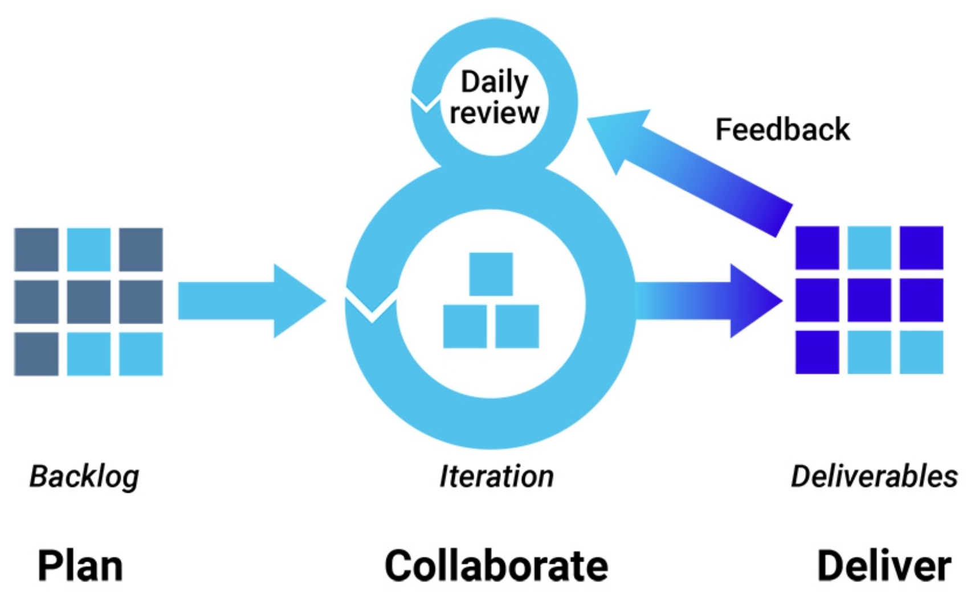
Figure 1: Agile development methodology [76]

  - Feature-driven development (FDD)

FDD is one of the agile development methods, which was proposed by famous software experts Jeff de Luca, Eric Lefebvre and Peter Coad [79]. It emphasizes feature-driven, fast iteration, which can ensure rapid development, as well as appropriate documentation and quality. FDD divides the whole project into many detailed features and each feature will spend to not more than two weeks to achieve [80].

FDD is made up of five activities:
- ‘Develop overall model’
- ‘Build feature list’
- ‘Plan by feature list’
- ‘Design by feature’
- ‘Build by feature’

The first and second activities will establish an overall model shape and the last three activities are be used to iterate for each feature [78]. In addition, the detailed information for these five activities are discussed in the following sections.

    - Develop overall model

This phase will build and design the modules needed for the project based on the requirements of the entire project.

Main requirements of this project
- Basic data visualization analysis of data sets, building web applications, such as the rational use of various charts on the web page to show more information from the data sets.
- Transferring the computing part of the web application to the spark cluster to run, and then the web application directly calls the result data after the cluster runs to promote the effect of data visualization.

Design needed modules of this project
This project will include two modules, web module and spark module. In details, the web module is responsible for the construction of web program, including server, web template, and the connection with database, etc. On the other hand, spark module is responsible for processing and analysing data and submitting tasks to spark cluster.

    - Build feature list

This phase focuses on building the features or functions will be achieved in this project and the prioritization technique will be used is MoSCoW [81], which is an abbreviation for the initials of four priorities, must, should, could and will not. Especially, there are four stages of the MoSCoW:
- Must Have: ‘Must have’ represents necessary requirements and it represents whether this project can meet the most basic requirements.
- Should Have: ‘Should have’ represents that requirements are important, but they are not necessary for delivery within the current delivery time.
- Could Have: ‘Could have’ represents the requirements desirable but not very necessary. The requirements of this part are the improvements of the project and those stuff could always be included if meet the permit of the resources and the time.
- Won’t Have this time: This project should not be implemented before this submission, which can be understood as the least important, or the least rewarding, or the inappropriate requirements or the time is not allowed at present. It will not be planned in the current delivery plan.

As it is mentioned above, MoSCoW is adopted in this project. In addition, the detailed steps are as following and all techniques will be introduced in section 4.1.4 such as Springboot, Mybatis etc. that will be mentioned in this part:
- Must Have
Pre-processing of data set
- Data acquisition
- Data integration
- Deleting all erroneous data
- Appropriate filling of missing data
- Combining the digital data with the actual meaning of the text
- Importing it in the database.
Constructing application in web module
- Building a maven project using IntelliJ idea IDE.
- Adding a web module in the project.
- Using Springboot to build basic web application.
- Configuring FreeMarker to facilitate data and page binding.
- Configuring the local MySQL server.
- Configuring mybatis to facilitate database and project bundling.
- Using layui [82] to easily build user interface page.
- Building corresponding controller files, entity files, service files and the interface and its configuration files of Mybatis.
Basic web-based visualization
- Using Echarts.js and the data from database to build line charts of some specific attributes of the data set in local database.
- Building pie charts using echarts.js of some specific attributes of the data set in local database.
- Building heat map using Map JavaScript API with the geographic coordinates data of the data set in local database.
- Building bubble charts using echarts.js of some specific attributes of the data set in local database.
Building and configuring spark cluster
- Installing three Linux systems as CentOS 6.8 on three physical machines
- Configuring each machine's network, firewall, Network Working Group (SSH) keyless access, time synchronization, etc.
- Installing and configuring Hadoop on each node
- Installing and configuring Zookeeper on each node
- Installing and configuring spark on each node
Building web-based visualization using web module and spark module
- Building a spark module and configuring Scala [83] available in the project.
- Building controller and service files to achieve the functions that acquiring data from database, processing data onto the spark cluster and then storing the results back to database.
- Constructing the links between result data and page visualization.
- Should Have
Improvement for the heat map visualization
- Heatmap of tile map using LOD and Ajax techniques
- Storing data on HDFS and HBase.
- Using spark platform to compute.
- Could Have
Security of the system
- Client can register and login to web page with different limits of authority.
- Client can use the web application to upload file to process on my Spark platform and get data visualization on the web page.
- Won’t Have this time
Additional functions
- Client can submit data files to the system through the web page
- The system can automatically process and compute these files on the spark cluster.
- After the system processes the files, the results are stored in a distributed database.
- Users can choose different kinds of data visualization charts according to their own needs.

    - Plan by feature list

This phase will build a project development plan. There are some specific indicators such as dependent relations between functions, complexity of functions and time constraints.

According to the MoSCoW method in Chapter 4.1.2, according to the priority technology, the first step is to develop the functions in ‘Must have’, then secondly is the functions in ‘Should have’, and finally is the functions in ‘Could have’ and ‘Will not have this time’. In addition, this project will just spend 2 months to develop so that the functions in ‘Must have’ and ‘Should have’ will be considered in the plan. On the other hand, the functions in the ‘Could have’ and ‘Will not have this time’ will be considered if there are much free time before the deadline.

Specifically, in the phase of ‘Must have’:
- Pre-processing of data set will take a week to complete.
- Constructing application in web module will use two weeks to build the most web module of a web application, because there are many technologies involved in building a web application such as Springboot, freemarker, Mybatis and user interface framework Layui.
- Basic web-based visualization will take a week to complete as well.
- Building and configuring spark cluster will take two weeks to implement, because building a spark cluster requires a lot of work, such as installing three Linux systems, configuring each machine's network, firewall, SSH keyless access, time synchronization and configuring Hadoop, Zookeeper, Spark, etc. Especially, this process is easily meet many various problems or mistakes, so two weeks are at least to spend.
- Building web-based visualization using web module and spark module is also at least two weeks to implement, because the construction of multi-module applications, the use of multi-medium programming languages, the network configuration with Spark cluster, the submission of tasks, the partition of spark tasks and so on will lead to a series of issues of making decisions and meeting mistakes.

On the other hand, in the phase of ‘Should have’:
Since the function development in ‘Must have’ already taken at least 8 weeks, it can be said that there is not more time left for ‘Should have’ to build, but these functions are within the plan, so the final solution is that after completing the function development in ‘Must have’, try to make more time to involve the functions in ‘Should have’.

    - Design and build by feature

As mentioned in chapter 4.1.3 above, each feature will be completed within one to two weeks. After completing the development of each feature, the next feature will be checked and developed according to the agile development process. In short, every feature will go through an iterative process of design, development and review.

In addition, the design and development of each function will be described in the chapter 5.

- Development

This section will explain the design and development of each function concretely, including data set processing, the establishment of basic web applications, data visualization of various charts of data in the database on Web pages, the specific building process of Spark cluster and the web visualization function combined with Spark cluster.

  - Pre-processing of the data set and importing and managing it into database

This project will use road safety data provided by Department for Transport. In addition, the transport department provides the data on road traffic collisions from 1979 to 2018, and each year's data includes three files such as road traffic collision data set, vehicle data set and casualty data set.

The road traffic collision data set will be mainly used in this project, because every record in this data set has a very detailed record of information. In details, there are mainly 13 attributes will be used in this project:
- The area of police force for example: North Yorkshire, Metropolitan Police and so on.
- Accident severity for example: slight, serious and fatal.
- The number of relative vehicles.
- The number of relative casualties.
- The time information like date and year.
- The geographic information for example: latitude and longitude.
- Rode type for example: roundabout.
- Junction detail for example: T or staggered junction.
- Junction control for example: give way or uncontrolled.
- Light condition for example: Daylight, Darkness - lights lit, Darkness - no lighting and so on.
- Weather condition for example: Fine no high winds, Raining no high winds, Fog or mist and so on.
- Road surface condition for example: Wet or damp, Frost or ice, Flood over 3cm deep, Mud, Oil or diesel, Dry and so on.
- Urban or rural.

- Integrating data sets

This project will mainly analyse the annual traffic collision data, and the data provided by the transportation department from 2010 to 2018 are recorded annually in the corresponding Comma-Separated Values (CVS) files, so the first step of data processing in advance is to integrate all road traffic collision data from 2010 to 2018 into a CSV file. What is more, the integrated CSV file of road traffic collision data will be beyond one million records is shown in figure 2:

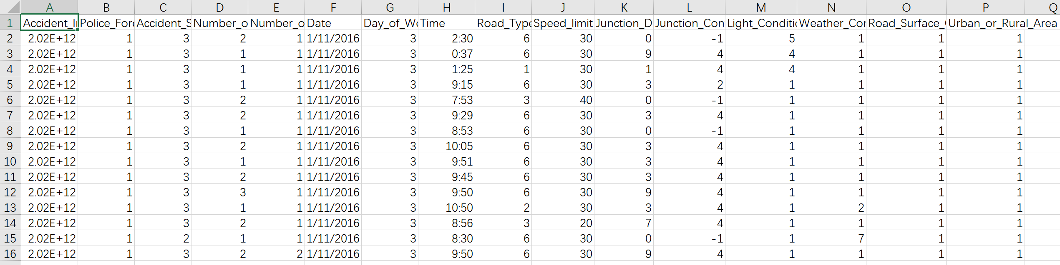
Figure 2: Integrated CSV file of road traffic collision data

- Deleting all unnecessary data and dealing with empty data

There are some attribute columns that are not involved in this project, so the first thing is to delete these unused attribute columns. Secondly, it is very important to deal with attribute values without data. The specific way is to fill the most frequent value of the attribute where the value without data are located in it. Because there are just serval values without data of beyond one million data, so the impacts of this solution can be ignored Especially, in this case shown in figure 3, the value ‘6’ will be filled in this empty value.

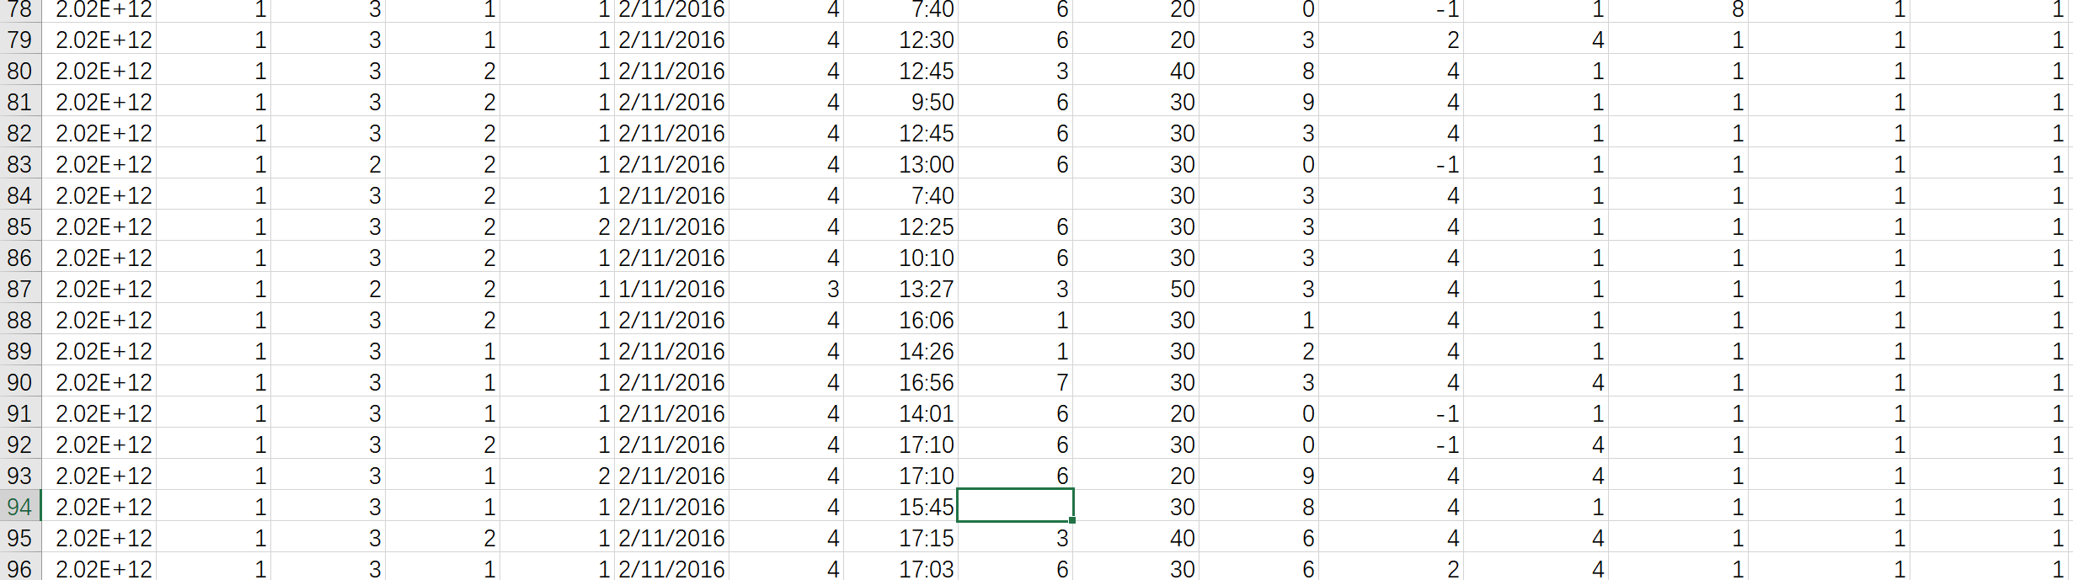
Figure 3: Dealing with empty value

- Importing data set into the database

Firstly, the database used in this project is MySQL 5.7.26. The second thing is to Import the CSV file of road traffic collision data into database, and the table of it in database is named tb_roadacc. In addition, the attributes properties are shown in figure 4 and the data in database is shown in figure 5:

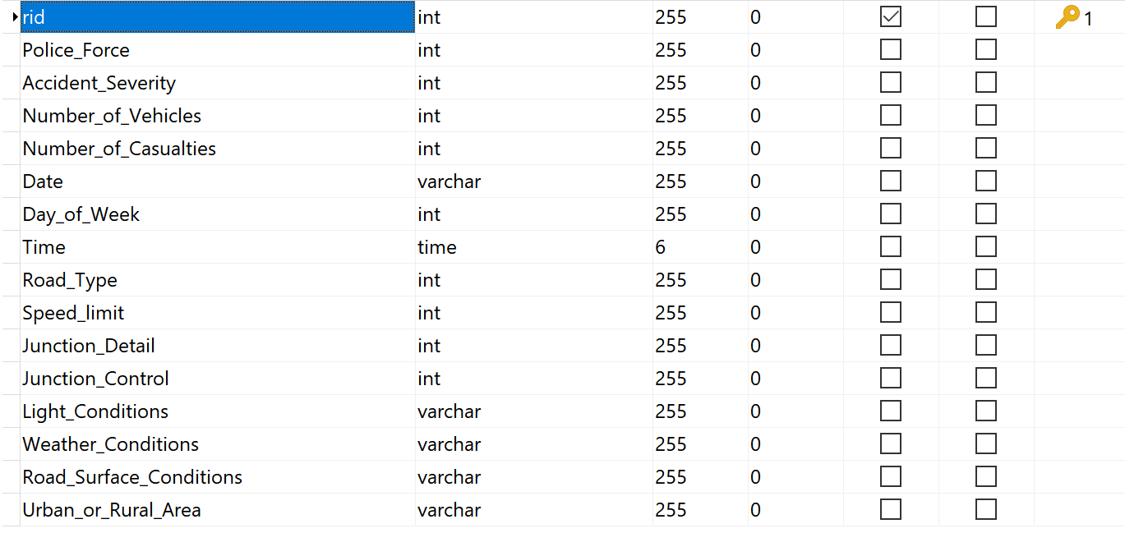
Figure 4: The attributes properties of tb_roadacc
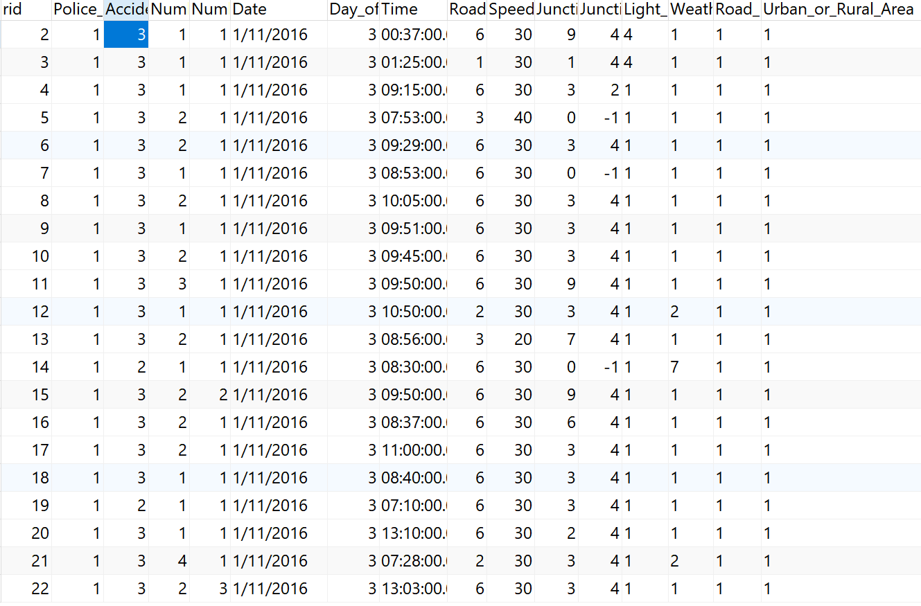
Figure 5: Data in database of tb_roadacc

- Creating multiple tables to correspond to the actual meaning of each column of data in the tb_roadacc table

In the Figure 4, it is fact that the data in the table are all numbers, and the actual meaning cannot be found of each value. Therefore, the multiple tables need to be created to correspond to each column in tb_roadacc to give each number real meaning. For example, focusing on the third column of tb_roadacc, the tb_s is created to correspond to it shown in figure 6:

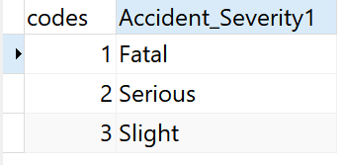
Figure 6: the table of tb_s

In addition, some other tables similar to tb_s are shown in figure 7:

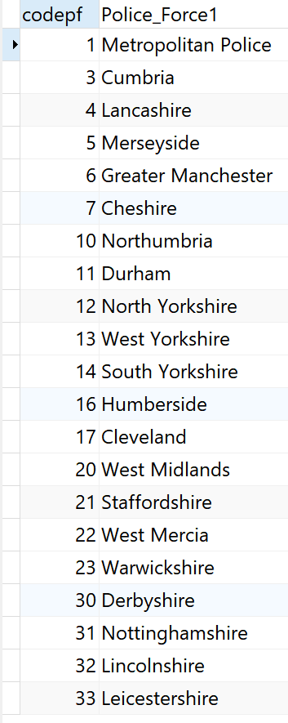
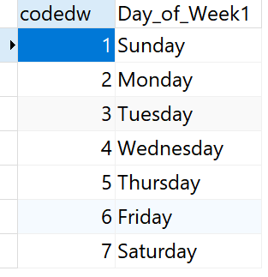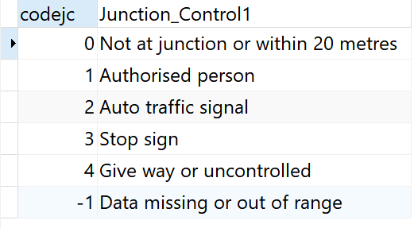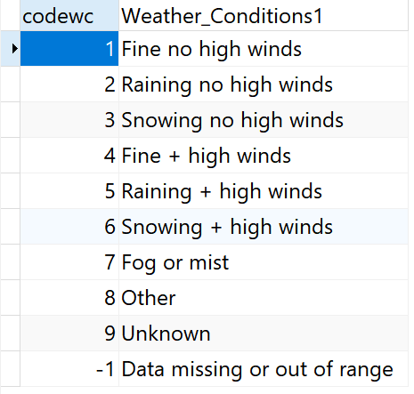
Figure 7: Some other tables to correspond to tb_roadacc

  - Constructing web application in web module

For this feature constructing web application in web module, firstly, it is necessary to design the overall framework of this project. And the second thing is to build the project according to the result of the design in first step. In addition, this feature will spend two weeks to develop.

- Design of overall framework of this project

First of all, this project will consist of two modules, web module and spark module. The task of these two weeks is to build web module and realize the basic web application. Specifically, this project will be developed using IntelliJ idea, and the web module will use Springboot to build basic web applications, FreeMarker to serve as a template engine for facilitating the binding of web pages and data and MyBatis to simplify the connection and operation between programs and databases.

- Building the web application in web module

This project is mainly built by maven [84] which is an automated management tool for project construction and dependency management under the Java platform.

Building the framework of the project

First, an empty Maven project named demo is built in idea, and then two Maven modules named web and spark are built in the working project directory of demo. The directory of the project is shown in figure 8:

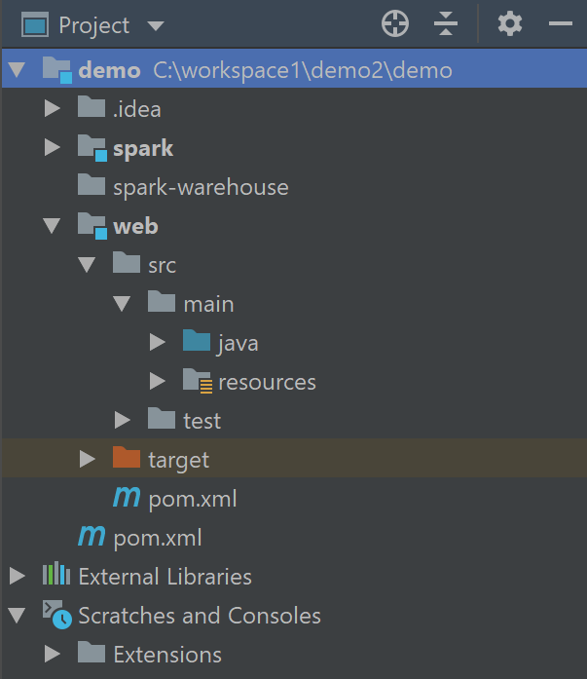
Figure 8: Directory of the project

Configuring the relations of these two modules with parent project

These two modules need to be explicitly affiliated with the main project demo, so it needs to configure their own pom.xml files to clarify the relationship between the modules and the main project.

- This is the pom.xml file of main project demo and the below configuration in pom.xml is to make the spark and web modules for own submodules:

<modules>
<module> spark </module>
<module> web </module>
</modules>

- This is the pom.xml file of spark and web module and the below configuration in each pom.xml is to make the spark and web modules make sure who is the parent project:

<parent>
<artifactId> demo </artifactId>
<groupId> new.project </groupId>
<version> 1.0-SNAPSHOT </version>
</parent>

Adding the Springboot framework in the web module and building the basic web application

- Configuring the Springboot framework in the pom.xml file of main project demo.

- Configuring the basic web application in the pom.xml file of web module and After adding this configuration, the program will automatically launch the default built-in web server Tomcat [85] which is a free open source web application server.

Adding and configuring the FreeMarker template engine and the Mybatis persistence framework

- Adding FreeMarker in the pom.xml file of web module

- Configuring FreeMarker in application.yml file of web module which is a default configure file of the web module. Specifically, the following configurations involve some basic property configurations including caching, character encoding, file suffix name, template file location information, etc.

- Adding the MyBatis in the pom.xml file of web module.

- Configuring MyBatis in application.yml file of web module. Specifically, the following configurations involve some basic property configurations including configuration of database, location information of MyBatis master configuration file and location of files that stores specific database statements.

- Testing whether Mybatis can work well with database

Firstly, entity class, control class and mapper interface need to be created in src source directory of web module. In the meanwhile, configuration file corresponding to MyBatis in resouces directory needs to be created as well. Specifically, the role of entity class is to accept the results of queries. Besides, controller class is responsible for receiving requests, processing data and returning results to web pages. Furthermore, the function of mapper interface is to set specific database operation methods for database operation and the implementation of this interface is the responsibility of MyBatis which means this project can ignore the implement of the mapper interface. On the other hand, moving to the configuration file of MyBatis, the function of it is to configure database operation statement concretely according to mapper interface.

Using JUnit framework to test and the specific code and the result are as following:

@Autowired
RoadAccMapper roadAccMapper;

@Test
public void sqltest1() {
List<RoadAcc> l1 = roadAccMapper.countRoad_Type1();
for (RoadAcc rs : l1) {
System.out.println( rs.getRoad_Type1() + " " + rs.getSum() +
" " + rs.getJunction_Control1() );
}
}

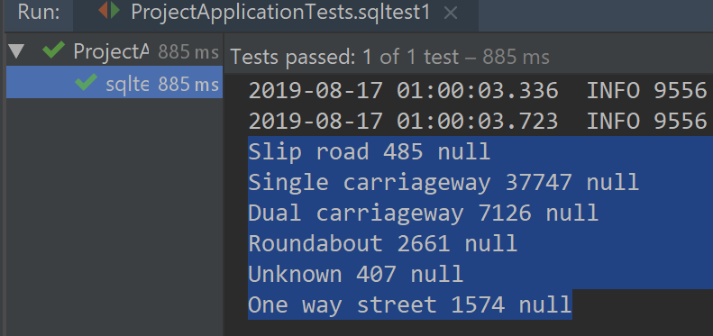

Using Layui to easily build user interface of the web application

First the JavaScript and Cascading Style Sheets (CSS) files should be downloaded from the Layui website and put them into the static.plugin package in the resources directory of the project. Then using these JavaScript and CSS files in the page resource to quickly build the elements in the page. Here the main page of the project will be used to describe some specific operations.

- Introducing CSS and JavaScript files to the main web page

<link rel="stylesheet" href="/plugin/layui/css/layui.css"> // In header

<script src="/plugin/layui/layui.js"></script> // In body

- Creating left menu for example in the main web page

<div class="layui-side-scroll">
<!-- Left side manu-->
<ul class="layui-nav layui-nav-tree" lay-filter="test">
<li class="layui-nav-item">
<a href="javascript:;">Basic Visualization</a>
<dl class="layui-nav-child">
<dd><a href="${"/basicVisualization"}">Basic Charts</a></dd>
<dd><a href="${"/AttributesVisualization"}">Road Attributes</a></dd>
<dd><a href="${"/bubbleVisualization"}">Bubble&Pie charts</a></dd>
<dd><a href="${"/mapVisualizationG"}">GoogleMap</a></dd>
</dl>
</li>
<li class="layui-nav-item">
<a href="javascript:;">Spark-based Visualization</a>
<dl class="layui-nav-child">
<dd><a href="${"/hello"}">Computing on Spark</a></dd>
<dd><a href="${"/select"}">Select on Spark</a></dd>
<dd><a href="${"/TestVisualization"}">Test Visualization</a></dd>
<dd><a href="">link</a></dd>
</dl>
</li>
<li class="layui-nav-item"><a href="">Other</a></li>
</ul>
</div>

According to this code, the left menu can be easily created on the page with only a few parameters. In the first line of the above code, for example, according to this code '<div class="layui-side layui-bg-black">', as long as it is clear that the class is layui-side, the page will create a left menu given by layui. In addition, the result is shown in figure 9:

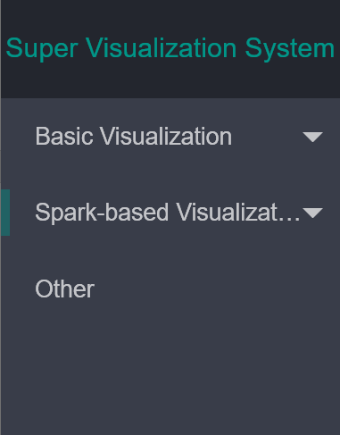
Figure 9: Left menu of the main web page

  - Basic web-based visualization in web module

For this feature constructing web-based visualization in web module, firstly, it is necessary to design which kinds of data visualization will be developed in this part. And the second thing is to develop various charts according to the result of the design in first step and the data set. Finally, this feature will spend two weeks to develop.

- Design of the data visualization in web module

The first thing is to show the basic properties of the data in the database through basic charts such as histograms, line graphs, pie charts, and so on and Echarts.js will be used to build these basic charts. The second thing is to display the data heat map on the map through geographic data such as latitude and longitude in the data set and Google Map API will be used to build this function.

- Developing basic web-based visualization in web module

This part will focus on data visualization in two ways. The first way is the bar chart to show basic property information for the dataset, such as the number of collisions that occur each day of the week. Another way to visualize is the heat map on the Google Map, through which it shows how many collisions occur on each road segment.

Using echarts.js and the data from database to build line charts of some specific attributes of the data set in local database.

Firstly, the web page sends a get request to the controller and secondly, in the controller, data is retrieved from the database through Mybatis, and the obtained data is stored in a list set containing the entity class and after the data is processed in the controller, the data is returned to the page by json, array, list or some other data structures.

- Creating a container on the page to place the chart.
<div class="layui-col-md12">
<div id="main" style="width: 1000px; height:300px;"></div>
</div>

- In the tag '<script type="text/javascript"> </script>', initializing the bar chart with Echarts.js
var myChart = echarts.init(document.getElementById('main'));
myChart.setOption({
title: {
text: 'Accident Day of Week'
},
tooltip: {},
legend: {
data: ["Accident Count"]
},
xAxis: {
name: "Day of Week",
data: []
},
yAxis: {name: "Accident"},
series: [{
name: 'Accident Count',
type: 'bar',
data: []
}]
});

- Sending get request to the controller to acquire data.
//load data from server
$.get('acnewDayofweek').done(function (data) {
// insert data into the bar chart
myChart.setOption({
xAxis: {
data: data.dayofweek
},
series: [{
// Corresponding to the corresponding series according to the name
name: 'Accident Number',
data: data.number
}]
});
});

- In controller, receiving request, acquiring data from database by MyBatis, processing data and finally returning data to the web page.
- @Autowired
RoadAccMapper roadAccMapper;

- @ResponseBody
@GetMapping(value = "acnewDayofweek")
public Map<String, Object> getDayofweek() {
/*Create a collection to accept database data*/
List<RoadAcc> xlist = new ArrayList<RoadAcc>();
- /*Create a map collection to hold the two arrays of month and sales*/
Map<String, Object> xmap = new HashMap<String, Object>();
/*Accept data*/
xlist = roadAccMapper.countDayofweek();
/*Create a monthly inventory of loading*/
String[] xxdata = new String[7];
- /*Create a load month array*/
String[] xdata = new String[7];
/*Traversing database data*/
int i = 0;
for (RoadAcc acnew : xlist) {
xdata[i] = acnew.getDay_of_Week1();
xxdata[i] = acnew.getSum();
i++;
}
/*Save two arrays in the collection*/
xmap.put("xDayofweek", xdata);
xmap.put("xSum", xxdata);
return xmap;
}

Using Map JavaScript API with Google Map and the data from database to build heat map

In this part, the principles of these aspects are similar to those of the previous section, such as the page sending a request to the controller, the controller fetching data from the database, processing the data, and returning the data to the page, so this section will not focus on introducing them. Then the core part of this heat map function is inside the ‘<script></script>’ element, which will be introduce as following.

- Preparing geographical data array to be used for the heat map
- // Setting array and variable to store data from controller
var xseverity = [];
var xlatitude = [];
var xlongitude = [];
var coordinates;
var heatmapData1 = [];
- // Sending get request to controller and process data after the controller successfully returned data
$.getJSON("acnewGetCoordianteSeverity", function (rs) {
var obj = $.parseJSON(rs);
xseverity = obj.xseverity;
xlatitude = obj.xlatitude;
xlongitude = obj.xlongitude;
- // Building the appropriate data to add to the result array
for (var i = 0; i < xlatitude.length; i++) {
coordinates = new google.maps.LatLng(xlatitude[i], xlongitude[i]);
heatmapData1.push(coordinates);
}alert('success');
});

- Building the heat map
- // Setting center point on the map
var centerpoint1 = new google.maps.LatLng(51.774546, -2.433523);
- // Initializing the map
map1 = new google.maps.Map(document.getElementById('map1'), {
center: centerpoint,
zoom: 5,
mapTypeId: 'hybrid'
});
- // Setting the heat map
var heatmap1 = new google.maps.visualization.HeatmapLayer({
data: heatmapData1,
opacity: 0.6
//radius: 1px;
});
heatmap1.setMap(map);

  - Building and configuring Spark cluster

For this feature building and configuring spark cluster, firstly, it is necessary to design the overall setup and configuration process of Spark cluster. And the second thing is to install and configure each part of design in first step. Finally, this process will spend two weeks to build.

- Design of overall setup and configuration process of Spark cluster

For configuring the Spark cluster, first of all, due to the limited equipment, this project will choose to use three computers with Linux system as CentOS 6.8. It is needed on each computer to configure the network, firewall, SSH keyless access, time synchronization and so on. Furthermore, HDFS and Zookeeper will be installed and configured on each machine, because Spark computing platform uses HDFS to store data and Spark strongly depends on Zookeeper. Finally, installing and configuring the Spark platform on each machine. In addition, this work will spend two weeks as well to implement.

- Installing and configuring the Spark cluster

Installing three Linux systems as CentOS 6.8 on three physical machines.

For this part, it is important to note that the first machine installs a system with a Linux desktop and the other two install a system without a desktop, because the latter two machines rarely operate directly, and this setting will save the resources of the computer. In addition, these three computers should be set in the same time zone for the convenience of later time synchronization settings.

Setting the network, firewall, SSH keyless access, time synchronization on each machine.

- First of all, the network setting of each machine needs to set the IP address of each machine in the same network management, firewall and DNS server, etc. in order to ensure that each machine can access each other.
- Modifying the host name and IP mapping relationship of the three machines on each machine.
- Configuring the SSH keyless access: Each machine first needs to generate a key and distribute the public key to each machine.
- Configure the time server: First, correcting the time of the cluster's time server based on the network time, then synchronizing the time of each machine, and finally setting the time synchronization task.

Installing and configuring HDFS and Zookeeper framework on each machine

- Installing and configuring HDFS

There are three 2 roles of HDFS which is a distributed file system [HDFS], Namenode and Datanode. The functions of Namenode are managing data block mapping information, handling client read and write requests and so on. Besides, the functions of Datanode are storing the actual data block, performing data block read/write operations and so on.

The specific installation and configuration of HDFS includes the following aspects: first unpacking the installation and assigning the roles to each machine. Then the configuration files need to be modified including environment files, property files, and node settings files. And the web page of HDFS is shown in figure 10.

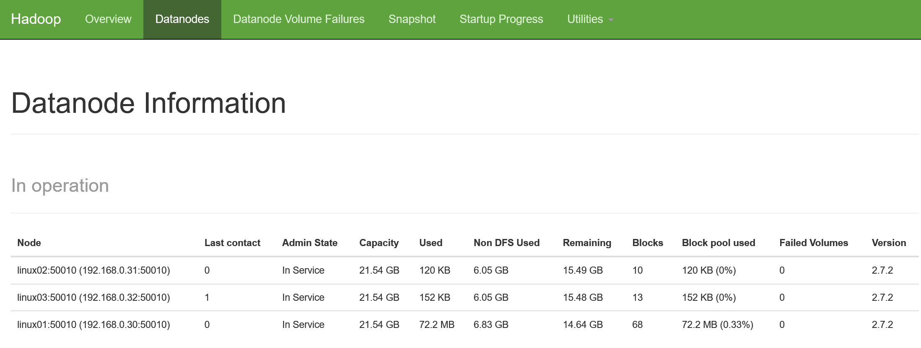
Figure 10: the nodes of HDFS

- Installing and configuring Zookeeper

Firstly, Zookeeper should be unpacked on each machine separately, then the Zookeeper configuration file zoo.cfg should be modified to set the information of each node and the myid file should also be modified.

Installing and configuring Spark platform on each machine

The installation and configuration of Spark is similar to the HDFS mentioned above. First, it should be unpacked and assigned roles to each machine, and then historical services and configuration files need to be configured as well. Finally, the Spark platform web page is shown in figure 11.

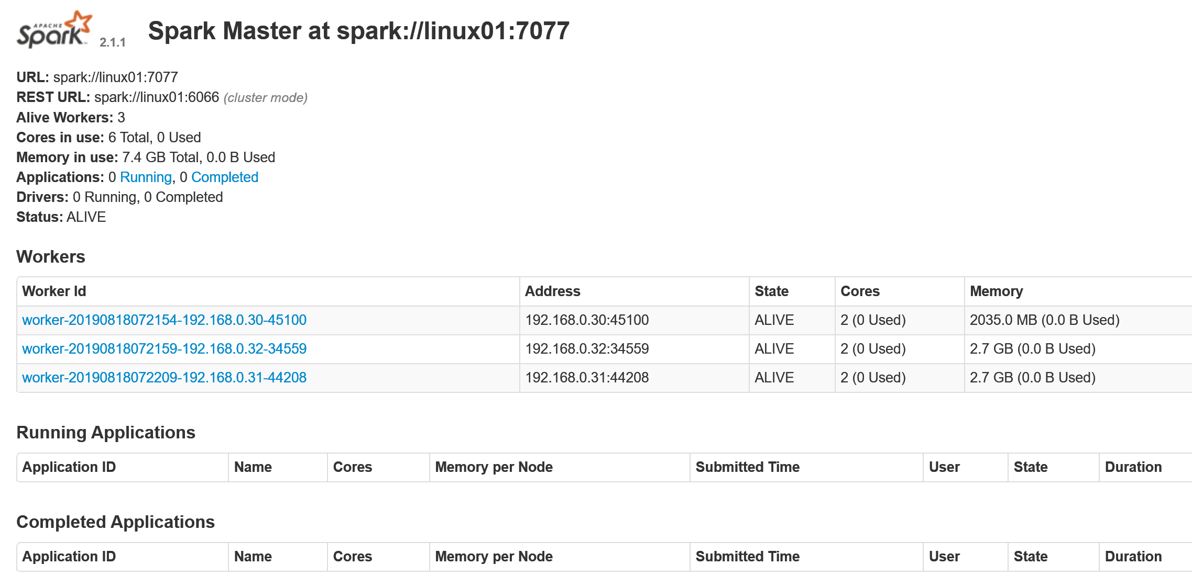
Figure 11: Spark platform

  - Building web-based visualization using web module and spark module

For this feature building web-based visualization using web module and spark module, firstly, it is necessary to design a system that is web-based data visualization with Spark platform. And the second thing is to develop each part of design in first step. Finally, this process will spend one weeks to develop.

- Design of a system that web-based data visualization with Spark platform

First of all, the purpose of this project is to transfer the calculation area of data visualization to the Spark platform for processing and computing, while the web application directly calls the result to visualize it to improve performance. Specifically, the first thing is to configure the Scala program language and establish ‘scala’ directory in the spark module and then create a controller in the ‘scala’ directory to receive requests, obtain data and send data to the Spark platform to process and store the result data. Finally, the web application will directly call the needed result data to realize data visualization.

- Developing a system that web-based data visualization with Spark platform

Configuring Scala available and creating Scala controller in the project

Firstly, it is easy to configure Scala in Idea and it just need to install a Scala plugin. And the created spark module, ‘scala’ directory and the ScalaController are shown in figure 12.

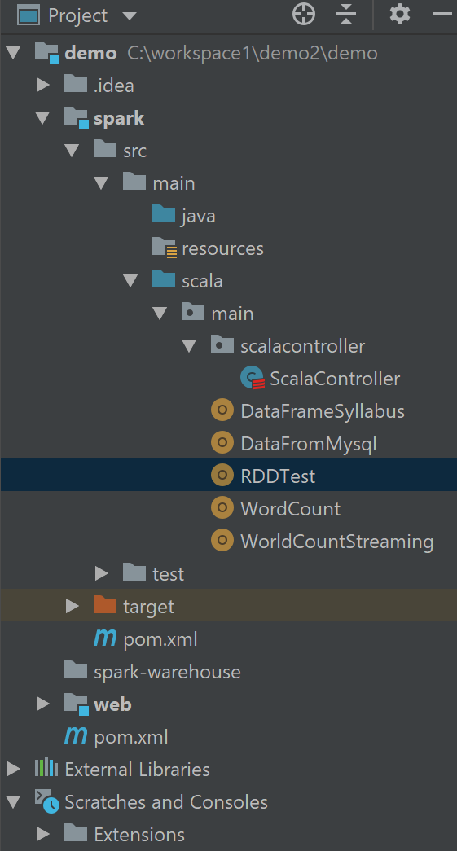
Figure 12: the directory of spark module

Developing ScalaController

In the ScalaController, it can receive request from web page, then send request to the Spark platform to get needed data from database and computing it on the Spark cluster and finally, the result data will be stored into database.

- Setting the configuration

val conf = new SparkConf()
.setMaster("spark://linux01:7077")
.setAppName("pre-spark-computing")
.setJars(Array("C:\\workspace1\\demo2\\demo\\spark\\target\\spark-1.0-SNAPSHOT.jar"))

- Building SparkContext to start program on Spark platform

val sc = new SparkContext(conf)

- Creating database statement
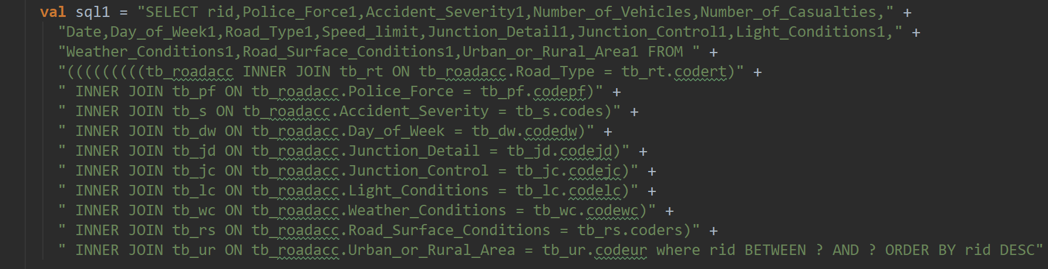

- Fetching data from database

val rdd1 = new org.apache.spark.rdd.JdbcRDD(sc,
() => {
Class.forName("com.mysql.cj.jdbc.Driver").newInstance()
java.sql.DriverManager.getConnection(
"jdbc:mysql://192.168.0.37:3306/springboot?serverTimezone=GMT%2B8",
"dongsheng",
"123456")
},
sql1,
1,
1000000,
48,
r => (r.getString(7),r.getInt(4),r.getInt(5), r.getInt(6)))

- Processing data

val rddtmp2010 = rdd1.map(x => (x._1, (1, x._2, x._3, x._4)))
.filter(x => x._2._4.contains("2010"))
val rddtmp2016 = rdd1.map(x => (x._1, (1, x._2, x._3, x._4)))
.filter(x => x._2._4.contains("2016"))
val rdd2010 = rddtmp2010.reduceByKey((s, h) => (s._1 + h._1, s._2 + h._2, s._3 + h._3, "2010")).map(x => (x._1, x._2._1, x._2._2, x._2._3, x._2._4))
val rdd2016 = rddtmp2016.reduceByKey((s, h) => (s._1 + h._1, s._2 + h._2, s._3 + h._3, "2016")).map(x => (x._1, x._2._1, x._2._2, x._2._3, x._2._4))

- Storing result data into database

val spark: SparkSession = SparkSession.builder().getOrCreate()
import spark.implicits._
val testDF = rdd2010.toDF("Day_of_Week1", "sum", "vehiclesum", "casualtysum", "year")
testDF.show()
testDF.write
.mode(SaveMode.Overwrite)
.format("jdbc")
.option("url", "jdbc:mysql://192.168.0.37:3306/springboot?serverTimezone=GMT%2B8")
.option("dbtable", "tb_rsdw2010")
.option("user", "dongsheng")
.option("password", "123456")
.save()
println("SUCESS!!!!!!!!!!!!")

- Results and Discussion

This chapter will be divided into three parts. The first part is based on the last chapter, which develops some basic web visualization charts, including bar chart, line chart, pie chart and the heat map for statistical analysis of basic attributes of data set from the database.

On the other hand, the second part is the comparison of the performance of the two modes, local mode and Spark mode. The local mode is that all tasks of the application will be performed locally, while the spark mode is that the computing part of the application will be transferred to the Spark cluster for execution. Specifically, the spark mode is a method to optimize the performance of web-based data visualization, which transfers the data computing part of the web data visualization system from the local machine to the Spark platform, while the web data visualization application only needs to call the result data processed on the Spark platform for data visualization analysis.

  - The basic data visualization of the data set

This section mainly introduces 4 kinds of data visualization charts to show more information of the data set in the web module, including line graph, bar graph, pie graph and heat map.

Line chart with the attribute of severity of the data set

The line chart with attribute of the severity is shown in the below figure 12. Specifically, this chart shows the number of collision accidents with the severity attribute from 2010 to 2016. The x-axis is the severity of collision accidents, while the y-axis corresponds to the total number of collision accidents.

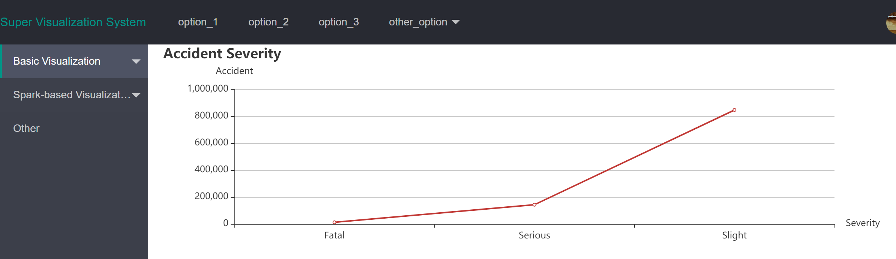
Figure 12: Line chart with severity information

Bar chart with the attribute of day of week of the data set

The bar chart with attribute of the day of week is shown in the below figure 13. Specifically, this chart shows the number of collision accidents with the day of week attribute from 2010 to 2016. The x-axis is the day of week of collision accidents, while the y-axis corresponds to the total number of collision accidents.

From this chart, it can be seen that vehicle collision accident may most likely occur in Friday, while the number of vehicle collisions on weekends is the least.
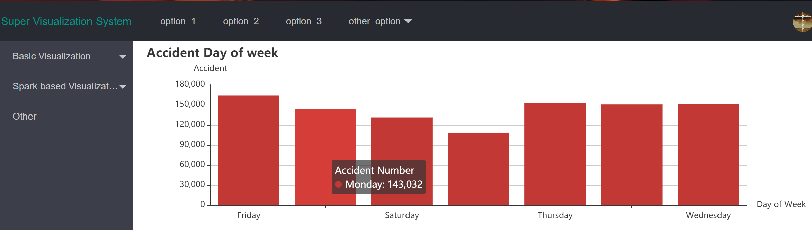
Figure 13: Bar chart with the attribute of day of week

Pie charts of the data set

There are four pie charts shown in figure 14. Data visualization analysis is respectively carried out for the four attributes of the data set, including the road type, the weather condition, the light condition and road surface condition. When moving mouse to the chart, the detailed information will display in each chart such as the number of collision and the percentage in this case.

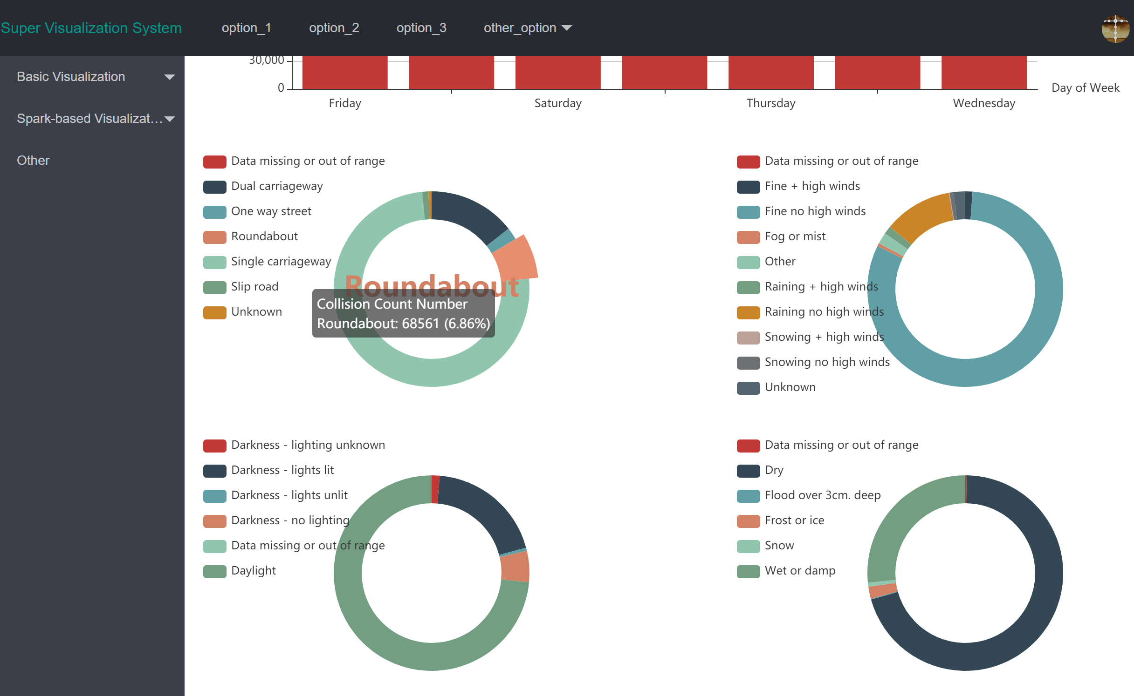
Figure 14: Pie charts

Heat map with the latitude and longitude information from data set in the web module

Figure 15 and 16 uses longitude and latitude coordinates of the data set and Google Maps to show the spatial and geographic information of the data set, through which it can be very intuitive to determine where the accident highly occurs and other information. Figure 16 shows that more detailed information can be retrieved by zooming the mouse.

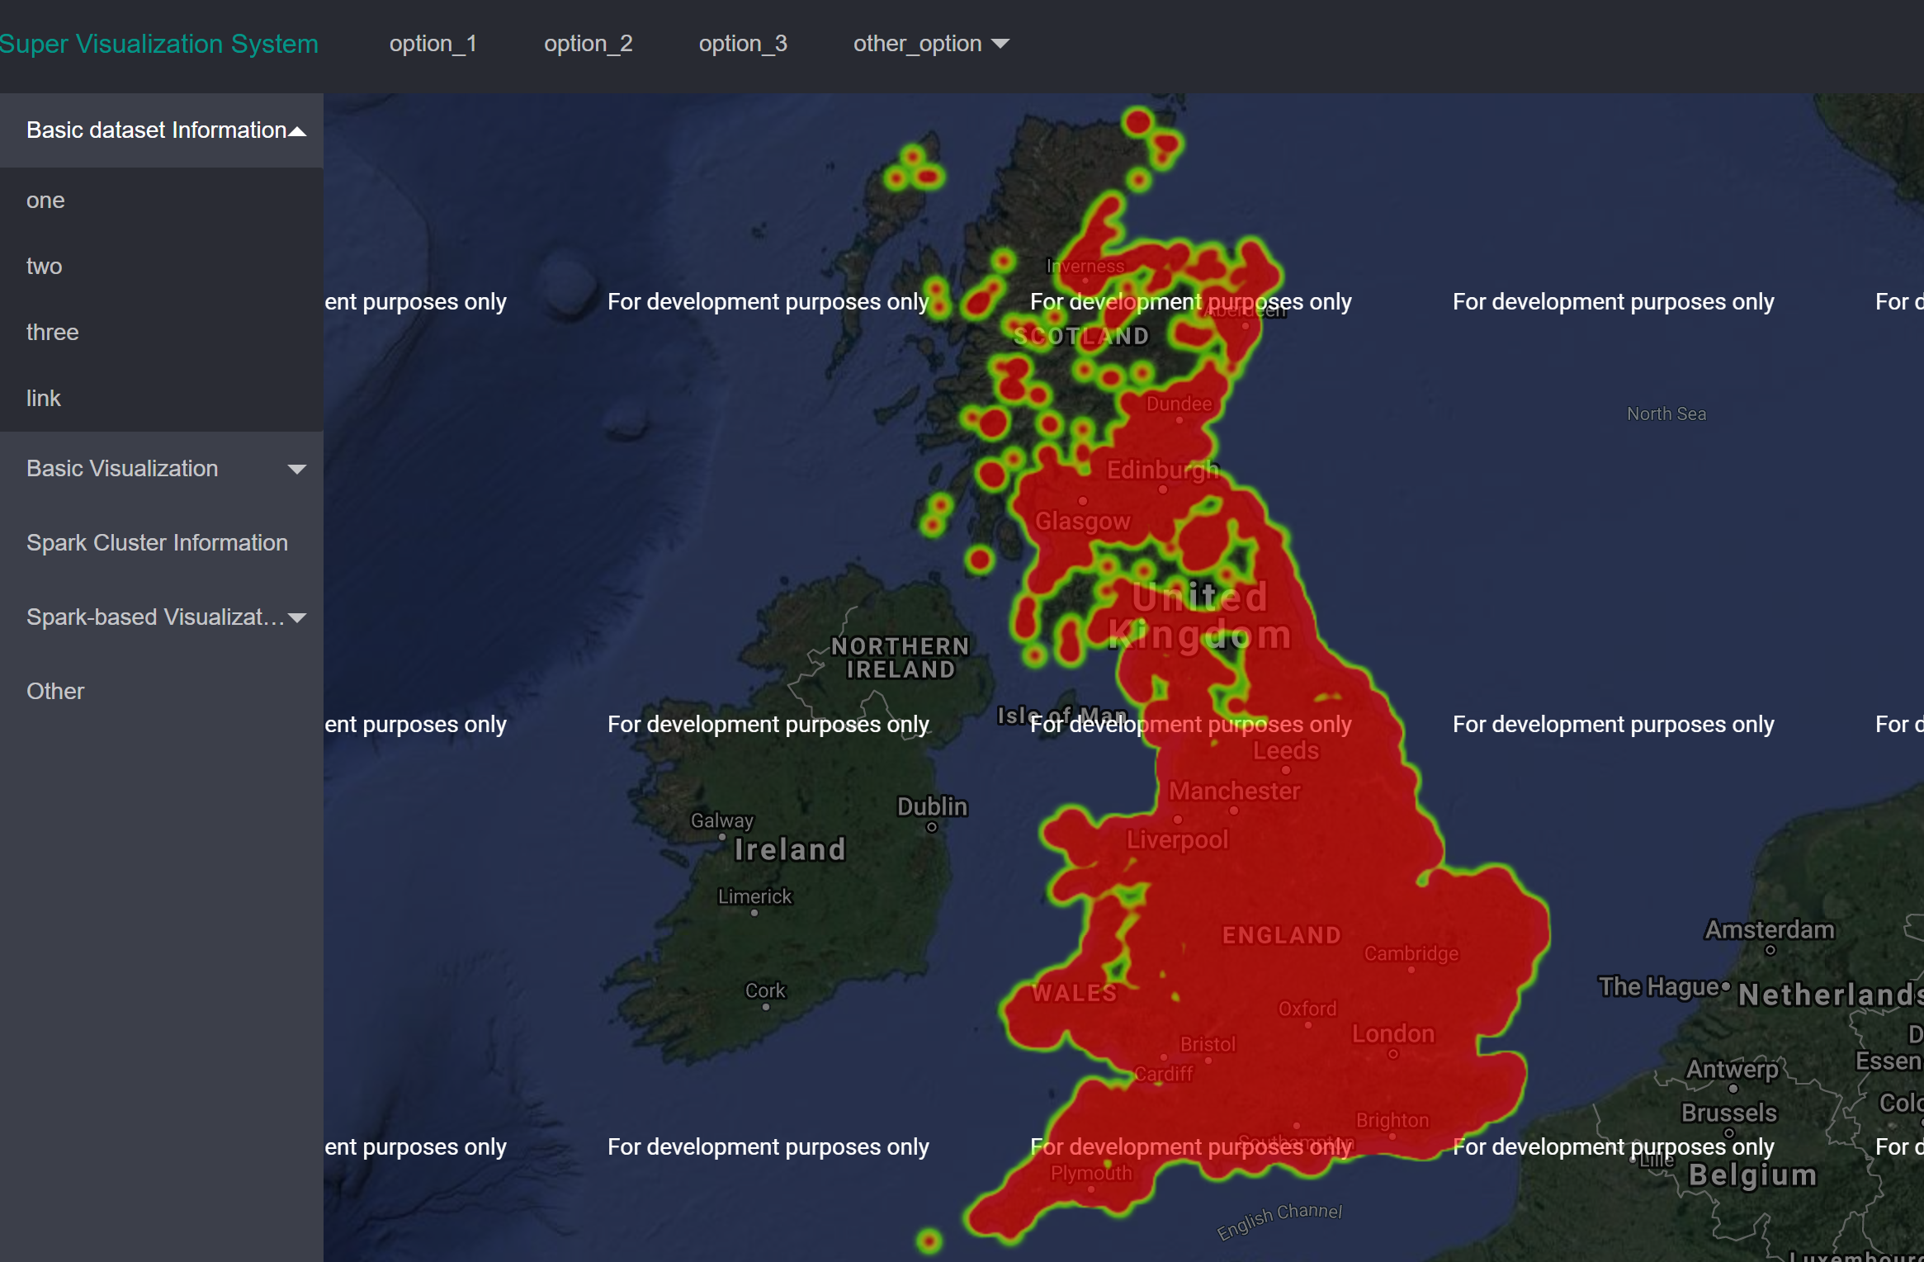
Figure 15: heat map of the data set in UK
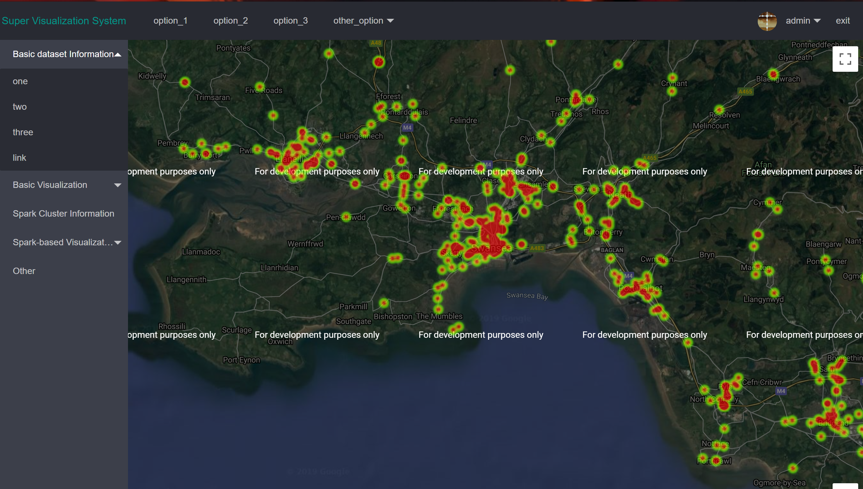
Figure 16: heat map of the data set in Swansea

  - The comparison of the local mode and the Spark mode

There are three web-based data visualization cases to describe the performance comparison with two modes.

Case 1 is a pie chart that counts the number of accident collisions for each road type using the Road_Type column of the dataset. In details, the statistical calculation code of this case is very simple. Under the local mode, the collision number of each road type is calculated directly in the SQL statement when querying data from the database, while in the Spark mode, the collision number of each road type is calculated by a simple algorithm written by the program. By contrast, the computational complexity of Spark mode is slightly more than that of local mode in this case.

Case 2 is a bubble chart that counts the number of accident collisions, related vehicles, related casualties and the years for each every day in a week using the Day_of_Week column of the dataset. The statistical calculation code of this case is similar with the case 1 and the meaning of case 2 is to add some more information in one chart to check the difference to the case 1.

Case 3 is also a bubble chart that similarly counts the number of related vehicles, related casualties and the years for each every day in a week using the Day_of_Week column of the dataset. Especially, the difference between case 3 and case 2 is that case 3 uses the Accident_Severity as the weight value to identify the size of each bubble and the weight value will lead to much more computing works of the program, which means there are more computing codes after querying data from database. Under the local mode, these computing works will spend more time than case 2, while under the Spark mode, these computing works will also be executed on the Spark platform.

Case 1: Pie chart with less computing works

Figure 17 shows a comparison of web-based data visualization in the web module and in the mode of computing with Spark. For this case ‘Data Visualization with Spark’ on the right, the first thing is to click the ‘pre-SparkComputing’ button below, and the program will submit the part of the data that needs to be calculated to Spark. After the calculation, the ‘load’ button needs to be clicked to load the result data and view.

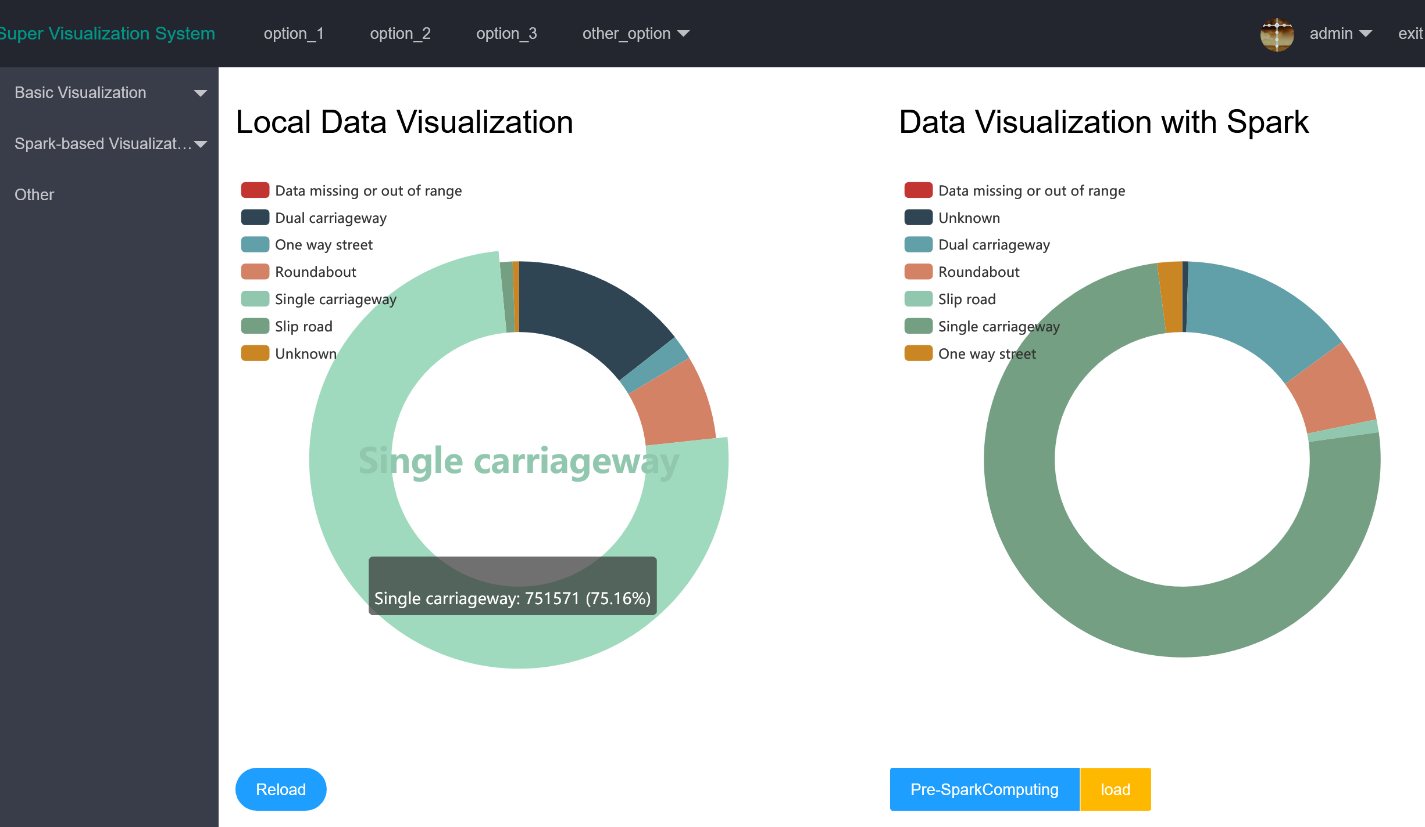

Figure 17: Pie chart comparison of two modes

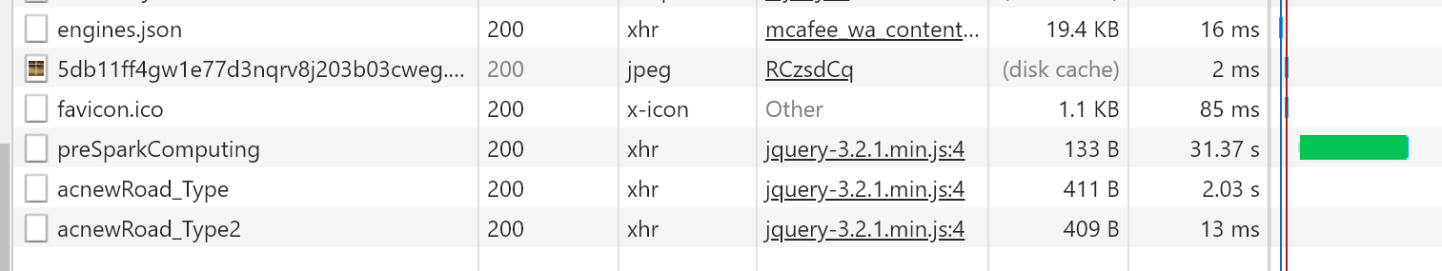
Figure 18: Time consuming of two modes

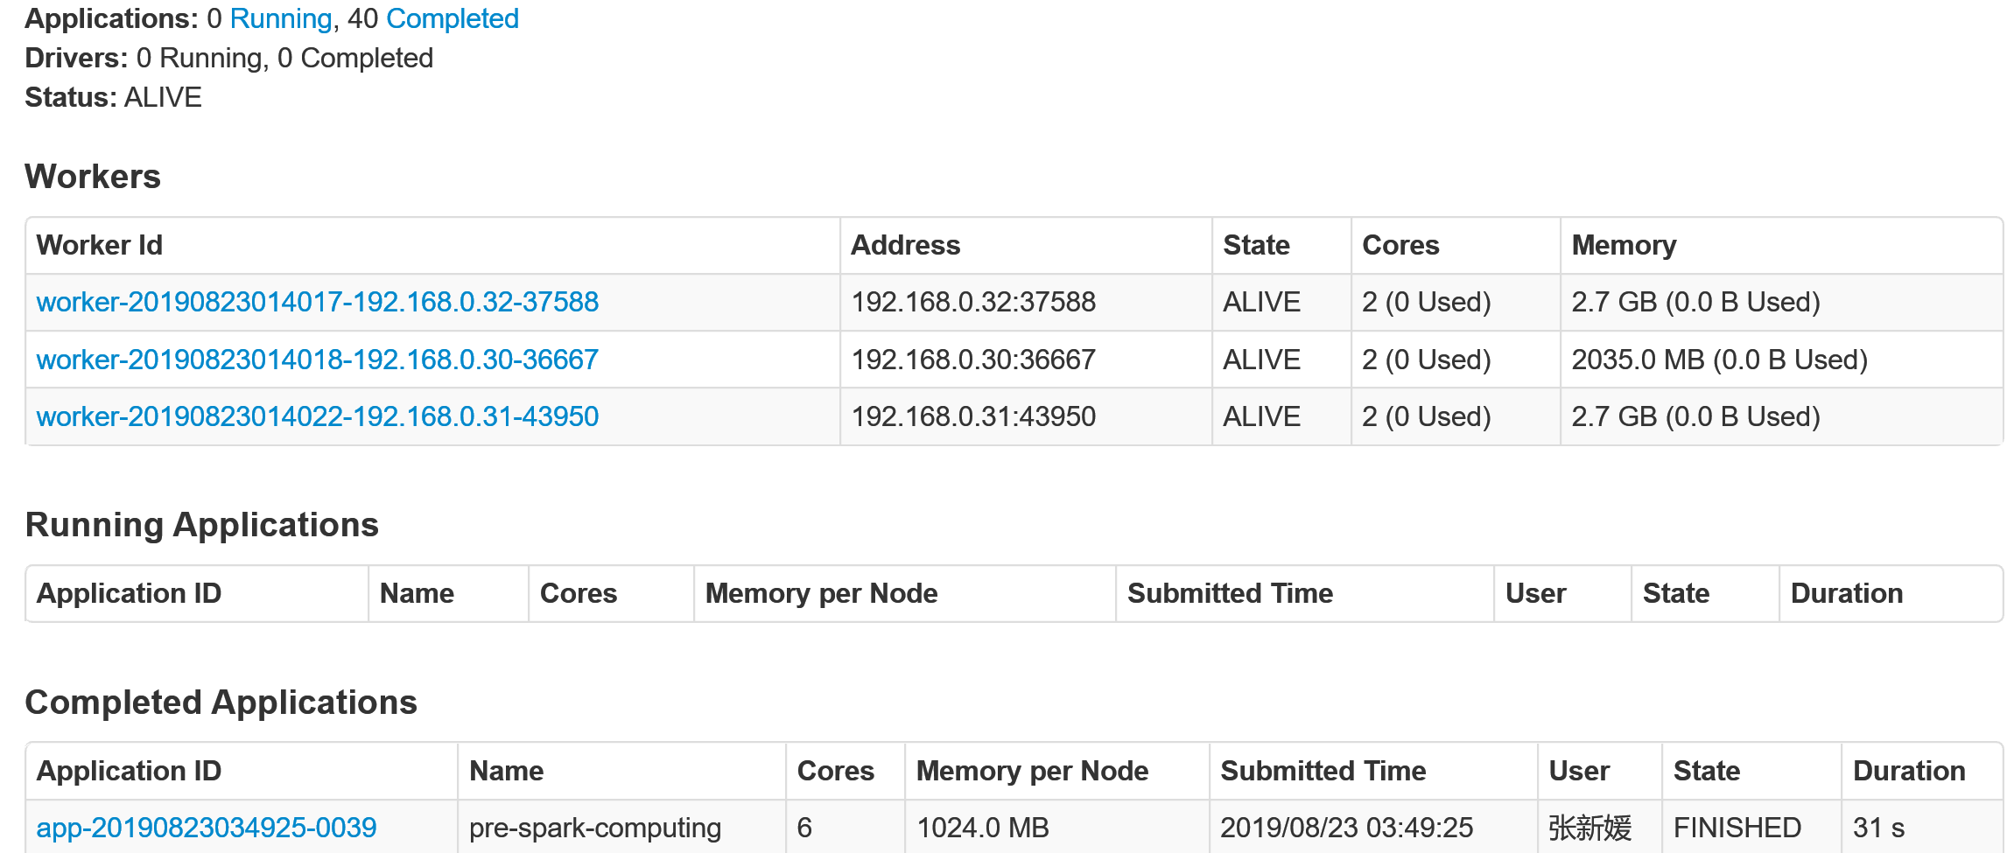
Figure 19: Time consuming on the Spark platform

 | 1 | 2 | 3 | 4 | 5
Local mode | 2.33s | 2.07s | 1.84s | 1.87s | 2.08s
Spark mode | 48ms | 24ms | 15ms | 10ms | 13ms
Computing on the Spark | 31s | 25s | 28s | 23s | 25s
Table 1: The overall time consuming of two modes in 5 times

Figure 19 shows the loading time of each component of the web page. ‘AcnewRoad_Type’ represents the loading time of graph data in the local mode, while the ‘preSparkComputing’ represents the computing time of tasks in the Spark mode on Spark cluster, and ‘AcnewRoad_Type2’ represents the loading time of graph data after computing on the Spark platform by clicking the 'load' button in figure 17. In addition, figure 19 shows the time consuming of computing tasks on the Spark platform as well.

On the other hand, table 1 shows the overall time consumption results of the 5 times in the two modes respectively. Through this comparison, the Spark mode computing on the Spark platform can obviously improve the loading performance of data visualization, but the computing job on the Spark platform spent too much time. In Figure 19, this ‘pre-spark-computing’ task used 31s to achieve and it is much more than the time consuming of local mode, which perhaps caused by many reasons such as the inferior cluster machines, the code is not optimized enough, time wasting on submitting the task and launching, the data is too less to reflect the effect, the and so on. Finally, the project will continue to research these issues in the future. Therefore, it is concluded that the optimization of Spark mode is not obvious.

Case 2: Bubble chart with less computing works but more information of the data set

Figure 17 shows a comparison of web-based data visualization in the web module and in the mode of computing with Spark. The operation is similar like case 1 to load the data with two modes.

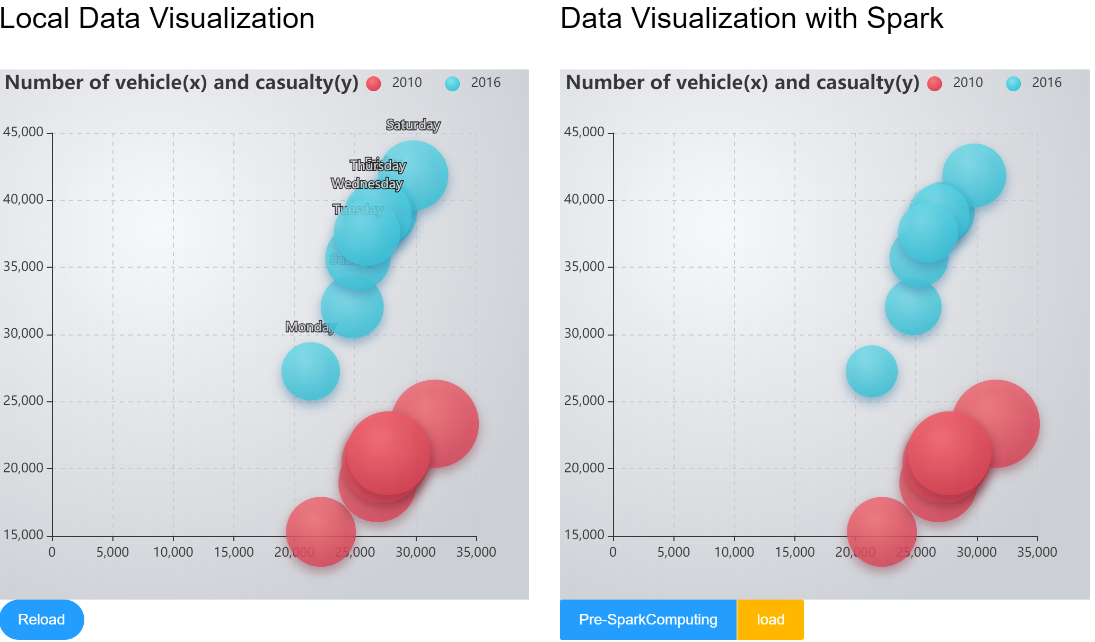
Figure 20: Bubble chart comparison of two modes

Figure 21: Time consuming of the two modes

Figure 22: Time consuming on the Spark platform

 | 1 | 2 | 3 | 4 | 5
Local mode | 2.85s | 2.97s | 2.85s | 3.01s | 2.76s
Spark mode | 14ms | 25ms | 14ms | 20ms | 18ms
Computing on the Spark | 42s | 45s | 43s | 46s | 41s
Table 2: The overall time consuming of two modes in 5 times

Figure 21 shows the loading time of each component of the web page. ‘getBubbleLocal’ represents the loading time of graph data in the local mode. And the ‘getBubbleSpark’ represents the loading time of graph data after computing on the Spark platform by clicking the 'load' button in figure 20. In addition, the ‘pre-spark-computing-bubble’ in figure 22 represents the computing time of tasks in the Spark mode on Spark cluster.

On the other hand, table 2 shows the overall time consumption results of the 5 times in the two modes respectively. Through the table 2, the ‘Spark mode’ means loading time after the computing on Spark, which is much less than the ‘Local mode’. In other word, ‘Spark mode’ can improve the performance on loading data. However, same as case 2, the time consuming on the Spark is still much more. Therefore, it is concluded that the optimization of spark mode is not obvious as well.

Case 3: Bubble chart with more computing works

Figure 23 shows a comparison of web-based data visualization in the web module and in the mode of computing with Spark. The operation is similar like case 1 to load the data with two modes. In addition, the main difference of this case to the case 2 is that the Accident_Severity of data set is used to identify the size of each bubble and it also can be seen as the weight value of each item and the main code in local mode of it is as following:

// ‘3’ represents ‘Fatal’. ‘2’ represents ‘Serious’. ‘1’ represents ‘Slight’
// Weight value in local mode
for(RoadAcc roadAcc : roadAccs){
if (roadAcc.getAccident_Severity()==3){
sum += roadAcc.getAccident_Severity()*3;
}else if(roadAcc.getAccident_Severity()==2){
sum += roadAcc.getAccident_Severity()*2;
}else {
sum += roadAcc.getAccident_Severity();
}
}

// Weight value in spark mode
val rddtmp2010 = rdd1.map(x => (x._1, (x._5*x._5, x._2, x._3, x._4))).filter(x => x._2._4.contains("2010"))
val rddtmp2016 = rdd1.map(x => (x._1, (x._5*x._5, x._2, x._3, x._4))).filter(x => x._2._4.contains("2016"))
val rdd2010 = rddtmp2010.reduceByKey((s, h) => (s._1 + h._1, s._2 + h._2, s._3 + h._3, "2010")).map(x => (x._1, x._2._1, x._2._2, x._2._3, x._2._4))
val rdd2016 = rddtmp2016.reduceByKey((s, h) => (s._1 + h._1, s._2 + h._2, s._3 + h._3, "2016")).map(x => (x._1, x._2._1, x._2._2, x._2._3, x._2._4))

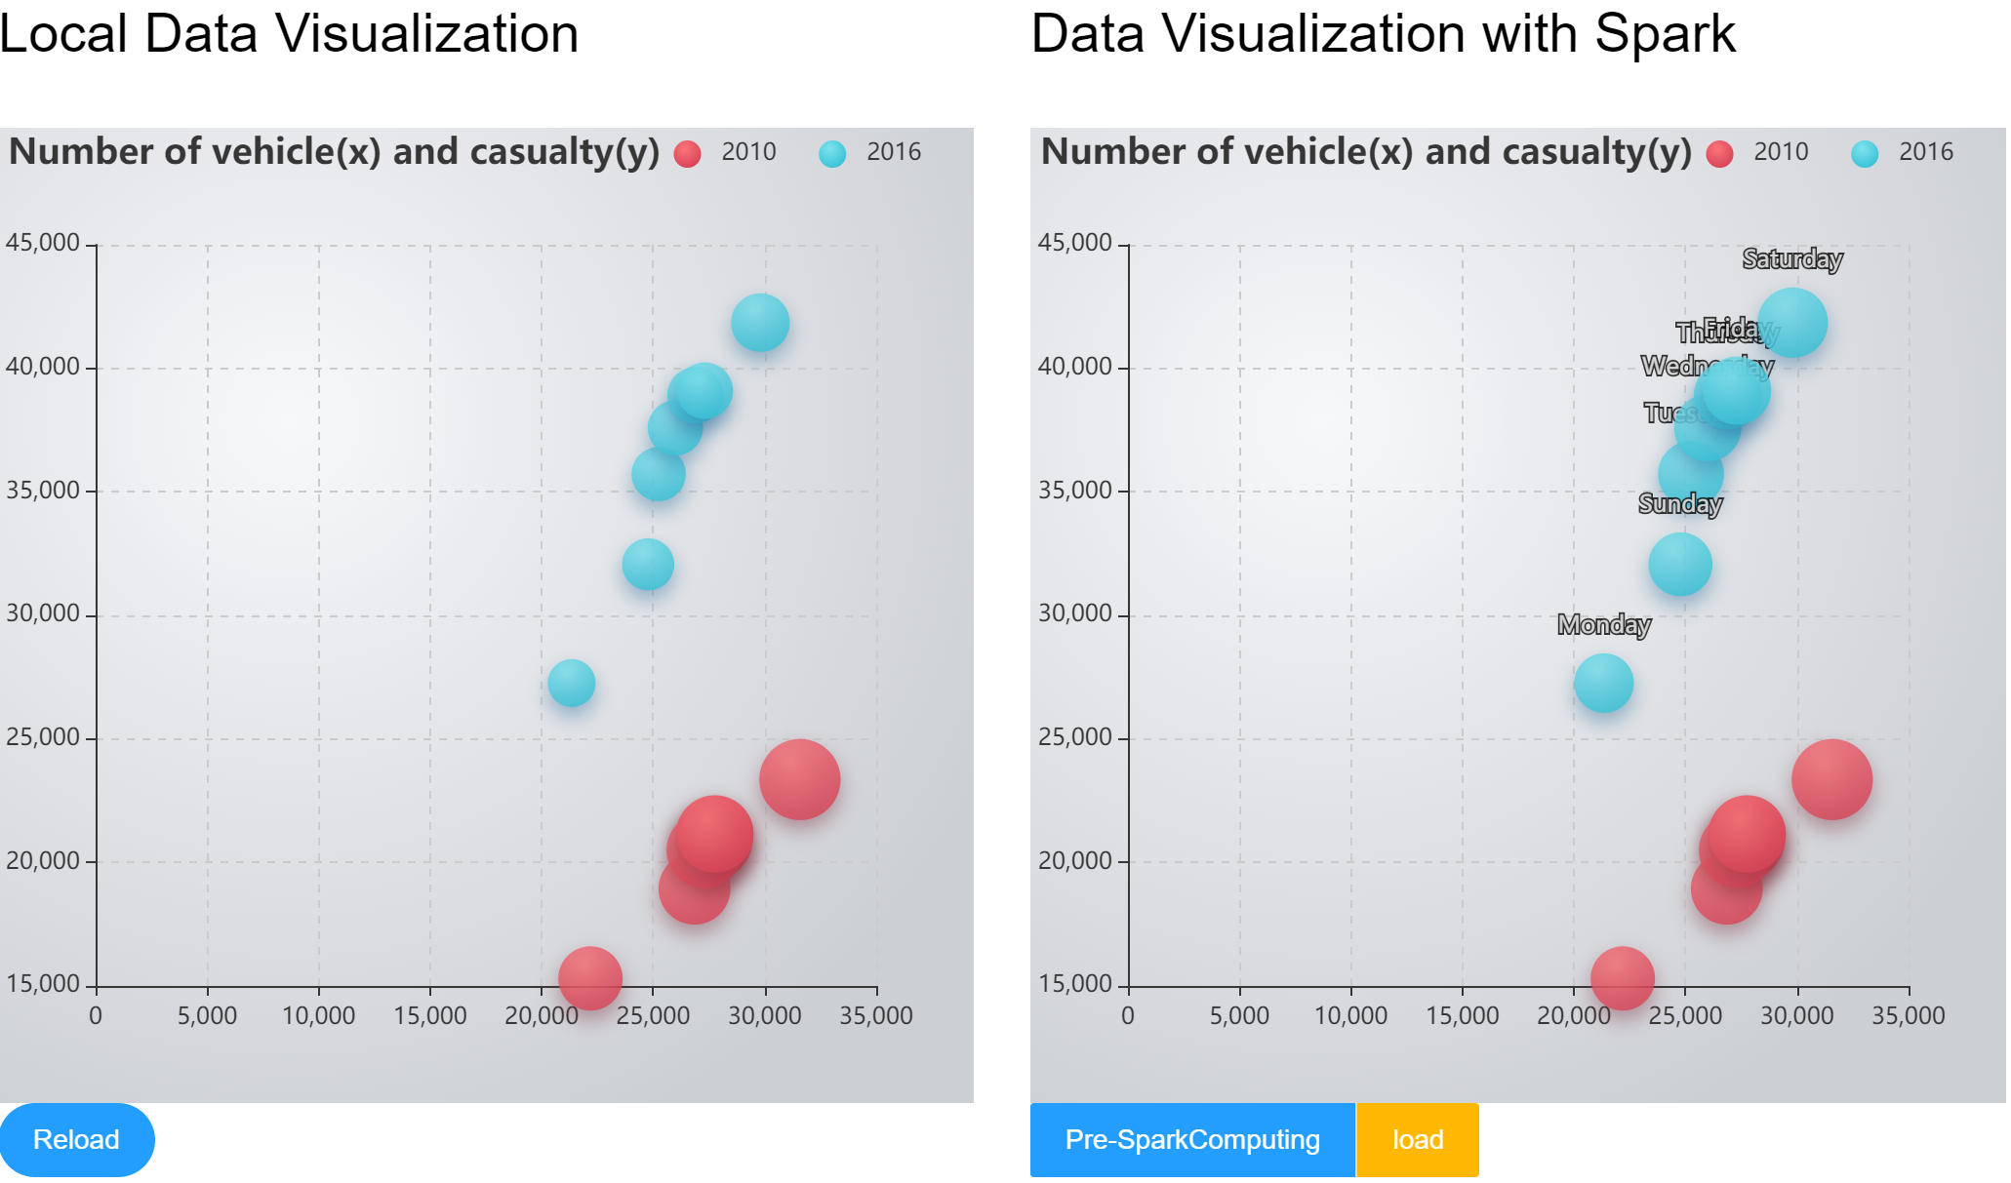
Figure 23: Bubble chart comparison of two modes
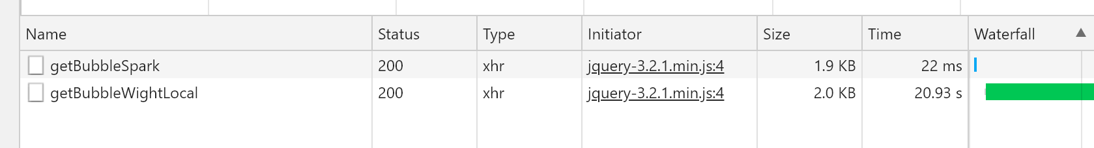
Figure 24: Time consuming of two modes

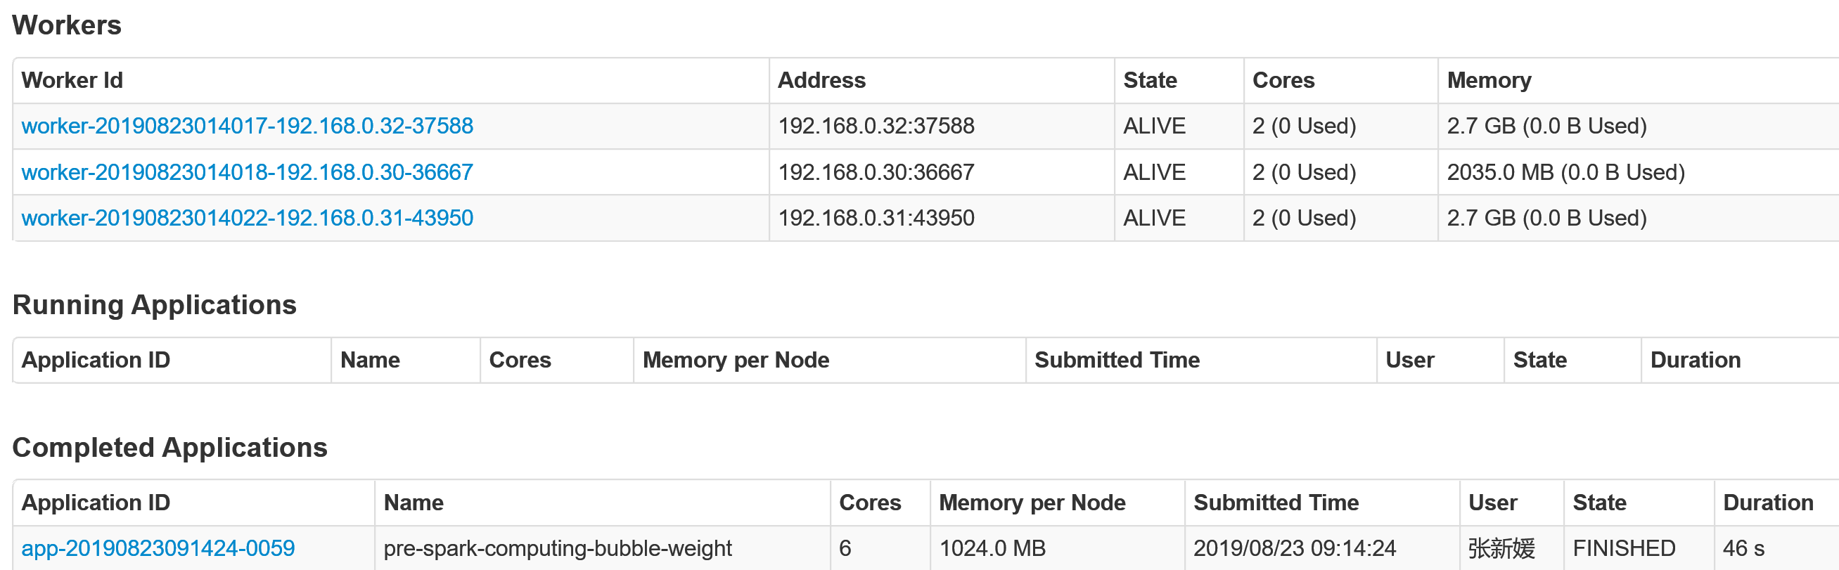
Figure 25: Time consuming on the Spark platform

 | 1 | 2 | 3 | 4 | 5
Local mode | 20.93s | 23.08s | 22.18s | 20.87s | 21.50s
Spark mode | 22ms | 24ms | 38ms | 19ms | 28ms
Computing on the Spark | 46s | 39s | 41s | 38s | 40s
Table 3: The overall time consuming of two modes in 5 times

Figure 24 shows the loading time of each component of the web page. ‘getBubbleWightLocal’ represents the loading time of graph data in the local mode. And the ‘getBubbleSpark’ represents the loading time of graph data after computing on the Spark platform by clicking the 'load' button in figure 23. In addition, the ‘pre-spark-computing-bubble-weight’ in figure 25 represents the computing time of tasks in the Spark mode on the Spark platform.

On the other hand, table 3 shows the overall time consumption results of the 5 times in the two modes respectively. Through this comparison, the Spark mode computing on the Spark platform can obviously improve the loading performance of data visualization as well and in this case, the computing job on the Spark platform spent not too much time compared with the local mode.

Specifically, this case shows that after the computing on the Spark platform, it will be very quick to load the data compared with the local mode. What is more, the time consuming of spark mode has also increased slightly compared to the case 2, while the time consuming of local mode with more computing works has increased extremely in last two cases. In addition, spark mode just needs once computing on the Spark platform while the local mode needs computing locally of each time. Therefore, it is concluded that the optimization of Spark mode in this case is obvious.

Finally, it is acknowledged that the time consuming of Spark platform is mainly subjected to the quality of the Spark cluster as the Spark cluster in this case is quite inferior. One of next works of this project is to use more powerful Spark cluster to test the performance. The Figure 26 is the time consuming on the Spark platform using Spark cluster with better quality in 5 times and the table 4 is the overall time consuming in these 5 times of two modes:

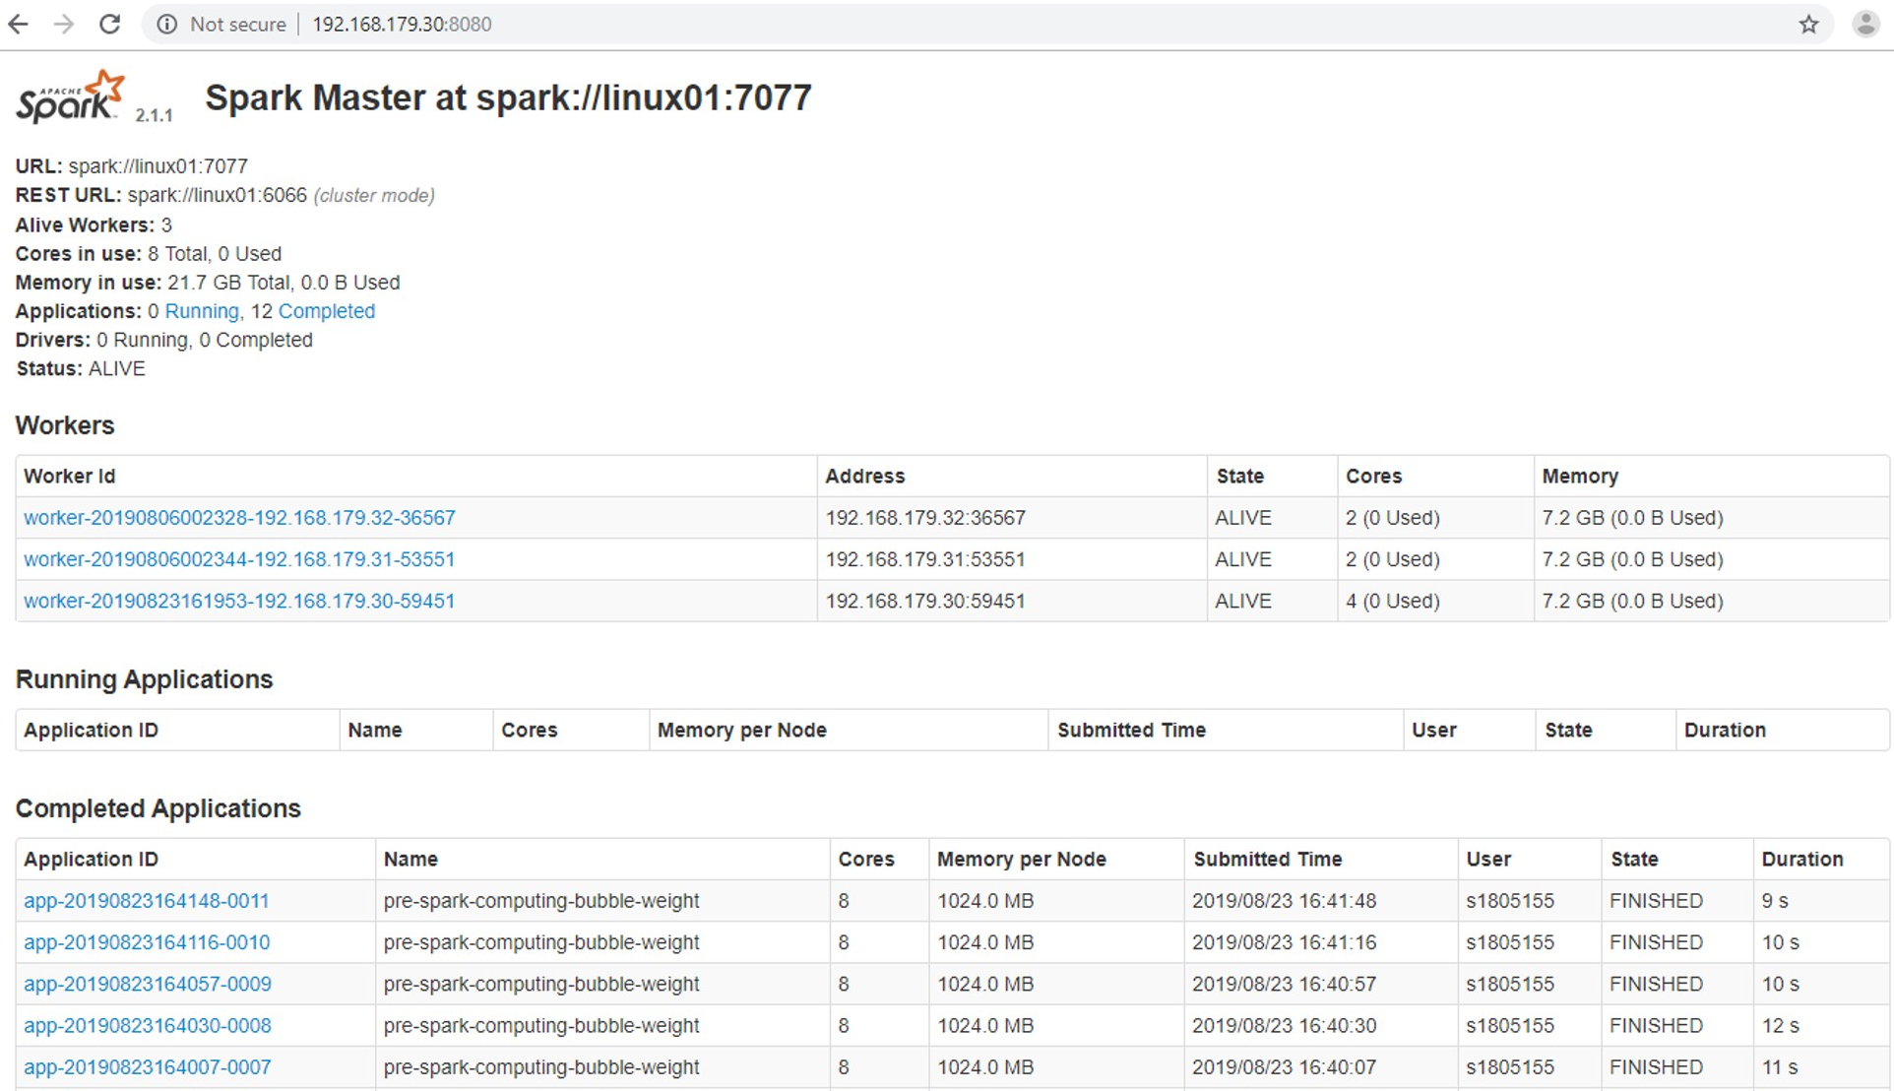

 | 1 | 2 | 3 | 4 | 5
Computing on the Spark | 9s | 10s | 10s | 12s | 11s
Spark mode | 20.52s | 21.6s | 23.1s | 22.32s | 19.82s
Local mode | 25ms | 22ms | 21ms | 25ms | 29ms
Table 4: The overall time consuming of computing tasks on Spark platform in 5 times

Through the table 4, it is acknowledged that in this case spark mode improved performance not only on the loading time, but also on the computing time on the Spark platform. Especially, the spark mode of the application, the computing works just need to be executed once while the same works need to be executed every time. Therefore, it is explicit that the spark mode in this case has improved the performance compared with the local mode.

- Conclusions and Recommendations

This project has taken two months to develop, and basically has achieved the objectives planned in chapter 1, including the pre-process of the data set and importing and managing it into the database, the construction of web application, the visualization analysis of data sets based on web application, the construction and configuration of Spark big data computing platform, and the visualization analysis of the data set on the web page based on Spark platform and so on.

Specifically, this project has achieved five kinds of chart for data visualization analysis of the data from database such as the line chart based on the Accident_Severity attribute, bar chart based on the Day_of_Week attribute, the pie charts based the Road_Type, Weather_Conditons, Light_Conditions and the Road_Surface_conditions respectively, the heat map based on the Latitude and Longitude attribute and the bubble chart based on the Day_of_Week attribute.

On the other hand, this project has used three cases in chapter 6 to compare the performance of the local mode and the spark mode. And in these three cases, it is concluded that spark mode certainly can improve the performance in terms of the cases with much more computing works like case 3, but for the case 1 and case 2 with less computing works, the optimization of spark mode is not obvious.

For the time consuming on the Spark platform, the performance of it is mainly subjected to the quality of the Spark cluster including the quality of each modes and the number of nodes. In the final part of chapter 6, the case 3 with the spark mode computing on the Spark platform using the better Spark cluster, performed an excellent result of time consuming compared with the inferior Spark cluster. In the meanwhile, there are also many factors may influence the performance of Spark platform such as the partition of Resilient Distributed Datasets (RDD) that is the basic data unit on the Spark platform, the rationality of the code and so on. These factors will be considered in the continuing project researches.

In a word, for the web-based data visualization applications, the optimization of spark mode is obvious in terms of the application with much more data and the computing works. In addition, another advantage of the spark mode is that the computing works just need to be executed once, but for the local mode, it will be executed every time to load the data.

On the other hand, the continuing project researches are listed as following:
- This project will continue to compare the performance of the map visualization of the data set, which will focus on adding weight value for each point on the map. Taking the heat map visualization using Google Map in figure 15 for example, the works adding weight value of each point will be computed on the Spark platform and then the web application to use the processed data to realize the heat map visualization on the Google Map.
- Furthermore, for the map visualization as well, it will focus on the map interaction performance when zooming in and out the map displaying the map with several levels of the map. In details, the application to use the map layers processed on the Spark platform like combining the processed transparent heat map layer with each map layer.
- this project will continue to research the relevant optimizations of data storage for the large-scale data set, which is to store data into NoSQL database like using Hbase, and then Spark platform works with Hbase, that is, Spark platform operating the job by calling data in HBase, and then storing the result data into HBase. Finally, the web application can directly use the data from the HBase.
- The real-time data visualization is also the important issues for this project to research. This project will continue to focus on solving real-time problems of data visualization in the future, as well as the distributed data visualization solutions for other charts.

- Reference

[1] | S. Holtz, G. Valle, J. Howard, and P. Morreale, “Visualization and pattern identification in large scale time series data,” in 2011 IEEE Symposium on Large Data Analysis and Visualization, 2011, pp. 129–130.
[2] | X. Yang, S. Liu, K. Feng, S. Zhou, and X.-H. Sun, “Visualization and Adaptive Subsetting of Earth Science Data in HDFS: A Novel Data Analysis Strategy with Hadoop and Spark,” in 2016 IEEE International Conferences on Big Data and Cloud Computing (BDCloud), Social Computing and Networking (SocialCom), Sustainable Computing and Communications (SustainCom) (BDCloud-SocialCom-SustainCom), 2016, pp. 89–96.
[3] | M. Friendly, “Milestones in the history of thematic cartography, statistical graphics, and data visualization * Michael Friendly,” 2008.
[4] | M. Rouse, “Data visualization,” WhatIs.com, July 2017.
[5] | Ren L. Research on interaction techniques in information visualization [Ph.D. Thesis]. Beijing: The Chinese Academy of Sciences, 2009 (in Chinese with English abstract).
[6] | R. M. Rohrer and E. Swing, “Web-based information visualization,” IEEE Comput. Graph. Appl., vol. 17, no. 4, pp. 52–59, 1997.
[7] | Y. Wang, “Model-driven data visualization platform design and implementation,” Beijing: Beijing Jiaotong University, 2015.
[8] | H. Guo, Z. Wang, B. Yu, … H. Z.-2011 I. P., and undefined 2011, “Tripvista: Triple perspective visual trajectory analytics and its application on microscopic traffic data at a road intersection,” ieeexplore.ieee.org.
[9] | J. Pu, S. Liu, Y. Ding, H. Qu, L. N.-2013 I. 14th International, and undefined 2013, “T-Watcher: A new visual analytic system for effective traffic surveillance,” ieeexplore.ieee.org.
[10] | J. Pu, S. Liu, Y. Ding, H. Qu, L. N.-2013 I. 14th International, and undefined 2013, “T-Watcher: A new visual analytic system for effective traffic surveillance,” ieeexplore.ieee.org.
[11] | P. C. Wong, H.-W. Shen, C. R. Johnson, C. Chen, and R. B. Ross, “The Top 10 Challenges in Extreme-Scale Visual Analytics,” IEEE Comput. Graph. Appl., vol. 32, no. 4, pp. 63–67, Jul. 2012.
[12] | C. U. I. Di, G. U. O. Xiaoyan, and C. Wei, “Challenges and recent progress in big data visualization,” vol. 37, 2017.
[13] | H. E. Wentao and S. Cheng, “The Development and Challenges of Industrial Big Data Analysis Technology,” 2018.
[14] | “What is Entity Relationship Diagram (ERD)?” [Online]. Available: https://www.visual-paradigm.com/guide/data-modeling/what-is-entity-relationship-diagram/. [Accessed: 05-Aug-2019].
[15] | B. Andreas, “Experimental psychology,” 1972, p.186.
[16] | I. Spence, “No Humble Pie: The Origins and Usage of a Statistical Chart,” J. Educ. Behav. Stat., vol. 30, no. 4, pp. 353–368, Dec. 2005.
[17] | N. Oresme and M. Clagett, Nicole Oresme and the medieval geometry of qualities and motions : a treatise on the uniformity and difformity of intensities known as Tractatus de configurationibus qualitatum et motuum. Madison: University of Wisconsin P, 1968.
[18] | L. Wilkinson and M. Friendly, “The History of the Cluster Heat Map,” Am. Stat., vol. 63, no. 2, pp. 179–184, May 2009.
[19] | A. Bojko, “Informative or Misleading? Heatmaps Deconstructed,” 2009, pp. 30–39.
[20] | C Shiwei, S Lingyun, “A survey on visualization for eye tracking data,” Journal of Computer-Aided Design & Computer Graphics, 2014.
[21] | Y. Ma, T. Lin, Z. Cao, C. Li, … F. W.-I. T. on, and undefined 2015, “Mobility viewer: An Eulerian approach for studying urban crowd flow,” ieeexplore.ieee.org.
[22] | D. Rothlisberger, … O. N.-2009 I. 17th, and undefined 2009, “Supporting task-oriented navigation in IDEs with configurable HeatMaps,” ieeexplore.ieee.org.
[23] | R. Gove, N. Gramsky, R. Kirby, … E. S.-… on S., and undefined 2011, “NetVisia: Heat map &amp; matrix visualization of dynamic social network statistics &amp; content,” ieeexplore.ieee.org.
[24] | C. Köpp, H.-J. von Mettenheim, and M. H. Breitner, “Decision Analytics with Heatmap Visualization for Multi-step Ensemble Data,” Bus. Inf. Syst. Eng., vol. 6, no. 3, pp. 131–140, Jun. 2014.
[25] | T. Almroth, “Data visualization for the modern web: A look into tools and techniques for visualizing data in Angular 5 applications,” 2018.
[26] | M. Bostock, V. Ogievetsky, … J. H. on visualization, and undefined 2011, “D³ data-driven documents,” ieeexplore.ieee.org.
[27] | Z. Wang, C. Zhang, “Design and Implementation of Data Visualization Analysis Component Based on ECharts,” Journal of Microcomputer and application, 2016.
[28] | X. Xu, “Visual design and implementation of technical statistics based on ECharts,” Journal of Tianjin Science and Technology, 2019.
[29] | Q Ma, “Smart Map: Google Earth/Maps/KML Core Development Technology Secret [M],” Beijing: Electronic Industry Press, 2010. (in Chinese with English abstract).
[30] | C. Zhang, Z. Sun, G. Heo, L. Di, and L. Lin, “A GeoPackage implementation of common map API on Google Maps and OpenLayers to manipulate agricultural data on mobile devices,” in 2016 Fifth International Conference on Agro-Geoinformatics (Agro-Geoinformatics), 2016, pp. 1–4.
[31] | M. Yang, T. Liu, X. Wang, Y. Yan, R. Hu, and Q. Zhu, “Design of WebGIS System Based on Javascript and ArcGIS Server,” in 2017 International Conference on Smart Grid and Electrical Automation (ICSGEA), 2017, pp. 709–712.
[32] | YingBin Cao, Zhengde Zhao, Xu Huaiyu, Yan ZhenXing, Jiang Peng, and Duan Wei, “An instant messaging system based on Google Map,” in 2010 2nd International Conference on Advanced Computer Control, 2010, pp. 21–24.
[33] | M. Liu, J. Wang, J. Wang, G. Tang, and M. Sun, “Design and Implementation of Emergency and Evacuation System Based on Baidu Map API,” in 2018 26th International Conference on Geoinformatics, 2018, pp. 1–5.
[34] | “mapv - clojure.core | ClojureDocs - Community-Powered Clojure Documentation and Examples.” [Online]. Available: https://clojuredocs.org/clojure.core/mapv. [Accessed: 06-Aug-2019].
[35] | G. Halevi, H. Moed, “The evolution of big data as a research and scientific topic: overview of the literature,” Research trends, pp. 3-6, 2012.
[36] | T. Hey, D. Gannon, J. P.- Computer, and undefined 2012, “The future of data-intensive science,” computer.org.
[37] | P. Jiansu, Q. Huamin, Y. Ming, “Visualization of moving track data,” Journal of Computer-Aided Design and Graphics, pp. 1273-1282, 24 10 2012.
[38] | H. Xianguo, “Taxi GPS Big Data Visualization Research,” Hangzhou: Zhejiang University of Technology, 2014.
[39] | X. Guoxuan, “Road traffic status determination based on taxi GPS data,” Xi'an: Chang'an University, 2015.
[40] | H. Baoqin, “Research on the application of spatial and temporal visual analysis of traffic accidents,” Xiamen University, 2016.
[41] | P. Xuan, F. Aifen, Q. Chenlu, and Z. Jianning, “Research on Key Technologies of Highway Traffic Accidents Visual Analysis,” China Public Secur. Acad. Ed., vol. 55, no. 2, pp. 52–56, 2019.
[42] | J. R. Asor, G. M. B. Catedrilla, and J. E. Estrada, “A study on the road accidents using data investigation and visualization in Los Baños, Laguna, Philippines,” 2018 Int. Conf. Inf. Commun. Technol. ICOIACT 2018, vol. 2018-Janua, pp. 96–101, 2018.
[43] | A. Imawan and J. Kwon, “A timeline visualization system for road traffic big data,” in 2015 IEEE International Conference on Big Data (Big Data), 2015, pp. 2928–2929.
[44] | H. Zhiyuan, Z. Liang, X. Ruihua, and Z. Feng, “Application of big data visualization in passenger flow analysis of Shanghai Metro network,” in 2017 2nd IEEE International Conference on Intelligent Transportation Engineering (ICITE), 2017, pp. 184–188.
[45] | A. Fang, X. Peng, J. Zhou, and L. Tang, “Research on the Map-matching and Spatial-temporal Visualization of Expressway Traffic Accident Information,” in 2018 3rd IEEE International Conference on Intelligent Transportation Engineering (ICITE), 2018, pp. 23–27.
[46] | D. Benslimane, S. Dustdar, and A. Sheth, “Services Mashups: The New Generation of Web Applications,” IEEE Internet Comput., vol. 12, no. 5, pp. 13–15, Sep. 2008.
[47] | D. A. Turner, “Web page caching in Java Web applications,” in International Conference on Information Technology: Coding and Computing (ITCC’05) - Volume II, 2005, pp. 805-808 Vol. 2.
[48] | Dandan Zhang, Zhiqiang Wei, and Yongquan Yang, “Research on Lightweight MVC Framework Based on Spring MVC and Mybatis,” in 2013 Sixth International Symposium on Computational Intelligence and Design, 2013, pp. 350–353.
[49] | P. Gupta, M. G.-I. J. of E. S. and, and undefined 2010, “Spring Web MVC Framework for rapid open source J2EE application development: a case study,” Citeseer.
[50] | S. Ladd, D. Davison, S. Devijver, C. Yates, and R. Harrop, “Expert Spring MVC and Web Flow,” 2006.
[51] | R. Yongchang, T. Xing, … Z. X.-… on C. and, and undefined 2011, “Application research for integrated SSH combination framework to achieve MVC mode,” ieeexplore.ieee.org.
[52] | D. Zhang, Z. Wei, Y. Y.-2013 S. I. Symposium, and undefined 2013, “Research on lightweight MVC framework based on spring MVC and mybatis,” ieeexplore.ieee.org.
[53] | Y. Hou, “Design and Implementation of the Framework for Spring+SpringMVC+MyBatis in the Development of Web Application,” in 2017 International Conference on Computer Technology, Electronics and Communication (ICCTEC), 2017, pp. 368–371.
[54] | P. Webb, D. Syer, J. Long, S. Nicoll, … R. W.-P. I. S. B., and undefined 2013, “Spring boot reference guide,” iyd.cl.
[55] | S. M.-J. O. C. A. D. AND and undefined 2002, “3D visualization of large DEM data set based on grid division,” Sci. Press.
[56] | B. Zhenyu, S. Guihua and L. Jun, “A feature-based seeding method for multi-level flow visualization,” Journal of Computer-Aided Design & Computer Graphics, pp. 32-40, 2016.
[57] | H. Qun and Y. Mingchuan, “WebGIS-based big data visualization and optimization,” Telecommunications Technology, pp. 37-40, 2015.
[58] | Y. Wei, L. Jiping and W. Yong, “Computation of Heat distribution for geographic object space,” Bulletin of Surveying and Mapping, pp. 391-393, 2012.
[59] | X. Li, A. Kuroda, … H. M.-2015 I. 5th, and undefined 2015, “Advanced aggregate computation for large data visualization,” ieeexplore.ieee.org.
[60] | Z. Fan, Y. Zhaokang, X. Fanping, Y. Kun and W. Zhangye, “Research on Heatmap for Big Data Based on Spark,” Journal of Computer-Aided Design & Computer Graphics , pp. 1881-1886, 11 2016.
[61] | S. Chintapalli et al., “Benchmarking Streaming Computation Engines: Storm, Flink and Spark Streaming,” in 2016 IEEE International Parallel and Distributed Processing Symposium Workshops (IPDPSW), 2016, pp. 1789–1792.
[62] | S. A. Noghabi et al., “Samza,” Proc. VLDB Endow., vol. 10, no. 12, pp. 1634–1645, Aug. 2017.
[63] | V. Agneeswaran, “Big data analytics beyond hadoop: real-time applications with storm, spark, and more hadoop alternatives,” 2014.
[64] | Y. Ohno, S. Morishima, and H. Matsutani, “Accelerating Spark RDD Operations with Local and Remote GPU Devices,” in 2016 IEEE 22nd International Conference on Parallel and Distributed Systems (ICPADS), 2016, pp. 791–799.
[65] | V. Vavilapalli, A. Murthy, … C. D.-P. of the 4th, and undefined 2013, “Apache hadoop yarn: Yet another resource negotiator,” dl.acm.org.
[66] | “Apache Kafka.” [Online]. Available: https://kafka.apache.org/intro. [Accessed: 19-Aug-2019].
[67] | Jing Han, Haihong E, Guan Le, and Jian Du, “Survey on NoSQL database,” in 2011 6th International Conference on Pervasive Computing and Applications, 2011, pp. 363–366.
[68] | M. V.-P. of 2011 I. C. on and undefined 2011, “Hadoop-HBase for large-scale data,” ieeexplore.ieee.org.
[69] | A. El Alami, M. Bahaj, and Y. Khourdifi, “Supply of a key value database redis in-memory by data from a relational database,” in 2018 19th IEEE Mediterranean Electrotechnical Conference (MELECON), 2018, pp. 46–51.
[70] | M. M. Patil, A. Hanni, C. H. Tejeshwar, and P. Patil, “A qualitative analysis of the performance of MongoDB vs MySQL database based on insertion and retriewal operations using a web/android application to explore load balancing — Sharding in MongoDB and its advantages,” in 2017 International Conference on I-SMAC (IoT in Social, Mobile, Analytics and Cloud) (I-SMAC), 2017, pp. 325–330.
[71] | D. Sinha, “Philosophy and Phenomenological Research,” International Phenomenological Society, pp. 562-577, 1963.
[72] | “Road Safety Data - data.gov.uk.” [Online]. Available: https://data.gov.uk/dataset/cb7ae6f0-4be6-4935-9277-47e5ce24a11f/road-safety-data. [Accessed: 19-Aug-2019].
[73] | L. R. Vijayasarathy and C. W. Butler, “Choice of Software Development Methodologies: Do Organizational, Project, and Team Characteristics Matter?,” IEEE Softw., vol. 33, no. 5, pp. 86–94, Sep. 2016.
[74] | “Top 4 software development methodologies | Synopsys.” [Online]. Available: https://www.synopsys.com/blogs/software-security/top-4-software-development-methodologies/. [Accessed: 06-Aug-2019].
[75] | H. C.-O. S. & S. I. digital and undefined 2011, “Understanding agile project management methods using Scrum,” emeraldinsight.com.
[76] | L. Lindstrom and R. Jeffries, “Extreme Programming and Agile Software Development Methodologies,” Inf. Syst. Manag., vol. 21, no. 3, pp. 41–52, Jun. 2004.
[77] | K. Motoki, T. Okahisa, R. Hirota, … S. N.-U. P., and undefined 2007, “Method of growing GaN crystal, method of producing single crystal GaN substrate, and single crystal GaN substrate,” Google Patents.
[78] | Ashraf Ferdouse Chowdhury and Mohammad Nazmul Huda, “Comparison between Adaptive Software Development and Feature Driven Development,” in Proceedings of 2011 International Conference on Computer Science and Network Technology, 2011, pp. 363–367.
[79] | J. Coad, P., Lefebvre, E., De Luca, “No TitleJava modelling In Color With UML: Enterprise Components and Process,” Prentice Hall Int., 1999.
[80] | S. R. (Stephen R. Palmer and J. M. Felsing, A practical guide to feature-driven development. Prentice Hall PTR, 2002.
[81] | J. Khan, I. Rehman, … Y. K.-… J. of M., and undefined 2015, “Comparison of requirement prioritization techniques to find best prioritization technique,” pdfs.semanticscholar.org.
[82] | “layui - Classic modular UI framework.” [Online]. Available: https://www.layui.com/. [Accessed: 19-Aug-2019].
[83] | M. Odersky, P. Altherr, V. Cremet, B. Emir, and S. Maneth, “An overview of the Scala programming language,” 2004.
[84] | “Maven – Welcome to Apache Maven.” [Online]. Available: https://maven.apache.org/. [Accessed: 20-Aug-2019].
[85] | V. Chopra, S. Li, and J. Genender, “Professional apache tomcat 6,” 2007.

Appendix

