

Master of Business Administration
In International Business

Module name: Financial Management
Module code: (LCMB7002_LON)
Lecturer name: Shengfeng Mei, Ghulam Mujtaba
Student name: Priyanshi Manoj Parikh
Student ID: 2543469
Word count: 4401
Title: Financial Performance and Strategic Financial Management of InterContinental Hotels Group PLC
Submission date: 13 August 2026

Table of content

1. Financial Health Check 4
2. Working Capital Management Analysis 8
3. Strategic Financial Restructuring Plan 10
4. Investment Appraisal and Capital Budgeting 12
5. Critical Reflection on AI Usage 16
Conclusion 18
References 19
Appendices 23

Introduction
InterContinental Hotels Group PLC (“IHG”) is a British multinational hotel company, based in Windsor, England, whose shares are traded on the London Stock Exchange (FTSE 100) and on the New York Stock Exchange (NYSE), as an American Depository Receipt (IHG plc, 2026a). It offers a range of 21 hotel brands – from InterContinental to Kimpton and Regent at the luxury end of things, to Holiday Inn Express and Staybridge Suites – and more than 7,000 hotels and over one million rooms in upwards of 100 countries, backed by the IHG One Rewards loyalty programme that has expanded to over 160 million members (IHG plc, 2026a). IHG's asset-light approach, where the bulk of its revenue comes from franchise fees and hotel-management fees instead of owning hotel property, leads to less cyclicality in its asset values but still allows it to enjoy the economies of scale of a global brand, reservations system and loyalty program (Busch, 2023).

This report is written from the perspective of IHG's Chief Financial Officer who is preparing a Board review. It has three inter-related objectives: firstly, to analyse the actual performance of IHG in the financial period FY2021 to FY2025, and what that indicates about the Group's financial strengths and weaknesses; secondly, to then use that analysis to develop a suitable financial plan for the Group, which includes the working capital, the financing mix and the balance-sheet structure; and thirdly, to formally apply investment-appraisal financial discipline to three potential capital projects, ensuring that any recommendation to the Board is based on evidenc rather than intuition. The report continues by performing a financial health check (Section 1), a working capital review (Section 2), a restructuring strategy (Section 3), an investment appraisal (Section 4), and reflection on the use and verification of AI tools during the analysis (Section 5).

1. Financial Health Check

(a) Five-Year Financial Trend

The financial statement of IHG for the financial years (FY) 2021-2025 is quite clear in terms of the recovery and growth path it is on (IHG plc, 2026c; StockAnalysis.com, 2026). Revenue increased from $2,907m in FY2021 to $5,189m in FY2025. Operating profit (EBIT) increased by over 200% to $1,198m and EBITDA grew by more than 400%, to $1,344m. Net income grew to $759m and free cash flow grew to $870m. Diluted EPS rose more than threefold to $4.87, which included profit growth and a decrease in the number of shares due to continued buybacks. The balance sheet is another story: shareholders' equity was already negative at $1,474m in FY2021, but dropped even further to a deficit of $2,736m by FY2025 as, on one hand, cash was repatriated to shareholders through dividends and buybacks, and on the other hand, retained earnings were consistently less than cash returned to shareholders, a deliberate capital-allocation choice that is explored in more detail below and in Section 3 that shows no weakness in the trading.

(b) Ratio Analysis
Six categories of ratio were examined: profitability, liquidity, efficiency, gearing, investment, and cash flow. A full five-year data set is provided in Appendix 1; the key findings for each category are summarised below.

Profitability
Profitability ratios measure how effectively revenue and capital are converted into profit (Wall Street Prep, 2024). IHG's net profit margin rose from 9.1% (FY2021) to 14.6% (FY2025), and operating margin from 17.0% to 23.1%, evidencing strong operating leverage: because most of IHG's cost base is fixed at corporate level, growth in the fee-earning hotel system converts disproportionately into profit. Return on capital employed more than doubled, from 16.0% to 36.9%, reflecting the capital efficiency inherent in an asset-light franchise model.

Liquidity Ratios

Liquidity ratios gauge a company’s ability to satisfy short-term debts (Fachrian and Hidayat, 2023). In this case, the opposite is true as both the current ratio declined from 1.27x to 0.98x and the quick ratio (almost identical considering insignificant inventories) declined from 1.27x to 0.97x within five years, making current liabilities greater than current assets. Whether this poses a real problem is discussed further below in part (d) as the response will depend largely on the benchmark applied.

Efficiency Ratios

Efficiency ratios measure efficiency of asset management in generating revenue (Corporate Finance Institute, 2026a). Both asset turnover and receivable days increased from 0.62x to around 1.0x and from 72.2 to 60.5, respectively, reflecting a more mature and efficient fee collection process. The cash conversion cycle of IHG (receivables days minus payables days) was negative for all five years (approximately -32 days for FY2021 to -9 days for FY2025), which is elaborated upon in Section 2(a)

Gearing

Gearing shows the level of debt and the ability to pay it back (Rusu and Roman, 2022). Since the shareholders' equity has been negative every year in the review period, the traditional debt/equity ratio does not work for IHG, while net debt/EBITDA and interest cover ratios are used. Net debt/EBITDA has decreased from 2.64x to 1.87x in FY2023 and increased again to 2.59x in FY2025 with the resumption of debt-financed buybacks. Interest cover ratio has been improving from 3.36x to 5.93x (with a peak of 8.46x in FY2023) indicating that the growth in EBIT has so far outpaced the increase in debt servicing costs.

Investment

Investment ratios show the amount earned by the shareholders (Accaglobal, 2026). The return on equity has no meaning since the negative value in the denominator converts the growing profit into negative (−18% to −28%). More useful indicators are diluted EPS and dividends per share: EPS have grown from $1.45 to $4.87, while DPS – from $0.86 to $1.845.

Cash Flow
Cash flow ratios reveal how much cash a business actually generates, as opposed to reports (Seretidou et al., 2025). IHG's operating cash flow margin moved from 21.9% to 17.3% (dipping to 14.7% in FY2024), while free cash flow rose in absolute terms from $619m to $870m and consistently exceeded net income — evidence of high cash-quality earnings rather than accounting profit alone.

(c) Trends, Strengths and Threats

Three key themes emerge from the five-year analysis: ongoing improvement in profitability and capital efficiency from the trough in FY2022; a balance sheet that has become increasingly leveraged on a book basis through capital returns rather than trading losses; and declining liquidity starting from an already relatively low level in FY2021 to below-1.0x current and quick ratios from FY2023 onwards.

The positive aspects are an unusually high margin and capital efficient business and management model; an ROCE near 37%; consistent free cash flow generation; a global diversified brand portfolio and presence along with a future fee revenue pipeline (694 hotels/102,100 rooms in FY2025); and interest cover nearly doubling from FY2021 despite a bigger debt pile. Negative points are a negative and worsening book equity position which makes it harder to cope with a demand shock from the balance sheet point of view; a negative RevPAR trend in Greater China (−1.6% in FY2025) against a positive one elsewhere; increasing gross interest expense as the result of debt pile expansion; and a capital allocation approach where buybacks take precedence leaving limited room for M&A activity or additional demand shocks financing without debt.

(d) Liquidity Against Industry Benchmarks
The current ratio of 0.98x (for FY2025) is considerably lower than the benchmark corporate finance industry-wide norm of 1.5x–2.0x, but also lower than what would be expected for asset-intensive firms operating through real estate investment trust structures like Host Hotels & Resorts, which has had a current ratio of more than 4x in recent years due to holding significant cash reserves, in contrast with its different operating model (Macrotrends, 2026). For IHG, however, the right comparison is not Host Hotels & Resorts but other asset-light players in its industry using the same business model based on franchising and hotel management, namely Marriott International, with a current ratio of about 0.45x in recent years, and Hilton Worldwide, with a current ratio of about 0.70x–0.80x (Macrotrends, 2026; StockAnalysis.com, 2026). Against those peers, the current ratio of ~0.98x for IHG is in fact the highest, not the lowest, driven by low inventory levels and deferred revenue/loyalty balances in current liabilities (Karim et al., 2023).

Table 1: IHG liquidity vs asset-light hotel peers.
Company | Current Ratio | Business Model
IHG | 0.98x | Asset-light franchise/management (98%+ fee-based)
Hilton Worldwide | ~0.70–0.80x | Asset-light franchise/management
Marriott International | ~0.45x | Asset-light franchise/management
Host Hotels & Resorts | ~4.0x | Owned-asset REIT (not a direct comparator)
Generic textbook benchmark | 1.5x–2.0x | General/asset-heavy norm

2. Working Capital Management Analysis

(a) The Cash Operating Cycle
The cash operating cycle is the time span between the payment of operating inputs and the collection of the cash from the customers, and it is an important measure of the company's liquidity management (Karim et al., 2023). The inventory held by IHG is insignificant — less than $5m for the entire analysis period – as the risk associated with physical inventory rests on the franchisees and managed hotel owners. The accounts receivable are mostly from franchise royalty and management fees, and are estimated to be about 60 days, affected by the billing cycle and the financial standing of the franchisees. On the other side of the cycle, the increasing deferred revenue balance – particularly the IHG One Rewards loyalty obligation, which went up from $617m to $829m during the analysis period – along with payables related to the costs of managed hotels that have to be reimbursed, give the company a structurally negative cash operating cycle, estimated to be about −32 days in FY2021 and −9 days by FY2025.
This implies that IHG receives and retains the cash in advance of making payments – a true, inexpensive form of working capital financing that has been declining continuously despite increasing leverage on the balance sheet. That narrowing trend, more than the absolute negative figure, is what the Board should watch.

(b) Improving Liquidity Through Working Capital Reform
With the current and quick ratios now falling below 1.0x and the cash coverage of current liabilities more than halved (cash ratio 0.89x to 0.54x during this period), three recommendations are made, guided by the working capital management literature (Wang & Nie, 2025).
First, tighter receivables management is feasible: consolidating billing for franchisees and management fees across regions, uniform timing of invoices, automation of reminder letters for overdue payments, and small discounts for prompt payment can potentially reduce collections time from the current average of about 60 days by five to ten days without additional financing (Shah O., 2025). Second, active management of the float generated by customer loyalty programmes is necessary – the increase in membership of IHG One Rewards programme and partnerships will generate higher unearned revenues, a low-cost financing option, as long as the liability for redemptions is carefully reserved. Third, payment terms of the payables associated with reimbursable hotel costs can be harmonised and, where appropriate, extended through supplier finance programs allowing major suppliers to receive payment from a third party financier earlier than IHG makes payment (Lien, 2024; Zheng et al., 2025) — though this must be pursued with care, since aggressive term extension risks damaging relationships with smaller suppliers and carries the ethical and reputational concerns discussed in Section 3(c).
Underpinning all three, a more centralised global cash-pooling structure would help, given IHG holds cash across multiple currencies and legal entities in over 100 countries (Kubranová, 2020). This would improve visibility of Group-wide liquidity and reduce reliance on local cash buffers, complementing a larger committed-but-undrawn revolving credit facility, which is the most direct backstop against a sub-1.0x current ratio.

(c) Short-Term vs Long-Term Financing
IHG already blends short-term facilities (revolving credit lines, commercial paper) with long-term instruments (bonds, term loans); long-term debt stood at $3,723m in FY2025 against a current portion of long-term debt that has grown to $478m. Short-term financing is cheaper on a running-cost basis and well suited to smoothing the modest, recurring seasonal swings inherent in fee collection, but carries refinancing risk that becomes acute exactly when credit markets tighten in a downturn (Prudential, 2019; Shah A., 2025). Long-term financing costs more in coupon terms but removes that refinancing risk and better matches the multi-year duration of brand investment and the ongoing buyback programme.
Given the current portion of debt has nearly doubled year-on-year and net debt/EBITDA is trending back up toward 2.6x, IHG should term out a larger share of near-term maturities into longer-dated, fixed-rate instruments — including exploring a sustainability-linked bond tranche, discussed in Section 3(c) — while reserving short-term facilities strictly for working-capital smoothing rather than for funding buybacks, which should increasingly come from recurring free cash flow instead.

3. Strategic Financial Restructuring Plan

(a) Restructuring Options
IHG is not in financial distress — it has been profitable throughout the review period — so restructuring here means capital-structure and portfolio optimisation, not turnaround (Oord, 2024). Three complementary options are set out in Table 2 and discussed below.
Table 2: Restructuring options assessed for IHG.
Option | Mechanism | Primary rationale
Continued divestiture of owned real estate | Sell any remaining owned/leased hotel assets not aligned with the asset-light model; recycle proceeds into brand, technology and loyalty investment (Oktaviyani et al., 2020). | Raises ROCE further; reduces property-price cyclicality; simplifies the portfolio.
Disciplined bolt-on M&A | Continue targeted acquisitions in high-growth segments, as with the 2025 Ruby Hotels deal, funded by a mix of free cash flow and debt (Shijaku et al., 2025). | Expands the fee-earning system and cross-sell base without the leverage of a transformational merger.
Moderated buyback pace | Slow debt-funded repurchases in years where net debt/EBITDA is at or above 2.5x, retaining more earnings (Prokop, 2025). | Self-funded, non-dilutive way to rebuild book-equity headroom and protect the credit profile.
A primary equity issuance is deliberately not proposed: IHG is strongly cash-generative, and a fresh share issue would be dilutive and unnecessary in the base case; it is best held in reserve as a contingency response to a severe, prolonged demand shock rather than deployed now.

(b) Impact on Shareholder Value, Debt and Flexibility
Divestiture tends to create near-term value through higher cash flow and improved ROIC, though the loss of income from sold assets can weigh on future earnings (Teschner and Paul, 2020); it also directly reduces net debt and improves borrowing capacity, and simplifies operations for management. Bolt-on M&A can generate durable value where synergies are realised promptly, but integration failure risks value destruction (Giannopoulos et al., 2023) and increases near-term leverage, requiring a clear deleveraging plan; it also demands short-term integration resource but expands the Group's reach into new markets and segments (Shijaku et al., 2025). Moderating buybacks is mildly dilutive to the EPS-growth momentum that a shrinking share count has been generating, and may be read cautiously by the market in the short run, but it materially reduces the risk of the Group being forced into a dilutive, value-destructive equity raise during a future downturn (Nguyen Thi et al., 2025) — trading a small amount of near-term optics for materially improved medium-term resilience and continued flexibility to invest through the cycle.

(c) International and Ethical Dimensions
Operating across more than 100 countries and reporting in US dollars from a UK domicile exposes IHG's restructuring plan to several cross-border dynamics (Widjaja, 2021). Tax: IHG must navigate the OECD's global minimum tax framework, which coordinates the reallocation of taxing rights across the jurisdictions in which multinational groups operate (OECD, 2026); any divestiture or M&A activity should be underpinned by transparent, arm's-length transfer pricing on intercompany franchise and management-fee flows, both to manage tax risk and protect reputation. Currency: fee income arises in a wide range of local currencies while debt and reporting skew to US dollars and sterling, warranting continued natural hedging and FX forward cover, with particular attention to RMB volatility given the Greater China RevPAR softness noted in Section 1(c).
Ethically, restructuring decisions affect employees, franchisees and local communities, and should be pursued as a responsible transition rather than a purely financial exercise (Amiri et al., 2022). IHG's Corporate Social Responsibility and ESG commitments should not be set aside in the process (Christensen et al., 2021); this includes continuing to fund the “Journey to Tomorrow” 2030 responsible-business programme covering carbon, water and waste reduction and community investment (IHG plc, 2024), and ensuring any renegotiation of supplier payment terms (Section 2(b)) preserves fair terms for smaller suppliers rather than using scale to extract unilaterally longer payment windows.

4. Investment Appraisal and Capital Budgeting
IHG is evaluating three mutually exclusive £50m projects, each with a five-year cash-flow profile, against an 8% cost of capital and straight-line depreciation to zero (£10m per annum per project). Project A yields £10m, £12m, £14m, £10m and £8m across Years 1–5; Project B yields a constant £11m per year; Project C yields £5m, £10m, £20m, £25m and £5m. Five appraisal techniques are applied below; full year-by-year workings for all three projects appear in Appendix 3 and in the accompanying Excel workbook, where every figure is computed by live formula and cross-checked against an independent Python calculation.

Payback Period
Payback period measures how long a project's cumulative cash inflows take to recover the initial outlay (Wall Street Prep, 2025). Project A recovers £46m by the end of Year 4, leaving £4m to be recovered from Year 5's £8m inflow, giving a payback of 4.5 years. Project B recovers £44m by Year 4, leaving £6m against an £11m Year-5 inflow, giving 4.55 years. Project C recovers £35m by Year 3, leaving £15m against a £25m Year-4 inflow, giving 3.6 years — the shortest of the three.

Accounting Rate of Return
ARR relates average annual accounting profit to average investment (Rajgopal et al., 2023). Against an average investment of £25m (half of £50m) and annual depreciation of £10m, Project A's total accounting profit of £4m (from £54m of inflows less £50m of depreciation) gives an average annual profit of £0.8m and an ARR of 3.2%. Project B's £5m total profit gives an average of £1.0m and an ARR of 4.0%. Project C's £15m total profit gives an average of £3.0m and an ARR of 12.0% — three to four times higher than the other two projects.

Net Present Value and Profitability Index
NPV discounts a project's future cash flows to present value and nets off the initial outlay, explicitly pricing in the time value of money (Corporate Finance Institute, 2026b); PI expresses that present value per pound invested and is the correct ranking tool under capital rationing (Ogunbiyi, 2023). At 8%, Project A's inflows discount to £43.46m against a £50m outlay, an NPV of −£6.54m and a PI of 0.869. Project B's inflows discount to £43.92m, an NPV of −£6.08m and a PI of 0.878. Project C's inflows discount to £50.86m, an NPV of +£0.86m and a PI of 1.017 — the only project that is NPV-positive and the only one with a PI above 1.0.

Internal Rate of Return
IRR is the discount rate at which NPV equals zero (Wall Street Prep, 2026). Project A's IRR is 2.72%, Project B's is 3.26%, and Project C's is 8.59% — the only one of the three that clears IHG's 8% cost of capital.
Table 3: Investment appraisal summary @ 8% discount rate.
Metric | Project A | Project B | Project C
Payback period | 4.50 years | 4.55 years | 3.60 years
ARR (average investment basis) | 3.2% | 4.0% | 12.0%
NPV | £(6.54)m | £(6.08)m | £0.86m
Profitability Index | 0.869 | 0.878 | 1.017
IRR | 2.72% | 3.26% | 8.59%
Clears 8% hurdle? | No | No | Yes
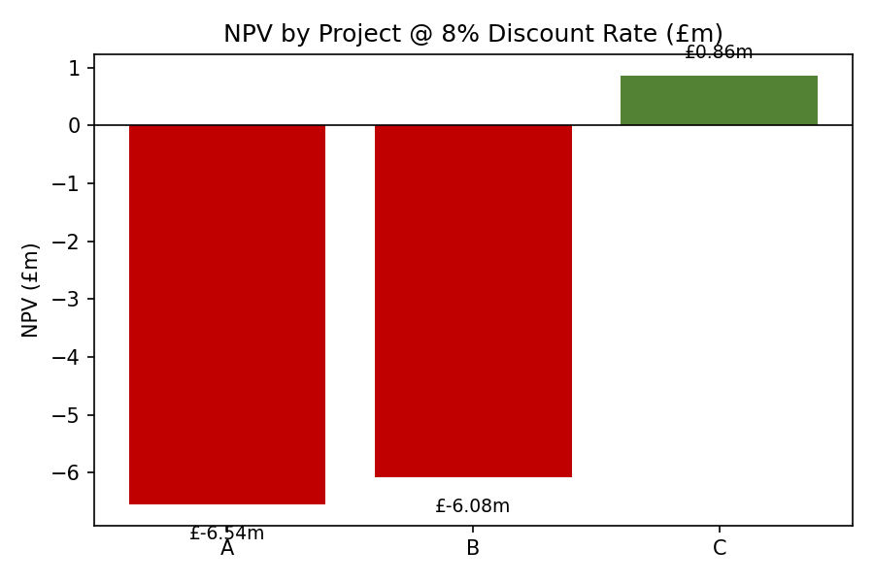
Figure 1: NPV by project @ 8% discount rate.

Recommendation
Project C is recommended without qualification: it wins on every one of the five methods, and — critically — it is the only project that creates value at IHG's cost of capital, while Projects A and B both destroy value despite showing positive accounting returns and eventually paying back on an undiscounted basis. This is precisely why payback and ARR cannot be used in isolation: neither accounts for the time value of money, and both mask the fact that A's and B's cash flows arrive too late, and in too modest a size, to compensate for the 8% discount rate. IHG's own financial position reinforces the recommendation — ROCE near 37%, interest cover of 5.9x, net debt/EBITDA around 2.6x and FY2025 free cash flow of $870m together mean Project C could be funded from internal cash generation without recourse to new debt or equity, and without stressing any of the credit metrics identified in Section 1.
Non-financial risk should still be diligenced before sign-off. Politically, if Project C sits in an emerging or single-country market, expropriation, capital-control and planning risk should be assessed, with particular reference to the Greater China RevPAR softness already observed. Project C's own cash-flow shape is itself worth investigating: inflows collapse from £25m in Year 4 to just £5m in Year 5, a pattern consistent with new competitive supply, a scheduled renovation, or a management-contract expiry, and management should be asked to justify this before the Board approves the project. Finally, if Project C would require IHG to hold or co-invest in a physical asset, that would sit awkwardly against the divestiture-led, asset-light strategy recommended in Section 3, and the ownership structure should be confirmed as consistent with Group strategy.

Capital Rationing at a £100m Budget
Capital rationing addresses how to allocate a limited pool of funds across competing projects (Lorentzen and Osmundsen, 2023). With £100m available and each project requiring £50m, IHG could in principle fund any two of the three. Ranking by PI — the theoretically correct metric here, since it measures value created per pound of scarce capital — places Project C first (1.017), Project B second (0.878) and Project A third (0.869). But PI ranking alone does not settle the question when more than one project has a PI below 1.0, so the combinations themselves must be compared directly.
Table 4: Combined NPV of feasible project pairings within the £100m budget.
Combination | Total Outlay | Combined NPV
A + B | £100m | £(12.62)m
A + C | £100m | £(5.69)m
B + C | £100m | £(5.22)m
Project C only | £50m | £0.86m
Every combination that includes A and/or B produces a lower combined NPV than accepting Project C alone, because both destroy value individually. Since capital rationing exists to maximise value created, not to maximise capital deployed, the optimal choice is Project C alone: invest £50m, decline both A and B, and redeploy the unused £50m to debt reduction, a future value-accretive opportunity, or the ordinary shareholder-return programme — any of which, unlike A or B, does not destroy value at IHG's cost of capital.

5. Critical Reflection on AI Usage

(a) Tool Disclosure
This report was prepared with the assistance of Claude (Anthropic), used for three specific tasks: retrieving IHG's FY2021–FY2025 financial data from IHG plc's own investor-relations releases, SEC filings, and standardised financial databases; building the ratio-analysis and investment-appraisal calculations in Excel with live formulas; and structuring and drafting the narrative in this report. The analytical direction, interpretation and final recommendations are my own, developed by reviewing and testing the AI-assisted outputs described below.

(b) Critical Evaluation of AI Output
I treated no AI output as correct by default. Every externally sourced figure was checked against a primary source — IHG's own results announcements or SEC filings — rather than accepted from a single aggregator, and I explicitly distinguished IHG's fee-based “revenue from reportable segments” (roughly $2.5bn) from total consolidated revenue including reimbursed costs (roughly $5.2bn), since these are easily conflated. Every ratio in this report was independently recomputed from underlying line items rather than taken on trust. In doing so, I found and corrected a logic error in an early draft of the payback-period formula, where a cumulative cash flow already net of the £50m outlay was compared against that same £50m a second time, producing an incorrect “not recovered” result for all three projects; this was caught by cross-checking against an independent calculation, traced to its cause, corrected, and re-verified through a full recalculation that confirmed zero residual formula errors.

(c) Contribution Analysis
The mechanical work — locating public financial data, performing calculations, and producing a first-pass draft structure — was AI-assisted. The judgement was mine: reading IHG's negative book equity as a deliberate consequence of its buyback policy rather than distress; recommending a slower buyback pace to rebuild balance-sheet headroom; rejecting Projects A and B despite their positive accounting returns on NPV/IRR grounds; flagging Project C's Year-5 cash-flow drop as a matter for further diligence; and the ethical, tax and ESG framing in Section 3 are all my own analysis, for which I take direct responsibility.

(d) Ethical and Professional Reflection
Using AI on a report of this kind raises three points worth stating plainly. Transparency: a Board relying on this analysis for capital-allocation decisions is entitled to know which parts were AI-assisted and how they were checked, rather than have AI output presented as unassisted human work. Data privacy: everything used here was public, listed-company disclosure — no confidential internal data or personal information was involved, which is the correct boundary for any genuine use of AI on Board-level material. Over-reliance: the payback-formula error above is a concrete reminder that AI output can be fluent and internally consistent while still being wrong, and that no CFO should present an AI-derived figure externally without independently verifying it; in a real executive setting, this points toward a formal policy requiring named human sign-off on any figure used to support a capital-allocation decision.

Conclusion
IHG's underlying trading performance over FY2021–FY2025 has been strong across every profit and cash-flow measure examined in this report, and its capital-light franchise model continues to generate an unusually high return on capital employed for the sector. The concerns this report identifies sit on the balance sheet rather than in the trading business: liquidity ratios below 1.0x, a shareholders' deficit that has continued to widen, and net debt/EBITDA drifting back up as buybacks have resumed at scale. None of this points to distress, but all of it argues for the moderated, self-funded restructuring set out in Section 3 — slower buybacks in higher-leverage years, tighter receivables and treasury management, and a longer-dated debt maturity profile — rather than for either inaction or a more dramatic intervention such as a primary equity raise.
On the capital projects put to the Board, the appraisal is unambiguous: Project C is the only one of the three that creates value at IHG's cost of capital, and remains the right choice even when a full £100m of capital is available, since neither Project A nor Project B is worth funding on its own merits. Taken together, the recommendations in this report point toward a financial strategy that protects IHG's genuine operating strengths while addressing the capital-structure risks that its own five-year record has begun to reveal.

References
Accaglobal. (2026) Ratio analysis, Home. Available at: https://www.accaglobal.com/gb/en/student/exam-support-resources/fundamentals-exams-study-resources/f2/technical-articles/ratio-analysis.html [Accessed: 13 August 2026].
Amiri, S., King, D.R. and Duesing, R.J. (2022). Managing divestments as projects: Benefits of stakeholder orientation. International Journal of Project Management, 40(4). Available at: https://www.sciencedirect.com/science/article/abs/pii/S0263786322000461.
Busch, G. (2023). How hotel franchise business models generate high returns and excess cash flow. American Money Management. Available at: https://www.amminvest.com/how-marriotts-business-model-generates-high-returns-and-excess-cash-flow/ [Accessed 13 Aug. 2026].
Christensen, H.B., Hail, L. and Leuz, C. (2021). Mandatory CSR and sustainability reporting: Economic analysis and literature review. Review of Accounting Studies, 26(3), pp.1176–1248.
Corporate Finance Institute. (2026a) Efficiency ratios. Available at: https://corporatefinanceinstitute.com/resources/accounting/efficiency-ratios/ [Accessed: 13 August 2026].
Corporate Finance Institute. (2026b) Net present value (NPV). Available at: https://corporatefinanceinstitute.com/resources/valuation/net-present-value-npv/ [Accessed: 13 August 2026].
Fachrian, Z. and Hidayat, W.W. (2023). The influence of liquidity ratio as current (CR), (DER) ratio leverage and asset structure on return on investment of coal companies. International Journal of Accounting and Management Information Systems, 1(1), pp.17–31.
Giannopoulos, G., Lianou, A. and Elmarzouky, M. (2023). The impact of M&As on shareholders' wealth: Evidence from Greece. Journal of Risk and Financial Management, 16(3), p.199.
IHG plc (2026a) About us. Available at: https://www.ihgplc.com/en/about-us [Accessed: 13 August 2026].
IHG plc (2026b) Investors — Annual report and results centre. Available at: https://www.ihgplc.com/en/investors [Accessed: 13 August 2026].
IHG plc (2026c) Full year results for the year to 31 December 2025. Available at: https://www.ihgplc.com/en/news-and-media/news-releases/2026/full-year-results-for-the-year-to-31-dec-2025 [Accessed: 13 August 2026].
IHG plc (2024) Journey to Tomorrow. Available at: https://www.ihgplc.com/en/responsible-business/journey-to-tomorrow [Accessed: 13 August 2026].
IHG plc /NEW/ (2026) Form 20-F, FY2025. U.S. Securities and Exchange Commission. Available at: https://www.sec.gov/Archives/edgar/data/0000858446/000085844626000010/ihg-20251231.htm [Accessed: 13 August 2026].
Karim, R., Mamun, A. Al and Kamruzzaman, A.S.Md. (2023). Cash conversion cycle and financial performance: Evidence from manufacturing firms of Bangladesh. Asian Journal of Economics and Banking, 8(1).
Kubranová, M. (2020). Cash concentration and liquidity policy. Available at: https://www.shs-conferences.org/articles/shsconf/pdf/2020/11/shsconf_appsconf2020_01039.pdf [Accessed 13 Aug. 2026].
Lien, C. (2024). Liquidity management through contracts with customers. Available at: https://papers.ssrn.com/sol3/Delivery.cfm/4210805.pdf?abstractid=4210805&mirid=1.
Lorentzen, S. and Osmundsen, P. (2023). Capital rationing and business cycles in the Norwegian petroleum industry. SSRN Working Paper 4549624.
Macrotrends (2026) Intercontinental Hotels Group quick ratio 2010–2025. Available at: https://www.macrotrends.net/stocks/charts/IHG/intercontinental-hotels-group/quick-ratio [Accessed: 13 August 2026].
Nguyen Thi, C., Anh, K.T. and Tran, K.B.N. (2025). Corporate distress and financial restructuring decisions in different stages of life cycle. Journal of Economics and Development, 27(3), pp.264–276.
OECD (2026). Cross-border and international tax. Available at: https://www.oecd.org/en/topics/cross-border-and-international-tax.html [Accessed: 13 August 2026].
Ogunbiyi, J.O. (2023). Practical demonstrations of the use of select property investment viability appraisal models: Net present value, profitability index and net terminal value. Urban Economics & Regional Studies eJournal, 16(82).
Oktaviyani, Sudhartio, L. and Wahyuni, S. (2020). Financial need vs core business focus. Proceedings of the International Conference on Business and Management Research (ICBMR 2020).
Oord, B. (2024). What is financial restructuring? FBM Corporate Finance. Available at: https://www.fbm.nl/en/what-is-financial-restructuring/ [Accessed 13 Aug. 2026].
Prokop, S. (2025). Restructuring capital and business turnaround financing. Medium. Available at: https://medium.com/@stanprokop/restructuring-capital-and-business-turnaround-financing-08f6dcabb84a [Accessed 13 Aug. 2026].
Prudential (2019). The benefits of long-term vs. short-term financing. Available at: https://www.prudentialprivatecapital.com/perspectives/the-benefits-of-long-term-vs-short-term-financing [Accessed 13 Aug. 2026].
Rajgopal, S., Srivastava, A. and Zhao, R. (2023). Do digital technology firms earn excess profits? Alternative perspectives. The Accounting Review, 98(4), pp.321–344.
Rusu, V.D. and Roman, A. (2022). The relationship between financing decision of SMEs and their performance. In: Business Development and Economic Governance in Southeastern Europe. Cham: Springer, pp.353–367.
Seretidou, D., Billios, D. and Stavropoulos, A. (2025). Integrative analysis of traditional and cash flow financial ratios: Insights from a systematic comparative review. Risks, 13(4), p.62.
Shah, A. (2025). Strategic financing: Choosing between short-term, medium-term, and long-term options. Medium. Available at: https://medium.com/@arjunshah311220/strategic-financing-choosing-between-short-term-medium-term-and-long-term-options-fce10e2811a4.
Shah, O. (2025). Gain transformation momentum early by optimizing working capital. McKinsey & Company. Available at: https://www.mckinsey.com/capabilities/transformation/our-insights/gain-transformation-momentum-early-by-optimizing-working-capital [Accessed 13 Aug. 2026].
Shijaku, E., Lou, B. and Bauer, F. (2025). Exploring synergies in business restructuring: A dynamic framework. Business Horizons, 69(2), pp.179–196.
StockAnalysis.com (2026) InterContinental Hotels Group (IHG) — Financials. Available at: https://stockanalysis.com/stocks/ihg/financials/ [Accessed: 13 August 2026].
Teschner, N. and Paul, H. (2020). The impact of divestitures on shareholder wealth – the DACH case. European Journal of Management and Business Economics, 30(1), pp.55–71.
Wall Street Prep. (2024) Profitability ratios. Available at: https://www.wallstreetprep.com/knowledge/profitability-ratio/ [Accessed: 13 August 2026].
Wall Street Prep. (2025) Payback period. Available at: https://www.wallstreetprep.com/knowledge/payback-period/ [Accessed: 13 August 2026].
Wall Street Prep. (2026) Internal rate of return (IRR): Formula + calculator. Available at: https://www.wallstreetprep.com/knowledge/irr-internal-rate-of-return/ [Accessed: 13 August 2026].
Wang, D. and Nie, H. (2025). Business process digitalization and efficiency of corporate working capital management. International Review of Economics & Finance, 104, p.104606.
Widjaja, G. (2021). Impact of transfer pricing toward benefits and sustainable of multinational hotel industry. Linguistics and Culture Review, 5(S4), pp.2090–2101.
Zheng, M., Wang, R., Ye, J. and Li, T. (2025). How does supply chain finance enhance firms' supply chain resilience? International Review of Economics & Finance, p.104231.

Appendices

Appendix 1: Five-Year Ratio Summary
Table A1: Full ratio summary, FY2021–FY2025. Source: IHG plc (2026c); StockAnalysis.com (2026); author's calculations.
Ratio | FY21 | FY22 | FY23 | FY24 | FY25
Gross margin | 30.4% | 27.7% | 30.7% | 29.6% | 31.3%
Operating (EBIT) margin | 17.0% | 16.1% | 23.1% | 21.2% | 23.1%
Net margin | 9.1% | 9.7% | 16.2% | 12.8% | 14.6%
ROCE | 16.0% | 23.5% | 40.6% | 36.9% | 36.9%
ROE (ending equity; n/m — deficit) | −18.0% | −23.4% | −38.5% | −27.2% | −27.7%
Current ratio | 1.27x | 1.09x | 0.97x | 0.97x | 0.98x
Quick ratio | 1.27x | 1.08x | 0.97x | 0.97x | 0.97x
Cash ratio | 0.89x | 0.63x | 0.60x | 0.52x | 0.54x
Working capital ($m) | 442 | 134 | (61) | (59) | (51)
Asset turnover | 0.62x | 0.92x | 0.96x | 1.04x | 0.97x
Receivables days | 72.2 | 62.1 | 59.6 | 59.8 | 60.5
Cash conversion cycle (days) | (32.3) | (28.4) | (21.3) | (8.6) | (8.7)
Net debt/EBITDA | 2.64x | 2.36x | 1.87x | 2.26x | 2.59x
Interest cover | 3.36x | 5.32x | 8.46x | 5.85x | 5.93x
Diluted EPS (US$) | 1.45 | 2.06 | 4.41 | 3.85 | 4.87
Dividend per share (US$) | 0.86 | 1.38 | 1.52 | 1.68 | 1.85
OCF margin | 21.9% | 16.6% | 19.3% | 14.7% | 17.3%
Free cash flow ($m) | 619 | 592 | 865 | 695 | 870

Appendix 2: Ratio Trend Charts
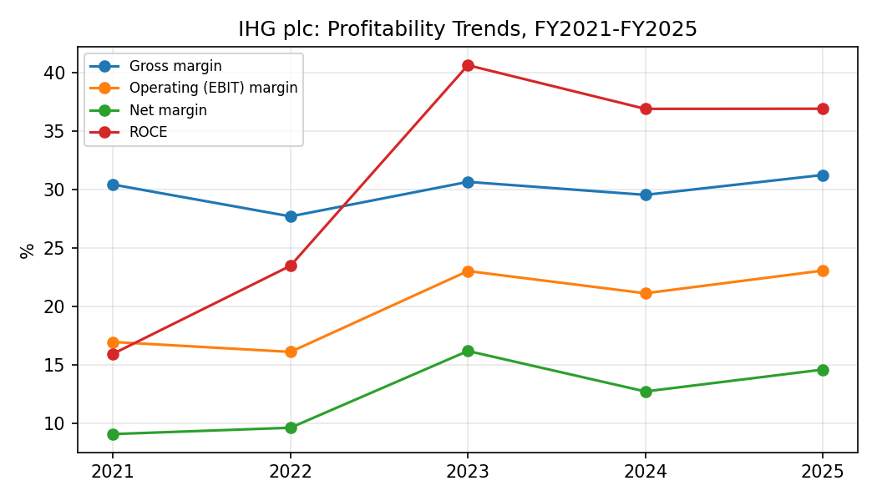
Figure A1: Profitability trends, FY2021–FY2025.
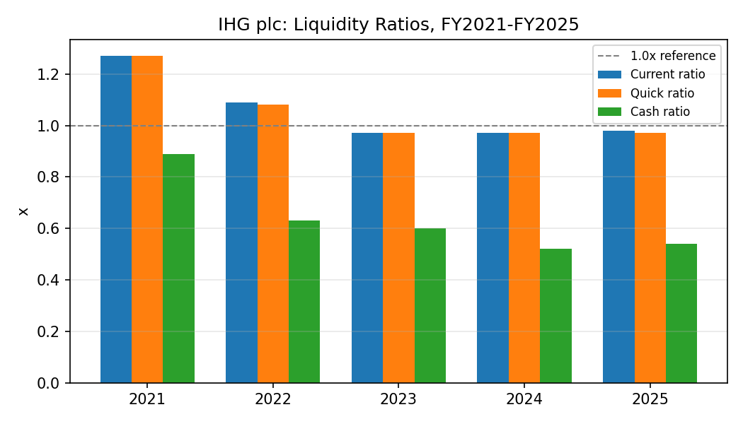
Figure A2: Liquidity ratios, FY2021–FY2025.
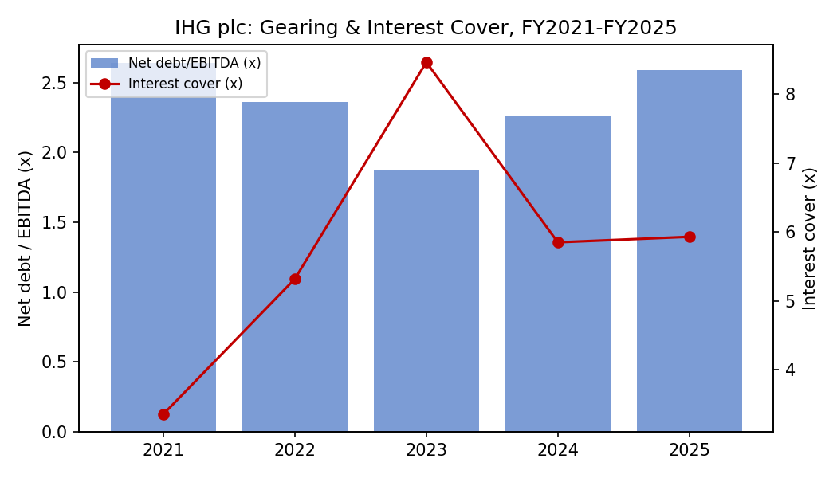
Figure A3: Gearing and interest cover, FY2021–FY2025.

Appendix 3: Investment Appraisal Workings
Project A: discounted cash flow schedule (£m).
 | Year 0 | Year 1 | Year 2 | Year 3 | Year 4 | Year 5
Net cash flow | (50) | 10 | 12 | 14 | 10 | 8
Discount factor @8% | 1.000 | 0.926 | 0.857 | 0.794 | 0.735 | 0.681
Present value | (50.0) | 9.26 | 10.29 | 11.11 | 7.35 | 5.44
Cumulative undiscounted CF | (50.0) | -40.0 | -28.0 | -14.0 | -4.0 | 4.0
Cumulative NPV | (50.0) | -40.74 | -30.45 | -19.34 | -11.99 | -6.54
Project B: discounted cash flow schedule (£m).
 | Year 0 | Year 1 | Year 2 | Year 3 | Year 4 | Year 5
Net cash flow | (50) | 11 | 11 | 11 | 11 | 11
Discount factor @8% | 1.000 | 0.926 | 0.857 | 0.794 | 0.735 | 0.681
Present value | (50.0) | 10.19 | 9.43 | 8.73 | 8.09 | 7.49
Cumulative undiscounted CF | (50.0) | -39.0 | -28.0 | -17.0 | -6.0 | 5.0
Cumulative NPV | (50.0) | -39.81 | -30.38 | -21.65 | -13.57 | -6.08
Project C: discounted cash flow schedule (£m).
 | Year 0 | Year 1 | Year 2 | Year 3 | Year 4 | Year 5
Net cash flow | (50) | 5 | 10 | 20 | 25 | 5
Discount factor @8% | 1.000 | 0.926 | 0.857 | 0.794 | 0.735 | 0.681
Present value | (50.0) | 4.63 | 8.57 | 15.88 | 18.38 | 3.40
Cumulative undiscounted CF | (50.0) | -45.0 | -35.0 | -15.0 | 10.0 | 15.0
Cumulative NPV | (50.0) | -45.37 | -36.80 | -20.92 | -2.54 | 0.86
Note: the accompanying Excel workbook (IHG_Financial_Model.xlsx) contains four linked tabs — Financials, Ratio Analysis, Investment Appraisal and Capital Rationing — built with live Excel formulas, recalculated in full with zero formula errors prior to submission.

