
Applied Industrial Placement (SPORT)
M5X02295
Placement Portfolio Template

Student Name
Name – Luke Jenkins
P Number – P146737
Report
Title – placement assignment/report
Word Count – 2000
References (Total) –
Job Title – Gym promotion
Organisation
Name – Anytime Fitness gym
Address – Parc Fforest Fach Shopping Park, Fforest-fach, Swansea SA5 4BB
Email – swansea@anytimefitness.co.uk
Telephone Number – 01792 720550
Line Manager
Name – Daniel Thomas
Position – Manager
Email – swansea@anytimefitness.co.uk
Telephone Number – 01792 720550

TASK A – (Reflective Learning Log 1 - 500 words – First Experience of Placement)
Recommend to link the reflective experience to two different key themes.
My first experience of placement was a very interesting experience and also very positive. I was looking forward to starting placement at any time fitness gym and was very excited to learn the methods that they use on a day to day bases that makes the gym so successful. There was a sense of nervousness but also excitement as I walked into the gym. I was welcomed in straight away by the manager Daniel, who then introduced me to the members of staff. The first task that I was asked to do was to go around the gym and make sure that all the equipment was put back in the correct place and make sure that there was nothing left out that could cause any harm to any members of staff or members of the public that come in daily to use the facility. For example, any loose weights that were left out on the floor were put back onto the correct stands, so no one could trip over them resulting in them sustaining any type of injury.
The HSW Act and the regulations made under it apply to employers and the self-employed. The law requires them to do what is reasonably practicable to ensure health and safety. The HSW Act sets out the general duties that employers have towards their employees. It also requires employers and the self-employed to protect people other than those at work (e.g. volunteer staff like coaches, club members, visiting teams and spectators) from risks to their health and safety arising out of, or in connection with, their work activities. (HSE)

I also experienced a very good start to placement as I was quickly set a task along with another member of staff who was called Jordan, to go out into the local area offering the members of public that live locally a free week’s trial with no strings attached. If they were interested in having the free trial then they could either take a leaflet off myself or give Jordan and myself details for us to contact them and organise the date and time of when they wanted to have the trial. This gave me confidence early on to carry on working with confidence when approaching members of the public.
“Each time we face our fear, we gain strength, courage, and confidence in the doing”. - Theodore Roosevelt.
Confidence to use mental skills
Confidence to make the right decisions
Confidence to learn new things

TASK A – (Reflective Learning Log 2 - 500 words – Mid Point Experience)
Recommend to link the reflective experience to two different key themes.
The whole experience of being on placement was very beneficial for myself as it gave me a lot of confidence. The placement was very beneficial for both student and company as I had the opportunity to experience the day to day running of a full time 24 hour gym available for use to members. During my mid point experience of placement, I got to know more about the manager who gave me the opportunity to complete my placement. Daniel is very motivated to keep growing the gym which was very positive. He was very keen on sending myself and a member of staff out almost every day for a while to gain contacts to see if they were interested in the gym. He was very motivated to make the gym very successful which was impressive. My mid-point experience of working at any time fitness was very interesting as I had more opportunities to help try and get members of the public and also the local residents to try and join the gym. As previously mentioned above, myself and a member of staff would go out and hand out flyers and free membership trial cards for 5 days at the gym to see if the person would enjoy it and then sign up as a full time member. Instead of going around the local shops in the area, we went and visited a local housing estate offering the same deals to the residents. I feel that this was a much more beneficial in methods of interesting people with the latest offers on the gym. By being polite and not taking up too much of the residents time whilst they seemed busy, myself and the member of staff that went out trying to gain members were very successful in gaining contact information so they could either give the gym a call or we could contact them in a few days to see if they were still interested. For example, one lady whose door we knocked on was already interested in joining before we contacted her and eventually she joined with her daughter which gained two new members. The ladies daughter was 16 years old which could have been a problem as most gyms only allow members at the age of 18 years old or above. The staff at the gym checked and made sure with the company that it was all clear for the young lady to join but she can only visit the gym when her mother / carer is present at all times. This was a very impressive move by the gym as they really went out of their way to make sure that no one misses out on opportunities on joining the gym.
“You’re not just joining a gym. You’re joining a supportive community of like-minded people who are here to give you the encouragement you need” – Anytime fitness.co.uk

TASK A – (Reflective Learning Log 3 - 500 words – Mid Point Experience)
Recommend to link the reflective experience to two different key themes.
“the act of being friendly and welcoming to guests and visitors”
Most of the duration of my placement involved a lot of hospitality and communicating with members of the gym and also outside members of the public. I feel that by being out in the public promoting the gym it gained more recognition and also interested people that didn’t know about what the facility has to offer. I feel that during the placement I gained a lot of confidence in the mid-point of the experience which will be very beneficial for myself in the sporting industry in the future. Placement was very positive for myself but there is always room for improvement in every area. I feel that the staff at the gym can sometimes communicate with their members more often when it comes to offering more discounts monthly and even on a day to day running of thr gym. I feel that when I was present there was not enough communication towards the members from the staff. For example, members would walk in with most staff members sat in the office. I feel that this is an area where the gym can improve on. For example, every so often a staff member should walk around the facility communicating with its members to at least show interest in the members. This can have a huge positive effect on member’s attitude towards the gym and will make them want to use the facilities more often. A bit of kindness from the staff by showing interest in someone can even make the members recommend the facility to their friends and family.

A positive attitude in customer service means happy customers, which in turn means success for the company. ... Everyone would be more mindful of their manners towards customers and would put the customer's interest in mind.
A positive attitude in customer service is all about remaining calm during interactions, making every effort to build robust relationships with customers, and ensuring that customers view the company as authentic through their demeanour. Customers expect high standards of service and top class experiences with a company – every time and through every touch-point. Creating such positive experiences for customers is possible only by maintaining a positive attitude in customer service, which sometimes can be hard to cultivate and display. It is important for a company to provide training and coaching to help the service staff understand the important of offering the most positive service as possible.

TASK A – (Reflective Learning Log 4 - 500 words – Near end of Experience)
Recommend to link the reflective experience to two different key themes.
I had learnt a lot throughout the whole of my placement and was really impressed with the different types of situations that I was put in and the confidence that I gained from working in the fitness and sporting industry day to day. Placement is all about gaining experience and having a taste of what working life is like compared to studying and learning in a classroom. Placements give students the opportunity to gain skills specific to their subject or industry of choice as well as the employability skills required for real-life work. It also increases their knowledge of an industry or sector, allowing them to make better informed decisions about future career choices.

At the end of my placement I was happy and also proud of the way that I conducted myself representing anytime fitness gym and also UWTSD Swansea. I feel that the marketing can be a lot better regarding gaining members to join. Also the prices on the gym aren’t affordable for everyone as it starts from around twenty five pounds per month for a membership which is quite expensive. May other gyms in the area charge a lot less and even have more on offer at the facility such as a bigger area with more equipment and even a swimming pool which is a major attraction for a lot of members of the public to join local gyms.
When one starts a business or is running a business, one needs to make people aware of the fact. Promotion is important for any type of business to let others know about the business. Any type of business, whether it is run online or offline requires customers so that it can experience a good business turnaround. However, the only means of reaching customers is advertising. This is why advertising is important for a business. Once a business advertises about its products and services, it is able to run in a competitive environment.
Advertising is important for every aspect of a business. It plays an imperative role for both manufacturers and consumers. Advertising is important for the business on the whole as it lets the business gain more customers, thereby increasing business turnaround.
Advertising can be achieved using various media like television, newspapers, radio, banners, pamphlets, websites etc. Each advertising media has its own pros and cons and one must evaluate all of them before selecting a particular media. The main thing that needs to be considered is that the advertising medium selected must be able to reach a large number of customers.

TASK A – (Add 250 words on link to future Continued Professional Development and Reference list based on total referenced material in Task A)
Continued Professional Development post placement (250 words - Link to pre placement module)
There have been many positives from going on placement at any time fitness gym. I have learnt many things about the industry such as different methods of marketing, communicating with members of the public on a day to day basis and have also gained a lot more confidence. The main area I feel that I have developed is staying calm in different situations. For example, usually if there is a feeling of nervousness I can start to talk to quick and then get all worked up. Due to being on placement it gave me a great opportunity to learn how to stay calm and communicate with many different types of people with different personalities and feel that I will benefit from this experience in the future in the sporting industry. I have also learnt what type of career I would like to possibly pursue in the near future. Even though I enjoyed the experience of working in a gym, I feel that I would like to concentrate on perusing a different route towards gaining a job in the sporting industry. Placement has been very beneficial as it has gave myself and many other students a taste of what it is like in these types of jobs. Some may enjoy it but some may not. I personally feel that the placement scheme has been very successful and would recommend it to continue for many years to come as it really does teach upcoming students different skills and roles in the industry they are studying in and preparing for.

References from TASK A (10+ references)
- . Anytime Fitness. (2018). Gym Membership - Fitness Membership | Anytime Fitness. [online] Available at: https://www.anytimefitness.co.uk/membership/ [Accessed 25 Jul. 2018]. (JENKINS)

- . Hse.gov.uk. (2018). Health and safety leisure activities: Leisure activities. [online] Available at: http://www.hse.gov.uk/entertainment/leisure/basics.htm [Accessed 25 Jul. 2018]. (JENKINS)

- . The UK's leading Sports Psychology Website. (2018). Developing confidence in sport - The UK's leading Sports Psychology Website. [online] Available at: https://believeperform.com/coaching/developing-confidence-in-sport/ [Accessed 25 Jul. 2018] (JENKINS)

- . Dictionary, h. (2018). hospitality Meaning in the Cambridge English Dictionary. [online] Dictionary.cambridge.org. Available at: https://dictionary.cambridge.org/dictionary/english/hospitality [Accessed 25 Jul. 2018]. (JENKINS)

- Newman, E. (2018). Importance of a Positive Attitude in Customer Service - Yonyx. [online] Yonyx. Available at: http://corp.yonyx.com/customer-service/importance-of-a-positive-attitude-in-customer-service/ [Accessed 25 Jul. 2018]. (JENKINS)

- Business, N. (2018). What are the benefits of a quality placement?. [online] NCUB. Available at: http://www.ncub.co.uk/placements-report/the-benefits-of-a-high-quality-placement.html [Accessed 25 Jul. 2018]. (JENKINS).

- . Adarmygroup.com. (2018). Why Advertising Is Important In Today's Economy. [online] Available at: http://www.adarmygroup.com/advertising-important.php [Accessed 25 Jul. 2018]. (JENKINS)

.

- .

- .

TASK B – (YouTube Video – 10 x 1 min integrated video) (Experience, Roles, Improvements)
NOTE – Make sure the link works correctly
Website Link –

Link Password –

Video Duration –

Device used to create video –

Software used to create video –

Production contributors
Name | Position | Organisation

TASK B – (Picture Board – 5 pics (40MB upload limit to Turnitin) (Experience, Roles, Improvements)
Picture | Text (Paragraph)
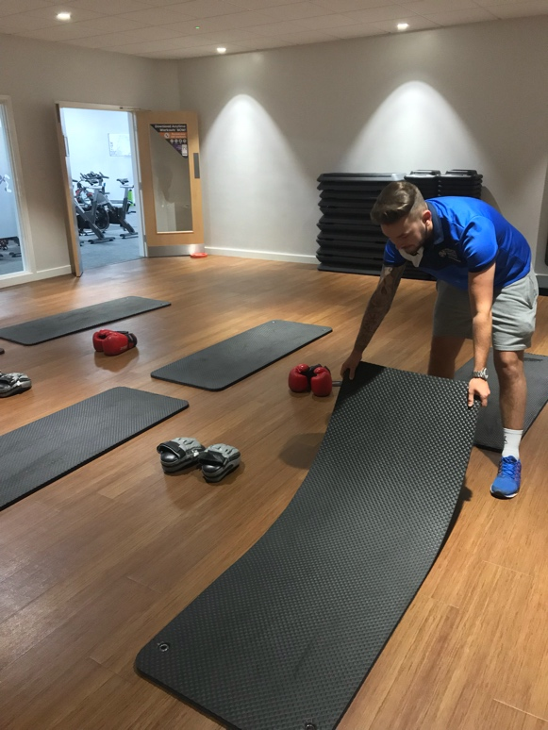 | As the picture shows, setting up the correct equipment for many different classes at the gym was one of the many tasks assigned for me to complete during my placement. I was shown what type of set up that the class was use too and would then make sure that the correct equipment was ready to use for the upcoming class that was going to take place at the time. I feel that this helped me personally improve when it came to preparation.
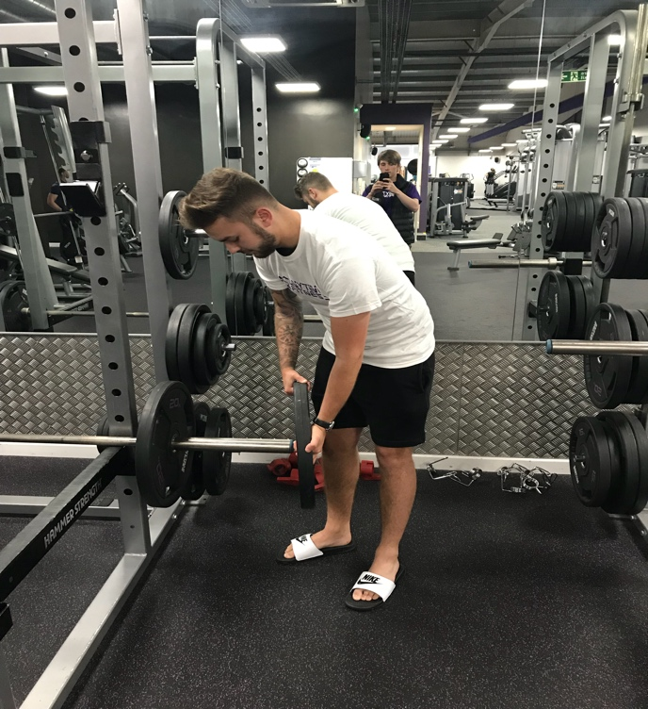  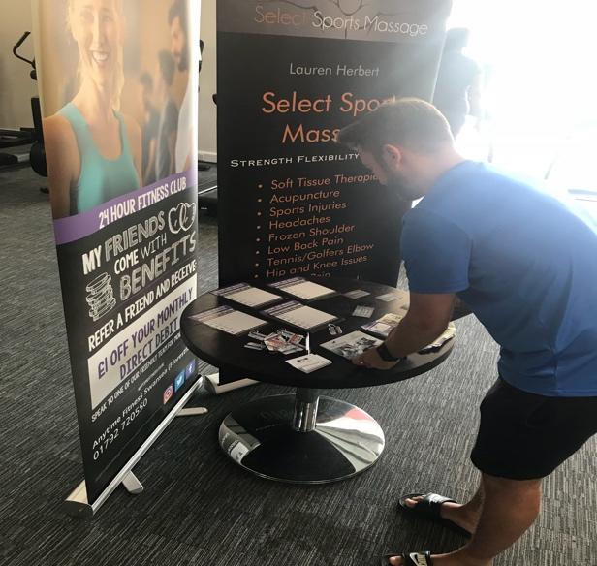 | Making sure that loose equipment that had been left out by members using the equipment was another one of the tasks that I was given when on placement. Health and safety is taken very seriously by anytime fitness gym which was very good to know as all members and staff should feel safe and secure at all times. For example, I made sure that all weights were put back correctly to avoid anyone falling over the loose equipment to avoid any sort of injury.  As you can see, making sure that the entrance of the gym was tidy was one of my duties given to me during my time on placement. When entering the gym, there is a table with different booklets and leaflets on offer for the public with information on the gym and different offers on choice. I made sure that it was always neat and tidy when I was present.
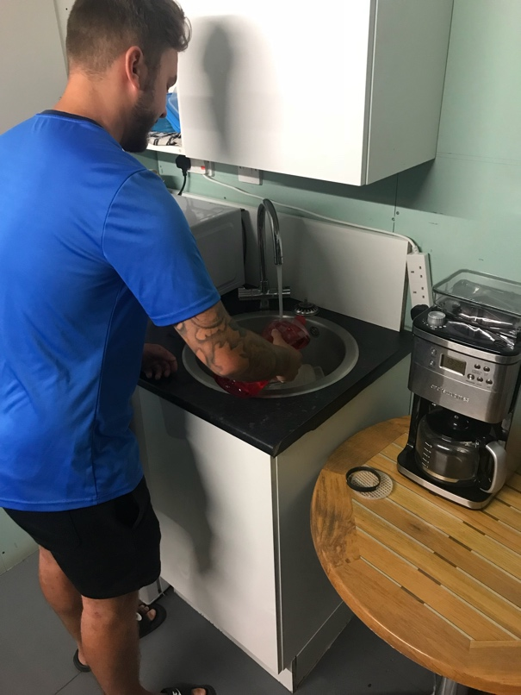 | Here is another picture of me helping out in the kitchen was one of my duties assigned to myself whilst on placement. I would make sure that the dishes and glasses that had been used by the staff members were cleaned and ready for use for either later on or the next day.
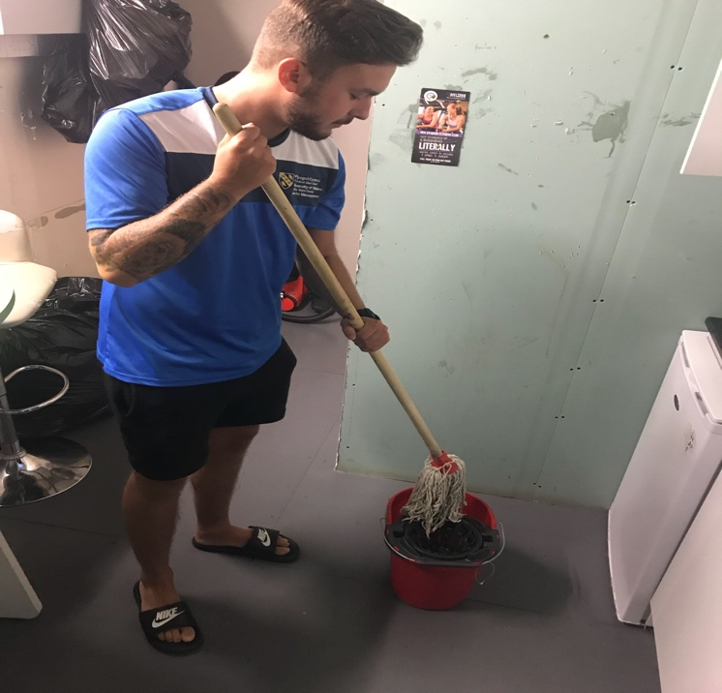 | Washing the floor and making sure the surfaces were clean and tidy was also one of my tasks that I completed whilst on placement. I made sure that the areas of the gym were cleaned and that there was no rubbish or dirt on the floors. It is very important that the gym was clean and tidy

TASK B – (Picture Board Cont.–5 pics (40MB upload limit to Turnitin) (Experience, Roles, Improvements)
Picture | Text (Paragraph)
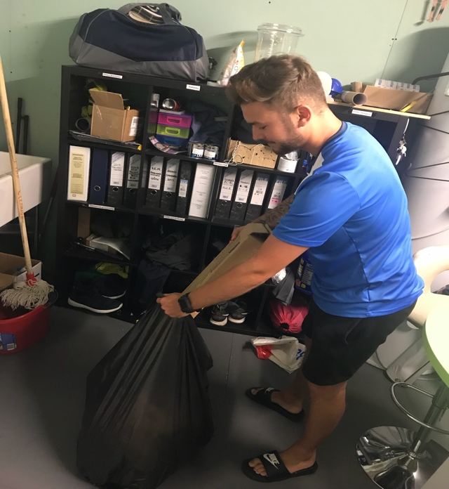 | As mentioned above, cleaning was one of my main tasks that I would carry out whilst on placement. I would make sure that all bins were emptied and would also change the bags if they were full. All rubbish would be disposed and put in a black bag to make sure that the gym was in the best condition possible.
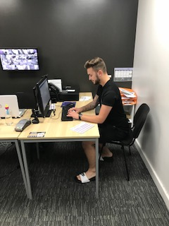  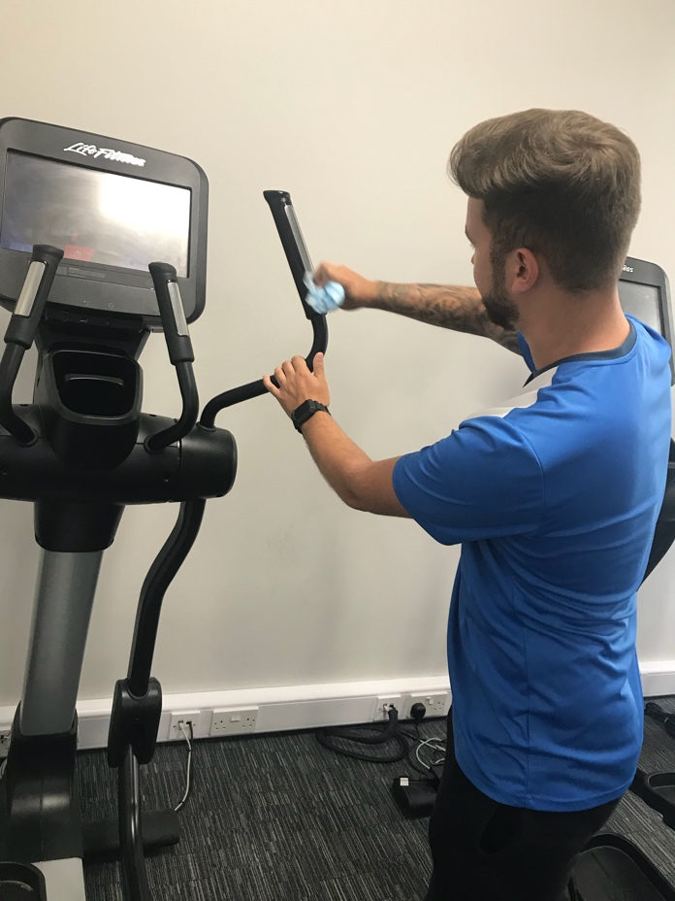  Making sure that all equipment was clean for the members to use was one of my tasks that I had to complete regularly whilst on placement at anytime fitness gym. When tidying up in general around the gym I would go around the machines that were not being used and wipe them over with the wipes that are available for the members to use. A lot of the members clean them themselves which is very good but I still made sure they were clean in case the whole handle hadn’t been cleaned. | I also helped out in the office when it came to sending out emails to members and also recommended contacts that I already had that I thought may have been interested in joining the gym. This would then be very helpful to the staff as they had more people to contact to see if they were interested in joining on different deals.
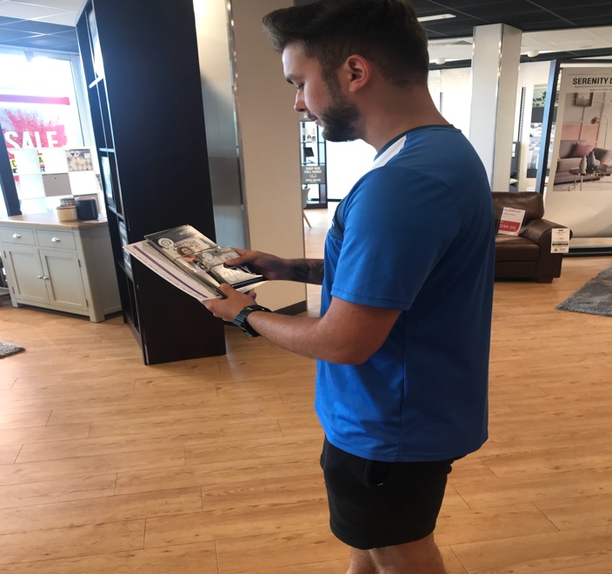 | One of the main tasks that I was often asked to complete was promotion of anytime fitness. I would often visit shops in the same area and offer the staff that work in the shops the chance to have a free trial with the gym. The staff of the shops could either take a few leaflets off myself or place them in their staff rooms or could give me their details if they were interested individually and they could then organise a meeting for a trial of the gym to see if they were keen on joining as a permanent member.
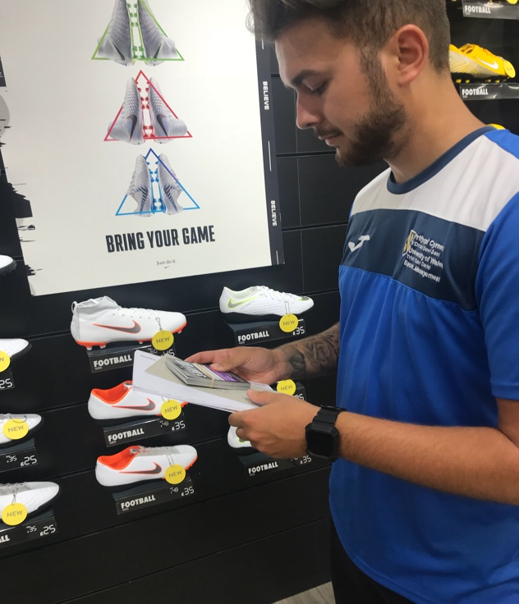 | Visit local shops was one of my main jobs to complete whilst on placement, but I did not only visit shops to offer the chance for people to join the gym. I and another member of staff would visit local housing estates to offer the local residents the chance to join or have a free trial with the gym. As already mentioned above, the resident could either take a leaflet or call the gym or we could take some personal details and get in contact if they were really interested in the opportunity to test out the facility.

TASK C Evidence – Employer Report (Signed),
NOTE – This will be compared against the report sent to the University.
NOTE – You will need to complete additional copies if you have more than one provider.
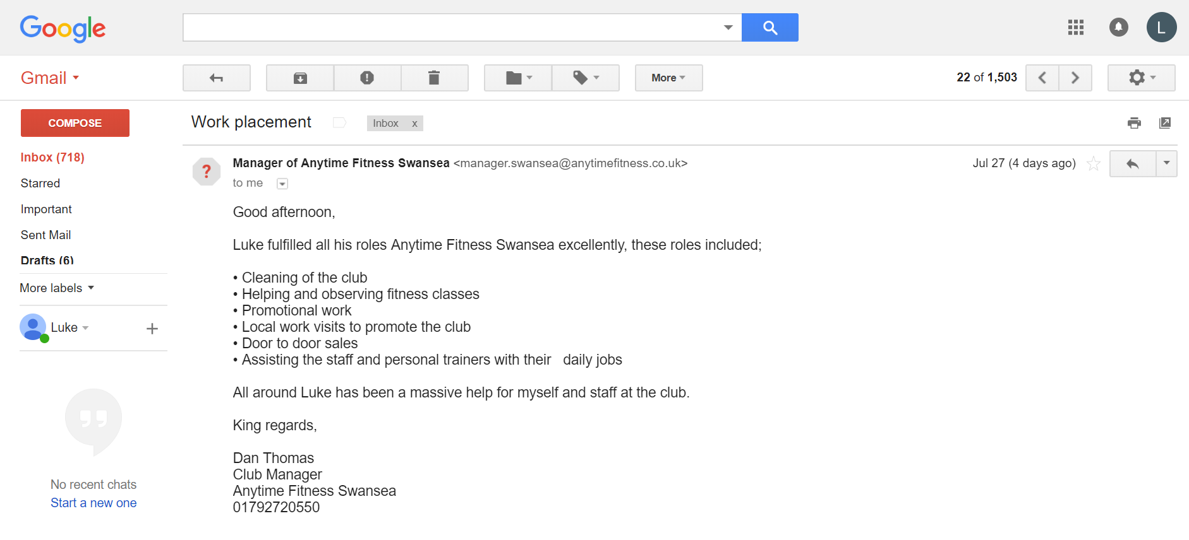

TASK C Continued Evidence – Employer Report (Signed),
NOTE – This will be compared against the report sent to the University.

TASK C Evidence – Ethics Form – Signed by Organisation and Lecturer
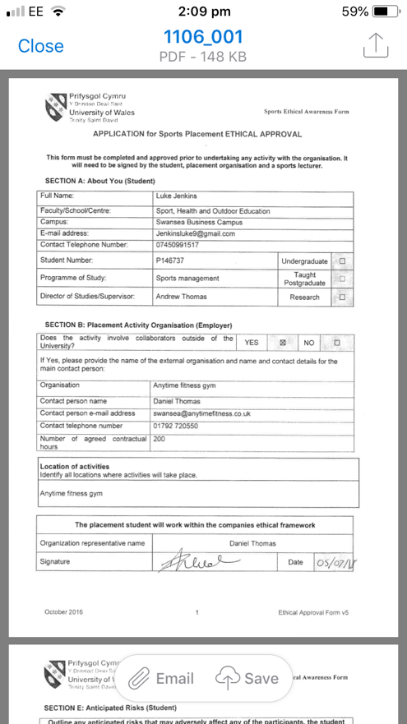
NOTE – You will need to complete additional copies if you have more than one provider.
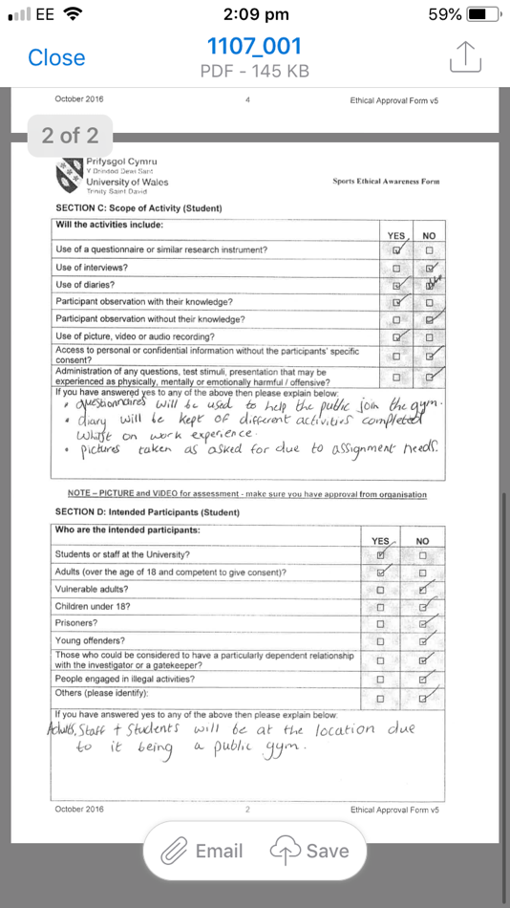

TASK C Evidence – Ethics Form Continued
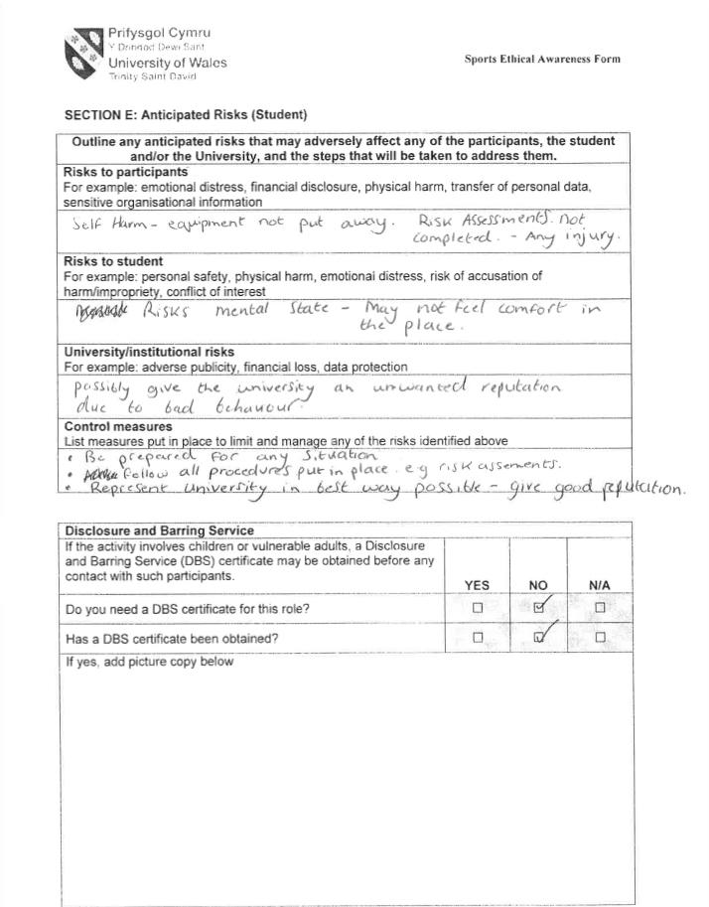

TASK C Evidence – Ethics Form Continued
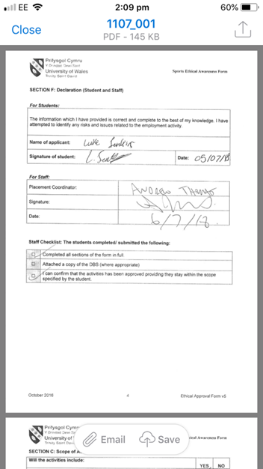

TASK C Evidence – Ethics Form Continued

TASK C Evidence – Post Placement Review and Feedback
Dear Participant

Many thanks for your involvement in the work placement. I hope that you had a positive experience. The University of Wales Trinity Saint David reviews the provision annually for enhancement purposes and so we would be pleased to hear your feedback on any aspect of the placement.

Yours sincerely

Andrew Thomas, Placement Coordinator Sports Management Portfolio

Name of provider’s organisation: |  | Anytime fitness gym
Name of student: |  | LUKE JENKINS
What were the positive aspects?
The most positive aspect of going on placement at anytime fitness gym was communicating with different members of the public and trying to get to know people when it came to asking if they were interesting in joining the gym. I thought the promotion of the gym was very positive.

Were there any problems?
There were no problems at all. I feel that everything involving the placement was very positive and a great learning curve.

Do you have any recommendations for enhancement for the future?
I would like to possibly get involved with organising events with the staff members and give more input of certain ideas to them.

Signed: | 
Name in block capitals: | LUKE JENKINS
Position (please tick one): | ☐ Placement Provider  ☒ Student  ☐ Placement Tutor |  | Date: | 31/07/2018

TASK C Evidence – Student Placement Induction Checklist
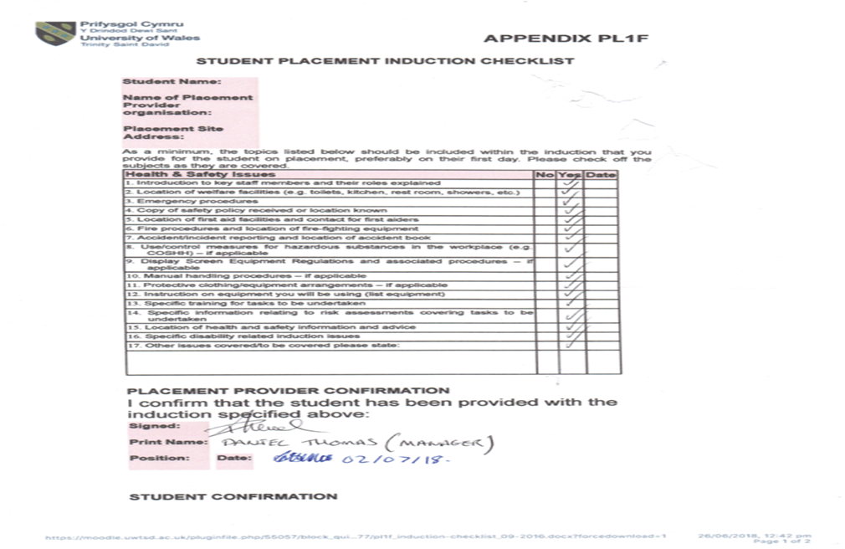
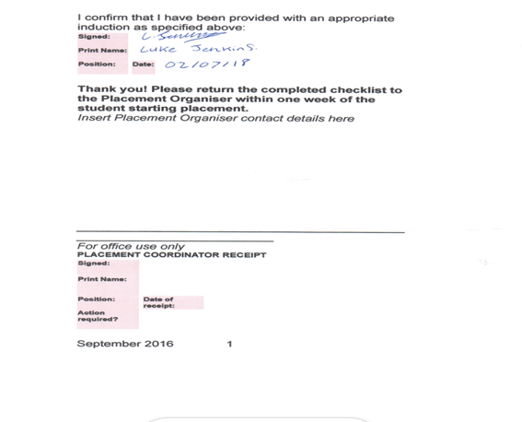


UWTSD SPORT
Placement

