The Holy Well of Saint Gwenog (also known as Saint Wenog). Medicine and Miracles, HPHI5019.
By Julia Jones 2007994.
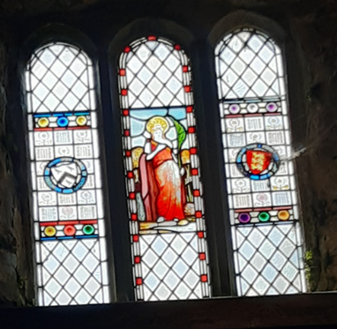
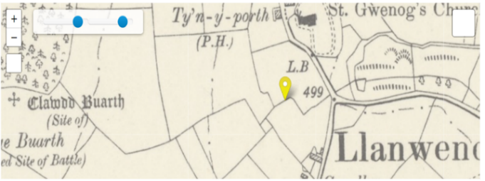
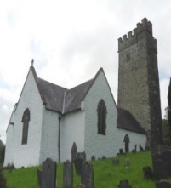
Image 2: Stained glass window depicting Saint Gwenog (Own Image, 2021).
Ffynnon Gwenog

Map 1: Ffynnon Gwenog (Saint Gwenog’s Well). “Head Name: Undefined. Type: Topographic feature. Grid Reference: SN 49350 45426. Parish: Llanwenog. County: Cardiganshire. Recorded: 1699. Primary Source: Parochialia 3” (RCAHMW, 2023).

A
B
C
Image 1: Llanwenog Church (Llanwenog Council, 2016).

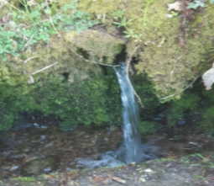
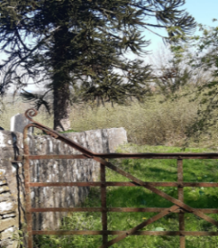
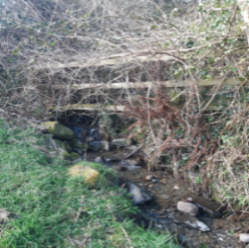
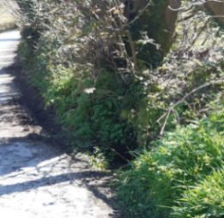
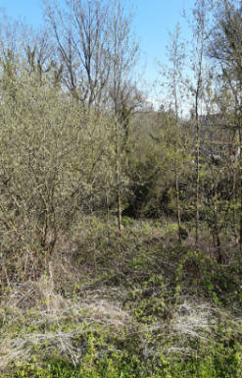
The Holy Well of Saint Gwenog’s Church (Image 1) was the only one dedicated to this female Saint (Image 2). The well (Map 1a), possibly swallowed up by the redirection of the river and waterlogged land, was situated below the graveyard of Saint Gwenog’s Church, Llanwenog, Ceredigion, SA40 9UT, in West Wales (Images 3 - 9). Saint Gwenog’s Church is approximately 6 miles from the nearest town of Lampeter, 2 ½ miles from the village of Llanybydder, 13.5 miles from Llanddewi-Brefi and 3 miles from the village of Llanwnen. Formerly called Capel Mair (Mary’s Chapel) it was also known as a ‘Lady Chapel,’ dedicated to the Virgin Mary and nicknamed Eglwys fach (little Church) by the locals.
Image 4: Stream joining the river Teifi below (Own Image, 2021).

Image 3: Path to Saint Gwenog’s Well site (Own Image, 2021).

Image 6: water coming down the hill from original site of St Gwenog’s Chapel (Own Image, 2021).

Image 5: Water outlet on the opposite side of the road (Own Image, 2021).

Image 7: Saint Gwenog’s Well site hidden by trees (Own Image, 2021).
It might not be the most famous Well in Wales, but it is probably one of the most mysterious. Local accounts join a folk-law tale, passed down through the generations of a nun, possibly called Gwen, who used the healing waters of the well to perform her miracles by curing children’s back disorders. Wells such as Saint Gwenog’s, with healing properties, became known as Holy Wells when the worshipped water sites of the Pagans close to the Christian churches were walled up and affiliated to a Saint. The well would have played an important part in society, with the Saint's feast day being celebrated around it. Saint Gwenog’s feast day was on the third of January, with the ‘Ffair Wenog’ (Llanwenog fair) happening approximately eleven days later. The fair brought in people from miles around who would have bought or sold goods and animals to raise money to pay the tithes, first to the King and later to the church on behalf of the King. From the Eighth Century on It was also said to be when pilgrims would go to the well to be restored to health by Saint Gwenog, (R) however, no first-hand evidence of this has been found.
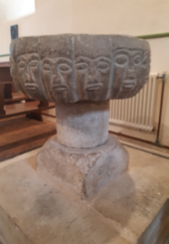
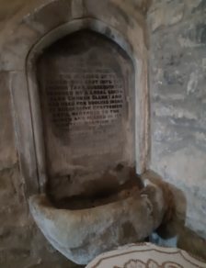
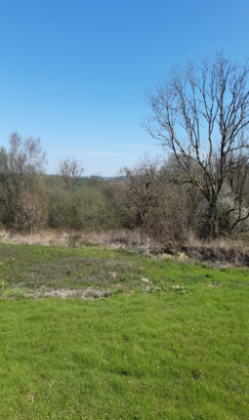
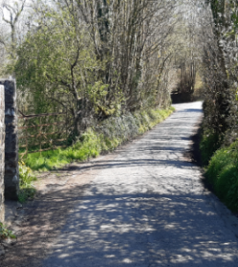
Image 10: Pre-Norman font with the 12 apostles carved around the outside (Own Image, 2021).
Image 11: 14 - 15th Century Medieval Font (Own Image, 2021).
Image 9: Well sight now too dangerous to access due to waterlogged field (Own Image, 2021).
Image 8: Path to well site on left, and water running down the hill on the right (Own Image, 2021).

Unlike today the water was not piped into every home. People would get their water from rivers such as the Teifi, which runs through Llanwenog, Rhyddlan and the parklands of Highmead, or the Cledlyn which is split into two streams at Cwrtnewydd, flows through the village of Drefach, past Croesgwenllian farm, Ty-Cam and Cryg-y-whil, (map 3) or fresh spring water which had been naturally filtered through the mineral-enriched soils, occasionally rising to the surface as if from nowhere, and used for the church and all its needs. Many pre-Christian well sites were presumed to be Pagan, with some considering them to be Celtic or Scandinavian, however, most wells lost their Celtic names in the fifth or sixth century after the Anglo-Saxon Invasion and retreat of the Romans. The church has both a Pre-Norman (Image 10) and a fourteenth or fifteenth-century Medieval font (Image 11). Traditionally the water was needed for baptisms, blessings, repelling evil and cleaning the Church. The water would have been retrieved from the Holy Well and placed into the fonts. The Medieval font (Image 11), which had been missing for many years, was found to have been used by a local blacksmith to cool his hot Irons and was returned to its original place within the Church. The Pre-Norman font (Image 10), which dates approximately to the eleventh century, is no longer in its original setting and has twelve simply carved faces with a fish above one. The fish symbol may represent the earlier Christian faith and its link between the different worlds or that it is Saint Peter represented below it. The development of Catholicism started when Jesus set Peter apart from the other disciples in approximately 30 AD. Peter became the first pope of the Roman Catholic Church in what was to become the formation of the papacy. By 90 AD most of the native Welsh tribes had been destroyed in England, and most of Wales was under Roman rule. The Roman roads had been completed in Wales by 100 AD, with travellers along them needing water for drinking, cooking, washing, illness, or injuries, and as described by Carmichael below especially important for women and the process of giving birth.
“Though art well compassion
Though art is the root of consolation
Thou art the living stream of the virgins
And of them who bear children.”
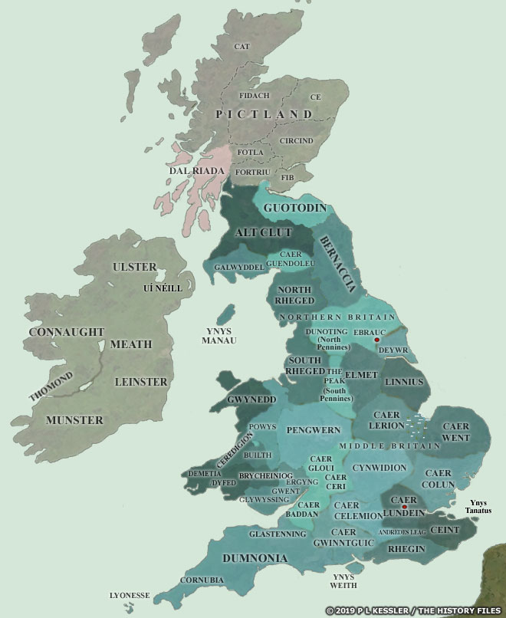
There is a brief mention of St Gwenog asking for her help, written on a side margin of a page in the Laws of Hywel Dda (Hywel the Good), a thirteenth-century book containing Welsh laws that took six weeks to write, as well as a record of an inquiry into two priests being paid for the same area when there should have only been one. and Samuel Meyrick (1783 – 1848), in the ‘History and Antiquities of the County of Cardigan’ states that the church was dedicated to Saint Gwynnog, a son of Gildas. To understand who Saint Gwenog was, the importance of her well and how she miraculously changed from a male Saint to a female Saint, an understanding of what was going on at the time is needed. During the Middle Ages, many wells were often renamed after the landowner or their use. The land that Saint Gwenog church is situated on was given to Gwynnog a six or seventh-century Saint by his father Gildas, who was an early Irish-Breton King said to be a wise man and historian who studied in Wales under Saint Illtud and had preached to Non before the birth of her son, Dewi (David, the Patron Saint of Wales). Gwynnog or Gwynog left Wales around the time of the Yellow Plague in 547/664 AD and took refuge in Britany, leaving only a local legend of the spirit of Gweno, seen hovering over a crag in the village of Caio, (R) which was not close enough or miraculous enough for the Catholic Church to associate with Llanwenog Church.
Map 2: Map of the Island of Britain AD 450-600 displaying Ceredigion, Demetia, Dyfed and Brycheiniog (Kessler, 2019).
During the Late Middle Ages, women in the clergy had been restricted to the nunnery, however, the rights of women grew with the popularity of the cult of the Virgin Mary. The Holy Well may have been visited in the eighth century or even earlier in connection to a chapel situated between Capel Mair, now Saint Gwenog’s church and what was supposedly a wooden Castle structure of Castell Dol Wolf (Dol Wllf Castle). Built on a stone ruin that may at one time have been named Castell Santesau (Saintes Castle) near the village of Llanybydder (Map 3). Brychan Brycheiniog was born in Ireland and moved to Wales after his father Anlach’s death. Raised by Nobles, his success was supposedly predicted by a wise man called Drichan, and he ruled his Kingdom of Brycheiniog from Talgarth (Map 2). He had over twenty children, many becoming Saints, such as Gwynnen, Gwynnws, Gwladys, Gwen, Wenna, Nennocha and Gwennan. Not all were from the same mother, and some may have been stepchildren or even adopted, becoming known as one of the “Holy Families of Britain”. There were said to be fierce battles in Wales with the life-giving waters of the Teifi, at times being filled with bodies of the Saxons, Britons, Mercians, Norsemen, Vikings, Danes known as Pagans and the warriors, priests, and villagers who fought back to protect their lands, county, and kings and Prince’s. Capel Santesau may have been destroyed in one of the battles in the area such as the one thought to have taken place on Ty-cam’s field known as Caer Vaes (Battlefield) against Godfrid and the Danes in c.981 AD (Map 1c).
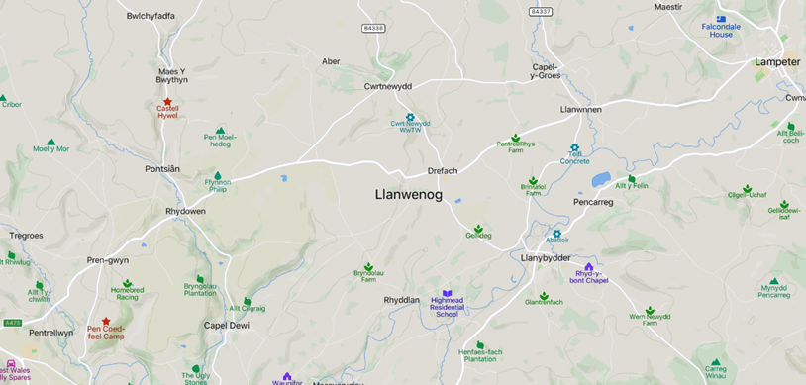
Map 3: Map of Llanwenog (Wenog’s Church enclosure), Cwrtnewydd (New court), High mead, Aber, Drefach (small town), Rhuddlan, (Church land or free enclosure), depending on how it is translated are shown in red. Not showing Alltyblacca, Gorsgoch, or Cwmsychbant which were also part of Llanwenog (Mapcarta, 2023).

Whilst the Kings were fighting over land the Abbots were gaining it. Whitland or the Holy Cross Abbey was founded in 1151 by the Cistercian Monks from Clairvaux, Talyllychau or Talley Abbey as it is known, was founded by Rhys ap Gruffudd the last Prince of Wales in c.1165, It was independent of the Norman-founded Abbeys in Whitland (The Mother Church) and England. It received papal approbation from Pope Honorius II in 1185. (R) Llanwenog Chapel was owned by (Talley) Abbey in the Middle Ages by the Bishops of Saint David’s from the Llandaff diocese, attached to Llandewi Brefi. Monks from Whitland Abbey, known as Cistercians or White Monks expelled the monks of Talley, who were later reinstated by the Archbishop of Canterbury. Whitland received the grange Rhyddlan (Ruthelan, Buthelan) between Llanwenog and Llanybydder (Map?) and any other dwellings and land connected as compensation, such as the fulling and corn mills, allt’s, covered in large forests that once hid the poorer members of the community, workers, meadows, commons, waters, and profits from fines, rents, and services. English common law was introduced into Wales between c.1284 – 1536 (R) causing the community of Llanwenog and some of its surrounding areas who did not appreciate being taken over and losing their land to be helped by the Abbots of Talley Abbey who avoided collecting tithes from their tenants, and Nuns of Whitland, Llanllyr possibly as educated as the men helped the locals by creating the story of Gwen and her miraculous healing waters, in the same way the Bishops had carefully selected names for their children and properties that were similar or the same as the ruling Kings, lords and places of importance, to possibly hide documents for the same properties under different, names which made the population look bigger and more fierce than it actually was, also enabling loans to be granted with the illusion that they were wealthy enough to be able to pay it back which may have been used to educate the male and female children regardless of their background, hiding in the cover of the large forests away from the main roads taken by wandering pilgrims, tax collectors or their spies, with many going on to have good jobs, travel to other countries, becoming bishops or Abbesses and marrying into wealthy families.
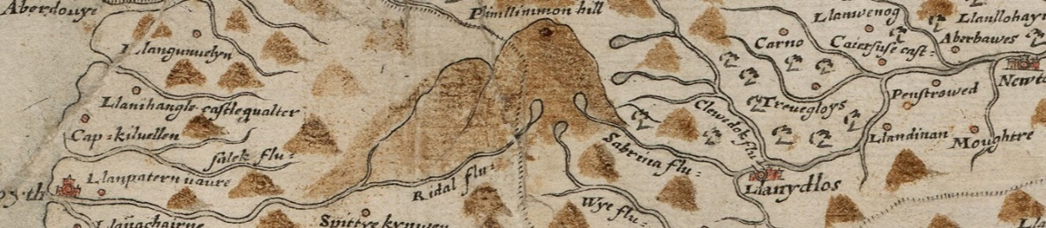
Map 4: Historical Place Names: Llanwenog (RCAHMW, 2023).

Saint Gwenog may, or may not have healed children’s backs in February, using freezing water from the Well or River but she (or her community), did help to stop their identities and rights from being taken away and to survive poverty, plagues, and war as they swept through Wales. The numerous changes in power ended with the King of England trying to stamp out anything other than Catholicism. The rivalry between at least two different branches of the same religion and their followers lasted centuries. Dominated first, by Anglo-Norman Cistercians, then by Welsh Kings and Princes. For Gwen to be recognised as a Saint, all the community needed was a Saint’s Day, a hall for the collection of tithes, and places for the king, his family and his entourage to stay when and if they visited, which could have been built reasonably quickly and easily out of the Oaks from the surrounding forests in preparation for any Royal visits. Changing the original male Saint Gwynnog, who in their eyes abandoned them in their greatest time of need, alongside no appearance of any worthy miracles, to Gwen or Saint Gwenog, the true definition of a saint. Someone who helped keep a service in Welsh going. Possibly teaching the local children to read, some of which may have been orphaned or children of Kings and Queens hidden for safety. Language, rule, and land areas changed alongside centuries of invasion and integration, making it difficult to know who owned what many generations after the first owner Saint Gwynog, abandoned his gifted lands and they were officially recorded as Saint Gwenog. The waters that seemed magical to pagans and miraculous to Catholics might not be walled up, but the continuation of equality, religion, language, and care still flowing through the hearts and minds of all who benefited from Saint Gwenog and her elusive, Holy Well.

Bibliography
AA Route Planner, “Llanwenog” to “Llanybydder”, (2019) <https://www.theaa.com/route-planner/route?from=Llanwenog%20Church,%20Llanwenog,%20Llanybydder,%20UK&to=Llanybydder,%20UK> (Accessed 11-04-2023).
AA Route Planner, “Llanwenog” to “Lampeter”, (2019) < https://www.theaa.com/route-planner/route?from=Llanwenog%20Church,%20Llanwenog,%20Llanybydder,%20UK&to=Lampeter,%20UK> (Accessed 11-04-2023).
AA Route Planner, “Llanwenog” to “Llanddewi-Brefi”, Tregaron (2019) <https://www.theaa.com/routeplanner/route?from=Llanwenog%20Church,%20Llanwenog,%20Llanybydder,%20UK&to=Llanddewi-Brefi,%20Tregaron,%20UK> (Accessed 11-04-2023).
AA, Route Planner “Llanwnnen” to “Llanwenog”, (2019) <https://www.theaa.com/route-planner/route?from=Llanwenog,%20Llanybydder%20SA40%209UT,%20UK&to=Llanwnnen,%20Lampeter,%20UK> (Accessed 11-04-2023).
Pearson, M. J., In, British History Online, “Archdeacons: Carmarthen”, “Fasti Ecclesiae Anglicanae 1066-1300” Vol. 9, the Welsh Cathedrals (Bangor, Llandaff, St Asaph, St Davids), (London, 2003), 58-59. British History Online http://www.british-history.ac.uk/fasti-ecclesiae/1066-1300/vol9/pp58-59 (Accessed 26 April 2023).
BBC, “Religions – Christianity: Mary”, (2011), <https://www.bbc.co.uk/religion/religions/christianity/history/virginmary_1.shtml> (Accessed 02-04-2023).
Bowen, E. G., Illtud (c. 475 - c. 525) A Celtic saint and one of the founders of monachism in Britain. Dictionary of Welsh Biography, (1959) <https://biography.wales/article/s-ILLT-UD0-0475> (Accessed 13-06-2023).
British History Online, “Miscellanea: Ecclesiastical documents”, in Cardiff Records: Volume 4, ed. Matthews, John, Hobson, (Cardiff, 1903), British History Online, (2019), <http://www.british-history.ac.uk/cardiff-records/> vol. 4, 126-129 (Accessed 31-03-2023).
Catholic Online, “St. Wenog”, (2023), <https://www.catholic.org/saints/saint.php?saint_id=2098> (Accessed 31-03-2023).
Catholic World Mission, Timeline of the Catholic Church, (2023), <https://catholicworldmission.org/catholic-church-timeline/> (Accessed 29-03-2023).
Davies, J. C., 2017. Folk-Lore of West and Mid-Wales: Chap. XI Folklore of fountains Lakes and Caves, The Holy Well of St Gwenog (2017), 315-335, <https://www.gutenberg.org/files/53915/53915-h/53915-h.htm> (Accessed 29-03-2023).
Davies, J. “A History of Wales”, Penguin, (1994), <https://archive.org/details/historyofwales0000davi/page/n7/mode/1up> (Accessed 23-06-2023).
Davies, W. Ll., “Meyrick, Sir Samuel Rush” (1783 – 1848), antiquary. Dictionary of Welsh Biography, (1959), <https://biography.wales/article/s-MEYR-RUS-1783> (Accessed 29-03-2023).
Building History, In, Domesday book, 1086 “Researching Historic Buildings In, the British Isles”, Researching the History of Mills, Building History, (2013), <https://buildinghistory.org/buildings/mills.shtml> (Accessed 16-04-2023).
Find My Past, Newspaper Archive Limited, Llansawel “Baner Ac Amserau Cymru” Wednesday 16 February 1881 (In) British Newspaper Archive, (2023), <https://www.britishnewspaperarchive.co.uk/viewer/bl/0000037/18810216/027/0010> (Accessed 10-04-2023).
Ford, David, Nash, “St. Wenna the Queen”, Early British Kingdoms (2001), <http://www.earlybritishkingdoms.com/bios/wennacg.html> (Accessed 10-04-2023).
Ford, David, Nash, “St. Wenna of Talgarth”, (2006), Early British Kingdoms <http://www.earlybritishkingdoms.com/bios/wennabg.html> (Accessed 10-04-2023).
Ford, David, Nash, “Brychan Brycheiniog, King of Brycheiniog”, Early British Kingdoms (2001), http://www.earlybritishkingdoms.com/bios/brychbbg.html> (Accessed 10-04-2023).
Ford, David, Nash, “Children of Brychan”, Early British Kingdoms 2001, <http://www.earlybritishkingdoms.com/articles/brychild.html> (Accessed 18-06-2023).
Genealogy, Genealogy Report: “Ancestors of Peter John Everard Davies Davies”, Generation, (2023), <https://www.genealogy.com/ftm/d/a/v/Peter-J-Davies-BC/GENE2-0005.html> (Accessed 31-03-2023).
History.com Editors, “Middle Ages”, A&E Television Networks, (2023), <https://www.history.com/topics/middle-ages/middle-ages> (2010), (Accessed 11-04-2023).
Howard, 2020. “Plague was one of history’s deadliest diseases—then we found a cure”, <https://www.nationalgeographic.com/science/article/theplague?loggedin=true&rnd=1683748334216> (Accessed 11-04-2023).
Frith Francis, “Historic Ordnance Survey Map of Llanwenog”, (1904), <https://www.francisfrith.com/llanwenog/llanwenog-1904_hosm43527> (Accessed 13-07-2023).
Johnson, Ben, “Timeline of Roman Britain”, (2015), <https://www.historic-uk.com/HistoryUK/HistoryofWales/The-Romans-in-Wales/> (Accessed 11-04-2023).
Jones, F., “St Gwenog’s Church Llanwenog”, “The Holy Wells of Wales”, Coflein, (1992), 159, <https://coflein.gov.uk/en/site/220?term=St%20Gwenog%27s%20Well> (Accessed 11-04-2023).
Kessler, “Map of the Island of Britain AD 450-600”, History Files, Map 2, (2019), <https://www.historyfiles.co.uk/FeaturesBritain/BritishMap.htm> (Accessed 23-04-2023).
Lewis, Samuel, 1849. “Llanvlewin – Llanwnda”, A Topographical Dictionary of Wales (London, 1849), 147-157, In, British History <https://www.british-history.ac.uk/topographical-dict/wales/pp147-157#h2-0001> (Accessed 26-4-2023).
Lewis Samuel “Llanwenog” A Topographical Dictionary of Wales, London, S., (1833).
Live Science, “What Was the Black Death?”, (2019), <https://www.livescience.com/what-was-the-black-death.html> (Accesses 06-05-2023).
Llanwenog Council, “Llanwenog Church,” pdf., (2016), <http://cyngorllanwenogcouncil.org.uk/wp-content/uploads/2016/05/Llanwenog-Church_2016_English.pdf> (Accessed 24-4-2023).
Llanwenog Council, Llanwenog Church Guide, UWTSD, (2016), <http://cyngorllanwenogcouncil.org.uk/wp-content/uploads/2016/05/Llanwenog-Church_2016_English.pdf> (Accessed 27-03-2023).
Lloyd, John Edward, (Vol 1 pp. 4 - 271) “A History of Wales from the Earliest Times to the Edwardian Conquest”, National Library of Wales, (1911), Vol 1, 179, <https://www.library.wales/discover-learn/digital-exhibitions/europeana-rise-of-literacy/history-books/a-history-of-wales-from-the-earliest-times-to-the-edwardian-conquest#?c=&m=&s=&cv=244&xywh=-338%2C0%2C3169%2C3787> (Accessed 03-04-2023).
Mark, Joshua J., “Illuminated Manuscripts”, World History Encyclopedia, (2018), <https://www.worldhistory.org/Illuminated_Manuscripts/> (Accessed 04-04-2023).
Mark, Joshua J., “Women in the Middle Ages”, World History Encyclopaedia, (2019), https://www.worldhistory.org/article/1345/women-in-the-middle-ages/ (Accessed 04-04-2023).
Mark, Joshua J., “The Medieval church”, World History Encyclopaedia, (2019), <https://www.worldhistory.org/Medieval_Church/> (Accessed 04-04-2023).
Medieval Heritage, “Ancient and medieval architecture: Llanwenog, St Gwenog’s Church History,” (2017),< https://medievalheritage.eu/en/main-page/heritage/wales/llanwenog-st-gwenogs-church/> (Accesses 29-03-2023).
Morval Parish Website, “St Wenna’s Church, Morval”, Morval Widgegates, (2023), <https://morvalwidegates.weebly.com/st-wennas-church.html> (Accessed 04-04-2023).
Netchev S., Christian Pilgrimage in the Middle Ages, C. 1000, (2022), <https://www.worldhistory.org/image/16082/christian-pilgrimage-in-the-middle-ages-c-1000/> (Accessed 04-04-2023).
Oxford, Bodleian Libraries, MS. Rawl. C. 743, fol. 25. Bodleian Archives and Manuscripts, (special collections, 1714) <https://archives.bodleian.ox.ac.uk/repositories/2/archival_objects/329273> (Accessed 25-06-2023).
Rattue, The living stream: holy wells in historical context. Boydell Press, (1995).
Ray, C., 2014. The origins of Ireland’s holy wells. Archaeopress Publishing Ltd.
Royal Commission on the Ancient and Historical Monuments of Wales Recorded name: “Ffynnon Gwenog”, RCAHMW, Map 3, (2023), <https://historicplacenames.rcahmw.gov.uk/> (Accessed 07-04-2023).
RCAHMW, “The Inventory of Historic Battlefields in Wales”, RCAHMW, (2023) <https://rcahmw.gov.uk/the-inventory-of-historic-battlefields-in-wales-2/> (Accessed 10-07-2023).
Rhys, J., and Morris, T.E., 1893. Sacred wells in Wales. Folklore, 4(1), pp.55-79.
Royal Commission on the Ancient and Historical Monuments of Wales (RCAHMW), 2023. List of Historic place names. Recorded name: Ffynnon Gwenog. Map 1 [online] Available At: <https://historicplacenames.rcahmw.gov.uk/placenames/headname/d7bbd509-b67f-41b1-8a50-daf969ca6305> (Accessed 04-05-2023).
Shaw, Entry Book: April 1693, 11-20 British History Online, University 0f London, 2019, (1935), <https://www.british-history.ac.uk/cal-treasury-books/vol10/pp152-164> (Accessed 10-07-2023).
The British Newspaper Archive, 2023. Llansawel “Baner ac Amserau Cymru: Wednesday 16 February 1881”. Find my Past [online] Available At: https://www.britishnewspaperarchive.co.uk/viewer/bl/0000037/18810216/027/0010 (Accessed 25-06-2023).
The Gatehouse Gazetteer, “Castell Dol Wllf, Llanwenog”, The Gatehouse Gazetteer, (2016), <http://gatehouse-gazetteer.info/Welshsites/133.htm>l (Accessed 28-03-2023).
The Gatehouse Gazetteer, “List of Medieval fortified sites in the Historic County of Cardiganshire, Wales”, (2017), <http://gatehouse-gazetteer.info/Indexs/WalesCounty/Cardiganshire.html> (Accessed 06-07-2023).
The National Library of Wales, “Llanwenog”, (2023), 32, <https://journals.library.wales/view/1177372/1178863/41#?xywh=-589%2C351%2C3778%2C2422> (Accessed 04-04-2023).
The National Library of Wales, “Rhuddlan Teifi,” Cardiganshire Antiquarian Society, (2023), 35, <https://journals.library.wales/view/1177372/1178863/41#?xywh=-589%2C351%2C3778%2C2422> (Accessed 04-04-2023).
The National Library of Wales, “Ffynnon Wenog” “Traditions handed down by old inhabitants”, Cardiganshire Antiquarian Society, (2023), 36, <https://journals.library.wales/view/1177372/1178863/41#?xywh=-589%2C351%2C3778%2C2422> (Accessed 04-04-2023).
The National Library of Wales, “Laws of Hywel Dda”, Peniarth MS 28, (2023), <https://www.library.wales/discover-learn/digital-exhibitions/manuscripts/the-middle-ages/laws-of-hywel-dda/> (Accessed 06-05-2023).
Thornton, David E. Kings, Chronologies, and Genealogies: studies in the political history of early medieval Ireland and Wales. Vol. 10. Occasional Publications UPR, (2003).
Varner, G.R., 2009. Sacred wells: a study in the history, meaning, and mythology of holy wells & waters. Algora Publishing.
Vermaat, R., “Who was Gildas?” Vortigern Studies, (1999), <http://www.vortigernstudies.org.uk/artsou/gildas.htm< (Accesses 24-06-2023).
Word Hippo, “óg” meaning in Irish, (2023), <https://www.wordhippo.com/what-is/the-meaning-of/irish-word-bbc4bc27283728ad34a6f954714ddd7612d523e5.html> (Accessed 03-04-2023).

Lewis Samuel “Llanwenog” A Topographical Dictionary of Wales, London, S., (1833).
AA Route Planner, Llanwenog to Lampeter, (2019) <https://www.theaa.com/route-planner/route?from=Llanwenog%20Church,%20Llanwenog,%20Llanybydder,%20UK&to=Lampeter,%20UK> (Accessed 11-04-2023).
AA Route Planner, Llanwenog to Llanybydder, (2019) <https://www.theaa.com/route-planner/route?from=Llanwenog%20Church,%20Llanwenog,%20Llanybydder,%20UK&to=Llanybydder,%20UK> (Accessed 11-04-2023).
AA, Route Planner Llanwnnen, (2019) <https://www.theaa.com/route-planner/route?from=Llanwenog,%20Llanybydder%20SA40%209UT,%20UK&to=Llanwnnen,%20Lampeter,%20UK> (Accessed 11-04-2023).
The National Library of Wales, “Ffynnon Wenog” “Traditions handed down by old inhabitants”, Cardiganshire Antiquarian Society, (2023), 40, https://journals.library.wales/view/1177372/1178863/41#?xywh=-589%2C351%2C3778%2C2422 (Accessed 04-04-2023).
Llanwenog Council, “Llanwenog Church,” pdf., (2016), http://cyngorllanwenogcouncil.org.uk/wp-content/uploads/2016/05/Llanwenog-Church_2016_English.pdf (Accessed 24-4-2023).
Davies, J. C., 2017. Folk-Lore of West and Mid-Wales: Chap. XI Folklore of fountains Lakes and Caves, The Holy Well of St Gwenog (2017), 315-335, https://www.gutenberg.org/files/53915/53915-h/53915-h.htm (Accessed 29-03-2023).
Rattue, The living stream: holy wells in historical context. Boydell Press, (1995), 1.
Jones, F., “St Gwenog’s Church Llanwenog”, “The Holy Wells of Wales”, Coflein, (1992), 159, https://coflein.gov.uk/en/site/220?term=St%20Gwenog%27s%20Well (Accessed 11-04-2023).
Find My Past, Newspaper Archive Limited, Llansawel “Baner Ac Amserau Cymru” Wednesday 16 February 1881 (In) British Newspaper Archive, (2023), https://www.britishnewspaperarchive.co.uk/viewer/bl/0000037/18810216/027/0010 (Accesses 10-04-2023).
Catholic Online, “St. Wenog”, (2023), <https://www.catholic.org/saints/saint.php?saint_id=2098> (Accessed 31-03-2023).
The National Library of Wales, “Rhuddlan Teifi,” Cardiganshire Antiquarian Society, (2023), 35, https://journals.library.wales/view/1177372/1178863/41#?xywh=-589%2C351%2C3778%2C2422 (Accessed 04-04-2023).
Pearson, M. J., In, British History Online, “Archdeacons: Carmarthen”, “Fasti Ecclesiae Anglicanae 1066-1300” Vol. 9, the Welsh Cathedrals (Bangor, Llandaff, St Asaph, St Davids), (London, 2003), 58-59. British History Online http://www.british-history.ac.uk/fasti-ecclesiae/1066-1300/vol9/pp58-59 (Accessed 26 April 2023).
Llanwenog Council, Llanwenog Church Guide, UWTSD, (2016), http://cyngorllanwenogcouncil.org.uk/wp-content/uploads/2016/05/Llanwenog-Church_2016_English.pdf (Accessed 27-03-2023).
Llanwenog Council, Llanwenog Church Guide, UWTSD, (2016).
Llanwenog Council, Llanwenog Church Guide, UWTSD, (2016).
Morval Parish Website, “St Wenna’s Church, Morval”, Morval Widgegates, (2023), https://morvalwidegates.weebly.com/st-wennas-church.html (Accessed 04-04-2023).
Llanwenog Council, Llanwenog Church Guide. Published by UWTSD, 2016, http://cyngorllanwenogcouncil.org.uk/wp-content/uploads/2016/05/Llanwenog-Church_2016_English.pdf (Accessed 27-03-2023).
Catholic World Mission, Timeline of the Catholic Church, (2023), <https://catholicworldmission.org/catholic-church-timeline/> (Accessed 29-03-2023).
Johnson, Ben, “Timeline of Roman Britain”, 2015, https://www.historic-uk.com/HistoryUK/HistoryofWales/The-Romans-in-Wales/ (Accessed 11-04-2023).
Carmichael, 1958, In, Lloyd, J. E., (Vol 1 pp. 4 - 271) “A History of Wales from the Earliest Times to the Edwardian Conquest” National Library of Wales, (1911), Vol 1, 179, https://www.library.wales/discover-learn/digital-exhibitions/europeana-rise-of-literacy/history-books/a-history-of-wales-from-the-earliest-times-to-the-edwardian-conquest#?c=&m=&s=&cv=244&xywh=-338%2C0%2C3169%2C3787 (Accesses 03-04-2023).
The National Library of Wales, “Laws of Hywel Dda”, Peniarth MS 28, (2023), https://www.library.wales/discover-learn/digital-exhibitions/manuscripts/the-middle-ages/laws-of-hywel-dda/ (Accessed 06-05-2023).
Shaw, Entry Book: April 1693, 11-20 British History Online, University 0f London, 2019, (1935), https://www.british-history.ac.uk/cal-treasury-books/vol10/pp152-164 (Accessed 10-07-2023).
Davies, W. Ll., “Meyrick, Sir Samuel Rush” (1783 – 1848), antiquary. Dictionary of Welsh Biography, (1959), https://biography.wales/article/s-MEYR-RUS-1783 (Accessed 29-03-2023).
Llanwenog Council, “Llanwenog Church,” pdf., (2016).
Bowen, E. G., Illtud (c. 475 - c. 525) A Celtic saint and one of the founders of monachism in Britain. Dictionary of Welsh Biography, (1959) <https://biography.wales/article/s-ILLT-UD0-0475> (Accessed 13-06-2023).
Vermaat, R., “Who was Gildas?” Vortigern Studies, (1999), http://www.vortigernstudies.org.uk/artsou/gildas.htm (Accesses 24-06-2023).
Mark, Joshua J., “Women in the Middle Ages”, World History Encyclopaedia, (2019) https://www.worldhistory.org/article/1345/women-in-the-middle-ages/ (Accessed 04-04-2023).
BBC, “Religions – Christianity: Mary”, (2011).
Genealogy, Genealogy Report: “Ancestors of Peter John Everard Davies Davies”, Generation, (2023), https://www.genealogy.com/ftm/d/a/v/Peter-J-Davies-BC/GENE2-0005.html (Accessed 31-03-2023).
Lewis Samuel “Llanwenog”, (1833).
Ford, D., “Brychan Brycheiniog, King of Brycheiniog”, (2001), http://www.earlybritishkingdoms.com/bios/brychbbg.html (Accessed 10-04-2023).
Ford, David, Nash, “Children of Brychan”, 2001, http://www.earlybritishkingdoms.com/articles/brychild.html (Accessed 18-06-2023).
Ford, D., “Brychan Brycheiniog, King of Brycheiniog”, (2001),
The National Library of Wales, “Llanwenog”, (2023), 35, https://journals.library.wales/view/1177372/1178863/41#?xywh=-589%2C351%2C3778%2C2422 (Accessed 04-04-2023).
RCAHMW, “The Inventory of Historic Battlefields in Wales”, (2023) https://rcahmw.gov.uk/the-inventory-of-historic-battlefields-in-wales-2/ (Accessed 10-07-2023).
Coflein, Llanwenog, supposed site of Battle, (2021), <https://coflein.gov.uk/en/site/404457?term=Llanwenog> (Accessed 11-04-2023).
Davies, J. “A History of Wales”, Penguin, (1994), https://archive.org/details/historyofwales0000davi/page/n7/mode/1up (Accessed 23-06-2023).
Medieval Heritage, “Ancient and medieval architecture: Llanwenog, St Gwenog’s Church History,” (2017), https://medievalheritage.eu/en/main-page/heritage/wales/llanwenog-st-gwenogs-church/ (Accesses 29-03-2023).
Lewis Samuel “Llanwenog”, (1833).
The National Library of Wales, “Ffynnon Wenog” “Traditions handed down by old inhabitants”, Cardiganshire Antiquarian Society, (2023), 36, https://journals.library.wales/view/1177372/1178863/41#?xywh=-589%2C351%2C3778%2C2422 (Accessed 04-04-2023).
Lewis Samuel “Llanwenog”, (1833).
British History Online, “Miscellanea: Ecclesiastical documents”, in Cardiff Records: Volume 4, ed. Matthews, John, Hobson, (Cardiff, 1903), British History Online, (2019), http://www.british-history.ac.uk/cardiff-records/vol4, 126-129 (Accessed 31-03-2023).
Shaw, Entry Book: April 1693, 11-20 British History Online, University 0f London, 2019, (1935), https://www.british-history.ac.uk/cal-treasury-books/vol10/pp152-164 (Accessed 10-07-2023).

