Student: Radu Andreescu (2026729)
Lecturer: dr. Sujeeva Herath
Module: Developing Relationships and Workplace Achievement (BMSW5102)

Developing relationships and Workplace Achievement

Table of Contents
1.1 Introduction 3
2.1 Benefits of developing individual staff members 3
3.1. Training and Development for Fresh Direct employees 4
4.1. Development vehicles for employees. 6
5.1. Conclusion 7
6.1 References 8

Introduction

Fresh Direct is a company with a great potential, facing an even greater opportunity due
pandemic conditions in business environment. But a good opportunity and a good business environment is not enough to achieve success and first signs of problems are shown in the situation encountered like complaints from customers, staff working longer hours than contracted, a worrying workforce turnover, operational productivity decreased. One of the skills of the management is to identify when, how many and where employees need to be hired and to be prepared to work and this is what defines workforce planning (De Bruecker at al., 2015). Obviously at Fresh Direct workforce planning was not optimum. The company had many other issues dealing with increased demand for its products: unproper environment for hiring as online may not be the best environment for finding farmhands, not maintaining a database with previous interviews so they can appeal past candidates, short period pf training that can be ineffective (Hodkinson and Hodkinson, 2005) and probably a lack of performance management and motivation and engagement strategy. Due to pandemic conditions the online interviews were short and not good enough to check workers skills as farmhands and this may also be a cause of the problems. Shadowing an experienced worker for only one day before getting individual tasks may be also a cause for decreasing productivity. More than sure unproper employees , unproper skilled for the tasks they have to perform and under trained are some of the reasons for the issues the company encounter.

2.1 Benefits of developing individual staff members

Solutions to fix the issues Fresh Direct is dealing with must start with developing individuals already hired as well as finding new employees to be prepared for workforce turnover. The benefits are all to be considered for the future of the company. One of the benefits would be to reduce customer complaints. A better quality of work from individuals would eliminate the reasons of complaints. Operational productivity will increase as an effect of developing individuals and this will lead to less pressure on the old employees as the new commers will be more efficient. Another benefit for developing individuals is that the workforce turnover is lowering. It is a very complex connection between efficiency, productivity, motivation, performance management and engagement. Developing individuals increase motivation as it helps employees to grow and develop their skills (Dobre, 2013). Individual development is also very important for employee’s health and wellbeing (Eilström and Kock, 2008). Another benefit for Fresh Direct that comes from developing individuals is the decrease workforce turnover (Ayodele, Chang-Richards and Gonzalez, 2020). The recruiting costs are reduced this way and performance of the company is higher. It is also to be considered that individual development is an important drivers that contribute to engagement of the employees (Macey at all., 2009). Once the engagement is higher in the company, the willingness to perform better , to go the extra mile and to improve themselves is higher and company can only benefit out of this (Robinson, Perryman and Hayday, 2004). Performance management is a natural type of management that aims to performance and efficiency. In W Demings performance cycle Plan Do Check Act both planning and do section has as a component personal (individual) development as shown in figure:

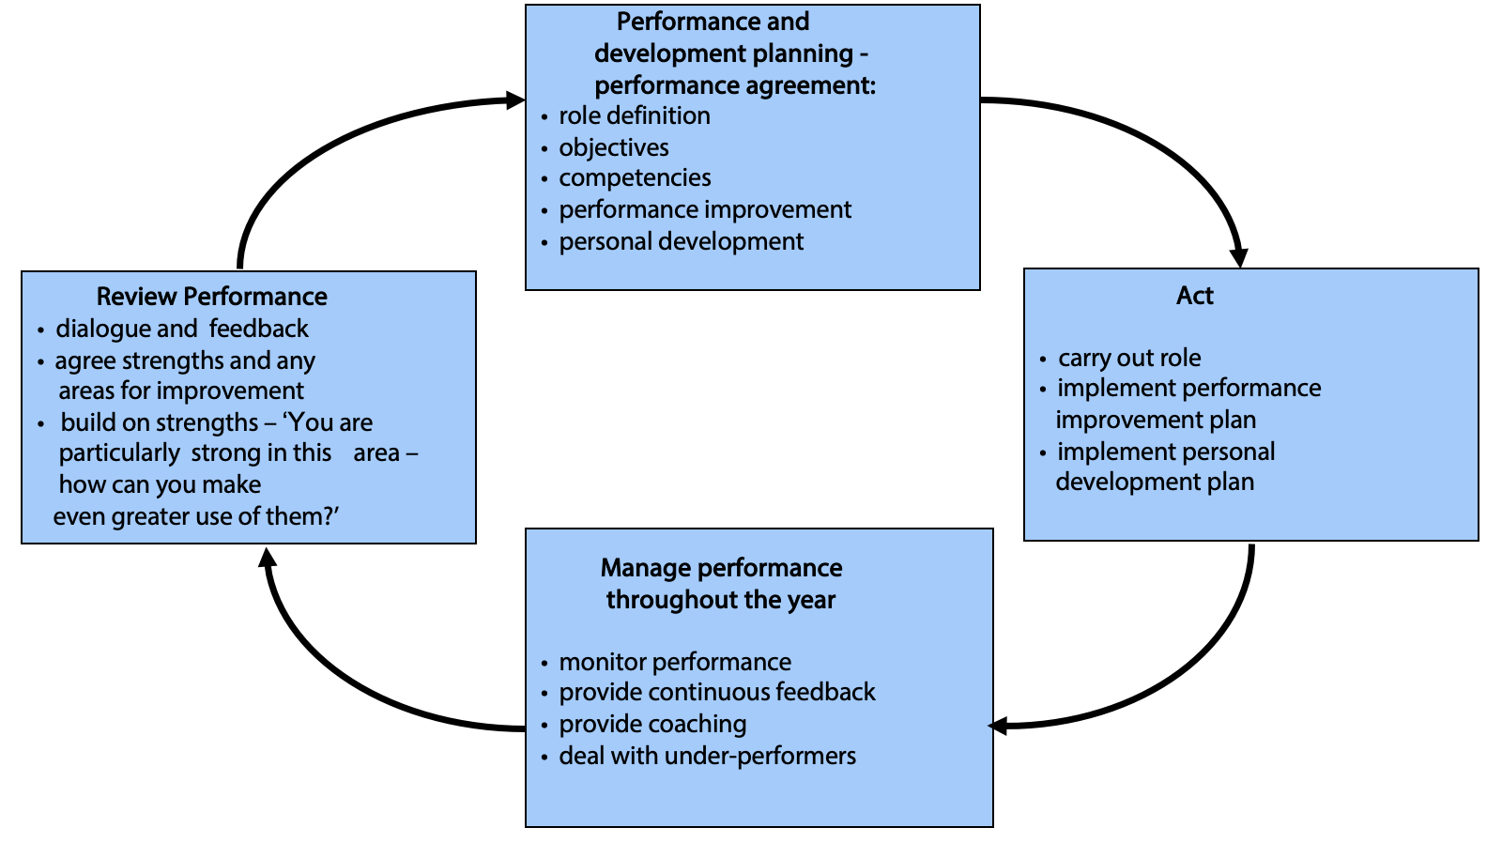
Source: The Process of Performance Management – week4 UWTSD

3.1. Training and Development for Fresh Direct employees

In the situation as seen above from Fresh Direct, training and development are vital. Firstly will get familiar with GAP concept. This stands for the difference, the gap between planned activity and reality. In our case the plan is to deliver fresh food to all customers in an acceptable time frame with high standards of the products and a good delivery process. At the moment the deliveries are delayed they are incomplete. First step is to analyse the reasons and it is not a guess that the short training and not enough time of shadowing the experienced workers leads to those problems. It is very important to train better those needed farmhands. The importance derives from the fact that is the only way to increase productivity, to achieve higher standards, to maintain the initial quality of the services, to reduce the mistakes that makes customers unhappy and to give to the staff both old and new to give feedback and to be open to their suggestions of improvement. The main benefit of training is to make sure a skill needed for the tasks performed are improved (Kraiger and Ford, 2021). Training is short term and job oriented and in our case must be focused on increasing operational productivity, a better to fasten delivery process and to increase quality of the preparation for those deliveries. Regarding GAP concept we need to develop with training ASK concept which stands for Attitude, Skills and Knowledge. The principles of Learning are Participation and older employees can involve new comers offering a longer period of shadowing so they can increase skills by doing it next to better qualified employees, Repetition that stands for what was mentioned before for more days, Relevance being thought specific tasks like pick up of the fresh food , or packing and preparing for delivery. Transference and Feedback are another 2 principles to be implemented in training. First step is the analyse to identify the exact needs based on inputs from internal sources like employees and external from customers feedback (Goldstein and Ford, 2002). The trainings provided can be of multiple types from safety oriented to efficiency, workload management, products with deficiency report regarding all issues that can be pinpointed after analysing the processes. Planning the trainings and prioritising them regarding company resources and available timetable without lowering productivity it is essential. A perfect plan will have 3 components time wise as for short term, medium term and long term. As a perspective of easiness the knowledge improvement trainings are most likely to be short term ones, skill improvement on medium term and attitude changing the long term ones. Trainings can be individual and custom made after individuals weaknesses and strengths. It is important to identify the efficient trainers regarding trainings provided to have a comfortable environment with a good quality communication and a feedback mechanism. The late one is important to evaluate the efficiency of the training on three time levels. Immediate feedback after training was provided, post-training test in evaluating how the skills are used at workplace and post training appraisals that will come from supervisors or managers. Increasing efficiency of each employee with training also with better trainings shaped for new employees the pressure over the working hours will lower. Also those trainings are tailored to have as an effect to shorten the working hours to the contracted ones. Happier and more efficient employees will lead to happy customers in the end and as a long term plan individual development will engage better the Fresh Direct personnel.

4.1. Development vehicles for employees.

Motivation it is a great development vehicle. A good mix of intrinsic and extrinsic motivation it is an important component of helping employees to work more efficient towards goal achievement. For fresh Direct having a financial reward for employees that perform in achieving goals and tasks. Complementary opportunity for career progression and upskill it is also important motivation that can reduce turnover. Understanding of Maslow’s Theory it is important in order to create a proper motivation mechanism. This theory it is a hierarchy of needs from basic biological and psychological ones to the highest ranked like personal growth and fulfilment (Maslow and Lewis, 1987). Each employment level has its level of needs and identifying and providing those needs it is a good motivation. Another theory is Herzberg’s two factors model. This theory separate intrinsic factors related to the job itself like job interest, recognition or career advancement and extrinsic or hygiene factors like rate of pay or working conditions. Using those 2 categories of factors and looking for the gap between employees expectancy and what Fresh Direct provides can be used as motivator with good consequences for efficiency and company profit. (Herzberg, 2003).
Engagement it is the level of commitment to the job and organization as well to the career path, investment of the individual self in the role (Rich, Lepine and Crawford, 2010). Improving employees engagement is vital for Fresh Direct to lower turnover and to increase operational productivity. One of the engagement theories suggest that is a social exchange two ways, between company and employees (Saks, 2006). Drivers of engagement are autonomy at workplace, support and coaching, responsibility, feedback and task variety, etc. As an outcome of engagement employees are willing to improve their performance, are having a better understanding of the big picture in the company and are more helpful and respectful to the colleagues. Learning and development programs are essential together with a good leadership to improve engagement. To enhance engagement at Fresh Direct a strong positive culture is needed, good people management, resources for rewards are needed and listening the voice of the employee is as well important. A good people management with a good rewards system brings satisfaction and increase engagement and leads to performance (Brown and Reilly, 2008).
Feedback it is an important development vehicle defined as information about differences between desired and actual action. It is information that evaluates a process or a service. It is information that can be used by a learner to improve the output of its work (Fong at al., 2019). Negative feedback was already introduced in our example from Fresh Direct by those customers not very happy with delivery times and missing products. It is important to be seen as an opportunity for improvement and to correct the mistakes. A good quality feedback inside the company it is very precis, describes accurate the problem without judging, gives the lines of what is a good work behaviour, it is transmitted in a positive constructive way, focus on the problems and leads to action. In difficult situations needs a proper manner of communication avoiding emotional outburst and having a good control of professionalism. 360 degrees feedback involves all parties at all levels from colleagues , managers in the department or from other departments as well from customers. It gives a wide view of the person, service or product but it is resources consuming, increase self awareness but is is over bureaucratic and studies shows that is not very efficient.

5.1. Conclusion

Fresh Direct needs all the wide tools offered by a good human resources management. The way to happy customers and a successful business is with good skilled employees on the right jobs with high motivation and high engagement. For this to be possible analysis of work processes and of personal with a good quality of hiring process and a good plan of personal development through trainings on short medium and long term are essential. Motivation and engagement together with individual development are important factors for performance management , performance being what customers expect in quality of the products they receive and services they pay for. Good employees , skilled motivated and engaged makes customers happy and this is the way for a successful business. It is not possible to have a successful business without a good human resources management (Noe at al., 2006).

6.1 References

Ayodele, O.A., Chang-Richards, A. and Gonzalez, V., 2020. Factors affecting workforce turnover in the construction sector: A systematic review. Journal of construction engineering and management, 146(2), p.03119010.

Brown, F.W. and Reilly, M.D., 2008. Emotional intelligence, transformational leadership and gender: correlation and interaction possibilities. The Journal of International Management Studies, 3(2), pp.1-9.

De Bruecker, P., Van den Bergh, J., Beliën, J. and Demeulemeester, E., 2015. Workforce planning incorporating skills: State of the art. European Journal of Operational Research, 243(1), pp.1-16.

Dobre, O.I., 2013. Employee motivation and organizational performance. Review of applied socio-economic research, 5(1).

Eilström, P.E. and Kock, H., 2008. Competence development in the workplace: concepts, strategies and effects. Asia pacific education review, 9(1), pp.5-20.

Fong, C.J., Patall, E.A., Vasquez, A.C. and Stautberg, S., 2019. A meta-analysis of negative feedback on intrinsic motivation. Educational Psychology Review, 31(1), pp.121-162.

Goldstein, I.L. and Ford, J.K., 2002.Training in organisations: Needs Assessment, Development and Evaluation. Fourth. ROBERT G JONES, 239.

Herzberg, F. (2003). One more time: How do you motivate employees? Harvard Business Review, 81(1), 86.

Hodkinson*, H. and Hodkinson, P., 2005. Improving schoolteachers' workplace learning. Research papers in education, 20(2), pp.109-131.

Kraiger, K. and Ford, J.K., 2021. The science of workplace instruction: Learning and development applied to work. Annual Review of Organizational Psychology and Organizational Behavior, 8(1), pp.45-72.

Macey, W H, Schneider, B, Barbera, K M and Young, S A (2009) Employee Engagement, Wiley-Blackwell, Malden, MA

Maslow, A. and Lewis, K.J., 1987. Maslow's hierarchy of needs. Salenger Incorporated, 14(17), pp.987-990.

Noe, R., Hollenbeck, J., Gerhart, B. and Wright, P., 2006. Human Resources Management: Gaining a Competitive Advantage, Tenth Global Edition. New York, MA: McGraw-Hill Education.

Rich, B.L., Lepine, J.A. and Crawford, E.R., 2010. Job engagement: Antecedents and effects on job performance. Academy of management journal, 53(3), pp.617-635.

Robinson, D., Perryman, S., & Hayday, S. 2004. The Drivers of Employee Engagement. Brighton, Institute for Employment Studies

Saks, A.M., 2006. Antecedents and consequences of employee engagement. Journal of managerial psychology.

SMART/SWOT Analysis and PDP

A SMART analysis was made for Radu A, hired as human resources officer for Fresh Direct. Being better informed about skills and attitude it is easier to elaborate a Personal Development Plan (PDP).
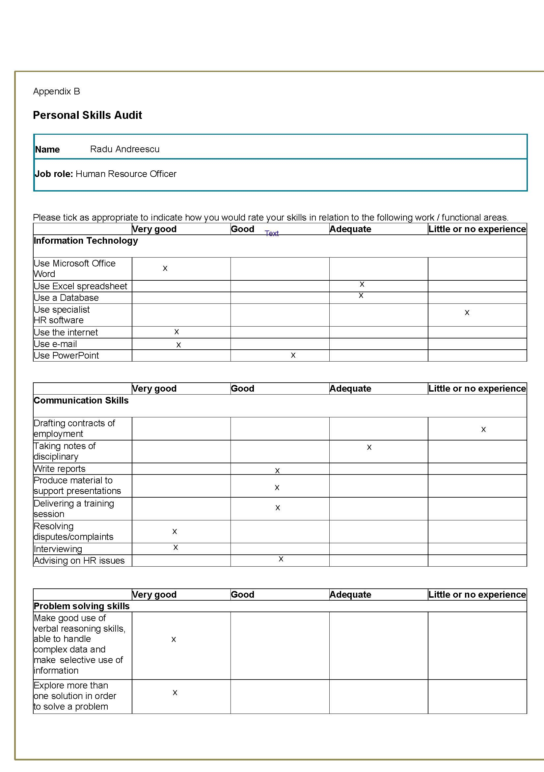

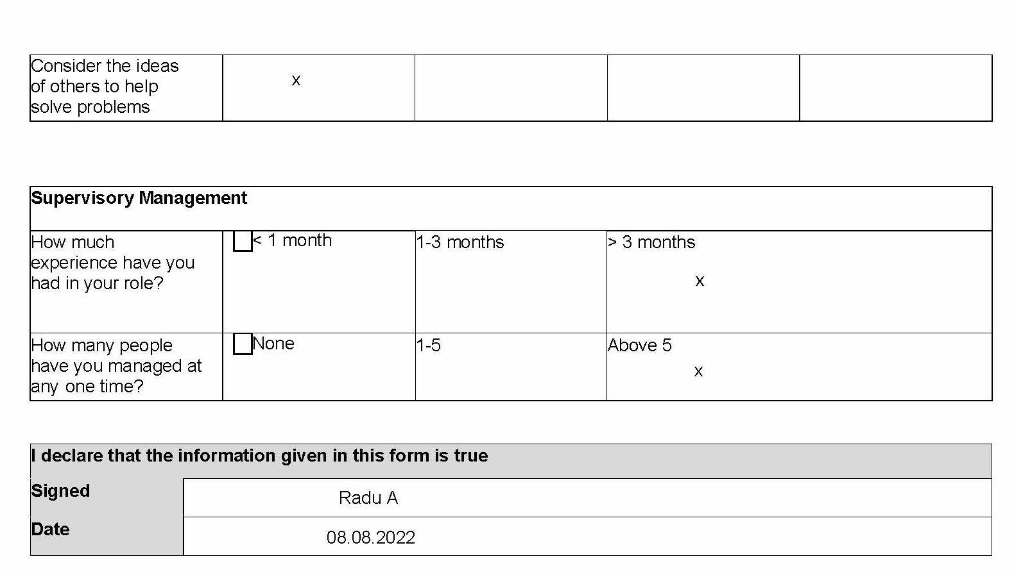

It is clear that his strengths are the skills regarding Microsoft Office Word, the use of e-mail and internet, resolving disputes and complaints and interviewing, with good critical thinking reasoning skills and problem solving oriented with proper skills to leadership. On the other side weaknesses are using specialist HR software, drafting contracts of employment with a big need to improve the use of databases and Excel spreadsheets and taking notes of disciplinary. It is important to make a PDP with a structure for short term, medium term and long term in order to increase Radu’s efficiency and to increase as result the performance in HR department. The structure has to prioritise the needs of the department, resources available and the time allocated for training and personal development. The PDP regarding Radu A it is as fallows:

Personal Development Plan

Development Aim | Action to be taken | Resources and Support | Development outcome (criteria) | Target date for review | Target date for completion
Using specialist HR software | Training for specific software | Software developer manual, tutorial | Easiness in using software  Making inputs with easiness | 09.09.2022 | 09.10.2022
Drafting contracts for employment | Training with legal advisor | Trainer for legal advice employment | Understanding of legal work related environment | 09.09.2022 | 09.10.2022
Use of databases | Database user training | Tutorials and working with HR manager | Easiness in using databases  Inputs/interrogations | 10.11.2022 | 17.11.2022
Microsoft Excel Spreadsheets | Training  Microsoft | Certified trainer,  Tutorials | Able to create Spreadsheets with easiness | 12.12.2022 | 12.01.2023
Disciplinary notes | Training | HR manager  Working with previous samples | Easiness in taking disciplinary notes | 15.08.2022 | 22.08.2022

Some actions are to be done on a short term even in an horizon of coming weeks like taking disciplinary notes while other actions like Microsoft Excel Spreadsheets are to be finished in January next year. If after reviews regarding progress employee shows commitment and engagement a new set of goals are updated for personal development plan to motivate Radu A and guide for a career path development.

