8/21/2020
Mirela Urzica
GROUP LEADER
DIGITAL SKILLS AND RESEARCH METHODS
McDONALDS

DIGITAL SKILLS AND RESEARCH METHODS
McDONALD’S

Student Name ID Topic
MIRELA MIHAELA URZICA | 1922003 | Background of Organisation
ALMPIONA NTEMAI | 1920427 | Challenges before introducing modern technology
TERESA BARRANCO ABAD | 1920375 | Insights of modern technology introduced
BORISLAV MITKOV BISEROV | 1921534 | Impact of modern technology
NICOLAE MARIAN VASILESCCU | 1919897 | Lessons drawn from the case study

TABLE OF CONTENTS
- INTRODUCTION
- BACKGROUND OF THE ORGANISATION
- CHALLENGES BEFORE INTRODUCING MODERN TECHNOLOGY
- INSIGHTS OF MODERN TECHNOLOGY INTRODUCED
- IMPACT OF MODERN TECHNOLOGY
- LESSONS DRAWN FROM THE CASE STUDY
- CONCLUSION
- REFERENCES

INTRODUCTION
As the role of the technology is increasing nowadays and it is becoming very essential part of every human life. The new digital technology is also helping people of workplace to remove skills gaps and make them updated with new invention by making workers very smart. In the workplace also there are various of new technology used which make the work very easy and systematic for workers and use of technology in workplace also help management to communicate effectively. Through the technology, all workers information is also handled very effectively with use of apps, websites. The various things such as social networking , emails and virtual office , cloud storage made workplace working very easy and efficient. For the report McDonald’s company is taken and its use of various technique on contemporary workplace for maintaining employability and efficiency and there data handling of workplace through use of advance technology. The company use challenges, insight, impact and lessons drawn from the case study.

BACKGROUND OF THE ORGANISATION
The McDonald’s is the American company of fast food which is founded in 1940 from today 80 years ago in San Bernardino by Maurice and Richard McDonald’s. The headquarter of various McDonald’s is in Chicago Ilinois U.S. McDonald’s is public limited company and its restaurants are serving worldwide. McDonald’s offers various of products such as Milkshakes, Wraps, Hamburgers, French fries, Soft drink, desserts, variety of breakfast and coffee. Revenue earned by McDonald’s company in 2019 is US$21.076 billion and number of employees working in company are 210.000.
Both Maurice and Richard McDonald’s first open the McDonald’s at the 1398 in North E street in California in 1940 May 15. Then in 1961 company registered the trademark for U.S in name of McDonald’s. McDonald’s serving the 68 million of the customers each of day and operating 37,855 restaurants worldwide. McDonald’s company also give franchise to 35,085 location in which 21,685 are conventional franchised. In 2018 McDonald’s traded its share at rate of $145 per share and market capitalization of the share valued at US$134.5 billion. As is serving globally so also called many of time ‘’ McDonaldization’’ in society. In McDonald’s both type of services are offered to customer dine-in at which customer eat in restaurant only and Take out in which customer take food out(McDonald’s 2020).
McDonald’s also believe in giving best quality product and service to their customer with variety of new taste to attract various of new customers. In the 2018 September McDonald’s announced that they will not use the artificial preservatives such as colours and flavours for various colours burgers such as Cheese Burger and the Big Mac Burger, so that the health of their customer may not get affected. The McDonald’s company also have international menu as per country variations. The McDonald’s also allow their customer to create their own taste by providing various of new services and product. McDonald’s company also made playgrounds in suburban certain cities and area for giving their customer feature of outdoor and indoor playgrounds. In 2006 McDonald’s introduced the Forever Young brand through redesigning their restaurant in 1970 s. McDonald’s also banned the smoking in their restaurants and food chain from 1994 for their customer. In the 2019-2020 due to COVID-19 situation McDonald’s closed most of their setting in US restaurants (McDonald’s 2020) and in entire world.

The challenges Mc Donald’s faced before introducing tablet kiosk technology.

1-Promotion
Mc Donald’s advertises their brand in radio, newspaper, television, and so on. In this way they became famous but their information is not updated to reach a wider audience which benefits them in a service change and understanding the buying habits of their customers.
Customers didn’t had opportunity to receive local promotion based on how they are interacting with that restaurant.

2-Human service
Before using tablet and voice technology Mc Donald’s ‘was just about serving, serving, fast, and fast and was very stressful’. R.Thomas (N.D).They were struggling with servers, the order process wasn’t efficient and accurate because there were a lot of people ordering in a till, and they get confused by taking order in a paper or putting in a system. The restaurant needed waitresses and waiters because of the volume of customers. Sometimes they louse or mixed the paper order with the different customer and this cost them losing time and money.

3-Bar queues
Before customers use to order in a till for their drink, or bar snacks, burgers and waiting in a queue, without sitting in a table. Those things make them more frustrated and sometimes some of the customers can not wait to take the food because of the time and a long queue. Especially for families who are placing orders with their children in tow. They louse time and that makes the business to louse the customers and because of that the company louse money.

4-Cash Payments
To make a payment, customers use to wait until a member of staff became free and that makes them lose their time and they lose some of their customers.

5-Human relationship
The training was vital. They spend time supporting the customers to serve them, keeping a good relationship being passion and respectful they tried to be great in their service but was difficult to serve a lot of customers at the same time.

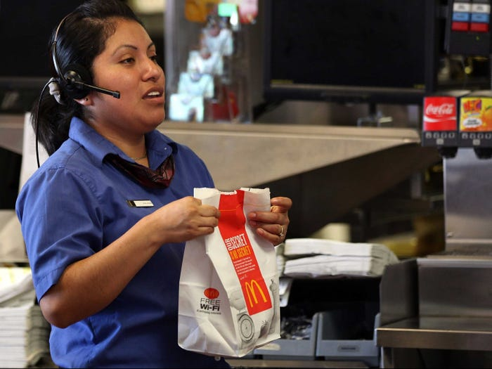

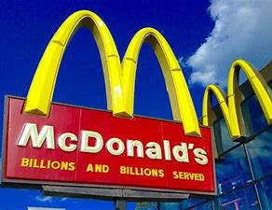

Insights of the Modern Technology Introduced

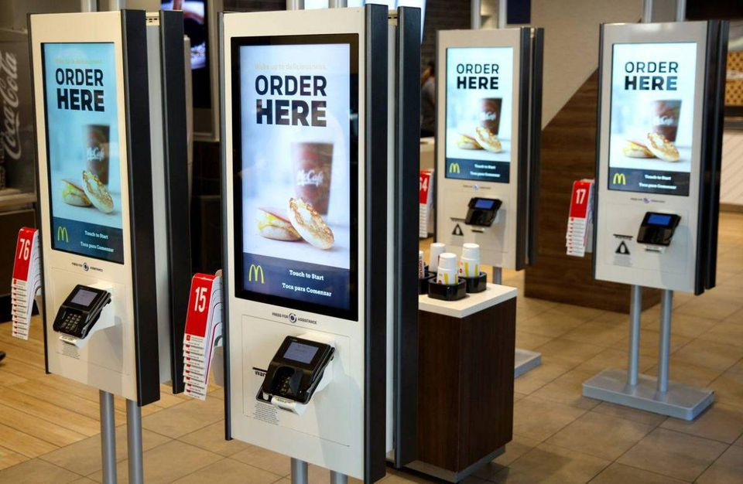

Definition of Self – Service Kiosk

Self-Service Kiosk are big touch screens that let the customers order exactly what they want with a lot of choices to customize their order without having to queue up and request for their food to be brought to their tables by employees. This kiosks accept mobile payment options from Apple and Google, and debit and credit cards, and only requires contact with the employees in case they need to pay in cash or to take their order from the conventional tills if they did not request table service.

Characteristics of Self-Service Kiosk

Self-Service Kiosks are giant touch screens which includes the display, scanner, credit card reader and receipt printer. They are situated in all the restaurants around the world, updated with all the menu of food and drinks the customer can find in the conventional tills, with the difference that they don’t have to interact with the employees, making the ordering process more efficient and fast.

Models of Self-Service Kiosk

We can find the same model of Self-Service Kiosk in all the restaurants.

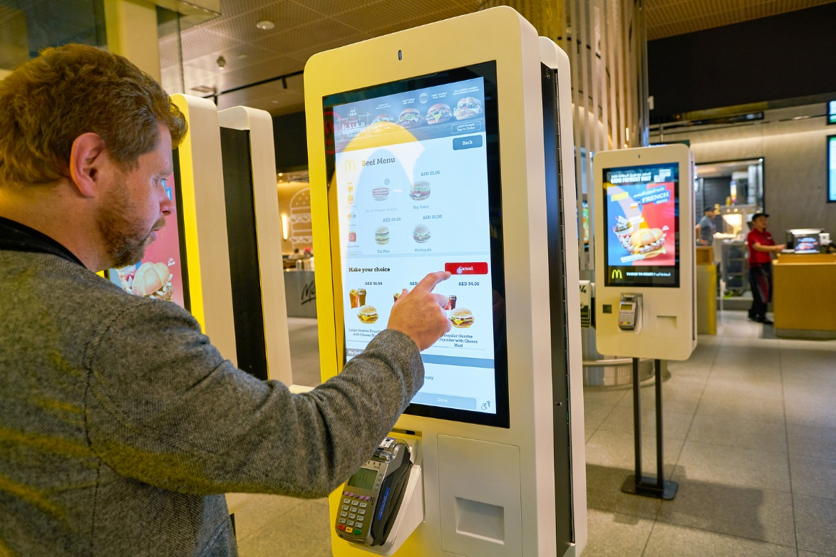

Advantages and Disadvantages of Self-Service Kiosks
Advantages:
- The ordering process is more efficient, which is why they have become popular in fast food chains.
- The human staff have the opportunity to be in other roles that can improve the customer experience, walking around and strike up conversations with guests to make sure they are satisfied.
- They help with order accuracy and customization, with the simple step of adding and deleting ingredients.
- The customers tend to spend 30% more, because the Self-Service Kiosks never forget to ask if they would like something else to complete their menu and customers are more likely to do so on a screen.

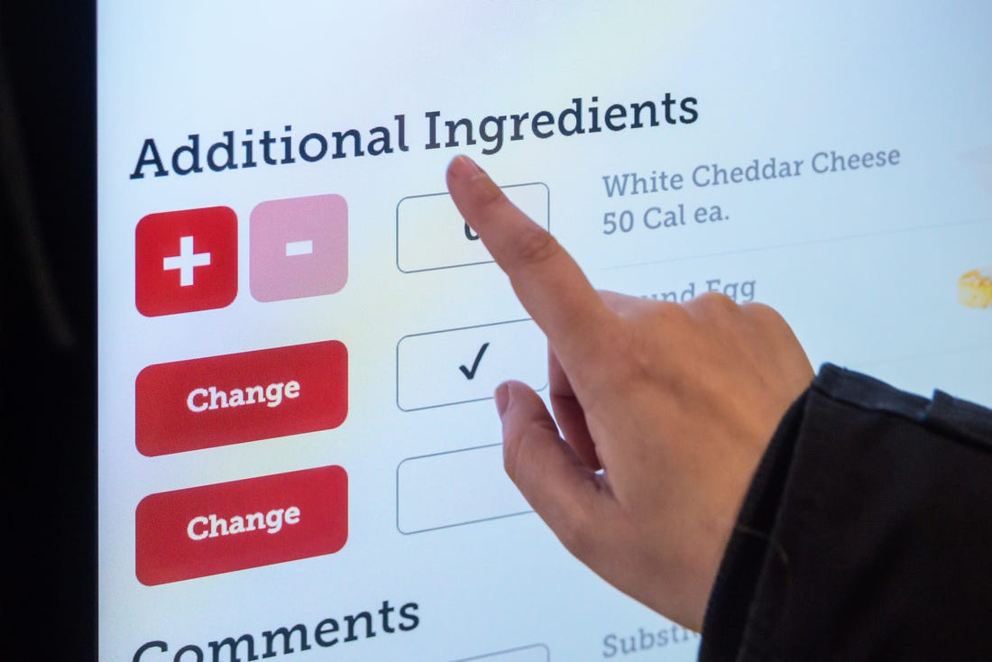

Disadvantages:

- Add technology to a business, it requires an upfront investment and not all the restaurants can do it. Every kiosk is about 5.000 dollars, and this price can climb depending on what type of customizations restaurants decide to add.
- Depending on your target customer base, there is also the possibility that people just do not to rely on technology to order and pay for their meal.
- Even if with this technology the idea is not to hire less employees, could be the possibility that some restaurants don’t need to much staff.
- This kind of technology needs technic maintenance in case they get broken or they have any technical issue.

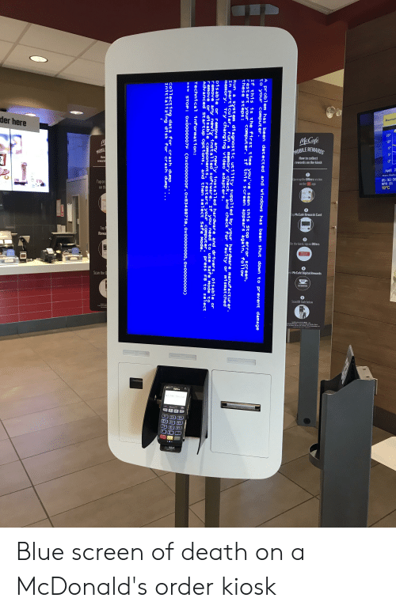

IMPACT OF MODERN TECHNOLOGY

McDonald's has posted a 20 percent rally so far after a 35 percent jump a year ago, making it remarkable compared to other performing blue chips in U.S. ad value. The low-cost food goliath announced $ 7.5 earnings per share a year ago, 53 percent more than in 2015. In addition to improving productivity, the energy finance specialist is further supported by the expectation that the organization's new innovations will bring generous benefits.
In addition to this, this year alone, McDonald's has won several technology companies. In March, the organization reported the acquisition of Dynamic Yield. Anam (Dynamic) man-made innovation (AI) can make menus customized to win the climate and traffic conditions of cafes. McDonald's has just introduced the innovation with more than 8,000 stores in the United States, and the result is expected to be acceptable. The organization further expects to use AI to improve administration to pass through customers, who account for half of its revenue in the US and Australian markets (Marketing Week, 2019).
Using innovations to confirm the discourse of Apprentice, starting in Israel starting only this month, the transition through customers may long ago have been possible to organize through a brilliant speaker. Despite easing the development of advertising in the United States, McDonald's continues to see strong developments in various markets, such as Southeast Asia, Africa and as well as that other countries like Russia (Tin-yau, 2019). Opening the development of emerging markets and expectations that McDonald's interest in innovation will bring attractive reserve funds and will consolidate new deals to help the heart of the offer.
Several organizations, for example, McDonald's, are creating a system for other competing business organizations, and the people of the nation want to grow as fast as can reasonably be expected (Marketing Week, 2019). As mentioned recently, data-based administrations, place the planet through electronic channels can be produced and sent to another area for use. Truth be told, data innovation administrations for such key variables as globalization are happening. Unlike the physical commodity, the administration, coordination and appropriation, establishment, and dispersion, when there is no place, at this point is simple. Generally, a global organization sends messages to customers via mail or media, and they can also convert to money worldwide, and a combination of a focal fee is possible. In essence, data, advice, making requests / reservations, critical thinking and paying for most of the prospects, from the phone to the page, must be possible through the broadcast of communications. As producers, also make a more efficient value chain for the chance to use national contrasts in an almost preferred position. Organizations can further reduce the cost of a huge fixed venture.
It seems that during a system gateway, which is not the Internet address of web addresses must be dynamic. For the past few years, McDonald's innovative items have been involved. Step by step the organization made an alternative kind of innovative endeavours with different results.
According to Takeaway Expo (2020), the organization is also testing a unique contribution framework based on brands. McDonald's credit or check card customer data was filtered and printed. At this point, in order to make a purchase, customers additionally announced against only one printer, scanner and squeezed their thumbs. Preliminary launched in January 2002, but within a few months after customers did not care about a unique brand for McDonald's.
A framework for paying time while making claims, McDonald has agreed to push its administration to remote access. It is currently available for use at 10 McDonald's in Manhattan. According to the organization's website, there are several hundred cafes, as "better types of help will be offered in the coming months." Mats Lederhausen, McDonald's head of business improvement for the administration's original function, says our customers are evolving after offering an amazing method of extracting value-added food and advice to be so consistent that MacDonald is more -just to say lead-mail. "In any case, the promotion was in order. In any case, during the nearly three-month testing period, McDonald's customers and the program improved slightly.

LESSONS DRAWN FROM THE CASE STUDY

Willems et al. (2017) revealed that digital adaptation and technological revolution has encouraged retail customers to be more engaged in retail ordering systems such as Kiosk technologies. McDonald’s adopted digital ordering systems such as electronic tablet and Kiosks at the stores instead of face to face ordering system (CNBC, 2020). At McDonalds, electric tablet is an order placement device kept at tables (Business Insider, 2018). Whilst, Kiosk is a similar technology of menu selection and order placement through a big screen monitor. Both avoids face to face communication.
Both Kiosk and electronic tablet have significantly positive impact on the sales and customer engagement at McDonald’s because a large number of customers appreciated the newness in ordering. Maze (2019) reported that introduction of Kiosks across McDonalds in the USA has increased same-store sale
s by 4.8% since customers are placing larger orders. Business Insider (2018) also reported that McDonalds will soon regained the lost sales of $2.7 billion which will be possible because of adaptation of advanced technology and engaging customers in the system in excellent manners. Above information shows that introduction of Kiosks and electronic tablets have positive correlation with customer engagement and sales volume of McDonalds. However, Van Tonder et al. (2018) reported that majority of customers prefer face to face communication while placing orders at restaurants. This might create some obstacles for some customers at McDonalds.
I believe that kiosks or tablets both are excellent and timely technology especially now to avoid human attachment to avoid spread of COVID-19. Secondly, such technologies will inform customers about food values and calorie information leading to better food selection. Thirdly, I believe that technologies helped McDonald’s staff concentrate better in work because they do not need to talk to customers.

CONCLUSION
The above report concluded that in the workplace digital skills are very useful while using the recent develop technology. The various available tool in todays market made the work in workplace very easy for remembering information of customer as well as workers. The digital skills such as Microsoft office excel which make handling of data so easy for the manager. As McDonald’s company use very new and update technology for their customer so with use of new technology workers of McDonald’s can easily gained the digital skills for serving their customer effectively and give them good experiences.

References:
McDonald’s (2020). About us (online) Available at http://www.mcdonald’s.com/us/en-us/about-us.html. (Accessed 12 august 2020)
McDonald’s (2020). Company overview(online) Available at http://corporate.mcdonald’s.com/corpmed/investors-relations/company-profile.html. (Accessed 12 august 2020)

Maclver. K. (2016). McDonald’s delivering a digital experience
Lukas. A. (2020). McDonald’s create digital customer engagement as part of his tech push.
Thomas. R. (2014) How Digital Technology is Changing McDonald’s structure , Offer and Customer Relationship. http://www.business2community.com.
Photo: Then and Now-McDonald’s through the years-Business Insider. (N/D)
8 Benefits of Self- Serve Kiosck.(2020). http://www.triniteq.com/blog/self-service-kiosks.
McDonald’s (2020). http://www.mcdonalds.com/gb/en-gb/what-mcdonalds-use-to-help-provide-a-speedy-service.html.
Fleming. M. (2019). McDonald’s turns to tech to build the future of fast food. Marketing Week(online). Available from: http://www.marketingweek.com/macdonads-digital-transformation/ (Accessed 15.08.2020)
Takeaway Expo(2020). How has Technology Increased McDonald’s Bottom Line? Restaurant and Takeaway Innovation(online). Available from: http://www.takeawayexpo.co.uk/news/blog.asp?blog id=10035.( Accessed 15.08.2020)
Tin-yau.K. (2019). How technology is transforming McDonald’s operation. Enjinsight(online). Available from: http://www.ejinsight.com/eji/article/id/2254439/20190919-how-technology-is-transforming-mcdonalds-operation. (Accessed: 15.08.2020)

Business Insider, (2018). We tried the kiosks that analysts say could help McDonald's win back $2.7 billion in sales. Here's the verdict. Retrieved from: https://www.businessinsider.com/mcdonalds-kiosk-vs-cashiers-photos-2018-3 [Assessed date: 18 Aug 2020]
CNBC, (2020). McDonald’s creates digital customer engagement team as part of its tech push. Retrieved from: https://www.cnbc.com/2020/01/08/mcdonalds-creates-digital-customer-engagement-team-as-part-of-its-tech-push.html [Assessed date: 18 Aug 2020]
Maze, J., (2019). KIOSKS AND HIGHER PRICES DRIVE MCDONALD’S SALES. Winsight LLC. [Online] Retrieved from: https://www.restaurantbusinessonline.com/financing/these-are-five-markets-disrupted-most-covid-19-week [Assessed on 18 August 2020]
Van Tonder, E., Saunders, S. G., Lisita, I. T., & de Beer, L. T. (2018). The importance of customer citizenship behaviour in the modern retail environment: Introducing and testing a social exchange model. Journal of Retailing and Consumer Services, 45, 92-102.
Willems, K., Smolders, A., Brengman, M., Luyten, K., & Schöning, J. (2017). The path-to-purchase is paved with digital opportunities: An inventory of shopper-oriented retail technologies. Technological Forecasting and Social Change, 124, 228-242.

