Pathway Project 1: Sustainability and Global Citizenship
Reflective Writing
Eunice Ojo 1703977

Contents
Introduction 2
Topic Group &skills 2
Reflective observation 3
Conceptualisation 5
Active Examination 5
Conclusion 6
References 7

Introduction
As part of my assignment I was allocated a group to pick a chosen topic, the topic that we decided to go further into was community and participations locally and nationally. This topic discusses the importance of, community participations and other community inputs and projects. Research showed the different contributions and projects made by individuals and the community, in helping people live better lives. After being very indecisive, we finally decided to choose the charity prince trust, an organisation founded in 1976 in helping young vulnerable adults. The aim of prince trust is to allow each young person from the ages 11 to 30 years despite their bad circumstances, to have the opportunity to employability, education and housing and many more services provided by the princess trust. Followed by many success stories, to prove how beneficial and community participated the charity is. Not only is Prince Trust work nationally but also, work internationally forming several partnerships and organisations around the world. When writing my reflective report I will be including some of Kolbs theory (Trust, 2018).

Topic Group &skills
Unquestionably, Princes trust is one of the largest charities ran internationally reason being why myself and my group were so eager to choose this topic. Prince trust is a charity for young adults who are trying to resettle and have a better future for themselves, this includes ex-offenders, homeless young individuals and individuals struggling with day to day mental illnesses and drug habits. There are homeless shelters put in place so individuals have a place to stay and can later on in the future own their own council property. The homeless shelters also provide educational advice and counselling. At first I and the group were very unsettled and unsure of what topic to pick, due to the limited knowledge of the assignment. At this point a group leader was not yet assigned which made this even more difficult to keep the group intact. As a result, to this, we had to come up with a solution a figure out who would be best suitable for this role. We had to put skills in place to ensure this assignment was achieved as time went on we found that delegating would be the best way to guarantee a successful project to make sure task were completed on time. Following six simple steps,
- Preparing, myself and the group made sure the topic was researched in order to have a better understanding of the project and not just rushing into it, leaving us in confusion like we started off.
- Assign, the team leader later on assigned each group member with a certain point to cover about the topic, making communication and information clearer for myself.
- Confirm and understanding for myself, in the group we met up weekly ensuring each and every one of us had a clear understanding of what was expected of them and how it should be produced. I regularly asked my group member about advice on certain points as she did with me to ensure I was on the right track.
- Confirm and commitment.
- Avoiding ‘Reverse delegating.
- Ensuring accountability.
(company, 2013)
Time management was very critical for me while doing this assignment, because great time management produced in the group helped ensure I had the best knowledge of what was expected of me while producing the benefits of the organisation. By me firstly prioritising tasks for myself, setting myself times and dates for when work should be produced, when the group met up. Also ensuring I was on time for each group meet up, because being late could alter my knowledge of what I needed to know about my chosen topic and what was expected in the presentation. I made sure I was always on time in order to refresh my knowledge more and more in each meet up, until I was fully satisfied to start writing up my work. (Solent, 2018)
Also using my interpersonal communication skills, I was able to communicate with my group members affectively when giving them an understanding of the charity. Some group members were a bit confused about the topic and what was expected of us in the presentation. Even though some people in the group said they understood I didn’t just want to assume so I made sure I addressed it and asked what they knew about the topic, to have a better understanding of what knowledge they had and also learning new things about the topic from them. I did this by being an active listener and always maintaining an open posture with a can-do attitude, allowing others to feel welcome to voice their opinions to have the best outcome possible. (Holt, 2018)

Reflective observation
At first, I felt the group formed very well and I was really excited because, the topic we choose I was very familiar with and had actually received support from the prince trust when I was younger and was part of the housing resettlement program at Creekside foyer, which is an emergency accommodation for young individuals struggling with housing on a day to day basis. Prince trust helped with funding me with a temporary accommodation and that later helped me with having my own council house. I produced a high standard of work while working in my group due to my knowledge and experiences with the organisation. I choose to cover the benefits of the Prince trust because, the charity was very beneficial for me reasons I am in education and I am now in a council flat due to their support. The team leader was very eager at first and I was confident that the presentation would be up to standard and completed on time, through the positive meet ups and the work that was always discussed. Other members of the group would bring in their laptops which made it look like they were focused and, on a go, to work and I did not bring mine which could have come across as me being unbothered and not really on completing tasks. Finally, all members of the group knew their assigned work for the presentation and sent it to the group leader, on the first week I sent over my work and so did the others which then showed how eager I was to complete tasks. Unfortunately, for the practice presentation members of the group still did not receive a copy of the presentation despite, all work had been sent to the group leader. We did not get to do the practice presentation because, the leader was late and had no copy of the presentation, at this stage I became very worried and distressed because, in order to pass the module, we would need to work as a team and if one failed to produce work it would affect the whole group. Luckily from help from another group member and myself we helped produce and presentation slide show covering all the aspects needed to be addressed as a header to each slide to make it easier for the group leader to paste each piece of work in each slide. Two days before the presentation, the copy of the presentation was then sent to us and that gave me a few days to familiarise myself with the whole presentation lay out and how it would be projected on the day. I worked very well during this time and did not let my team leader’s fall backs affect my performance and I found a solution, using my initiative and made sure I had a backup presentation just in case I did not receive it from my team leader. Below I have included the benefits I included:
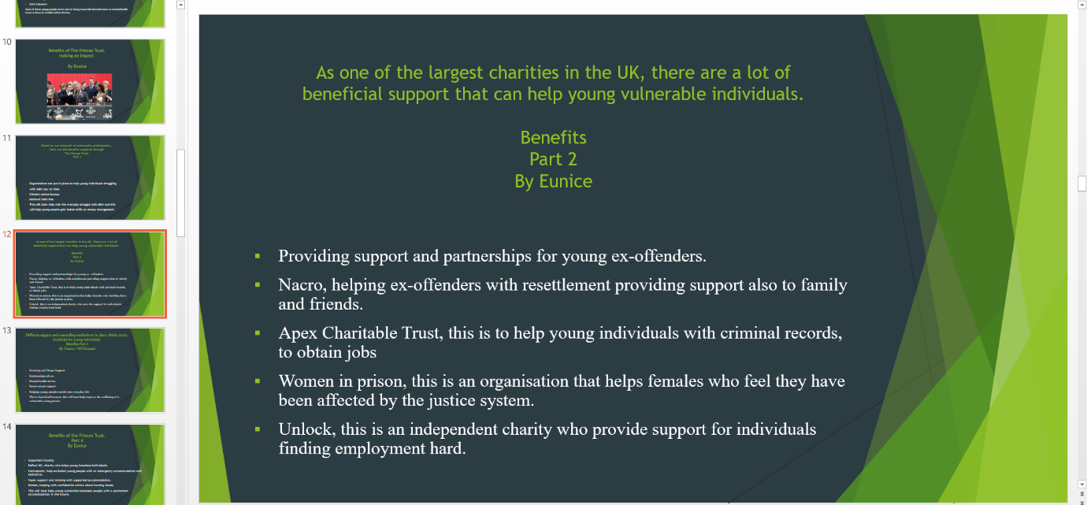
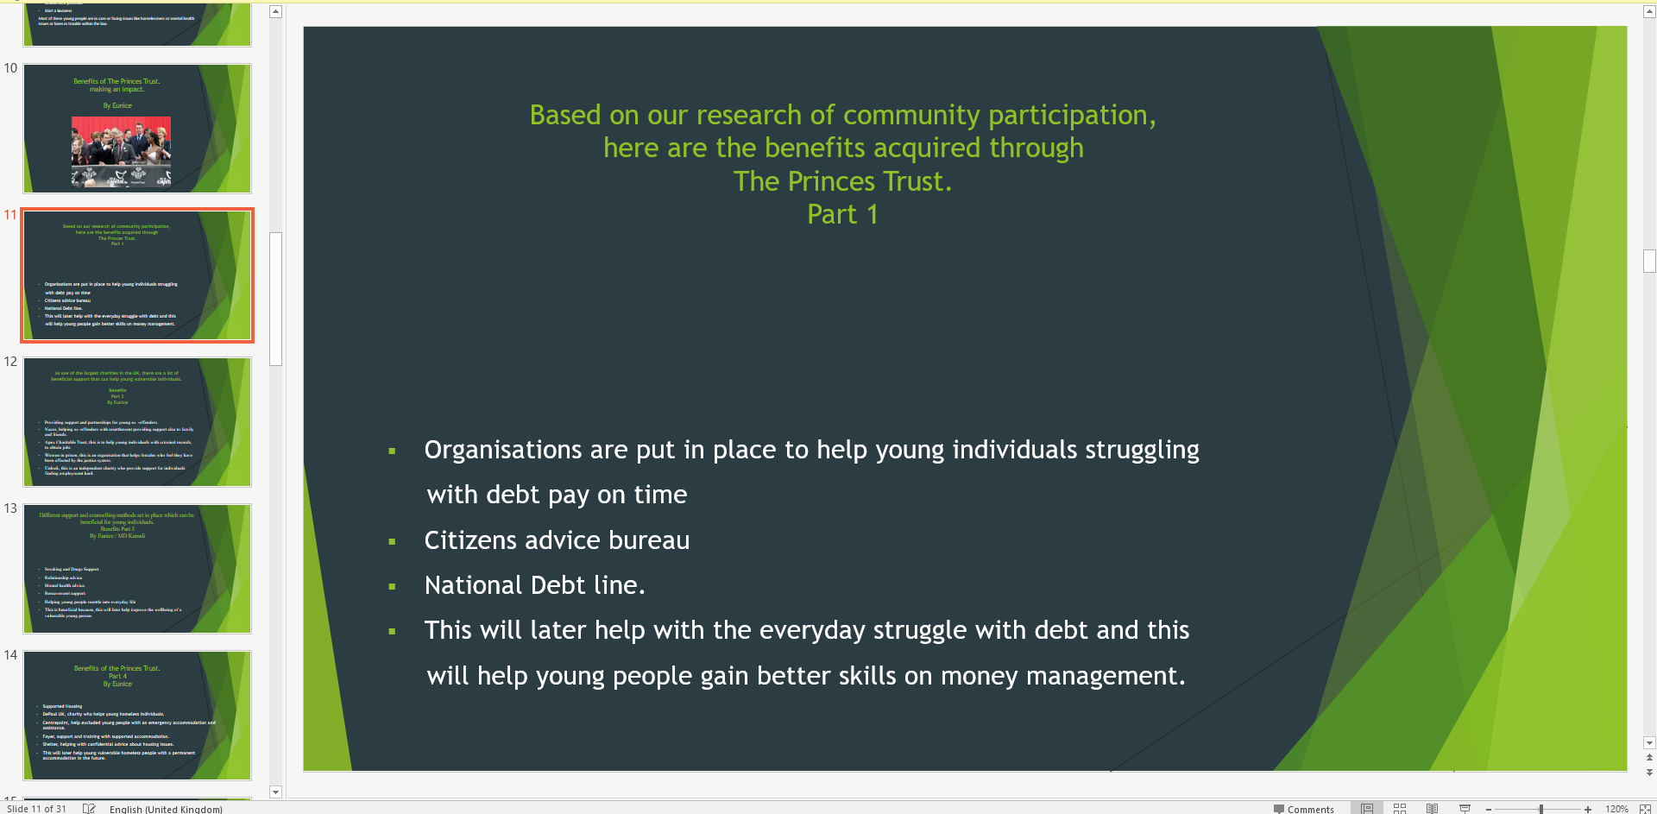
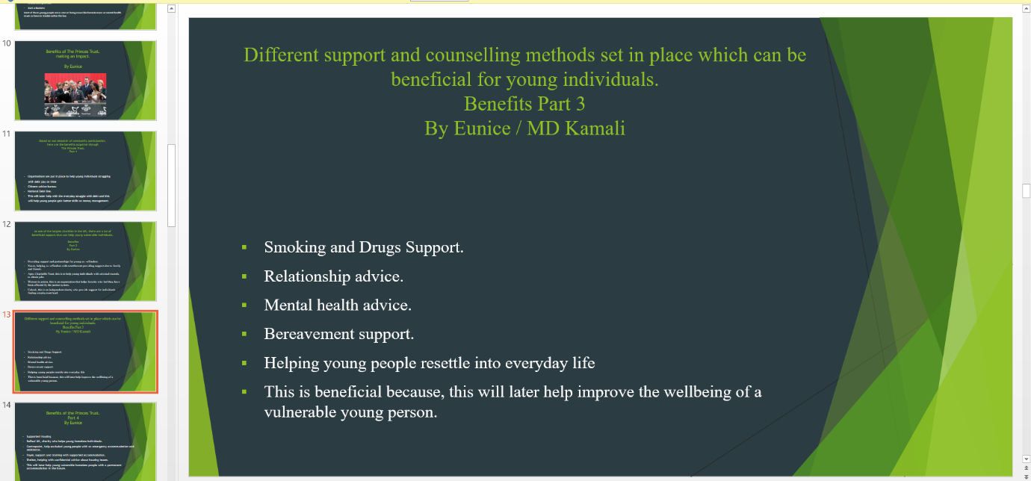
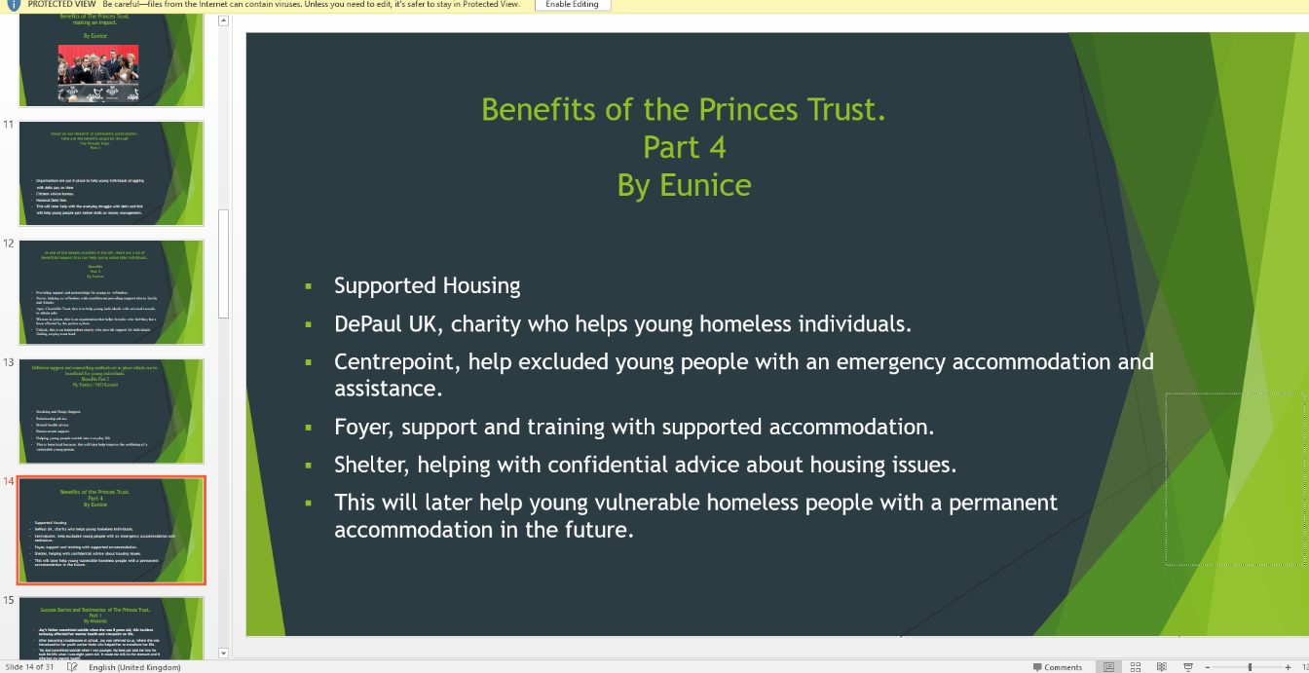

Conceptualisation
Initially I was not aware, that the prince trust specialised in helping young individuals as I thought it was for a wider range of people. Also, I thought it was only aimed at helping people with re housing and emergency accommodation. As research went on I learned that it helped ex-offenders, with re housing and other services such as, civil legal advice, Drugs counselling, mental health counselling, help with obtaining a job and getting back into education and also helping with funding to start up a business. Furthermore, I learned that prince trust formed partnerships with different organisations like, NHS, Nacro, Women justice system and many more organisations that I never even knew exist. To my surprise I discovered that, the royal bank of Scotland formed a partnership with prince trust funding a large amount of £3m, I never thought of how the charity was funded and of course the money would need to come from somewhere to allow all aims of the organisation to come to past. (Kolb’s theory)
(Trust,2018)
(Society, 2018)

Active Examination
Through my experience I would have definitely considered more meet ups to ensure work was produced on time and stayed back after classes to ensure sure the presentation was produced by myself and the group on time. As I understand a lot of the group members have outside commitments and may not have as much time in their hands to do work other than the days they are in. I would also would have set myself a deadline to improve my delegating skills. During this experience I learned how to work effectively as a team and also furthered my interpersonal skills, with this being said I feel this is essential as a professional to have these skills to have the best results while doing a project. Interpersonal skills are used in every day to lives when communicating with individuals or a group and it is proven that, with this skill it allows an individual to be more successful in their professional and personal lives. This project has made me want to create a project in the future which benefits in helping young individuals live better lives and with all the success stories this has made me feel so empowered and due to all my personal experiences with the charity. (need, 2018)
(Kolb’s theory)

Conclusion
Overall, I feel that prince trust charity is a very beneficial charity and it is very community participated, especially for young adults, which made this a great topic to pick. It is proven that 6 1% of young adults agree that having a job makes them feel more of use and a sense of purpose whereas 49% feel it has improved their mental health when having a job, supported by all the success stories. While working in a group this has made me open up and learn more about the project and the use of everyone’s opinion and decision made this even easier for me to gain more knowledge. Despite, I already knowing a lot about prince trust through my experiences. I learned how it is funded which has made it one of the largest charities going which is beneficial for me when later in the future I decide to start my own charity. (2018,Trust)

References
company, f., 2013. 6 steps for more effective delegation. [Online]
Available at: http://www.fastcompany.com
[Accessed 12th April 2018].
Holt, M., 2018. effective team work and interpersonal skills. effective team work and interpersonal skills , 28th April, p. 1.
need, S. y., 2018. [Online]
Available at: http://www.skillsyouneed.com
[Accessed 30th April 2018].
Society, C., 2018. CivilSociety. [Online]
Available at: http://www.adatum.com
[Accessed 1st May 2018].
Solent, L., 2018. Time management and group work. [Online]
Available at: http://www.Learn.solent.co.uk
[Accessed 22nd April 2018].
Trust, P., 2018. www.Princetrust.org. [Online]
Available at: www.Princetrust.org
[Accessed 10th April 2018].

Learning Log (Apendix)

Date of meeting | Place of meeting | Time of meeting | Members attended | Topics discussed. | Outcomes agreed.
22/02/2018 | University Library | 11am | All except Nez | We choose our groups | Group was formed and we choose a team leader.
08/03/2018 | University Library | 11am | All except Nez | We generated all our ideas and choose our topic. | We all finally agreed on the chosen topic.
15/03/2018 | University Library | 11am | All except Nez | The team leader assigned what each individual will need to cover about the topic. | We discussed as a group what we felt comfortable covering and started generating ideas.
23/03/2018 | University Library | 11am | All except Nez | Follow up | We gave all our ideas in the group to see if we were on the right page.
29/03/2018 | University Library | 11am | All except Nez | Preparation, we discussed how we would individually present our work. | We agreed how we would project our work using a clear example and clear voice.
05/04/2018 | University Library | 11am | All except Nez | We all showed our final piece of work and then sent it to the team leader. | We presented our final piece of work and were all happy about each person’s work produced.
12/04/2018 | University Library | 11am | All Group members attended. | Final version development, we practiced the presentation as a group. | We presented our work as a practice run and we were all satisfied with the outcome.

