Ophelia chase
Student ID 2020346
BMHP5005

Research Project: Literature Review
Title: The role of Health and social care organisations in helping the young adults to recover from the severe effect of depression: A Case Study of the organisation Mind

Abstract
The research has highlighted the importance of Mind in managing young people recovering from depression. Depression is one of the major drawbacks to the development of the future generation the research has dealt with this topic for shedding light on this factor. The different functions which have been acquired by the care and health organisation have helped immensely in recovering the mental health issue. The faced challenges by the young people became a guide for Mind in solving the issues and implemented positivity within the youngsters. The significant role played by the Mind in mitigating the issues of the mental strength of the young generation has been a major help. The stated recommendations additionally added meaning to the work strategy of Mind and lead the organisation to secure a better position in the market in the future to help the younger generation to attain better growth for the nation.

Table of Contents
Chapter One: Introduction 5
Introduction 5
Background of the Research and Company 5
Aim and Objectives 6
Rationale 6
Chapter Two: Methodology 8
Research Onion 8
Role of ethical Codes and Policies 10
Chapter Three: Literature review 12
Introduction 12
Analyse the different functions that are undertaken to mitigate different mental health problems 12
Challenges that are faced by people with depression of poor sleep 13
The significant role played by the health and social care organisation in helping young adults to overcome the phase of depression 14
Summary 16
Chapter Four: Findings and Discussions 26
Findings 26
Discussions 29
Chapter Five: Conclusion and Recommendation 30
Conclusion 30
Recommendation 30
References 32
Appendix 1: List of Figures 37

Chapter One: Introduction

Introduction
The research will be focusing on the role of health and social care organisations in helping young adults to recover from depression. Young adults are the building blocks of the future generation and depression can diminish the future opportunities and growth of the individual. Thus, this research will discuss the role of the Mind in bringing back the youngsters in the human race. Different functions will be discussed for highlighting the role of social care in mitigating the challenges faced by young adults. The methodology will help the researcher further to develop the project in a strategic and systematic way. The detailed discussion about the topic through the validation of academic books, journals and scholarly articles will increase the quality of the work and the understanding as well. At the end of this research findings will gain more knowledge on the fact and recommendations will help in a better future development by restoring the values within the young adults.

Background of the Research and Company
Mind is one of the leading mental health charities based in the UK. The organisation has been founded in the year of 1946 as the National Association for Mental health. It provides support to the people who are suffering from mental health and solves their problems by investigating the matter. Mind also organises several campaigns for spreading the awareness that the mental state of an individual is equally important similar to someone's physical health. UK government has reported that more than 31% of young adults are suffering from depression and majorly women are affected by this (gov.uk, 2022). Further, the outbreak of Covid-19 has increased the isolation and loneliness within the people due to the occurrence of complete lockdown and social distancing. Thus, this research will aim to mitigate the increasing ratio of young adults emerging into depression and the role of the Mind in removing this.

Aim and Objectives
Aim: To understand the role of the Mind in helping the young adults to overcome the phase of depression
Objectives:
1. To analyse the different functions that are undertaken by the Mind to mitigate different mental health problems.
2. To examine the different challenges that are faced by people with depression symptoms of poor sleep.
3. To determine the significant role played by the Mind in helping young adults to overcome the phase of depression.
Research Questions:
1. What are the different functions that are undertaken by the Mind to mitigate different mental health problems?
2. What are the different challenges that are faced by people with depression?
3. What is the significant role played by the Mind in helping young adults to overcome the phase of depression?

Rationale
Young adults are the prime contributor to the development of the nation's workforce. Healthy development and well-being of the future generation can change the growth of the country. Young Adults perform according to the current requirement of the world to fulfil all their needs. However, depression is a growth factor which is affecting the mental health of this generation and impacting the education, creativity and growth opportunities of that individual as well as the nation. The support of the health and social care organisation can be an effective step in managing the young generation and help them in reducing stress levels to add value to life. Depression is a mental state and mood disorder and proper guidance, support, companionship and good habits can help in managing stress and anxiety and performing in a well-mannered way.

Chapter Two: Methodology
The methodology is a contextual framework that helps the researcher in the strategic development of the research. It includes several tools and techniques for assisting the researcher's systematic expansion of the work. The researcher will be using Saunders' research onion model for evaluating the objectives of the research in a concrete way.
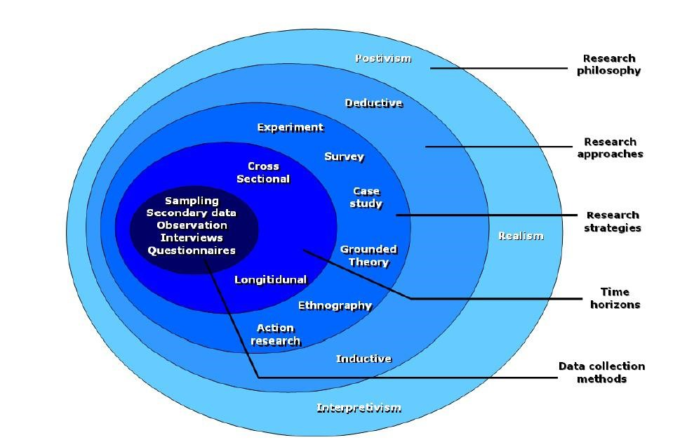
Source: (Assadpour et al., 2022)

Research Onion
Saunders developed this model in the year 2007 for helping the researcher in the development of the research. Completion of one model enables the researcher to move forward to the next level. The layer-to-layer model is similar to an onion and it has several stages which the researcher has to complete for finding a comprehensive answer to the research.
Research Philosophy
The researcher has chosen the positivism philosophy for the development of the research. Positivism has helped the researcher to focus on the actual truth. It does not believe in the aspects which have no existence. The information has to be true or false otherwise it cannot be considered. The factuality of the information helps the researcher to maintain the authenticity of the work.
Research Approach
The research onion model offers two types of research approaches for helping the researcher in the development of the work. Here, inductive research has been used by the researcher as it has enabled the researcher to validate the work with pre-established theories or scholarly journals. It complements the positivism approach and helps the researcher to build a better understanding of the work (Grant, 2022, pp. 11-22).
Research Choice
Three types of research choices are available in Saunders' model and the researcher has picked the multi-method for meeting the objectives of this research. The multi-method allowed the researcher to collect qualitative and quantitative data. Both data types increased the value and meaningfulness of the work. Further, storing the data within a single file removed the volatility of the data. It enhanced the quality and assisted in meeting all the research questions.
Time Horizon
A cross-sectional time horizon has been used here by the researcher as it enables to collection of data from a select time period. Unlike longitudinal, it restricts the researcher within a selected time zone and reduces the possibility of the data being changed in the future (Da, et al., 2021, pp.175-196). It is more time-saving in comparison to the longitudinal time horizon and thus increases the value of the work.
Data Collection
Data collection is the core step of Saunders’ research onion model and it increases the reliability and validity of the data. Two types of data collection have been offered by Saunders primary and secondary data collection. Here, the researcher has chosen the secondary data collection method and valued other researchers' works and thoughts. Cross-validation of the collected data with others' work helps the researcher to increase the value of the work. Secondary data collection in accordance with several books, journals and articles has gained complete importance of the fact.

Role of ethical Codes and Policies
Ethics are referred to as a set of rules that helps in differentiating the right and wrong of any activity. Similarly, here ethics focus on the respective discipline and the standards that the research has followed and maintained. Another reason for the importance of ethics in research is that it promotes the aim of the research, such as truth, avoidance of error, knowledge, and much more.
Honesty: Ethics strive for honesty from all the sources and especially from the scientific communications. It helps in reporting data, methods, procedures status. Ethical codes also prevent in fabricating the research with false and fake data (Switzer, 2020).
Objectivity: Ethical codes and policies promotes biasness when conducting any experimental design, data analysis, and to expert testimony. Generally, ethical codes help the research to prevent self-deception. Along with this, objectivity of research is also maintained by not disclosing the financial and personal interest.
Carefulness: The ethical codes and policies is also responsible for avoiding errors and mistakes that take place due to irresponsibility and careless. The ethics in research help keeping a good track of all kind of records, data, and research activities securely (Dryka, 2020).
Transparency: The respective policies also help in keeping transparency in assumptions, analysis, and other related data to the research. Transparency helps in completing the research by relating the data from all segments and hence, makes it easy to evaluate the whole research.
Data protection: Ethical codes helps in keeping the data protected from the unethical practitioners present in the society. Data protection helps in keeping the research safe and real to an extent.

Chapter Three: Literature review

Introduction
The literature review will discuss the objectives that are stated above and different sources will be used for the supporting the research. The following literature review will also illustrate the importance of functions and overcoming strategies implemented by the health and social care services. The validation of several books, journals and scholarly articles will help the researcher in maintaining the evaluability of the research.

Analyse the different functions that are undertaken to mitigate different mental health problems
Companionship
Mental health charity performs different functions and programs to make the young adults who are suffering from the mental health problems. To this, the functions that they consider is the communications skills with the help of which the respective workers of the health and social care try to communicate with the survivals. Throughout the process, they try to analyse the mental and state of their mind. Not only this, there are also many other functions are the undertaken like compassion, care, and competence. With the help of this functions, they analyse the patients and then evaluate several ways to make them recover. Companionship reduces the loneliness of the individual and helps them to achieve success and enjoy life.
Developing Hobbies
According to Oudshoorn et, al., (2018), there are various other activities that the organisation focuses for bringing development and stability in the mental state of the young adults who are suffering from depression. Other activities include keeping them active by making them reading books, keeping them busy in different thoughts, allowing them to eat well, and much more. The workers of the health and social care organisation advise those young adults to go for outing and to take break from their regular day work. It will help them to bring little but better changes in their life. With the help of those activities, the individuals who are suffering from depression will be able to bring a kind of refreshment.

Challenges that are faced by people with depression of poor sleep
Sleep and mental health both are interrelated to each other as sleep is the aid to better physical health for each and every individual. Sleep deficiency can be a major reason behind depression, irritable feeling and long-term health hazards. Psychiatric conditions causes sleeping related problems and disrupts the growth of the youth and harms their future.
Insomnia
According to Lloyd, et al., (2018), the challenges that the depression affected young adults usually face includes chronic pains, injuries in their heads, several virtual tensions, losing independence, losing support from the society in which they are residing, and much more. The young adults who are suffering from depression are majorly affected by insomnia. Approximately 33% of the world population has been affected by sleep deprivation and it impacting the youth negatively. According to the Centres for Disease Control and Prevention (CDC) in this world of digitalisation youths are more inclined towards social media, alcoholism and it is resulting into sleepless nights and anxiety and causing mental illness. Youths are attempting suicide due to depression causing mainly from sleep deficiency and anxiety.
Stress and Depression
As stated by Jahnke, et al., (2018), another issue of sleep deficiency is that they have to go through a long period of medication for their recovery purpose for a trivial illness. Poor sleep increases the frazzled feeling, short temperament and frustration. It detached the individual from society and isolating them form public sphere. As a consequence, regular head pains, chronic pains, joint pains, and much more pains take place in their body. All this kind of things not only impacts their health but also prevents them to take part but also stretch them towards negative thoughts. The affected young adults start taking help of addictive drinks such as alcohols, wines, beers, and much more. Further, alcohol consumption causing excessive anxiety and stress and causing sleep deficiency. Sleep deficiency is causing immense mental stress and affecting mental stability of the youth. Poor sleep make individuals to cope up with the simple things difficult to adopt. A study has reported that 3700 participants suffer from anxiety, depression, stress and paranoia. Sleep deprivation disrupts the health condition of the youth and lead them to leading a poor standard life.

The significant role played by the health and social care organisation in helping young adults to overcome the phase of depression
Good Habits
According to Dschaak et al., (2018), the health and social care organisation helps in building new and more energised relationship with the young adults suffering from depression. The workers of the organisation whenever handling such cases where they are facing any depression affected individual, initially, they try to create a bond with them. It is because developing relationship and creating bonds with them allow the men of the health and social care organisation to know the life of them. The relationship has been created, they start their procedures for recovering them without giving them any clue. At first, they become an important person in their life and then start inserting different things into the daily routine of their life. They start off with exercise that gives the depression affected individual little push towards recovery. Throughout the process, the workers of the organisation become an important person for them as they think that that person is the only one who listens to them without any kind of objections and negligence.
Therapy
As per Rooney et al., (2022), the health and social care organisation also promotes different types of therapy to the depression affected young adults. Those therapy includes psychodynamic therapy, cognitive therapy, and interpersonal therapy, and much more. Throughout the therapy, they try to change the way of thinking and mentality of such patients from negative and positive. Along with this, various drugs also been taken into consideration. Thus, the health and social care organisation plays an important role to bring change and to help the young adults getting recovered from depression. Therapies are the most things that they apply in their procedure to bring development. It is because therapies are the only way which indirectly force the depression affected adults to develop the quality to think and hence, thinking will help them to bring change in their life finally.
Spreading Awareness
Another way in which health and social care organisation plays a significant role is by raising awareness among the individuals who are at the entry point of depression illness. They not only improve those who are affected but also improve their service to make others aware of such illness and also share message that it is okay to get affected from such illness. Like others illness, it is also an illness which can infect anyone and there is nothing to be shameful. There is no use to hide such illness and accepting such disease promotes motivation among others and also givers power and courage to others to come out and accept their illness in front of others. With this, health and social care organisation also organise several campaigns with the help of which they take care of the business of young adults suffering from depression with their consent. The organisation has also published many fiction and non-fiction books that shares ideas to overcome the mental distress and depression. The health and social care organisation also involved campaign Rethink Mental Illness and their main motive to run the campaign is to reduce the psychiatric illness from the individuals falling under the young age group.

Summary
The literature review has explained different factors under the ethical codes which help in keeping the research safe and secure. Furthermore, the literature review has also summarised different sources to define the objectives that are stated above and hence, has also discussed the various functions that the health and social care organisation has taken to deliver better service to their service seekers.
Author Data | Aim of Paper | Type of Study | Key Findings | Strengths and Weakness
(Marco Colizzi, et al., 2020) | Prevention of Youth mental health for mitigating mental disorder. | Qualitative Data | Mental disorder starts from minimum of 14 years age. Psychological disturbance occurs mental stress, burden and disrupts future growth. Thus, multidisciplinary interventions is needed to mitigate these issues. | The current knowledge will be used in determining the mental stress on delivering promotion and preventive interventions.
(Søvold1, et al., 2021) | Prioritizing the Mental Health and Well-Being of Healthcare Workers: An Urgent Global Public Health Priority | Qualitative Data | Covid-19 has a negative impact on the mental health of each and every individuals. The fear of the situation causing mental disorder, trauma, and depression. Thus, mitigating these issues are the primary concern of this article. | The challenges during the pandemic that workers had faced has been discussed here for gaining a complete understanding of the fact.
(WHO, 2022) | Mental health in the workplace | Qualitative Data | Depression affecting the economy causing negative work environment and increasing bullying and harassment. | A study has been organized by WHO to investigate about the matter. The result has arrived that more than 264 million of people suffers from depression.
(Brennan, 2021) | How Does Mental Health Affect Physical Health | Qualitative and Quantitative Data | Mental disorder causing health issues such as chronic physical disorder, sleep problems, smoking and asses’ health care. | Every side-effects of the mental disorder has been mentioned and precautions are elaborated as well to achieve good health.
(Pfefferbaum & North, 2020) | Mental Health and the Covid-19 Pandemic | Qualitative Data | Covid-19 has raised public health emergencies and affect health condition, safety and wellbeing. It is affecting the mental health of the individuals as well. | Perspectives of two doctors have been recorded within this article and thus, the experiences of diagnosis of the patients and drawing conclusion from it gain a complete understanding of the fact.
(CDC, 2019) | Mental Health in the Workplace | Qualitative and Quantitative Data | Mental disorder and mental issues affecting the future generations. The low morale and lack of confidence affecting the working age and impacting the growth of the nation. | A survey has been conducted within the employees for getting their opinions on the fact and impacted the research.
(WHO, 2021) | Adolescent mental health | Qualitative and Quantitative Data | Globally ten to nineteen years old experiences mental health disorder and causing depression, anxiety and behavioural disorder. Suicidal tendency of the youth are higher than usual due to this. | The evidence based clinical protocol help in developing the meaningfulness of the outcomes and create a positive impact of the study.
(Radez, et al., 2020) | Why do children and adolescents (not) seek and access professional help for their mental health problems? A systematic review of quantitative and qualitative studies | Qualitative and Quantitative Data | Mental health disorders are one of the common adjectives of this modernised world and it is affecting specially the youths. One in seven youth meet with diagnostic criteria for recovering the factors. | The systematic review for collecting data has impacted the article immensely and in collecting the relevant data that has increased the value of the article.
(youth.gov, 2022) | Mental Health | Qualitative Data | Negative impacts creating mental illness and increasing complexities of life. Reduce discrimination for building healthy relationships and mitigating mental issues for providing better life to the youth of this nation. | Strong validation of literature review has gained adequate knowledge on the fact and improves understandings.
(Newsome, 2022) | Depression and Sleep | Qualitative Data | The fundamental meaning of depression has been elaborated and the discussion of its symptoms moving towards to causing sleep deficiency has been defined for gaining importance of this emerging issues. | The article has been reviewed by a Psychiatrist named Alex Dimitriu and thus, it has increased the value of the article and increased its acceptance.
(hopkinsmedicine, 2022) | Depression and Sleep: Understanding the Connection | Qualitative Data | Depression is the main reason for insomnia and poor sleep is resulting in poor health and increasing stress. The reason behind depression will be elaborated and understand the relation of depression and sleep which is interrelated | The article has been published by a medicine websites and thus, the importance of the fact is trustworthy and valuable.
(Chang-Myung & Kim, 2019) | Sleep Quality of Individuals with High Risk for Insomnia: A Population-Based Study | Qualitative study and quantitative | The article has discussed the harmful impact of depression on the sleep pattern of the individuals. The strong relationship of insomnia with psychological diseases have been established here. | The article is written and published by experts in the field however, the article focuses on the specific impact of psychological problem.
(clevelandclinic, 2022) | Insomnia | Qualitative research | The focus of this article is insomnia as a psychological disease and its impact on the psychical health of patients. | The article was written and published by an organisation specialising on the disorder. The name of particular author is missing making it less reliable.
(Blackwelder, et al., 2021) | Effect of Inadequate Sleep on Frequent Mental Distress | Qualitative study | A large part of the population is sleeping less than they should due to their mental illness. The relationship of sleep and mental pressure have been evaluated here. | The article has been written by experts in the field. The article aims the population of a different country rather than UK.
(mind, 2022) | What we do | Qualitative study | Raising awareness and understanding among young adults can help in empowering them. | The organisation is the topic of research however, it does not only focus on the depression of youth.
(Marsh, 2021) | Ways to Overcome Depression | Qualitative study | The article focused on the ways to overcoming depression such as taking out time for fun and limiting alcohol consumption. | The facts of the article were medically checked by experts. The article only suggests methods for reducing the depression not eliminating it.
(Jurewicz, 2018) | Mental health in young adults and adolescents – supporting general physicians to provide holistic care | Qualitative study | Adolescence and their increasing problem related to mental health has been pointed out here. The article mentions that depression is one of the main problems of youth. | The source is reliable as it has been published by authentic source. The publication date of the article is old reducing is credibility.

Chapter Four: Findings and Discussions

Findings
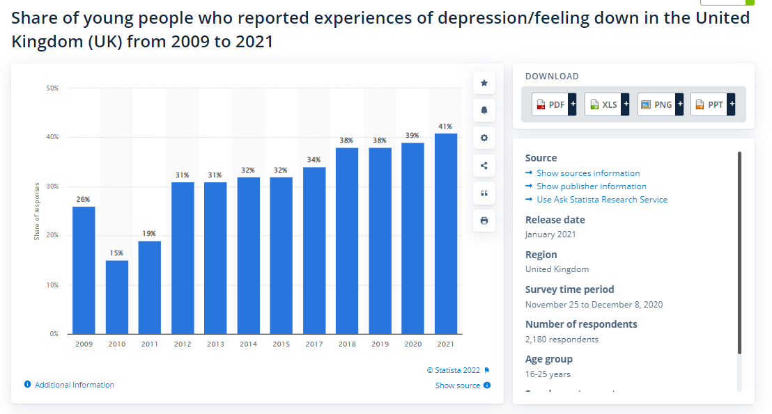
Figure 1
Source: (Stewart, 2022)
Analysis:
According to the recorded data in this graph, the young people of the UK are highly affected by depression. Depression makes an individual mentally ill and does not allow to perform well. The graph is showing the increased number of young people affected by depression. The ratio of the young adult was 15% in the year 2010 and in the year 2021, it has amplified to 41%. Digitalisation has been another major reason behind the isolation of the youngsters. Social media activities leave positive as well as negative impacts on this generation. The suicidal attempt of one individual influenced others and resulted in a massive massacre. Thus, the Mind must take important takes in helping the young adults and help them to regenerate positivity within them. The organisation believe in making a better community and they take active participation in raising fund for supporting others in recovering from their mental illness. Apart from fundraising Mind allows people to participate in the game and marathons for supporting the young people with the mental imbalance of peace (Mind, 2022).
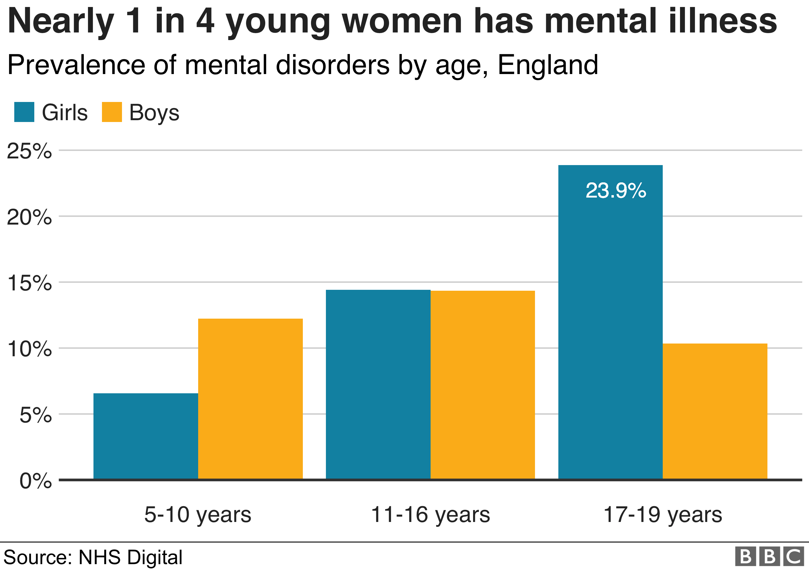
Figure 2
Source: (Guibourg & Jeavans, 2018)
Analysis:
According to the graph which has been presented by the BBC report women are affected majorly in comparison to men. The individuals aged between 17 to 19 are the active members who are facing difficulties related to anxiety. However, the affection ratio of the girls is double that of the boys. The ratio of the boys who are suffering from depression is 10% whereas the ratio of girls being affected by depression is recorded at 23.9%. Health issues such as menopause, perimenopause, hormonal imbalance, and early age of sexual involvement can be the reason behind the high ratio of women being affected by depression. One out of four women in England is facing mental illness which is damaging the capabilities of education and other activities and removing future opportunities for achieving growth. For removing these facts Mind has launched Tampon Tax Fund for women across England and Wales for getting the girls back from the risk. Apart from this, the organisation has also introduced Clean Break, The survivors' Forum, and the Ethiopian Women Empowerment Group for supporting women in helping them from mental illness.

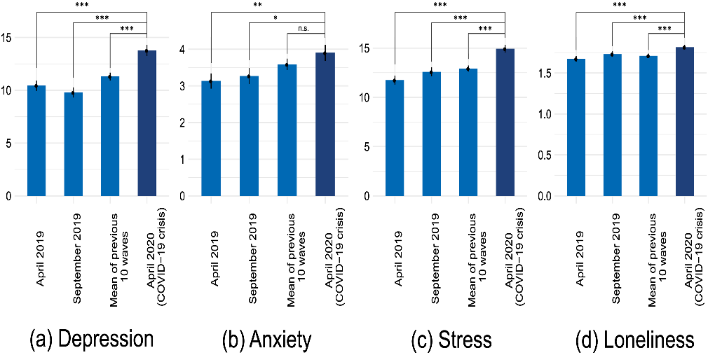
Figure 3
Source: (Elmer, et al., 2020)
Analysis:
Covid-19 is another major reason behind the increase in depression among young adults. The complete lockdown and social distancing have resulted in loneliness. The isolated feeling of every individual increases anxiety regarding the situation. Further, the closure of education and every refreshment resource invites monotonousness within the individual's life. Lack of engagement and communication resulted in stress and loneliness. The ratio of depression, anxiety, stress and loneliness was equally high among young people during the global pandemic. Mind has implemented regular video calls and connecting people digitally to reduce the everyday monotonousness and fear of the pandemic. Mind has looked after people affected by mental illness during the pandemic through regular checkups and by staying in touch with them virtually. The organisation has also implemented creative ways of relaxing depressed minds (Mind, 2022). Assistance in creative activities such as drawing, colouring, sewing, many DIY, playing pieces of music, singing and listening, yoga and meditation and posting them on their public sites attracts each of the members and keeps them busy in doing these creative activities.

Discussions
The above findings have impacted the entire research with the meaningfulness of the research topic. The findings have evaluated the authenticity of the topic as it has reflected the increasing nature of young people getting affected by depression. Loneliness and the competitive nature of the human are the major reason that is affecting the positivity within an individual and diminished the spirit of doing something good. Further, the findings have recorded how women suffer from depression due to a lack of health concerns. Mind's take on solving these issues has gained immense benefit and contributed to a better society. Additionally, Covid-19 has played the role of a catalyst in diminishing the morale of the young individual during the pandemic. However, Mind's initiative of arranging virtual campaigns and programmes have helped several UK population to restore their lost faith and values. Their assistance has generated success in their mission of mitigating depression and bringing back them to the main human race.

Chapter Five: Conclusion and Recommendation

Conclusion
The research has successfully discussed the role of health and social care in diminishing the growing impact of depression. Mind is one of the leading charitable organisations that deal with mental illness and provides support all across England and Wales. The increased number of young people affected by depression has been a major challenge for the organisation. However, they actively participated in restoring positivity within the young adults. The main focus of this research has been confined to the young adults of the research as they are the hope for a better nation. Positivity can increase satisfaction in one's self and mitigation of stress and depression level have helped the young people to get back into the human race. Moreover, Mind's initiative of spreading awareness of the fact all over the community and being the support for the mentally weak people have helped remove the challenges. The systematic development of methodology has helped the researcher in the development of the research further. Secondary research allowed the researcher in collecting authentic data from reliable sources and increase the quality of the work. Literature review adds meaning to the work by evaluating the work with relevant scholarly sources. Findings at the end of the research gained a complete understanding of the fact and the quantitative data helped in analysing the effectiveness of the topic.

Recommendation
The recommendation will be helping Mind for attaining further growth in the organisation by supporting more young people. The improved activities by the Mind can be a solution and aid for depressed people.
Communication
Communication is an effective tool that allows one to share one's perspective with others. Engaging the members in active communication regularly can reduce the stress level of young people. Listening to others' opinions can influence the individual to attain positive changes and achieve success in this way. It helps to connect two or more souls to connect and share their pain and happiness with each other and create a sense of belongingness (Dorfman, et al., 2022). Mind in this way can also be able to track the progression of their member and help more people to secure a better life.
Therapies and Meditation
Therapies are mediation rejuvenates one's body and soul and allows the individual to access happiness. Happiness is the key to staying healthy in this complex world where anxiety, stress and unwanted worries are an inseparable part of everyone's life. Meditation helps to generate mental peace and increase inner strength (Wallman et al., 2022, pp.43-51). Thus, Mind's participation in arranging virtual or open meditation and therapies for their member would be immensely helpful in bringing back the members of the actual human race and spreading positivity among others in a similar way.
Social Gatherings
Social gatherings are another way of bringing people together. It helps to break the monotonousness of one's self and add meaning to life. Social existence is one of the major factors for people who are suffering from isolation. Further, the social gathering also helped everyone to stay detached from the pain and suffering they have in their personal life. Temporary relief from pain helps them to gain positivity in life. Thus, Mind must organise monthly gatherings and events for boosting the morale of the employees and bringing back to the main human race.

References
Assadpour, H., Ghalehnoee, M. and Bahramian, A., (2022). Developing the model of research method in urban landscape studies emphasizing Saunders research onion. Motaleate Shahri.
bbc, (2021). Covid: Depression rises in young and women during second peak. [Online]Available at: https://www.bbc.com/news/health-56993575
Blackwelder, A., Hoskins, M. & Huber, L., (2021). Effect of Inadequate Sleep on Frequent Mental Distress. [Online] Available at: https://www.cdc.gov/pcd/issues/2021/20_0573.htm
Brennan, D., (2021). How Does Mental Health Affect Physical Health. [Online] Available at: https://www.webmd.com/mental-health/how-does-mental-health-affect-physical-health
CDC, (2019). Mental Health in the Workplace. [Online]Available at: https://www.cdc.gov/workplacehealthpromotion/tools-resources/workplace-health/mental-health/index.html
Chang-Myung & Kim, Y. H., (2019). The Effect of Anxiety and Depression on Sleep Quality of Individuals With High Risk for Insomnia: A Population-Based Study. [Online] Available at: https://www.frontiersin.org/articles/10.3389/fneur.2019.00849/full
clevelandclinic, (2022). Insomnia. [Online]Available at: https://my.clevelandclinic.org/health/diseases/12119-insomnia
Da, Z., Huang, X. and Jin, L.J., (2021). Extrapolative beliefs in the cross-section: What can we learn from the crowds?. Journal of Financial Economics, 140(1), pp.175-196.
Dorfman, C.S., Stalls, J., Lachman, S., Shelby, R.A., Somers, T.J. and Oeffinger, K.C., (2022). Symptom Communication Preferences and Communication Barriers for Young Adult Cancer Survivors and Their Health Care Providers. Journal of Adolescent and Young Adult Oncology.
Dryka, M., (2020). Benefits of a Code of Ethics. [Online]Available at: https://brainhub.eu/library/benefits-of-code-of-ethics
Dschaak, Z.A. and Juntunen, C.L., (2018). Stigma, substance use, and help-seeking attitudes among rural and urban individuals. Journal of Rural Mental Health, 42(3-4), p.184.
gov.uk, (2022). Young people’s well-being in the UK: (2020). [Online] Available at: https://www.ons.gov.uk/peoplepopulationandcommunity/wellbeing/bulletins/youngpeopleswellbeingintheuk/2020#:~:text=There%20is%20evidence%20of%20increasing,five%20years%20earlier%20(26%25).
Grant, A., (2022). Working within a research paradigm and choosing a topic. In Doing Your Research Project with Documents (pp. 11-22). Policy Press.
Guibourg, C. & Jeavans, C., (2018). In charts: Report into children's mental health. [Online]Available at: https://www.bbc.com/news/health-46306241
hopkinsmedicine, (2022). Depression and Sleep: Understanding the Connection. [Online]Available at: https://www.hopkinsmedicine.org/health/wellness-and-prevention/depression-and-sleep-understanding-the-connection
Jahnke, S., (2018). The stigma of pedophilia: Clinical and forensic implications. European Psychologist, 23(2), p.144.
Jurewicz, I., (2018). Mental health in young adults and adolescents – supporting general physicians to provide holistic care. [Online]Available at: https://www.ncbi.nlm.nih.gov/pmc/articles/PMC4953734/
Lloyd, B., Blazely, A. and Phillips, L., (2018). Stigma towards individuals who self harm: Impact of gender and disclosure. Journal of Public Mental Health.
Marco Colizzi, Ruggeri, M. & Lasalvia, A., (2020). Prevention and early intervention in youth mental health: is it time for a multidisciplinary and trans-diagnostic model for care?. [Online]Available at: https://ijmhs.biomedcentral.com/articles/10.1186/s13033-020-00356-9
Marsh, A., (2021). Ways to Overcome Depression. [Online] Available at: https://www.verywellmind.com/what-to-know-about-overcoming-depression-5097360
Mind, (2022). Coronavirus and your wellbeing. [Online]Available at: https://www.mind.org.uk/information-support/coronavirus/coronavirus-and-your-wellbeing/
Mind, (2022). Donate or fundraise. [Online] Available at: https://www.mind.org.uk/get-involved/donate-or-fundraise/
mind, (2022). What we do. [Online] Available at: https://www.mind.org.uk/about-us/what-we-do/
Newsome, R., (2022). Depression and Sleep. [Online]Available at: https://www.sleepfoundation.org/mental-health/depression-and-sleep
Oudshoorn, A. and Sinclair, B., (2018) Mental health stigma reduction through simulated professional practice.
Pfefferbaum, B. & North, C. S., (2020). Mental Health and the Covid-19 Pandemic. [Online]Available at: https://www.nejm.org/doi/full/10.1056/nejmp2008017
Radez, J., Reardon, T., Creswell,, C. & Waite , P.,(2020). Why do children and adolescents (not) seek and access professional help for their mental health problems? A systematic review of quantitative and qualitative studies. [Online]Available at: https://link.springer.com/article/10.1007/s00787-019-01469-4
Rooney, K.L. and Domar, A.D., (2022). The relationship between stress and infertility. Dialogues in clinical neuroscience.
Søvold1, L. E., Kousoulis, A. A. & Naslund, J. A., (2021). Prioritizing the Mental Health and Well-Being of Healthcare Workers: An Urgent Global Public Health Priority. [Online]Available at: https://www.frontiersin.org/articles/10.3389/fpubh.2021.679397/full
Stewart, C.,(2022). Share of young people who reported experiences of depression/feeling down in the United Kingdom (UK) from (2009) to (2021). [Online] Available at: https://www.statista.com/statistics/1199302/depression-among-young-people-in-the-united-kingdom/
Switzer, T., (2020). Code of ethics: Why are they important?. [Online] Available at: https://www.yourmembership.com/blog/code-ethics-important/#:~:text=It%20provides%20a%20common%20set,legal%20standard%20for%20the%20profession
Timon Elmer, T., Stadtfeld, C. & Mepham, K., (2020). Students under lockdown: Comparisons of students’ social networks and mental health before and during the COVID-19 crisis in Switzerland. [Online]Available at: https://journals.plos.org/plosone/article?id=10.1371/journal.pone.0236337
Wallman, E.J., Segrave, R.A., Gordon, M.S., Fraser, M.J.O.B., Pavlou, C. and Melvin, G.A., (2022). Acceptability, safety and tolerability of antidepressant repetitive transcranial magnetic stimulation for adolescents: A mixed-methods investigation. Journal of Affective Disorders, 310, pp.43-51.
WHO, (2022). Mental health in the workplace. [Online] Available at: Mental health in the workplace
WHO,( 2021). Adolescent mental health. [Online] Available at: https://www.who.int/news-room/fact-sheets/detail/adolescent-mental-health
youth.gov, (2022). Mental Health. [Online] Available at: https://youth.gov/youth-topics/youth-mental-healt/

Appendix 1: List of Figures
Figure 1
Figure 2
Figure 3

