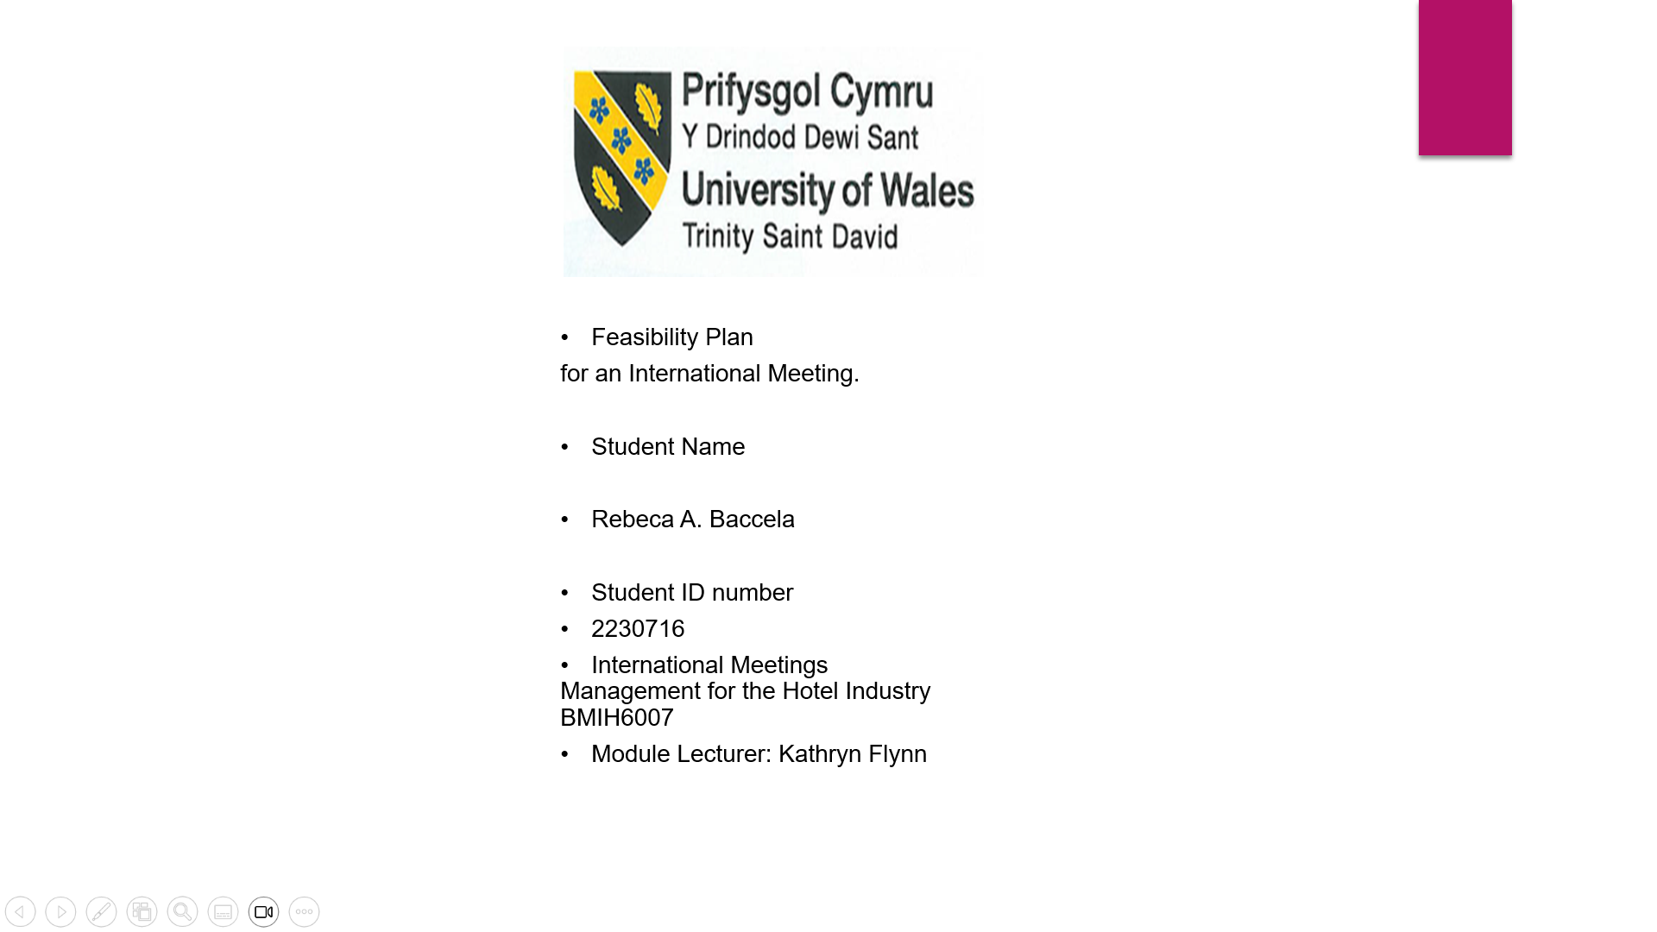

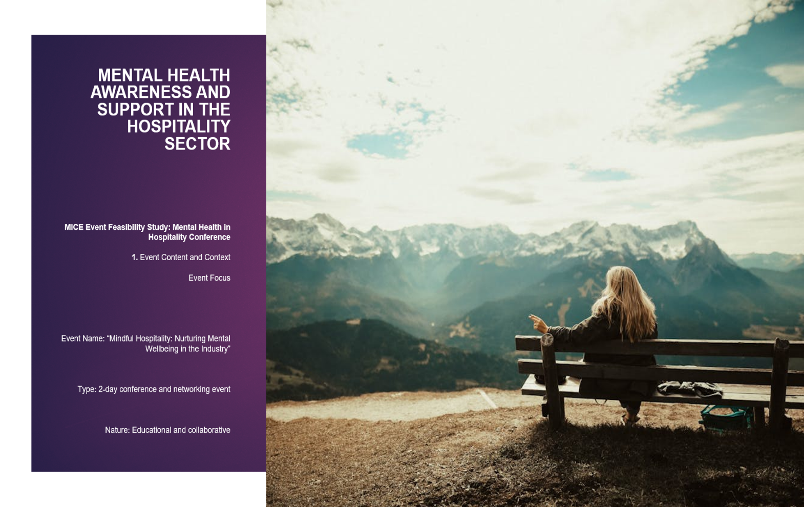
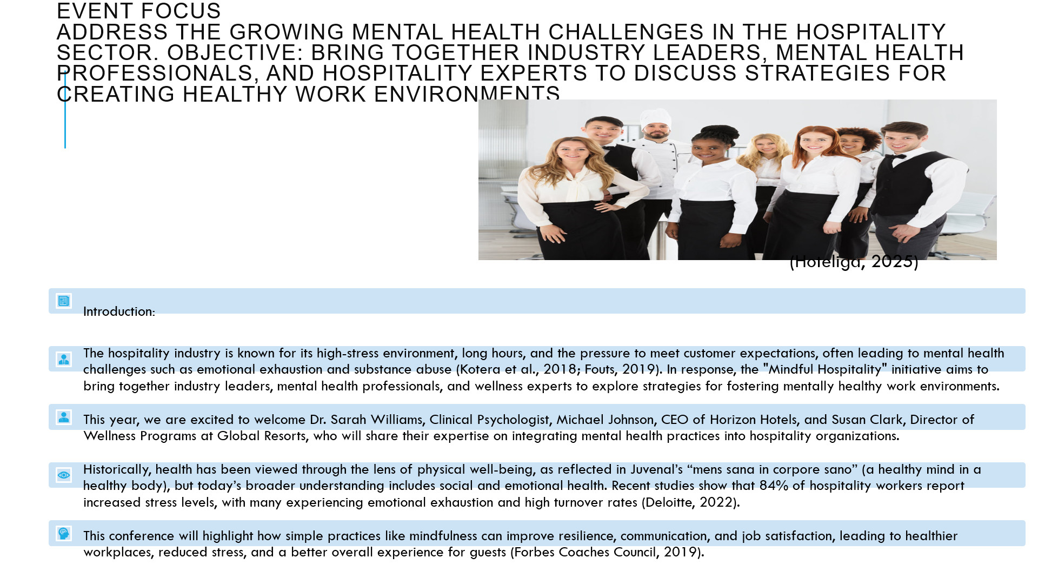
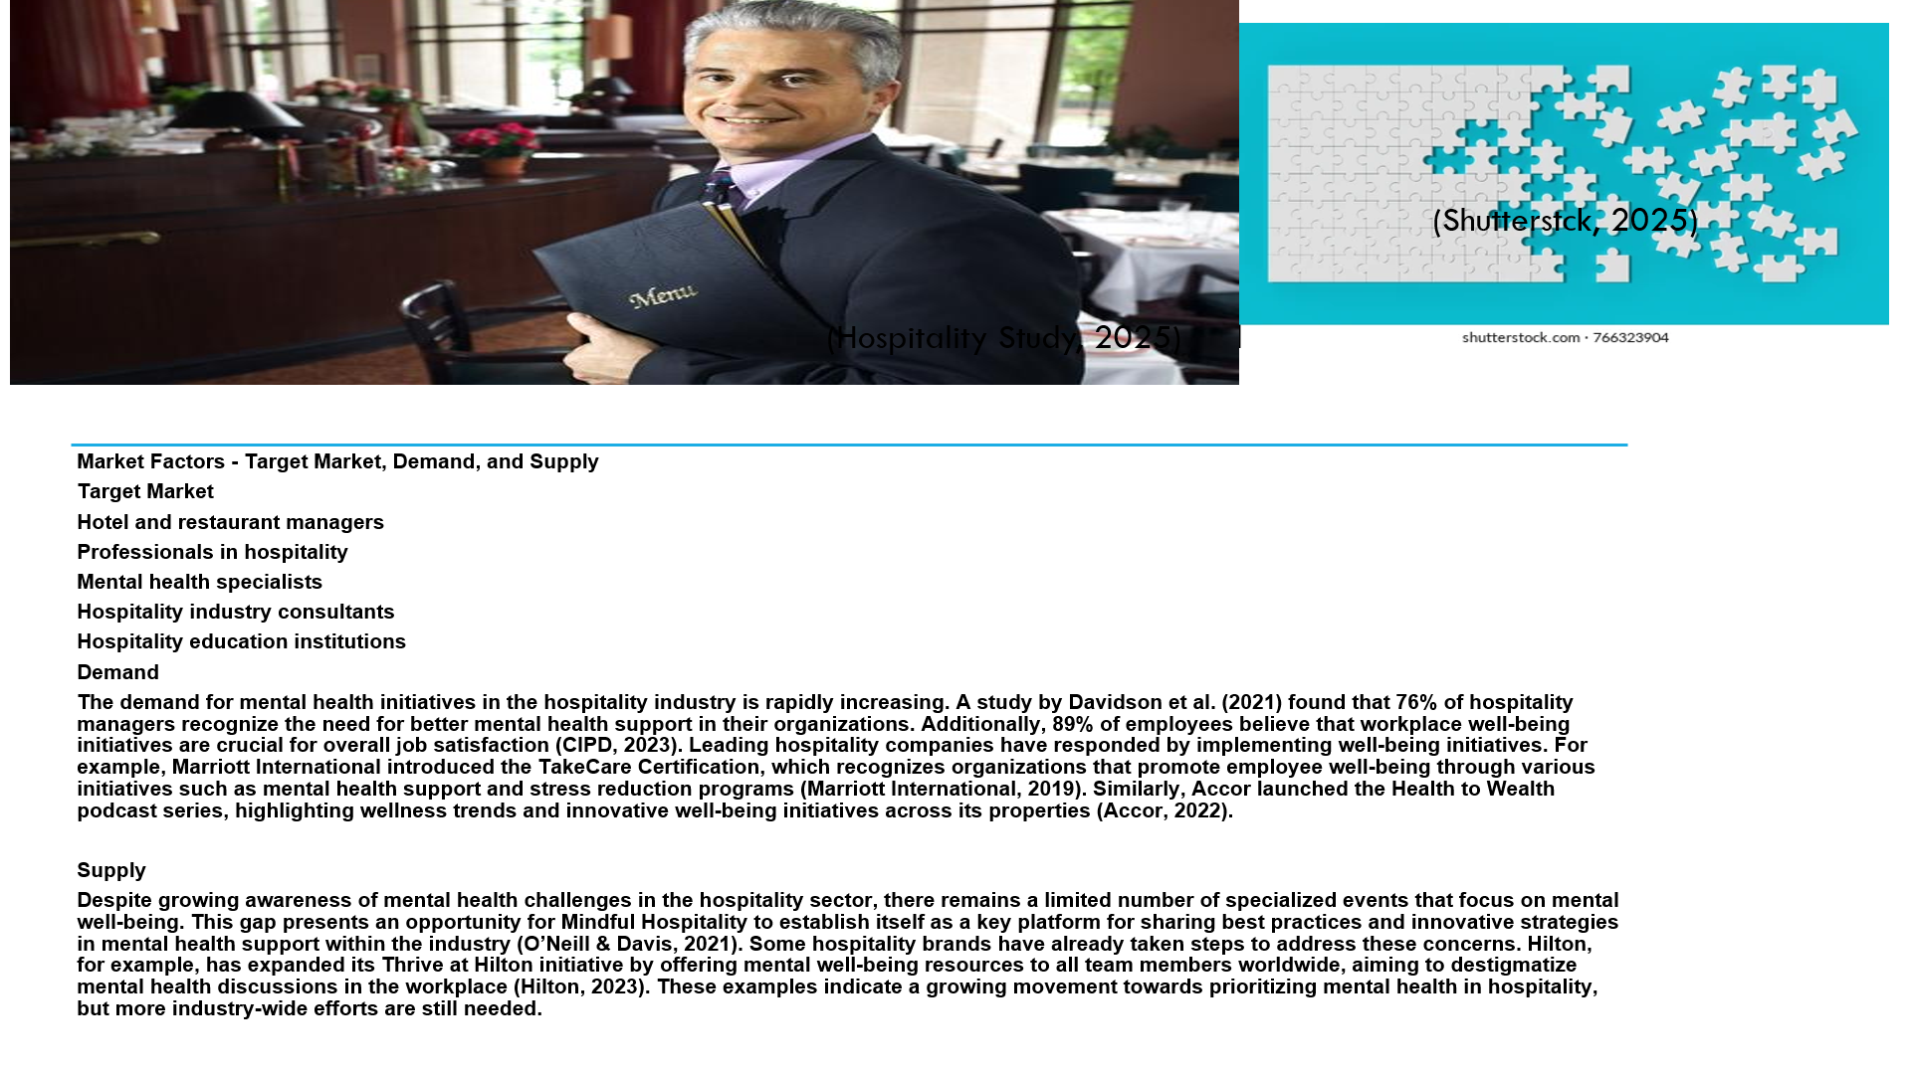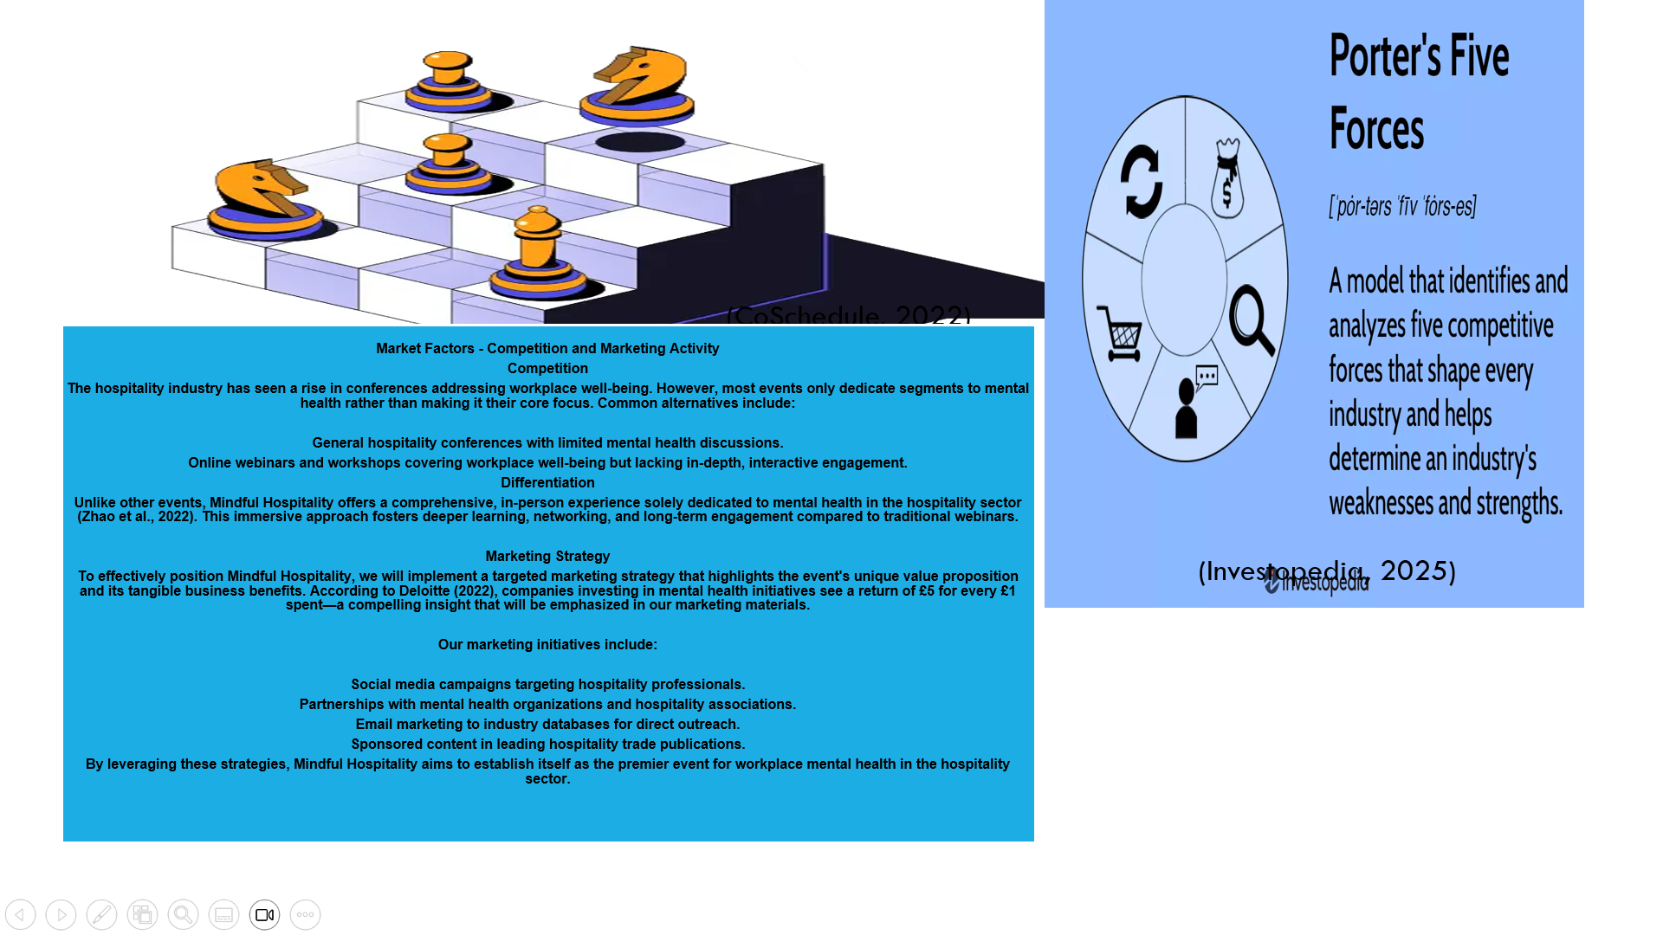
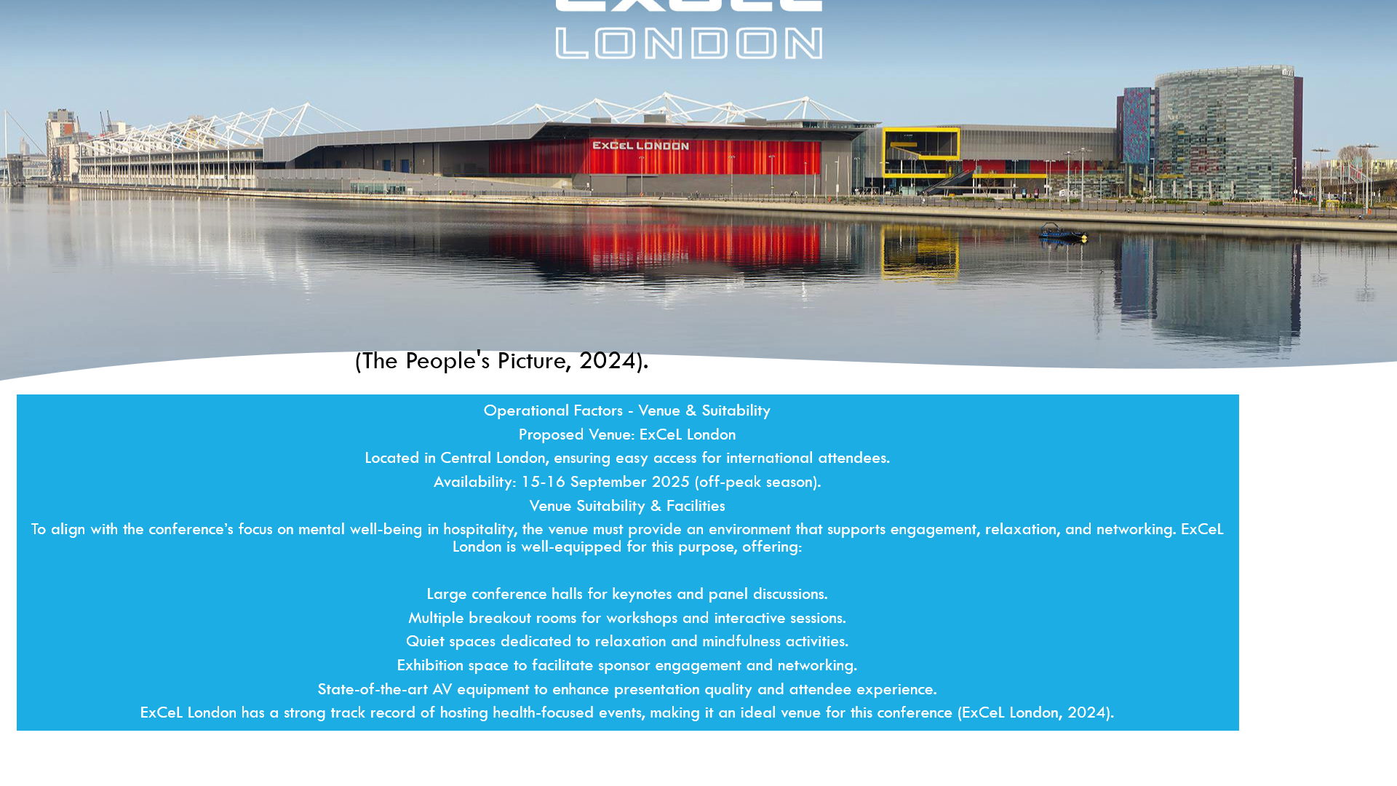
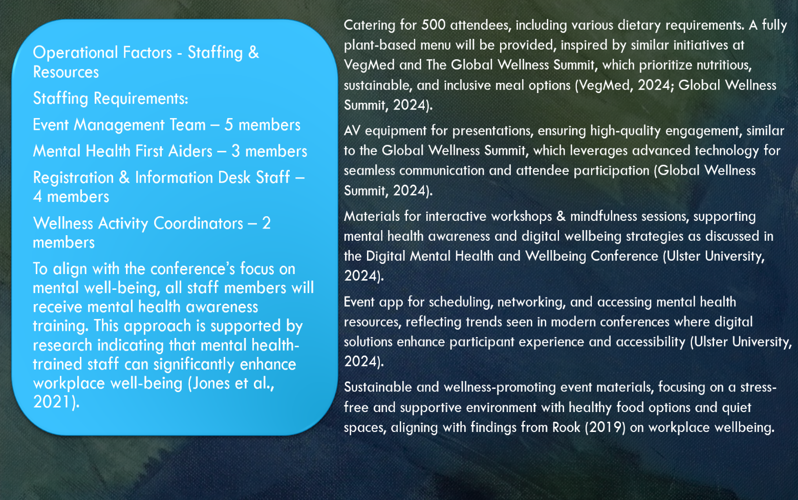

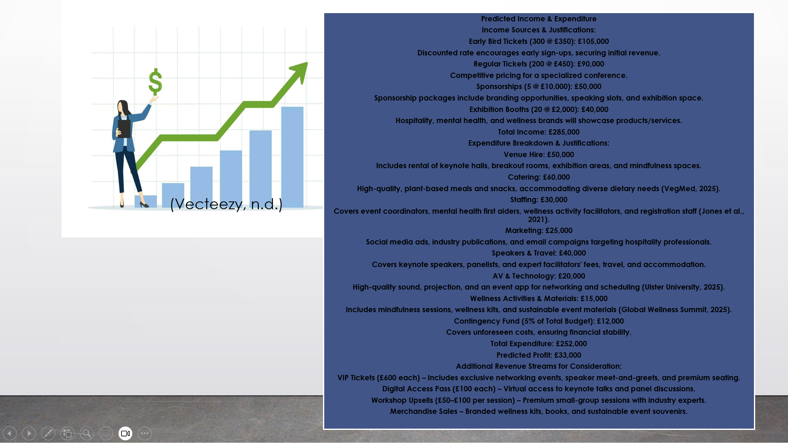
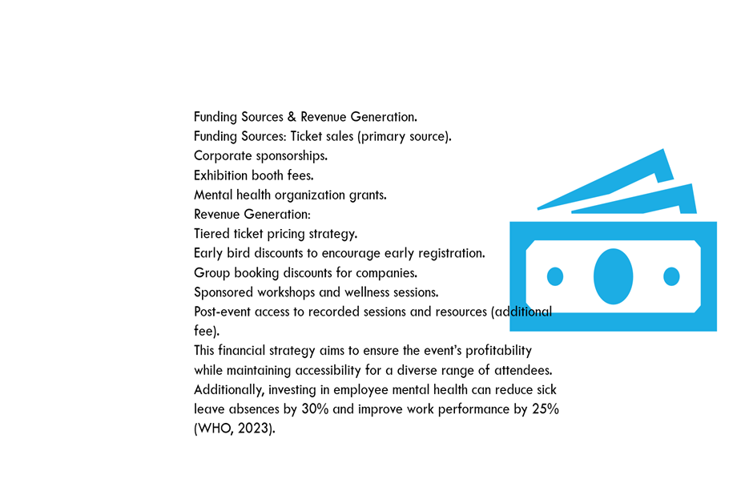
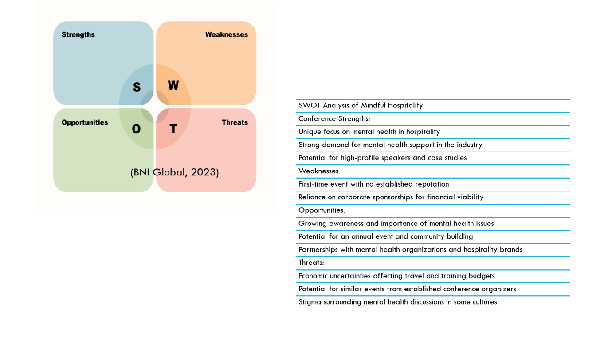

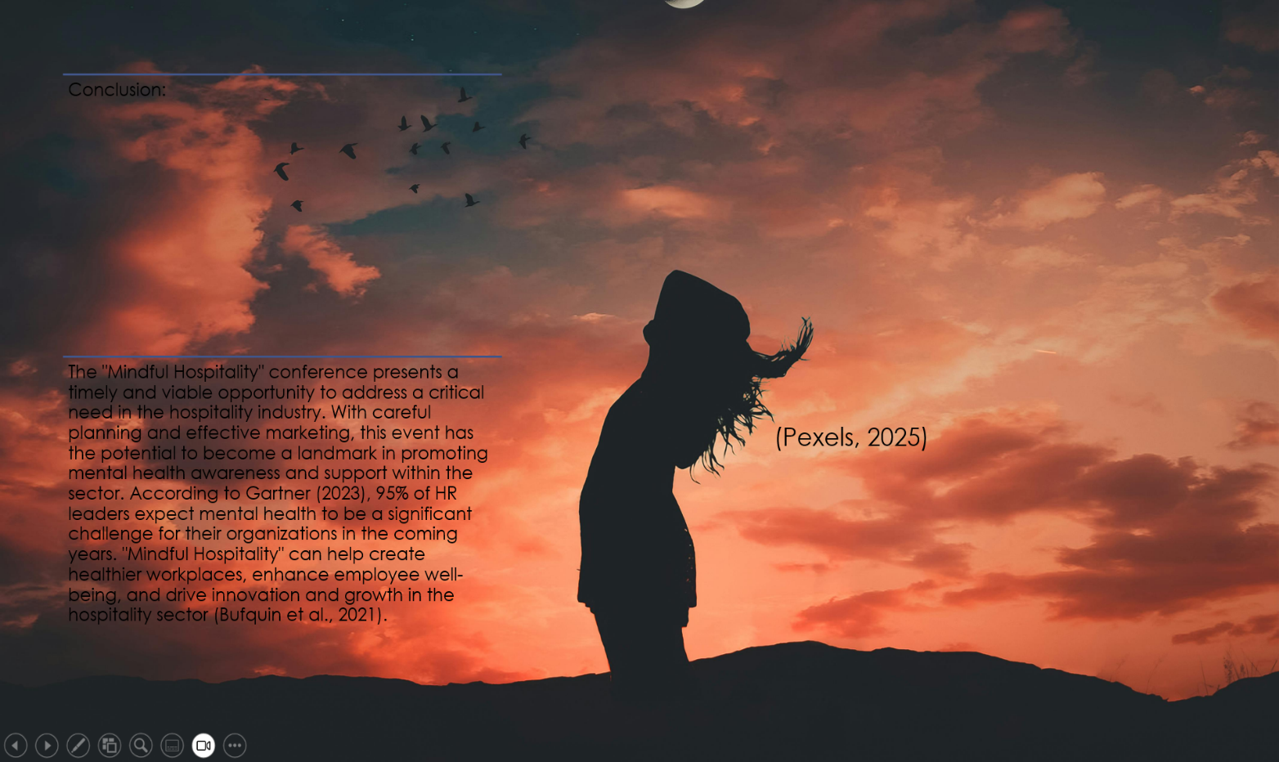

References:
Accor, 2022. Accor Debuts ‘Health to Wealth’ Series and Shares Wellness Trends at Hotels Across North America. Available at: https://press.accor.com/americas/accor-debuts-health-to-wealth-series-shares-wellness-trends/?lang=en [Accessed 4 February 2025].
BNI Global, 2023. 3 Easy Steps to Create a SWOT Analysis. [online] Available at: https://www.bni.com/the-latest/blog-news/3-easy-steps-to-conduct-a-swot-analysis/ [Accessed 4 February 2025].
Bufquin, D., Park, J.Y., Back, R.M., de Souza Meira, J.V. and Hight, S.K., 2021. ‘Employee work status, mental health, substance use, and career turnover intentions: An examination of restaurant employees during COVID-19’, International Journal of Hospitality Management, 93, p. 102764.
CIPD, 2023. Health and wellbeing at work. Available at: https://www.cipd.co.uk/knowledge/culture/well-being/health-well-being-work [Accessed 4 February 2025].
CoSchedule, 2022. Marketing strategy: Templates, definitions, importance, & benefits. Available at: https://coschedule.com/marketing-strategy [Accessed 4 February 2025].
Davidson, M.C., Timo, N. and Wang, Y., 2021. ‘How much does labour turnover cost?: A case study of Australian four-and five-star hotels’, International Journal of Contemporary Hospitality Management, 33(1), pp. 101-120.
Davidson, J., Smith, R. and Lee, M., 2021. ‘Mental Health and Hospitality: Addressing Employee Well-Being,’ International Journal of Hospitality Management, 98, p. 103047.
Deloitte, 2022. Mental health and employers: The case for investment - pandemic and beyond. Available at: https://www2.deloitte.com/uk/en/pages/consulting/articles/mental-health-and-employers-refreshing-the-case-for-investment.html [Accessed 4 February 2025].
ExCeL London, 2024. Accessibility at ExCeL London. Available at: https://www.excel.london/visitor/accessibility [Accessed 4 February 2025].
Fouts, J., 2019. Mindfulness Improving the Culture of Service in the Hospitality Industry. Forbes Coaches Council. [online] Available at: https://www.forbes.com/councils/forbescoachescouncil/2019/09/13/mindfulness-improving-the-culture-of-service-in-the-hospitality-industry/ [Accessed 4 February 2025].
Gartner, 2023. Top 5 HR Trends and Priorities for 2023. Available at: https://www.gartner.com/en/human-resources/trends/top-priorities-for-hr-leaders [Accessed 4 February 2025].
Hilton, 2023. Hilton Releases New Global Mental Wellbeing Learning Resources for Team Members, Launches Year-Long Initiative to Destigmatize Mental Wellness in the Workplace. Available at: https://stories.hilton.com/releases/hilton-releases-new-global-mental-wellbeing-learning-resources-for-team-members-launches-year-long-initiative-to-destigmatize-mental-wellness-in-the-workplace [Accessed 4 February 2025].
Hoteliga, 2025. The importance of diversity in the hospitality industry. Available at: https://www.hoteliga.com/en/blog/the-importance-of-diversity-in-the-hospitality-industry [Accessed 5 February 2025].
Jones-Chick, R. and Kelloway, E.K., 2021. The Three Pillars of Mental Health in the Workplace: Prevention, Intervention and Accommodation. In: The SAGE Handbook of Organizational Wellbeing, pp. 356-367. SAGE Publications Ltd.
Kotera, Y., Adhikari, P. and Van Gordon, W., 2018. ‘Motivation types and mental health of UK hospitality workers’, International Journal of Mental Health and Addiction, 16(3), pp. 751-763.
Leriche, R., 1930. Health is life lived in the silence of the organs. [pdf] Available at: https://www.prsinstitute.org/downloads/related/health/AnAmplifiedConceptofHealth.pdf [Accessed 5 February 2025].
Marriott International, 2019. Marriott International Announces Expanded Wellbeing Certification Program. Available at: https://news.marriott.com/news/2019/09/18/marriott-international-announces-expanded-wellbeing-certification-program [Accessed 4 February 2025].
O’Neill, J.W. and Davis, K., 2021. ‘Work stress and well-being in the hotel industry’, International Journal of Hospitality Management, 30(2), pp. 385-390.Rook, C., 2019. Workplace Wellbeing: The Science Behind a Stress-Free Environment. London: Wellbeing Press.
Rook, J., 2019. ‘The impact of workplace health and wellbeing initiatives on employee stress, presenteeism, and productivity’, International Journal of Environmental Research and Public Health, 16(22), p. 4370.
Shutterstock, 2025. Unsolved Puzzles Illustrations. Available at: https://www.shutterstock.com/search/unsolved-puzzles?image_type=illustration [Accessed 4 February 2025].
The People's Picture, 2024. ExCeL London. [online] Available at: https://thepeoplespicture.com/projects/excel-london/ [Accessed 4 February 2025].
Ulster University, 2024. Digital Mental Health and Wellbeing Conference. Available at: https://www.ulster.ac.uk/conference/digital-mental-health-and-wellbeing [Accessed 5 February 2025].
VegMed, 2024. Event Information. Available at: https://vegmed.org/ [Accessed 5 February 2025].
Vecteezy, n.d. Sales staff concept: marketing or investment professional. Available at: https://www.vecteezy.com/vector-art/27196249-sales-staff-concept-marketing-or-investment-professional-earn-profit-or-sales-commission-money-successful-growth-planning-or-financial-adviser-businesswoman-holding-dollar-with-growth-chart [Accessed 4 February 2025].
WHO, 2023. Mental health in the workplace. Available at: https://www.who.int/teams/mental-health-and-substance-use/promotion-prevention/mental-health-in-the-workplace [Accessed 4 February 2025].
Zhao, X., Ghiselli, R., Law, R. and Ma, J., 2022. ‘Motivating frontline employees: Role of job characteristics in work and life satisfaction’, Journal of Hospitality and Tourism Management, 47, pp. 27-38.

