University Of Wales Trinity Saint David – Swansea – Abertawe: BSc (Hons) Professional Policing Practise.
Honours Project Title:
‘How can law enforcement agencies effectively implement mental health resources and support systems for their officers?’

Student: Enya Mcinerney
Student Number: 2236901
Word Count: 8660 Main Body – 14,375 in total

Declaration
This work has not previously been accepted in substance for any degree and is not being concurrently submitted in candidature for any degree.
Signed: Enya Mcinerney
Date: 02.10.2025
Statement 1 –
This dissertation is being submitted in partial fulfilment of the requirement for the degree of BSc (Hons) Professional Policing Practise
Signed: Enya Mcinerney
Date: 02.10.2025
Statement 2 –
This dissertation is the result of my own independent work/ investigation, except where otherwise stated. Other sources are acknowledged by footnotes giving explicit references. A bibliography is appended.
Signed: Enya Mcinerney
Date: 02.10.2025
Statement 3 –
I hereby give consent for my dissertation, if accepted, to be available for photocopying and interlibrary loan, and for the title and summary to be made available to outside organisations.
Signed: Enya Mcinerney
Date: 02.10.2025
Statement 4 –
I hereby give consent for my dissertation, if accepted, to be available on the university’s IT system to those who have consent to use the system.
Signed: Enya Mcinerney
Date: 02.10.2025

Acknowledgements
Firstly, I would like to thank my dissertation supervisor Jane Davies who has provided support and guidance to myself throughout the duration of this research project.
Secondly, I would like to thank my colleagues who have maintained support and assistance throughout the duration of this project and helped myself whenever necessary.
Finally, I would like to thank my partner and immediate family for the continued support and encouragement throughout the duration of this project.

Abstract
It is reasonable to propose that most of this research focuses on studies that were conducted in a variety of forces over a variety of time periods as opposed to a single force. This is because there is an excessive amount of academic literature that covers how law enforcement agencies effectively implement mental health resources and support systems for their officers’ mental health. To assist officers who are struggling with their mental health, this research study intends to establish the support systems that have been put in place inside police departments. The purpose of the research was to determine the present state of mental health resources that are accessible to law enforcement officers. Additionally, the researcher set out to identify the most effective practices that have been implemented by successful mental health projects. Finally, the researcher investigated the obstacles that prevent individuals from gaining access to mental health help, as well as the influence that mental health resources have on the well being and performance of officers in their jobs.
Within the scope of the investigation, the researcher then directed their own primary study in the form of a questionnaire, this data was then compared to the secondary data collected to see whether any themes had emerged. Afterwards, these results were documented, and suggestions were made regarding how the support systems have been implemented for law enforcement officers struggling with their mental health.
From findings, it is highlighted that the stigmatising preconceptions of mental health support can be reduced and engaging with mental health services can be improved.

Contents
Declaration 2
Acknowledgement 3
Abstract 4
(1.0) Chapter One – Introduction 6
(2.0) Chapter Two- Literature Review 7
(2.1) Introduction to this chapter 7
(2.2) Definition of Mental health 7
(2.3) Assess the status of mental health resources available to police officers 7
(2.4) Identify best practise from successful mental health initiatives 8
(2.5) Evaluate the impact of mental health resources on officer wellbeing and job performance 9
(2,6) Explore the barriers in accessing mental health support 10
(2.7) Conclusion 11
(3.0) Chapter Three – Research Methodology 12
(3.1) Introduction into this chapter 12
(3.2) Research methodology models 12
(3.2.1) Research Onion 12
(3.3) Research Viewpoint 13
(3.4) Research Approach 13
(3.5) Research Strategy 13
(3.6) Research Choices 14
(3.7) Timeframe 14
(4.0) Techniques 15
(4.1) Data Collection 15
(4.2) Data Analysis 15
(4.3) Limitations 15
(4.4) Conclusion 15
(5.0) Chapter Five – Results 16
(5.1) Introduction into chapter 16
(5.2) Survey 16
(5.2.1) Question One 16
(5.2.2) Question Two 17
(5.2.3) Question Three 17
(5.2.4) Question Four 19
(5.2.5) Question Five 20
(5.2.6) Question Six 21
(5.2.7) Question Seven 22
(5.2.8) Question Eight 23
(5.2.9) Question Nine 23
(5.2.10) Question Ten 25
(5.3) Conclusion 26
(6.0) Chapter Six – Findings and Conclusion 28
(6.1) Introduction into this chapter 28
(6.2) Achievements of objectives 28
(6.3) Main Findings 28
(6.3.1) Topic One – Assess the current status of mental health resources available to police officers 29
(6.3.2) Topic Two – Identify best practice from successful mental health initiatives 29
(6.3.3) Topic Three – Evaluate the impact of mental health resources on officer wellbeing and job performance 29
(6.3.4) Topic Four – Explore the barriers to accessing mental health support 29
(7.0) Chapter Seven – Recommendations 31
(7.1) Recommendation One 31
(8.0) Chapter Eight – Conclusion 32
(9.0) Bibliography 33
(10.0) Appendices 37
(10.1) Appendix One – Survey 37
(10.2) Appendix Two – Survey Results 38
(11) Appendix Three – Dissertation Proposal 45
(12) Appendix Four – Ethics Form 48

- Chapter one: Introduction
This dissertation will explore how law enforcement agencies can effectively implement mental health resources and support systems for their officers. Within this dissertation, the researcher will assess the status of mental health resources available to police officers as well as identifying best practise for mental health initiatives. Within this dissertation, the impact of mental health resources on officer wellbeing and job performance will be evaluated as well as studying any barriers there are when attempting to access mental health support.
Existing research highlights that mental health is a big contribution to the workplace and a topic that people believe has an unnecessary stigma that I would like to explore upon. I believe it is worthy of consideration as it is a topic I believe many people can relate to and a topic that people can be educated further about. Law enforcement agencies face significant challenges related to the mental health of their officers due to high stress nature of their work. It would be favourable to research and highlight what support systems are available to police officers so that when they begin to struggle with their mental health, they know who to turn to.
National Police Foundation Survey, (2021) found that around 30% of officers reported experiencing symptoms of depression, and about 40% indicated they had experienced high levels of stress. The researcher intends to allow those officers struggling with their mental health to identify what support networks are in place to chaperon them in the right direction for support.
The reason for this research is to educate officers on the different support systems and routes in which they can take to help protect and improve their mental health. This research is to prove that mental health is as important as many things in the job and that if an officer is to allow their mental health to take a toll, it doesn’t just influence them but influences a person’s performance and decision making. Addressing mental health can also help reduce the stigma behind it so that people suffering can foster a better relationship that allows them to engage with the challenges they are dealing with. Finally, researching this topic can contribute to developing best practise that promotes healthier work environments, improve community policing efforts and ultimately enhance public safety.
The researcher decided to work on this project because it is something they have personal experience with, it is an important subject, and the researcher is of the opinion that there is a need for increase familiarity and respect in this area. A personals mental health is vital at all stages of their life. Since mental health does not discriminate and may be experiences by anyone, it is not particular and can manifest itself in a variety of ways.

(2.0) Chapter Two: Literature Review
(2.1) Introduction into the chapter –
A literature review is essential to research since it provides information and studies on the topic of inquiry, which is the mental health of police officers and the resources accessible to them. This analysis will include key studies relative to the topic. This chapter is divided into five sections; the first section will provide an overview of the literature surrounding the mental health resources accessible to police officers. Section two will focus on the identification of best practise for successful mental health initiatives. Section three will evaluate the impact of mental health resources on officer wellbeing and job performance. Section four will explore the barriers to accessing mental health support. Finally, section five will outline a conclusion to concur this chapter. To begin this literature review, I will give a brief definition of what mental health is.
(2.2) Definition of Mental Health
The definition of “mental health2 in Section 1 of the Mental Health Act 1983 is “any disorder or disability of the mind which includes brain injury”. Further exploration reveals that mental health is defined by the World Health Organisation (WHO), in 2022 as “a state of mental wellbeing that enables people to cope with the stressors of life, realise their abilities, learn and work well and contribute to their community”. A personal capacity to operate in society is strengthened by a complex chemistry of psychological, biological and social pressures that determines their mental health (WHO, 2022). There is no “one size fits all” definition of mental health; rather, it is a comprehensive concept that encompasses a variety of diagnoses and problems that might impact a person and a wide range of symptoms. Not everyone who suffers from mental illness will gave the same symptoms or emotions, and experiences with mental health can differ amongst entities (Mind Charitable Association, 2022).
(2.3) Assess the status of Mental Health resources available to police officers.
The mental health of police officers is becoming a big concern, especially in the uk for several interconnected reasons. Police officers are exposed to various stressors, including critical incidents, long working hours and the inherent dangers of the profession. Studies indicate that these factors contribute to higher rates of mental health issues among officers compared to the general population, (Health Psychol Res, 2024). For instances, a study by the Police Federation in 2016 found that 39% of officers reported needing help for mental ill health (PolFed,2016). Additionally, the culture within police, which often emphasizes emotional self-control and resilience, can discourage officers from seeking help, leading to untreated mental health problems.
Not only is mental health receiving more attention in policing, but it is also becoming less stigmatised in England and Wales. The subject of whether police officers have access to enough support to help them cope with their emotions after responding to distressing calls, is one that has been widely discussed in the UK in recent years. The research hypothesis at this time is that policing organisations do not adequately support the mental health requirements of police officers. They also contend that there is a significant disagreement over the lack of resources specifically designed to provide mental health care to police personnel within forces.
Most UK police forces provide Occupational Health Services that offer confidential support, counselling and treatment for mental health issues. “These services aim to identify and address mental health concerns early, promoting the well-being of officers”, (HMICFRS, 2019). These programs often include 24/7 helplines, referral services, and online resources to assist officers in managing mental health challenges. Another program that is available to police officers’ is Peer Support Programs and Trauma Risk Management (TRiM). This program provides officers with the opportunity to discuss their experiences and receive support from specialists. “TRiM has been shown to reduce symptoms of PTSD and promote healthier help- seeking behaviour among officers” (GOVUK, 2023).
Despite the availability of various support resources, several barriers hinder officers from seeking help. These barriers include stigma and cultural barriers. “The prevailing culture within policing often views seeking mental health support as a sign of weakness, leading to stigma and reluctance among officers to disclose mental health issues” (College of Policing, 2023). Another barrier is confidentiality concerns. Studies show that “Officer’s frequently fear that seeking mental health support may compromise their career progression or lead to discrimination, particularly regarding promotion or assignments” (Francis & Taylor, 2019).
To enhance the mental health support available to police officers, several strategies are recommended such as cultural transformation. Cultural transformation initiatives to shift organisational culture towards one that normalises mental health care and reduces stigma are crucial. A final strategy that can enhance the mental health support offered to police officers is policy and structural changes. Implementing policies that ensure confidentiality and protect career progression for those seeking help can alleviate concerns and encourage utilization of mental health resources.
Even though there have been significant advancements in the provision of mental health care to police personnel, there are still considerable obstacles to overcome. Making progress in overcoming these issues necessitates a multi-faceted strategy that includes cultural change, police reform and the increase of services that are readily available to the public. Police forces may improve the mental health of their officers by putting these techniques into practise which will ultimately result in a staff that is both healthier and more productive.
(2.4) Identify best practise from successful mental health initiatives.
Law enforcement officers are routinely exposed to traumatic incidents, chronic stress and organisational pressures that place them at high risk for mental health issues including post-traumatic stress disorder (PTSD), depression, anxiety and substance misuse. Despite growing recognition of this burden, stigma, lack of access to care and institutional culture has historically impeded help seeking among officers. In response, several mental health initiatives have emerged to support police well-being.
Police officers face disproportionately high levels of psychological distress compared to the general population. Studies show elevated rates of PTSD (10-35%), suicidal ideations, and burnout (Violanti, 2018). The high pressure, often combative nature of the policing environment, combined with rigid cultural norms around toughness and emotional suppression, creates barriers to seeking psychological help.
Best practises are evidence-based interventions and programs that demonstrate measurable improvements in officer well-being, are adaptable across departments and can be implemented sustainably. Several programs have emerged globally, each incorporating distinct strategies. Common successful models include peer support programs. “This program allows trained officers to provide confidential emotional support to peers. The effectiveness of this is that peer support is widely accepted and reduces stigma” (Papazoglou & Andersen, 2014). The best practise element of peer support is the strong leadership support and voluntary participation. Another program is Critical Incident Stress Debriefing (CISD) and Management (CISM). “This program is a structured group that is debriefed after all traumatic incidents. The effectiveness of this program is that there is mixed evidence received which can help normalise stress responses but risks harm if poorly implemented. The best practise implement is that this group is voluntary and provides follow up mental health resources if required” (Tidal Training, 2024). Another program is the Employee Assistance Programs (EAPs) which is the confidential counselling and support services offered by employers. McLeod, (2001) states that the effectiveness of this program is that it is helpful when culturally competent and accessible.
Whilst promising models exist, challenges will remain such as the lack of standardization, sparse longitudinal data meaning that many studies focus on short term outcomes without tracking long term effects. Another limitation being culture resistance. British Medical Association, 2024 states that cultural resistance is connected to the fact that institutional stigma surrounding mental health disorders impedes implementation and evaluation, which is one of the reasons why many officers choose to keep their issues to themselves. The officers believe that admitting to suffering from mental health issues demonstrates weakness, which is the stigma that many people adhere to.
There is no universal solution, but a growing body of research supports multifaceted approaches that combine clinical care, peer support, proactive wellness, and cultural change. Best practises in police mental health care must be rooted in confidentiality, accessibility and a deep understanding of occupational culture. Further research should prioritise long term evaluations, equity of access and the development of clear implementation frameworks.
(2.5) Evaluate the impact of mental health resources on officer wellbeing and job performance.
Police work is one of the most psychologically demanding professions, marked by exposure to violence, trauma, high stress decision making, and public scrutiny. These stressors significantly affect officers menta health, leading to burn out, PTSO, anxiety and depression. In response, police agencies have increasingly implemented mental resources aimed at improving officer mental well-being and sustaining job performance.
Police officers report higher levels of psychological distress compared to other professions. Studies indicate that “prolonged exposure to stress correlates with decreased cognitive function, poor decision making, increased use of force incidents and lower job satisfaction and retention” (BMC Psychiatry, 2015). These finding underscores how chronic stress doesn’t just affect mental health – it impairs judgement, increases conflict and drives people away from their jobs. It makes a compelling case for addressing stress as both a performance and wellbeing issues, especially in fields where decisions have serious consequences.
Evidence supports a positive correlation between the availability of mental health resources and improved officer wellbeing. For example, Christopher, (2016) found that MBRT significantly reduced stress and improved emotional regulation. Komarovskaya, (2014) reported that trauma focused interventions lowered PTSD symptoms and boosted overall wellness. Finally, Kantor, (2017) showed that access to counselling increased officers’ willingness to seek help, reducing stigma around mental illnesses. Gallagher, 2025 states “Improved mental health outcomes include better sleep, reduced substance use, and higher life satisfaction – all of which contributes to resilience in the field”. This quote by Gallagher links mental health and workplace resilience showing that when individuals experience better sleep, lower substance use and greater life satisfaction, they are more capable of enduring the demands of their work. It’s a strong argument for making mental well-being a strategic priority – not just for personal benefit but for operational effectiveness and long-term sustainability.
“Mental health resources can enhance job performance through several mechanisms such as reduced absenteeism and presenteeism meaning that officers with better mental health are more consistently effective on duty” (Luduc, 2023). “Resilience training enhances cognitive functioning in high stakes scenarios” (Mealer, 2017). Studies also show that “departments with strong support programs report reductions in use of force complaints” (GOVUK,2023).
The literature strongly supports the positive impact of mental health resources on both officer wellbeing and job performance. While the availability of such programs is growing, their effectiveness hinger on overcoming institutional barriers and ensuring consistent engagement. Further research should focus on long term program evaluations, cost benefit analysis and tailoring interventions to department size and community context.
(2.6) Explore the barriers to accessing mental health support.
Police officers frequently encounter traumatic events, high stress situations, and organisational pressures that place them at an increased risk for mental health issues such as depression, anxiety, PTSD and substance misuse. “Despite a growing recognition of these risks, police officers remain less likely than the general population to seek mental health support” (Mind, 2019). This literature review synthesizes existing research to explore the primary barriers that impede police officers from accessing mental health services, categorised into stigma related, organisational cultural and structural barriers.
Stigma remains one of the most frequently cited barriers to mental health care in policing. “Officers often fear being labelled as “weak” or “unfit of duty” if they disclose psychological struggles” (BMC Psychiatry, 2021). The internalized stigma and perceived risk of professional repercussions contribute to a culture of silence. Studies have shown that “officers worry about confidentiality and how seeking help might affect their career trajectory or peer perceptions”, (Bell, 2021). Moreover, the “hyper masculine culture in policing, which values emotional toughness and stoicism, further discourages help seeking behaviours”. ( Buhrig, 2024). Mental health issues are often seen as personal failures rather than legitimate heath concerns, reinforcing a reluctance to acknowledge psychological distress.
Organizational barriers, such as lack of access to services, limited mental health education, and inadequate support systems, significantly impact officers’ willingness and ability to seek help. According to a study by National Police Chiefs’ Council (2019), “many departments lack embedded mental health professionals or have insufficient Employee Assistance Programs (EAPs)”. This both shows and draws attention to a serious gap in workplace mental health infrastructure. Without embedded professionals or effective EAPS, departments risk neglecting the wellbeing of their staff – especially in high stress environments. The result is a workforce more vulnerable to burnouts, mistakes and long-term psychological harm.
Additionally, policies may not clearly define pathways for mental health support, creating confusion or fear about the consequences of disclosure. “Shift work, long hours and the unpredictable nature of policing can also make it difficult for officers to schedule regular mental health appointments” (Costa, 2021). This study shows that even when officers want to seek help in regard to their mental health, their work schedule and the chaotic nature of the job often makes it nearly impossible to attend regular mental health appointments. It underscores the need for systematic changes, including more accessible and flexible support options tailored to the realities of police work.
Distrust towards mental health professionals, particularly those outside the law enforcement community, is another prominent barrier. “Officers often express concerns that civilian clinicians may not understand the unique pressures of police work” (Violanti, 2017). This gap in the cultural competence can lead to ineffective treatment or alienation, further discouraging future help- seeking. To address this, “some studies have advocated for peer support programs and training mental health professionals in police- specific trauma” (NHS UK, 2023). However, the availability and implementations of such programs vary widely across departments.
Recent efforts to mitigate barriers include integrating mental health education into police training, normalising psychological wellness, and increasing the presence of police specific metal health services. “Programs like Critical Incident Stress Management (CISM) and peer support teams have shown promise, through their effectiveness in contingent on department culture and leadership support” (Mind, 2024). Efforts to reduce stigma through leadership endorsement and mental health literacy campaigns are also crucial. Organisational transparency, clear confidentiality policies and culturally competent care can foster greater trust and uptake of these services.
Barriers to mental health support for police officers are multifaceted, involving individual, cultural and systemic factors. Addressing these barriers requires a comprehensive approach that includes leadership- driven cultural change, improved access to tailored mental health services, and ongoing education to normalise help seeking behaviour. Future research should continue to evaluate the efficacy of intervention programs and explore ways to embed mental wellness into the fabric of police forces.
(2.7) Conclusion
This research project has two primary objectives: first, it seeks to determine whether police officers have access to mental health resources and support within their respective policing organisations. Second, it aims to identify any gaps that may exist in current literature pertaining to this research project. This study contains research that illustrates the ways in which officers are subjected to operational stresses because of the positions they have, as well as the effects that this has on their mental health. In addition, it shows what mental health support, police officers have access to. The goal of this research project is to determine and highlight what resources are accessible to police officers employed by Gwent Police and why in which officers that are struggling with their mental health should come forward. The purpose of this literature review is to provide an overview of the resources available to police personnel and how we can improve the number of officers coming forward to ask for help and support with their wellbeing.

(3.0) Chapter Three: Research Methodology
(3.1) Introduction to this chapter –
The term ‘research’ can be defined as “A process of systematic inquiry that entails collection of data; documentations of critical information; and analysis and interpretation of that data/ information, in accordance with suitable methodologies set by specific professional fields and academic disciplines” (Hampshire College, 2022). This chapter’s main goal includes selected research techniques meant to advance this academic study through the project of; ‘How can law enforcement agencies effectively implement mental health resources and support systems for their officers?’
This research will be completed with the intention of identifying how law enforcement agencies effectively implement mental health resources and support systems for their officers. Previous studies, as identified within the literature review has identified that police forces have implemented different mental health resources and support systems for officers to have access to when suffering with their mental health. However, within the literature review, it is outlined that there are many limitations throughout the support system offered to police officers, since many officers see a stigma in coming forward to seek help for their mental health.
(3.2) Research methodology models –
Research methods are frequently used in academic studies because they can pinpoint current issues with the research at hand. Since a literature review is necessary to formulate issues found in the research, a research process can help address the studies questions (research articles, 2010). The “basic framework of research” model is an illustration of a research model that aids in academic studies.
The basic framework of research model -
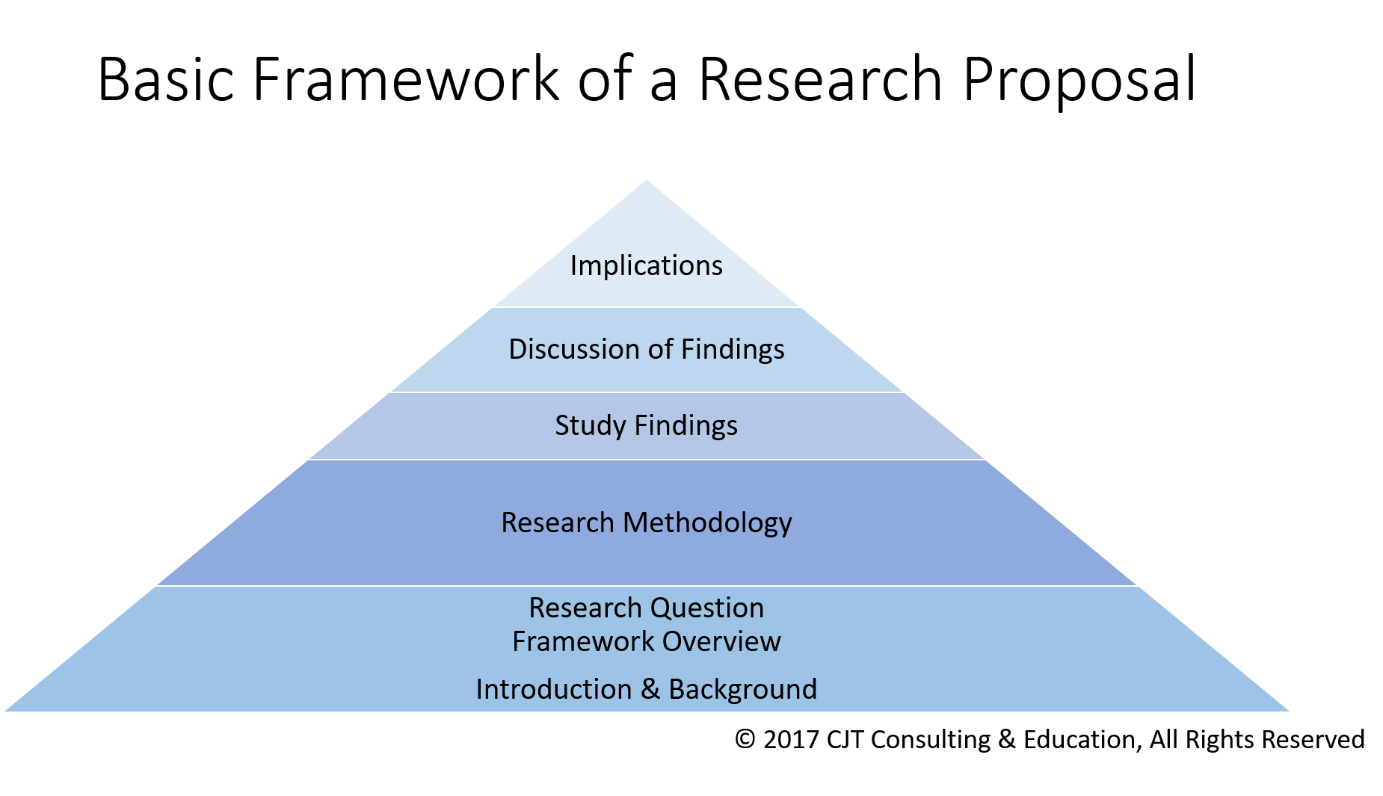
(Thompson, CJT Consulting & Education, 2017)
To accomplish the research goals, the model as described above attempts to create a theatrical framework within the study by working through the pyramid’s phases and motions (Godfrey, 2019).

(3.2.1) Research Onion –
Another recognised research method, known as the ‘Research Onion’ was developed by Sauder’s et al, (2007) which describes the different processes that are commended upon conducting research. This method is designed on the idea of unpeeling ‘each layer’ of the ‘onion model’ to reach the next stage of developing a research strategy with each layer providing a further in- depth description of the unfolding process (Saunders, 2007).
The Research Onion -
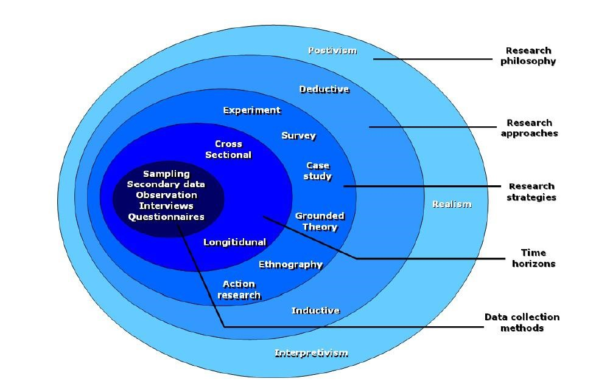
(Institute Numerique, 2012).
(3.3) Research Viewpoint –
Finding out how law enforcement organisations successfully provide mental health resources and support networks for their officers is the aim of the research mentioned previously. Referring to the ‘research onion,’ this would be taking a ‘pragmatism’ approach, which in turn permits a fluid approach towards both qualitative and/or quantities research (Hammond, 2017). In philosophy, ‘pragmatism’ is defined as an approach that evaluates models and options in terms of the success of their applied request (Business research methodology, 2022). A further ‘interpretive’ approach might also be requiring because, according to Dudovskiy’s (2022) theory, researchers must ‘modify their philosophical assumptions over time and move to a new position on the continuum’.
(3.4) Research Approach –
An ‘inductive approach’ will work best for this academic study. Since inductive research is defined as an investigation that begins with a problem observation and seeks to analyse concepts associated with the problem, it starts with previously compiled data and builds upon it (Indeed, 2021). Wong, (2022) states that ‘Inductive research is an approach that the researcher uses to perform investigation on such a type of research topic on which there is little or no existing literature’. Although the literature review found that there are many support systems and mental health resources available to officer that require them, it also highlights the gaps within the research and that very few officers actually ask for help or come forward to express their concerns and struggles, so to concur this inductive approach, research will unpeel the next layer of the onion which will then provide either qualitative or quantitative data to the project.
(3.5) Research Strategy –
At this point, the ‘deductive approach’ might be used to think about the specifics of the study. This stage of the ‘research onion’ is linked to gathering data, typically through the creation and dissemination of surveys. These surveys are typically linked to a quantitative approach to reach projects through participant sampling, which permits the collection of diverse data that can be used to address the objectives of the research question (Bryman, 2012). This research project’s primary goal is to gather data by distributing an online survey. According to Gaille (2020), the ‘deductive approach’ will be the most effective because surveys enable data collection from multiple sources with few obstacles.
(3.6) Research Choices –
The following layer of the ‘onion model’ consists of research choices; for this project, a survey using a questionnaire was selected. To enable a fluid approach to gathering both qualitative and quantitative data, the survey will include a variety of questions. It combines the advantages of both quantitative and qualitative research methods; this collection of various approaches that can help obtain a comprehensive understanding of the project.
(3.7) Timeframe –
The ‘Time horizon’ layer, which is the last layer of the ‘onion’ framework, describes how the planned research data will be gathered in terms of a timeline (Thisismind, 2019). Both ‘longitudinal’ and ‘cross sectional’ data collection techniques arere used in this section. A ‘cross sectional’ approach will be used in this project since the data collection is defined as gathering information from multiple participants at a single time (Simkus, 2010).

(4.0) Chapter Four: Techniques
(4.1) Data Collection –
For this academic project, two online surveys will be used. ‘Survey Monkey’ an online survey generator that allows for the creation and distribution of custom questionnaires, will be used to generate the surveys (SurveyMonkey, 2022). Each survey is expected to include ten questions with the goal of reaching ten police officers, a single survey will be sent out, electronically by email to current Gwent Police Officers of numerous ranks and time in service. Ten employees who work in Gwent Polices ‘wellbeing’ department will have the same ten questions sent in hope that they will also complete it. This survey will have a seven-day timeframe for completion.
(4.2) Data Analysis –
Data analysis is essential to research projects because, to concur, it gives insight into the findings from the data collected for a project (Grant, 2020). The process of gathering, reviewing, and analysing data to determine the outcomes of a goal is known as data analysis (Grant, 2020). Drawing conclusions from the two surveys and arranging the data in graphs with the aid of Microsoft Office will be the projects method of data analysis.
(4.3) Limitations –
There are restrictions on all data collection. This project may have limitations because the survey was only given to Gwent Police officers, which automatically limits the research to a single force and may result in inaccurate findings. Furthermore, if officers do not respond to questionnaires, problems may arise with the dependability of their involvement. Additionally, the sensitive nature of the survey and the fact that the second surveys audience is restricted to the wellbeing team may raise ethical concerns.
(4.4) Conclusion –
In agreement, this methodology has described the most relevant research for the ongoing project, with the selected research method being identified as an online survey. To answer the study’s questions, the survey will attempt to answer the projects questions and offer data to back it up as evidence.

(5.0) Chapter Five: Results
(5.1) Introduction into this chapter –
To collect data for the dissertation, a survey was created by the researcher.
The survey consisted of ten questions which were anonymous and disseminated on 7th August 2025 amongst 30 serving police officers of all different ranks within Gwent Police via a link to the survey monkey platform which the survey was recorded. The link remained live for 3 weeks and gathered a total of twelve responses. Upon closure of this survey accessibility, results were gathered from the responses made by those who participated.
The results gathered could pose as an issue within my research and dissertation as the data captured is reflected through lack of envisioned responses. The results are displayed in the graphs below.
(5.2) Survey -
(5.2.1) Question One –
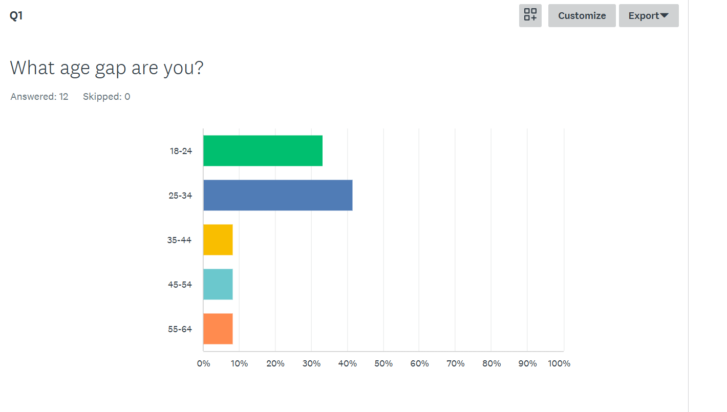
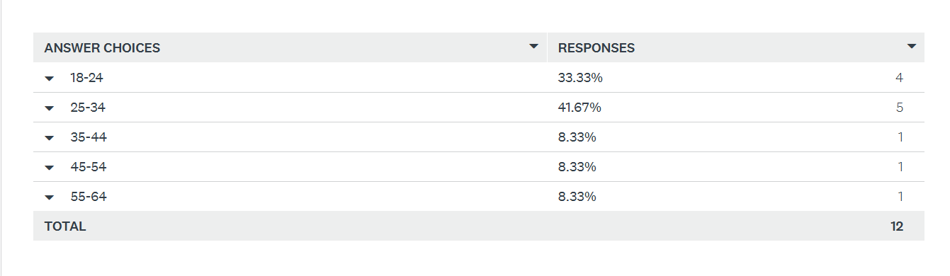
The results in this graph show that 33.33% of responses fall under the 18-24 year bracket, 41.67% of responses fall under the 25-34 year bracket, 8.33% of responses fall under the 35-44 year bracket, 8.33% of responses fall under the 45-54 year bracket and 8.33% of responses fall under the 55-64 year bracket.
(5.2.2) Question Two –
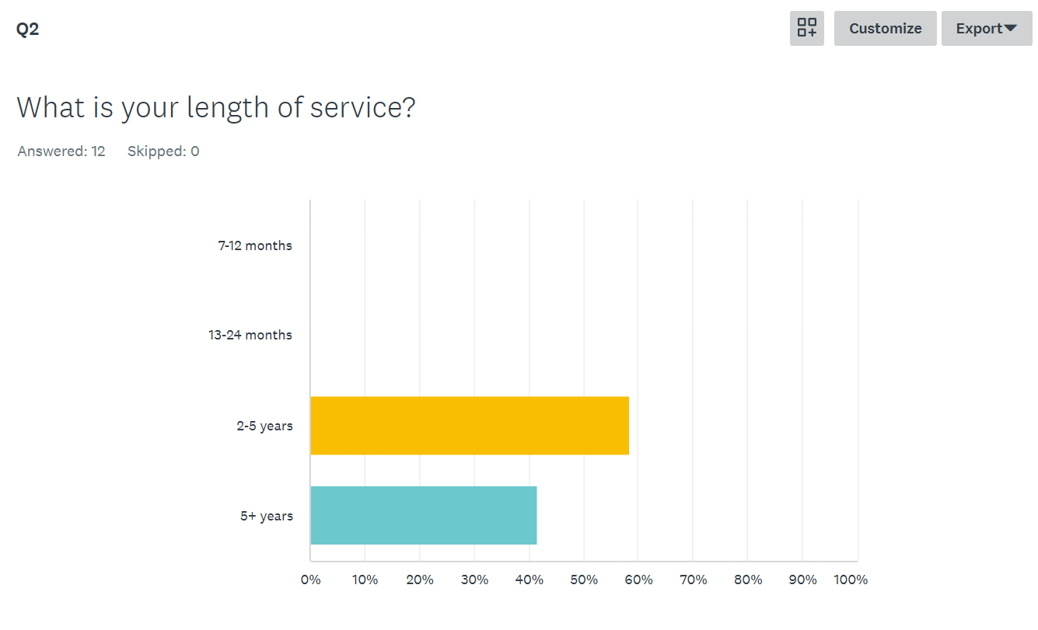
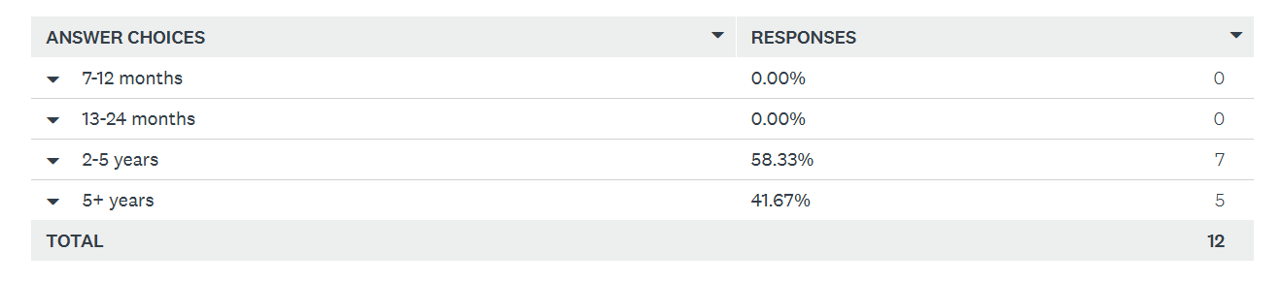
The results in this graph show that no participants were in both the 7–12-month bracket or the 13–24-month bracket. 58.33% of participants are in the 2–5-year bracket and 41.67% of participants are in the 5+ year bracket.
(5.2.3) Question Three –
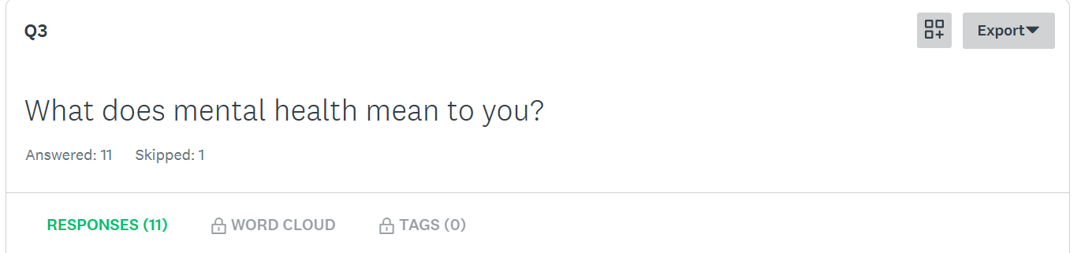
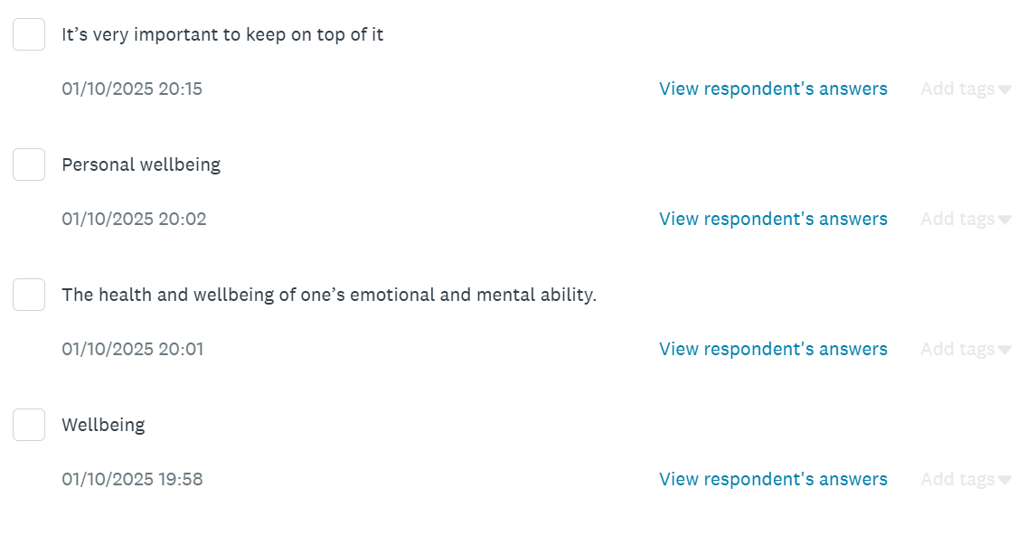
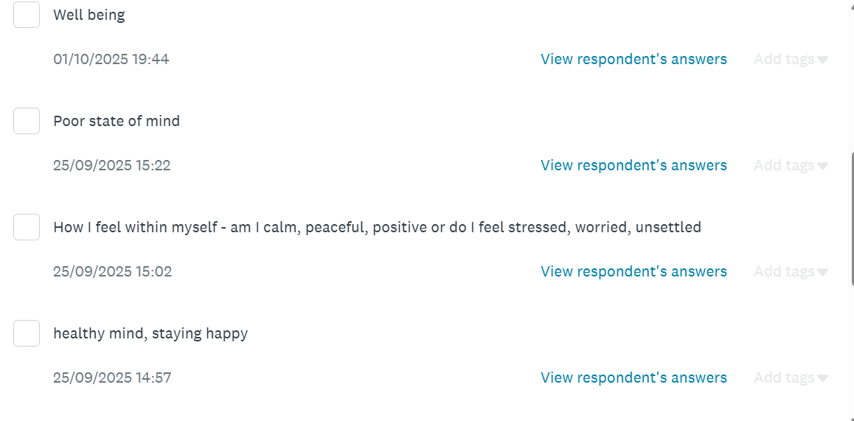
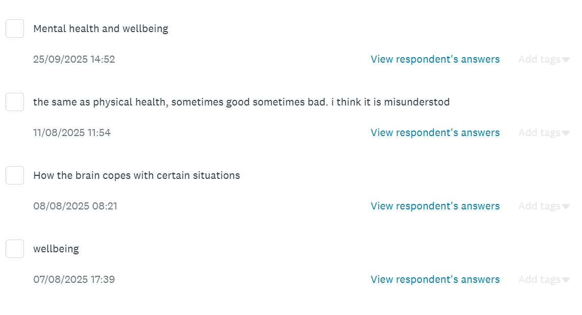
Within question three, participants were asked to give their views on what the term ‘mental health’ meant to them. From the results provided, it shows that participants have different visions of the words Mental Health and that to each person, the term can differ but overall stems back to the mind of a human and how we look after our minds to look after ourselves.
(5.2.4) Question Four –
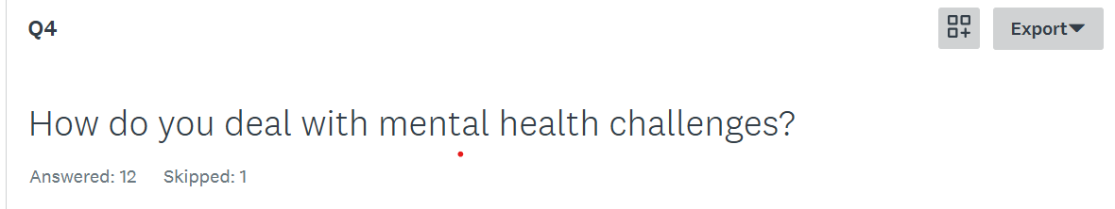
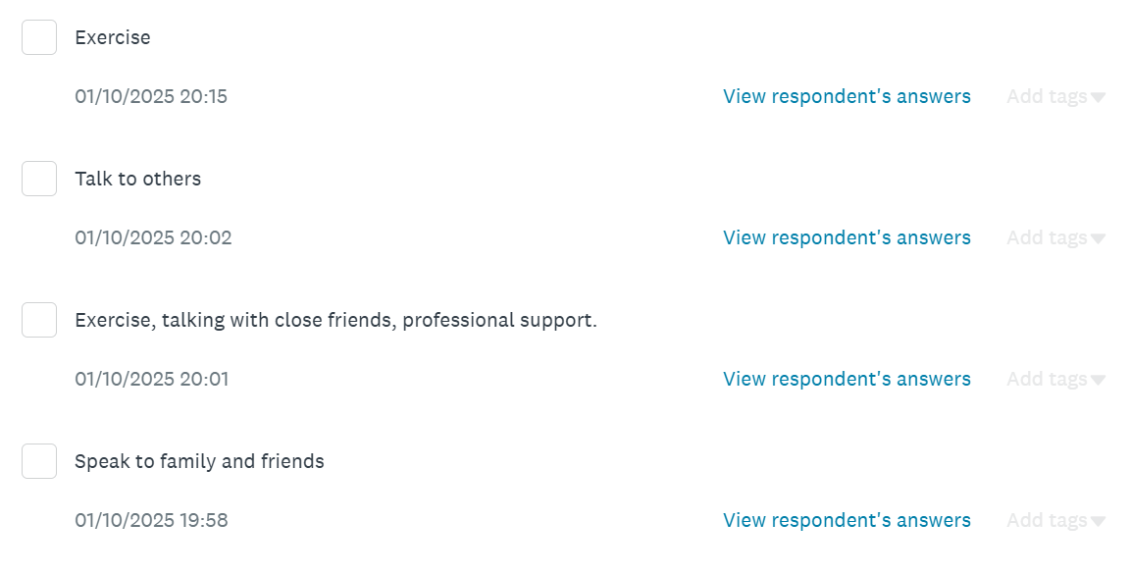
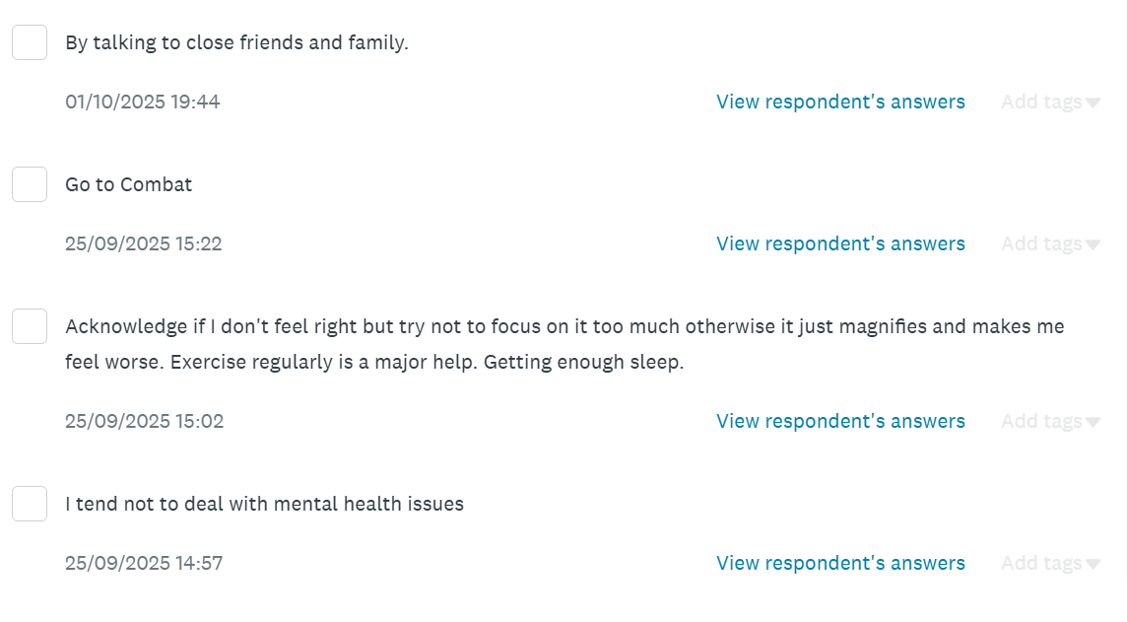
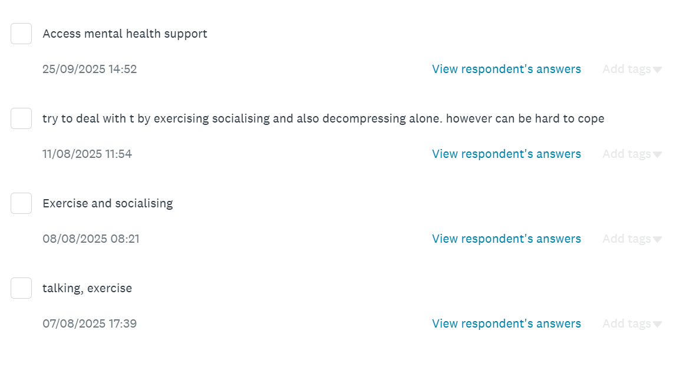
Within question four, participants were asked how they deal with mental health challenges. From looking at the results five out of twelve responses expressed how they engage in exercise as they believe that it helps when dealing with their mental health, seven out of twelve responses stated that they talk with friends and family and socialises with others as it is a way of asking for help and getting advise on what other strategies can help when dealing with mental health challenges, one participant stated that they do not suffer with mental health issues and another participant states that they access mental health support as a way of dealing with their challenges. Overall, some answers are different, yet some are similar, when it comes to mental health challenges, finding what strategy works best for you is priority.
(5.2.5) Question Five –
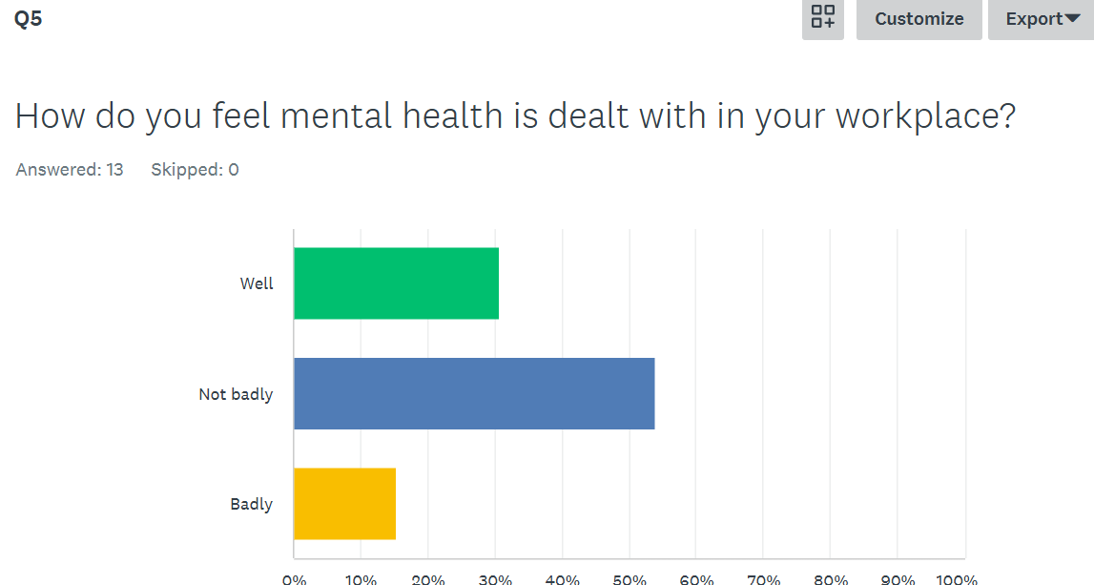
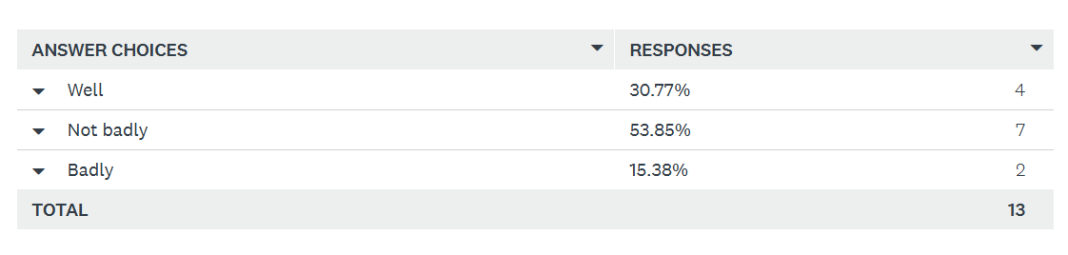
The results in this graph show that 30.77% of responses fell under the ‘yes’ bracket, 53.85% of responses fall under the ‘not badly’ bracket and 15.38% of responses fall under the ‘badly’ bracket.
(5.2.6) Question Six –
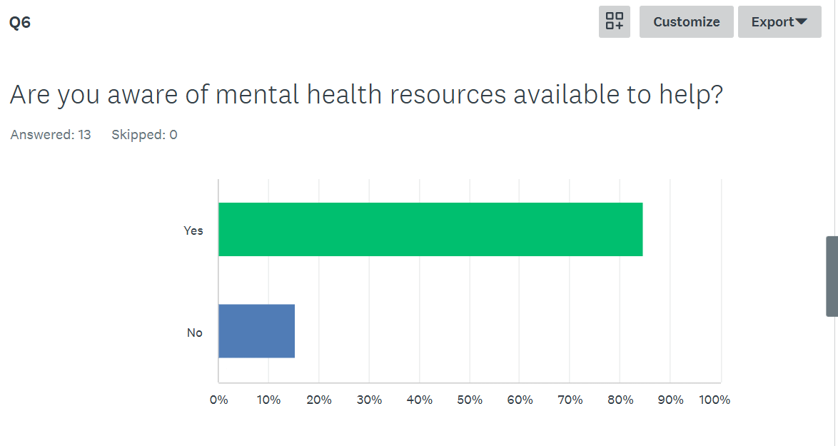
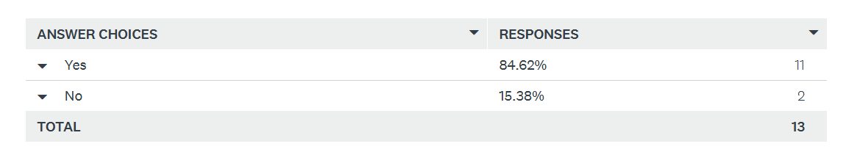
The results in this graph show that 84.62% of results fall under the ‘yes’ bracket and 15.38% of results fall under the ‘no’ bracket.
(5.2.7) Question Seven –
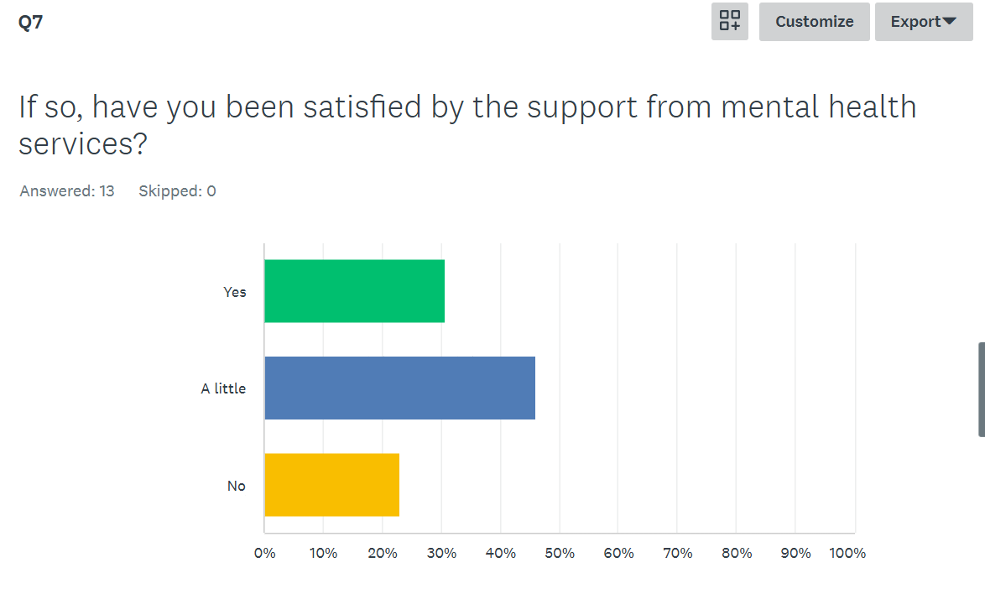
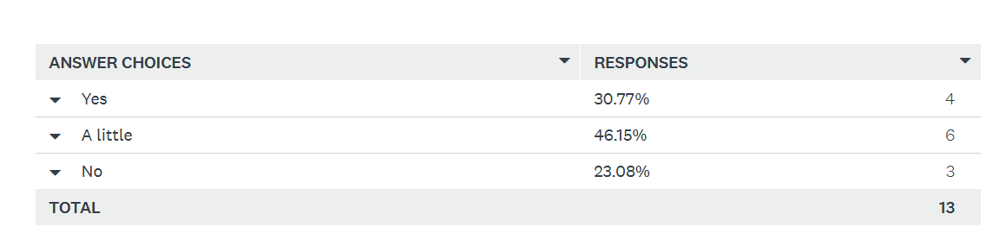
The results in this graph show that 30.77% of responses fall under the ‘yes’ bracket, 46.15% of responses fall under the ‘a little’ bracket and 23.08% of responses fall under the ‘no’ bracket.
(5.2.8) Question Eight –
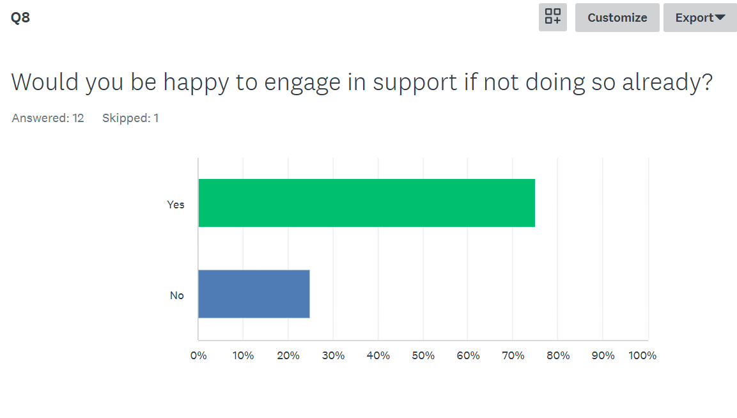
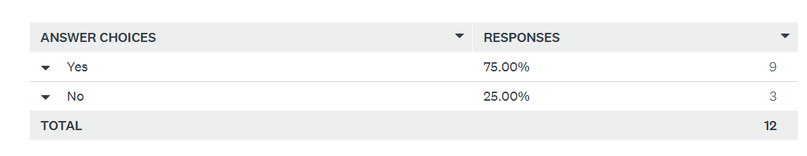
The results in this graph show that 75% of responses fall under the ‘yes’ bracket and 25% of responses fall under the ‘no’ bracket.
(5.2.9) Question Nine –
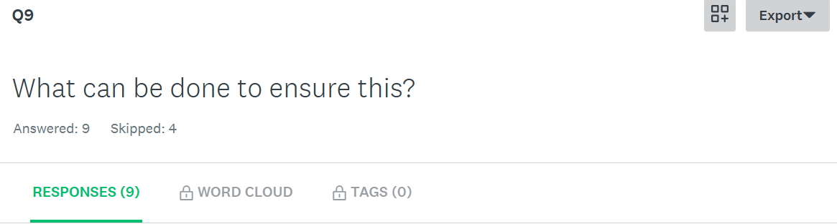
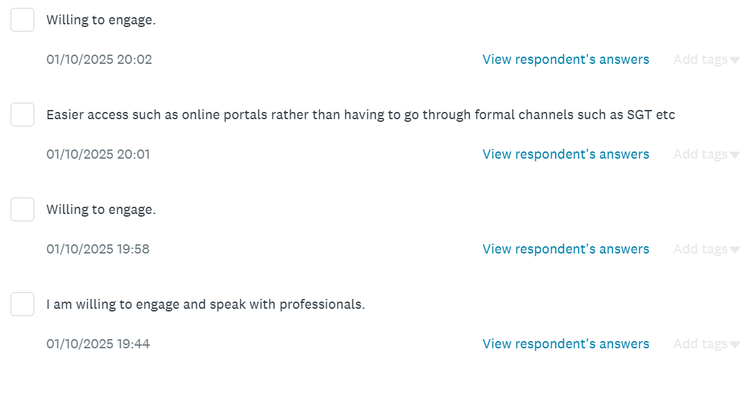
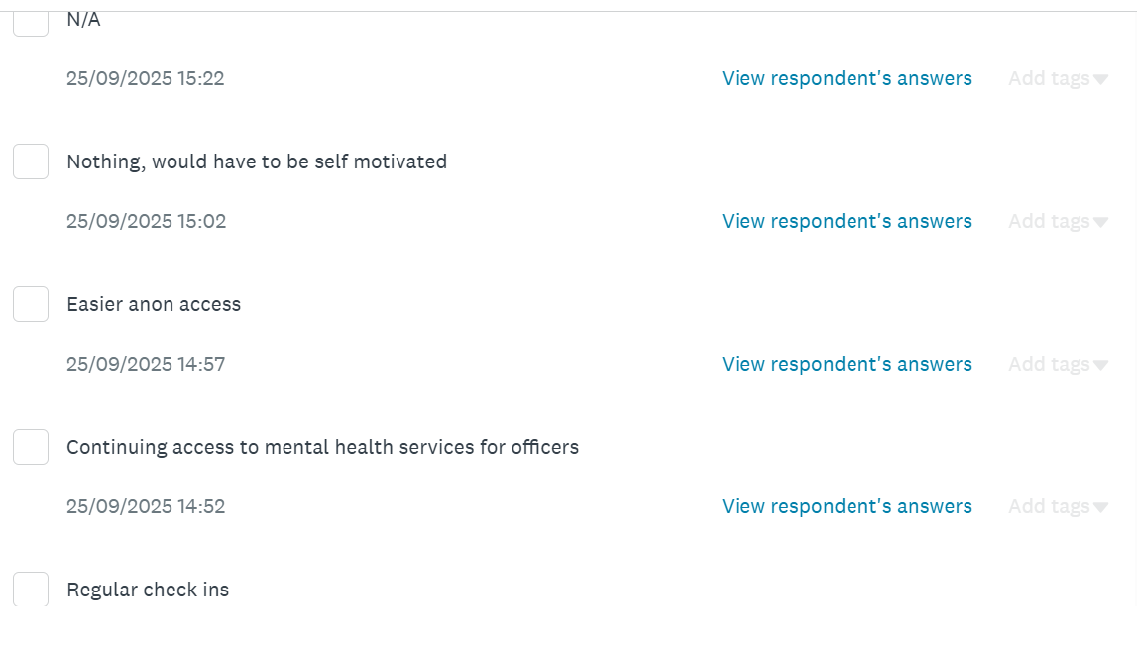
Within question nine, participants were asked what can be done to ensure that they will engage in mental health support. Many responses stated that they would be willing to engage, one response stated that regular check ins would ensure that they would engage with mental health services, one response stated that anonymous access to services would ensure they would engage as well as one participant stating that easier access channels to mental health help would ensure engagement with help. One participant stated that nothing would help them engage other than their own motivation to do so – for many people engaging with mental health support can be the hardest part of all which is why different strategies would help different people.
(5.2.10) Question Ten –
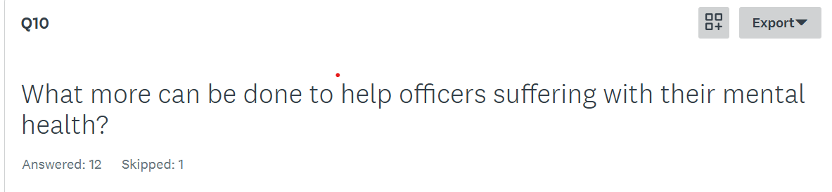
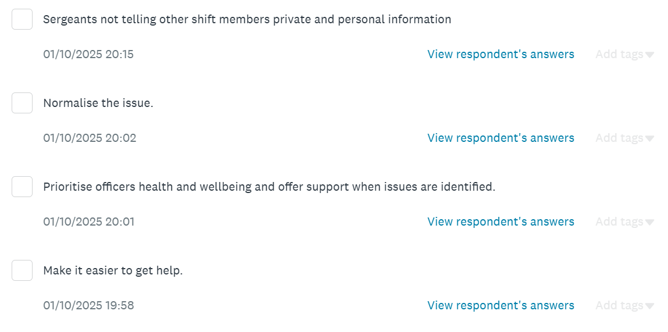
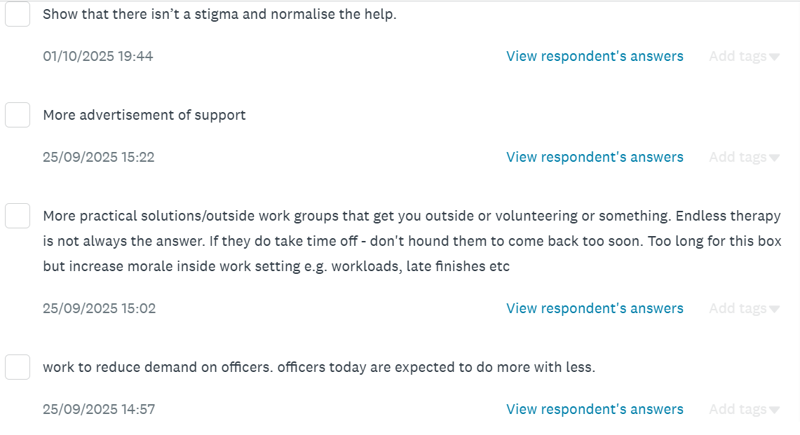
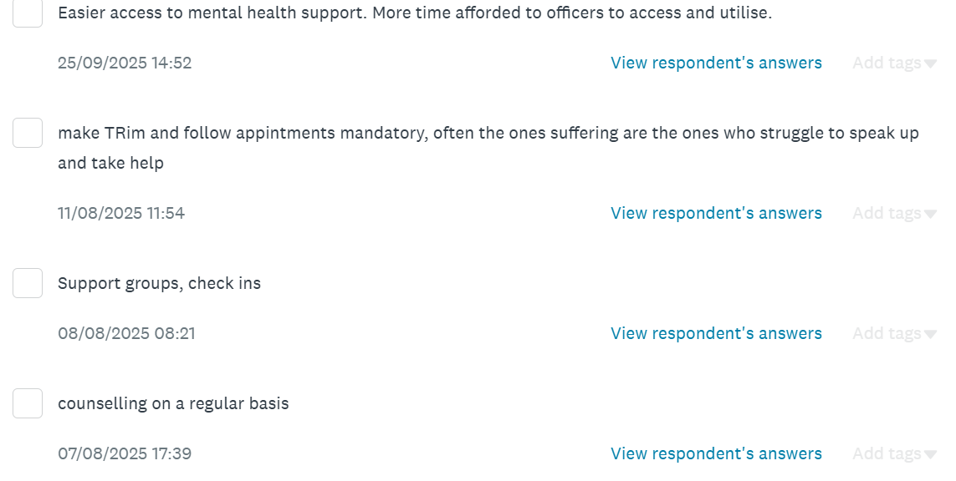
Within question ten, participants were asked what more could be done for officers struggling with their mental health. From the results, it was clear that each participant had a different view on this, ranging from regular check ins for officers, easier access to mental health support, giving officers the time to deal with their mental health, normalising mental health and reducing demand and stress on officers.
(5.3) Conclusion –
In conclusion, the researcher has identified through their research that current serving police officers employed within Gwent Police believe that mental health issues are still present in the workplace and that the organisation have room to improve when attempting to deal with them. However, results do show that participants are aware of the mental health services in which the force have to offer and that participants are happy to engage with support.
Furthermore, it is clear from results that many participants find their own strategies in which they feel benefits them the most when attempting to deal with their mental health. It is important to highlight that not all persons suffering with their mental health would like to bring up their problems in a work environment due to stigma and being unsure where their information is being taken and for this reason would prefer to work on their own mental health alone.

(6.0) Chapter Six: Findings and conclusion
(6.1) Introduction to this chapter –
The initial chapters of the research project have progressed smoothly, commencing with the introduction, followed by a literature review, research methods, preparation and an examination of the completed research. The preceding chapter examined the results of the main findings collected through the quantitative study. Bulbous themes that are meticulously comparable to the findings reported in the research projects literature review arose because of the quantitative data analysis. This chapter will rely on these predispositions to provide recommendations and to specifically detail them. This chapter will conclude with a conclusion from the researcher that addresses the access in which police officers have to mental health support as well as determining whether additional academic research is warranted in this area.
(6.2) Achievements of objectives –
The aim throughout this research project was to identify the following objectives.
- Assess the currently status of mental health resources available to police officers.
- Identify best practise from successful mental health initiatives.
- Evaluate the impact of mental health resources on officer wellbeing and job performance.
- Explore barriers to accessing mental health support.

Expelling a comprehensive literature review that absorbed and identified existing academic literature that highlighted the access to mental health resources among serving police officers, as well as the support that is available to police officers to address their mental health needs, and what we can do to combat the stigma of coming forward and asking for help, was the means by which the above objectives were accomplished. The literature has also shed light on the obstacles that highlight the reasons why a significant number of law enforcement officers do not come forward and seek assistance from mental health specialists inside of their place of employment.

Throughout the utilisation of the research onion, the objectives were successful completed (Saunders et al, 2016). The researcher was provided with a plan to methodically gather data using a survey to collect information from participants. This information was designed to help with the confirmation or denial of perspectives that were discussed within the literature review portion of the project.

Using the internet platform known as ‘Survey Monkey’, the researcher was able to distribute a survey to several employees working for Gwent Police. The researcher then shared the survey with staff through the internal emailing system. This allowed the researcher to successfully accomplish the objective. Within the scope of this study approach, the researcher was able to compile quantitative data for examination.
(6.3) Main findings –
As a result of the findings that the researcher compiled in relation to this research project, it is evident that serving police officers are aware of the mental health support that their organisations have to offer; however, for a variety of reasons, individuals who are experiencing difficulties will not come forward and seek assistance and support from professionals. Within the context of the literature review, the main data provided will support the secondary data. After analysing the two different sets of studies, the researcher concluded that although while there is a greater recognition today for the importance of mental health care, there is still a certain amount of stigma associated with receiving such treatment.

(6.3.1) Topic One - Assess the status of mental health resources available to police officers.
Based on the findings of the secondary data, it was found that the mental health of serving police officers is becoming increasingly obvious. Furthermore, it was found that very few officers were coming out and asking for assistance because they do not believe that the resources available within their organisation are sufficient to assist them. The information that was gathered using the main research technique indicated that officers do not believe that there is adequate assistance for officers who are struggling with their mental health, even though they are aware that there are a variety of options available to them that they may utilise. Since the findings of the primary and secondary research are extremely comparable, the researcher can recognise a common thread that connects the two types of research. Even though there are a greater number of secondary discoveries, this could be because there is a dearth of primary findings because of a lack of study.
(6.3.2) Topic Two - Identify best practise from successful mental health initiatives.
The findings from the secondary research highlights that there are many positive identifiable factors such as different schemes that have been created over the years that have been put in place to ensure that officers suffering with their mental health are able to come forward and seek the help. However, from secondary research, studies show that although many programmes have been set up, officers still find coming forward and expressing their struggles the hardest part due to the stigma about asking for help. Studies show that many people deal with their emotions themselves and that activities such as exercising, can help a person’s mental health. This study then married up with the primary research I gathered due to five out of twelve survey participants expressing that their strategy to dealing with their mental health is to exercise.
(6.3.3) Topic Three - Evaluate the impact of mental health resources on officer wellbeing and job performance.
Based on the findings of the secondary research, studies show that officers are becoming more aware of resourcing around them and how the level of support is growing due to the importance of mental health. Secondary research shows that although there are support systems available to officers, many do not engage with professionals due to different reasons. From primary research, it was made apparent that participants would benefit from regular check ins and easier access to these support systems for them to begin engaging with professionals. The researcher was unable to identify a generalised reflection from the primary results on the viewpoints of the respondents in relation to this question. This may suggest that there was a gap in the primary research, meaning that more research is needed.
(6.3.4) Topic Four - Explore barriers to accessing mental health support.
Within the scope of the project, the subsequent objective for achieving success was to determine whether there were any obstacles to gaining access to mental health support within Gwent Police. As a result of the data collected from the primary research, the researcher was able to acquire expertise from serving police officers, which in turn, would assist the researcher in gaining an understanding. Even though primary research was extremely restricted, secondary research revealed a great deal of difficulty in gaining access to mental health support. For a more comprehensive grasp of the subject matter, it would be required to do additional study to discover the perspectives of other serving police officers.

(7.0) Chapter Seven: Recommendations
As a result of the findings that have been offered within this research project, the subsequent recommendations mirror the perceptions that have bene present. According to the findings of the primary research survey, serving police officers are aware of the mental health support systems that are available to them within their organisation. However, findings show that they believe that the way these systems are utilised could be improved to increase the number of officers who engage with professionals. The common theme appears to be that there is a stigma associated with expressing your feelings to another person, and because of this growing stigma, many people choose to deal with their feelings on their own rather than opening and talking about them. This is even though the participants judgement indicated that they are willing to engage with mental health professionals. It is quite clear that recommendations will be required to proceed with the process of producing changes.
This can be achieved by:
(7.1) Recommendation One – Completing further research
Since Gwent Police was selected as the relevant police force to use for the purpose of this study, the views that were compiled from the research methodologies that were utilised by the researchers within this project represents the perspectives of participants that are exclusives to Gwent Police. It should be noted that the data retrieved was restricted to the representation and views of police officers employed by Gwent Police and did not include retrospective information from other forces in the United Kingdom.
The researcher also found a problem with the number of responses gained from the surveys completed. The survey was handed out too many serving police officers with only a total of twelve responses.

(8.0) Chapter Eight: Conclusion
In conclusion, the findings of the primary and secondary research indicate that law enforcement officers are aware of the mental health resources available to them and that there are many resources for them to access. Throughout the research however, it has become apparent that there are numerous reasons that need to be further investigated as to why these officers who are struggling with their mental health do not come forward.
The focus of the dissertation has been on the ways in which law enforcement agencies can effectively incorporate mental health resources and support systems for their officers. An objective perspective has been adopted by the researcher, and the researcher has placed an emphasis on the benefits that the current level of support provides. The researcher has identified gaps in both the primary and secondary data collected through the process of creating this project. Additional resources are to be researched in hope to recognise future care officers may need when experiencing mental health issues. This research project has provided attention and familiarity to the existing matters surrounding the topic so that it can be addressed further.

(9.0) Bibliography
AP News, (2021) New approach to police training: December 2023. Available at: www.apnews.com. (Accessed: 9th May 2025).
BMC Psychiatry, (2015) The effects of stress on cognitive aging, physiology and emotion: July 2015. Available at: https://pmc.ncbi.nlm.nih.gov. (Accessed: 9th May 2025)
BMC Psychiatry, (2021) Mental health screening amongst police officers: March 2021. Available at: https://bmcpsychiatry.biomedcentral.com. (Accessed: 9th May 2025)
British Medical Association, (2024) Failing mental health systems: June 2024. Available at: https://www.bma.org.uk. (Accessed: 9th May 2025)
College Of Policing, (2023) Seeking help: September 2023. Available at: https://www.college.policing.uk. (Accessed 9th May 2025).
Dictionary.cambridge.org. (2022). Research. [online] Available at: <https://dictionary.cambridge.org/dictionary/english/research> [Accessed: 16th June 2025].
Dudovskiy, J., (2022). The ultimate guide to writing a dissertation in business studies. 1st ed. United Kingdom: Research Methodology, pp.22-25.
Francis&Taylor, (2022) Police and mental health: November 2022. Available at: https://scholar.google.co.uk/scholar. (Accessed 9th May 2025).
G Costa, (2021) Shift work and health: December 2021. Available at: https://pmc.ncbi.nlm.nih.gov. (Accessed: 9th May 2025)
Gaille, L., (2020). 20 Advantages and Disadvantages of Survey Research. [online] Vittana.org. Available at: <https://vittana.org/20-advantages-and-disadvantages-of-survey-research> [Accessed 16th June 2025].
Gallagher, (2025) What improves my mental health?: March 2025. Available at: https://bupa.co.uk. (Accessed: 9th May 2025)
George, T., (2021). Mixed Methods Research | Definition, Guide & Examples. [online] Scribbr. Available at: <https://www.scribbr.com/methodology/mixed-methods-research/> [Accessed 16th June 2025].
Godfrey, M., (2019). What is a research framework and why do we need one?. [online] Medium. Available at: <https://uxdesign.cc/what-is-a-research-framework-and-why-do-we-need-one-b3fac8351d46> [Accessed 16th June 2025].
GOVUK, (2023) Public perception of policing: August 2023. Available at: https://www.gov.uk. (Accessed: 9th May 2025)
GOVUK, (2023) Trauma Risk Management- TRiM: April 2023. Available at: https://assets.publishing.services.gov.uk. (Accessed 9th May 2025)
Grant, A., (2020). What Is Data Analysis and Why Is It Important?. [online] MUO. Available at: <https://www.makeuseof.com/tag/what-is-data-analysis/> [Accessed 16th June 2025].
Hammond, M., (2017). what is pragmatism. [online] Warwick.ac.uk. Available at: <https://warwick.ac.uk/fac/soc/ces/research/current/socialtheory/maps/pragmatism/> [Accessed 16th June 2025].
Hampshire College. (2022). What is Research? [online] Available at: <https://www.hampshire.edu/what-research> [Accessed 16th June 2025].
Health Psychol Res, (2024) Mental Disorders and Mental Health Promotion in Police Officers: February 2024. Available at: https://pmc.nln.nih.gov/articles/PMC10875161. (Accessed 9th May 2025)
HMICFRS, (2019) Occupational Health Services: April, 2019. Available at: https://hmicfrs.justiceinspectorates.gov.uk. (Accessed: 9th May 2025)
Indeed Career Guide. (2021). Inductive Research: What It Is, Who Uses it and How. [online] Available at: <https://www.indeed.com/career-advice/career-development/inductive-research#:~:text=Inductive%20research%20is%20an%20investigation%20that%20begins%20with,a%20hypothesis%20on%20what%20led%20to%20the%20data.> [Accessed 16th June 2025].
Institut-numerique.org. (2012). CHAPTER 3: RESEARCH METHODOLOGY. [online] Available at: <https://www.institut-numerique.org/chapter-3-research-methodology-4ffbd6e5e3391> [Accessed 16th June 2025].
Jansen, D., (2021). Saunders' Research Onion: Explained Simply (+ Examples) - Grad Coach. [online] Grad Coach. Available at: <https://gradcoach.com/saunders-research-onion/> [Accessed 16th June 2025].
JM Violanti, (2018) Police Work Stressors: August 2018. Available at: https://pubmed.ncbi.nlm.nih.gov. (Accessed: 9th May 2025)
Komarovskaya, (2014) Trauma differences: July 2018. Available at: https://cycj.org.uk. (Accessed: 9th May 2025)
M Christopher, (2016) Mindfulness Training: April 2024. Available at: https://pmc.ncbi.nlm.nih.gov. (Accessed: 9th May 2025)
M Mealer, (2017) Resillience: November 2017. Available at: https://pmc.ncbi.nlm.nih.gov. (Accessed: 9th May 2025)
M Violanti, (2017) Police Stressors and health: March 2017. Available at: https://pmc.ncbi.nlm.nih.gov. (Accessed: 9th May 2025)
McLeod, (2001) Employee Assistance Training: February 2025. Available at: https://www.employment-studies.co.uk. (Accessed: 9th May 2025)
Mind, (2019) Mental health in the emergency services: July 2019. Available at: https://www.mind.org.uk. (Accessed: 9th May 2025)
Mind, (2024) Peer support groups: June 2024. Available at: https://www.mind.org.uk. (Accessed: 9th May 2025)
N Luduc, (2023) The impacts of leadership behaviours: October 2023. Available at: https://www.emerald.com. (Accessed: 9th May 2025)
National Police Chiefs’ Council, (2019) Mental health and policing strategy: January 2019. Available at: https://www.npcc.police.uk. (Accessed: 9th May 2025)
National Police Foundation Survey, (2021)Available at: 30% increase in Surrey officers being signed off with stress, anxiety, depression and PTSD (Accessed: 6th February 2025)
NHS UK, (2023) Peer support: September 2023. Available at: https://www.england.nhs.uk. (Accessed: 9th May 2025)
Papazoglou&Andersen, (2018) Practical approaches to addressing psychological needs of officers: April 2018. Available at: https://journals.sagepub.com. (Accessed: 9th May 2025).
PolFed, (2016) Mental health: March 2016. Available at: https://www.polfed.org/our-work/mental-health. (Accessed 9th May 2025)
R Buhrig, (2024) Masculinity cultures in police organisations: November 2024. Available at: https://academic.oup.com. (Accessed: 9th May 2025)
Research-Methodology. (2022). Pragmatism Research Philosophy - Research-Methodology. [online] Available at: <https://research-methodology.net/research-philosophy/pragmatism-research-philosophy/> [Accessed 16th June 2025].
Simkus, J., (2021). Cross-Sectional Study | Definition, Designs & Examples - Simply Psychology. [online] Simplypsychology.org. Available at: <https://www.simplypsychology.org/what-is-a-cross-sectional-study.html> [Accessed 16th June 2025].
SurveyMonkey. (2022). SurveyMonkey: The World’s Most Popular Free Online Survey Tool. [online] Available at: <https://www.surveymonkey.com/> [Accessed 16th June 2025].
Taylor& Francis, (2021) Police staff and mental health: July 2021. Available at: https://www.tandfonline.com. (Accessed: 9th May 2025)
The IACP,International Association of Chiefs of Police, (2021) Available at: Center for Police Research | International Association of Chiefs of Police (Accessed: 6th February 2025)
Thisismind. (2019). The Research Onion. [online] Available at: <https://thesismind.com/analysis-of-saunders-research-onion/> [Accessed 16th June 2025].
Thompson, C., (2022). How to Use a Theory to Frame Your Research Study - Nursing Education Expert. [online] Nursing Education Expert. Available at: <http://nursingeducationexpert.com/theory-frame-research/> [Accessed 16th June 2025].
Tidal Training, (2024) The importance of PTSD debriefing: July 2024. Available at: https://www.tidaltraining.co.uk. (Accessed: 9th May 2025).
V Kantor, (2017) Perceived barriers and facilitators of mental health: June 2017. Available at: https://www.sciencedirect.com. (Accessed: 9th May 2025)
Voxco.com. (2022). Limitations of survey research. [online] Available at: <https://www.voxco.com/blog/the-methodological-limitations-of-survey-research/> [Accessed 16th June 2025].
Wisdom Wellbeing, (2025) Employee Assistance Programme (EAP) services: February 2025. Available at: https://www.healthassured.org. (Accessed: 9th May 2025).
Wong, A., (2020). Inductive Research. [online] Singapore Assignment Help. Available at: <https://www.singaporeassignmenthelp.com/blogs/inductive-research/#:~:text=Inductive%20is%20a%20research%20approach%20which%20the%20researcher,investigator%20design%20theory%20after%20completion%20of%20the%20study.> [Accessed 16th June 2025]

(10.0) Appendices
(10.1) Appendix One: Survey
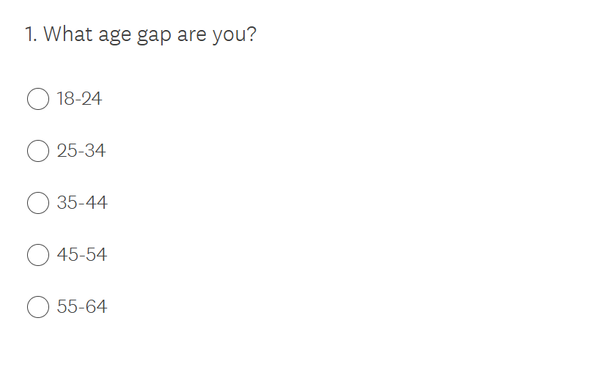
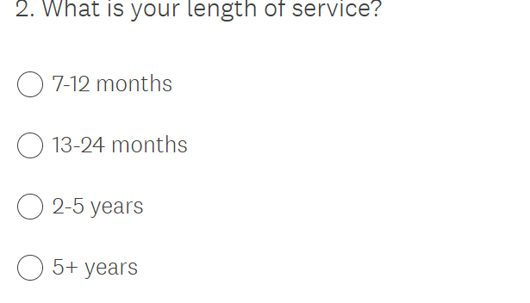
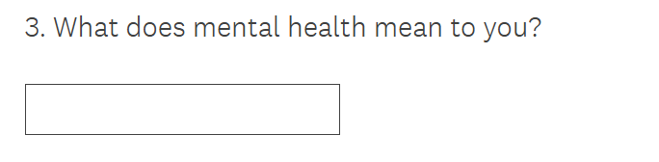
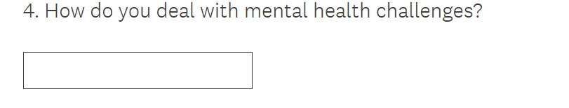
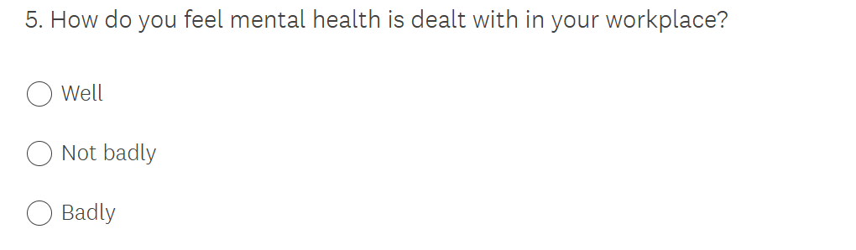
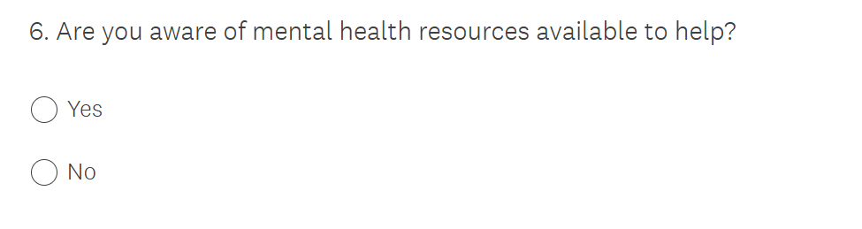
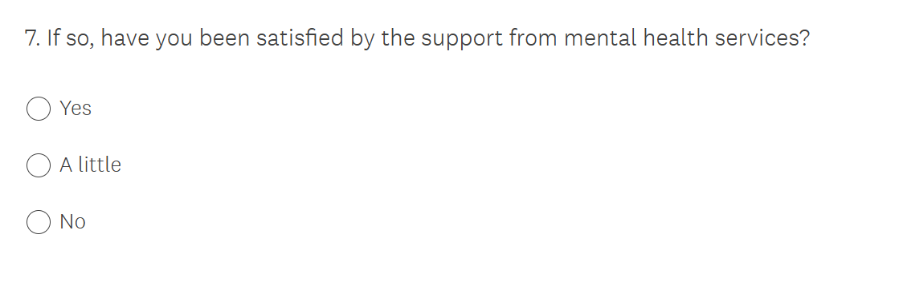
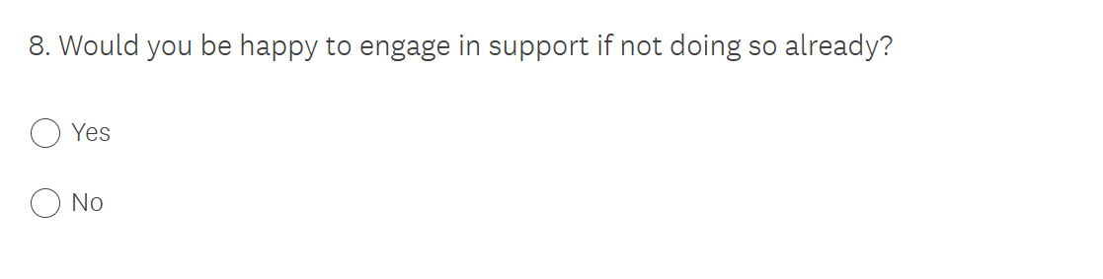
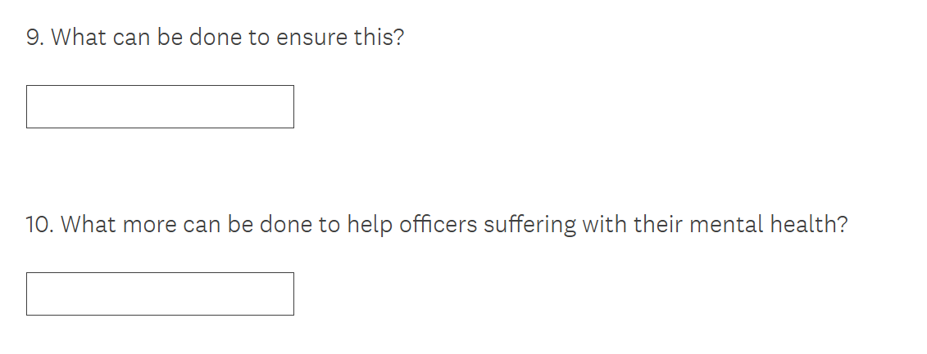
(10.2) Appendix Two - Survey Results

(11.0) Appendix Three - Dissertation Proposal
How can law enforcement agencies effectively implement mental health resources and support systems for their officers?
Introduction –
This dissertation will explore how law enforcement agencies can effectively implement mental health resources and support systems for their officers. Within this dissertation, the researcher will assess the status of mental health resources available to police officers as well as identifying best practise for mental health initiatives. Within this dissertation, the impact of mental health resources on officer wellbeing and job performance will be evaluated as well as studying any barriers there are when attempting to access mental health support.
Existing research highlights that mental health is a big contribution to the workplace and a topic that people believe has an unnecessary stigma that I would like to explore upon. I believe it is worthy of consideration as it is a topic I believe many people can relate to and a topic that people can be educated further about. Law enforcement agencies face significant challenges related to the mental health of their officers due to high stress nature of their work. It would be favourable to research and highlight what support systems are available to police officers so that when they begin to struggle with their mental health, they know who to turn to.
National Police Foundation Survey, (2021) found that around 30% of officers reported experiencing symptoms of depression, and about 40% indicated they had experienced high levels of stress. The researcher intends to allow those officers struggling with their mental health to identify what support networks are in place to chaperon them in the right direction for support.
The reason for this research is to educate officers on the different support systems and routes in which they can take to help protect and improve their mental health. This research is to prove that mental health is as important as many things in the job and that if an officer is to allow their mental health to take a toll, it doesn’t just influence them but influences a person’s performance and decision making. Addressing mental health can also help reduce the stigma behind it so that people suffering can foster a better relationship that allows them to engage with the challenges they are dealing with. Finally, researching this topic can contribute to developing best practise that promotes healthier work environments, improve community policing efforts and ultimately enhance public safety.
Summary of research objectives –
My goal of this research is to develop an understand of the resources available and the support system offered to officers that are struggling with their mental health. By researching and becoming more knowledgeable about the topic, I hope to educate those who are unaware so that more officers realise what help is available so that they do not have to suffer alone.

- Assess the currently status of mental health resources available to police officers.
- Identify best practice from successful mental health initiatives.
- Evaluate the impact of mental health resources on officer wellbeing and job performance.
- Explore barriers to accessing mental health support.

The results of these studies will allow me to understand the effectiveness and ineffectiveness of the resources put in place to help officers struggling with their mental health.
These four stages have been chosen to achieve the best research outcomes in the time frame created.
Literature Review –
Research surrounding my chosen topic can be accessible through online resources. Throughout my dissertation and research, I would consider using different resources such as textbooks, articles and others.
I also plan to create surveys to gain access to personal experiences.
I feel as though resources surrounding mental health is widely accessible online meaning at present, I do not believe I will encounter any gaps in my research procedure.
For the purpose of this project, the researcher will attempt to conduct a review of the current literature by conducting an analysis of information obtained by academic publications and journals, key reports from respected organisations and excellent practise from police services. The researcher has determined that although there is a great amount of literature that is available regarding the subject matter, there may be gaps within. The researcher will make attempts to fill these gaps by using research methodologies that are relevant to the project to collect information.
Summary of research – Survey Methods
There are many survey methods that could be used when attempting to gather information in the most effective way.
I feel as though creating an anonymous questionnaire and sharing it with the force would be the most effective for me. I plan on creating a questionnaire relating to the mental health of officers and asking questions that would relate to their judgement on the way it is handled within the force and personal experiences they have had whilst dealing with it.
The survey would be distributed amongst serving police officers of Gwent Police and the figures derived from the survey will then be subject to quantitative research to inspect the project topic.
The most important findings will then be presented in the form of a chart and will be compared to previous research to uncover any recurring themes in the data. Furthermore, recommendations can be developed based on the findings of this comparison.
By keeping the questionnaire anonymous, it allows those taking part to fully open about their experiences without the worry of someone finding out about the response they have given.
This questionnaire would be a good way of engaging with officers about a sensitive topic without knowing who would be behind the responses given.
I plan to base my questions around different mental health illnesses officers deal with, the way in which they deal with them, if they receive support from work and what that support is and if they do not receive any support or have access to any resources to help them, why that is and how that can be changed.

Summary of sampling framework -
I feel that creating a questionnaire for officers to complete is the best method when trying to understand people’s personal experiences on a normal day to day.
Personal experiences after resonating more with individuals because they reflect real life situations and emotions.
I also feel when someone shares their own story, it can come across as more genuine and trustworthy compared to abstract professional advice. People may feel more connected to someone who has gone through similar challenges.
For this reason, I feel seeking the perspective from members of the force rather than experts will have more of an impact when finding out personal views.
It is important to balance personal experiences with professional advice, especially in areas like mental health, where trained professionals can provide evidence-based strategies and advice.
This topic can be relevant to many people’s experiences; however, I only intend in seeking the views of police officers in each branch.
Ethical issues -
The importance of developing a clear understanding of the resources put in place to help and support police officers who are suffering with their mental health is crucial.
However, when attempting to discuss the mental health of officers, problems may arise.
One problem may be the confidentiality of officers. Ensuring the privacy of participants is crucial, officers may be hesitant to share personal experience if they fear their responses could be traced back to them, potentially affecting their careers.
Another problem may be informed consent. It is important that officers fully understand the purpose of the research and what participation entails. They will be made aware of how their responses will be collected in means of surveys and how they will remain private.
In summary, there are many problems that have been made aware of when researching about the mental health within forces and the resources offered to officers who are struggling so finding that better understanding and ensuring that officers are aware of what support is around them and the confidentiality behind this topic, is very important.
Addressing these ethical concerns is vital for conducting responsible and impactful research in this sensitive area.
Time Scale –
Due to working the shift patterns of six consecutive days ranging between two mornings, two afternoons and two nights before having four rest days which includes juggling both family and social time, it is vital that a time frame is cohered to so that I can ensure all research and completion of the dissertation, and its requirements is enforced.
Word count - 1385

Appendix Four: Ethic Form
In order for research to result in benefit and minimise risk of harm, it must be conducted ethically. A researcher may not be covered by the University’s insurance if ethical approval has not been obtained prior to commencement.

The University follows the OECD Frascati manual definition of research activity: “creative work undertaken on a systematic basis in order to increase the stock of knowledge, including knowledge of man, culture and society, and the use of this stock of knowledge to devise new applications”. As such this covers activities undertaken by members of staff, postgraduate research students, and both taught postgraduate and undergraduate students working on dissertations/projects.

The individual undertaking the research activity is known as the “principal researcher”.

Ethical approval is not required for routine audits, performance reviews, quality assurance studies, testing within normal educational requirements, and literary or artistic criticism.

Please read the notes for guidance before completing ALL sections of the form.

This form must be completed and approved prior to undertaking any research activity. Please see Checklist for details of process for different categories of application.

SECTION A: About You (Principal Researcher)
1 | Full Name: |  | Enya Mcinerney
2 | Tick all boxes that apply: |  | Member of staff: | ☐ | Honorary research fellow: | ☐
 | Undergraduate Student | ☒ | Taught Postgraduate Student | ☐ | Postgraduate Research Student | ☐

3 | Institute/Academic Discipline/Centre:
4 | Campus: | Swansea
5 | E-mail address: | 2236901@student.uwtsd.ac.uk
6 | Contact Telephone Number:
 | For students:
7 | Student Number: | 2236901
8 | Programme of Study: | BSc (Hons) Professional Policing Practice.
9 | Director of Studies/Supervisor:

SECTION B: Approval for Research Activity
1 | Has the research activity received approval in principle?  (please check the Guidance Notes as to the appropriate approval process for different levels of research by different categories of individual) |  | YES | ☒ | NO | ☐
 |  |  |  |  | Date
2 | If Yes, please indicate source of approval (and date where known): Approval in principle must be obtained from the relevant source prior to seeking ethical approval | Research Degrees Committee |  | ☒
2 |  | Institute Research Committee |  | ☐
2 |  | Other (write in) |  | ☐

SECTION C: Internal and External Ethical Guidance Materials
 | Please list the core ethical guidance documents that have been referred to during the completion of this form (including any discipline-specific codes of research ethics, location-specific codes of research ethics, and also any specific ethical guidance relating to the proposed methodology). Please tick to confirm that your research proposal adheres to these codes and guidelines. You may add rows to this table if needed.
1 | UWTSD Research Ethics & Integrity Code of Practice | ☒
2 | UWTSD Research Data Management Policy | ☒
3 | [List any other relevant documents here] | ☐

SECTION D: External Collaborative Research Activity
If there are external collaborators then you should gain consent from the contact persons to share their personal data with the university. If there are no external collaborators then leave this section blank and continue to section E.
1 | Institution
2 | Contact person name
3 | Contact person e-mail address
4 | Is your research externally funded? |  | YES | ☐ | NO |  | ☐
5 | Are you in receipt of a KESS scholarship? |  | YES | ☐ | NO |  | ☐
6 | Are you specifically employed to undertake this research in either a paid or voluntary capacity? | Voluntary | YES | ☐ | NO | ☐
7 |  | Employed | YES | ☐ | NO | ☐
8 | Is the research being undertaken within an existing UWTSD Athrofa Professional Learning Partnership (APLP)? | If YES then the permission question below does not need to be answered. | YES | ☐ | NO |  | ☐
9 | Has permission to undertake the research has been provided by the partner organisation? | (If YES attach copy)  If NO the application cannot continue | YES | ☐ | NO |  | ☐

Where research activity is carried out in collaboration with an external organisation
10 | Does this organisation have its own ethics approval system? | YES | ☐ | NO | ☐
 | If Yes, please attach a copy of any final approval (or interim approval) from the organisation (this may be a copy of an email if appropriate).

SECTION E: Details of Research Activity
1 | Indicative title: | How can law enforcement agencies effectively implement mental health resources and support systems for their officers?
2 | Proposed start date: | January 2025 | Proposed end date: | January 2026
Introduction to the Research (maximum 300 words per section)
Ensure that you write for a Non-Specialist Audience when outlining your response to the points below:
- Purpose of Research Activity
- Proposed Research Question
- Aims of Research Activity
- Objectives of Research Activity
Demonstrate, briefly, how Existing Research has informed the proposed activity and explain
- What the research activity will add to the body of knowledge
- How it addresses an area of importance.
3 | Purpose of Research Activity  The purpose of my research activity is to find out how law enforcement agencies effectively implement mental health resources and what these resources are as well as what support systems are accessible for police officers struggling with their mental health.  I feel as though this topic is important and relatable to many police officers and is a topic that is not often spoken about for many reason so I feel that building my knowledge around the sensitive topic will allow me to understand the reasons as to why there is a stigma behind talking about mental health and ways in which we can stop this stigma by implementing health resources and support systems.  This piece of research will include online research and statics that I feel relevant to this chosen topic, as well as officers’ thoughts and opinions about the support and resources accessible to them.  (this box should expand as you type)
4 | Research Question  How can law enforcement agencies effectively implement mental health resources and support systems for their officers?  (this box should expand as you type)
5 | Aims of Research Activity  By focusing on the aims in which I believe are relevant to the chosen topic, the research activity can contribute to the development of effective mental health strategies that benefit both officers and the community in which they serve.  (this box should expand as you type)
6 | Objectives of Research Activity  - Assess the currently status of mental health resources available to police officers.  - Identify best practise from successful mental health initiatives.  - Evaluate the impact of mental health resources on officer wellbeing and job performance.  - Explore barriers to accessing mental health support.  (this box should expand as you type)
Proposed methods (maximum 600 words)
Provide a brief summary of all the methods that may be used in the research activity, making it clear what specific techniques may be used. If methods other than those listed in this section are deemed appropriate later, additional ethical approval for those methods will be needed. You do not need to justify the methods here, but should instead describe how you intend to collect the data necessary for you to complete your project.
7 | There are numerous methods that are available to me during my research that will broaden my knowledge on the chosen topic.  I will gather statistics from online resources to back up any research I have gathered in relation to the topic.  I also feel that gathering statistics can help strengthen any research found and make it more realistic and easier to understand.  I also plan to execute professional discussions with mental health professionals within the force to gather their thought and feelings about the support they put in place for officers and how we can encourage officers to speak to these professionals more freely without having anything to worry about.  I feel as though gaining the opinion and views of a person that deals with those coming forward for help is ideal as it gives an insight of what they deal with, and the problems officers come forward with.  I also plan to create a survey for all officers and police staff to complete in regard to mental health in the workplace, the support systems that are accessible and what resources are in place to overcome these thoughts and feelings. By gathering the responses from the survey in which I have created, I can see what needs improving and what works well and will allow those involved in the survey to give their opinion on the support they believe is given from the force and how this can be improved to ensure that more people that are struggling can come forward to seek help and advice.  (this box should expand as you type)
Location of research activity
Identify all locations where research activity will take place.
8 | GWENT POLICE- NEWPORT CENTRAL POLICE STATION.  (this box should expand as you type)
Research activity outside of the UK
If research activity will take place overseas, you are responsible for ensuring that local ethical considerations are complied with and that the relevant permissions are sought. Specify any local guidelines (e.g. from local professional associations/learned societies/universities) that exist and whether these involve any ethical stipulations beyond those usual in the UK (provide details of any licenses or permissions required). Also specify whether there are any specific ethical issues raised by the local context in which the research activity is taking place, for example, particular cultural and/or legal sensitivities or vulnerabilities of participants. If you live in the country where you will do the research then please state this.
9 | All research conducted will be sourced from the UK.  (this box should expand as you type)

10 | Use of documentation not in the public domain: Are any documents NOT publicly available? | NO | ☒
10 |  | YES | ☐
11 | If Yes, please provide details here of how you will gain access to specific documentation that is not in the public domain and that this is in accordance with the current data protection law of the country in question and that of England and Wales.  (this box should expand as you type)

 | Does your research relate to one or more of the seven aims of the Well-being of Future Generations (Wales) Act 2015? | YES | NO
12 | A prosperous Wales | ☐ | ☒
13 | A resilient Wales | ☐ | ☒
14 | A healthier Wales | ☐ | ☒
15 | A more equal Wales | ☐ | ☒
16 | A Wales of cohesive communities | ☐ | ☒
17 | A Wales of vibrant culture and thriving Welsh language | ☐ | ☒
18 | A globally responsible Wales | ☐ | ☒
19 | If YES to any of the above, please give details:
 | (this box should expand as you type)

SECTION F: Scope of Research Activity
 | Will the research activity include: | YES | NO
1 | Use of a questionnaire or similar research instrument? | ☒ | ☐
2 | Use of interviews? | ☐ | ☒
3 | Use of focus groups? | ☐ | ☒
4 | Use of participant diaries? | ☐ | ☒
5 | Use of video or audio recording? | ☒ | ☐
6 | Use of computer-generated log files? | ☐ | ☒
7 | Participant observation with their knowledge? | ☐ | ☒
8 | Participant observation without their knowledge? | ☐ | ☒
9 | Access to personal or confidential information without the participants’ specific consent? | ☐ | ☒
10 | Administration of any questions, test stimuli, presentation that may be experienced as physically, mentally or emotionally harmful / offensive? | ☐ | ☒
11 | Performance of any acts which may cause embarrassment or affect self-esteem? | ☐ | ☒
12 | Investigation of participants involved in illegal activities? | ☐ | ☒
13 | Use of procedures that involve deception? | ☐ | ☒
14 | Administration of any substance, agent or placebo? | ☐ | ☒
15 | Working with live vertebrate animals? | ☐ | ☒
16 | Procedures that may have a negative impact on the environment? | ☐ | ☒
17 | Other primary data collection methods. Please indicate the type of data collection method(s) below. | ☐ | ☒
 | Details of any other primary data collection method:  (this box should expand as you type) | ☐ | ☒
If NO to every question, then the research activity is (ethically) low risk and may be exempt from some of the following sections (please refer to Guidance Notes).

If YES to any question, then no research activity should be undertaken until full ethical approval has been obtained.

SECTION G: Intended Participants
If there are no participants then do not complete this section, but go directly to section H.

 | Who are the intended participants: | YES | NO
1 | Students or staff at the University? | ☐ | ☒
2 | Adults (over the age of 18 and competent to give consent)? | ☒ | ☐
3 | Vulnerable adults? | ☐ | ☒
4 | Children and Young People under the age of 18? (Consent from Parent, Carer or Guardian will be required) | ☐ | ☒
5 | Prisoners? | ☐ | ☒
6 | Young offenders? | ☐ | ☒
7 | Those who could be considered to have a particularly dependent relationship with the investigator or a gatekeeper? | ☐ | ☒
8 | People engaged in illegal activities? | ☐ | ☒
9 | Others. Please indicate the participants below, and specifically any group who may be unable to give consent. | ☐ | ☒
 | Details of any other participant groups:  N/A  (this box should expand as you type) | ☐ | ☒

Participant numbers and source
Provide an estimate of the expected number of participants. How will you identify participants and how will they be recruited?
10 | How many participants are expected? | A total of 20 participants.  (this box should expand as you type)
11 | Who will the participants be? | Police officers and police staff from all departments and ranks.  (this box should expand as you type)
12 | How will you identify the participants? | An internal email will be sent to all officers and staff with an inserted anonymous survey attached.  (this box should expand as you type)

 | Information for participants: | YES | NO | N/A
13 | Will you describe the main research procedures to participants in advance, so that they are informed about what to expect? | ☒ | ☐ | ☐
14 | Will you tell participants that their participation is voluntary? | ☒ | ☐ | ☐
15 | Will you obtain written consent for participation? | ☐ | ☐ | ☒
16 | Will you explain to participants that refusal to participate in the research will not affect their treatment or education (if relevant)? | ☐ | ☐ | ☒
17 | If the research is observational, will you ask participants for their consent to being observed? | ☐ | ☐ | ☒
18 | Will you tell participants that they may withdraw from the research at any time and for any reason? | ☒ | ☐ | ☐
19 | With questionnaires, will you give participants the option of omitting questions they do not want to answer? | ☒ | ☐ | ☐
20 | Will you tell participants that their data will be treated with full confidentiality and that, if published, it will not be identifiable as theirs? | ☒ | ☐ | ☐
21 | Will you debrief participants at the end of their participation, in a way appropriate to the type of research undertaken? | ☒ | ☐ | ☐
22 | If NO to any of above questions, please give an explanation
 | (this box should expand as you type)

 | Information for participants: | YES | NO | N/A
24 | Will participants be paid? | ☐ | ☒ | ☐
25 | Is specialist electrical or other equipment to be used with participants? | ☐ | ☒ | ☐
26 | Are there any financial or other interests to the investigator or University arising from this study? | ☐ | ☒ | ☐
27 | Will the research activity involve deliberately misleading participants in any way, or the partial or full concealment of the specific study aims? | ☐ | ☒ | ☐
28 | If YES to any question, please provide full details
 | (this box should expand as you type)

SECTION H: Anticipated Risks

Outline any anticipated risks that may adversely affect any of the participants, the researchers and/or the University, and the steps that will be taken to address them.

If you have completed a full risk assessment (for example as required by a laboratory, or external research collaborator) you may append that to this form.
1 | Full risk assessment completed and appended? |  | Yes | ☐
1 |  |  | No | ☒
2 | Risks to participants  For example: sector-specific health & safety, emotional distress, financial disclosure, physical harm, transfer of personal data, sensitive organisational information
 | Risk to participants:  - Participants may be concerned that the information they have disclosed about personal experience may be broadcasted.  - The participants may be concerned about the questions asked due to the sensitive topic.  (this box should expand as you type) | How you will mitigate the risk to participants:  - Protect confidentiality data and ensure participants that all information given will remain anonymous.  - Give participants a disclaimer of the topic that the survey is going to be focusing on and the fact that some may find the questions sensitive.  (this box should expand as you type)
3 | If research activity may include sensitive, embarrassing or upsetting topics (e.g. sexual activity, drug use) or issues likely to disclose information requiring further action (e.g. criminal activity), give details of the procedures to deal with these issues, including any support/advice (e.g. helpline numbers) to be offered to participants. Note that where applicable, consent procedures should make it clear that if something potentially or actually illegal is discovered in the course of a project, it may need to be disclosed to the proper authorities
 | (this box should expand as you type)
4 | Risks to the investigator  For example: personal health & safety, physical harm, emotional distress, risk of accusation of harm/impropriety, conflict of interest
 | Risk to the investigator:  - Participants quite midway or unable to find enough participants within the limited time frame.  (this box should expand as you type) | How you will mitigate the risk to the investigator:  - Be fully prepared to deal with any potential difficulties.  (this box should expand as you type)
5 | University/institutional risks  For example: adverse publicity, financial loss, data protection
 | Risk to the University:  (this box should expand as you type) | How you will mitigate the risk to the University:  (this box should expand as you type)
6 | Environmental risks  For example: accidental spillage of pollutants, damage to local ecosystems
 | Risk to the environment:  (this box should expand as you type) | How you will mitigate the risk to environment:  (this box should expand as you type)

 | Disclosure and Barring Service
 | If the research activity involves children or vulnerable adults, a Disclosure and Barring Service (DBS) certificate must be obtained before any contact with such participants. | YES | NO | N/A
7 | Does your research require you to hold a current DBS Certificate? | ☐ | ☒ | ☒
8 | If YES, please give the certificate number. If the certificate number is not available please write “Pending”; in this case any ethical approval will be subject to providing the appropriate certificate number.

SECTION I: Feedback, Consent and Confidentiality

1 | Feedback  What de-briefing and feedback will be provided to participants, how will this be done and when?
 | (this box should expand as you type)
2 | Informed consent  Describe the arrangements to inform potential participants, before providing consent, of what is involved in participating. Describe the arrangements for participants to provide full consent before data collection begins. If gaining consent in this way is inappropriate, explain how consent will be obtained and recorded in accordance with prevailing data protection legislation.
I will ensure that the survey handed out to participants will always remain anonymous meaning that the consent from participants to hand out personal information or responses will not be required.

The survey will be sent through an automatic email sender meaning that the survey will not be sent to specific people but will be sent force wide for voluntary commission.

(this box should expand as you type)
3 | Confidentiality / Anonymity  Set out how anonymity of participants and confidentiality will be ensured in any outputs. If anonymity is not being offered, explain why this is the case.
I will ensure that throughout the whole process, all participant identity will remain anonymous.
Whilst completing my survey, I will ensure that no questions are including that could be a breach of anonymity, this would include information that could like the subjects’ responses with identifying information and ensure to remove the contributors name as the basic step to protect a participants identity. Besides avoiding more pieces of information that are presented together, for example, a person’s age, job title and strongly expressed opinions.

I will only report aggregate findings, not individuals level data, to the public.

(this box should expand as you type)

SECTION J: Data Protection and Storage

 | Does the research activity involve personal data (as defined by the General Data Protection Regulation 2016 “GDPR” and the Data Protection Act 2018 “DPA”)? | YES | NO
1 | “Personal data” means any information relating to an identified or identifiable natural person (‘data subject’). An identifiable natural person is one who can be identified, directly or indirectly, in particular by reference to an identifier such as a name, an identification number, location data, an online identifier or to one or more factors specific to the physical, physiological, genetic, mental, economic, cultural or social identity of that natural person. Any video or audio recordings of participants is considered to be personal data. | ☐ | ☐
 | If YES, provide a description of the data and explain why this data needs to be collected:
2 | (this box should expand as you type)
 | Does it involve special category data (as defined by the GDPR)? | YES | NO
3 | “Special category data” means sensitive personal data consisting of information as to the data subjects’ –  (a) racial or ethnic origin,  (b) political opinions,  (c ) religious beliefs or other beliefs of a similar nature,  (d) membership of a trade union (within the meaning of the Trade Union and Labour Relations (Consolidation) Act 1992),  (e) physical or mental health or condition,  (f) sexual life,  (g) genetics,  (h) biometric data (as used for ID purposes), | ☐ | ☐
 | If YES, provide a description of the special category data and explain why this data needs to be collected:
4 | (this box should expand as you type)

 | Will data from the research activity (collected data, drafts of the thesis, or materials for publication) be stored in any of the following ways? | YES | NO
5 | Manual files (i.e. in paper form)? | ☐ | ☒
6 | University computers? | ☐ | ☒
7 | Private company computers? | ☐ | ☒
8 | Home or other personal computers? | ☐ | ☒
9 | Laptop computers/ CDs/ Portable disk-drives/ memory sticks? | ☒ | ☐
10 | “Cloud” storage or websites? | ☐ | ☒
11 | Other – specify: | ☐ | ☒
12 | For all stored data, explain the measures in place to ensure the security of the data collected, data confidentiality, including details of backup procedures, password protection, encryption, anonymisation and pseudonymisation:
All research will be completed on force issued laptop as I believe it is the most secure device that I can ensure will prevent any unauthorised access.
A way in which to ensure a device is securely locked is by having a strong password, strong passwords can be created by using a mixture of letters, numbers and symbols.
There are other ways to access your personal device such as facial identification which makes it harder for an unauthorised user to gain access into your device.
(this box should expand as you type)

 | Data Protection
 | Will the research activity involve any of the following activities: | YES | NO
13 | Electronic transfer of data in any form? | ☐ | ☒
14 | Sharing of data with others at the University outside of the immediate research team? | ☐ | ☒
15 | Sharing of data with other organisations? | ☐ | ☒
16 | Export of data outside the UK or importing of data from outside the UK? | ☐ | ☒
17 | Use of personal addresses, postcodes, faxes, emails or telephone numbers? | ☐ | ☒
18 | Publication of data that might allow identification of individuals? | ☐ | ☒
19 | Use of data management system? | ☐ | ☒
20 | Data archiving? | ☐ | ☒
21 | If YES to any question, please provide full details, explaining how this will be conducted in accordance with the GDPR and Data Protection Act (2018) (and any international equivalents, where appropriate):
 | (this box should expand as you type)
22 | List all who will have access to the data generated by the research activity:
Myself.

(this box should expand as you type)
23 | List who will have control of, and act as custodian(s) for, data generated by the research activity:
Only myself.
(this box should expand as you type)
24 | Give details of data storage arrangements, including security measures in place to protect the data, where data will be stored, how long for, and in what form. Will data be archived – if so how and if not why not.
I will take steps to maintain the integrity of the data and ensure that appropriate security measures are in place to prevent any unauthorised access.

(this box should expand as you type)
25 | Please indicate if your data will be stored in the UWTSD Research Data Repository (see https://researchdata.uwtsd.ac.uk/ ). If so please explain. (Most relevant to academic staff)
 | (this box should expand as you type)
26 | Confirm that you have read the UWTSD guidance on data management (see https://www.uwtsd.ac.uk/library/research-data-management/) | YES | ☒
27 | Confirm that you are aware that you need to keep all data until after your research has completed or the end of your funding | YES | ☒

SECTION K: Declaration
The information which I have provided is correct and complete to the best of my knowledge. I have attempted to identify any risks and issues related to the research activity and acknowledge my obligations and the rights of the participants.

In submitting this application I hereby confirm that I undertake to ensure that the above named research activity will meet the University’s Research Ethics and Integrity Code of Practice which is published on the website: https://www.uwtsd.ac.uk/research/research-ethics/
1 | Signature of applicant: | E MCINERNEY | Date:  24.02.2025

For STUDENT Submissions:
2 | Director of Studies/Supervisor: |  | Date:
3 | Signature: |  | Date:

For STAFF Submissions:
4 | Academic Director/ Assistant Dean: |  | Date:
5 | Signature: |  | Date:

Checklist: Please complete the checklist below to ensure that you have completed the form according to the guidelines and attached any required documentation:
☒ | I have read the guidance notes supplied before completing the form.
☒ | I have completed ALL RELEVANT sections of the form in full.
☒ | I confirm that the research activity has received approval in principle
☒ | I have attached a copy of final/interim approval from external organisation (where appropriate)
☒ | I have attached a full risk assessment (where appropriate) ONLY TICK IF YOU HAVE ATTACHED A FULL RISK ASSESSMENT
☒ | I understand that it is my responsibility to ensure that the above named research activity will meet the University’s Research Ethics and Integrity Code of Practice.
☒ | I understand that before commencing data collection all documents aimed at respondents (including information sheets, consent forms, questionnaires, interview schedules etc.) must be confirmed by the DoS/Supervisor, module tutor or Academic Director.

RESEARCH STUDENTS ONLY
Once complete, submit this form via the MyTSD Doctoral College Portal at (https://mytsd.uwtsd.ac.uk).

RESEARCH STAFF ONLY
All communications relating to this application during its processing must be in writing and emailed to pgresearch@uwtsd.ac.uk , with the title ‘Ethical Approval’ followed by your name.

STUDENTS ON UNDERGRADUATE OR TAUGHT MASTERS PROGRAMMES should submit this form (and receive the outcome) via systems explained to you by the supervisor/module leader.

