Hotel Name: The Four Seasons Hotel, Cyprus
Student Name: Adriana Mitran
Student Number:1920087
Lecturer’s Name: Neil Dyer
Word Count: 6265
Name of Company: White-stone Advisory

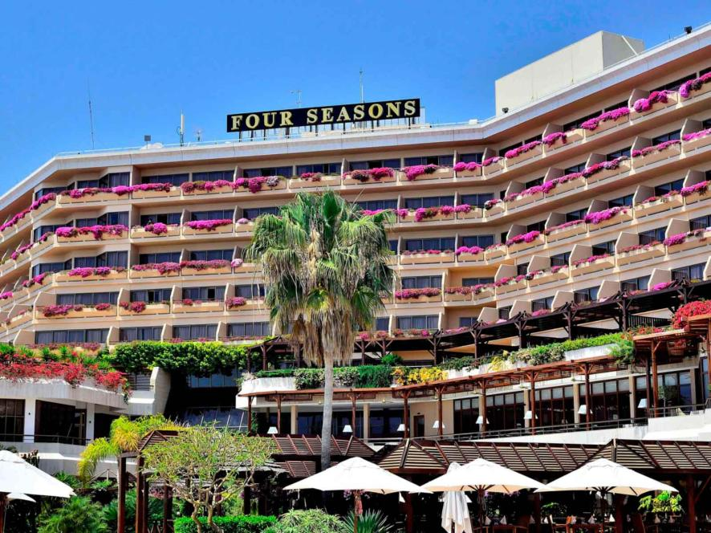
AI Declaration
I acknowledge that I have use AI in this report for research purpose and for the structure of the report.
Executive Summary
Tension between managers and union representatives is causing more labor disputes at the Four Seasons Cyprus Hotel. It damages the overall peace and professionalism necessary for any local luxury hospitality business. Some problems are that employees may get paid less, feel mistreated and worry about the rise in foreign workers replacing local workers. Such tensions harm team morale may lead to a drop-in service and that can disappoint our guests and influence our business performance. Along with the problems related to labor, the hotel deals with issues concerning the environment as well. Many tourists these days are reporting bad environmental incidents which spreads negative impressions and reduces the amount of money hotels earn. Because of the concerns, a thorough investigation was done by using real tools and systems to spot the core problems and suggest actions to fix them. A SWOT analysis helped identify the hotel’s assets, flaws, chances, and pressures. The hotel itself is found to be affected by old facilities and frequent changing of staff which prevents it from keeping its level of service up all the time. Nonetheless, because Four Seasons Hotel Cyprus is known for its lavish services and a reputation for fine care, it enjoys a leading position in its market. There were also many external signs of progress. For example, a rise in regional tourism creates an occasion for the hotel to see more visitors if it manages any challenges internally. Also, new technological tools could improve both the quality of services and operational performance. Even so, a series of problems stand in the way, for example, less tourism when the season is low, poor feedback spreading around and continuous labor disputes.
A STEEP analysis (Social, Technological, Economic, Environmental and Political) was done to help understand the hotel’s situation. Consequently, it pointed out several factors that required swift response. The hotel should implement the latest technology to meet what guests now look for. Because customers are changing in terms of demographics, companies must adjust services by focusing on personalization and more convenient ways of serving. It is important to follow any changes in labor laws and how businesses deal with staff. Social challenges like the employee’s happiness, the way they are treated, and fairness are still being addressed. Because of these findings, it becomes obvious that implementing strategic change is not only choice but also a requirement for the continued success of the hotel. The attitude needs to shift, and it should start by believing that hotel staff are capable of positive change and development. Get rid of practices and workplaces that have been in use for ages to help staff manage the changes. Recognizing and encouraging little achievements such as when more people show up or check in faster, is an important way to push for even better results. After positive changes start to work well, the hotel should stay on track by always finding new ways to improve and train its employees. To ensure improvements last, they must become regular aspects of how the hotel is managed. You can do this by having a good onboarding process, a clear reward and recognition policy and regular performance checks. Because these routines are built into the hotel’s structure, the most recent improvements will always remain.
A well-prepared plan for implementation makes it more likely that plans will be completed. The plan needs to set out clear deadlines and important performance goals. Setting up a labor relations committee and initiating quality improvement projects can be finished between three and six months. Taking these actions would make employees feel more relaxed and encourage everybody to get along better. Alternatively, organizing recruitment activities targeting residents to enhance workers’ chances in Cyprus might take longer, a time of six to eight months. By doing these steps, the hotel can make changes smoothly, without disturbing its ongoing operations. All the costs of solutions are included within the entire report itself. Even though bringing in consultants, updating technology and recruiting new people can be costly at first, the results are well worth it. When staff retention improves, guests are happy and the hotel is full, this will directly enhance the hotel's profit levels. It will be important to track staff turnover, occupancy, Average Daily Rate, Revenue per Available Room and visitor fulfilment ratings regularly to see how things are changing and respond to them. It is important for the hotel to stay flexible and use constant performance reviews plus staff and guest input to compete effectively. A company needs to pay attention to changes in the market and what customers prefer to remain successful. By using real-time and dependable information, the hotel can respond to what customers want and what is happening in the industry. At this time, the Four Seasons Hotel Cyprus is dealing with problems which can be overcome. Proper action plans can enable the hotel to be noticed by travelers in the luxury industry once again. The issues at the Four Seasons Hotel Cyprus prompt management to do something. Taking advantage of weaknesses within the hotel, using outside possibilities, and staying innovative will support the hotel in becoming more solid, effective, and focused on guests. Following this advice will allow the hotel to do well in the present while remaining respected and sought after in the international luxury hotel market. This report’s strategy equips hotel leaders with the knowledge and ability to manage changes in the travel industry.
Table of Contents
1 Introduction 6
2 Analysis 7
2.1 Identified Issue and Its Impacts 7
2.2 Root causes of labour shortage 8
2.3 SWOT ANALYSIS 9
2.4 TOWS ANALYSIS 10
2.5 STEEPLED Analysis 11
3 Recommendations and Change Management 15
3.1 Improve Local Recruitment Efforts 15
3.2 Increase Employee Benefits and Satisfaction 15
3.3 Develop Comprehensive Training Programs 16
3.4 Enhance Labour Relations and Communication 16
3.5 Leverage Technology to Reduce Operational Pressure 17
3.6 Staff management and communication plans 18
3.7 Success metrics and KPI 18
3.8 Change Management Strategy: Kotter's Model 19
3.9 Implementation plan for each recommendation 21
4 Action Plan 22
4.1 COST-BENEFIT ANALYSIS 23
5 Conclusion 24
6 Reference List 26

Introduction
This report concerns the Four Seasons Hotel, Cyprus, a five-star luxury resort situated on Limassol's beachfront. Their international hotel is the Four Seasons, headquartered in Toronto, Canada (Four Seasons, 2024). The hotel is renowned for its diverse range of services, which includes five upscale dining restaurants serving Mediterranean, Asian, and international cuisine, recognized for their culinary excellence (Four Seasons, 2024). The Four Seasons hotel in Cyprus offers approximately 296 rooms, ranging from guest rooms and garden studios to a series of suites designed to suit both leisure and business travelers alike. The hotel was founded in 1994 and underwent its most recent renovation in 2004, maintaining its strong market presence in the Cyprus tourism industry through its commitment to excellence, luxury, and sustainability. The blend of accommodations and family-friendly services has earned the Four Seasons Hotel Cyprus a sought-after destination for international visitors. Although the Four-Season Hotel has a good reputation, the hotel is currently facing some serious management issues. The most prominent issues at the Four Seasons Hotel Cyprus are facing a critical labor shortage (BDigital Web Solutions, 2024). This leads to slow service and a poor guest experience. The hotel has become increasingly dependent on foreign employees, resulting in lower working conditions, fewer rights for domestic employees, and discontent among hotel workers, all of which negatively impact staff morale and the delivery of services. Another key issue is constant labor conflicts, which affect the customer service (Lashley, 2024). The internal problems are showed in guests' reviews, which resulted in slow service, overcrowding at peak times, and inconsistencies in the quality of service. The hotel's five-star, luxury reputation has been damaged due to reviews regarding management issues affecting its well-earned reputation. In addition to the management issues, there has been a decline in tourism in Cyprus, affecting all hotels broadly. This report will describe the issues identified by the hotel, their impact on the hotel and the causes. The report will also include the issues identified by the reviews and their effect on reputation and income. Additionally, its scope will be discussed. In this report, several frameworks and tools are employed to address the issue from multiple perspectives. The first framework used is STEEPLED analysis (Social, Technological, Economic, Environmental, Political, Legal, Ethical, and Demographic). This framework will show how the labor shortage is increasing. Later, a SWOT analysis is conducted, examining the hotel's powers, faults, chances, and dangers. Then, a TOWS analysis, built upon a SWOT study, is applied to increase a deeper insight of the hotel's position and planned selections. To strengthen our analysis, the report incorporates TripAdvisor reviews. After analysis, the report will deliver principal recommendations that the hotel can adopt to address the identified problems. Recommendations will entail improving local recruitment efforts, increasing employee benefits and satisfaction, developing comprehensive training programs, enhancing labor relations and communications, and leveraging technology to reduce operational pressure. Finally, the report will provide a comprehensive action plan with concrete actions the hotel can take to enhance staffing, improve service delivery, improve labor relations, and attract more guests to the hotel despite the prevailing downturn in tourism. The report will conclude with an overview of the findings and the strategic relevance of initiative-taking adjustments in maintaining the Four Seasons Hotel Cyprus as a leading extravagance venue in the industry.

Analysis

Identified Issue and Its Impacts
The current problem the Four-Season Cyprus Hotel is facing is the critical shortage of local employees. Negative publicity for unfair labor practices can deter visitors and erode trust in management (Lenz, 2021). According to Memon et al. (2022), unresolved labor relations can decrease employee self-confidence, negatively impacting productivity and guest satisfaction. A luxury hotel like Four Seasons must maintain its consistency in excellence, or it will compromise its high-end brand image. The Four-Season hotel is increasingly employing foreign workers to address the staffing shortage (Papageorgiou et al., 2024). Still, it is possible that the foreign staff may not be integrated appropriately or trained to fulfil certain guest expectations, particularly in luxury environments (Bharwani and Mathews, 2021). Another key issue is the ongoing labor conflicts between hotel management and workers' unions and disputes over working conditions, wages, and work terms. The union demands the safeguarding of local workers' rights in hiring foreign workers (Volha Yakavenka et al., 2023). Additionally, guests occasionally complain about slow service, overcrowding during busy seasons, and inconsistent service quality. The reviews on TripAdvisor show similar concerns from Summer 2024. One review states that the staff was very inattentive. Another review says, ‘too packed, the rooms are too hot, the service is horrible.’ The feedback on TripAdvisor has significantly disrupted the hotel's image. According to the research of Darvishmotevali et al. (2025) the feedback lowers customers' trust and affects their decisions. Fewer guests mean lower income and lower revenue generation (Jibril and Yeşiltaş, 2022). With fewer visitors, hotels must compete more vigorously, sometimes by offering reduced prices, which can erode profit margins. All these issues reduce the hotel's image and the service quality.

Root causes of labor shortage
The shortage of labor is caused by multiple problems. The hotel tries to hire foreign staff from the Philippines, Sri Lanka, Nepal, Vietnam, and India. However, there are challenges associated with migrant work visas, including complex application procedures, exploitation, labor rights violations, and difficulties in accessing legal recourse and enforcement. There is uncertainty in the flow of tourism, as it has a seasonal nature, with high demand during the summer, resulting in temporary spikes (Jafari et al., 2021). The wages are low, and working conditions are poor, particularly for housekeeping and kitchen staff, with a notable shortage of accommodation for staff.
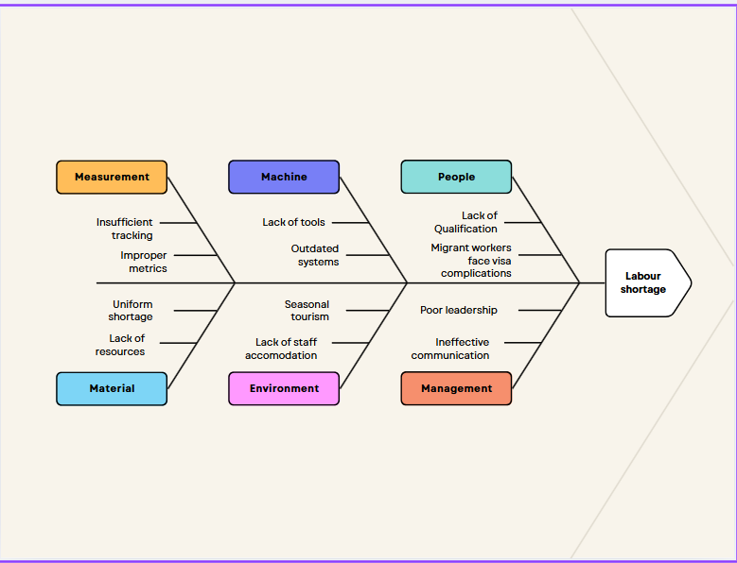

According to the above diagram, the labor shortage is primarily caused by six factors: people, management, environment, machines, measurement, and materials. There is a lack of qualifications, and the migrant workers face complications regarding their visas. The management has poor leadership, and there is an ineffective way of communication. There is a seasonal spike in tourism in Cyprus, and a lack of staff accommodation makes it difficult to attract workers from foreign countries. The hotel has a decline in tool usage and outdated systems, which creates complexity in management, especially during peak seasons. The tracking of inventory and other records is not real-time and up to date. Additionally, the metrics are improper. Furthermore, a shortage of essential supplies, including uniforms and other resources, exacerbates the management conditions.

SWOT ANALYSIS
STRENGTH –The hotel benefits from being associated with the universally recognized Four Seasons reputation, thereby attracting upscale visitors. Its beachfront location in Limassol is attractive to both professional and vacation travelers. The hotel has 296 rooms, five restaurants, a spa, a fitness center, and family facilities, making it stand out in terms of luxury and diversity (Four Season, 2025). The hotel features award-winning restaurants, making it more attractive, especially to gastronomic travelers. | WEAKNESS - A lack of trained local staff and an overreliance on foreign workers leads to operational inefficiencies (Zopiatis and Theocharous, 2022). The infrastructure was last renovated in 2004, potentially putting the hotel at a disadvantage compared to newer competitors in terms of modern design and amenities. Candra et al. (2023) states that, the hotel's renovation affects customer loyalty and occupancy rates. Various guest reviews, especially during high-season periods, indicate difficulties in delivering consistent service levels.
OPPORTUNITIES - The hotel can expand into tourism markets and penetrate new regional markets, such as the Middle East, leading to increased occupancy. Conferences, wellness packages, and local events can help fill hotel rooms during off-peak seasons, generating additional annual revenue. According to Anwar et al. (2024), the digital experience can be enhanced by diversifying digital guardian and guest feedback mechanisms, simplifying services, and improving guest satisfaction. | THREATS - According to the research by Ibnou-Laaroussi et al. (2020), there has been a decline in tourism in Cyprus, resulting in lower international tourist numbers, which in turn leads to lower revenues and increased competition. The continued union tensions and staff discontent pose the risk of operational disruption. According to Yaghi (2024), a risk to reputation stemming from poor reviews or negative media coverage can quickly tarnish a brand's perception in the luxury market.

TOWS ANALYSIS
 | Strengths (S) | Weakness (W)
Opportunities (O) | S-O strategies  - The hotel can leverage its strong brand and culinary excellence by offering customised packages to emerging tourism markets, such as the Middle East and Eastern Europe.  - The sustainable practices should be presented in marketing to attract eco-conscious travellers (Jana et al., 2025).  - According to (Senbeto and Hon, 2021), spa and wellness facilities can attract health and event tourism during off-peak seasons. | W-O strategies  - The hotel should enhance employee development and training by utilising government tourism revival incentives.  - The phased facility upgrades can be initiated without disrupting operations.  - Digital facilities, such as app arrival and innovative controls, can help ease staffing pressures (Alieva et al., 2023)
Threats (T) | S-T strategies  - The hotel’s service excellence and award-winning dining can help businesses stay competitive amid declining tourism.  - The management of online reviews and investment in digital feedback tools will help protect the brand and reduce pressure from limited staffing. | W-T strategies  - Labour shortages can be addressed through partnerships with vocational schools and job centres.  - Services should be streamlined in low seasons to maintain core quality (Sofi et al., 2025).  - The union engagement should be strengthened through open communication.

STEEPLED Analysis
S-social
- Tourism plays an essential role, and the hospitality industry of Cyprus reflects a culturally rich and service-oriented society (Golverdi et al., 2024).
- Social factors influence service quality operations, such as seasonal employment, an ageing workforce, and rising customer expectations.
- There are not enough workers in Cyprus’s hospitality industry because many migrate, and demand increases during summer months which impacts service reliability and efficiency.
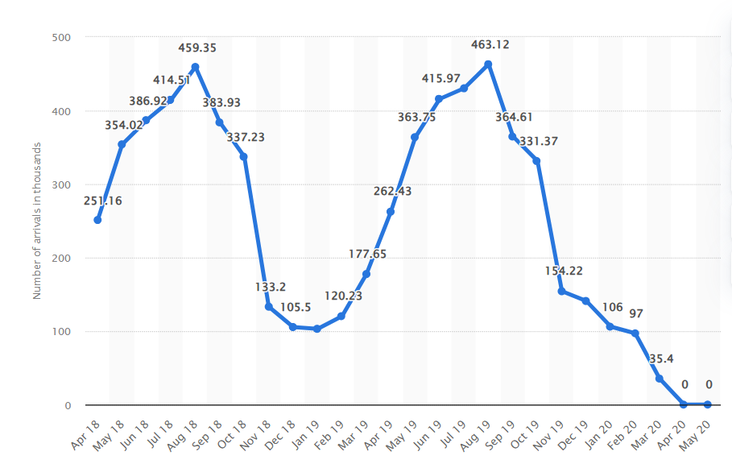
Figure one Monthly arrival in tourist accommodation in Cyprus 2018-2020
SOURCE: Statista (2021).
- In the figure above, it is shown that the arrivals at hotels in March 2020 decreased to thirty-five thousand from 178 thousand logged during the similar period in the previous year. During April and May 2019, there were no arrivals from either local or foreign sources due to the pandemic.
T-Technological
- The hospitality sector in Cyprus is encountering a virtual alteration, driven by the worldwide adoption of online booking arrangements, digital check-in and check-out, innovative room technologies, and real-time guest feedback tools.
- Cypriot hotels are making more use of technology through AI in customer service, analyzing data and energy systems.
E-Economic
- The Cyprus hospitality industry makes an important influence on the country's GDP and relies heavily on tourism, which results in fluctuations in revenue and employment during peak seasons.
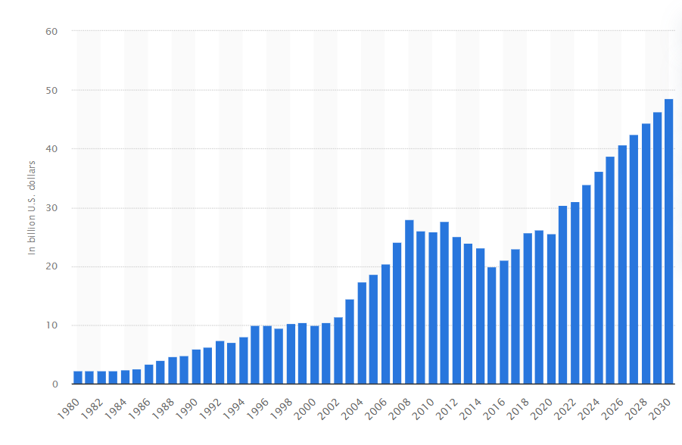
Figure two: Gross domestic product (GDP) in current prices from 1980 to 2030 in Cyprus.
SOURCE: Statista (2025)
- In the figure above, it is shown that there has been a varying rise between 1980 and 2025, with a total rise of almost 36.43 billion U.S dollars. Additionally, there has been an unceasing rise between 2025 and 2030. The GDP will increase by 48.53 billion U.S dollars.
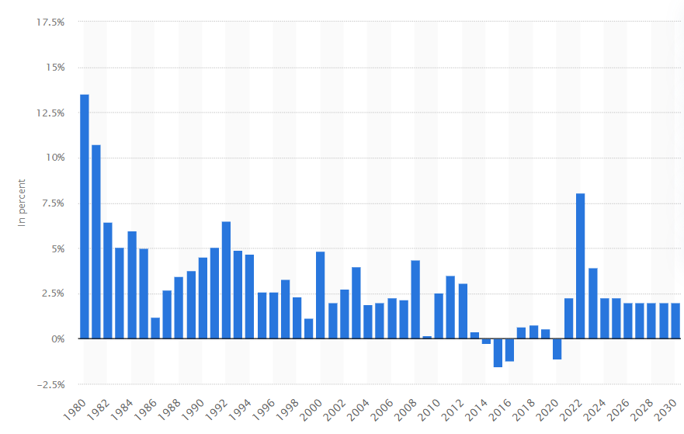
Figure three Average inflation rate from 1980 to 2030 in Cyprus.
SOURCE: Statista (2025)
- The figure shows a shifting decrease between 1980 and 2025 by approximately 11.25%, although the decline was not constant. Inflation is expected to decrease by approximately 0.27% in 2025. The rising inflation in hospitality
- The economic recovery following the pandemic, EU funding, and rising operational costs are influencing the sector (Sanabria et al., 2022).
E-Environmental
- Because of the fluctuating behavior of tourism peaks, the service industry faces environmental challenges, including water shortages, waste management issues, and excessive energy consumption (Mdoda et al., 2024).
- Increasing laws and global sustainability trends are pressuring hotels to adopt ecological practices, such as using solar power, water conservation technologies, and green certifications.
- These attract environmentally conscious travelers and help reduce environmental challenges.
- To fight against future problems in the environment, Cyprus’s hospitality sector is now using eco-friendly buildings, sourcing resources sustainably and adopting strategies that withstand climate change.
P-Political
- The industry operates within a politically stable EU member state, benefiting from pro-tourism government policies and international partnerships.
- Labor and visa regulations primarily affect staffing regarding migrant workers.
- Government approaches support the infrastructure and sustainable tourism development.
- As Cyprus follows EU tourism rules and cooperates with other countries, it gets more funding, better crisis management and improved cross-border travel.
L- Legal
- National laws and EU regulations shape the hospitality industry of Cyprus.
- The key areas include labor law compliance, employee rights, health and safety standards, consumer protection, and environmental regulations (Hu et al., 2021). Hotels must adhere to data protection laws (GDPR), food safety regulations, and licensing requirements to ensure their operations comply.
- Since the EU rules are updated often, Cypriot hospitality businesses must often amend their policies to ensure proper compliance.
E- Ethical
- Cyprus’ hospitality industry is based on fair labor practices, employee welfare, and responsible tourism (Giousmpasoglou, 2024).
- The key issues include the ethical treatment of foreign workers, preventing misuse, and ensuring equal opportunities.
- Environmental responsibility and cultural sensitivity are also emphasized as hotels strive to balance profit with social and ethical impacts.
D- Demographic
- Cyprus's hospitality industry caters to a diverse range of demographics, with tourists primarily coming from the UK, Russia, Germany, and emerging Middle Eastern markets (Cyprus Profile, 2024).
- The local workforce is ageing, and there is an increasing reliance on foreign workers.
- There is a shift in guest demographics, including an increase in solo travelers and eco-conscious millennials, which is enhancing guest expectations.

Recommendations and Change Management

Improve Local Recruitment Efforts
The hotel should maintain a close relationship with local job centers and colleges. They can set up job fairs in their region and are encouraged to apply for jobs in hospitality. Emphasizing what the job offers will inspire others to submit their application. Hiring people from the local community helps guests easily understand their surroundings (Chen et al., 2020). The accommodation needs to cooperate well with the local job centers and colleges. Job fairs are a way for them to encourage people to consider hospitality careers. It was found by Basnyat and Clarence Lao (2020) that staff turnover, reported by the turnover rate, may indicate difficulties in management or among staff. By knowing how much energy the visitors use, the hotel can find out its energy efficiency and where it spends its money and affects the environment negatively (Filimonau and Magklaropoulou, 2020). According to the study of Charalambous and Violaris, (2021) the hotel should cooperate with schools to promote interest in tourism work. Hiring close to home makes it more likely to overcome language and cultural difficulties guests face. The hotel should work closely with local job centers and colleges Dogru et al., (2020); they can run job fairs to attract people to hospitality jobs. They should offer school partnerships to build interest in tourism careers. Highlighting growth and benefits will motivate more people to apply. Hiring locally also reduces language and cultural barriers for guests.

Increase Employee Benefits and Satisfaction
The improvement of the benefits will help attract and retain good hotel staff. Offer bonuses to seasonal staff completing their contracts successfully (Ghani, 2022). Provide staff with meals, wellness support, and transportation to enhance morale. According to Papageorgiou et al., (2024) studies, the hotel must develop staff reward programs to recognize excellent service and attendance. Happy staff means better service and a great guest experience (Padma and Ahn, 2020). Improved benefits will help attract and retain good hotel staff. Offer bonuses for seasonal staff who complete their contracts successfully. Provide staff with meals, wellness support, and transportation to enhance morale. Develop staff reward programs to recognize excellent service and attendance. Happy staff means better service and a great guest experience. Improved benefits will help attract and retain good hotel staff (Jibril and Yeşiltaş, 2022). Offer bonuses for seasonal staff who complete their contracts successfully. Provide staff with meals, wellness support, and transportation to enhance morale. Develop staff reward programs to recognize excellent service and attendance. A happy staff leads to better service and a superior guest experience (Zarezadeh et al., 2022).

Develop Comprehensive Training Programs
The staff must be trained in guest service and professional behavior. The training should include cultural awareness and standards for luxury brands. Regular workshops improve staff performance and reduce complaints (Waqanimaravu and Arasanmi, 2020). Trained staff feel more confident and less likely to leave. Use experienced staff to mentor recruits during training (Volha Yakavenka et al., 2023). All employees need to be taught how to help guests and act professionally. Liasidou et al. (2024) state that employee training must include guest service and professionalism. Luxury hospitality professionals should learn about cultural differences and the industry standards of luxury brands. Iintroducing advanced technology, for example self-check-in and booking systems, will minimize pressure on the staff. These technologies will increase front desk efficiency and lessen administrative workload. Managers can quickly resolve issues by using tech tools to track team performance and visitor happiness in real-time. Workshops held on a regular basis help staff improve and lead to fewer complaints (Garanti and Stylianou, 2022). When staff feel prepared through training, their likelihood of staying higher. The experienced staff will mentor recruits during training. Staff must be trained in guest service and professional behavior. Training should include cultural awareness and standards for luxury brands.

Enhance Labor Relations and Communication
The hotel should listen to staff concerns and meet with unions. Open communication fosters trust between workers and management Prikshat et al., (2020). Review wage policies and job terms to avoid future disputes. Involve employees when planning new schedules or contract updates. This reduces strikes and improves the workplace atmosphere for all. The hotel should listen to staff concerns and meet with unions. Open communication fosters trust between workers and management (Rahimizhian and Irani, 2025). The hotel should listen to staff concerns and meet with unions. Open communication builds trust between workers and management. Review wage policies and job terms to avoid future disputes. Involve employees when planning new schedules or contract updates. This reduces strikes and improves the workplace atmosphere for all. The hotel should listen to staff concerns and meet with unions. Open communication fosters trust between workers and management (Guzzo et al., 2021). Review wage policies and job terms to avoid future disputes. Involve employees when planning new schedules or contract updates. This reduces strikes and improves the workplace atmosphere for all.

Leverage Technology to Reduce Operational Pressure
The hotel software is used to manage bookings and reduce front desk load. The self-check-in kiosks are particularly helpful during peak check-in periods. The technology lets managers quickly track performance and guest satisfaction (Buhalis et al., 2024). This helps to prevent mistakes and enhances the overall service speed. Hand booking and related work over to hotel software to ease the pressures on the front desk. According to Papademetriou et al., (2023) ttechnology allows managers to observe the company’s performance and immediately entertain the guests. As a result, fewer mistakes happen, and service is faster. The software helps with bookings so that the front desk is not as busy. According to the studies of Osadare et al. (2024), technology enables managers to track performance and guest satisfaction quickly. This also reduces mistakes and improves the overall service speed. Digital systems reduce paperwork and save daily staff time (Oliinyk et al., 2022). Papademetriou et al. (2024) suggest that technology allows managers to track performance and guest satisfaction quickly. This also reduces mistakes and improves the overall service speed. Hotels should show how they care about social responsibility by getting involved with important groups and causes. The presence of supportive leaders matters a lot; managers are expected to support open conversations and help staff members grow.

Staff management and communication plans
Four Seasons Cyprus should have a comprehensive strategy that prioritizes employee development, well-being, and recognition to improve staff management and communication. Build a program focused on learning from feedback, regularly review your staff’s performance and let them keep learning and aim for career advancements. The hotel should offer training employees in areas of business culture, the product, welfare, health and safety and relatable laws. To run effective training and meet what staff desires, the hotel must collect and analyze input regularly (El-Said, Al Hajri and Smith, 2020). Letting run know about critical information by using clear procedures is an effective way to improve the overall communication system (Putra and Law, 2023). Some of the ways to inform staff about HR issues are through newsletters, the intranet and team meetings. It can conduct regular performance reviews and gather feedback on issues that need improvement and how happy workers are. The hotel should focus on competitive advantages like support programs for employees, so there is a stronger focus on managing employees (Elrehail et al., 2020). The hotel can recognize its outstanding workers by giving them Employee of the Month or Employee of the Year awards.

Success metrics and KPI
The main things to monitor at The Four Seasons Hotel Cyprus are how happy clients are, the financial results and how smoothly everything is operated. Success indicators are strongly influenced by the occupancy rate, average daily rate (ADR), revenue per available room (RevPAR), how happy staff and visitors are, and comments made on hotels’ online reviews. A full house usually reflects that many people are determined to spend with the business. The ADR shows how much each room sells for every day it is occupied. It makes it easier to check how pricing strategies shape the sales process. Revenue per available room (RevPAR) helps to uncover occupancy and ADR in one calculation. Surveys, feedback forms and online reviews can be used to increase guest satisfaction by learning what guests think and how they feel about the services provided (Li et al., 2020). In addition, checking evaluations on online platforms such as TripAdvisor and Google Reviews helps to choose where improvements are needed and check how guests feel. The upselling revenue tracks the money made from upselling visitors to more expensive accommodations or facilities. Finally, the hotel must measure the average price paid for rooms to provide insights into pricing strategies.

Change Management Strategy: Kotter's Model
- Create a Sense of Urgency
Employees should be informed about lost revenue, staff shortages, and visitor concerns (Karsavuran, 2020). This will make it more straightforward to everyone why quick action is necessary for stability and long-term success.
- Form a Powerful Coalition
Union representatives, managers, and HR directors should collaborate (Marneros et al., 2020). This team will spearhead the transformation and guide others through it, guaranteeing open communication, respect for one another, and steady advancement in every sector.
- Create a Vision for Change
The hotel's objectives must be well-defined. Strategies to provide better service and increase efficiency, guest satisfaction, employee engagement, and long-term business success include employing local personnel, improving training, and utilizing modern technology.
- Communicate the Vision
The leadership should communicate this vision through regular meetings, posters, and email updates to ensure widespread awareness and understanding (Shen, Qian and Chen, 2020). Regular updates help keep everyone focused and involved.
- Empower Employees for Action
The hotel should take down any obstacles preventing development (Demetriou, 2022). This could entail fostering a culture of continuous development, increasing adaptation, lowering resistance, revising policies, and providing training to help employees feel comfortable using new systems.
- Create Quick Wins
Early, modest victories contribute to the development of trust in the change process. For instance, better staff attendance or quicker check-in should be highlighted to inspire workers, reward good conduct, and highlight the advantages of continuous development.
- Build on the Change
To promote long-term growth, maintain momentum, and integrate change into day-to-day operations, keep refining hiring, training, and the visitor experience based on performance and feedback.
- Anchor the Changes in Culture
This includes using them in job training, staff reviews, and promotions to ensure consistency, reinforce expectations, drive accountability, and support continuous organizational excellence.
Change Management Strategy: STAR Model
The STAR model developed by Edward Lawler is a strategic organizational design framework (Mohrman and Worley, 2025). This model focuses on the five key components, such as the Strategy, Structure, Processes, Rewards, and People. Applying this model to Four Seasons Hotel Cyprus helps to address labor and service quality issues holistically:
- Strategy: The hotel must align all HR and service operations with its luxury brand promise and guest satisfaction objectives. This includes prioritizing local recruitment and employee wellbeing.
- Structure: Redesign team hierarchies to support decentralized decision-making and promote better union-management communication.
- Processes: Implement clear performance evaluation, training, and service delivery protocols to standardize quality.
- Rewards: Develop incentive systems linked to performance and customer feedback to boost employee morale.
- People: Invest in talent development programs, focusing on hiring locally and building employee skills aligned with guest expectations.

Implementation plan for each recommendation
Pointing out the career benefits and plus points of working at the hotel will appeal to more locals (Seyedabolghasemi et al., 2022). This means reduced language and cultural challenges that improve the chances of lasting employment. People with more experience in the industry should guide junior coworkers and the team needs to attend workshops often to keep their knowledge up to date. Employees will feel better, stay with the company longer and visitors should have fewer issues. It is especially important to strengthen labour relations. Management should meet regularly with unions and workers to keep the conversation honest (Katemliadis et al., 2021). Reviewing how salaries are determined and allowing employees to be included in making schedules can make the workplace more pleasant and frictionless. According to Mousavi (2022), training on hotel principles, safety rules, and sustainability should be part of any effective staff communication program. Newsletters and performance assessments will regularly keep staff members informed and involved. Excellence will be rewarded through recognition programs like "Employee of the Month." KPIs will be used to measure success, including occupancy rate, guest reviews, staff satisfaction, and operational effectiveness. These indicators will direct ongoing development and guarantee that modifications become ingrained in the hotel's culture.

Action Plan
Problem | Solution | Outcome | Timeframe
Employee shortage | Launch local talent hunt initiative, partner with local colleges | Attract and retain qualified local talent | 6-8 months
Negative feedback | Hire an HR and ethics consultant, and establish a labor relations committee | Build trust internally and externally, and improve workplace culture | 3 months
Continued labor conflicts | Implement a quarterly labor review form | Better communication and stable operations | 6 months
Service quality decline | Hire a guest experience manager, real-time service feedback | Higher guest satisfaction, better reviews | 3 months

Four key issues that need to be addressed immediately and strategically are pursuing the Four-Season Cyprus Hotel. The first problem is that a chronic staffing shortage has impacted the hotel's operations. Implementing this solution should take six to eight months, which will give the hotel enough time to hire, train, and integrate inexperienced staff members into the operations. The second issue is the rise in unfavourable comments, especially from employees. Unresolved disputes with the labour union, which have been interfering with day-to-day operations, are the third problem. The last issue is the apparent drop in service quality, which is a major concern in the hotel sector.

COST-BENEFIT ANALYSIS
DECISION | ESTIMATED COST (€) | TIMEFRAME | EXPECTED BENEFITS
Local talent recruitment | 2000-4000 | Quarterly events | There will be reduced hiring fees for the agencies, and staff retention will be enhanced.
Increase employee benefits | 15,000-25,000 | 3-6 months | Workplace morale will improve, and increased guest satisfaction
Develop training programs | 10,000-15,000 | 3-month | There will improvement in services resulting in lower complaints.
Enhance labor relations | 3,000-5,000 | 1-2 months | Fewer disputes will improve communication and trust.
Use of Technology | 30,000-50,000 | 4-6 months | The efficiency will be increased, service will be faster, and the workload will be reduced.
Staff Management and Communication | 7,000-10,000 | 3 months | It will enhance culture and develop better sustainability practices. It will also help in communicating clearly.

This cost benefit analysis table is developed to tackle the main difficulties faced by the Four-Season Hotel, Cyprus. The labor shortage is the main issue, and the leading solution is to conduct a talent hunt program. The second issue is known as negative feedback. The solution suggested is to hire someone who specializes in HR and ethics to audit labor practices and start developing an agreement between employees and employers, under the supervision of a labor relations committee. The third issue is that the public keeps experiencing labor disputes, which can lead to inefficiency, so a quarterly version of the labor review form is needed. The last main issue is that most complaints relate to poor service quality, and the answer suggested is to hire an experienced manager and receive feedback in real time.

Conclusion
The hotel faces big constraints, but these are not impossible to address. Several urgent areas where fast and thoughtful action is required have been identified in this report. What mostly causes the hotel to become unstable is a shortage of dedicated and qualified employees. Because there is too much reliance on foreign workers, problems in employee management and less focus on training, the problem has gotten worse. Because of the seasonal tourism and flow of visitors, old technology and tension between staff, the hotel is finding it harder to maintain its reputation and lofty standards. The research includes comprehensive and important advice. Company policies often cover hiring locally, providing better welfare and benefits, creating multiple training programs, connecting with unions, and using technology to lower paperwork. They use strategies that come from feasible steps guided by research and industry trends. A hotel might find local workers by working with organizations and technical schools in its area. For example, including things like programs for health and easier commutes can enhance how happy employees are and decrease how often they leave the company. The research includes comprehensive and important advice. Company policies often cover hiring locally, providing better welfare and benefits, creating multiple training programs, connecting with unions, and using technology to lower paperwork. They use strategies that come from feasible steps guided by research and industry trends. A hotel might find local workers by working with organizations and technical schools in its area. Looking after labor relations should also be given priority. It is especially important for management and employees to have a culture where respect and trust exist between them. Managing workforce stability in a hotel can be achieved by noticing what workers do and involving them in decision-making (Cizrelioğulları and Babayiğit, 2022). Tracking the results of actions and offering feedback often helps to identify issues early and manage them carefully. Rather than replacing employees, technology here supports staff in meeting guests and following procedures better. The suggested implementation strategy guarantees that every suggestion is measurable and actionable with precise metrics and reasonable deadlines. Tracking the results of actions and offering feedback often helps to identify issues early and manage them carefully. Rather than replacing employees, technology here supports staff in meeting guests and following procedures better. The suggested implementation strategy guarantees that every suggestion is measurable and actionable with precise metrics and reasonable deadlines. The report describes how to convey urgency, build coalitions, share visions, and maintain momentum using Kotter's change management framework. Crucially, these efforts must become fixed in the hotel's everyday operations and culture rather than temporary solutions. The Four Seasons Hotel Cyprus's long-term viability rests on its capacity to adjust, pay attention to its employees, and continuously fulfil its brand promise. With an initiative-taking, organized, and inclusive approach to change, the hotel will fix current problems and prepare for upcoming industry difficulties.

Reference List
Alieva, V.S., Maksimenko, L.S. and Godina, O.V. (2023). Technological innovations and digitalization affect the competitiveness of hospitality industry enterprises. Vestnik Voronežskogo gosudarstvennogo universiteta. Seriâ èkonomika i upravlenie, (3), pp.19–32. Doi: https://doi.org/10.17308/econ.2023.3/11388.
Anwar, F.A., Deliana, D. and Suyamto, S. (2024). Digital Transformation in the Hospitality Industry: Improving Efficiency and Guest Experience. International Journal of Management Science and Information Technology, [online] 4(2), pp.428–437. Doi: https://doi.org/10.35870/ijmsit.v4i2.3201.
Basnyat, S. and Clarence Lao, C.S. (2020). Employees’ perceptions on the relationship between human resource management practices and employee turnover. Employee Relations: The International Journal, 42(2), pp.453–470. Doi: https://doi.org/10.1108/er-04-2019-0182.
Buhalis, D., Efthymiou, L., Uzunboylu, N. and Thrassou, A., (2024). Charting the progress of technology adoption in tourism and hospitality in the era of industry 4.0. EuroMed Journal of Business, 19(1), pp.1-20. https://doi.org/10.1108/EMJB-11-2023-0310
Candra, P., Mahaputra, M.R. and Mahaputra, M.R. (2023). Service Quality and Customer Satisfaction Have an Impact on Increasing Hotel Room Occupancy Ratio: Literature Review Study. Greenation International Journal of Tourism and Management, [online] 1(4), pp.400–412. Doi: https://doi.org/10.38035/gijtm.v1i4.127.
Charalambous, C. and Violaris, J., (2021). Support for environmental, social, and economic tourism industry development in Cyprus. Worldwide Hospitality and Tourism Themes, 13(6), pp.719-730. https://doi.org/10.1108/WHATT-07-2021-0094
Chen, Y.-L., Chen, J., Liu, W.-Y. and Sharma, T. (2020). Expected benefits of people interactions and guest experiences. International Hospitality Review, ahead-of-print(ahead-of-print). Doi: https://doi.org/10.1108/ihr-04-2020-0010.
Cizrelioğulları, M.N. and Babayiğit, M.V. (2022). Effects of High-Performance Work System on Job Satisfaction: The Mediating Role of Psychological Capital in the Hotel Employees of North Cyprus. Journal of Tourism and Services, 13(24), pp.43–70. Doi: https://doi.org/10.29036/jots.v13i24.284.
Cyprus Profile (2024). Tourism. [online] www.cyprusprofile.com. Available at: https://www.cyprusprofile.com/sectors/tourism.
Demetriou, P. (2022). Hotel food waste in Cyprus: An exploratory case study of hotels in Limassol. Cogent Social Sciences, 8(1). Doi: https://doi.org/10.1080/23311886.2022.2026556.
Dogru, T., McGinley, S., and Kim, W.G. (2020). The effect of hotel investments on employment in the tourism, leisure, and hospitality industries. International Journal of Contemporary Hospitality Management, 32(5), pp.1941–1965. Doi: https://doi.org/10.1108/ijchm-11-2019-0913.
Elrehail, H., Harazneh, I., Abuhjeeleh, M., Alzghoul, A., Alnajdawi, S. and Ibrahim, H.M.H. (2020). Employee satisfaction, Human Resource Management Practices and Competitive Advantage. European Journal of Management and Business Economics, [online] 29(2), pp.125–149. Doi: https://doi.org/10.1108/EJMBE-01-2019-0001.
El-Said, O.A., Al Hajri, B. and Smith, M., (2020). An empirical examination of the antecedents of training transfer in hotels: the moderating role of supervisor support. International Journal of Contemporary Hospitality Management, 32(11), pp.3391-3417. https://doi.org/10.1108/IJCHM-04-2020-0262
Filimonau, V. and Magklaropoulou, A. (2020). Exploring the viability of a new ‘pay-as-you-use’ energy management model in budget hotels. International Journal of Hospitality Management, 89, p.102538. Doi: https://doi.org/10.1016/j.ijhm.2020.102538.
Four seasons (2024). Dine in Style | Restaurants in Limassol. [online] Fourseasons.com.cy. Available at: https://www.fourseasons.com.cy/dine-in-style.
Four Seasons (2024). Four Seasons History | Four Seasons Luxury Hotels and Resorts. [online] www.fourseasons.com. Available at: https://www.fourseasons.com/about_four_seasons/four_seasons_history/.
Four Seasons (2025). Service Culture. [online] Fourseasons.com. Available at: https://www.fourseasons.com/about_four_seasons/service_culture/.
Garanti, Z. and Stylianou, C. (2022). Opening the path of gastro-tourism cluster development: the case of Cyprus. Worldwide Hospitality and Tourism Themes, 14(5), pp.492–500. Doi: https://doi.org/10.1108/whatt-07-2022-0076.
Ghani, B., Zada, M., Memon, K.R., Ullah, R., Khattak, A., Han, H., Ariza-Montes, A. and Araya-Castillo, L., (2022). Challenges and strategies for employee retention in the hospitality industry: A review. Sustainability, 14(5), p.2885. https://doi.org/10.3390/su14052885
Giousmpasoglou, C., (2024). Working Conditions in the Hospitality Industry: The Case for a Fair and Decent Work Agenda. Sustainability, 16(19), p.8428. https://doi.org/10.3390/su16198428
Golverdi, M., Sharifirad, M.S. and Rastegar, R., (2024). Mapping organisational justice in tourism, hospitality, and events literature: An in-depth scoping review. Journal of Hospitality and Tourism Management, 60, pp.22-32. https://psycnet.apa.org/doi/10.1016/j.jhtm.2024.06.004
Guzzo, R.F., Wang, X., Madera, J.M. and Abbott, J., (2021). Organizational trust in times of COVID-19: Hospitality employees’ affective responses to managers’ communication. International Journal of Hospitality Management, 93, p.102778. https://doi.org/10.1016/j.ijhm.2020.102778
Hu, X., Yan, H., Casey, T., and Wu, C.H., (2021). Creating a safe haven during the crisis: How organizations can achieve deep compliance with COVID-19 safety measures in the hospitality industry. International Journal of Hospitality Management, 92, p.102662. https://doi.org/10.1016/j.ijhm.2020.102662
Ibnou-Laaroussi, S., Rjoub, H. and Wong, W.K., (2020). Sustainability of green tourism among international tourists and its influence on the achievement of green environment: Evidence from North Cyprus. Sustainability, 12(14), p.5698. https://doi.org/10.3390/su12145698
Jafari, K., Özduran, A. and Saydam, M.B. (2021). Hospitality and tourism industry amid COVID-19 pandemic: voices from small Mediterranean town. International Hospitality Review, [online] ahead-of-print(ahead-of-print). Doi: https://doi.org/10.1108/ihr-07-2021-0054.
Jana, A., Shandilya, G. and Srivastava, P., (2025). Eco-conscious luxury: decoding the preferences of affluent travellers in sustainable hospitality. Journal of Hospitality and Tourism Insights, 8(5), pp.1717-1739. https://doi.org/10.1108/JHTI-04-2024-0375
Jibril, I.A. and Yeşiltaş, M. (2022). Employee Satisfaction, Talent Management Practices and Sustainable Competitive Advantage in the Northern Cyprus Hotel Industry. Sustainability, 14(12), p.7082. Doi: https://doi.org/10.3390/su14127082.
Karsavuran, Z. (2020). Surviving a major crisis: the case of dismissed tourism and hospitality employees. Journal of Policy Research in Tourism, Leisure, and Events, 13(2), pp.243–265. Doi: https://doi.org/10.1080/19407963.2020.1787421.
Katemliadis, I., Kolongou, E.S. and Drousiotis, P. (2021). Rising sustainability standards: the Cyprus Sustainable Tourism Initiative. Worldwide Hospitality and Tourism Themes, ahead-of-print(ahead-of-print). Doi: https://doi.org/10.1108/whatt-07-2021-0096.
Lashley, C. (2024). Conflict and Hostility in Hotels, Restaurants, and Bars. Taylor & Francis.
Lenz, R. (2021). ‘Hotel Royal’ and other Spaces of Hospitality. Routledge eBooks, pp.209–229. Doi: https://doi.org/10.4324/9781003087229-10.
Li, H., Liu, Y., Tan, C.-W. and Hu, F. (2020). Comprehending customer satisfaction with hotels. International Journal of Contemporary Hospitality Management, [online] 32(5). Doi: https://doi.org/10.1108/ijchm-06-2019-0581.
Liasidou, S., Afxentiou, G., Malkawi, E. and Antoniades, G., (2024). Attesting to hotel employees' professionalism: views and perceptions of managers. EuroMed Journal of Business, 19(4), pp.720-735. https://doi.org/10.1108/EMJB-04-2022-0075
Mahlagha Darvishmotevali, Hasan Evrim Arici and Mehmet Ali Koseoglu (2024). Customer satisfaction antecedents in uncertain hospitality conditions: an exploratory data mining approach. Journal of hospitality and tourism insights. Doi: https://doi.org/10.1108/jhti-11-2023-0845.
Marneros, S., Papageorgiou, G. and Efstathiades, A. (2020). Identifying key success competencies for the hospitality industry: the perspectives of professionals. Journal of Teaching in Travel & Tourism, 20(4), pp.1–25. Doi: https://doi.org/10.1080/15313220.2020.1745732.
Mdoda, S.S., Dube, K. and Montsiemang, T., (2024). Tackling Water and Waste Management Challenges Within the Tourism and Hospitality Industry: A Sustainable Development Goals Perspective. Water, 16(24), p.3545. https://doi.org/10.3390/w16243545
Memon, K.R., Ghani, B. and Han, H., (2025). Customer-oriented front-line employees' voice behaviours in the hospitality industry: a comprehensive literature review. Journal of Hospitality and Tourism Insights, 8(2), pp.572-611. https://doi.org/10.1108/JHTI-01-2024-0020
Mohrman, S. A., and Worley, C. G. (2025). Socio-Technical Organization Design in the Digital Era: A Collaborative Exploration. In Research in Organizational Change and Development (pp. 59-88). Emerald Publishing Limited.
Mousavi, S.A. (2022). Sustainable Hotel Building Local Assessment Model: A Case of Northern Cyprus. Sustainability, 14(19), p.12752. Doi: https://doi.org/10.3390/su141912752.
Oliinyk, O., Krasovskyi, S., Vasylenko, O., Prykhod'ko, K., Pliuta, O. and Tonkykh, O., (2022). Digitalization of business processes in the hospitality industry. Economic Affairs, 67(4s), pp.725-733. DOI:10.46852/0424-2513.4s.2022.6
Osadare, O.O., Akande, O.N., Soladoye, A.A. and Sobowale, P.O., (2024). Smart Hospitality: Leveraging Technological Advances to enhance Customer Satisfaction. FUOYE Journal of Engineering and Technology, 9(3), pp.553-557.https://doi.org/10.4314/fuoyejet.v9i3.28
Padma, P. and Ahn, J. (2020). Guest satisfaction & dissatisfaction in luxury hotels: An application of big data. International Journal of Hospitality Management, 84, p.102318. Doi: https://doi.org/10.1016/j.ijhm.2019.102318.
Papademetriou, C., Ragazou, K. and Garefalakis, A., (2023), April. Adapting Artificial Intelligence in Cypriot Hotel Industry: The Views of Hotel Managers. In Eurasia Business and Economics Society Conference (pp. 143-155). Cham: Springer Nature Switzerland. https://doi.org/10.1007/978-3-031-64140-4_8
Papademetriou, C., Ragazou, K. and Garefalakis, A., (2024). Adapting Artificial Intelligence in Cypriot Hotel Industry: The Views of Hotel. In Eurasian Business and Economics Perspectives: Proceedings of the 43rd Eurasia Business and Economics Society Conference (p. 143). Springer Nature.
Papageorgiou, G., Marneros, S. and Efstathiades, A., (2024). Predicting career success in the hospitality industry of Cyprus: A competency-based approach. Journal of Teaching in Travel & Tourism, 24(3), pp.236-268. http://dx.doi.org/10.1080/15313220.2024.2341616
Prikshat, V., Rajesh, J.I. and Rajaguru, R. (2020). The growth satisfaction in jobs among hospitality employees: the role of transformational leadership, interpersonal communication satisfaction and trust. Journal of Human Resources in Hospitality & Tourism, 20(1), pp.1–27. Doi: https://doi.org/10.1080/15332845.2020.1821427.
Putra, K. and Law, R. (2023). Critical success factors for virtual hotel operator partnership with small- and medium-sized hotels: perspectives of owners and operators. Journal of hospitality and tourism insights. [online] Doi: https://doi.org/10.1108/jhti-06-2022-0244.
Rahimizhian, S. and Irani, F. (2025). Unlocking Northern Cyprus: innovations in destination management for enhanced tourism experiences. Research in Hospitality Management, 15(2), pp.119–123. Doi: https://doi.org/10.1080/22243534.2025.2465413.
Sanabria-Díaz, J.M., Aguiar-Quintana, T. and Araujo-Cabrera, Y. (2021). PUBLIC STRATEGIES TO RESCUE THE HOSPITALITY INDUSTRY FOLLOWING THE IMPACT OF COVID-19: A CASE STUDY OF THE EUROPEAN UNION. International Journal of Hospitality Management, 97, p.102988. Doi: https://doi.org/10.1016/j.ijhm.2021.102988.
Senbeto, D.L. and Hon, A.H.Y. (2021). Shaping organizational culture in response to tourism seasonality: A qualitative approach. Journal of Vacation Marketing, p.135676672110067. Doi: https://doi.org/10.1177/13567667211006759.
Seyedabolghasemi, Maryam Alsadat, et al. “Residents’ Perceptions of Sustainable Tourism Destination Recovery: The Case of Northern Cyprus.” Land, vol. 11, no. 1, 7 Jan. 2022, p. 94, https://doi.org/10.3390/land11010094. Accessed 28 Jan. 2022.
Shen, L., Qian, J. and Chen, S.C. (2020). Effective Communication Strategies of Sustainable Hospitality: A Qualitative Exploration. Sustainability, [online] 12(17), p.6920. Available at: https://www.mdpi.com/2071-1050/12/17/6920.
Sofi, M.R., Bashir, I., Alshiha, A., Alnasser, E. and Alkhozaim, S., (2025). Creating exceptional guest experiences: the role of engagement and relationship building in hospitality. Journal of Hospitality and Tourism Insights, 8(3), pp.891-914. https://doi.org/10.1108/JHTI-04-2024-0318
Statista (2020). Monthly tourist arrivals in Cyprus 2020| Statista. [online] Statista. Available at: https://www.statista.com/statistics/1130972/number-of-monthly-arrivals-short-stay-accommodation-in-cyprus/ [Accessed 22 May 2025].
Statista (2025). Cyprus - Gross domestic product (GDP) 2028. [online] Statista. Available at: https://www.statista.com/statistics/382104/gross-domestic-product-gdp-in-cyprus/.
Statista (2025). Cyprus- Inflation rate 2021. [online] Statista. Available at: https://www.statista.com/statistics/382109/inflation-rate-in-cyprus/.
TripAdvisor (2024). Four Seasons Hotel Cyprus Reviews. [online] Available at: https://www.tripadvisor.com/Hotel_Review-g190382-d231436-Reviews-Four_Seasons_Hotel-Limassol.html [Accessed 15 Jun 2025].
Volha Yakavenka, Vlachos, D., Papadopoulos, A.M., Tomáš Klieštik, Yianna Orphanidou, Leonidas Efthymiou and Psilla, D. (2023). Features of Foreign Working Force for Cypriot Hotel Industry. Springer proceedings in business and economics, pp.231–242. Doi: https://doi.org/10.1007/978-3-031-29426-6_14.
Waqanimaravu, M. and Arasanmi, C.N. (2020). Employee training and service quality in the hospitality industry. Journal of Foodservice Business Research, 23(3), pp.216–227. http://dx.doi.org/10.1080/15378020.2020.1724850.
Yaghi, S., (2024). The Impact of Brand Reputation on Consumers’ Readiness to Pay a Premium: An Analysis in the Hospitality Sector. In AI in Business: Opportunities and Limitations: Volume 2 (pp. 241-250). Cham: Springer Nature Switzerland. https://doi.org/10.1007/978-3-031-49544-1_21
Zarezadeh, Z. Z., Rastegar, R., and Xiang, Z. (2022). Big data analytics and hotel guest experience: a critical analysis of the literature. International Journal of Contemporary Hospitality Management, 34(6), 2320-2336. https://doi.org/10.1108/IJCHM-10-2021-1293
Zopiatis, A. and Theocharous, A.L. (2020). Career change in a small island tourism destination: evidence from former hospitality managers. International Journal of Hospitality & Tourism Administration, pp.1–26. Doi: https://doi.org/10.1080/15256480.2020.1862017.

