Title: A comparison of marketing methods of two multinational hotel brands
(Six Senses and Moxy)
Name: Marian Bogdan Staicu
Student ID: 2234128
Module: Marketing Essentials
Module code: BMIH4005
Lecturer: Luciana Sardi
Word Count: 1601 words

Introduction:
Globalization has allowed brands to grab opportunities that were not possible before; globalization and international trade have allowed businesses to develop, especially the hospitality industry, boosted by the growth in tourism (Frank and Watchravesringkan, 2016). The competition among multinational hotel brands has increased, and these brands are involved in adopting new ideas to capture the consumer market. Six Senses were started in the 1990s, and it set a benchmark in the hospitality industry by providing quality and offering services to consumers to bring them away and reconnect them with themselves. Six Senses aim to adopt responsible practices and offer exotic resorts, spas, private clubs and luxury residency options for consumers. Six Senses’ services are based on the view of setting the resort's location near nature and attractive destinations to provide a quality experience to the consumers. It is recognized for its exceptional services to guests in remote locations, i.e., majestic mountains, romantic valleys and coral-fringed bays (Six Senses, 2023). Moxy is a Marriott brand which was started in 2014 in Milan; it is designed to capture the growing markets, especially the new generation travellers; the brand is designed as contemporary and stylish designs through integrating new technology and setting affordable prices to attract the targeted consumers. Moxy hotels are designed to meet expectations, and it provides a friendly environment. Its most prominent feature is the bars, which offer complimentary cocktails to their consumers. It is designed for people who like nightlife (Moxy, 2023). Both multinational brands offer different services and target different consumers, whereas the essay aims to evaluate and compare the marketing strategies of both brands.

Main Body:
Since both companies belong to the hospitality industry, analysing it’s external environment is important. Firstly, the British government is stable and leads to high revenue. However, even though the economy is robust and getting back to its feet after the pandemic, the hospitality industry still has a long way to go because of travel bans (Ntounis et al., 2022). However, things are going back to normal. Furthermore, the sector is also influenced by sustainability, which gains popularity regularly. Proof can be seen in Appendix 8. Because of this, customers are also growing more aware about environmental impacts, and they would prefer hotels that know where its loyalties should lie. Besides that, the growing trend of technological adoption has eased things for the companies and its customers with the introduction of online reservations, chatbots, and mobile applications for better guest services (Eissner and Gannon, 2018). According to this, Six Senses’ main strength is its excellent spas and luxury resorts, which resonate with its personal, sustainable, and realistic style. However, since it focuses more on the ambiance, its brand image gets affected. The company grew even further by adopting technological processes for enhanced customer services. But while doing so, it needs to stay vigilant about the industrial competition.
On the contrary, Moxy’s biggest strength is its parent organization, Marriott, which ensures all financial support is attained. However, its weakness is its price, which are high in contrast to its business, which leaves a negative impact on customers. Nevertheless, it can expand its portfolio and collaborate with other Marriott brands to welcome a more diverse audience. But it should also stay mindful of the competition like Six Senses. Moving on, coming to Bowman’s Strategy Clock (refer to appendix 6), which is a handy tool to use for comparison, it can be observed that Six Senses falls in the hybrid quadrant while Moxy does so on focused differentiation. The difference resides in how Six Senses tries to concentrate on offering low prices while Moxy does so with high prices, thus creating a sense of differentiation in both.
Furthermore, both companies can also be analyzed via the marketing mix, or the 7 Ps. Product: Six Senses offers resorts, spa escapes and five-star hotels. It also provides early booking and discounts option of extended stay. Beauty and rejuvenation treatments, and services of experts for travellers are also offered (Sobol et al., 2018). On the other hand, Moxy hotel offers stylish rooms, bars and amenities. The rooms are designed to attract party-loving people. Moxy offers a common space for people’s interactions, and 24/7 Grab and go options. Consumers can easily book their rooms and enjoy (Privitera et al., 2015). Price: Six Senses offer high prices because it focuses on luxury services for consumers, such as free parking and pets allowed. On average, the price for a deluxe double room is $8912 (Piuchan and Prachansit, 2019). On the other hand, Moxy offers a flexible pricing strategy as it targets youngsters and offers reasonable prices and different options like rooms, lobbies and bars. The mixed guest room with 1 queen is $3,288 per night. The differences in the pricing strategy are visible. Place: Six Senses have expanded its business in the international market, mainly in the Pacific, Europe, and Middle East Africa (Ting, 2018). At the same time, Moxy has hotels in Asia, Australia and the Pacific, Europe and North America. In Asia, Moxy is present in 16 countries; it only has 1 hotel in Australia; in Europe, Moxy owns 83 hotels and 34 in North America (Saleem et al., 2016). Promotion: The marketing choice for the Six Senses and Moxy change based on trends and preferences. Both brands, at their early stage, use traditional marketing strategies like public relations, Advertisements and billboards and outdoor advertising. Six Senses promote thorough discounts offerings of up to 10 nights of free stay or reward club points (Anwar et al., 2021). Whereas the Moxy hotel also invests in advertisements on television and designs different campaigns. Appendix 1 shows the traffic of both companies based in different countries. Moxy shares 61.7% market share in the UK while Six Senses receive 37% (Similarweb, 2023). Six Senses and Moxy also use digital marketing. In this era, both brands extensively use social media and digital media marketing. Appendix 2 shows the traffic graph on the websites of both companies. Six Senses have 1.230 M traffic and, comparatively, Moxy has 686817 traffic on the website. Based on the analysis of the channel, it has been identified that Six Senses are best performing compared to Moxy at 1.180 M and 633,587 for Six Senses and Moxy, respectively; further, refer to appendix 7. Moreover, Six Senses consider sustainability as customer attraction (Carvalho and Pinto, 2018). It is well known for its sustainability. For example, Six Senses promote its business by bringing plastic-free initiatives and reducing plastic use. Appendix 3 shows how the company does that. Appendix 5 shows how the company connects with nature. Meanwhile, Moxy also incorporates social issues in their advertisements that target customer values. The promotions in Appendix 4 show how Moxy targets young customers. Targeting the younger generation has always been its motive. Process: Moxy and Six Senses are also sensitive towards different issues and trends after the Covid-19 outbreak. Both brands took responsibility and promoted awareness about the covid-19 and also promoted safety measures and information. People: both brands have well-trained staff on the premises, particularly because of their reputation. Finally, the physical evidence can be seen with their attractive websites and guest services.
Six Senses segmented the consumer market based on demographic and psychographic factors, which helped the company to target the consumers and segregate them, consumers, based on their needs and preferences. Segmentation: Six Senses segmented the consumers based on regions and their preferences for peace and self-connection (Bilgihan and Nejad, 2015). On the other hand, Moxy also divided the consumer market into different groups, as Moxy separated the consumers who are price conscious and also based on the age group (George, 2021). Targeting: Six Senses target consumers who prefer luxury services and prefer to spend their holidays close to nature and manage the overall resources. Six Senses differentiate its services by offering resorts close to attractive locations (Backaler and Backaler, 2018).
Whereas the Moxy hotel targets youngsters by promoting parting and clubbing in hotels that also target visitors who enjoy night parties and social events (IHG, 2023). Positioning: Six Senses positioned itself as a luxury brand which aims to provide a peaceful and luxurious experience for visitors; it has positioned itself as a luxury brand that cares about visitors' well-being and also cares for environmental sustainability (BBC, 2023). Moxy hotel, on the hand, is positioned itself as price flexible and suitable place for social people. It positioned itself as a youngsters' place to live and enjoy their night plans and parties.
Based on the analysis, it has been recommended that the Moxy brand develop its market ad serves its services in other regions of the world. In addition to that, the Moxy brand should focus on the pricing of their rooms in different regions because it varies. The double rooms in Kyoto price $85 whereas the same room costs $13 in Dublin. So Moxy should focus on pricing flexibility. Moxy should focus on South America and Australia to expand its business. For Six Senses, it is recommended to the brand for working on its social media and consumers services which provide ease to the consumers; along with that, it has been recommended that Six Senses develop an atmosphere for the youngsters to attract them and increase their consumer base and invest in the influencers marketing strategy.

Conclusion:
As aforementioned, it has been stated that Six Senses and Moxy are targeting different consumers through different strategies because six senses are focused on sustainability and natural and peaceful experience for the consumers. At the same time, the Moxy hotel brand is focused on targeting the young generation through offering bars, clubs and room services.

References:
Anwar, A.E., Putra, A.M. and Ariani, N.M., 2021 Persepsi karyawan food & beverage culinary terhadap kinerja butcher di hotel six senses uluwatu.
Backaler, J. and Backaler, J., 2018. Working with influencers: Potential paths to take. Digital Influence: Unleash the Power of Influencer Marketing to Accelerate Your Global Business, pp.119-135.
BBC, 2023. Changes in what consumers want - the dynamic nature of business - Edexcel - GCSE business revision - edexcel - BBC bitesize, BBC News. BBC. Available at: https://www.bbc.co.uk/bitesize/guides/zm4krj6/revision/3 (Accessed: February 2, 2023).
Bilgihan, A. and Nejad, M., 2015. Innovation in hospitality and tourism industries. Journal of hospitality and Tourism Technology, 6(3).
Carvalho, C. and Pinto, A., 2018. Case Study: Moxy Hotel Bored Piles Wall. In Proceedings of China-Europe Conference on Geotechnical Engineering: Volume 2 (pp. 906-909). Springer International Publishing.
Eissner, S. and Gannon, J., 2018. Experiences of mentoring in the UK hospitality sector. Journal of Human Resources in Hospitality & Tourism, 17(3), pp.296-313.
Frank, P. and Watchravesringkan, K., 2016. Exploring antecedents and consequences of young consumers’ perceived global brand equity. Journal of Product & Brand Management, 25(2), pp.160-170.
George, R., 2021. Market Segmentation, Targeting, and Positioning. In Marketing Tourism and Hospitality: Concepts and Cases (pp. 221-246). Cham: Springer International Publishing.
IHG, 2023. Home, IHG. Available at: https://www.ihg.com/content/us/en/deals/welcome-sixsenses (Accessed: February 2, 2023).
Moxy, 2023. Stylish Budget Hotels, Moxy Hotels. Available at: https://moxy-hotels.marriott.com/ (Accessed: February 2, 2023).
Ntounis, N., Parker, C., Skinner, H., Steadman, C. and Warnaby, G., 2022. Tourism and Hospitality industry resilience during the Covid-19 pandemic: Evidence from England. Current Issues in Tourism, 25(1), pp.46-59.
Piuchan, M. and Prachansit, S., 2019. Hotel pioneers' leadership styles: A case study on the founders of Oberoi Group and Soneva and Six Senses Resort and Spa. Tourism: An International Interdisciplinary Journal, 67(4), pp.375-388.
Privitera, D. and Nesci, F.S., 2015. Globalization vs local. The role of street food in the urban food system. Procedia Economics and Finance, 22, pp.716-722.
Saleem, M., Le Berre, T., Pombo, E. and Camarero, P., 2016. Environmental Impact Assessment for the partial renovation and upgrading works of Six Senses Laamu, L. Olhuveli. Signature.
Six Senses, 2022. Luxury resorts, wellness spas, and Five-star hotels: Six senses, Luxury Resorts, Wellness Spas, and Five Star Hotels | Six Senses. Available at: https://www.sixsenses.com/en (Accessed: February 2, 2023).
Sobol, K., Cleveland, M. and Laroche, M., 2018. Globalization, national identity, biculturalism and consumer behaviour: A longitudinal study of Dutch consumers. Journal of Business Research, 82, pp.340-353.
Statista. 2021. Market Size of Ecotourism. [online]. Available at: https://www.statista.com/statistics/1221034/ecotourism-market-size-global/ (Accessed 10th February 2023).
Ting, D., 2018 The inside story behind Marriott's moxy-led invasion of Manhattan, Skift. Available at: https://skift.com/2018/04/24/the-inside-story-behind-marriotts-moxy-led-invasion-of-manhattan/ (Accessed: February 2, 2023).

Appendices

Appendix 1: Top countries
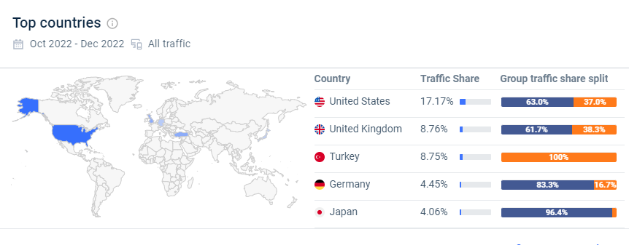

Appendix 2: Traffic on website
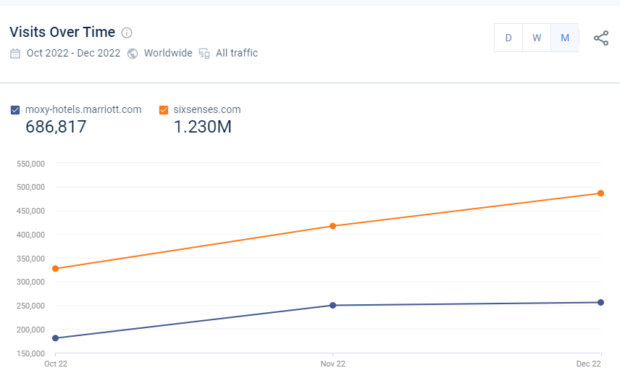

Appendix 3: Sustainable promotions
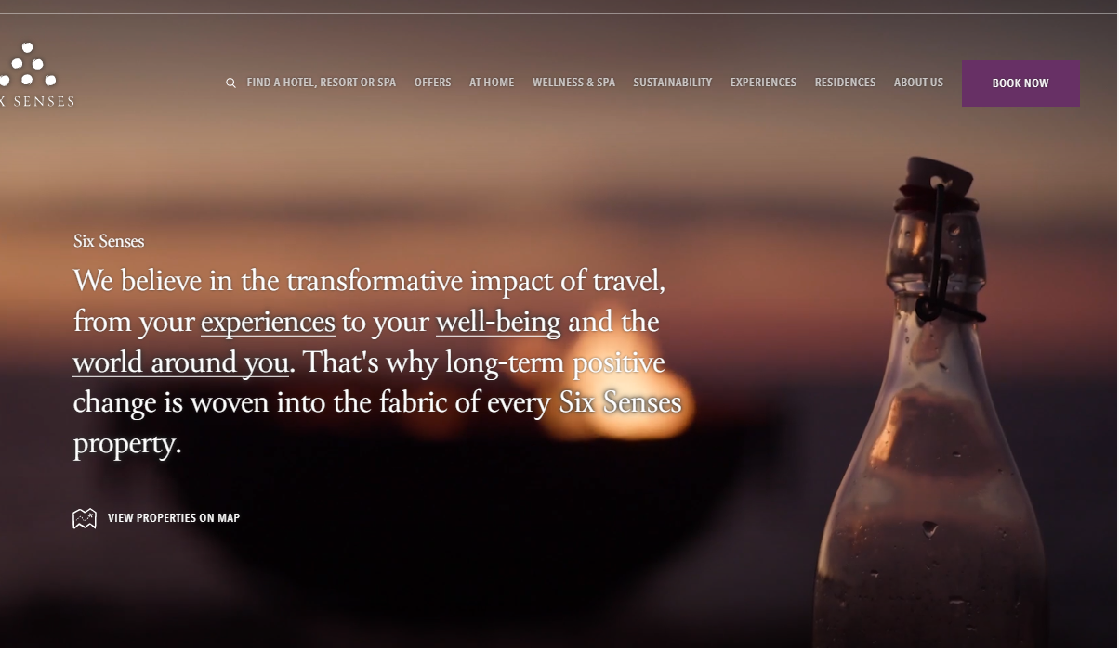

Appendix 4: Moxy Facebook advertisements
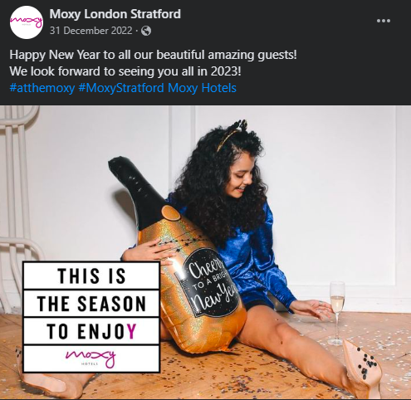

Appendix 5: Six Senses advertisement
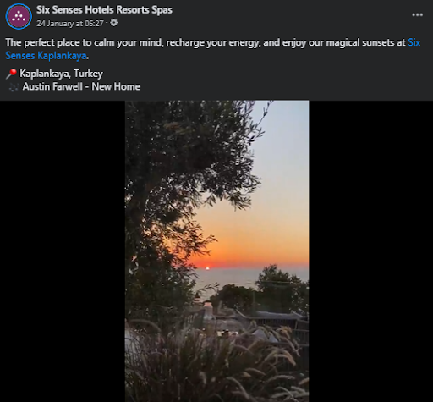

Appendix 6:
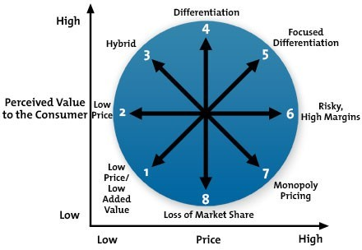

Figure 1: Bowman’s Strategy Clock

Appendix 7: Marketing channels comparison
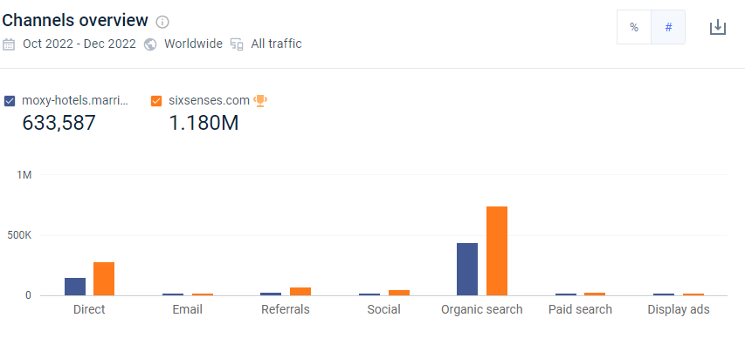
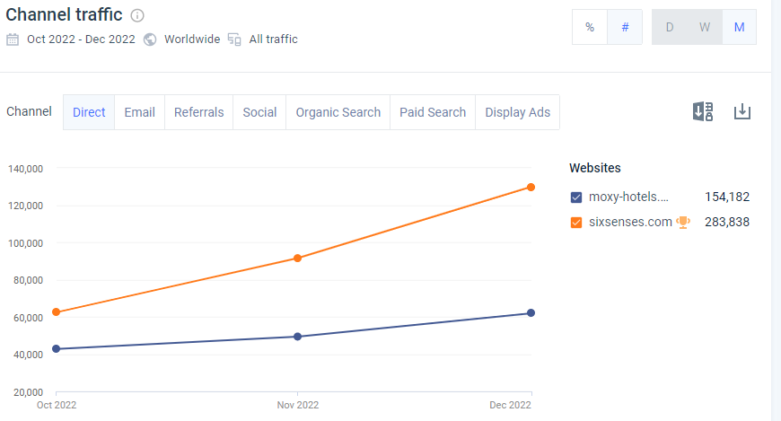

Appendix 8:
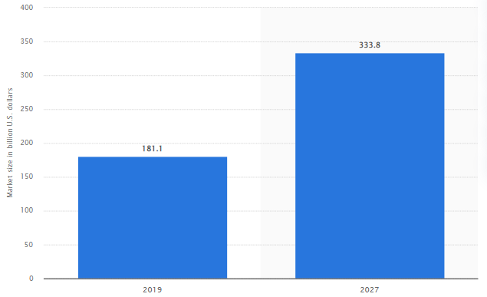
(Market Size of Ecotourism - Statista, 2021)

