Grace Exley: P149776
University of Wales Trinity Saint David, Swansea
BA (Hons) Surface Pattern Design
Supervisor: Ainsley Hillard
Module Number: M6X01791
Word Count: 5,949
The Female Nude: Historical Representation and Contemporary Challenges of Idealised Beauty.

CONTENTS:
Introduction………………………………………………………… Page 2
Chapter One……………………………………………………….. Page 4
Chapter Two……………………………………………………….. Page 12
Conclusion…………………………………………………………. Page 23
Bibliography………………………………………………………... Page 25
List of Illustrations…………………………………………………. Page 27

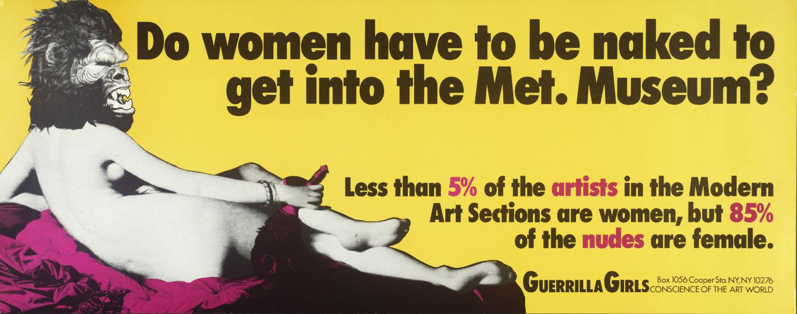INTRODUCTION
Figure One: [no title], 1985-1990

Arts and media offer us a lens through which we observe our culture and society and throughout time there has been an unequal representation of the sexes in these mediums.
Images created by men to the ideals determined by men, have typically objectified women, particularly presenting them as a nude. In doing so this has enabled men to define the female identity and create ideals that satisfy male interests.
The framing of women as objects and the often sexualisation of the image established the male gaze and reinforced the female’s social position within a patriarchal society.
This dissertation will evaluate how women have historically been presented in art and in comparison, with current female artists, it will highlight how contemporary art is challenging these representations and confronting the male gaze.
Considering work by artists including Manet and Jenny Saville and referencing relevant texts such as The Beauty Myth (Wolf, 1990), it will also examine the effects of the male gaze on the “value” of being female and how it continues to reinforce expectations of women in the 21st century.

This unequal relationship is so deeply embedded in our culture that it still structures the consciousness of many women. They do to themselves what men do to them. They survey, like men, their own femininity, (Berger, 1972, p.63).

CHAPTER ONE
The Male Gaze and Representation of Idealised Beauty in Historical Painting
In a world ordered by sexual imbalance, pleasure in looking has been split between active/male and passive/female. The determining male gaze projects its fantasy on to the female figure, which is styled accordingly, (Mulvey, 1989, p.19).

In Visual and Other Pleasures (Mulvey, 1989), the male gaze is a term that suggests a sexualised way of looking at women that empowers men and creates an unequal balance of power. This visualisation of women positions them as an ‘object’ that serves and is available for male desire.
Figure Two, The Sleeping Venus (Giorgione, 1508-1510) is a perfect example of this. Venus is a well-known Roman goddess of love and beauty. Her popularity with male viewers made her the most common subject of artwork, as well as being one of the greatest female nudes in art history.
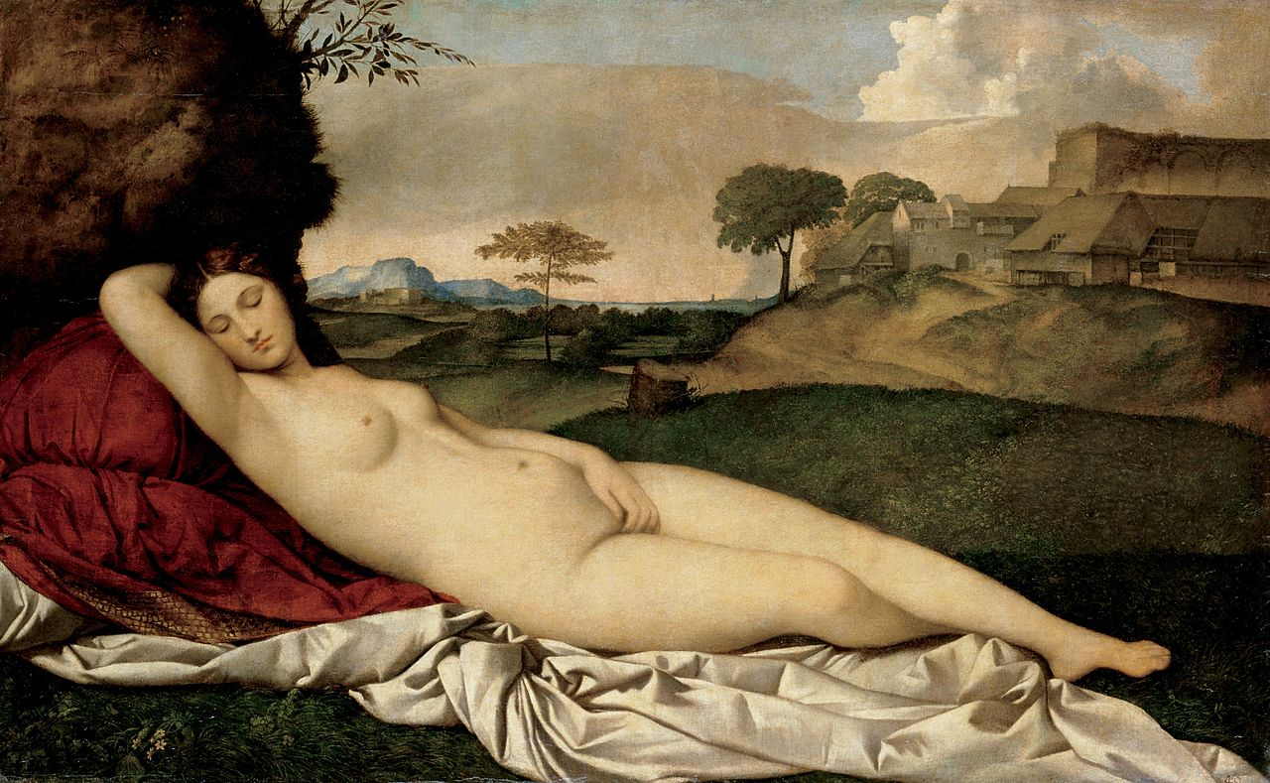

Figure Two: The Sleeping Venus, 1508-1510

In this painting, Venus is depicted with her eyes closed, suggesting that she is asleep. One hand is curled into her groin and the other hand behind her head. Her reclining position opens up her body to the viewer as if the invite appreciative observation, whilst the positioning of her hand against her genitals directs attention to this part of her body, perhaps as if to suggest her interest and availability for sexual attention.
The beauty of the surrounding nature whilst she sleeps frames her sleeping form, centralising her for the male gaze and its derived pleasure.
As an observer we are unclear about why she is exposing herself to her surroundings, as well as being unsure about what she is thinking or feeling, or even what her own sexual desires are. However, this is less important than being the centre of the male gaze and so we choose to believe she is dreaming about love and consciously doing this intimate act for male pleasure.
It is also worth noting that how she is presented to the viewer, her plump, soft skin and smooth elegant curves, her relaxed nature and deferential pose are traits commonly used when creating an idealised view of the feminine physical beauty.
It is interesting that the background is painted in muted colours, so that the viewer’s gaze is drawn to The Seeping Venus. This contrasts particularly with the deep red of the cushion that Venus is lying upon, which is a typical colour used to represent sensuality.
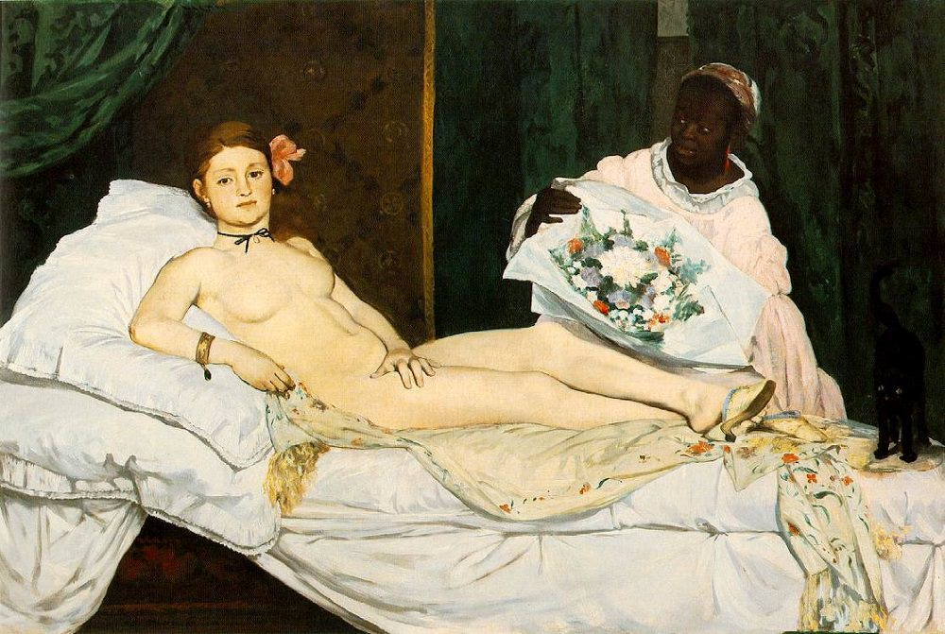

Figure Three: Olympia, 1863
An example where the male gaze is challenged can be seen in figure three, Olympia (Manet, 1863). This painting shows a woman reclined on a bed, but in contrast to Giorgione’s The Sleeping Venus, her head is raised, and she directly looks at the viewer, almost with a confrontational gaze. This suggests she is in control of the gaze and has some power over her situation by challenging the viewer to see her nakedness rather than her as a nude.
It was the art historian Kenneth Clark (1956) who claimed there is a difference between being naked and being nude. He wrote in his book The Nude;
To be naked is to be deprived of our clothes and the word implies some of the embarrassment which most of us feel in that condition. The word nude, on the other hand, carries, in educated usage, no uncomfortable overtone. The vague image it projects into the mind is not of a huddled and defenceless body, but of a balanced, prosperous and confident body: the body re-formed, (Clark, 1956, p1).
It is well known that this painting depicts a prostitute and in viewing Olympia as naked rather than nude, we are challenged to see the sordidness of her environment. The different techniques used by Giorgione and Manet reveal different attitudes towards representing women.
Both figures two and three share common aspects of how the female body is epitomised, despite being created a century apart. Both portray a flawless body figure, reclining postures, with no to very little body hair. This shaped the idealisation of beauty from these periods of time, that has been looked upon throughout decades/centuries beyond this era.
Figure two has a slightly profiled face which combined with her sleeping form, suggests a coy compliance with her situation that satisfies the ideals for male appreciation.
Manet’s muse on the other hand directly connects with the viewer through her direct gaze back to us. This connection isolates the idea that we’re alone in a private setting which allows us to consume without being seen and consequently exposes us as voyeurs.
The fact her face is on full show suggests she is aware of us and is comfortable and confident in her own nakedness and by being so moves her from being a sensual nude but to a naked female who is challenging her objectification.
Jonathan Schroeder (1998) wrote that, ‘to gaze implies more than to look at – it signifies a physiological relationship of power in which the gazer is superior to the object of the gaze’, (Schroeder, 1998, p.193-230).
Other comparisons between figures two and three can be made to the backgrounds each woman is painted in and the tones used to illustrate them. Venus’ surroundings are almost romantic and idyllic, whilst Olympia appears to be in her working environment upon a rumpled bed. The tones used in painting both the sheets and Olympia’s complexion are starker than those used to paint Venus. This infers the harshness of Olympia’s life.
Manet caused uproar in the French society who complained that the woman’s slim physique made her look like a young teenage girl, rather than the sensual, curvaceous physique usually depicted. Olympia is in control and superior to the observer; she is not passive nor an object as we have seen in the previous example, figure two, and consequently she holds the power of the gaze. In addition, the position and shape of her hand suggests she has an independence from men and is in control of allowing the male gaze to view her nakedness. It represents the contractual relationship she has with men.
Comments were made about how her hand was painted suggesting society’s unease with the idea of an independent woman particularly viewing them as shameless. T.J Clarke’s response to this was,
It failed to enact the lack of the phallus (which is not to say it quite signified the opposite). When the critics said it was shameless, flexed, in a state of contraction, dirty, and shaped like a toad, they toyed with various meanings, none of them obscure. The genitals are in the hand, (Clarke, 1985, p. 135).
Clarke also went on to suggest a contrasting view to the critics, claiming a different meaning to Olympia’s hand.
The hand is Olympia’s whole body, disobeying the rules of the nude. We might even say that it stands too strongly for that disobedience, for, after all, the body on the bed is not simply scandalous; the hand is a detail, and the critics were wrong to focus upon it, as they sometimes did, as if there were nothing else there to be seen, (Clarke, 1985, p. 136).

Whether Manet intended this response is unclear. He certainly incorporated features into his painting that can be considered beauty ideals of the female form of that time. However, he offset them with elements that empowered women and exposed the male gaze as voyeuristic.
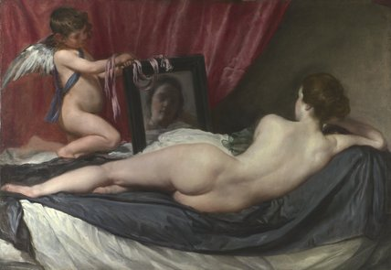

Figure Four: The Rokeby Venus, 1647-1651
The Rokeby Venus (Velazquez, 1647- 1651) in figure four presents its subject in a reclining sensual pose, similar to those in figures two and three. However, this painting could be considered unusual as it plays upon the act of looking and being looked upon with a contrast illusion in art.
It can be considered that this painting is presenting two perspectives; a feminine and masculine viewpoint that serves to confuse the viewer as to what to believe and consequently creating a sense of unease about its meaning.
On one hand we are presented with a nude Venus. Her smooth, pale naked body is sharply contrasted against the dark background. The black sheet accentuates Venus’ nudity and draws the viewer’s attention to it, particularly her bottom which is painted almost in 3D.
Cupid, Venus’ son and also god of physical love, holds a mirror in front of her. At first look it appears that Venus is gazing and admiring herself and could suggest that women are as interested in gazing and admiring themselves as men are of them, complicit with and validating the male gaze.
However, the closer we look and analyse the reflected image in the hand mirror, which is blurred and uneven, we realise that this may not be the case.
The male gaze portrays Venus as a beautiful woman, who is idealised as feminine physical beauty and includes many common characteristics of beauty ideals (of that period) including unflawed skin and a curvaceous body. However, in comparison to other depictions of Venus in art, Velazquez’s version paints a skin tone that is less radiant, perhaps suggesting that this Venus is reflective of real women.
This would support the alternative female perspective which is illustrated in the mirrored reflection and which does not appear to present beauty in the conventional ways of the male gaze. This suggests that what Venus sees (of herself) conflicts with how she is seen through the male gaze. The uneven discolouration used to create her reflection, highlights her potential insecurities or even self-loathing.
A further consideration is that Venus is using the mirror to observe herself being observed, implying that she is not comfortable with nor welcomes our gaze.
Whether she is using the mirror to scrutinise the attention she’s receiving or scrutinising her own looks, it is clear that the female perspective is not aligned to that of the male.
Perhaps this is commentary that reinforces the challenge still being faced in the 21st century by women who feel they are objectified through the need to conform to certain beauty ideals.
Every time we criticize a figure, saying that a neck is too long, hips are too wide or breasts too small, we are admitting, in quite concrete terms, the existence of ideal beauty, (Clark, 1956, p.12).

Alternatively, the use of the mirror in which Venus could be observing her viewers, could suggest that as an observer Venus becomes the subject and not the object of the male gaze.
On the face of it, the male gaze can adore female nakedness in all its forms whereas the female will see and seek something different, feeling uncomfortable in her own body, blinded by the obsession to conform to beauty ideals defined by the male gaze.
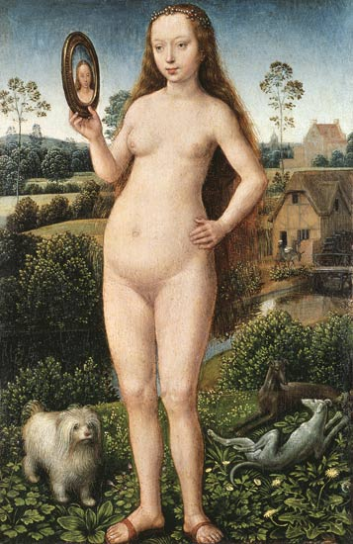

Figure Five: Vanity, 1485

The painting in figure five by Hans Memling from 1485 is part of a triptych called Triptych of Earthly Vanity and Divine Salvation. It shows the above figure known as “Vanity” between the images of death and hell.

Vanity is presented as a nude woman, framed by a religious symbolic background but one which places her at the centre of the image. Her nakedness is meant to be erotic and conforms to the beauty ideals previously mentioned: flawless, youthful skin and no body hair. Which satisfies the male gaze.
Berger analyses this in Ways of Seeing;
You painted a naked woman because you enjoyed looking at her, put a mirror in her hand and you called the painting ‘Vanity’, thus morally condemning the woman whose nakedness you had depicted for your own pleasure, (Berger, 1972, p.51).

Berger suggests that Vanity (figure five) is a creation made with the sole purpose of giving the male viewing audience pleasure upon what they spectate. It is interesting that her reflection in the mirror frames her image in a way that suggests she is viewing it in the manor of the male gaze. However, it also demonstrates hypocrisy in its inference that the female is sinful because of her nakedness and in the way, she enjoys looking at herself of being naked. This is suggested by her wearing sandals which are symbolic of vanity and lust.
This double standard served to reinforce the patriarchal power which both elevated and condemned women. The next chapter will explore further the impact of the male gaze today.

CHAPTER TWO:
Challenging the conventions of Idealised Beauty in Western Culture

This chapter will look at the male gaze and the idealisation of women and their perception of beauty which is portrayed in art and the media in current day. As stated by Naomi Wolf, author of The Beauty Myth,
To live in a culture in which women are routinely naked where men aren't is to learn inequality in little ways all day long. So even if we agree that sexual imagery is in fact a language, it is clearly one that is already heavily edited to protect men’s sexual—and hence social—confidence while undermining that of women, (Wolf, 1990, p.139).
Alexander McQueen’s Spring/Summer collection in 2001, VOSS, has become one of his most iconic catwalk collections that he has ever produced. Like many other collections that has the designer’s view of beauty merged into a distinct theme, McQueen created a catwalk resembling an asylum. The set created a tense mood throughout the room creating an awkwardness and self-consciousness within the audience; a set of double-sided surveillance mirrors were use, forcing the audience to stare at their reflections, whilst listening to the beat of a heart. By forcing the audience to look at their reflections in an intense wait for the start of the show, it provides them time to evaluate and observe themselves. It also allows them and subconsciously pressures them to critique their looks and identify their own flaws and imperfections that might not like about themselves.
After enduring a one hour-long wait, the lights dimmed and what was once a set of mirrors and people’s reflections, actually appeared to be a box padded out with white tiled floor and walls resembling an asylum. This was constructed with a glass box centre piece in the middle of this mirrored room.
As the models began to walk out, they all looked to have white fabric wrapped around their heads, as if wrapped in bandages to protect that feature. In an interview, McQueen describes the bandages as the representation of surgery; cosmetic surgery to change our looks and generate a “happiness” of being in our own skins.
the bandages on the model’s head and this idea of surgery to make yourself more than who you actually are. And then at the end you this acceptance of what life is. Life isn’t perfect and we’re not all perfect. We’re not all size zero models and you know there’s beauty within the eye of the beholder, that was the idea, (BBC, 2009).
The set of mirrors that was once reflecting the viewers faces, became inverted, obscuring the audience from the models inside this box-like room so that the audience became spectators, - watching the models looking at themselves (shown in figure six).
It implied that the models were admiring themselves after ‘surgery’, once their perceived flaws had been fixed. The idea of this makes the audience question the idea of conventional beauty and what is normal and what lengths people are willing to go, to finally be considered as ‘beautiful’.
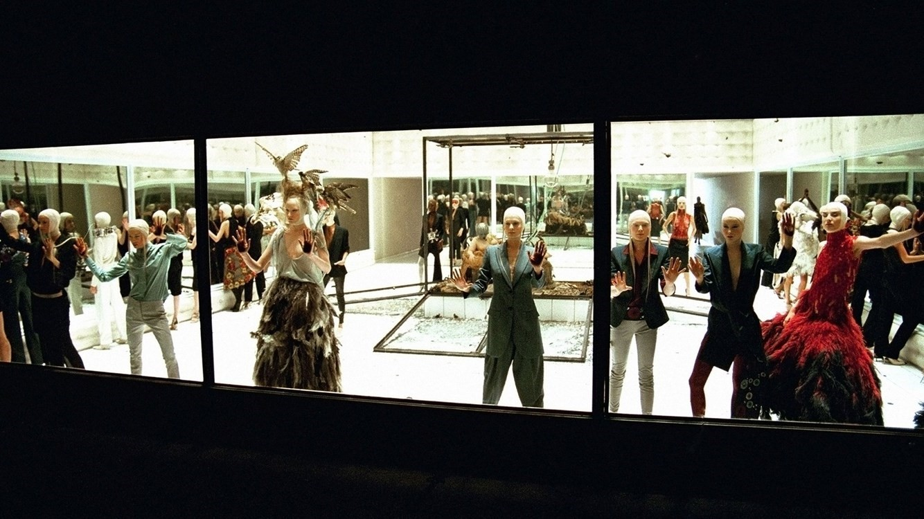

Figure Six: VOSS, 2001
At the end of the show – or so what the audience believed was the end – one last surprise was revealed.
After the last model left the stage, the glass centre piece in the middle of the room, began to fall. As the mirrors smashed to the ground, this large, box- like centre piece revealed a naked women (Michelle Olley) reclining in a chair, wearing a mask with moths covering her entire body (figure seven).

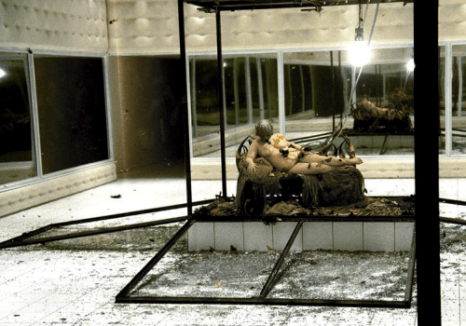

Figure Seven: VOSS, 2001

This relaxed, laid back posture is practically the same to Manet’s and Giorgione’s paintings, but a key difference is who has power of the gaze: the fact that throughout the whole show, she was unseen, she was in control of the gaze, she had the power over whether and when she could be seen by the viewers.
The concept that is possibly the most interesting from this show, is the fact that we, the audience, cannot identify the model. The reasons for this are open to interpretation. It could be because the individual has undergone surgery on her face losing her identity so that she now is unidentifiable. Alternatively, she could be a generic representation of all women that multiple audience members could identify with.
A common symbol associated to moths is that of life and death, or metamorphosis. This use of them in the show could be interpreted in two different ways, one being that beauty brings life and death to the self - esteem of women. Young women follow trends and common images to develop their own identity but quickly become trapped in the never-ending pursuit of perfection that ultimately destroys their self-esteem and disempowers them.
Alternatively, they could symbolise the metamorphosis an individual undergoes when using cosmetic surgery to fix perceived imperfections; entering the process as imperfect and emerging with features they believe are beautiful.
Olley’s presentation disrupts what we understand as male gaze. Her face is obscured so that the viewer cannot determine the presence of her own gaze to establish who owns the power. The inclusion of tubes protruding from the mask suggests a vulnerability that is enhanced by the model’s nakedness, creating a sense of discomfort for those observing her.
Her surroundings are stark rather than beautiful, so this is an absence of being framed for the pleasure of observation. We also feel as if we’re intruding her space and contributing to her vulnerability by looking at her naked form.
However, the comment from McQueen below perhaps suggest that a male gaze is still being applied, albeit it from the perspective of an alternative consideration of beauty.
The term male gaze, used by Mulvey (1989) can be found in two key forms, interactions and social encounters. Examples of both include being subjected to catcalls or receiving sexual comments and the blatant gazing at women’s body parts.
There is a long-standing debate about the influence of media over how women feel about themselves and the perception of female beauty ideals. Whilst those ideals may have changed since the time of Manet or Giorgione, they are still rooted in and presented in ways that satisfy male desires.
Magazines invariably, whatever the subject matter, present the female form in a particular way and applies a cruel criticism to anything that falls outside the expected ideal. Even magazines developed by women for female readers, presents female images from the perspective of the male gaze.
Popular media bombard women with articles about exercise, dieting and surgery. There is an endless cycle of self-consciousness and self-hatred within women, feeling as though they have failed to fulfil society’s impossible task to look ‘perfect’ explained by Naomi Wolf in The Beauty Myth (1990). ‘A consequence of female self-love is that the woman grows convinced of social worth. Her love for her body will be unqualified, which is the basis of female identification’, (Wolf, 1990, p.145).
This emphasis serves to associate perfection with beauty and ‘sexy’, objectifying women as sexual objects. The specific focus on how women should look and be is very intimate and reinforces the idea that the viewer holds control by taking the role of the subject.
This can make women feel particularly vulnerable if they perceive themselves to not conform to the ideal. However, it also serves to perpetuate the ideals of how women should look and be seen, which in turn can generate unrealistic and unwanted male scrutiny. Through media representations, women are presented as objects rather than subjects and by definition, something that actions or feelings are directed towards. It results in women responding to the expectations of the male gaze through how they present, judge and define themselves.
The 21st century development of cosmetic surgery and social media can be considered as complicit in the objectification of women.
In a world where there is an obsession to seek physical perfection, surgery has come to the forefront giving us a quick fix to achieve this. Often, surgery to improve specific areas of the body can be ordered like ordering items from a menu. By reducing surgery into being a quick fix to perfection, it continues to support the notion that a woman is just a sum of her body parts; objects rather than a whole subject.
Concepts such as phone apps that provide filters to give us a ‘flawless’ look whenever we take a photograph are also becoming more popular. As an example, the ratio of Snapchat filters which adjust a person’s photographic image by changing or adding to facial features, are disproportionately made to generate flawless skill, lush eyelashes, rosy cheeks and white teeth. All of these are modern day ideals of beauty associated with being ‘sexy’ which subsequently serve to sexualise the image.
Additionally, the growth in ‘selfies’, photographic self-portraits reinforces the technique of framing oneself, within an image, to enhance viewing pleasure. Looking back to examples such as Giorgione’s Venus (figure two), we can see this is a technique used by the male gaze.
The above examples provide evidence that women are learning that their value is about how they look rather than how they feel. Ultimately it is the male gaze that determines this value through objectifying women.
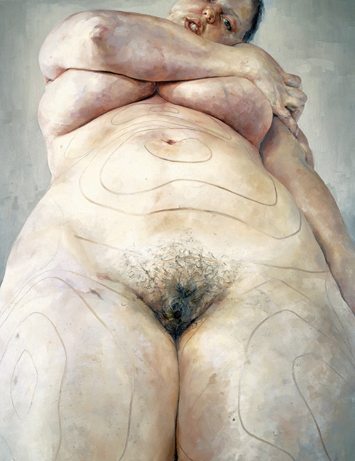

Figure Eight: Plan, 1993
Painted in 1993, Plan (figure eight) was one of Jenny Saville’s earliest pieces, snapshotting the image of a female nude. The most notable difference with this presentation of a woman is that she is the subject rather than an object.
The painting is a glimpse of a self-portrait of a figure that struggles to contain itself within the frame. This itself challenges the technique of framing the image where the nude is typically surrounded by scenery or background that presents her for observation. It also challenges and confronts the ideal that women should be slight or diminutive as Saville’s nude spills outside of the view.
It recognises the issues that women have with their bodies, and the obsession and pressure to be a petite, small figure. The artist ORLAN commented in The Huffington Post, ‘Our time hates flesh and urges us towards anorexia, while we have all eternity to be skeletal’, (Frank, 2013).
A culture fixated on female thinness is not an obsession about female beauty, but an obsession about female obedience. Women's dieting has become what Yale psychologist Judith Rodin calls a 'normative obsession,' a never-ending passion play given international coverage out of all proportion to the health risks associated with obesity and using emotive language that does not figure even in discussions of alcohol or tobacco abuse. […] Dieting is the most potent political sedative in women's history; a quietly mad population is a tractable one, (Wolf, 1990, p.187).
Saville’s painting has captured every vein, dimple and every strand of hair using a colour palette that’s realistic. The scale of the work causes us to observe her entire body as she lifts her heavy breasts with her hand, whilst at the same time her gaze meets the eyes of the viewer. The perspective which we view the woman suggests that she is viewing us, lifting her breasts out of the way to observe us properly. This shifts her being the object being viewed to the subject doing the viewing.
The realism of this painting is felt through its nonconformance with the expectations that the male gaze sets out. Comparing this image to Giorgione’s painting of Venus (figure two) there is a stark difference in how the female body is depicted. In the first instance the skin tones are very different; Saville’s flesh is pigmented and suggestive of a true flesh tone and not the unblemished, smooth skin depicted in historical art, as seen in figures two, three, four and five.
Saville’s nude displays an element of modesty, which is not seen in previous figures, as she covers her breasts, again unlike figures two, three and five, who are painted fully frontal with their breasts on show. The most obvious difference is the inclusion of pubic hair and her rationale for doing so can be found in her comments in The Independent, ‘In history, pubic hair has always been perfect, painted by men. In real life, it moves around, up your stomach, or down your leg', (Davies, 1994).
Saville is challenging herself to change the way we view a woman’s body in female art – especially in female nudes. In an attempt of changing art history, Saville commented, ‘The history of art has been dominated by men, living in ivory towers, seeing women as sexual objects. I paint women as most women see themselves’ (Davies, 1994) Like Manet’s Olympia, this woman is interacting with the viewer through her gaze and in doing so is in control of the interaction and observation.
It’s also interesting that Saville has drawn onto her body, the markings suggestive of pending surgery. We see a woman covered in target-like marks which could be considered as a ‘breathing dartboard’ (Cooke, 2012). Cooke suggests that they have been drawn by a surgeon in preparation of surgery.
When I made Plan [showing the lines drawn on a woman's body to designate where liposuction would be performed], I was forever explaining what liposuction was. It seemed so violent then. These days, I doubt there's anyone in the western world who doesn't know what liposuction is. Surgery was a minority sport; now that notion of hybridity is everywhere. There's almost a new race: the plastic surgery race, (Cooke, 2012).

The statement ‘Surgery was a minority sport’ combined with the phrase ‘the plastic surgery race’ can be interpreted as these drawn marks and associated surgery are becoming a norm, which many are competing to become the first to achieve perfection in. This mapping of body areas to change is affecting the relationship we have between our mental and physical forms. We compare our bodies to beauty ideals causing us not to love what we have but turn against it and turn to surgery to accomplish our desire to become ‘perfect’. As described by Clark, ‘The body is not one of those subjects which can be made into art by direct transcription — like a tiger or a snowy landscape. . .. We do not wish to imitate; we wish to perfect’, (Clark, 1956, p.6).
‘52% of women aged between 18 and 34, have said they’re interested in cosmetic procedures’ (Hoggard, 2018). This ranges from practices like liposuction to tummy tuck, from breast enlargement to facelift. The notion that more and more women are turning to surgery every year is all in the name of beauty, must acknowledge that it is the male gaze and how it influences the representation of women, that determine those ideals. The overall thought that women appear to be less satisfied with their appearance whilst experiencing reduced self-esteem suggests that the male gaze remains as powerful today as it has been for centuries.
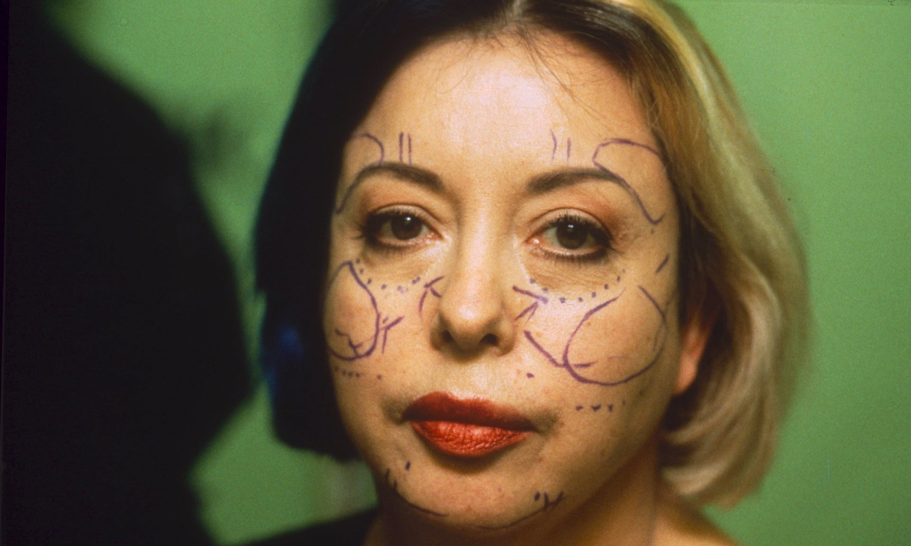

Figure Nine: Omnipresence-Surgery
Figure nine is a photographic image of ORLAN, a French performance artist who wanted to change and raise awareness of how women have been represented in historic art, largely receiving the male gaze and being undressed. Undergoing nine different surgical procedures, ORLAN is known for being the only artist who radically works on her own body, by going under the surgeon’s knife again and again. Her aim being, not to achieve the standard of beauty which has been idealised through decades of historic pieces of art (as evaluated about figure two and three).
I am not sure I can change such a thing, but I can produce images that are different from those we find in comics, video games, magazines and TV shows, (Jeffries, 2009).
Each operation has been different, altering her body using it as a powerful piece of art to make viewers question the status of a woman’s body in today’s society. By doing this, ORLAN has given herself a double role, both being, the observer and being observed. One technique used is that of altering her forehead to look like the enhanced brow of Mona Lisa (Da Vinci, 1503-1506). Another process used was to change the way her chin looked, to mimic the painting The Birth of Venus (Botticelli, 1484-1486). She explains herself when interviewed by The Guardian ‘I tried to use surgery not to better myself or become a younger version of myself, but to work on the concept of image and surgery the other way around’, (Jeffries, 2009).
Beauty is a product of ideology, this ideology changes through time, as we can see through art history, changing our perception on what is beautiful. Bodies like Venus and Olympia have been conditioned for us to believe that all women figures should look like this.
Both Saville and ORLAN confront the male gaze by challenging the viewer, both in different ways, to look closely at the representation of women and the way that the male gaze has idealised a woman’s beauty.
Another influential artist that confronts the male gaze is Hannah Wilke, particularly focusing on figure ten, S.O.S Starification Object Series (1974-1975). It consists of a series of photographs of Wilke topless, mimicking similar poses of female celebrities and models in the media and advertisements. The difference between them both, is that Wilke has vulva shaped miniature sculptures made out of chewing gum stuck to her body which ‘starify’ her (Manchester, 2008).
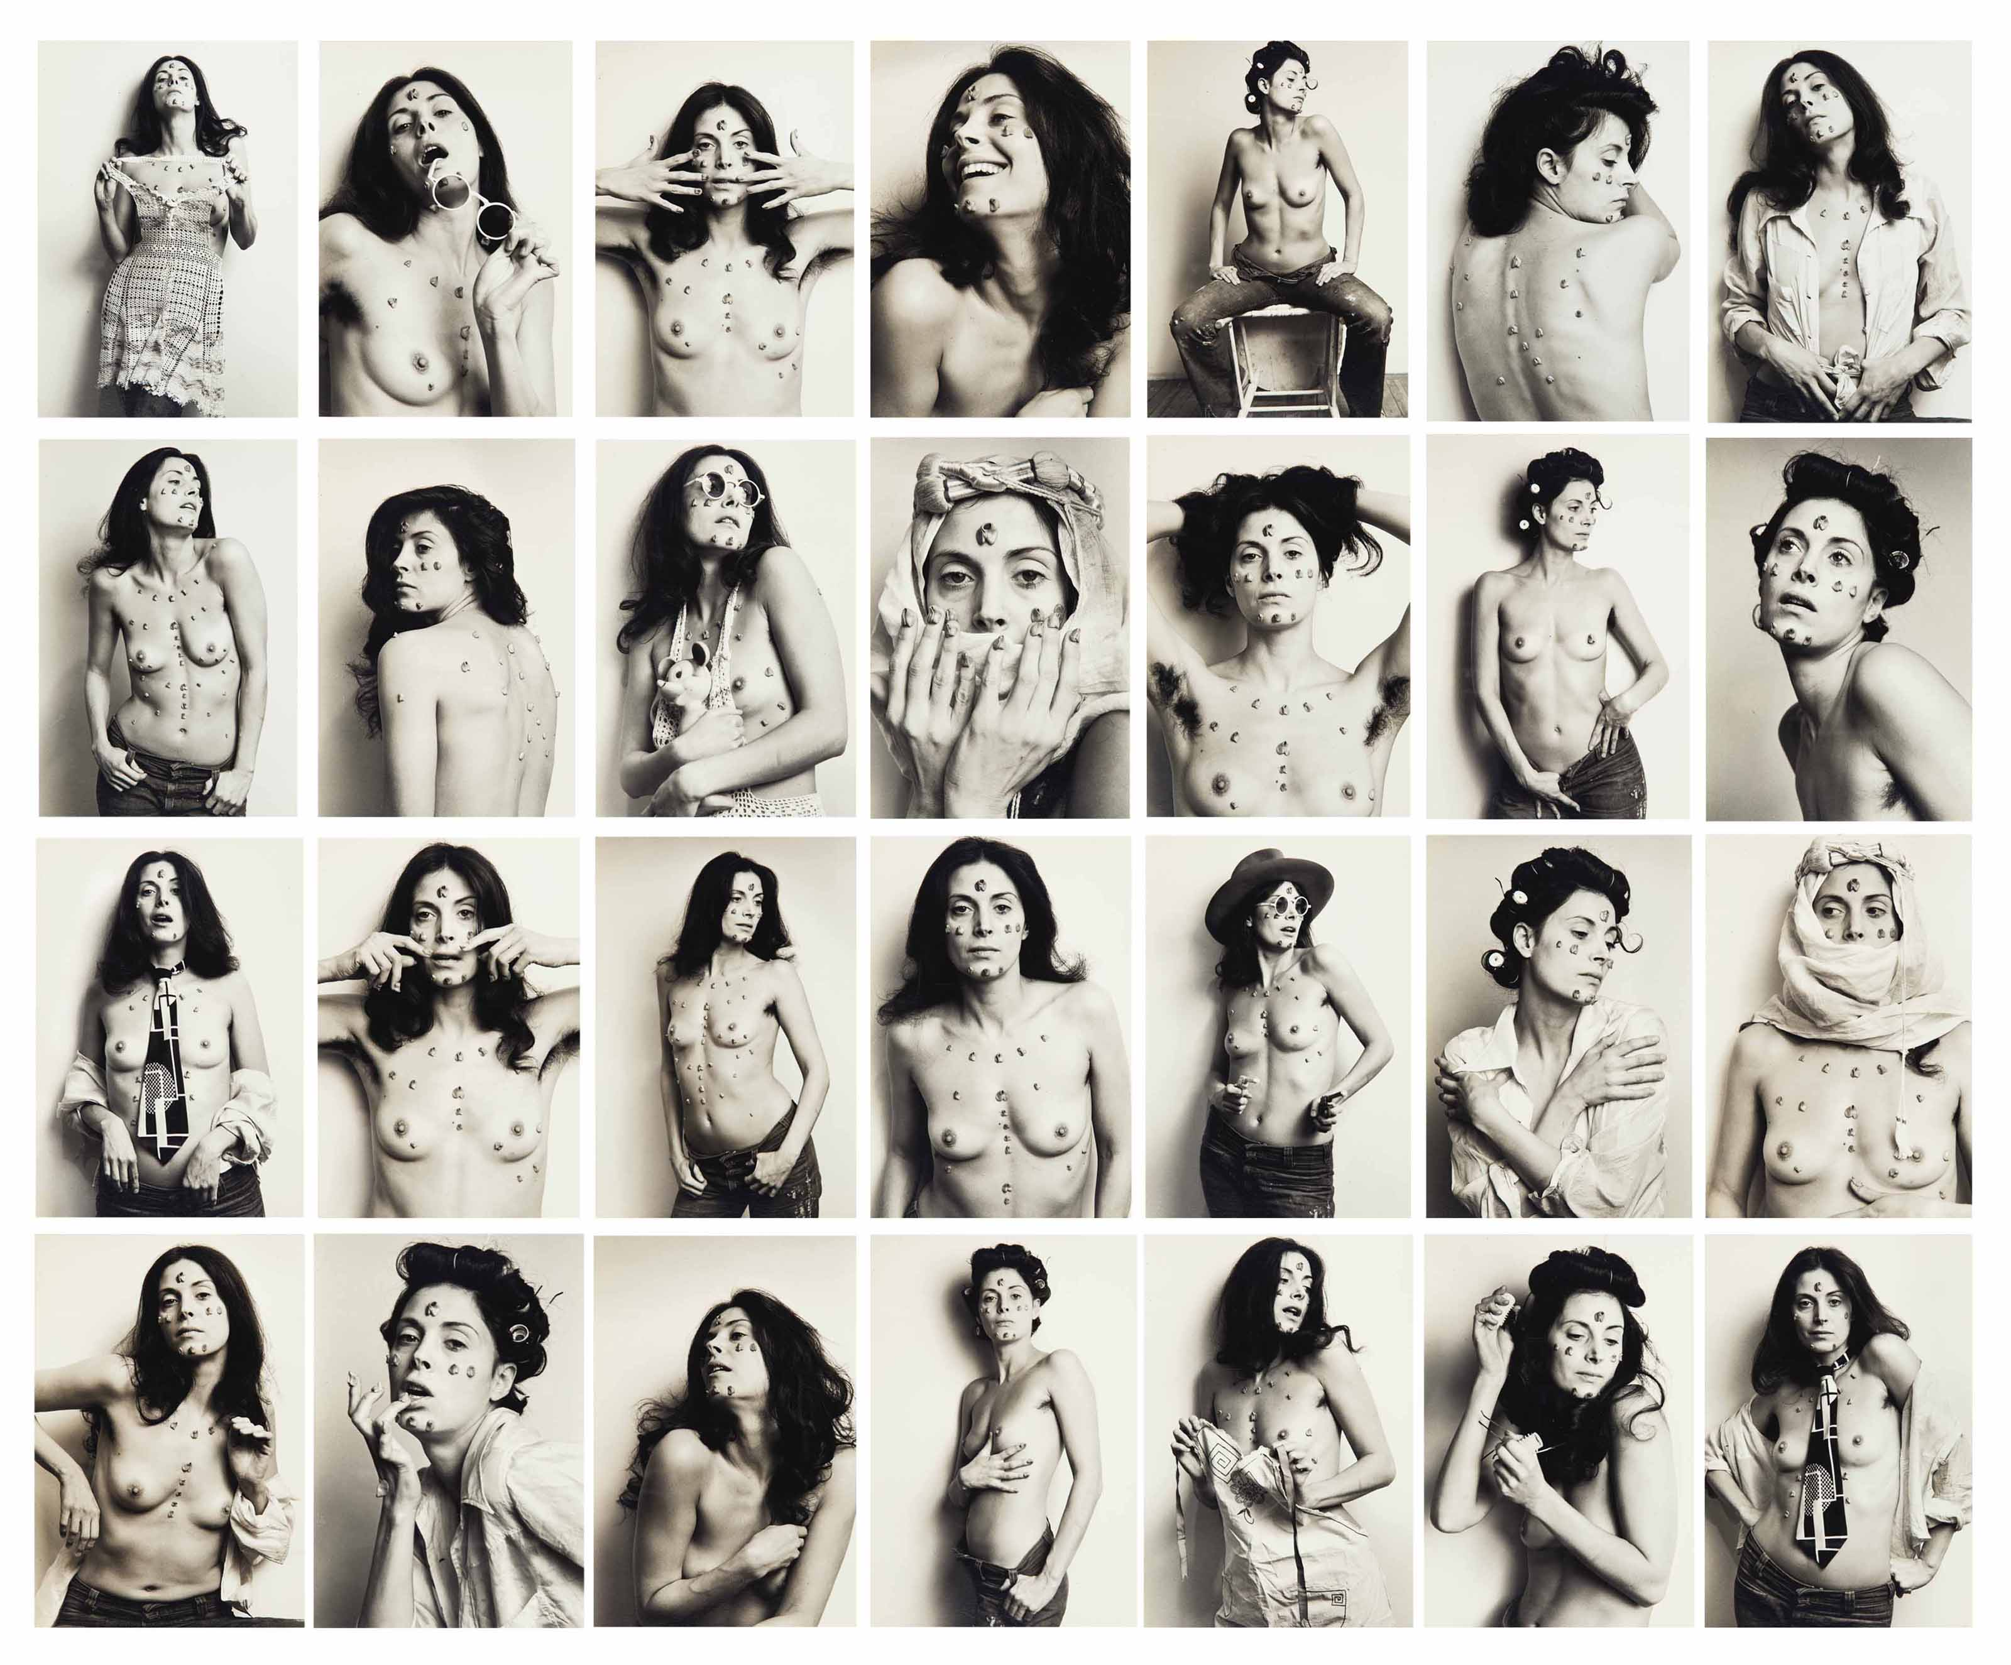

Throughout this series of images, Wilke is shown as both an object of viewing and being in charge of objectification. Bringing attention to herself as well as depicting stereotypes about femininity and disrupting the male pleasure.
Figure Ten: S.O.S Starification Object Series, 1974-1975
Her mockingly flirtatious poses, consisting of wearing a man’s tie, playing with her hair and smiling with her lips parted, are typical of images used today to represent women. However, the blemishes created by the small vulva-like sculptures stuck on her body invite the viewer to look more closely and could be interpreted as exposing that attention as indecent and improper. It explicitly confronts and distracts the viewers gazing at her body, confronting them about their sexual thoughts about the body in the photographs. Looking closely at these unusual looking shapes placed on her face, back and chest, they come across like growths, making the viewer step back (making the body unappealing) and re-evaluate the image, distorting their gaze. This is reversing the role, empowering Wilke over the viewer, objectifying the gaze as it’s not welcome.
Additionally, the use of intermittent images which show her face as cold and almost lifeless, distances herself from the viewer. This allows them to view the forms of her figure fully, while she acts as though she doesn’t know and suggests that the viewer is a voyeur, taking gratification from the fact that the object is unaware and non-consensual to this observation.
Wilke in Body Art/Performing the Subject (Jones, 1998) describes why she used gum and the symbolism behind it, ‘I chose gum because it’s the perfect metaphor for the American woman – chew her up, get what you want out of her, throw her out and pop in a new piece’, (Jones, 1998, p.182).
The word ‘starification’ used in the title, can be seen as being played upon the word scarification, referring to scars and marks on the body. Looking closely at the relationship between a woman and her body, emphasising that each mark has a story/experience behind them. For example, a scar from a childhood story or sketch-marks from pregnancy, or it could also be considered as being wounded by this so called ‘glamourous’ industry that models find themselves in.
Wilke’s technique of exposing herself with these scar like forms, brings the awareness of the damage that the male gaze has caused. Creating a pressure and strain on women to continuously look and feel good about themselves, reminds us of its influence in idealising beauty and driving the pursuit to achieve it.

CONCLUSION:
This dissertation has illustrated how through art and media, women have been represented in a way to satisfy the male gaze.
Berger explains the fact that throughout time, the way the female body has been illustrated in comparison to men, has not changed because of a consistent attitude and perception regarding male and female roles; namely that the female role is one to be subject to male desire and attention.
The essential way of seeing women, the essential use to which their images are put, has not changed. Women are depicted in a quite different way from men – not because the feminine is different from the masculine – but because the ‘ideal’ spectator is always assumed to be male and the image of the woman is designed to flatter him, (Berger, 1972, p.64).
Consistent methods and techniques to present the female form have subsequently created an idealised perception of beauty and image, that has been defined by men and which women have pursued in order to feel valued and feminine.
Women have typically been depicted in a way that they become a passive component to the image, relinquishing the power to the viewer to judge and validate them. This has helped reinforce the patriarchal expectation of a woman’s role and identity, supporting the status quo of unequal societal power.
Berger also recognises the explosion of different platforms now used to depict, judge and validate the female form; ‘Today the attitudes and values which informed that tradition are expressed through other more widely diffused media – advertising, journalism, television’, (Berger, 1972, p.63).
This means that more than ever women are being confronted with images from multiple sources, that continues to drive a beauty ideology that has been created by the male gaze.
No matter what a woman’s appearance may be, it will be used to undermine what she is saying and taken to individualize – as her personal problem – observations she makes about the beauty myth in society, (Wolf, 1990, p.11).
Whilst ever we continue to use traditional conventions to depict women, we will continue to perpetuate the effects of the male gaze.
The works of artists such as Jenny Saville light the way for us to follow and challenge how women are represented; disrupting the male gaze so that viewers are supported to reject it.

BIBLIOGRAPHY:
BBC (2009) Breaking The Rules - Fashion Rebel Look [documentary] Available at: Vimeo https://vimeo.com/9420627 [09:06-11:05] (Accessed on: 16th November).
Berger, J (1972) Ways of Seeing. New York: British Broadcasting Corporation and Penguin Books.
Clark, K (1956) The Nude. London: Penguin Books.
Clarke, T (1985) The Painting of Modern Life: Paris in the Art of Manet and His Followers. London: Thames and Hudson.
Cooke, R (2012) ‘Jenny Saville: I want to be a painter of modern life, and modern bodies’, The Guardian. Available at: https://www.theguardian.com/artanddesign/2012/jun/09/jenny-saville-painter-modern-bodies (Accessed on: 27th November).
Davies, H (1994) ‘Interview: This is Jenny, and this is her Plan: Men Paint female’, The Independent. Available at: https://www.independent.co.uk/life-style/interview-this-is-jenny-and-this-is-her-plan-men-paint-female-beauty-in-stereotypes-jenny-saville-1426296.html (Accessed on: 28th November).
Frank, P (2013) ‘We Have All Eternity To Be Skeletal’, The Huffington Post. Available at: https://www.huffingtonpost.co.uk/entry/performance-artist-orlan-interview-beauty-surgery_n_2526077 (Accessed on: 1st December).
Hoggard, E (2018) ‘31% of Brits Would Consider Cosmetic Surgery, Research Finds’, Happiful Magazine. Available at: https://happiful.com/31-percent-brits-would-consider-cosmetic-surgery-research-finds/ (Accessed on: 5th December).
Jeffries, S (2009) ‘Orlan's art of sex and surgery’, The Guardian. Available at: https://www.theguardian.com/artanddesign/2009/jul/01/orlan-performance-artist-carnal-art (Accessed on: 1st December).
Jones, A (1998) Body Art/Performing the Subject. London: University of Minnesota Press.
Kershner, R.B (2003) Cultural Studies of James Joyce. Amsterdam- New York: Rodopi.
Manchester, E (2008) ‘Marxism and At: Beware of Fascist Feminism’, Hannah Wilke, 1977 | Tate’, Tate. Available at: https://www.tate.org.uk/art/artworks/wilke-marxism-and-art-beware-of-fascist-feminism-p79357 (Accessed on: 3rd December).
Mulvey, L (1989) Visual and Other Pleasures. New York: Palgrave.
Schroeder, J (1998) Consuming Representation: A Visual Approach to Consumer Research. New York: Routledge.
Wolf, N (1990) The Beauty Myth. London: Chatto & Windus.

LIST OF ILLUSTRATIONS:
Figure One: Girls, G (1985-1990) No Title [Screen-printed on Paper]. Available at: http://www.londnr.com/fashion-art/nudes-the-female-form/ (Accessed on: 7th December).
Figure Two: Girogione. (1508-1510) The Sleeping Venus [Oil on canvas]. Available at: https://artsandculture.google.com/asset/sleeping-venus/xgFm1GCECrnfQA?hl=en-GB (Accessed on: 7th November).
Figure Three: Manet, E (1863) Olympia [Oil on canvas]. Available at: http://www.manet.org/olympia.jsp (Accessed on: 10th November).
Figure Four: Velazquez, D (1647-1651) The Rokeby Venus [Oil on canvas]. Available at: https://www.nationalgallery.co.uk/products/the-toilet-of-venus-the-rokeby-venus-print/p_NG2057 (Accessed on: 14th November).
Figure Five: Memling, H (1485) Vanity [Oil on Oak Panel]. Available at: http://artfcity.com/2017/01/04/remembering-john-berger-the-old-master-of-seeing/ (Accessed on: 2nd November).
Figure Six: McQueen, A (2001) VOSS, S/S Collection [Fashion Catwalk]. Available at: https://bon.se/blogs/vnivrs/the-stages-of-alexander-mcqueen-ss-2001-voss/ (Accessed on: 15th November).
Figure Seven: McQueen, A (2001) VOSS, S/S Collection [Fashion Catwalk]. Available at: https://vossehf.wordpress.com/about/voss/ (Accessed on: 15th November).
Figure Eight: Saville, J (1993) Plan [Oil on canvas]. Available at: https://curiator.com/art/jenny-saville/plan (Accessed on: 27th November).
Figure Nine: ORLAN (1993) Omnipresence-Surgery [Performance Act]. Available at: https://www.theguardian.com/artanddesign/2016/jan/15/orlan-i-walked-a-long-way-for-women (Accessed on: 30th November).
Figure Ten: Wilke, H (1974-1975) S.O.S Starification Object Series [Photograph Series]. Available at: https://www.christies.com/lotfinder/Lot/hannah-wilke-1940-1993-sos-starification-object-series-6100201-details.aspx (Accessed on: 3rd December).

