Synthesize a Solution to a Potential Real-Life Scenario
Author Laurance Cutforth P146632
Lecture Dr Carlene Campbell

Abstract: -
This report has been made to provide a network design for the University of Wales Trinity Saint David’s new campus, this design will incorporate IoT technologies such as RFID readers to secure the campus. This report also included a review on what IoT is and what Smart Cities are, this will involve describing some of the threats both topics face, this will also involve providing possible solutions on how to counter these threats.

Table of Contents
Abstract: - 1
Table of Contents 1
Table of Figures 1
Introduction 2
Design 2
Class Room 4
Garden 5
Car Park 5
Possible Improvements 6
Conclusion 6
Internet of Things and Smart City Security Issues 7
Introduction 7
What is IoT and Smart City 7
Threats to IoT 8
Threats to Smart Cities 9
Security measures 9
IoT Security Measures 9
Smart City Security Measures 10
Conclusion 10
References 10

Table of Figures
Figure 1 UWTSD IoT Network 2
Figure 2 Server redundancy 3
Figure 3 Remote access 3
Figure 4 UWTSD IoT Class Room 4
Figure 5 UWTSD IoT Outdoor Facility (Garden) 5
Figure 6 UWTSD IoT Car Park 6
Figure 7 Barcelona Smart City, Spain [5] 8

Introduction
The University of Wales Trinity Saint David (UWTSD), has tasked to author of this project to design and simulate security measures for the protection of resources and services, for the new Waterfront “Smart Campus”. The designing of this network will be done using Cisco Packet tracer, and will include: Class Room Management, Outdoor Facilities, Car Parks and the devices required to run them. The second port of this report will include a detailed look into the security issues for Internet of Things (IoT) and Smart Cities.

Design
UWTSD has tasked the author to design a IoT network to be used at their campuses, and then provide a detailed description on the potential security threats to the network. The design specifications the UWTSDs set for the author to include are:
- Class Room management
- Car Park
- Outdoor Facilities (Smart Garden)
- Remote home access
- Severs (DHCP, Web, Application, Database etc.)
- Physical and Software security (Firewalls and security doors etc.)
- IoT technologies (lighting, temperature control etc.)

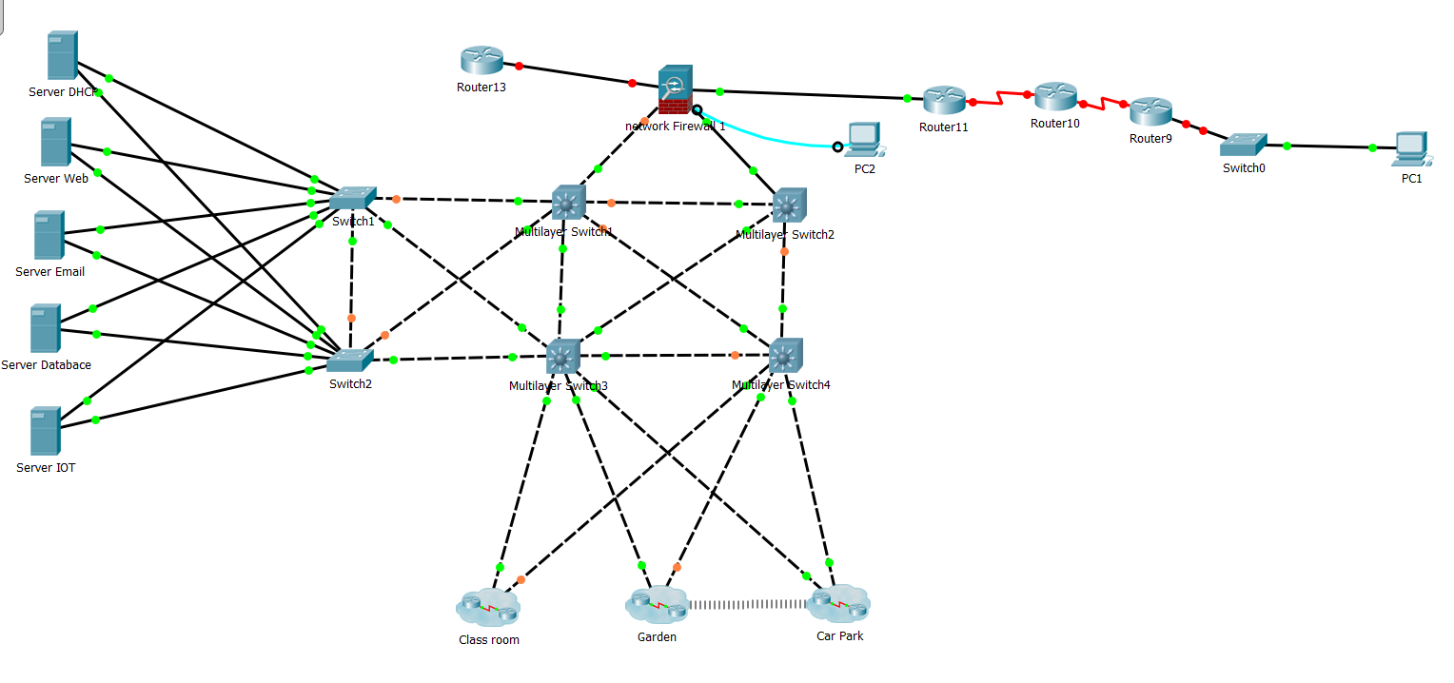
Figure 1 UWTSD IoT Network
Figure 1 shows the basic design for the UWTSD network infrastructure, redundancy was a big concern when designing the network as to reduce the problems caused by system down time due to broken links. In figure 3 it can also be seen that all network traffic going in and out of the network is routed through a firewall, this is done to ensure the security of the network when attempting to access internet content, or when users attempt to remote access the network.
Figure 1 also shows that the Class Room, Garden and Car park sections of the IoT infrastructure has been segregated from the rest of the network, in figure 4,5,6 it can be seen that each segregated section has some of the same devices, for instance there is a wireless access point connected to a fire wall in each section. This enables secure Bring Your Own Device (BYOD) infrastructure within the IoT Network, all traffic on the wireless network will be monitored and filtered by the connected firewalls. Each section also has a security door (the car park has a garage) with some RFID readers used to access the building, this provides physical security for the campus.
Figure 2 Server redundancy
Figure 2 shows the UWTSD’s server infrastructure setup, by having DHCP, Database, Email and Web servers it can be shown that users are able to gain access to UWTSD resources with relative ease. This design also suggests having the server’s setup in a server farm, this will enable staff effortless access for maintenance and management. The IoT server shown in figure 2 will be used to manage the UWTSD’s IoT devices, this server is only access able to IT management staff for maintenance and monitoring.

Figure 3 Remote access
In figure 3 the remote user access and internet access can be seen, the remote user access allows authorised users to access the UWTSD network form a remote location such as their home, the internet access router just shows that the network will have internet connectivity. Both access routes go through the UWTSD firewall, this allows IT staff to monitor traffic and block unauthorised transactions such as web downloads, without the proper authorised credentials.

Class Room

In figure 4 it can be seen that there are multiple IoT devices in each class room to be used for management and security: -
- Management tools: Motion detectors used to manage lighting by reducing costs for when no one is using the room, when movement is detected the LED lights are turned on, the lights can also be manually used. Temperature sensors used in tandem with Thermostats and Air conditioners are used to manage the rooms temperature, by setting a maximum and minimum room temperature the Air conditioner can be automated.
- Security tools: Smoke and fire detectors are used to monitor the rooms for instances of fire, if detected alarms and the sprinkler system will be set off. The use of Carbon monoxide detectors is put in place for the propose of protecting staff and students. To secure the rooms, and protect the UWTSD devices form theft, security doors with RFID readers are used to secure the rooms and provide information about who has accessed the rooms.

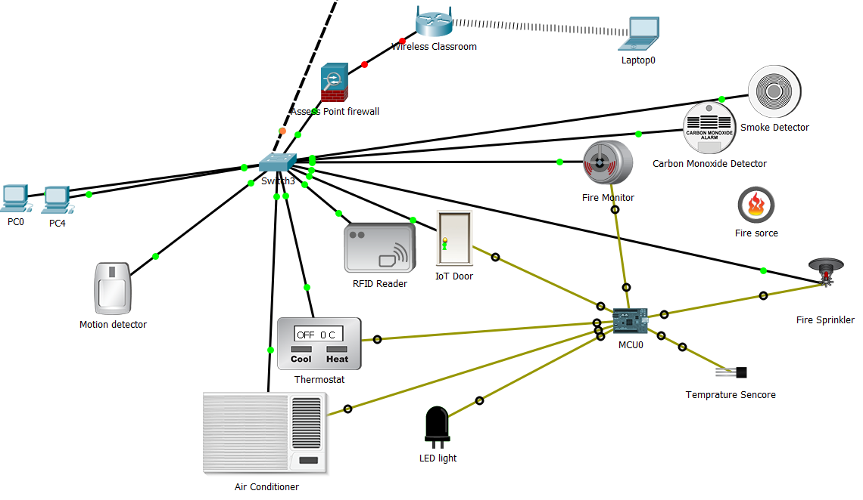
Figure 4 UWTSD IoT Class Room

Garden

It can be seen in figure 5 that although the garden has some of the IoT devices that the rest of the campus has, such as the security doors. The garden has many utility devices that are used to manage the garden:
- Weather detection: the use of wind detectors, temperature and photo sensors, provide the university with a possible automated system for the management of the grounds. The wind and temperature detectors can be used to monitor the weather and provide an automated sprinkler system for the grounds management, while the photo sensor can be used to monitor sun light levels and provide lighting using the smart LED.
- Power efficiency: by using solar panels the university can power all the devices in the garden area, each device can also be powered by the mains for overcast days.

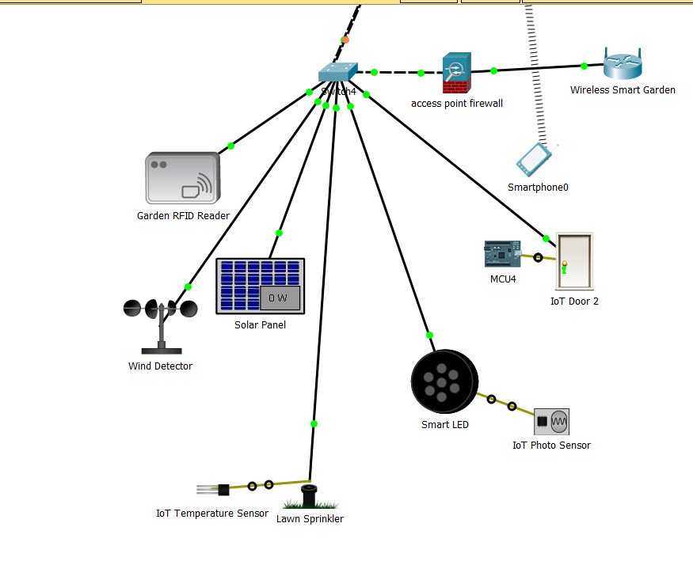
Figure 5 UWTSD IoT Outdoor Facility (Garden)

Car Park

The unique features of the car park shown in figure 6 are set into management and monitoring IoT devices:
- Management: the security room device shown in figure 6 is for the uses of security and IT management staff, the security staff should have constant day shifts to secure the vehicles stored there.
- Monitoring: the devices used for monitoring the car park are the standard carbon monoxide and fire detectors encase there is a fire, or carbon monoxide reaches dangerous levels, a motion sensor for the management of lighting. The most unique device is a trip sensor, this device will be used to monitor the amount of free spaces left within the car park.

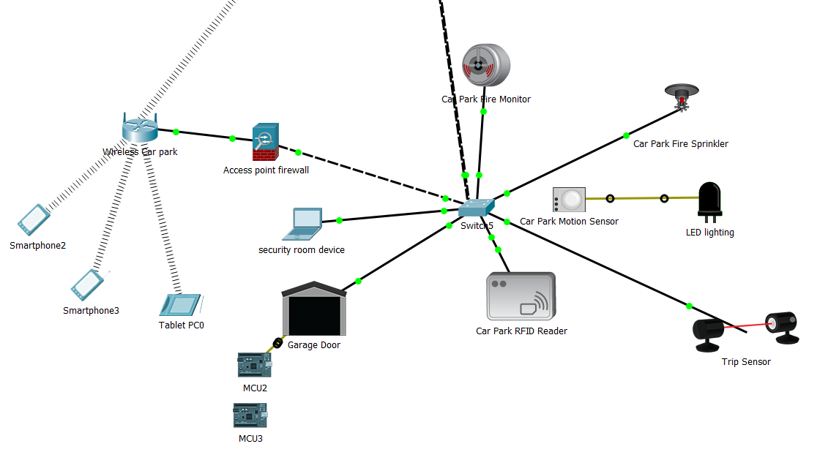
Figure 6 UWTSD IoT Car Park

Possible Improvements
An improvement in the design would have been to add an offsite data storage centre, this would allow for a quick recovery if the network goes down. Another improvement that could be made to the design, could also be to provide a visual representation of the possible future growth of the UWTSD’s network. Currently the design shows what a IoT network could look like, what it does not show is the size the wireless section of the network can be. For example, with the uses of BYOT it is possible to have a WLAN set up to double the number of users on a campus, it is also possible to show expansion through the uses of dark sites and back up locations for when a catastrophic shut down of the system happens there are ways to recover within the same day.

Conclusion
In conclusion the author has designed a simple IoT network for UWTSD, this network was designed to be simplistic and effective, for example the garden area can be a completely automated except for the maintenance. Although not shown in the diagram, the UWTSD is a growing university and will need to expand their network, this will allow for the ever-growing student population and the members of staff required to keep such an industry running.

Internet of Things and Smart City Security Issues

Introduction
This section of the report in focusing on the security issues that can affect a IoT environment, the topics discussed in this section are: What is IoT, the Threats that can be found in a IoT Smart City.

What is IoT and Smart City
The Internet of Things (IoT) [1] is the application of every physical tool being connected in a network, what this means is everything from a user’s phone to their front door is network enabled [2]. IoT enables device to device communication that does not require the use of human interaction, this comes with many challenges such as: security, energy consumption, network management and reliability [3].
The IoT Challenges: -
- Security: IoT networks are normally connected to Wireless networks, so they naturally inherent the same security weaknesses such as insufficient authentication.
- Energy consumption: IoT devices require power, many can run on mains circuits or batteries, this can lead to high Electrical costs.
- Network management: insecure network services are a threat to IoT that can be mitigated by proper management of network services such as blocking ports.
- Reliability: wireless networks have problems with range and coverage, caused by weather and obstacles, this must be taken into consideration when implementing a IoT environment.
Smart Cities [1] are municipalities that use information and communication technologies to increase the operational efficiency of everyday life in the city. An example of a Smart City is Barcelona, Spain shown in figure 5, the municipal services of this city have incorporated lighting technology, for example LED and Light sensing Technology has been used to provide automatic and efficient street lighting [4].
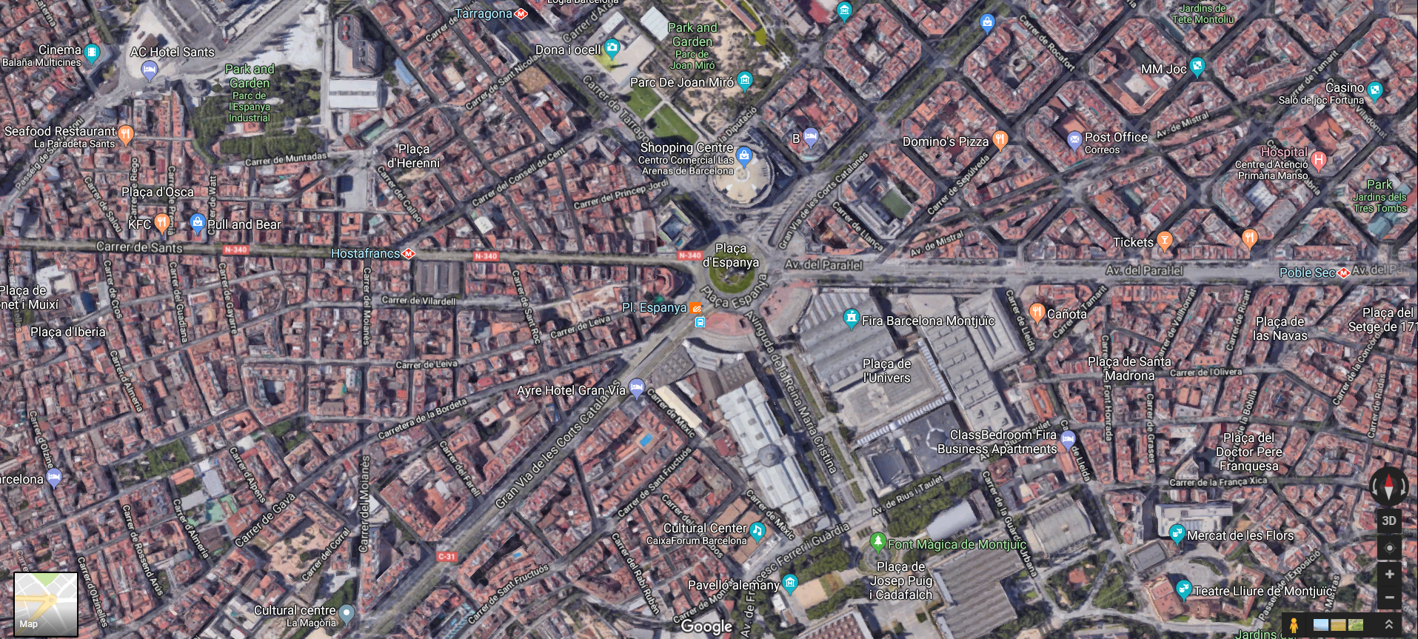
Figure 7 Barcelona Smart City, Spain [5]

Threats to IoT
There are many threats to a IoT network, from malware, hackers to simple missuses with or without malicious intent. As large amount of data is transported over IoT network, many things can go wrong [6], such as data loss from user negligence the following threats are some of what can be found in an IoT environment: -
- Insecure User Interfaces: Interfaces that are built into IoT devices allow the user to interact with a device and use the IoT recourses, they also allow attackers to gain unauthorised access to an unsecured device. This problem can be caused by not having or having a week password on the device such as a mobile phone, and allows an attacker to gain access to the user’s private data.
- Inadequate Authentication: this problem can also be caused by improper password practises, unfortunately people can be very predictable with their thinking patterns and often uses very simplistic passwords they believe no one would think of trying, such as “password123” or they use passwords that are significant to them in some way like they child’s birth data. The problem with this line of thinking is that hackers, uses brute force attacks (a script that will try out every letter and numerical combination until it finds the password), and phishing attacks (social engineering to get you to tell them the password) to gain the users password.
- Poor Transport Encryption: as large quantities of data are constantly flowing through an IoT network, any unencrypted data that is intercepted can be viewed and used by the attacker, this can lead to the source or destination devices being compromised, this problem can be caused by a misconfigured SSL/TLS certification.
- Meagre Physical Security: attackers will not always attempt cyber-attacks against a IoT network, theft, defacement and destruction of a physical device [7].
- Reduced Software Legitimacy [8]: as time goes on software becomes out of data, this makes it vulnerable to attack and uncountability issues. The main problem with this is updating the software and firmware of IoT devices such as the Wi-Fi security on public transport.

Threats to Smart Cities
Smart Cities are large computer networks, that allow the everyday running of the city to be as close to automated as humanly possible, securing these technologically dependant infrastructures is a monumental task that requires the joint co-operation of both the private sector and local governing body to achieve [9].
The threats that face a Smart City are: -
- Cybercriminals: as Smart Cities are comprised of millions (if not billions) of interconnected devices, criminals have a plentiful bounty of potential victims and targets for their illegal operations, such as but not limited to, hacking, ID theft, Phishing and Data Ransoming.
- Cyber Activists: although this type of threat can be considered to be under the threat of cybercriminal, cyber activists launch cyber-attacks for the goal of political gain. The attacks perpetrated by cyber activists can range from defacement of private and government property, websites for example [10], to the extreme of targeting Smart City’s traffic light grid to cause traffic accidents. A possible attack that cyber activists could us a Permanent Denial of Service (PDoS), also known as Phlashing this attack is a targeted at a devices firmware, and modifies or corrupts it to make the device unusable.

Security measures

IoT Security Measures
Although the threats that are discussed above are not a complete collection by any standard, the following security measures suggested are a basic coverall for most situations: -
- Requiring the Change of Default Passwords: many devices come with a basic factory set password, for instance Virgin Media Hubs come preinstalled with the password “Change me “, such password is well known and attackers can easily gain access to a device that has not had the default password changed.
- Requiring the Enforcement of Strong Password Policies: to make it as hard as possible for attackers, companies often enforce policies that dictate the minimum length and complexity of a password, for example many websites require users to have a minimum of a six-character password with variations in the capitalisation of the letters and at least one number, for example “7eVen6” is a much stronger password than “seven”.
- Checking Configuration: as the human error is one of the biggest threats to a IoT environment, or any networking environment it is important to check the configuration of a set function before it is set live, the reason for this is that if something like encryption is misconfigured the network can still work. To check the configuration tools like Kali Linux [11] can be used to provide penetration testing to find out the weaknesses of a network.
- Physical Security: every network will eventually be breached, so having a way to detect this and respond on a 24:7 basis, the best way to do this is to have automated warning email system in place to inform IT staff of the security breach and to have security guards on duty 24:7. Another basic method of physical security it to have locked security doors to protect devices from theft.
- Set Update Times: when devices become out of date it is important to set up an update schedule, this will minimize the effects of network down time. In reference to the example provided above (Reduces Software Legitimacy), software updates can be scheduled to happen during physical maintenance and off hours.

Smart City Security Measures
Although it is a monumental task organizations and city planners can take precautions in an attempt to ensure a secure infrastructure. The precautions that can be taken are: -
- Prioritisation of the security for critical assets: Public and Private sectors will have to work in conjuncture, with each other to identify the IoT assets that are critical to the continued operational status of the city and provide the maximum levels of security available to them, an example of such an asset is the waste management services of the city.
- Network behaviour based security: auditing the devices that are active on in a Smart City is not feasible, so to prevent the possibility of malware or other cyber threats on the network, a baseline of optimal functionality should be set so significant deviations from this baseline can be detected quickly and efficiently.
- Replacement of components: as technology used in a Smart City advances, so does the potential threats to the Smart City. To combat this all security software, applications and OS should be kept up to date, this prevents attackers from being able to gain access to some degree, another facture is old and damages physical devices need to be replaces, this prevents attackers from being able to physically attack the network.

Conclusion
In conclusion IoT and Smart Cities are ever growing, and important part of everyday life for people. The problem with these infrastructures is that security will always be an issue, networks will be breached, human error will cause loss of data and malicious intentions will cause the destruction of software and hardware. With that said there are many basic security procedure, such as basic password protection and complexity, that can be used to protect IoT and Smart City networks.

References
[1] ‘AI Security software and how it could interact with The Internet of Every thing’. .
[2] A. Sheth, U. Jaimini, and H. Y. Yip, ‘How Will the Internet of Things Enable Augmented Personalized Health?’, IEEE Intell. Syst., vol. 33, no. 1, pp. 89–97, Jan. 2018.
[3] K. Shafique et al., ‘Energy Harvesting Using a Low-Cost Rectenna for Internet of Things (IoT) Applications’, IEEE Access, pp. 1–1, 2018.
[4] ‘Street lighting management | Ecology, Urban Planning and Mobility’. [Online]. Available: http://ajuntament.barcelona.cat/ecologiaurbana/en/services/the-city-works/maintenance-of-public-areas/energy-management/street-lighting-management. [Accessed: 09-May-2018].
[5] ‘Google Maps’. [Online]. Available: https://www.google.co.uk/maps/@41.3737845,2.1763852,1062m/data=!3m1!1e3. [Accessed: 09-May-2018].
[6] M. Husamuddin and M. Qayyum, ‘Internet of Things: A study on security and privacy threats’, in 2017 2nd International Conference on Anti-Cyber Crimes (ICACC), 2017, pp. 93–97.
[7] J. Chen and Q. Zhu, ‘Security as a Service for Cloud-Enabled Internet of Controlled Things Under Advanced Persistent Threats: A Contract Design Approach’, IEEE Trans. Inf. Forensics Secur., vol. 12, no. 11, pp. 2736–2750, Nov. 2017.
[8] ‘Security Policy and Models’. p. 1986, 1986.
[9] ‘Control Risks’ Cyber Security Services provide threat intelligence, protection and response in the face of a continually evolving cyber threat landscape’.
[10] ‘Government websites in 4 states hacked with ISIS messages - CNNPolitics’. [Online]. Available: https://edition.cnn.com/2017/06/26/politics/websites-hacked-isis/index.html. [Accessed: 09-May-2018].
[11] Offensive Security, ‘Kali Linux Trademark Policy | Kali Linux’. [Online]. Available: https://www.kali.org/trademark-policy/. [Accessed: 01-Dec-2017].

marking criteria and Student FEEDBACK

This section details the assessment criteria. The extent to which these are demonstrated by you determines your mark. The marks available for each criterion are shown. Lecturers will use the space provided to comment on the achievement of the task(s), including those areas in which you have performed well and areas that would benefit from development/improvement.

Common Assessment Criteria Applied (Assignment 1) | Marks available | Marks  awarded
1. Research-informed Literature
Extent of research and/or own reading, selection of credible sources, application of appropriate referencing conventions.
Your research aspect could be more referenced. Referencing convention used. (Grade mark: 66.67%) | 15 | 10
2. Knowledge and Understanding of Subject
Extent of knowledge and understanding of concepts and underlying principles associated with the discipline.
Clear awareness of challenges to established views and the limitations of the knowledge base. Did not used IEEE format. (Grade mark: 66.67%) | 15 | 10
3. Analysis
Analysis, evaluation and synthesis; logic, argument and judgement; analytical reflection; organisation of ideas and evidence
The practical area covered the documentation of the setting up and configurations of tools and software. No discussion on any test or simulation conducted to draw inferences about the design. How does your implementation inter-relate with your research aspect. No cross-referencing evidence. Your conclusion need improvement, see feedback in report. (Grade mark: 56.67%) | 30 | 17
4. Practical Application and Deployment
Deployment of methods, materials, tools and techniques; application of concepts; formulation of innovative and creative solutions to solve problems.
This design whilst basic does lack in the fundamental area of security in that a laptop can be consoled into any of the layer 2 / 3 switches and any of the ports. It is necessary to shutdown unused ports and prevent access to the console ports as a minimum when considering the implementation. (Grade mark: 43.33%) | 30 | 13
5. Skills for Professional Practice
Attributes in professional practice: individual and collaborative working; deployment of appropriate media; presentation and organisation.
Can communicate professionally and confident in a suitable format. Need formatting to look more presentable. (Grade mark: 60.00%) | 10 | 6

Assignment Mark (Assessment marks are subject to ratification at the Exam Board. These comments and marks are to give feedback on module work and are for guidance only until they are confirmed. ) | Late Submission Penalties (tick if appropriate) |  | 56%
 | Up to four weeks late |  | 56%
 | First Attempt? |  | 56%

