Evaluate the concept of evidence-based practice and assess how approaches to evidence-based practice can be used to provide insight that supports sound decision-making across a range of people practices and organisational issues. (AC1.1)

Evidence based practice is a process of using reliable evidence to guide practitioners in making informed decisions. By using reliable evidence, decision making can then be made in a rational way without causing affect to the organisation and any individuals.

There are many different approaches to evidence based practice and how to collate data, such as the four sources of data, Scientific, Organisational, Experimental and Stakeholder Evidence. By using the 4 sources of evidence identified by Barends, Rousseau and Briner (2014) a wide range of information can be evaluated on a non bias basis to be able to make decisions correctly first time around with the least amount of impact made to the organisation or individual but has the highest amount of positive change.

Although decision making within an organisation may not always be ‘best practice’ where one organisation takes a way of working ‘cherry picking’ from another organisation. Without critically evaluating the impacts it will have on their organisation, and the effectiveness of the change made. Using a tool such as the profession map CIPD (2023) helps support sound decision making and can help drive changes within the organisation by keeping the core purpose of the decision making at heart and then adding the elements on top such as knowledge, behaviour and specialist behaviour (Waite et al., 2021).

Evaluate one appropriate analysis tool and one appropriate analysis method that might be applied by organisations to recognise and diagnose issues, challenges, and opportunities. (AC 1.2)

There are many analysis tools and methods available for organisations to use to help identify issues, challenges and opportunities, such as SWOT analysis, PESTLE tool and Porter’s five forces. There are four analysis methods used in organisations are descriptive, diagnostic, predictive and prescriptive.

PESTLE analysis is a very useful tool to use as it looks at more external factors that may affect the organisation in comparison to an analysis tool such as SWOT. Which only looks at the business at a set moment in time rather, than looking at the wider factors that may affect the organisation. SWOT analysis is a very useful tool but is a very simple and quick tool that can be used to evaluate an organisation but can also be used on self reflection. In the organisation that I work for we use SWOT analysis when looking at a snapshot on the day. It’s an easy tool to use when looking for a quick result and it doesn’t specify on looking at a number of issues, it has a broad range that can be interpreted by the user for their needs.

By using the PESTLE tool an organisation is able to look at political, economic, social, technological, legal and environmental issues. It gives organisations the ability to understand the wider environment surrounding the organisation, pick out potential threats in the future and plan to avoid them or minimise their impacts and it encourages strategic thinking. Although organisations using PESTLE need to be aware of the disadvantages of the tool, where too much information is collected and then no effective decision can be made, the data collected can sometimes be over simplified and then the assumptions may later happen, the tool needs to be repeatedly used to ensure all the data is up to date and the best quality information is collated and used (waite et al,. 2021)

An analysis method used by organisations is diagnostic analysis, organisations will use diagnostic analysis when looking at past data and root causes of what caused these issues to happen. So information that may be presented if around absence on a particular day or week, which could be a sporting event and this caused the sporadic sickness percentage to spike. From using this data that has been collated and analysed this can then be passed onto the relevant people to ensure if the same sporting event were to happen again, then the business can prepare accordingly to ensure sickness percentages don’t spike and if they do spike ensure that extra resources and support have been put into place prior to the event happening, rather than trying to fix the issue to close to the event (waite et al,. 2021).

Explain the main principles of critical thinking and describe how these might apply to your own and others’ ideas to assist objective and rational debate. (AC 1.3)

The main principles of critical thinking are ensuring that decisions are made using rational thinking and independently in a non biassed way. For organisations being able to hold a meeting and giving rational thoughts and ideas to a discussion with valid ideas and thoughts is critical in decision making. To think critically in a structured way, HR is able to engage issues and matters that you aren’t specialist in and isn’t your subject field but you are able to give a valued opinion on the matter using three key elements. These are being able to talk about standards, which gives us a baseline of what we want to achieve at the end of the discussion and what we need to use for decision making. The second is common errors and this is where decisions are made using previous history or because we think it's the right decision or it’s an easy way out of a decision rather than actually putting all the information together with a valid reason and making the correct decision rather than making a quick, easy decision. The third is being able to hold a conversation and being able to persuade people into the correct way of thinking in decision making (Howlett and Coburn, 2019).

Also the CIPD Profession map can be used to ensure that all decision making is made in a critical way, which keeps the core purpose of the decision making at the centre and then using principles and evidence to collate an outcome which will drive the right outcome (CIPD, 2023).

There are also other tools that can be used to support critical thinking such as the Briner (2019) six steps approach. By using the six steps and a wide range of data this helps develop more factual knowledge and understands a wide range of issues that occur across many organisations (Waite, et al,. 2021)

Explain three decision-making processes that can be applied to ensure that effective outcomes are achieved. (AC 1.4)

There are many different tools that can be used to make effective decision making such as the Kepner and Tregoe model, De Bono’s six thinking hats and Deming’s PDSA cycle. Kepner and Tregoe model is used as a decision making tool to root cause problems, there are many steps to follow in this process which gives the operator the ability to look at a problem with many different perspectives. Using this tool the operator is able to look at the potential problems that have or may occur, identify possible causes and what has caused the issues and then being able to identify what caused the issue and to assess future decision making to ensure the issue doesn’t occur again. Although the graph has very clear steps to follow there are many steps to follow which could then cause blurred boundaries between steps which may cause decisions to become blurred (Mindtools, 2024).

De Bono’s six thinking hats is also a tool that can be used to help with decision making, each hat is to represent a different perspective on a situation. It is to be used as a team and can either be that a different person in the team ‘wears’ a different coloured hat or as a team you ‘wear’ each different coloured hat and generates deeper consideration using parallel perspectives to make efficient decisions. This gives a wide range of perspectives as not everyone will look at the situation with the same view, giving many different points to discuss (Taylor and Woodhams, 2022)

Deming’s PDCA cycle Plan, do, check, act is also a tool that can be used for decision making although this is a very simple tool with only looking at four elements. The input and output are very basic, plan what is going to change, carry out small studies of the new change, check the results of the change and then act on the decision from using the results collated and then you’d repeat the process again until the results are as the organisation would expect.

Assess three different ethical perspectives and explain how understanding of these can be used to inform and influence moral decision-making. (AC 1.5)

For an organisation to have sound ethical principles that aline to the organisation's vision and values produces a positive mindset amongst employees and the working environment. To be able to make ethical decisions there are key reasons that support ethics, self interest, mutual interests and common good. Self interest is about managing one's reputation to display integrity, common interests is about developing ethics across the organisation to improve effectiveness and common good relates to the wider environment.

This then leads onto ethical perspectives and there are a number of theories such as Deontological theory, utilitarianism, equity theory, stakeholder theory and justice. To evaluate three theories, Deontological theory is the principle of ‘doing the right thing’ based on a number of elements such as justice, fairness and equality. So when organisations are having to make decisions they use this theory to ensure they are making the right decision on fundamental rights and wrongs and ensuring they are following a duty of care when making decisions.

Justice theory of ethics is a theory ensuring that all decisions are made on fairness, equality and equitable treatment of all decisions that are made in an organisation. Being able to stay unbiased and impartial to a situation then gives a clear vision on what decisions need to be made, to ensure the correct outcome is made. This justice theory can be used when carrying out disciplinary actions within an organisation. By ensuring the company has a clear vision and value, the decision is then easier to make ensuring the disciplinary manager has an unbiased view on the matter and can then make a clear and ethical decision (Waite et al,. 2021)

Utilitarianism is a perspective that is made for the greater good and to please the highest number of people and considers results in happiness, as doing the right thing and would oppose actions that would create unhappiness or harm. Although this might sound like a good theory, utilitarianism doesn’t take into account things like emotions, justice or cultures. In an organisation this would then have limitations in decision making, where decisions are made on a whim as it pleases the ‘greater good’ rather than looking at what both the positives and negatives of the argument and to choose the right decision not only for the organisation but also for the employees (Tardi, 2024).

To make ethical decisions in organisations and influence moral decision making eight ethical lenses can be used to support decision making, none state a right or wrong way to make a decision but put different perspectives on work issues. By following the eight principles of fairness, merit, market, democracy, well being, rights & duties, characters and handing down, this allows decisions to be made to ensure there is a good working environment within the organisation for the greater good and then in turn should create a fair and ethical sound environment for employees to work in (CIPD, 2015).

Appraise two different ways organisations measure financial and non-financial performance, providing one example of each. (AC 3.1)

There are many ways in which organisations can measure financial and non financials performance, whether it’s financial results, profitability, Customer data or employee data. An example of non financial performance would be customer data. This can be from many forms of data collection, whether it be face to face customer feedback, customer feedback from questionnaires or multi choice questions but it can also be from collating data around shopping habits, such as customer footfall or average basket spend. There are many ways in which an organisation can collate data and collect data using many different perspectives. Data such as a multi choice questionnaire is only collecting data that the organisation wants to know and only gives a very narrow view on the information collected (waite et al, 2021). The company that I work for has recently started monthly customer roundtable meetings and the amount of feedback received which has been very constructive and changed the way the company and store have now started to look at customer feedback and take action on the information given. With the round table meetings not being led by a narrative that the company wants, and is led by the customer, we have been able to personally change things in store to support customers shopping and journey with the company. Which is information we would never have had, if the narrative given to the customer was driven by the company (rockcontent, 2023).

A way for organisations can measure financial performance is by using Key Performance Index. This can be used to measure sales performance on a daily, weekly and monthly basis and can also be used to track actual sales against what was the planned takings for the organisation. This tool can then be used to look at any trends that may occur over a short or long period of time and where the organisation can then look to increase sales and can also link it to customer data from non-financial performance such as customer footfall or customer average basket spend. By being able to link this performance data together and having an understanding of the business and customer needs the organisation can then look to make improvements and aim to make growth in company sales. Goals can be set out using SMART (specific, measurable, achievable, relevant and time bound) which can then be used when targeting an area of the business to evaluate and to set targets and goals to achieve and ensuring the goals are successful. (waite et al,. 2021).

Explain how people practices add value in an organisation and identify two methods that might be used to measure the impact of people practices. (AC 3.2)

There are many processes of people practices that are used over an employee lifecycle, from recruitment, onboarding, development, disciplines, policies and termination. Ensuring an organisation has a strong people practice in place allows colleagues to feel valued, and clear policies are in place to support employees and for them to be used appropriately when needed in the working environment.

It is now seen that the impact of people practices now has on organisations not only relates to issues such as recruitment and absence but also to the wider organisation such as legal and financial aspects. With knowing the organisation as a whole, people practices can be relevant to issues within the organisation. When looking at recruitment for example, if an area which is classed as skilled has a vacancy, looking to recruit a person who is trained in that particular area might mean the company have to pay a slightly higher wage for the new recruit but the long term gain for the organisation will then be that they have to pay for less training of the new recruit, trade is less likely to be affected as the new recruit has previous knowledge and then the output whether product or sales will be affected minimally. The new recruit may also bring with them new ways of working or ideas that could benefit the organisation.

Methods that can be used to measure people practices within an organisation can be absence levels and productivity and these methods can be linked. If an organisation has a high number of employees who are absent, then this can have a direct affect on productivity within the organisation. Whether this be long term or short absence, by managing absence effectively and ensuring all absence is managed on the same consistency across the organisation. By facing issues around absence and listening to the colleagues who are absent may reveal that there is a trend to the absence or that there is an issue within the organisation that hasn’t previously been seen. This then gives the organisation the ability to resolve any issues that are causing colleagues to go absent and in the long term should increase the morale of the organisation and will boost productivity and support the colleagues who are in the organisation with their workload and work stress, to then reduce further absence (Acas, 2023).

With reference to a people practice issue, interpret analytical data using appropriate analysis tools and methods (AC 2.1)

A, Percentage of each gender by type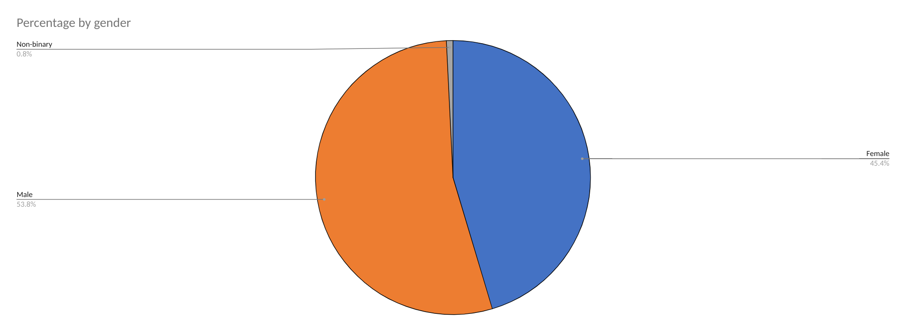
From the pie chart above with the data from the organisation on employee gender, there is a higher percentage of male employees 53.8% than female 45.4% and non binary employees 0.8%. This may be due to the organisations line of work, if this is an organisation that stereotypically in a industry with a higher number of employees are male this might why the percentage is higher and as society has changed over the recent years more female, non binary employees have joined the organisation hence for a smaller percentage. This means the organisation has plenty of room to improve its gender work force which may mean an improvement of policies or facilities to ensure a wider range of gender types are involved with the organisation (CIPD, 2020).

B. Ethnicity as a percentage per team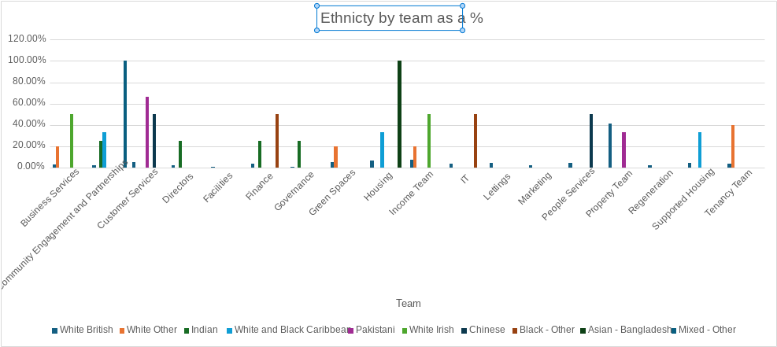

There is a wide range of ethnic backgrounds that work for the organisation which could suggest they have a well established inclusive policy within their organisation and employees feel supported and listened to. But within some of the teams within the organisation the ethnicity is majority only one ethnicity such as community engagement and partnership team, so the organisation could look at ways of making this team more diverse. Ensuring that management teams are aware of Equality, Diversity and Inclusion and they play a key role in ensuring colleagues, the business is behaving in an inclusive manner(CIPD, 2022).

C. Disability percentage as an organisational whole and by teams. 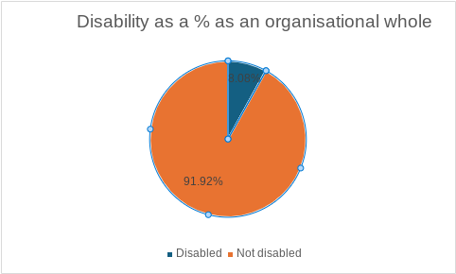

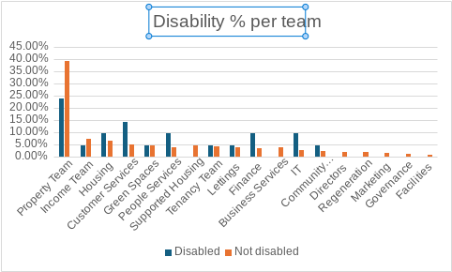
The above graphs show disability as an organisational whole and in teams and that only 8% of the entire workforce is classed as disabled and that the team with the highest percentage of disabilities is the property team. This might be that the data is old for only a small proportion of the workforce is classed as disabled or that maybe employees didn’t want to disclose that information in case they felt they could be penalised because of it. The organisation may want to look into ways of making other teams in the organisation more accommodating to employees with disabilities. And also different ways of being more enticing to employees who are disabled and offering them part time work, or the choice to work from home where they won’t have to come across daily challenges, like travelling to work and accessibility to different workplace locations (CIPD, 2022).

D. Salary difference across gender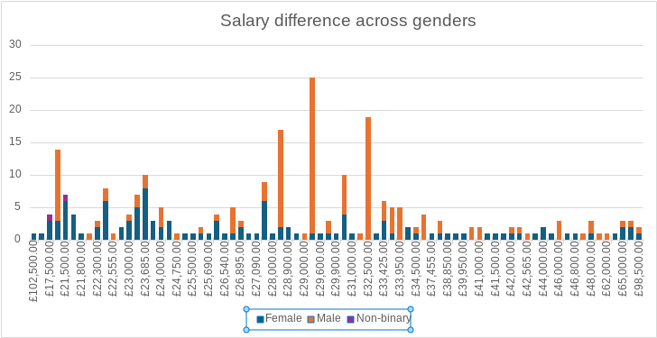
From the data employees who are non binary are in a lower salary bracket only earning a maximum of £21500, whilst some of the highest paid employees in the organisation are female although this data doesn’t show that the highest earning female employees are in director roles within the organisation which then may distort the salary by gender data to any external looking at the organisations salary by gender data (CIPD,2024). Recommendations on improving gender pay differences for organisations will in turn improve the organisations reputation, the talent they can recruit in the future as the organisation to work for will be more appealing, it shows that organisations are inclusive and promote fairness within their policies (CIPD,2024).

E. overall average salary paid by the organisation. 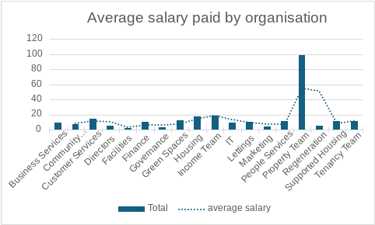
The overall average salary paid by the organisation is around £30,000 with employees in the property team earning the highest average salary in the organisation at just less than £60,000 (CIPD, 2024). From looking at the data from the organisation it is clear that some teams are paid a higher average salary than others this may be down to role complexity and the qualifications and training requirements to complete these roles, but this may lead to different teams working at different performance levels within the organisation rather than sharing the educational working environment amongst the organisation which improve performance levels for the organisation. It may also suggest that teams with a lower average salary have many part-time employees which will affect the salary levels within the organisation (White,2023).

Present key findings for stakeholders from people practice activities and initiatives (AC2.2)

Table 2 which displays employee feedback on hybrid working practices, provides great evidence that can be evaluated and adapted to ensure a better working model or if changes to the hybrid working environment needs to be made.

Make justified recommendations based on evaluation of the benefits, risks, and financial implications of potential solutions (AC2.3)

From evaluating the data around hybrid working practices there are some clear and strong benefits and negative data that has come out of the sample group of 300 colleagues.

Hybrid working seems to offer the best of both worlds where employees can work a few days from home and the rest in an office setting, giving employees the benefits of reduced travel costs and time, working around childcare commitments and having a healthy work life balance. Over half the colleagues surveyed stated that hybrid working supported their work life balance and well being. Employers are then able to spend less money on office spaces, and the money savings the organisations can make can then be reinvested back into the business. Hybrid working still gives organisations the balance of seeing colleagues in the workplace setting to ensure workloads are being met, and colleague welfare is maintained, communications and engagements are being upheld between employees and the organisation (Taylor and woodhams, 2022).
From the table and the data collected it showed that out of the 300 colleagues who were surveyed, 250 of the colleagues found that they feel more stressed working from home than they did working in the office.

The risks this could have on the organisation is that colleagues are doing less work at home as they are feeling stressed, confused and unsure how to complete the work load. This could also lead to colleagues being absent from work with stress, as they feel they are unable to have a healthy work life balance, which will then be a financial implication to the organisation.The organisation will then being paying a colleague sick pay and will then have to pay another colleague to complete the work of this colleague who is off sick or another colleague will then pick up this extra workload.The workload of having colleagues off sick will then put a higher burden on the remaining colleagues in the organisation and while the colleague is off on the sick which could then in turn incase the sickness rate in the organisation. Organisations then need to look at their health and wellbeing policies to ensure they can support colleagues who are hybrid working (Taylor and Woodham,2022).

The organisation may struggle to stay in contact with the colleague due to the hybrid working arrangements and therefore getting the colleague back into work may take longer. To ensure this the organisation can set up some robust hybrid working arrangements such as weekly one to ones with colleagues, ensuring there are communications being the organisation and employees and a regular basis both remotely and when in the workplace. Inclusiveness with team building exercises and ensuring the colleagues feeling their wellbeing is paramount (CIPD,2021).

When organisations are looking at hybrid working and whether it’s compatible with their organisation there are many pros and cons that can come with it and it may affect some organisations differently to others. Some organisations that have a well established flexible working policy and welfare policies in place may benefit from the hybrid working with employees benefiting from working from home, with a healthier lifestyle and work life balance. While other companies may initially struggle with setting up the hybrid working approach, having to invest in equipment for colleagues to use at home may have big financial implications and also if the employers teams have large numbers of employee to manager ratio. The manager may struggle with the balance of supporting colleagues both at home and in the workplace environment, so the input and output will produce different results between different organisations.

Reference list

ACAS (2023) Reducing Absence Managing Sickness Absence. Available at:https://www.acas.org.uk/recording-and-reducing-sickness-absence/reducing-sickness-absence (Accessed:22nd June 2024)

CIPD (2024) PESTLE Analysis. Available at: https://www.cipd.org/uk/knowledge/factsheets/pestle-analysis-factsheet/ (Accessed:6th June 2024)

CIPD (2023) How to use the Profession Map. Available at:https://www.cipd.org/uk/the-people-profession/the-profession-map/how-it-works/ (Accessed:6th June 2024)

CIPD (2015) A Head For Hiring: The Behavioural Science of Recruitment. Available at:https://www.cipd.org/uk/knowledge/evidence-reviews/recruitment-science/ (Accessed:3rd June 2024)

CIPD (2024) People Analytics. Available at:https://www.cipd.org/uk/knowledge/factsheets/analytics-factsheet/ (Accessed:18th June 2024)

CIPD (2015) Ethical Decision Making: Eight Perspectives on workplace dilemmas. London:CIPD Avaliable at:https://www.cipd.org/globalassets/media/knowledge/knowledge-hub/reports/ethical-decision-making-2015-eight-perspectives-on-workplace-dilemmas_tcm18-9564.pdf (Accessed:20th June 2024)

CIPD (2022) Can remote working close the disability employment gap Available at: https://www.cipd.org/uk/knowledge/bitesize-research/disability-employment-gap/ (Accessed:11th July 2024)

CIPD (2022) Equality, Diversity and Inclusion in the workplace Available at:https://www.cipd.org/uk/knowledge/factsheets/diversity-factsheet/#Equality (Accessed: 11th July 2024)

CIPD (2024) Are British employers making progress in reducing the gender pay gap? Available at:https://www.cipd.org/uk/views-and-insights/thought-leadership/insight/is-britain-reducing-its-gender-pay-gap/ (Accessed:11th July 2024)

CIPD (2020) Traditional attitudes on gender and work Available at:https://www.cipd.org/uk/knowledge/bitesize-research/traditional-gender-work/ (Accessed:11th July 2024)

CIPD (2021) Hybrid Working Practical Guidance London:CIPD

CIPD (2021) Effective hybrid working: Practical guidance Available at: https://www.cipd.org/uk/knowledge/guides/effective-hybrid-working/ (Accessed: 14th July 2024)

CIPD (2024) Gender pay gap reporting:understand what it is, if you need to report it and why Available at:https://www.cipd.org/uk/knowledge/guides/what-is-the-gender-pay-gap?_gl=1*1nyxe64*_ga*MTYyOTA5MDQzNi4xNjc4MzcwNzg0*_ga_D9HN5GYHYY*MTY5NjI2NDI0Ni43MC4xLjE2OTYyMzY1MjMuNjAuMC4w (Accessed:19th July 2024)

Howlett, W and Coburn, T,. (2019) ‘Episode 154’ Critical thinking. [podcast]. Available at: https://www.cipd.org/uk/knowledge/podcasts/critical-thinking/ (Accessed:29th May 2024)

IESE (2017) The 10 Most Common Mistakes in Decision Making. Available at:https://www.iese.edu/insight/articles/common-mistakes-decision-making/ (Accessed:18th June 2024)

Mindtools (2024) The Kepner-Tregoe Matrix. Available at:http://www.mindtools.com/atznth6/the-kepner-tregoe-matrix (Accessed:17th June 2024)

Rockcontent (2023) How to conduct a successful roundtable. Available at:https://rockcontent.com/blog/roundtable/ (Accessed: 8th July 2024)

Tardi, C (2024) Utilitarianism: What it is, Founders, and Main Principles. Available at:https://www.investopedia.com/terms/u/utilitarianism.asp#:~:text=Utilitarianism%20is%20a%20theory%20of,of%20society%20as%20a%20whole (Accessed:20th June 2024)

Taylor, S and Woodhams, C,. (2022) Studying Human Resource Management A guide to the study, context and practice of HR (eds.) London: Koganpage

Waite, K., Beevers, K., Small, N., Tomlinson, K., Hussain, S. (2021) People Practice A complete Guide (eds.) London: koganpage

White, N (2023) Low and High pay in the UK:2023 Available at:https://www.ons.gov.uk/employmentandlabourmarket/peopleinwork/earningsandworkinghours/bulletins/lowandhighpayuk/2023 (Accessed:19th July 2024).

