SOFTWARE SOLUTIONS FOR BUSNIESS:
28/04/2026

MODUL NAME: SOFTWARE SOLUTIONS FOR BUSINESS
MODULE CODE: ACCA 4026
LETURER: AMITAVE BANK
STUDENT NAME: AL NATHIR HAMED
STUDENT ID:2525499
STUDENT NAME: ALNATHIR HAMED
STUDENT ID: 2525499

Table of Contents
Introduction 1
Task 1. e-Commerce Website builders or software solutions 1
1.1 WooCommerce 1
1.2 Wix 1
Task 2. Mind-map of contemporary software applications 1
a. Mind mapping and explain the benefits of using mind mapping in business operations 1
b. Create a mind map of contemporary software applications 1
Task 3. Office Applications 1
a. Four office software solutions for business operations 1
MS Word 1
MS PowerPoint 1
MS Excel 1
MS Access 2
b. Practical demonstration of Two Office Features 2
Mail Merge 2
If Statement 2
Task 4. Communication and Collaboration applications 2
a. One contemporary Communication and one Online Collaboration applications/tools 2
MS Outlook 2
MS Teams 2
b. One feature of a freely available Communication (1) and one feature of a Collaboration (1) application 2
MS Outlook 2
Ms Teams 2
Conclusion 2
References 3

INTRODUCTION:
In today’s digital world corporate software solutions are essential for increasing productivity, efficiency and overall performance, to automate processes, manage data, and facilitate decision making, businesses utilises a variety of software, including cloud based platforms accounting systems, and customer relationships management applications, these technologies improve communication inside organisation, save time, and lower operating expenses.
Businesses may satisfy client needs more successfully, react to market changes faster, and keep a competitive edge in their sector by implementing the proper software.

Task 1. e-Commerce Website builders or software solutions

Shopify and Wix are the two popular modern e-commerce websites builders. Although both platforms allow companies to set up and run online stores, their features, usability, and scalability are different.
WIX
Wix is well known website builder that provides e-commerce features, making it an adaptable option for small and medium -sized enterprises. In contrast to Shopify, Wix started out as a generic websites builder before adding features for online sales. It is especially known well known for being simple to use, providing a drag and drop editor that lets users create websites without knowing any code. Forbes +1 Wix design flexibility is one of its key benefits.
It gives businesses more creative control over their online stores by offering hundreds of templates and allowing consumers to freely customize layouts. Additionally, Wix has built in a capability like marketing connecters, SEO tools and AI powered website design that enables customers to swifty construct professional looking websites. Wix facilitates online payment processing order management, and the sale of both physical and digital goods. [1]
Along with features like subscriptions and personalised checkouts choices, it also permits multichannel selling. However, Wix advanced e-commerce capabilities are more limited than Shopify’s and therefore might not be as appropriate for complex or large- scale online stores. Wix is more often beginner friendly and cost effective, making it perfects for startups, freelancers, or enterprises with narrower productive range. However, businesses planning significantly growth or requiring advanced features may eventually outgrow the platform. WIX user friendly design and integrated features that streamline the process of setting up an online store are the key reasons it is regarded as simple for e-commerce. Furthermore, Wix offers prebuilt designs made especially for online retailers. [2]
Shopify

One of the most popular e-commerce websites builders is Shopify, which was created especially to assist companies in setting up, running, and growing online stores, it is an all-in-one platform that offers payment processing, inventory management, websites design tools, and hosting all under one roof.
This makes it especially appropriate for companies looking for a specialised solutions that is solely focused on online sales Shopify facilitates a variety of sales channels, enabling companies to sell through social media and marketplace like Amazon in addition to their own website. [3]
Shopify’s sophisticated e-commerce features are one of its main advantages. It provides strong tools for order processing, worldwide inventory tracking, product management, and analytics business can monitor performance and make data driven choices thanks to these features.
Furthermore, Shopify has a vest app marketplace with hundreds of integrations that let users add features like automation, marketing tools and customer care systems. Shopify’s scalability is another significant benefit. Because it can manage massive volumes of goods and transactions, it is appropriate for both tiny businesses and large corporations.
Furthermore, the platform offers dependable hosting, fraud prevention, and safe payment methods guaranteeing a secure and stable environment for online enterprises. But for novices, Shopify can be more complicated, and premium themes and apps might cost more. All things considered, Shopify works best for companies that value expansion, cutting edge capabilities on e-commerce, because Shopify offers an all-in-one platform that makes setting up and maintaining an online store easier, it is seen as simple for e-commerce users.

Task 2. Mind-map of contemporary software applications

Mind mapping and explain the benefits of using mind mapping in business operations
A visual thinking method called mind mapping is used to arrange data around a main concept. To illustrate connected concepts, tasks, or themes, a central notion is positioned in the centre of a diagram and branches are drawn outward. A structured yet adaptable network of information can be created by further subdividing theses Braches. In contract to conventional linear note taking, mind mapping represents organises and processes information. Tony Buzan popularised the idea by marketing for learning, creativity and problem solving. [4]
Benefits of Mind Map
Mind mapping has a few significant benefits for corporate operations. Better organisation and clarity are among the key advantages. Companies frequently deal with intricate procedures including workflow design, strategy planning, and projects management. These procedures can be divided into smaller, easier to manage components using mind maps. Managers and teams may easily see how various components are relate to one another by visualising tasks and their relationships. This helps to avoid confusion and guarantees that crucial details are not missed.
Improved creativity and idea development is another important advantage. Because mind mapping promotes unstructured though, it works especially well during brainstorming sessions. A more open and creative approach is made possible by employee’s ability to swiftly contributes ideas without worrying about structure in the early stages.in sectors like product creation, marketing efforts, and problem solving this may result in more inventive solutions. It is simpler to spot trends and opportunities that might not be apparent in conventional lists or documents since concepts are visibly connected. [5]
Additionally, mind mapping enhances teamwork and communication. A visual diagram is a helpful tool during meetings and presentations since it is frequently simpler to understand than long textual explanations. Real time idea contributions from team members guarantee that everyone is participating in the conversation. By enabling serval users to work on the same map at once, even while working remotely, digital mind mapping applications like mind meister and X mid further improves collaboration. This promotes collaboration and keeps departments in sync.
Furthermore, mind mapping facilitates improved decisions making. Managers are better able to asses’ decisions when many options, risks, and dependencies are presented visually. Comparing options, seeing any problems, and figuring out the best course of action become simpler. When making complicated or important decisions, this organised summary is especially helpful.
Lastly mind mapping helps with better memory and retention of information. The information is made more interesting and memorable using keywords, colours and spatial organisation. Employee training, process documentation, and information sharing within the company all benefit greatly from this. Employees don’t need to read a lot of material to swiftly study mind maps and remember important information.
In conclusion, mind mapping is a flexible and useful tool for corporate operations organisation, creativity communication, decision making, and memory retention are all improved by it. Businesses can operate more productively and overcome obstacles in a fast-paced setting by employing mind mapping techniques. [6]

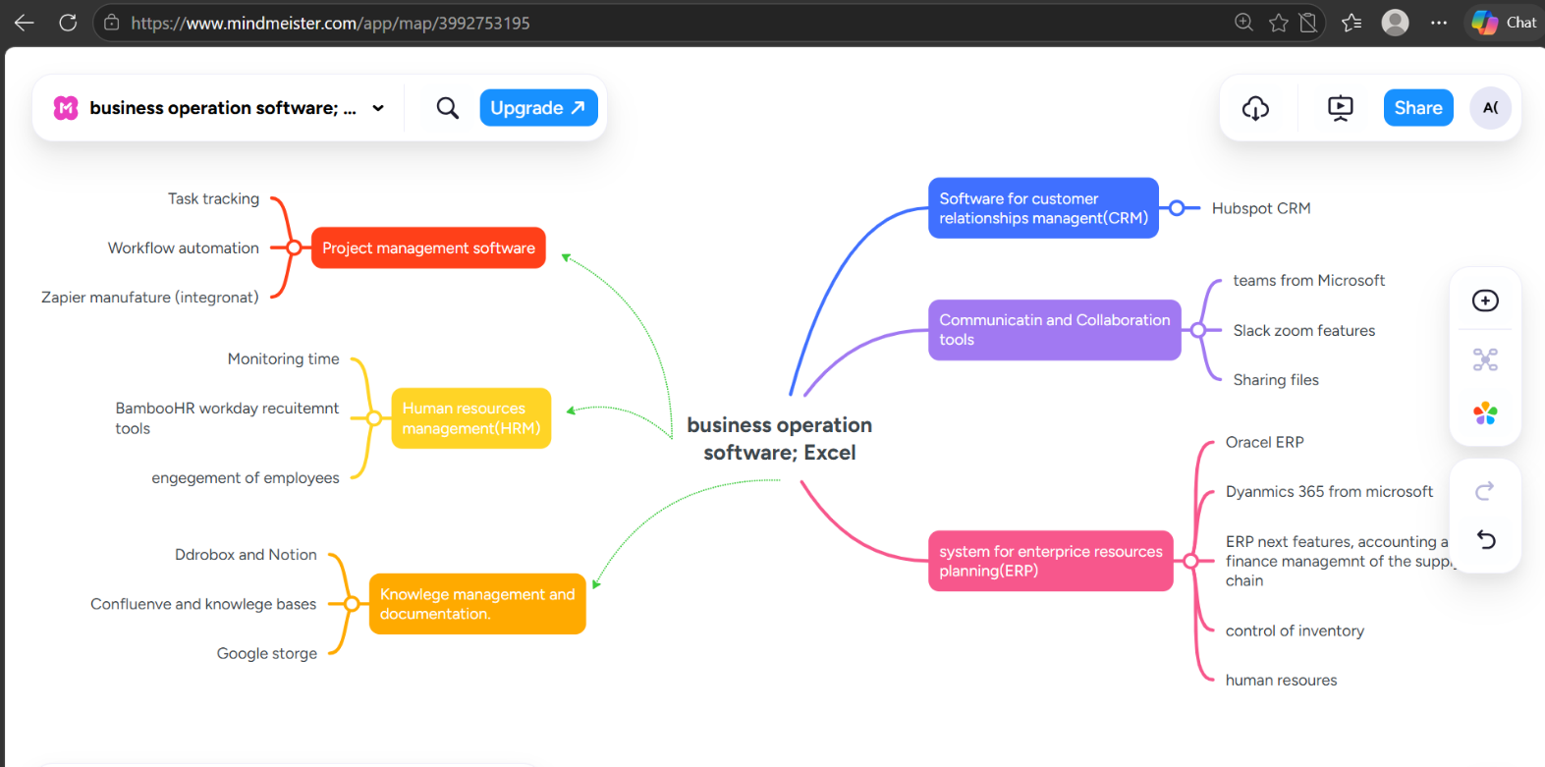
Create a mind map of contemporary software applications

Task 3. Office Applications

Four office software solutions for business operations

MS Word
One of the most popular word processing programs in contemporary business settings is Microsoft Word. It is component of the Microsoft 365 suite is intended to facilitate the effective creation editing, formatting, and sharing of text-based documents. Microsoft Word is used by business to create a variety of professional documents, such as proposals contracts, reports, letters and meeting minutes.
Benefits of MS Word;
Microsoft Word’s extensive collection of formatting and editing capabilities is one of its main advantages. To produce polished and businesslike papers, users can alter fonts paragraph styles, spacing and layouts, Additionally, the program has built in templates that let users quickly create standardised documents like company reports or resumes. Additionally, Word’s proofreading tools, such as autocorrect, grammar suggestions, and speel check help enhance the precision and calibre of written communication, which is crucial in professional contexts.

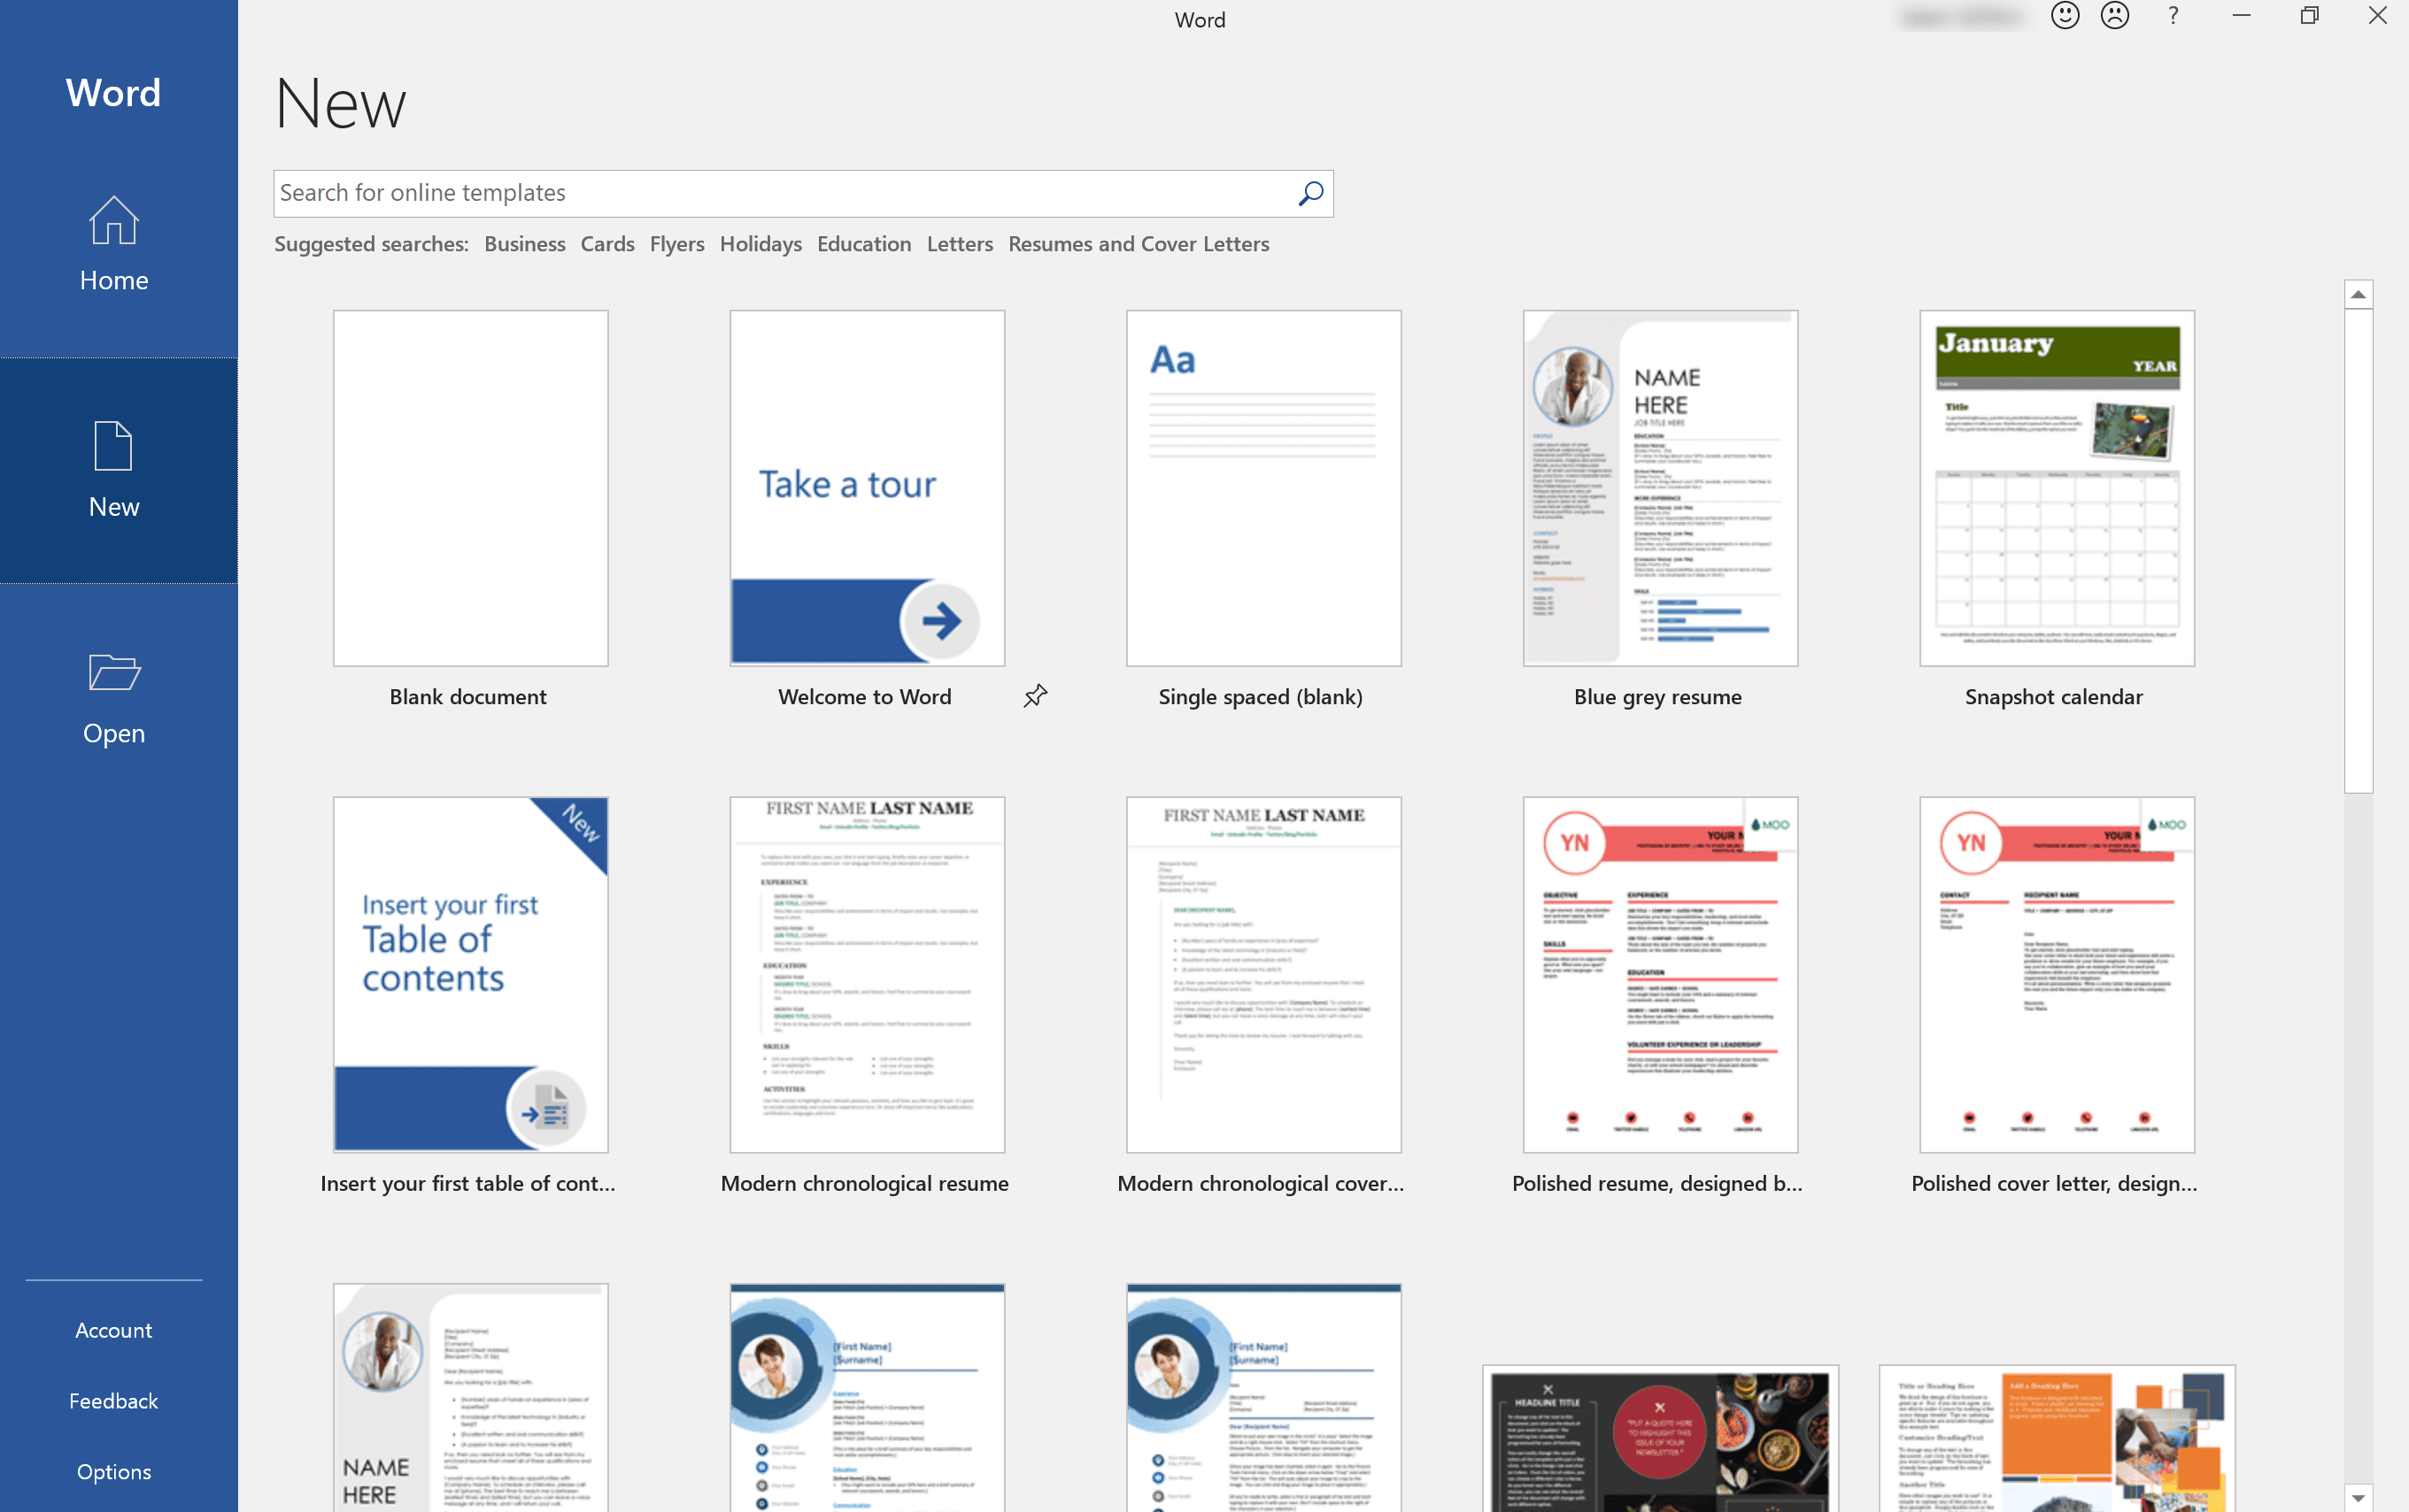
Figer [7]
Word’s insert design capabilities are another crucial feature. Tables, charts, pictures, shapes, headers, and footers can all be added by user to improve papers. Because of this, it may be used for both straightforward text documents and more intricate reports that call for graphic components. Additionally, users can effectively manage huge papers thanks. The navigation pane and document structuring capabilities such as headings and table of contents helped user a lot and made it easy for them.
Major features:
Microsoft Word facilitates real time editing and document sharing, particularly when utilised in conjunction with online services like one Drive. Multiple users may review and update documents together. User should appreciate features like Track changes and comments which is very helpful for team-based projects and approval workflow. Sensitive company data is additionally protected by security features like password protection and limited editing.
Microsoft Word has many advantages for corporate operations. Because of its ease of use, both novice and expert users can utilise it. Because of its expensive use, there are fewer problems when sharing documents because it guarantees compatibility across organisations. Because templates and automation features shorten the time needed to prepare, the software also increase efficiency and productivity. Additionally, it facilitates smooth workflow across many corporate processes, users should appreciate the interface with other Microsoft programs like Excel and Outlook.
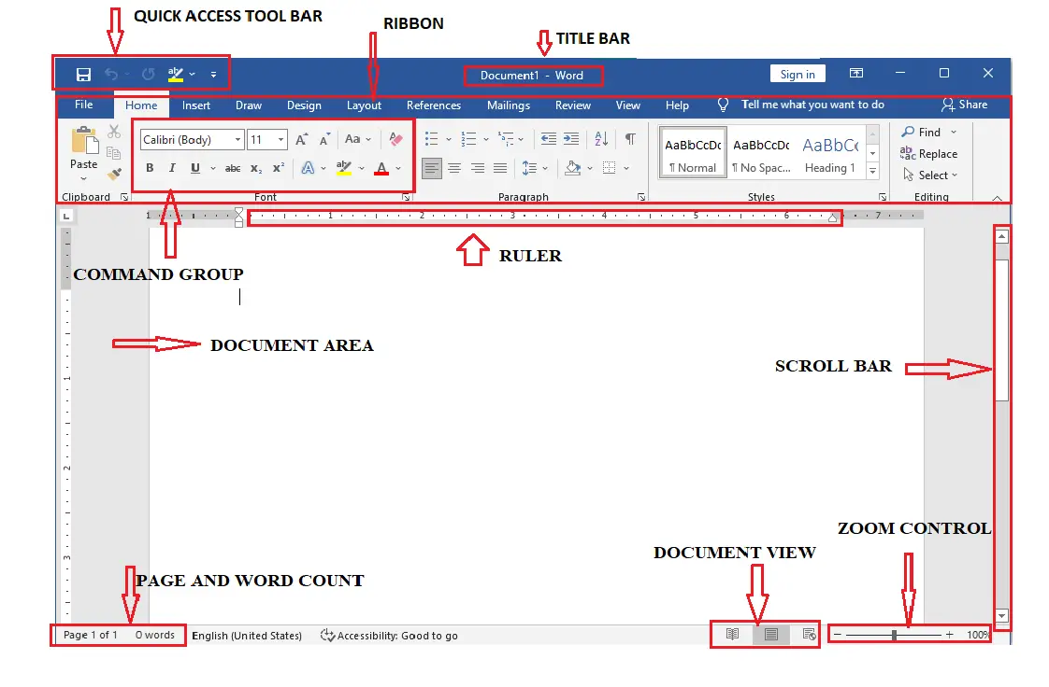
Figer [8]
Limitations:
Nevertheless, there are several restrictions with Microsoft Word. One disadvantage is that full access usually requires a paid subscription. Additionally, new users may find the software confusing or overwhelming due to its extensive feature set. Some users still find it less intuitive than fully cloud native options, despite improvements in collaboration tools. Huge file size from huge documents with lot of formatting or photos may also affect sharing and storge. Finally, if appropriate safeguards are not followed, Word documents may become a target for security concerns like macro- based due to their widespread use.
In conclusion, Microsoft Word is still an essential tool for business documentation, communication and academic studying, for them to create presentations, essay, formatting documents. Despite a few drawbacks, its robust features, user- friendliness, and integration potential make it essential for daily operations. [7]

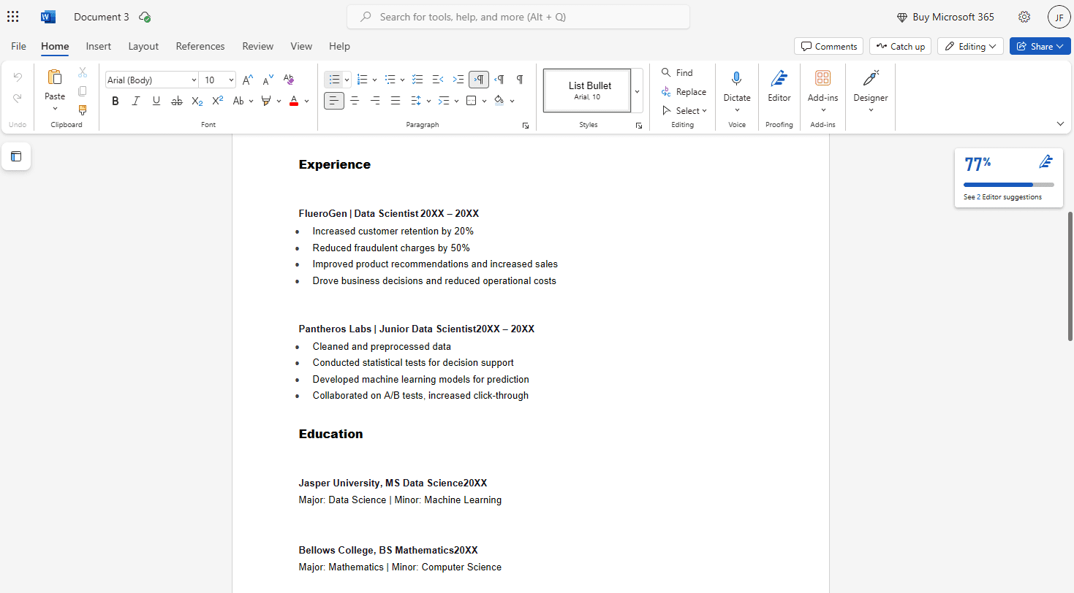
Figer [10]

MS PowerPoint
MS Power Point is poplar presentation tool that aids companies in visually communicating concepts, plans, and information. It is frequently used for meetings, training sessions, sales presentations, and internal reporting in a variety of businesses. It is component of the MS office suits. It is versatile platforms for both straightforward and intricate corporate communication because it combines text, graphics, charts and multimedia.
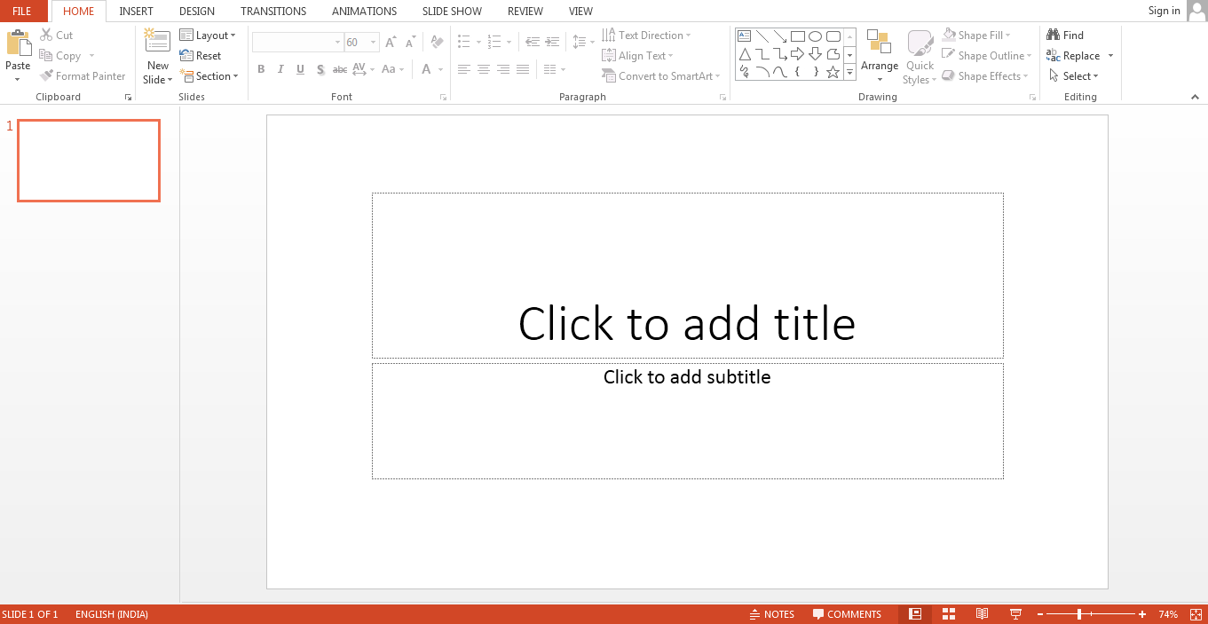

Figer [11]
Major Features;
Number of features in MS Power Point are intended to improve the effectiveness and quality of presentations. It slides based design, which enables users to arrange information into understandable portions, is one of its main strengths. Without the need for templates and themes that support consistent branding and polished appearance.
Multimedia integration is another important component. To make presentations more interesting, users can use animations, movies audio, and photos. Charts, graphs, and smart art are example of data visualization technologies that let businesses display complex data in an easy to understand aesthetically pleasing way.
Another key strength is cooperation Multiple team members can edit presentations
At the same time and access them form different locations, we should appreciate to interaction with cloud services like MS one Drive. By offering timing controls and suggestions, presenter tool like speaker notes and presenter view assist suers in delivering presentations more successfully.
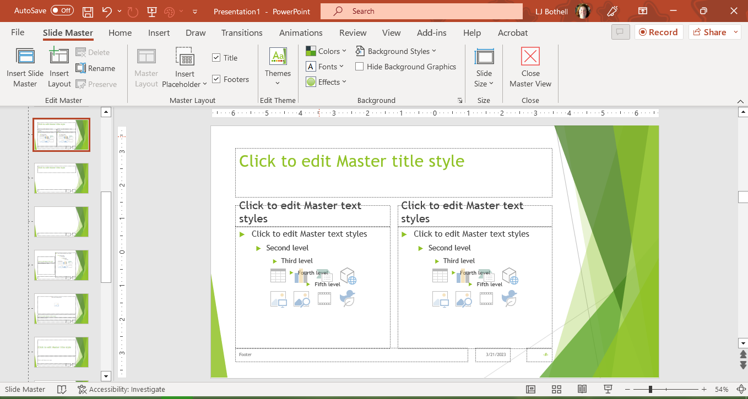
Figer [12]

Benefits;
Organizational communication is greatly enhanced with Power Point. It enables teams to communicate concepts effectively, which is crucial for stakeholder involvement , project planning, and decision making. Slide ’s visual format makes it easer for viewers to immediately understand important concepts, which minimises misunderstanding and saves time. It is also quite adaptable. Power Point cab be used by businesses for variety of tasks, such as client proposals, financial reports, marketing presentations, and training materials because of this flexibility, less specialized instruments are required.
Accessibility and usability are further advantages. Power Point reduces training time and boosts productivity because many professionals are already familiar with it. Data and information may be seamlessly integrated; we should appreciate its compatibility with other MS programs like Word and Excel.
Power Point also improves professionalism. Slides that are well designed can improve a company’s reputation and increase the persuasiveness of presentations, which investors and salespeople.
Limitations;

MS Power Point has a number of drawbacks when it comes to company operations, despite its benefits. Over reliance on slides is one prevalent problem. excessive text or animations in poorly designed presentations might make them less understandable and turn off viewers. In some situations, communication may be hampered rather than aided by the instrument.

Another drawback is that, in comparison to specialized tools like project management or data analytics software, Power Point is not the best option for in depth data analysis or real time collaboration. Although it is capable for intricate workflow or in-depth analysis. Version control and file compatibility can sometimes be problematic, particularly when sharing presentations across various program versions or computers. Inconsistencies can still happen even with cloud integration.
Lastly, rather than encouraging participatory debate, Power Point presentations can occasionally promote passive communication. [8]
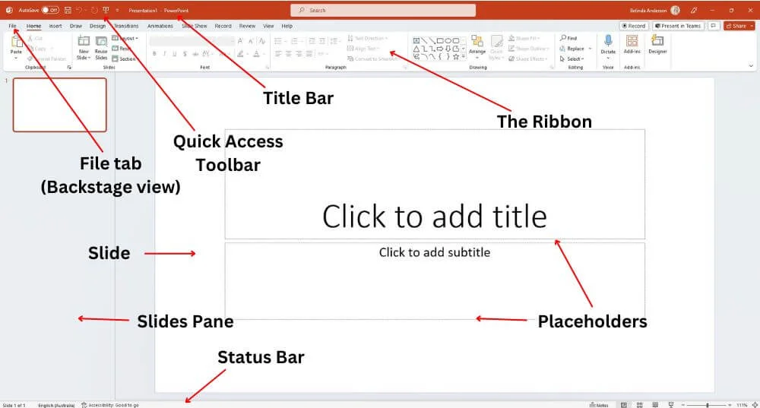
Figer [14]

MS Excel
MS Excel is a powerful spreadsheet program is frequently used in business operations for data management, analysis, and organization. Excel a component of the MS office suite. Facilitates a wide range of tasks, such as data tracking forecasting, budgeting, financial analysis, and reporting. It is a crucial tool in many industries because of its grid – based structure, which enables users to store a massive amount of data in ana accessible and week organised way.
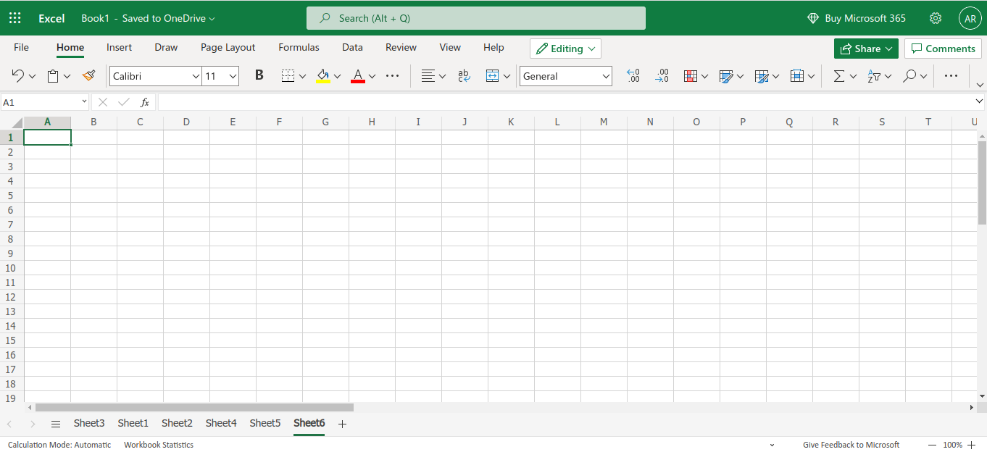
Figer [15]
Major Features;
Excel has many capabilities that facilitates effective data processing and analysis. The use of formulae and functions, which let users to carry out computations ranging from basic arithmetic to intricate financial and statistical analysis, is one of its most significant aspects. Automating repetitious processes and increasing accuracy are made possible by function like SUM, VLOOKUP, and IF.
Data visualization is another important component. Excel has capabilities for making dashboards, graphs, and charts that turn unprocessed data into insightful information, because they enable users to swiftly summarise and evaluates huge datasets, pivot tables and pivot charts are very useful.

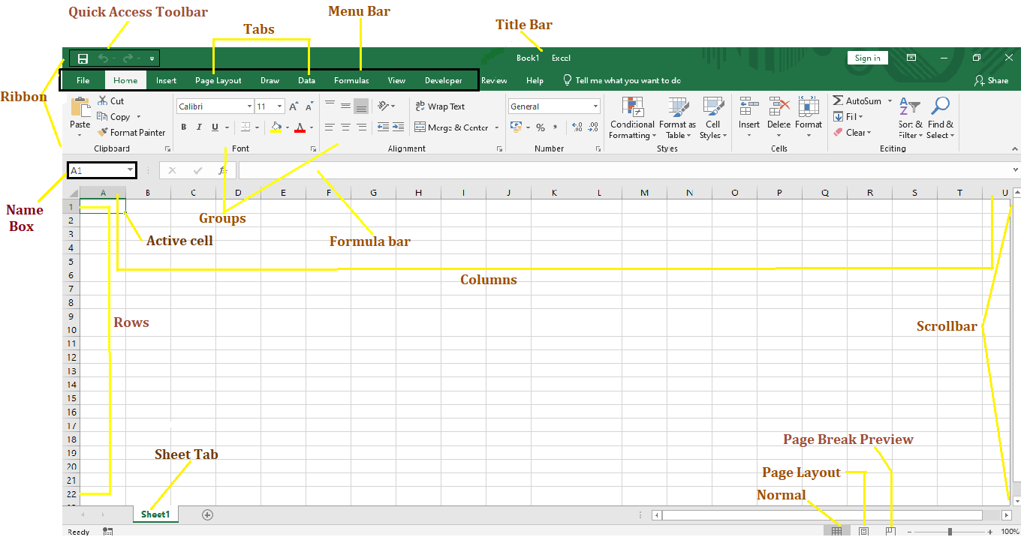
Figer [16]
Data management functions like sorting, filtering, and conditional formatting are also supported by Excel users can find trends, patterns and anomalies in data with the aid of these tools. Excel also allows team members to collaborate and edit in real time by integrating with cloud services like Ms OneDrive.
Another advantage is automation; tools like VBA Visual Basic applications, and macros let users design unique workflow and simplify difficult procedures.
Benefits;
Excel has many advantages that improve decision making and company productivity. Better data organization one of the main benefits. Large volumes of data can be managed and stored by businesses in an organized way, which facilitates record access and updating. Better decision making also supported by it. Businesses can learn about performance, see trends, and make wise strategics decision by utilising formulas, charts, and analytical tools. Excel, for instance, makes budgeting and financial more precise and effective.
Cost effectiveness is an additional advantage. Business can utilise Excel without making a large investment because it is generally accessible and it does not require
Specialist training for basic use. Because of its adaptable, it may be utilized for variety of tasks, without the need for extra software. Its value further increased by cooperation and integration. Excel’s seamless integration with other Ms products makes it simple for users to input and export data. This increases the effectiveness of workflow and fosters department cooperation.
Limitation:
Excel has a number of drawbacks when it comes to corporate operations, despite irs advantages. Its scalability is a significant disadvantage. Excel is less appropriate than specialised database systems because, although it can manage massive datasets, it may become sluggish or ineffective when handling very vast or complex data.
The possibility of mistakes is another drawback. E errors that may go unreported and affect decision making can result from manual data entry and complicated formulae. Excel does not always have robust error checking features, in contrast to specialist systems.

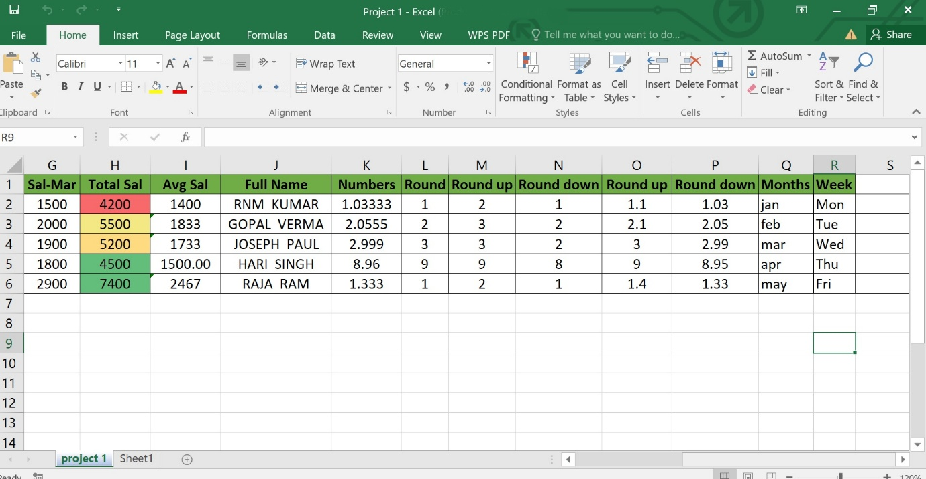
Figer [16]
Even while cloud integration enhance collaboration, problems like version control or unintentional overwriting can still arise. [9]

MS Access
MS Access is a relational database management system that comes with MS Office. It is intended to assist companies in effectively managing, sorting, and retrieving massive volumes of structured data. Access can handle more complicated data process like order tracking, inventory systems, and customer records since it arranges data into tables with relationships, unlike spreadsheets.

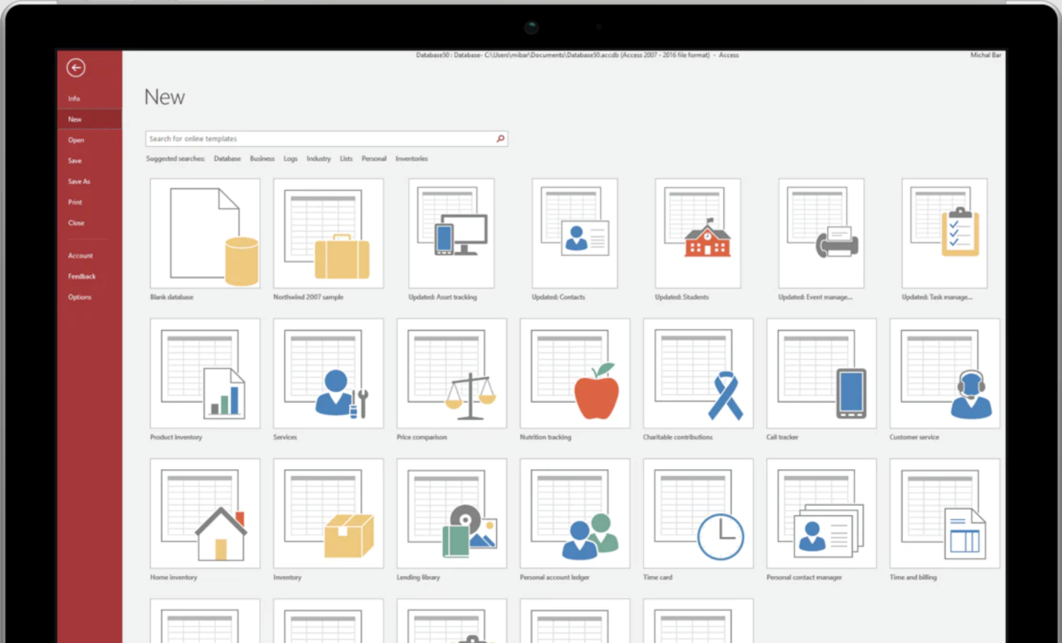
Figer [19]

Major Features:
The relational database structure of access is one of its fundamental characteristics. In order to minimize duplication and enhance data integrity. Data is kept in several tables that can be connected via relationships. Compered to flat- file systems, this enables firms to handle complicated information more efficiently.
Access has a strong query tool as well. To swiftly search, filter, and analyse data, users can develop queries. Businesses can extract useful information for decision making by using these queries, which can range in complexity from basic to highly sophisticated.
The usage of forms is another crucial component. Forms offer an easy-to-use interface for data entry and modification, which lowers errors and boosts productivity. Another important feature is report. Which let users create prepared outputs including performance reports, summaries, and bills.
Visual basic for application (VBA) and macros offer automation, allowing users to automate repetitive activities access also improves data sharing and workflow efficiency by integrating with other Microsoft products like Excel.

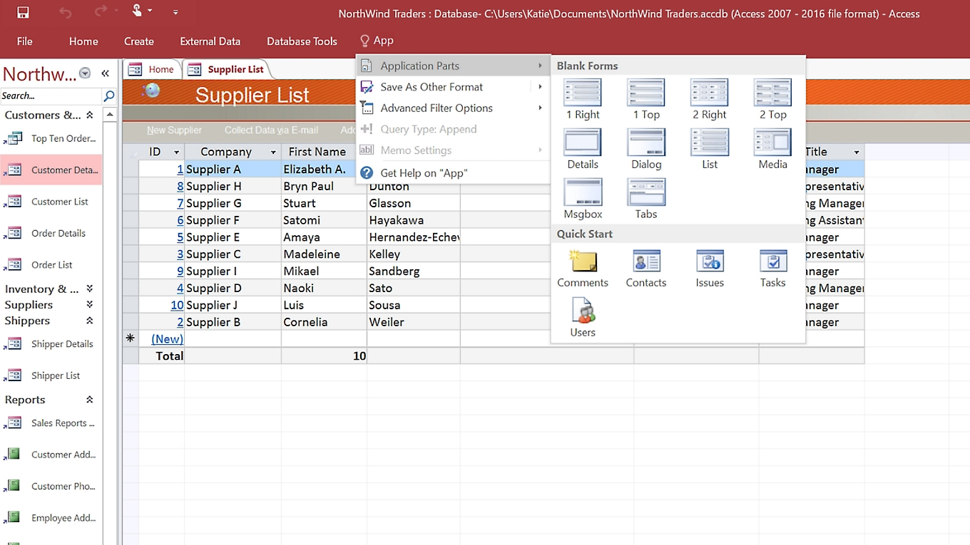
Figer [20]

Benefits:
Access is useful for corporate use because it offers a number of advantages. Better data organization is one of the main benefits. Business can keep accurate and consistent record by organizing data into related tables, which is crucial like inventory control and customer management.
Additionally. It decreases redundancy and improves data accuracy. Since data is maintained in a centralized database duplication and inconsistency is eliminated. This results in more trustworthy data for making decisions.
For small medium sized applications, ease of use is an additional advantage. Compared to more sophisticated database systems, access has a very straightforward interface, making it usable by people with little technical knowledge. Custom database solutions can be swiftly developed by businesses without requiring a deep understanding of programming. Another benefit is cost effectiveness. Access, a component of the Microsoft office suite, is viable choice for smaller businesses because it is less expensive than many enterprise level database systems.
Limitation:
Ms access has a number of drawbacks despite its advantages. Scalability is a major disadvantage. It is less appropriate for large organizations or systems demanding strong simultaneous usage because it is not made for very large database or high traffic situations. Performance is another restriction. Access may become slower and less effective as the database size increase especially when managing complicated queries or numerous suers.
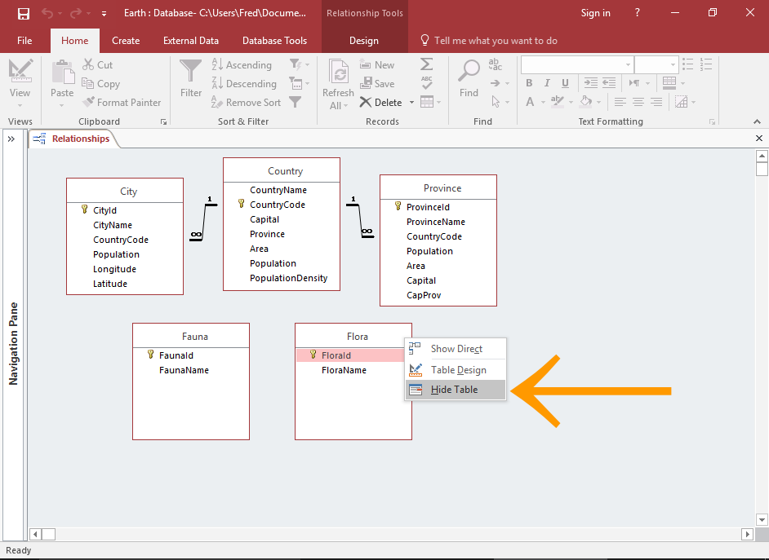
Figer [21]

Another issue be security. Access does not give the same level of security as more powerful database management systems like SQL server, despite having some basic security capabilities. Business that handles extremely sensitive data may find this problematic. Furthermore, access’s accessibility is limited in comparison to cloud based database solutions because it is essentially a desktop application. [10]

Practical demonstration of Two Office Features

Mail Merge
First, you to Mailings, then click on start a mail merge, then choose email message.

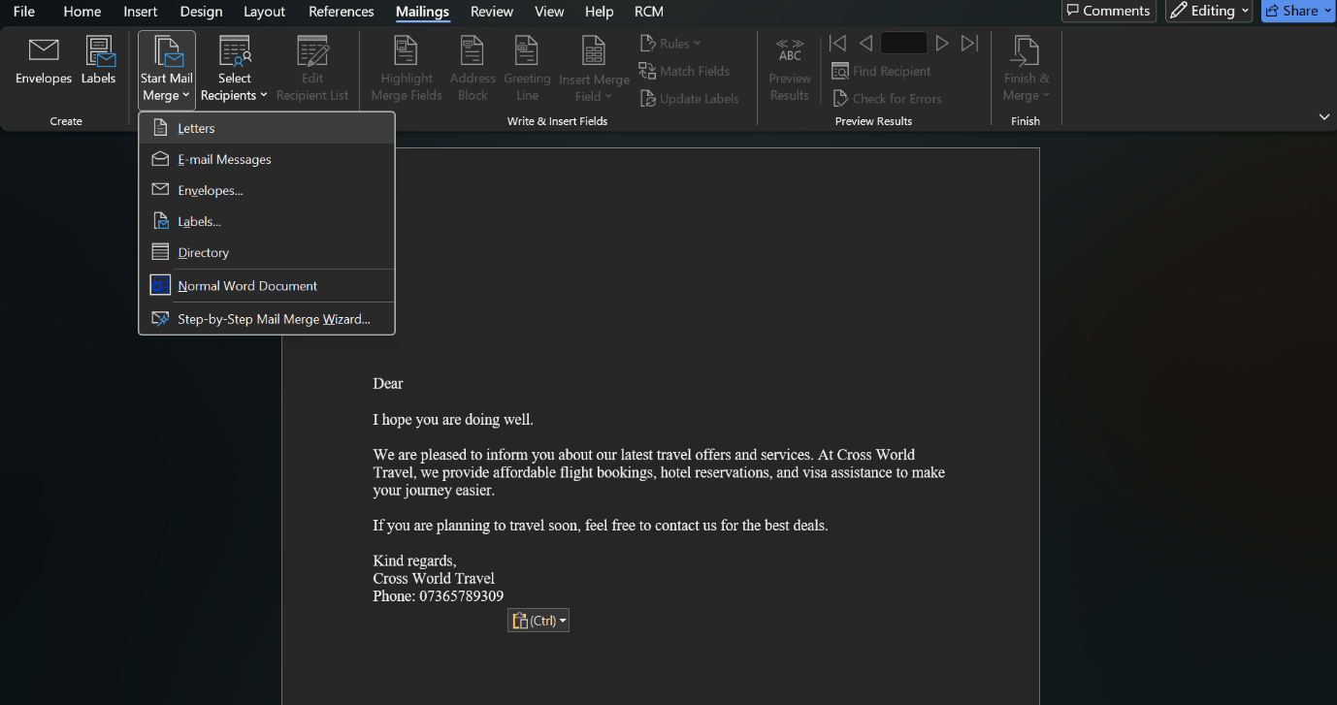
Second step is selecting Recipients, then create a new list, as you can see that I have created a new list. Then click ok.

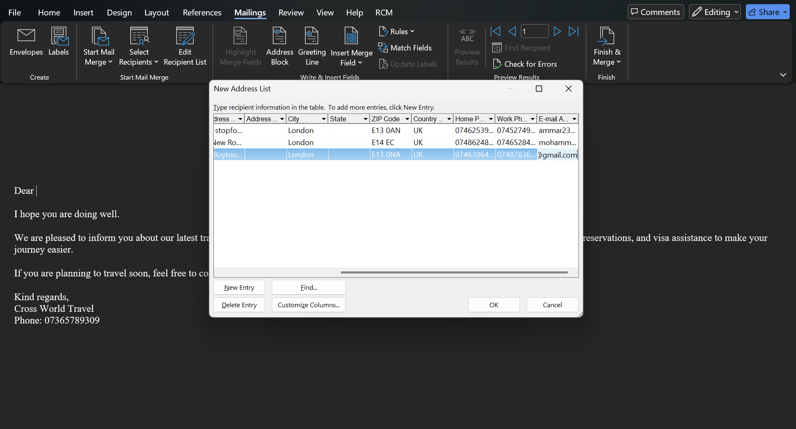

Third step is saving the list i have created.
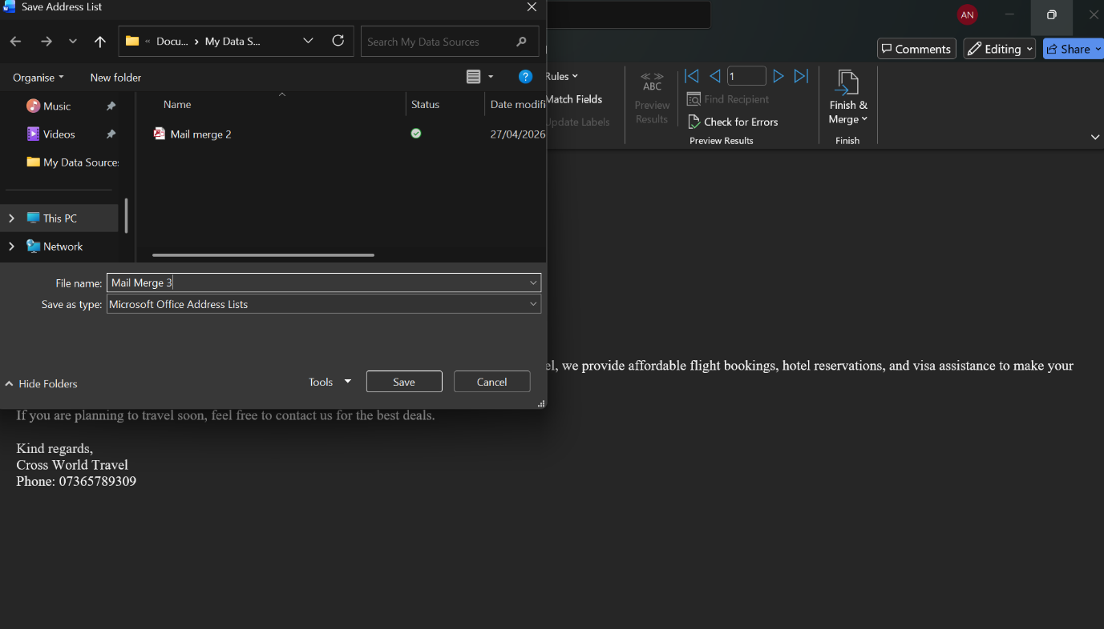
Forth step; this is the email content that I have wrote.

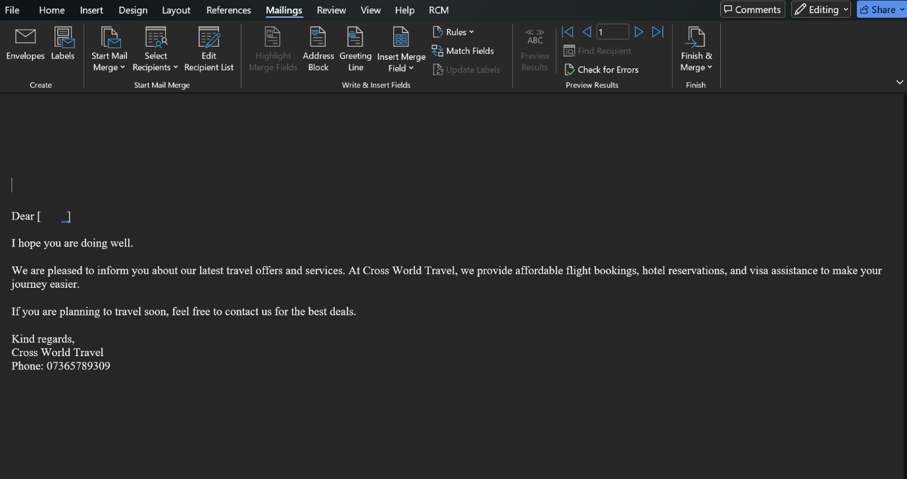

Fifth step; this is where I have inserted merge field, I selected first name and it appeared on the on the email as you can see it on the screenshot.

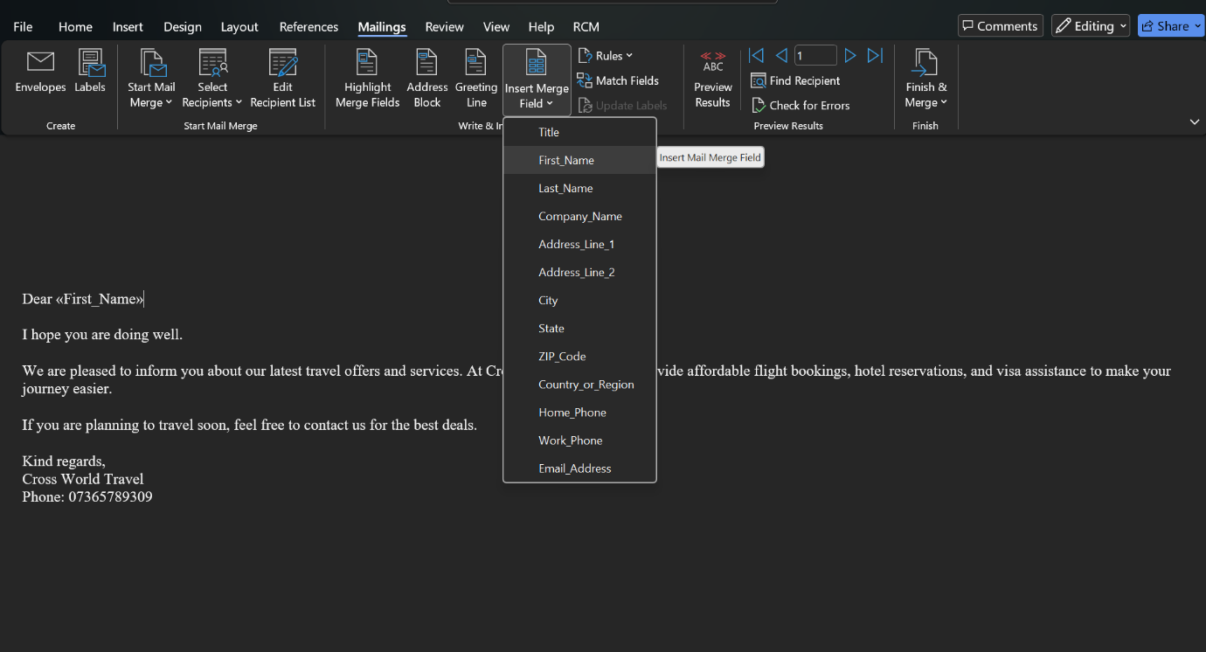
Sixth step; I clicked on preview results on the first name field, and Ammar name has appeared on the email as you can see it on the screenshot.

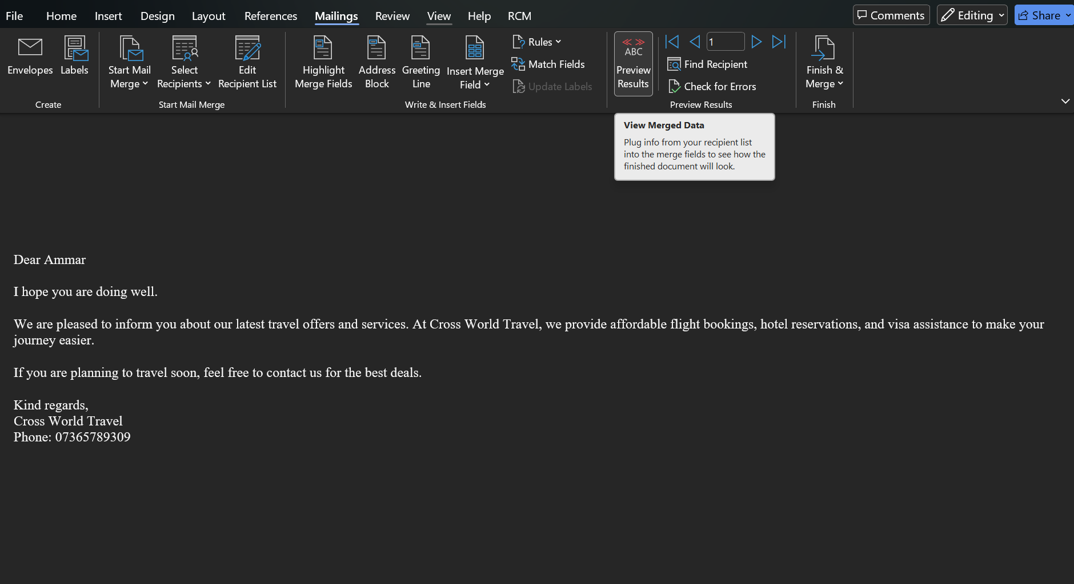
Lastly, you click on finish merge and select send email message.

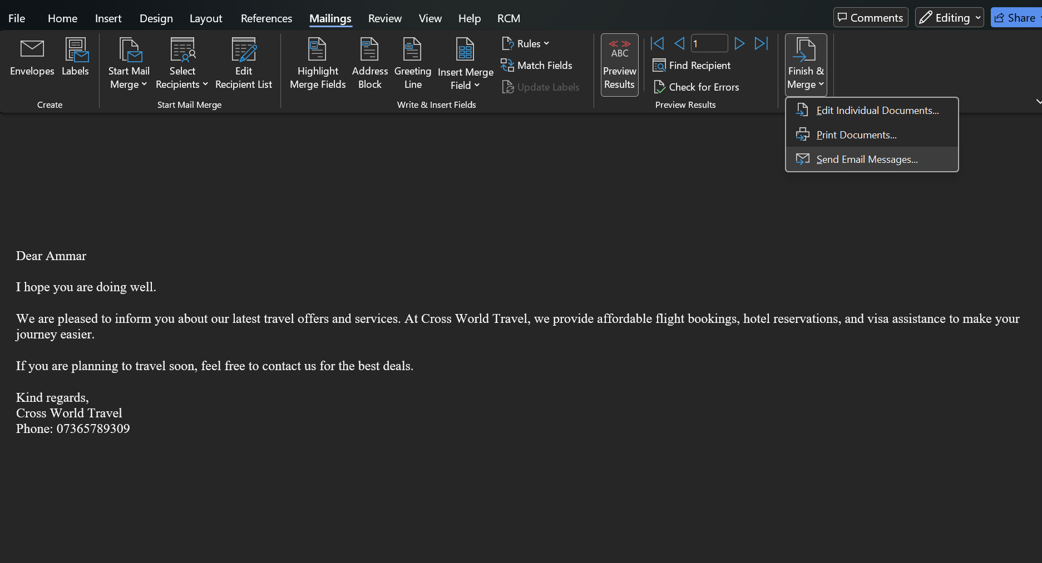
After selecting send an email message this will appear, then click ok to finish the mail merge.

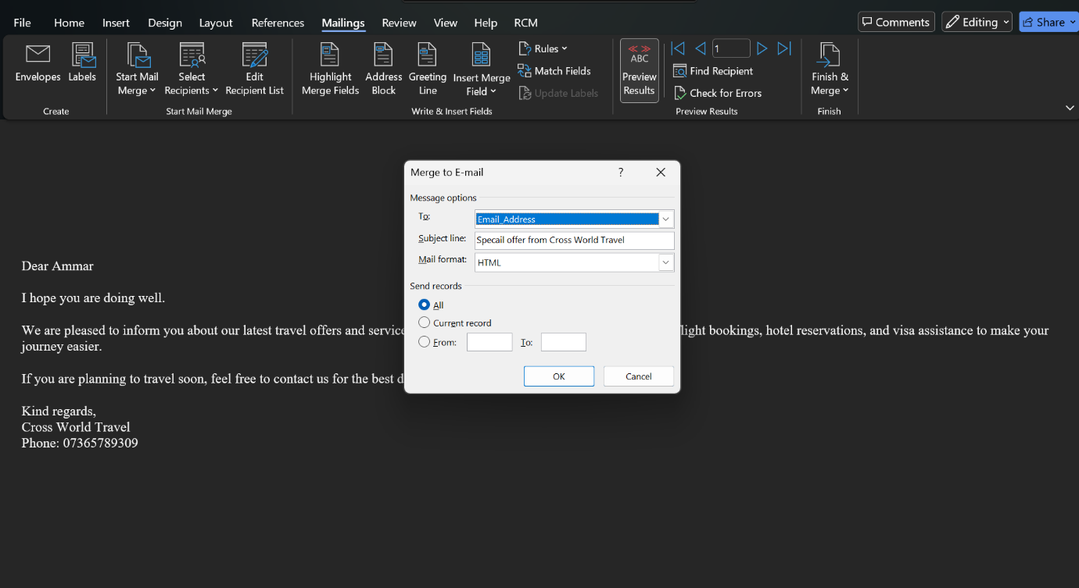

If Statement
Step one; showing the condition as you can see it on the screenshot.

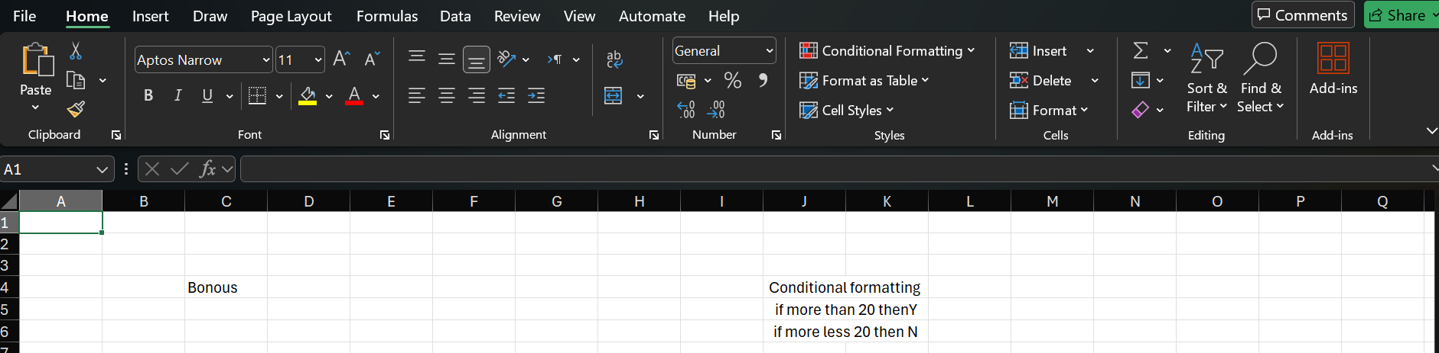

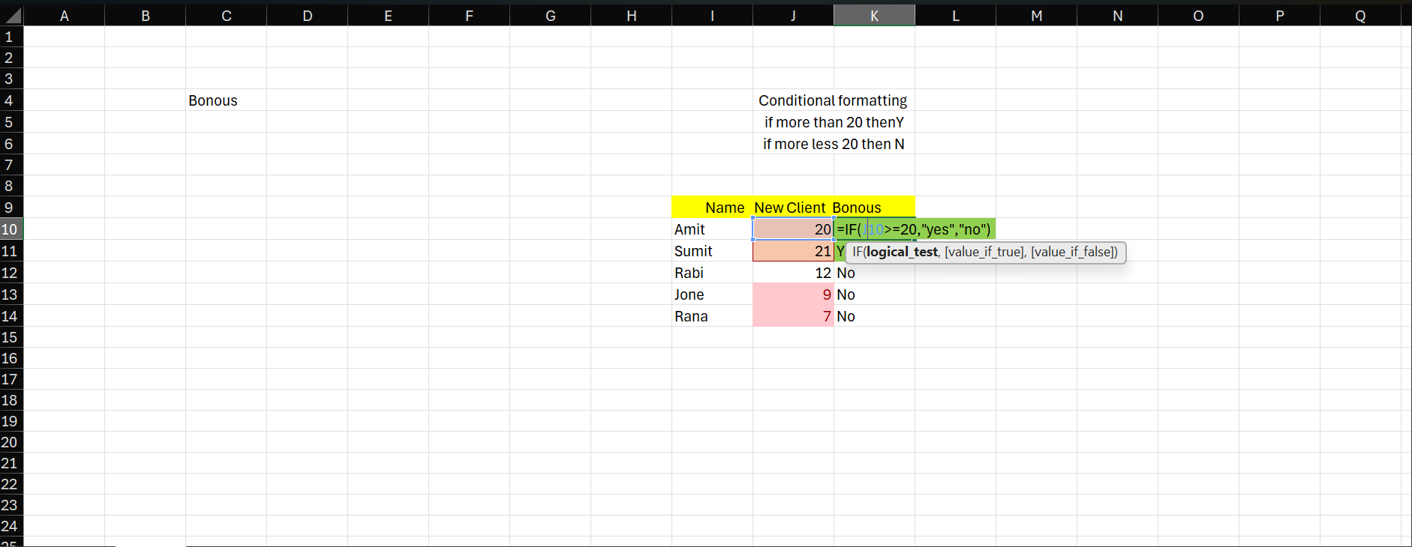
Step two; it shows the formula possess, as you can see it on the screenshot.
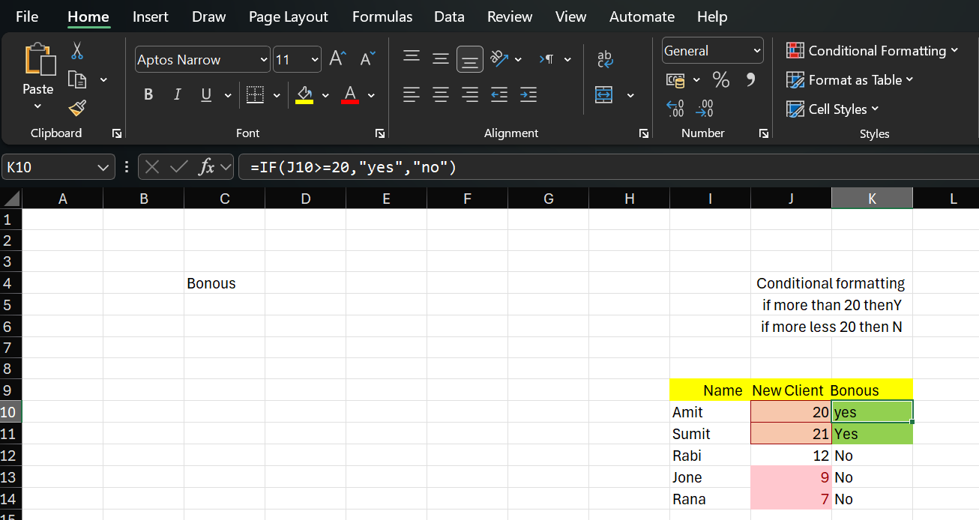
This is the if formula as you can see it.
Finally, this table shows the output results.

Task 4. Communication and Collaboration applications

One contemporary Communication and one Online Collaboration applications/tools

MS Outlook
Ms Outlook is a vital instrument for productivity and communication that is used extensively in contemporary enterprises. It facilitates day to day operations by combining emails, scheduling, task management, and collaboration capabilities into a single platform as part of the Microsoft 365 ecosystem. Its dependability, familiarity, and capacity to centralize workplace communication are what propel its widespread acceptance.
Email communication:
Outlook is best renowned for its powerful email features, which are crucial in professional settings. Workers utilize it for official letters, client communication, and internal collaboration. Features like conversation threading, focused inbox, and sophisticated filtering make it easier for consumers to effectively handle high email volumes. Quick access to previous messages is made possible by the search features, which is essential for record keeping and decision making.
Calendar and scheduling:
Ms Outlook calendar function is essential for time management. Users can communicate their availability with coworkers, create reminders, and arrange meetings. By showing participants availability, the scheduling assistant makes meeting planning easier and minimizes scheduling disputes. Users may generate virtual meeting links right within calendar invites, we should appreciate the Ms teams integration, which supports remote and hybrids world environments.

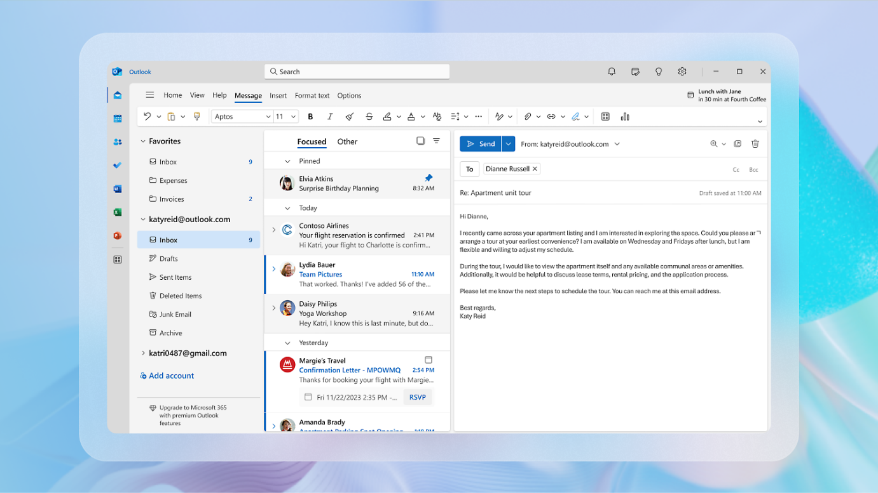
figer [23]
Contact management:
Maintaining business relationships is made easier with outlook organized contact management system. Detailed contact details, such as phone numbers, email addresses, and organizational responsibilities, can be stored by users. Business can deliver customized communication to team’s departments, or client groups by grouping contacts for effective communication.
Task and workflow management:
Another crucial component that improves efficiency is task management. Outlook lets users make tasks, set due dates, and monitor their progress. It is possible to turn emails into tasks so that crucial request is not missed. Employees are better able to maintain organization and accountability in their roles because to integration of task tracking and communication. [11]
Integration with business tools:
Outlook smooth interaction with other Microsoft programs, including word, Excel, and SharePoint, is one of its best features. Users may share and edit documents straight from their mailbox, we should appreciate to this networked solution, which increase workflow effectiveness. It saves time and improves teamwork by reducing the need to switch between various application.

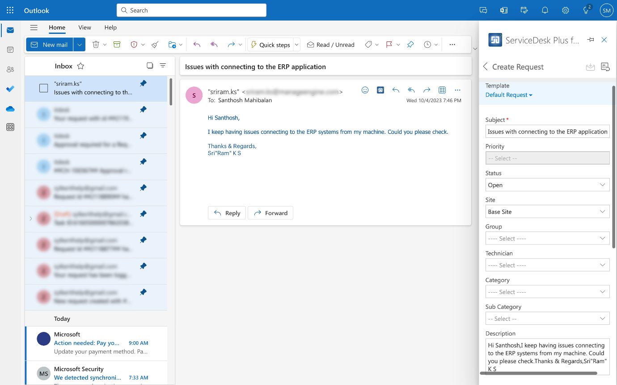
Figer [25]

Compliance and security:
MS outlook enterprise level security features have earned it widespread confidence. Spam filtering, phishing detection, encryption, and data loss prevention rules are all included. These features guarantee adherence to industry regulations and safeguard confidential company data. This degree of protection is crucial for businesses that handle sensitive data.
Features of automation and productivity:
Ms outlook has automation features that assist simplify repeated operations, like rules and quick steps. Incoming emails can be automatically sorted, flagged as essential, or Forword to designed folders by users. Employees can concentrate on more important tasks; we should appreciate these characteristics which lessen physical labor.
In conclusion, because of its extensive features set and smooth interaction with Microsoft ecosystem, Microsoft outlook continues to be vital tool in contemporary business. It improves productivity, fosters collaboration, and enables business to function more effectively in a fast-paced digital environment by integrating email, scheduling task management, and security into a single platform. [12]

MS Teams
MS Teams has emerged as a key instrument in contemporary business, especially with the growth of remote and hybrid work. It integrates productivity, collaboration, and communication capabilities into one platform as part of the Microsoft 365 ecosystem. Teams helps organizations improve real time collaboration across department and geographies, streamline workflow, and lessen dependency on several applications.
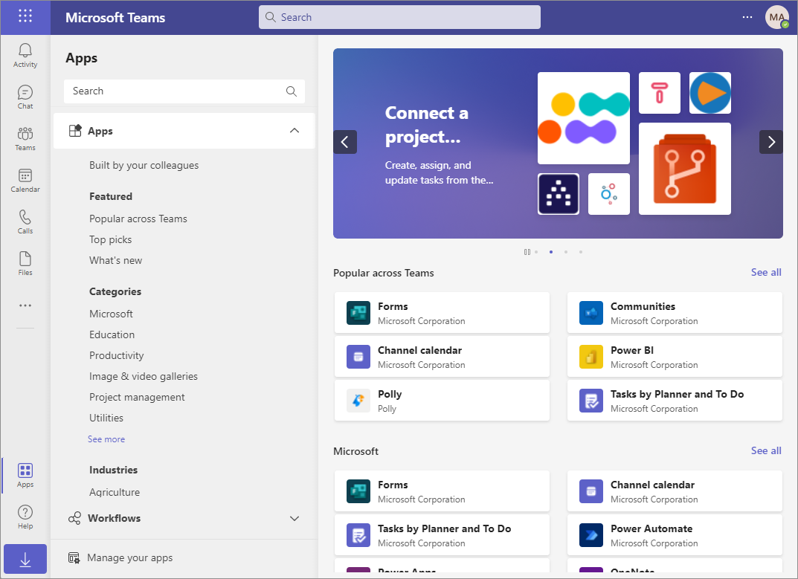
Figer [27]
Messaging and communication:
Instant communication is one of the MS Teams main applications. It provides chat-based messaging for both individuals and groups, enabling rapid communication among staff members without depending entirely on email. It easier to track and mange conversations when they are divided into channels according to teams, projects, or subjects. Features that enhance clarity and guarantee that crucial information is readily available include mentions, threaded answers and file sharing within chat.
Meetings and Video Conferencing:
Many people use MS teams for video conference and online meetings. Companies use it for webinars, client presentations and internal meetings. Meeting records, screen sharing, and high-quality audio and video calls are all supported. Meeting scheduling and participation are made possible via integration with outlook calendars. Teams are now crucial for preserving communication in remote work settings because of this feature.
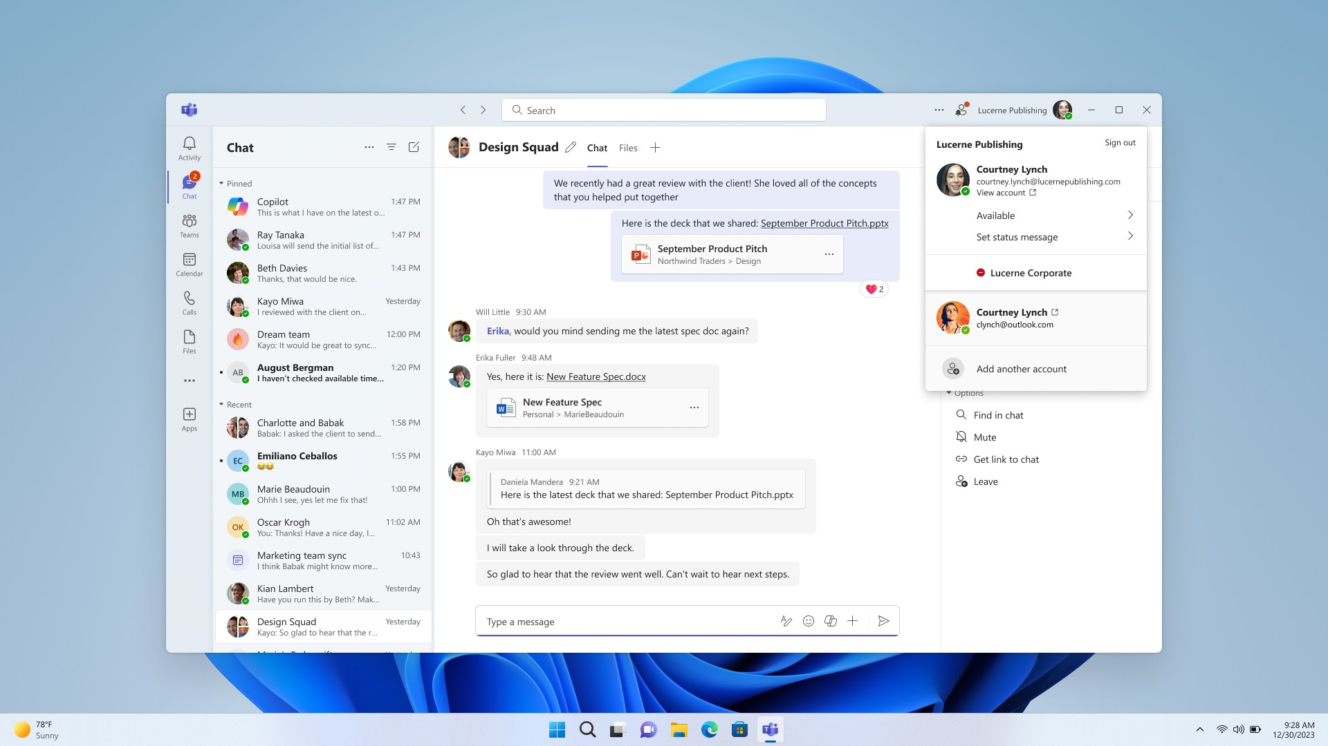
Figer [28]
Cooperation and file exchange:
MS teams integrate with programs like MS Word, MS Excel, and MS Power Point to facilitate real time collaboration. The platform allows users to directly create, modify, and share documents. Share Points is used to store and mange files, guaranteeing version control and convenient access. This increases team efficiency and does way with need to communicate numerous file versions via email.
Channel and Team Organization:
Teams organized structure via teams and channels is one of its main features. While channels concentrate on certain projects or subjects, teams usually represent department or sizable organizations. Business can avoid information overload and maintain regulated communication with aid of this structure. Workers can quicky switch between channels to locate pertinent resources and topics.
Connectivity to business applications:
Numerous Microsoft and third-party apps are integrated with Microsoft teams. Channel can directly incorporate programs like Microsoft one Notes and planner. This enables users to keep track of their progress, take notes, and mange projects all form within the application by consolidating serval processes in one location, these linkages increase productivity.
Compliance and security:
Businesses place a high priority on security, and team offers enterprise level security. Data encryption, multi factor authentication, and adherence to international standards are all part it. Sensitive corporate communications and files are kept safe, we should appreciate these capabilities, which is essential for sectors handling private data.
Productivity and automation:
Additionally, Microsoft teams facilitate automations via processes and bots’ companies can set automated, procedures, like task updates, notifications, and approvals, using programs like Power automate. Teams are able to concentrate on more strategic tasks as result of the decrease in manual labor.
Conclusion: Ms teams is extensive utilized in contemporary enterprise due to its ability to consolidate productivity, communication, and collaboration features onto a single platform. It is a crucial tool for enhancing efficiency and teamwork because of its messaging video conferencing, file sharing and integration features. [13]

One feature of a freely available Communication (1) and one feature of a Collaboration (1) application

MS Outlook
This screenshot shows that, the email composition, it also shows me writing an email with a subject, and a message. Folders an email list, formatting tools, and send button for sending emails are shown in the interface

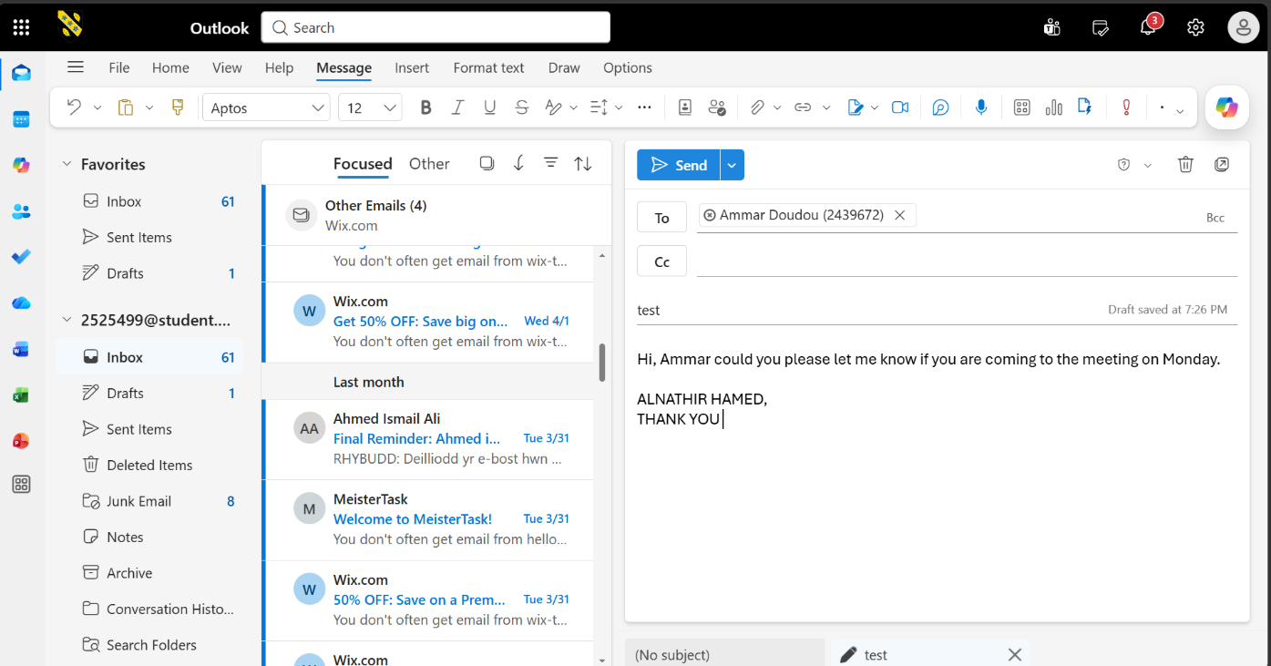

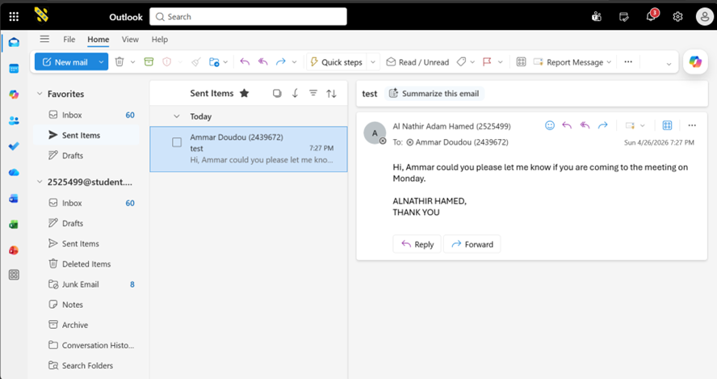
This screenshot shows a sent email displayed in the sent item folder.

this screenshot shows all the emails I have on the inbox folder, as you can see it.

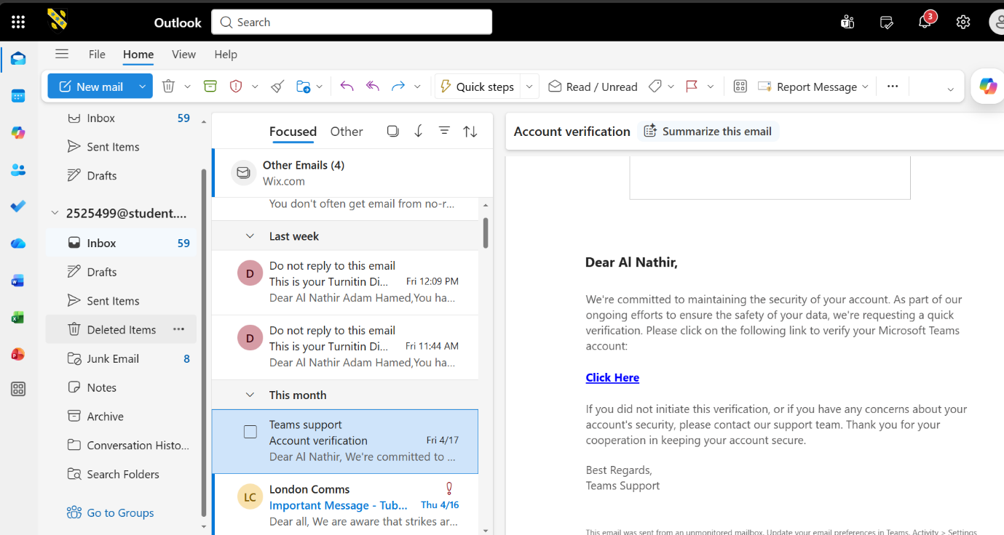

Ms Teams
This shows an existing team, you can join this team if you have the code.
In the navigation bar, you can see teams, this where you can join a team or create your own team, you click on the plus button to create your own team.

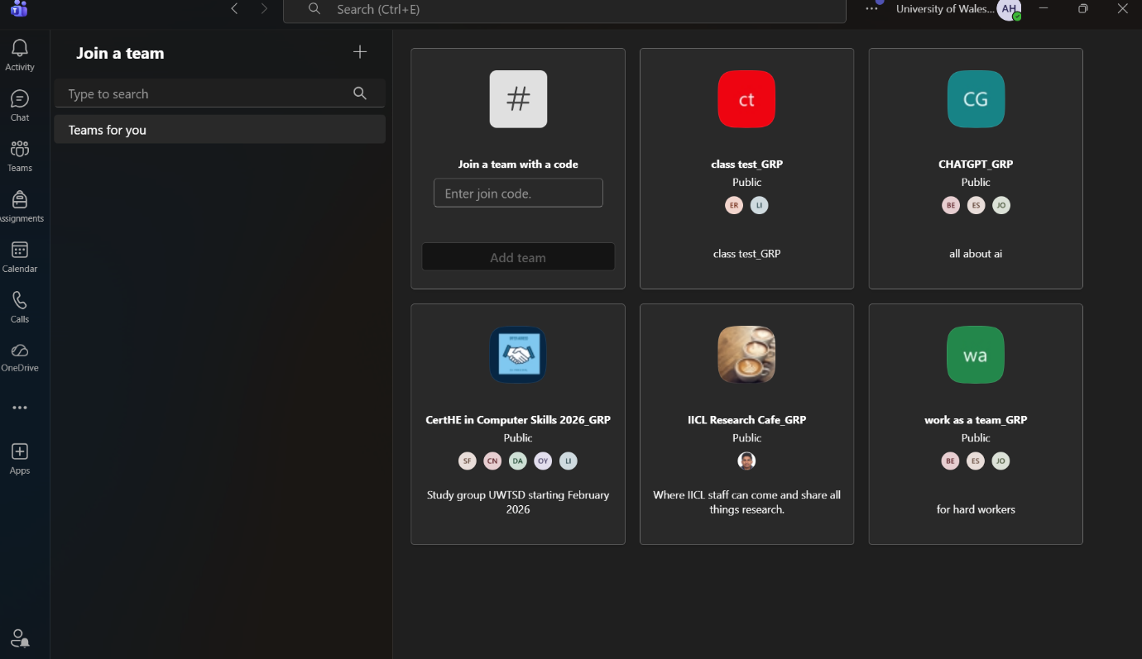

You could also start a call or a video call.
You can start a new conversation by clicking there. As you can see I have started conversation with Ammar.
This is chat, which is ideal for chatting and communicating in smaller groups.



In the navigation bar you could see calendar, this where you could see your upcoming meetings.
This screenshot shows that you can schedule a new meeting as you can see you just click on new.

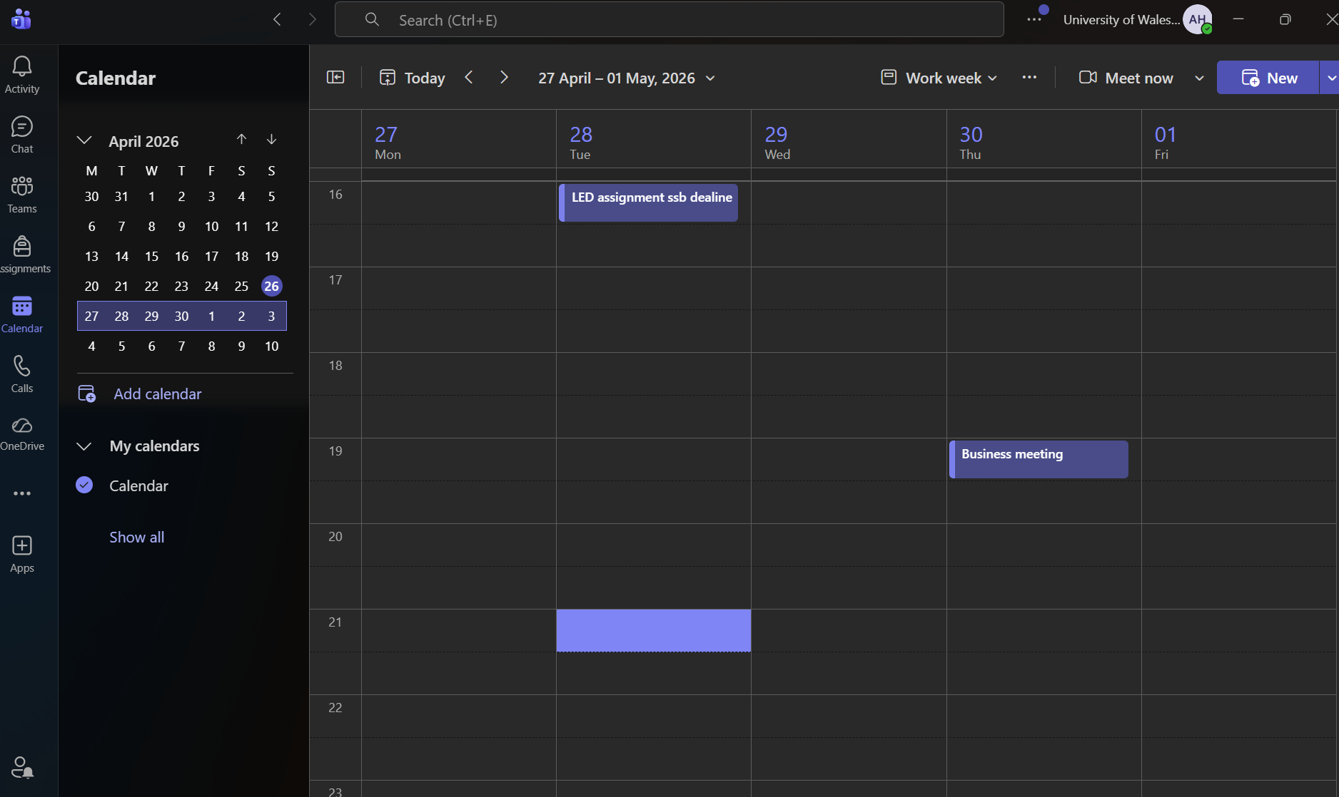

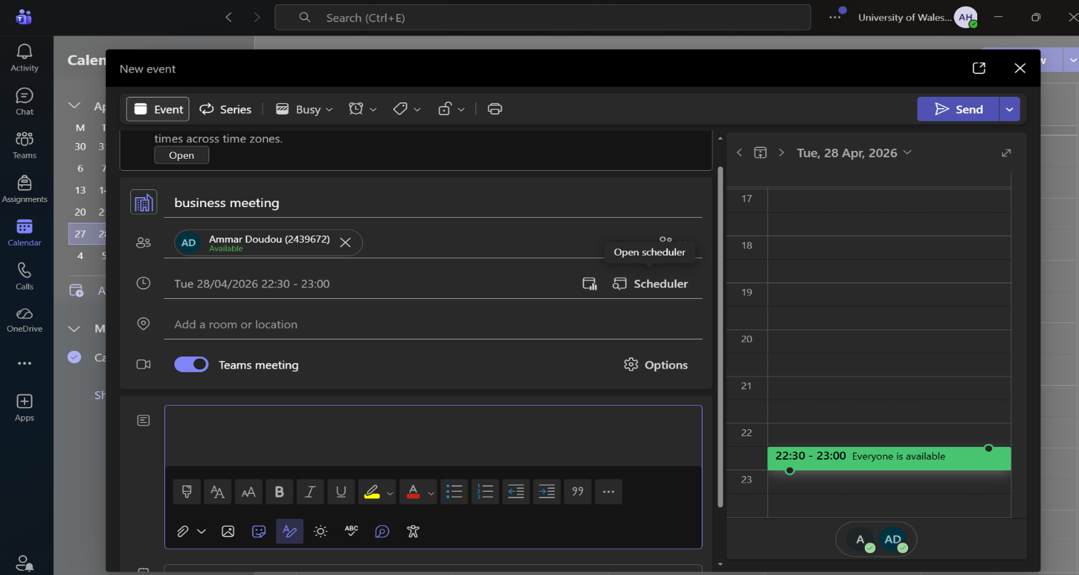
This screenshot shows that with a meeting detail you can type a subject, add recipients and write a description. Then click send.

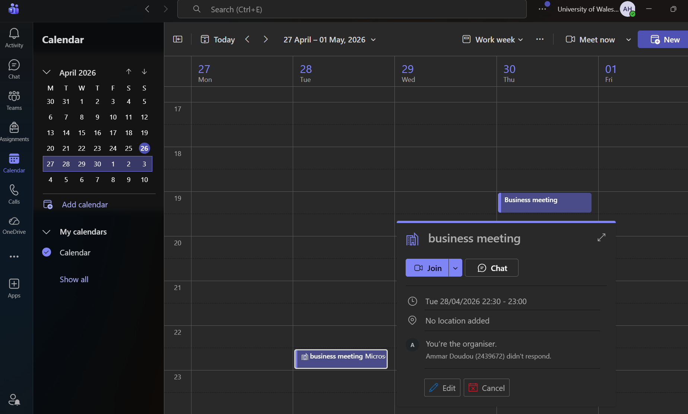
This screenshot shows the new even and now you can join the meeting.

Conclusion
This assignment has examined a variety of modern software programs that are essential to contemporary corporate operations. It started by looking at e-commerce website builders, emphasising how companies can rapidly and effectively construct online shopfronts without needing sophisticated technological skills, we should appreciate platforms like Shopify and Wix. These tools enable business to access international markets and facilitates digital transformation.
The conversation on mind mapping showed how useful it is for planning, structuring thoughts, and strengthening decision making in professional settings. Mind maps help teams better grasp complex processes and increase productivity by organising knowledge visually.
Additionally, the examination of office software, such as Microsoft Word, Power Point, Excel and access demonstrates how crucial these programs are for document creation, information presentation, and decision assistance. Together, they create a potent suite for managing routine business tasks, even if each program has its own special features, advantages, and drawbacks. Features like mail merge and Excel functions were tested practically to give users a hands-on experience and show how valuable they are in the real world for increasing accuracy and efficiency.
Lastly, the assessment of collaboration and communication technologies emphasised how crucial they are for fostering teamwork, particularly in remote and hybrid work settings. These programs facilitate file sharing, real time communication, and project coordination all of which are critical for sustaining efficiency and productive teamwork.

References

[1] | ". e. W. B. Wix, https://www.wix.com, [Apr.27.26].
[2] | W. r. f. p. m. Forbes, https://www.forbes.com, 2023.[online] [accessed Apr.27.26].
[3] | ". S. f. [. Shopify, https://www.shopify.com, [Apr.2027.2026].
[4] | T. M. M. B. T. Buzan, 2010..
[5] | M. Davies, Concepts mapping and mind mapping,, [2011,].
[6] | ". m. i. e. e. A. J. Mento al, [1999].
[7] | M. 3. p.-. Review, [2023].
[8] | P. o. M. W. W. a. Functions.
[9] | Microsoft, Mcrosoft word - Features and Overview,, [2023].
[10] | Write on Microsoft online.
[11] | Ms Power Point - introduction, features and use.
[12] | Chapter 9: Microsoft Power Point - Business technology essentails.
[13] | ". M. P. P.-. F. a. O. Microsoft, [2023].
[14] | Presentation and M. P. P. W. w. live.
[15] | 4 Benefits Microsoft Excel Dalam Menganalisis Data.
[16] | Components of Excel spreadsheet.
[17] | Microsoft Excel template Downloads.
[18] | M. o. 3. &. E. G. Shelly and M. Vermaat, [2019].
[19] | Microsoft Access Software,, 2025 Reviews, pricing & Demo.
[20] | Database Software and Applications/ Microsoft Access.
[21] | Microsoft Access.
[22] | ". M. A.-. F. a. O. Microsoft, [2023].
[23] | Microsoft out look inbox.
[24] | ". O.-. F. a. O. Microsoft, [2023].
[25] | Microsoft ecosystem integration for servive mangament platform.
[26] | M. O. &. O. G. Shelly and. M. Vermaat, [2019].
[27] | Microsoft Team Template-vrgou.com.
[28] | M. T. features.
[29] | ". M. T.-. F. a. O. Microsoft, [2023].
[30] | Components of Excel Spreesheet.

