Tomb of Saint Bernadette of Lourdes

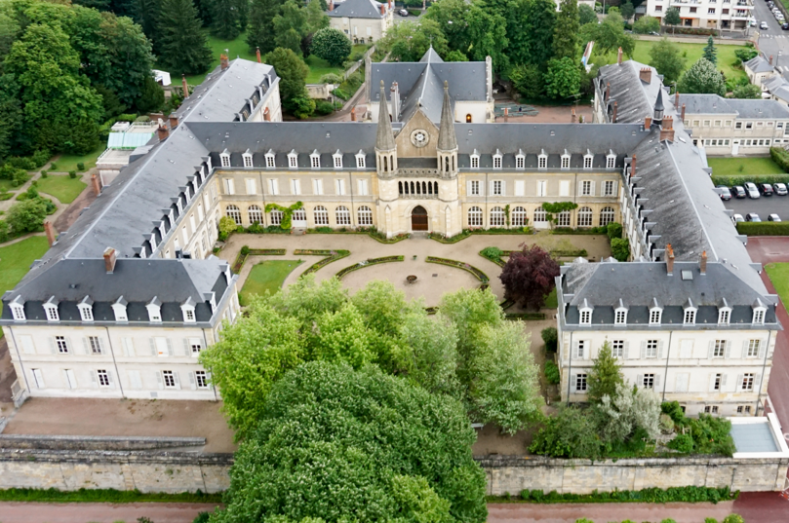

The Couvent Saint-Gildard was the place where Saint Bernadette is buried. The place of her burial is significant to the story of Saint Bernadette as after her apparitions in Lourdes she came to the convent and the Couvent Saint-Gildard was where she served as a Nun. when she died it was the place of her burial. So, for Saint Bernadette was a place of personal refuge from the public life at the time. She was at peace in the Couvent Saint-Gildard and now she rests at peace. This place is of spiritual significance to Saint Bernadette.

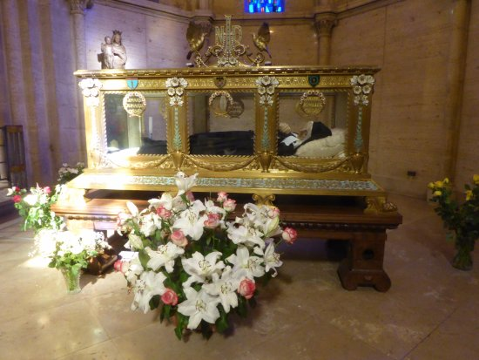

The interesting thing about the Tomb of Saint Bernadette is the Care and devotion put into her tomb. Through the Gold gilded case to the flower and the condition of the church reflects the importance of Saint Bernadette. Because Saint Bernadette is in a Gold framed glass case, is clearly showing that she is a holy figure that people want to see the Saint. This type of glass case burial breaks with the usual burial in the ground, and it shows that People gather to see the Saint. The Flowers laid show respect and give almost an innocence to the image because she is surrounded by flowers it shows the devotion people give to her. People all round the world come and pay their respects to the Saint. The Saint attracts 5 million people to Lourdes to see the Grotto, according to Aleteia and 200,000 people across the world come to see Saint Bernadette according to trip advisor. the entire image shows the innocence and holiness of the story of Saint Bernadette from the Virgin Mary watching over her body to the flowers and the simplicity of the chapel. The Virgin Mary’s Statue watching over Bernadette’s body is significant. Saint Bernadette’s story is about her having 18 apparitions of the Virgin Mary. The fact that the only imaging in the chapel is of the Virgin Mary is significant to the Story of Saint Bernadette that even after death Bernadette is still in the company of the Virgin Mary.

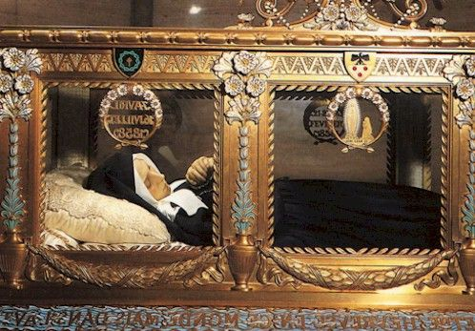

The Case of Saint Bernadette has an important image on it. The common image of Bernadette praying with the Virgin Mary is significant and the high point of her story. The case itself is significant for Bernadette as it is well known that Saint Bernadette came from a poor family so the case and the way she is buried is significant because it suggests that rich benefactors paid for Saint Bernadette to be buried this way. She is also buried in the convent she lived in as well as buried in her habit. The Glass enables Bernadette to be seen by visitors. She is an object of holiness, a connection to the divine. On a Religious aspect Bernadette is a Person that brings People all over the world in connection to the Virgin Mary. The case is incredible in its simplicity yet had a lot of decoration to relay the innocence of Bernadette.

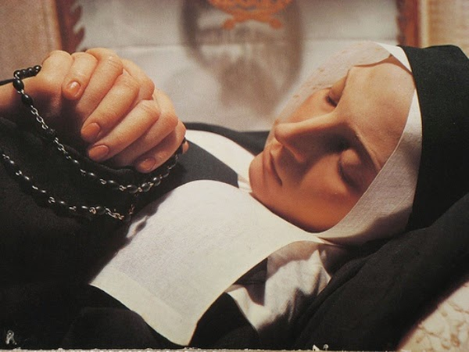

When Saint Bernadette was being canonised, they said her body was incorrupt being another miracle that made her became a Saint according to Atlas Obscura. Yes, the body may have gone blackish but according to the church and reports it was still in good condition and according to Atlas Obscura, most think that is she was left alone she would have remained incorrupt. The wax was so well done it makes Saint Bernadette life like. Saint Bernadette looks as if she is in deep prayer with her hands in a prayer position and her rosaries in her hand. This pose is unique to some saints but for Bernadette it tells her story. Being in a prayer position with her rosaries is what she did with the Virgin Mary in some of the apparitions she had. It gives Bernadette a holy and innocent look almost like death has untouched her. It is also unique for a saint to have such well-preserved wax or even to be in wax. It shows a further understanding that Bernadette was innocent and young when she died. Bernadette holding the Rosaries is a huge significance. The Rosary is known to be associated with the Virgin Mary, again another signal to the Virgin Mary and the story of Saint Bernadette. These References and little details relay the story of Saint Bernadette.

References

Sanctuaire de nevers [Photo] https://www.sainte-bernadette-soubirous-nevers.com/en/le-sanctuaire/ [Assessed: 14th October 2022]

Trip advisor [Photo] Saint Gildard and museum https://www.tripadvisor.com/LocationPhotoDirectLink-g196542-d674344-i276237743-Saint_Gildard_Convent_Museum-Nevers_Nievre_Bourgogne_Franche_Comte.html [Assessed: 14th October 2022]

Aleteia Traveling to Lourdes? Go out of your way to visit St. Bernadette’s incorrupt body https://aleteia.org/2017/10/11/traveling-to-lourdes-go-out-of-your-way-to-visit-st-bernadettes-incorrupt-body/ [Assessed: 14th October 2022]

Trip Advisor Espace Bernadette https://www.tripadvisor.co.uk/Attraction_Review-g196542-d4749745-Reviews-Espace_Bernadette-Nevers_Nievre_Bourgogne_Franche_Comte.html\ [Assessed: 14th October 2022]

The Divine Mercy [Photo] https://www.thedivinemercy.org/articles/bernadettes-body-still-rests-incorrupt [Assessed: 14th October 2022]

Catholic news world [Photo] http://www.catholicnewsworld.com/2019/04/saint-april-16-st-bernadette-soubirous.html [Assessed: 14th October 2022]

Atlas Obscura The Not-Quite Incorruptible St. Bernadette of Lourdes Available at: https://www.atlasobscura.com/places/not-quite-incorruptible-st-bernadette-lourdes [Assessed: 14th October 2022]

