 |  | Stop Bagging the Planet | March 2022
 |  | Say NO to plastic bags, stop choking the Earth!
8 million pieces of plastic pollution find their way into our ocean daily. (2)  79% of plastic waste is sent to landfills or the ocean, while only 9% is recycled, and 12% gets incinerated. (1)  Nearly 700 species, including endangered ones, are known to have been affected by plastics. (3)  Many creatures are killed as a result of humans littering near coasts, simply because the litter gets into the water and chokes sea life, resulting in death and extinction. (4) |  |   Plastic is taking over the world  Plastic litter in the ocean harms and kills fish, seabirds, and marine animals. Persistent organic contaminants in the marine environment adhere to the surface of plastic waste, and floating plastics in the oceans have been discovered to collect pollutants and transmit them via ocean currents. Plastic accounts about 80 percent of all marine garbage discovered from surface waters to deep-sea sediments, and at least 14 million tonnes of it ends up in the ocean every year.  This needs to come to a stop! (5)  Approximately 8 million tonnes of plastic garbage spills into the oceans each year from coastal countries. That's the same as dumping five rubbish bags full of litter on every foot of coastline on the planet. This is a major problem that needs to be addressed immediately to prevent it from destroying the planet. (6)  We as humans have most likely absorbed microplastics in our seafood at some time in our life as a result of the massive amounts of plastic which are polluting our ocean.  Yet the majority of us humans still continue to litter! Why? When fossil fuels are converted into plastic resins and additives, very hazardous chemicals are released into the atmosphere. This has a significant negative impact on sea life, resulting in the loss of life. (7)
Human Resources Manager

Skills needed to be a successful Human Resource Manager: (1)
- Communication
- Organisation
- Flexibility
- Patience
- Negotiation
- Compassion
- Leadership abilities
- Able to multi-task

Why are these skills important?
These are abilities that I believe are critical for a Human Resource Manager to have, for obvious reasons such as dealing with employees who may desire to leave the company on a regular basis. As an HR Manager, you must be able to negotiate and interact with employees to reach an agreement that benefits both the company and the employee.
An HR expert is responsible for completing projects, resolving challenges, and addressing the requirements of employees. Employees may feel inadequate or underappreciated as a result of half-hearted efforts, which could contribute to high turnover rates. Even if employees stay, if they don't feel valued or respected, they may not do their best work.
If a Human Resources Manager employs any of these talents, they will be successful and significantly lessen any problems that a company may face. (5)
Patience
Patience, I believe, is another important quality for a Human Resource Manager to possess. I believe this is because they deal with a large number of complaints and must not lose their cool with the employees or individuals who have contacted them to resolve the issue. (3)
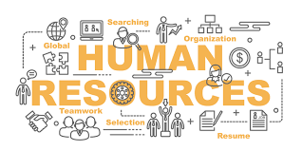
Communication
When it comes to becoming a Human Resource Manager, I believe that communication is crucial. This is because you'll be dealing with salary negotiations, benefit explanations, conflict resolution, company presentations, employee handbook revisions, and so on every day. As a result, both verbal and textual communication are critical. (2)

Organisation
Employees of a company will seek assistance from the Human Resources department, therefore being organised is a necessary ability. Although the HR Manager may not always have the answer, they should be well-organized so that they know where to find the information for the employee. (4)

What is design thinking?
Design thinking is a problem-solving method that prioritises the demands of the customer above anything else. It is based on observing how people interact with their surroundings with empathy and using an iterative, hands-on approach to develop unique solutions. (1)

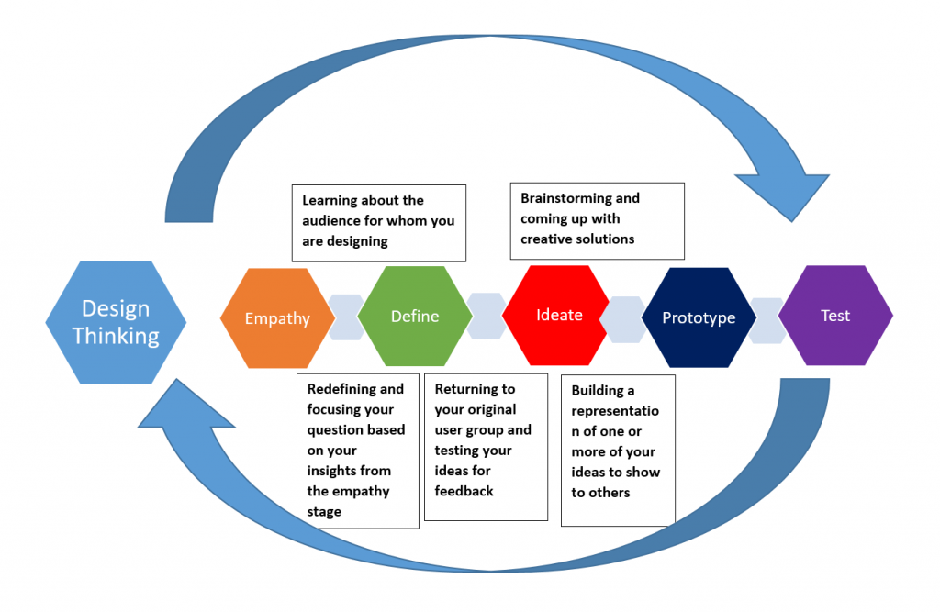
Another disadvantage of Design Thinking is that it demotivates business executives. This is due to the fact that so much time and thought goes into planning that it saps their enthusiasm to enhance the company and carry out their objectives. Many business management Design Thinking teams are urged to cut corners by reducing critical ethnography work to phone interviews and limiting creative period for ideation to four hours of a two-day session, with limiting devastating outcomes. Overall, there are many merits and shortcomings to Design Thinking which Business management have to look at closely and work together to solve. (4)
Although there are many merits of design thinking there are also shortcomings!
The shortcomings of design thinking are that for business management they must manage large groups of stakeholders who want to be engaged and included in the entire design and development process are frequently involved in Design Thinking. The creatives must devote a significant amount of time to involving their team in the process, which detracts from the real design and production work. (3)
How is design thinking used in business management?
Design thinking is used in business management in several ways. To begin with, it is utilised to respond to the needs of customers or clients. This is critical in corporate management since it allows problems to be resolved swiftly and the company to succeed. Design thinking also aids corporate management in responding to shifting consumer trends and behaviour. This is critical since it allows them to comprehend consumer expectations. (2)

Merits of design thinking for Business Management.

